Statement of Contribution

COMP 3019J – Project

Week Number: 6

Milestone Number: 1

We declare that the following contribution to the project for the Web Application Development module is correct, and agreed to by the entire team. We accept that this breakdown of contribution will affect the distribution of grade for the project.

We further accept that in case these contributions are found to be falsified / misleading / incorrect, by any means, now or in the future, the team as a whole is liable. We understand that penalty for such action could range from failing the project to a referral to the disciplinary committee.

**Project Name: A Movie Rating Website**

**Contribution (%) of Teammate #1: 34%**

**Contribution (%) of Teammate #2: 33%**

**Contribution (%) of Teammate #3: 33%**

(must add up to 100%)

|  |  |  |  |
| --- | --- | --- | --- |
|  | **Teammate #1** | **Teammate #2** | **Teammate #3** |
| Name (in capital) | YANG QIU | SHAOROU TANG | SHUQI DAI |
| UCD-ID | 21207231 | 21207312 | 21207304 |
| UCDconnect Email | yang.qiu@ucdconnect.ie | shaorou.tang@ucdconnect.ie | shuqi.dai@ucdconnect.ie |

**Teammate #1 Signature:**

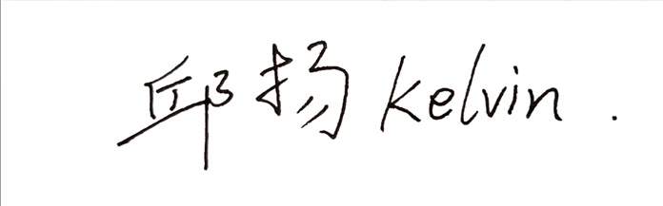

**Teammate #2 Signature:**



**Teammate #3 Signature:**



**Date: 01-10-2023**