ECEN5283 Project 2 Edge Detection
(Due on March 2, 2024)

- Given two color retinal images, blood vessels are major anatomical structures which are very important for disease diagnosis. The images are RGB true color (24 bits per pixel). You can implement edge detection on the green channel only (I=imread(‘retina1.bmp’); J(:,:)=I(:,:,2);).
- You are required to implement the Matched filtering-based blood vessel extraction. Try to optimize the parameters in matched filtering by trying multiple settings and comparing the results. Please also implement the length filtering technique to remove small regions. (Refer to Slide 13 of Lecture 12).
- Use the Matlab edge detection function (refer to Slide 11 of Lecture 13) to create the edge detection results using the LoG and Canny detectors under different settings for comparative analysis as below.
- Bonus Problem:
  - Read the HED paper and download the source code from https://github.com/s9xie/hed.
  - Watch YouTube video https://www.youtube.com/watch?app=desktop&v=UIrvEG9Oj1s
  - Create edge detection results on some self-selected images using the HED method.

PPT Report Requirements.
- The source codes for the matched filtering method implemented should be attached.
- Demonstrate and discuss your experimental results for all four retinal images. Try to optimize the parameters to produce good edge detection results. Some examples are shown below.
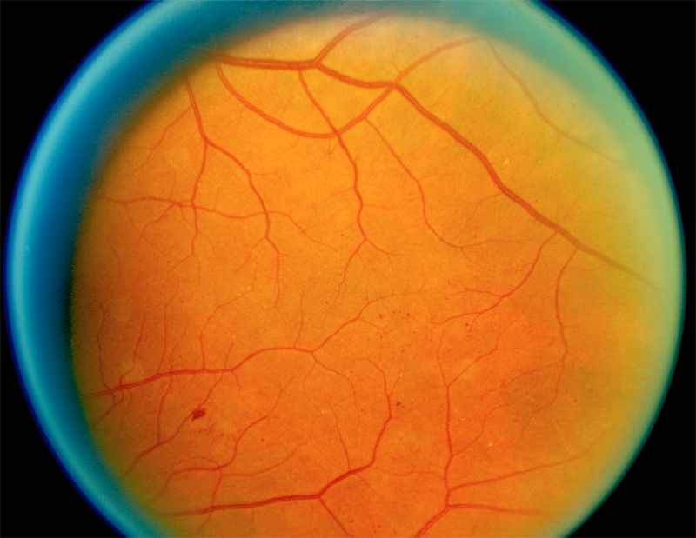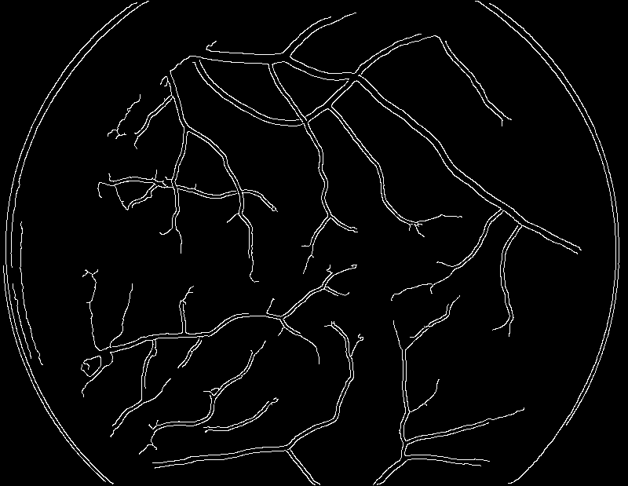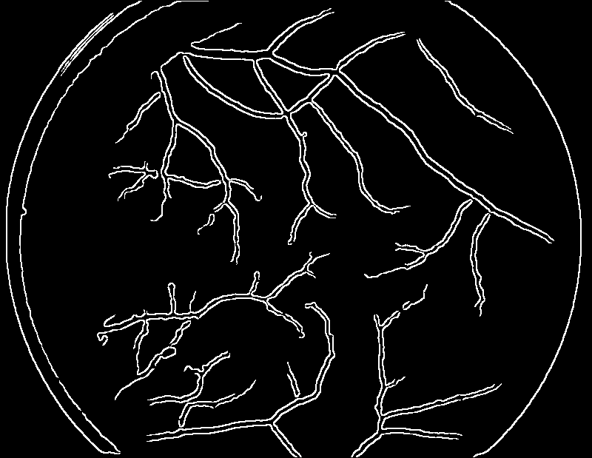
A retinal image Canny detection LoG detection
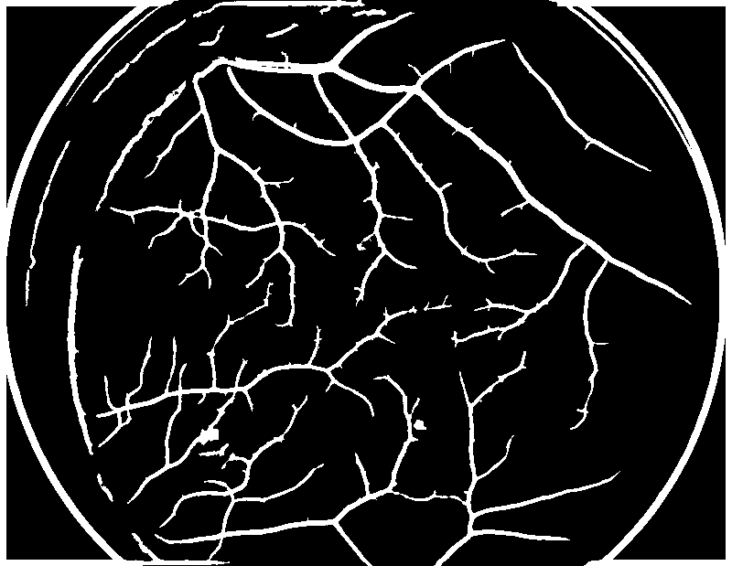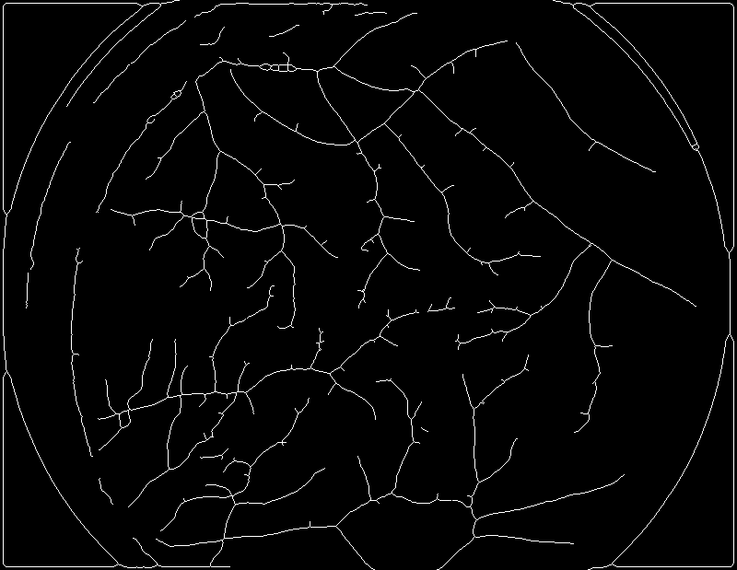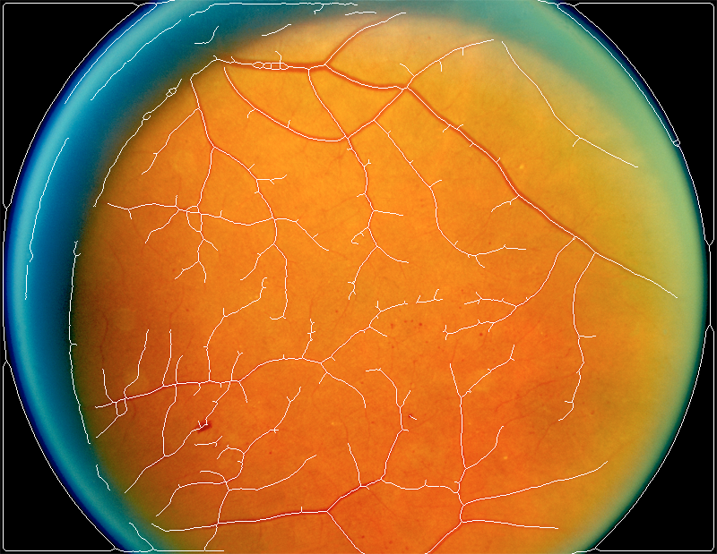
Matched filtering detection Thinning result Superimposed result

