ECEN5283 Project 4. Image Segmentation by Clustering
(Due on April 6, 2024)

In this project, you will apply two clustering techniques learned from the class, K-means and EM, to solve the problem of image segmentation. Two mosaic images (mosaicA.bmp and mosaicB.bmp) are given, and the ground truth maps (mapA.bmp and mapB.bmp) are also provided for numerical comparison. The features for clustering will a multi-dimensional feature vector extracted by a Gabor filter bank. You can use the optimal Gabor features obtained in your Project 3 here for feature extraction. Then, you need to implement the EM algorithm for image segmentation that can be initialized by K-means.

Specifically, you need to discuss the following issues.
- You can use the Matlab function “kmeans” for K-means clustering that has a built-in heuristic initialization method (https://www.mathworks.com/help/stats/kmeans.html).
- You can run “kmeans” multiple times and record the intra-class divergence values that can be computed from the output of the kmeans function). Find the global optimal solution according to the minimum intra-class divergence.
- Use the optimal K-means results to initialize the EM algorithm with two plots to show the training results. Evaluate the log-likelihood function during EM iteration (refer to Slide 6 of Lecture 24) and the segmentation accuracy (refer to Slide 12 of Lecture 25). One is the plot of “data log-likelihood vs. the iteration number” and the other is the plot of “the segmentation accuracy vs. the iteration number”.
- Change the initialization of the EM algorithm and compare the new results with the previous one. Discuss the effect of initialization on the EM clustering results.
- Find a couple of real-world color images for image segmentation. Add RGB (3-channel colors) and/or XY (pixel coordinates) features along with the Gabor features for segmentation. Discuss different features in terms of their effect on the segmentation results.
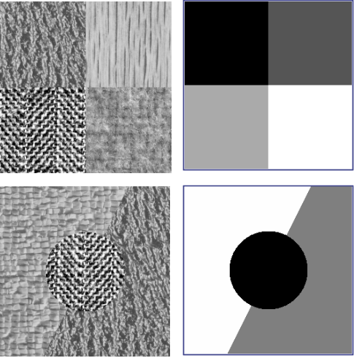
Additional Report Requirements.
- Discuss and compare the two clustering algorithms.
- The source code of the EM algorithm should be attached.
- Demonstrate your experimental results and discuss your any interesting findings.
- Create a video to show step-by-step segmentation results for each image.

Note : Two Matlab functions are provided. One is for Gabor filtering and the other is for computing the segmentation accuracy by comparing two segmentation maps.

