**Unit:**

**“Designing and Developing A Website”**

**Assignment Title:**

**“Standing Desk Limited”**

**Spring 2024 – Winter 2024**

**Name: Sai Aung Htet Myat**

**Student_ID:**

**Center Name: Twinkle Private University**

**Unit: Designing and Developing A Website**

**Qualifications: Level 4 (Diploma In Computing)**

**Contents**

Task 1: Hypertext Markup Language 4

Home Page of Standing Desk Website 4

Contact Us Page of Standing Desk Website 5

5

Rising Desk Page of Standing Desk Company Website 6

Health Benefits Page of Standing Desk Website 7

Basket Page of Standing Desk Website 8

Task 2: Cascading Style Sheet - CSS 9

Task 3: Testing a Website and Reporting Test 10

11

Testing website in chrome browser 13

Testing website on Firefox browser 14

Clarification of the role of “W3C” 16

Task 4: Critical Evaluation 16

A – Discussions and Evaluation of a website development 16

B – Website application development tools 16

C – Accessibility features 17

D – Further Development of website 17

# Task 1: Hypertext Markup Language

## Home Page of Standing Desk Website

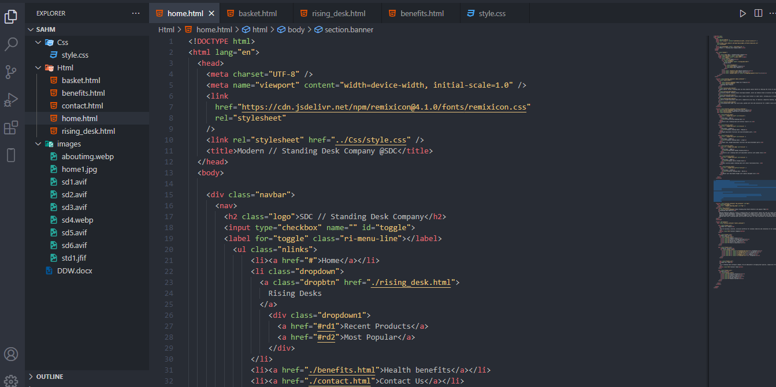

Fig (1.0) Home Page - code file (Index.html)

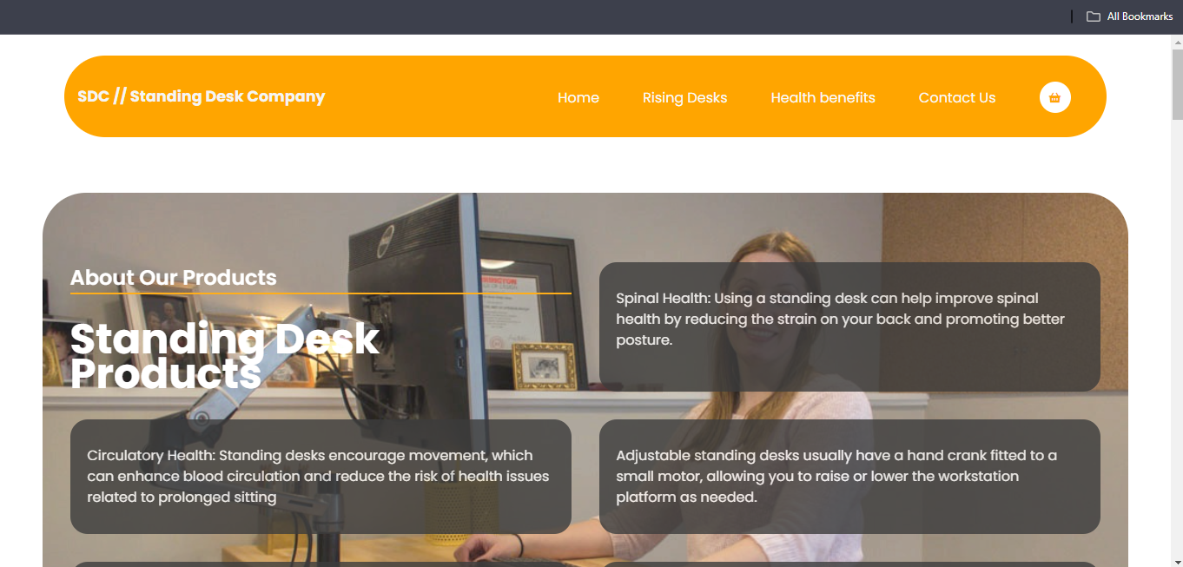

Fig (1.1) Home Page of Standing Desk Website

## Contact Us Page of Standing Desk Website

## 

Fig (2.0) Contact Us page - code file (contactus.html)

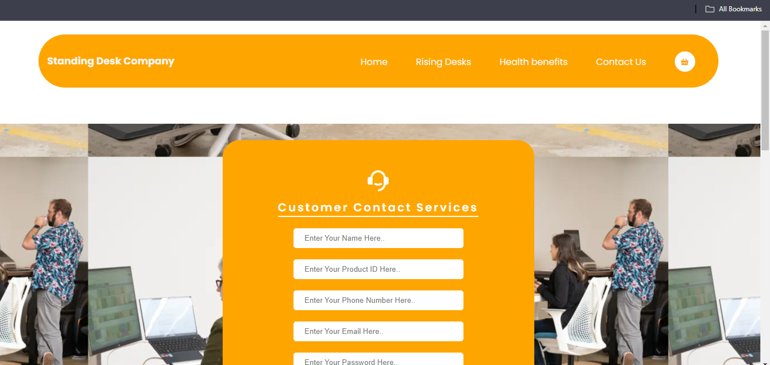

Fig (2.1) Contact Us Page of standing desk website

## Rising Desk Page of Standing Desk Company Website

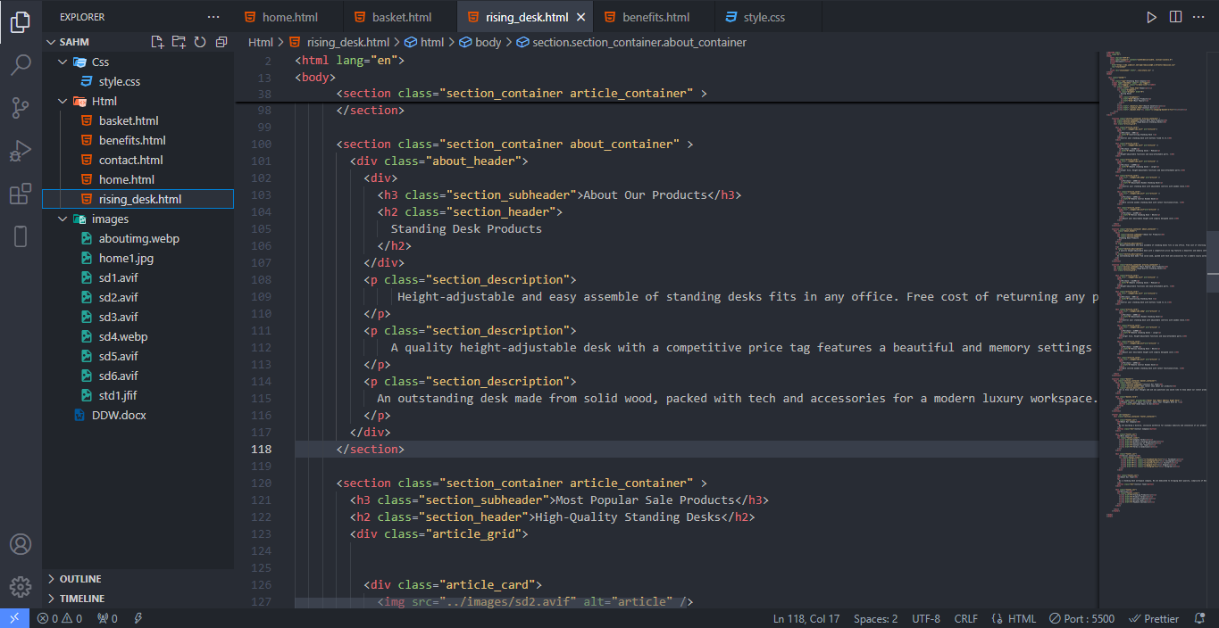

Fig (3.0) Rising Desk page – code file (rising_desk.html)

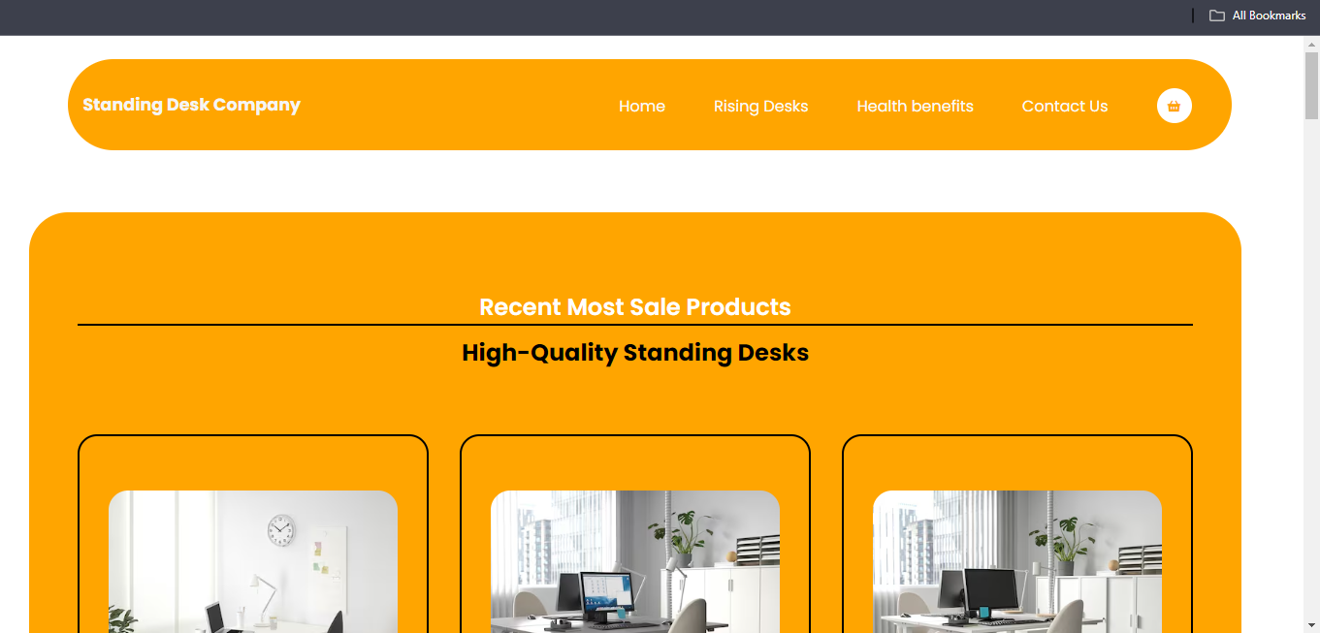

Fig (3.1) Rising Desk page of standing desk website

## Health Benefits Page of Standing Desk Website

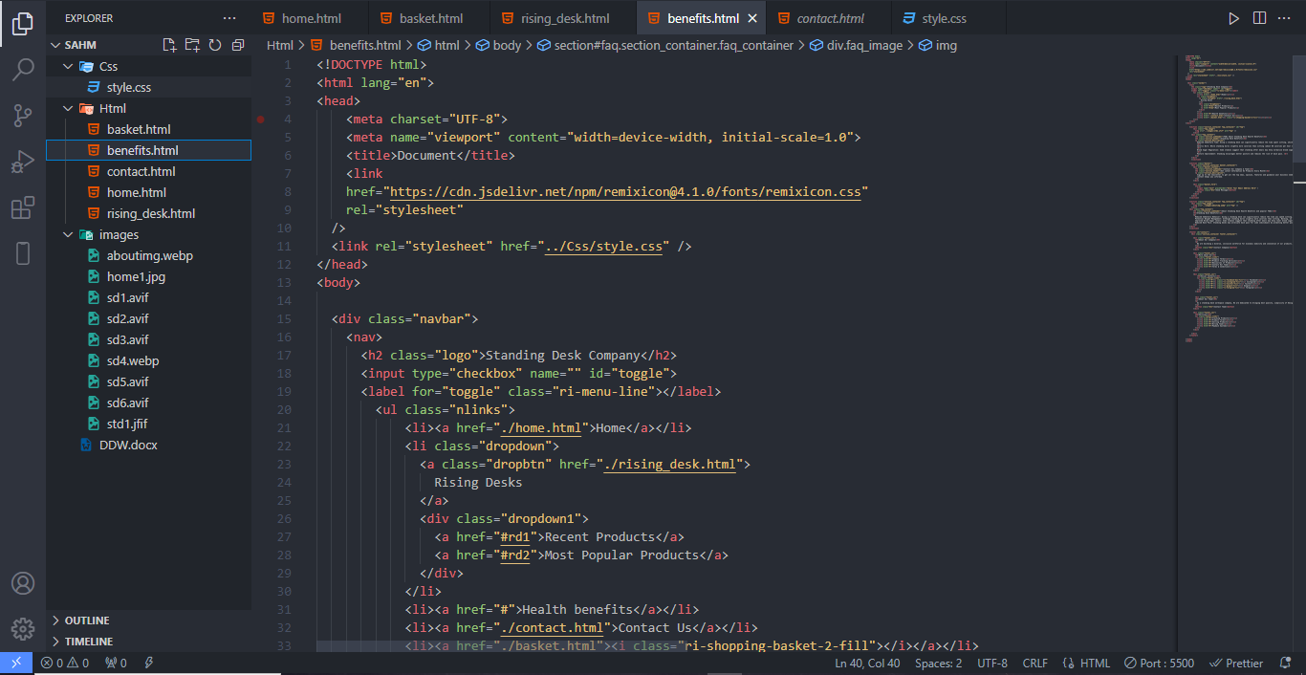

Fig (4.0) Health Benefits page – code file (benefits.html)

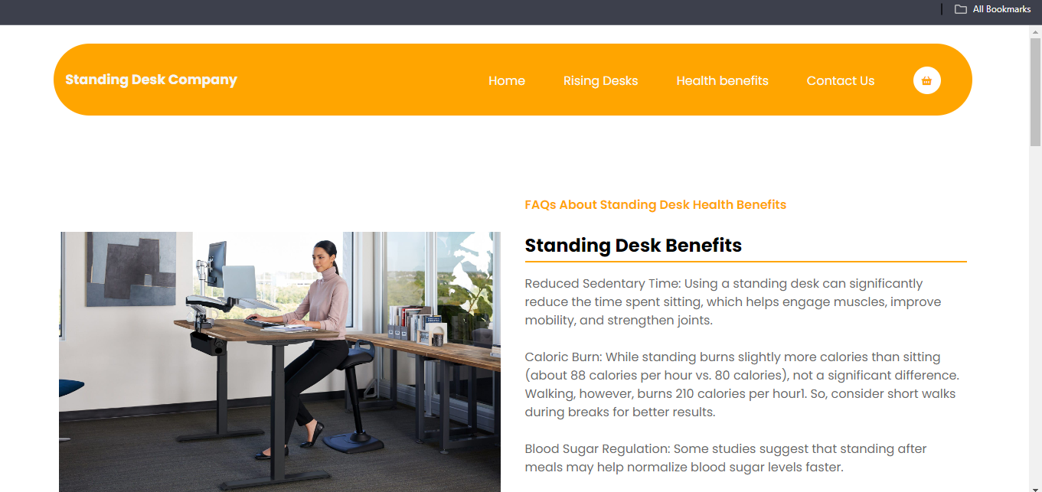

Fig (4.1) Health Benefits page of standing desk website

## Basket Page of Standing Desk Website

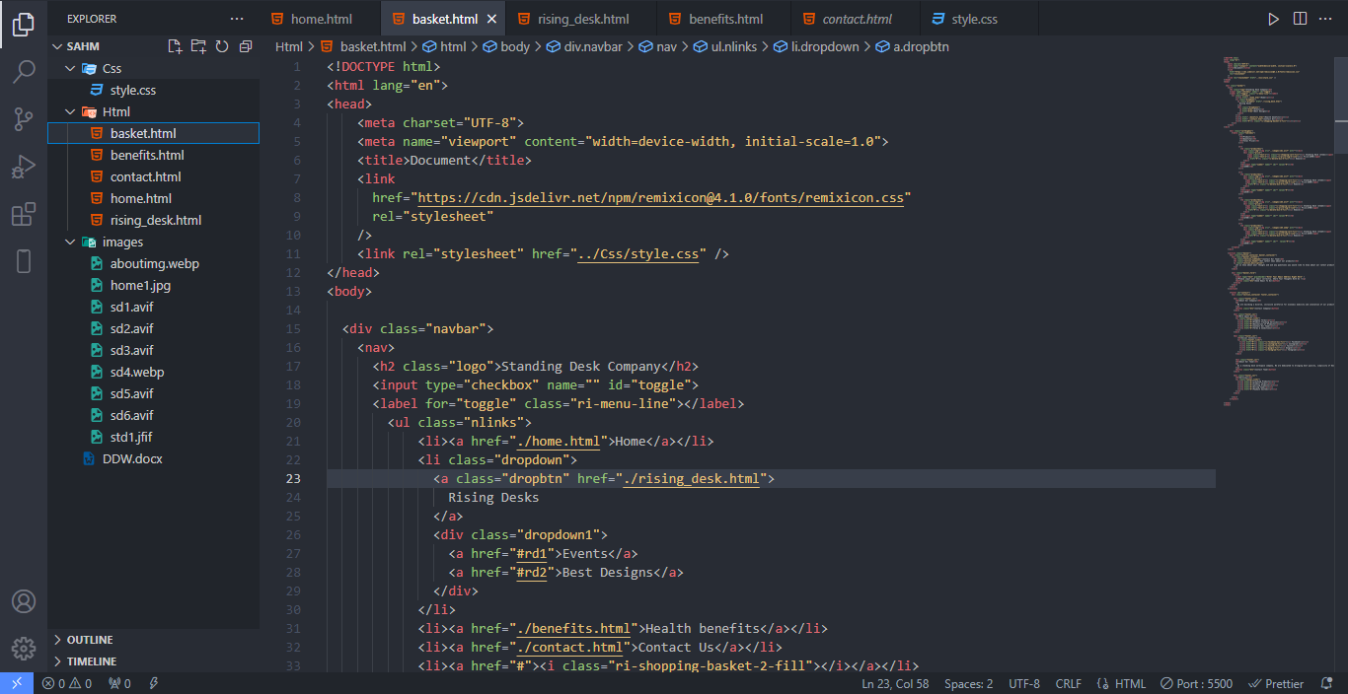

Fig (5.0) Basket page – code file (basket.html)

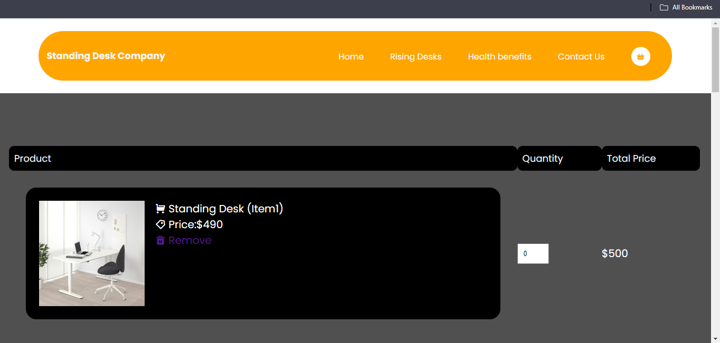

Fig (5.1) Basket Page of standing desk website

# Task 2: Cascading Style Sheet - CSS

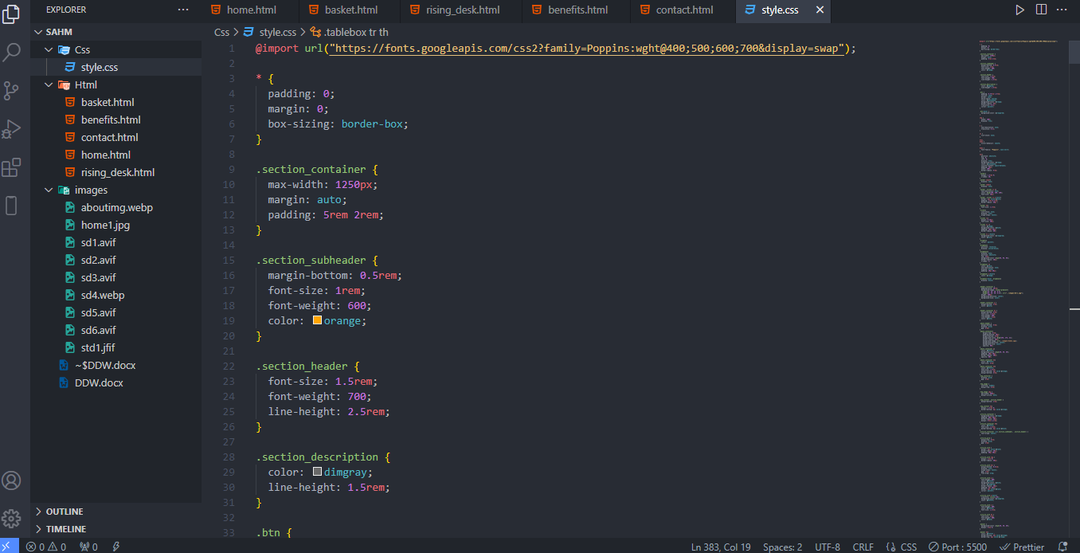

Fig (6.0) CSS code file page of standing desk website (style.css)

# Task 3: Testing a Website and Reporting Test

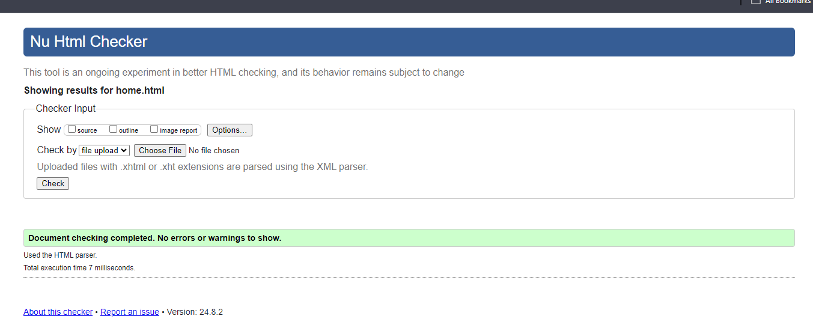

Fig (7.0) Testing home page code file at W3C HTML validator

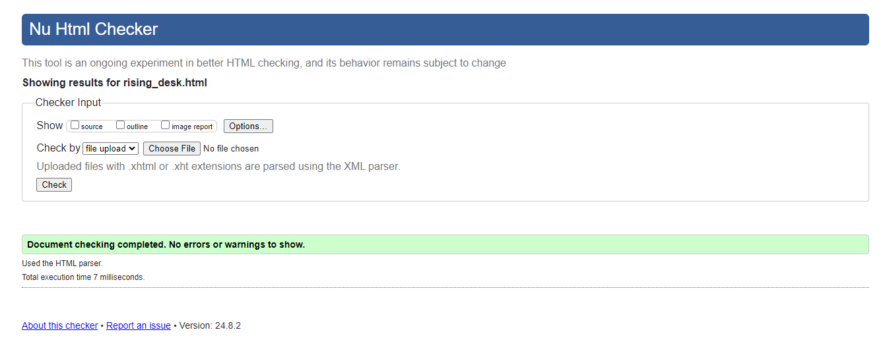

Fig (7.1) Testing rising desk code file at W3C HTML validator

## 

Fig (7.3) Testing contact page code file at W3C validator

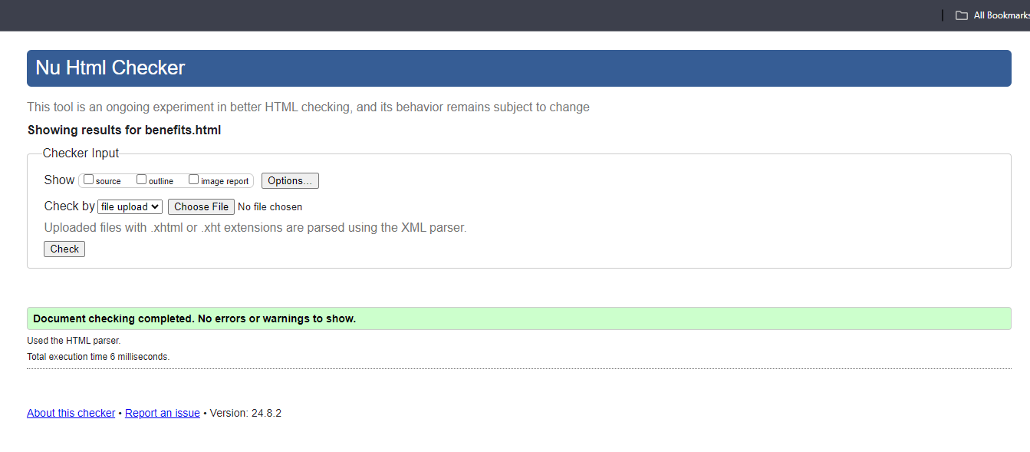

Fig (7.4) Testing benefits page code file at W3C validator

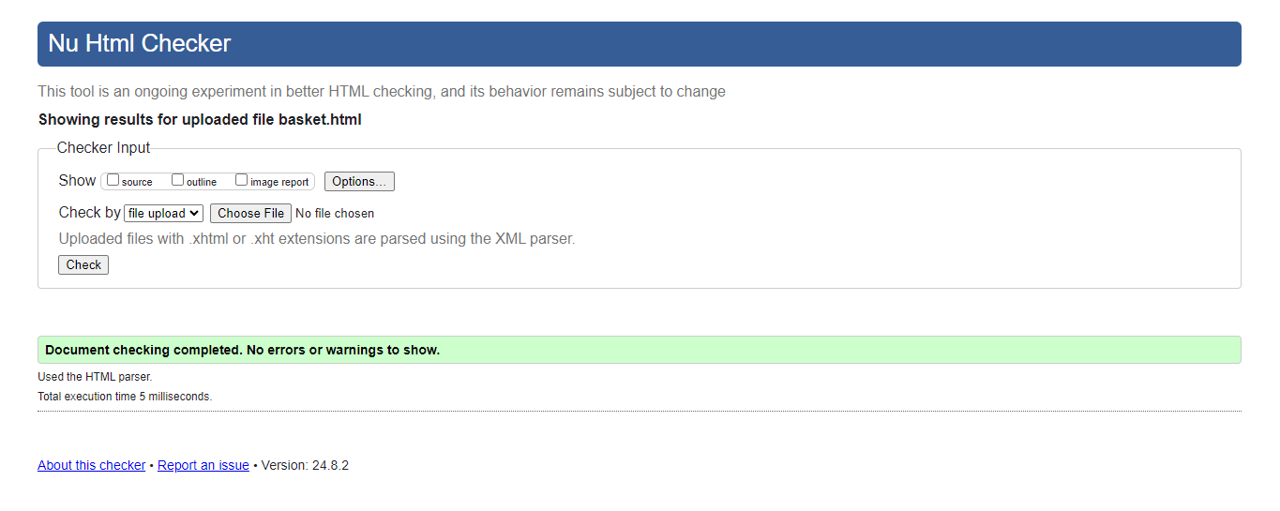

Fig (7.5) Testing basket page code file at W3C validator

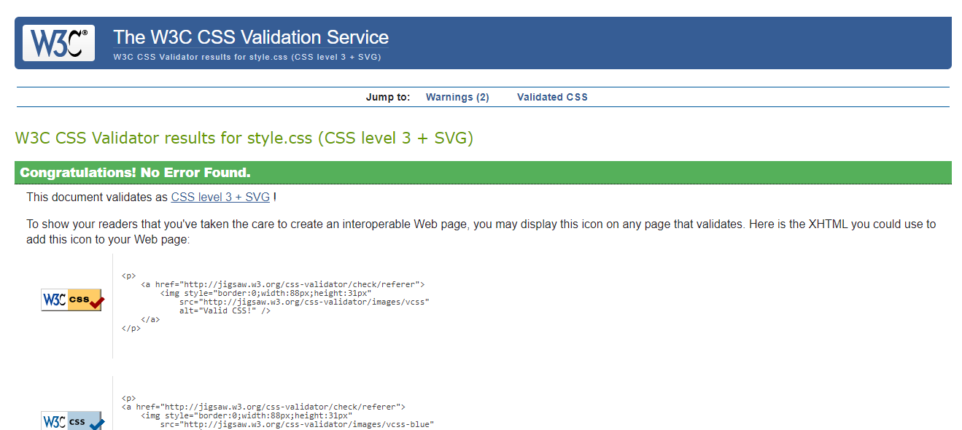

Fig (7.6) Testing CSS code file at W3C validator

## Testing website in chrome browser



Fig (8.0) Testing website in chrome website

Start testing the standing desk website on chrome browser, the developed frontend website shows up almost immediately when opening a website in chrome window. Tested product items, recent popular standing desk designs, newsletter to reach out customers’ advices to company teams and contact sections. Assessed with user-friendly simple designs, using of pale colors to reduce eye impact and checking user navigation bar filled with various properties and taking notes in user experiences. The choice of pale colors used in this website provide users of bad eyesight that reduce concentration of low colors (pale colored orange, white, low concentration of black). With the usage of screen reader mode in website extension, the screen reader function also provides users to support users to help reading the website descriptions, related labels and reading the product details of images. Usability issues are based on users and customers experiences.

## Testing website on Firefox browser

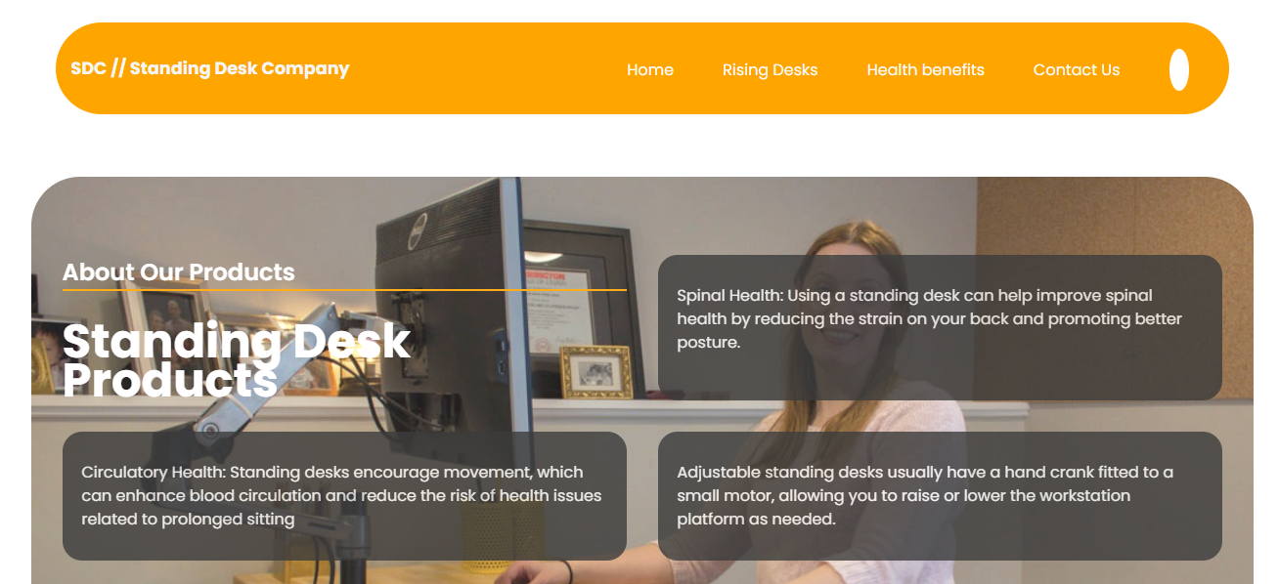

Fig (8.1) Testing website in Firefox browser

This testing discusses how a single developed frontend website behave differently when opened in different website vendors. It highlights exact issues when running the website in Firefox browser. In Chrome website browser, it runs smoothly but in Microsoft edge there are evident issues in loading of linked icons and images, some fonts may appear smaller than usual. However, overall designs and images’ positions are remaining mostly unchanged. Since each popular browser uses a specific rendering engine, these engines may run HTML, CSS and other programming languages in slightly different methods, leading to many different small issues. In summary, testing the developed website in Firefox website browser can be seen issues slightly differently, particularly focusing on the issues that observed in “Firefox” website browser.

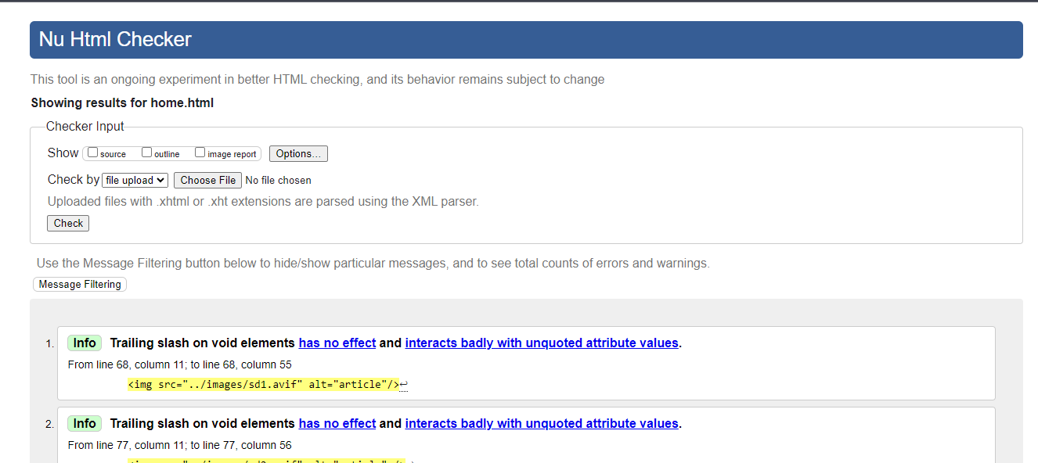

Fig (8.2) Testing the errors of home.html in W3C HTML validator

The W3C HTML validation services is showing that trailing slash on void elements that interacting with attribute values in HTML file. Removing the extra slash on HTML attributes fixed the error completely.

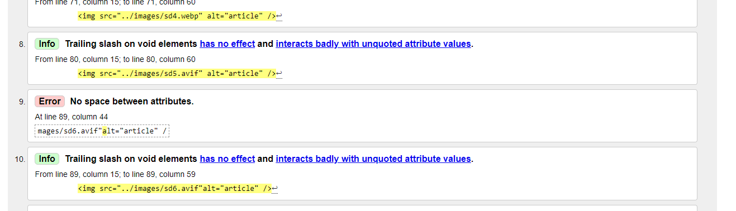

Fig (8.3) Testing the error in W3C HTML validator

The W3C HTML validation services is showing that there are no spaces between attributes in HTML file. By putting space between the attributes fixed the error completely.

## Clarification of the role of “W3C”

The worldwide web consortium is an international company where member organizations, full time staff and the public collaborate to developed web standards. Founded in 1994, and led by Tim-Berners Lee, W3C plays crucial role in maintaining rules and framework for world wide web. W3C develops the validation services, guidelines and website learning place for every developer to develop a standard obedient website. W3C standards are optimized for ensuring the that web technologies work together.

# Task 4: Critical Evaluation

## A – Discussions and Evaluation of a website development

In this assignment, the attachment of this assignment file is kind of frontend development website mainly using “HTML” which is known as Hypertext Markup Language and “CSS” which is known as cascading stylesheet. In this frontend developed website project, the html files are separate into five parts including home page, item display page, contact page, cart page and checkout page. In CSS which stands for cascading style sheet, the written codes are styling for HTML language to better and colorful sight of each web pages. In this website, rising desk page is one of the important pages in this website development as it is displaying the specific facts about company main products.

## B – Website application development tools

To provide this website development, visual studio code is used which is a tool and powerful editor software widely used for developing website applications. Visual studio code offers a wide range of enhancing the work flow of developing a website. In the part of editing HTML and CSS code, using the built-in intelliSense for HTML and CSS to write code efficiently. Other helping extensions are **“Liver server”** which allows developer to run HTML and CSS in live server automatically refreshing changes, **“Prettier”** which formats code consistently and “Bracket Pair Colorizer” to rename closing tabs and the changing the opening tags.

## C – Accessibility features

Accessibility in website development involves designing and building web applications or websites that every end user can use including people with bad eyesight, bad hearing, color blinds and other impairments. For people with blindness or low-level visions, this website provides low concentration colors and simple design displays. This website also provides alternative text for those end-users who are visually challenged users or those with slow connections.

## D – Further Development of website

Improving website is essential for better user experience, increased traffic, and achieving goals. Develop a plan for websites’ growth. Brainstorm online strategies with your team and set meaningful goals aligned with best practices. To stay organized, optimizing the website navigation tools including menus and sidebars for easy to use. Regularly update and improve the website content, ensuring the website is relevant, engaging and valuable to the end users, using clear contexts and evident headlines.

**References**

W3C. (2024). Available W3C: [**https://www.w3c.com**](https://www.w3c.com) (August 10, 2024)

Visual Studio Code. (2024). Available at Visual Studio Code: <https://www.code.visualstudio.com>

(August 12, 2024)

Firefox. (2024). Available at Firefox: <https://www.mozilla.org/en-US/firefox/new/>

(August 13, 2024)

Chrome. (2024). Available at Chrome: [**https://www.google.com**](https://www.google.com) (August 13, 2024)