**ABC ENGLISH CENTER**

**Software Requirements Specification**

**Document Code: ABC_SRS_001**

**Version: 1.0**

# Approval Page

The endorsement by the authorized CLIENT representative on this document indicates the agreement of CLIENT and VENDOR on the Software Requirements Specification document.

|  |  |  |  |
| --- | --- | --- | --- |
| Prepared by | VENDOR  Business Analyst | Signature: | CHÂU THÁI ÁI THIÊN (ThienCTA)  ____________________ |
|  | Date: | 22/May/2022 |
|  | Signature: | ĐỖ NGUYỄN MINH THƯ (ThuDNM2)  ____________________ |
|  | Date: | 22/May/2022 |
|  | Signature: | ĐỖ THỊ THẢO DUYÊN (DuyenDTT1)  ____________________ |
|  | Date: | 22/May/2022 |
|  | Signature: | ĐỖ THỊ THU THẢO (ThaoDTT13)  ____________________ |
|  | Date: | 22/May/2022 |
|  | Signature: | VÕ NGỌC CAO THẮNG (ThangVNC)  ____________________ |
|  | Date: | 22/May/2022 |
| Reviewed by | VENDOR  Project Manager | Signature: | _______________ |
|  |  | Date: | ____  /____   / ____ |
| Supported by | CLIENT  (Position) | Signature: | ____________________ |
|  |  | Date: | ____  /____   / ____ |
| Approved by | CLIENT  (Position) | Signature: | ____________________ |
|  |  | Date: | ____  /____   / ____ |

# 

# Revision History

|  |  |  |  |  |
| --- | --- | --- | --- | --- |
| **Date** | **A, U, D** | **Editor** | **Change description** | **New version** |
| 22 May 2022 | A | Team 1: ThienCTA, ThuDNM2, DuyenDTT1, ThaoDTT13, ThangVNC | Create the first version with the document overview and high level requirement. | 1.0 |

* A: Added, U: Updated, D: Deleted

**Glossary and Abbreviation**

|  |  |
| --- | --- |
| **Acronym** | **Reference** |
| SRS | System/ Software Requirement Specification |
| UC | Use case |
| BR | Business rule |
| VR | Validation rule |
| SMS | Successful message |
| EMS | Error message |
| AMS | Alert message |
| TBD | To be determined |
| N/A | Not available |
| Y | Yes |
| N | No |

**Table of Contents**

1. Overview 8
2. Document introduction 8
3. Business context and purpose 8
4. Main business entities 8
5. Related requirements 8
6. High level requirements 9
   1. System context diagram 9
   2. UC diagram 10
   3. UC description completion 11
   4. Common components screen description 11
      1. Wireframe 11
      2. Components description 12
   5. Open issue 13
7. Functionality 13
8. [UC001# Reset password] description 13
   1. UC summary 13
   2. Activity flow 14
   3. Scenario description 15
      1. Basic flow 15
      2. Alternate flow 15
      3. Exceptional flow 15
   4. Screen description 16
      1. Reset password 16
         1. Wireframe 16
         2. Components description 17
      2. Verification code 19
         1. Wireframe 19
         2. Components description 19
      3. Create a new password 21
         1. Wireframe 21
         2. Components description 22
9. [UC002# Create teacher account] description 25
   1. UC summary 25
   2. Activity flow 26
   3. Scenario description 27
      1. Basic flow 27
      2. Alternate flow 27
      3. Exceptional flow 28
   4. Screen description 28
      1. Wireframe 28
      2. Components description 29
10. [UC003# Update teacher’s account] description 42
    1. UC summary 42
    2. Activity flow 43
    3. Scenario description 44
       1. Basic flow 44
       2. Alternate flow 44
       3. Exceptional flow 45
    4. Screen description 45
       1. Wireframe 45
       2. Components description 46
11. [UC004# Update user’s information] description 59
    1. UC summary 59
    2. Activity flow 60
    3. Scenario description 61
       1. Basic flow 61
       2. Alternate flow 62
       3. Exceptional flow 62
    4. Screen description 63
       1. Wireframe 63
       2. Components description 63
12. [UC005# Enter grade test] description 79
    1. UC summary 79
    2. Activity flow 80
    3. Scenario description 81
       1. Basic flow 81
       2. Alternate flow 81
       3. Exceptional flow 82
    4. Screen description 82
       1. Wireframe 82
       2. Components description 83
13. [UC006# Add topic into course] description 89
    1. UC summary 89
    2. Activity flow 90
    3. Scenario description 91
       1. Basic flow 91
       2. Alternate flow 91
       3. Exceptional flow 91
    4. Screen description 92
       1. Wireframe 92
       2. Components description 92
14. [UC007# View teacher’s account] description 95
    1. UC summary 95
    2. Activity flow 95
    3. Scenario description 96
       1. Basic flow 96
       2. Alternate flow 96
       3. Exceptional flow 96
    4. Screen description 96
       1. Wireframe 96
       2. Components description 97
15. [UC008# View courses list] description 104
    1. UC summary 104
    2. Activity flow 105
    3. Scenario description 105
       1. Basic flow 105
       2. Alternate flow 105
       3. Exceptional flow 105
    4. Screen description 106
       1. Wireframe 106
       2. Components description 106
16. [UC009# Search users list] description 110
    1. UC summary 110
    2. Activity flow 110
    3. Scenario description 111
       1. Basic flow 111
       2. Alternate flow 111
       3. Exceptional flow 111
    4. Screen description 112
       1. Wireframe 112
       2. Components description 112
17. [UC010# View schedule] description 123
    1. UC summary 123
    2. Activity flow 123
    3. Scenario description 124
       1. Basic flow 124
       2. Alternate flow 124
       3. Exceptional flow 124
    4. Screen description 124
       1. Wireframe 124
       2. Components description 125
18. Validation rules and messages 132
19. Validation rules 132
20. Successful messages 132
21. Error messages 133

Table of Images

Figure 1: Training Management System Context Diagram 9

Figure 2: ABC English Center UC Diagram 10

Figure 3: Common Components Screen 11

Figure 4: Activity flow – [UC001# Reset password] 14

Figure 5: Screen “Reset password” 16

Figure 6: Screen “Verification code” 19

Figure 7: Screen “Create a new password” 21

Figure 8: Activity flow – [UC002# Create new teacher account] 26

Figure 9: Screen “Create new teacher account” 28

Figure 10: Activity flow – [UC003# Update teacher’s account] 43

Figure 11: Screen “Update teacher’s account” 45

Figure 12: Activity flow – [UC004# Update user’s information] 60

Figure 13: Screen “Update user’s information” 63

Figure 14: Activity flow – [UC005# Enter grade test] 80

Figure 15: Screen “Enter grade test” 82

Figure 16: Activity flow – [UC006# Add topic into course] 90

Figure 17: Screen “Add topic into course” 92

Figure 18: Activity flow – [UC007# Search teacher account” 95

Figure 19: Screen “Search teacher account” 96

Figure 20: Activity flow – [UC008# View courses list] 105

Figure 21: Screen “View courses list” 106

Figure 22: Activity flow – [UC009# Search users list] 110

Figure 23: Screen “Search users list” 112

Figure 24: Activity flow – [UC010# View schedule] 123

Figure 25: Screen “View schedule” 124

# OVERVIEW

## 1. Document Introduction

## The Software Requirement Specification Document (SRS) defines the requirements for the Administrator, Class Manager, and Teacher that describes what the software will do and how it will be expected to perform. It also describes the functionality the product needs to fulfill all stakeholder’s needs.

## The SRS shall be reviewed and endorsed by all key stakeholders before it is published to the vendor.

## 2. Business context and purpose

This Training Management System is aimed at developing a web-based system that manages the activity of “Training”. This system can be used to manage teacher accounts, manage Class Manager accounts, manage course categories, manage courses, manage topics, assign the topic to a course, and assign a teacher to a topic.

a) Management and information system related to courses and classes.

b) Management and information system related to teachers in the center.

The application has 3 main actors:

* System Administrator: logs into the system to manage the database, assigns functions for each registered users (class manager, teacher) and fixes issues when having bugs in the system.
* A Class Manager: can have close management of the content in the test, can acknowledge the feedback from teacher and students to improve the management system, manages course and teacher activities, i.e. imports a list of student accounts from an Excel file into the system.
* A Teacher: can update their profile, can view course, can prepare lesson plans, assigns homework as well as controls grade tests for the student.

## 3. Main business entities

There are 5 entities in this application: Account entity, Course entity, Topic entity, Schedule entity, Customer entity.

## 4. Related requirements

N/A

## 5. High Level Requirements

### 5.1. System Context Diagram

The purpose of this system context diagram is to depict the boundaries of the system scope being developed at a high level by illustrating the information exchanges between system with all the integration roles and external system

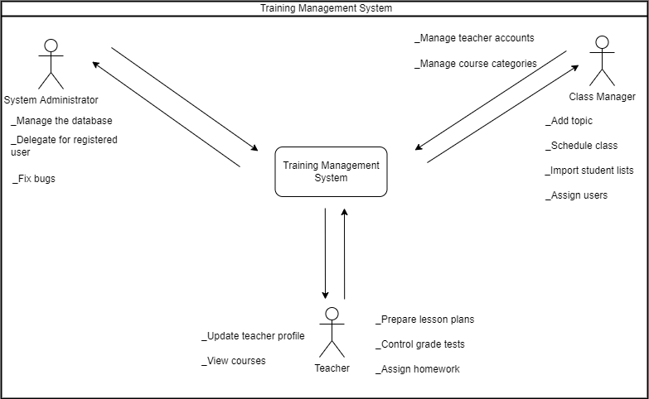

*Figure 1: Training Management System Context Diagram*

**5.2. Use Case Diagram**

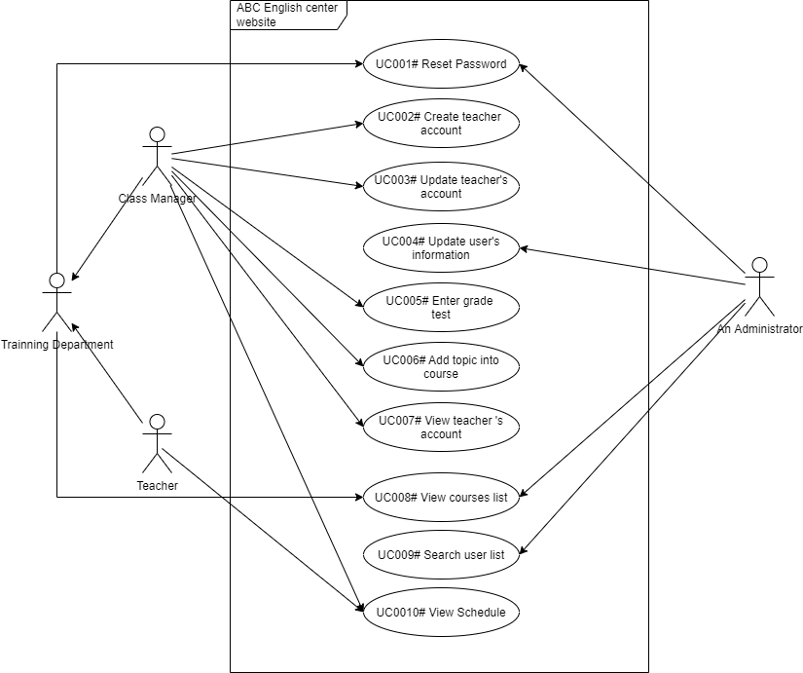

*Figure 2: ABC English Center UC Diagram*

## 5.3. UC description completion

|  |  |  |  |  |
| --- | --- | --- | --- | --- |
| **UC Code** | **PIC** | **% Completion** | **Open**  **issue** | **Note** |
| [[UC001# Reset password] | ThuDNM2 | 85 | No |  |
| [UC002# Create teacher account] | ThangVNC | 85 | No |  |
| [UC003# Update teacher’s account] | ThienCTA | 85 | No |  |
| [UC004# Update user info] | DuyenDTT1 | 85 | No |  |
| [UC005# Enter grade test] | ThaoDTT13 | 85 | No |  |
| [UC006# Add topic into course] | ThuDNM2 | 85 | No |  |
| [UC007# View teacher’s account] | ThangVNC | 85 | No |  |
| [UC008# View courses list] | ThienCTA | 85 | No |  |
| [UC009# Search users list] | DuyenDTT1 | 85 | No |  |
| [UC010# View schedule] | ThaoDTT13 | 85 | No |  |

**5.4. Common components screen description**

#### **5.4.1. Wireframe**

*Figure 3:* [*Common Components Screen*](https://docs.google.com/document/d/1FDX9aeWonjh5k_v_ZBo9IpKTKHxhlCk5/edit#heading=h.3jtnz0s)

#### **5.4.2. Components Description**

|  |  |  |  |  |  |  |
| --- | --- | --- | --- | --- | --- | --- |
| **#** | **Component** | **Comp. Type** | **Data**  **type** | **Man**  **datory** | **Default** | **Description** |
| 1 | Company  name | Label | N/A | N/A | * Default state: N/A * Default value: N/A | * Label: “ABC English center” * Available value: N/A * Data source: N/A * Validation rule: N/A |
| 2 | User  Profile  image | Label | N/A | N/A | * Default state: Enabled * Default value: N/A | * Label: “Welcome, ” + [Full Family Name + Full Middle Name + Full First Name ] * Placeholder text: N/A * Available value: N/A * Data source: Retrieved from database. * Entity: Image * Attribute: User image * Validation rule: N/A |
| 3 | Change  language | Button | N/A | N/A | * Default state: Enabled * Default value: English as default, if the user selected and saved other language, the system will display that language. | * Label: “Change language” * Placeholder text: N/A * Available value: N/A * Data source: N/A * Validation rule: N/A * EN/VN * After clicking on change language icon, user can choose English or Vietnamese which user wants. |

## 5.5 Open issue

N/A

**II. Functionality**

### 1. [UC001# Reset password] description

### 1.1. UC Summary

|  |  |
| --- | --- |
| **Objective** | This UC allows users to reset password when they forgot password. |
| **Actor** | Class Manager, Administrator, Teacher. |
| **Trigger** | User triggers “Reset password” feature. |
| **Precondition** | User had account on the system. |
| **Post condition** | User resets password successfully. |
| **Frequency of use** | High. |
| **Priority** | High. |
| **Related UC(s)** | [UC011# Login] |
| **Navigation path** | {Login screen/Reset password button} |
| **PIC** | ThuDNM2 |

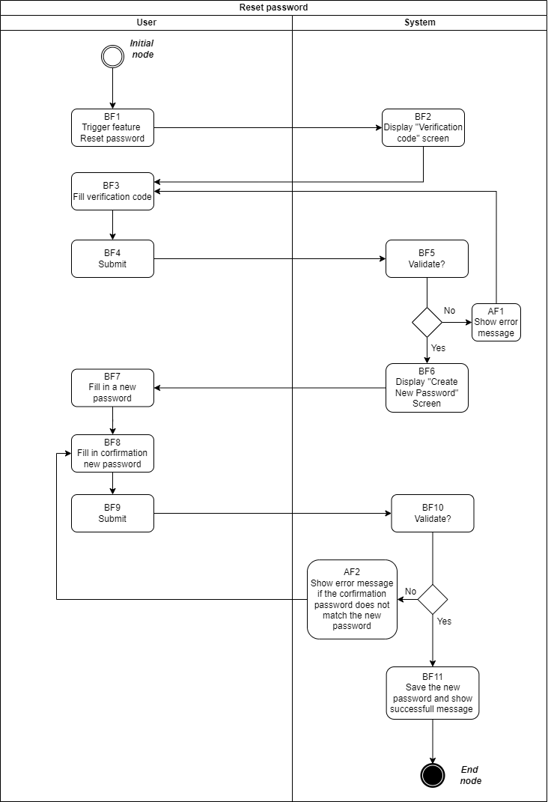 **1.2. Activity Flow**

*Figure 4: Activity flow – [UC001# Reset password]*

**1.3. Scenario description**

**1.3.1. Basic Flow**

|  |  |  |
| --- | --- | --- |
| **Step** | **Actor** | **Description** |
| BF1 | User | Trigger “Reset password” feature |
| BF2 | System | Display “Verification code” screen. |
| BF3 | User | Fill verification code. |
| BF4 | User | User clicking on “Submit” button. |
| BF5 | System | Validate  + If yes, go to BF6 step.  + If no, go to Alternate Flow AF1. |
| BF6 | System | Display “Create New Password” screen. |
| BF7 | User | Fill in a new password. |
| BF8 | User | Fill in confirmation new password. |
| BF9 | User | User clicking on “Submit” button. |
| BF10 | System | Validate  + If yes, go to BF10 step.  + If no, go to Alternate Flow AF2. |
| BF11 | System | Save the new password and show successful message. |

**1.3.2. Alternate flow:**

**AF01: User inputs incorrect information**

|  |  |  |
| --- | --- | --- |
| **Step** | **Actor** | **Description** |
| AF1 | System | Show error message to user. |
| AF2 | System | Show error message to user. |

**1.3.3. Exceptional flow:**

N/A

**1.4. Screen description**

**1.4.1. Reset password**

**1.4.1.1. Wireframe**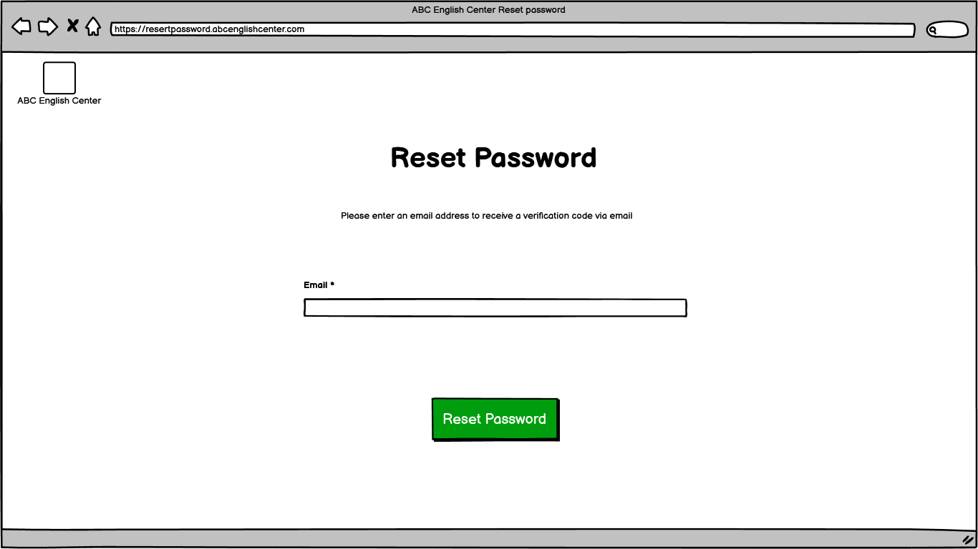

*Figure 5: Screen “Reset password”*

**1.4.1.2. Components description**

|  |  |  |  |  |  |  |
| --- | --- | --- | --- | --- | --- | --- |
| **#** | **Compo**  **nent** | **Comp. Type** | **Da**  **ta**  **type** | **Mandatory** | **Default** | **Description** |
| 1 | Screen name | Label | N/A | N/A | * Default state: N/A * Default value: N/A | * Label: “Reset password” * Available value: N/A * Data source: N/A * Validation rule: N/A |
| 2 | Content | Label | N/A | N/A | * Default state: N/A * Default value: N/A | * Label: “Please enter an email address to receive a verification code via email” * Available value: N/A * Data source: N/A * Validation rule: N/A |
| 3 | Email | Text input | Var  char  (50) | Yes | * Default state: Enabled * Default value: Blank | * Label: “Email” * Available value: N/A * Data source: N/A * Validation rule: apply   + VR001#  + VR005#  + Syntax: “Account of teacher” + @abcenglishcenter.com.vn |
| 4 | Reset Password | Button | N/A | N/A | * Default state: Enabled * Default value: N/A | * Label: “Reset Password” * Available value: N/A * Data source: N/A * After clicking on “Reset Password” button, system will send verification code via email and go to “Verification code” page. * Validation rule: N/A |

**1.4.2. Verification code**

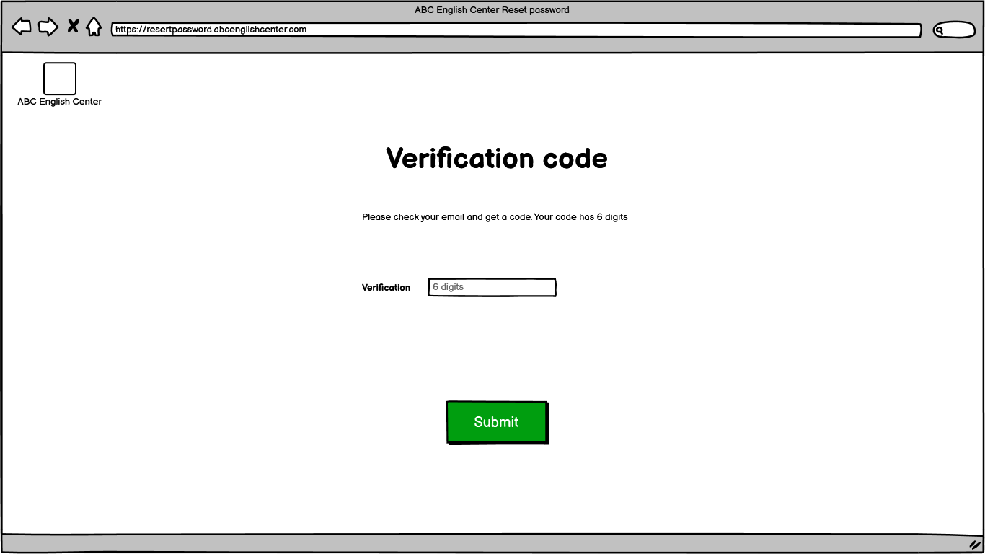**1.4.2.1. Wireframe**

*Figure 6: Screen “Verification code”*

**1.4.2.2. Components description**

|  |  |  |  |  |  |  |
| --- | --- | --- | --- | --- | --- | --- |
| **#** | **Compo**  **nent** | **Comp. Type** | **Da**  **ta**  **type** | **Mandatory** | **Default** | **Description** |
| 1 | Verification code | Label | N/A | N/A | * Default state: N/A * Default value: N/A | * Label: “Verification code” * Available value: N/A * Data source: N/A * Validation rule: N/A |
| 2 | Content | Label | N/A | N/A | * Default state: N/A   Default value: N/A | * Label: “Please check your email and get a code. Your code has 6 digits” * Available value: N/A * Data source: N/A * Validation rule: N/A |
| 3 | Verification | Text input | Var  char  (6) | Yes | * Default state: Enabled * Default value: N/A | Will be set automatically.   * Label: “Verification” * Placeholder text: 6 digits * Available value: N/A * Data source: N/A * Validation rule: apply   + VR001#  + VR007# |
| 4 | Submit | Button | N/A | N/A | * Default state: Enabled * Default value: N/A | * Label: “Submit” * Available value: N/A * Data source: N/A * After clicking on “Submit” button, system will validate that filled information.   + If that filled information have been validated, system will go to “Create a new password” page.  + If that filled information have not been validated, system will show error message and user must fill verification code again (apply EMS003#).   * Validation rule: apply EMS003# |

**1.4.3. Create a new password**

**1.1.4.3.1. Wireframe**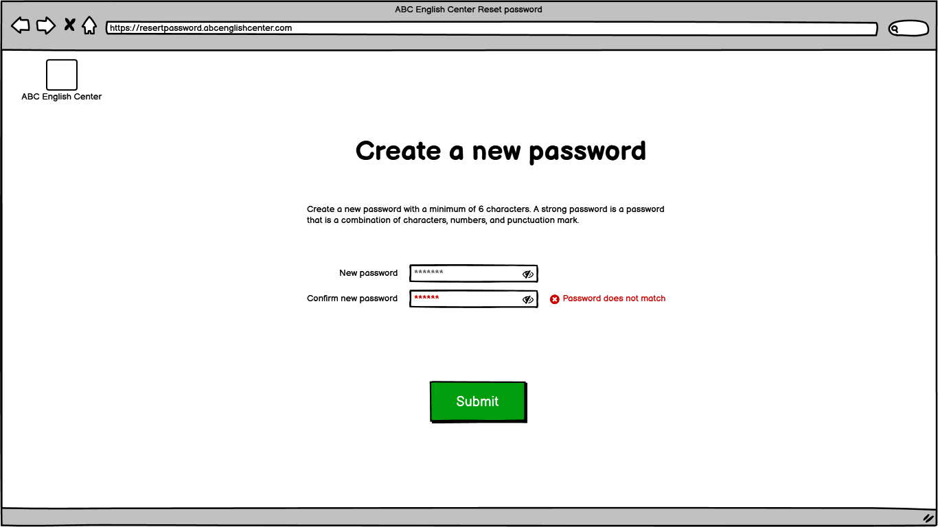

*Figure 7: Screen “Create a new password”*

**1.4.3.2. Components description**

|  |  |  |  |  |  |  |
| --- | --- | --- | --- | --- | --- | --- |
| **#** | **Compo**  **nent** | **Comp. Type** | **Da**  **ta**  **type** | **Mandatory** | **Default** | **Description** |
| 1 | Create a new password | Label | N/A | N/A | * Default state: N/A * Default value: N/A | * Label: “Create a new password” * Available value: N/A * Data source: N/A * Validation rule: N/A |
| 2 | Content | Label | N/A | N/A | * Default state: N/A * Default value: N/A | * Label: “Please check your email and get a code. Your code has 6 digits” * Available value: N/A * Data source: N/A * Validation rule: N/A |
| 3 | New Password | Text input | Var  char (7) | Yes | * Default state: Enabled * Default value: Blank | * Label: “New password” * Available value: N/A * Data source: N/A * Validation rule: apply   + VR001#  + VR006# |
| 4 | Eye Slash | Icon | N/A | N/A | * Default state: Enabled * Default value: Hide password as default by showing “*” character, if the user want to see the password, the system will display it. | * Label: N/A * Available value: N/A * Data source: N/A * Validation rule: N/A * Icon: “Eye Slash”/ Icon Eye * After clicking on “Eye Slash” icon, it will be showed and user can see that password. |
| 5 | Confirm New Password | Text input | Var  char (7) | Yes | * Default state: Enabled * Default value: N/A | * Label: “Confirm new password” * Available value: N/A * Data source: N/A * Validation rule: apply   + VR001#  + VR006#  + The “Confirm new password” must match with the “New password” which user created above. |
| 6 | Submit | Button | N/A | N/A | * Default state: Enabled * Default value: N/A | * Label: “Submit” * Available value: N/A * Data source: N/A * After clicking on “Submit” button, system will validate that filled information.   + If that filled information have been validated, system will save that data and show successful message (apply SMS002#).  + If that filled information have not been validated, system will show error message and user must fill the new password and the confirm password again (apply EMS004#).   * Validation rule:   + SMS002#  + EMS004# |

**2. [UC002# Create teacher account] description**

**2.1. UC Summary**

|  |  |
| --- | --- |
| **Objective** | This UC allows class manager to create teacher accounts. |
| **Actor** | Class Manager. |
| **Trigger** | User triggers “create teacher account” feature. |
| **Precondition** | User logged in. |
| **Post-condition** | User creates teacher accounts successfully. |
| **Frequency of use** | High. |
| **Priority** | High. |
| **Related UC(s)** | [UC003# Update teacher’s account]  [UC012# View teacher’s account]  [UC013# Delete teacher’s account] |
| **Navigation path** | {User list- Info/Create button} |
| **PIC** | ThangVNC |
|  |  |

**Purpose của create account: Giup hệ thống cũng như bên nhà quản trị cụ thể là admin có thể quản ly được unregister và register user nói chung và nắm được thông tin chi tiết hơn của user nói riêng**

**2.2. Activity Flow**

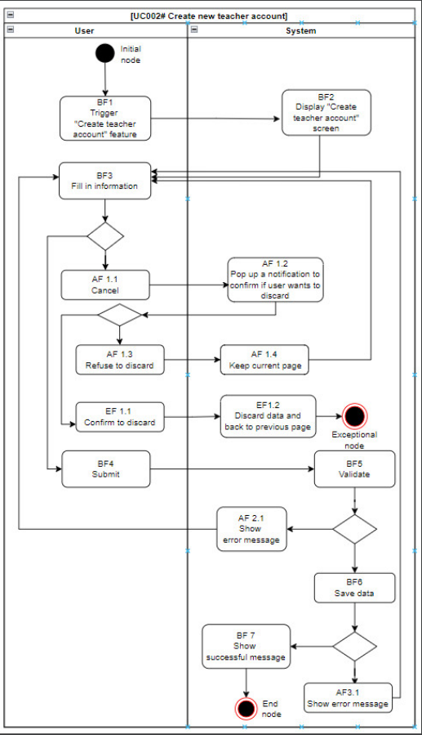

*Figure 8: Activity flow – [UC002#Create new teacher account]*

**2.3. Scenario description**

**2.3.1. Basic Flow**

|  |  |  |
| --- | --- | --- |
| **Step** | **Actor** | **Description** |
| BF1 | User | Trigger “Create teacher account” feature. |
| BF2 | System | Display “Create teacher account” screen. |
| BF3 | User | Fill in information into components.  + If the user wants to submit, go to BF4 step.  + If the user wants to cancel, go to Alternate Flow AF01 (refer to Activity flow, AF 1.1). |
| BF4 | User | Decide to submit by clicking on “Submit” button. |
| BF5 | System | Check validation is valid?  + If yes, go to BF6 step.  + If no, go to Alternate Flow AF01 (refer to Activity flow, AF2.1). |
| BF6 | System | Save data  + If save successful, go to BF7 step.  + If save unsuccessful, go to Alternate flow AF03(refer to activity flow, AF3.1). |
| BF7 | System | Show successful message to user if that filled data had been saved successfully. |

**2.3.2. Alternate flow**

**AF01: User wants to cancel (stop filling information)**

|  |  |  |
| --- | --- | --- |
| **Step** | **Actor** | **Description** |
| AF 1.1 | User | Want to cancel (stop filling in information). |
| AF 1.2 | System | Display a notification to confirm if the user wants to discard |
| AF 1.3 | User | Refuse to discard |
| AF 1.4 | System | Keep current page |

**AF02: User inputs invalid information**

|  |  |  |
| --- | --- | --- |
| **Step** | **Actor** | **Description** |
| AF 2.1 | System | Show error message to the user that filled data was invalid. |

#### **AF03: User clicks submit and save data**

|  |  |  |
| --- | --- | --- |
| **Step** | **Actor** | **Description** |
| AF 3.1 | System | Show error message to the user if that filled data had not been saved successfully. |

#### **2.3.3. Exceptional flow**

#### **EF01: User wants to cancel (stop filling information)**

|  |  |  |
| --- | --- | --- |
| **Step** | **Actor** | **Description** |
| EF 1.1 | User | Confirm to discard data by selecting “Yes” (option). |
| EF 1.2 | System | Discard data and go back to the previous page. |

**Purpose của create account: Giup hệ thống cũng như bên nhà quản trị cụ thể là admin có thể quản ly được unregister và register user nói chung và có được thông tin chi tiết hơn của user nói riêng**

**2.4. Screen description**

**2.4.1. Wireframe**

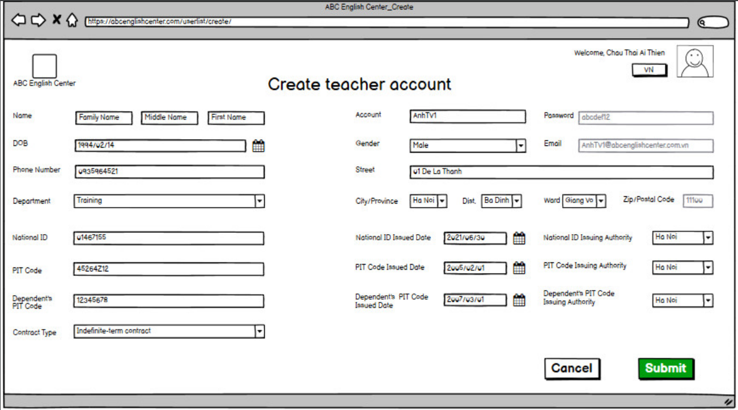



*Figure 9: Screen “Create new teacher account”*

**2.4.2. Components description**

|  |  |  |  |  |  |  |
| --- | --- | --- | --- | --- | --- | --- |
| **#** | **Component** | **Comp. Type** | **Da**  **ta**  **type** | **Mandatory** | **Default** | **Description** |
| 1 | Screen name | Label | N/A | N/A | * Default state: N/A * Default value: N/A | * Label: “Create teacher account” |
| 2 | Family name | Textbox | Nvar  char  (20) | Yes | * Default state: Enabled  * Default value: Family name | Fill teacher’s family name.   * Label: “Name”  * Available value: N/A * Data source: N/A * Placeholder text: Family name |
| 3 | Middle name |  |  |  |  |  |
| 4 | First name |  |  |  |  |  |
| 5 | Account | Textbox | Var  char  (10) | N/A | * Default state: Disabled  * Default value: N/A | Teacher’s account will be set automatically.   * Label: “Account”  * Available value: N/A * Data source: N/A * Validation rule: apply   + VR001#  + VR002#  + Syntax: “Name” + the first letter of “Family name” + the first letter of “Middle name” + sequence (avoid duplication) |
| 6 | DOB |  |  |  | * Default value: YYYY/MM/DD for English and DD/MM/YYYY for Vietnamese. | * Display format: YYYY/MM/DD or DD/MM/YYYY (based on language option). |
| 7 | Gender | Combo  box |  |  | * Default state: Enabled  * Default value: “Male” | * ” * Available value: Static list following this order:   + Male  + Female  + Others |
| 8 | Password |  |  |  | * Default state: Disabled | Teacher’s password will be set automatically. |
| 9 | Phone  number | Textbox |  |  | * Default state: Enabled * Default value: Blank | Fill teacher’s phone number.   * Label: “Phone number” |
| 10 | Email | Textbox |  |  | * Default state: Disabled | Email will be set automatically.  + Syntax: “Account of teacher” + @abcenglishcenter.com.vn |
| 11 | Zip/Postal code |  |  |  | * Default state: Disable | Zip/ Postal code will be set automatically based on City / Province.   * Data source: Retrieved from database. * Entity: Place * Attribute: Zip/Postal code |
| 12 | City / Province | Combo  box | Nvarchar  (50) | Yes | * Default state: Enabled  * Default value: “Ha Noi” | Choose teacher’s city/province.   * Label: “City/Province” * Available value: N/A |
| 13 | District. | Combo  box | Nvar  char  (50) | Yes | * Default state: Enabled  * Default value: “Ba Dinh” |  |
| 14 | Ward | Combo  box | Nvar  char  (50) | Yes | * Default state: Enabled * Default value: “Giang Vo” |  |
| 15 | Street | Textbox | Nvar  char  (50) | Yes | * Default state: Enabled  * Default value: Blank | Fill teacher’s street address. |
| 16 | Department | Combo  box | Nvar  char  (20) | Yes | * Default state: Enabled  * Default value: “Training” | * Available value: Static list following this order:   + Training  + HR |
| 17 | Contract type | Combo  box |  |  | * Default value: “Indefinite – term contract” | * Available value: Static list following this order:   + Indefinite – term contract  + Fixed – time contract  + Probationary contract   * Data source: N/A * Validation rule: apply VR005# |
| 18 | National  ID | Textbox | Var  char (30) |  |  |  |
| 19 | National  ID issued date | Date chooser | Date | Yes | * Default state: Enabled * Default value: YYYY/MM/DD for English and DD/MM/YYYY for Vietnamese. | Fill teacher’s national ID issued date.   * Label: “National ID issued date” * Available value: N/A * Data source: N/A * Display format: YYYY/MM/DD or DD/MM/YYYY (based on language option). * After clicking on calendar icon, user can choose date which user wants. * Validation rule: apply   + VR001#  + National ID issued date cannot be greater than the current date. |
| 20 | National  ID issuing authority | Combo  box | Nvar  char  (50) | Yes | * Default state: Enabled * Default value: “Ha Noi” | Must choose National ID issuing authority.   * Label: “National ID issuing authority” * Available value: N/A * Data source: Retrieved from database. * Entity: Place * Attribute: City/ Province * Validation rule: apply VR005# |
| 21 | PIT code | Textbox | Number (20) | Yes | * Default state: Enabled * Default value: Blank | Fill teacher’s PIT code.   * Label: “PIT code” * Available value: N/A * Data source: N/A * Validation rule: apply   + VR001#  + VR003# |
| 22 | PIT code issued date | Date chooser | Date | Yes | * Default state: Enabled * Default value: YYYY/MM/DD for English and DD/MM/YYYY for Vietnamese. | Fill teacher’s PIT code issued date   * Label: “PIT code issued date” * Available value: N/A * Data source: N/A * Display format: YYYY/MM/DD or DD/MM/YYYY (based on language option). * After clicking on calendar icon, user can choose date which user wants. * Validation rule: apply   + VR001#  + PIT code issued date cannot be greater than the current date. |
| 23 | PIT code issuing authority | Combo  box | Nvar  char  (50) | Yes | * Default state: Enabled * Default value: “Ha Noi” | Must choose PIT code issuing authority.   * Label: “PIT code issuing authority” * Available value: N/A * Data source: Retrieved from database. * Entity: Place * Attribute: City/ Province * Validation rule: apply VR005# |
| 24 | Dependent’s PIT code | Textbox | Number (20) | N/A | * Default state: Enabled * Default value: Blank | Fill dependent’s PIT code.   * Label: “Dependent’s PIT code” * Available value: N/A * Data source: N/A * Validation rule: apply VR003# |
| 25 | Dependent’s PIT code issued date | Date chooser | Date | N/A | * Default state: Enabled * Default value: YYYY/MM/DD for English and DD/MM/YYYY for Vietnamese. | Fill dependent’s PIT code issued date.   * Label: “Dependent’s PIT code issued date” * Available value: N/A * Data source: N/A * Display format: YYYY/MM/DD or DD/MM/YYYY (based on language option). * After clicking on calendar icon, user can choose date which user wants. * Validation rule: apply   + VR001#  + Dependent’s PIT code issued date cannot be greater than the current date. |
| 26 | Dependent’s PIT code issuing authority | Combo  box | Nvar  char  (50) | Yes | * Default state: Enabled * Default value: “Ha Noi” | Must choose Dependent’s PIT code issuing authority.   * Label: “Dependent’s PIT code issuing authority” * Available value: N/A * Data source: Retrieved from database. * Entity: Place * Attribute: City/ Province * Validation rule: apply VR005# |
| 27 | Cancel | Button | N/A | N/A | * Default state: Enabled * Default value: N/A | User can choose “Cancel” if user wants to stop filling in information.   * Label: “Cancel” * Available value: N/A * Data source: N/A * Validation rule: N/A * After clicking on “Cancel” button, system will show alert and ask user to confirm it.   + If user wants to continue filling in information, system will keep current page.  + If user wants to cancel filling in information and system will discard all filled data and back to previous page. |
| 28 | Submit | Button | N/A | N/A | * Default state: Enabled * Default value: N/A | * Label: “Submit” * Available value: N/A * Data source: N/A * After clicking on “Submit” button, system will validate that filled information.   + If that filled information have been validated, system will save that data and show successful message (apply SMS001#).  + If that filled information have been validated but not save successful, the system will show error message and user must try again (apply EMS001#).  + If that filled information have not been validated, system will show error message and user must fill information again (apply EMS002#).   * Validation rule:   + SMS001#  + EMS001#  + EMS002# |

**3. [UC003# Update teacher’s account] description**

**3.1. UC Summary**

|  |  |
| --- | --- |
| **Objective** | This UC allows Class Manager to update teacher’s account. |
| **Actor** | Class Manager. |
| **Trigger** | User triggers “update teacher’s account” feature. |
| **Precondition** | User logged in. |
| **Post-condition** | User updates teacher’s accounts successfully. |
| **Frequency of use** | High. |
| **Priority** | High. |
| **Related UC(s)** | [UC002# Create new teacher’s account]  [UC012# View teacher’s account]  [UC013# Delete teacher’s account]  [UC014# Search teacher’s account] |
| **Navigation path** | {Users list- Info/Update button} |
| **PIC** | ThienCTA |

**3.2. Activity Flow**

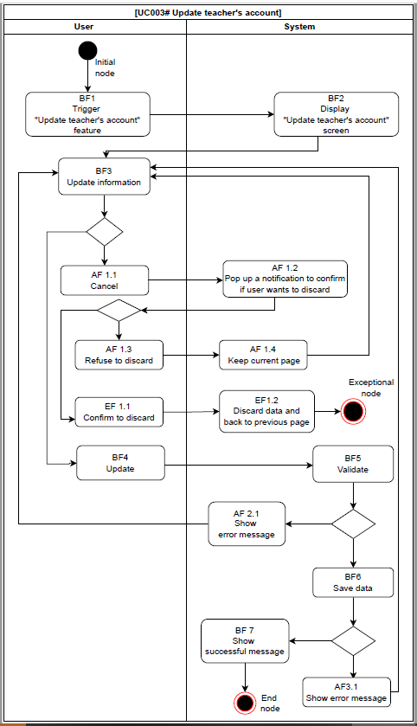

*Figure 10: Activity flow – [UC003#Update teacher’s account]*

**3.3. Scenario description**

**3.3.1. Basic Flow**

|  |  |  |
| --- | --- | --- |
| **Step** | **Actor** | **Description** |
| BF1 | User | Trigger “Update teacher’s account” feature. |
| BF2 | System | Display “Update teacher’s account” screen. |
| BF3 | User | Update information into components.  + If the user wants to update, go to BF4 step.  + If the user wants to cancel, go to Alternate Flow AF01 (refer to Activity flow, AF1.1) |
| BF4 | User | Decide to update by clicking on “Update” button. |
| BF5 | System | Check validation is valid?  + If yes, go to the BF 6 step.  + If no, go to Alternate Flow AF01 (refer to activity flow, AF2.1) |
| BF6 | System | Save the updated data.  + If save successful, go to BF7 step.  + If save unsuccessful, go to Alternate flow AF02 (refer to activity flow, AF3.1 |
| BF7 | System | Show successful message to user if that updated data has been saved successfully. |

**3.3.2. Alternate flow**

**AF01: Use wants to cancel (stop updating information)**

|  |  |  |
| --- | --- | --- |
| **Step** | **Actor** | **Description** |
| AF1.1 | User | Want to cancel (stop updating information) |
| AF1.2 | System | Display a notification to confirm if the user wants to discard. |
| AF1.3 | User | Refuse to discard. |
| AF1.4 | System | Keep current page. |

**AF02: User updates invalid information**

|  |  |  |
| --- | --- | --- |
| **Step** | **Actor** | **Description** |
| AF2.1 | System | Show error message to the user if that updated data was invalid. |

**AF03: User clicks update and save data**

|  |  |  |
| --- | --- | --- |
| **Step** | **Actor** | **Description** |
| AF3.1 | System | Show error message to the user if that updated data has not been saved successfully. |

**3.3.3. Exceptional flow**

**EF01: User wants to cancel (stop updating information)**

|  |  |  |
| --- | --- | --- |
| **Step** | **Actor** | **Description** |
| EF1.1 | User | Confirm to discard data by selecting “Yes” (option). |
| EF1.2 | System | Discard data and go back to the previous page. |

**3.4. Screen description**

**3.4.1. Wireframe**

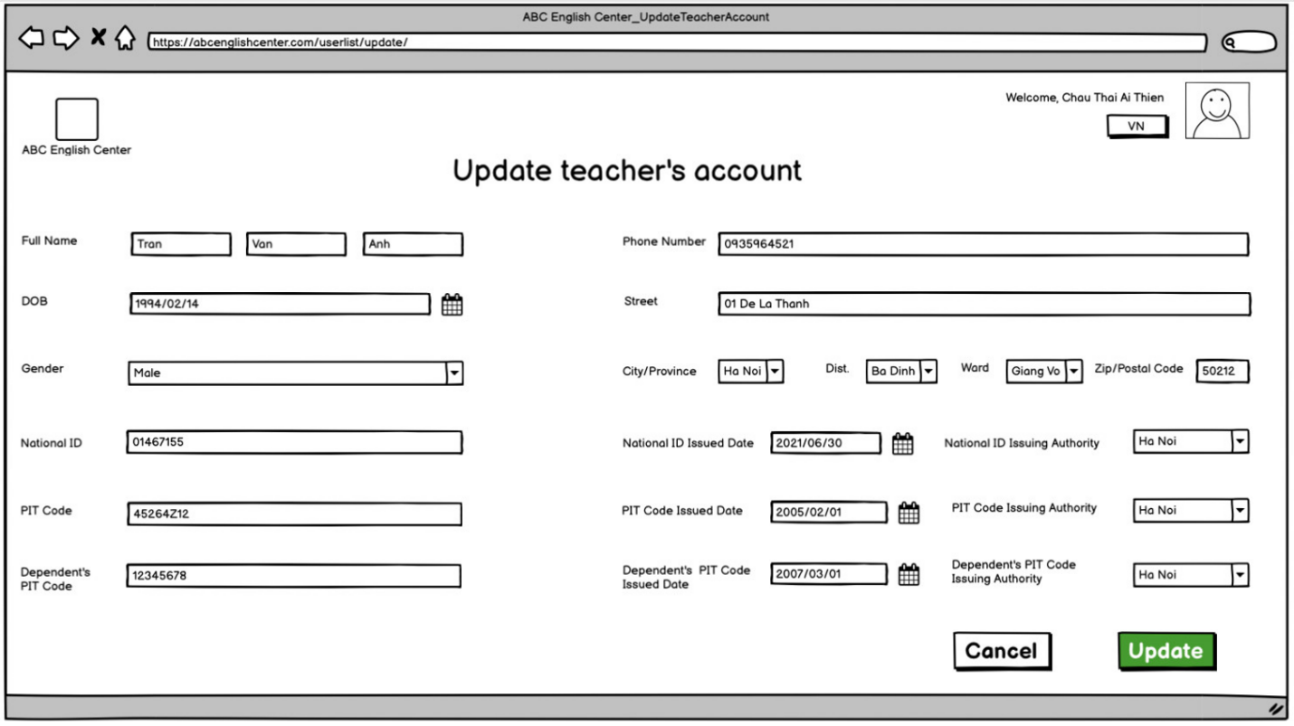

*Figure 11: Screen “Update teacher’s account”*

**3.4.2. Component description**

|  |  |  |  |  |  |  |
| --- | --- | --- | --- | --- | --- | --- |
| **#** | **Component** | **Comp. Type** | **Da**  **ta**  **type** | **Mandatory** | **Default** | **Description** |
| 1 | Screen name | Label | N/A | N/A | * Default state: N/A * Default value: N/A | * Label: “Update teacher’s account” * Available value: N/A * Data source: N/A * Validation rule: N/A |
| 2 | Family name | Textbox | Nvar  char  (20) | Yes | * Default state: Enabled * Default value: Based on teacher’s account which has been saved on the database. | Update family name (in case of need)   * Label: “Full Name” * Available value: N/A * Data source: Retrieved from database. * Entity: Teacher Account * Attribute: Family name * Validation rule: apply   + VR001#  + VR003#  + “Family name” must be started with one or more alphabets in range a-z; not a symbol or any special characters and must not include digits. |
| 3 | Middle name | Textbox | Nvar  char  (20) | Yes | * Default state: Enabled * Default value: Based on teacher’s account which has been saved on the database. | Update middle name (in case of need).   * Available value: N/A * Data source: Retrieved from database. * Entity: Teacher Account * Attribute: Middle name * Validation rule: apply   + VR001#  + VR003#  + “Middle name” must be started with one or more alphabets in range a-z; not a symbol or any special characters and must not include digits. |
| 4 | First name | Textbox | Nvar  char  (20) | Yes | * Default state: Enabled * Default value: Based on teacher’s account which has been saved on the database. | Update first name (in case of need).   * Available value: N/A * Data source: Retrieved from database. * Entity: Teacher Account * Attribute: First name * Validation rule: apply   + VR001#  + VR003#  + “First name” must be started with one or more alphabets in range a-z; not a symbol or any special characters and must not include digits. |
| 5 | Phone  number | Textbox | Var  char (20) | Yes | * Default state: Enabled   Default value: Based on teacher’s account which has been saved on the database. | Update phone number (in case of need).   * Label: “Phone number” * Available value: N/A * Data source: Retrieved from database. * Entity: Teacher Account * Attribute: Phone number * Validation rule: apply   + VR001#  + VR003#  + “Phone number” must be not a symbol or any special characters, alphabets. |
| 6 | DOB | Date chooser | Date | Yes | * Default state: Enabled * Default value: Based on teacher’s account which has been saved on the database | Update DOB (in case of need).   * Label: “DOB” * Available value: N/A * Data source: Retrieved from database. * Entity: Teacher Account * Attribute: DOB * Display format: YYYY/MM/DD for English and DD/MM/YYYY for Vietnamese. * After clicking on calendar icon, user can choose date which user wants. * Validation rule: apply   + VR001#.  + The teacher ‘s age is not allowed to be less than 18 years old as of the present time. |
| 7 | Street | Textbox | Nvar  char  (50) | Yes | * Default state: Enabled   Default value: Based on teacher’s account which has been saved on the database | Update street address (in case of need).   * Label: “Street” * Available value: N/A * Data source: Retrieved from database. * Entity: Teacher Account * Attribute: Street * Validation rule: apply   + VR001#  + VR005#  + The street name is combination of digits and letters.  + The street name does not have a symbol or any special characters. |
| 8 | City / Province | Combo  box | Nvar  char  (50) | Yes | * Default state: Enabled * Default value: Based on teacher’s account which has been saved on the database | Update city/province (in case of need).   * Label: “City/Province” * Available value: N/A * Data source: Retrieved from database. * Entity: Teacher Account * Attribute: City/Province * Validation rule: apply VR005# |
| 9 | District | Combo  box | Nvar  char  (50) | Yes | * Default state: Enabled * Default value: Based on teacher’s account which has been saved on the database | Update district (in case of need).   * Label: “Dist.” * Available value: N/A * Data source: Retrieved from database. * Entity: Teacher Account * Attribute: District * Validation rule: apply VR005# |
| 10 | Ward | Combo  box | Nvar  char  (50) | Yes | * Default state: Enabled * Default value: Based on teacher’s account which has been saved on the database | Update ward ((in case of need).   * Label: “Ward” * Available value: N/A * Data source: Retrieved from database. * Entity: Teacher Account * Attribute: Ward * Validation rule: apply VR005# |
| 11 | Zip/Postal code | Text box | Number (20) | Yes | * Default state: Disabled * Default value: Based on teacher’s account which has been saved on the database | Zip/ Postal code will be set automatically based on City / Province.   * Label: “Zip/Postal code” * Available value: N/A * Data source: Retrieved from database. * Entity: Teacher Account * Attribute: Zip/Postal code * Validation rule: apply VR003# |
| 12 | Gender | Combo  box | Nvar  char  (10) | Yes | * Default state: Enabled * Default value: Based on teacher’s account which has been saved on the database | Update gender (in case of need).   * Label: “Gender” * Available value: Static list following this order:   + Male  + Female  + Others   * Data source: Retrieved from database. * Entity: Teacher Account * Attribute: Gender * Validation rule: apply VR002# |
| 13 | National  ID | Textbox | Var  char (30) | Yes | * Default state: Enabled * Default value: Based on teacher’s account which has been saved on the database | Update national ID (in case of need).   * Label: “National ID” * Available value: N/A * Data source: Retrieved from database. * Entity: Teacher Account * Attribute: National ID * Validation rule: apply   + VR001#  + VR004# |
| 14 | National  ID issued date | Date chooser | Date | Yes | * Default state: Enabled * Default value: Based on teacher’s account which has been saved on the database. | Update national ID issued date (in case of need).   * Label: “National ID issued date” * Available value: N/A * Data source: Retrieved from database. * Entity: Teacher Account * Attribute: National ID issued date * Display format: YYYY/MM/DD for English and DD/MM/YYYY for Vietnamese. * After clicking on calendar icon, user can choose date which user wants. * Validation rule: apply   + VR001#  + National ID issued date cannot be greater than the current date. |
| 15 | National  ID issuing authority | Combo  box | Nvar  char  (50) | Yes | * Default state: Enabled * Default value: Based on teacher’s account which has been saved on the database | Update city/province (in case of need).   * Label: “National ID issuing authority” * Available value: N/A * Data source: Retrieved from database. * Entity: Teacher Account * Attribute: National ID issuing authority * Validation rule: apply VR005# |
| 16 | PIT code | Textbox | Number (20) | Yes | * Default state: Enabled * Default value: Based on teacher’s account which has been saved on the database | Update PIT code (in case of need).   * Label: “PIT code” * Available value: N/A * Data source: Retrieved from database. * Entity: Teacher Account * Attribute: PIT code * Validation rule: apply   + VR001#  + VR003# |
| 17 | PIT code issued date | Date chooser | Date | Yes | * Default state: Enabled * Default value: Based on teacher’s account which has been saved on the database | Update PIT code issued date (in case of need).   * Label: “PIT code issued date” * Available value: N/A * Data source: Retrieved from database. * Entity: Teacher Account * Attribute: PIT code issued date * Display format: YYYY/MM/DD for English and DD/MM/YYYY for Vietnamese. * After clicking on calendar icon, user can choose date which user wants. * Validation rule: apply   + VR001#  + PIT code issued date cannot be greater than the current date. |
| 18 | PIT code issuing authority | Combo  box | Nvar  char  (50) | Yes | * Default state: Enabled * Default value: Based on teacher’s account which has been saved on the database | Update city/province (in case of need).   * Label: “PIT code issuing authority” * Available value: N/A * Data source: Retrieved from database. * Entity: Teacher Account * Attribute: PIT code issuing authority * Validation rule: apply VR005# |
| 19 | Dependent’s PIT code | Textbox | Number (20) | N/A | * Default state: Enabled * Default value: Based on teacher’s account which has been saved on the database | Update dependent’s PIT code (in case of need).   * Label: “Dependent’s PIT code” * Available value: N/A * Data source: Retrieved from database. * Entity: Teacher Account * Attribute: Dependent’s PIT code * Validation rule: apply VR003# |
| 20 | Dependent’s PIT code issued date | Date chooser | Date | N/A | * Default state: Enabled * Default value: Based on teacher’s account which has been saved on the database | Update dependent’s PIT code issued date (in case of need).   * Label: “Dependent’s PIT code issued date” * Available value: N/A * Data source: Retrieved from database. * Entity: Teacher Account * Attribute: Dependent’s PIT code issued date * Display format: YYYY/MM/DD for English and DD/MM/YYYY for Vietnamese. * After clicking on calendar icon, user can choose date which user wants. * Validation rule: apply   + VR001#  + PIT code issued date cannot be greater than the current date. |
| 21 | Dependent’s PIT code issuing authority | Combo  box | Nvar  char  (50) | Yes | * Default state: Enabled * Default value: Based on teacher’s account which has been saved on the database | Update city/province (in case of need).   * Label: “Dependent’s PIT code issuing authority” * Available value: N/A * Data source: Retrieved from database. * Entity: Teacher Account * Attribute: Dependent’s PIT code issuing authority * Validation rule: apply VR005# |
| 22 | Cancel | Button | N/A | N/A | * Default state: Enabled * Default value: N/A | User can choose “Cancel” if user wants to stop filling in information.   * Label: “Cancel” * Available value: N/A * Data source: N/A * Validation rule: N/A * After clicking on “Cancel” button, system will show alert and ask user to confirm it.   + If user wants to continue filling in information, system will keep current page.  + If user wants to cancel filling in information and system will discard all filled data and back to previous page. |
| 23 | Update | Button | N/A | N/A | * Default state: Enabled * Default value: N/A | * Label: “Update” * Available value: N/A * Data source: N/A * After clicking on “Update” button, system will validate that filled information.   + If that filled information have been validated, system will save that data and show successful message (apply SMS003#).  + If that filled information have been validated but not save successful, the system will show error message and user must try again (apply EMS001#).  + If that filled information have not been validated, system will show error message and user must fill information again (apply EMS002#).   * Validation rule:   + SMS001#  + EMS001#  + EMS002# |

1. **[UC004# Update User’s information] description**

**4.1. UC Summary**

|  |  |
| --- | --- |
| **Objective** | This UC allows admin to update user’s information. |
| **Actor** | Admin. |
| **Trigger** | Admin triggers “Update user’s information” feature. |
| **Precondition** | Admin logged in. |
| **Post-condition** | Admin updates user’s information successfully. |
| **Frequency of use** | High. |
| **Priority** | High. |
| **Related UC(s)** | Search users list |
| **Navigation path** | {Home screen/ User list- Info/ Search/ Update} |
| **PIC** | DuyenDTT1 |

* 1. **Activity Flow**

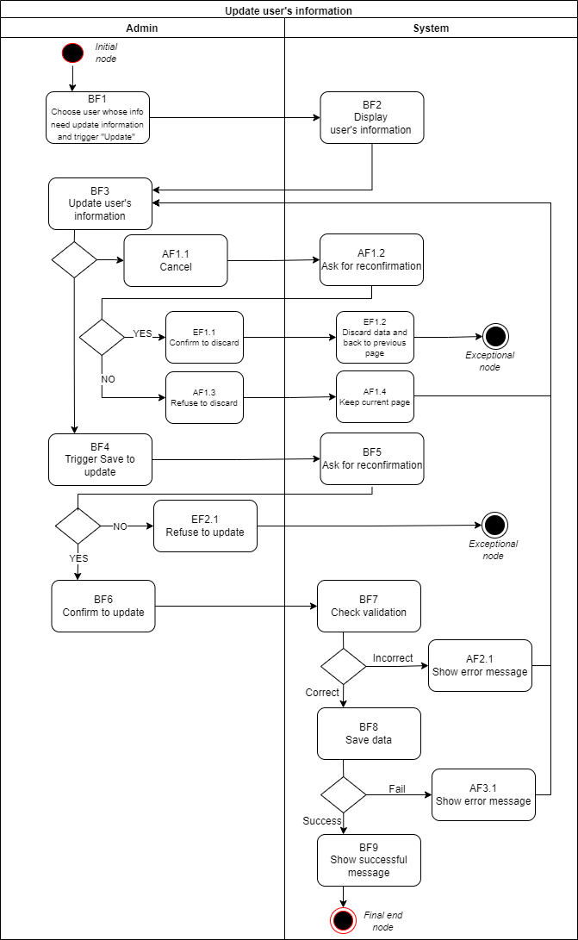

*Figure 12: Activity flow – [UC004# Update user’s information]*

**4.3. Scenario description**

**4.3.1. Basic Flow**

|  |  |  |
| --- | --- | --- |
| **Step** | **Actor** | **Description** |
| BF1 | Admin | Choose user in Search user list-info screen and trigger “Update” feature. |
| BF2 | System | Display user’s information. |
| BF3 | Admin | Update information into components.  + If admin want to save, go to the next step.  + If admin want to cancel, go to Alternate Flow AF01(refer to Activity flow, AF 1.1). |
| BF4 | Admin | Decide to save data by clicking on “Save” button. |
| BF5 | System | Show alert and ask admin to confirm it.  + If admin confirm to update user’s information, go to next step.  + If admin refuse to update user’s information, go to Exceptional flow EF02(refer to Activity flow, EF2.1). |
| BF6 | Admin | Confirm to update user’s information. |
| BF7 | System | Check validation.  + If validation is correct, go to next step.  + If validation is incorrect, go to Alternate Flow AF02 (refer to Activity flow, AF2.1). |
| BF8 | System | Save data.  +If save data is successful, go to next step.  +If save data is fail, go to Alternate flow AF03(refer to activity flow, AF3.1) |
| BF9 | System | Show successful message. |

**4.3.2. Alternate flow**

**AF01: Admin wants to cancel (stop update user’s information)**

|  |  |  |
| --- | --- | --- |
| **Step** | **Actor** | **Description** |
| AF 1.1 | Admin | Want to cancel (stop update user’s information). |
| AF 1.2 | System | Display a alert and ask admin to confirm it. |
| AF 1.3 | Admin | +If refuse to discard, go to the next step.  +If confirm to discard, go to Exceptional Flow EF01(refer to Activity flow, EF1.1). |
| AF 1.4 | System | Keep current page. |

**AF02: Validation is incorrect**

|  |  |  |
| --- | --- | --- |
| **Step** | **Actor** | **Description** |
| AF 2.1 | System | Show error message. |

#### **AF03: Save data is fail**

|  |  |  |
| --- | --- | --- |
| **Step** | **Actor** | **Description** |
| AF 3.1 | System | Show error message. |

#### **4.3.3. Exceptional flow**

#### **EF01: Admin confirm to discard (cancel updated user’s information)**

|  |  |  |
| --- | --- | --- |
| **Step** | **Actor** | **Description** |
| EF 1.1 | Admin | Confirm to discard data. |
| EF 1.2 | System | Discard data and go back to the previous page. |

**EF02: Admin refuse to update user’s information**

|  |  |  |
| --- | --- | --- |
| **Step** | **Actor** | **Description** |
| EF 2.1 | Admin | Refuse to update user’s information. |

**4.4. Screen description**

**4.4.1. Wireframe**

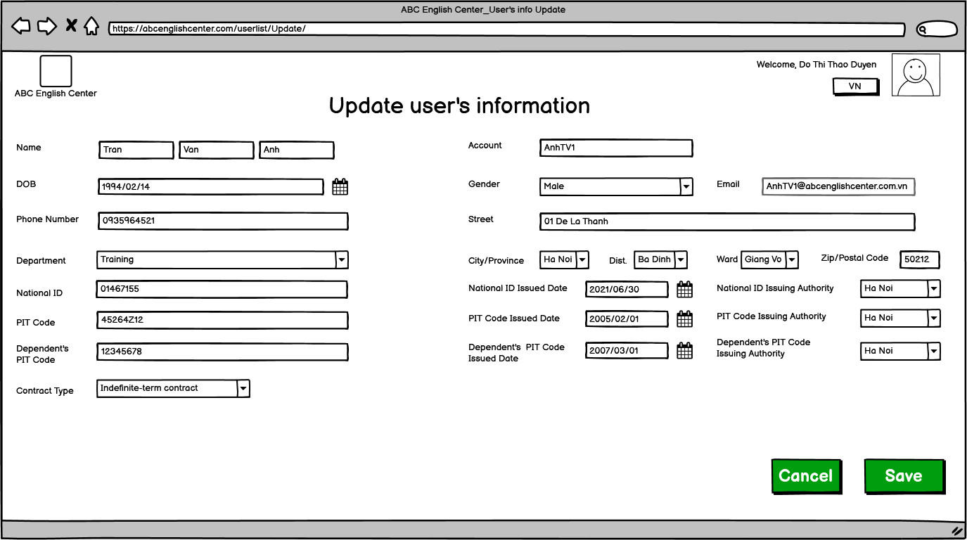

*Figure 13: Screen “Update user’s information”*

**4.4.2. Components description**

|  |  |  |  |  |  |  |
| --- | --- | --- | --- | --- | --- | --- |
| **#** | **Component** | **Comp. Type** | **Da**  **ta**  **type** | **Mandatory** | **Default** | **Description** |
| 1 | Screen name | Label | N/A | N/A | * Default state: N/A * Default value: N/A | * Label: “Update User’s information” * Available value: N/A * Data source: N/A * Validation rule: N/A |
| 2 | Family name | Textbox | Nvar  char  (20) | Yes | * Default state: Enabled * Default value: Based on user account which has been saved on database. | Fill user’s family name.   * Label: “Name” * Available value: N/A * Data source: retrieved from database   + Entity: User  + Attribute: Family name   * Validation rule: apply   + VR001#  + VR003#  + “Family name” must be started with one or more alphabets in range a-z; not a symbol or any special characters and must not include digits. |
| 3 | Middle name | Textbox | Nvar  char  (20) | Yes | * Default state: Enabled * Default value: Based on user account which has been saved on database. | Fill user’s middle name.   * Available value: N/A * Data source: retrieved from database   + Entity: User  + Attribute: Middle name   * Validation rule: apply   + VR001#  + VR003#  + “Middle name” must be started with one or more alphabets in range a-z; not a symbol or any special characters and must not include digits. |
| 4 | First name | Textbox | Nvar  char  (20) | Yes | * Default state: Enabled * Default value: Based on user account which has been saved on database. | Fill user’s first name.   * Available value: N/A * Data source: retrieved from database   + Entity: User  + Attribute: First name   * Validation rule: apply   + VR001#  + VR003#  + “First name” must be started with one or more alphabets in range a-z; not a symbol or any special characters and must not include digits. |
| 5 | Date of Birth | Date chooser | Date | Yes | * Default state: Enabled * Default value Based on user account which has been saved on database. | Choose user’s date of birth.   * Label: “DOB” * Available value: retrieved from database   + Entity: User  + Attribute: DOB   * Data source: N/A * After clicking on calendar icon, admin can choose date which admin wants. * Validation rule: apply   + VR001#.  + The teacher ‘s age is not allowed to be less than 10 years old as of the present time. |
| 6 | Gender | Combo  box | Nvar  char  (10) | Yes | * Default state: Enabled * Default value: Based on user account which has been saved on database. | Choose user’s gender.   * Label: “Gender” * Available value: Static list following this order:   + Male  + Female  + Others   * Data source: retrieved from database   + Entity: User  + Attribute: Gender   * Validation rule: apply VR002# |
| 7 | Account | Textbox | Var  char  (10) | N/A | * Default state: Enabled * Default value: Based on user account which has been saved on database. | Fill user’s account.   * Label: “Account” * Available value: N/A * Data source: retrieved from database   + Entity: User  + Attribute: Account   * Validation rule: apply   + VR001#  + VR002#  + Syntax: “Name” + the first letter of “Family name” + the first letter of “Middle name” + sequence (avoid duplication) |
| 8 | Phone  number | Textbox | Var  char (20) | Yes | * Default state: Enabled * Default value: Based on user account which has been saved on database. | Fill user’s phone number.   * Label: “Phone number” * Available value: N/A * Data source: retrieved from database   + Entity: User  + Attribute: Phone number   * Validation rule: apply   + VR001#  + VR003#  + “Phone number” must be not a symbol or any special characters, alphabets. |
| 9 | Email | Textbox | Var  char  (50) | Yes | * Default state: Enabled * Default value: Based on user account which has been saved on database. | User’s Email will be set  automatically.   * Label: “Email” * Available value: N/A * Data source: retrieved from database   + Entity: User  + Attribute: Email   * Validation rule: apply   + VR001#  + VR005#  + Syntax: “Account of teacher” + @abcenglishcenter.com.vn |
| 10 | Zip/Postal code | Text box | Number (20) | Yes | * Default state: Disable * Default value: Based on user account which has been saved on database. | Zip/ Postal code will be set automatically based on City / Province.   * Label: “Zip/Postal code” * Available value: N/A * Data source: retrieved from database   + Entity: User  + Attribute: ZIP/Postal code   * Validation rule: apply VR003# |
| 11 | City / Province | Combo  box | Nvar  char  (50) | Yes | * Default state: Enabled * Default value: Based on user account which has been saved on database. | Choose user’s city/province.   * Label: “City/Province” * Available value: N/A * Data source: retrieved from database   + Entity: User  + Attribute: City/Province   * Validation rule: apply VR005# |
| 12 | District | Combo  box | Nvar  char  (50) | Yes | * Default state: Enabled * Default value: Based on user account which has been saved on database. | Choose user’s district.   * Label: “Dist.” * Available value: N/A * Data source: retrieved from database   + Entity: User  + Attribute: Dist.   * Validation rule: apply VR005# |
| 13 | Ward | Combo  box | Nvar  char  (50) | Yes | * Default state: Enabled * Default value: Based on user account which has been saved on database. | Fill user’s ward.   * Label: “Ward” * Available value: N/A * Data source: retrieved from database   + Entity: User  + Attribute: Ward   * Validation rule: apply VR005# |
| 14 | Street | Textbox | Nvar  char  (50) | Yes | * Default state: Enabled * Default value: Based on user account which has been saved on database. | Fill user’s street address.   * Label: “Street” * Available value: N/A * Data source: retrieved from database   + Entity: User  + Attribute: Street   * Validation rule: apply   + VR001#  + VR005#  + The street name is combination of digits and letters.  + The street name does not have a symbol or any special characters. |
| 15 | Depart  ment | Combo  box | Nvar  char  (20) | Yes | * Default state: Enabled * Default value: Based on user account which has been saved on database. | Choose user’s department.   * Label: “Department” * Available value: Static list following this order:   + Training  + HR   * Data source: retrieved from database   + Entity: User  + Attribute: Department   * Validation rule: apply VR003# |
| 16 | Contract type | Combo  box | Nvar  char  (50) | Yes | * Default state: Enabled * Default value: Based on user account which has been saved on database. | Choose user’s contract type.   * Label: “Contract type” * Available value: Static list following this order:   + Indefinite – term contract  + Fixed – time contract  + Probationary contract   * Data source: retrieved from database   + Entity: User  + Attribute: Contract type   * Validation rule: apply VR005# |
| 17 | National  ID | Textbox | Var  char (30) | Yes | * Default state: Enabled * Default value: Based on user account which has been saved on database. | Fill user’s national ID.   * Label: “National ID” * Available value: N/A * Data source: retrieved from database   + Entity: User  + Attribute: National ID   * Validation rule: apply   + VR001#  + VR004# |
| 18 | National  ID issued date | Date chooser | Date | Yes | * Default state: Enabled   Default value: Based on user account which has been saved on database. | Choose user’s national ID issued date.   * Label: “National ID issued date” * Available value: N/A * Data source: retrieved from database   + Entity: User  + Attribute: National ID issued date.   * Display format: YYYY/MM/DD or DD/MM/YYYY (based on language option). * After clicking on calendar icon, admin can choose date which admin wants. * Validation rule: apply   + VR001#  + National ID issued date cannot be greater than the current date. |
| 19 | National  ID issuing authority | Combo  box | Nvar  char  (50) | Yes | * Default state: Enabled * Default value: Based on user account which has been saved on database. | Choose user’s city/province.   * Label: “National ID issuing authority” * Available value: N/A * Data source: retrieved from database   + Entity: User   * + Attribute: National ID issuing authority * Validation rule: apply VR005# |
| 20 | PIT code | Textbox | Number (20) | Yes | * Default state: Enabled   Default value: Based on user account which has been saved on database. | Fill user’s PIT code.   * Label: “PIT code” * Available value: N/A * Data source: retrieved from database   + Entity: User   * + Attribute: PIT Code * Validation rule: apply   + VR001#  + VR003# |
| 21 | PIT code issued date | Date chooser | Date | Yes | * Default state: Enabled   Default value: Based on user account which has been saved on database. | Fill user’s PIT code issued date   * Label: “PIT code issued date” * Available value: N/A * Data source: retrieved from database   + Entity: User   * + Attribute: PIT Code issued date * Display format: YYYY/MM/DD or DD/MM/YYYY (based on language option). * After clicking on calendar icon, admin can choose date which admin wants. * Validation rule: apply   + VR001#  + PIT code issued date cannot be greater than the current date. |
| 22 | PIT code issuing authority | Combo  box | Nvar  char  (50) | Yes | * Default state: Enabled * Default value: Based on user account which has been saved on database. | Choose user’s city/province.   * Label: “PIT code issuing authority” * Available value: N/A * Data source: retrieved from database   + Entity: User   * + Attribute: PIT Code issuing authority * Validation rule: apply VR005# |
| 23 | Dependent’s PIT code | Textbox | Number (20) | N/A | * Default state: Enabled   Default value: Based on user account which has been saved on database. | Fill dependent’s PIT code.   * Label: “Dependent’s PIT code” * Available value: N/A * Data source: retrieved from database   + Entity: User   * + Attribute: Dependent’s PIT code * Validation rule: apply VR003# |
| 24 | Dependent’s PIT code issued date | Date chooser | Date | N/A | * Default state: Enabled * Default value: Based on user account which has been saved on database. | Choose dependent’s PIT code issued date.   * Label: “Dependent’s PIT code issued date” * Available value: N/A * Data source: retrieved from database   + Entity: User   * + Attribute: Dependent’s PIT code issued date * Display format: YYYY/MM/DD or DD/MM/YYYY (based on language option). * After clicking on calendar icon, admin can choose date which admin wants. * Validation rule: PIT code issued date cannot be greater than the current date. |
| 25 | Dependent’s PIT code issuing authority | Combo  box | Nvar  char  (50) | Yes | * Default state: Enabled * Default value: Based on user account which has been saved on database. | Choose user’s city/province.   * Label: “Dependent’s PIT code issuing authority” * Available value: N/A * Data source: retrieved from database   + Entity: User  + Attribute: Dependent’s PIT code issuing authority   * Validation rule: apply VR005# |
| 26 | Cancel | Button | N/A | N/A | * Default state: Enabled * Default value: N/A | Admin can choose “Cancel” if admin wants to stop update user’s information.   * Label: “Cancel” * Available value: N/A * Data source: N/A * Validation rule: N/A * After clicking on “Cancel” button, system will show alert and ask user to confirm it.   + If admin wants to continue updating information, system will keep current page.  + If admin wants to cancel update user’s information and system will discard all updated data and back to previous page. |
| 27 | Save | Button | N/A | N/A | * Default state: Enabled * Default value: N/A | * Label: “Save” * Available value: N/A * Data source: N/A * After clicking on “Save” button, system will validate that filled information.   + If that updated information have been validated, system will save that data and show successful message (apply EMS002#).  + If that updated information have been validated but not save successful, the system will show error message and user must fill information again (apply EMS002#).  + If that updated information have not been validated, system will show error message and user must update user’s information again (apply EMS003#).   * Validation rule:   + SMS001#  + EMS001#  + EMS002# |

**5. [UC005# ﻿Enter grade test] description**

**5.1. UC Summary**

|  |  |
| --- | --- |
| **Objective** | This UC allows class manager to enter grade test. |
| **Actor** | Class Manager. |
| **Trigger** | User triggers “Enter grade test” in the “Control grade test” feature. |
| **Precondition** | User logged in. |
| **Post-condition** | User enters grade test successfully. |
| **Frequency of use** | High. |
| **Priority** | High. |
| **Related UC(s)** | [UC015# View grade test]  [UC016# Update grade test]  [UC014# Grade test analysis] |
| **Navigation path** | {Menu/Control grade test/Enter grade test} |
| **PIC** | ThaoDTT13 |

**5.2. Activity Flow**

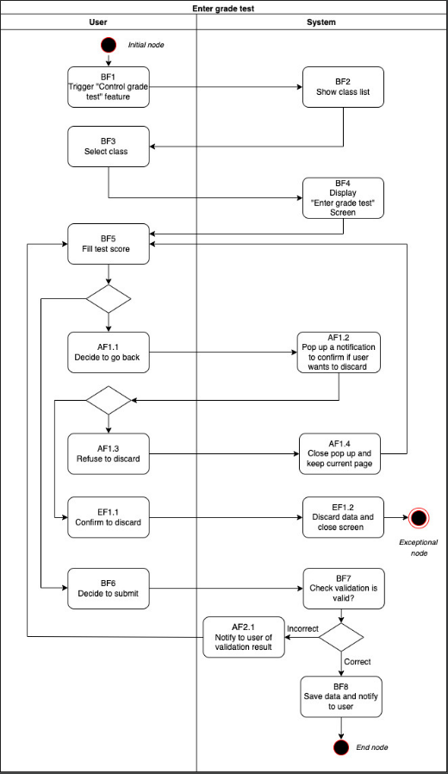

*Figure 14: Activity flow – [UC005****#*** *Enter grade test]*

**5.3. Scenario description**

**5.3.1. Basic Flow**

|  |  |  |
| --- | --- | --- |
| **Step** | **Actor** | **Description** |
| BF1 | User | Trigger “Control grade test” feature. |
| BF2 | System | Show class list (be managed by this user). |
| BF3 | User | Select class. |
| BF4 | System | Display class list and grade entry. |
| BF5 | User | Fill score (Corresponding to student information)  + If user wants to submit, go to BF6 step.  + If user wants to cancel, go to AF1.1 step. |
| BF6 | User | User clicking on “Save” button. |
| BF7 | System | Validate  + If yes, go to BF8 step.  + If no, go to Alternate Flow AF1.1 (refer to Activity flow, AF1.1). |
| BF8 | System | Save data and show message. |

**5.3.2. Alternate flow**

**AF01: User wants to cancel (stop filling information)**

|  |  |  |
| --- | --- | --- |
| **Step** | **Actor** | **Description** |
| AF 1.1 | User | Want to cancel (stop filling in information) or click on the navigation button. |
| AF 1.2 | System | Display a notification to reconfirm whether user wants to cancel or not. |
| AF 1.3 | User | Refuse to discard. |
| AF 1.4 | System | Close a notification and go back to step BF5. |

**AF02: User inputs incorrect information**

|  |  |  |
| --- | --- | --- |
| **Step** | **Actor** | **Description** |
| AF 2.1 | System | Show error message to user. |

**5.3.3. Exceptional flow**

**EF01: User decides to discard**

|  |  |  |
| --- | --- | --- |
| **Step** | **Actor** | **Description** |
| EF 1.1 | User | Confirm to discard data. |
| EF 1.2 | System | Clear the entered data and close the screen. |

**5.4. Screen description**

* + 1. **Wireframe**

*Figure 15: Screen “Enter grade test”*

**5.4.2. Components description**

|  |  |  |  |  |  |  |
| --- | --- | --- | --- | --- | --- | --- |
| **#** | **Component** | **Comp. Type** | **Da**  **ta**  **type** | **Mandatory** | **Default** | **Description** |
| 1 | Screen name | Label | N/A | N/A | * Default state: N/A * Default value: N/A | * Label: “Input grade test” * Available value: N/A * Data source: N/A * Validation rule: N/A |
| 2 | Class info | Label | N/A | N/A | * Default state: N/A * Default value: Based on the class name which has been selected. | * Label: “Class name: ” + [ Class name] * Available value: N/A * Data source: Retrieved from database.   + Entity: Class  + Attribute: Class name   * Validation rule: N/A |
| 3 | No | Label | N/A | N/A | * Default state: N/A * Default value: Based on sequence number of student. | * Label: “No” * Available value: N/A * Data source: Retrieved from database.   + Entity: Student Info  + Attribute: No   * Validation rule: N/A |
| 4 | ID | Label | N/A | N/A | * Default state: N/A * Default value:   Base on the ID of student. | * Label: “ID” * Available value: N/A * Data source: Retrieved from database.   + Entity: Student Info  + Attribute: ID   * Validation rule: N/A |
| 5 | Full Name | Label | N/A | N/A | * Default state: N/A * Default value: Based on the full name of student. | * Label: “Full Name” * Available value: N/A * Data source: Retrieved from database.   + Entity: Student Info  + Attribute: Full name   * Validation rule:   + Sorted by alphabet. |
| 6 | DOB | Label | N/A | N/A | * Default state: N/A * Default value: Based on the date of birth of student. (DD/MMM/YYYY for English,   DD/MM/YYYY  for Vietnamese). | * Label: “DOB” * Available value: N/A * Data source: Retrieved from database.   + Entity: Student Info  + Attribute: DOB   * Display format: DD/MMM/YYYY or DD/MM/YYYY (based on language option). * Validation rule: N/A |
| 7 | Read (depending  on name of subject) | Textbox | Number | No | * Default state: Enabled * Default value: * Blank | * Label: “Read”   (depending  on name of subject)   * Available value: N/A * Data source: N/A * Validation rule: apply VR008# |
| 8 | Listen (depending  on name of subject) | Textbox | Number | No | * Default state: Enabled * Default value: * Blank | * Label: “Read”   (depending  on name of subject)   * Available value: N/A * Data source: N/A * Validation rule: apply VR008# |
| 9 | Write (depending  on name of subject) | Textbox | Number | No | * Default state: Enabled * Default value: * Blank | * Label: “Write”   (depending  on name of subject)   * Available value: N/A * Data source: N/A * Validation rule: apply VR008# |
| 10 | Cancel | Button | N/A | N/A | * Default state: Enabled * Default value: N/A | User can choose “Cancel” if user wants to stop filling in information.   * Label: “Cancel” * Available value: N/A * Data source: N/A * Validation rule: N/A * After clicking on “Cancel” button, system will show alert and ask user to confirm it.   + If user wants to continue filling in information, system will keep current page.  + If user wants to cancel filling in information and system will discard all filled data and back to previous page. |
| 11 | Save | Button | N/A | N/A | * Default state: Enabled   Default value: N/A | * Label: “Save” * Available value: N/A * Data source: N/A * After clicking on “Save” button, system will validate that filled information.   + If that filled information have been validated, system will save that data and show successful message (apply SMS003#).  + If that filled information have been validated but not save successful, the system will show error message and user must try again (apply EMS001#).  Validation rule: N/A |
| 12 | Note | Label | N/A | N/A | * Default state: N/A   Default value: N/A | * Label: Double click to enter the score." + "* Press "enter" for new line." * Available value: N/A * Data source: N/A   Validation rule: N/A |

1. **[UC006# Add topic into course] description**

**6.1. UC Summary**

|  |  |
| --- | --- |
| **Objective** | This UC allows Class Manager to add topic into course. |
| **Actor** | Class Manager. |
| **Trigger** | User triggers the feature “Add topic”. |
| **Pre-condition** | User logged in and choose one course to add topic. |
| **Post condition** | User add topic into course successfully. |
| **Frequency of use** | High. |
| **Priority** | High. |
| **Related UC(s)** | [UC0021# View course] |
| **Navigation path** | {Home screen/Add topic button} |
| **PIC** | ThuDNM2 |

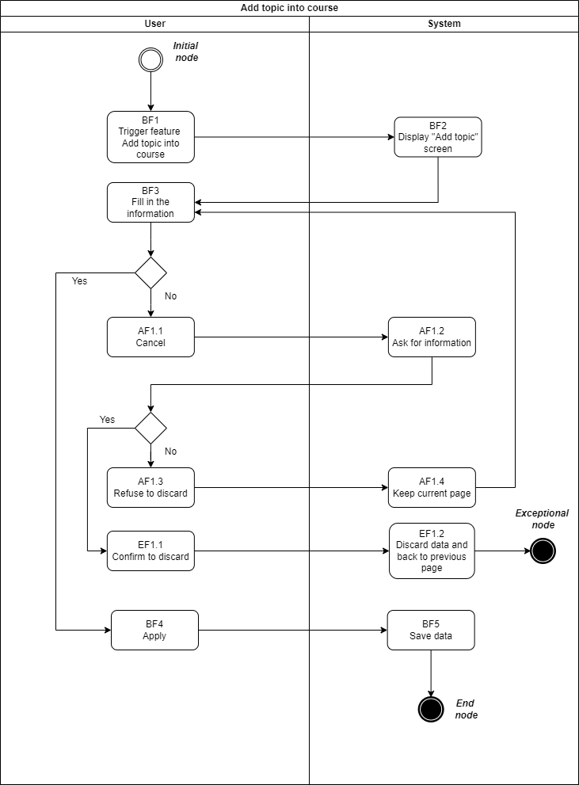 **6.2. Activity Flow**

*Figure 16: Activity flow – [UC006# Add topic into course]*

**6.3. Scenario description**

**6.3.1. Basic Flow**

|  |  |  |
| --- | --- | --- |
| **Step** | **Actor** | **Description** |
| BF1 | User | Trigger feature Add topic into course. |
| BF2 | System | Display “Add topic” screen. |
| BF3 | User | Fill in information into components.  + If user wants to submit, go to BF4 step.  + If user wants to cancel, system will request user to reconfirm that he/she want to execute or not. |
| BF4 | User | User clicking on “Apply” button. |
| BF5 | System | Save data. |

**6.3.2. Alternate flow:**

**AF01: User wants to cancel (stop filling information)**

|  |  |  |
| --- | --- | --- |
| **Step** | **Actor** | **Description** |
| AF 1.1 | User | Want to cancel (stop filling information). |
| AF 1.2 | System | Display a notification to ask that user wants to cancel or not. |
| AF 1.3 | User | Confirm to discard:  + If refusing to discard, go to the next step.  + If confirming to discard, go to Exceptional Flow 1. |
| AF 1.4 | System | Close notification and keep current page. |

**6.3.3. Exceptional flow:**

**EF01: User decides to discard and go back to the previous page**

|  |  |  |
| --- | --- | --- |
| **Step** | **Actor** | **Description** |
| EF1.1 | User | Confirm to discard. |
| EF1.2 | System | Discard data and back to previous page. |

**6.4. Screen description**

**6.4.1. Wireframe**

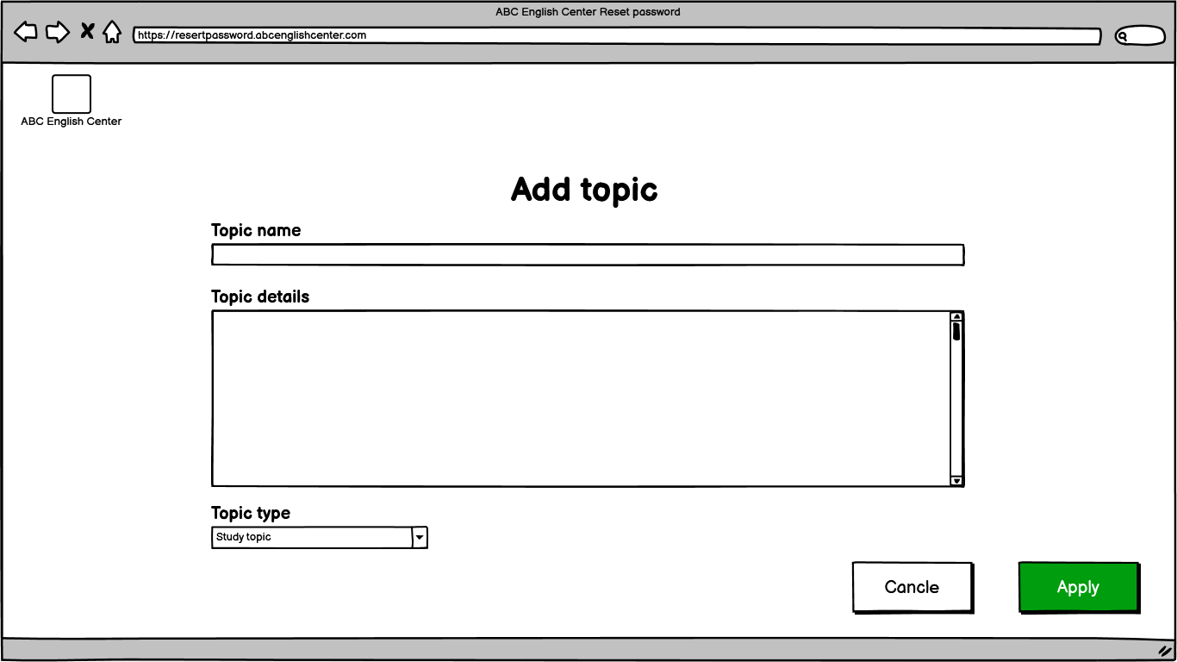

*Figure 17: Screen “Add topic into course”*

**6.4.2. Components description**

|  |  |  |  |  |  |  |
| --- | --- | --- | --- | --- | --- | --- |
| **#** | **Compo**  **nent** | **Comp. Type** | **Da**  **ta**  **type** | **Mandatory** | **Default** | **Description** |
| 1 | Add topic | Label | N/A | N/A | * Default state: N/A * Default value: N/A | * Label: “Add topic” * Available value: N/A * Data source: N/A * Validation rule: N/A |
| 2 | Topic name | Text input | Var  char  (50) | Yes | * Default state: Enabled * Default value: N/A | * Label: “Topic name” * Available value: N/A * Data source: N/A * Validation rule: apply   + VR001#  + VR005# |
| 3 | Topic details | Text input | Var  char  (1000) | Yes | * Default state: Enabled * Default value: N/A | * Label: “Topic details” * Available value: N/A * Data source: N/A * Validation rule: apply   + VR001#  + VR009# |
| 4 | Topic type | Combo  box | Nvar  char  (30) | Yes | * Default state: Enabled * Default value: “Study topic” | * Label: “Topic type” * Available value: Static list following this order:   + Study topic  + Conversation topic  + Skill topic   * Data source: N/A * Validation rule: apply VR004# |
| 5 | Cancel | Button | N/A | N/A | * Default state: Enabled * Default value: N/A | User can choose “Cancel” if user wants to stop adding topic into course.   * Label: “Cancel” * Available value: N/A * Data source: N/A * Validation rule: N/A * After clicking on “Cancel” button, system will show alert and ask user to confirm it.   + If user wants to continue filling in information, system will keep current page.  + If user wants to cancel filling in information and system will discard all filled data and back to previous page. |
| 6 | Apply | Button | N/A | N/A | * Default state: Enabled * Default value: N/A | * Label: “Apply” * Available value: N/A * Data source: N/A   After clicking on “Apply” button, system will save that data and show successful message (apply SMS004#). |

**7. [UC007# View teacher account] description**

**7.1. UC Summary**

|  |  |
| --- | --- |
| **Objective** | This UC allows class manager to view teacher accounts. |
| **Actor** | Class Manager. |
| **Trigger** | User triggers “view teacher account” feature. |
| **Precondition** | User logged in. |
| **Post-condition** | User view teacher accounts successfully. |
| **Frequency of use** | High. |
| **Priority** | High. |
| **Related UC(s)** | [UC001# Create teacher account]  [UC003# Update teacher’s account]  [UC004# Delete teacher’s account]  [UC014# Search teacher’s account] |
| **Navigation path** | {User list- Info/Search teacher account/On click view icon} |
| **PIC** | ThangVNC |

**7.2. Activity Flow**

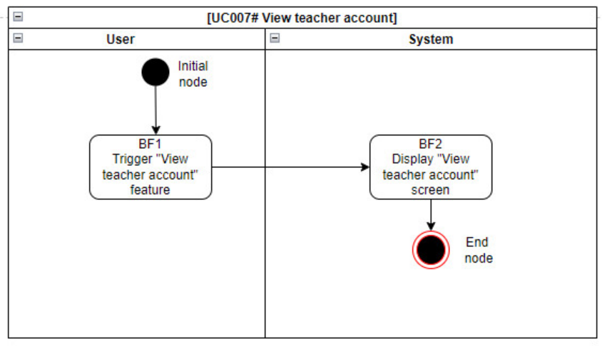

*Figure 18: Activity flow – [UC007#View teacher account]*

**7.3. Scenario description**

**7.3.1. Basic Flow**

|  |  |  |
| --- | --- | --- |
| **Step** | **Actor** | **Description** |
| BF1 | User | Trigger “View teacher account” feature. |
| BF2 | User | Display “View teacher account” screen. |

**7.3.2. Alternate flow**

N/A

#### **7.3.3. Exceptional flow**

N/A

**7.4. Screen description**

**7.4.1. Wireframe**

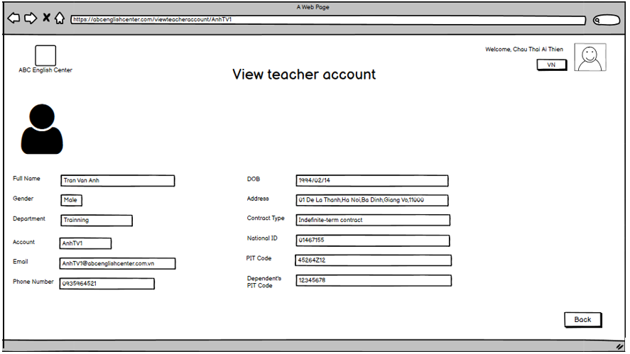

*Figure 19: Screen “View teacher account”*

**7.4.2. Components description**

|  |  |  |  |  |  |  |
| --- | --- | --- | --- | --- | --- | --- |
| **#** | **Component** | **Comp. Type** | **Da**  **ta**  **type** | **Mandatory** | **Default** | **Description** |
| 1 | Screen name | Label | N/A | N/A | * Default state: N/A * Default value: N/A | * Label: “View teacher account” * Available value: N/A * Data source: N/A * Validation rule: N/A |
| 2 | Teacher Image | Image avatar | N/A | N/A | * Default state: N/A * Default value: N/A | Display teacher’s image.   * Placeholder text: N/A * Available value: N/A * Data source: Retrieved from database. * Entity: Image * Attribute: Teacher Image * Validation rule: N/A |
| 3 | Full name | Textbox | Nvar  char  (20) | Yes | * Default state: N/A * Default value: Based on teacher account which was saved on the database. | Display teacher’s full name.   * Label: “Full Name” * Available value: N/A * Data source: Retrieved from database. * Entity: Teacher Account * Attribute: Full name * Validation rule: N/A |
| 4 | Account | Textbox | Var  char  (10) | N/A | * Default state: N/A * Default value: Based on teacher account which was saved on the database. | Display teacher’s account   * Label: “Account” * Available value: N/A * Data source: Retrieved from database. * Entity: Teacher Account * Attribute: Account * Validation rule: N/A |
| 5 | DOB | Texbox | Date | Yes | * Default state: N/A * Default value: Based on teacher account which was saved on the database. | Display teacher’s DOB.   * Label: “DOB” * Available value: N/A * Data source: Retrieved from database. * Entity: Teacher Account * Attribute: DOB * Display format: YYYY/MM/DD for English, DD/MM/YYYY for Vietnamese. * Validation rule: N/A |
| 6 | Gender | Textbox | Nvar  char  (10) | Yes | * Default state: N/A * Default value: Based on teacher account which was saved on the database. | Display teacher’s gender.   * Label: “Gender” * Available value: N/A * Data source: Retrieved from database. * Entity: Teacher Account * Attribute: Gender * Validation rule: N/A |
| 7 | Phone  number | Textbox | Var  char (20) | Yes | * Default state: N/A * Default value: Based on teacher account which was saved on the database. | Display teacher’s phone number.   * Label: “Phone number” * Available value: N/A * Data source: Retrieved from database. * Entity: Teacher Account * Attribute: Phone number * Validation rule:N/A |
| 8 | Email | Textbox | Var  char  (50) | Yes | * Default state: N/A * Default value: Based on teacher account which was saved on the database. | Email will be set automatically.   * Label: “Email” * Available value: N/A * Data source: Retrieved from database. * Entity: Teacher Account * Attribute: Email * Validation rule: N/A |
| 9 | Zip/Postal code | Text box | Number (20) | Yes | * Default state: N/A * Default value: Based on teacher account which was saved on the database. | Display District’s Zip/Postal code.   * Label: “Zip/Postal code” * Available value: N/A * Data source: Retrieved from database. * Entity: Teacher Account * Attribute: Zip/Postal code * Validation rule: N/A. |
| 10 | City / Province | Textbox | Nvar  char  (50) | Yes | * Default state: N/A * Default value: Based on teacher account which was saved on the database. | Display teacher’s city/province.   * Label: “City/Province” * Available value: N/A * Data source: Retrieved from database. * Entity: Teacher Account * Attribute: City/Province * Validation rule: N/A |
| 11 | District. | Textbox | Nvar  char  (50) | Yes | * Default state: N/A * Default value: Based on teacher account which was saved on the database. | Display teacher’s dist.   * Label: “Dist.” * Available value: N/A * Data source: Retrieved from database. * Entity: Teacher Account * Attribute: District * Validation rule: N/A |
| 12 | Ward | Textbox | Nvar  char  (50) | Yes | * Default state: N/A * Default value: Based on teacher account which was saved on the database. | Display teacher’s Ward.   * Label: “Ward” * Available value: N/A * Data source: Retrieved from database. * Entity: Teacher Account * Attribute: Ward * Validation rule: N/A |
| 13 | Street | Textbox | Nvar  char  (50) | Yes | * Default state: N/A * Default value: Based on teacher account which was saved on the database. | Display teacher’s street address.   * Label: “Street” * Available value: N/A * Data source: Retrieved from database. * Entity: Teacher Account * Attribute: Street * Validation rule: N/A |
| 14 | Depart  ment | Textbox | Nvar  char  (20) | Yes | * Default state: N/A * Default value: Based on teacher account which was saved on the database. | Display teacher’s department.   * Label: “Department” * Available value: N/A * Data source: Retrieved from database. * Entity: Teacher Account * Attribute: Department * Validation rule: N/A |
| 15 | Contract type | Textbox | Nvar  char  (50) | Yes | * Default state: N/A * Default value: Based on teacher account which was saved on the database. | Display teacher’s contract type.   * Label: “Contract type” * Available value: N/A * Data source: Retrieved from database. * Entity: Contract * Attribute: Contract type * Validation rule: N/A |
| 16 | National  ID | Textbox | Var  char (30) | Yes | * Default state: N/A * Default value: Based on teacher account which was saved on the database. | Display teacher’s national ID.   * Label: “National ID” * Available value: N/A * Data source: Retrieved from database. * Entity: Teacher Account * Attribute: National ID * Validation rule: N/A |
| 17 | PIT code | Textbox | Number (20) | Yes | * Default state: N/A * Default value: Based on teacher account which was saved on the database. | Display teacher’s PIT code.   * Label: “PIT code” * Available value: N/A * Data source: Retrieved from database. * Entity: Teacher Account * Attribute: PIT Code * Validation rule: N/A |
| 18 | Dependent’s PIT code | Textbox | Number (20) | N/A | * Default state: N/A * Default value: Based on teacher account which was saved on the database. | Display teacher ‘s dependent’s PIT code.   * Label: “Dependent’s PIT code” * Available value: N/A * Data source: Data source: Retrieved from database. * Entity: Teacher Account * Attribute: Dependent’s PIT Code * Validation rule: N/A |
| 19 | Back | Button | N/A | N/A | * Default state: Enabled * Default value: N/A | User can choose “Back” if user wants to stop view teacher account.   * Label: “Back” * Available value: N/A * Data source: N/A * Validation rule: N/A * After clicking on “Back” button, system will show alert and ask user to confirm it:   + If user wants to continue viewing teacher account, system will keep current page.  + If user wants to cancel viewing teacher account and system will back to previous page. |

**8. [UC008# View Courses list] description**

**8.1. UC Summary**

|  |  |
| --- | --- |
| **Objective** | This UC allows users to view courses list. |
| **Actor** | Admin, Class managers, Teachers. |
| **Trigger** | User triggers the “View courses list” button. |
| **Precondition** | User logged in. |
| **Post-condition** | User views courses list successfully. |
| **Frequency of use** | High. |
| **Priority** | High. |
| **Related UC(s)** | [UC006# Add topics into courses] |
| **Navigation path** | {Courses list button/On click view courses list} |
| **PIC** | ThienCTA |

**8.2. Activity Flow**

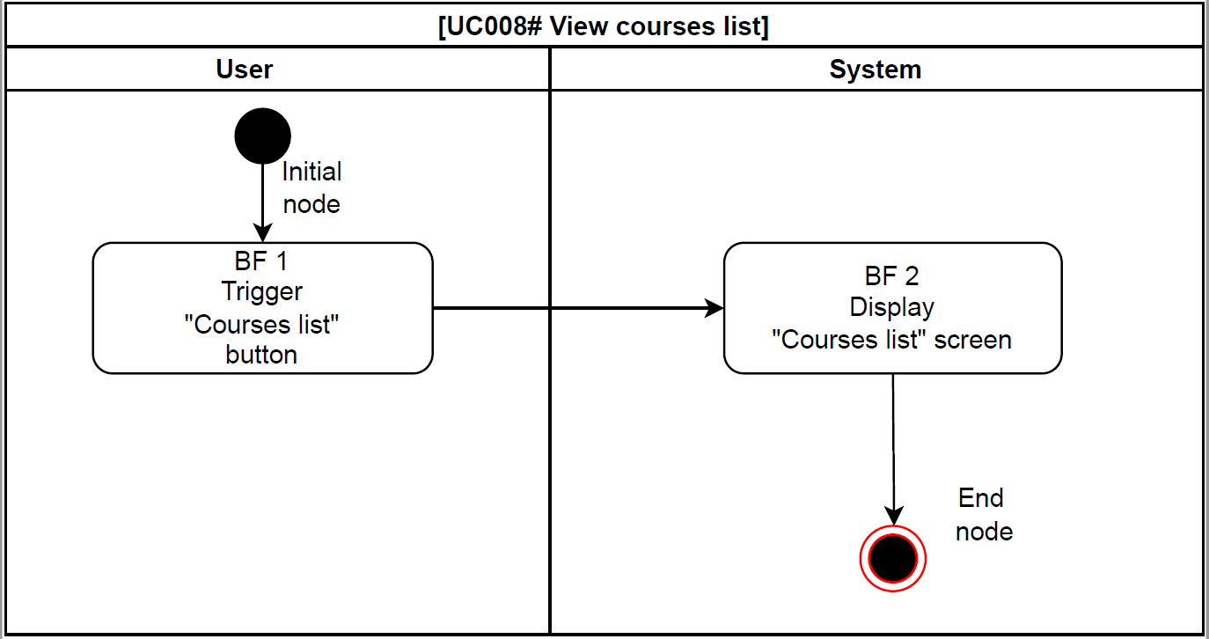

*Figure 20: Activity flow – [UC008#View Courses list]*

**8.3. Scenario description**

**8.3.1. Basic Flow**

|  |  |  |
| --- | --- | --- |
| **Step** | **Actor** | **Description** |
| BF 1 | User | Trigger “Courses list” button. |
| BF 2 | System | Display “Courses list” screen. |

**8.3.2. Alternate flow**

N/A

**8.3.3. Exceptional flow**

N/A

**8.4. Screen description**

**8.4.1. Wireframe**

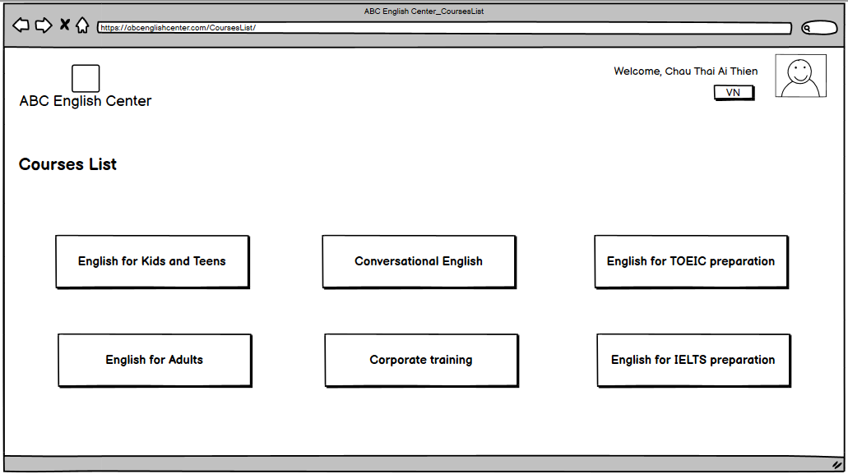

*Figure 21: Screen “View courses list”*

**8.4.2. Components description**

|  |  |  |  |  |  |  |
| --- | --- | --- | --- | --- | --- | --- |
| **#** | **Component** | **Comp. Type** | **Da**  **ta**  **type** | **Mandatory** | **Default** | **Description** |
| 1 | Screen name | Label | N/A | N/A | * Default state: N/A * Default value: N/A | * Label: “Courses list” * Available value: N/A * Data source: N/A * Validation rule: N/A |
| 2 | English for Kids and Teens | Button | N/A | N/A | * Default state: Enabled * Default value: N/A | * Label: “English for Kids and Teens” * Available value: N/A * Data source: N/A * Validation rule: N/A * After clicking on “English for Kids and Teens” button, user can see the detail contents of that course such as objectives, study pathway, etc... . |
| 3 | English for Adults | Button | N/A | N/A | * Default state: Enabled   Default value: N/A | * Label: “English for Adults” * Available value: N/A * Data source: N/A * Validation rule: N/A * After clicking on “English for Adults” button, user can see the detail contents of that course such as objectives, study pathway, etc... . |
| 4 | Conversational English | Button | N/A | N/A | * Default state: Enabled   Default value: N/A | * Label: “Conversational English” * Available value: N/A * Data source: N/A * Validation rule: N/A * After clicking on “Conversational English” button, user can see the detail contents of that course such as objectives, study pathway, etc... . |
| 5 | Corporate training | Button | N/A | N/A | * Default state: Enabled   Default value: N/A | * Label: “Corporate training” * Available value: N/A * Data source: N/A * Validation rule: N/A * After clicking on “Corporate training” button, user can see the detail contents of that course such as objectives, study pathway, etc... . |
| 6 | English for TOEIC preparation | Button | N/A | N/A | * Default state: Enabled   Default value: N/A | * Label: “English for TOEIC preparation” * Available value: N/A * Data source: N/A * Validation rule: N/A * After clicking on “English for TOEIC preparation” button, user can see the detail contents of that course such as objectives, study pathway, etc... . |
| 7 | English for IELTS preparation | Button | N/A | N/A | * Default state: Enabled   Default value: N/A | * Label: “English for IELTS preparation” * Available value: N/A * Data source: N/A * Validation rule: N/A * After clicking on “English for IELTS preparation” button, user can see the detail contents of that course such as objectives, study pathway, etc... . |

**9. [UC009# Search Users list] description**

**9.1. UC Summary**

|  |  |
| --- | --- |
| **Objective** | This UC allows admin to search users list. |
| **Actor** | Admin. |
| **Trigger** | Admin triggers the feature “Search” in users list-info screen. |
| **Precondition** | Admin logged in and input user’s information value. |
| **Post condition** | Admin search users list successfully. |
| **Frequency of use** | High. |
| **Priority** | High. |
| **Related UC(s)** | Delete user’s information  Update user’s information |
| **Navigation path** | {Home screen/ Users list- Info/ Search} |
| **PIC** | DuyenDTT1 |

**9.2. Activity Flow**

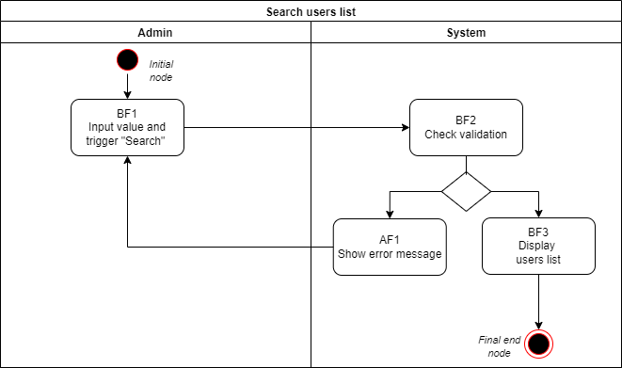

*Figure 22: Activity flow – [UC009#Search users list]*

**9.3. Scenario description**

**9.3.1. Basic Flow**

|  |  |  |
| --- | --- | --- |
| **Step** | **Actor** | **Description** |
| BF1 | Admin | Fill in information and trigger “Search” feature in users list-Info screen. |
| BF2 | System | Check validation.  + If validation is correct, go to next step.  + If validation is incorrect, go to Alternate Flow AF01 (refer to Activity flow, AF1.1). |
| BF3 | System | Display users list. |

**9.3.2. Alternate flow**

|  |  |  |
| --- | --- | --- |
| **Step** | **Actor** | **Description** |
| AF1 | System | Show error message. |

**9.3.3. Exceptional flow**

N/A

**9.4. Screen description**

**9.4.1. Wireframe**

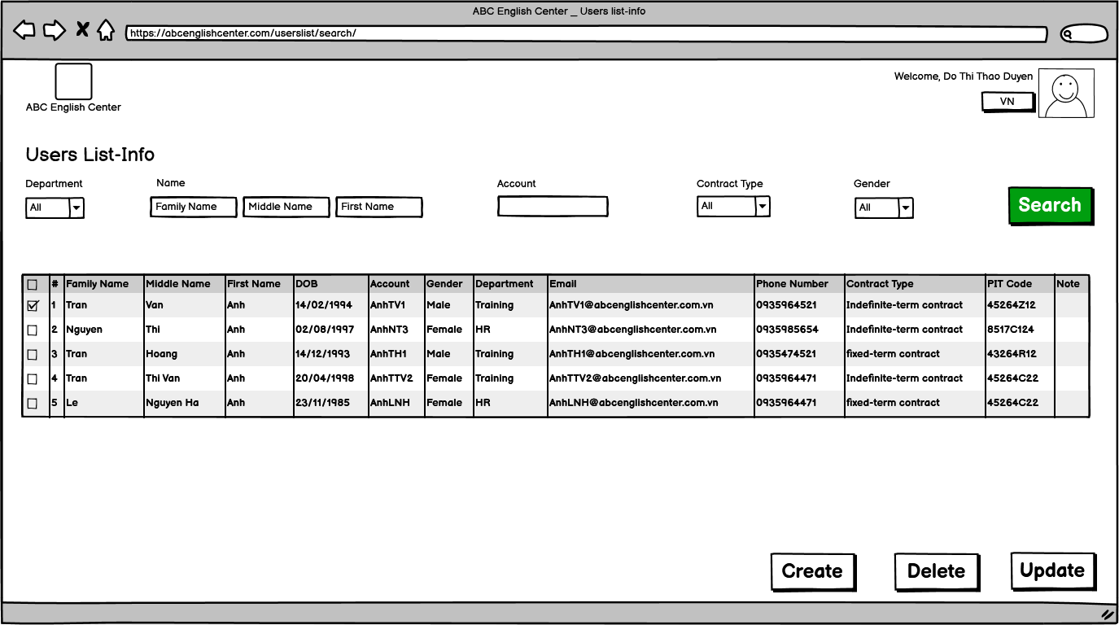

*Figure 23: Screen “Search users list”*

**9.4.2. Components description**

|  |  |  |  |  |  |  |
| --- | --- | --- | --- | --- | --- | --- |
| **#** | **Component** | **Comp. Type** | **Da**  **ta**  **type** | **Mandatory** | **Default** | **Description** |
| 1 | Screen name | Label | N/A | N/A | * Default state: N/A * Default value: N/A | * Label: “Users list - Info” * Available value: N/A * Data source: N/A * Validation rule: N/A |
| 2 | Department | Combo  box | Nvar  char  (20) | No | * Default state: Enabled * Default value: “All” | Choose user’s department.   * Label: “Department” * Available value: Static list following this order:   + All  + Training  + HR   * Data source: N/A * Validation rule: apply VR003# |
| 3 | Family name | Textbox | Nvar  char  (20) | No | * Default state: Enabled * Default value: Family name | Fill user’s family name.   * Label: “Name” * Available value: N/A * Data source: N/A * Placeholder text: “Family name” * Validation rule: apply   + VR003#  + “Family name” must be started with one or more alphabets in range a-z; not a symbol or any special characters and must not include digits. |
| 4 | Middle name | Textbox | Nvar  char  (20) | No | * Default state: Enabled * Default value: Middle name | Fill user’s middle name.   * Available value: N/A * Data source: N/A * Placeholder text: “Middle name” * Validation rule: apply   + VR003#  + “Middle name” must be started with one or more alphabets in range a-z; not a symbol or any special characters and must not include digits. |
| 5 | First name | Textbox | Nvar  char  (20) | No | * Default state: Enabled * Default value: First name | Fill user’s first name.   * Available value: N/A * Data source: N/A * Placeholder text: “First name” * Validation rule: apply   + VR003#  + “First name” must be started with one or more alphabets in range a-z; not a symbol or any special characters and must not include digits. |
| 6 | Account | Textbox | Var  char  (10) | No | * Default state: Enabled * Default value: Blank | Fill user’s account.   * Label: “Account” * Available value: N/A * Data source: N/A * Validation rule: apply   + VR002#  + Syntax: “Name” + the first letter of “Family name” + the first letter of “Middle name” + sequence (avoid duplication) |
| 7 | Contract type | Combo  box | Nvar  char  (50) | No | * Default state: Enabled * Default value: “All” | Choose user’s contract type.   * Label: “Contract type” * Available value: Static list following this order:   + All  + Indefinite – term contract  + Fixed – time contract  + Probationary contract   * Data source: N/A |
| 8 | Gender | Combo  box | Nvar  char  (10) | No | * Default state: Enabled * Default value: “All” | Choose user’s gender.   * Label: “Gender” * Available value: Static list following this order:   + All  + Male  + Female  + Others   * Data source: N/A * Validation rule: apply VR002# |
| 9 | Search | Button | N/A | N/A | * Default state: Disabled * Default value: N/A | This button is disable until admin inputs value in the user’s information (Department, family name, middle name, first name, account, contract type, gender).   * Available value: N/A * Data source: N/A * After clicking on “Search” button, system will validate that inputted information.   + If that inputted information have been validated, system will show the users list.  + If that inputted information have not been validated, system will show error message and user must fill again (apply EMS002#). |
| 10 | Check box | Check square- multi choice | N/A | No | * Default state: Unchecked * Default value: Blank | Allow multiple selection.   * Label: “ ” * Available value: N/A * Data source: N/A * Validation rule: N/A |
| 11 | Family name | Grid Header | N/A | N/A | * Default state: N/A * Default value: N/A | Display user’s family name.   * Column name: “Family name” * Available value: retrieved from database   + Entity: User  + Attribute: Family name   * “Family name” must be started with one or more alphabets in range a-z; not a symbol or any special characters and must not include digits. |
| 12 | Middle name | Grid Header | N/A | N/A | * Default state: N/A * Default value: N/A | Display user’s middle name.   * Column name: “Middle name” * Available value: retrieved from database   + Entity: User  + Attribute: Middle name   * “Middle name” must be started with one or more alphabets in range a-z; not a symbol or any special characters and must not include digits. |
| 13 | First name | Grid Header | N/A | N/A | * Default state: N/A * Default value: N/A | Display user’s first name.   * Column name: “First name” * Available value: retrieved from database   + Entity: User  + Attribute: First name   * “First name” must be started with one or more alphabets in range a-z; not a symbol or any special characters and must not include digits |
| 14 | Date of birth | Grid Header | N/A | N/A | * Default state: N/A * Default value: N/A | Display user’s date of birth.   * Column name: “DOB” * Available value: retrieved from database   + Entity: User  + Attribute: DOB   * Display format: YYYY/MM/DD or DD/MM/YYYY (based on language option). |
| 15 | Account | Grid Header | N/A | N/A | * Default state: N/A * Default value: N/A | Display user’s account.   * Column name: “Account” * Available value: retrieved from database   + Entity: User  + Attribute: Account |
| 16 | Gender | Grid Header | N/A | N/A | * Default state: N/A * Default value: N/A | Display user’s gender.   * Column name: “DOB” * Available value: retrieved from database   + Entity: User  + Attribute: Gender |
| 17 | Department | Grid Header | N/A | N/A | * Default state: N/A * Default value: N/A | Display user’s department.   * Column name: “Department” * Available value: retrieved from database   + Entity: User  + Attribute: Department |
| 18 | Email | Grid Header | N/A | N/A | * Default state: N/A * Default value: N/A | Display user’s email.   * Column name: “Email” * Available value: retrieved from database   + Entity: User  + Attribute: Email |
| 19 | Phone number | Grid Header | N/A | N/A | * Default state: N/A * Default value: N/A | Display user’s phone number.   * Column name: “Phone number” * Available value: retrieved from database   + Entity: User  + Attribute: Phone number |
| 20 | Contract type | Grid Header | N/A | N/A | * Default state: N/A * Default value: N/A | Display user’s contract type.   * Column name: “Contract type” * Available value: retrieved from database   + Entity: User  + Attribute: Contract type |
| 21 | PIT Code | Grid Header | N/A | N/A | * Default state: N/A * Default value: N/A | Display user’s PIT code.   * Column name: “PIT Code” * Available value: retrieved from database   + Entity: User  + Attribute: PIT Code |
| 22 | Note | Textbox | Nvar  char  (50) | No | * Default state: Enabled * Default value: Blank | Fill user’s notes if any.   * Column name: “Note” * Available value: N/A * Data source: N/A * Validation rule: applyVR005# |
| 23 | Create | Button | N/A | N/A | * Default state: Enabled * Default value: N/A | Allow admin create a new user.   * Label: “Create” * Available value: N/A * Data source: N/A * Validation rule: N/A |
| 24 | Delete | Button | N/A | N/A | * Default state: Enabled * Default value: N/A | * Allow admin delete all the user in users list that is selected by clicking the checkbox. * Label: “Delete” * Available value: N/A * Data source: N/A |
| 25 | Update | Button | N/A | N/A | * Default state: Enabled * Default value: N/A | * Allow admin update all the user’s information in users list that is selected by clicking the checkbox. * Label: “Update” * Available value: N/A * Data source: N/A |

**10. [UC010# ﻿View schedule] description**

**10.1. UC Summary**

|  |  |
| --- | --- |
| **Objective** | This UC allows the user to view schedule. |
| **Actor** | Class Manager, Teacher. |
| **Trigger** | User triggers the “View schedule” feature. |
| **Precondition** | User logged in. |
| **Post-condition** | User views schedule successfully. |
| **Frequency of use** | High. |
| **Priority** | Medium. |
| **Related UC(s)** | [UC018# Create schedule]  [UC019# Update schedule]  [UC020# Delete schedule] |
| **Navigation path** | { Menu/Schedule/View } |
| **PIC** | ThaoDTT13 |

**10.2. Activity Flow**

*Figure 24:  Activity flow – [UC010****#*** *View schedule]*

**10.3. Scenario description**

**10.3.1. Basic Flow**

|  |  |  |
| --- | --- | --- |
| **Step** | **Actor** | **Description** |
| BF1 | User | Trigger feature “View schedule”. |
| BF2 | System | Display “View schedule” screen with default time is this week. |
| BF3 | User | Select the date and class name (be managed by this user) that the user wants to see the schedule. |
| BF4 | System | Display schedule with detail information. |

**10.3.2. Alternate flow**

N/A

**10.3.3. Exceptional flow**

N/A

**10.4. Screen description**

**10.4.1. Wireframe**

*Figure 25: Screen “Input grade test”*

**10.4.2. Components description**

|  |  |  |  |  |  |  |
| --- | --- | --- | --- | --- | --- | --- |
| **#** | **Component** | **Comp. Type** | **Da**  **ta**  **type** | **Mandatory** | **Default** | **Description** |
| 1 | Screen name | Label | N/A | N/A | 1. Default state: N/A 2. Default value: N/A | * Label: “View schedule” * Available value: N/A * Data source: N/A * Validation rule: N/A |
| 2 | Class info | Combo Box | N/A | Yes | * Default state: Enabled * Default value: * A class in the list of managed classes. | * Label: “Class” * Available value: Depending on name (ID) of class * Depending on name (ID) of class * Data source: Name attribute of “Class” entity. * Validation rule: N/A |
| 3 | Date | Date chooser | Date | Yes | * Default state: Enabled * Default value: (DD/MMM/YYYY for English,   DD/MM/YYYY  for Vietnamese). | * Label: “Date” * Available value: Today * Data source: Calendar sheet. * Display format: DD/MMM/YYYY or DD/MM/YYYY (based on language option). * After clicking on calendar icon, user can choose date which user wants. * Validation rule: start time to end time of class. |
| 4 | First column (Time) | Label | Time | N/A | * Default state: N/A * Default value:   (08:00, 09:00, …, 21:00) | * Label: “Time” * Available value: N/A * Data source: N/A * Validation rule: N/A |
| 5 | Second column | Label | Date | N/A | * Default state: N/A * Default value:   N/A | * Label: Weekday + Date time (selected first date) * Available value: N/A * Data source: N/A * Validation rule: N/A * Show lesson slot by block (Descripted by #16 of this table). |
| 6 | Third column | Label | Date | N/A | * Default state: N/A * Default value: N/A | * Label: Weekday + Date time (selected first date + 1) * Available value: N/A * Data source: N/A * Validation rule: N/A * Show lesson slot by block (Descripted by #16 of this table). |
| 7 | Fourth column | Label | Date | N/A | * Default state: N/A * Default value: N/A | * Label: Weekday + Date time (selected first date + 2) * Available value: N/A * Data source: N/A * Validation rule: N/A * Show lesson slot by block (Descripted by #16 of this table). |
| 8 | Fifth column | Label | Date | N/A | * Default state: N/A * Default value: N/A | * Label: Weekday + Date time (selected first date + 3) * Available value: N/A * Data source: N/A * Validation rule: N/A * Show lesson slot by block (Descripted by #16 of this table). |
| 9 | Sixth column | Label | Date | N/A | * Default state: N/A * Default value: N/A | * Label: Weekday + Date time (selected first date + 4) * Available value: N/A * Data source: N/A * Validation rule: N/A * Show lesson slot by block (Descripted by #16 of this table). |
| 10 | Seventh column | Label | Date | N/A | * Default state: N/A * Default value: N/A | * Label: Weekday + Date time (selected first date + 5) * Available value: N/A * Data source: N/A * Validation rule: N/A * Show lesson slot by block (Descripted by #16 of this table). |
| 11 | Eighth column | Label | Date | N/A | * Default state: N/A * Default value: N/A | * Label: Weekday + Date time (selected first date + 6) * Available value: N/A * Data source: N/A * Validation rule: N/A * Show lesson slot by block (Descripted by #16 of this table). |
| 12 | Lesson slot | Label | N/A | N/A | * Default state: N/A * Default value: N/A | * Label: Class name + name of subject. * Available value: N/A * Data source: N/A * Validation rule: N/A * The block will be corresponding to the lesson time. |
| 13 | Close | Button | N/A | N/A | * Default state: Enabled   Default value: N/A | * Label: “Close” * Placeholder text: N/A * On click: After clicking on this button, “View schedule” screen closes and returns to the home page. * Data source: N/A   Validation rule: N/A |

**III. Validation rules and messages**

**1. Validation rules**

|  |  |  |
| --- | --- | --- |
| **#** | **Code** | **Description** |
| 1 | VR001# | [Component name] is not null. |
| 2 | VR002# | The maximum of text is 10 characters. |
| 3 | VR003# | The maximum of text is 20 characters. |
| 4 | VR004# | The maximum of text is 30 characters. |
| 5 | VR005# | The maximum of text is 50 characters. |
| 6 | VR006# | Always 7 characters (including 5 letters and 2 numbers). |
| 7 | VR007# | Always 6 digits |
| 8 | VR008# | Is a positive integer and less than 101 |
| 9 | VR009# | The maximum test is 1000 characters. |

**2. Successful messages**

|  |  |  |
| --- | --- | --- |
| **#** | **Code** | **Description** |
| 1 | SMS001# | Display message “Account MMM has been created successfully”. |
| 2 | SMS002# | Display message “Reset password successfully, please keep in mind your new password”. |
| 3 | SMS003# | Display message “Save data successfully”. |
| 4 | SMS004# | Display message “Topic has been created successfully” |

**3. Error messages**

|  |  |  |
| --- | --- | --- |
| **#** | **Code** | **Description** |
| 1 | EMS001# | Display message “Save unsuccessful. Please try again”. |
| 2 | EMS002# | Display message “Error information. Please fill again”. |
| 3 | EMS003# | Display message “Sorry, this verification is note correct”. |
| 4 | EMS004# | Display message “Password does not match” |

* **Không nên 6 digit trong reset password(cho security)**
* **Tô đỏ cái field đó lên( nếu rõ cái lỗi đang bị thì nó sẽ tường minh hơn)**
* **-Nếu update thì chuyện gì sẽ xảy ra nếu cancel thì sẽ sao. Nói rõ cái action của user**
* **Khó cho mặt design UI**
* **Trình bày: thiếu sự tương tác với người nghe(thiếu nhấn nhá – có sự tương tác với người nghe)**