CI/CD Pipeline for a Hotel Room Booking Portal
Complete DevOps Project Report - all 15 tasks
Python / Flask - Git & GitHub - Jenkins - pytest & Selenium - Docker - Ansible
Evidence verified on 2026-10-20. Generated from docs/task-reports/*.md.
Repository: https://github.com/KemNxts/hotel-room-booking-cicd

Contents
Task Reports - CI/CD Pipeline for a Hotel Room Booking Portal 3
00 - Project Audit (before writing the task reports) 5
Task 1 - Problem Definition and Scope 9
Task 2 - Agile Planning and DevOps Workflow 16
Task 3 - Requirements, Architecture and Technology Setup 24
Task 4 - Git and GitHub Repository Initialization 37
Task 5 - Feature Development with Branching 48
Task 6 - MVP Completion and Git Collaboration 56
Task 7 - Jenkins Installation and Continuous Integration 76
Task 8 - Pipeline as Code and Server Deployment 90
Task 9 - Selenium Test Design and Local Execution 101
Task 10 - Continuous Testing in Jenkins 111
Task 11 - Docker Image and Container Lifecycle 119
Task 12 - Jenkins-Docker Continuous Deployment 130
Task 13 - Configuration Management with Ansible 137
Task 14 - Automated Provisioning and Reliability Validation (Idempotency and Rollback) 148
Task 15 - Final End-to-End Release, Documentation and Viva 159
Viva Cheat Sheet - CI/CD Pipeline for a Hotel Room Booking Portal 174
Screenshot inventory 177

Task Reports - CI/CD Pipeline for a Hotel Room Booking Portal
One self-contained report per professor-assigned task. Each report has the same structure: A objective and status, B beginner explanation, C what was implemented, D screenshots and evidence, E how to demonstrate it, F screenshot checklist, G viva questions and answers, H troubleshooting, I revision notes.
Start with the audit: 00-project-audit.md - the real state of the repository, services and evidence on 2026-10-20.
# | Report | In one sentence | Status
1 | Problem Definition and Scope | why a booking portal and a delivery pipeline are needed, and how success is measured | Implemented and verified
2 | Agile Planning and DevOps Workflow | user stories, backlog, board, sprints, Definition of Done and the lifecycle diagram | Partially completed - GitHub issues pending
3 | Requirements, Architecture and Setup | SRS, layered Flask architecture, database, routes and local setup | Implemented and verified
4 | Git and GitHub Initialization | repository skeleton, ignore rules, templates, branch policy, GitHub remote | Implemented and verified
5 | Feature Development and Branching | feature branches with commits and tests merged into develop | Partially completed - real GitHub PRs pending
6 | MVP Completion and Collaboration | six workflows, a real merge conflict and release tags | Implemented and verified
7 | Jenkins Installation and CI | Jenkins in Docker, the CI job, reports and artifacts | Implemented and verified (polling; Python not Maven)
8 | Pipeline as Code and Deployment | the 10-stage Jenkinsfile, parameter, secrets and health-checked deploy | Implemented and verified
9 | Selenium Test Design and Execution | five browser journeys, waits, isolated data, screenshots on failure | Implemented and verified
10 | Continuous Testing in Jenkins | tests as a quality gate, proven with a deliberate defect | Implemented and verified
11 | Docker Image and Container Lifecycle | the Dockerfile and every lifecycle operation, incl. persistent data | Implemented and verified
12 | Jenkins-Docker Continuous Deployment | version+SHA images, registry, deploy, health check, record | Implemented and verified (local registry) - Docker Hub pending
13 | Configuration Management with Ansible | inventory, variables and playbook provisioning a fresh server | Implemented and verified (container lab, not a VM)
14 | Provisioning, Idempotency and Rollback | changed=0 on repeat runs and a verified rollback | Implemented and verified (container lab)
15 | End-to-End Release and Documentation | the whole flow, final documentation and the 12-minute demo | Implemented and verified, with pending external items

Also in this folder
File | Purpose
VIVA_CHEAT_SHEET.md | 30-second intro, 2-minute explanation, the four stories, honest answers about limitations, demo commands
screenshot-index.md | every screenshot with task, purpose, date and status
GENERATION_STATUS.md | progress record of this documentation pass
assets/task-01/ ... assets/task-15/ | screenshots per task (.txt next to rendered terminal images = the raw output)
assets/raw/ | raw logs captured on 2026-10-20 (Jenkins build #11, Docker lifecycle, Ansible runs)
Complete_DevOps_Project_Report.docx / .pdf | all 15 reports in one document
word/Task_01_...docx ... word/Task_15_...docx | one Word document per task

The Markdown files are the source of truth; the Word/PDF files are generated from them.

Other project documentation
README - Project report - 15-task checklist - Viva notes - Evidence - UI design

00 - Project Audit (before writing the task reports)
Audit date: 2026-10-20. Auditor: documentation pass over the real repository, services and evidence. Every "verified" below means a command was run or a page was opened on this date and the result was seen.

1. Repository state
Item | Actual value (2026-10-20) | How checked
Local path | D:\DevOPS\CICD_FOR_HOTEL_ROOM_BOOKING | -
Current branch | feature/ui-redesign | git branch --show-current
Uncommitted work | The UI redesign (templates, CSS, app.js, fonts, 4 test assertions, scripts/capture_ui.py, docs/09-ui-design.md, docs/ui-evidence/) and one edit by the student to docs/01-problem-definition.md. None of it is committed or pushed. | git status --short (see assets/task-15/git-status-final.png)
Latest commit on develop | 1c2103c Merge branch 'docs/history-rewrite' into develop | git log
main | bea6a4c (docs merge after release v1.1.0) | git log --first-parent main
Tags | v1.0.0 -> 224de14, v1.1.0 -> ce1726d (annotated) | git tag -n1, git cat-file -p v1.1.0
Local branches | 20: main, develop, 13 feature/* (including the unpushed feature/ui-redesign), 1 fix/*, 2 experiment/*, 2 docs/* | git branch -a
Remote | origin = https://github.com/KemNxts/hotel-room-booking-cicd (public) | git remote -v, GitHub API

Commit IDs changed once (important when reading evidence)
On 2026-10-12, before publishing to GitHub, commit messages were edited to remove a co-author line. File contents did not change, but every commit ID did. Evidence captured before that date (Jenkins logs of builds #1-#10, docs/evidence/) shows the original IDs; Git and GitHub today show the current IDs. The full mapping is in docs/evidence/git/commit-id-map.md. The IDs used most often:
Meaning | Original ID (old evidence) | Current ID (Git/GitHub now)
release v1.0.0 | 661751d | 224de14
release v1.1.0 | d07929b | ce1726d
deliberate defect | 554cad3 | 5844eec
corrective commit | 30c6a05 | 2fb62d6
merge-conflict resolution | 8728b62 | 9e766ac
first commit (skeleton) | 08702db | 541dad5

Note: the Docker images in the local registry and the running staging/prod containers were built before the rewrite, so their tags and /health also show original IDs (e.g. prod = 1.1.0-d07929b). Jenkins build #11 (2026-10-20) was built after the rewrite and shows the current ID 1c2103c.

2. GitHub (checked through the public GitHub REST API, read-only)
Item | Result
Repository | exists, public, default branch main, last push 2026-10-12
Branches on GitHub | 19 (everything except feature/ui-redesign)
Tags on GitHub | v1.0.0, v1.1.0
Issues | 0 - not created yet
Pull requests | 0 - not created yet; merges were done locally with git merge --no-ff and pushed

3. Fresh verification run on 2026-10-20
Check | Command | Result | Evidence
Lint | .venv\Scripts\flake8 -j 1 app tests scripts wsgi.py gunicorn.conf.py | no findings | assets/task-09/full-test-suite.png
Unit tests | .venv\Scripts\python -m pytest tests/unit | 59 passed | same
Integration tests | ... pytest tests/integration | 26 passed | same
Selenium tests | ... pytest tests/e2e | 5 passed | assets/task-09/selenium-run.png
Screenshot on failure | temporary failing test (deleted afterwards) | screenshot + HTML saved by the hook | assets/task-09/selenium-failure-*.png
Jenkins build #11 | Build with parameters BRANCH=develop, APP_ENV=staging | SUCCESS, all 10 stages, 90 tests, images 1.1.0-1c2103c pushed and deployed, health check passed | assets/raw/jenkins-build-11.log, assets/task-07/*, assets/task-08/*
Jenkins history | Jenkins REST API | builds #1-#11 present; #2 and #9 FAILURE (deliberate), all others SUCCESS | assets/task-07/jenkins-job-stage-view.png
Docker lifecycle | scripted demo (build, tag, run, ports, logs, inspect, stop/start/restart, rm, new container on same volume) | all steps worked; an account created in the first container could log in from the second | assets/raw/docker-lifecycle.txt, assets/task-11/lifecycle-*.png
Local registry | GET localhost:5000/v2/hotel-booking-app/tags/list | 8 tags incl. 1.1.0-1c2103c | assets/task-12/registry-tags.png
Ansible, fresh lab server | runs from clean clones of tags v1.0.0 and v1.1.0 | run 1 changed=7, run 2 changed=5, run 3 changed=0, rollback changed=3 -> 1.0.0 | assets/raw/ansible-run1..4*.txt
Restored release works | v1.0.0's own Selenium tests against the rolled-back server | 5 passed | assets/raw/ansible-run5-e2e-after-rollback.txt
Demo commands in the reports | Docker demo (Task 11), Ansible lab demo incl. rollback (Tasks 13/14), merge-conflict replay in a throw-away clone (Task 6) | all ran as written | (outputs checked during the audit)
Running services | /health of each | dev :5001 ok, staging :8081 ok (1c2103c), prod :8082 ok (d07929b), lab :8088 ok, Jenkins :8090 up, registry :5000 up | assets/task-15/all-environments-health.png

4. Status of the 15 tasks
# | Task | Status | Reason
1 | Problem definition and scope | Implemented and verified | Document exists and is published on GitHub
2 | Agile planning and DevOps workflow | Partially completed | Backlog, stories, board, DoD, diagram exist; GitHub issues = 0 (pending external action)
3 | Requirements, architecture and setup | Implemented and verified | Routes, layers and tests checked today
4 | Git and GitHub initialization | Implemented and verified | Repo, templates, branches, tags on GitHub (API)
5 | Feature development with branching | Partially completed | Feature branches + --no-ff merges verified; real GitHub PRs = 0 (pending external action)
6 | MVP completion and collaboration | Implemented and verified | 6 features pass tests today; conflict reproduced today in a clone; tags exist
7 | Jenkins installation and CI | Implemented and verified | Build #11 today. Polling, not a webhook (no public URL). Maven not used - confirm with professor
8 | Pipeline as code and deployment | Implemented and verified | Build #11 deployed staging and passed the health check
9 | Selenium test design and execution | Implemented and verified | 5/5 today; failure screenshot hook shown today
10 | Continuous testing in Jenkins | Implemented and verified | Builds #2/#3/#9 records checked today (experiment itself run 2026-10-11)
11 | Docker image and container lifecycle | Implemented and verified | Full lifecycle re-run today
12 | Jenkins-Docker continuous deployment | Implemented and verified (local registry) | Docker Hub publishing not tested - pending external action (needs an account)
13 | Configuration management with Ansible | Implemented and verified (container lab) | Target is a privileged Docker container, not a separate VM
14 | Provisioning, idempotency and rollback | Implemented and verified (container lab) | Re-run today: changed=0, rollback + 5/5 Selenium
15 | End-to-end release and documentation | Implemented and verified, with pending external items | See the limitations below

5. Limitations and pending actions (not hidden)
- GitHub issues - none created. Backlog exists as docs/02-agile-plan.md (HB-01..HB-15).
- GitHub pull requests - none created. PR texts prepared in docs/pull-requests/. Merges were real local merges, now visible on GitHub.
- Docker Hub - publishing path is implemented (REGISTRY parameter + registry-creds credential) but never run; the local registry:2 was used.
- Ansible target - a disposable Ubuntu 24.04 container with systemd + SSH, not a separate VM or cloud server.
- Maven/Gradle/Ant and Tomcat - not used. This is a Python project: pip + pytest + flake8 are used for build/test, Gunicorn + Nginx for serving. Whether this satisfies the brief needs the professor's confirmation.
- Webhook - Jenkins polls Git every ~5 minutes; a GitHub webhook needs a publicly reachable Jenkins.
- UI redesign not committed - application screenshots in Tasks 3, 6, 9 and 15 show the redesigned interface running from the working tree (dev server). The deployed staging/prod containers still run the v1.1.0 interface (see assets/task-12/prod-portal-v1.1.0.png). Commit it, merge it and run Jenkins to deploy it.
- Branch protection rules on GitHub were not configured (documented as a policy in CONTRIBUTING.md only). Cannot be checked without logging in to GitHub.

6. Environment notes
- Windows 11, Docker Desktop 29.7.2, Python 3.13 venv (pipeline uses 3.11), Chrome for Selenium.
- Avast HTTPS scanning intercepts TLS; containers trust its root certificate through the optional certs/ folder.
- Port 5000 is used by the local Docker registry, so the development server must use another port: python -m flask --app wsgi run --port 5001.
- Docker Desktop does not start automatically after a reboot.

7. About the screenshots in these reports
- Browser screenshots are real captures (headless Chrome) of the running portal, Jenkins, the registry and the public GitHub pages.
- "Terminal" images were produced by scripts/capture_report_evidence.py: the command was run for real, its raw output saved as .txt beside the image, and the output rendered as an image. Each such image says so in its footer. Images of older logs say which log file they were rendered from.
- No screenshot was edited. No GitHub PR, hosted registry or remote server is shown because none exists.

Task 1 - Problem Definition and Scope

A. Task title and objective
Task 1: Problem Definition and Scope
Objective: state clearly what problem the project solves, for whom, what is in and out of scope, and how success will be measured - before any code is written.
Professor's required deliverables
- Problem statement and real-world need
- Target users and stakeholders
- Existing pain points
- Objectives
- Technical and operational constraints
- Measurable success criteria
- The approved MVP scope (15 tasks)
What this task demonstrates: that the project is driven by a real need and has a fixed, measurable scope, so later work (code, tests, pipeline) can be checked against it.
Current status: Implemented and verified. The document docs/01-problem-definition.md exists, covers every deliverable, and is published on GitHub (Figure 1.1). Its success criteria were re-checked against fresh results on 2026-10-20 (90 tests passed, Jenkins build #11 green, Ansible re-run changed=0).
Honest note: the stakeholders and pain points are a reasoned description of a small hotel. No real hotel staff or guests were interviewed.

B. Explanation for a complete beginner
An everyday picture. Before building a house you agree with the owner how many rooms it needs, what the budget is and when it counts as "finished". Without that, builders argue forever about whether the job is done. Task 1 is that agreement for software.
Problem statement - one short paragraph that says what is wrong today. Why needed: everyone works on the same problem. In this project: a small hotel takes bookings by phone and spreadsheet, so guests cannot see free rooms and the same room is sometimes given to two people.
Stakeholders - everyone affected by the system: the hotel owner, front-desk staff, guests, the development team, operations, and the course instructor. Why needed: each group wants something different (owner: no double bookings; guest: self-service; operator: safe deployments).
Scope and MVP - scope is the list of what will and will not be built. An MVP (Minimum Viable Product) is the smallest version that is genuinely useful. Why needed: it stops "scope creep" (endless extra features). In this project: the MVP is six booking workflows; payments, an admin screen and e-mails are deliberately out of scope.
Measurable success criteria - targets that can be checked with a yes/no answer or a number, e.g. "at least 50 automated tests, all passing". Why needed: "it works well" cannot be proven; "90 of 90 tests pass" can.
Why DevOps is part of the problem. DevOps (Development + Operations) is the practice of building, testing and releasing software automatically and safely. The hotel needs not only an app but also a safe way to change it: if a new version breaks bookings, guests suffer. So the project has two halves - the booking portal and the automated delivery pipeline (CI/CD: Continuous Integration / Continuous Delivery) that tests and deploys it.

C. What was actually implemented
The deliverable is the document docs/01-problem-definition.md. Its sections map one-to-one to the professor's list:
Professor's item | Section in docs/01-problem-definition.md
Problem statement and need | "Problem statement" (manual bookings, double bookings, manual deployments)
Target users | "Target users": Guest, Developer, Operator/examiner
Stakeholders | "Stakeholders": owner, front desk, guests, dev team, operations, instructor
Pain points | "Existing pain points": 6 items (double bookings ... no rollback)
Objectives | "Objectives": O1-O7 (6 workflows, no overlap, Jenkins, quality gate, Docker, Ansible, rollback)
Constraints | "Constraints": Python/Flask/SQLite, Windows + Docker Desktop, no public server, 10-day schedule, antivirus HTTPS scanning
Success criteria | "Measurable success criteria": a table with target and achieved evidence
MVP scope | "Approved MVP scope": six workflows in, list of out-of-scope items

The six MVP workflows (all implemented in app/):
- Registration and login - app/services/auth_service.py
- Room availability by date - BookingService.search_rooms
- Booking request (creates PENDING) - BookingService.request_booking
- Booking confirmation (PENDING -> CONFIRMED) - confirm_booking
- Booking cancellation (-> CANCELLED) - cancel_booking
- Booking status tracking ("My bookings") - list_bookings
Success criteria compared with fresh results (2026-10-20)
Criterion (from the document) | Target | Result today
MVP workflows | 6 of 6 | 6 of 6 - Selenium journeys 5/5 passed
Automated tests | >= 50, all passing | 90 passed (59 unit, 26 integration, 5 Selenium)
No double booking | impossible, even concurrently | 10-thread race test + database trigger tests pass
Pipeline duration | < 5 minutes | Jenkins build #11: 103 seconds
Failed test blocks deploy | always | builds #2 and #9 failed, Deploy stage skipped
Deploy traceable | version + commit visible | staging /health = {"commit":"1c2103c",...,"version":"1.1.0"}
Ansible re-run | changed=0 | run 3 on 2026-10-20: changed=0
Rollback works | verified | rollback to 1.0.0, then 5/5 Selenium journeys passed

D. Screenshots and evidence
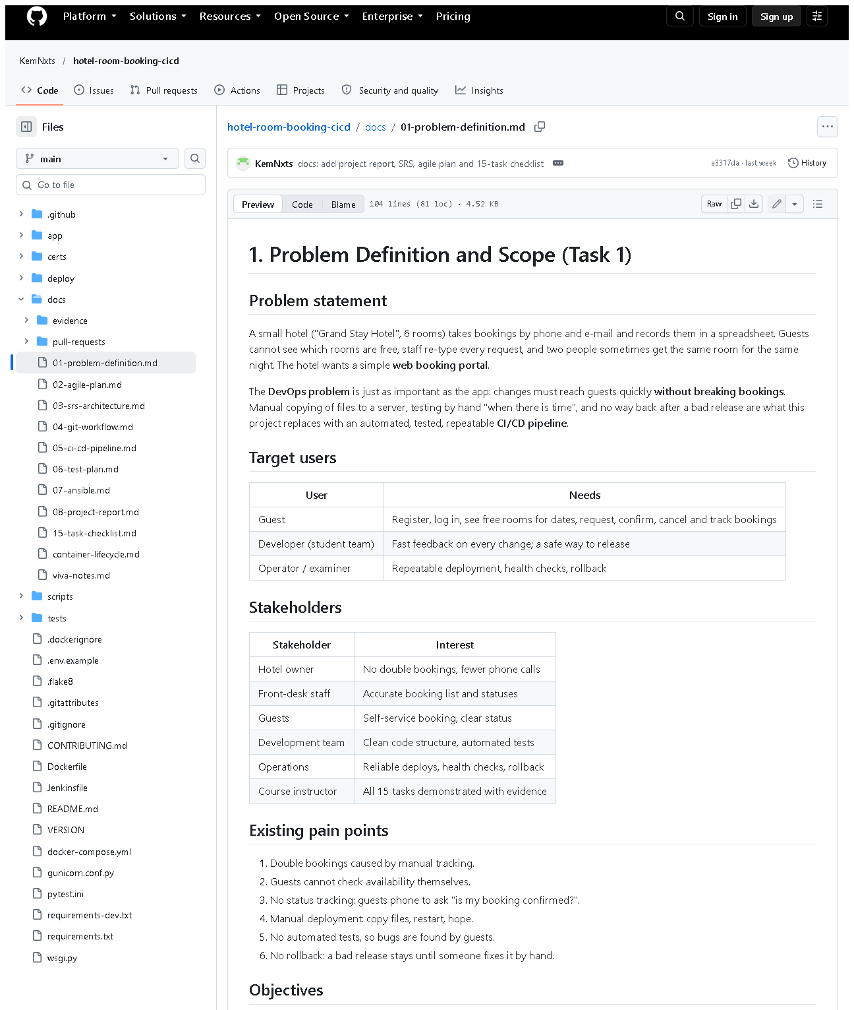 (part 1 of 3)
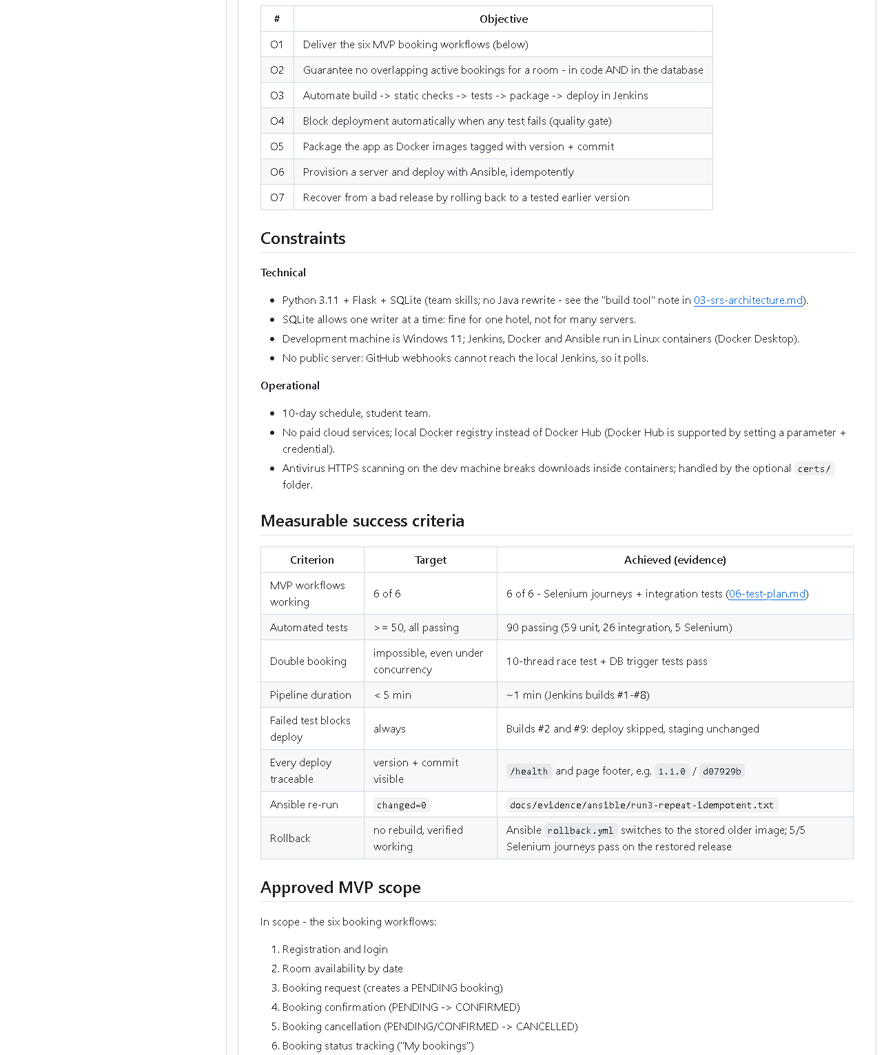 (part 2 of 3)
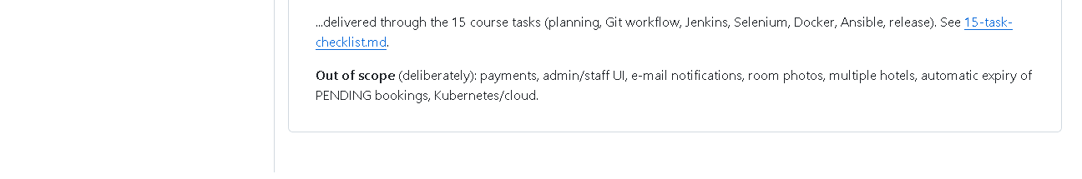 (part 3 of 3)
Figure 1.1 - docs/01-problem-definition.md as published on the public GitHub repository (captured 2026-10-20). What to notice: the sections Problem statement, Target users, Stakeholders, Pain points, Objectives O1-O7, Constraints, the success-criteria table with an "Achieved (evidence)" column, and the in/out-of-scope lists. Why it proves the task: every deliverable of Task 1 is present in one published, version-controlled document.
Supporting evidence used by the criteria (in other task folders): assets/task-09/full-test-suite.png (90 tests), assets/task-14/ansible-run3-repeat-idempotent.png (changed=0).

E. How to demonstrate this task to the professor (about 2 minutes)
Before the demo: open the project folder in VS Code, or open https://github.com/KemNxts/hotel-room-booking-cicd/blob/main/docs/01-problem-definition.md in a browser.
- Open the document (VS Code: docs/01-problem-definition.md, press Ctrl+Shift+V for the preview). Say: "Task 1 is the problem definition. A small hotel manages bookings by phone and spreadsheet, which causes double bookings and manual, risky software releases."
- Scroll to "Stakeholders" and "Existing pain points". Say: "Each stakeholder wants something different - the owner wants no double bookings, the operator wants safe deployments."
- Scroll to "Objectives" and "Measurable success criteria". Say: "Every objective has a measurable target. For example: at least 50 tests - we have 90; a re-run of Ansible must report zero changes - it does."
- Prove one criterion live (PowerShell, in D:\DevOPS\CICD_FOR_HOTEL_ROOM_BOOKING):Expected: 85 passed, 5 deselected in about 15 seconds.
.venv\Scripts\python -m pytest -q -m "not e2e"
- Scroll to "Approved MVP scope". Say: "Six workflows are in scope; payments and an admin screen are deliberately out of scope."
If something fails: if .venv is missing, run python -m venv .venv then .venv\Scripts\pip install -r requirements-dev.txt. The document itself needs nothing running.

F. Expected screenshots for the final submission
- assets/task-01/github-doc-01-problem-definition.png - the published problem definition - exists, captured 2026-10-20.
- (Optional, cross-reference) assets/task-09/full-test-suite.png - proves the "90 tests" criterion - exists, captured 2026-10-20.

G. Probable viva questions and answers
- What problem does your project solve? Two problems: hotel guests cannot book rooms themselves and double bookings happen; and the software is released manually without tests. The portal solves the first, the CI/CD pipeline the second.
- Who are your stakeholders? Hotel owner, front-desk staff, guests, the development team, operations (who deploy and roll back), and the course instructor.
- What is an MVP and what is yours? The smallest useful version. Ours is six workflows: register/login, availability, booking request, confirmation, cancellation, status tracking.
- Why did you leave payments out? Payments add security and legal requirements (card data) that do not help demonstrate DevOps; they are listed as future work.
- What makes your success criteria "measurable"? Each has a number or yes/no check: 90 tests passing, pipeline under 5 minutes (build #11 took 103 s), changed=0 on a repeat Ansible run.
- Did you interview real hotel staff? No. The stakeholders and pain points are a reasoned model of a small hotel; that is a limitation, and real interviews would be the next step.
- Which constraint affected the design most? SQLite: one writer at a time, so double-booking prevention uses a locking transaction and a database trigger; and the lack of a public server, which is why Jenkins polls Git instead of using a webhook.
- (Project-specific) Where is the scope written down and how is it versioned? In docs/01-problem-definition.md, committed in Git and published on GitHub, so changes to scope are tracked like code changes.
- (Project-specific) How do you know objective O2 (no overlapping bookings) is met? Tests prove it: test_simultaneous_requests_create_only_one_booking (10 threads, exactly 1 booking) and test_trigger_rejects_overlapping_insert.
- Why is the delivery pipeline part of the problem definition? Because a broken release would break bookings for real guests; the hotel's need includes "change the system safely", not just "have a website".

H. Common mistakes and troubleshooting
Symptom | Likely cause | Inspect | Safe fix | Confirm
The document title does not render as a heading in some viewers | Leading spaces before # (the working copy currently has two) | first line of docs/01-problem-definition.md | remove the spaces before # 1. Problem... | preview shows a large heading
Examiner asks for numbers that differ from the document | Numbers changed since the document was written | pytest -q output, Jenkins build page | quote today's numbers and say the document is a snapshot | rerun the command live
"Scope creep" question: why no admin page? | Scope not explained | "Approved MVP scope" section | point to the out-of-scope list | -
Success criterion cannot be shown live | Service (Jenkins/Docker) not running | Docker Desktop tray icon | start Docker Desktop, wait ~1 minute | docker ps lists hotel-jenkins-jenkins-1

I. Quick revision notes
Five key points
- Problem: manual bookings cause double bookings; manual releases are risky.
- Two deliverables: a booking portal and an automated CI/CD pipeline.
- MVP = 6 workflows; payments/admin/e-mail out of scope.
- Every objective has a measurable target and is met with evidence.
- Stakeholders are modelled, not interviewed - say so honestly.
30-60 second spoken explanation "Task 1 defines the problem. A small hotel takes bookings by phone and spreadsheet, so guests can't see availability and rooms get double-booked. We also need to change the software safely, so the project has two parts: a web portal with six booking workflows, and a CI/CD pipeline that tests and deploys it automatically. The scope is fixed in docs/01-problem-definition.md with measurable success criteria - for example at least 50 automated tests; today 90 pass - and anything else, like payments, is explicitly out of scope."
Caveat: stakeholder needs are assumed, not gathered from real users.
Readiness checklist
- â˜ I can name the 6 workflows from memory.
- â˜ I can name 4 stakeholders and what each wants.
- â˜ I can quote 3 success criteria and today's result.
- â˜ I can open docs/01-problem-definition.md quickly.

Task 2 - Agile Planning and DevOps Workflow

A. Task title and objective
Task 2: Agile Planning and DevOps Workflow
Objective: plan the work in small, testable pieces (user stories), order them (backlog), schedule them (sprints), agree when a piece is finished (Definition of Done), and show the full DevOps flow from code to operations.
Professor's required deliverables
- User stories with acceptance criteria
- Product backlog
- A 15-task Kanban/Scrum board
- Sprint plan
- Definition of Done
- DevOps lifecycle diagram (development to operations)
- Backlog linked to repository issues where possible
Current status: Partially completed.
Part | Status
Stories, acceptance criteria, backlog, board, sprints, DoD, diagram | Implemented and verified - docs/02-agile-plan.md, published on GitHub
Backlog items as GitHub issues | Pending external action - the GitHub API reports 0 issues (checked 2026-10-20); see Figure 2.2

B. Explanation for a complete beginner
An everyday picture. Planning a wedding: you write every job on a sticky note ("book the hall", "send invitations"), put them in order of importance, and move each note across a whiteboard from To do to Doing to Done. Agile planning is exactly that, for software.
Agile - a way of working in short cycles, delivering a small working piece each time and adjusting the plan as you learn. Problem it solves: big "deliver everything at the end" projects discover problems too late.
User story - a requirement written from the user's point of view: "As a guest I want to cancel a booking so that the room is released." Why: it keeps the focus on what the user gets, not on technical details.
Acceptance criteria - the conditions that must be true for a story to be accepted, e.g. "a cancelled booking cannot be cancelled again". In this project every criterion is checked by an automated test, and the test names are written next to the story.
Product backlog - the ordered list of all work items. Here: HB-01 to HB-15, one per course task.
Kanban board - columns (Backlog, To do, In progress, Review, Done) that show where each item is. Scrum - work in fixed periods called sprints (here 3 short sprints), each ending with a review and a retrospective.
Definition of Done (DoD) - one checklist that applies to every item, so "done" means the same thing to everyone (tests pass, pipeline green, merged...).
DevOps lifecycle - the loop Plan -> Code -> Build -> Test -> Release -> Deploy -> Operate -> Monitor -> back to Plan. In this project each step has a real tool (Git, pip, pytest/Selenium, Docker, Jenkins, Ansible, /health).
GitHub issue - a ticket on GitHub that tracks one backlog item. Linking items to issues lets commits and pull requests say "Closes #12".

C. What was actually implemented
File: docs/02-agile-plan.md.
User stories (9). US1-US6 cover the six booking workflows, US7 automatic testing, US8 one-command deployment, US9 rollback. Each row lists the acceptance criteria and the tests that check them, for example:
Story | Acceptance criterion (excerpt) | Automated check
US3 request a booking | never two active bookings overlap, even simultaneously | test_simultaneous_requests_create_only_one_booking
US5 cancel | cannot cancel twice | TestCancelBooking::test_cannot_cancel_twice
US7 every commit tested | any failure skips packaging and deployment | Jenkins builds #2, #9

Backlog. HB-01 ... HB-15, one per course task, with the related story and status.
Kanban board (final state). All HB items in Done; out-of-scope ideas (payments, admin UI, auto-expiry of PENDING bookings) stay in Backlog.
Sprint plan. Sprint 1 Foundation (days 1-3), Sprint 2 Automation (4-6), Sprint 3 Operations & release (7-10).
Definition of Done (7 points): feature/fix branch with conventional commits; automated tests; flake8 clean and all tests pass; Jenkins green; merged with --no-ff using the PR checklist; docs updated; no secrets.
DevOps lifecycle diagram. A Mermaid diagram (text that GitHub draws as a picture). It shows the failure loop: if tests fail, nothing is released and the developer fixes the code.
How the DoD is enforced in this repository
DoD point | Real mechanism
tests pass | pytest stages in Jenkinsfile
flake8 clean | "Static checks" stage
pipeline green | Deploy runs only after every test stage
PR checklist | .github/pull_request_template.md
no secrets | .gitignore excludes .env, credentials/, *.key, certs/*.crt

GitHub issues - what is missing. The repository is public, but no issues were created (Figure 2.2). The backlog text says so: "replace HB-xx with the real issue number" after creating them.

D. Screenshots and evidence
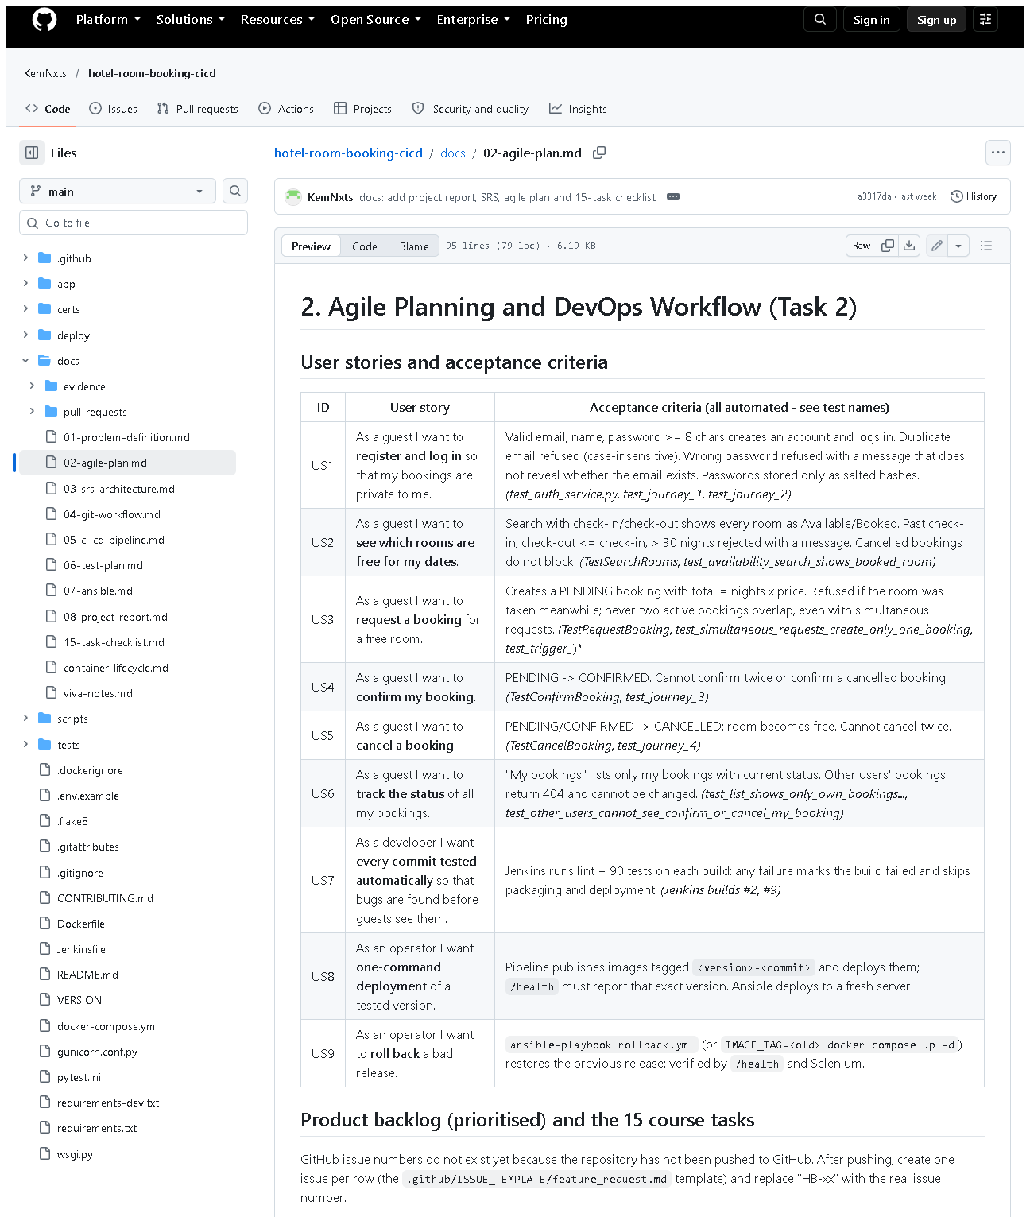 (part 1 of 3)
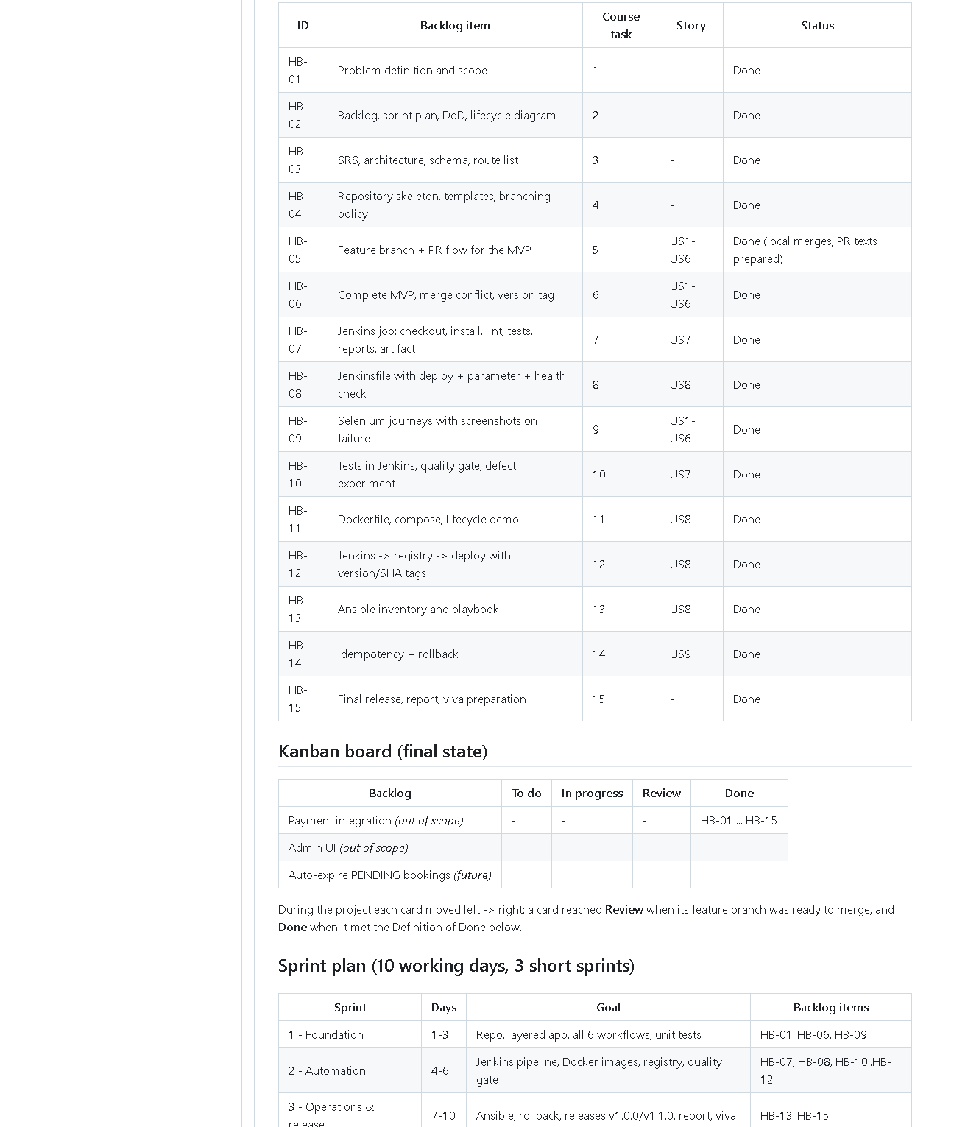 (part 2 of 3)
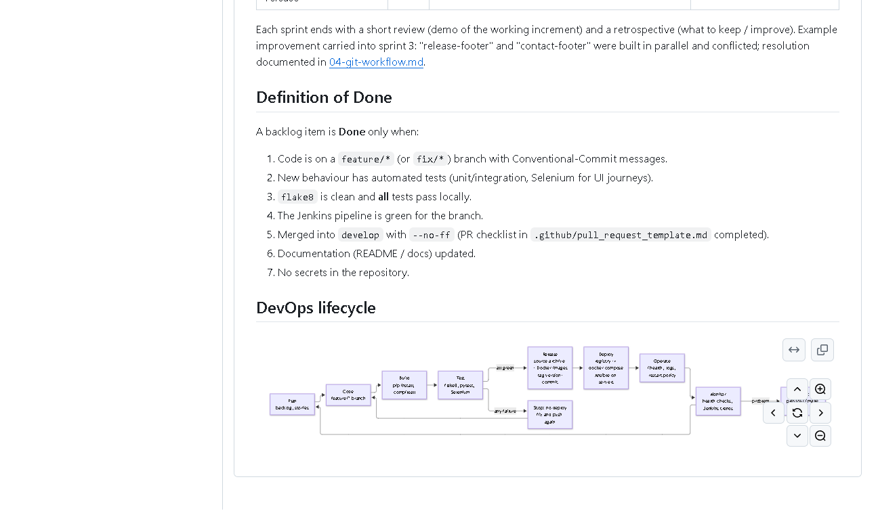 (part 3 of 3)
Figure 2.1 - docs/02-agile-plan.md on GitHub (captured 2026-10-20). What to notice: the user-story table with test names, backlog HB-01-HB-15, the Kanban table, sprint plan, the Definition of Done, and at the bottom the DevOps lifecycle diagram drawn by GitHub from Mermaid text. Why it proves the task: all planning deliverables exist in one versioned document.
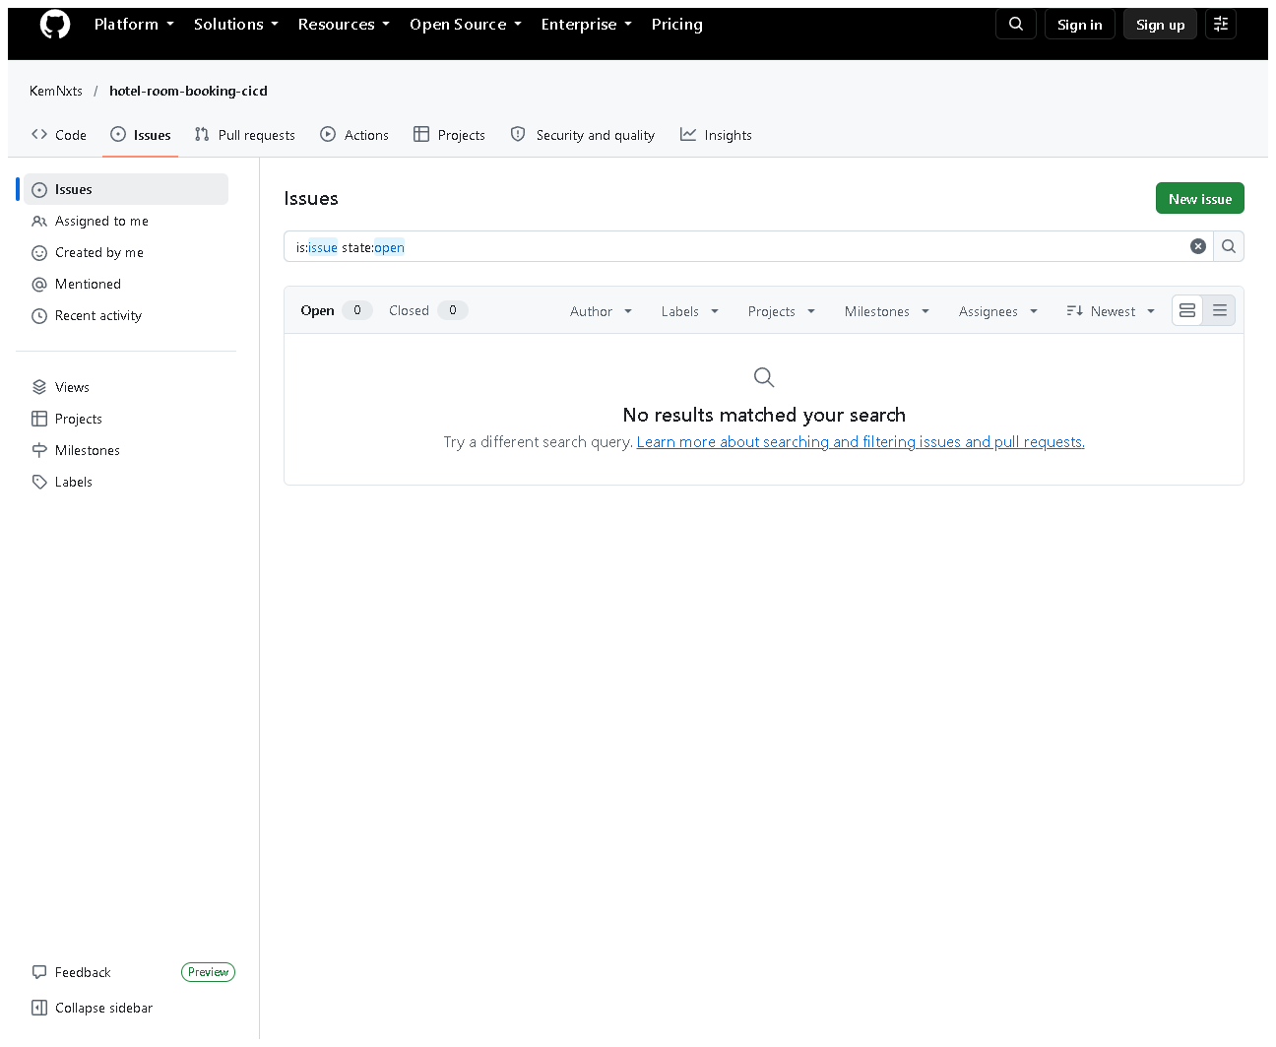
Figure 2.2 - The repository's Issues page (all states) shows no issues (captured 2026-10-20). What to notice: zero open and zero closed issues. Why it matters: this honestly shows the remaining step; the backlog is local (in the document), not yet on GitHub Issues.

E. How to demonstrate this task to the professor (about 3 minutes)
Before the demo: open docs/02-agile-plan.md (VS Code preview with Ctrl+Shift+V, or on GitHub - GitHub draws the diagram).
- User stories. Say: "Each requirement is a user story with acceptance criteria, and next to each criterion I wrote the automated test that checks it."
- Prove one story live (PowerShell, project folder):Expected: 7 passed, 31 deselected (the cancellation tests, e.g. test_cannot_cancel_twice). Say: "US5 says a booking cannot be cancelled twice - this test proves it."
.venv\Scripts\python -m pytest -q tests/unit/test_booking_service.py -k "cancel"
- Backlog and Kanban board. Say: "The 15 course tasks are backlog items HB-01 to HB-15. The board shows their final state."
- Definition of Done. Say: "An item is done only when tests pass, the Jenkins pipeline is green and it is merged - the pipeline enforces most of this."
- Lifecycle diagram (bottom of the page on GitHub). Trace it with the mouse: "Plan, code, build, test - if any test fails we stop - release, deploy, operate, monitor, roll back if needed."
- Be honest about issues: open https://github.com/KemNxts/hotel-room-booking-cicd/issues - "The backlog is in the repository; creating GitHub issues for it is the remaining step."
To complete the pending part (needs your GitHub login): on GitHub click Issues -> New issue -> Feature request, create one issue per HB item (title e.g. "HB-07 Jenkins job"), then edit the backlog table to show the issue numbers and commit the change.

F. Expected screenshots for the final submission
- assets/task-02/github-doc-02-agile-plan.png - planning document incl. diagram - exists, captured 2026-10-20.
- assets/task-02/github-issues-empty.png - honest state of GitHub issues - exists, captured 2026-10-20.
- assets/task-02/github-issues-created.png - issues HB-01..HB-15 on GitHub - requires manual capture after the issues are created (open the Issues page, all states, screenshot).

G. Probable viva questions and answers
- What is a user story? A short requirement from the user's viewpoint: "As a I want so that ."
- What are acceptance criteria? The conditions that make a story accepted. Ours are checked automatically by named tests.
- Difference between a backlog and a sprint? The backlog is the whole ordered to-do list; a sprint is a short time-box in which a chosen part of the backlog is completed.
- Kanban or Scrum - which did you use? A light mix: a Kanban board to show status and three short Scrum-style sprints with a review each.
- What is your Definition of Done? Branch + conventional commits, tests, flake8 clean, all tests pass, Jenkins green, --no-ff merge with the PR checklist, docs updated, no secrets.
- How is the DoD enforced, not just written? Jenkins runs flake8 and all 90 tests; deployment happens only if they pass (shown by failed build #2).
- (Project-specific) Where are your GitHub issues? None exist yet (0 issues on GitHub). The backlog is in docs/02-agile-plan.md; creating the issues needs my GitHub account and is the remaining step.
- (Project-specific) Which story covers rollback and how is it proven? US9; proven by deploy/ansible/rollback.yml runs where /health showed 1.0.0 again and 5/5 Selenium journeys passed.
- What does the DevOps lifecycle diagram show that a simple list does not? The feedback loops: failed tests go back to Code, and problems in operation lead to rollback and new planning.
- What happened in your sprint retrospective? Two features built in parallel (two footers) caused a merge conflict; the lesson was to agree on shared files earlier. The conflict and its resolution are documented.

H. Common mistakes and troubleshooting
Symptom | Cause | Inspect | Fix | Confirm
Diagram shows as code text in VS Code | VS Code preview does not draw Mermaid by default | docs/02-agile-plan.md | show it on GitHub, or install a Mermaid preview extension | the boxes and arrows appear
Examiner asks to see the issues | Issues not created | GitHub Issues page | explain the pending step; create them if allowed | Issues page lists HB items
pytest -k cancel selects 0 tests | wrong folder/typo | command | run from the project folder exactly as written | "passed" count > 0
Story says a test name that no longer exists | test renamed | grep -rn "def test_" tests | update the story table | names match

I. Quick revision notes
Five key points
- 9 user stories; every acceptance criterion maps to an automated test.
- Backlog HB-01..HB-15 = the 15 course tasks.
- 3 sprints: foundation, automation, operations & release.
- Definition of Done is enforced by Jenkins (lint + 90 tests before deploy).
- GitHub issues are not created yet - pending.
30-60 second explanation "I planned the work with nine user stories, for example 'as a guest I want to cancel a booking'. Each has acceptance criteria, and each criterion is checked by a named automated test. The 15 course tasks form the backlog HB-01 to HB-15, shown on a Kanban board and split into three sprints. Our Definition of Done says tests pass, Jenkins is green and the work is merged - and Jenkins enforces that. The DevOps diagram shows the loop from planning to monitoring. The one missing piece is that the backlog isn't yet entered as GitHub issues."
Caveat: no GitHub issues exist; the board is a table in a document.
Readiness checklist
- â˜ I can explain story vs. acceptance criterion vs. test.
- â˜ I can recite the Definition of Done.
- â˜ I can trace the lifecycle diagram including the failure loop.
- â˜ I can explain honestly why there are no GitHub issues.

Task 3 - Requirements, Architecture and Technology Setup

A. Task title and objective
Task 3: Requirements, Architecture and Technology Setup
Objective: write down what the system must do (requirements), design how its parts fit together (architecture), choose the technologies, set up the development environment, and prove the booking rules work.
Professor's required deliverables
- SRS summary (Software Requirements Specification)
- Use-case diagram
- Application architecture diagram
- Database schema, relationships and data model
- API / route list
- Local development setup
- Technology choices with reasons
- Working registration, login, availability, request, confirmation, cancellation, status tracking
- Booking rules that block invalid dates, overlaps, unauthorised cancellation and inconsistent states
Current status: Implemented and verified. Re-checked 2026-10-20: the route list was printed from the real app (Figure 3.2), 59 unit + 26 integration tests passed, and the app started locally. Technology note: build and test use Python tools (pip, pytest, flake8), not Maven - see section C.

B. Explanation for a complete beginner
An everyday picture. A restaurant has a waiter (takes your order), a chef (decides how to cook it, following the recipes) and a store-room keeper (fetches ingredients). Each does one job. Our application is organised the same way.
Requirements / SRS - a list of what the system must do (functional: "a guest can cancel a booking") and how well (non-functional: "no double bookings even with simultaneous requests", "passwords never stored in plain text").
Use case - one goal a user achieves with the system ("Request booking"). A use-case diagram shows the users and their goals.
Architecture - how the code is split into parts and how they talk.
Layers in this project
Layer | Folder | Restaurant role | Job
Controller | app/controllers/ | waiter | reads the web request, calls a service, returns a page
Service | app/services/ | chef | business rules (dates valid? room free? may this user cancel?)
DAO (Data Access Object) | app/dao/ | store-room keeper | the only place with SQL
Model | app/models.py | the plate | plain data objects (User, Room, Booking)

Why layers? Each part can be changed and tested alone. The rules can be tested without a browser; the database could be replaced by changing only the DAOs.
Flask - a small Python web framework: it maps a URL like /bookings to a Python function. Route - that mapping. SQLite - a database stored in a single file, built into Python. Schema - the definition of the tables.
Virtual environment (venv) - a private folder of Python packages for this project, so versions don't clash with other projects. pip installs the pinned versions listed in requirements.txt.

C. What was actually implemented
Documents: docs/03-srs-architecture.md - 11 functional requirements (FR1-FR11), 7 non-functional (NFR1-NFR7), a use-case diagram, architecture diagram, ER (Entity-Relationship) diagram, booking state machine, route list and technology table.
Route list (printed from the running code, Figure 3.2)
Method | URL | Controller function | Purpose
GET | /rooms?check_in=&check_out= | rooms.list_rooms | rooms / availability
GET, POST | /register, /login | auth.register, auth.login | accounts
POST | /logout | auth.logout | log out
GET / POST | /bookings | my_bookings / create | list / request
GET | /bookings/<id> | detail | one booking (owner only)
POST | /bookings/<id>/confirm, /cancel | confirm, cancel | change status
GET | /health | health | status + version for Docker/Jenkins/Ansible

How one request travels (example: "Book room 201")
- Browser sends POST /bookings with room_id, check_in, check_out, csrf_token.
- app/controllers/csrf.py check_csrf() (line 25) rejects the request with HTTP 400 if the token is missing or wrong.
- app/controllers/booking_routes.py create() (line 22) calls the service.
- app/services/booking_service.py request_booking() (line 48) runs validate_stay() (line 19): valid dates, check-in not in the past, check-out after check-in, at most 30 nights.
- It calls BookingDao.create_if_room_free() in app/dao/booking_dao.py (line 34), which inside a locked transaction checks for an overlap and inserts a PENDING row.
- SQLite triggers in app/schema.sql (lines 42 and 56) refuse any overlapping active booking even if code above had a bug.
- The controller redirects to /bookings/<id>, which shows status PENDING.
The core rule - overlap - in SQL (app/dao/booking_dao.py, from line 9; the # explanations are added here for the reader and are not in the file):
_OVERLAP_SQL = """
check_in < :check_out # existing stay starts before the new one ends
AND check_out > :check_in # and ends after the new one starts
AND status IN ('PENDING', 'CONFIRMED') # cancelled bookings never block
"""
A guest may check in on the day the previous guest checks out (strict <).
Database (app/schema.sql) - tables users, rooms (6 seeded rooms: 101, 102 Single; 201, 202 Double; 301 Deluxe; 401 Suite), bookings (foreign keys to both). Constraints: CHECK (check_out > check_in), CHECK (status IN ('PENDING','CONFIRMED','CANCELLED')), two overlap triggers.
Booking rules and the tests that prove them
Rule | Test
invalid / past dates, > 30 nights | TestValidateStay::test_invalid_stays_are_rejected
no overlap for one room | test_overlapping_booking_is_rejected
concurrency: 10 simultaneous requests -> 1 booking | test_simultaneous_requests_create_only_one_booking
only the owner can view/confirm/cancel | test_other_users_cannot_see_confirm_or_cancel_my_booking
no cancel twice / no confirm of cancelled | test_cannot_cancel_twice, test_cannot_confirm_a_cancelled_booking
database blocks overlaps directly | test_trigger_rejects_overlapping_insert

Technology choices and the Maven/Tomcat question
Brief mentions (Java world) | This project (Python) | Same purpose
Maven/Gradle/Ant pom.xml | requirements.txt + pip | pinned dependencies
mvn compile | python -m compileall + flake8 | catch syntax/style errors
mvn test (JUnit) | pytest with JUnit-XML reports | run tests, report to Jenkins
WAR file | source tarball + Docker images | deployable artifact
Tomcat | Gunicorn behind Nginx | serve the app

pip and pytest are not Maven and are not presented as Maven. Whether the Python equivalents satisfy the brief must be confirmed with the professor.
Local setup (Windows PowerShell)
python -m venv .venv
.venv\Scripts\pip install -r requirements-dev.txt
.venv\Scripts\python -m flask --app wsgi run --port 5001 # 5000 is taken by the local Docker registry

D. Screenshots and evidence
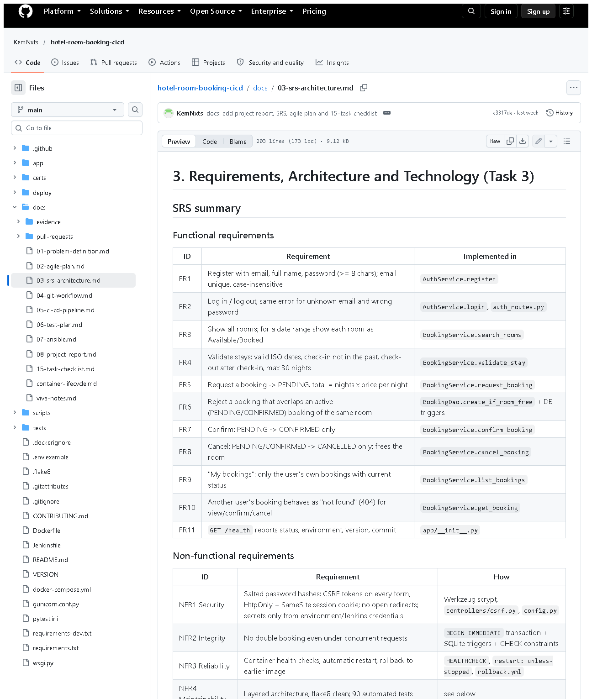 (part 1 of 4)
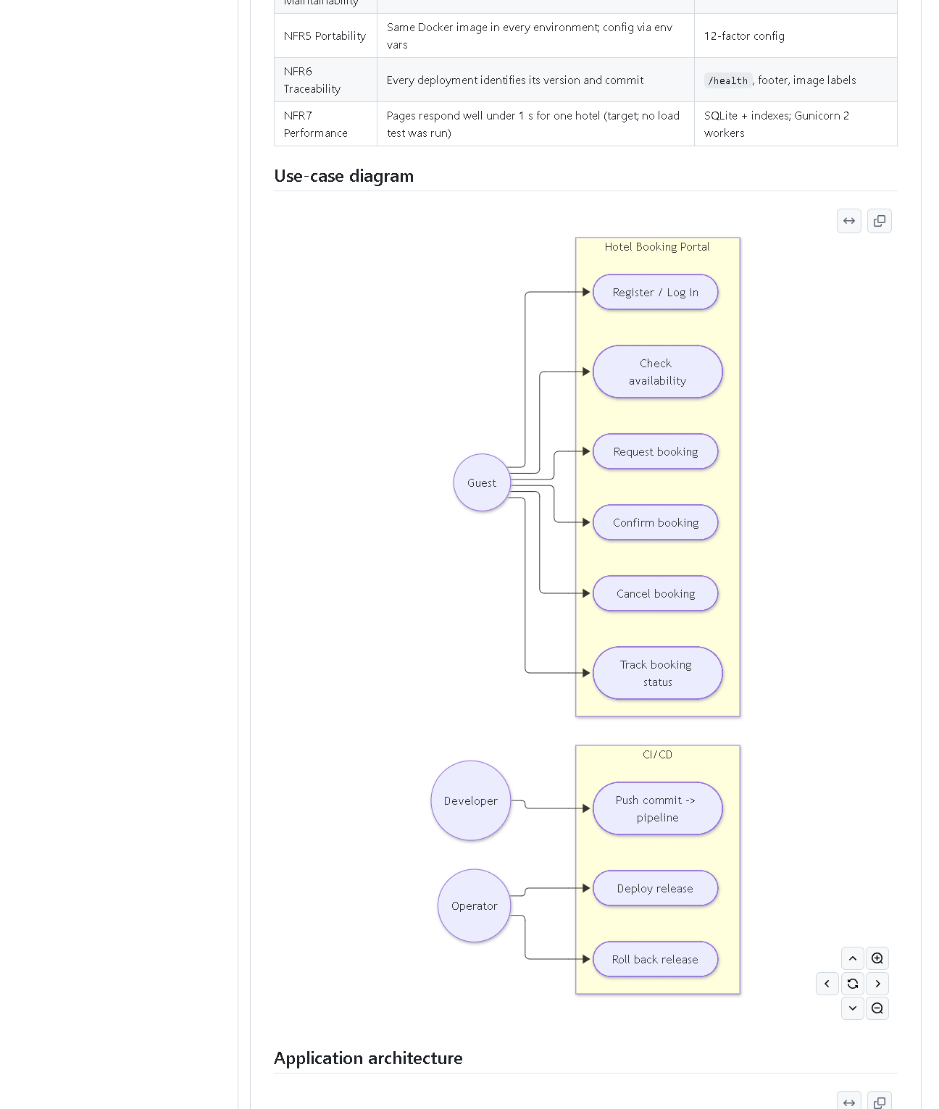 (part 2 of 4)
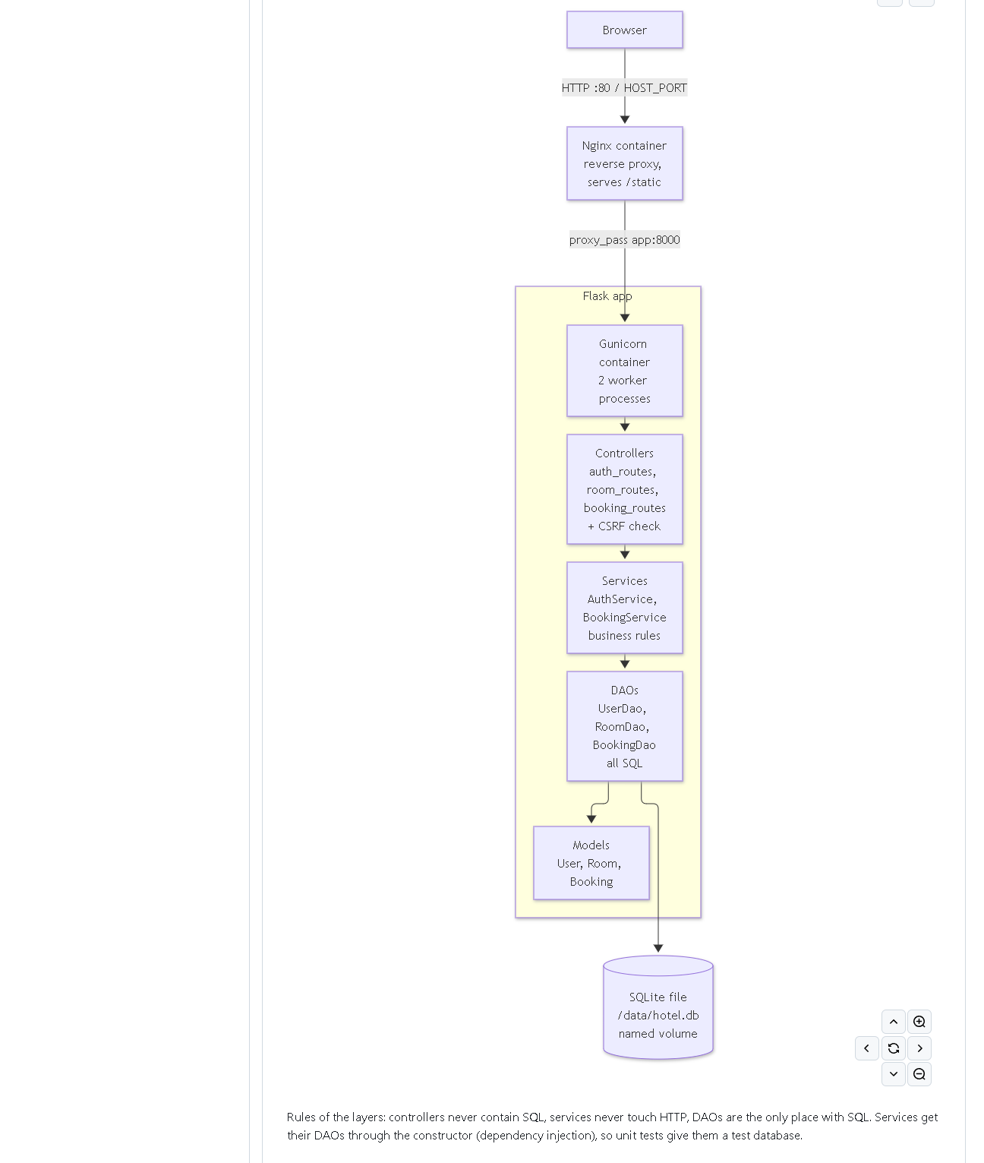 (part 3 of 4)
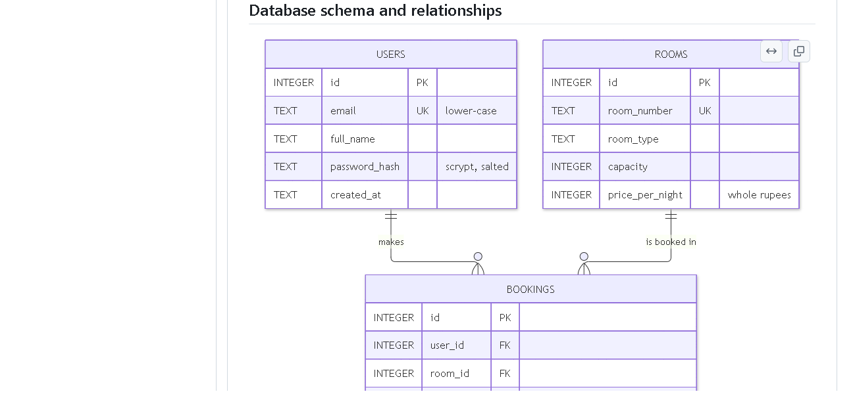 (part 4 of 4)
Figure 3.1 - docs/03-srs-architecture.md on GitHub with diagrams rendered (captured 2026-10-20). Notice: the FR/NFR tables, the use-case diagram, the layered architecture diagram, the ER diagram and the booking state machine. Proves: SRS, use cases, architecture, data model and route list exist.
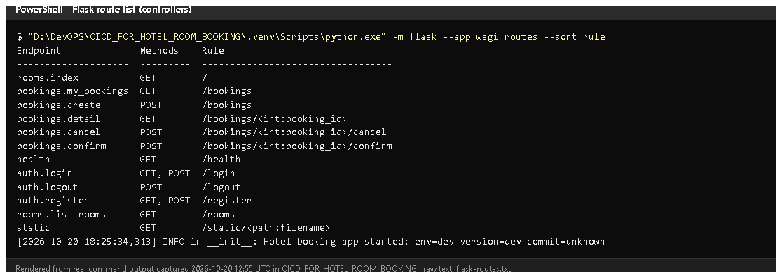
Figure 3.2 - python -m flask --app wsgi routes run on 2026-10-20 (rendered from real output). Notice: every URL with its HTTP method and controller function. Proves: the route list in the document matches the real code.
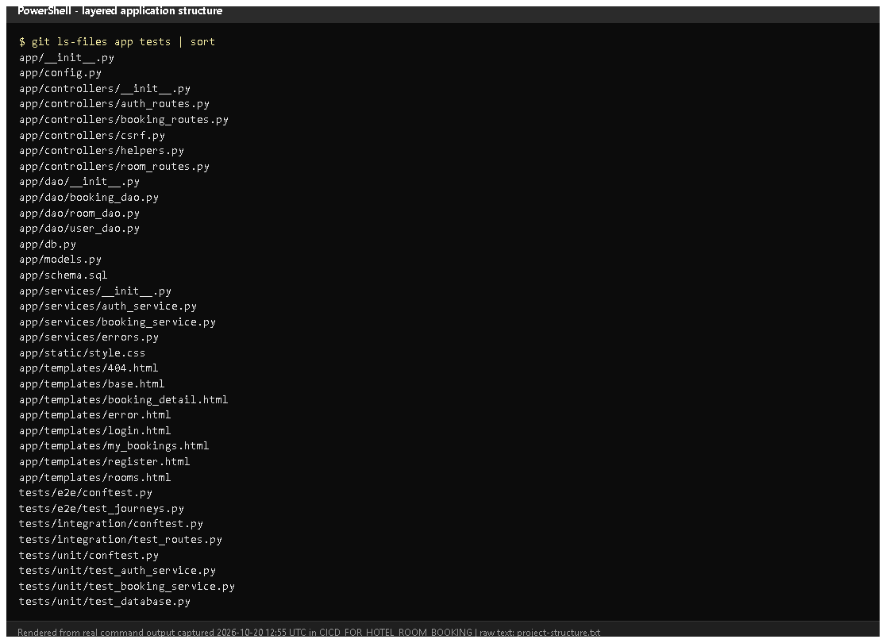
Figure 3.3 - Files under app/ and tests/ (from git ls-files, rendered from real output). Notice: separate controllers/, services/, dao/ folders and models.py. Proves: the layered architecture is real, not only drawn.
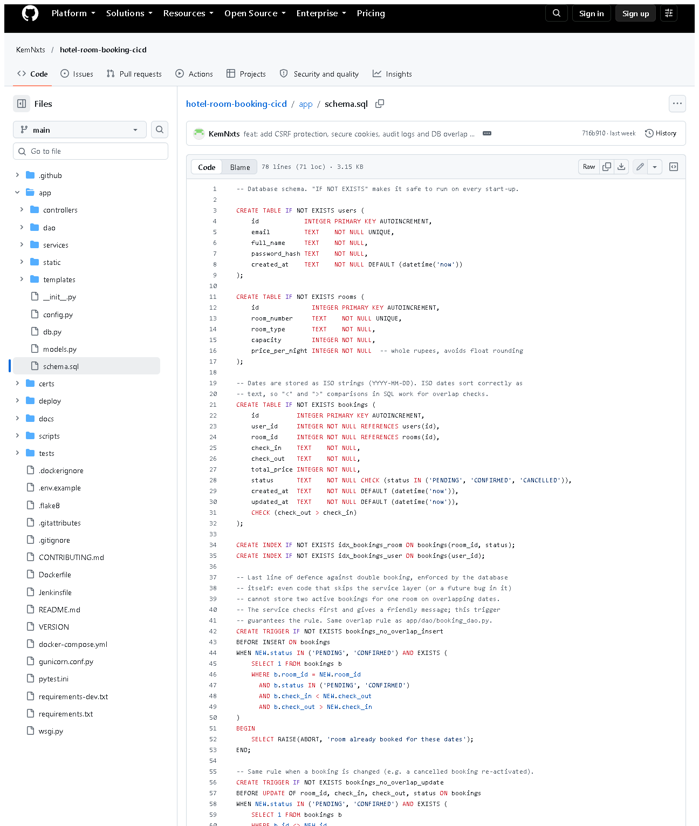 (part 1 of 2)
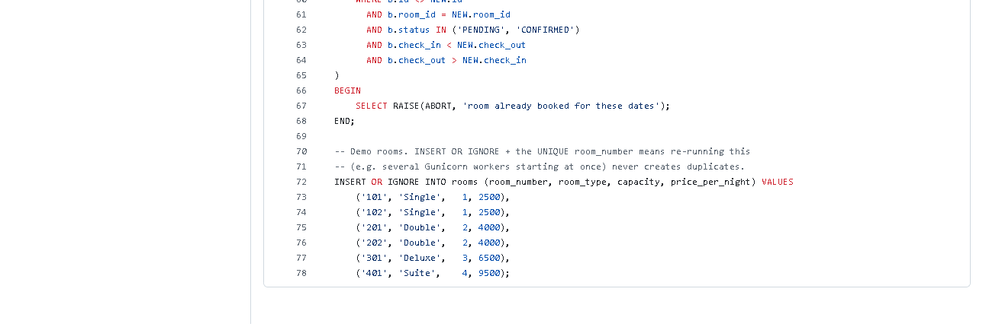 (part 2 of 2)
Figure 3.4 - app/schema.sql on GitHub. Notice: three tables, CHECK constraints, the two bookings_no_overlap_* triggers, the six seeded rooms.
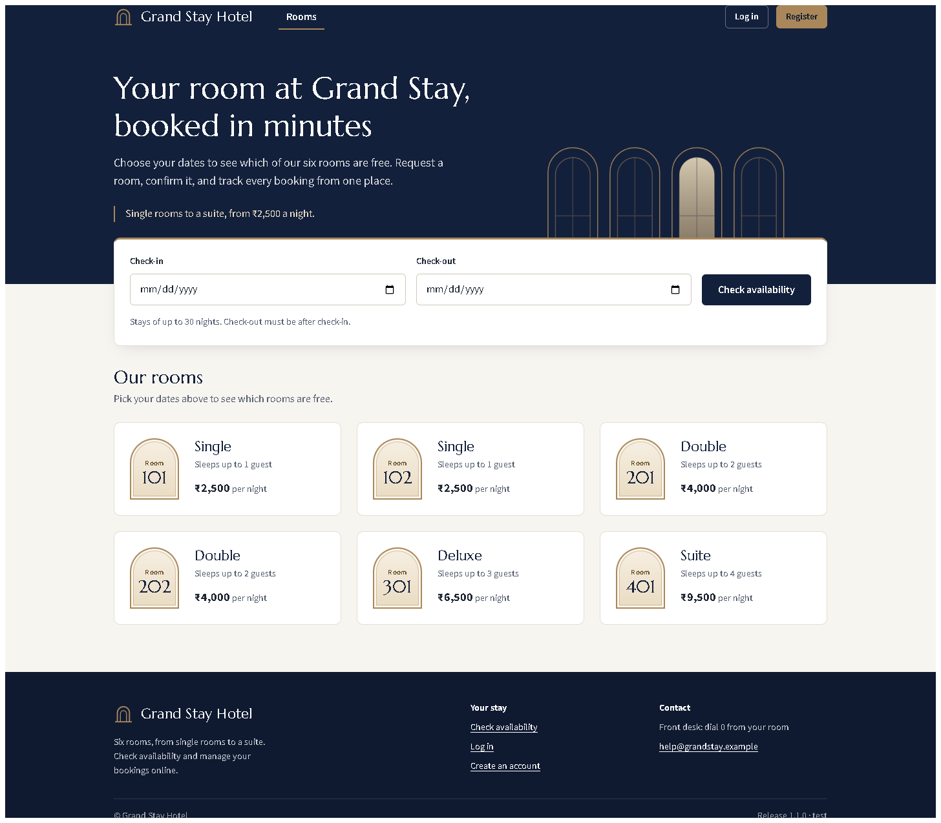
Figure 3.5 - Rooms page served by the local development server (redesigned UI from the working tree, captured 2026-10-20). Notice: the six seeded rooms with type, capacity and price.

E. How to demonstrate this task to the professor (about 4 minutes)
Before the demo: PowerShell open in D:\DevOPS\CICD_FOR_HOTEL_ROOM_BOOKING; VS Code open on the same folder.
- Show the document docs/03-srs-architecture.md (or on GitHub to see diagrams). Say: "These are the functional and non-functional requirements, the use cases and the architecture."
- Start the application (PowerShell):Expected: Running on http://127.0.0.1:5001. Leave this window open.
.venv\Scripts\python -m flask --app wsgi run --port 5001
- Open http://127.0.0.1:5001 in the browser - the six rooms appear. Open http://127.0.0.1:5001/health - {"status": "ok", ...}.
- Show the route list in a second PowerShell window:
.venv\Scripts\python -m flask --app wsgi routes
- Trace one request in VS Code: open app/controllers/booking_routes.py (create), then app/services/booking_service.py (request_booking), then app/dao/booking_dao.py (create_if_room_free). Say: "Controller, service, DAO - only the DAO has SQL."
- Prove the rules:Expected: 85 passed. Point at the overlap and concurrency tests.
.venv\Scripts\python -m pytest -q tests/unit tests/integration
- Stop the server with Ctrl+C in its window.
Recovery: "An attempt was made to access a socket..." means the port is taken - use another port (--port 5002). "No module named flask" means the venv is missing: python -m venv .venv and .venv\Scripts\pip install -r requirements-dev.txt.

F. Expected screenshots for the final submission
- assets/task-03/github-doc-03-srs-architecture.png - SRS + diagrams - exists, 2026-10-20.
- assets/task-03/flask-routes.png - real route list - exists, 2026-10-20.
- assets/task-03/project-structure.png - layered folders - exists, 2026-10-20.
- assets/task-03/github-file-app_schema.sql.png - schema - exists, 2026-10-20.
- assets/task-03/app-desktop-01-home.png - running app - exists, 2026-10-20.

G. Probable viva questions and answers
- What is an SRS? A Software Requirements Specification: what the system must do (functional) and qualities it must have (non-functional).
- Explain your layers. Controllers handle HTTP, services hold business rules, DAOs hold all SQL, models are plain data. Each only calls the layer below.
- Why separate services from controllers? Rules can be unit-tested without a web request, and they are not duplicated in several routes.
- Why SQLite? Built into Python, zero setup, one file; enough for one hotel. Limitation: one writer at a time and one server only.
- How do you prevent double bookings? Three layers: the service checks; the DAO checks and inserts inside BEGIN IMMEDIATE (a locked transaction); and database triggers refuse overlaps. A 10-thread test proves only one wins.
- (Project-specific) What does /health return and who uses it? {"status","env","version","commit"}; used by the Docker HEALTHCHECK, the Jenkins health-check stage and the Ansible playbook.
- (Project-specific) Why can't another user cancel my booking? BookingService.get_booking checks the owner and raises "not found" otherwise, so the route returns 404 - proven by an integration test.
- Is pip your Maven? No. pip installs Python packages and pytest runs tests; they do the same jobs as Maven's dependency and test phases, but they are different tools. I need the professor's confirmation that this is acceptable.
- Why Gunicorn and Nginx instead of Tomcat? Tomcat runs Java servlets. Python apps run on a WSGI server (Gunicorn); Nginx is the public entry point and serves static files.
- What is the booking state machine? PENDING -> CONFIRMED, PENDING or CONFIRMED -> CANCELLED; nothing else. Status changes use UPDATE ... WHERE status IN (allowed) so check and change happen atomically.
- What is CSRF and how do you stop it? Cross-Site Request Forgery: another site making your browser submit our forms. Every form has a secret token stored in the session; POSTs without it get HTTP 400.

H. Common mistakes and troubleshooting
Symptom | Cause | Inspect | Fix | Confirm
python wsgi.py fails: "access a socket ... forbidden" | port 5000 used by the local Docker registry | Get-NetTCPConnection -LocalPort 5000 | run with --port 5001 | page opens on :5001
HTTP 400 "Your form has expired" | CSRF token missing/old | browser tab opened before a restart | reload the page and resubmit | form works
RuntimeError: SECRET_KEY must be set | started with APP_ENV=prod without a key | environment variables | set SECRET_KEY, or use dev mode | app starts
Data from earlier tests appears | local DB instance/hotel.db | instance/ folder | delete instance/hotel.db to reset (local dev only) | 6 rooms, no bookings

I. Quick revision notes
Five key points
- 11 functional + 7 non-functional requirements in docs/03-srs-architecture.md.
- Layers: controllers -> services -> DAOs -> SQLite; models carry data.
- Overlap rule check_in < new_out AND check_out > new_in, enforced three times.
- Routes printed from real code; /health is used by Docker, Jenkins, Ansible.
- Python tooling (pip/pytest/flake8, Gunicorn/Nginx) - not Maven/Tomcat; confirm with the professor.
30-60 second explanation "The requirements are in an SRS with use cases, architecture and data-model diagrams. The Flask app has layers: controllers handle web requests, services apply booking rules, DAOs contain all SQL, and SQLite stores users, rooms and bookings. A booking request passes the CSRF check, date validation, and an overlap check inside a locked transaction, and database triggers block any overlap that slips through. Ninety automated tests prove these rules."
Caveat: Python tools are used instead of Maven/Tomcat - needs professor approval.
Readiness checklist
- â˜ I can start the app on port 5001 and open /health.
- â˜ I can trace a booking request through the three layers.
- â˜ I can explain the overlap rule and the three protections.
- â˜ I can explain the Maven/Tomcat difference honestly.

Task 4 - Git and GitHub Repository Initialization

A. Task title and objective
Task 4: Git and GitHub Repository Initialization
Objective: put the project under version control from day one, with a clean structure, rules for branches and commits, templates for issues and pull requests, and a remote copy on GitHub.
Professor's required deliverables
- README
- .gitignore (and .gitattributes)
- Folder structure
- Issue and pull-request templates
- Branch naming policy
- Meaningful commit history
- Initial source baseline (skeleton commit)
Current status: Implemented and verified. Checked 2026-10-20 with Git commands (Figures 4.1-4.3) and the public GitHub repository (Figures 4.4-4.6): 19 branches and both release tags are on GitHub.
One note: the branch policy is written in CONTRIBUTING.md; GitHub "branch protection rules" (settings that technically block direct pushes) were not configured - that needs the repository owner's login.

B. Explanation for a complete beginner
An everyday picture. Git is like the "version history" of a Google Doc, but for a whole folder of files, and much more precise: every saved version has a name, an author, a date and a message saying why it changed.
Term | Plain meaning | In this project
Repository (repo) | the project folder plus its full history | D:\DevOPS\CICD_FOR_HOTEL_ROOM_BOOKING
Commit | one saved snapshot with a message | e.g. 541dad5 chore: initialise repository skeleton
Branch | a separate line of work, so experiments don't disturb stable code | main, develop, feature/*
Merge | joining a branch's work into another branch | features merged into develop
Tag | a permanent name for one commit, e.g. a release | v1.0.0, v1.1.0
Remote | a copy of the repo on a server | origin = GitHub
Push / pull | send commits to / fetch commits from the remote | git push origin develop
.gitignore | list of files Git must never save | .env (secrets), .venv, *.db
.gitattributes | rules for how files are stored, e.g. line endings | LF line endings in the repo

Git vs GitHub. Git is the tool on your computer that records history. GitHub is a website that hosts a copy of a Git repository and adds collaboration features (issues, pull requests, web view). You can use Git without GitHub, but not the other way round.
Why it matters for DevOps: Jenkins builds whatever is committed, so Git is the starting point of the whole pipeline - and every deployment can be traced back to one commit.

C. What was actually implemented
Repository files
Deliverable | File | Content
README | README.md | features, stack, layout, run/test/Docker/Jenkins/Ansible instructions
Ignore rules | .gitignore | Python caches, .venv/, instance/, *.db, reports/, .env, deploy/ansible/credentials/, *.pem, *.key, certs/*.crt
Line endings | .gitattributes | * text=auto eol=lf - the same line endings on Windows and Linux (needed for scripts run in Linux containers); *.bat/*.ps1 keep Windows CRLF; *.png/*.jpg are binary
Issue templates | .github/ISSUE_TEMPLATE/bug_report.md, feature_request.md | forms for bugs and features
PR template | .github/pull_request_template.md | author + reviewer checklists
Branch & commit rules | CONTRIBUTING.md | main / develop / feature/* / fix/* / experiment/*, Conventional Commits (feat:, fix:, test:, ci:, docs: ...)

Folder structure - app/ (controllers, services, dao, templates, static), tests/ (unit, integration, e2e), deploy/ (nginx, jenkins, ansible), docs/, scripts/, plus Dockerfile, docker-compose.yml, Jenkinsfile.
Initial baseline. The first commit 541dad5 chore: initialise repository skeleton (2026-10-11) added exactly the skeleton: .gitattributes, the two issue templates, the PR template, .gitignore, CONTRIBUTING.md, README.md and empty deploy/ansible, tests/e2e, tests/unit folders (Figure 4.2).
Branches (20 local) - main (releases), develop (integration), 13 feature/* (including the unpushed feature/ui-redesign), fix/jenkins-stale-reports, experiment/defect-demo and -2, docs/final-build-record, docs/history-rewrite.
Tags - v1.0.0 -> 224de14, v1.1.0 -> ce1726d (annotated tags with a message).
Remote - origin = https://github.com/KemNxts/hotel-room-booking-cicd (public). Pushed on 2026-10-12. GitHub shows 19 branches and both tags.
Commit messages follow the convention, e.g. from git log: feat: add CSRF protection, ..., test: add route-level integration tests ..., ci: add lint, versioned images, ..., fix: stop Jenkins publishing stale test reports ....
History rewrite (be ready to explain). On 2026-10-12, before pushing, commit messages were edited to remove a co-author line. Contents stayed the same but all commit IDs changed; old evidence shows the old IDs. Mapping: docs/evidence/git/commit-id-map.md.

D. Screenshots and evidence
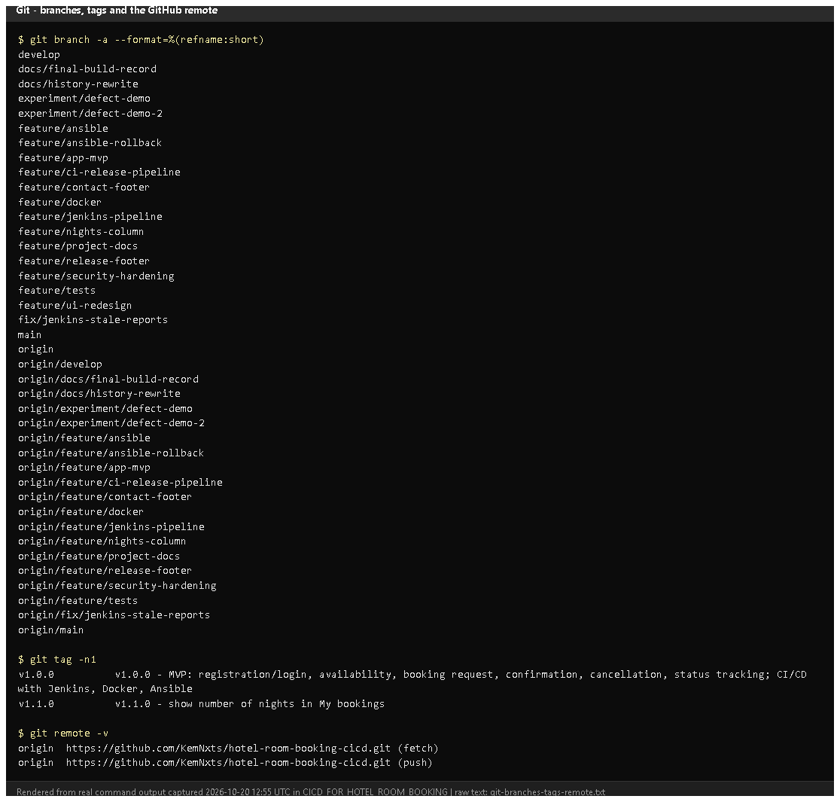
Figure 4.1 - git branch -a, git tag -n1, git remote -v (rendered from real output, 2026-10-20). Notice: local and origin/... branches, the two release tags with messages, and the GitHub remote. Proves: branching model, tags and remote exist.
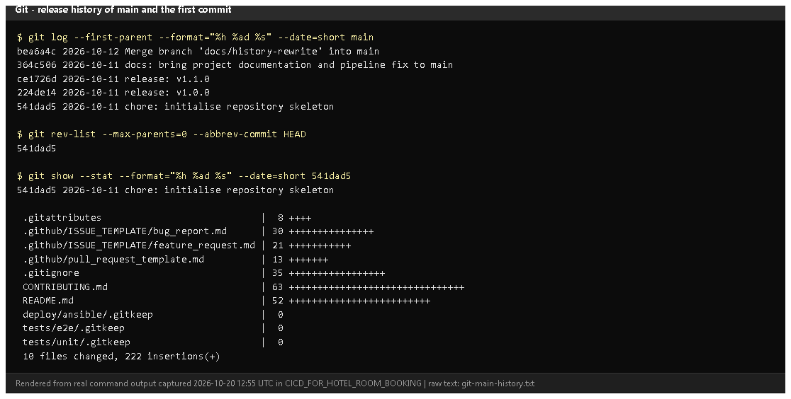
Figure 4.2 - Main-branch history and the skeleton commit 541dad5 with its files (rendered from real output). Notice: main contains only the skeleton and the release merges; the first commit added the README, ignore rules and templates. Proves: an initial source baseline and meaningful history.
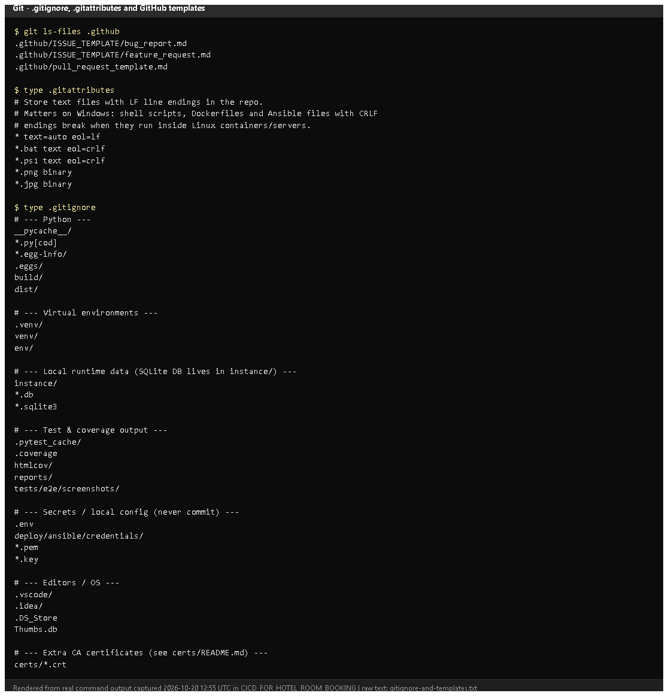
Figure 4.3 - .github templates, .gitattributes and .gitignore (rendered from real output). Notice: .env, credentials, keys and certificates are ignored. Proves: secrets and generated files are kept out of Git.
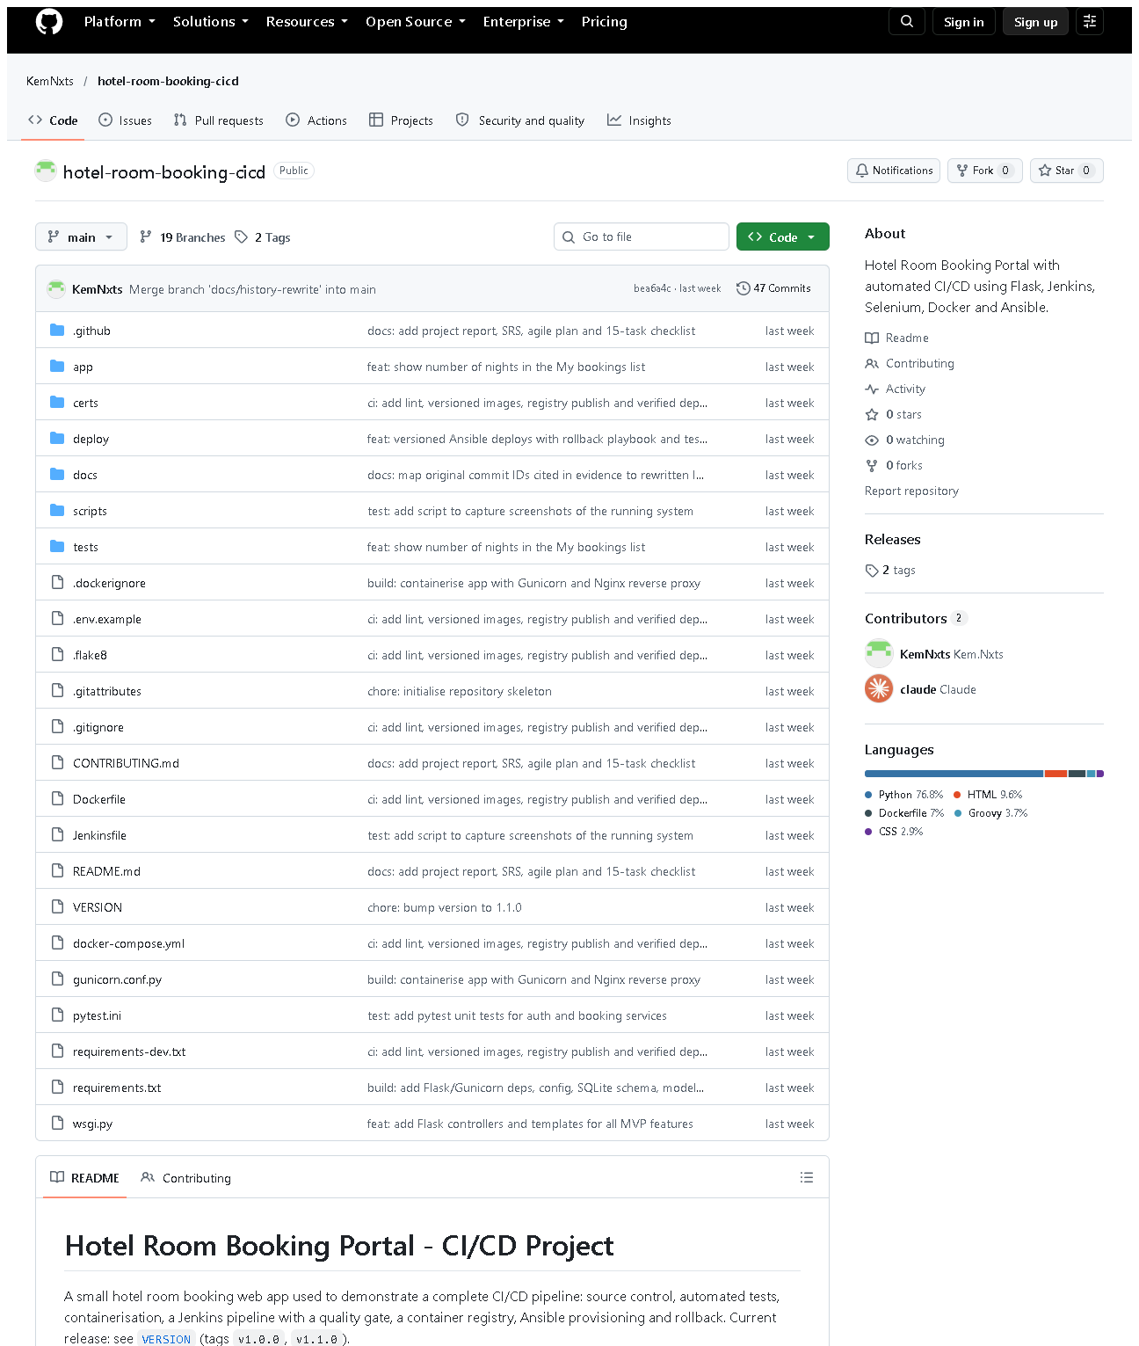 (part 1 of 3)
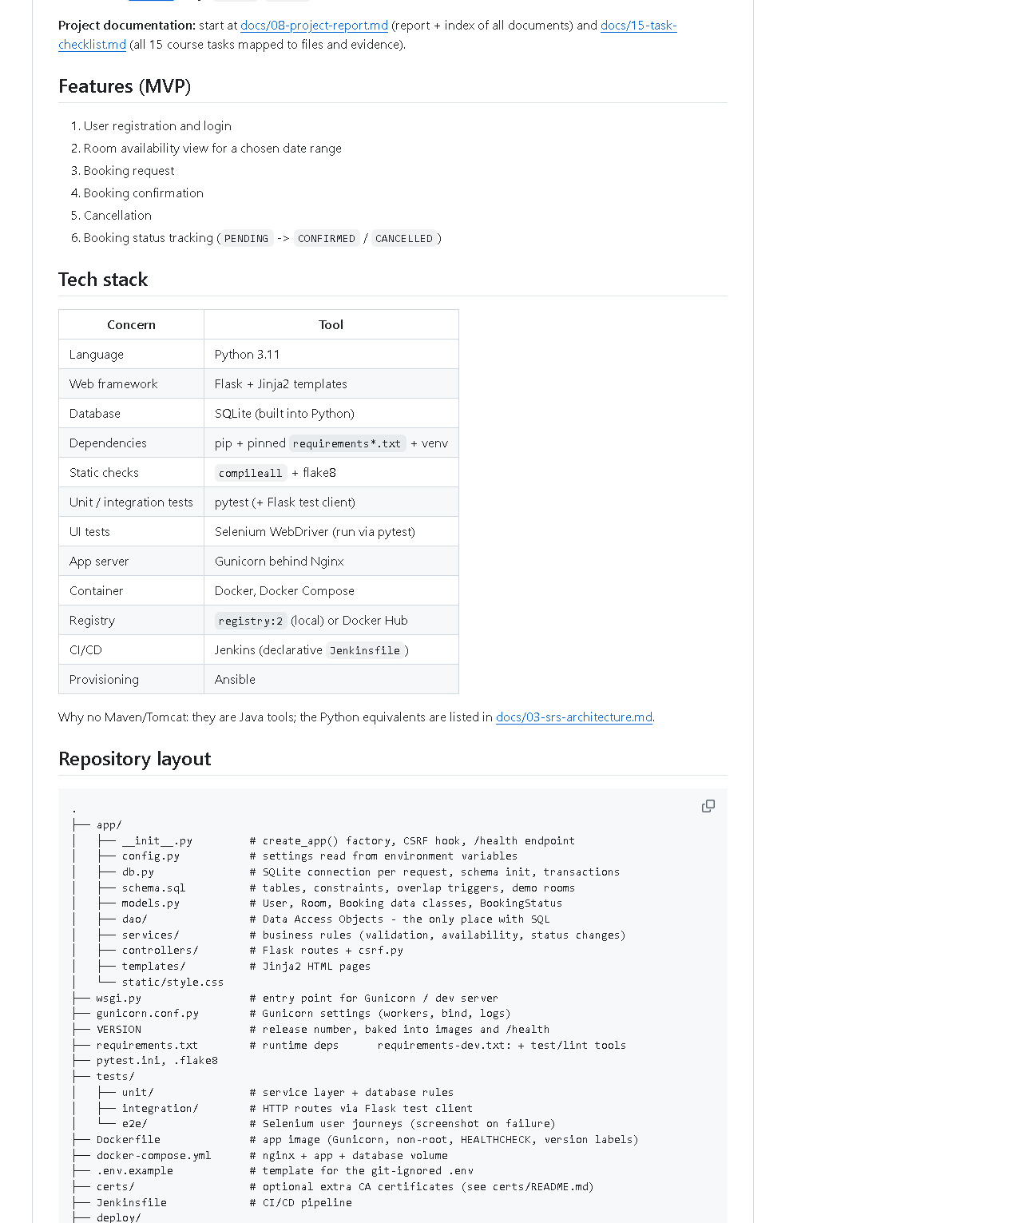 (part 2 of 3)
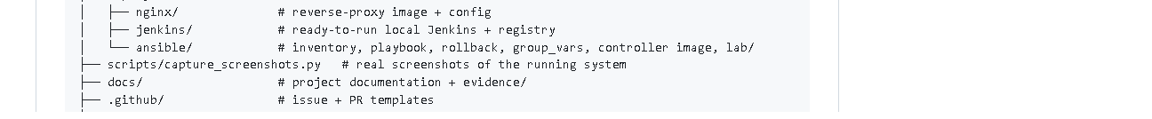 (part 3 of 3)
Figure 4.4 - The public GitHub repository home page (captured 2026-10-20). Notice: the folder structure, README rendered below, branch/tag counts.
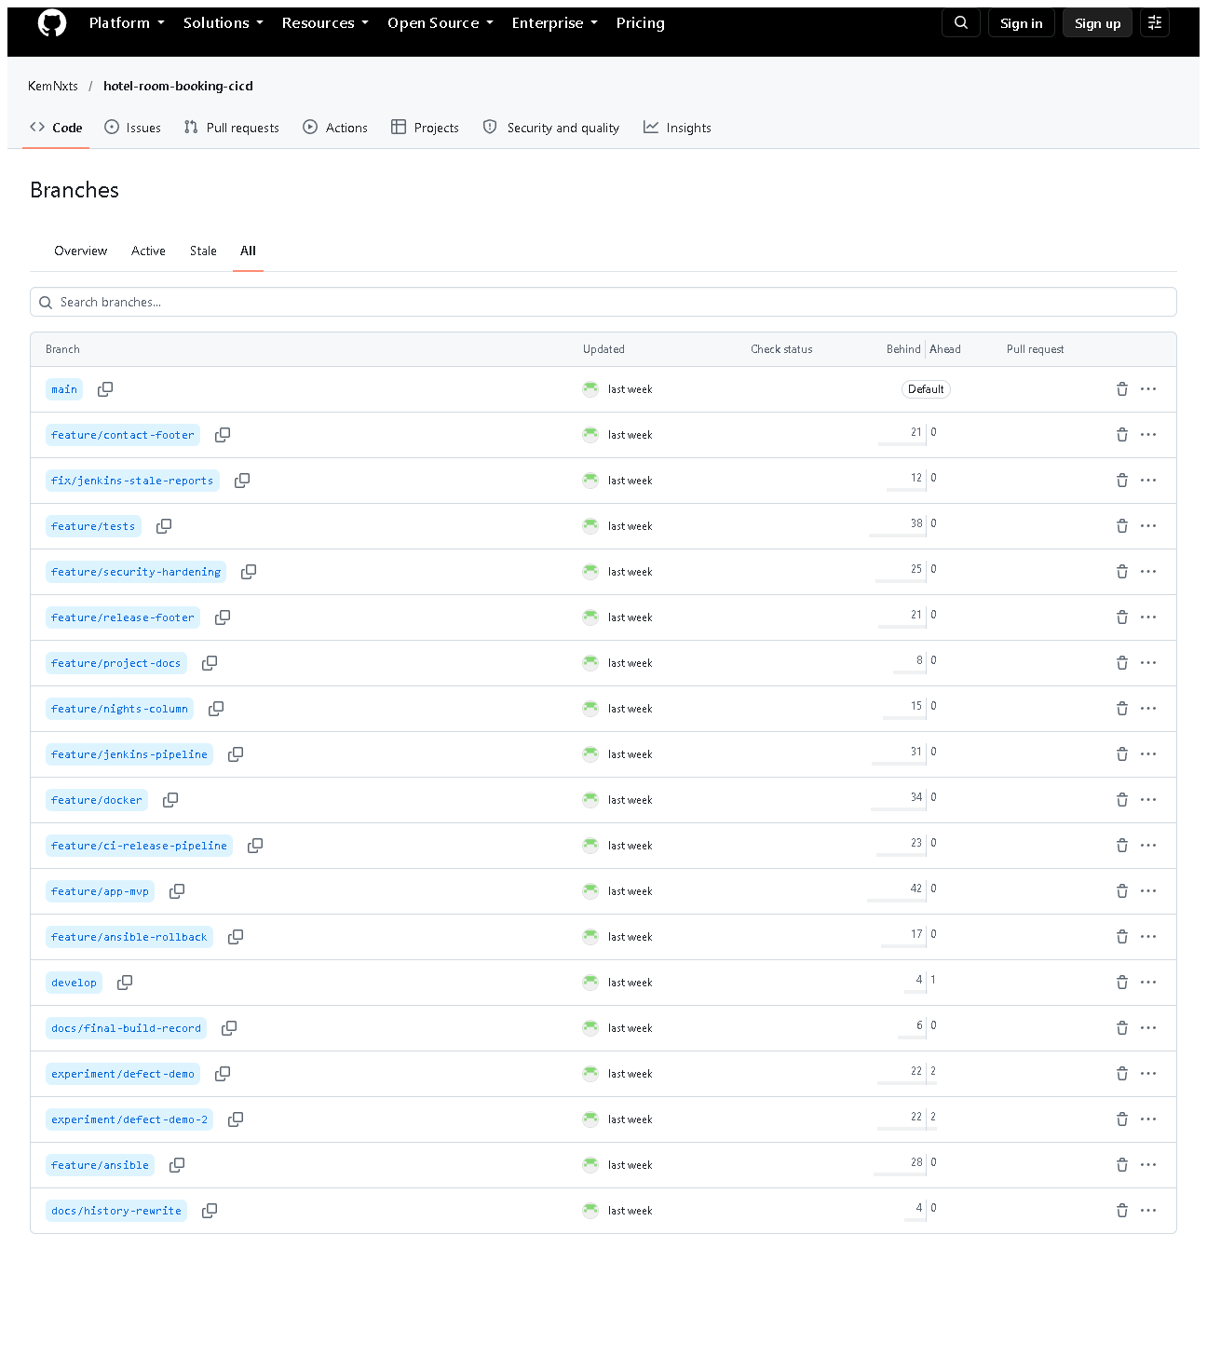
Figure 4.5 - All branches on GitHub. Notice: main, develop, feature/*, fix/*, experiment/*.
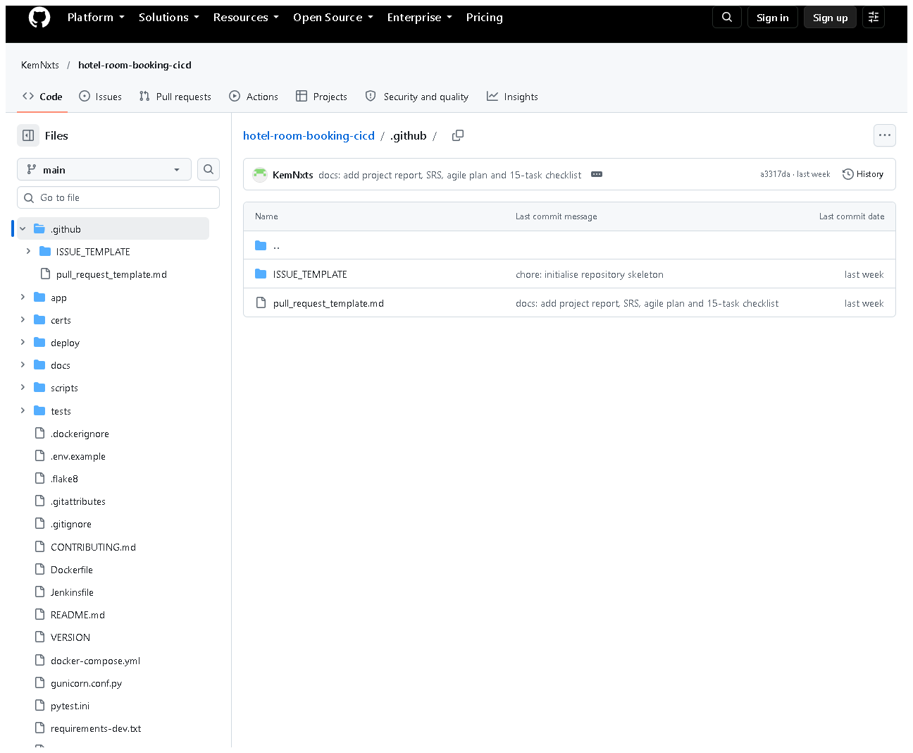
Figure 4.6 - .github/ on GitHub: ISSUE_TEMPLATE/ and pull_request_template.md.

E. How to demonstrate this task to the professor (about 3 minutes)
Before the demo: PowerShell in D:\DevOPS\CICD_FOR_HOTEL_ROOM_BOOKING; browser tab with https://github.com/KemNxts/hotel-room-booking-cicd.
- Say: "This folder is a Git repository." (Today it shows the branch feature/ui-redesign and uncommitted UI files - say they are work in progress.)
git status
- Say: "main holds releases, develop integrates features, each feature had its own branch. The tags mark the releases. origin is GitHub."
git branch -a
git tag -n1
git remote -v
- Say: "Each commit has a type prefix like feat: or fix: and the merges show each feature branch."
git log --oneline --graph -15 develop
- Say: "The very first commit was the skeleton: README, ignore rules and templates."
git show --stat 541dad5
- Open .gitignore in VS Code - point to .env, credentials/, *.key.
- On GitHub: show the file list, the branches page, the tags page and .github/.
Recovery: if git log opens a pager that "hangs", press q. If GitHub asks you to sign in, you are viewing the public page - no login is needed to read.

F. Expected screenshots for the final submission
- assets/task-04/git-branches-tags-remote.png - exists, 2026-10-20.
- assets/task-04/git-main-history.png - exists, 2026-10-20.
- assets/task-04/gitignore-and-templates.png - exists, 2026-10-20.
- assets/task-04/github-repository-home.png - exists, 2026-10-20.
- assets/task-04/github-branches.png - exists, 2026-10-20.
- assets/task-04/github-templates-folder.png - exists, 2026-10-20.
- assets/task-04/github-branch-protection.png - requires manual capture only if you configure branch protection (GitHub Settings -> Branches, needs your login).

G. Probable viva questions and answers
- Git vs GitHub? Git records history locally; GitHub hosts a copy online and adds issues, PRs and a web view.
- What is a commit? A saved snapshot of the files with an ID, author, date and message.
- Branch vs tag? A branch moves forward as you commit; a tag is fixed to one commit forever (we use tags for releases).
- Why .gitignore? To keep secrets (.env), local databases and generated files out of the repository.
- What does .gitattributes do here? Forces LF line endings so shell scripts and configs work in Linux containers even when edited on Windows.
- Explain your branch policy. main = released code, develop = integration, feature/<name> per change, fix/<name> for fixes, experiment/<name> never merged. Features merge into develop with --no-ff.
- (Project-specific) What is in your first commit? 541dad5: README, CONTRIBUTING, .gitignore, .gitattributes, issue and PR templates and empty folders.
- (Project-specific) Why do commit IDs in your evidence differ from GitHub? Messages were edited once before publishing; IDs are hashes that include the message, so all IDs changed. docs/evidence/git/commit-id-map.md maps them.
- What is a Conventional Commit? A message format type: summary, e.g. fix: reject check-out before check-in, making history easy to read.
- Is your main branch protected? Only by policy in CONTRIBUTING.md; GitHub protection rules were not configured (needs the owner's settings).
- Why have both main and develop? develop can be tested on staging while main only receives releases that passed the pipeline.

H. Common mistakes and troubleshooting
Symptom | Cause | Inspect | Fix | Confirm
git log output does not end | pager waiting | terminal | press q, or add --no-pager | prompt returns
A secret file appears in git status | missing ignore rule | git check-ignore -v <file> | add a rule to .gitignore; never commit it | file no longer listed
git push rejected | remote has newer commits / no login | git status, git fetch | git pull first; sign in to GitHub | push succeeds
Line-ending warnings (CRLF/LF) | Windows editor | .gitattributes | harmless; Git normalises to LF | -
Old commit ID not found | history rewrite | docs/evidence/git/commit-id-map.md | use the current ID | git show <id> works

I. Quick revision notes
Five key points
- Git = local history; GitHub = hosted copy + collaboration.
- Skeleton commit 541dad5: README, ignore rules, templates, CONTRIBUTING.
- Branches: main / develop / feature / fix / experiment.
- Tags v1.0.0 and v1.1.0 mark releases.
- .gitignore keeps .env, credentials and databases out of Git.
30-60 second explanation "The project is a Git repository published on GitHub. The first commit created the skeleton - README, contributing rules, ignore rules and issue and pull-request templates. We use main for releases, develop for integration and one branch per feature, with conventional commit messages. Releases are tagged v1.0.0 and v1.1.0. Secrets like .env are ignored and never committed. Everything Jenkins builds starts from a commit here."
Caveat: branch protection is a written policy, not a GitHub setting.
Readiness checklist
- â˜ I can explain branch vs tag vs commit.
- â˜ I can run git branch -a, git tag -n1, git log --graph.
- â˜ I can open the repo on GitHub and show branches and tags.
- â˜ I can explain why evidence shows different commit IDs.

Task 5 - Feature Development with Branching

A. Task title and objective
Task 5: Feature Development with Branching
Objective: develop a core feature on its own branch, with meaningful commits and tests, have it reviewed through a pull request, and merge it into develop.
Professor's required deliverables
- Feature branch
- Changes and tests on that branch
- Meaningful commits (add / commit / push / pull / log)
- Pull request with review comments / review checklist
- Merge into develop
Current status: Partially completed.
Part | Status
Feature branches, commits with tests, --no-ff merges into develop, pushed to GitHub | Implemented and verified (Git + GitHub, 2026-10-20)
Review checklist | Implemented - .github/pull_request_template.md; written review records in docs/pull-requests/
Real GitHub pull requests and review comments | Pending external action - GitHub shows 0 pull requests (Figure 5.4). Merges were done locally and then pushed.

No PR screenshots or review comments are shown here because none exist.

B. Explanation for a complete beginner
An everyday picture. Several authors write a book. Each writes a new chapter in a separate copy, so a half-finished chapter never appears in the printed book. When a chapter is ready, an editor reviews it, and only then is it added to the master copy.
- Feature branch = the separate copy for one feature (feature/security-hardening).
- develop = the master copy where finished features meet.
- Pull request (PR) = on GitHub, a request "please review and merge my branch", with a discussion page, review comments and a merge button.
- Code review = another person reads the changes before they are merged.
- Merge = adding the branch's commits into develop. With --no-ff ("no fast-forward") Git always creates a merge commit, so the history clearly shows "this group of commits was one feature".
Basic commands
Command | Meaning
git checkout -b feature/x develop | create a new branch from develop and switch to it
git add <files> | choose which changes go into the next commit
git commit -m "feat: ..." | save a snapshot with a message
git push -u origin feature/x | upload the branch to GitHub
git pull | download and apply new commits from GitHub
git log --oneline --graph | view history as a graph
git merge --no-ff feature/x | merge into the current branch with a merge commit

C. What was actually implemented
Worked example: feature/security-hardening - real output of git log --graph --oneline -4 bdfc2fb (current commit IDs):
* bdfc2fb Merge branch 'feature/security-hardening' into develop
|\
| * fd3cb60 test: add route-level integration tests and database rule tests
| * 716b910 feat: add CSRF protection, secure cookies, audit logs and DB overlap guard
|/
* 475cecd Merge branch 'feature/ansible' into develop
- Branch created from develop: git checkout -b feature/security-hardening develop.
- Commit 1 716b910 feat: - CSRF protection (app/controllers/csrf.py), secure cookie settings (app/config.py), audit logging, /health version, overlap triggers in app/schema.sql.
- Commit 2 fd3cb60 test: - new tests/integration/test_routes.py and tests/unit/test_database.py.
- Checked locally: flake8 clean, 87 tests passed at that time.
- Review record written with the PR template checklist: docs/pull-requests/feature-security-hardening.md.
- Merged: git checkout develop then git merge --no-ff feature/security-hardening -> bdfc2fb.
- Pushed to GitHub on 2026-10-12 together with all other branches and the tags.
All feature work used this pattern - 12 feature/*, 1 fix/* and 2 docs/* branches merged into develop with merge commits (Figure 5.2), e.g. feature/app-mvp, feature/tests, feature/docker, feature/jenkins-pipeline, feature/ansible, feature/ci-release-pipeline, feature/nights-column.
Review checklist (.github/pull_request_template.md): author checklist (branch name, commit convention, flake8, tests, Jenkins green, no secrets, docs) and reviewer checklist (no SQL outside app/dao/, server-side validation, ownership checks, CSRF token on new forms, tests would fail if broken).
Prepared PR descriptions (docs/pull-requests/): security hardening, CI release pipeline, release footer (with the merge conflict), release v1.1.0. These are written review records, not GitHub PRs.
Proof on GitHub that a feature branch was merged: the compare page develop...feature/nights-column says "develop is up to date with all commits from feature/nights-column" (Figure 5.3); comparing the branch with its starting point shows its own commit and diff (Figure 5.5).

D. Screenshots and evidence
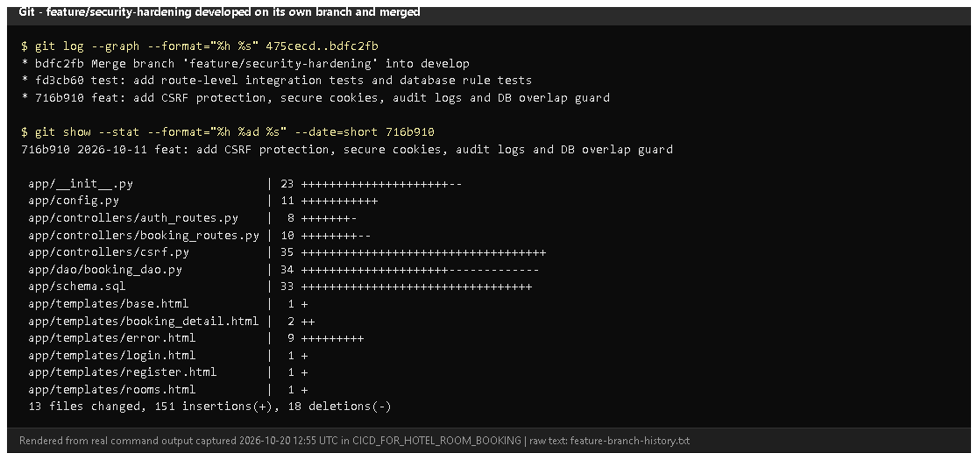
Figure 5.1 - git log --graph of feature/security-hardening and git show --stat 716b910 (rendered from real output, 2026-10-20). Notice: two commits on the side branch (a feat: and a test:), then the merge commit into develop; the file list of the feature commit. Proves: a feature branch with code and tests, merged with --no-ff.
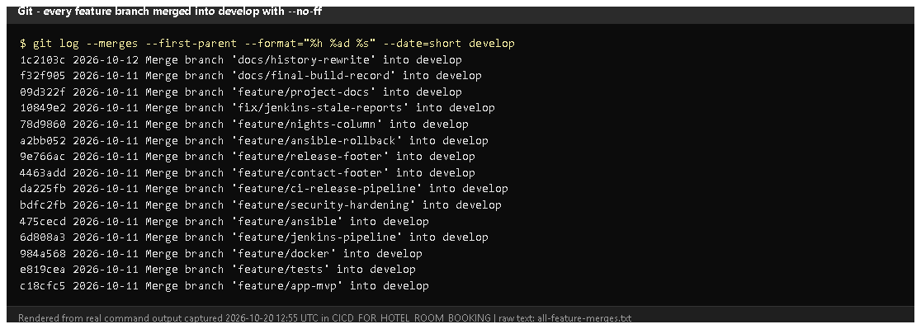
Figure 5.2 - git log --merges --first-parent develop (rendered from real output). Notice: every change arrived in develop through a Merge branch 'feature/...' commit.
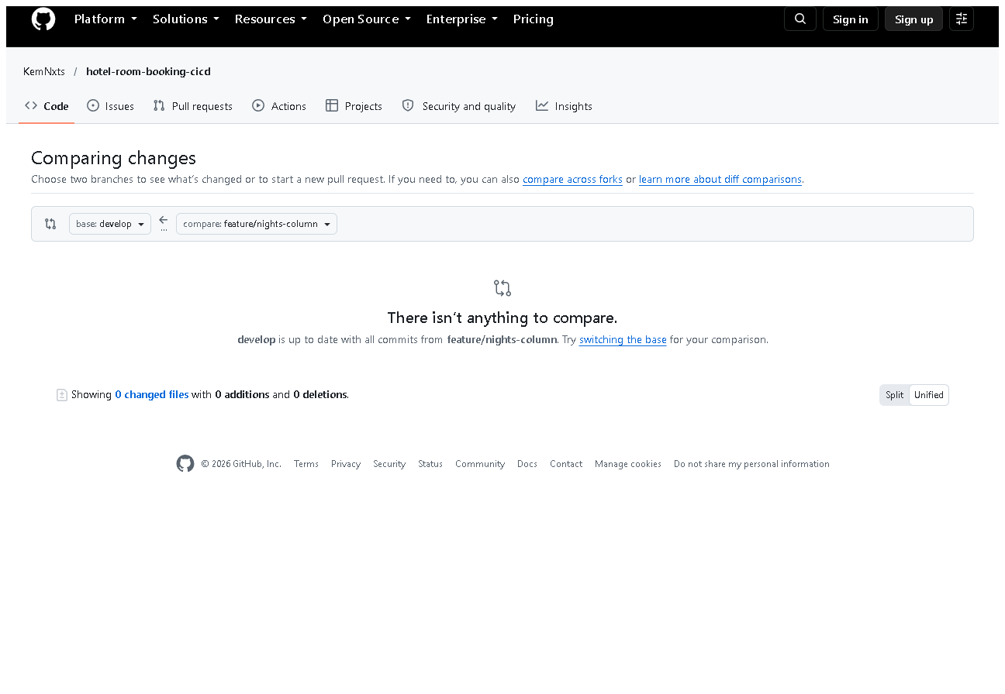
Figure 5.3 - GitHub compare develop...feature/nights-column (captured 2026-10-20). Notice: "develop is up to date with all commits from feature/nights-column".
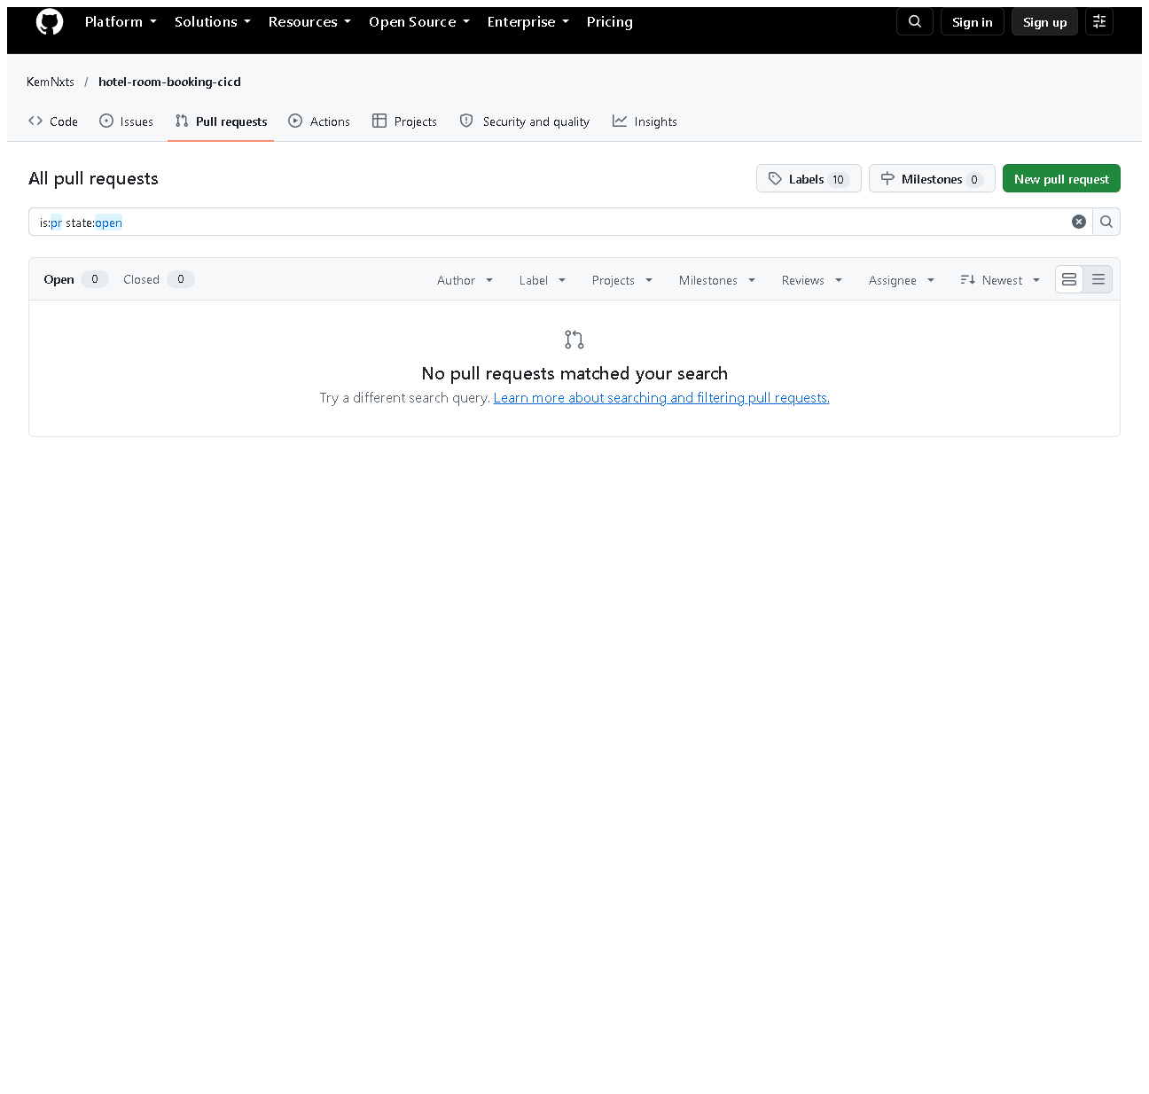
Figure 5.4 - The repository's Pull requests page (all states): none. Why included: honest evidence that real PRs are still pending.
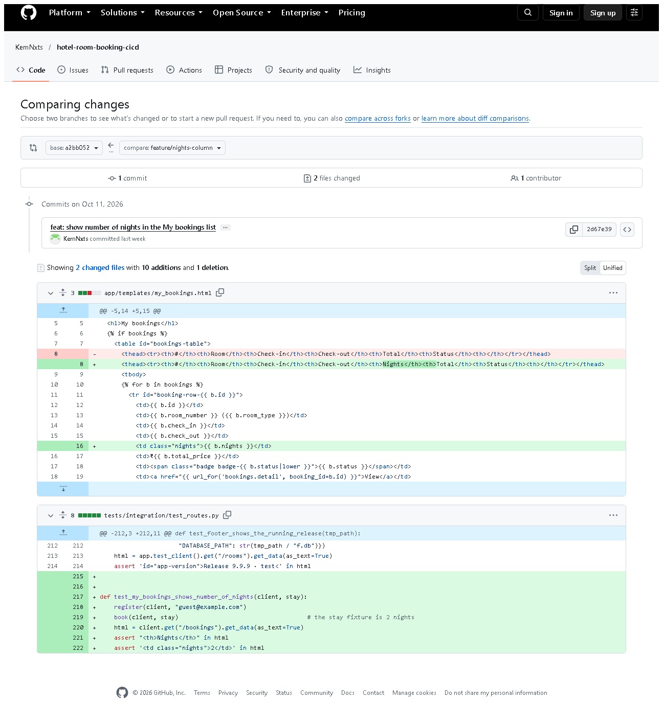
Figure 5.5 - GitHub compare from the branch's starting point a2bb052 to feature/nights-column. Notice: 1 commit (2d67e39 feat: show number of nights...), 2 files - the template change and its new test. This is a compare view, not a PR.

E. How to demonstrate this task to the professor (about 4 minutes)
Before the demo: PowerShell in D:\DevOPS\CICD_FOR_HOTEL_ROOM_BOOKING; browser on the GitHub repository.
- Expected: the graph in section C (the side line | * is the feature branch). Say: "This feature was built on its own branch with a code commit and a test commit, then merged into develop."
git log --graph --oneline -4 bdfc2fb
- Say: "Here is what the feature changed."
git show --stat 716b910
- Say: "Every feature reached develop through a merge commit."
git log --merges --first-parent --oneline develop
- Open docs/pull-requests/feature-security-hardening.md - Say: "I reviewed it with our PR checklist; this is the written review record."
- Open .github/pull_request_template.md - the checklist.
- On GitHub open Pull requests - Say honestly: "The merges were done locally and pushed, so GitHub shows no PRs yet. Here is how a real one is made:"
Live mini-demo of a real feature-branch PR (optional, needs your GitHub login, ~5 min):
git checkout develop
git pull
git checkout -b feature/demo-readme-note
# edit README.md (add one sentence), save
git add README.md
git commit -m "docs: add a note about the demo"
git push -u origin feature/demo-readme-note
Then on GitHub: Compare & pull request -> base develop -> write a description using the template -> Create pull request -> add a review comment -> Merge pull request. Capture screenshots of the PR page (see section F).
Recovery: "Your local changes would be overwritten by checkout" - you have uncommitted work (today: the UI redesign). Commit it or run git stash first, then git stash pop afterwards.

F. Expected screenshots for the final submission
- assets/task-05/feature-branch-history.png - exists, 2026-10-20.
- assets/task-05/all-feature-merges.png - exists, 2026-10-20.
- assets/task-05/github-compare-merged-into-develop.png - exists, 2026-10-20.
- assets/task-05/github-compare-feature-changes.png - exists, 2026-10-20.
- assets/task-05/github-pull-requests-empty.png - exists, 2026-10-20 (honest current state).
- assets/task-05/github-pr-open.png - a real PR with description and checklist - requires manual capture after creating a PR.
- assets/task-05/github-pr-review-comment.png - a review comment - requires manual capture.
- assets/task-05/github-pr-merged.png - the merged PR - requires manual capture.

G. Probable viva questions and answers
- Why use feature branches? Unfinished work stays out of develop, so develop always builds and passes tests; several features can progress in parallel.
- What is a pull request? A GitHub page that asks to merge one branch into another, where the change is reviewed and discussed first.
- Did you create pull requests? Not on GitHub - GitHub shows 0 PRs. I merged locally with --no-ff and pushed; the review records are in docs/pull-requests/. Creating real PRs is my remaining step.
- What does --no-ff do? Always creates a merge commit, so a feature's commits stay grouped in the history.
- git pull vs git fetch? fetch downloads new commits; pull = fetch + merge into your current branch.
- (Project-specific) Show a feature branch and its commits. feature/security-hardening: 716b910 feat: add CSRF protection... and fd3cb60 test: add route-level integration tests..., merged as bdfc2fb.
- (Project-specific) What does your review checklist check? No SQL outside DAOs, server-side validation, booking ownership, CSRF token on new forms, and that tests would fail if the code were broken.
- How did you test the feature before merging? flake8 and the full pytest suite locally; after merging, Jenkins built develop.
- What would a reviewer comment look like? A note on a specific line, e.g. "this route changes data - does the form include csrf_token?" (an example - no real comments exist yet).
- What if two features change the same lines? A merge conflict - see Task 6, where exactly that happened and was resolved.

H. Common mistakes and troubleshooting
Symptom | Cause | Inspect | Fix | Confirm
Commit went to develop instead of the feature branch | forgot checkout -b | git branch --show-current | create the branch from that commit, reset develop only if not pushed | git log shows commit on the feature branch
git push says "no upstream branch" | first push of a new branch | message text | git push -u origin <branch> | branch visible on GitHub
Checkout refused: local changes would be overwritten | uncommitted work | git status | commit or git stash | checkout succeeds
PR shows unrelated commits | branch started from the wrong base | git merge-base develop <branch> | rebase onto develop or recreate the branch | PR shows only the feature commits

I. Quick revision notes
Five key points
- One branch per feature, created from develop.
- Separate commits for code (feat:) and tests (test:).
- Merged with --no-ff, so each feature is a visible unit.
- Review checklist = .github/pull_request_template.md; records in docs/pull-requests/.
- No real GitHub PRs yet - say so and show how to make one.
30-60 second explanation "Each feature was developed on its own branch. For example feature/security-hardening has one commit adding CSRF protection and a second adding tests. I checked it with flake8 and pytest, reviewed it against our pull-request checklist, and merged it into develop with --no-ff, which keeps a merge commit in the history. All branches are pushed to GitHub, and GitHub confirms develop contains their commits. Real pull requests on GitHub haven't been created yet - that's my next step."
Caveat: review was a self-review with a checklist; there are no GitHub PRs or reviewer comments.
Readiness checklist
- â˜ I can show git log --graph for one feature.
- â˜ I can explain PR vs merge.
- â˜ I can explain honestly why GitHub shows 0 PRs.
- â˜ I know the steps to create a real PR.

Task 6 - MVP Completion and Git Collaboration

A. Task title and objective
Task 6: MVP Completion and Git Collaboration
Objective: finish all six booking workflows securely, and show collaboration with Git: a second feature branch, a real merge conflict and its resolution, release tags and a stable source baseline.
Professor's required deliverables
- All six workflows: registration/login, availability, booking request, confirmation, cancellation, status tracking
- A second feature branch
- A real merge conflict and its resolution
- A version tag and a release-ready baseline
- Updated backlog
- Security: password hashing, session protection, server-side validation, authorisation
Current status: Implemented and verified.
- Six workflows: 5/5 Selenium journeys and 85 unit/integration tests passed on 2026-10-20.
- Merge conflict: happened for real on 2026-10-11 (output saved at the time), the resolution commit 9e766ac is in Git, and on 2026-10-20 the same conflict was reproduced in a throw-away clone (section E).
- Tags v1.0.0 and v1.1.0 exist locally and on GitHub.
Note: the application screenshots below show the redesigned interface that currently runs from the working tree (branch feature/ui-redesign, not yet committed). The six workflows behave the same in the committed v1.1.0.

B. Explanation for a complete beginner
An everyday picture. Two people edit the same sentence of a shared document while offline. When they sync, the software cannot know which version to keep, so it shows both and asks a human. That is a merge conflict.
Why conflicts happen in Git. Git merges automatically when two branches change different lines. When both change the same lines, Git stops, marks the file with <<<<<<<, =======, >>>>>>> and asks you to decide. Resolving means editing the file to the correct final content, testing, and committing the merge.
Branch vs tag. A branch is a moving pointer that advances with every new commit (like a bookmark you keep moving). A tag is a fixed label on one commit (like engraving "Release 1.0" on one page). Releases get tags so you can always return to exactly what was shipped.
MVP - the six workflows that make the portal useful. Stable baseline - a tagged commit on main that passed the whole pipeline.
Security terms: password hashing - storing a one-way scrambled form of the password, never the password itself; session - the login cookie; authorisation - checking a user may access this booking.

C. What was actually implemented
The six workflows
# | Workflow | Route | Service function | Verified by
1 | Register / log in | /register, /login | AuthService.register, login | journeys 1, 2
2 | Availability by date | GET /rooms?check_in=&check_out= | BookingService.search_rooms | journey 3, 5
3 | Booking request -> PENDING | POST /bookings | request_booking | journey 3
4 | Confirmation -> CONFIRMED | POST /bookings/<id>/confirm | confirm_booking | journey 3
5 | Cancellation -> CANCELLED | POST /bookings/<id>/cancel | cancel_booking | journey 4
6 | Status tracking | GET /bookings | list_bookings | journey 4

Security in code
- Passwords: generate_password_hash / check_password_hash (Werkzeug, scrypt) in app/services/auth_service.py (lines 35, 46).
- Session cookie HttpOnly + SameSite=Lax (app/config.py); CSRF token on every form (app/controllers/csrf.py).
- Server-side validation of e-mail, name, password length, dates (auth_service.py, booking_service.py validate_stay).
- Authorisation: get_booking returns "not found" for another user's booking (integration test test_other_users_cannot_see_confirm_or_cancel_my_booking).
Second feature branch and the real merge conflict
Two features started from the same develop commit (da225fb, original f4d0b26):
Branch | Commit (current / original) | Change
feature/contact-footer | 74a153d / 65ad990 | footer with hotel contact details
feature/release-footer | 63498a8 / c24148f | footer showing the running release

Both added a footer in the same place. contact-footer merged first (4463add). Merging release-footer then gave (saved 2026-10-11):
CONFLICT (content): Merge conflict in app/static/style.css
CONFLICT (content): Merge conflict in app/templates/base.html
CONFLICT (content): Merge conflict in tests/integration/test_routes.py
Automatic merge failed; fix conflicts and then commit the result.
Resolution (merge commit 9e766ac, original 8728b62): both features were wanted, so both lines were kept - contact first, release second; one combined CSS rule; both tests kept. Then flake8 was clean and 89 tests passed, and the merge was committed with a message describing each decision.
Release tags and baseline
Tag | Commit on main | Pipeline evidence
v1.0.0 | 224de14 (original 661751d) | Jenkins #4 (develop) and #5 (main -> prod) green
v1.1.0 | ce1726d (original d07929b) | Jenkins #6/#7 (develop) and #8 (main -> prod) green

The production environment still runs 1.1.0-d07929b - the v1.1.0 release.
Backlog update - docs/02-agile-plan.md marks HB-06 Done; the merge conflict is recorded as a sprint-retrospective lesson.

D. Screenshots and evidence
The six workflows (redesigned UI, working tree, 2026-10-20)
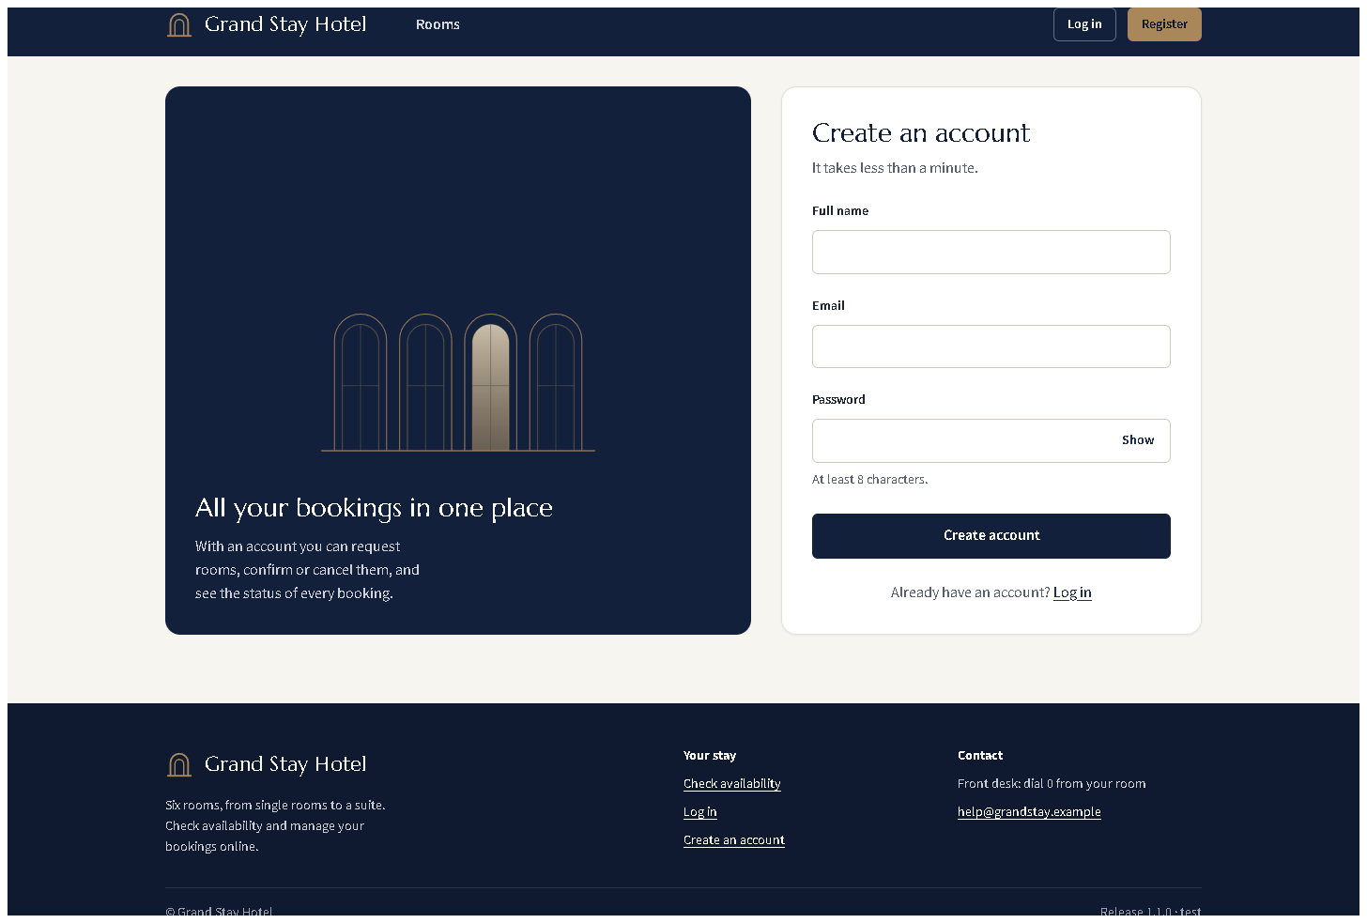
Figure 6.1 - Workflow 1: registration form with labelled fields and the password rule.
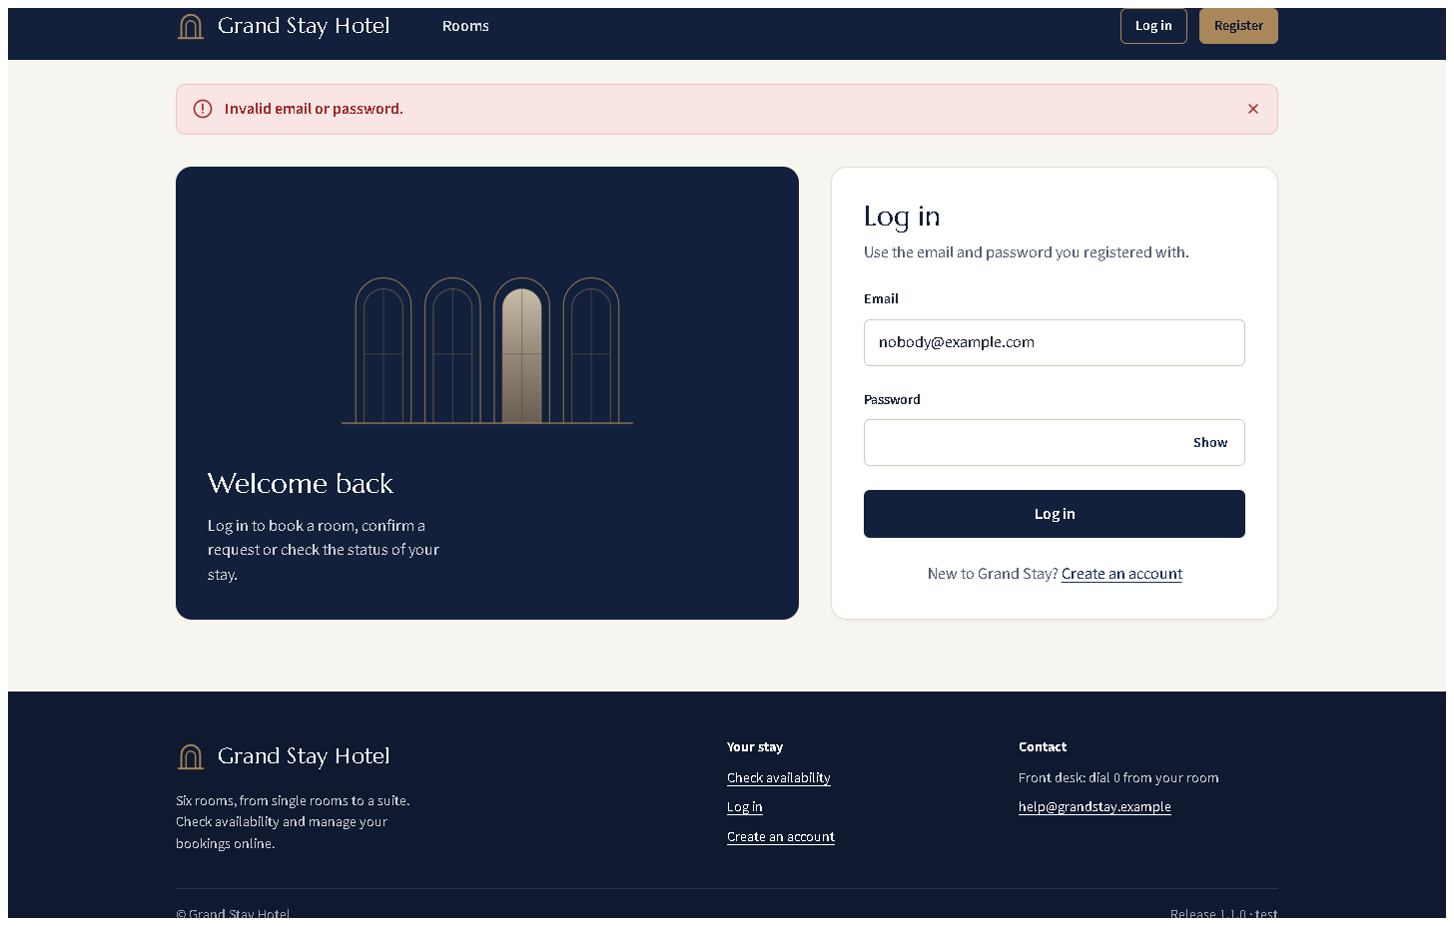
Figure 6.2 - Workflow 1: login with wrong credentials shows a neutral error (does not reveal which part was wrong).
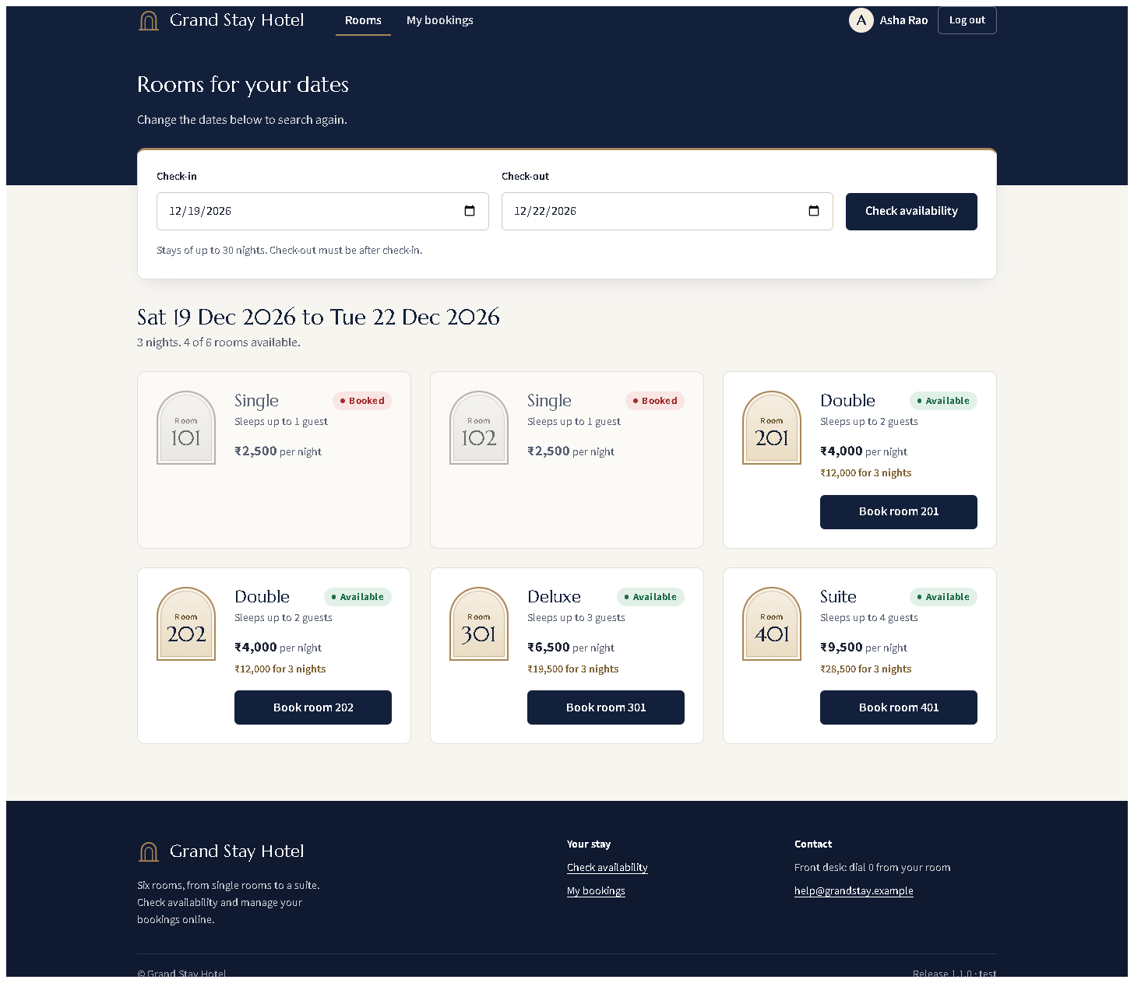
Figure 6.3 - Workflow 2: availability for the chosen dates - booked rooms marked "Booked", free rooms with the total for the stay.
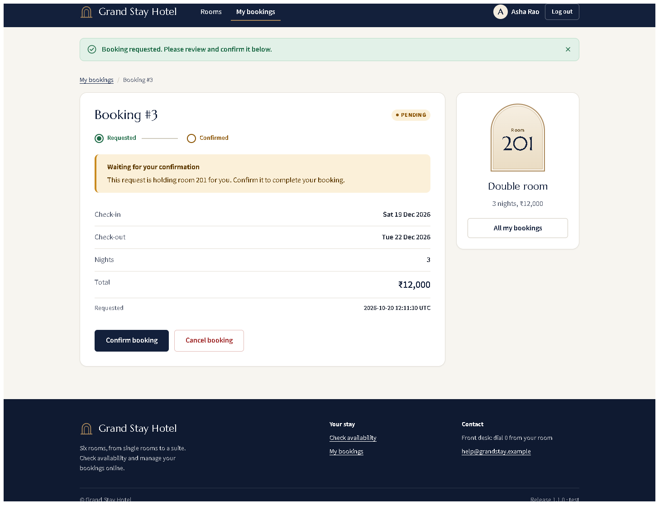
Figure 6.4 - Workflow 3: the new booking is PENDING.
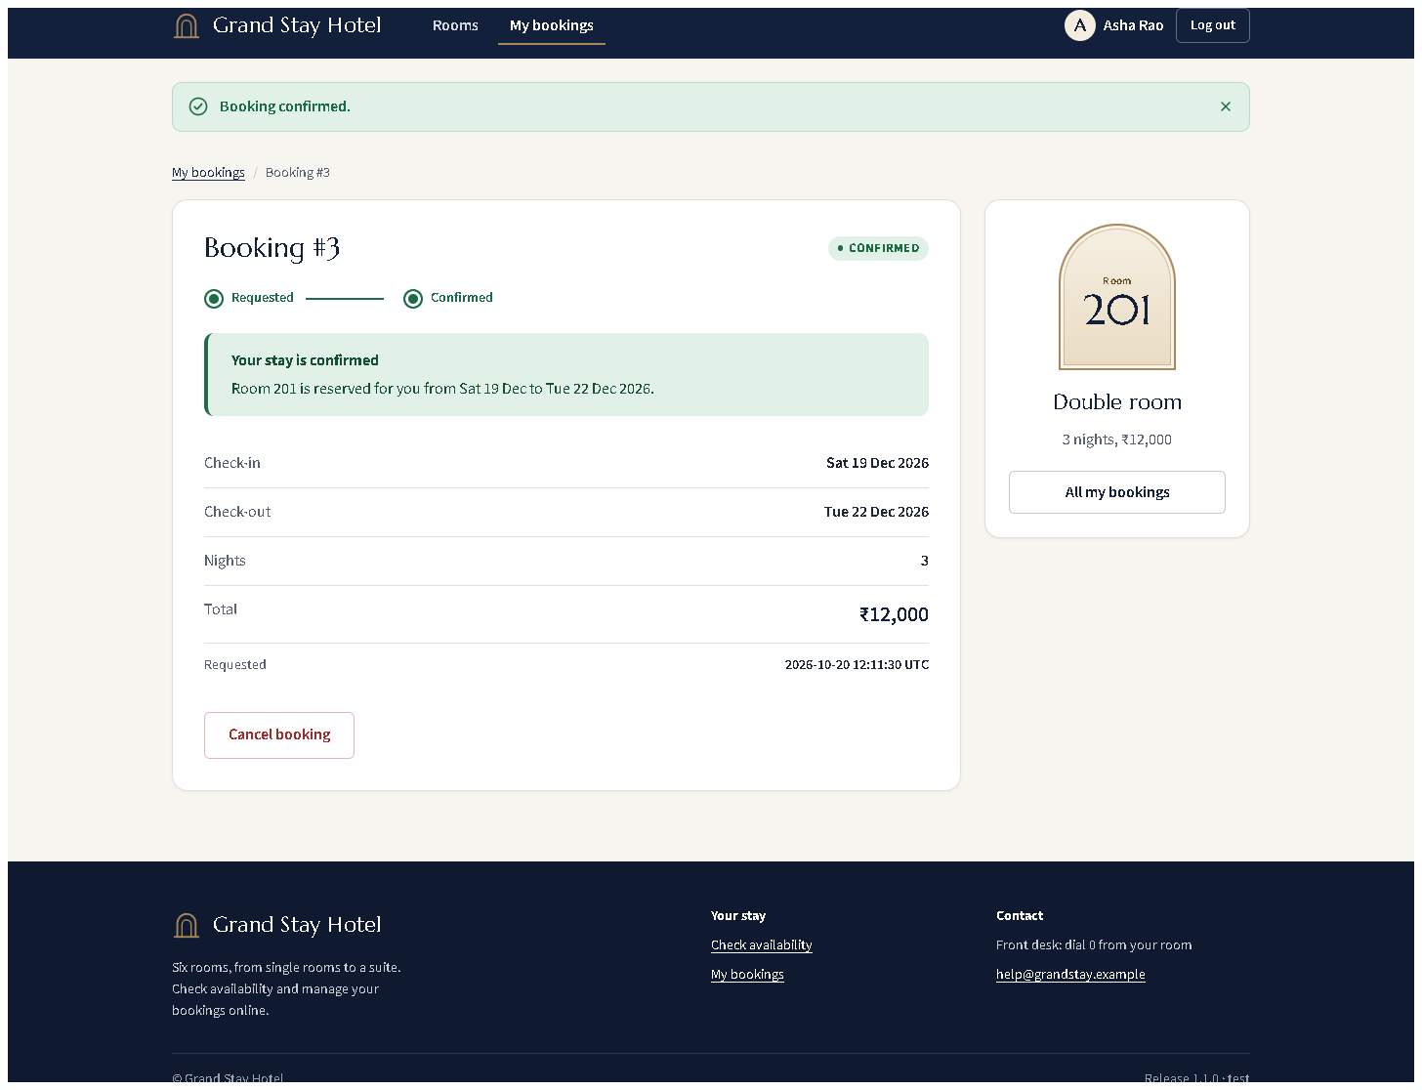
Figure 6.5 - Workflow 4: CONFIRMED, progress shows both steps done.
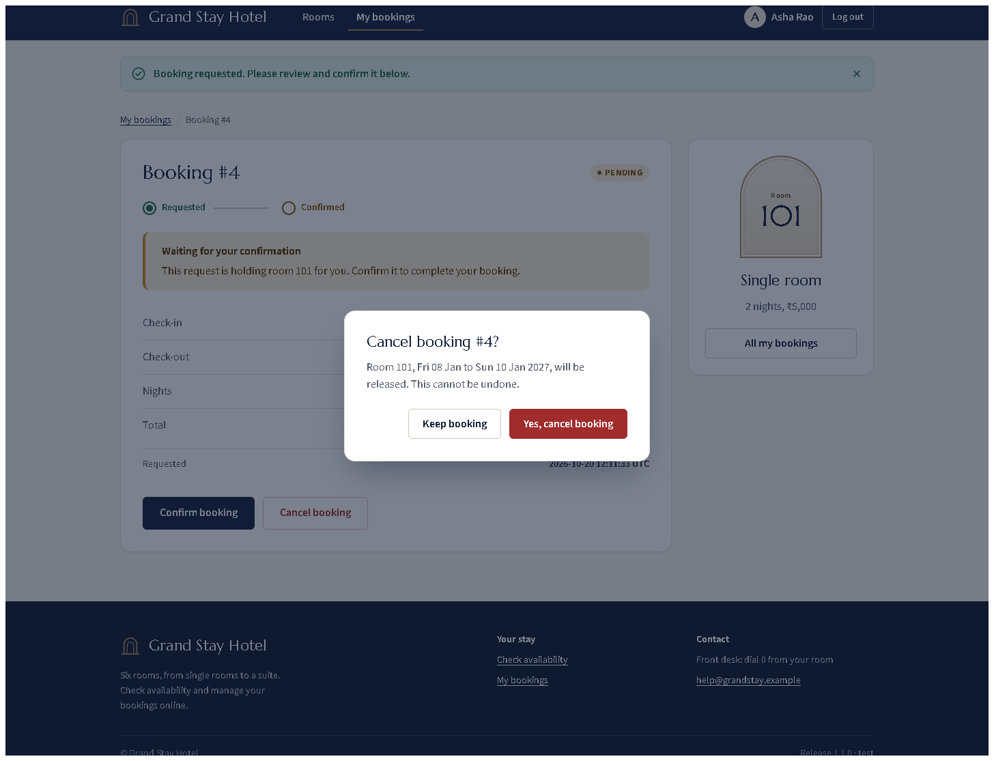
Figure 6.6 - Workflow 5: cancelling opens a confirmation dialog first.
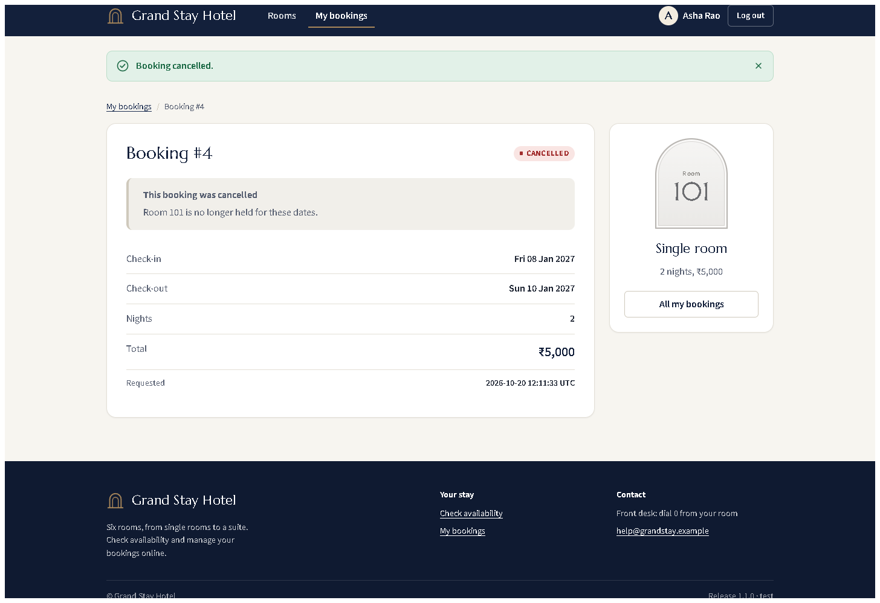
Figure 6.7 - Workflow 5: status CANCELLED, room released.
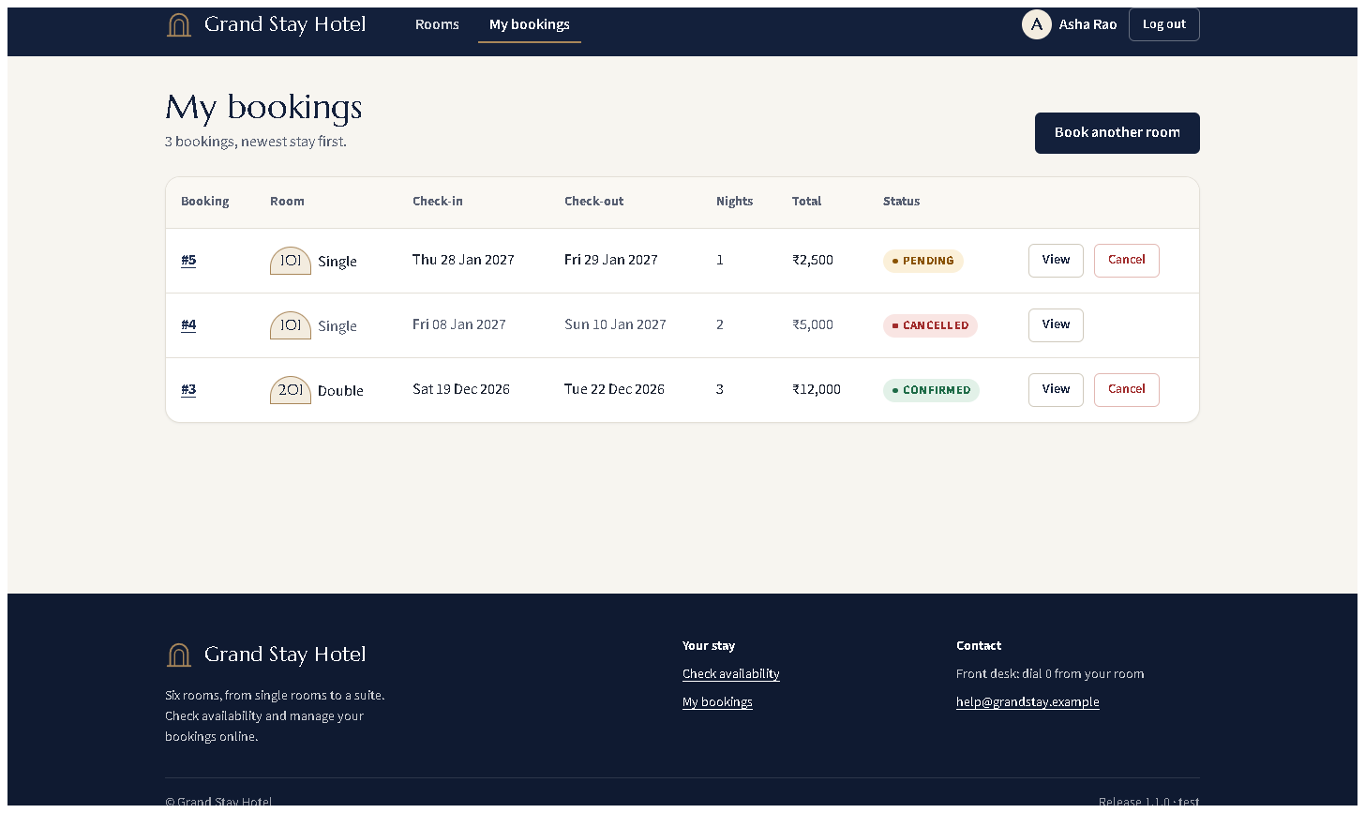
Figure 6.8 - Workflow 6: status tracking for all of the guest's bookings (PENDING, CANCELLED, CONFIRMED).
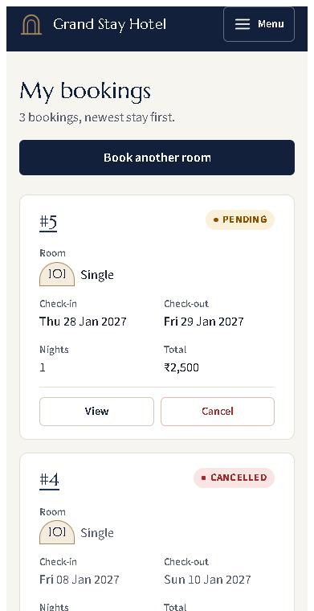 (part 1 of 3)
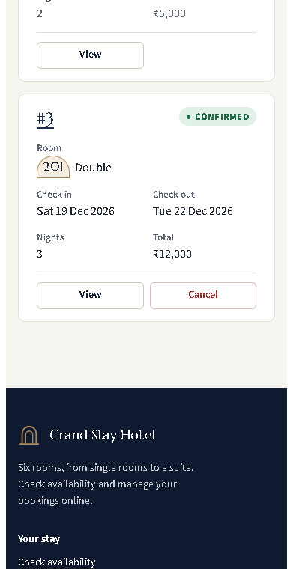 (part 2 of 3)
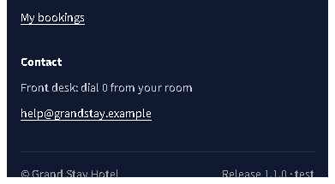 (part 3 of 3)
Figure 6.9 - The same page at phone width (375 px).
Collaboration
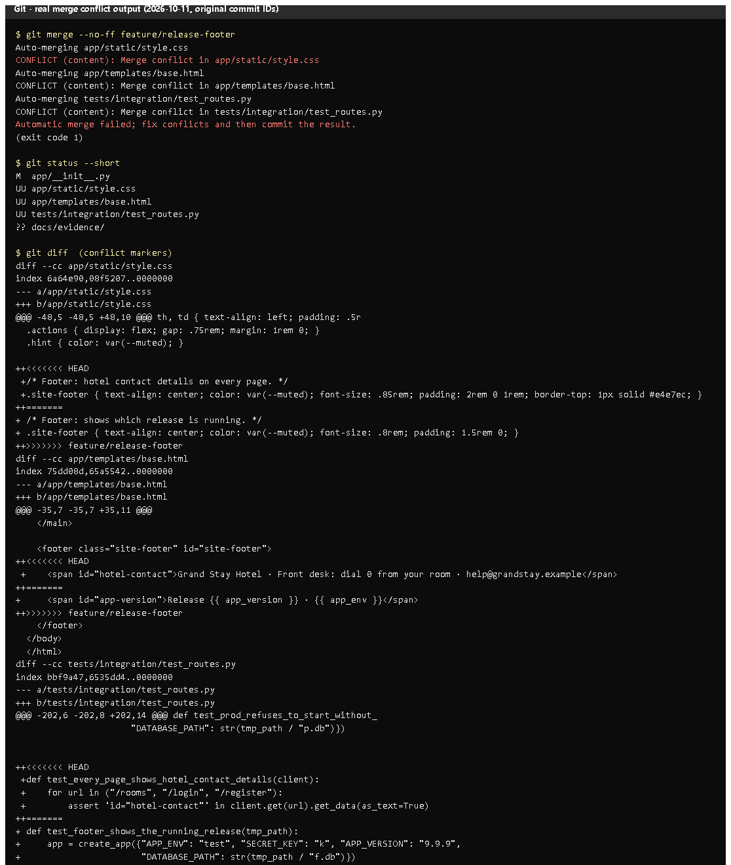 (part 1 of 2)
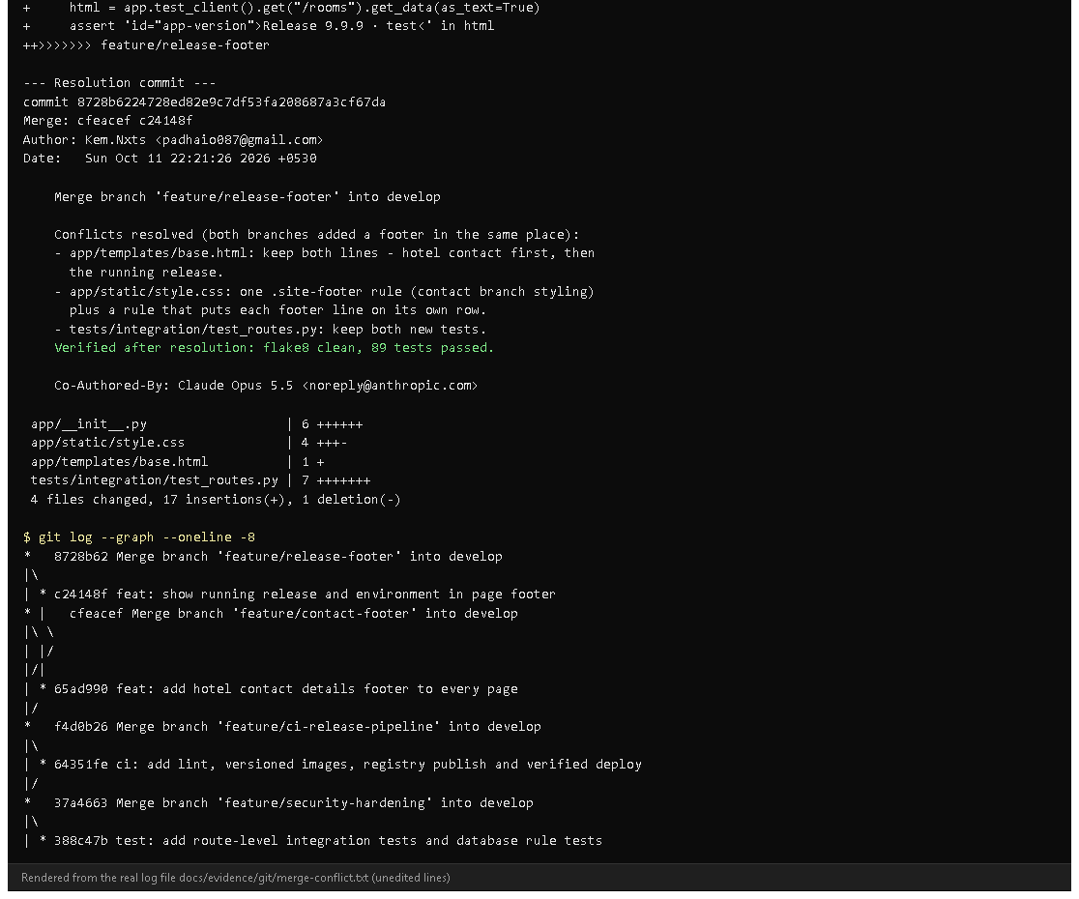 (part 2 of 2)
Figure 6.10 - The conflict as recorded on 2026-10-11 (rendered from docs/evidence/git/merge-conflict.txt; original commit IDs). Notice: three CONFLICT (content) lines and the conflict markers from both branches. Proves: the conflict was real Git output, not described afterwards.
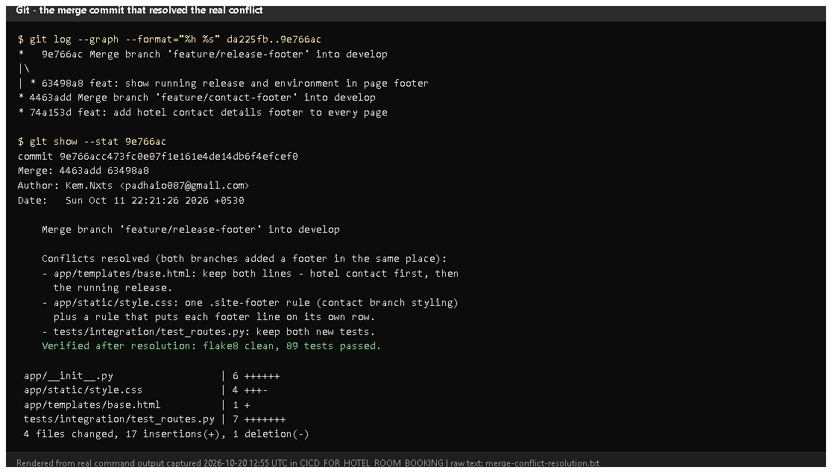
Figure 6.11 - git log --graph and git show --stat 9e766ac today (rendered from real output). Notice: the two footer branches in the graph and the merge message describing each resolution decision.
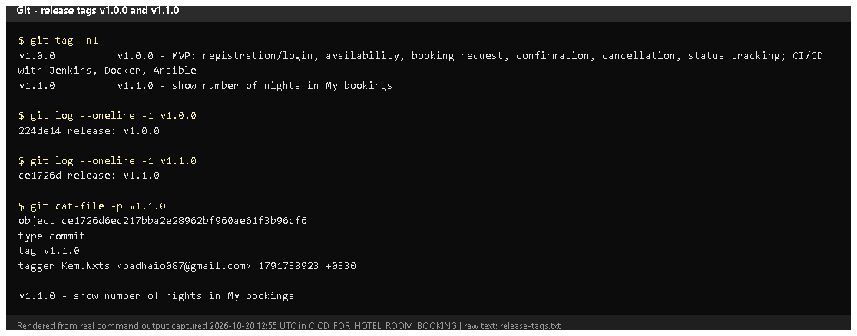
Figure 6.12 - git tag -n1 and the annotated tag object of v1.1.0 (rendered from real output).
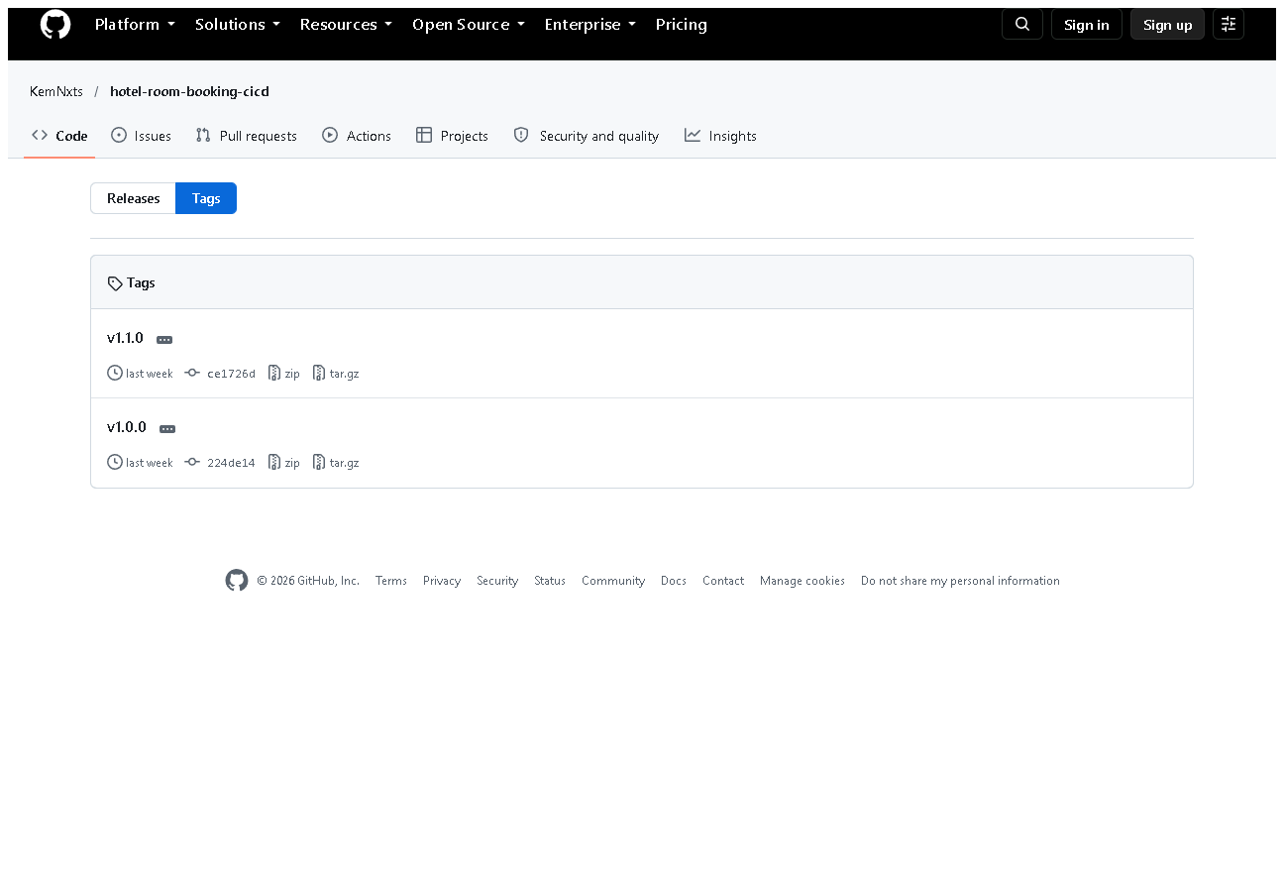
Figure 6.13 - v1.0.0 and v1.1.0 on GitHub.
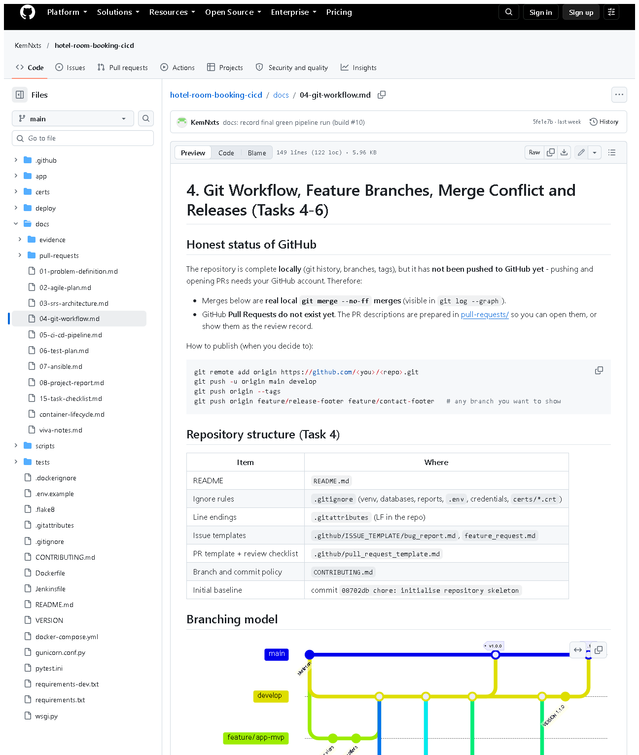 (part 1 of 3)
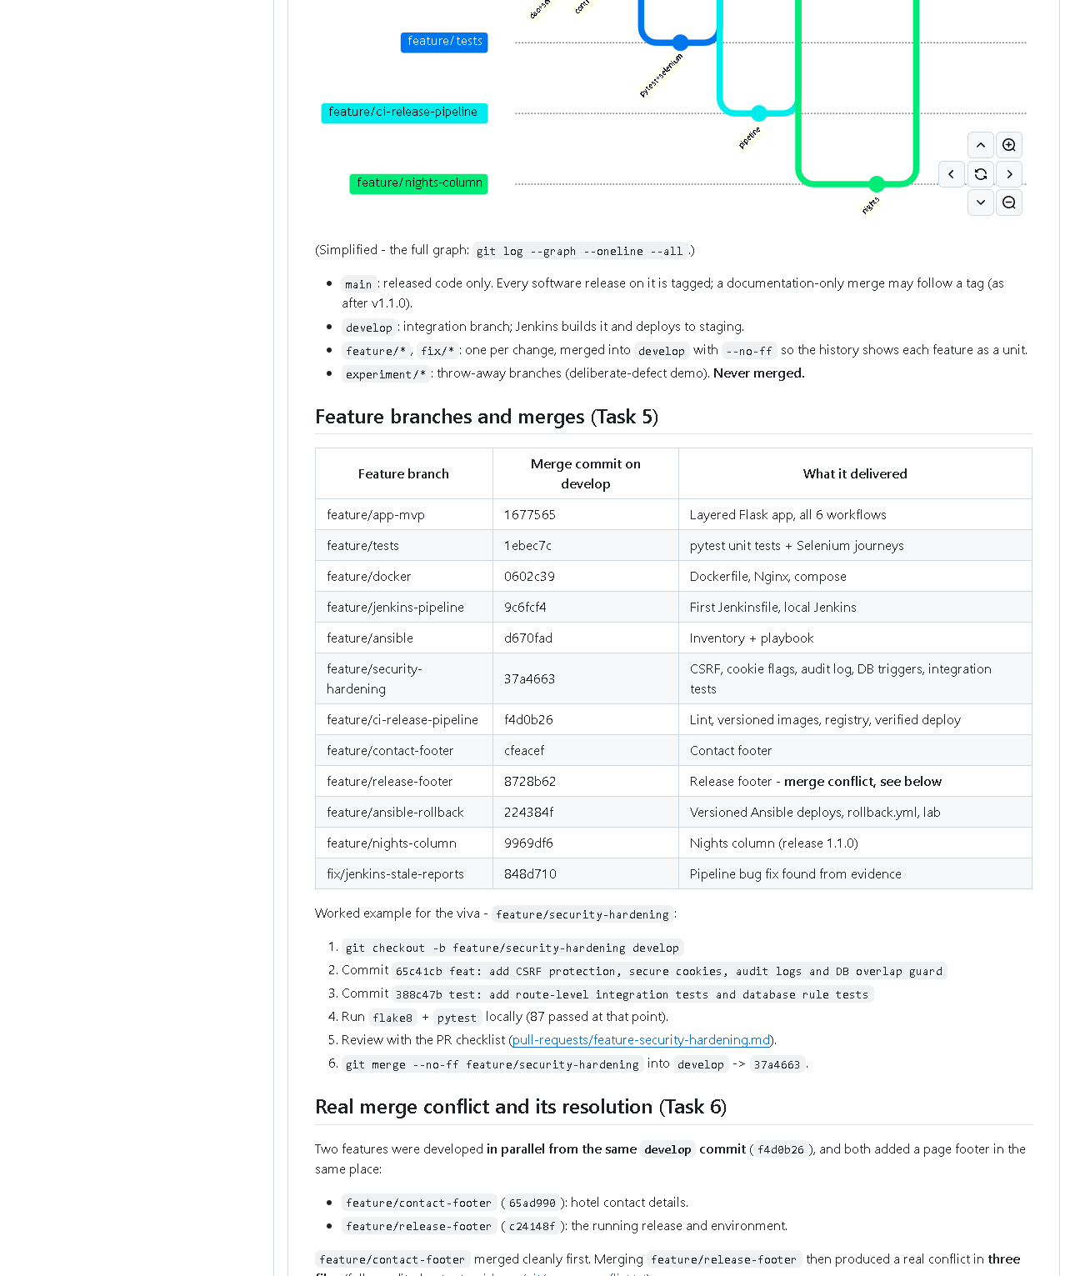 (part 2 of 3)
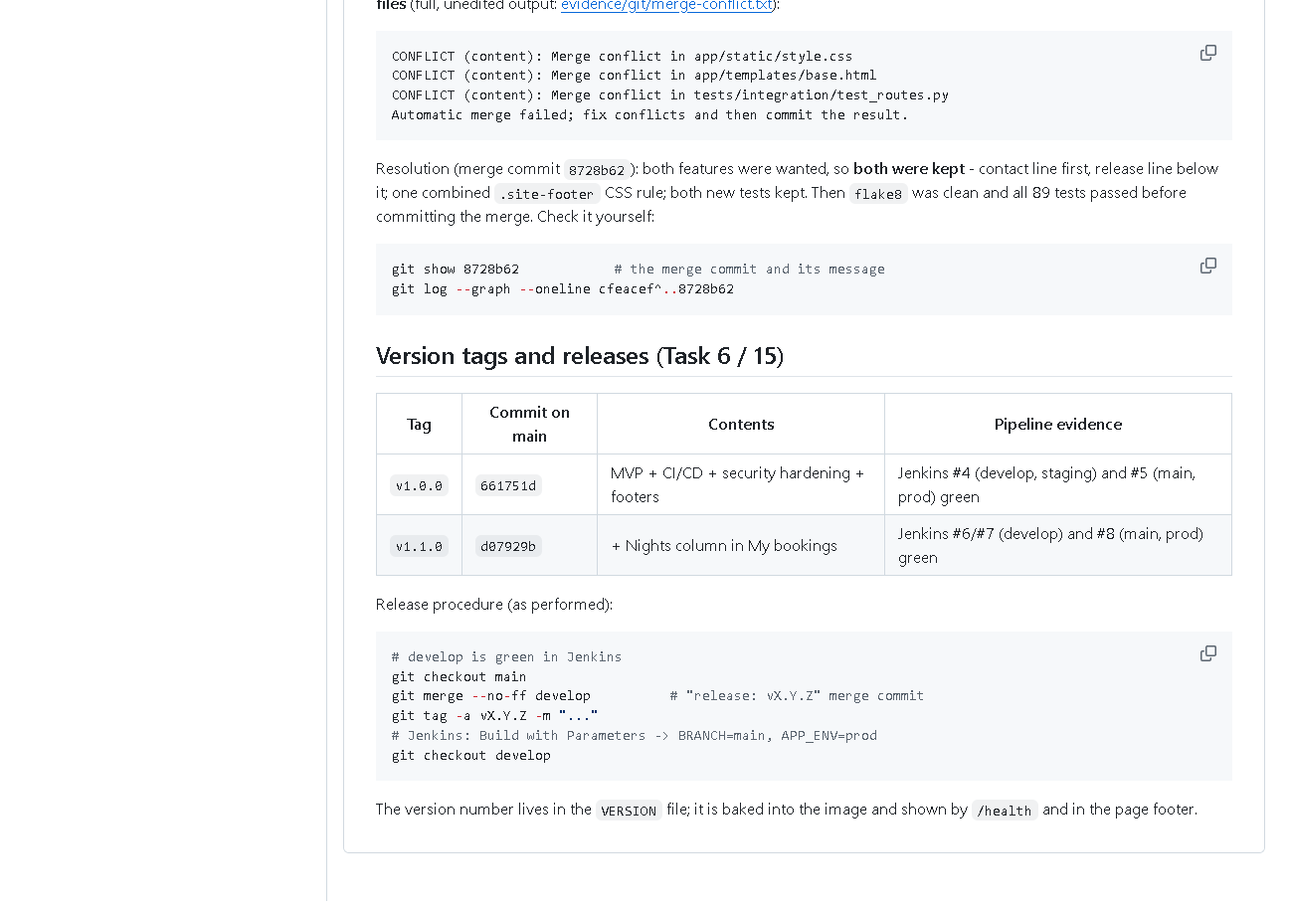 (part 3 of 3)
Figure 6.14 - docs/04-git-workflow.md on GitHub: branching model, merges, the conflict story and the release procedure.

E. How to demonstrate this task to the professor (about 5 minutes)
Before the demo: PowerShell in D:\DevOPS\CICD_FOR_HOTEL_ROOM_BOOKING.
Part 1 - the six workflows (browser).
.venv\Scripts\python -m flask --app wsgi run --port 5001
Open http://127.0.0.1:5001: register -> search dates -> Book room -> Confirm booking -> book another -> Cancel booking -> Yes, cancel booking -> My bookings. Say: "These are the six MVP workflows; they are also checked automatically by five Selenium journeys."
Part 2 - the real merge conflict, replayed safely in a throw-away copy (new PowerShell window; nothing in the real repository changes):
cd $env:TEMP
git clone D:\DevOPS\CICD_FOR_HOTEL_ROOM_BOOKING conflict-demo
cd conflict-demo
git checkout -b replay da225fb
git merge --no-ff --no-edit origin/feature/contact-footer
git merge --no-ff --no-edit origin/feature/release-footer
Expected: the first merge succeeds; the second prints three CONFLICT (content) lines and "Automatic merge failed" (verified 2026-10-20).
git status
git diff
Point to: UU files and the <<<<<<< HEAD / ======= / >>>>>>> blocks. Say: "Both branches added a footer in the same place, so Git asks a human. I kept both lines." Then show the real resolution and clean up:
git merge --abort
git show --stat 9e766ac
cd ..
Remove-Item -Recurse -Force conflict-demo
Part 3 - tags. In the project folder:
git tag -n1
git show v1.0.0 --stat --oneline
Say: "Tags are fixed labels for the released commits; branches keep moving."
Recovery: if git clone says the folder exists, run Remove-Item -Recurse -Force $env:TEMP\conflict-demo first.

F. Expected screenshots for the final submission
- assets/task-06/app-desktop-03-register.png - exists, 2026-10-20 (copied from docs/ui-evidence/after/).
- assets/task-06/app-desktop-05-login-error.png - exists, 2026-10-20.
- assets/task-06/app-desktop-06-availability-logged-in.png - exists, 2026-10-20.
- assets/task-06/app-desktop-08-booking-requested.png - exists, 2026-10-20.
- assets/task-06/app-desktop-09-booking-confirmed.png - exists, 2026-10-20.
- assets/task-06/app-desktop-10-cancel-dialog.png - exists, 2026-10-20.
- assets/task-06/app-desktop-11-booking-cancelled.png - exists, 2026-10-20.
- assets/task-06/app-desktop-12-my-bookings.png - exists, 2026-10-20.
- assets/task-06/app-mobile-12-my-bookings.png - exists, 2026-10-20.
- assets/task-06/merge-conflict-output.png - exists (rendered from the 2026-10-11 log).
- assets/task-06/merge-conflict-resolution.png - exists, 2026-10-20.
- assets/task-06/release-tags.png - exists, 2026-10-20.
- assets/task-06/github-release-tags.png - exists, 2026-10-20.
- assets/task-06/github-doc-04-git-workflow.png - exists, 2026-10-20.

G. Probable viva questions and answers
- What is a merge conflict? Two branches changed the same lines; Git cannot choose, so a human edits the result.
- How did your conflict happen? Two features branched from the same commit and both added a footer in base.html (plus CSS and a test). The second merge conflicted in all three files.
- How did you resolve it? Kept both features (contact line, then release line), merged the CSS into one rule, kept both tests, ran flake8 and all tests (89 passed), then committed the merge 9e766ac.
- How do you know you didn't break anything? Tests after resolution, and Jenkins build #4 of develop was green before the v1.0.0 release.
- Branch vs tag? A branch moves with new commits; a tag stays on one commit.
- Why tag releases? To redeploy or roll back exactly what was released (v1.0.0 was used for the Ansible rollback demo).
- (Project-specific) How are passwords stored? Werkzeug scrypt hashes (generate_password_hash), never plain text - a unit test checks this.
- (Project-specific) What stops one guest cancelling another's booking? The service checks the owner; another user gets 404 and the status stays unchanged (integration test).
- What is a stable baseline? A tagged commit on main that passed the full pipeline - v1.1.0 (ce1726d), running in prod.
- Why are there two IDs for the same commit in your documents? The messages were edited once before publishing (removing a co-author line); the map is in docs/evidence/git/commit-id-map.md.
- Is the conflict screenshot genuine? Yes - Git's own output was saved to a file at the time, and the conflict can be reproduced live from the pushed branches, as in the demo.

H. Common mistakes and troubleshooting
Symptom | Cause | Inspect | Fix | Confirm
Replay merge does not conflict | wrong start commit | git log --oneline -1 | start from da225fb | three CONFLICT lines
Conflict markers left in a file | resolution incomplete | git grep -n "<<<<<<<" | edit file, remove markers | grep finds nothing; tests pass
git merge --abort fails | merge already committed | git status | in the throw-away clone just delete it | folder removed
Booking button missing | logged out, or room booked | page shows "Log in to book"/"Booked" | log in / choose other dates | Book button appears
HTTP 400 on a form | stale CSRF token | page open across restart | reload the page | form submits

I. Quick revision notes
Five key points
- Six workflows, each with a route, a service function and a Selenium journey.
- Security: hashed passwords, CSRF tokens, secure cookies, owner checks.
- Real conflict between feature/contact-footer and feature/release-footer, 3 files.
- Resolved by keeping both; merge commit 9e766ac; 89 tests passed afterwards.
- Releases tagged v1.0.0, v1.1.0; prod runs v1.1.0.
30-60 second explanation "All six booking workflows are complete and tested by Selenium. For collaboration, two features were developed in parallel from the same commit - a contact footer and a release footer. Both changed the same lines, so the second merge produced a real conflict in three files. I kept both features, ran all tests, and committed the merge. After the pipeline passed, I merged develop into main and tagged the releases v1.0.0 and v1.1.0. I can replay the conflict live in a throw-away copy of the repository."
Caveat: the screenshots show the new UI, which is not yet committed or deployed.
Readiness checklist
- â˜ I can click through all six workflows.
- â˜ I can replay the conflict in a temp clone and explain the markers.
- â˜ I can explain branch vs tag.
- â˜ I can explain the two commit IDs.

Task 7 - Jenkins Installation and Continuous Integration

A. Task title and objective
Task 7: Jenkins Installation and Continuous Integration (CI) Job
Objective: install Jenkins and configure a job that, for every change, checks out the repository, prepares Python, installs dependencies, runs static checks and tests, publishes test reports and archives artifacts.
Professor's required deliverables
- Jenkins installed and a job configured for the repository
- Checkout; Python environment; reproducible dependency installation
- Linting / syntax checks
- pytest execution and test reports
- Archived artifacts (source package + reports)
- Build trigger: GitHub webhook if possible, otherwise polling or manual trigger (documented)
Current status: Implemented and verified. A real run on 2026-10-20 - Jenkins build #11 - passed every stage with 90 tests and archived its artifacts (Figures 7.3-7.5). All 11 builds are visible in Jenkins (Figure 7.1).
Two honest points:
- Trigger: Jenkins polls Git every ~5 minutes (pollSCM) and builds are started with Build with Parameters. A GitHub webhook was not set up because this Jenkins runs on localhost, which GitHub cannot reach.
- Build tool: the job uses Python tools (pip, compileall, flake8, pytest), not a Maven job. Professor's approval of this equivalent is needed.

B. Explanation for a complete beginner
An everyday picture. Imagine a quality inspector at a factory who, every time a new batch of parts arrives, takes them, assembles a sample, runs all the standard checks and writes a report - every time, the same way, without being asked. Jenkins is that inspector for code.
Continuous Integration (CI) - every change is automatically built and tested soon after it is committed, so problems are found within minutes, not weeks later.
Term | Meaning | In this project
Jenkins | an automation server that runs jobs | Jenkins LTS 2.580.1 in a Docker container, http://localhost:8090
Job | a configured task Jenkins can run | hotel-booking
Pipeline | a job made of ordered stages | defined in the Jenkinsfile (Task 8)
Build | one run of the job, numbered | #1 ... #11
Agent | the machine where steps run | here the Jenkins container itself (built-in node)
Trigger | what starts a build | polling every 5 min, or a person clicking Build
Polling | Jenkins asks Git "anything new?" on a schedule | pollSCM('H/5 * * * *')
Webhook | GitHub tells Jenkins immediately when something is pushed | not possible: Jenkins not reachable from the internet
Linting | automatic style/error checking without running the code | flake8
Artifact | a file produced by a build and kept with it | source tarball + checksum, test XML, deployment record
Plugin | add-on for Jenkins | Pipeline, Git, JUnit, Credentials Binding, Stage View, Timestamper

Three different things - don't mix them up
- An installed Jenkins - the server is running (http://localhost:8090 answers).
- A saved pipeline definition - the Jenkinsfile in Git.
- An executed job - a numbered build with results, e.g. build #11 SUCCESS.
Only (3) proves the CI works; this report shows all three.

C. What was actually implemented
Installation as code - deploy/jenkins/:
File | Purpose
Dockerfile | Jenkins LTS (JDK 21) + Python 3.11 + Chromium & chromedriver (for Selenium) + Docker CLI with the compose plugin; trusts extra CA certificates from certs/
plugins.txt | workflow-aggregator, git, junit, credentials-binding, pipeline-stage-view, timestamper
init.groovy.d/01-setup.groovy | on first start: creates user admin (password from .env), the secret-text credential hotel-secret-key, and the job hotel-booking ("Pipeline script from SCM", repository file:///repo, branch */${BRANCH}, parameters APP_ENV/BRANCH/REGISTRY)
docker-compose.yml | runs Jenkins on 127.0.0.1:8090 and a local image registry on 127.0.0.1:5000; mounts the repository read-only at /repo and the host's Docker socket
.env.example | template for the git-ignored .env (JENKINS_ADMIN_PASSWORD, HOTEL_SECRET_KEY)

Start command (from deploy\jenkins): docker compose up -d --build.
What the CI part of the job does (stages from the Jenkinsfile):
Stage | Command | Fails when
Checkout | checkout scm, rm -rf reports dist, read VERSION + commit | branch missing
Install dependencies | python3.11 -m venv .venv then pip install -r requirements-dev.txt (pinned versions) | a package cannot be installed
Static checks | python -m compileall -q app wsgi.py + flake8 app tests scripts wsgi.py gunicorn.conf.py | syntax or lint error
Unit & integration tests | pytest tests/unit tests/integration --junitxml=reports/unit-integration-tests.xml | any test fails
E2E tests (Selenium) | pytest -m e2e --junitxml=reports/e2e-tests.xml | any journey fails
Package source | git archive ... -o dist/hotel-booking-<tag>.tar.gz + sha256sum | -

Reports and artifacts (post { always { ... } }, Jenkinsfile lines 211-212):
junit allowEmptyResults: true, testResults: 'reports/*.xml' // test trend + Tests page
archiveArtifacts artifacts: 'reports/**, dist/**', allowEmptyArchive: true // kept with the build
Build #11 archived: hotel-booking-1.1.0-1c2103c.tar.gz (+ .sha256), unit-integration-tests.xml, e2e-tests.xml, health.json, deployment.txt.
Build history (from the Jenkins API, 2026-10-20)
Build | Branch | Result
#1 | feature/ci-release-pipeline | SUCCESS
#2 | experiment/defect-demo | FAILURE (deliberate defect, Task 10)
#3-#8 | experiment fix, develop, main | SUCCESS
#9 | experiment/defect-demo-2 | FAILURE (deliberate, Task 10)
#10 | develop | SUCCESS
#11 | develop (1c2103c) | SUCCESS, 90 tests, 103 s - run during this audit

Python instead of Maven. A Maven job would run mvn test on a Java project. This project is Python, so the equivalent steps are pip (dependencies), compileall + flake8 (compile/lint) and pytest (tests, writing the same JUnit XML format that Maven's Surefire plugin writes). They are not Maven.

D. Screenshots and evidence
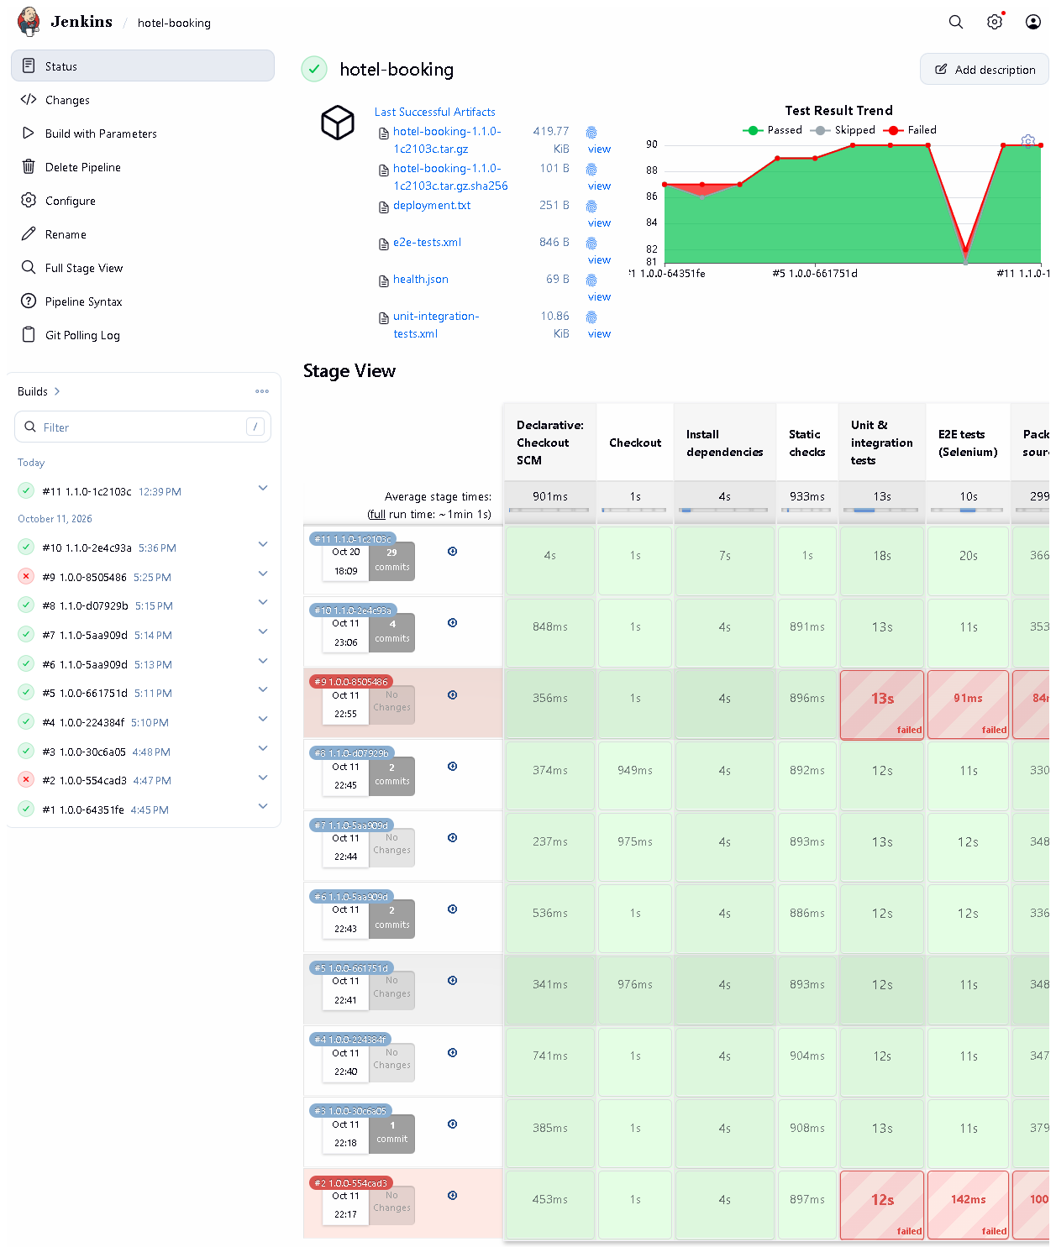 (part 1 of 2)
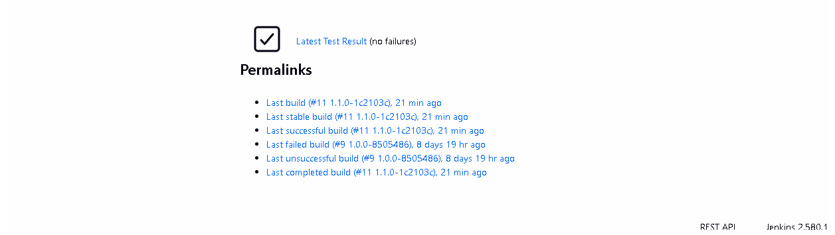 (part 2 of 2)
Figure 7.1 - Job hotel-booking: build history #1-#11, test-result trend, last artifacts and the stage view (captured 2026-10-20). Notice: builds #2 and #9 red, all others green; each stage's duration per build. Proves: Jenkins is installed, the job exists and has really executed builds.
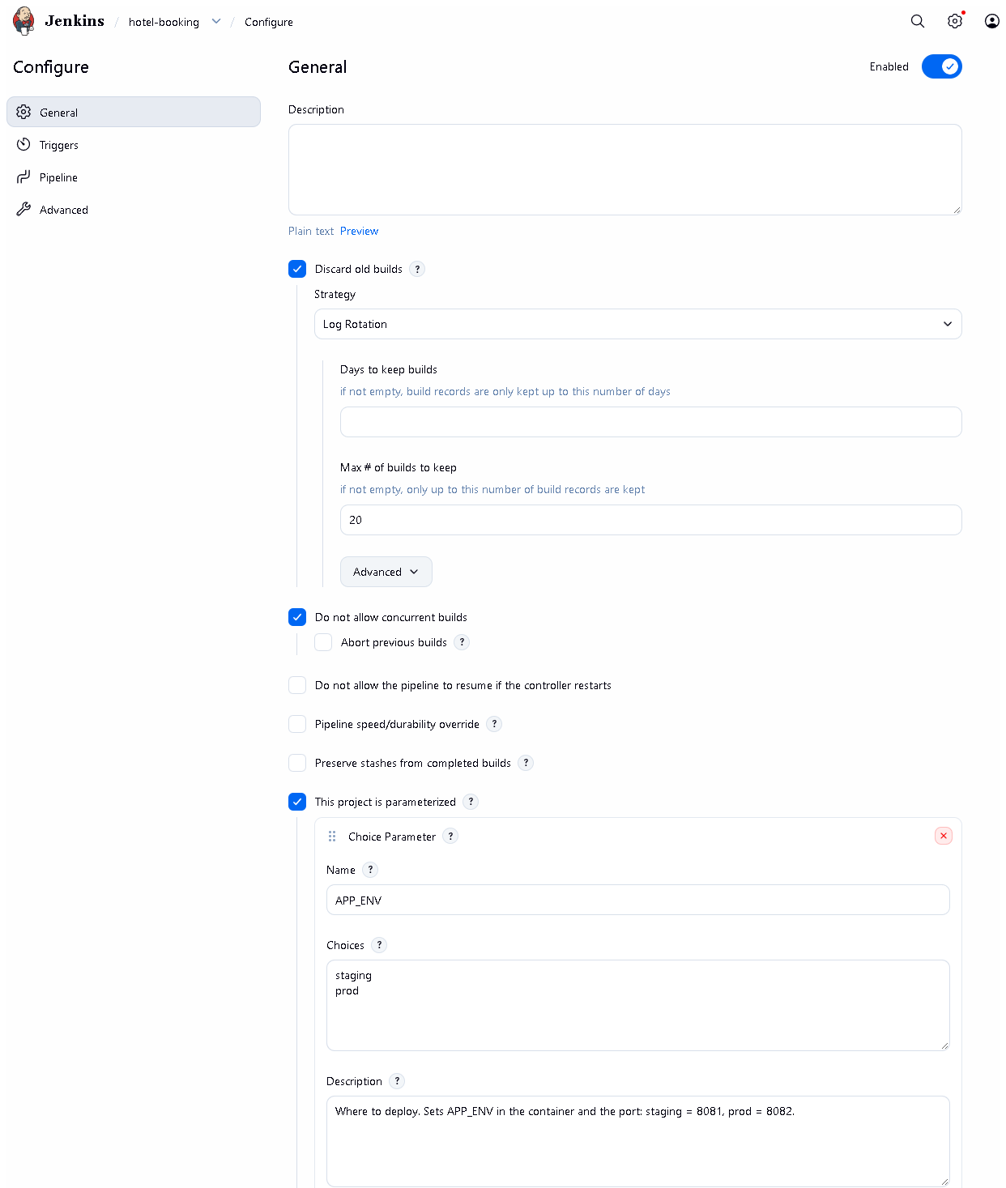 (part 1 of 3)
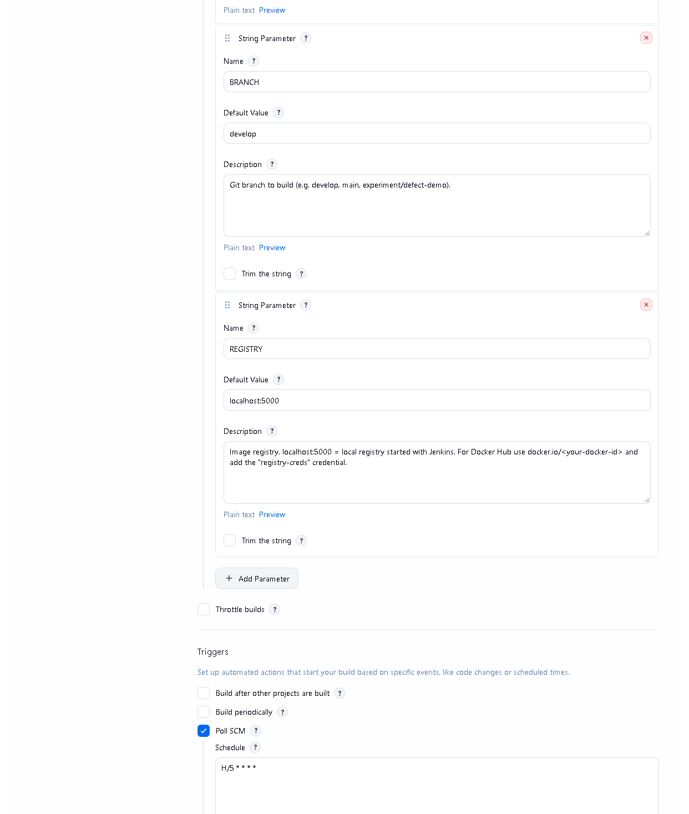 (part 2 of 3)
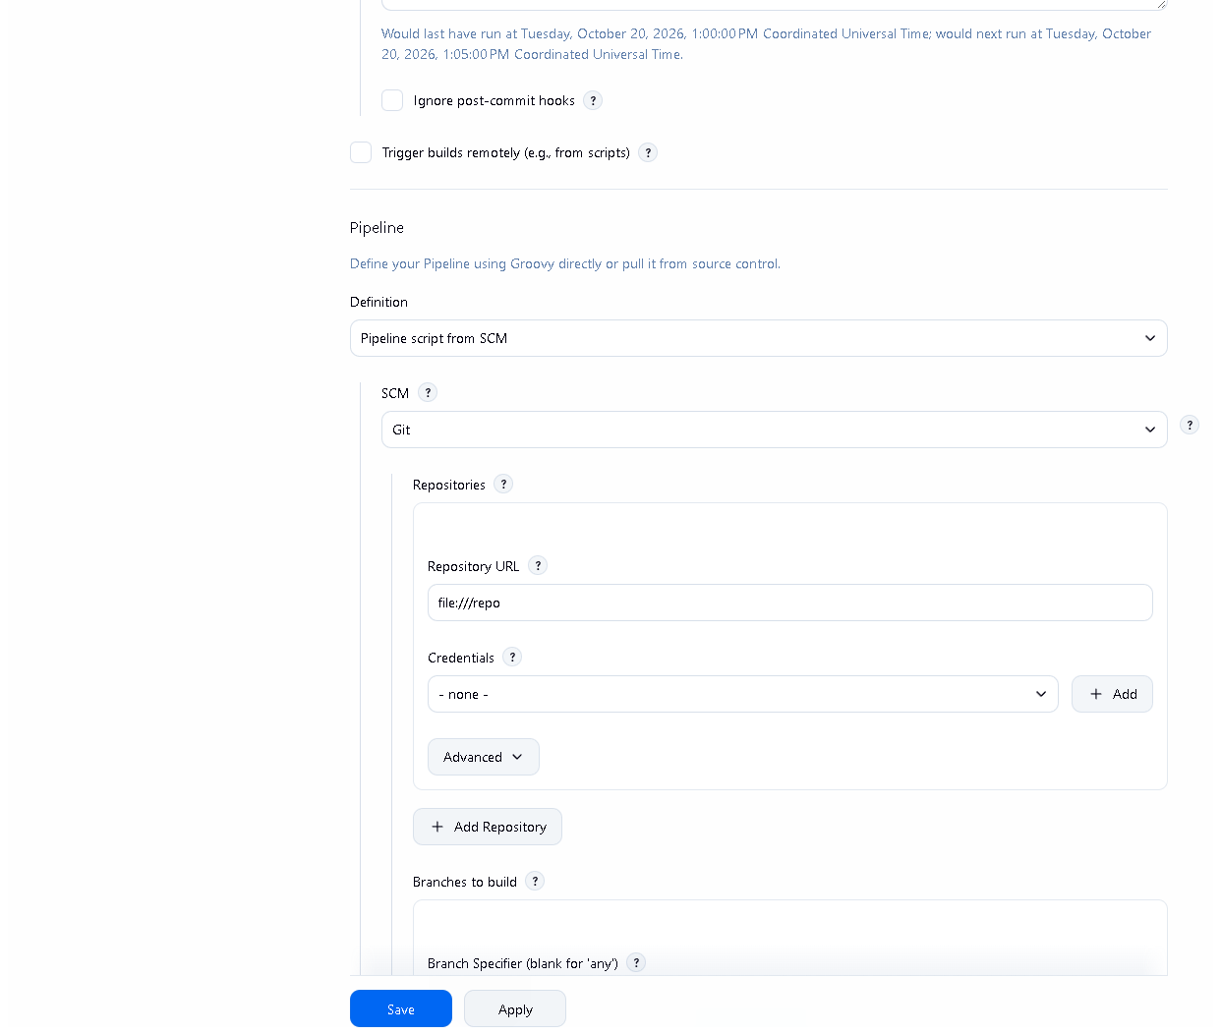 (part 3 of 3)
Figure 7.2 - Job configuration: the three parameters, "Do not allow concurrent builds", Poll SCM H/5 * * * *, and "Pipeline script from SCM" with repository file:///repo. Proves: the trigger and SCM settings described above. No secret values appear on this page.
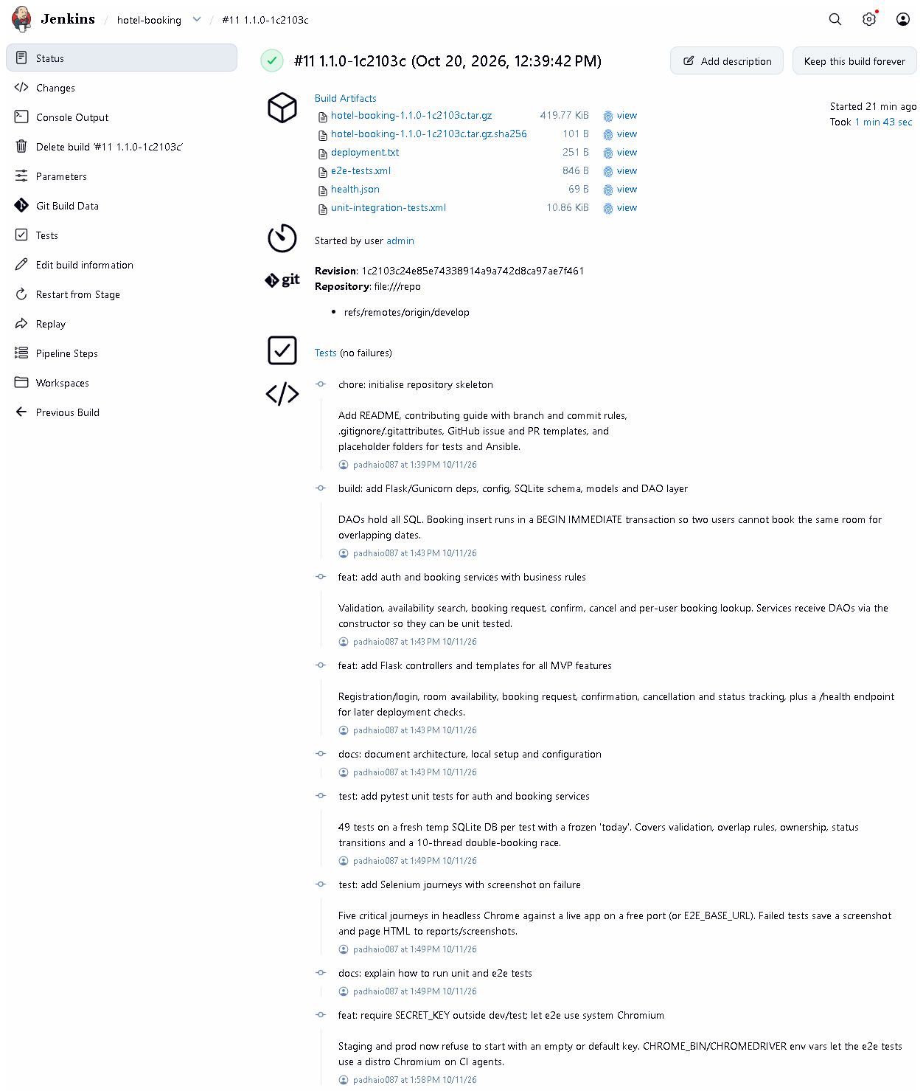 (part 1 of 3)
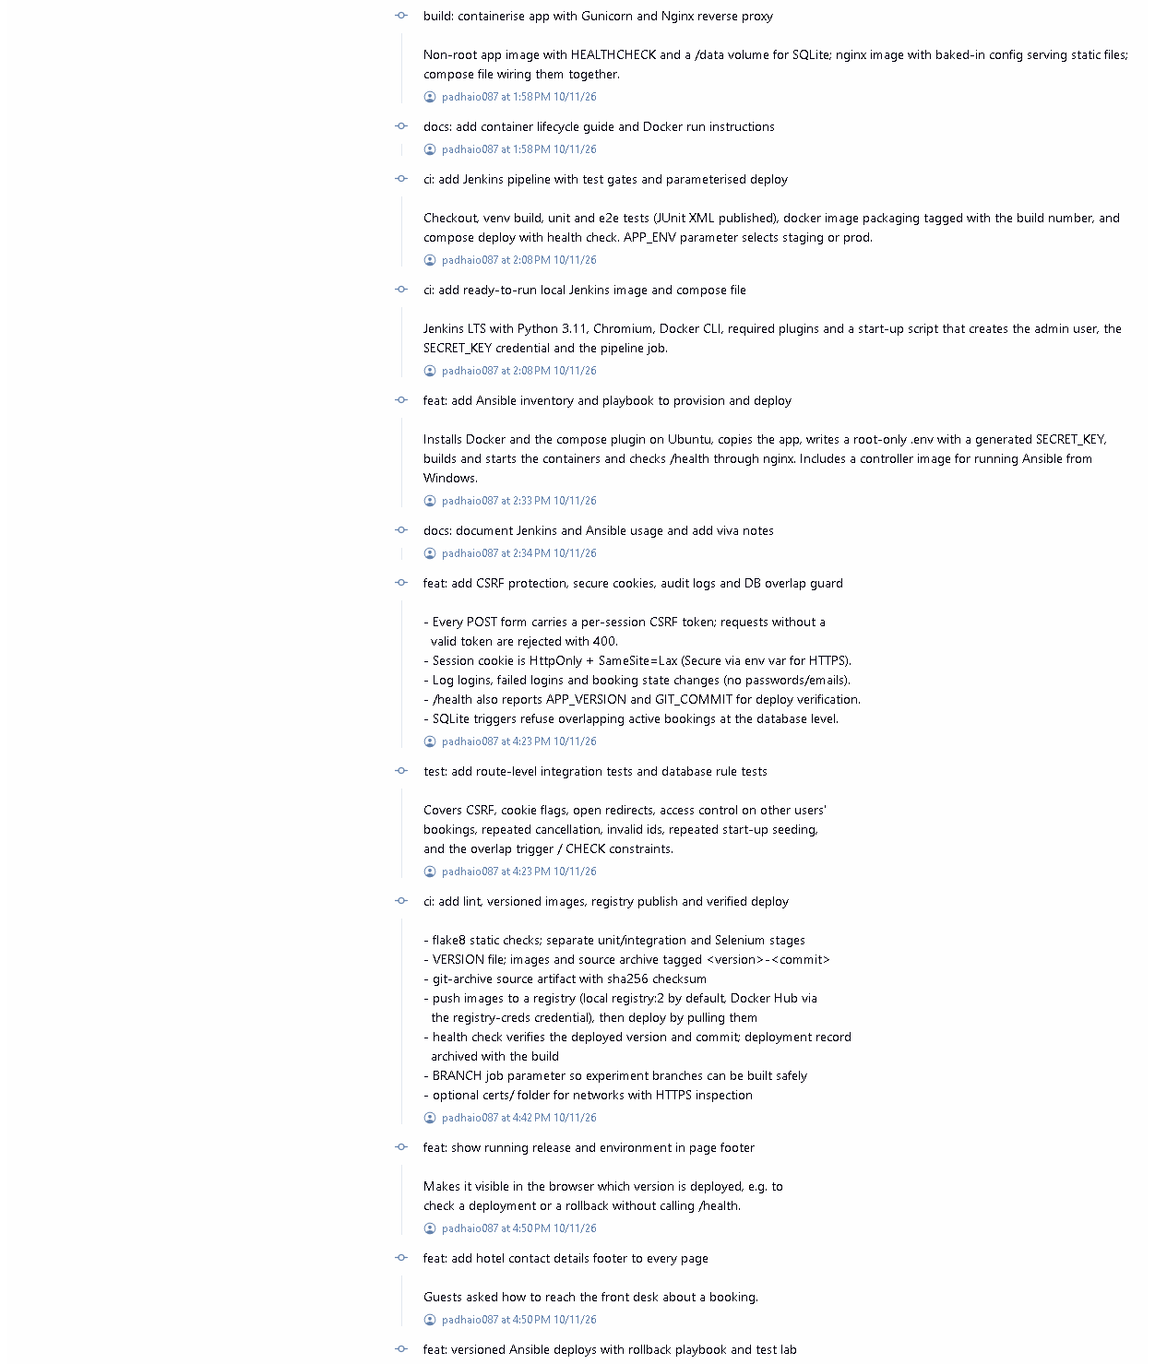 (part 2 of 3)
 (part 3 of 3)
Figure 7.3 - Build #11 (1.1.0-1c2103c), started 2026-10-20: result SUCCESS.
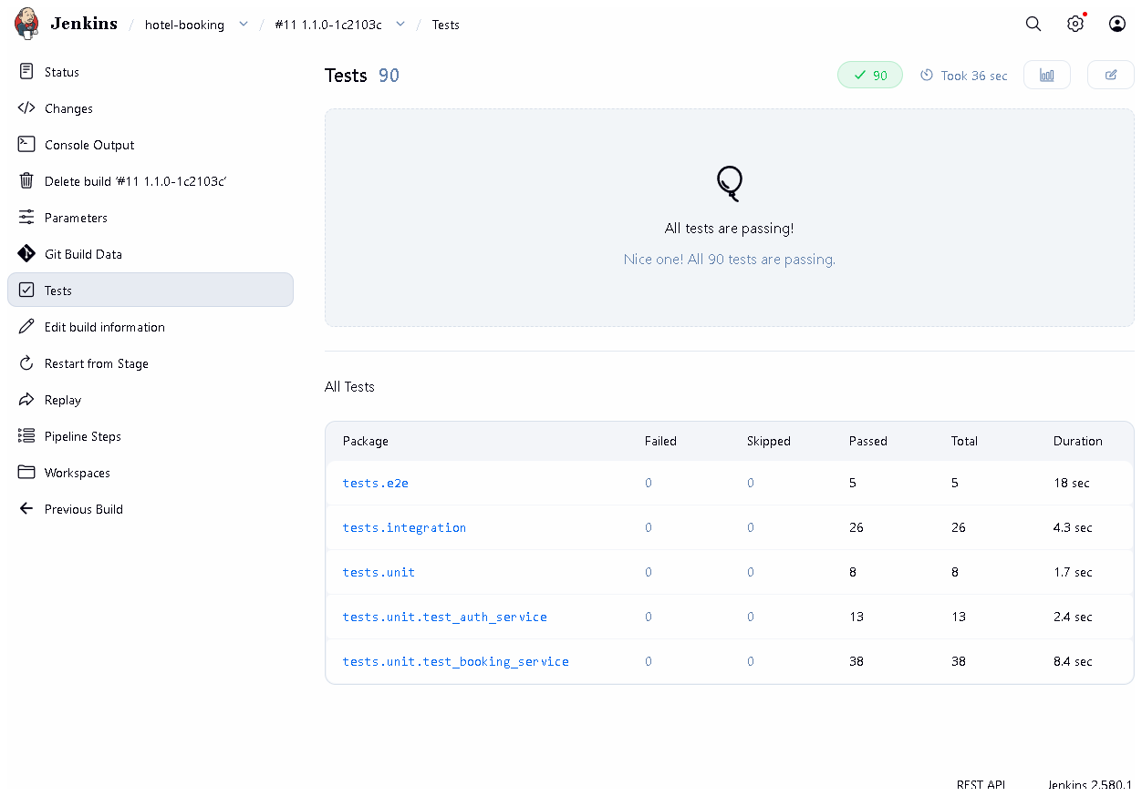
Figure 7.4 - Test report of build #11: 90 tests, 0 failures, grouped by package (unit, integration, e2e). Proves: pytest ran inside Jenkins and its JUnit reports were published.
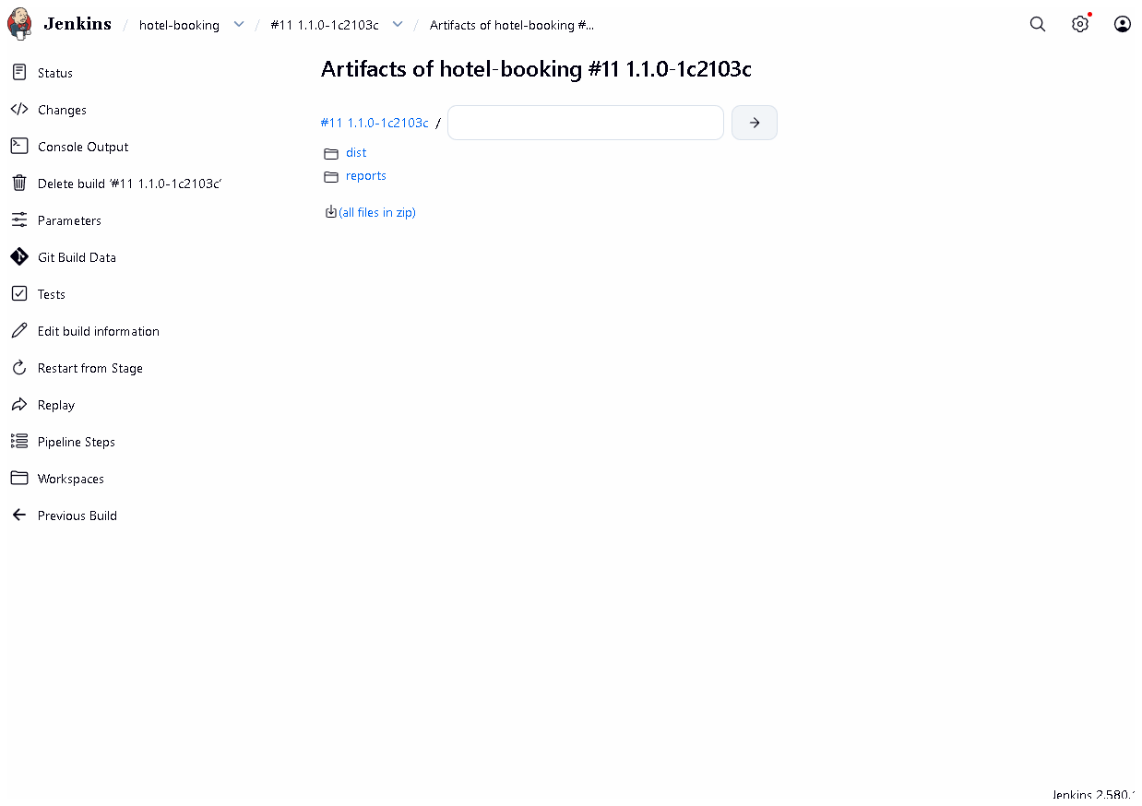
Figure 7.5 - Archived artifacts of build #11: source tarball + .sha256, test XML, health.json, deployment.txt.
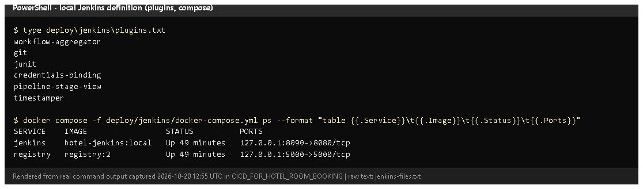
Figure 7.6 - deploy/jenkins/plugins.txt and the running Jenkins + registry containers (rendered from real output, 2026-10-20).

E. How to demonstrate this task to the professor (about 4 minutes)
Before the demo: Docker Desktop running ("Engine running" in its window). Know the admin password: it is the JENKINS_ADMIN_PASSWORD= line in deploy\jenkins\.env (do not show this file on screen).
- Make sure Jenkins runs (PowerShell):Expected: jenkins and registry "Up". If not: docker compose up -d, wait ~1 minute.
cd D:\DevOPS\CICD_FOR_HOTEL_ROOM_BOOKING\deploy\jenkins
docker compose ps
- Open http://localhost:8090, log in as admin.
- Open job hotel-booking. Say: "This is the CI job. The stage view shows every build; red ones were deliberate experiments."
- Click Configure (read only - don't save). Show This project is parameterized, Poll SCM H/5 * * * *, Pipeline script from SCM. Say: "Jenkins checks the repository every five minutes. A webhook needs Jenkins to be reachable from GitHub, which a laptop is not."
- Click Build with Parameters -> BRANCH=develop, APP_ENV=staging -> Build. Watch the stage view (about 2 minutes). Say each stage name as it turns green.
- Open the new build -> Tests (90 passed) -> Build Artifacts (tarball, checksum, reports).
- Open Console Output and scroll to flake8 and 90 passed lines.
Recovery: login page not loading - wait: Jenkins needs ~60 s after a start. "permission denied ... docker.sock" (Linux host only) - set DOCKER_GID in deploy/jenkins/.env. Build cannot see your latest change - Jenkins builds committed code only; commit first.

F. Expected screenshots for the final submission
- assets/task-07/jenkins-job-stage-view.png - exists, 2026-10-20.
- assets/task-07/jenkins-job-configuration.png - exists, 2026-10-20.
- assets/task-07/jenkins-build-11-summary.png - exists, 2026-10-20.
- assets/task-07/jenkins-build-11-tests.png - exists, 2026-10-20.
- assets/task-07/jenkins-build-11-artifacts.png - exists, 2026-10-20.
- assets/task-07/jenkins-files.png - exists, 2026-10-20.
- assets/task-07/github-webhook.png - only if a webhook is configured on a public Jenkins (manual; currently not applicable).

G. Probable viva questions and answers
- What is Jenkins? An automation server that runs build/test/deploy jobs automatically.
- What is Continuous Integration? Automatically building and testing every change soon after it is committed, so errors are found quickly.
- Installed Jenkins vs Jenkinsfile vs executed build? The server, the pipeline definition stored in Git, and an actual numbered run with results. Only a build (e.g. #11) proves it works.
- How is your build triggered? Poll SCM every ~5 minutes, plus manual Build with Parameters. A webhook isn't possible because GitHub cannot reach localhost.
- How do you install dependencies reproducibly? A fresh venv each build and pip install -r requirements-dev.txt with pinned versions (Flask==3.1.3, pytest==9.1.1...).
- What does flake8 check? Syntax errors, undefined names, unused imports and style (config in .flake8, line length 110).
- Where do the test reports come from? pytest writes JUnit XML (--junitxml), and the JUnit plugin shows them on the Tests page.
- (Project-specific) What artifacts does a build keep? The source archive hotel-booking-<version>-<commit>.tar.gz with its sha256, test XML, health.json and deployment.txt.
- (Project-specific) Why run Jenkins in Docker? The whole server (plugins, Python, Chromium, Docker CLI, the job) is defined in files in deploy/jenkins/ and starts with one command; nothing is clicked by hand.
- Is this a Maven job? No. The project is Python; pip, flake8 and pytest do the jobs Maven would do for Java. I'll confirm with the professor that this is acceptable.
- What is an agent? The machine that executes the steps; here the built-in node (the Jenkins container), which uses the host's Docker through the mounted socket.

H. Common mistakes and troubleshooting
Symptom | Cause | Inspect | Fix | Confirm
http://localhost:8090 not reachable | Docker Desktop or the container stopped | docker compose ps in deploy\jenkins | start Docker Desktop; docker compose up -d | login page loads
Build doesn't include my change | change not committed | git status | commit (and choose that branch in BRANCH) | console "Building commit "
Stage "Install dependencies" fails with SSL errors | antivirus HTTPS scanning | console output | put the root CA in certs/ and rebuild Jenkins (docker compose up -d --build) | stage green
Login fails | wrong password | deploy\jenkins\.env (privately) | use that value; it is set on first start only | dashboard opens
Tests page shows old results | stale report files (fixed) | Checkout stage runs rm -rf reports dist | already fixed in fix/jenkins-stale-reports | build #9 lists only tests that ran

I. Quick revision notes
Five key points
- Jenkins runs in Docker, defined in deploy/jenkins/, at http://localhost:8090.
- Job hotel-booking = pipeline from SCM (Jenkinsfile), parameters APP_ENV / BRANCH / REGISTRY.
- CI stages: checkout, venv + pinned pip install, compileall + flake8, pytest (85 + 5).
- JUnit reports and artifacts (tarball + sha256) are kept with each build.
- Trigger = polling (no public URL for a webhook); Python tools, not Maven.
30-60 second explanation "Jenkins runs in a Docker container that is completely defined in the repository - plugins, Python, Chromium for Selenium and the job itself. The job hotel-booking reads the Jenkinsfile from Git. For each build it checks out the code, creates a fresh virtual environment, installs pinned dependencies, runs flake8 and all 90 tests, publishes the JUnit reports and archives a source package with a checksum. Build #11, run today, passed all stages. It polls Git every five minutes because a webhook needs a public Jenkins."
Caveat: no webhook; Python tooling instead of a Maven job (needs approval).
Readiness checklist
- â˜ Docker Desktop running; docker compose ps shows Jenkins up.
- â˜ I can log in and start Build with Parameters.
- â˜ I can open Tests and Artifacts of a build.
- â˜ I can explain polling vs webhook and Python vs Maven.

Task 8 - Pipeline as Code and Server Deployment

A. Task title and objective
Task 8: Pipeline as Code and Server Deployment
Objective: describe the whole build-test-package-deploy process in a Jenkinsfile stored in Git, parameterise at least one environment-specific setting, keep secrets out of the repository, and deploy automatically after all quality gates pass, followed by a health check.
Professor's required deliverables
- A Jenkinsfile with stages for checkout, dependencies, static checks, tests, packaging, Docker build, deployment and health check
- At least one parameterised environment-specific setting
- Configuration through environment variables / files; passwords, keys and registry credentials outside source control
- Deployment to an available target (local deployment acceptable if no server exists - documented)
Current status: Implemented and verified. Jenkins build #11 on 2026-10-20 ran all 10 stages, deployed release 1.1.0-1c2103c to the staging environment and the health check confirmed the version and commit (Figures 8.3-8.5).
Deployment target: a Docker Compose stack on the same machine as Jenkins (local "staging" on port 8081 and "prod" on port 8082). No separate remote server is used by Jenkins; remote-server deployment is done by Ansible (Task 13).

B. Explanation for a complete beginner
An everyday picture. A recipe card that lists every step in order ("preheat, mix, bake 20 minutes, test with a toothpick") lets anyone bake the same cake. A Jenkinsfile is the recipe card for releasing software: it lists every step, and because it lives in Git, changes to the recipe are reviewed and versioned like code.
Term | Meaning
Pipeline as code | the pipeline is a text file in the repository, not settings clicked in a web UI
Stage | one named step group (e.g. "Unit & integration tests"); stages run in order
Declarative pipeline | Jenkins' structured syntax: pipeline { parameters {...} stages {...} post {...} }
Parameter | a value chosen when starting a build (e.g. staging or prod)
Environment variable | a named value the commands can read (e.g. HOST_PORT)
Credential | a secret stored encrypted in Jenkins and injected only when needed
Deployment | starting the new version where users can reach it
Health check | asking the running app "are you OK, and which version are you?" (GET /health)
Quality gate | a check that must pass before the next step is allowed; here every test stage comes before Deploy

Why it helps: the same steps run every time, nothing is forgotten, history shows who changed the process, and a broken step stops the release.

C. What was actually implemented
File: Jenkinsfile (declarative pipeline).
Parameters (lines 19-29)
Parameter | Values | Effect
APP_ENV | staging / prod | sets APP_ENV in the container, the port (staging 8081, prod 8082) and the compose project name hotel-staging / hotel-prod (separate containers and separate database volume)
BRANCH | e.g. develop, main | which Git branch is built
REGISTRY | localhost:5000 (default) or docker.io/<user> | where images are pushed and pulled

Derived variables (lines 45-51): HOST_PORT, COMPOSE_PROJECT_NAME. In the Checkout stage: APP_VERSION (from the VERSION file), GIT_SHORT, IMAGE_TAG = <version>-<commit>, IMAGE_PREFIX.
Stages and what build #11 did
# | Stage (line) | What it does | Build #11 result
1 | Checkout (55) | checkout scm, delete old reports/ + dist/, compute tag | commit 1c2103c, tag 1.1.0-1c2103c
2 | Install dependencies (76) | fresh venv, pinned pip install | ok
3 | Static checks (88) | compileall, flake8 | no findings
4 | Unit & integration tests (99) | pytest, JUnit XML | 85 passed
5 | E2E tests (Selenium) (105) | headless Chromium | 5 passed
6 | Package source (113) | git archive + sha256sum | hotel-booking-1.1.0-1c2103c.tar.gz
7 | Build images (127) | docker build app + nginx, with APP_VERSION/GIT_COMMIT | 2 images
8 | Publish images (141) | docker push to the registry | pushed (digests in console)
9 | Deploy (163) | withCredentials(hotel-secret-key); docker compose pull; docker compose up -d --no-build --wait | containers healthy
10 | Health check (177) | wget /health through Nginx; grep the expected version and commit; write reports/deployment.txt | {"commit":"1c2103c","env":"staging","status":"ok","version":"1.1.0"}

Secrets stay outside Git
withCredentials([string(credentialsId: 'hotel-secret-key', variable: 'SECRET_KEY')]) {
sh '''
docker compose pull
docker compose up -d --no-build --wait --wait-timeout 120
'''
}
- hotel-secret-key is a Jenkins secret text credential (created from the git-ignored deploy/jenkins/.env); Jenkins masks it in logs. The build #11 log was searched for the key: not present.
- A remote registry password would be the credential registry-creds, used with docker login --password-stdin.
- docker-compose.yml refuses to start without SECRET_KEY (${SECRET_KEY:?...}), and the app refuses to start in staging/prod with a missing or default key.
Health check stage (simplified excerpt of lines 177-200 - the real file retries wget up to 5 times and escapes the quotes for Groovy as \\"; the # comments are added here)
docker compose exec -T nginx wget -qO- http://127.0.0.1/health > reports/health.json
grep -q "\"version\":\"$APP_VERSION\"" reports/health.json # right release?
grep -q "\"commit\":\"$GIT_SHORT\"" reports/health.json # right commit?
If the running app reports a different version or commit, grep fails and the build fails.
Deployment record (artifact reports/deployment.txt of build #11):
environment=staging
branch=develop
version=1.1.0
commit=1c2103c
image_tag=1.1.0-1c2103c
app_image=localhost:5000/hotel-booking-app:1.1.0-1c2103c
nginx_image=localhost:5000/hotel-booking-nginx:1.1.0-1c2103c
url=http://localhost:8081
jenkins_build=null
jenkins_build=null is a small known issue: Jenkins' own "Jenkins URL" setting was never filled in, so BUILD_URL is empty. Fix: Manage Jenkins -> System -> Jenkins Location -> Jenkins URL = http://localhost:8090/.

D. Screenshots and evidence
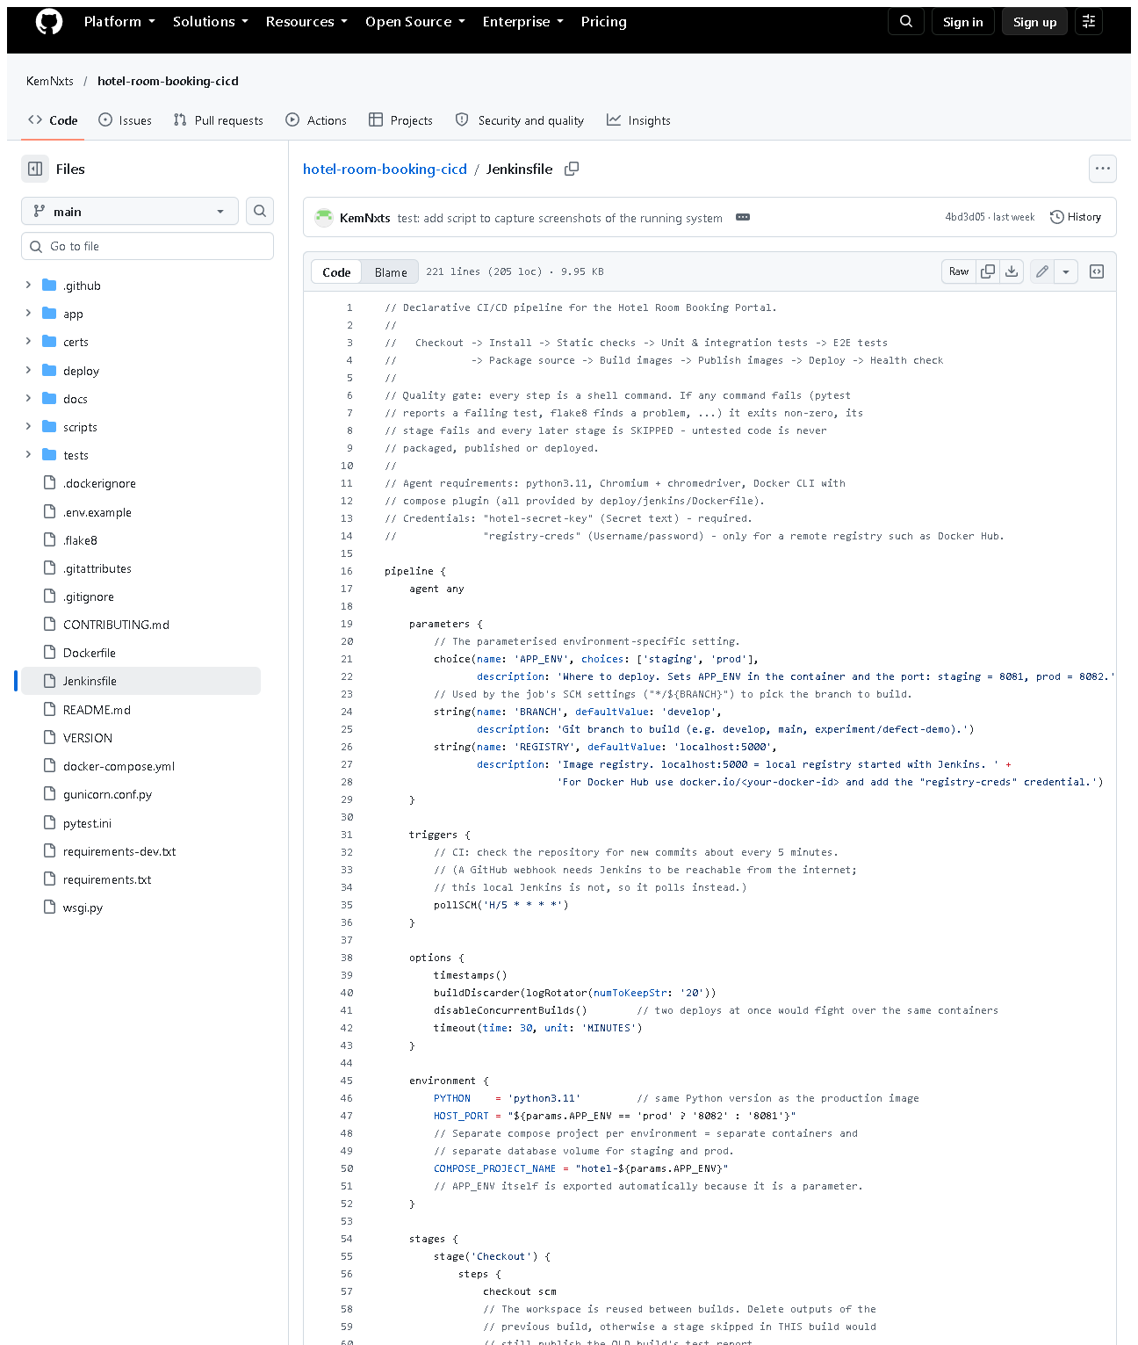 (part 1 of 4)
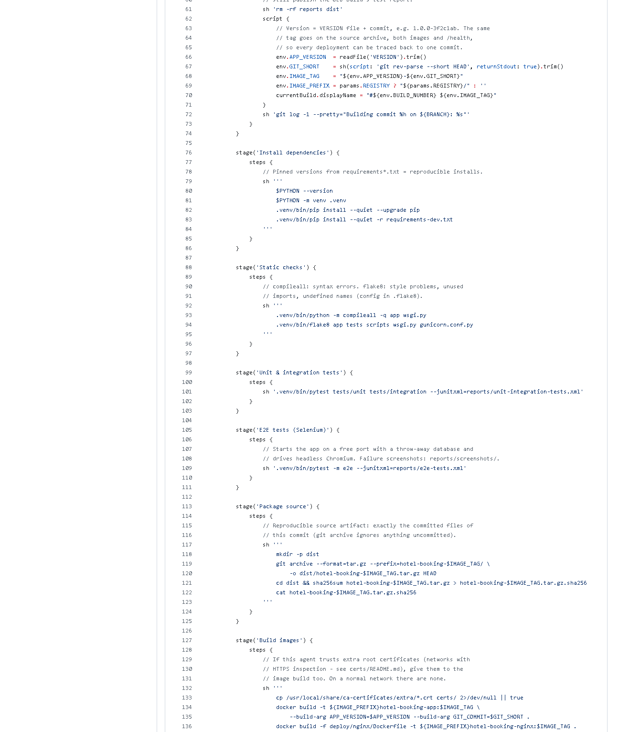 (part 2 of 4)
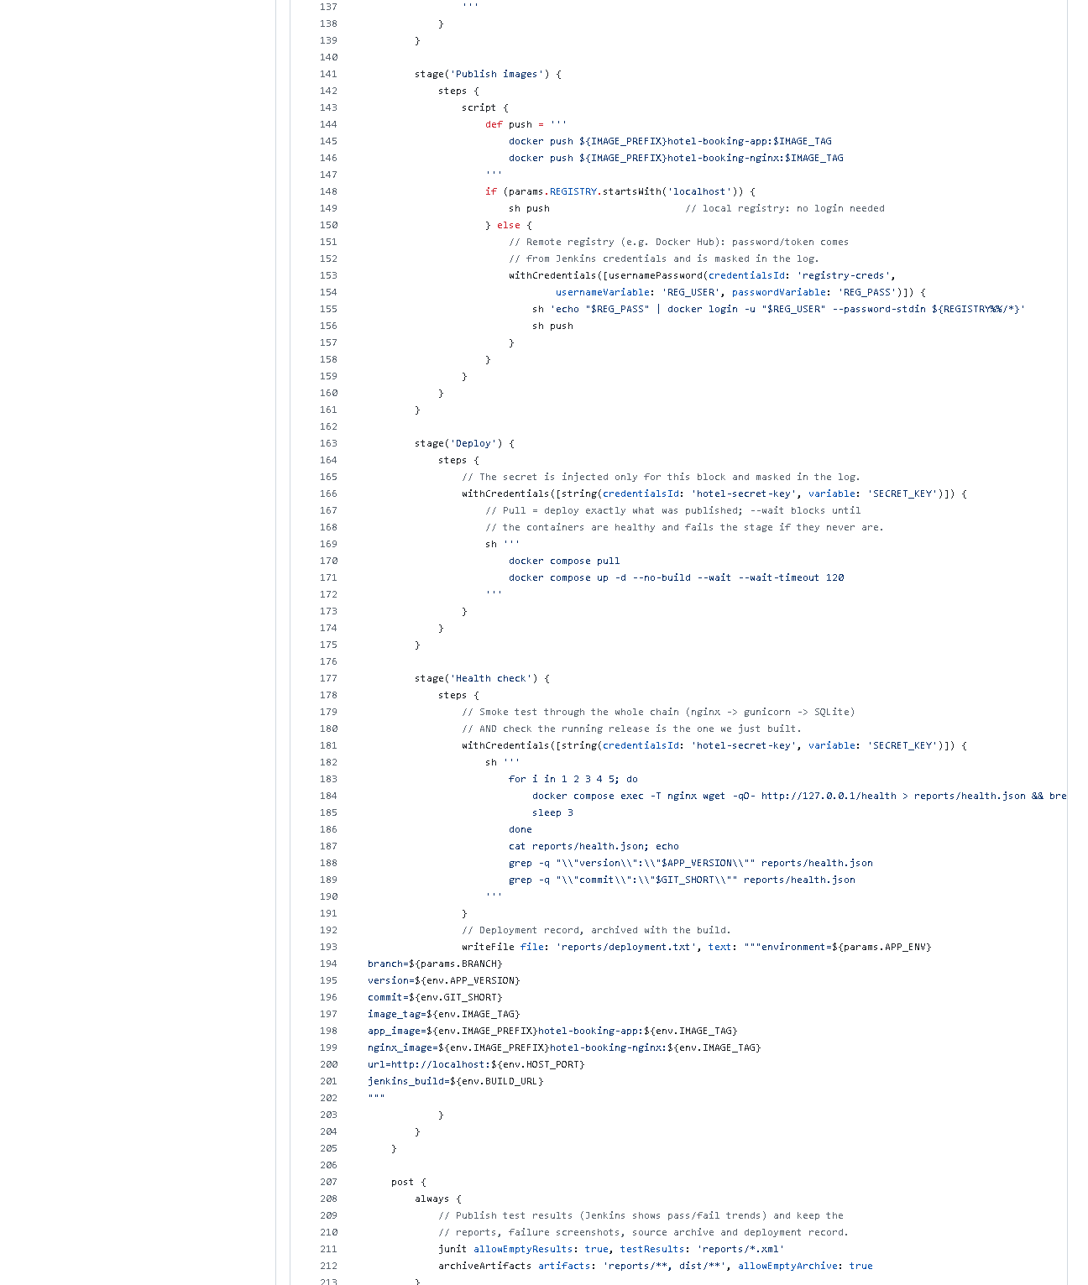 (part 3 of 4)
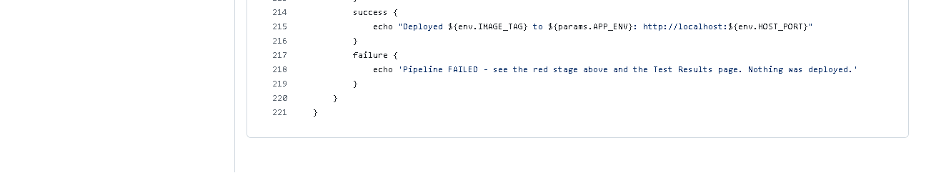 (part 4 of 4)
Figure 8.1 - Jenkinsfile on GitHub (captured 2026-10-20). Notice: parameters, triggers { pollSCM }, options, environment, the ten stages and post.
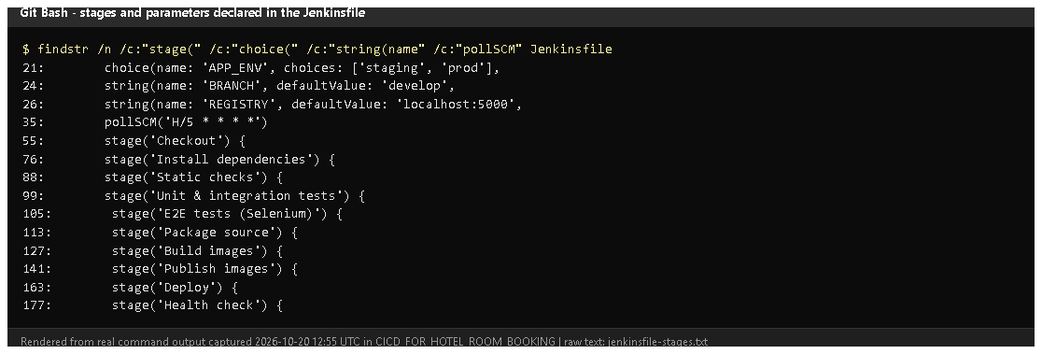
Figure 8.2 - Line numbers of every stage and parameter (findstr on the Jenkinsfile, rendered from real output).
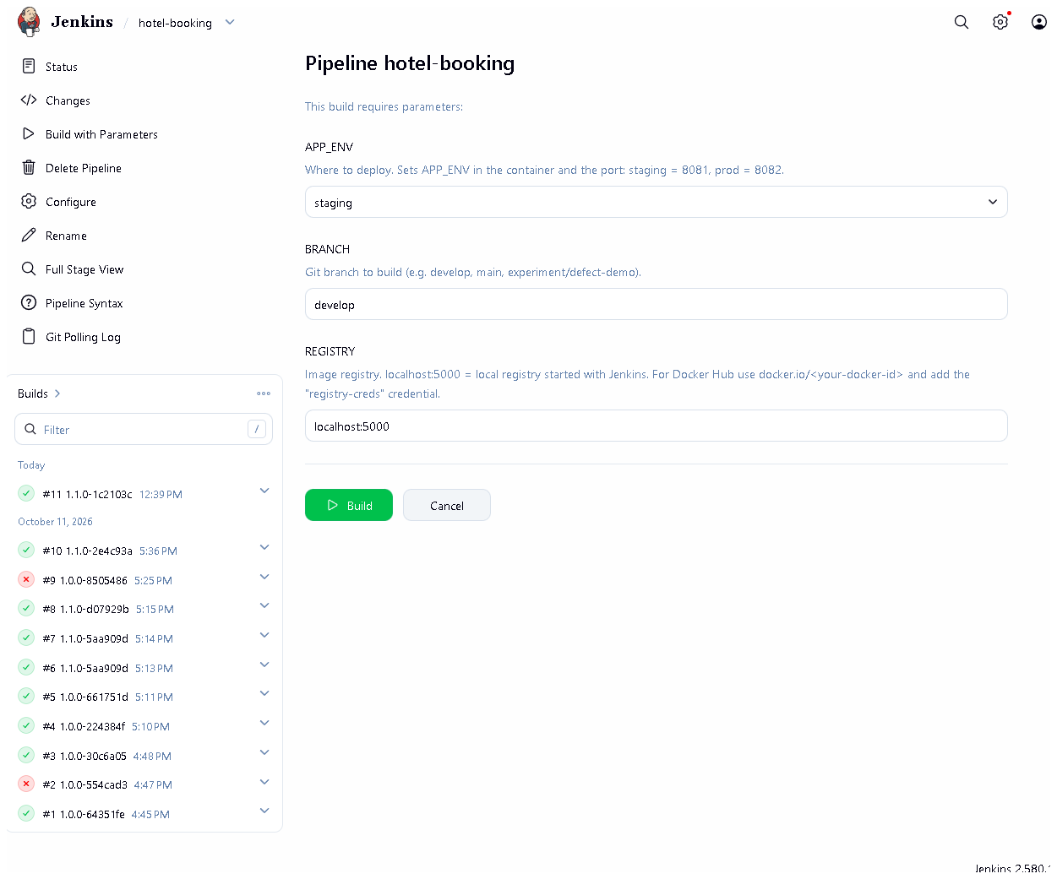
Figure 8.3 - The Build with Parameters form: APP_ENV, BRANCH, REGISTRY. Proves: the environment-specific setting is a real parameter.
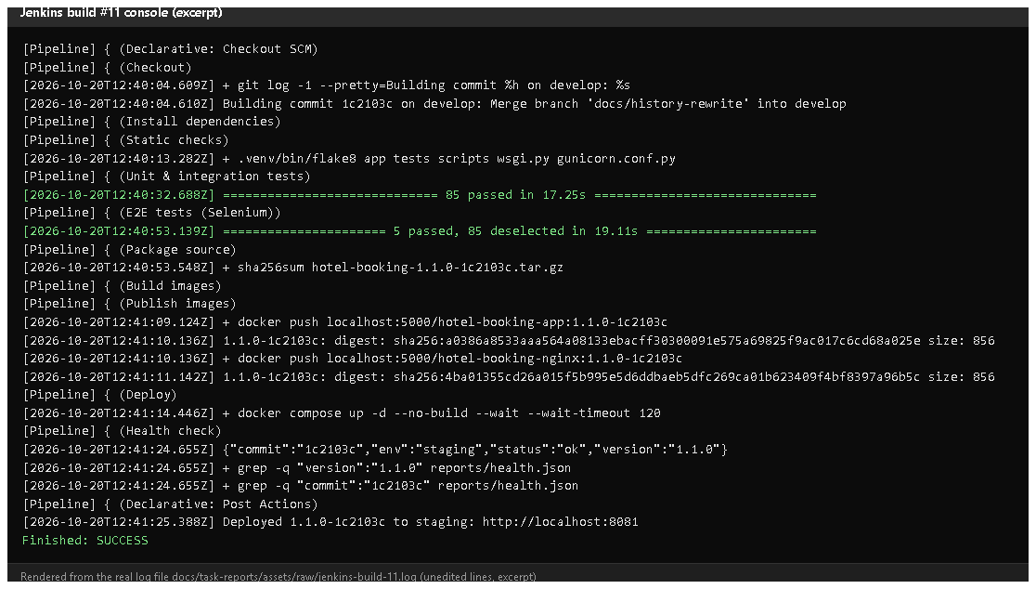
Figure 8.4 - Build #11 console excerpt (rendered from the saved console log): each stage starting, 85 + 5 tests passed, the archive checksum, image pushes with digests, /health and "Deployed 1.1.0-1c2103c to staging".
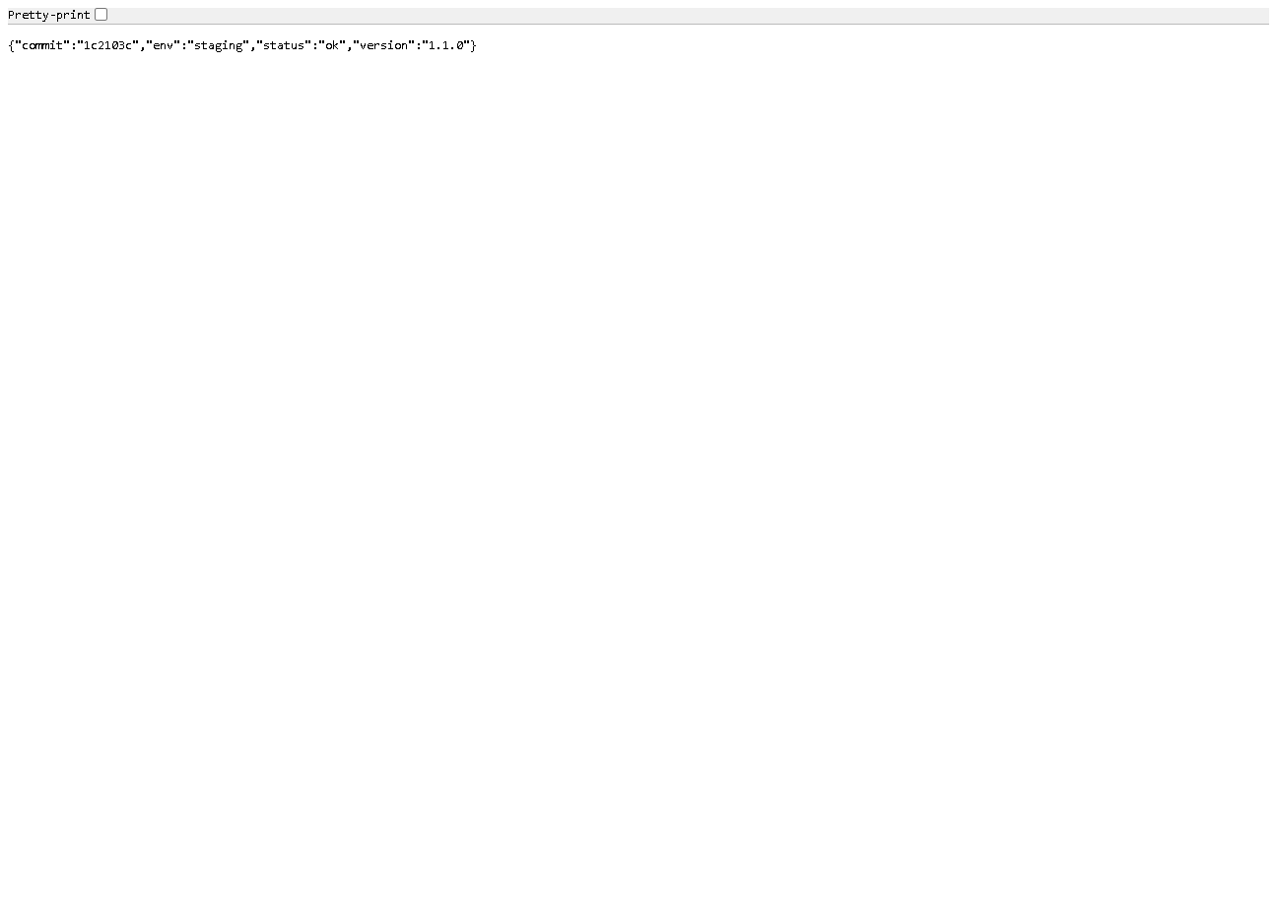
Figure 8.5 - http://localhost:8081/health in a browser after build #11: commit 1c2103c, env staging, version 1.1.0. Proves: the deployed app is the exact commit that was built and tested.
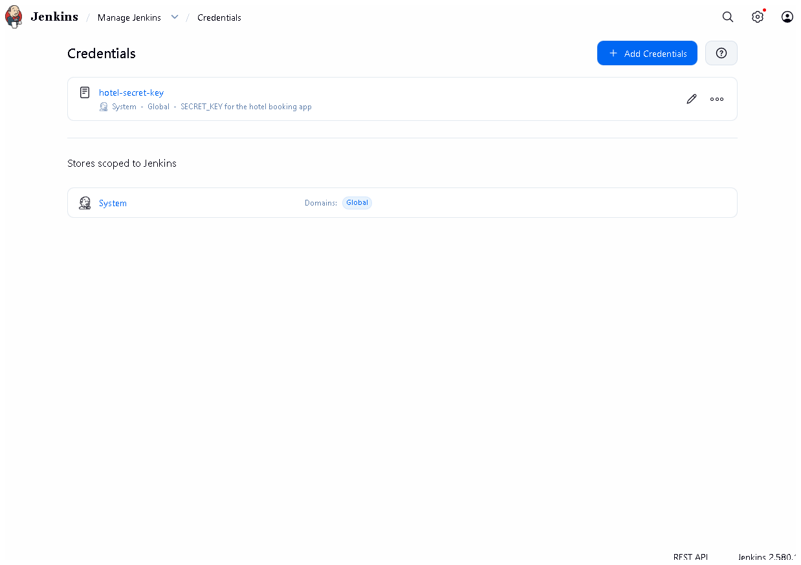
Figure 8.6 - Manage Jenkins -> Credentials: hotel-secret-key exists; its value is never displayed.

E. How to demonstrate this task to the professor (about 5 minutes)
Before the demo: Docker Desktop running; Jenkins up (docker compose ps in deploy\jenkins); VS Code open on the project.
- Open Jenkinsfile in VS Code. Walk through: parameters (APP_ENV), environment (HOST_PORT), then each stage(...). Say: "The whole pipeline is code in Git, so it is versioned and reviewed like the app."
- Start a deploy: Jenkins -> hotel-booking -> Build with Parameters -> APP_ENV = staging, BRANCH = develop -> Build.
- Narrate the stage view as stages turn green (about 2 minutes). Point out that Deploy is after both test stages - "that is the quality gate".
- Open the build's Console Output, search (Ctrl+F) for Deployed and "status":"ok".
- Prove it in a browser: http://localhost:8081/health - the commit equals the commit shown in the console line "Building commit ...".
- Show the parameter effect: run again with APP_ENV = prod and BRANCH = main; then http://localhost:8082/health shows "env":"prod". Say: "Same pipeline, different environment, chosen by one parameter."
- Show secrets handling: Manage Jenkins -> Credentials (value hidden); in VS Code show withCredentials in the Deploy stage.
Recovery: Deploy stage "port is already allocated" - another program uses 8081/8082; stop it or docker compose -p hotel-staging down and rebuild. Health check fails because of an old container - run the build again; it pulls and recreates the containers.

F. Expected screenshots for the final submission
- assets/task-08/github-file-Jenkinsfile.png - exists, 2026-10-20.
- assets/task-08/jenkinsfile-stages.png - exists, 2026-10-20.
- assets/task-08/jenkins-build-with-parameters.png - exists, 2026-10-20.
- assets/task-08/jenkins-build-11-console.png - exists, 2026-10-20 (rendered from the real console log).
- assets/task-08/staging-health-after-build-11.png - exists, 2026-10-20.
- assets/task-08/jenkins-credentials-masked.png - exists, 2026-10-20.

G. Probable viva questions and answers
- What is "pipeline as code"? The pipeline is a file (Jenkinsfile) in the repository, so it is versioned, reviewed and identical on every run.
- Name your stages in order. Checkout, Install dependencies, Static checks, Unit & integration tests, E2E tests, Package source, Build images, Publish images, Deploy, Health check.
- Which setting is parameterised? APP_ENV: staging or prod - it changes the app environment, the port (8081/8082) and the compose project (separate data).
- How are secrets handled? SECRET_KEY is a Jenkins credential injected with withCredentials only in Deploy/Health check and masked in logs; nothing secret is in Git.
- What happens if a test fails? That stage fails and every later stage, including Deploy, is skipped (build #2 shows this).
- (Project-specific) How do you know the deployed version is the tested one? Images are tagged <version>-<commit>; the health-check stage compares the version and commit returned by /health with the ones built.
- (Project-specific) Where does it deploy? To a Docker Compose stack on the Jenkins host: staging :8081, prod :8082. Real servers are handled by Ansible.
- Why --wait on docker compose up? It waits until containers are healthy (Docker HEALTHCHECK) and fails the stage if they never are.
- What is post { always } for? It publishes test reports and archives artifacts even when the build fails, so failures can be analysed.
- Why disableConcurrentBuilds? Two deployments at the same time would fight over the same containers.
- What is deployment.txt? A record archived with each build: environment, branch, version, commit, image names, URL.

H. Common mistakes and troubleshooting
Symptom | Cause | Inspect | Fix | Confirm
Health check stage fails on grep | old container still running another version | console: cat reports/health.json | rerun; check no other stack uses the port | /health shows the new commit
Deploy: SECRET_KEY is not set | credential missing | Manage Jenkins -> Credentials | recreate hotel-secret-key (secret text) | Deploy green
jenkins_build=null in deployment record | Jenkins URL not configured | Manage Jenkins -> System | set Jenkins URL http://localhost:8090/ | next record shows the build URL
Publish images: connection refused | registry container stopped | docker compose ps in deploy\jenkins | docker compose up -d registry | push succeeds
Changes in the Jenkinsfile ignored | not committed / wrong branch | console "Building commit" | commit and build that branch | stage list updated

I. Quick revision notes
Five key points
- Jenkinsfile = the pipeline as code, 10 stages, versioned in Git.
- Parameter APP_ENV chooses staging (:8081) or prod (:8082).
- Secrets come from Jenkins credentials (withCredentials), never from Git.
- Deploy runs only after lint + 90 tests; then /health must match version and commit.
- Build #11 (2026-10-20) deployed 1.1.0-1c2103c to staging and passed.
30-60 second explanation "Our pipeline is a Jenkinsfile in the repository. It checks out a branch, installs pinned dependencies, runs flake8 and all tests, packages the source, builds Docker images tagged with version and commit, pushes them to a registry, deploys them with Docker Compose and finally checks that /health reports exactly that version and commit. The APP_ENV parameter chooses staging or prod. The secret key is a Jenkins credential, never in Git. Build #11 today deployed commit 1c2103c to staging successfully."
Caveat: Jenkins deploys to Docker on its own host, not a remote server; jenkins_build in the record is empty until the Jenkins URL is set.
Readiness checklist
- â˜ I can name the 10 stages in order.
- â˜ I can run a staging and a prod build and show both /health pages.
- â˜ I can point to withCredentials and explain masking.
- â˜ I can explain why the health check compares the commit.

Task 9 - Selenium Test Design and Local Execution

A. Task title and objective
Task 9: Selenium Test Design and Local Execution
Objective: automate the most important user journeys in a real web browser, with stable locators, explicit waits, clear assertions and isolated test data; run them locally; produce reports and screenshots on failure.
Professor's required deliverables
- 3-5 meaningful Selenium journeys (register/login, availability, booking, confirmation/status, cancellation)
- Stable element selectors, explicit waits, assertions, deterministic test data
- Local execution (the brief mentions Maven - see the note below)
- Test reports and screenshots on failure
- Clean-up / isolated test database so repeated runs stay reliable
Current status: Implemented and verified. On 2026-10-20: 5 of 5 journeys passed locally (Figure 9.1), the full suite of 90 tests passed (Figure 9.2), and the screenshot-on-failure feature was demonstrated with a temporary, deliberately failing test (Figures 9.4-9.5) that was deleted afterwards.
Maven note: the tests are Python and run with pytest, not Maven. pytest writes the same JUnit-XML report format that Maven would, which Jenkins displays. If running through Maven is compulsory, this must be discussed with the professor.

B. Explanation for a complete beginner
An everyday picture. A robot sits at the computer, opens Chrome, types into the forms and clicks the buttons exactly like a guest - then checks that the right message appears. If something is wrong it takes a photo of the screen. That robot is Selenium.
Term | Meaning | In this project
Browser automation | a program controls a real browser | headless Chrome (no window)
WebDriver | the standard interface that lets code control a browser | selenium.webdriver.Chrome
Locator / selector | how the test finds an element on the page | By.ID, "booking-status"
Stable locator | one that does not change when the design changes | element ids like book-201, confirm-btn
Explicit wait | "wait until X is visible (max 10 s)", then continue at once | WebDriverWait(...).until(...)
Assertion | the check that decides pass/fail | assert status(driver) == "PENDING"
Test data | the users, dates and bookings a test creates | unique e-mails, random far-future dates
Fixture | pytest setup code a test can request | driver (a browser), base_url (a running app)
Headless | the browser runs without a visible window | default; HEADLESS=0 shows it

Why not time.sleep(3)? Sleeping either wastes time (page was ready earlier) or fails (page was slower). Explicit waits are faster and more reliable.
Unit vs integration vs Selenium tests (all three exist here)
Type | What it tests | Speed | Count
Unit | one service/database rule, no web server | ms | 59
Integration | real routes through Flask's test client (HTTP status, redirects, CSRF) | fast | 26
Selenium (end-to-end) | a full journey in a real browser | seconds each | 5

C. What was actually implemented
Files: tests/e2e/test_journeys.py (journeys and helpers) and tests/e2e/conftest.py (fixtures and the failure hook).
The five journeys (tests/e2e/test_journeys.py)
# | Test (line) | What the robot does | Key assertions
1 | test_journey_1_register_new_guest (81) | registers a new guest | name in the navbar, "account has been created", now on /rooms
2 | test_journey_2_login_rejects_wrong_password_then_accepts_right_one (89) | registers, logs out, wrong password, right password | "Invalid email or password", still logged out; then "Welcome back"
3 | test_journey_3_search_request_and_confirm_booking (108) | searches dates, books the first free room, confirms | status PENDING with the right dates; then CONFIRMED; no second Confirm button
4 | test_journey_4_cancel_booking_and_track_status (128) | books, confirms, cancels via the dialog, opens My bookings | dialog appears and status is still CONFIRMED until confirmed; then CANCELLED in detail and in My bookings
5 | test_journey_5_booked_room_is_unavailable_to_another_guest (150) | guest A books a room; guest B searches the same dates | the room shows "Booked" for B and has no Book button

Helpers (lines 22-75): wait() (explicit wait), stay() (dates), unique_email(), register(), logout(), search(), book_first_free_room(), status().
Stable locators - ids added to the templates for testing: register-btn, login-btn, nav-user, search-btn, availability-table, room-<number>, book-<number>, booking-status, confirm-btn, cancel-btn, cancel-confirm-btn, booking-row-<id>.
Explicit wait example (lines 22-23):
def wait(driver, condition, timeout=10):
return WebDriverWait(driver, timeout).until(condition) # continue as soon as true, fail after 10 s
Dates are set with JavaScript (line 60) because typing into <input type="date"> depends on the computer's date format (dd/mm vs mm/dd).
Deterministic, isolated test data
- base_url fixture (conftest.py line 26): starts the real app on a free port (make_server(..., 0, ...), line 36) with a throw-away SQLite database in a temporary folder, deleted after the run - repeated runs never interfere.
- To test a running deployment instead, set E2E_BASE_URL; then the tests use unique e-mails (uuid) and random dates 200-2000 days ahead (_SESSION_OFFSET, line 17) and book whichever room is free.
Screenshots on failure (conftest.py)
- The hook pytest_runtest_makereport (line 80) stores each test's result on the test item.
- After the test, the driver fixture checks rep_call.failed (line 65).
- If failed, _save_failure_artifacts (line 71) saves reports/screenshots/<test>.png and the page HTML.
- Jenkins archives reports/** with the build.
Reports: pytest --junitxml=reports/e2e-tests.xml (as in the Jenkinsfile) - JUnit XML that Jenkins shows on the Tests page.

D. Screenshots and evidence
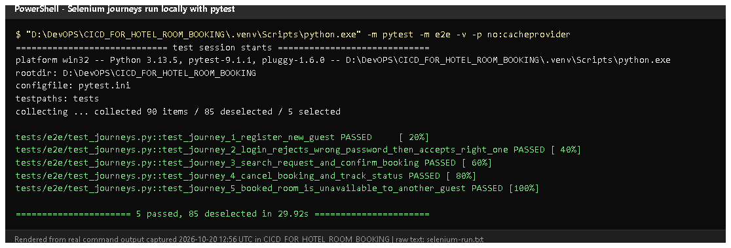
Figure 9.1 - pytest -m e2e -v on 2026-10-20 (rendered from real output): 5 journeys PASSED. Proves: the journeys run locally through pytest.
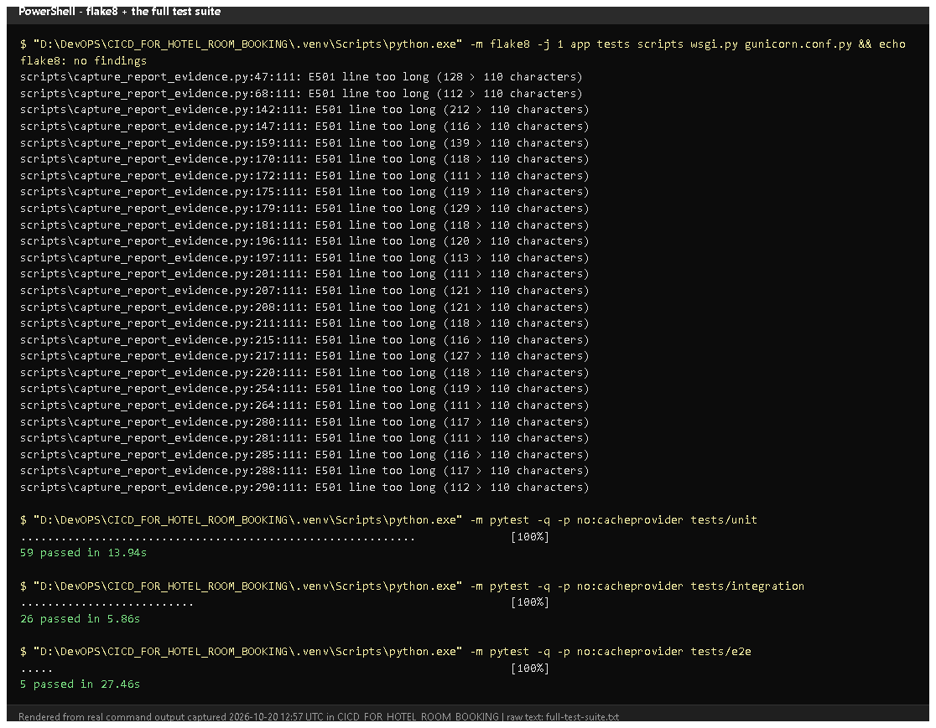
Figure 9.2 - flake8 (no findings), then unit 59, integration 26 and e2e 5 passed (rendered from real output, 2026-10-20).
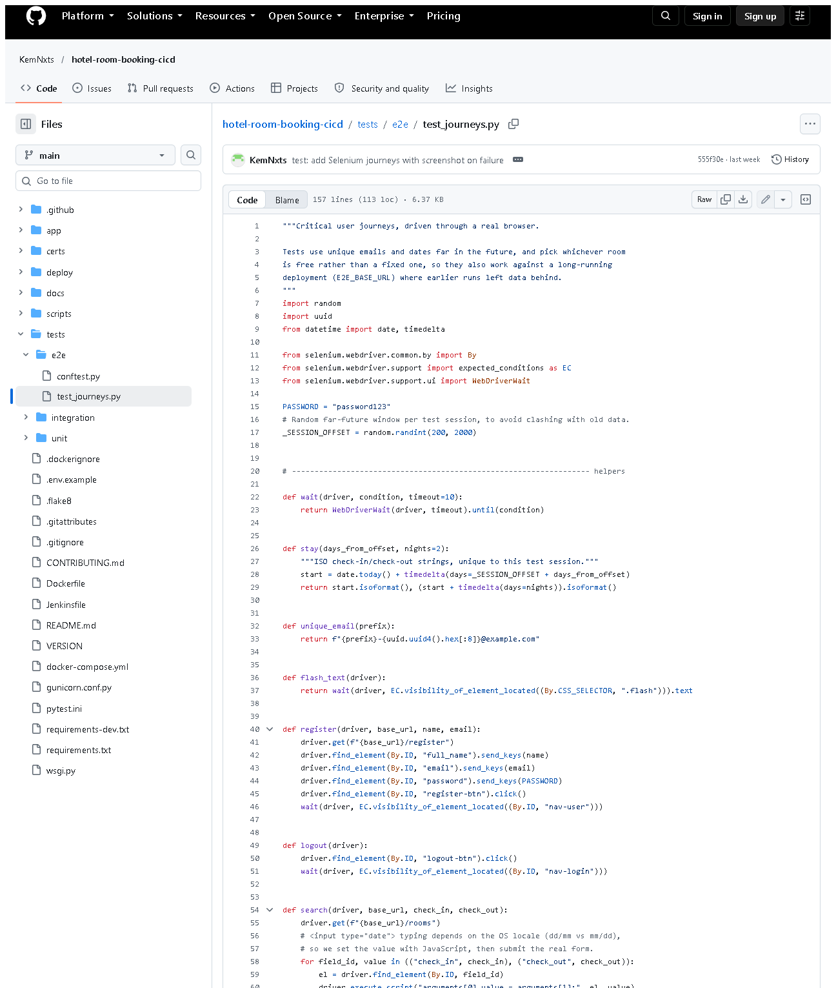 (part 1 of 3)
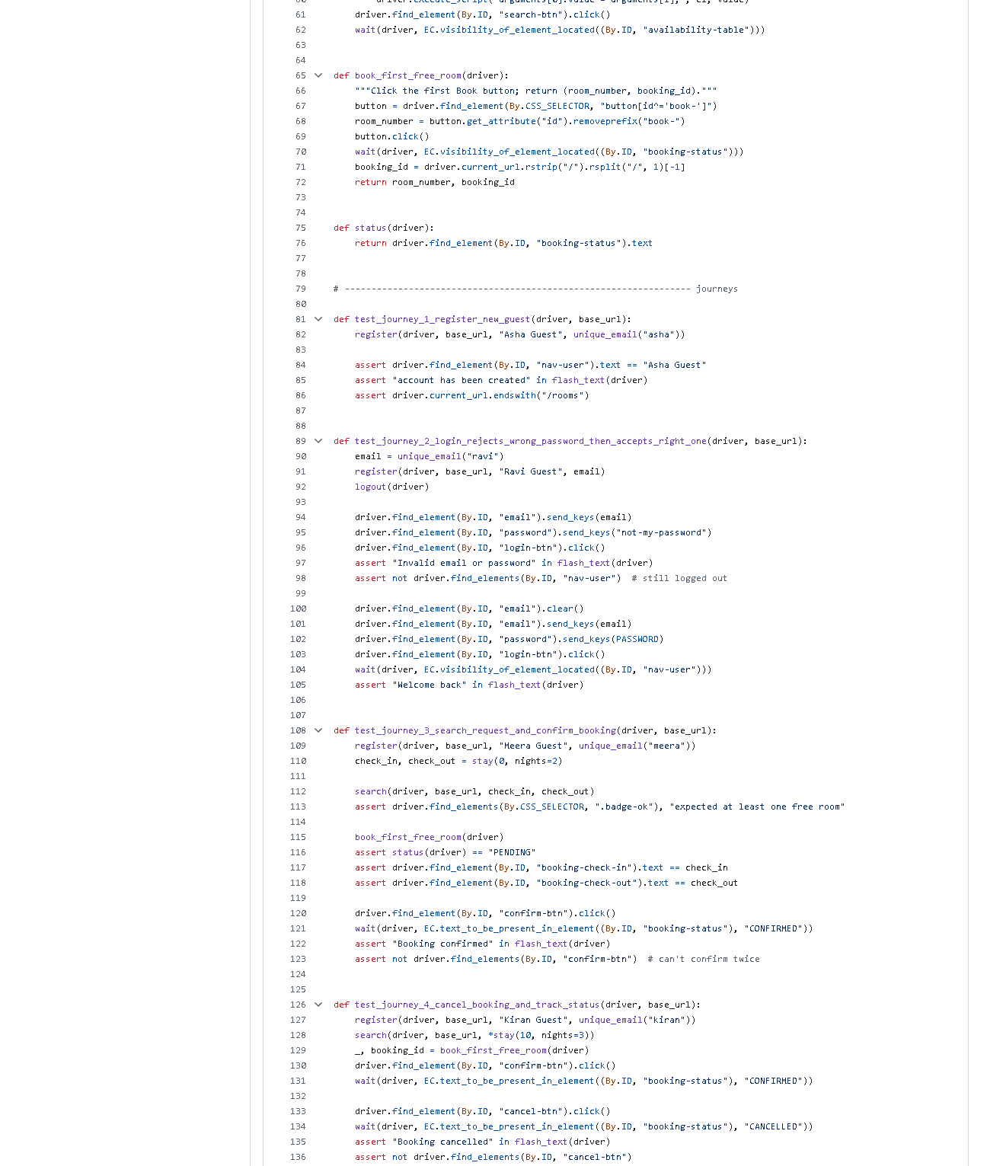 (part 2 of 3)
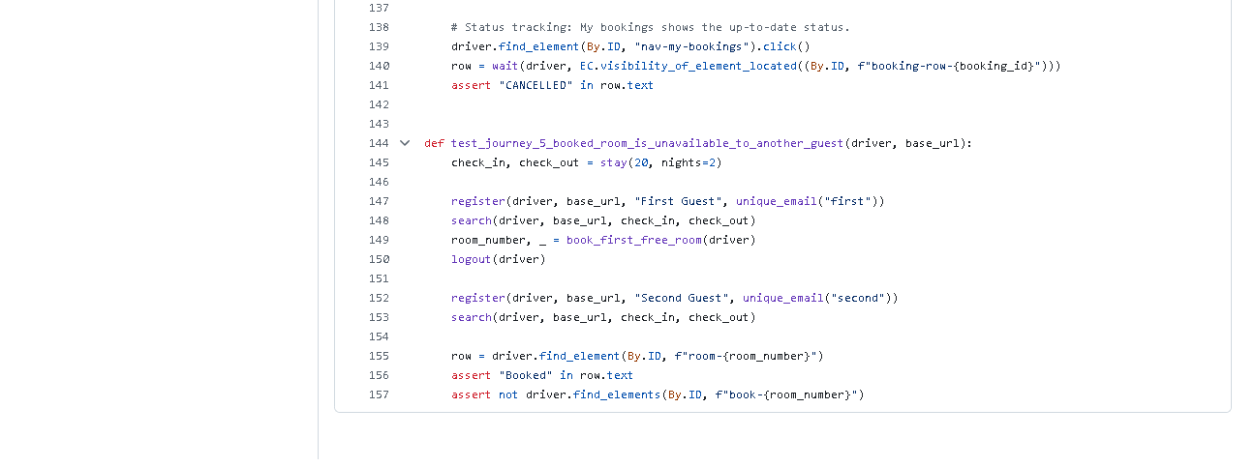 (part 3 of 3)
Figure 9.3 - tests/e2e/test_journeys.py on GitHub (the pushed version; the local working copy adds the confirmation-dialog step in journey 4 and the readable-date check in journey 3, both for the uncommitted UI redesign). Notice: By.ID locators, the wait() helper, assertions.
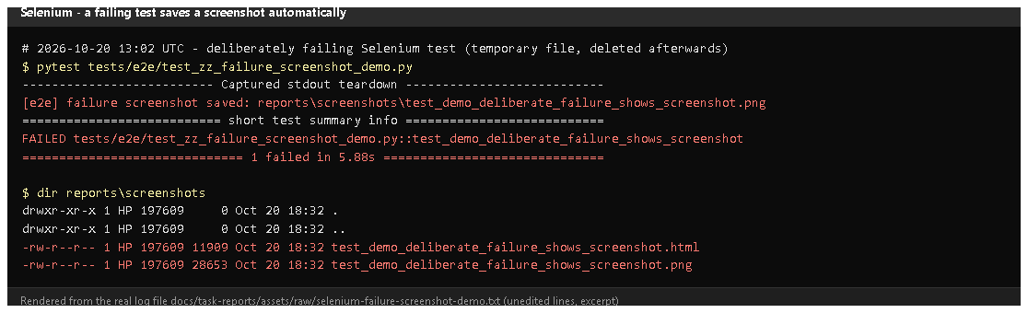
Figure 9.4 - A temporary, deliberately failing test run on 2026-10-20 (rendered from real output): "failure screenshot saved: reports\screenshots...png", then 1 failed; the folder contains a .png and an .html.
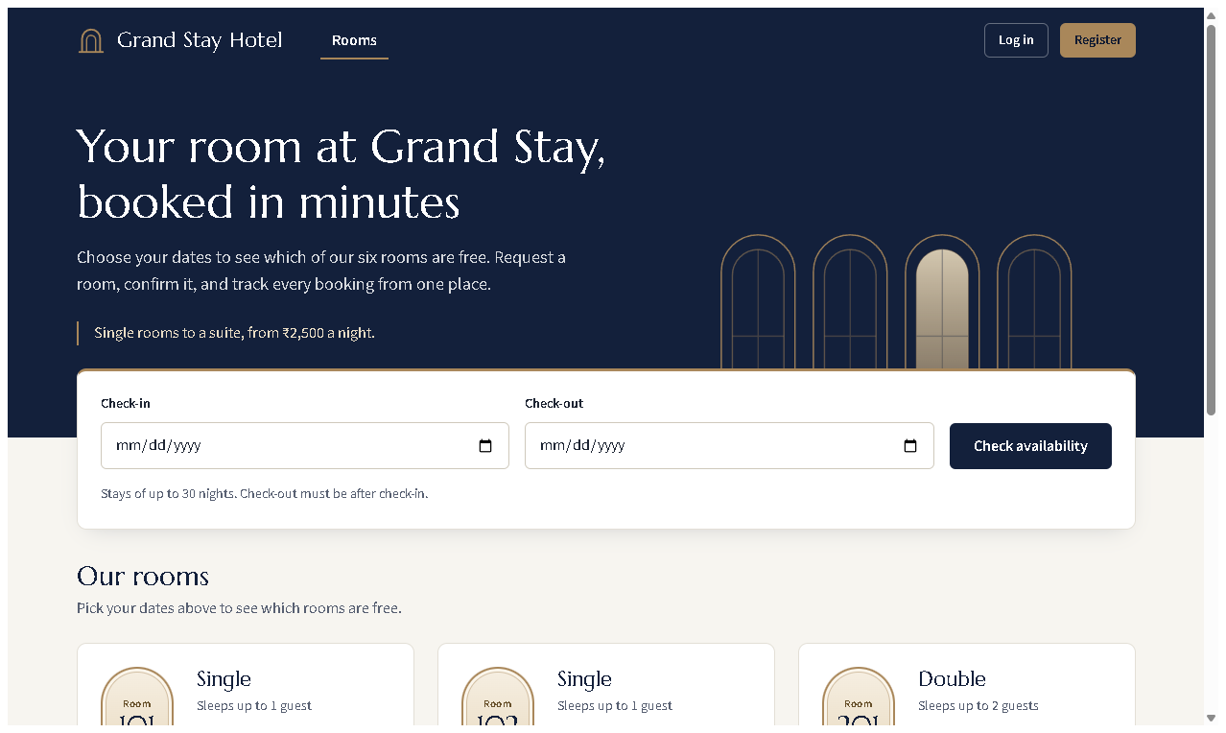
Figure 9.5 - The actual image saved by the hook: what the browser showed at the moment of failure. Proves: failures leave visual evidence automatically.
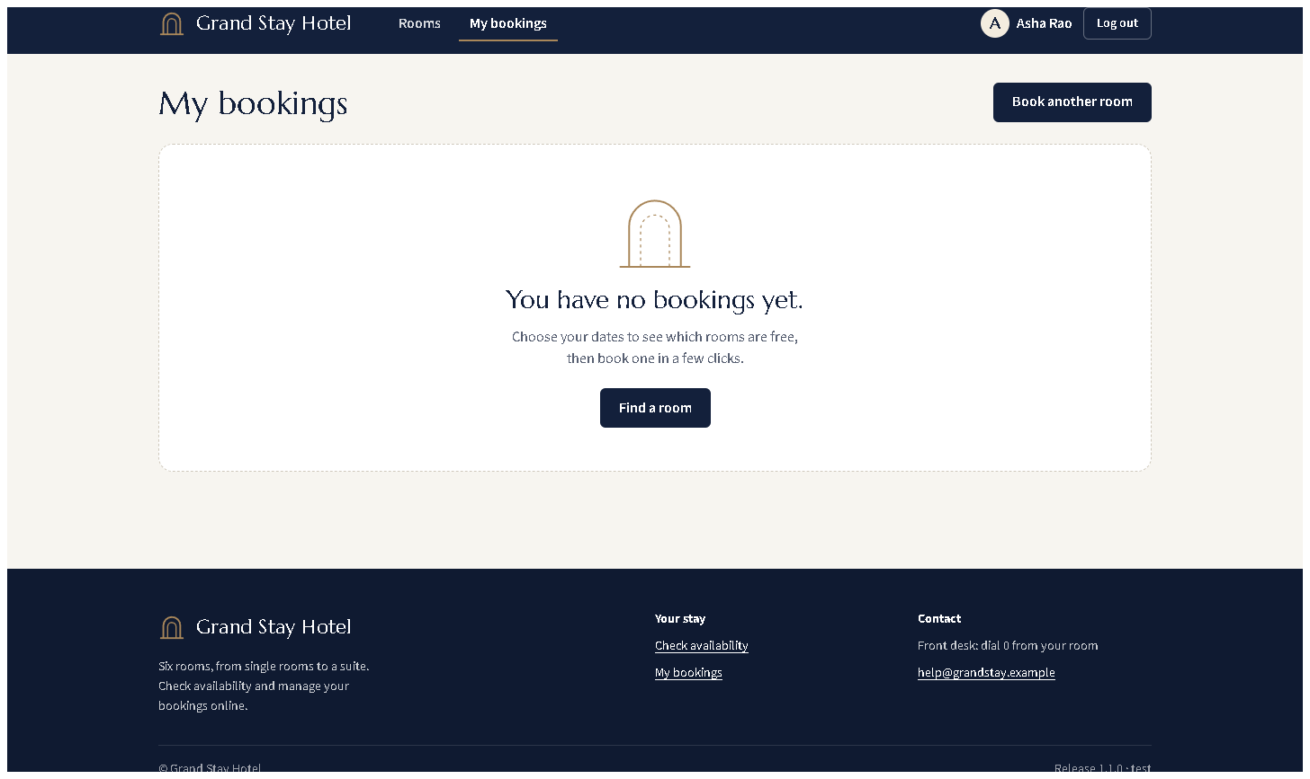
Figure 9.6 - The empty "My bookings" state (redesigned UI) - one of the pages the journeys navigate.

E. How to demonstrate this task to the professor (about 4 minutes)
Before the demo: Google Chrome installed; PowerShell in D:\DevOPS\CICD_FOR_HOTEL_ROOM_BOOKING.
- Open tests/e2e/test_journeys.py in VS Code; show journey 3 and the wait() helper. Say: "Locators use ids; waits are explicit; each journey ends with assertions."
- Run the journeys and let the professor watch the browser:Expected: Chrome windows open and click through the pages; finally 5 passed, 85 deselected (about 30 s).
$env:HEADLESS="0"
.venv\Scripts\python -m pytest -m e2e -v
Remove-Item Env:HEADLESS
- Produce a JUnit report:Open reports\e2e-tests.xml - one <testcase> per journey.
.venv\Scripts\python -m pytest -m e2e --junitxml=reports/e2e-tests.xml -q
- Explain isolation: "Each run starts the app with a brand-new temporary database, so runs never depend on each other."
- Screenshots on failure: show Figure 9.5, or point to conftest.py lines 65-76 and say: "When a journey fails, a screenshot and the HTML are saved and archived by Jenkins."
- Against a running deployment (optional, staging must be up):Note: staging currently runs the committed v1.1.0 interface, while the local tests expect the redesigned one (dialog, readable dates), so journeys 3 and 4 fail there (checked 2026-10-20: 3 passed, 2 failed) until the redesign is deployed. Test the deployment with the tests of the same version.
$env:E2E_BASE_URL="http://localhost:8081"
.venv\Scripts\python -m pytest -m e2e -q
Remove-Item Env:E2E_BASE_URL
Recovery: SessionNotCreatedException - update Chrome (Selenium downloads the matching driver automatically). Tests hang on first run - Selenium Manager is downloading chromedriver; wait once.

F. Expected screenshots for the final submission
- assets/task-09/selenium-run.png - exists, 2026-10-20.
- assets/task-09/full-test-suite.png - exists, 2026-10-20.
- assets/task-09/github-file-tests_e2e_test_journeys.py.png - exists, 2026-10-20.
- assets/task-09/selenium-failure-demo-output.png - exists, 2026-10-20.
- assets/task-09/selenium-failure-screenshot-saved-by-hook.png - exists, 2026-10-20.
- assets/task-09/app-desktop-07-my-bookings-empty.png - exists, 2026-10-20.
- (optional) a photo/screen recording of the visible browser run with HEADLESS=0 - requires manual capture (it is a live demo).

G. Probable viva questions and answers
- What is Selenium WebDriver? A library and protocol that lets code control a real browser - open pages, type, click, read text.
- Which journeys did you automate and why? Register; wrong-then-right login; search-book-confirm; cancel and track status; a booked room is unavailable to another guest - the six MVP workflows end to end.
- What is an explicit wait? Waiting for a condition (e.g. element visible) up to a timeout, continuing as soon as it is true. Better than sleep.
- Why ids as locators? They are unique and do not change when layout or styling changes; the UI redesign kept them, so the tests still passed.
- How do you keep test data from interfering? Each local run uses a new temporary database; against deployments, unique e-mails and random future dates.
- How do screenshots on failure work? A pytest hook records the result; the browser fixture saves a PNG and the HTML if the test failed.
- (Project-specific) Why are dates set with JavaScript? Typing into a date input depends on the OS date format; setting value is identical everywhere.
- (Project-specific) What changed in the tests for the UI redesign? Journey 4 now confirms the cancel dialog; journey 3 reads the ISO date from the datetime attribute and checks the readable text. Both still assert the same behaviour.
- Unit vs integration vs Selenium? Unit: one rule, no server. Integration: real HTTP routes in-process. Selenium: the full journey in a browser.
- Do you run Selenium through Maven? No - through pytest. It produces JUnit XML like Maven's Surefire would. Confirm with the professor if Maven is mandatory.
- How does Jenkins run a browser without a screen? Headless Chromium inside the Jenkins container (CHROME_BIN, CHROMEDRIVER set in its Dockerfile).

H. Common mistakes and troubleshooting
Symptom | Cause | Inspect | Fix | Confirm
SessionNotCreatedException | Chrome/driver mismatch or no Chrome | Chrome version | update Chrome | journeys start
TimeoutException waiting for nav-user | page layout changed or app error | reports/screenshots/*.png | look at the screenshot; fix the page or locator | test passes
Journeys 3/4 fail against staging | staging runs an older UI than the local tests expect | /health version | run the matching version's tests, or deploy the new UI | 5 passed
Tests pass alone but fail together | shared data | base_url fixture | keep the throw-away DB; use unique data | repeated runs pass
Date typed wrongly | locale-dependent typing | search() helper | use the JavaScript value setter | correct dates shown

I. Quick revision notes
Five key points
- 5 journeys covering all 6 MVP workflows, in tests/e2e/test_journeys.py.
- Stable By.ID locators + explicit WebDriverWait waits + clear assertions.
- Isolated data: a temporary database per run; unique e-mails and dates.
- Failure -> PNG + HTML in reports/screenshots/ (demonstrated 2026-10-20).
- Runs through pytest (JUnit XML), locally and in Jenkins; not Maven.
30-60 second explanation "Selenium drives a real Chrome browser through five journeys: registering, logging in with a wrong and then right password, searching and booking a room and confirming it, cancelling it and checking My bookings, and making sure a booked room is not offered to another guest. The tests find elements by id, wait explicitly, and assert the visible result. Each run starts the app with a fresh temporary database, so results are repeatable. If a journey fails, a screenshot and the page HTML are saved, and Jenkins keeps them. Today all five passed."
Caveat: pytest, not Maven, runs the tests.
Readiness checklist
- â˜ I can run the journeys with HEADLESS=0 so the browser is visible.
- â˜ I can explain explicit waits and stable locators with code on screen.
- â˜ I can show a failure screenshot (Figure 9.5).
- â˜ I can explain the three test levels.

Task 10 - Continuous Testing in Jenkins

A. Task title and objective
Task 10: Continuous Testing in Jenkins
Objective: run all automated tests (backend and Selenium) inside the pipeline, publish their reports, and make test failures stop the deployment - then prove it with a deliberately introduced defect, a corrective commit and a successful re-run.
Professor's required deliverables
- Backend and Selenium tests integrated into the pipeline
- Test report publication
- Failure propagation and a quality gate that blocks deployment
- A documented, deliberately introduced defect (on a disposable branch)
- Evidence the defect causes a test failure
- A corrective commit and a successful re-run
Current status: Implemented and verified. The experiment was run on 2026-10-11 (builds #2, #3, #9). On 2026-10-20 the build records were checked again directly in Jenkins (Figures 10.1-10.5), and today's build #11 again ran all 90 tests before deploying.

B. Explanation for a complete beginner
An everyday picture. At an airport, a plane cannot take off until the safety checklist is complete. If one check fails, the plane stays at the gate
- nobody "takes off anyway". A quality gate is that rule for software: if any test fails, the new version is not deployed.
Term | Meaning | In this project
Continuous testing | every build automatically runs the tests | every Jenkins build runs flake8 + 90 tests
Quality gate | a condition that must pass before the next step | test stages come before Deploy
Failure propagation | a failure travels up and marks the whole build failed | pytest exit code != 0 -> stage fails -> build FAILURE
Skipped stage | Jenkins does not run later stages after a failure | "Stage 'Deploy' skipped due to earlier failure(s)"
Regression | a test that passed before now fails | Jenkins labels it Regression
Defect experiment | breaking the code on purpose to prove the tests notice | an off-by-one bug in the overlap rule
Disposable branch | a branch for an experiment that is never merged | experiment/defect-demo

Build failure vs deployment failure. A build failure means the pipeline stopped before deploying (e.g. a test failed) - users are not affected. A deployment failure means the new version was started but is unhealthy - that is what the health check and rollback are for.

C. What was actually implemented
How tests stop the pipeline - each test stage is a shell command; pytest exits with a non-zero code when any test fails, so Jenkins marks the stage failed and skips every later stage:
stage('Unit & integration tests') {
steps { sh '.venv/bin/pytest tests/unit tests/integration --junitxml=reports/unit-integration-tests.xml' }
}
stage('E2E tests (Selenium)') {
steps { sh '.venv/bin/pytest -m e2e --junitxml=reports/e2e-tests.xml' }
}
// ... Package, Build images, Publish, Deploy, Health check come only after these
post { always { junit allowEmptyResults: true, testResults: 'reports/*.xml' } }
The deliberate-defect experiment (branch experiment/defect-demo, never merged into develop or main - git branch --contains 5844eec lists only the two experiment branches)
Step | Commit (current / original ID in logs) | What happened
Baseline | - | staging ran 1.0.0-64351fe (build #1)
1. Defect | 5844eec / 554cad3 | in app/dao/booking_dao.py the rule check_in < :check_out became check_in <= :check_out - an off-by-one that wrongly blocks a guest from arriving on the day the previous guest leaves
2. Build #2 | FAILURE | FAILED ...TestSearchRooms::test_overlap_rules[2030-01-08-2030-01-10-True], 1 failed, 81 passed; E2E, Package, Build images, Publish, Deploy, Health check skipped; staging still answered "commit":"64351fe"
3. Fix | 2fb62d6 / 30c6a05 | fix: restore strict overlap comparison in booking DAO
4. Build #3 | SUCCESS | 87/87 tests; staging moved to 1.0.0-30c6a05

The diff of the defect (Figure 10.3):
_OVERLAP_SQL = """
- check_in < :check_out
+ check_in <= :check_out
AND check_out > :check_in
The stale-report bug (found from the evidence, fixed, re-verified)
- Build #2's Tests page lists tests.e2e: 5 passed although its E2E stage was skipped (Figure 10.4). Cause: Jenkins reuses its workspace, and reports/e2e-tests.xml from build #1 was still there, so junit 'reports/*.xml' published it again.
- Fix on branch fix/jenkins-stale-reports: the Checkout stage now runs rm -rf reports dist before anything else.
- Proof: build #9 (experiment/defect-demo-2 = the same defect + the fix, current commit a3d8626, shown in Jenkins as 8505486) failed on the same test and its report lists 82 tests and no e2e package - only the tests that actually ran (Figure 10.5).
- Every later build (including #11 today) starts with + rm -rf reports dist, so a report can never come from an older build.

D. Screenshots and evidence
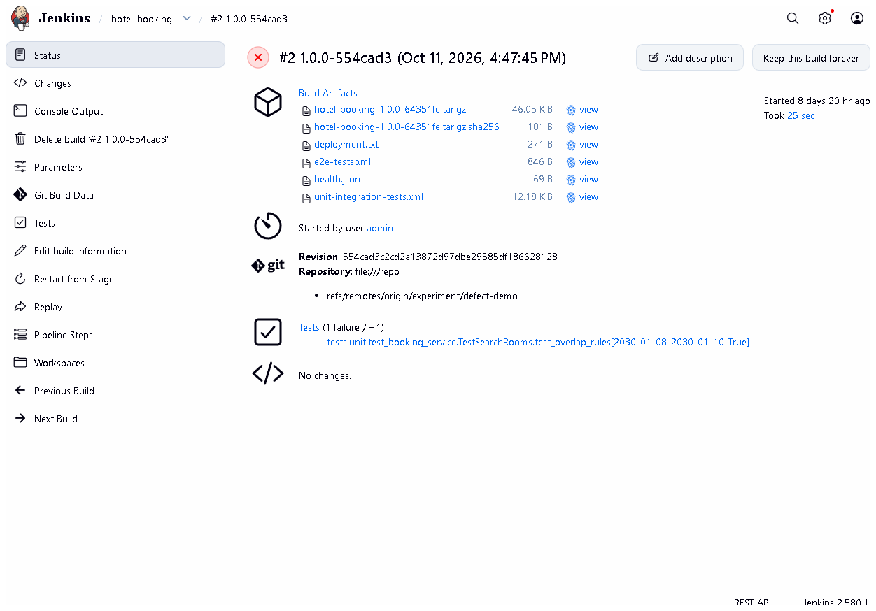
Figure 10.1 - Build #2 1.0.0-554cad3 in Jenkins (checked 2026-10-20): result FAILURE.
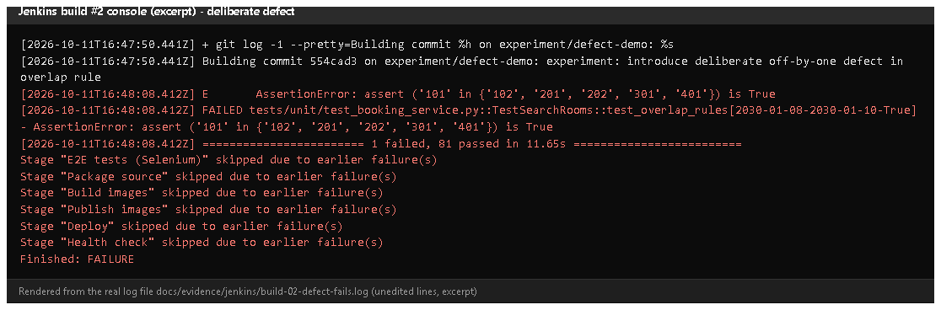
Figure 10.2 - Console excerpt of build #2 (rendered from the saved log docs/evidence/jenkins/build-02-defect-fails.log). Notice: the failing assertion, 1 failed, 81 passed, and six "skipped due to earlier failure(s)" lines including Deploy. Proves: the quality gate stopped the deployment.
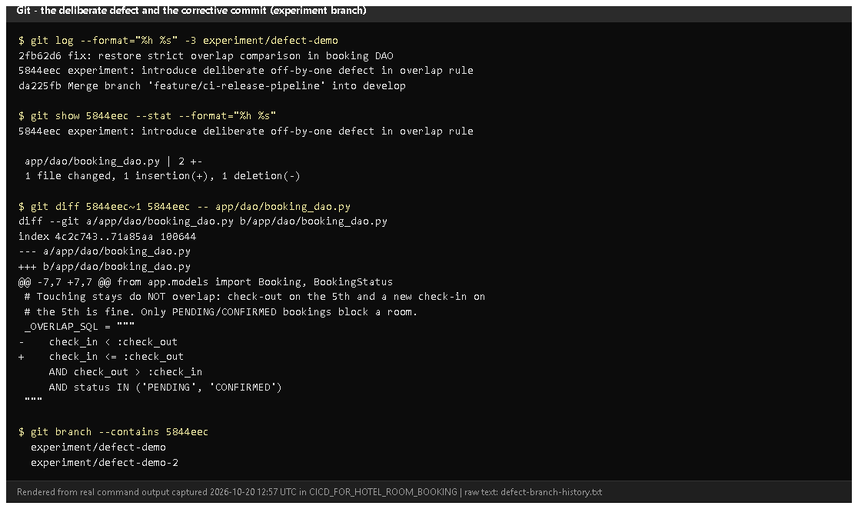
Figure 10.3 - The experiment branch history, the one-character diff, and the branches that contain the defect (rendered from real output, 2026-10-20).
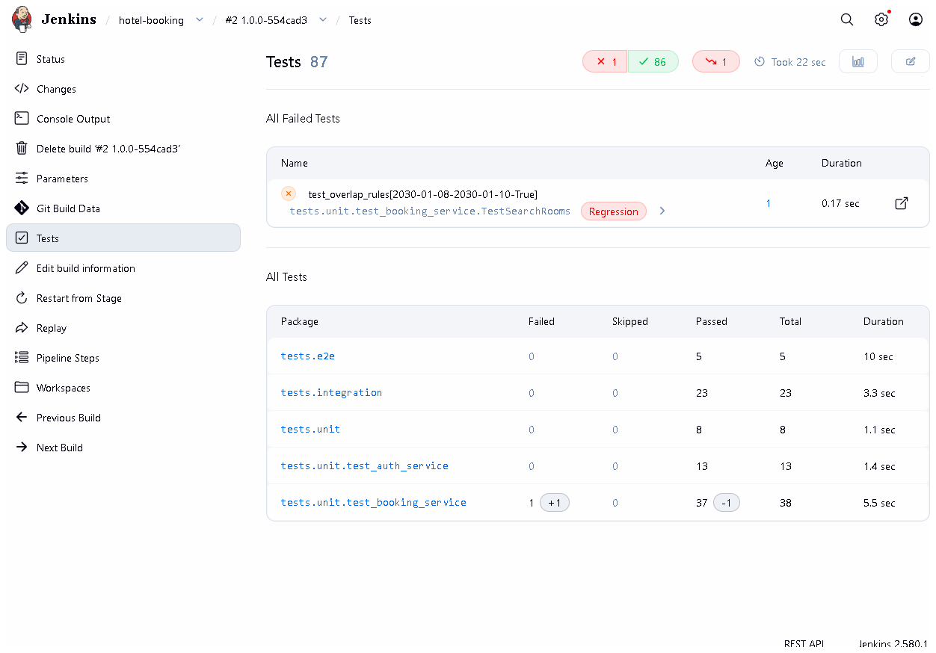
Figure 10.4 - Build #2's Tests page: 1 failed (test_overlap_rules[...-True], marked Regression). Also notice tests.e2e 5 - the stale report described above.
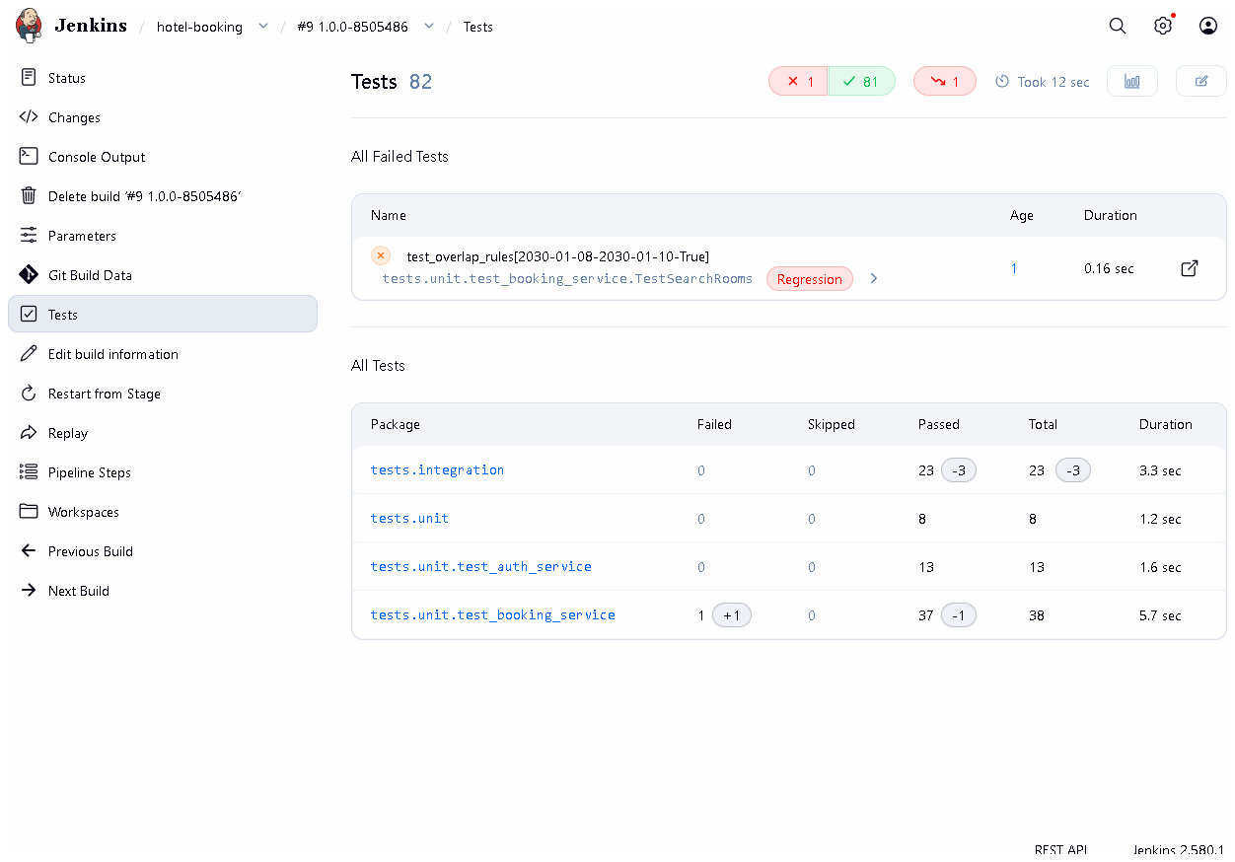
Figure 10.5 - Build #9 after the report fix: 82 tests, 1 failed, and no tests.e2e entry. Proves: the current build's report cannot reuse an older build's results.
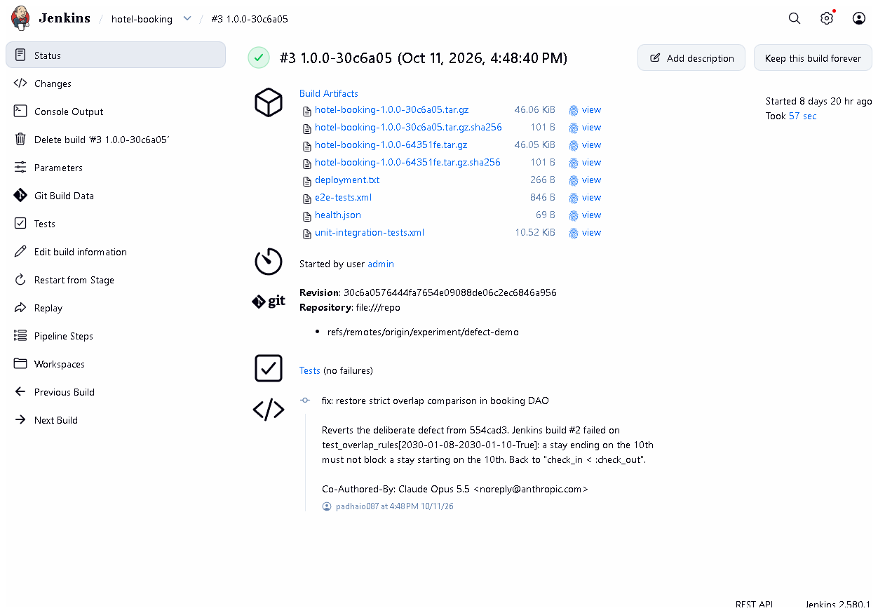
Figure 10.6 - Build #3 1.0.0-30c6a05: SUCCESS after the corrective commit.
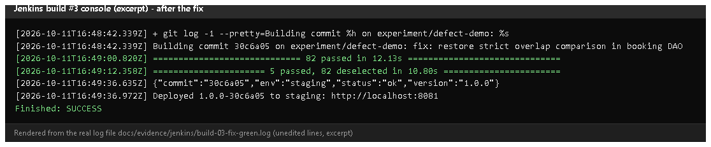
Figure 10.7 - Build #3 console excerpt (rendered from the saved log): tests passed, deployed, health check OK.
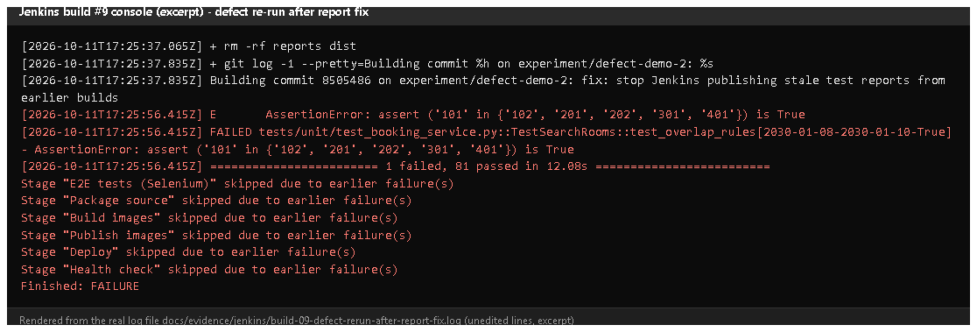
Figure 10.8 - Build #9 console excerpt: + rm -rf reports dist, the same failing test, later stages skipped.

E. How to demonstrate this task to the professor (about 5 minutes)
Option A - show the recorded experiment (safe, 2 minutes).
- Jenkins -> hotel-booking: point at red builds #2 and #9 in the stage view.
- Open #2 -> Console Output, Ctrl+F skipped due - Say: "The test failed, so Jenkins skipped packaging and deployment."
- Open #2 -> Tests - the failed overlap test.
- Open #3 - green after the fix.
- In PowerShell (project folder):Say: "One character, < to <=, and the tests caught it."
git log --oneline -3 experiment/defect-demo
git diff 5844eec~1 5844eec -- app/dao/booking_dao.py
Option B - repeat the experiment live (about 6 minutes, disposable branch). Warning: do this only on an experiment/* branch; never merge it.
git stash -u # only if you have uncommitted work (today: the UI redesign)
git checkout -b experiment/live-defect develop
Edit app/dao/booking_dao.py line 10: change check_in < :check_out to check_in <= :check_out, save.
git commit -am "experiment: deliberate off-by-one defect (live demo)"
Jenkins -> Build with Parameters -> BRANCH = experiment/live-defect, APP_ENV = staging -> Build. Expected: red at "Unit & integration tests", later stages "skipped". Check http://localhost:8081/health - the commit is unchanged (not deployed). Then fix and re-run:
git revert --no-edit HEAD
Build the same branch again - Expected: all green, staging shows the new commit. Clean up:
git checkout feature/ui-redesign # or the branch you were on
git stash pop # only if you stashed
git branch -D experiment/live-defect

F. Expected screenshots for the final submission
- assets/task-10/jenkins-build-02-failed.png - exists, 2026-10-20.
- assets/task-10/build-02-defect-console.png - exists (rendered from the 2026-10-11 log).
- assets/task-10/defect-branch-history.png - exists, 2026-10-20.
- assets/task-10/jenkins-build-02-failed-test.png - exists, 2026-10-20.
- assets/task-10/jenkins-build-09-tests-no-stale-report.png - exists, 2026-10-20.
- assets/task-10/jenkins-build-03-fixed.png - exists, 2026-10-20.
- assets/task-10/build-03-fix-console.png - exists (rendered from the 2026-10-11 log).
- assets/task-10/build-09-rerun-console.png - exists (rendered from the 2026-10-11 log).

G. Probable viva questions and answers
- What is a quality gate? A check that must pass before the pipeline continues - here all lint and tests before Deploy.
- How does a failed test stop deployment? pytest exits non-zero, the sh step fails, the stage fails and Jenkins skips all later stages.
- What defect did you introduce? < became <= in the overlap SQL, blocking back-to-back stays (check-out day = next check-in day).
- Which test caught it? TestSearchRooms::test_overlap_rules[2030-01-08-2030-01-10-True] - a stay ending on the 10th must not block one starting on the 10th.
- How do you know it wasn't deployed? The log shows Deploy skipped, and staging's /health still reported the previous commit 64351fe.
- Why on an experiment branch? So the defect never reaches develop or main; git branch --contains 5844eec lists only experiment branches.
- (Project-specific) What was the stale-report problem? Build #2's report showed 5 E2E tests passing although that stage never ran - an old XML file in the reused workspace. Fixed by deleting reports/ and dist/ at checkout; build #9 proves it.
- (Project-specific) Why do the IDs in Jenkins (554cad3) differ from Git (5844eec)? Commit messages were edited once before publishing, which changed all IDs; see docs/evidence/git/commit-id-map.md.
- Build failure vs deployment failure? Build failure: stopped before deploying (users unaffected). Deployment failure: the new version started but is unhealthy - caught by --wait and the health check, fixed by rollback.
- Do Selenium tests also gate the deploy? Yes - the E2E stage comes before Package/Deploy.
- Why publish reports even when the build fails? post { always } runs on failure too, so you can see which test failed.

H. Common mistakes and troubleshooting
Symptom | Cause | Inspect | Fix | Confirm
Report shows tests from an earlier build | stale XML in workspace | Checkout stage in the console | ensure rm -rf reports dist is present (it is since the fix) | report count = tests actually run
Defect build is green | defect not committed, or wrong branch built | console "Building commit ..." | commit and set BRANCH correctly | red stage
Experiment merged by accident | merged into develop | git branch --contains <defect id> | git revert the merge on develop | tests pass
git checkout refuses | uncommitted work | git status | git stash -u / git stash pop | branch switched

I. Quick revision notes
Five key points
- Every build runs flake8 + 85 unit/integration + 5 Selenium tests before deploying.
- A failing test -> stage fails -> later stages (incl. Deploy) skipped.
- Defect < -> <= (commit 5844eec) failed build #2; fix 2fb62d6 made build #3 green.
- Staging kept the old version during the failed build.
- Stale-report bug found, fixed (rm -rf reports dist), proven by build #9.
30-60 second explanation "Tests are the quality gate of our pipeline: Jenkins runs lint, unit, integration and Selenium tests, and only if all pass does it package and deploy. To prove it I introduced a one-character bug on an experiment branch, changing < to <= in the overlap rule. Build #2 failed on the overlap test, every later stage was skipped, and staging kept the previous version. A corrective commit made build #3 green. I also found that build #2's report reused an old Selenium result; I fixed that, and build #9 proves reports now only contain tests that really ran."
Caveat: the experiment ran on 2026-10-11; on 2026-10-20 its records were re-checked, not re-run (Option B shows how to re-run it).
Readiness checklist
- â˜ I can open builds #2, #3, #9 and explain each.
- â˜ I can show the one-line diff.
- â˜ I can explain the stale-report fix.
- â˜ I know how to repeat the experiment safely on an experiment branch.

Task 11 - Docker Image and Container Lifecycle

A. Task title and objective
Task 11: Docker Image and Container Lifecycle
Objective: package the Flask application into a Docker image that runs with a production server, as a non-root user, configured by environment variables and without secrets inside; then demonstrate the full life of a container: build, tag, run, port mapping, logs, inspection, stop, restart, removal and persistent data.
Professor's required deliverables
- Dockerfile with a suitable Python base image, reproducible dependency install, production WSGI server, exposed and mapped port, non-root user, environment-variable configuration, no baked-in secrets, .dockerignore, a health check
- Demonstration of build and tag, create and run, port mapping, logs and inspection, stop / restart / remove, persistent database storage
- Proof that the container actually starts and serves requests
Current status: Implemented and verified. The complete lifecycle was run again on 2026-10-20 (Figures 11.1-11.2): the container became healthy, answered on the mapped port, ran as appuser, and an account created in one container still worked in a new container using the same volume.

B. Explanation for a complete beginner
An everyday picture. A shipping container holds goods in a standard box that fits every ship, train and truck. A Docker container holds an application plus everything it needs (Python, libraries, settings) in a standard box that runs the same on any machine with Docker - "it works on my machine" stops being a problem.
Term | Plain meaning | In this project
Dockerfile | the recipe for building an image | Dockerfile (app), deploy/nginx/Dockerfile
Image | a read-only package built from the recipe (like a class / a template) | hotel-booking-app:1.1.0
Container | a running instance of an image (like an object) | hotel-demo, hotel-prod-app-1
Tag | the name:version label of an image | 1.1.0, latest, 1.1.0-1c2103c
Port mapping | connect a port on your computer to a port inside the container | -p 8095:8000
Volume | storage managed by Docker that lives outside containers | hotel-demo-data / hotel-data mounted at /data
Logs | what the app prints, collected by Docker | docker logs
Inspect | detailed JSON description of a container/image | docker inspect
Health check | a command Docker runs regularly to ask "are you OK?" | GET /health every 10 s
Docker Compose | starts several containers together from one file | docker-compose.yml: nginx + app + volume

Why can data survive deleting a container? A container's own file system disappears with it. Our SQLite file lives at /data/hotel.db, and /data is a volume, which Docker keeps until you delete the volume itself. A new container that mounts the same volume sees the same data.
Lifecycle states: created -> running -> (stopped = exited) -> running again -> removed. Health status: starting -> healthy (or unhealthy).

C. What was actually implemented
Dockerfile (application image) - key lines:
Line | Instruction | Why
3 | FROM python:3.11-slim-bookworm | small official Python image, same Python as the pipeline
7-8 | ARG APP_VERSION, ARG GIT_COMMIT | release info, shown by /health and as image labels
12-17 | ENV APP_ENV=prod, DATABASE_PATH=/data/hotel.db ... | configuration by environment variables
20-22 | LABEL org.opencontainers.image.version / revision | docker inspect shows which release and commit an image came from
29 | COPY certs/ ... + update-ca-certificates | optional extra root CAs (antivirus HTTPS scanning); folder normally empty
35-36 | COPY requirements.txt then RUN pip install --no-cache-dir ... | pinned dependencies; copied before the code so this slow layer is cached
38-39 | COPY app/ ..., COPY wsgi.py gunicorn.conf.py | the application
44-46 | useradd ... appuser, USER appuser | not root inside the container
50 | VOLUME /data | the database lives on a volume
52 | EXPOSE 8000 | Gunicorn's port
56-57 | HEALTHCHECK ... urllib.request.urlopen('http://127.0.0.1:8000/health') | Docker knows when the app is really ready
59 | CMD ["gunicorn", "--config", "gunicorn.conf.py", "wsgi:app"] | production WSGI server (2 workers)

No secrets in the image: SECRET_KEY is given at run time (-e or --env-file); the app refuses to start in prod without it. .dockerignore excludes .git, .venv, tests, docs, deploy/ansible, deploy/jenkins, *.md, .env and *.db.
docker-compose.yml - two services: app (image ${IMAGE_PREFIX}hotel-booking-app:${IMAGE_TAG}, volume hotel-data:/data, no published port) and nginx (reverse proxy, published on ${HOST_PORT:-8080}:80, starts only when the app is service_healthy); both restart: unless-stopped. The Nginx image (deploy/nginx/Dockerfile) bakes in hotel.conf and serves /static/ directly.
Lifecycle demo run on 2026-10-20 (raw output: assets/raw/docker-lifecycle.txt):
Step | Command (shortened) | Observed
build | docker build -t hotel-booking-app:1.1.0 --build-arg APP_VERSION=1.1.0 --build-arg GIT_COMMIT=1c2103c-dirty . | image built
tag | docker tag hotel-booking-app:1.1.0 hotel-booking-app:latest | two tags, same image ID
inspect image | docker image inspect -f '...' | labels version/revision, user=appuser, exposed 8000/tcp
volume | docker volume create hotel-demo-data | created
run | docker run -d --name hotel-demo -p 8095:8000 --env-file ... -v hotel-demo-data:/data hotel-booking-app:1.1.0 | Up (healthy), 0.0.0.0:8095->8000/tcp
request | curl -s http://localhost:8095/health | {"commit":"1c2103c-dirty","env":"prod","status":"ok","version":"1.1.0"}
use | register a guest over HTTP | HTTP 302 (success)
logs | docker logs --tail 6 hotel-demo | Gunicorn start, health checks, POST /register 302
inspect | docker inspect -f 'state=... health=... mounts=...' | running, healthy, hotel-demo-data->/data
user | docker exec hotel-demo whoami | appuser
stop | docker stop hotel-demo | Exited (0)
start / restart | docker start, docker restart | healthy again
remove | docker rm -f hotel-demo | gone
new container | same docker run on the same volume | healthy
data survived | log in with the account from the first container | HTTP 302 (success)
clean up | docker rm -f, docker volume rm | removed

(-dirty in the commit label means the image was built from a working tree with uncommitted changes - the UI redesign - and is honest about it.)

D. Screenshots and evidence
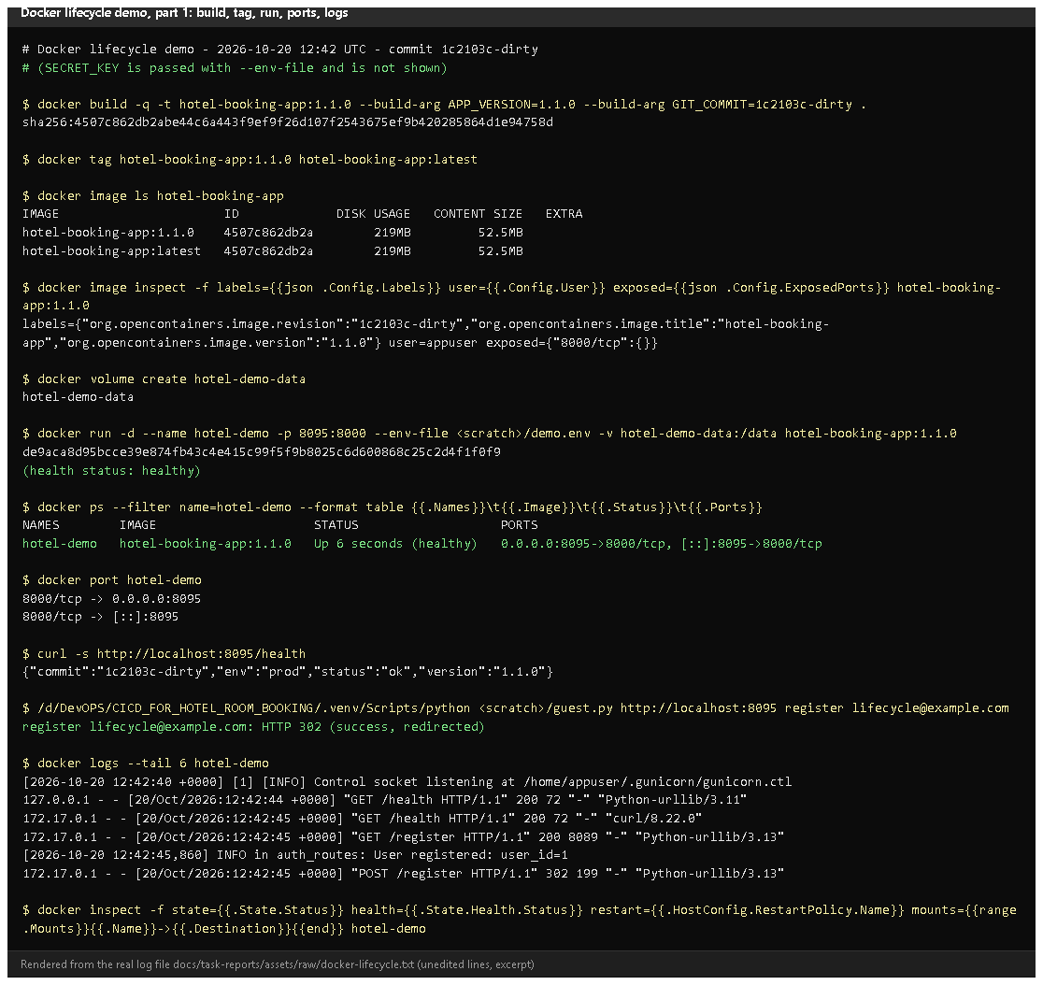
Figure 11.1 - Lifecycle demo, part 1: build, tag, image labels/user/port, volume, run, docker ps with port mapping, /health, registration, logs (rendered from the real run on 2026-10-20).
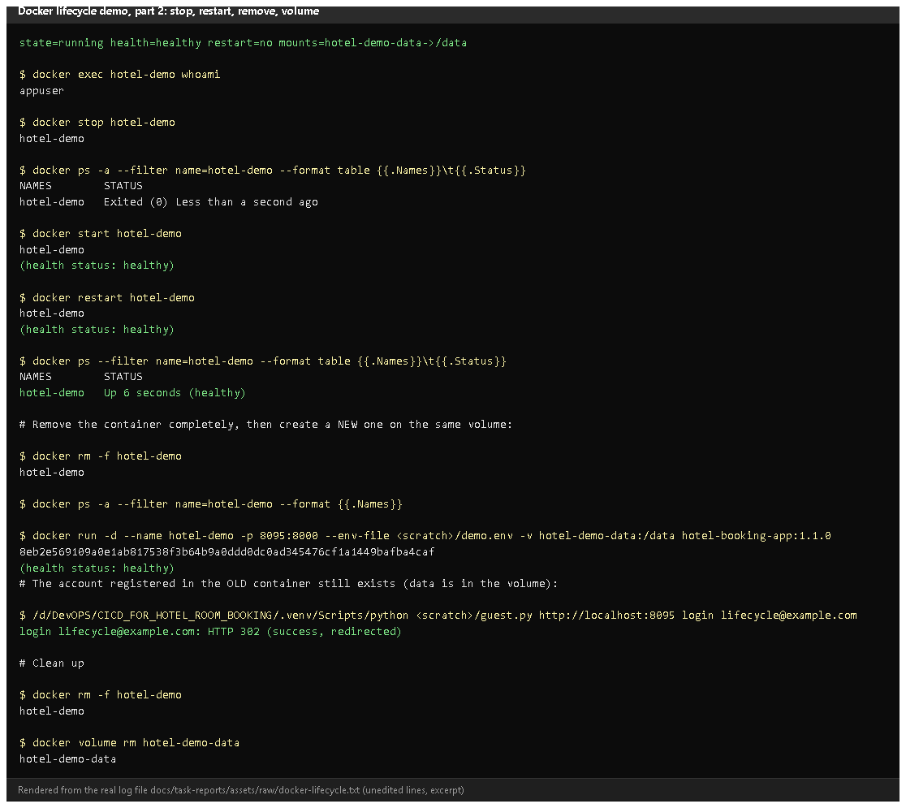
Figure 11.2 - Part 2: inspect, whoami = appuser, stop -> Exited, start, restart, remove, a new container on the same volume, the old account still logs in, clean-up. Proves: every lifecycle operation, and persistence through a volume.
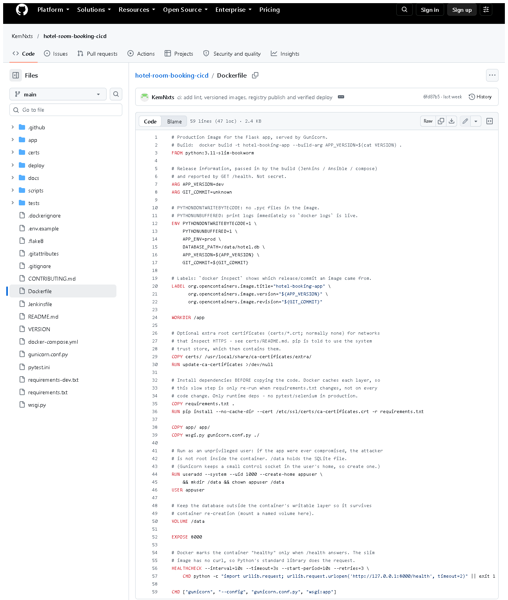 (part 1 of 2)
(part 2 of 2)
Figure 11.3 - Dockerfile on GitHub. Notice: slim base, dependencies before code, USER appuser, VOLUME, EXPOSE, HEALTHCHECK, Gunicorn CMD.
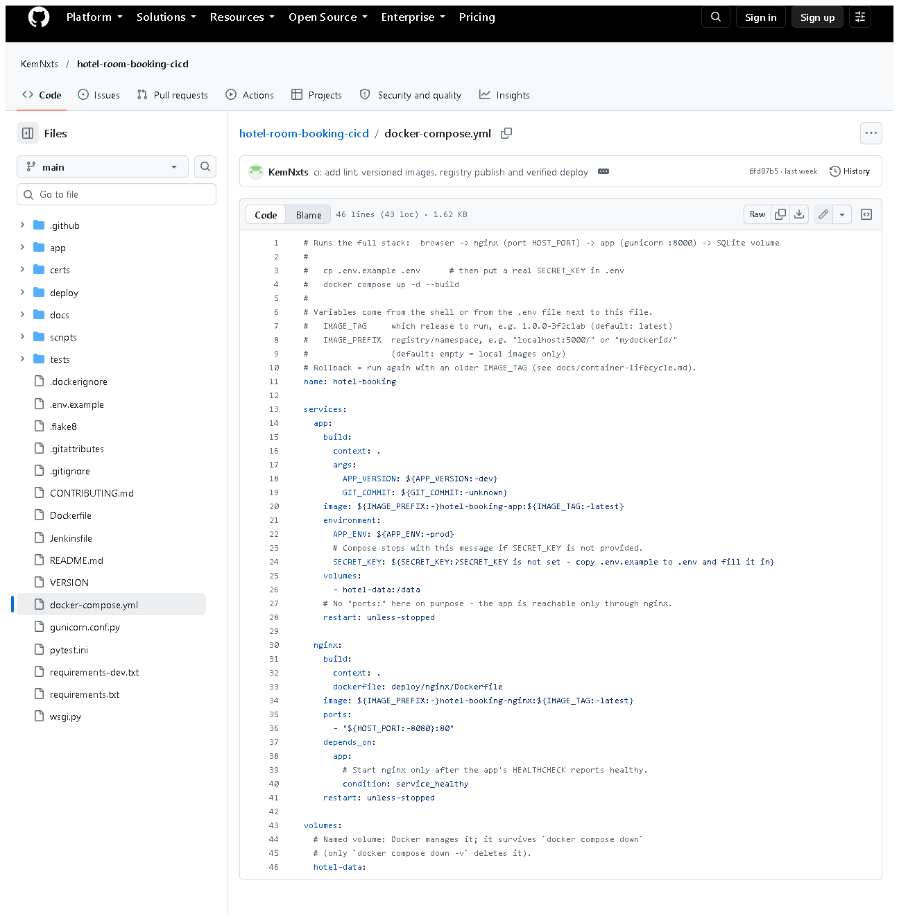
Figure 11.4 - docker-compose.yml: app + nginx, named volume, service_healthy dependency, SECRET_KEY required.
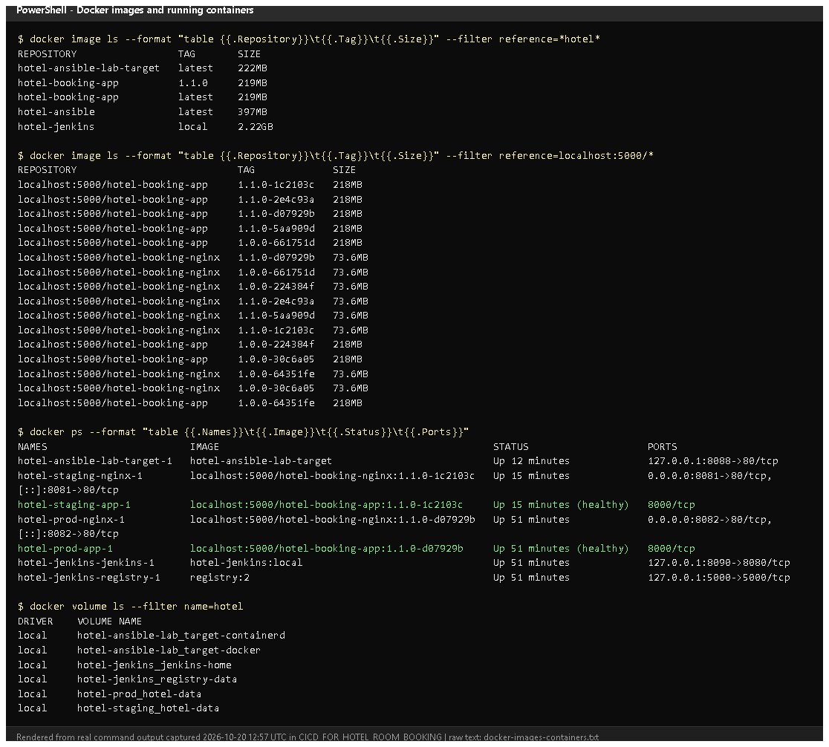
Figure 11.5 - docker image ls, docker ps and docker volume ls on 2026-10-20 (rendered from real output): versioned images, the running staging/prod/Jenkins/lab containers and the data volumes.

E. How to demonstrate this task to the professor (about 5 minutes)
Before the demo: Docker Desktop running. PowerShell in D:\DevOPS\CICD_FOR_HOTEL_ROOM_BOOKING. These exact commands were run on 2026-10-20.
# 1. build and tag the image
docker build -t hotel-booking-app:demo --build-arg APP_VERSION=1.1.0 .
docker image ls hotel-booking-app

# 2. create a volume and run a container with a port mapping
docker volume create hotel-demo-data
docker run -d --name hotel-demo -p 8095:8000 -e SECRET_KEY=demo-only-secret-123 -v hotel-demo-data:/data hotel-booking-app:demo
docker ps --filter name=hotel-demo
Expected: status Up ... (healthy) after ~10 s and 0.0.0.0:8095->8000/tcp. Say: "Port 8095 on my laptop is mapped to port 8000 inside the container."
# 3. it serves requests
curl.exe -s http://localhost:8095/health
Open http://localhost:8095/register in the browser and create an account.
# 4. logs and inspection
docker logs --tail 5 hotel-demo
docker inspect -f "{{.State.Health.Status}}" hotel-demo
docker exec hotel-demo whoami

# 5. stop, start, restart
docker stop hotel-demo
docker ps -a --filter name=hotel-demo
docker start hotel-demo
docker restart hotel-demo

# 6. remove the container, start a NEW one on the same volume
docker rm -f hotel-demo
docker run -d --name hotel-demo -p 8095:8000 -e SECRET_KEY=demo-only-secret-123 -v hotel-demo-data:/data hotel-booking-app:demo
Log in at http://localhost:8095/login with the account from step 3. Say: "The container was deleted, but the database is on a volume, so the account still exists." (Use the same SECRET_KEY - a different one only logs existing sessions out; the account stays.)
# 7. clean up
docker rm -f hotel-demo
docker volume rm hotel-demo-data
docker image rm hotel-booking-app:demo
Notes: in PowerShell use curl.exe (plain curl is a different PowerShell command). -e SECRET_KEY=... here is a throw-away demo value; real deployments take it from .env or Jenkins credentials.
Recovery: "port is already allocated" - choose another port, e.g. -p 8096:8000. "Conflict. The container name is already in use" - docker rm -f hotel-demo. Build fails with CERTIFICATE_VERIFY_FAILED - antivirus HTTPS scanning; see certs/README.md.

F. Expected screenshots for the final submission
- assets/task-11/lifecycle-part1-build-run.png - exists, 2026-10-20 (rendered from the real run).
- assets/task-11/lifecycle-part2-stop-restart-volume.png - exists, 2026-10-20.
- assets/task-11/github-file-Dockerfile.png - exists, 2026-10-20.
- assets/task-11/github-file-docker-compose.yml.png - exists, 2026-10-20.
- assets/task-11/docker-images-containers.png - exists, 2026-10-20.
- Earlier lifecycle evidence (2026-10-11): docs/evidence/docker/lifecycle.txt - exists.

G. Probable viva questions and answers
- Image vs container? An image is the read-only package; a container is a running instance of it. Many containers can run from one image.
- Why copy requirements.txt before the code? Docker caches each layer; dependencies are reinstalled only when requirements.txt changes, not on every code change.
- Why a non-root user? If the app were compromised, the attacker would not be root inside the container (whoami shows appuser).
- How is the app configured? Environment variables (APP_ENV, SECRET_KEY, DATABASE_PATH...); no secrets are in the image.
- What does the HEALTHCHECK do? Every 10 s it requests /health; Docker marks the container healthy/unhealthy, and compose starts Nginx only when the app is healthy.
- What is port mapping? -p 8095:8000 connects port 8095 on the host to 8000 in the container.
- (Project-specific) How did you prove data persistence? I created an account, deleted the container, started a new one on the same volume and logged in with that account - HTTP 302 success (2026-10-20).
- (Project-specific) Why Gunicorn and Nginx? Gunicorn runs the Python app with several workers; Nginx is the only public entry point and serves CSS directly. The app port isn't even published in compose.
- What does .dockerignore do? Keeps files like .git, .venv, tests, docs and .env out of the build context - smaller images, no secrets.
- docker stop vs docker rm? Stop ends the process (container still exists, can start again); rm deletes the container (volume kept).
- What happens to data with docker compose down -v? -v also deletes the volume - the database is lost. Plain down keeps it.

H. Common mistakes and troubleshooting
Symptom | Cause | Inspect | Fix | Confirm
failed to connect to the docker API | Docker Desktop not running | Docker Desktop window | start it, wait for "Engine running" | docker ps works
Container exits immediately | missing SECRET_KEY in prod | docker logs hotel-demo | pass -e SECRET_KEY=... | Up (healthy)
port is already allocated | port used | docker ps | other host port | container starts
Status stays starting/unhealthy | app error | docker logs, docker inspect | fix config; rebuild | healthy
Data gone after restart | no volume, or down -v | docker inspect -f "{{.Mounts}}" | always mount -v name:/data | data present
curl in PowerShell prints a table | PowerShell alias | - | use curl.exe | JSON shown

I. Quick revision notes
Five key points
- Image = package, container = running instance, tag = name:version.
- Dockerfile: slim Python, cached dependencies, non-root, VOLUME /data, HEALTHCHECK, Gunicorn.
- Configuration by environment variables; SECRET_KEY only at run time.
- Full lifecycle demonstrated on 2026-10-20, including persistence via a volume.
- Compose runs Nginx (public) + app (private) + named volume.
30-60 second explanation "The Dockerfile builds a small Python image: dependencies first for caching, then the code, a non-root user, a volume for the SQLite database, a health check, and Gunicorn as the production server. Configuration comes from environment variables, so the image contains no secrets. I demonstrated the lifecycle: build and tag, run with a port mapping, check /health, read the logs, inspect, stop, start, restart and remove. Because the database is on a volume, an account created in one container still worked in a brand-new one."
Caveat: the demo image was built from a working tree with uncommitted UI changes, so its commit label ends in -dirty.
Readiness checklist
- â˜ Docker Desktop is running before the viva.
- â˜ I can run the 7-step demo without notes.
- â˜ I can explain image vs container and why the volume keeps data.
- â˜ I remember curl.exe in PowerShell.

Task 12 - Jenkins-Docker Continuous Deployment

A. Task title and objective
Task 12: Jenkins-Docker Continuous Deployment
Objective: after all tests pass, have Jenkins build a Docker image, tag it with a version and the commit SHA, publish it to a registry, deploy exactly that tested image, check its health and record what was deployed.
Professor's required deliverables
- Build the image after the mandatory tests pass
- Tag it with a version and an identifiable commit SHA
- Publish it to Docker Hub or an available registry
- Deploy the tested version
- Perform a health check
- Record the deployed version and pipeline result
- Use Jenkins credentials securely; never deploy untested or uncommitted code
Current status: Implemented and verified (local registry). Build #11 on 2026-10-20 built, tagged 1.1.0-1c2103c, pushed to the local registry, deployed to staging, health-checked and archived the deployment record.
Docker Hub publishing: pending external action. The pipeline supports it (REGISTRY=docker.io/<user> + credential registry-creds), but it was never run - there is no Docker Hub account/token. All publishing so far went to the local registry at localhost:5000.

B. Explanation for a complete beginner
An everyday picture. A bakery tests each batch, then puts the approved loaves into labelled boxes ("Batch 1.1.0, baked from recipe card #1c2103c") in a store-room. Shops collect boxes from the store-room by label. If a batch turns out bad, a shop simply takes an older box. The store-room is the registry, the label is the image tag.
Term | Meaning | In this project
Continuous Deployment (CD) | every change that passes all tests is deployed automatically | Jenkins deploys after the test stages
CI vs CD | CI = build + test every change; CD = also release/deploy it automatically | stages 1-6 are CI, 7-10 are CD
Registry | a server that stores and serves Docker images | registry:2 container at localhost:5000
Docker Hub | Docker's public hosted registry on the internet | supported, not used (no account)
Local vs hosted registry | local runs on your machine (free, private, only you can reach it); hosted is on the internet (others/servers can pull) | local
Push / pull | upload an image to / download from a registry | docker push, docker compose pull
Commit SHA | the unique ID of a Git commit (short form 7 characters) | 1c2103c
Version tag | human release number from the VERSION file | 1.1.0

Why both version and SHA? 1.1.0 tells people which release; 1c2103c tells you exactly which code. Together (1.1.0-1c2103c) every running container can be traced to one commit and one Jenkins build.

C. What was actually implemented
Tag calculation (Jenkinsfile, Checkout stage):
env.APP_VERSION = readFile('VERSION').trim() // 1.1.0
env.GIT_SHORT = sh(script: 'git rev-parse --short HEAD', returnStdout: true).trim() // 1c2103c
env.IMAGE_TAG = "${env.APP_VERSION}-${env.GIT_SHORT}" // 1.1.0-1c2103c
env.IMAGE_PREFIX = params.REGISTRY ? "${params.REGISTRY}/" : '' // localhost:5000/
Stage by stage (build #11)
Stage | What happened
Build images | docker build -t localhost:5000/hotel-booking-app:1.1.0-1c2103c --build-arg APP_VERSION=1.1.0 --build-arg GIT_COMMIT=1c2103c . and the same for hotel-booking-nginx - only after both test stages passed
Publish images | docker push both; console shows 1.1.0-1c2103c: digest: sha256:a0386a85... and sha256:4ba01355...
Deploy | with SECRET_KEY from the Jenkins credential: docker compose pull (fetch exactly the pushed images) then docker compose up -d --no-build --wait (no rebuild on deploy)
Health check | /health must contain "version":"1.1.0" and "commit":"1c2103c"
Record | reports/deployment.txt archived (Figure 12.4)

Registry login logic (Jenkinsfile lines 148-155): if REGISTRY starts with localhost no login is needed; otherwise withCredentials([usernamePassword(credentialsId: 'registry-creds', ...)]) and echo "$REG_PASS" | docker login -u "$REG_USER" --password-stdin ... - the password never appears in the Jenkinsfile or the log.
Never untested or uncommitted code
- Images are built only after lint and all 90 tests pass (stage order).
- Jenkins checks out commits (checkout scm); uncommitted files on a laptop can never reach Jenkins.
- Deploy uses --no-build: it runs the image that was pushed, not a fresh build.
- The health check fails the build if the running commit differs.
What is deployed right now (checked 2026-10-20, Figure 12.1):
Environment | Image | /health
staging :8081 | localhost:5000/hotel-booking-app:1.1.0-1c2103c (build #11) | {"commit":"1c2103c","env":"staging",...,"version":"1.1.0"}
prod :8082 | localhost:5000/hotel-booking-app:1.1.0-d07929b (build #8, release v1.1.0) | {"commit":"d07929b","env":"prod",...,"version":"1.1.0"}

d07929b is the original ID of the v1.1.0 release commit (current ID ce1726d; commit messages were edited once before publishing - see docs/evidence/git/commit-id-map.md).
Registry contents - 8 tags of hotel-booking-app, one per successful build: 1.0.0-64351fe, 1.0.0-30c6a05, 1.0.0-224384f, 1.0.0-661751d, 1.1.0-5aa909d, 1.1.0-d07929b, 1.1.0-2e4c93a, 1.1.0-1c2103c. Old tags are kept, which is what makes rollback possible (Task 14).
How to switch to Docker Hub (not done): create an access token on Docker Hub; in Jenkins Manage Jenkins -> Credentials -> Add "Username with password", ID registry-creds; build with REGISTRY=docker.io/<your-docker-id>.

D. Screenshots and evidence
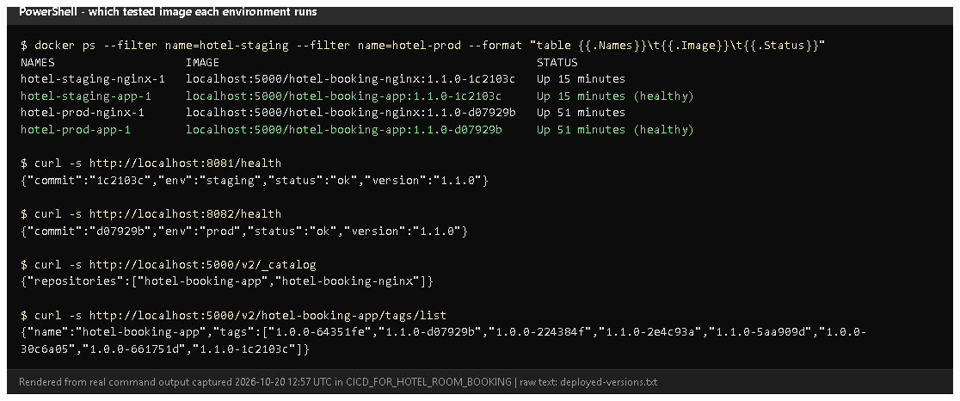
Figure 12.1 - Which image each environment runs, both /health answers, and the registry catalogue and tags (rendered from real output, 2026-10-20). Proves: images are tagged version-commit, stored in the registry and the deployed containers run them.
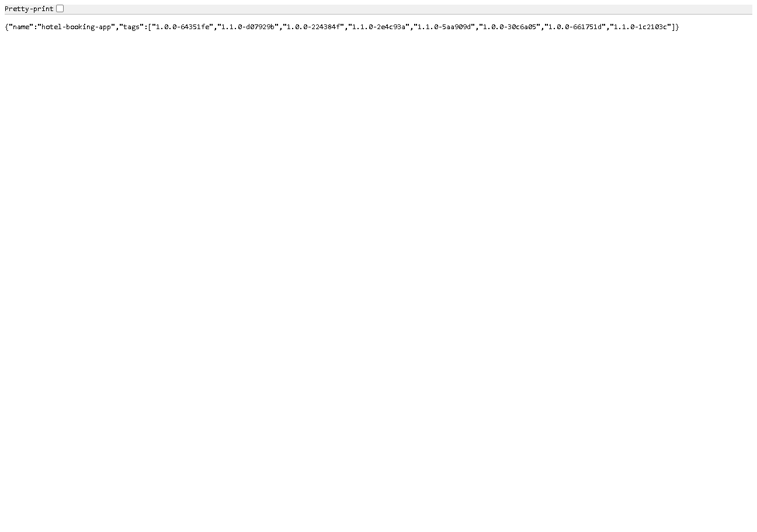
Figure 12.2 - http://localhost:5000/v2/hotel-booking-app/tags/list in the browser.
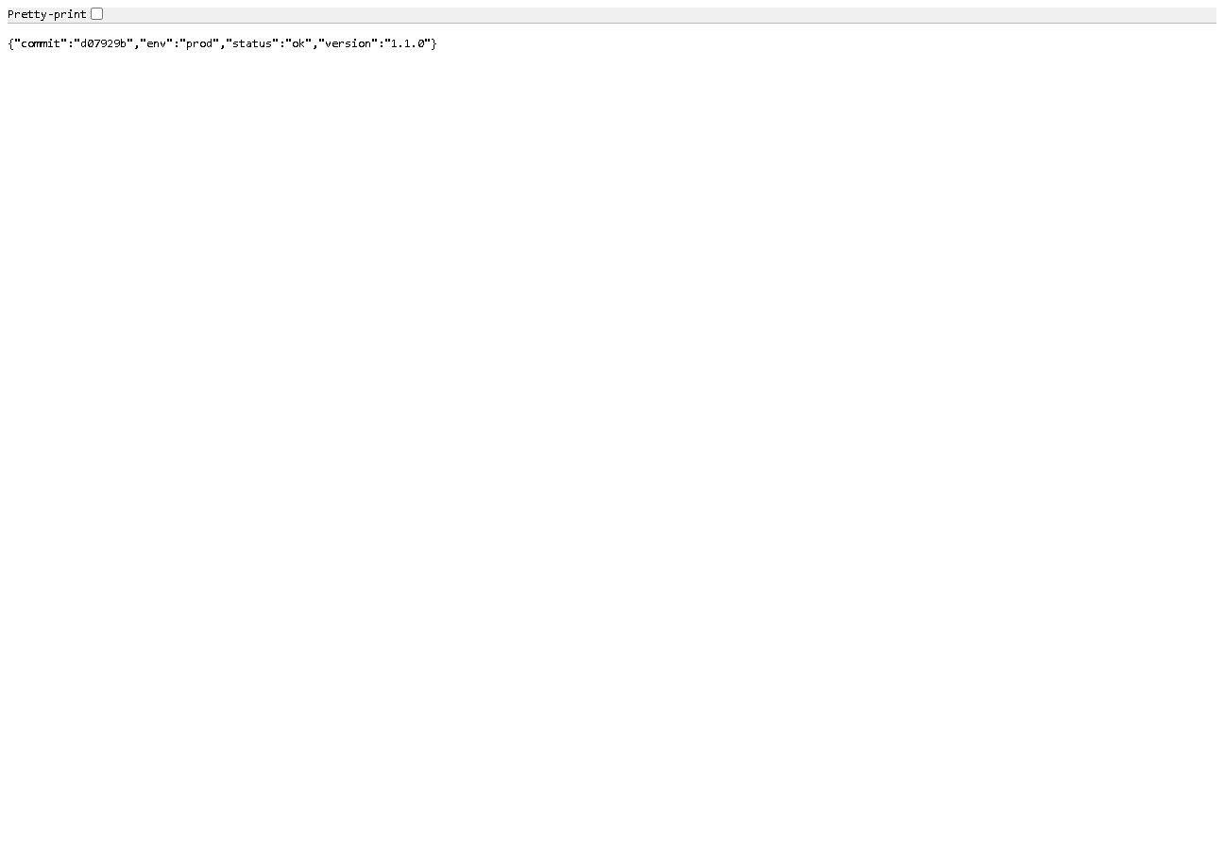
Figure 12.3 - http://localhost:8082/health: prod runs release 1.1.0 (d07929b).
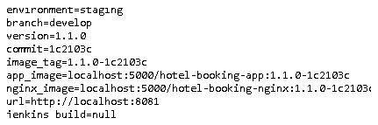
Figure 12.4 - reports/deployment.txt archived by build #11: environment, branch, version, commit, image names, URL. (jenkins_build=null: the Jenkins URL setting is not configured - see Task 8.)
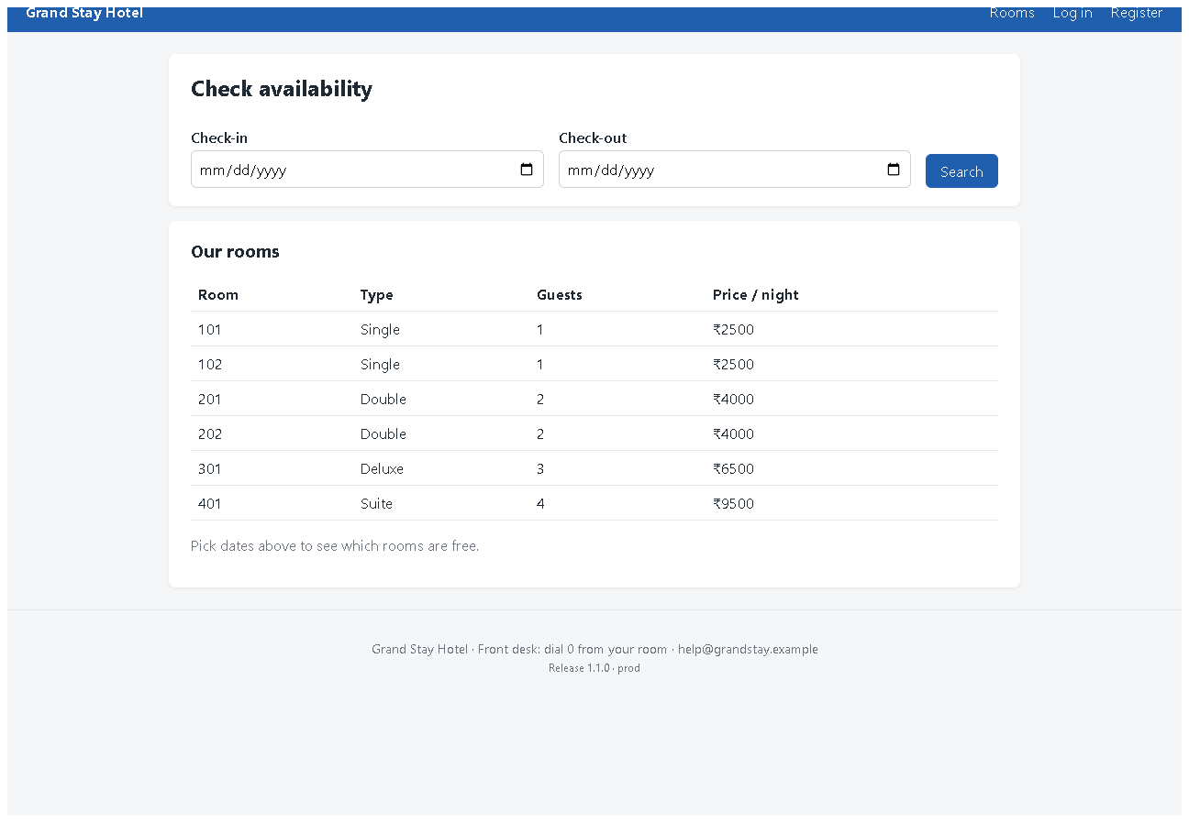
Figure 12.5 - The prod portal at http://localhost:8082 - the deployed v1.1.0 interface (the newer UI redesign is not deployed yet).

E. How to demonstrate this task to the professor (about 5 minutes)
Before the demo: Docker Desktop, Jenkins and the registry running (docker compose ps in deploy\jenkins).
- Jenkins -> hotel-booking -> Build with Parameters -> BRANCH = develop, APP_ENV = staging, REGISTRY = localhost:5000 -> Build.
- While it runs, open the Jenkinsfile at the Checkout stage and explain IMAGE_TAG = <VERSION>-<commit>.
- After it finishes: Console Output, Ctrl+F digest: - Say: "Both images were pushed to the registry."
- Browser: http://localhost:5000/v2/hotel-booking-app/tags/list - the new tag is in the list.
- PowerShell:Say: "The staging container runs the image from the registry with this exact tag, and /health reports the same commit."
docker ps --format "table {{.Names}}\t{{.Image}}\t{{.Status}}"
curl.exe -s http://localhost:8081/health
- Open the build's Build Artifacts -> reports/deployment.txt.
- Say about Docker Hub: "For Docker Hub I would add a registry-creds credential and set REGISTRY to my Docker ID; that path is implemented but not tested because I have no Docker Hub account."
Recovery: Publish stage "connection refused" - the registry container is stopped: docker compose up -d registry in deploy\jenkins. Deploy uses an old container - another stack on the same port; docker compose -p hotel-staging down, then build again.

F. Expected screenshots for the final submission
- assets/task-12/deployed-versions.png - exists, 2026-10-20.
- assets/task-12/registry-tags.png - exists, 2026-10-20.
- assets/task-12/prod-health.png - exists, 2026-10-20.
- assets/task-12/jenkins-build-11-deployment-record.png - exists, 2026-10-20.
- assets/task-12/prod-portal-v1.1.0.png - exists, 2026-10-20.
- assets/task-12/dockerhub-repository.png - the image on Docker Hub - requires manual capture after publishing to Docker Hub (pending external action).

G. Probable viva questions and answers
- CI vs CD? CI builds and tests every change; CD goes further and automatically releases/deploys every change that passed.
- Why tag with version and SHA? The version names the release; the SHA identifies the exact code. 1.1.0-1c2103c links a container to one commit and one build.
- Registry vs Docker Hub? A registry is any server that stores images; Docker Hub is one hosted public registry. We use our own local registry.
- Did you publish to Docker Hub? No - it is implemented (registry-creds
  - REGISTRY parameter) but not tested; the local registry was demonstrated.
- How do you ensure only tested code is deployed? Images are built after all tests pass, from a committed checkout; deploy uses --no-build with the pushed image; the health check compares the commit.
- (Project-specific) What runs in prod now and how do you know? 1.1.0-d07929b - docker ps shows the image and /health returns "commit":"d07929b".
- (Project-specific) Why docker compose pull before up? To deploy exactly what is in the registry - the same thing any other server would get.
- Where are registry credentials kept? In Jenkins credentials (registry-creds), passed with --password-stdin; not needed for the local registry.
- Why keep old images? For rollback: deploying an older tag needs no rebuild (shown in Task 14).
- Local registry limitation? Only this machine can pull from it; a separate server would need a hosted registry (Docker Hub) or network access to it.

H. Common mistakes and troubleshooting
Symptom | Cause | Inspect | Fix | Confirm
push fails "connection refused" | registry stopped | docker compose ps (deploy\jenkins) | docker compose up -d registry | push ok
Docker Hub push "unauthorized" | missing/wrong registry-creds | Jenkins credentials | add a Docker Hub access token as registry-creds | push ok
Health check: wrong commit | stale container | docker ps image tag | rebuild; ensure no other stack on the port | commit matches
Tag shows unknown | GIT_COMMIT not passed | Build images stage | keep --build-arg GIT_COMMIT=$GIT_SHORT | /health shows SHA
Registry fills the disk | every build adds a tag | docker system df | delete old tags you no longer need for rollback | space recovered

I. Quick revision notes
Five key points
- After tests: build -> tag <version>-<sha> -> push -> pull -> deploy -> health -> record.
- Local registry localhost:5000 holds 8 tags; old tags enable rollback.
- Deploy uses --no-build: the tested, pushed image is what runs.
- Credentials via Jenkins (hotel-secret-key, registry-creds), never in Git.
- Docker Hub: implemented, not tested (pending account).
30-60 second explanation "When all tests pass, Jenkins builds the app and Nginx images and tags them with the release version and commit, for example 1.1.0-1c2103c. It pushes them to our local Docker registry, then deploys by pulling exactly those images and starting them with Docker Compose. The health check confirms the running app reports the same version and commit, and a deployment record is archived with the build. Staging and prod run images from the registry. Docker Hub is supported by a parameter and a credential but hasn't been tested."
Caveat: only a local registry was used; Docker Hub publishing is pending.
Readiness checklist
- â˜ I can show the registry tag list in the browser.
- â˜ I can explain version + SHA tags.
- â˜ I can match docker ps image tags with /health.
- â˜ I can explain honestly why Docker Hub wasn't used.

Task 13 - Configuration Management with Ansible

A. Task title and objective
Task 13: Configuration Management with Ansible
Objective: describe in code how a server must be set up - packages, directories, configuration, permissions, services, ports, Nginx and health verification - and let Ansible bring a server to that state automatically, using variables for environment-specific values.
Professor's required deliverables
- Ansible inventory and playbook for the selected target
- Automated prerequisites: packages, deployment directories, application configuration, service/container setup, file permissions, network ports, Nginx configuration, application health verification
- Variables for environment-specific configuration
- No destructive changes; SSH/firewall settings not changed without checking
- If no separate target exists: the safest local/virtualised setup, documented
Current status: Implemented and verified (container-based lab). On 2026-10-20 the playbook provisioned a fresh lab server from scratch (Docker not installed beforehand): ok=14 changed=7 failed=0, and /health answered with release 1.0.0 (Figure 13.1).
Target honesty: the "server" is a disposable Ubuntu 24.04 Docker container with systemd and SSH (deploy/ansible/lab/), not a separate virtual machine or cloud server. The real-server inventory (deploy/ansible/inventory.ini, 192.168.56.10) has not been used.

B. Explanation for a complete beginner
An everyday picture. Instead of telling a new employee "install this, then create that folder, then copy these files...", you give them a written checklist that describes the finished state of the office. Anyone following it gets the same result - and if something is already done, they skip it. Ansible follows such a checklist on servers, over SSH.
Term | Meaning | In this project
Configuration management | describing a machine's desired state in files and applying it automatically | deploy/ansible/
Control node | the machine that runs Ansible | the hotel-ansible container (Ansible doesn't run natively on Windows)
Managed node / target | the server being configured | hotel-server (the lab container)
Inventory | the list of servers, in groups | inventory.ini (real) / lab/inventory.ini (lab) - group [web]
Playbook | a YAML file listing tasks for a group of hosts | playbook.yml, rollback.yml
Task | one desired state, using a module | "Install Docker engine..." using apt
Module | a built-in action (apt, copy, file, service, uri...) | 10 built-in modules, no extra collections
Variables | values that differ per environment | group_vars/web.yml
become | run tasks with administrator rights (sudo) | become: true
Handler | a task that runs only when notified by a change | not used in this project (compose restarts containers itself when their image or settings change)
Idempotent | running it again changes nothing if the state is already right | see Task 14 (changed=0)
Agentless | nothing needs installing on the server except SSH and Python | true for Ansible

Playbook vs inventory: the inventory says where (which servers); the playbook says what (which state).

C. What was actually implemented
Files (deploy/ansible/)
File | Content
inventory.ini | [web] group: hotel-server ansible_host=192.168.56.10 ansible_user=ubuntu (edit for a real server)
lab/inventory.ini | the same group pointing at the lab container target (lab-only password, not reachable from outside Docker)
group_vars/web.yml | app_dir: /opt/hotel-booking, app_env: prod, host_port: 80, app_version (read from the VERSION file), image_tag, git_commit (from Git, -dirty if uncommitted changes), secret_key (generated once by the password lookup into the git-ignored credentials/secret_key)
ansible.cfg | inventory path, interpreter_python = auto_silent, host_key_checking = False (lab setting, commented)
playbook.yml | provision + deploy (14 tasks, below; the run output also shows Ansible's automatic "Gathering Facts")
rollback.yml | return to the previous release (Task 14)
Dockerfile | the control-node image (python:3.12-slim + ansible-core 2.21.5 + ssh + git)
lab/docker-compose.yml, lab/Dockerfile.target | the disposable Ubuntu 24.04 target (systemd, sshd, privileged, port 8088 -> 80) and the controller

Tasks in playbook.yml and the deliverable each covers
Line | Task | Module | Deliverable
33 | Install Docker engine and the Docker Compose plugin | apt | packages
42 | Make sure Docker is running and starts on boot | service | service setup
49 | Create application directories (/opt/hotel-booking, .../deploy, root 0755) | file | directories, permissions
60 | Copy application source and Docker files | copy | application files
70-83 | Read current .env, work out the running release, remember it in previous_release | slurp, set_fact, copy | release tracking (for rollback)
90 | Write the environment file (SECRET_KEY, APP_ENV, HOST_PORT, version, IMAGE_TAG) mode 0600, no_log: true | copy | application configuration, permissions, secret protection
109 | Check whether images for this release and commit already exist | command (docker image inspect) | idempotency
119 | Build the Docker images on the server (only if needed) | command | container setup
126 | Start (or update) the containers and wait until healthy | command (docker compose up -d --no-build --wait) | container/service setup
134 | Check the portal answers through Nginx | uri with retries | health verification
143 | Check the expected release is the one running | assert | health verification
149 | Show result | debug | -

Nginx and ports: Nginx runs as a container whose configuration is baked into the hotel-booking-nginx image (deploy/nginx/hotel.conf); it publishes host_port (80) on the server. Not touched on purpose: SSH settings and firewall rules (the playbook says so in its header). If ufw is active, open host_port yourself after checking what else is exposed.
What the first run on the fresh lab server changed (2026-10-20, changed=7): Install Docker; start/enable Docker; create directories; copy files; write .env; build images; start containers. Then /health = {"commit":"224de14","env":"prod","status":"ok","version":"1.0.0"}.
State of the server afterwards (Figure 13.5): .env is 600 root, previous_release exists, images for 1.0.0 and 1.1.0 are present, the containers are healthy and Docker is enabled at boot.

D. Screenshots and evidence
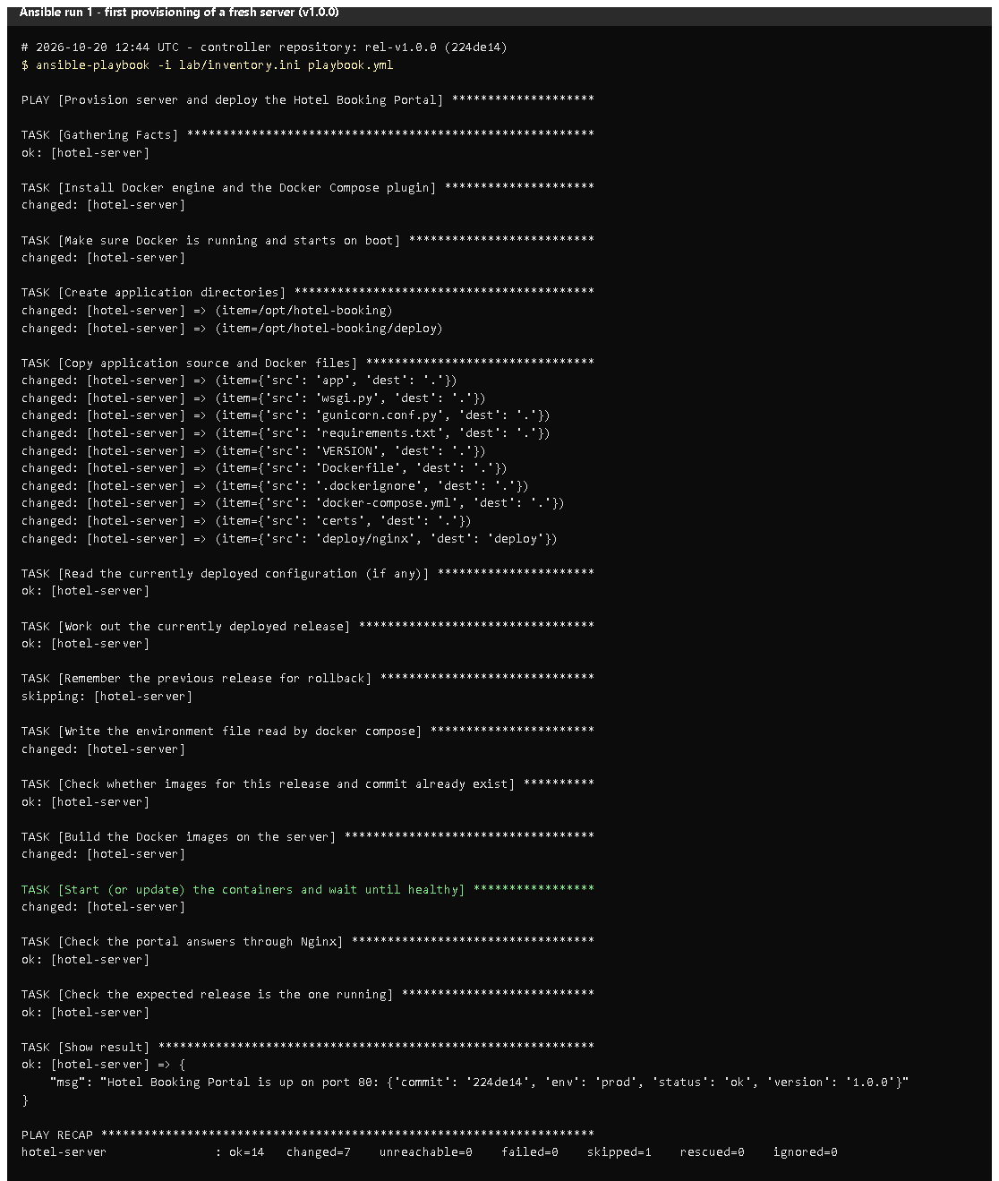 (part 1 of 2)
(part 2 of 2)
Figure 13.1 - Run 1 on a fresh lab server, from a clean clone of tag v1.0.0 (rendered from the real run on 2026-10-20). Notice: each task's changed/ok, the censored .env task (no_log), the final message with /health, and PLAY RECAP ... ok=14 changed=7 failed=0. Proves: Ansible installed prerequisites and deployed the application automatically.
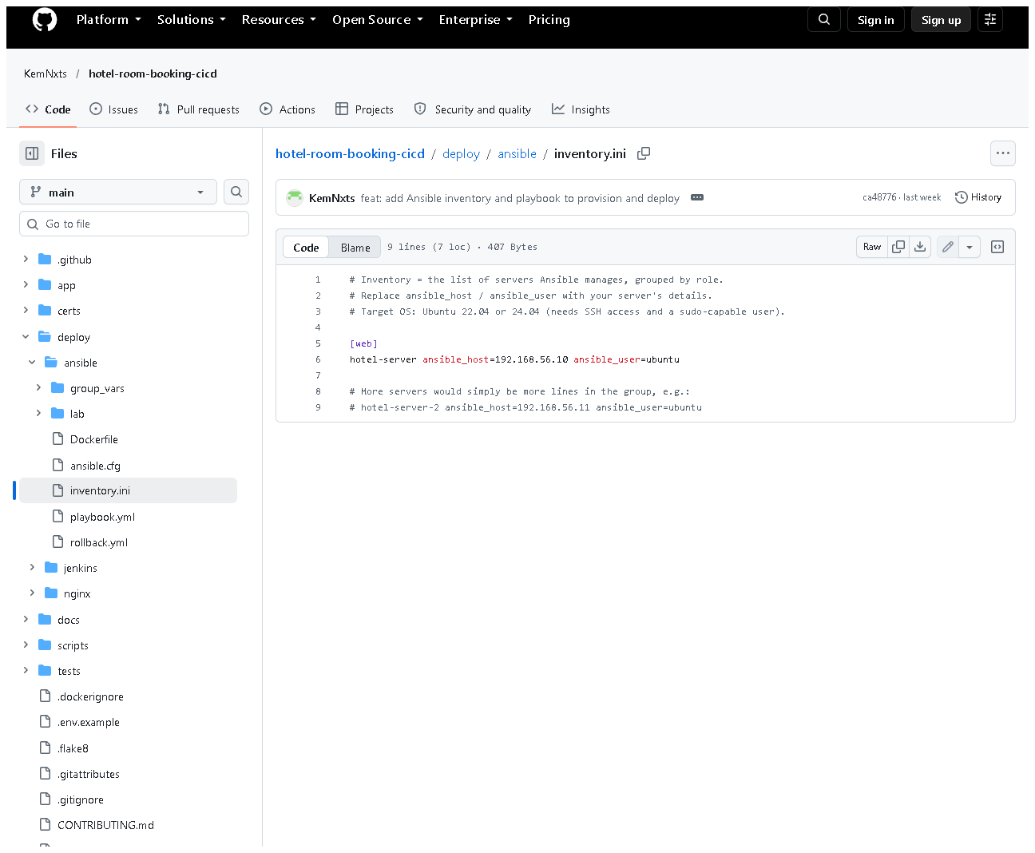
Figure 13.2 - deploy/ansible/inventory.ini on GitHub - group [web].
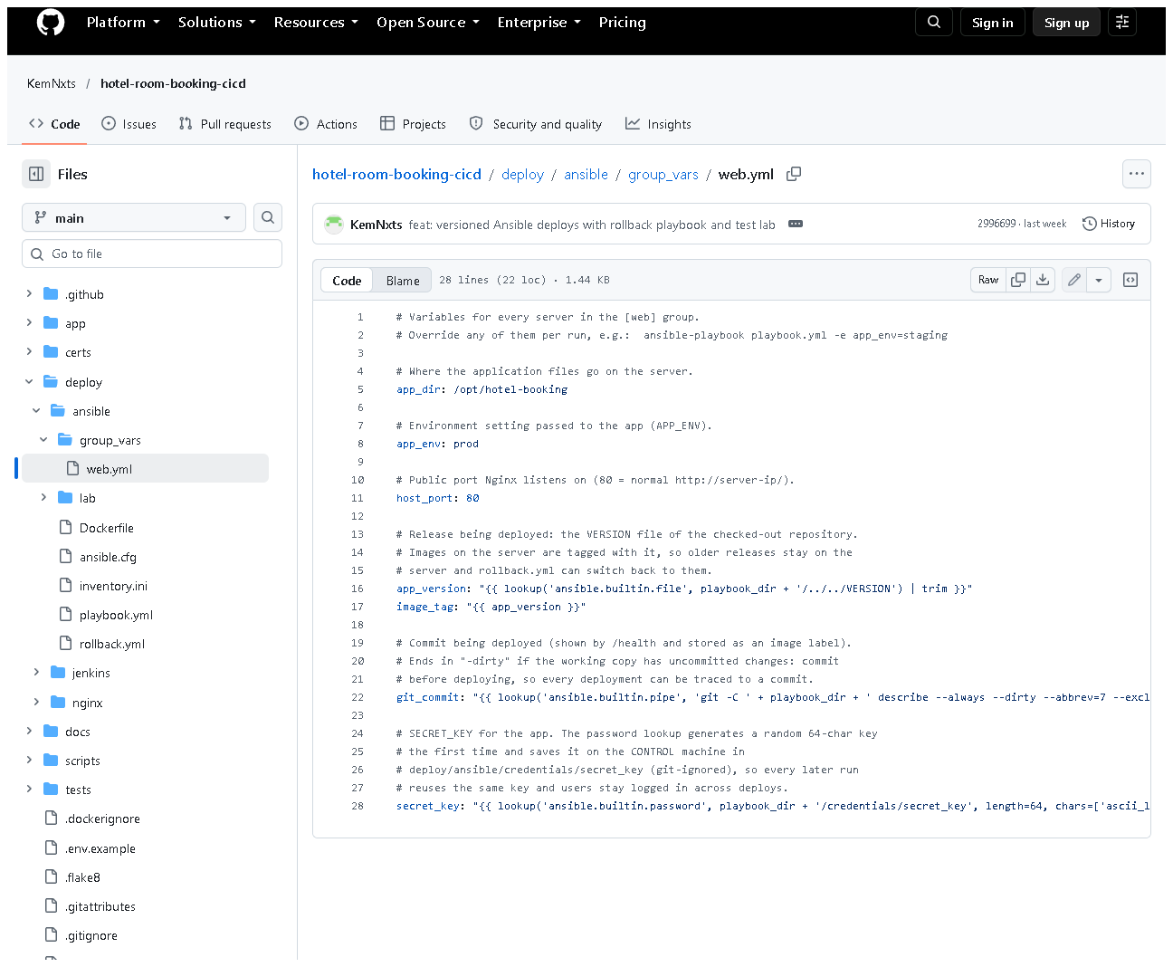
Figure 13.3 - group_vars/web.yml: environment-specific values, the version taken from VERSION, and the generated secret key.
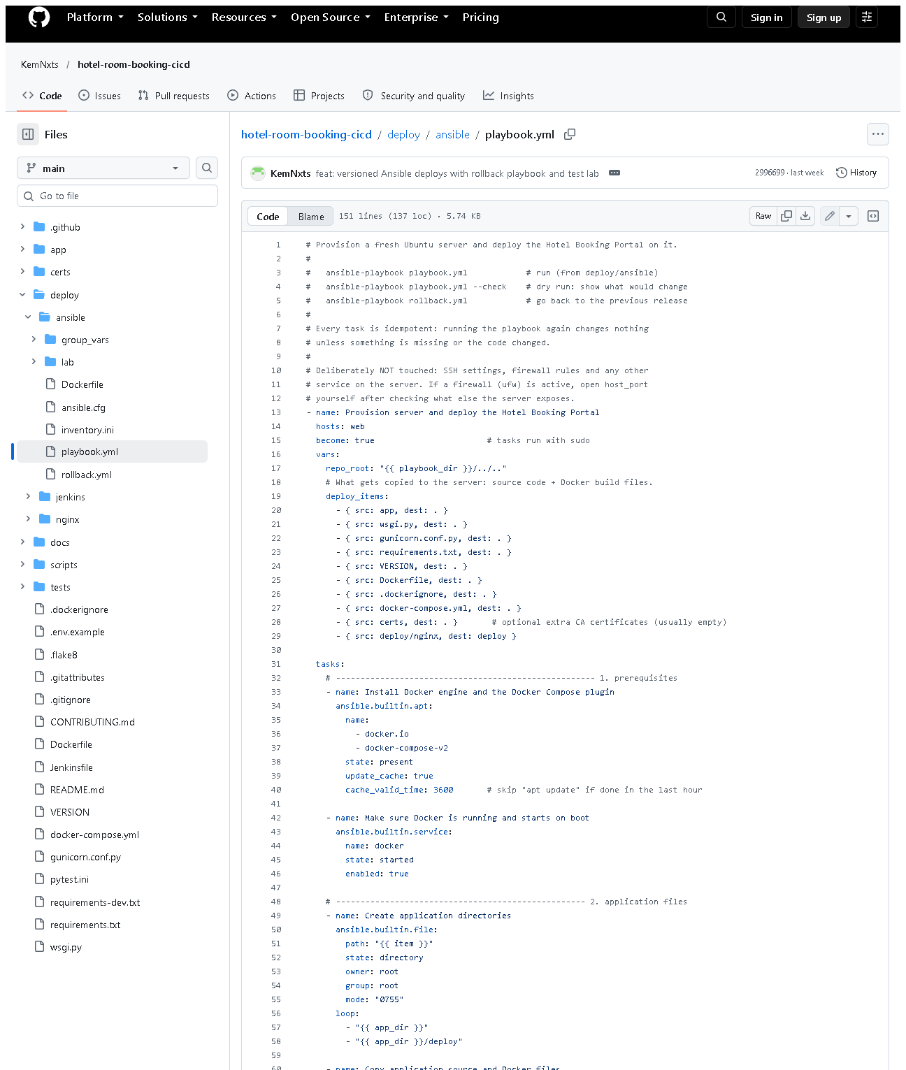 (part 1 of 3)
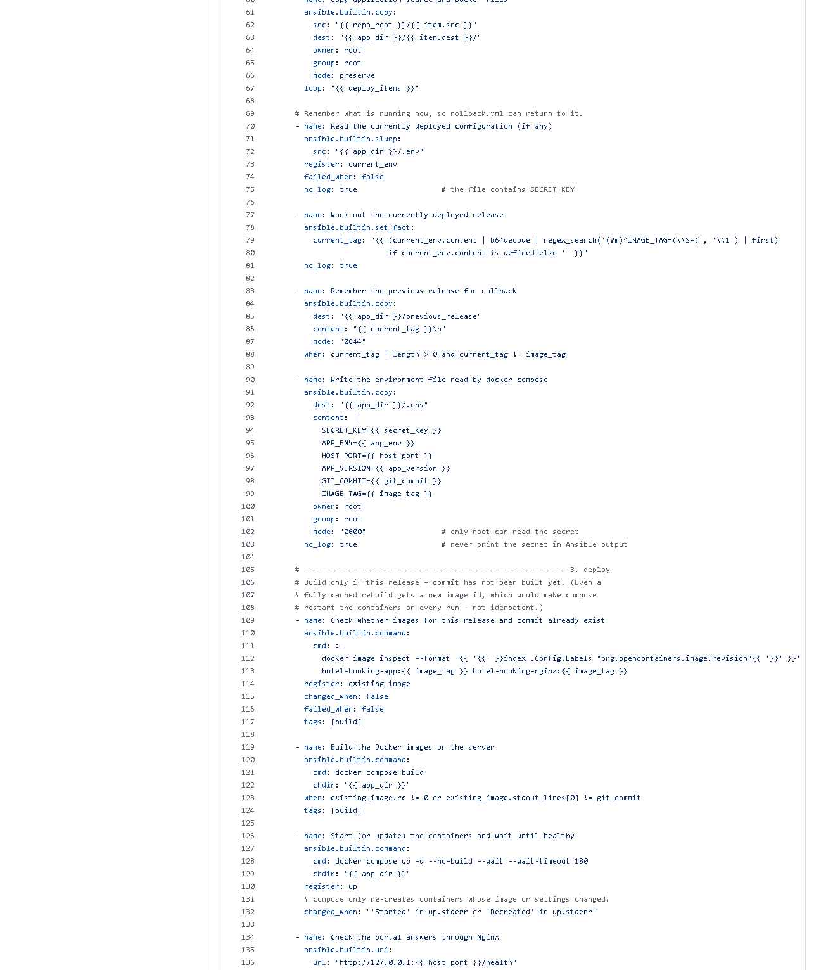 (part 2 of 3)
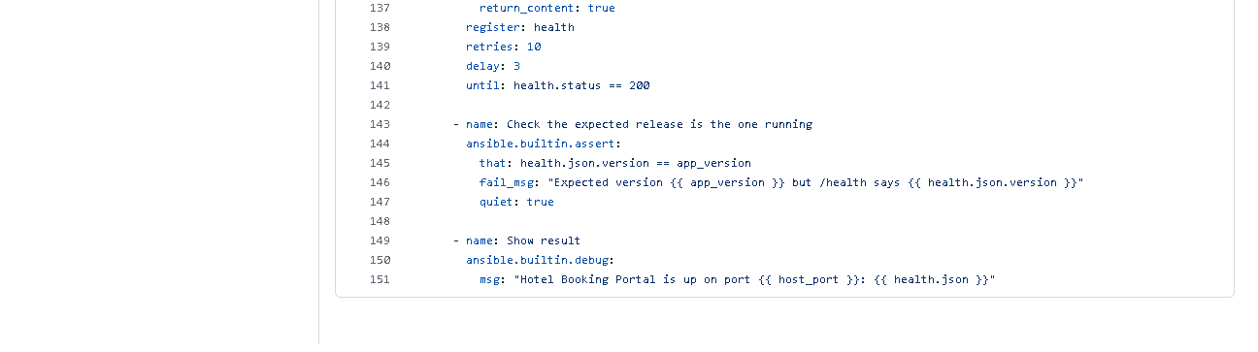 (part 3 of 3)
Figure 13.4 - playbook.yml on GitHub: the tasks listed above.
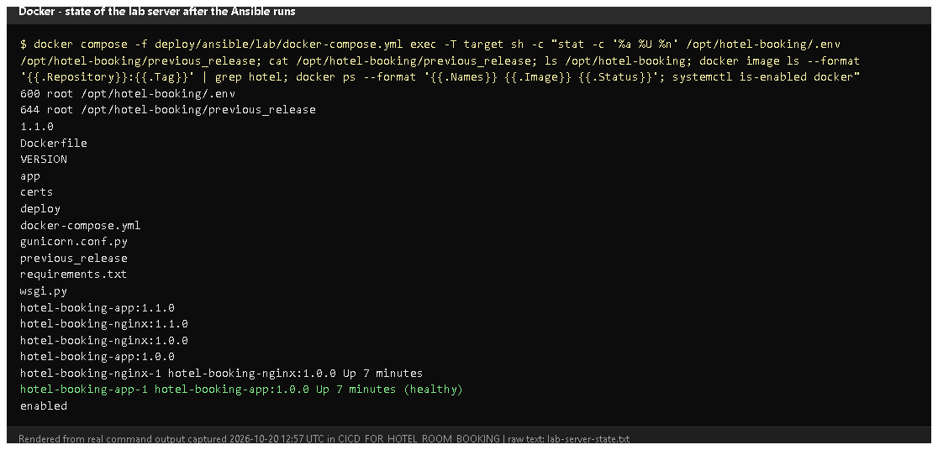
Figure 13.5 - Inside the lab server (rendered from real output, 2026-10-20): file permissions (600 root .env), the files in /opt/hotel-booking, images, running containers, docker enabled.

E. How to demonstrate this task to the professor (about 5 minutes)
Before the demo: Docker Desktop running. PowerShell. These commands were run exactly like this on 2026-10-20.
cd D:\DevOPS\CICD_FOR_HOTEL_ROOM_BOOKING\deploy\ansible\lab

# 1. a brand-new "server" (only if you want to start from zero - this deletes the old lab)
docker compose down -v
docker compose up -d --build target
docker compose exec target sh -c "command -v docker || echo no docker yet"
Expected: "no docker yet". Say: "This is a fresh Ubuntu server with nothing installed."
# 2. run the playbook (takes 3-5 minutes the first time)
docker compose run --rm controller ansible-playbook -i lab/inventory.ini playbook.yml
Point at: the task names scrolling by, changed vs ok, the censored .env task, the final "Hotel Booking Portal is up" message and PLAY RECAP ... failed=0.
# 3. prove it
curl.exe -s http://localhost:8088/health
docker compose exec target stat -c "%a %U %n" /opt/hotel-booking/.env
Expected: {"status":"ok",...} and 600 root /opt/hotel-booking/.env. Open http://localhost:8088 in the browser - the portal served from the "server".
- Show inventory.ini, group_vars/web.yml and playbook.yml in VS Code and map a few tasks to the deliverables (packages, directories, config, health).
- Say honestly: "The target is a container acting as a server because I had no VM; for a real server I put its IP in inventory.ini and run the same playbook."
For a real Ubuntu server (not done in this project): from the repository root
docker build -t hotel-ansible -f deploy/ansible/Dockerfile .
docker run --rm -it -v "${PWD}:/work" hotel-ansible ansible-playbook playbook.yml --ask-pass --ask-become-pass
Recovery: "UNREACHABLE" - the target container isn't running: docker compose up -d target and wait ~10 s. First run slow - it downloads Docker packages and base images. CERTIFICATE_VERIFY_FAILED during the image build on the server - antivirus HTTPS scanning; the certs/ folder is copied to the server.

F. Expected screenshots for the final submission
- assets/task-13/ansible-run1-first-deploy-v1.0.0.png - exists, 2026-10-20 (rendered from the real run).
- assets/task-13/github-file-deploy_ansible_inventory.ini.png - exists, 2026-10-20.
- assets/task-13/github-file-deploy_ansible_group_vars_web.yml.png - exists, 2026-10-20.
- assets/task-13/github-file-deploy_ansible_playbook.yml.png - exists, 2026-10-20.
- assets/task-13/lab-server-state.png - exists, 2026-10-20.
- assets/task-13/real-vm-run.png - a run against a real Ubuntu VM - requires manual capture if a VM becomes available (pending).

G. Probable viva questions and answers
- What is configuration management? Describing the desired state of servers in files and applying it automatically and repeatably.
- Playbook vs inventory? Inventory = which servers; playbook = which tasks/state.
- Why Ansible? Agentless (only SSH + Python on the server), readable YAML, idempotent built-in modules.
- What does your playbook set up? Docker + compose plugin, the docker service, /opt/hotel-booking directories, the app files, a root-only .env, the images, the containers, and a health/version check.
- How are environment differences handled? Variables in group_vars/web.yml, overridable per run, e.g. -e app_env=staging -e host_port=8080.
- How is the secret protected? Generated once on the control machine (git-ignored), written to .env with mode 0600 and no_log: true, so it is never printed.
- (Project-specific) What was your target? A disposable Ubuntu 24.04 container with systemd and SSH, defined in deploy/ansible/lab/ - not a separate VM.
- (Project-specific) What did the first run change? 7 tasks: install Docker, enable it, create directories, copy files, write .env, build images, start containers.
- Do you use handlers? No. Docker Compose recreates containers itself when their image or settings change, so no separate restart handler is needed.
- Does the playbook change the firewall or SSH? No, deliberately - those are risky to automate without knowing the server; it is documented.
- Why host_key_checking = False? Convenience for fresh lab machines; for real servers it should be True with known hosts.

H. Common mistakes and troubleshooting
Symptom | Cause | Inspect | Fix | Confirm
UNREACHABLE | target not running / wrong host | docker compose ps in lab | docker compose up -d target | ok= in recap
"Missing sudo password" (real server) | become needs a password | inventory | add --ask-become-pass | tasks run
Ansible ignores ansible.cfg | world-writable folder (Windows mount) | - | the controller image sets ANSIBLE_CONFIG | inventory found
Image build fails on the server | TLS interception | build task output | put the root CA in certs/ | build ok
assert fails: wrong version | old containers / wrong app_version | /health | rerun; check VERSION | assert ok

I. Quick revision notes
Five key points
- Inventory (where) + group_vars (values) + playbook (what) in deploy/ansible/.
- 14 tasks with built-in modules: packages, service, dirs, files, .env 0600, build, start, health, assert.
- Secret generated once, never printed (no_log), file mode 0600.
- Fresh lab server provisioned on 2026-10-20: changed=7, /health OK.
- Target is a container lab, not a VM; firewall/SSH deliberately untouched.
30-60 second explanation "Ansible describes the server I want: Docker installed and running, an application folder, the app files, a root-only environment file with the secret, the images built and the containers healthy. The inventory says which server, group_vars holds environment values, and the playbook lists the tasks using built-in modules. I ran it against a fresh Ubuntu server in a container lab: it installed everything and deployed the portal, with seven changes and no failures, and the final tasks check /health and the version."
Caveat: tested on a container-based lab target, not a separate VM.
Readiness checklist
- â˜ I can start the lab and run the playbook.
- â˜ I can map tasks to deliverables (packages, dirs, config, health).
- â˜ I can explain inventory vs playbook vs variables.
- â˜ I can explain the lab-vs-VM limitation.

Task 14 - Automated Provisioning and Reliability Validation (Idempotency and Rollback)

A. Task title and objective
Task 14: Automated Provisioning, Idempotency and Reliability Validation
Objective: prove that automated provisioning is safe to repeat (idempotent), that health checks confirm the application works, and that a bad release can be rolled back to a previous stable release - and that the restored release really works.
Professor's required deliverables
- First Ansible execution
- Second execution with evidence of idempotency
- Application health checks
- Recovery / rollback to a previous stable release
- Verification that the restored release actually works
- Commands, outcomes and limitations recorded (no unproven claims of zero downtime)
Current status: Implemented and verified (container-based lab). The whole sequence was run again on 2026-10-20 on a fresh lab server:
Run | What | PLAY RECAP | /health afterwards
1 | first provisioning, release v1.0.0 | ok=14 changed=7 failed=0 | 1.0.0 (224de14)
2 | upgrade to v1.1.0 | ok=15 changed=5 failed=0 | 1.1.0 (ce1726d)
3 | same playbook again | ok=13 changed=0 failed=0 skipped=2 | 1.1.0
4 | rollback.yml | ok=11 changed=3 failed=0 | 1.0.0 (224de14)
5 | v1.0.0's own Selenium journeys against the restored server | 5 passed | -

Limitation: the target is a privileged Ubuntu 24.04 container, not a separate VM. Rollback re-creates the containers, so there is a short interruption - zero downtime is not claimed.

B. Explanation for a complete beginner
An everyday picture. A light switch labelled "ON": pressing it when the light is already on changes nothing. A good provisioning script works the same way - running it twice gives the same result as running it once.
Term | Meaning | In this project
Provisioning | preparing a server from nothing to ready (software, folders, config, app) | playbook.yml on a fresh server
Idempotency | applying the same operation again changes nothing if the state is already correct | run 3: changed=0
Idempotency vs repeatability | repeatable = gives the same end result each time; idempotent = additionally makes no changes when nothing needs changing | our playbook is both
changed=N | Ansible's count of tasks that actually modified the server | 7 -> 5 -> 0
Health check | asking the running app whether it works and which version it is | GET /health through Nginx + assert
Stable release | a tested, tagged version that is known to work | v1.0.0, v1.1.0
Rollback | switching back to a previous stable release | rollback.yml
Deployment vs rollback | deployment moves to a new version; rollback returns to an older, already-tested one, without rebuilding | -

Why changed=0 matters: it proves the playbook checks before acting. Nothing was reinstalled, rewritten or restarted, so a repeat run is safe - you can run it any time to make sure the server is still correct.

C. What was actually implemented
Making the playbook idempotent
- Built-in modules are idempotent by design: apt state=present does nothing if Docker is installed; copy does nothing if the file content is identical; file/service likewise.
- Special case - images: even a fully cached docker build produces a new image ID, which would make compose restart containers every time. So the playbook first checks the image label (lines 109-119):
- name: Check whether images for this release and commit already exist
ansible.builtin.command:
cmd: docker image inspect --format '...org.opencontainers.image.revision...' hotel-booking-app:{{ image_tag }} hotel-booking-nginx:{{ image_tag }}
register: existing_image
changed_when: false # only reads, never counts as a change
failed_when: false

- name: Build the Docker images on the server
ansible.builtin.command: { cmd: docker compose build, chdir: "{{ app_dir }}" }
when: existing_image.rc != 0 or existing_image.stdout_lines[0] != git_commit # build only if missing
(Excerpt simplified: the real cmd uses a Jinja-escaped Go template.)
- docker compose up reports changed only if its output contains Started or Recreated.
Health checks - every run ends with uri http://127.0.0.1:{{ host_port }}/health (10 retries) and assert health.json.version == app_version.
Rollback mechanism (deploy/ansible/rollback.yml)
- Each deploy tags images with the release (hotel-booking-app:1.1.0) and keeps older images on the server.
- Before switching releases, the playbook writes the running release to /opt/hotel-booking/previous_release.
- rollback.yml reads that file (or -e rollback_to=1.0.0), refuses if the target images are not on the server, sets IMAGE_TAG in .env, saves the release it is leaving (so running it again rolls forward), runs docker compose up -d --no-build --wait, then asserts /health shows the target version.
- The database volume is kept, so bookings survive (no release changed the schema).
What each run changed (from the saved logs):
Run | Changed tasks
1 (7) | install Docker; start/enable Docker; create directories; copy files; write .env; build images; start containers
2 (5) | copy files (new code); remember previous release (1.0.0); write .env; build images; recreate containers
3 (0) | nothing - build skipped, previous-release skipped, everything ok
4 (3) | point .env at 1.0.0; save 1.1.0 as previous; restart containers on 1.0.0

Verification that the restored release works: after run 4, the Selenium journeys of release v1.0.0 (from a clean clone of the tag - the current tests expect the newer UI) were run against http://localhost:8088: 5 of 5 passed.
Rollback without Ansible (Docker level) - also demonstrated on 2026-10-11 for prod: IMAGE_TAG=1.0.0-661751d docker compose up -d --no-build --wait switched prod 1.1.0 -> 1.0.0 and back (docs/evidence/docker/rollback-prod.txt).

D. Screenshots and evidence
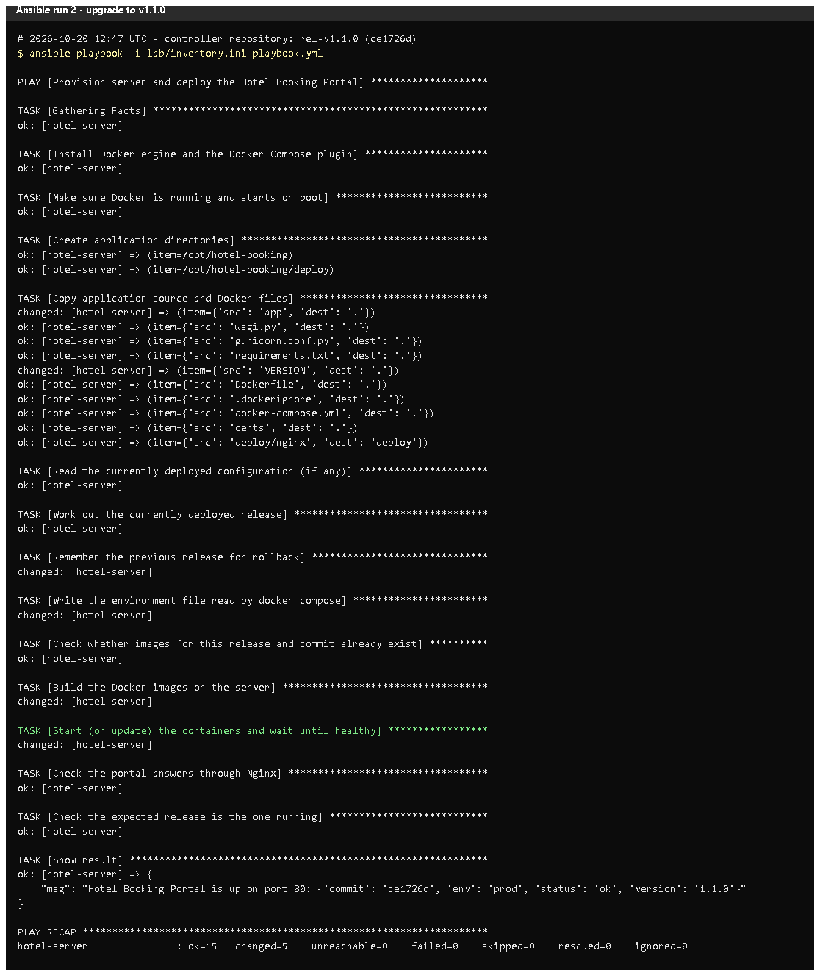 (part 1 of 2)
(part 2 of 2)
Figure 14.1 - Run 2 (upgrade to v1.1.0): changed=5, /health 1.1.0 (rendered from the real run, 2026-10-20).
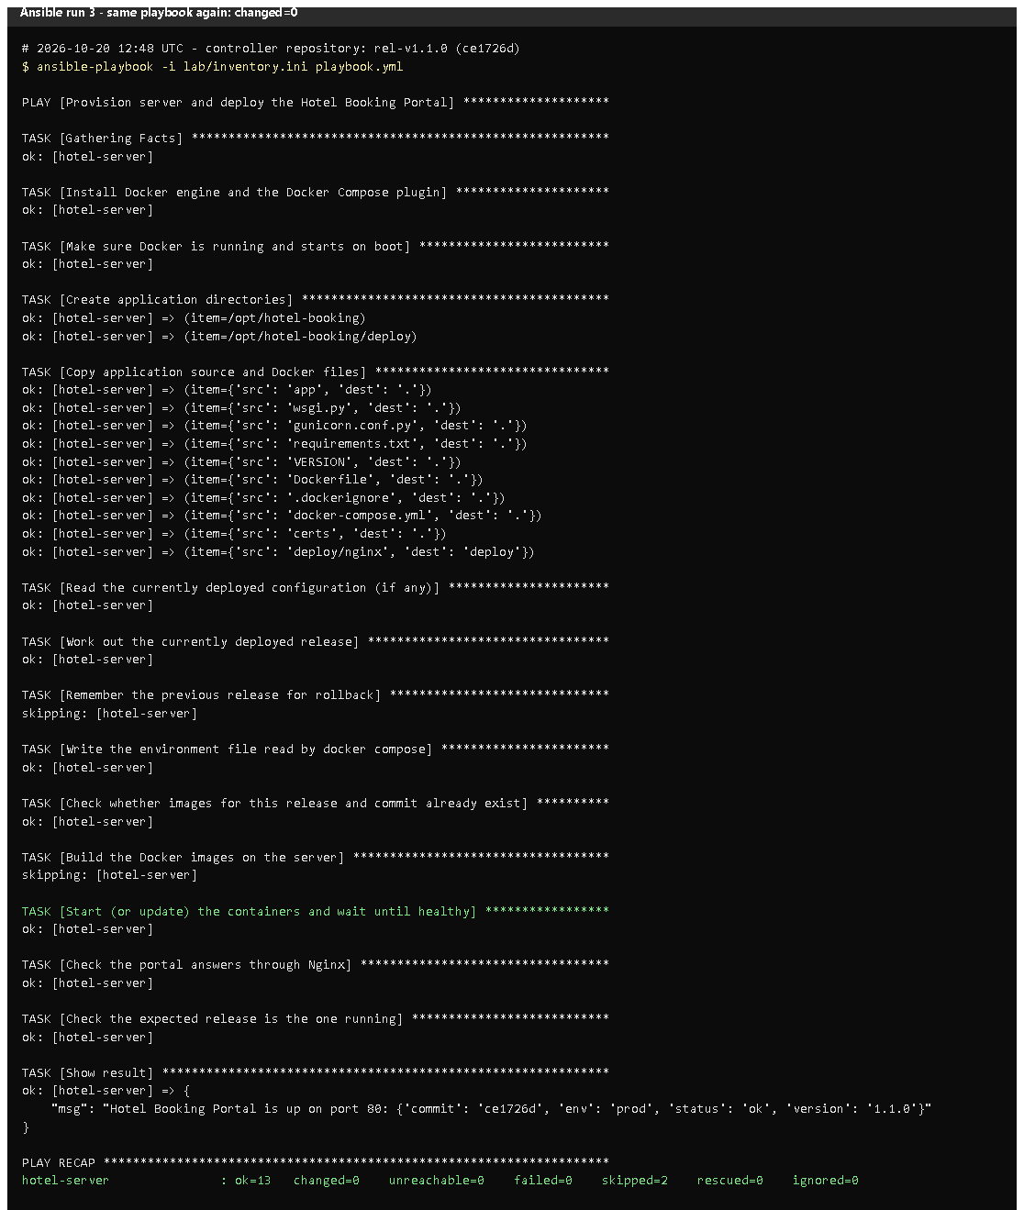 (part 1 of 2)
(part 2 of 2)
Figure 14.2 - Run 3, the same playbook again: every task ok or skipping, PLAY RECAP ... changed=0. Proves: idempotency.
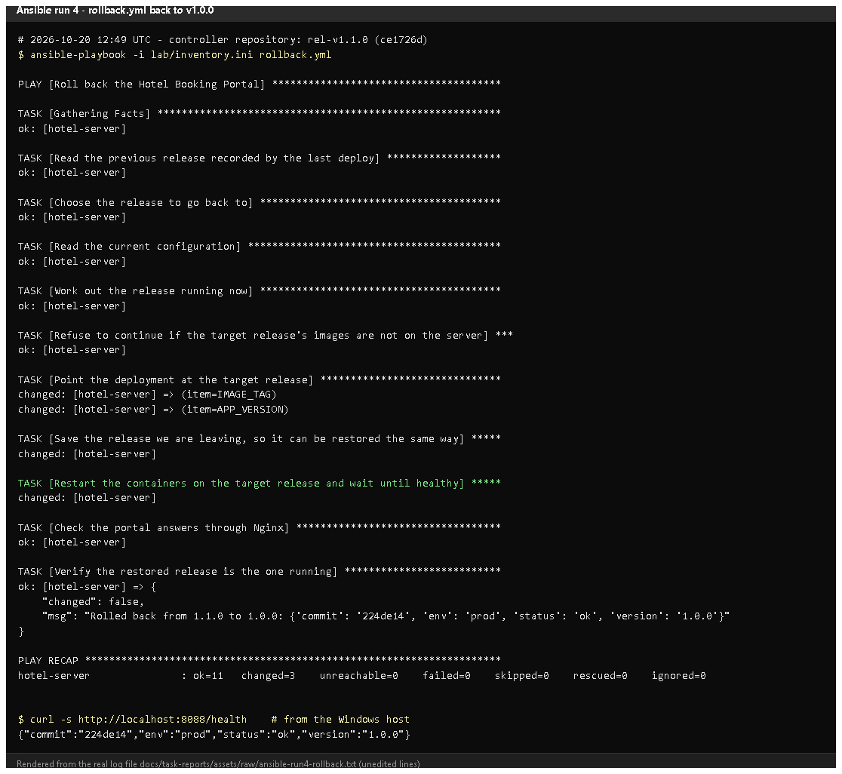
Figure 14.3 - rollback.yml: "Rolled back from 1.1.0 to 1.0.0", changed=3, /health 1.0.0.
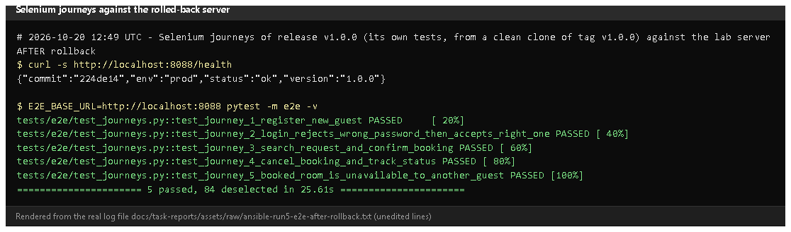
Figure 14.4 - The five v1.0.0 Selenium journeys pass against the rolled-back server. Proves: the restored release actually works, not only /health.
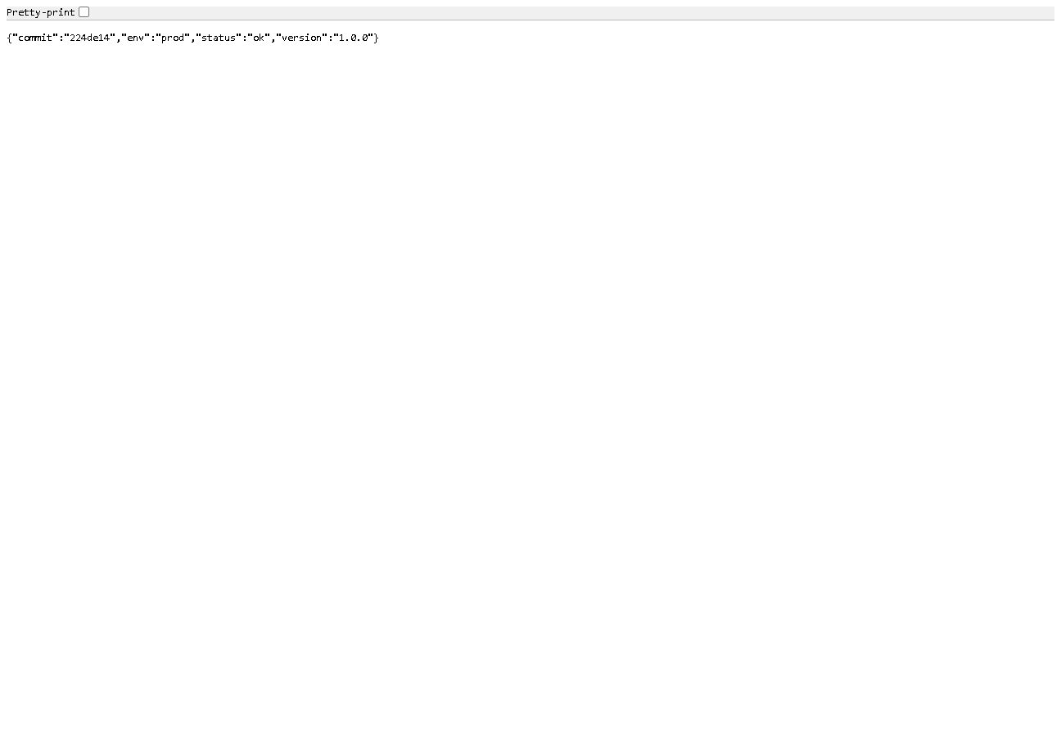
Figure 14.5 - http://localhost:8088/health: version 1.0.0, commit 224de14.
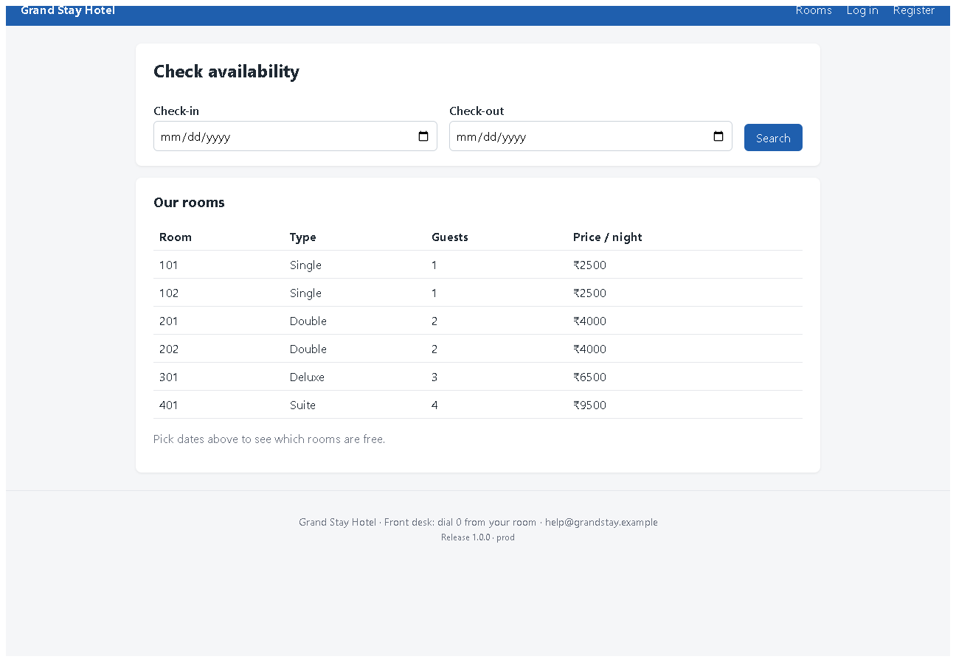
Figure 14.6 - The portal served by the lab server after the rollback (v1.0.0 interface).
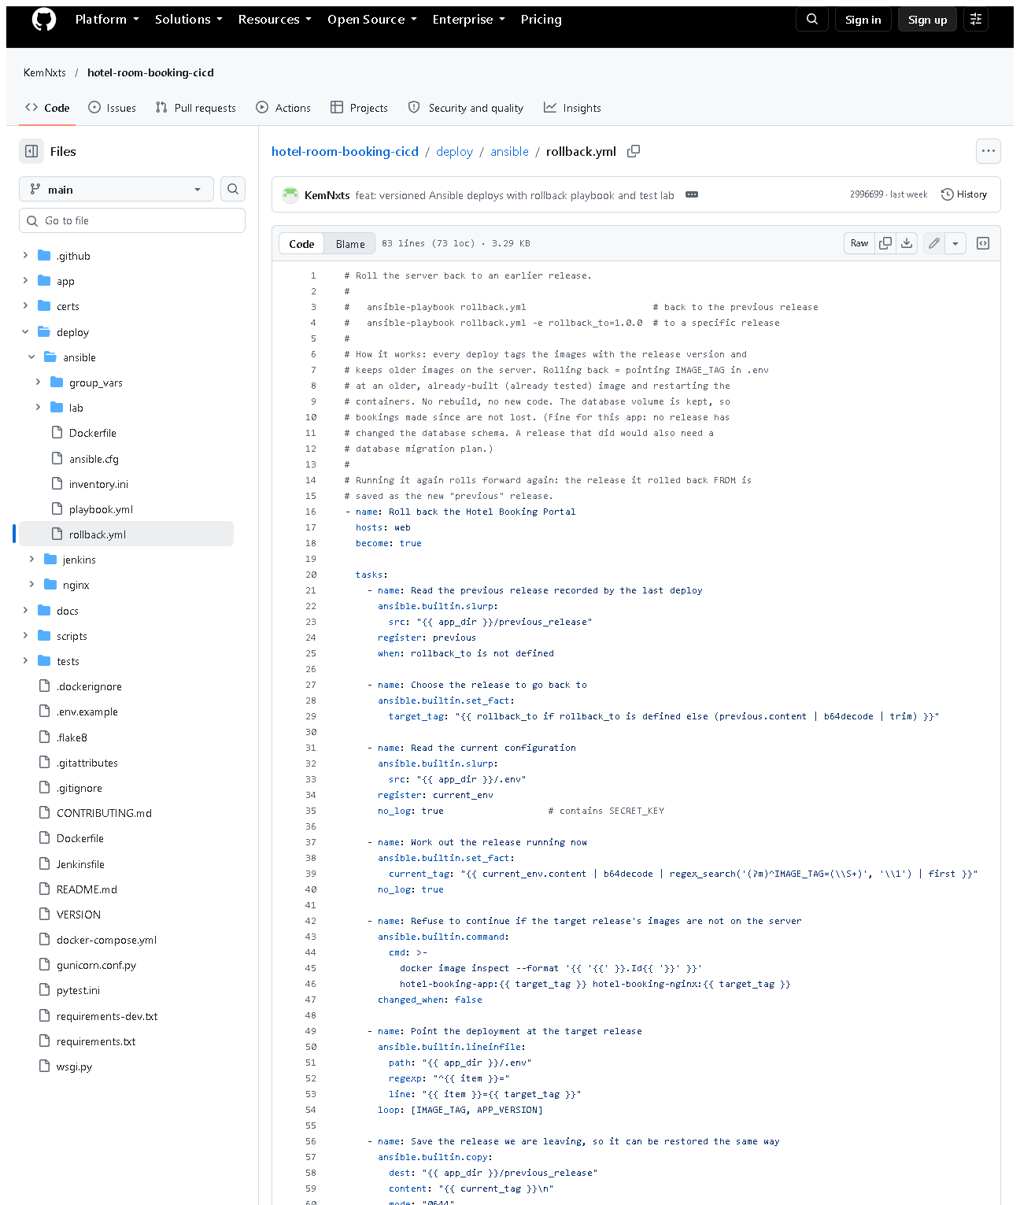 (part 1 of 2)
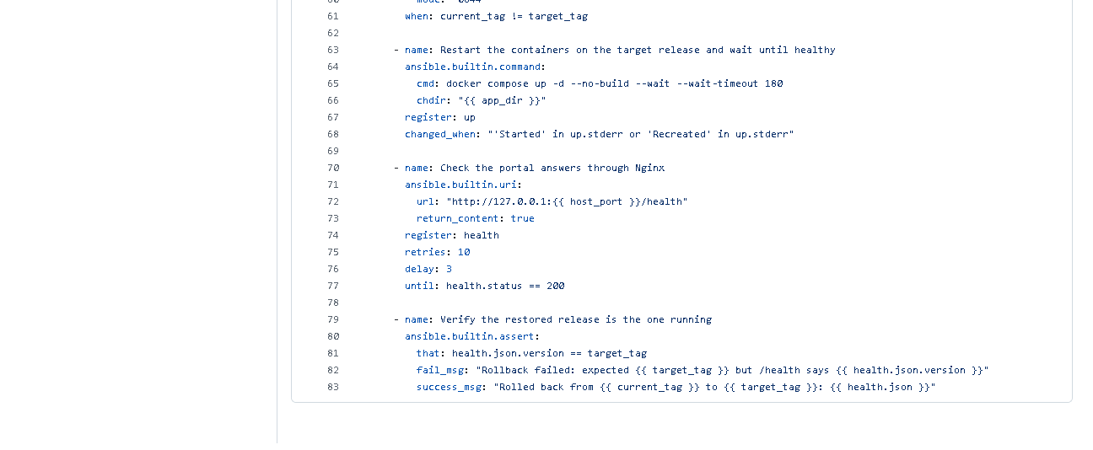 (part 2 of 2)
Figure 14.7 - deploy/ansible/rollback.yml on GitHub.

E. How to demonstrate this task to the professor (about 6 minutes)
Before the demo: Docker Desktop running; the lab target up (docker compose up -d target in deploy\ansible\lab). These commands were run exactly like this on 2026-10-20.
cd D:\DevOPS\CICD_FOR_HOTEL_ROOM_BOOKING\deploy\ansible\lab

# 1. deploy (if the server is fresh this is the first provisioning)
docker compose run --rm controller ansible-playbook -i lab/inventory.ini playbook.yml

# 2. run it again - idempotency
docker compose run --rm controller ansible-playbook -i lab/inventory.ini playbook.yml
Point at: PLAY RECAP ... changed=0. Say: "The second run checked every task and found nothing to change - that is idempotency." (If the lab server was already up to date, even run 1 shows changed=0 - verified on 2026-10-20. To show a first run with changes, start from a fresh server as in Task 13, step 1.)
# 3. simulate a new release (same code, new version number)
docker compose run --rm controller ansible-playbook -i lab/inventory.ini playbook.yml -e app_version=1.1.1-demo
curl.exe -s http://localhost:8088/health
Expected: "version":"1.1.1-demo". Say: "Pretend this release is bad."
# 4. roll back
docker compose run --rm controller ansible-playbook -i lab/inventory.ini rollback.yml
curl.exe -s http://localhost:8088/health
Expected: "Rolled back from 1.1.1-demo to 1.1.0" and "version":"1.1.0". Say: "The previous image was still on the server, so rollback is just a switch - no rebuild."
- Prove the restored version works: open http://localhost:8088, register and make a booking - or run the Selenium journeys (from the project folder):(The local tests match the interface of the working tree; for the v1.0.0 interface use the tests from that tag, as in Figure 14.4.)
cd D:\DevOPS\CICD_FOR_HOTEL_ROOM_BOOKING
$env:E2E_BASE_URL="http://localhost:8088"
.venv\Scripts\python -m pytest -m e2e -q
Remove-Item Env:E2E_BASE_URL
Recovery: rollback.yml fails "No such image" - that release was never deployed on this server; deploy it first or pass an existing -e rollback_to=.... UNREACHABLE - start the target container.

F. Expected screenshots for the final submission
- assets/task-14/ansible-run2-upgrade-v1.1.0.png - exists, 2026-10-20.
- assets/task-14/ansible-run3-repeat-idempotent.png - exists, 2026-10-20.
- assets/task-14/ansible-run4-rollback.png - exists, 2026-10-20.
- assets/task-14/ansible-run5-e2e-after-rollback.png - exists, 2026-10-20.
- assets/task-14/lab-server-health-after-rollback.png - exists, 2026-10-20.
- assets/task-14/lab-server-after-rollback-v1.0.0.png - exists, 2026-10-20.
- assets/task-14/github-file-deploy_ansible_rollback.yml.png - exists, 2026-10-20.
- Run 1 (first provisioning) is in Task 13: assets/task-13/ansible-run1-first-deploy-v1.0.0.png - exists, 2026-10-20.

G. Probable viva questions and answers
- What is idempotency? Running the same automation again makes no changes when the system is already in the desired state. Our run 3 reported changed=0.
- Idempotency vs repeatability? Repeatable = same end result each time; idempotent = also no unnecessary changes (nothing reinstalled or restarted).
- Why did run 1 change 7 things but run 3 none? Run 1 started from an empty server; run 3 found Docker installed, files identical and images for this release and commit already present, so it skipped the build.
- How did you make the image build idempotent? By checking the image's revision label first and building only if the release/commit is missing.
- How does rollback work? Old images stay on the server; rollback.yml points .env to the previous tag, restarts with --no-build and asserts /health shows that version.
- (Project-specific) How do you know the rollback really worked? /health returned 1.0.0 (224de14) and the five v1.0.0 Selenium journeys passed against the server.
- (Project-specific) What happens to bookings during rollback? They are kept - the database is on a volume that rollback does not touch.
- Is there downtime? A few seconds while containers are re-created; zero downtime would need blue/green deployment.
- What if the release changed the database schema? Rollback would need a migration plan; no release here changed the schema, so it was not needed.
- Deployment vs rollback? Deployment moves forward to a new version; rollback goes back to an earlier tested version without rebuilding.
- What are the limits of your test? It used a container acting as a server, not a VM, and a rollback within one server.

H. Common mistakes and troubleshooting
Symptom | Cause | Inspect | Fix | Confirm
Second run shows changed=1 | uncommitted changes since run 1 (commit label -dirty changed) or new code | the changed task | commit, then run twice | changed=0
rollback.yml: "No such image" | target release never deployed here | docker compose exec target docker image ls | deploy that release first / pick an existing one | rollback ok
/health still shows the new version | rollback task failed | rollback output | rerun; check previous_release | version = old
Selenium fails after rollback | tests from a newer UI | test version | use tests from the same tag | 5 passed
Lab gone after down -v | -v deletes volumes | - | docker compose up -d --build target + playbook | portal back

I. Quick revision notes
Five key points
- Run 1 changed=7, run 2 changed=5, run 3 changed=0 = idempotent.
- Images are built only when the release/commit is missing (label check).
- Each deploy remembers the previous release; images are kept.
- rollback.yml switches IMAGE_TAG, restarts without rebuilding, asserts /health.
- Restored v1.0.0 verified by /health and 5/5 Selenium journeys.
30-60 second explanation "On a fresh lab server the playbook made seven changes - installing Docker, copying the app, building images and starting containers. Upgrading to v1.1.0 made five. Running the same playbook again made zero changes, which proves it's idempotent and safe to repeat. Every deploy keeps the old images and remembers the previous release, so rollback.yml just switches the image tag and restarts. After rolling back to 1.0.0, /health showed 1.0.0 and that release's Selenium journeys all passed."
Caveat: container-based lab, not a VM; rollback has a short interruption.
Readiness checklist
- â˜ I can run the playbook twice and point at changed=0.
- â˜ I can simulate a release with -e app_version=... and roll back.
- â˜ I can explain why run 3 skipped the build.
- â˜ I can state the limitations honestly.

Task 15 - Final End-to-End Release, Documentation and Viva

A. Task title and objective
Task 15: Final Release, Documentation and Viva
Objective: show the complete journey from a code change to a tested, packaged, deployed, health-checked and recoverable release, and deliver the documentation and viva preparation for the whole project.
Professor's required deliverables
- End-to-end workflow: Git commit -> Jenkins checkout/build -> automated tests -> quality gate -> Docker image -> deployment -> health check -> configuration management -> rollback/recovery
- Final README, project report, architecture diagrams, SRS summary
- Setup and deployment guide, Jenkins documentation, Selenium test plan and reports, Docker lifecycle commands, Ansible documentation
- Troubleshooting guide, known limitations, future enhancements
- Screenshots and a demo-recording checklist
- Viva questions and answers
- A final deliverable checklist mapped to all 15 tasks
Current status: Implemented and verified, with pending external items. Every step of the workflow was run on 2026-10-20 (Jenkins build #11, Ansible runs 1-4, Selenium after rollback). The documentation set exists (section C). Pending - outside this machine or needing your accounts/decisions:
- GitHub issues (0) and pull requests (0)
- Docker Hub publishing (local registry used)
- A run against a real VM (container lab used)
- Professor's confirmation that Python tooling replaces Maven/Tomcat
- Recording the demo video
- Committing and deploying the UI redesign (currently uncommitted on feature/ui-redesign)

B. Explanation for a complete beginner
An everyday picture. A car factory: a design change is approved (Git), the assembly line builds the car automatically (Jenkins), inspectors test it and reject faulty ones (tests = quality gate), approved cars are shipped in standard containers (Docker images in a registry), dealers prepare their showroom the same way every time (Ansible), each car gets a final check before handover (health check), and if a model has a problem, the previous model is put back in the showroom (rollback).
The whole DevOps flow in this project
Step | Tool | What happens | Evidence
1. Change | Git | commit on a feature branch, merge into develop, tag releases on main | Tasks 4-6
2. Build | Jenkins | checkout, fresh venv, pinned dependencies | build #11
3. Test | flake8, pytest, Selenium | lint + 59 unit + 26 integration + 5 browser tests | build #11: 90 passed
4. Quality gate | Jenkinsfile stage order | any failure skips everything after it | builds #2, #9
5. Package | git archive, Docker | source tarball + checksum; images 1.1.0-1c2103c | build #11 artifacts
6. Publish | registry | images pushed to localhost:5000 | registry tag list
7. Deploy | Docker Compose | pull + up --wait (staging :8081 / prod :8082) | docker ps
8. Verify | /health | version and commit must match | build #11 health stage
9. Configure servers | Ansible | provision a fresh server, idempotent | lab runs 1-3
10. Recover | Ansible / Compose | rollback to the previous release, verified | lab run 4 + Selenium

C. What was actually implemented
Release sequence as it really happened
- Features merged into develop (Tasks 5-6); Jenkins #4 green on develop.
- git checkout main; git merge --no-ff develop -> 224de14, tag v1.0.0; Jenkins #5 deployed main to prod.
- New feature (nights column) + VERSION 1.1.0 on develop; Jenkins #6/#7 green.
- Merge to main -> ce1726d, tag v1.1.0; Jenkins #8 deployed it to prod - still running today (1.1.0-d07929b).
- Rollback demonstrated with Compose (prod 1.1.0 -> 1.0.0 -> 1.1.0, 2026-10-11) and Ansible (lab, 2026-10-20).
- 2026-10-20: Jenkins #11 rebuilt and redeployed develop (1c2103c) to staging; the lab was re-provisioned and rolled back.
Documentation delivered
Required item | Where
README | README.md
Project report (with troubleshooting, limitations, future work, demo checklist) | docs/08-project-report.md
Problem definition, agile plan, SRS + architecture/ER/use-case diagrams | docs/01, docs/02, docs/03
Git workflow, PR records | docs/04-git-workflow.md, docs/pull-requests/
Jenkins pipeline documentation | docs/05-ci-cd-pipeline.md
Selenium test plan + reports | docs/06-test-plan.md, docs/evidence/tests/
Docker lifecycle commands | docs/container-lifecycle.md
Ansible documentation | docs/07-ansible.md
UI design + before/after screenshots | docs/09-ui-design.md, docs/ui-evidence/
Deliverable checklist for all 15 tasks | docs/15-task-checklist.md
Viva Q&A | docs/viva-notes.md, docs/task-reports/VIVA_CHEAT_SHEET.md
Evidence (logs, screenshots) | docs/evidence/, docs/task-reports/assets/
These 15 task reports + audit | docs/task-reports/

Final state of all environments (2026-10-20, Figure 15.1)
Environment | URL | Version / commit
development (working tree, redesigned UI) | http://127.0.0.1:5001 | dev
staging (Jenkins #11) | http://localhost:8081 | 1.1.0 / 1c2103c
prod (Jenkins #8, release v1.1.0) | http://localhost:8082 | 1.1.0 / d07929b
Ansible lab server | http://localhost:8088 | 1.0.0 / 224de14 right after the rollback (Figure 15.1); 1.1.0 / 1c2103c-dirty after the Task 14 demo commands were re-checked later the same day

Future enhancements (from docs/08-project-report.md): PostgreSQL for several servers; HTTPS with secure cookies; auto-expiry of PENDING bookings; a staff dashboard; e-mail confirmations; GitHub webhook + multibranch pipeline; blue/green deployment and database migrations; monitoring and alerting; image vulnerability scanning.

D. Screenshots and evidence
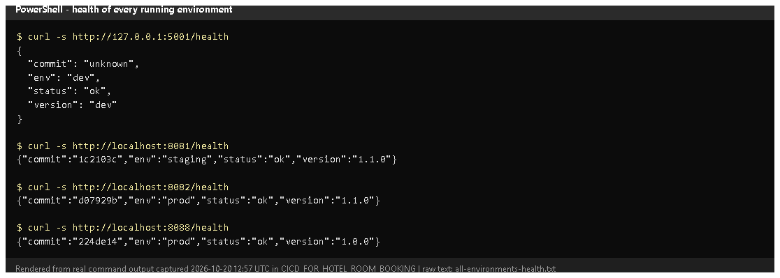
Figure 15.1 - /health of development, staging, prod and the lab server (rendered from real output, 2026-10-20).
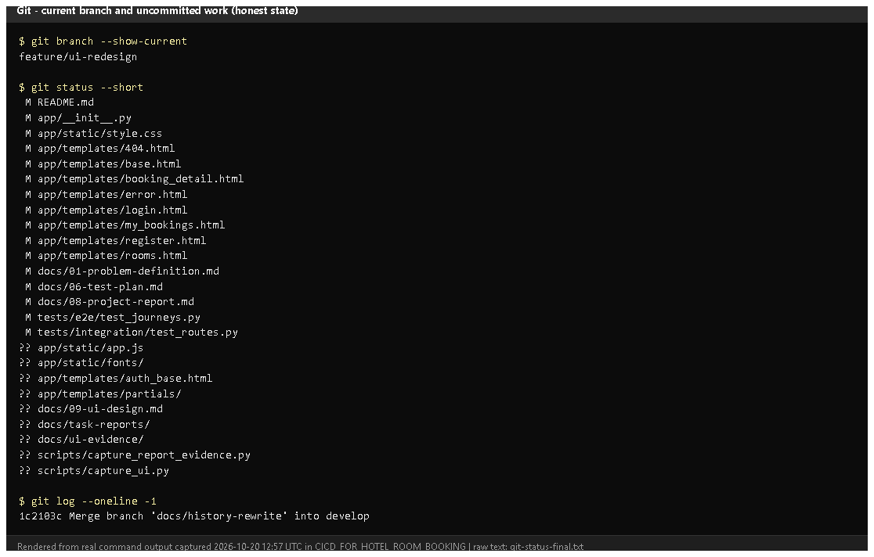
Figure 15.2 - Current branch and uncommitted files (rendered from real output): the UI redesign and these reports are not yet committed.
Figure 15.3 - The customer journey's central page: availability with totals for the stay (redesigned UI, working tree).
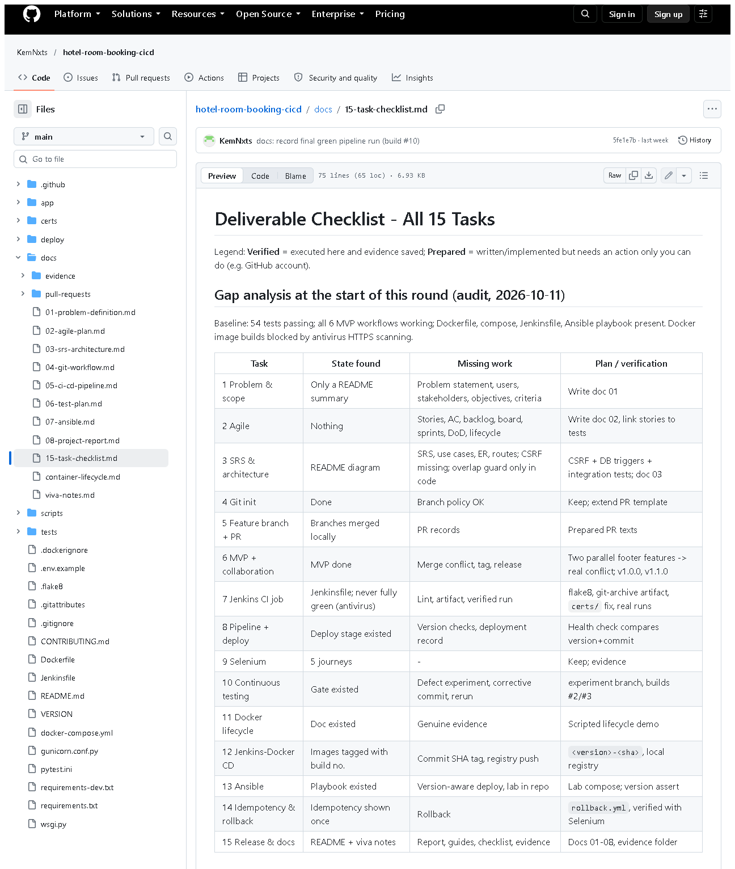 (part 1 of 4)
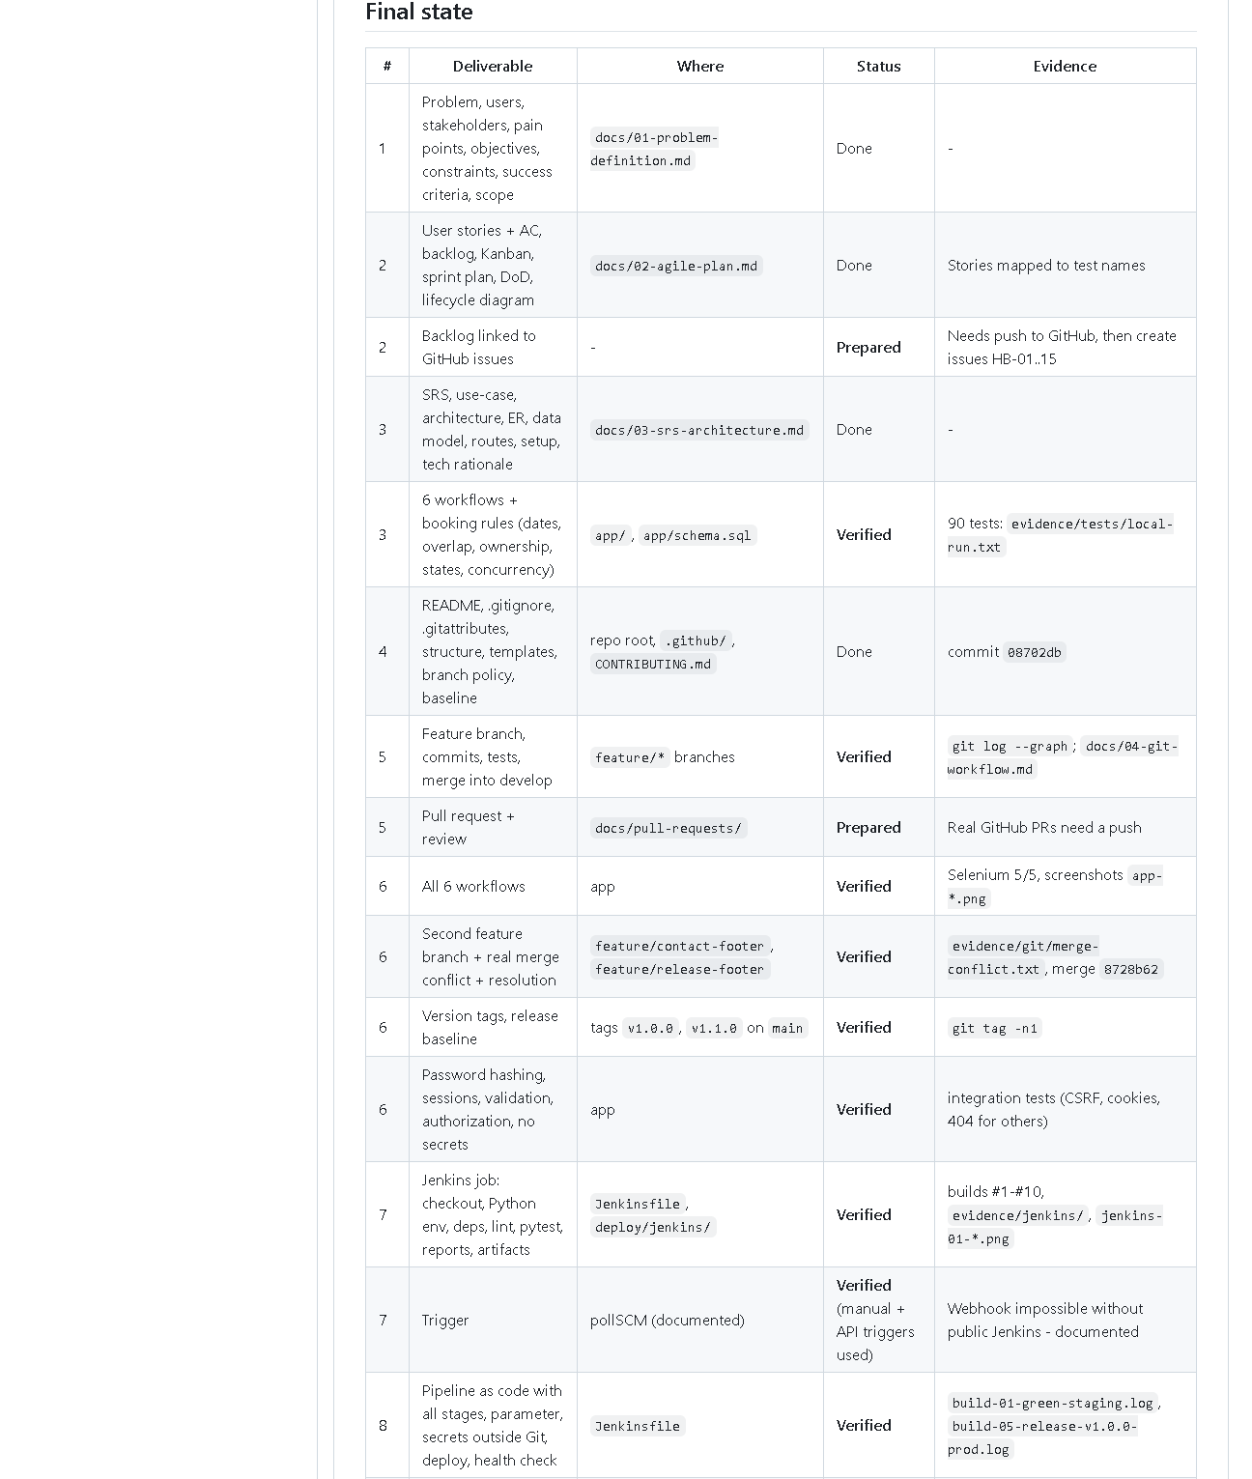 (part 2 of 4)
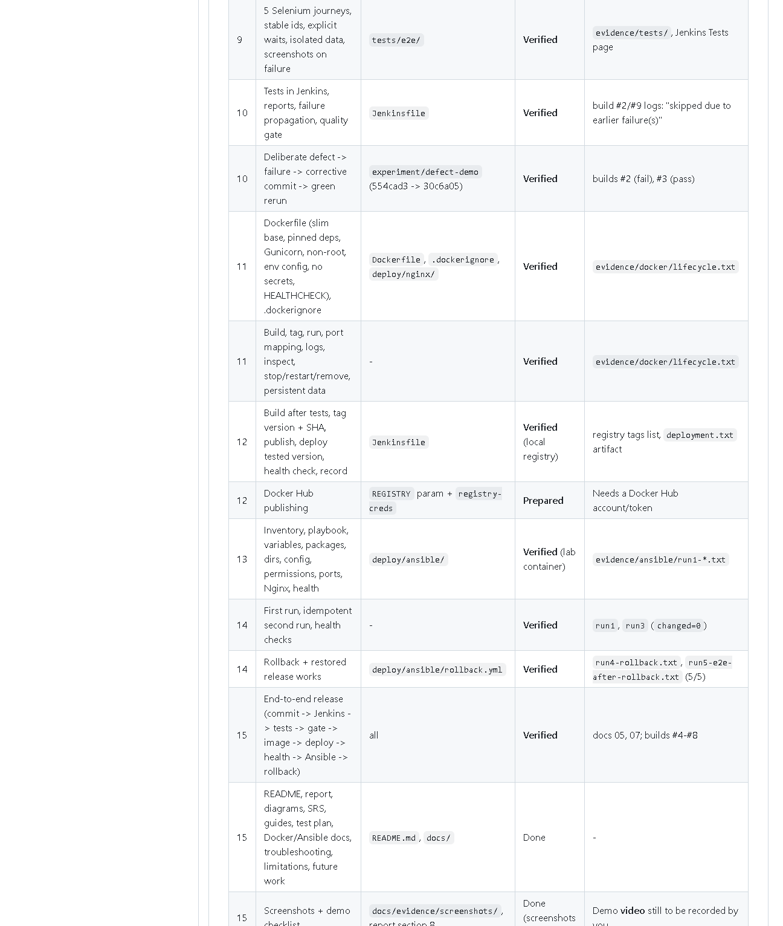 (part 3 of 4)
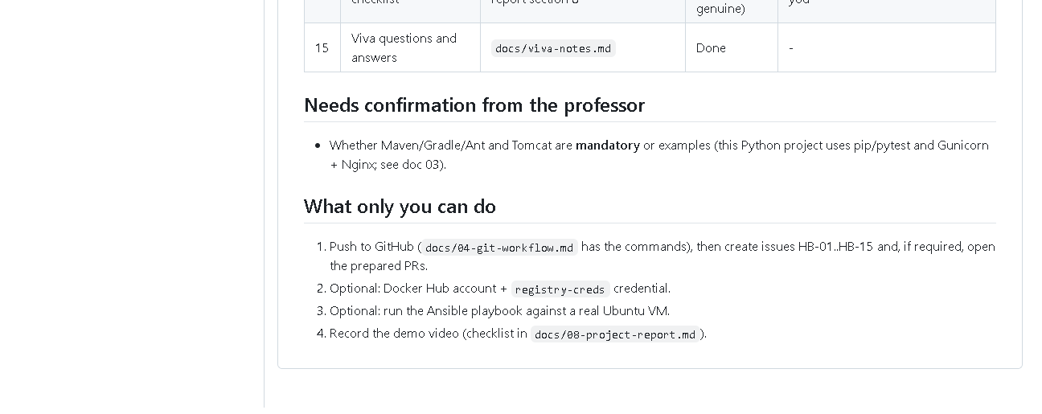 (part 4 of 4)
Figure 15.4 - docs/15-task-checklist.md on GitHub: gap analysis and the final deliverable status.
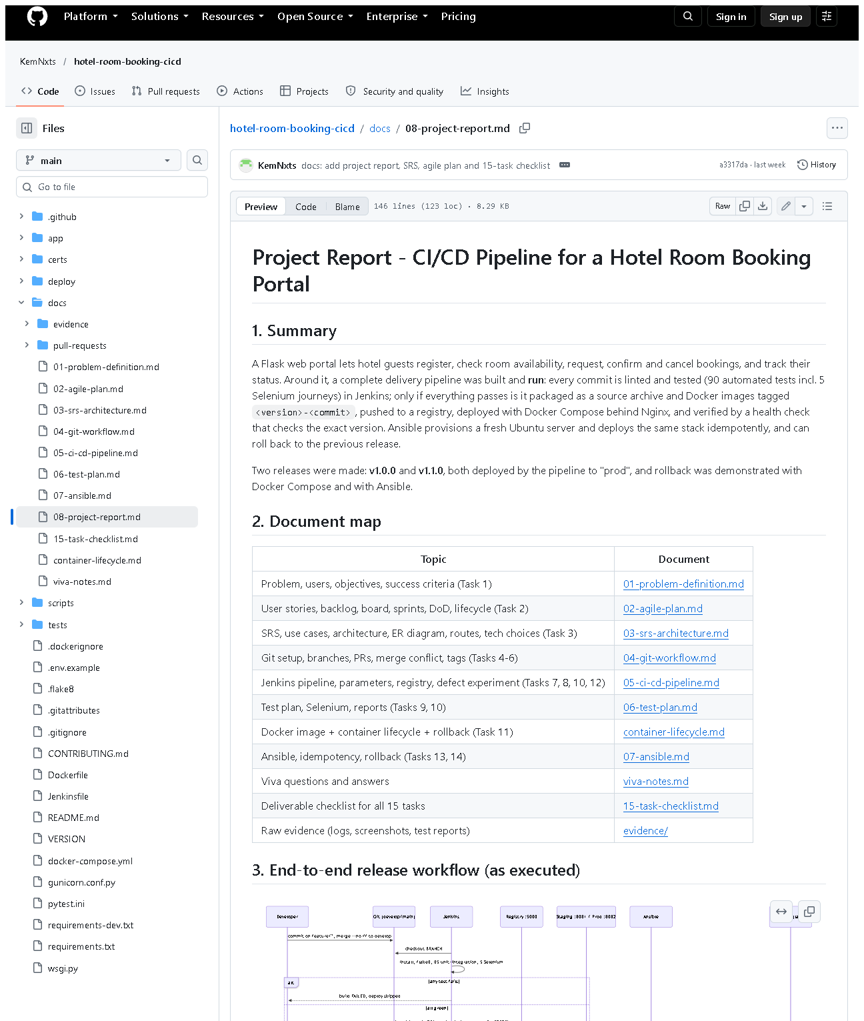 (part 1 of 3)
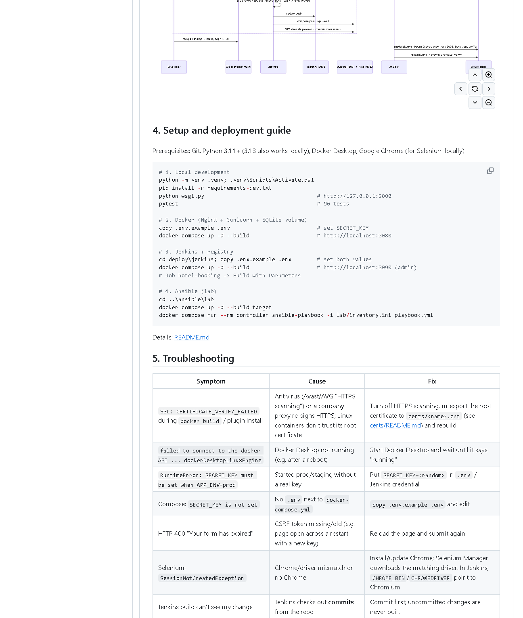 (part 2 of 3)
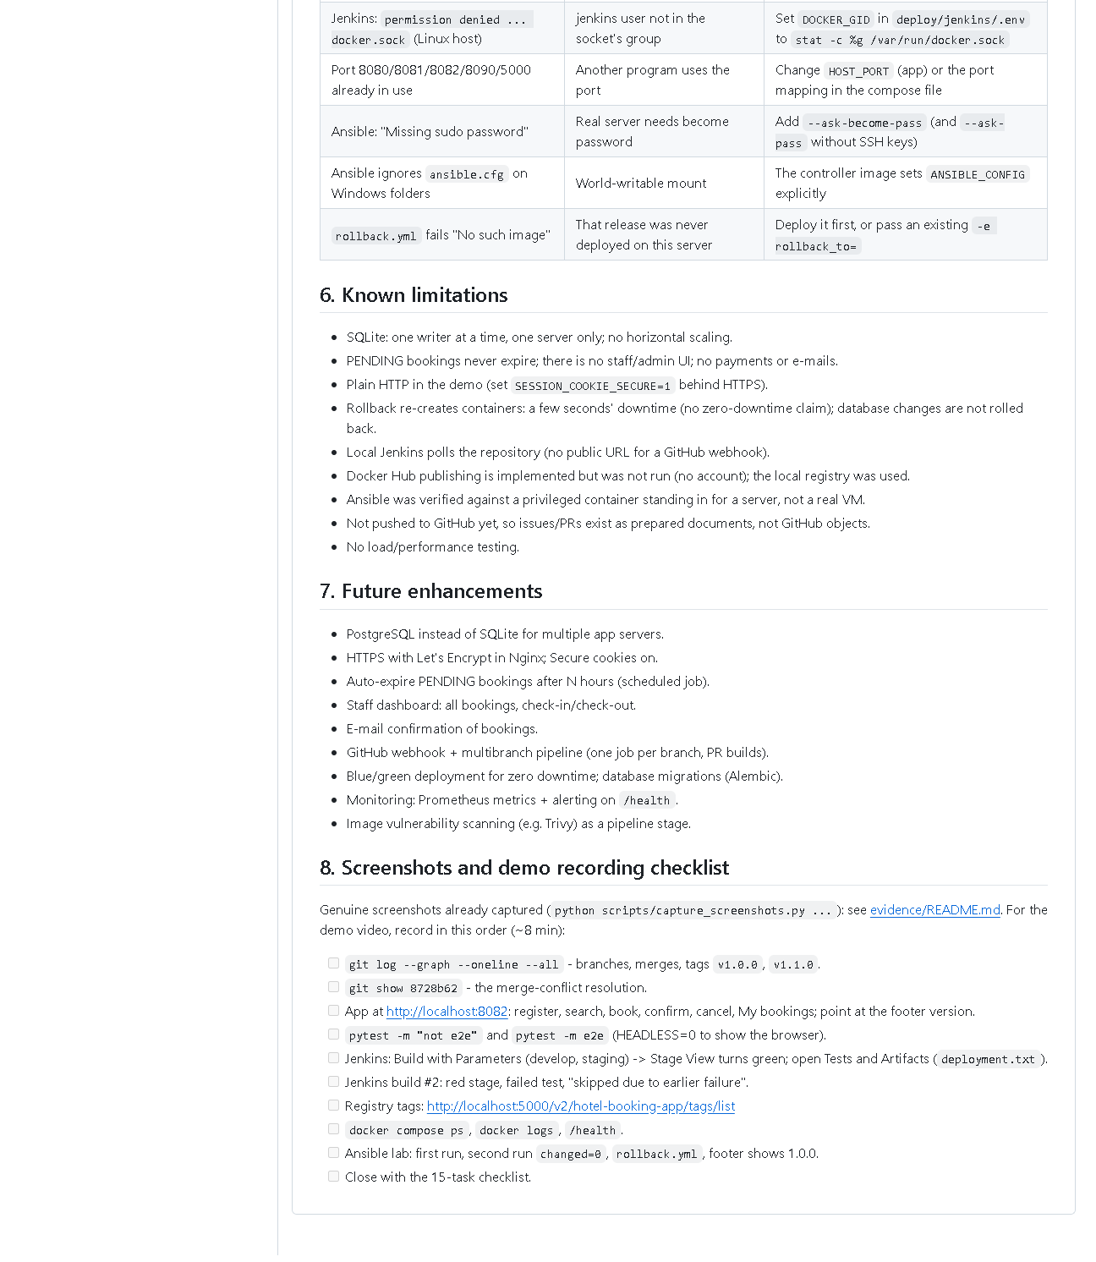 (part 3 of 3)
Figure 15.5 - docs/08-project-report.md on GitHub: summary, document map, end-to-end sequence diagram, setup guide, troubleshooting, limitations, future work and the demo checklist.
Key end-to-end evidence in other folders: assets/task-07/jenkins-job-stage-view.png, assets/task-08/jenkins-build-11-console.png, assets/task-12/registry-tags.png, assets/task-14/ansible-run3-repeat-idempotent.png, assets/task-14/ansible-run4-rollback.png.

E. How to demonstrate the whole project (about 12 minutes)
Before the viva (10 minutes earlier)
- Start Docker Desktop; wait for "Engine running".
- PowerShell:Expected: hotel-jenkins-jenkins-1, hotel-jenkins-registry-1, hotel-staging-*, hotel-prod-* up. If Jenkins is missing: cd deploy\jenkins; docker compose up -d; cd ..\..
cd D:\DevOPS\CICD_FOR_HOTEL_ROOM_BOOKING
docker ps --format "table {{.Names}}\t{{.Status}}"
- Open browser tabs: http://localhost:8090 (log in), http://localhost:8082, the GitHub repository.
The demonstration
Minute | Show | Say
0-1 | docs/01-problem-definition.md | "The problem: double bookings and risky manual releases."
1-3 | prod http://localhost:8082 - register, search, book, confirm, cancel, My bookings | "The six MVP workflows."
3-4 | git log --graph --oneline -12 develop, git tag -n1 | "Feature branches, merges, release tags."
4-7 | Jenkins -> Build with Parameters (develop, staging) -> stage view | "Lint and 90 tests, then images, registry, deploy, health check."
7-8 | build #2 Tests + Console (skipped due) | "A failing test blocks deployment."
8-9 | http://localhost:5000/v2/hotel-booking-app/tags/list and curl.exe -s http://localhost:8081/health | "Every image is tagged version-commit; the deployed commit matches."
9-11 | cd deploy\ansible\lab; playbook twice (changed=0); -e app_version=1.1.1-demo; rollback.yml; curl.exe -s http://localhost:8088/health | "Ansible configures servers idempotently and rolls back."
11-12 | docs/15-task-checklist.md | "All 15 tasks with evidence; these items are still pending."

(Exact Ansible commands: Task 14 section E. If the lab target is not running: cd deploy\ansible\lab; docker compose up -d target.)
Demo-video checklist: record the same 12 minutes with a screen recorder (e.g. Windows Snipping Tool -> Record), narrating as above; keep deploy\jenkins\.env and any password off screen.

F. Expected screenshots for the final submission
- assets/task-15/all-environments-health.png - exists, 2026-10-20.
- assets/task-15/git-status-final.png - exists, 2026-10-20.
- assets/task-15/app-desktop-06-availability-logged-in.png - exists, 2026-10-20.
- assets/task-15/github-doc-15-task-checklist.png - exists, 2026-10-20.
- assets/task-15/github-doc-08-project-report.png - exists, 2026-10-20.
- Demo video file - requires manual recording (pending).

G. Probable viva questions and answers
- Walk me through your pipeline in one sentence. Commit -> Jenkins checkout -> lint + 90 tests -> source archive and Docker images tagged version-commit -> push to registry -> deploy with Compose -> /health must match -> Ansible configures servers and can roll back.
- Where exactly is the quality gate? In the stage order of the Jenkinsfile: Package/Build/Publish/Deploy run only if lint and all tests passed.
- How do you know prod runs a tested version? It runs image 1.1.0-d07929b from build #8, which passed all tests; /health reports that commit.
- What happens if a bad release reaches prod? Roll back by switching to the previous image tag (Compose or rollback.yml); no rebuild.
- What role does Ansible play compared to Jenkins? Jenkins builds, tests and deploys to its own host; Ansible prepares and deploys to (other) servers in a repeatable way.
- (Project-specific) What are the four stories you'd tell? No double bookings (three layers); failed quality gate (build #2); the merge conflict (two footers, resolved keeping both); rollback (1.1.0 -> 1.0.0 verified by Selenium).
- (Project-specific) What is still pending? GitHub issues/PRs, Docker Hub, a real VM, the professor's Maven/Tomcat confirmation, the demo video, and committing the UI redesign.
- Why Python tools instead of Maven/Tomcat? It's a Python project; pip, pytest/flake8, Gunicorn and Nginx do those jobs. Needs the professor's approval.
- Biggest technical challenge? Antivirus HTTPS scanning broke downloads in containers; solved with an optional certs/ folder trusted by every image.
- What would you improve next? HTTPS, PostgreSQL, a GitHub webhook with PR builds, blue/green deploys and monitoring.
- Is all your evidence genuine? Yes - logs and screenshots come from real runs; rendered terminal images say so; pending items are labelled pending.

H. Common mistakes and troubleshooting
Symptom | Cause | Inspect | Fix | Confirm
Nothing loads | Docker Desktop not started after reboot | tray icon | start it, wait 1 min | docker ps lists containers
Dev server won't start on 5000 | registry uses port 5000 | - | python -m flask --app wsgi run --port 5001 | page opens
Jenkins build doesn't show new code | not committed | git status | commit, then build the branch | console commit ID
Selenium fails against staging/prod | deployed UI older than the local tests | /health version | use tests of the deployed version | 5 passed
Lab rollback "No such image" | release never deployed there | lab image list | deploy first | rollback ok

I. Quick revision notes
Five key points
- Flow: Git -> Jenkins -> tests (gate) -> images -> registry -> deploy -> /health -> Ansible -> rollback.
- Every step was run on 2026-10-20 (build #11, Ansible runs 1-4, Selenium 5/5).
- Versions are traceable: VERSION + commit in tags, /health and the page footer.
- All documentation is in docs/ and docs/task-reports/.
- Pending: issues/PRs, Docker Hub, VM, Maven approval, video, committing the redesign.
30-60 second explanation "A change starts as a commit on a feature branch. Jenkins checks it out, installs pinned dependencies and runs flake8 plus 90 tests. Only if all pass does it package the source, build Docker images tagged with version and commit, push them to our registry and deploy them with Docker Compose; the health check confirms the right commit is running. Releases are merged to main and tagged. Ansible provisions servers the same way every time - a second run changes nothing - and rollback.yml returns to the previous release, which I verified with Selenium."
Caveat: several external steps (GitHub issues/PRs, Docker Hub, real VM) are still pending.
Readiness checklist
- â˜ Docker Desktop started; all containers up.
- â˜ Jenkins logged in; GitHub tab open.
- â˜ I can do the 12-minute demo without notes.
- â˜ I can list the pending items honestly.
- â˜ I have read VIVA_CHEAT_SHEET.md.

Viva Cheat Sheet - CI/CD Pipeline for a Hotel Room Booking Portal

30-second introduction
"My project is a hotel room booking portal with a complete CI/CD pipeline. Guests register, check availability, request, confirm and cancel bookings and track their status. Every commit is checked by Jenkins with flake8 and 90 automated tests, including five Selenium browser journeys. Only if everything passes are Docker images built, tagged with the version and commit, pushed to a registry, deployed and health-checked. Ansible provisions a server the same way every time, a second run changes nothing, and one command rolls back to the previous release."

2-minute explanation
- Problem - a small hotel books by phone and spreadsheet: double bookings, no self-service, risky manual releases.
- Application - Python Flask with layers: controllers (HTTP), services (rules), DAOs (all SQL), SQLite. Six workflows. Passwords hashed, CSRF tokens, owner checks.
- Git - main for releases, develop for integration, one feature/* branch per change, --no-ff merges, tags v1.0.0 and v1.1.0, published on GitHub.
- Tests - 59 unit, 26 integration, 5 Selenium; isolated temporary database; screenshots on failure.
- Jenkins - the Jenkinsfile has 10 stages: checkout, install, static checks, unit & integration, Selenium, package source, build images, publish, deploy, health check. Parameter APP_ENV = staging (8081) or prod (8082). Secrets from Jenkins credentials.
- Docker - slim Python image, non-root, volume for the database, HEALTHCHECK, Gunicorn behind Nginx; images tagged <version>-<commit> in a local registry.
- Ansible - inventory, variables and a playbook that installs Docker, copies the app, writes a root-only .env, builds, starts and checks /health; idempotent; rollback.yml.
- Evidence - Jenkins builds #1-#11, Ansible runs with changed=7/5/0, rollback verified by Selenium.

The workflow in order
commit (feature branch) -> merge into develop -> Jenkins: checkout -> pip install (pinned)
-> flake8 -> pytest unit+integration -> Selenium -> [any failure: STOP, nothing deployed]
-> git archive + sha256 -> docker build (tag 1.1.0-<sha>) -> docker push (registry)
-> docker compose pull + up --wait -> /health must match version + commit -> deployment record
-> release: merge develop into main + tag vX.Y.Z -> deploy prod
-> Ansible: provision/deploy servers (idempotent) -> rollback.yml if needed

Tools and their roles
Tool | Role here
Git / GitHub | history, branches, tags / hosted copy (public)
Flask, SQLite | web app, database
pip + requirements*.txt | pinned dependencies (the Python equivalent of Maven's dependencies)
flake8, compileall | static checks
pytest | unit + integration tests, JUnit XML reports
Selenium WebDriver | browser journeys (headless Chrome)
Jenkins + Jenkinsfile | CI/CD pipeline as code
Docker, Docker Compose | images, containers, volume, health checks
registry:2 | local image registry (Docker Hub supported, not used)
Gunicorn, Nginx | production WSGI server, reverse proxy (instead of Tomcat)
Ansible | configuration management, provisioning, rollback

The four implementation stories
1. No double bookings (three layers). The service checks availability; the DAO checks and inserts inside BEGIN IMMEDIATE (a write-locked transaction), so simultaneous requests queue; and SQLite triggers refuse any overlapping active booking even if the code had a bug. Rule: existing check_in < new check_out AND check_out > new check_in. A test fires 10 threads at once - exactly one booking is created.
2. A failed quality gate prevented deployment. On experiment/defect-demo I changed < to <= in the overlap SQL (commit 5844eec). Jenkins build #2 failed on test_overlap_rules[2030-01-08-2030-01-10-True]; Package, Build images, Publish, Deploy and Health check were skipped; staging kept the old version. The fix 2fb62d6 made build #3 green. Bonus: build #2's report also showed 5 old Selenium results from a reused workspace - fixed with rm -rf reports dist, proven by build #9.
3. Merge conflict. feature/contact-footer and feature/release-footer both started at da225fb and added a footer in the same place. The second merge conflicted in base.html, style.css and test_routes.py. I kept both features, ran flake8 and all tests (89 passed) and committed merge 9e766ac. It can be replayed live in a throw-away clone.
4. Rollback. Every deploy tags images with the release and keeps old ones; the playbook stores the previous release. rollback.yml switches IMAGE_TAG, restarts with --no-build and asserts /health. On a fresh lab server: v1.0.0 -> v1.1.0 -> repeat run changed=0 -> rollback to 1.0.0 -> v1.0.0's own Selenium journeys 5/5 passed.

Common examiner questions
Question | Short answer
CI vs CD? | CI = build + test every change; CD = also deploy automatically after tests pass
Git vs GitHub? | local history tool vs hosted service with issues/PRs
Branch vs tag? | moving pointer vs fixed label on one commit (releases)
Image vs container? | read-only package vs running instance
Registry vs Docker Hub? | any image store vs one hosted public registry; we use a local one
Playbook vs inventory? | what to do vs which servers
Idempotency vs repeatability? | no changes when already correct vs same end result each time
Unit vs integration vs Selenium? | one rule / real HTTP routes in-process / full browser journey
Build failure vs deployment failure? | stopped before deploy (users unaffected) vs new version unhealthy (rollback)
Deployment vs rollback? | forward to a new version vs back to an older tested image, no rebuild
What is a quality gate? | tests must pass before Deploy can run (stage order)
How is the secret handled? | Jenkins credential / Ansible-generated, .env 0600, no_log, never in Git
Why /health? | Docker, Jenkins and Ansible use it to check the app and its version/commit
Why Nginx + Gunicorn? | Gunicorn runs Python; Nginx is the public entry point and serves static files

Limitations - honest answers
If asked | Answer
"Show me your GitHub issues / pull requests." | "There are none yet - GitHub shows 0. The backlog is in docs/02-agile-plan.md, merges were done locally with --no-ff and pushed, and review records are in docs/pull-requests/. Creating the issues and PRs is my next step."
"Did you publish to Docker Hub?" | "No. The pipeline supports it with a registry-creds credential and the REGISTRY parameter, but I tested only the local registry."
"Did you deploy to a real server?" | "Ansible was run against a disposable Ubuntu container with systemd and SSH, not a VM. The same playbook targets a real server by editing inventory.ini."
"Where is Maven / Tomcat?" | "It's a Python project: pip, flake8 and pytest do the dependency/compile/test jobs; Gunicorn + Nginx serve it. I need your confirmation that this equivalent is acceptable."
"Why polling and not a webhook?" | "Jenkins runs on localhost, which GitHub can't reach."
"Why do commit IDs differ between logs and GitHub?" | "Commit messages were edited once before publishing; the map is docs/evidence/git/commit-id-map.md."
"Is the new design deployed?" | "Not yet - the redesign is on feature/ui-redesign, uncommitted. Prod runs v1.1.0."
"Zero downtime?" | "No - rollback re-creates containers, a few seconds' interruption."

Commands for the practical (PowerShell, from D:\DevOPS\CICD_FOR_HOTEL_ROOM_BOOKING)
# 0. before anything: start Docker Desktop, then
docker ps --format "table {{.Names}}\t{{.Status}}"

# app locally (port 5000 is used by the registry)
.venv\Scripts\python -m flask --app wsgi run --port 5001

# tests
.venv\Scripts\python -m flake8 -j 1 app tests scripts wsgi.py gunicorn.conf.py
.venv\Scripts\python -m pytest -q -m "not e2e"
$env:HEADLESS="0"; .venv\Scripts\python -m pytest -m e2e -v; Remove-Item Env:HEADLESS

# git
git log --graph --oneline -12 develop
git tag -n1
git show --stat 9e766ac

# deployed versions and registry
curl.exe -s http://localhost:8081/health
curl.exe -s http://localhost:8082/health
curl.exe -s http://localhost:5000/v2/hotel-booking-app/tags/list

# Jenkins (if not running)
cd deploy\jenkins; docker compose up -d; cd ..\..
# -> http://localhost:8090, job hotel-booking, Build with Parameters

# Ansible lab
cd deploy\ansible\lab
docker compose up -d target
docker compose run --rm controller ansible-playbook -i lab/inventory.ini playbook.yml
docker compose run --rm controller ansible-playbook -i lab/inventory.ini playbook.yml -e app_version=1.1.1-demo
docker compose run --rm controller ansible-playbook -i lab/inventory.ini rollback.yml
curl.exe -s http://localhost:8088/health

Screenshot inventory
Generated from the figure references in the 15 task reports on 2026-10-20. Every file listed as verified exists on disk. "Browser screenshot" = captured from the running system or GitHub with headless Chrome; "rendered from real output" = a real command or log rendered as an image by scripts/capture_report_evidence.py (the raw text is kept next to it or in assets/raw/).
86 referenced screenshots, 0 missing references, 9 still to be captured manually.
Task | File | Evidence purpose | Captured | Status
1 | assets/task-01/github-doc-01-problem-definition.png | docs/01-problem-definition.md as published on the public GitHub repository (captured 2026-10-20). | 2026-10-20 | verified (browser screenshot)
2 | assets/task-02/github-doc-02-agile-plan.png | docs/02-agile-plan.md on GitHub (captured 2026-10-20). | 2026-10-20 | verified (browser screenshot)
2 | assets/task-02/github-issues-empty.png | The repository's Issues page (all states) shows no issues (captured 2026-10-20). | 2026-10-20 | verified (browser screenshot)
3 | assets/task-03/github-doc-03-srs-architecture.png | docs/03-srs-architecture.md on GitHub with diagrams rendered (captured 2026-10-20). | 2026-10-20 | verified (browser screenshot)
3 | assets/task-03/flask-routes.png | python -m flask --app wsgi routes run on 2026-10-20 (rendered from real output). | 2026-10-20 | verified (rendered from real command/log output)
3 | assets/task-03/project-structure.png | Files under app/ and tests/ (from git ls-files, rendered from real output). | 2026-10-20 | verified (rendered from real command/log output)
3 | assets/task-03/github-file-app_schema.sql.png | app/schema.sql on GitHub. | 2026-10-20 | verified (browser screenshot)
3 | assets/task-03/app-desktop-01-home.png | Figure 3.5 - The running application | 2026-10-20 | verified (browser screenshot)
4 | assets/task-04/git-branches-tags-remote.png | git branch -a, git tag -n1, git remote -v (rendered from real output, 2026-10-20). | 2026-10-20 | verified (rendered from real command/log output)
4 | assets/task-04/git-main-history.png | Main-branch history and the skeleton commit 541dad5 with its files (rendered from real output). | 2026-10-20 | verified (rendered from real command/log output)
4 | assets/task-04/gitignore-and-templates.png | .github templates, .gitattributes and .gitignore (rendered from real output). | 2026-10-20 | verified (rendered from real command/log output)
4 | assets/task-04/github-repository-home.png | The public GitHub repository home page (captured 2026-10-20). | 2026-10-20 | verified (browser screenshot)
4 | assets/task-04/github-branches.png | All branches on GitHub. | 2026-10-20 | verified (browser screenshot)
4 | assets/task-04/github-templates-folder.png | .github/ on GitHub: ISSUE_TEMPLATE/ and pull_request_template.md. | 2026-10-20 | verified (browser screenshot)
5 | assets/task-05/feature-branch-history.png | git log --graph of feature/security-hardening and git show --stat 716b910 (rendered from real output, 2026-10-20). | 2026-10-20 | verified (rendered from real command/log output)
5 | assets/task-05/all-feature-merges.png | git log --merges --first-parent develop (rendered from real output). | 2026-10-20 | verified (rendered from real command/log output)
5 | assets/task-05/github-compare-merged-into-develop.png | GitHub compare develop...feature/nights-column (captured 2026-10-20). | 2026-10-20 | verified (browser screenshot)
5 | assets/task-05/github-pull-requests-empty.png | The repository's Pull requests page (all states): none. | 2026-10-20 | verified (browser screenshot)
5 | assets/task-05/github-compare-feature-changes.png | GitHub compare from the branch's starting point a2bb052 to feature/nights-column. | 2026-10-20 | verified (browser screenshot)
6 | assets/task-06/app-desktop-03-register.png | Workflow 1: registration form with labelled fields and the password rule. | 2026-10-20 | verified (browser screenshot)
6 | assets/task-06/app-desktop-05-login-error.png | Workflow 1: login with wrong credentials shows a neutral error (does not reveal which part was wrong). | 2026-10-20 | verified (browser screenshot)
6 | assets/task-06/app-desktop-06-availability-logged-in.png | Workflow 2: availability for the chosen dates - booked rooms marked "Booked", free rooms with the total for the stay. | 2026-10-20 | verified (browser screenshot)
6 | assets/task-06/app-desktop-08-booking-requested.png | Workflow 3: the new booking is PENDING. | 2026-10-20 | verified (browser screenshot)
6 | assets/task-06/app-desktop-09-booking-confirmed.png | Workflow 4: CONFIRMED, progress shows both steps done. | 2026-10-20 | verified (browser screenshot)
6 | assets/task-06/app-desktop-10-cancel-dialog.png | Workflow 5: cancelling opens a confirmation dialog first. | 2026-10-20 | verified (browser screenshot)
6 | assets/task-06/app-desktop-11-booking-cancelled.png | Workflow 5: status CANCELLED, room released. | 2026-10-20 | verified (browser screenshot)
6 | assets/task-06/app-desktop-12-my-bookings.png | Workflow 6: status tracking for all of the guest's bookings (PENDING, CANCELLED, CONFIRMED). | 2026-10-20 | verified (browser screenshot)
6 | assets/task-06/app-mobile-12-my-bookings.png | The same page at phone width (375 px). | 2026-10-20 | verified (browser screenshot)
6 | assets/task-06/merge-conflict-output.png | The conflict as recorded on 2026-10-11 (rendered from docs/evidence/git/merge-conflict.txt; original commit IDs). | 2026-10-20 | verified (rendered from real command/log output)
6 | assets/task-06/merge-conflict-resolution.png | git log --graph and git show --stat 9e766ac today (rendered from real output). | 2026-10-20 | verified (rendered from real command/log output)
6 | assets/task-06/release-tags.png | git tag -n1 and the annotated tag object of v1.1.0 (rendered from real output). | 2026-10-20 | verified (rendered from real command/log output)
6 | assets/task-06/github-release-tags.png | v1.0.0 and v1.1.0 on GitHub. | 2026-10-20 | verified (browser screenshot)
6 | assets/task-06/github-doc-04-git-workflow.png | docs/04-git-workflow.md on GitHub: branching model, merges, the conflict story and the release procedure. | 2026-10-20 | verified (browser screenshot)
7 | assets/task-07/jenkins-job-stage-view.png | Job hotel-booking: build history #1-#11, test-result trend, last artifacts and the stage view (captured 2026-10-20). | 2026-10-20 | verified (browser screenshot)
7 | assets/task-07/jenkins-job-configuration.png | Job configuration: the three parameters, "Do not allow concurrent builds", Poll SCM `H/5 | 2026-10-20 | verified (browser screenshot)
7 | assets/task-07/jenkins-build-11-summary.png | Build #11 (1.1.0-1c2103c), started 2026-10-20: result SUCCESS. | 2026-10-20 | verified (browser screenshot)
7 | assets/task-07/jenkins-build-11-tests.png | Test report of build #11: 90 tests, 0 failures, grouped by package (unit, integration, e2e). | 2026-10-20 | verified (browser screenshot)
7 | assets/task-07/jenkins-build-11-artifacts.png | Archived artifacts of build #11: source tarball + .sha256, test XML, health.json, deployment.txt. | 2026-10-20 | verified (browser screenshot)
7 | assets/task-07/jenkins-files.png | deploy/jenkins/plugins.txt and the running Jenkins + registry containers (rendered from real output, 2026-10-20). | 2026-10-20 | verified (rendered from real command/log output)
8 | assets/task-08/github-file-Jenkinsfile.png | Jenkinsfile on GitHub (captured 2026-10-20). | 2026-10-20 | verified (browser screenshot)
8 | assets/task-08/jenkinsfile-stages.png | Line numbers of every stage and parameter (findstr on the Jenkinsfile, rendered from real output). | 2026-10-20 | verified (rendered from real command/log output)
8 | assets/task-08/jenkins-build-with-parameters.png | The | 2026-10-20 | verified (browser screenshot)
8 | assets/task-08/jenkins-build-11-console.png | Build #11 console excerpt (rendered from the saved console log): each stage starting, 85 + 5 tests passed, the archive checksum, image pushes with digests, /health and "Deployed 1.1.0-1c2103c to staging". | 2026-10-20 | verified (rendered from real command/log output)
8 | assets/task-08/staging-health-after-build-11.png | http://localhost:8081/health in a browser after build #11: commit 1c2103c, env staging, version 1.1.0. | 2026-10-20 | verified (browser screenshot)
8 | assets/task-08/jenkins-credentials-masked.png |  | 2026-10-20 | verified (browser screenshot)
9 | assets/task-09/selenium-run.png | pytest -m e2e -v on 2026-10-20 (rendered from real output): 5 journeys PASSED. | 2026-10-20 | verified (rendered from real command/log output)
9 | assets/task-09/full-test-suite.png | flake8 (no findings), then unit 59, integration 26 and e2e 5 passed (rendered from real output, 2026-10-20). | 2026-10-20 | verified (rendered from real command/log output)
9 | assets/task-09/github-file-tests_e2e_test_journeys.py.png | Figure 9.3 - Journey source on GitHub | 2026-10-20 | verified (browser screenshot)
9 | assets/task-09/selenium-failure-demo-output.png | A temporary, deliberately failing test run on 2026-10-20 (rendered from real output): "failure screenshot saved: reports\screenshots...png", then 1 failed; the folder contains a .png and an .html. | 2026-10-20 | verified (rendered from real command/log output)
9 | assets/task-09/selenium-failure-screenshot-saved-by-hook.png | The actual image saved by the hook: what the browser showed at the moment of failure. | 2026-10-20 | verified (browser screenshot)
9 | assets/task-09/app-desktop-07-my-bookings-empty.png | The empty "My bookings" state (redesigned UI) - one of the pages the journeys navigate. | 2026-10-20 | verified (browser screenshot)
10 | assets/task-10/jenkins-build-02-failed.png | Build #2 1.0.0-554cad3 in Jenkins (checked 2026-10-20): result FAILURE. | 2026-10-20 | verified (browser screenshot)
10 | assets/task-10/build-02-defect-console.png | Console excerpt of build #2 (rendered from the saved log docs/evidence/jenkins/build-02-defect-fails.log). | 2026-10-20 | verified (rendered from real command/log output)
10 | assets/task-10/defect-branch-history.png | The experiment branch history, the one-character diff, and the branches that contain the defect (rendered from real output, 2026-10-20). | 2026-10-20 | verified (rendered from real command/log output)
10 | assets/task-10/jenkins-build-02-failed-test.png | Build #2's Tests page: 1 failed (test_overlap_rules[...-True], marked Regression). Also notice tests.e2e 5 - the stale report described above. | 2026-10-20 | verified (browser screenshot)
10 | assets/task-10/jenkins-build-09-tests-no-stale-report.png | Build #9 after the report fix: 82 tests, 1 failed, and no tests.e2e entry. | 2026-10-20 | verified (browser screenshot)
10 | assets/task-10/jenkins-build-03-fixed.png | Build #3 1.0.0-30c6a05: SUCCESS after the corrective commit. | 2026-10-20 | verified (browser screenshot)
10 | assets/task-10/build-03-fix-console.png | Build #3 console excerpt (rendered from the saved log): tests passed, deployed, health check OK. | 2026-10-20 | verified (rendered from real command/log output)
10 | assets/task-10/build-09-rerun-console.png | Build #9 console excerpt: + rm -rf reports dist, the same failing test, later stages skipped. | 2026-10-20 | verified (rendered from real command/log output)
11 | assets/task-11/lifecycle-part1-build-run.png | Lifecycle demo, part 1: build, tag, image labels/user/port, volume, run, docker ps with port mapping, /health, registration, logs (rendered from the real run on 2026-10-20). | 2026-10-20 | verified (rendered from real command/log output)
11 | assets/task-11/lifecycle-part2-stop-restart-volume.png | Part 2: inspect, whoami = appuser, stop -> Exited, start, restart, remove, a new container on the same volume, the old account still logs in, clean-up. | 2026-10-20 | verified (rendered from real command/log output)
11 | assets/task-11/github-file-Dockerfile.png | Dockerfile on GitHub. | 2026-10-20 | verified (browser screenshot)
11 | assets/task-11/github-file-docker-compose.yml.png | docker-compose.yml: app + nginx, named volume, service_healthy dependency, SECRET_KEY required. | 2026-10-20 | verified (browser screenshot)
11 | assets/task-11/docker-images-containers.png | docker image ls, docker ps and docker volume ls on 2026-10-20 (rendered from real output): versioned images, the running staging/prod/Jenkins/lab containers and the data volumes. | 2026-10-20 | verified (rendered from real command/log output)
12 | assets/task-12/deployed-versions.png | Which image each environment runs, both /health answers, and the registry catalogue and tags (rendered from real output, 2026-10-20). | 2026-10-20 | verified (rendered from real command/log output)
12 | assets/task-12/registry-tags.png | http://localhost:5000/v2/hotel-booking-app/tags/list in the browser. | 2026-10-20 | verified (browser screenshot)
12 | assets/task-12/prod-health.png | http://localhost:8082/health: prod runs release 1.1.0 (d07929b). | 2026-10-20 | verified (browser screenshot)
12 | assets/task-12/jenkins-build-11-deployment-record.png | reports/deployment.txt archived by build #11: environment, branch, version, commit, image names, URL. | 2026-10-20 | verified (browser screenshot)
12 | assets/task-12/prod-portal-v1.1.0.png | The prod portal at http://localhost:8082 - the deployed v1.1.0 interface (the newer UI redesign is not deployed yet). | 2026-10-20 | verified (browser screenshot)
13 | assets/task-13/ansible-run1-first-deploy-v1.0.0.png | Run 1 on a fresh lab server, from a clean clone of tag v1.0.0 (rendered from the real run on 2026-10-20). | 2026-10-20 | verified (rendered from real command/log output)
13 | assets/task-13/github-file-deploy_ansible_inventory.ini.png | deploy/ansible/inventory.ini on GitHub - group [web]. | 2026-10-20 | verified (browser screenshot)
13 | assets/task-13/github-file-deploy_ansible_group_vars_web.yml.png | group_vars/web.yml: environment-specific values, the version taken from VERSION, and the generated secret key. | 2026-10-20 | verified (browser screenshot)
13 | assets/task-13/github-file-deploy_ansible_playbook.yml.png | playbook.yml on GitHub: the tasks listed above. | 2026-10-20 | verified (browser screenshot)
13 | assets/task-13/lab-server-state.png | Inside the lab server (rendered from real output, 2026-10-20): file permissions (600 root .env), the files in /opt/hotel-booking, images, running containers, docker enabled. | 2026-10-20 | verified (rendered from real command/log output)
14 | assets/task-14/ansible-run2-upgrade-v1.1.0.png | Run 2 (upgrade to v1.1.0): changed=5, /health 1.1.0 (rendered from the real run, 2026-10-20). | 2026-10-20 | verified (rendered from real command/log output)
14 | assets/task-14/ansible-run3-repeat-idempotent.png | Run 3, the same playbook again: every task ok or skipping, PLAY RECAP ... changed=0. | 2026-10-20 | verified (rendered from real command/log output)
14 | assets/task-14/ansible-run4-rollback.png | rollback.yml: "Rolled back from 1.1.0 to 1.0.0", changed=3, /health 1.0.0. | 2026-10-20 | verified (rendered from real command/log output)
14 | assets/task-14/ansible-run5-e2e-after-rollback.png | The five v1.0.0 Selenium journeys pass against the rolled-back server. | 2026-10-20 | verified (rendered from real command/log output)
14 | assets/task-14/lab-server-health-after-rollback.png | http://localhost:8088/health: version 1.0.0, commit 224de14. | 2026-10-20 | verified (browser screenshot)
14 | assets/task-14/lab-server-after-rollback-v1.0.0.png | The portal served by the lab server after the rollback (v1.0.0 interface). | 2026-10-20 | verified (browser screenshot)
14 | assets/task-14/github-file-deploy_ansible_rollback.yml.png | deploy/ansible/rollback.yml on GitHub. | 2026-10-20 | verified (browser screenshot)
15 | assets/task-15/all-environments-health.png | /health of development, staging, prod and the lab server (rendered from real output, 2026-10-20). | 2026-10-20 | verified (rendered from real command/log output)
15 | assets/task-15/git-status-final.png | Current branch and uncommitted files (rendered from real output): the UI redesign and these reports are not yet committed. | 2026-10-20 | verified (rendered from real command/log output)
15 | assets/task-15/app-desktop-06-availability-logged-in.png | The customer journey's central page: availability with totals for the stay (redesigned UI, working tree). | 2026-10-20 | verified (browser screenshot)
15 | assets/task-15/github-doc-15-task-checklist.png | docs/15-task-checklist.md on GitHub: gap analysis and the final deliverable status. | 2026-10-20 | verified (browser screenshot)
15 | assets/task-15/github-doc-08-project-report.png | docs/08-project-report.md on GitHub: summary, document map, end-to-end sequence diagram, setup guide, troubleshooting, limitations, future work and the demo checklist. | 2026-10-20 | verified (browser screenshot)

Awaiting manual capture (external actions)
Task | File | Purpose | Status
2 | assets/task-02/github-issues-created.png | Issues HB-01..HB-15 on GitHub | awaiting manual capture
4 | assets/task-04/github-branch-protection.png | Branch protection settings (only if configured) | awaiting manual capture
5 | assets/task-05/github-pr-open.png | A real pull request | awaiting manual capture
5 | assets/task-05/github-pr-review-comment.png | A review comment | awaiting manual capture
5 | assets/task-05/github-pr-merged.png | The merged pull request | awaiting manual capture
9 | (video/photo) | Visible browser run with HEADLESS=0 (live demo) | awaiting manual capture
12 | assets/task-12/dockerhub-repository.png | Image published on Docker Hub | awaiting manual capture
13 | assets/task-13/real-vm-run.png | Playbook against a real Ubuntu VM | awaiting manual capture
15 | (video) | Demo recording | awaiting manual capture

