Task 2 - Agile Planning and DevOps Workflow

A. Task title and objective
Task 2: Agile Planning and DevOps Workflow
Objective: plan the work in small, testable pieces (user stories), order
them (backlog), schedule them (sprints), agree when a piece is finished
(Definition of Done), and show the full DevOps flow from code to operations.
Professor's required deliverables
- User stories with acceptance criteria
- Product backlog
- A 15-task Kanban/Scrum board
- Sprint plan
- Definition of Done
- DevOps lifecycle diagram (development to operations)
- Backlog linked to repository issues where possible
Current status: Partially completed.
Part | Status
Stories, acceptance criteria, backlog, board, sprints, DoD, diagram | Implemented and verified - docs/02-agile-plan.md, published on GitHub
Backlog items as GitHub issues | Pending external action - the GitHub API reports 0 issues (checked 2026-10-20); see Figure 2.2

B. Explanation for a complete beginner
An everyday picture. Planning a wedding: you write every job on a sticky
note ("book the hall", "send invitations"), put them in order of importance,
and move each note across a whiteboard from To do to Doing to Done. Agile
planning is exactly that, for software.
Agile - a way of working in short cycles, delivering a small working piece
each time and adjusting the plan as you learn. Problem it solves: big
"deliver everything at the end" projects discover problems too late.
User story - a requirement written from the user's point of view:
"As a guest I want to cancel a booking so that the room is released."
Why: it keeps the focus on what the user gets, not on technical details.
Acceptance criteria - the conditions that must be true for a story to be
accepted, e.g. "a cancelled booking cannot be cancelled again". In this
project every criterion is checked by an automated test, and the test
names are written next to the story.
Product backlog - the ordered list of all work items. Here: HB-01 to HB-15,
one per course task.
Kanban board - columns (Backlog, To do, In progress, Review, Done) that
show where each item is. Scrum - work in fixed periods called sprints
(here 3 short sprints), each ending with a review and a retrospective.
Definition of Done (DoD) - one checklist that applies to every item, so
"done" means the same thing to everyone (tests pass, pipeline green, merged...).
DevOps lifecycle - the loop Plan -> Code -> Build -> Test -> Release ->
Deploy -> Operate -> Monitor -> back to Plan. In this project each step has a
real tool (Git, pip, pytest/Selenium, Docker, Jenkins, Ansible, /health).
GitHub issue - a ticket on GitHub that tracks one backlog item. Linking
items to issues lets commits and pull requests say "Closes #12".

C. What was actually implemented
File: docs/02-agile-plan.md.
User stories (9). US1-US6 cover the six booking workflows, US7 automatic
testing, US8 one-command deployment, US9 rollback. Each row lists the
acceptance criteria and the tests that check them, for example:
Story | Acceptance criterion (excerpt) | Automated check
US3 request a booking | never two active bookings overlap, even simultaneously | test_simultaneous_requests_create_only_one_booking
US5 cancel | cannot cancel twice | TestCancelBooking::test_cannot_cancel_twice
US7 every commit tested | any failure skips packaging and deployment | Jenkins builds #2, #9

Backlog. HB-01 ... HB-15, one per course task, with the related story and
status.
Kanban board (final state). All HB items in Done; out-of-scope ideas
(payments, admin UI, auto-expiry of PENDING bookings) stay in Backlog.
Sprint plan. Sprint 1 Foundation (days 1-3), Sprint 2 Automation (4-6),
Sprint 3 Operations & release (7-10).
Definition of Done (7 points): feature/fix branch with conventional
commits; automated tests; flake8 clean and all tests pass; Jenkins green;
merged with --no-ff using the PR checklist; docs updated; no secrets.
DevOps lifecycle diagram. A Mermaid diagram (text that GitHub draws as a
picture). It shows the failure loop: if tests fail, nothing is
released and the developer fixes the code.
How the DoD is enforced in this repository
DoD point | Real mechanism
tests pass | pytest stages in Jenkinsfile
flake8 clean | "Static checks" stage
pipeline green | Deploy runs only after every test stage
PR checklist | .github/pull_request_template.md
no secrets | .gitignore excludes .env, credentials/, *.key, certs/*.crt

GitHub issues - what is missing. The repository is public, but no issues
were created (Figure 2.2). The backlog text says so: "replace HB-xx with the
real issue number" after creating them.

D. Screenshots and evidence
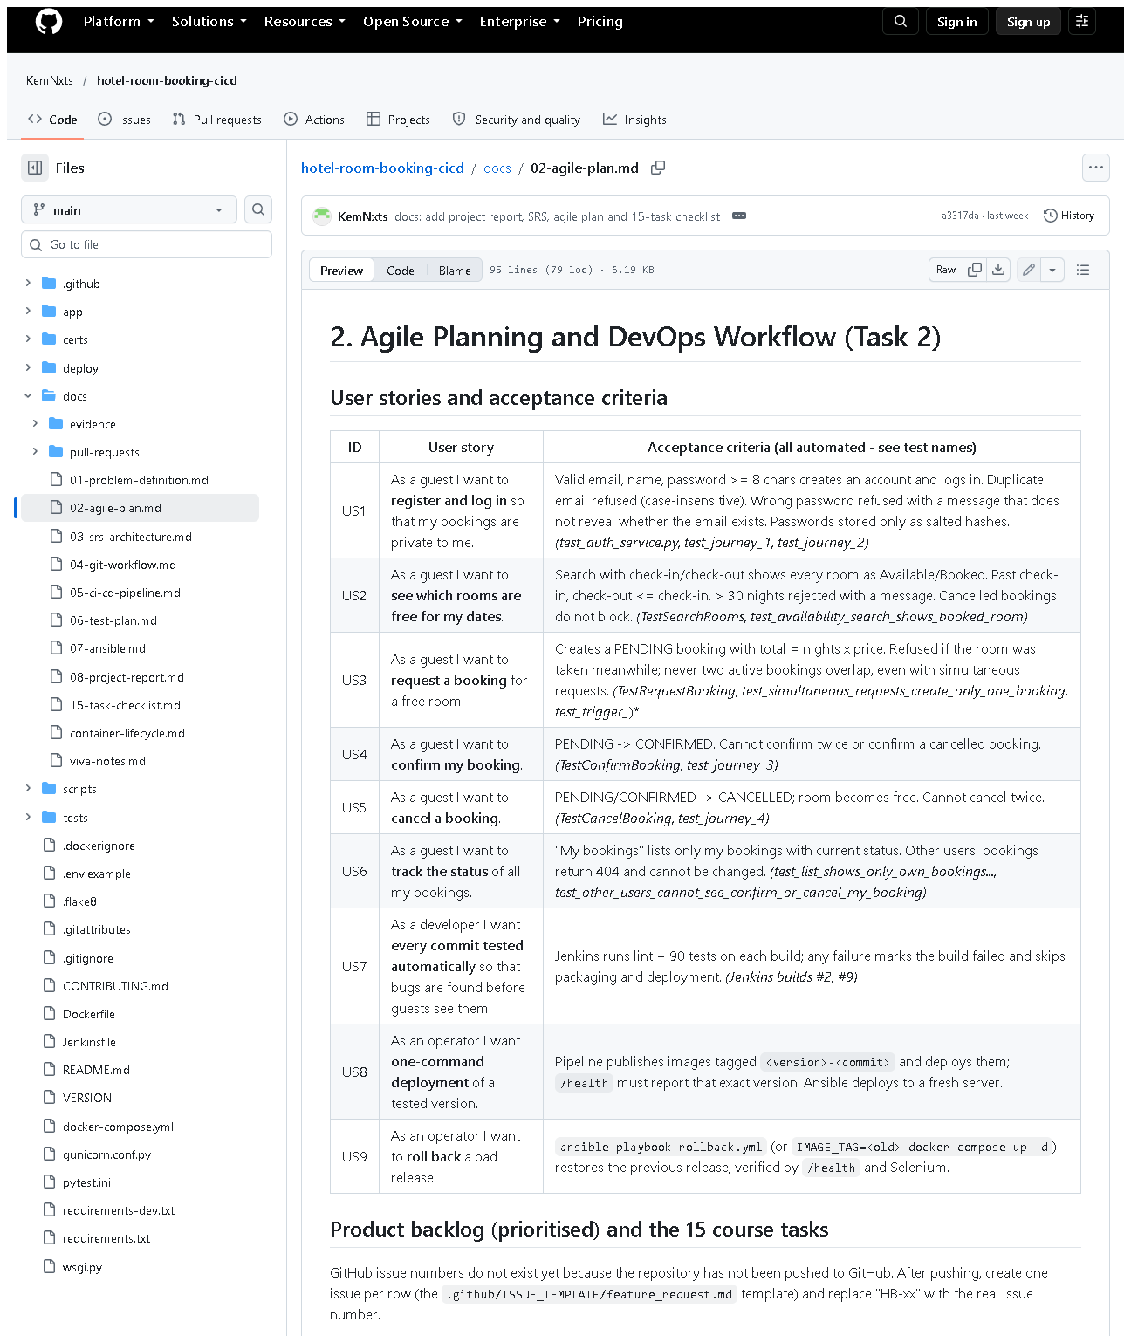 (part 1 of 3)
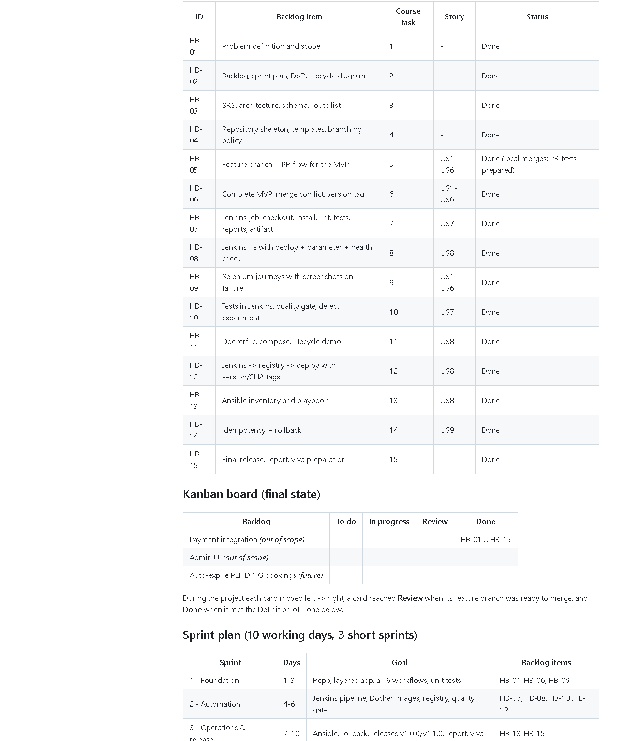 (part 2 of 3)
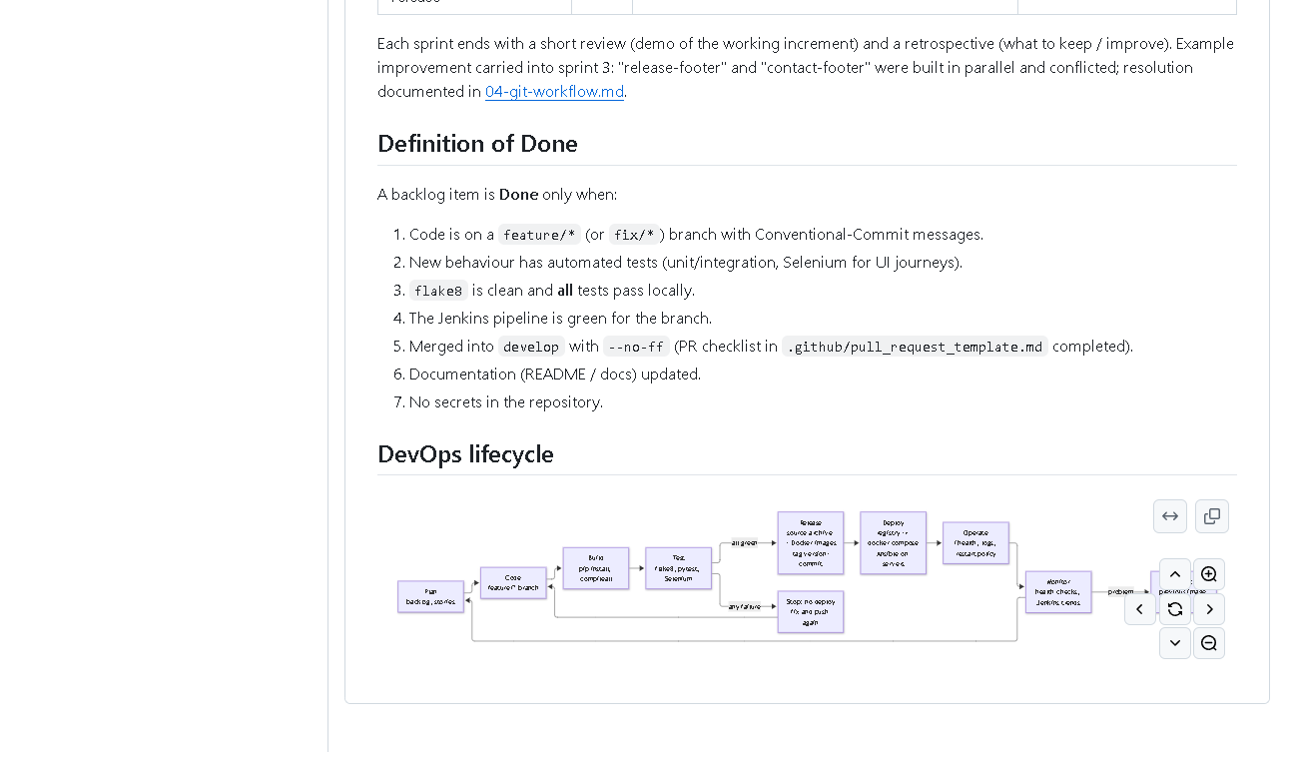 (part 3 of 3)
Figure 2.1 - docs/02-agile-plan.md on GitHub (captured 2026-10-20).
What to notice: the user-story table with test names, backlog HB-01-HB-15,
the Kanban table, sprint plan, the Definition of Done, and at the bottom the
DevOps lifecycle diagram drawn by GitHub from Mermaid text.
Why it proves the task: all planning deliverables exist in one versioned document.
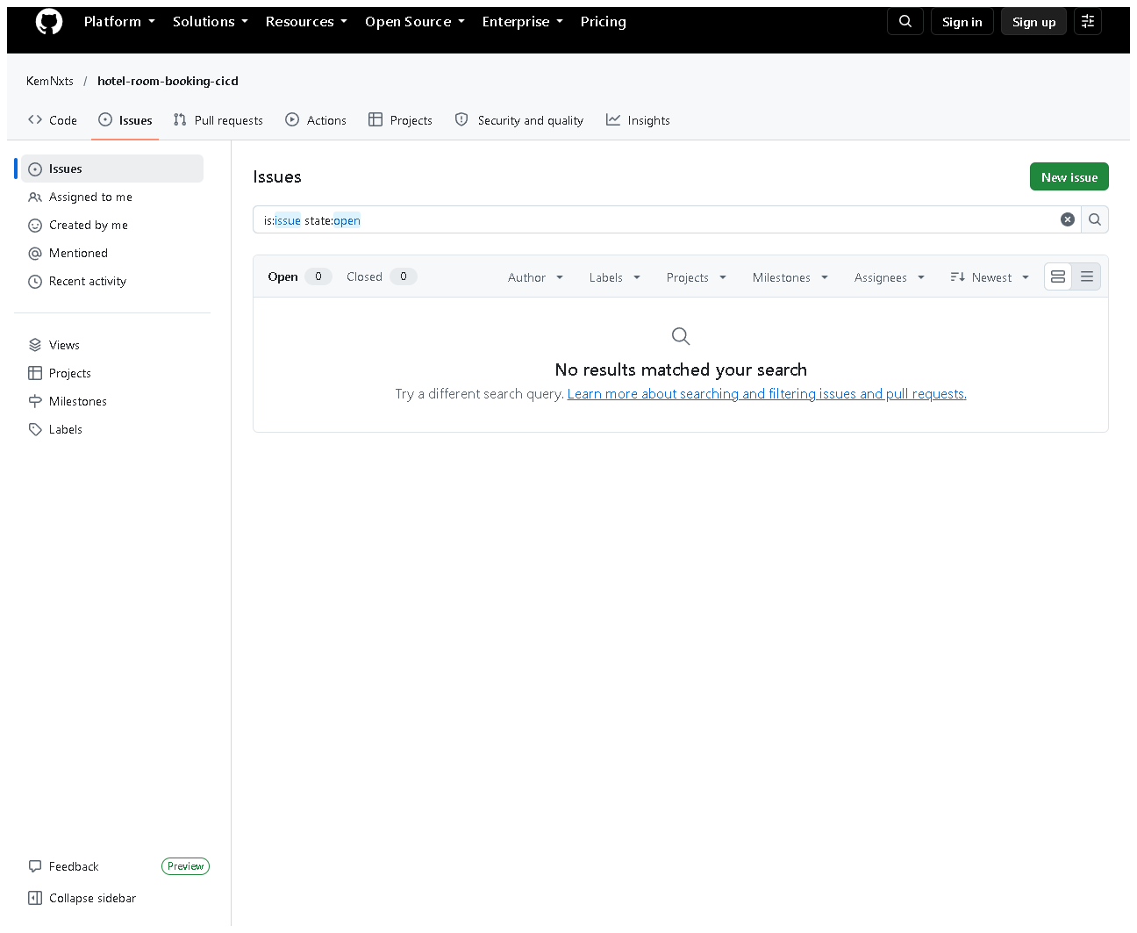
Figure 2.2 - The repository's Issues page (all states) shows no issues (captured 2026-10-20).
What to notice: zero open and zero closed issues.
Why it matters: this honestly shows the remaining step; the backlog is
local (in the document), not yet on GitHub Issues.

E. How to demonstrate this task to the professor (about 3 minutes)
Before the demo: open docs/02-agile-plan.md (VS Code preview with
Ctrl+Shift+V, or on GitHub - GitHub draws the diagram).
- User stories. Say: "Each requirement is a user story with
acceptance criteria, and next to each criterion I wrote the automated test
that checks it."
- Prove one story live (PowerShell, project folder):Expected: 7 passed, 31 deselected (the cancellation tests, e.g. test_cannot_cancel_twice).
Say: "US5 says a booking cannot be cancelled twice - this test proves it."
.venv\Scripts\python -m pytest -q tests/unit/test_booking_service.py -k "cancel"
- Backlog and Kanban board. Say: "The 15 course tasks are backlog items
HB-01 to HB-15. The board shows their final state."
- Definition of Done. Say: "An item is done only when tests pass, the
Jenkins pipeline is green and it is merged - the pipeline enforces most of this."
- Lifecycle diagram (bottom of the page on GitHub). Trace it with the
mouse: "Plan, code, build, test - if any test fails we stop - release,
deploy, operate, monitor, roll back if needed."
- Be honest about issues: open
https://github.com/KemNxts/hotel-room-booking-cicd/issues - "The backlog is
in the repository; creating GitHub issues for it is the remaining step."
To complete the pending part (needs your GitHub login): on GitHub click
Issues -> New issue -> Feature request, create one issue per HB item (title
e.g. "HB-07 Jenkins job"), then edit the backlog table to show the issue
numbers and commit the change.

F. Expected screenshots for the final submission
- assets/task-02/github-doc-02-agile-plan.png - planning document incl. diagram - exists, captured 2026-10-20.
- assets/task-02/github-issues-empty.png - honest state of GitHub issues - exists, captured 2026-10-20.
- assets/task-02/github-issues-created.png - issues HB-01..HB-15 on GitHub - requires manual capture after the issues are created (open the Issues page, all states, screenshot).

G. Probable viva questions and answers
- What is a user story? A short requirement from the user's viewpoint:
"As a I want so that ."
- What are acceptance criteria? The conditions that make a story
accepted. Ours are checked automatically by named tests.
- Difference between a backlog and a sprint? The backlog is the whole
ordered to-do list; a sprint is a short time-box in which a chosen part of
the backlog is completed.
- Kanban or Scrum - which did you use? A light mix: a Kanban board to
show status and three short Scrum-style sprints with a review each.
- What is your Definition of Done? Branch + conventional commits, tests,
flake8 clean, all tests pass, Jenkins green, --no-ff merge with the PR
checklist, docs updated, no secrets.
- How is the DoD enforced, not just written? Jenkins runs flake8 and all
90 tests; deployment happens only if they pass (shown by failed build #2).
- (Project-specific) Where are your GitHub issues? None exist yet
(0 issues on GitHub). The backlog is in docs/02-agile-plan.md; creating
the issues needs my GitHub account and is the remaining step.
- (Project-specific) Which story covers rollback and how is it proven?
US9; proven by deploy/ansible/rollback.yml runs where /health showed
1.0.0 again and 5/5 Selenium journeys passed.
- What does the DevOps lifecycle diagram show that a simple list does not?
The feedback loops: failed tests go back to Code, and problems in
operation lead to rollback and new planning.
- What happened in your sprint retrospective? Two features built in
parallel (two footers) caused a merge conflict; the lesson was to agree on
shared files earlier. The conflict and its resolution are documented.

H. Common mistakes and troubleshooting
Symptom | Cause | Inspect | Fix | Confirm
Diagram shows as code text in VS Code | VS Code preview does not draw Mermaid by default | docs/02-agile-plan.md | show it on GitHub, or install a Mermaid preview extension | the boxes and arrows appear
Examiner asks to see the issues | Issues not created | GitHub Issues page | explain the pending step; create them if allowed | Issues page lists HB items
pytest -k cancel selects 0 tests | wrong folder/typo | command | run from the project folder exactly as written | "passed" count > 0
Story says a test name that no longer exists | test renamed | grep -rn "def test_" tests | update the story table | names match

I. Quick revision notes
Five key points
- 9 user stories; every acceptance criterion maps to an automated test.
- Backlog HB-01..HB-15 = the 15 course tasks.
- 3 sprints: foundation, automation, operations & release.
- Definition of Done is enforced by Jenkins (lint + 90 tests before deploy).
- GitHub issues are not created yet - pending.
30-60 second explanation
"I planned the work with nine user stories, for example 'as a guest I want to
cancel a booking'. Each has acceptance criteria, and each criterion is checked
by a named automated test. The 15 course tasks form the backlog HB-01 to
HB-15, shown on a Kanban board and split into three sprints. Our Definition of
Done says tests pass, Jenkins is green and the work is merged - and Jenkins
enforces that. The DevOps diagram shows the loop from planning to monitoring.
The one missing piece is that the backlog isn't yet entered as GitHub issues."
Caveat: no GitHub issues exist; the board is a table in a document.
Readiness checklist
- â˜ I can explain story vs. acceptance criterion vs. test.
- â˜ I can recite the Definition of Done.
- â˜ I can trace the lifecycle diagram including the failure loop.
- â˜ I can explain honestly why there are no GitHub issues.

