Task 3 - Requirements, Architecture and Technology Setup

A. Task title and objective
Task 3: Requirements, Architecture and Technology Setup
Objective: write down what the system must do (requirements), design how
its parts fit together (architecture), choose the technologies, set up the
development environment, and prove the booking rules work.
Professor's required deliverables
- SRS summary (Software Requirements Specification)
- Use-case diagram
- Application architecture diagram
- Database schema, relationships and data model
- API / route list
- Local development setup
- Technology choices with reasons
- Working registration, login, availability, request, confirmation, cancellation, status tracking
- Booking rules that block invalid dates, overlaps, unauthorised cancellation and inconsistent states
Current status: Implemented and verified. Re-checked 2026-10-20: the route
list was printed from the real app (Figure 3.2), 59 unit + 26 integration
tests passed, and the app started locally. Technology note: build and test use
Python tools (pip, pytest, flake8), not Maven - see section C.

B. Explanation for a complete beginner
An everyday picture. A restaurant has a waiter (takes your order), a chef
(decides how to cook it, following the recipes) and a store-room keeper
(fetches ingredients). Each does one job. Our application is organised the
same way.
Requirements / SRS - a list of what the system must do (functional: "a
guest can cancel a booking") and how well (non-functional: "no double
bookings even with simultaneous requests", "passwords never stored in plain
text").
Use case - one goal a user achieves with the system ("Request booking").
A use-case diagram shows the users and their goals.
Architecture - how the code is split into parts and how they talk.
Layers in this project
Layer | Folder | Restaurant role | Job
Controller | app/controllers/ | waiter | reads the web request, calls a service, returns a page
Service | app/services/ | chef | business rules (dates valid? room free? may this user cancel?)
DAO (Data Access Object) | app/dao/ | store-room keeper | the only place with SQL
Model | app/models.py | the plate | plain data objects (User, Room, Booking)

Why layers? Each part can be changed and tested alone. The rules can be
tested without a browser; the database could be replaced by changing only the DAOs.
Flask - a small Python web framework: it maps a URL like /bookings to a
Python function. Route - that mapping. SQLite - a database stored in a
single file, built into Python. Schema - the definition of the tables.
Virtual environment (venv) - a private folder of Python packages for this
project, so versions don't clash with other projects. pip installs the
pinned versions listed in requirements.txt.

C. What was actually implemented
Documents: docs/03-srs-architecture.md -
11 functional requirements (FR1-FR11), 7 non-functional (NFR1-NFR7), a
use-case diagram, architecture diagram, ER (Entity-Relationship) diagram,
booking state machine, route list and technology table.
Route list (printed from the running code, Figure 3.2)
Method | URL | Controller function | Purpose
GET | /rooms?check_in=&check_out= | rooms.list_rooms | rooms / availability
GET, POST | /register, /login | auth.register, auth.login | accounts
POST | /logout | auth.logout | log out
GET / POST | /bookings | my_bookings / create | list / request
GET | /bookings/<id> | detail | one booking (owner only)
POST | /bookings/<id>/confirm, /cancel | confirm, cancel | change status
GET | /health | health | status + version for Docker/Jenkins/Ansible

How one request travels (example: "Book room 201")
- Browser sends POST /bookings with room_id, check_in, check_out, csrf_token.
- app/controllers/csrf.py check_csrf() (line 25) rejects the request with HTTP 400 if the token is missing or wrong.
- app/controllers/booking_routes.py create() (line 22) calls the service.
- app/services/booking_service.py request_booking() (line 48) runs validate_stay() (line 19): valid dates, check-in not in the past, check-out after check-in, at most 30 nights.
- It calls BookingDao.create_if_room_free() in app/dao/booking_dao.py (line 34), which inside a locked transaction checks for an overlap and inserts a PENDING row.
- SQLite triggers in app/schema.sql (lines 42 and 56) refuse any overlapping active booking even if code above had a bug.
- The controller redirects to /bookings/<id>, which shows status PENDING.
The core rule - overlap - in SQL (app/dao/booking_dao.py, from line 9;
the # explanations are added here for the reader and are not in the file):
_OVERLAP_SQL = """
check_in < :check_out # existing stay starts before the new one ends
AND check_out > :check_in # and ends after the new one starts
AND status IN ('PENDING', 'CONFIRMED') # cancelled bookings never block
"""
A guest may check in on the day the previous guest checks out (strict <).
Database (app/schema.sql) - tables users, rooms (6 seeded rooms:
101, 102 Single; 201, 202 Double; 301 Deluxe; 401 Suite), bookings
(foreign keys to both). Constraints: CHECK (check_out > check_in), CHECK (status IN ('PENDING','CONFIRMED','CANCELLED')), two overlap triggers.
Booking rules and the tests that prove them
Rule | Test
invalid / past dates, > 30 nights | TestValidateStay::test_invalid_stays_are_rejected
no overlap for one room | test_overlapping_booking_is_rejected
concurrency: 10 simultaneous requests -> 1 booking | test_simultaneous_requests_create_only_one_booking
only the owner can view/confirm/cancel | test_other_users_cannot_see_confirm_or_cancel_my_booking
no cancel twice / no confirm of cancelled | test_cannot_cancel_twice, test_cannot_confirm_a_cancelled_booking
database blocks overlaps directly | test_trigger_rejects_overlapping_insert

Technology choices and the Maven/Tomcat question
Brief mentions (Java world) | This project (Python) | Same purpose
Maven/Gradle/Ant pom.xml | requirements.txt + pip | pinned dependencies
mvn compile | python -m compileall + flake8 | catch syntax/style errors
mvn test (JUnit) | pytest with JUnit-XML reports | run tests, report to Jenkins
WAR file | source tarball + Docker images | deployable artifact
Tomcat | Gunicorn behind Nginx | serve the app

pip and pytest are not Maven and are not presented as Maven. Whether the
Python equivalents satisfy the brief must be confirmed with the professor.
Local setup (Windows PowerShell)
python -m venv .venv
.venv\Scripts\pip install -r requirements-dev.txt
.venv\Scripts\python -m flask --app wsgi run --port 5001 # 5000 is taken by the local Docker registry

D. Screenshots and evidence
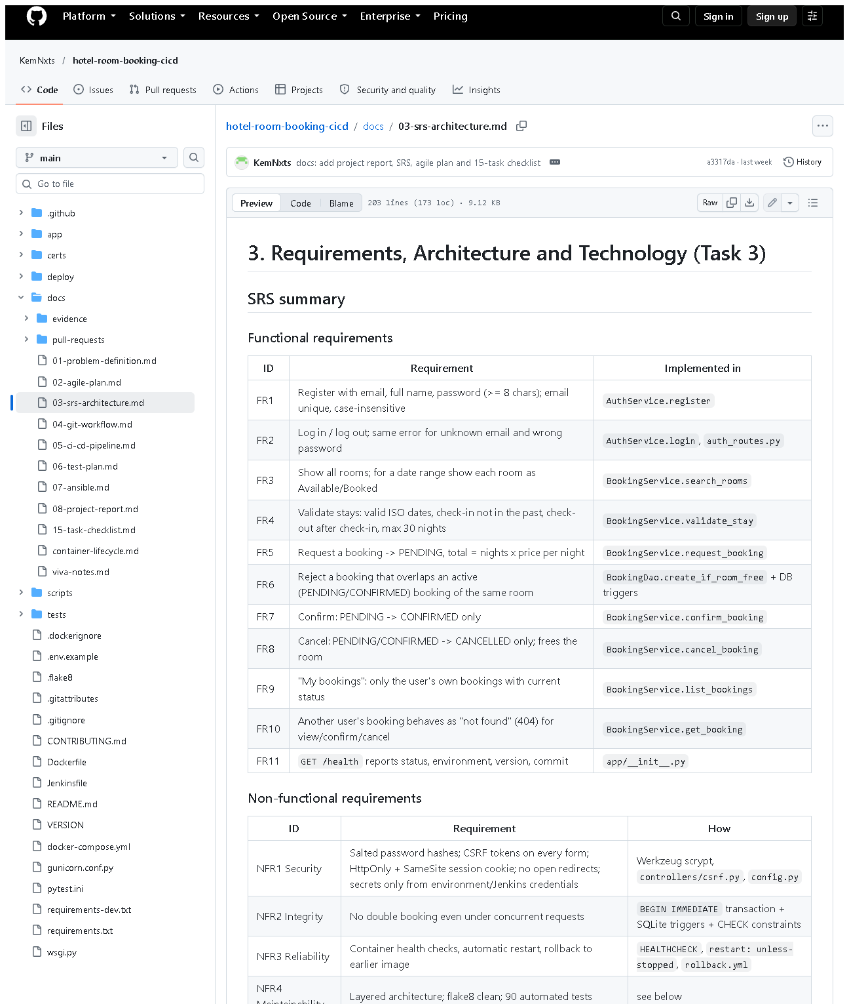 (part 1 of 4)
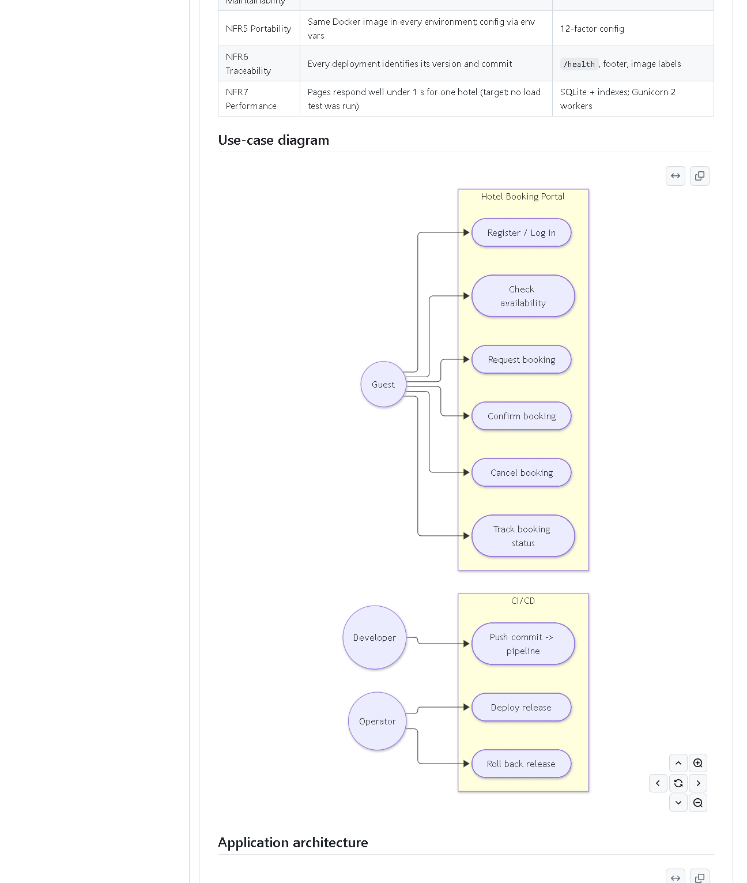 (part 2 of 4)
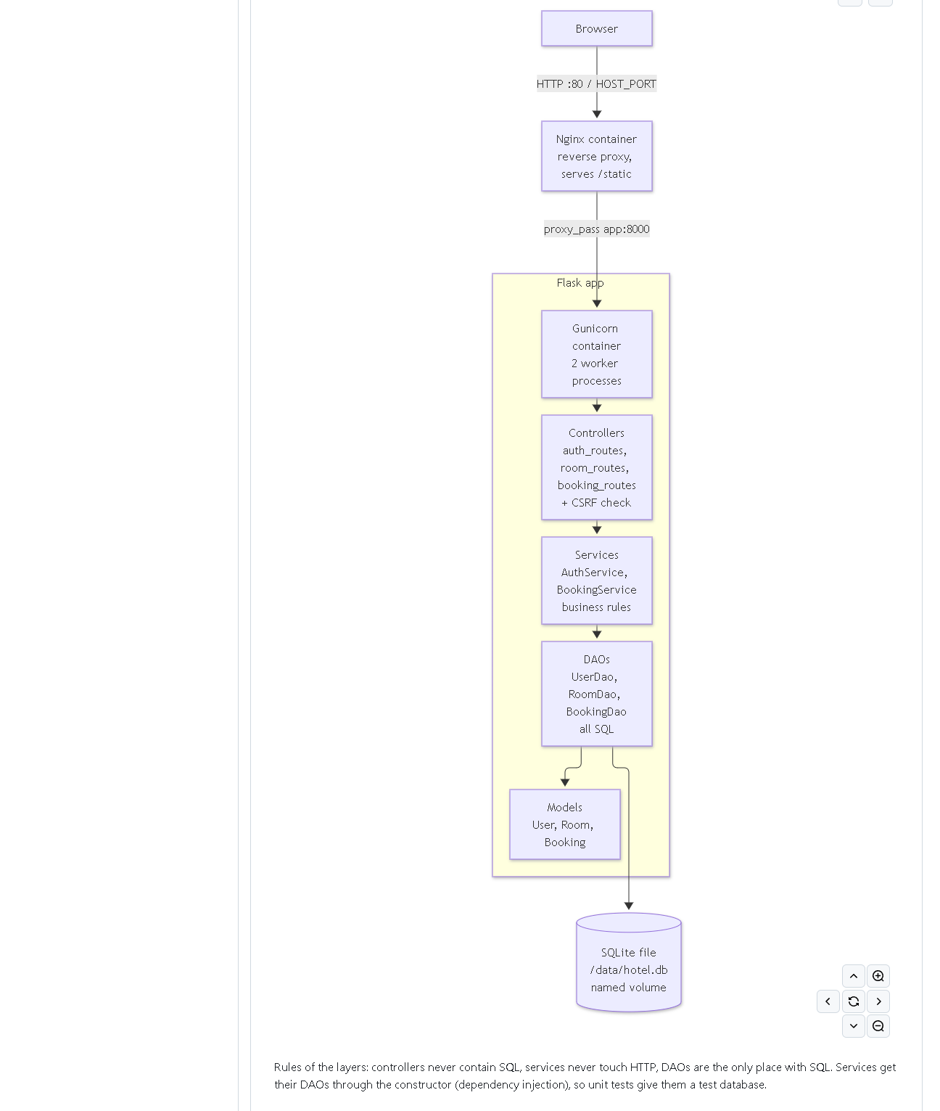 (part 3 of 4)
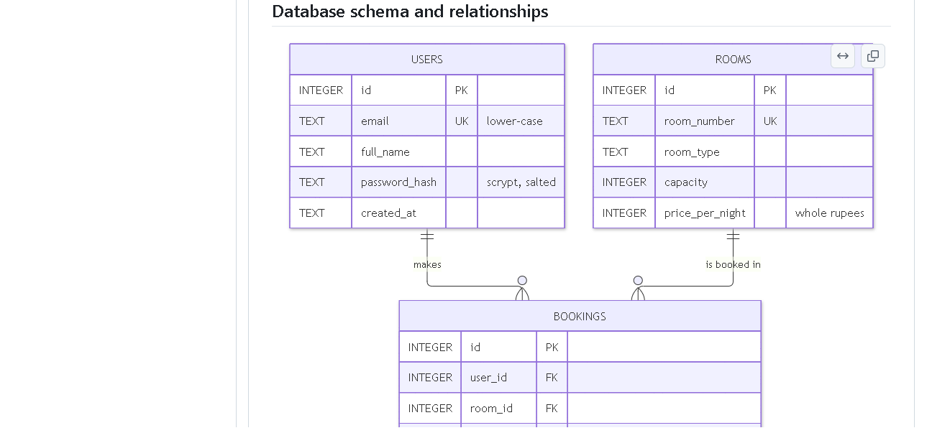 (part 4 of 4)
Figure 3.1 - docs/03-srs-architecture.md on GitHub with diagrams rendered (captured 2026-10-20).
Notice: the FR/NFR tables, the use-case diagram, the layered architecture
diagram, the ER diagram and the booking state machine.
Proves: SRS, use cases, architecture, data model and route list exist.
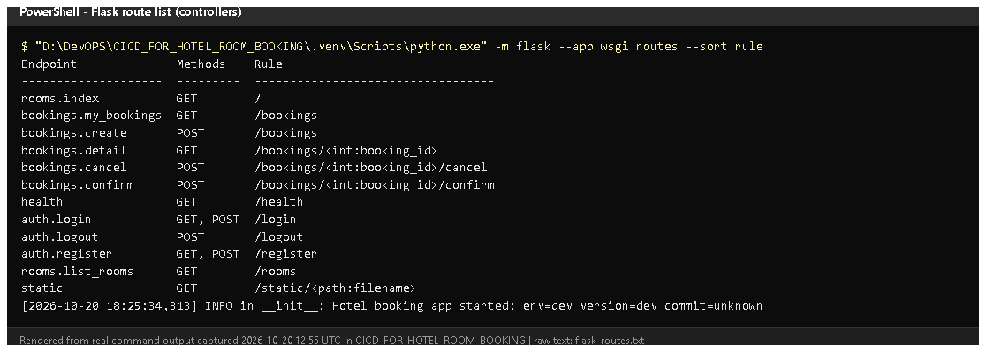
Figure 3.2 - python -m flask --app wsgi routes run on 2026-10-20 (rendered from real output).
Notice: every URL with its HTTP method and controller function.
Proves: the route list in the document matches the real code.
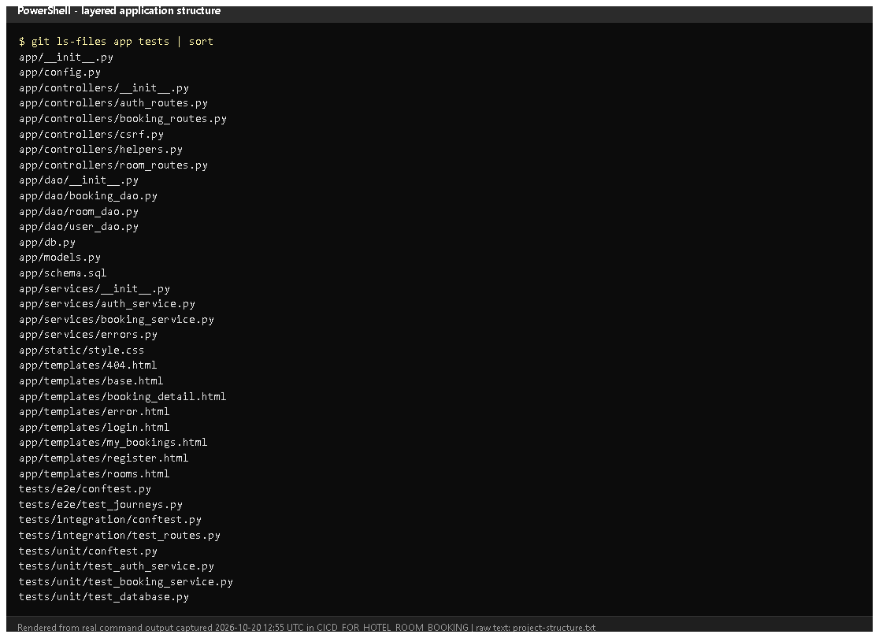
Figure 3.3 - Files under app/ and tests/ (from git ls-files, rendered from real output).
Notice: separate controllers/, services/, dao/ folders and models.py.
Proves: the layered architecture is real, not only drawn.
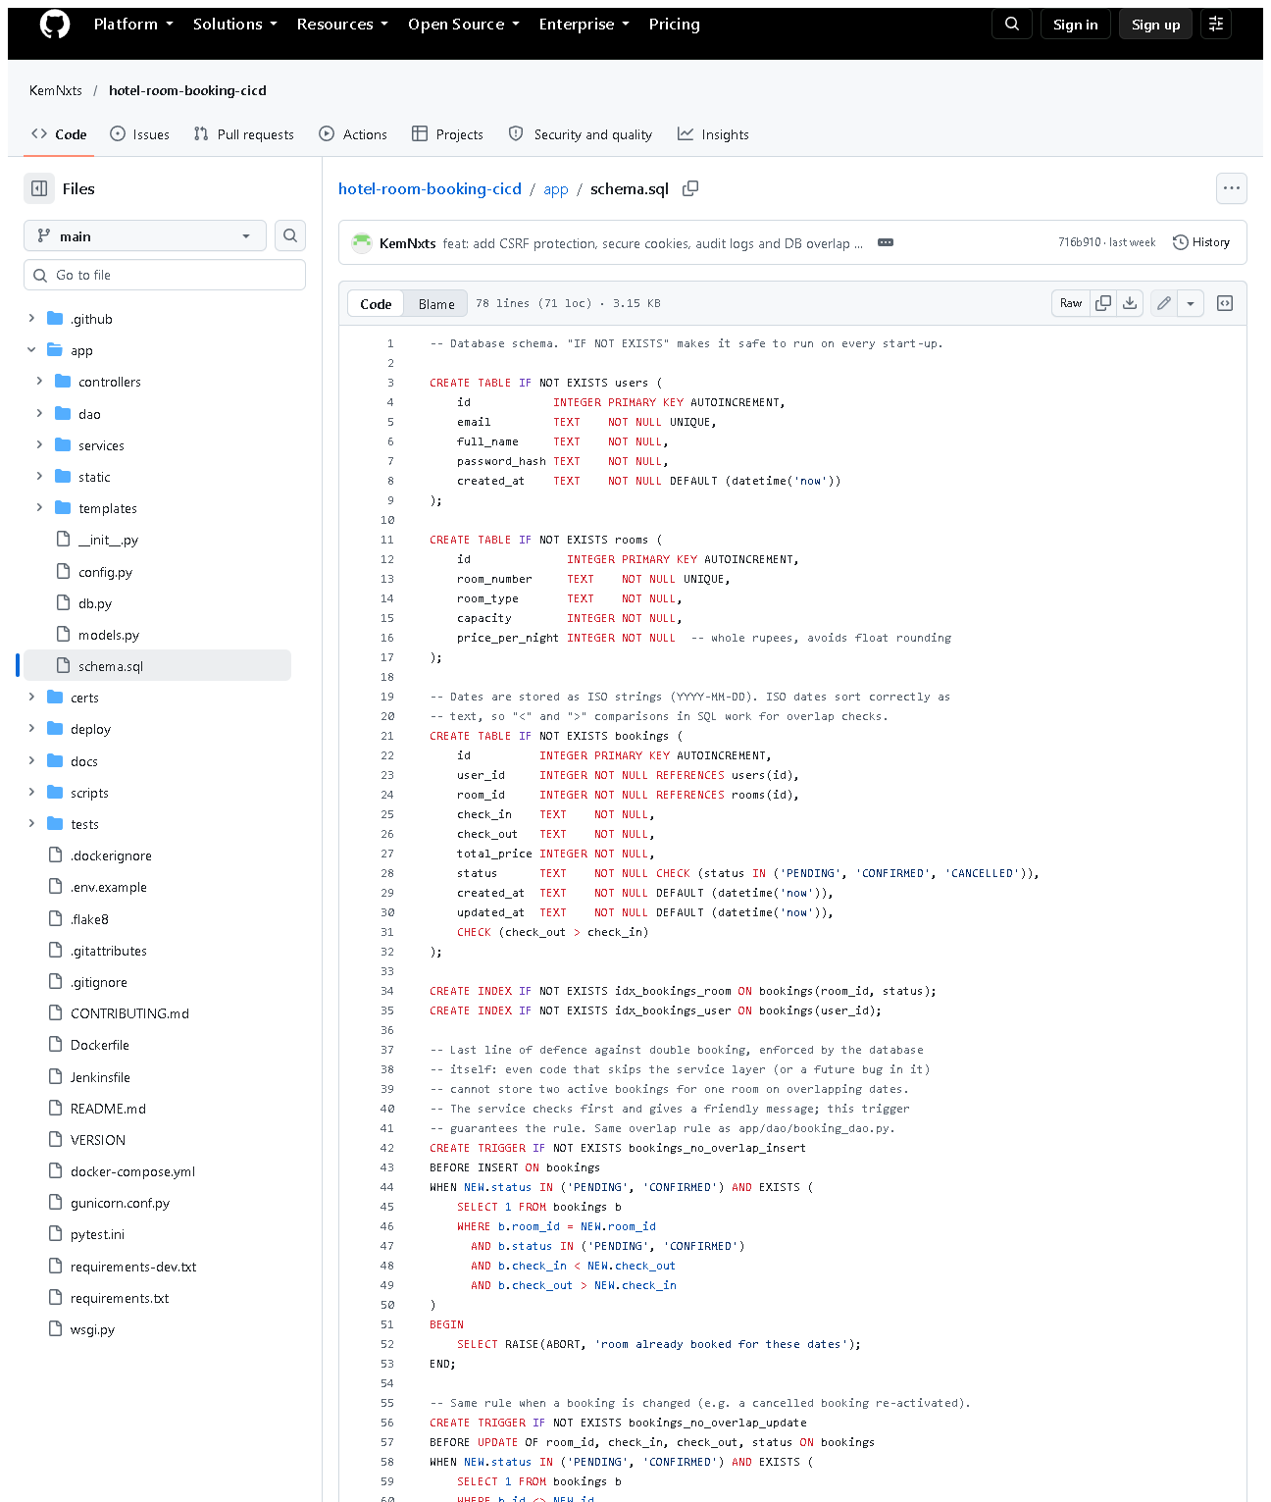 (part 1 of 2)
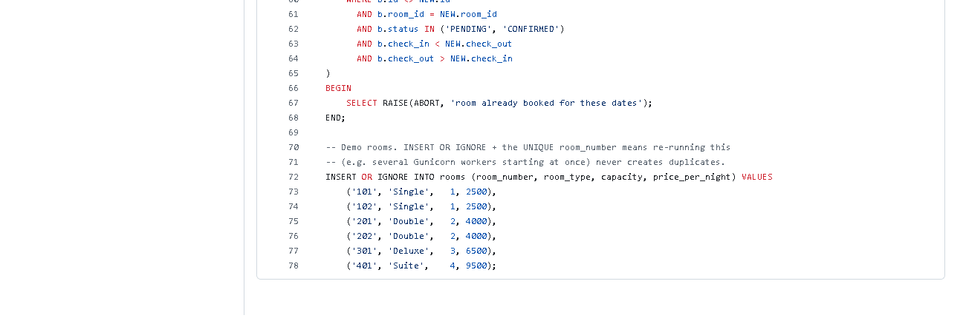 (part 2 of 2)
Figure 3.4 - app/schema.sql on GitHub. Notice: three tables, CHECK
constraints, the two bookings_no_overlap_* triggers, the six seeded rooms.
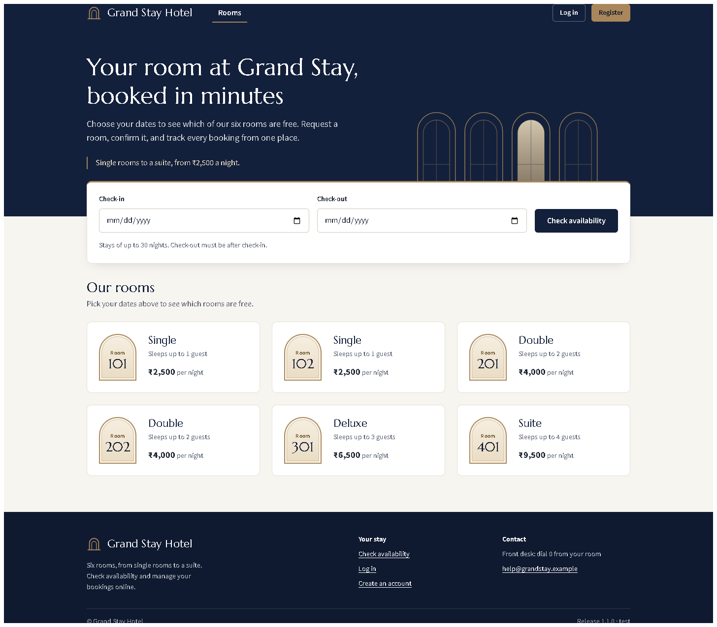
Figure 3.5 - Rooms page served by the local development server (redesigned
UI from the working tree, captured 2026-10-20). Notice: the six seeded rooms with type, capacity and price.

E. How to demonstrate this task to the professor (about 4 minutes)
Before the demo: PowerShell open in D:\DevOPS\CICD_FOR_HOTEL_ROOM_BOOKING; VS Code open on the same folder.
- Show the document docs/03-srs-architecture.md (or on GitHub to see diagrams).
Say: "These are the functional and non-functional requirements, the use cases and the architecture."
- Start the application (PowerShell):Expected: Running on http://127.0.0.1:5001. Leave this window open.
.venv\Scripts\python -m flask --app wsgi run --port 5001
- Open http://127.0.0.1:5001 in the browser - the six rooms appear.
Open http://127.0.0.1:5001/health - {"status": "ok", ...}.
- Show the route list in a second PowerShell window:
.venv\Scripts\python -m flask --app wsgi routes
- Trace one request in VS Code: open app/controllers/booking_routes.py
(create), then app/services/booking_service.py (request_booking), then
app/dao/booking_dao.py (create_if_room_free). Say: "Controller,
service, DAO - only the DAO has SQL."
- Prove the rules:Expected: 85 passed. Point at the overlap and concurrency tests.
.venv\Scripts\python -m pytest -q tests/unit tests/integration
- Stop the server with Ctrl+C in its window.
Recovery: "An attempt was made to access a socket..." means the port is
taken - use another port (--port 5002). "No module named flask" means the
venv is missing: python -m venv .venv and .venv\Scripts\pip install -r requirements-dev.txt.

F. Expected screenshots for the final submission
- assets/task-03/github-doc-03-srs-architecture.png - SRS + diagrams - exists, 2026-10-20.
- assets/task-03/flask-routes.png - real route list - exists, 2026-10-20.
- assets/task-03/project-structure.png - layered folders - exists, 2026-10-20.
- assets/task-03/github-file-app_schema.sql.png - schema - exists, 2026-10-20.
- assets/task-03/app-desktop-01-home.png - running app - exists, 2026-10-20.

G. Probable viva questions and answers
- What is an SRS? A Software Requirements Specification: what the system
must do (functional) and qualities it must have (non-functional).
- Explain your layers. Controllers handle HTTP, services hold business
rules, DAOs hold all SQL, models are plain data. Each only calls the layer below.
- Why separate services from controllers? Rules can be unit-tested
without a web request, and they are not duplicated in several routes.
- Why SQLite? Built into Python, zero setup, one file; enough for one
hotel. Limitation: one writer at a time and one server only.
- How do you prevent double bookings? Three layers: the service checks;
the DAO checks and inserts inside BEGIN IMMEDIATE (a locked transaction);
and database triggers refuse overlaps. A 10-thread test proves only one wins.
- (Project-specific) What does /health return and who uses it?
{"status","env","version","commit"}; used by the Docker HEALTHCHECK,
the Jenkins health-check stage and the Ansible playbook.
- (Project-specific) Why can't another user cancel my booking?
BookingService.get_booking checks the owner and raises "not found"
otherwise, so the route returns 404 - proven by an integration test.
- Is pip your Maven? No. pip installs Python packages and pytest runs
tests; they do the same jobs as Maven's dependency and test phases, but they
are different tools. I need the professor's confirmation that this is acceptable.
- Why Gunicorn and Nginx instead of Tomcat? Tomcat runs Java servlets.
Python apps run on a WSGI server (Gunicorn); Nginx is the public entry
point and serves static files.
- What is the booking state machine? PENDING -> CONFIRMED, PENDING or
CONFIRMED -> CANCELLED; nothing else. Status changes use
UPDATE ... WHERE status IN (allowed) so check and change happen atomically.
- What is CSRF and how do you stop it? Cross-Site Request Forgery: another
site making your browser submit our forms. Every form has a secret token
stored in the session; POSTs without it get HTTP 400.

H. Common mistakes and troubleshooting
Symptom | Cause | Inspect | Fix | Confirm
python wsgi.py fails: "access a socket ... forbidden" | port 5000 used by the local Docker registry | Get-NetTCPConnection -LocalPort 5000 | run with --port 5001 | page opens on :5001
HTTP 400 "Your form has expired" | CSRF token missing/old | browser tab opened before a restart | reload the page and resubmit | form works
RuntimeError: SECRET_KEY must be set | started with APP_ENV=prod without a key | environment variables | set SECRET_KEY, or use dev mode | app starts
Data from earlier tests appears | local DB instance/hotel.db | instance/ folder | delete instance/hotel.db to reset (local dev only) | 6 rooms, no bookings

I. Quick revision notes
Five key points
- 11 functional + 7 non-functional requirements in docs/03-srs-architecture.md.
- Layers: controllers -> services -> DAOs -> SQLite; models carry data.
- Overlap rule check_in < new_out AND check_out > new_in, enforced three times.
- Routes printed from real code; /health is used by Docker, Jenkins, Ansible.
- Python tooling (pip/pytest/flake8, Gunicorn/Nginx) - not Maven/Tomcat; confirm with the professor.
30-60 second explanation
"The requirements are in an SRS with use cases, architecture and data-model
diagrams. The Flask app has layers: controllers handle web requests, services
apply booking rules, DAOs contain all SQL, and SQLite stores users, rooms and
bookings. A booking request passes the CSRF check, date validation, and an
overlap check inside a locked transaction, and database triggers block any
overlap that slips through. Ninety automated tests prove these rules."
Caveat: Python tools are used instead of Maven/Tomcat - needs professor approval.
Readiness checklist
- â˜ I can start the app on port 5001 and open /health.
- â˜ I can trace a booking request through the three layers.
- â˜ I can explain the overlap rule and the three protections.
- â˜ I can explain the Maven/Tomcat difference honestly.

