Task 4 - Git and GitHub Repository Initialization

A. Task title and objective
Task 4: Git and GitHub Repository Initialization
Objective: put the project under version control from day one, with a
clean structure, rules for branches and commits, templates for issues and
pull requests, and a remote copy on GitHub.
Professor's required deliverables
- README
- .gitignore (and .gitattributes)
- Folder structure
- Issue and pull-request templates
- Branch naming policy
- Meaningful commit history
- Initial source baseline (skeleton commit)
Current status: Implemented and verified. Checked 2026-10-20 with Git
commands (Figures 4.1-4.3) and the public GitHub repository (Figures 4.4-4.6):
19 branches and both release tags are on GitHub.
One note: the branch policy is written in CONTRIBUTING.md; GitHub
"branch protection rules" (settings that technically block direct pushes)
were not configured - that needs the repository owner's login.

B. Explanation for a complete beginner
An everyday picture. Git is like the "version history" of a Google Doc,
but for a whole folder of files, and much more precise: every saved version
has a name, an author, a date and a message saying why it changed.
Term | Plain meaning | In this project
Repository (repo) | the project folder plus its full history | D:\DevOPS\CICD_FOR_HOTEL_ROOM_BOOKING
Commit | one saved snapshot with a message | e.g. 541dad5 chore: initialise repository skeleton
Branch | a separate line of work, so experiments don't disturb stable code | main, develop, feature/*
Merge | joining a branch's work into another branch | features merged into develop
Tag | a permanent name for one commit, e.g. a release | v1.0.0, v1.1.0
Remote | a copy of the repo on a server | origin = GitHub
Push / pull | send commits to / fetch commits from the remote | git push origin develop
.gitignore | list of files Git must never save | .env (secrets), .venv, *.db
.gitattributes | rules for how files are stored, e.g. line endings | LF line endings in the repo

Git vs GitHub. Git is the tool on your computer that records history.
GitHub is a website that hosts a copy of a Git repository and adds
collaboration features (issues, pull requests, web view). You can use Git
without GitHub, but not the other way round.
Why it matters for DevOps: Jenkins builds whatever is committed, so Git is
the starting point of the whole pipeline - and every deployment can be traced
back to one commit.

C. What was actually implemented
Repository files
Deliverable | File | Content
README | README.md | features, stack, layout, run/test/Docker/Jenkins/Ansible instructions
Ignore rules | .gitignore | Python caches, .venv/, instance/, *.db, reports/, .env, deploy/ansible/credentials/, *.pem, *.key, certs/*.crt
Line endings | .gitattributes | * text=auto eol=lf - the same line endings on Windows and Linux (needed for scripts run in Linux containers); *.bat/*.ps1 keep Windows CRLF; *.png/*.jpg are binary
Issue templates | .github/ISSUE_TEMPLATE/bug_report.md, feature_request.md | forms for bugs and features
PR template | .github/pull_request_template.md | author + reviewer checklists
Branch & commit rules | CONTRIBUTING.md | main / develop / feature/* / fix/* / experiment/*, Conventional Commits (feat:, fix:, test:, ci:, docs: ...)

Folder structure - app/ (controllers, services, dao, templates, static),
tests/ (unit, integration, e2e), deploy/ (nginx, jenkins, ansible),
docs/, scripts/, plus Dockerfile, docker-compose.yml, Jenkinsfile.
Initial baseline. The first commit 541dad5 chore: initialise repository skeleton (2026-10-11) added exactly the skeleton: .gitattributes, the two
issue templates, the PR template, .gitignore, CONTRIBUTING.md, README.md
and empty deploy/ansible, tests/e2e, tests/unit folders (Figure 4.2).
Branches (20 local) - main (releases), develop (integration), 13
feature/* (including the unpushed feature/ui-redesign), fix/jenkins-stale-reports,
experiment/defect-demo and -2, docs/final-build-record, docs/history-rewrite.
Tags - v1.0.0 -> 224de14, v1.1.0 -> ce1726d (annotated tags with a message).
Remote - origin = https://github.com/KemNxts/hotel-room-booking-cicd
(public). Pushed on 2026-10-12. GitHub shows 19 branches and both tags.
Commit messages follow the convention, e.g. from git log:
feat: add CSRF protection, ..., test: add route-level integration tests ...,
ci: add lint, versioned images, ..., fix: stop Jenkins publishing stale test reports ....
History rewrite (be ready to explain). On 2026-10-12, before pushing,
commit messages were edited to remove a co-author line. Contents stayed the
same but all commit IDs changed; old evidence shows the old IDs. Mapping:
docs/evidence/git/commit-id-map.md.

D. Screenshots and evidence
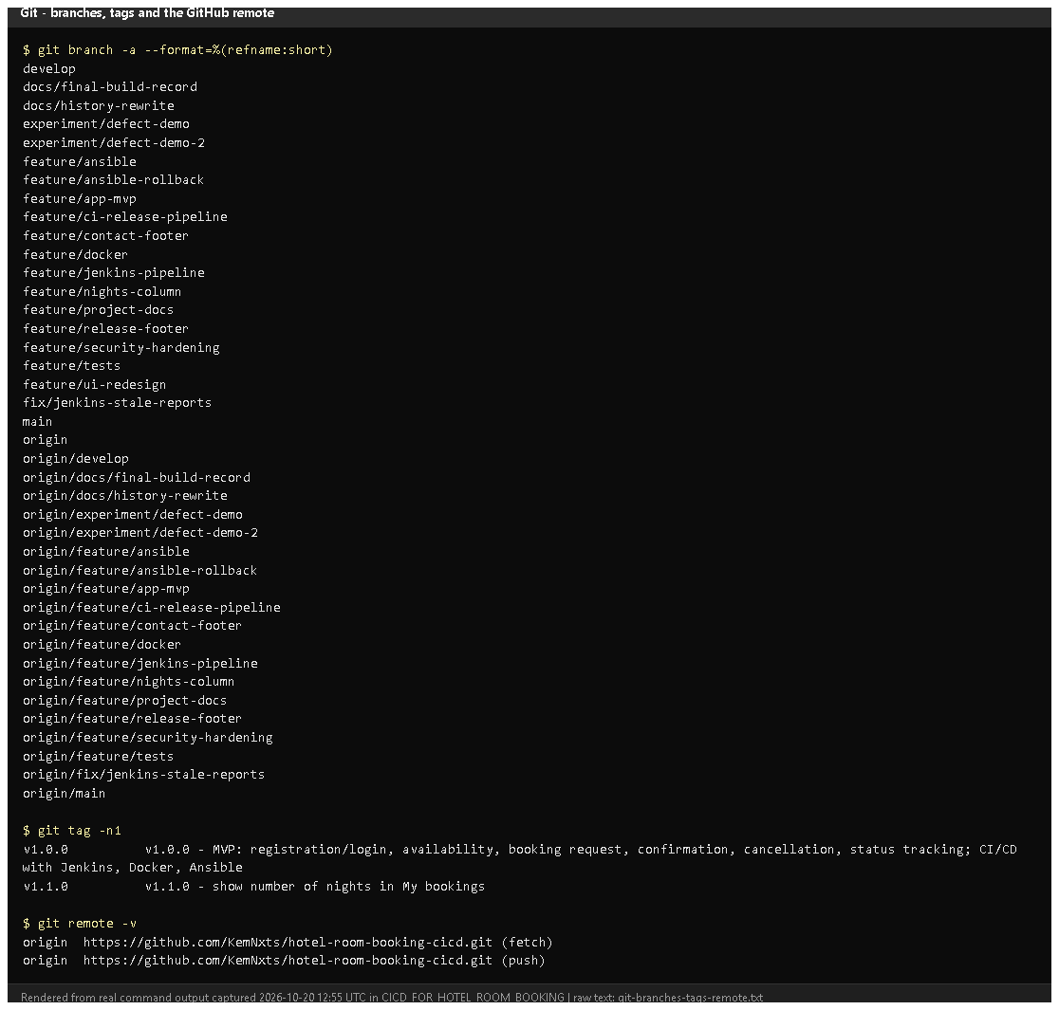
Figure 4.1 - git branch -a, git tag -n1, git remote -v (rendered from real output, 2026-10-20).
Notice: local and origin/... branches, the two release tags with messages, and the GitHub remote.
Proves: branching model, tags and remote exist.
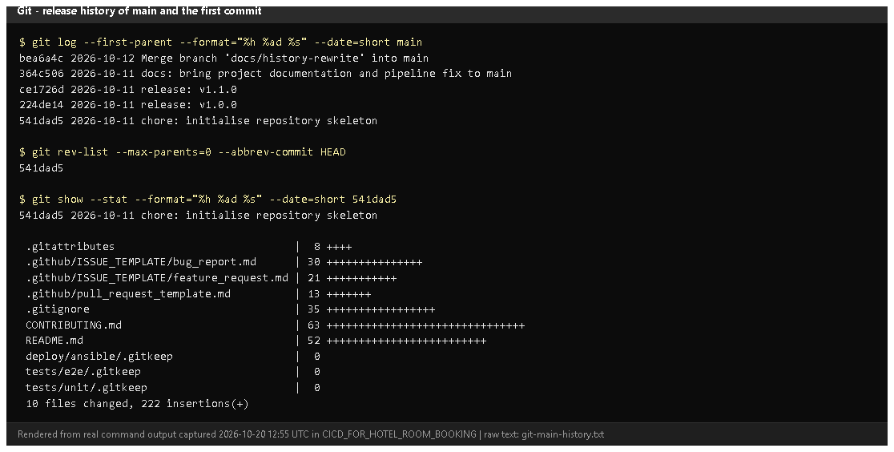
Figure 4.2 - Main-branch history and the skeleton commit 541dad5 with its files (rendered from real output).
Notice: main contains only the skeleton and the release merges; the
first commit added the README, ignore rules and templates.
Proves: an initial source baseline and meaningful history.
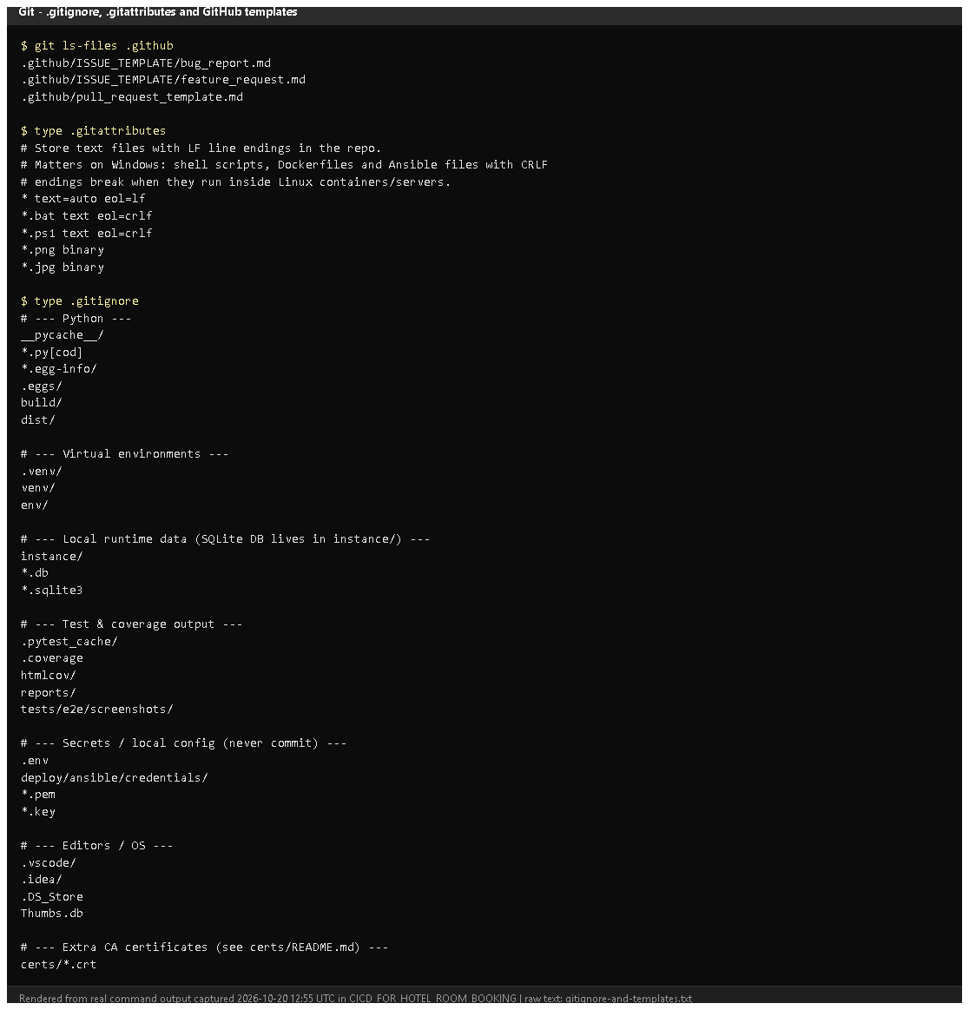
Figure 4.3 - .github templates, .gitattributes and .gitignore (rendered from real output).
Notice: .env, credentials, keys and certificates are ignored.
Proves: secrets and generated files are kept out of Git.
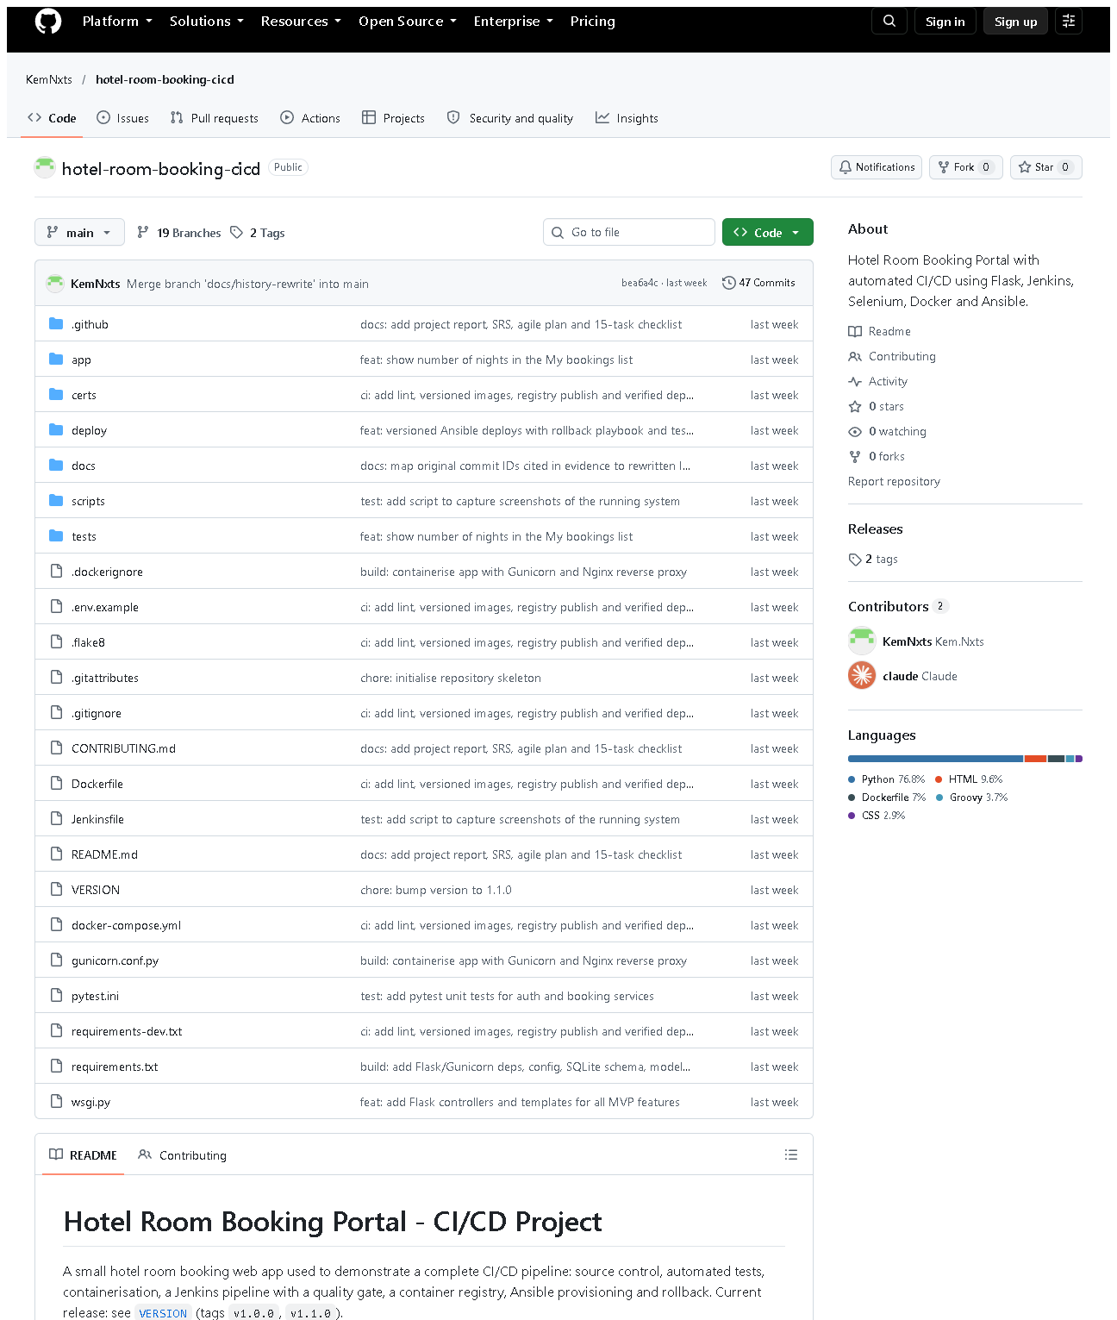 (part 1 of 3)
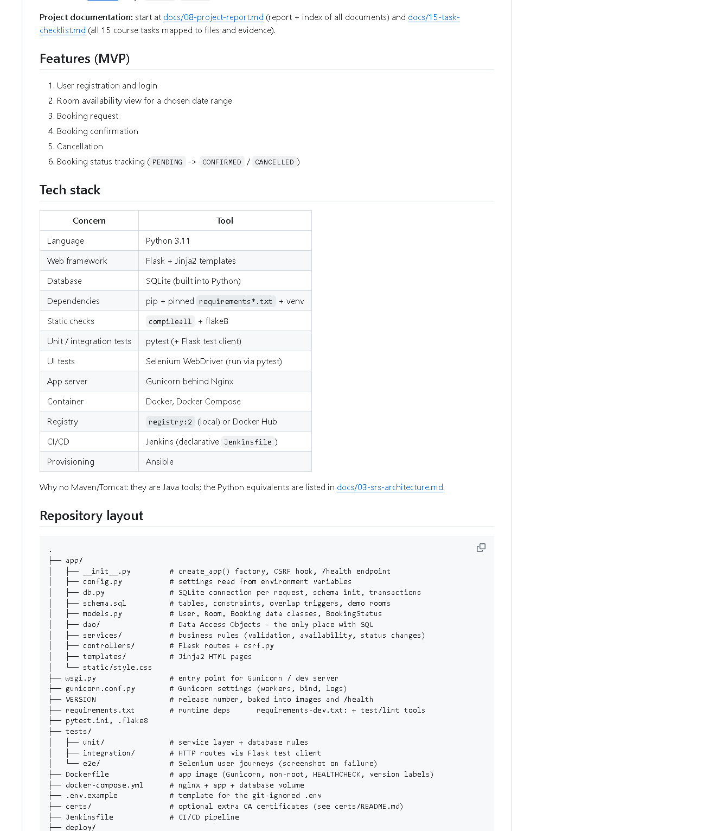 (part 2 of 3)
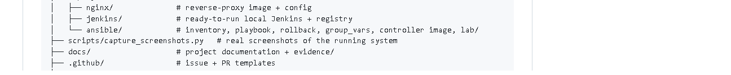 (part 3 of 3)
Figure 4.4 - The public GitHub repository home page (captured 2026-10-20).
Notice: the folder structure, README rendered below, branch/tag counts.
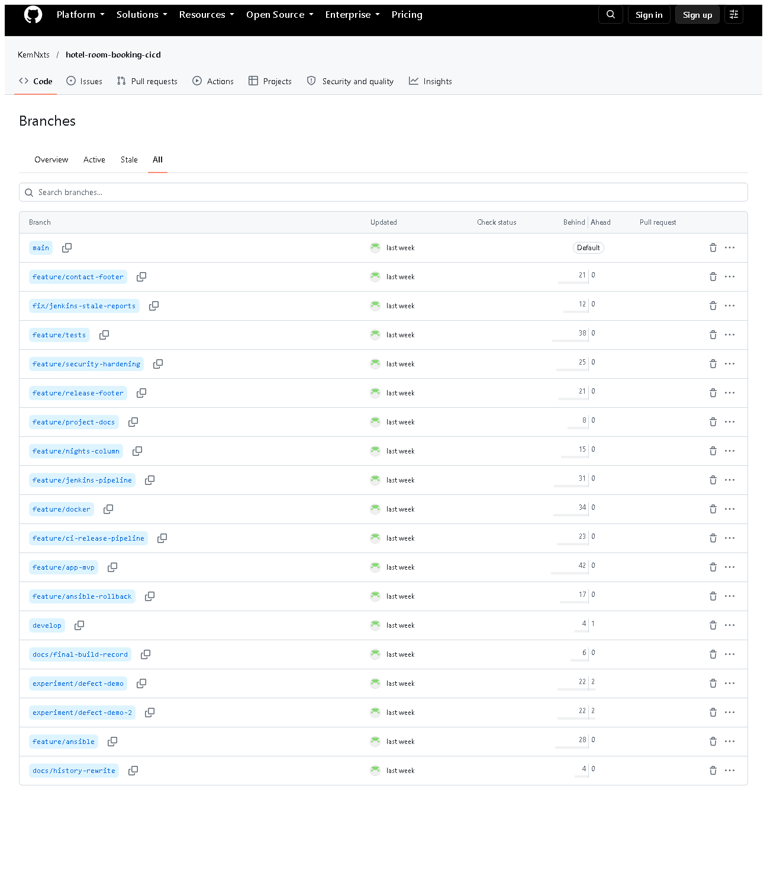
Figure 4.5 - All branches on GitHub. Notice: main, develop, feature/*, fix/*, experiment/*.
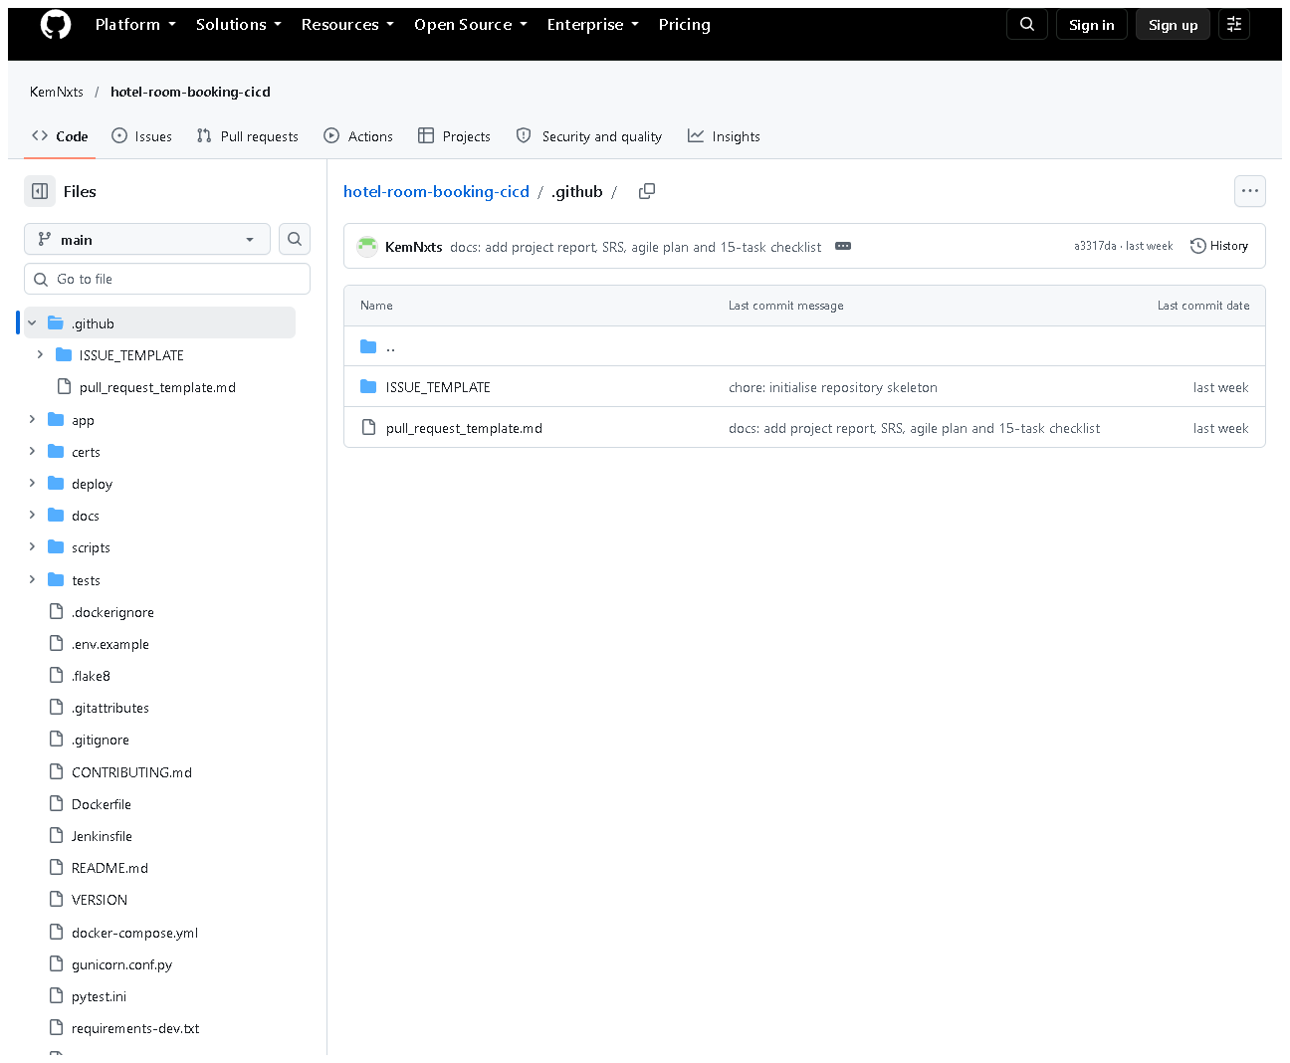
Figure 4.6 - .github/ on GitHub: ISSUE_TEMPLATE/ and pull_request_template.md.

E. How to demonstrate this task to the professor (about 3 minutes)
Before the demo: PowerShell in D:\DevOPS\CICD_FOR_HOTEL_ROOM_BOOKING; browser tab with https://github.com/KemNxts/hotel-room-booking-cicd.
- Say: "This folder is a Git repository." (Today it shows the branch
feature/ui-redesign and uncommitted UI files - say they are work in progress.)
git status
- Say: "main holds releases, develop integrates features, each feature
had its own branch. The tags mark the releases. origin is GitHub."
git branch -a
git tag -n1
git remote -v
- Say: "Each commit has a type prefix like feat: or fix: and the merges show each feature branch."
git log --oneline --graph -15 develop
- Say: "The very first commit was the skeleton: README, ignore rules and templates."
git show --stat 541dad5
- Open .gitignore in VS Code - point to .env, credentials/, *.key.
- On GitHub: show the file list, the branches page, the tags page and .github/.
Recovery: if git log opens a pager that "hangs", press q. If GitHub
asks you to sign in, you are viewing the public page - no login is needed to read.

F. Expected screenshots for the final submission
- assets/task-04/git-branches-tags-remote.png - exists, 2026-10-20.
- assets/task-04/git-main-history.png - exists, 2026-10-20.
- assets/task-04/gitignore-and-templates.png - exists, 2026-10-20.
- assets/task-04/github-repository-home.png - exists, 2026-10-20.
- assets/task-04/github-branches.png - exists, 2026-10-20.
- assets/task-04/github-templates-folder.png - exists, 2026-10-20.
- assets/task-04/github-branch-protection.png - requires manual capture only if you configure branch protection (GitHub Settings -> Branches, needs your login).

G. Probable viva questions and answers
- Git vs GitHub? Git records history locally; GitHub hosts a copy online and adds issues, PRs and a web view.
- What is a commit? A saved snapshot of the files with an ID, author, date and message.
- Branch vs tag? A branch moves forward as you commit; a tag is fixed to one commit forever (we use tags for releases).
- Why .gitignore? To keep secrets (.env), local databases and generated files out of the repository.
- What does .gitattributes do here? Forces LF line endings so shell
scripts and configs work in Linux containers even when edited on Windows.
- Explain your branch policy. main = released code, develop =
integration, feature/<name> per change, fix/<name> for fixes,
experiment/<name> never merged. Features merge into develop with --no-ff.
- (Project-specific) What is in your first commit? 541dad5: README,
CONTRIBUTING, .gitignore, .gitattributes, issue and PR templates and empty folders.
- (Project-specific) Why do commit IDs in your evidence differ from GitHub?
Messages were edited once before publishing; IDs are hashes that include
the message, so all IDs changed. docs/evidence/git/commit-id-map.md maps them.
- What is a Conventional Commit? A message format type: summary, e.g.
fix: reject check-out before check-in, making history easy to read.
- Is your main branch protected? Only by policy in CONTRIBUTING.md;
GitHub protection rules were not configured (needs the owner's settings).
- Why have both main and develop? develop can be tested on
staging while main only receives releases that passed the pipeline.

H. Common mistakes and troubleshooting
Symptom | Cause | Inspect | Fix | Confirm
git log output does not end | pager waiting | terminal | press q, or add --no-pager | prompt returns
A secret file appears in git status | missing ignore rule | git check-ignore -v <file> | add a rule to .gitignore; never commit it | file no longer listed
git push rejected | remote has newer commits / no login | git status, git fetch | git pull first; sign in to GitHub | push succeeds
Line-ending warnings (CRLF/LF) | Windows editor | .gitattributes | harmless; Git normalises to LF | -
Old commit ID not found | history rewrite | docs/evidence/git/commit-id-map.md | use the current ID | git show <id> works

I. Quick revision notes
Five key points
- Git = local history; GitHub = hosted copy + collaboration.
- Skeleton commit 541dad5: README, ignore rules, templates, CONTRIBUTING.
- Branches: main / develop / feature / fix / experiment.
- Tags v1.0.0 and v1.1.0 mark releases.
- .gitignore keeps .env, credentials and databases out of Git.
30-60 second explanation
"The project is a Git repository published on GitHub. The first commit
created the skeleton - README, contributing rules, ignore rules and issue and
pull-request templates. We use main for releases, develop for
integration and one branch per feature, with conventional commit messages.
Releases are tagged v1.0.0 and v1.1.0. Secrets like .env are ignored and
never committed. Everything Jenkins builds starts from a commit here."
Caveat: branch protection is a written policy, not a GitHub setting.
Readiness checklist
- â˜ I can explain branch vs tag vs commit.
- â˜ I can run git branch -a, git tag -n1, git log --graph.
- â˜ I can open the repo on GitHub and show branches and tags.
- â˜ I can explain why evidence shows different commit IDs.

