Task 5 - Feature Development with Branching

A. Task title and objective
Task 5: Feature Development with Branching
Objective: develop a core feature on its own branch, with meaningful
commits and tests, have it reviewed through a pull request, and merge it into
develop.
Professor's required deliverables
- Feature branch
- Changes and tests on that branch
- Meaningful commits (add / commit / push / pull / log)
- Pull request with review comments / review checklist
- Merge into develop
Current status: Partially completed.
Part | Status
Feature branches, commits with tests, --no-ff merges into develop, pushed to GitHub | Implemented and verified (Git + GitHub, 2026-10-20)
Review checklist | Implemented - .github/pull_request_template.md; written review records in docs/pull-requests/
Real GitHub pull requests and review comments | Pending external action - GitHub shows 0 pull requests (Figure 5.4). Merges were done locally and then pushed.

No PR screenshots or review comments are shown here because none exist.

B. Explanation for a complete beginner
An everyday picture. Several authors write a book. Each writes a new
chapter in a separate copy, so a half-finished chapter never appears in the
printed book. When a chapter is ready, an editor reviews it, and only then is
it added to the master copy.
- Feature branch = the separate copy for one feature (feature/security-hardening).
- develop = the master copy where finished features meet.
- Pull request (PR) = on GitHub, a request "please review and merge my
branch", with a discussion page, review comments and a merge button.
- Code review = another person reads the changes before they are merged.
- Merge = adding the branch's commits into develop. With --no-ff
("no fast-forward") Git always creates a merge commit, so the history
clearly shows "this group of commits was one feature".
Basic commands
Command | Meaning
git checkout -b feature/x develop | create a new branch from develop and switch to it
git add <files> | choose which changes go into the next commit
git commit -m "feat: ..." | save a snapshot with a message
git push -u origin feature/x | upload the branch to GitHub
git pull | download and apply new commits from GitHub
git log --oneline --graph | view history as a graph
git merge --no-ff feature/x | merge into the current branch with a merge commit

C. What was actually implemented
Worked example: feature/security-hardening - real output of git log --graph --oneline -4 bdfc2fb (current commit IDs):
* bdfc2fb Merge branch 'feature/security-hardening' into develop
|\
| * fd3cb60 test: add route-level integration tests and database rule tests
| * 716b910 feat: add CSRF protection, secure cookies, audit logs and DB overlap guard
|/
* 475cecd Merge branch 'feature/ansible' into develop
- Branch created from develop: git checkout -b feature/security-hardening develop.
- Commit 1 716b910 feat: - CSRF protection (app/controllers/csrf.py),
secure cookie settings (app/config.py), audit logging, /health version,
overlap triggers in app/schema.sql.
- Commit 2 fd3cb60 test: - new tests/integration/test_routes.py and
tests/unit/test_database.py.
- Checked locally: flake8 clean, 87 tests passed at that time.
- Review record written with the PR template checklist:
docs/pull-requests/feature-security-hardening.md.
- Merged: git checkout develop then git merge --no-ff feature/security-hardening -> bdfc2fb.
- Pushed to GitHub on 2026-10-12 together with all other branches and the tags.
All feature work used this pattern - 12 feature/*, 1 fix/* and 2
docs/* branches merged into develop with merge commits (Figure 5.2), e.g.
feature/app-mvp, feature/tests, feature/docker, feature/jenkins-pipeline,
feature/ansible, feature/ci-release-pipeline, feature/nights-column.
Review checklist (.github/pull_request_template.md): author checklist
(branch name, commit convention, flake8, tests, Jenkins green, no secrets,
docs) and reviewer checklist (no SQL outside app/dao/, server-side
validation, ownership checks, CSRF token on new forms, tests would fail if broken).
Prepared PR descriptions (docs/pull-requests/): security hardening,
CI release pipeline, release footer (with the merge conflict), release v1.1.0.
These are written review records, not GitHub PRs.
Proof on GitHub that a feature branch was merged: the compare page
develop...feature/nights-column says "develop is up to date with all commits
from feature/nights-column" (Figure 5.3); comparing the branch with its starting
point shows its own commit and diff (Figure 5.5).

D. Screenshots and evidence
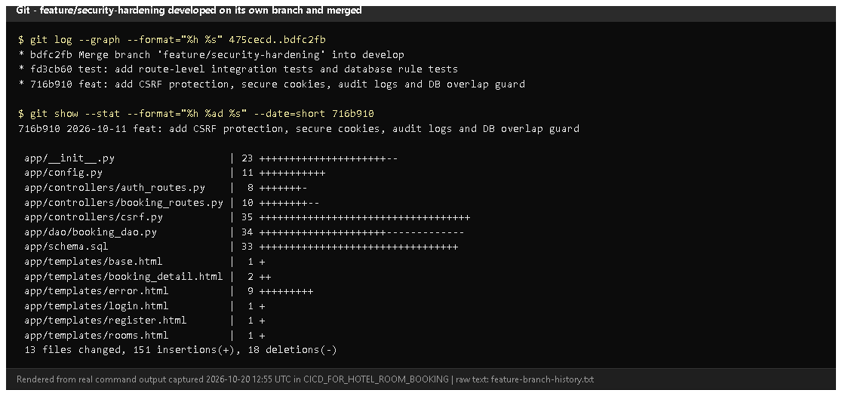
Figure 5.1 - git log --graph of feature/security-hardening and git show --stat 716b910 (rendered from real output, 2026-10-20).
Notice: two commits on the side branch (a feat: and a test:), then the merge commit into develop; the file list of the feature commit.
Proves: a feature branch with code and tests, merged with --no-ff.
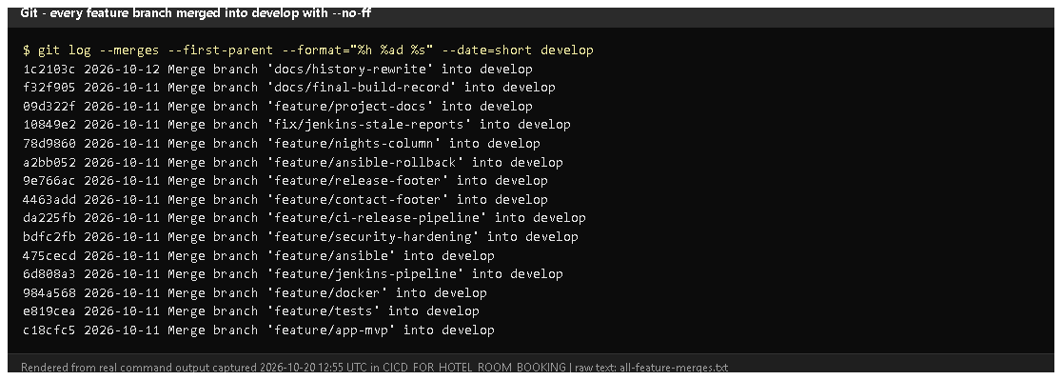
Figure 5.2 - git log --merges --first-parent develop (rendered from real output).
Notice: every change arrived in develop through a Merge branch 'feature/...' commit.
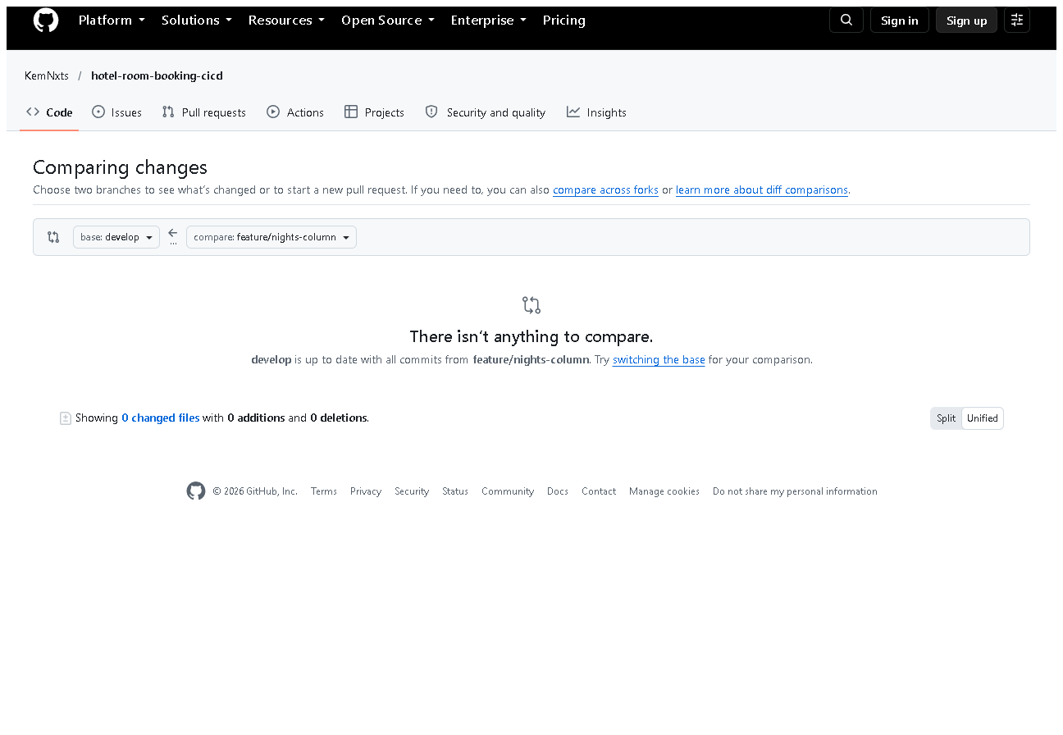
Figure 5.3 - GitHub compare develop...feature/nights-column (captured 2026-10-20).
Notice: "develop is up to date with all commits from feature/nights-column".
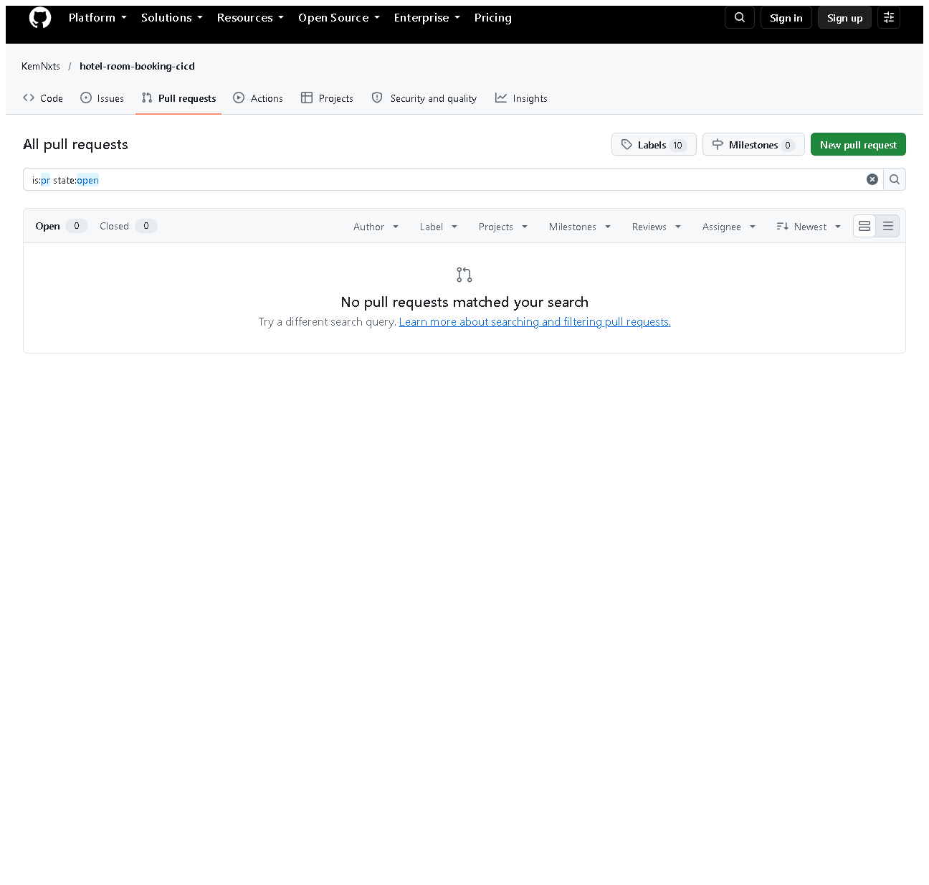
Figure 5.4 - The repository's Pull requests page (all states): none.
Why included: honest evidence that real PRs are still pending.
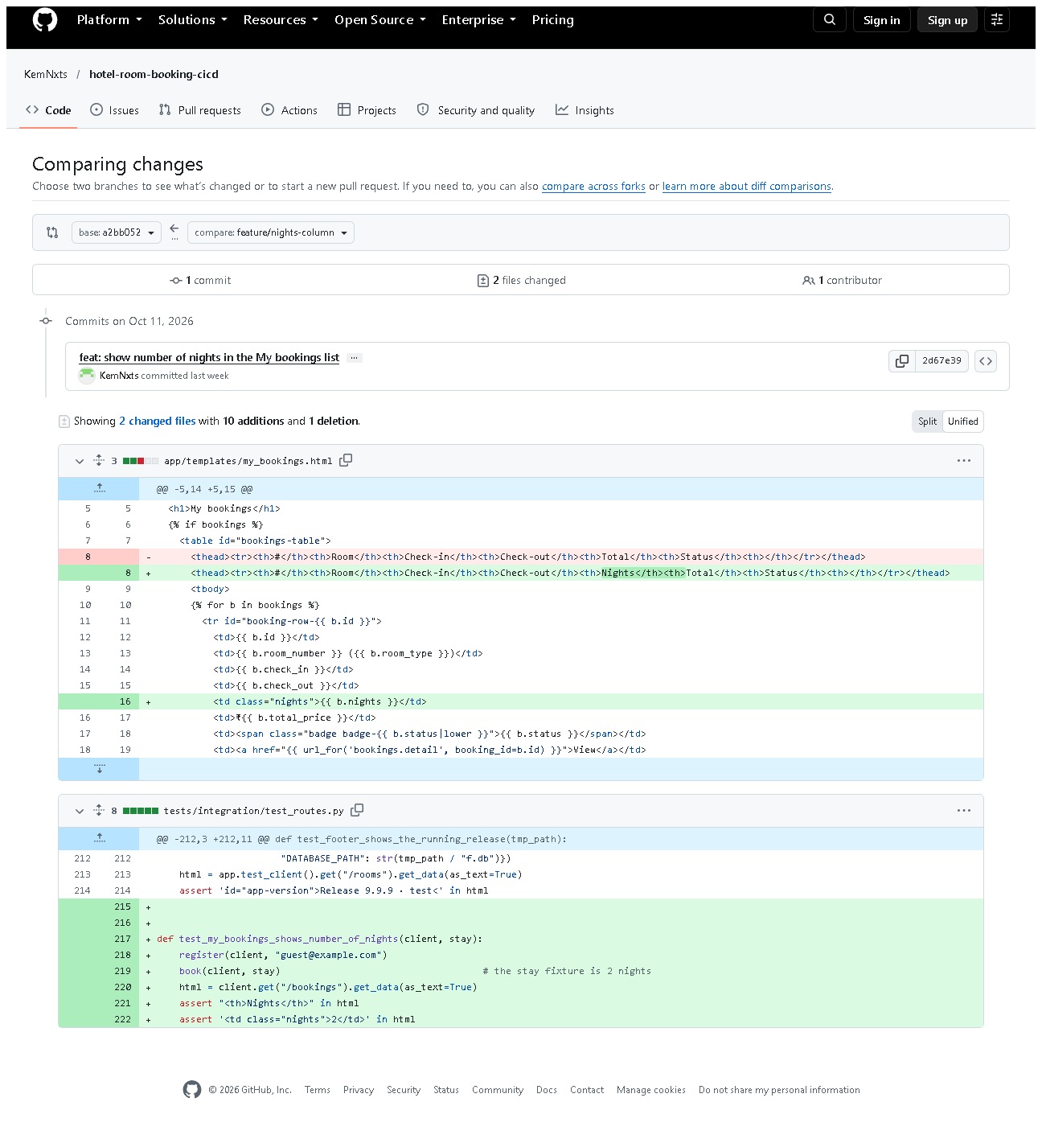
Figure 5.5 - GitHub compare from the branch's starting point a2bb052 to feature/nights-column.
Notice: 1 commit (2d67e39 feat: show number of nights...), 2 files - the
template change and its new test. This is a compare view, not a PR.

E. How to demonstrate this task to the professor (about 4 minutes)
Before the demo: PowerShell in D:\DevOPS\CICD_FOR_HOTEL_ROOM_BOOKING; browser on the GitHub repository.
- Expected: the graph in section C (the side line | * is the feature branch). Say: "This feature was built on its
own branch with a code commit and a test commit, then merged into develop."
git log --graph --oneline -4 bdfc2fb
- Say: "Here is what the feature changed."
git show --stat 716b910
- Say: "Every feature reached develop through a merge commit."
git log --merges --first-parent --oneline develop
- Open docs/pull-requests/feature-security-hardening.md - Say: "I
reviewed it with our PR checklist; this is the written review record."
- Open .github/pull_request_template.md - the checklist.
- On GitHub open Pull requests - Say honestly: "The merges were done
locally and pushed, so GitHub shows no PRs yet. Here is how a real one is made:"
Live mini-demo of a real feature-branch PR (optional, needs your GitHub login, ~5 min):
git checkout develop
git pull
git checkout -b feature/demo-readme-note
# edit README.md (add one sentence), save
git add README.md
git commit -m "docs: add a note about the demo"
git push -u origin feature/demo-readme-note
Then on GitHub: Compare & pull request -> base develop -> write a
description using the template -> Create pull request -> add a review
comment -> Merge pull request. Capture screenshots of the PR page (see section F).
Recovery: "Your local changes would be overwritten by checkout" - you
have uncommitted work (today: the UI redesign). Commit it or run git stash
first, then git stash pop afterwards.

F. Expected screenshots for the final submission
- assets/task-05/feature-branch-history.png - exists, 2026-10-20.
- assets/task-05/all-feature-merges.png - exists, 2026-10-20.
- assets/task-05/github-compare-merged-into-develop.png - exists, 2026-10-20.
- assets/task-05/github-compare-feature-changes.png - exists, 2026-10-20.
- assets/task-05/github-pull-requests-empty.png - exists, 2026-10-20 (honest current state).
- assets/task-05/github-pr-open.png - a real PR with description and checklist - requires manual capture after creating a PR.
- assets/task-05/github-pr-review-comment.png - a review comment - requires manual capture.
- assets/task-05/github-pr-merged.png - the merged PR - requires manual capture.

G. Probable viva questions and answers
- Why use feature branches? Unfinished work stays out of develop, so
develop always builds and passes tests; several features can progress in parallel.
- What is a pull request? A GitHub page that asks to merge one branch
into another, where the change is reviewed and discussed first.
- Did you create pull requests? Not on GitHub - GitHub shows 0 PRs. I
merged locally with --no-ff and pushed; the review records are in
docs/pull-requests/. Creating real PRs is my remaining step.
- What does --no-ff do? Always creates a merge commit, so a feature's
commits stay grouped in the history.
- git pull vs git fetch? fetch downloads new commits; pull = fetch + merge into your current branch.
- (Project-specific) Show a feature branch and its commits.
feature/security-hardening: 716b910 feat: add CSRF protection... and
fd3cb60 test: add route-level integration tests..., merged as bdfc2fb.
- (Project-specific) What does your review checklist check? No SQL
outside DAOs, server-side validation, booking ownership, CSRF token on new
forms, and that tests would fail if the code were broken.
- How did you test the feature before merging? flake8 and the full
pytest suite locally; after merging, Jenkins built develop.
- What would a reviewer comment look like? A note on a specific line,
e.g. "this route changes data - does the form include csrf_token?" (an
example - no real comments exist yet).
- What if two features change the same lines? A merge conflict - see
Task 6, where exactly that happened and was resolved.

H. Common mistakes and troubleshooting
Symptom | Cause | Inspect | Fix | Confirm
Commit went to develop instead of the feature branch | forgot checkout -b | git branch --show-current | create the branch from that commit, reset develop only if not pushed | git log shows commit on the feature branch
git push says "no upstream branch" | first push of a new branch | message text | git push -u origin <branch> | branch visible on GitHub
Checkout refused: local changes would be overwritten | uncommitted work | git status | commit or git stash | checkout succeeds
PR shows unrelated commits | branch started from the wrong base | git merge-base develop <branch> | rebase onto develop or recreate the branch | PR shows only the feature commits

I. Quick revision notes
Five key points
- One branch per feature, created from develop.
- Separate commits for code (feat:) and tests (test:).
- Merged with --no-ff, so each feature is a visible unit.
- Review checklist = .github/pull_request_template.md; records in docs/pull-requests/.
- No real GitHub PRs yet - say so and show how to make one.
30-60 second explanation
"Each feature was developed on its own branch. For example
feature/security-hardening has one commit adding CSRF protection and a
second adding tests. I checked it with flake8 and pytest, reviewed it against
our pull-request checklist, and merged it into develop with --no-ff, which
keeps a merge commit in the history. All branches are pushed to GitHub, and
GitHub confirms develop contains their commits. Real pull requests on GitHub
haven't been created yet - that's my next step."
Caveat: review was a self-review with a checklist; there are no GitHub PRs or reviewer comments.
Readiness checklist
- â˜ I can show git log --graph for one feature.
- â˜ I can explain PR vs merge.
- â˜ I can explain honestly why GitHub shows 0 PRs.
- â˜ I know the steps to create a real PR.

