Task 6 - MVP Completion and Git Collaboration

A. Task title and objective
Task 6: MVP Completion and Git Collaboration
Objective: finish all six booking workflows securely, and show
collaboration with Git: a second feature branch, a real merge conflict and
its resolution, release tags and a stable source baseline.
Professor's required deliverables
- All six workflows: registration/login, availability, booking request, confirmation, cancellation, status tracking
- A second feature branch
- A real merge conflict and its resolution
- A version tag and a release-ready baseline
- Updated backlog
- Security: password hashing, session protection, server-side validation, authorisation
Current status: Implemented and verified.
- Six workflows: 5/5 Selenium journeys and 85 unit/integration tests passed on 2026-10-20.
- Merge conflict: happened for real on 2026-10-11 (output saved at the time), the
resolution commit 9e766ac is in Git, and on 2026-10-20 the same conflict was
reproduced in a throw-away clone (section E).
- Tags v1.0.0 and v1.1.0 exist locally and on GitHub.
Note: the application screenshots below show the redesigned interface
that currently runs from the working tree (branch feature/ui-redesign, not
yet committed). The six workflows behave the same in the committed v1.1.0.

B. Explanation for a complete beginner
An everyday picture. Two people edit the same sentence of a shared
document while offline. When they sync, the software cannot know which
version to keep, so it shows both and asks a human. That is a merge
conflict.
Why conflicts happen in Git. Git merges automatically when two branches
change different lines. When both change the same lines, Git stops,
marks the file with <<<<<<<, =======, >>>>>>> and asks you to decide.
Resolving means editing the file to the correct final content, testing, and
committing the merge.
Branch vs tag. A branch is a moving pointer that advances with every
new commit (like a bookmark you keep moving). A tag is a fixed label on one
commit (like engraving "Release 1.0" on one page). Releases get tags so you can
always return to exactly what was shipped.
MVP - the six workflows that make the portal useful. Stable baseline -
a tagged commit on main that passed the whole pipeline.
Security terms: password hashing - storing a one-way scrambled form of
the password, never the password itself; session - the login cookie;
authorisation - checking a user may access this booking.

C. What was actually implemented
The six workflows
# | Workflow | Route | Service function | Verified by
1 | Register / log in | /register, /login | AuthService.register, login | journeys 1, 2
2 | Availability by date | GET /rooms?check_in=&check_out= | BookingService.search_rooms | journey 3, 5
3 | Booking request -> PENDING | POST /bookings | request_booking | journey 3
4 | Confirmation -> CONFIRMED | POST /bookings/<id>/confirm | confirm_booking | journey 3
5 | Cancellation -> CANCELLED | POST /bookings/<id>/cancel | cancel_booking | journey 4
6 | Status tracking | GET /bookings | list_bookings | journey 4

Security in code
- Passwords: generate_password_hash / check_password_hash (Werkzeug, scrypt) in app/services/auth_service.py (lines 35, 46).
- Session cookie HttpOnly + SameSite=Lax (app/config.py); CSRF token on every form (app/controllers/csrf.py).
- Server-side validation of e-mail, name, password length, dates (auth_service.py, booking_service.py validate_stay).
- Authorisation: get_booking returns "not found" for another user's booking (integration test test_other_users_cannot_see_confirm_or_cancel_my_booking).
Second feature branch and the real merge conflict
Two features started from the same develop commit (da225fb, original f4d0b26):
Branch | Commit (current / original) | Change
feature/contact-footer | 74a153d / 65ad990 | footer with hotel contact details
feature/release-footer | 63498a8 / c24148f | footer showing the running release

Both added a footer in the same place. contact-footer merged first
(4463add). Merging release-footer then gave (saved 2026-10-11):
CONFLICT (content): Merge conflict in app/static/style.css
CONFLICT (content): Merge conflict in app/templates/base.html
CONFLICT (content): Merge conflict in tests/integration/test_routes.py
Automatic merge failed; fix conflicts and then commit the result.
Resolution (merge commit 9e766ac, original 8728b62): both features
were wanted, so both lines were kept - contact first, release second; one
combined CSS rule; both tests kept. Then flake8 was clean and 89 tests passed,
and the merge was committed with a message describing each decision.
Release tags and baseline
Tag | Commit on main | Pipeline evidence
v1.0.0 | 224de14 (original 661751d) | Jenkins #4 (develop) and #5 (main -> prod) green
v1.1.0 | ce1726d (original d07929b) | Jenkins #6/#7 (develop) and #8 (main -> prod) green

The production environment still runs 1.1.0-d07929b - the v1.1.0 release.
Backlog update - docs/02-agile-plan.md marks HB-06 Done; the merge
conflict is recorded as a sprint-retrospective lesson.

D. Screenshots and evidence
The six workflows (redesigned UI, working tree, 2026-10-20)
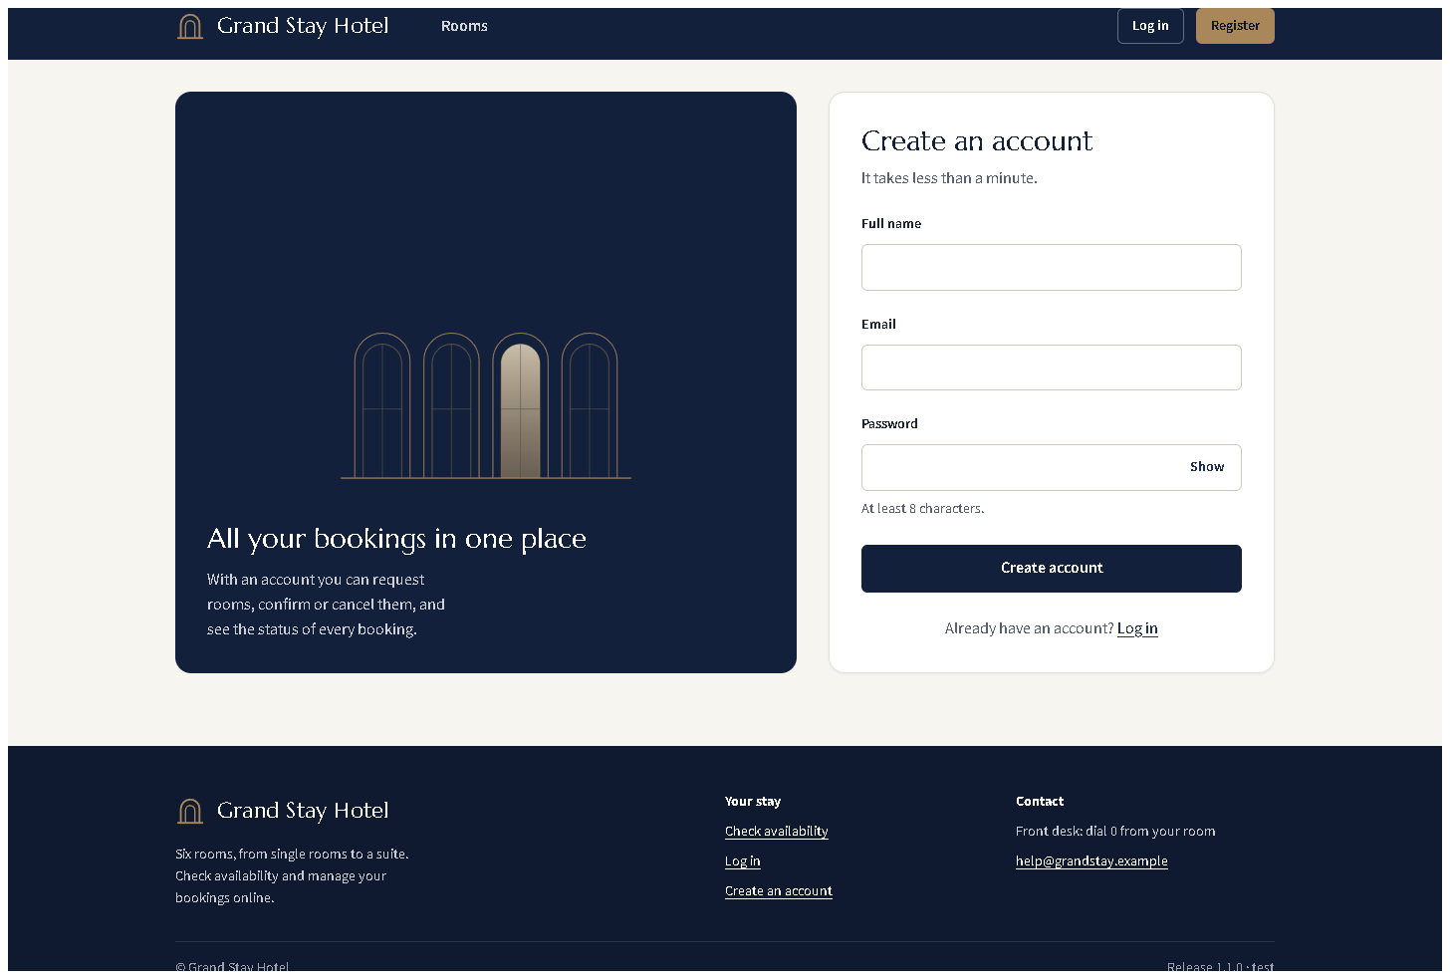
Figure 6.1 - Workflow 1: registration form with labelled fields and the password rule.
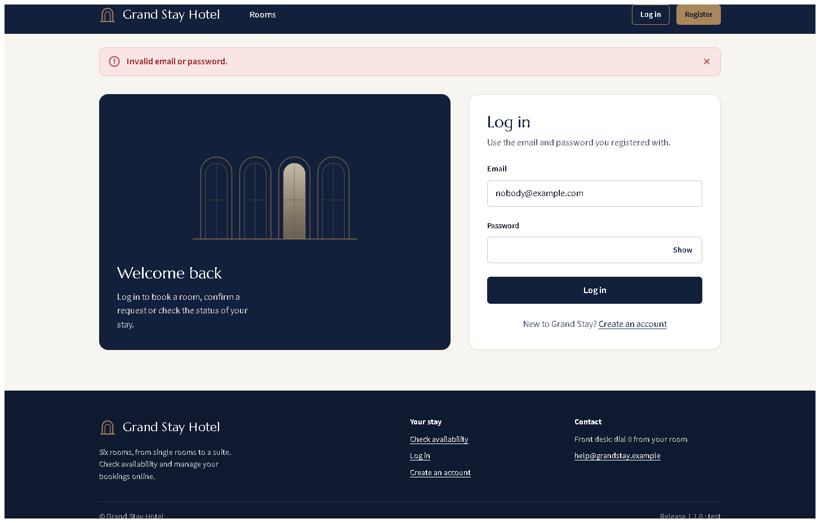
Figure 6.2 - Workflow 1: login with wrong credentials shows a neutral error (does not reveal which part was wrong).
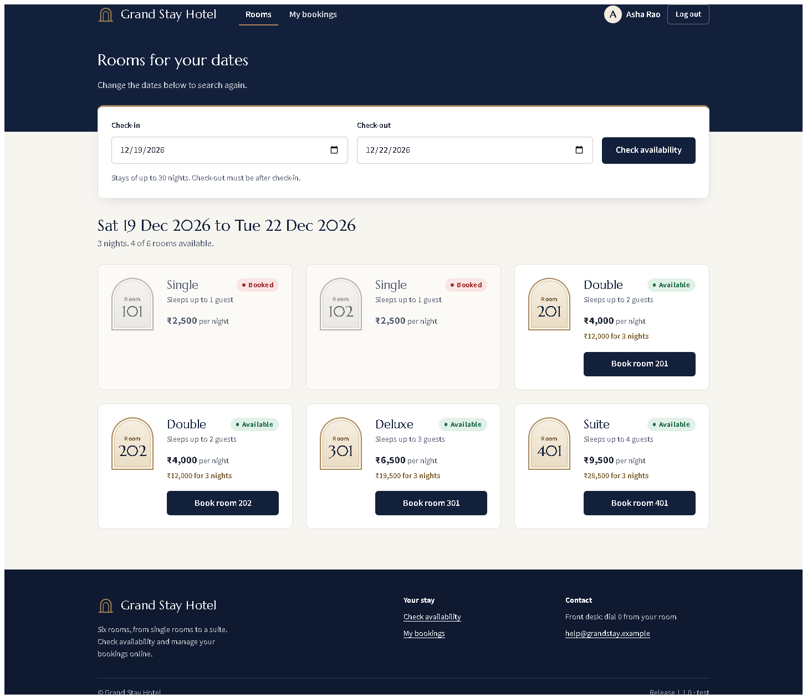
Figure 6.3 - Workflow 2: availability for the chosen dates - booked rooms marked "Booked", free rooms with the total for the stay.
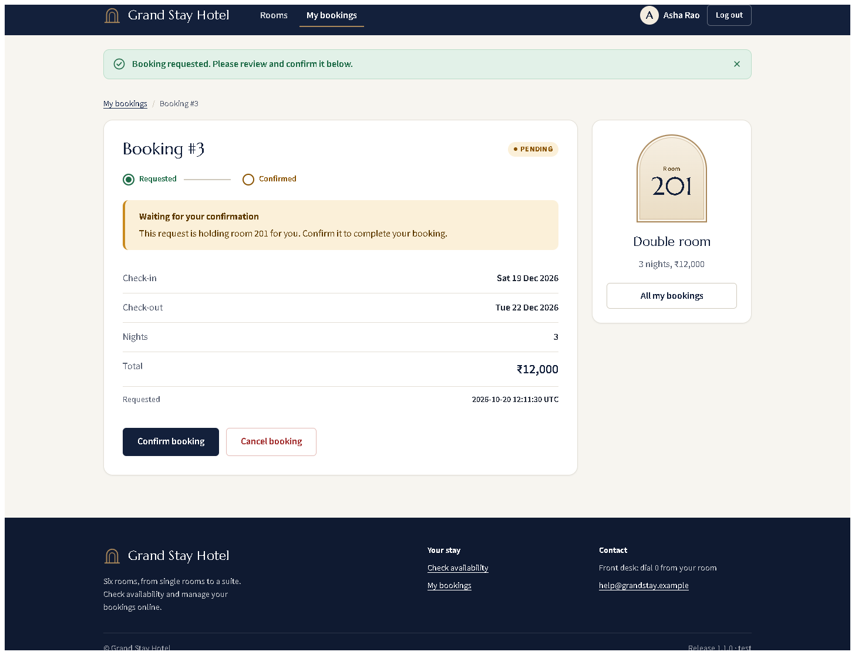
Figure 6.4 - Workflow 3: the new booking is PENDING.
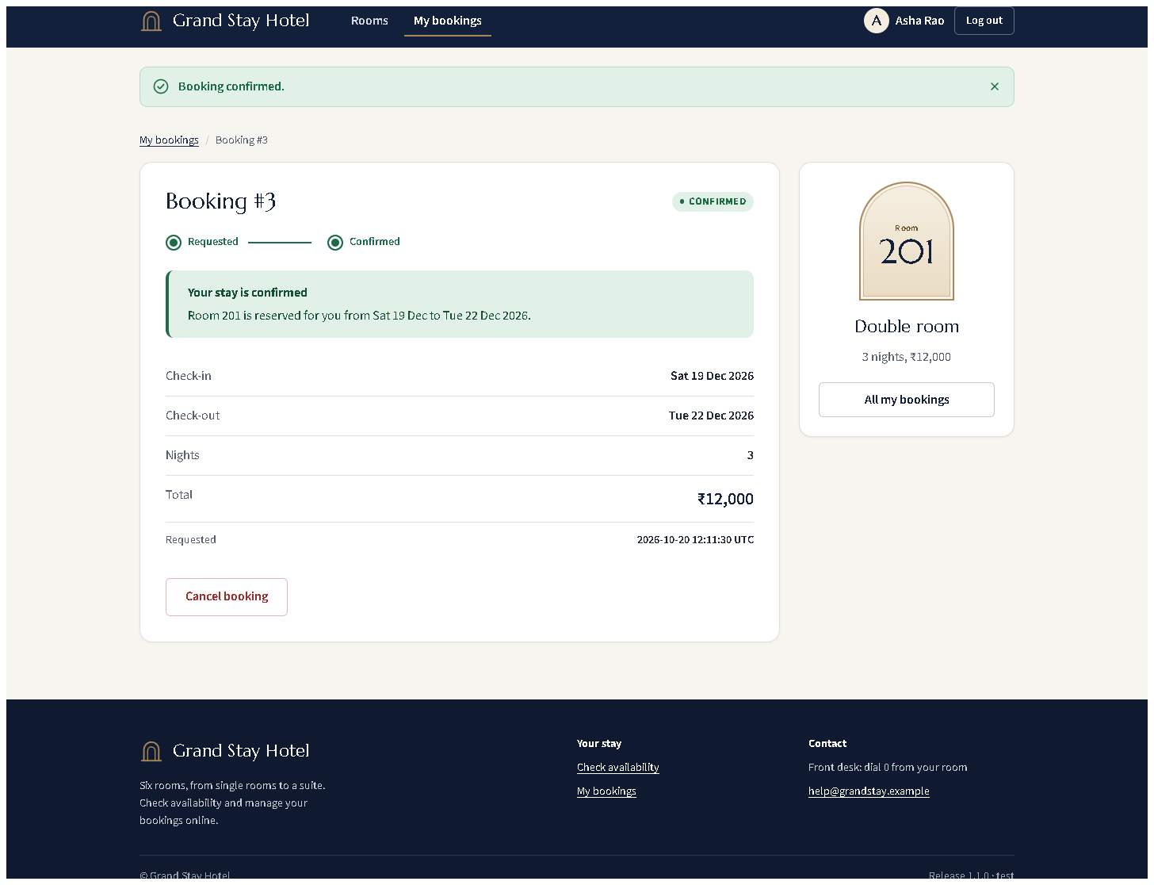
Figure 6.5 - Workflow 4: CONFIRMED, progress shows both steps done.
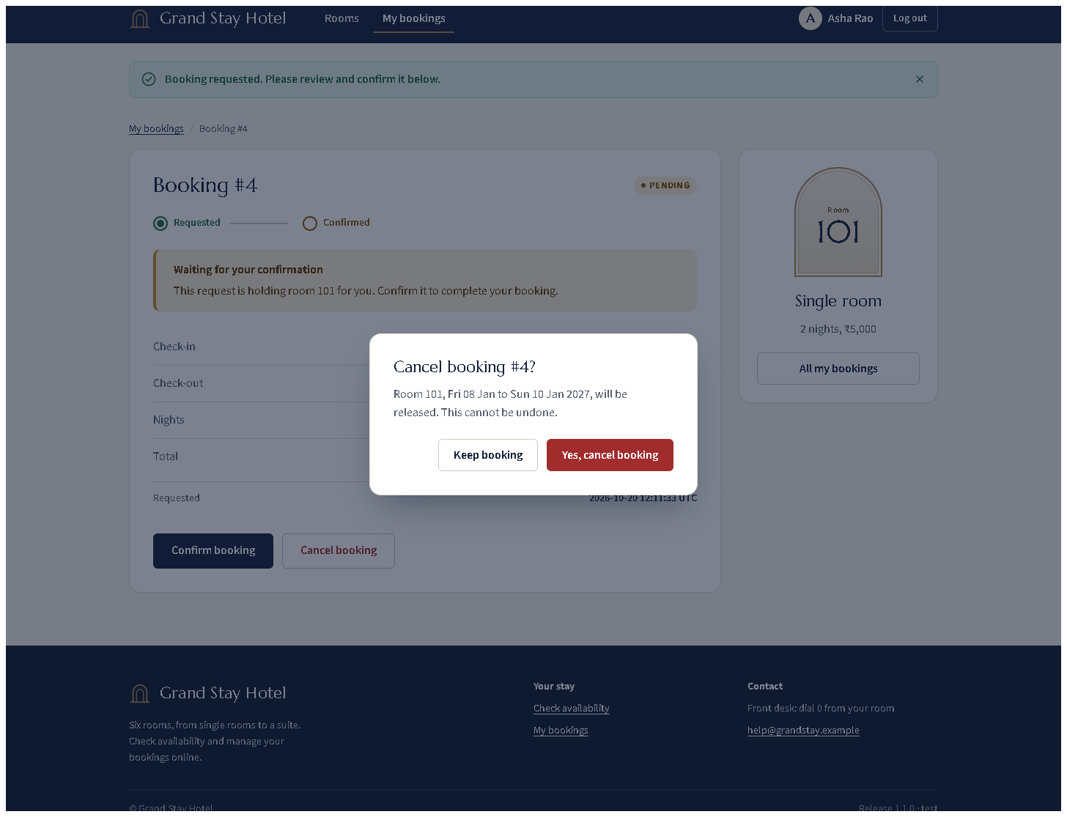
Figure 6.6 - Workflow 5: cancelling opens a confirmation dialog first.
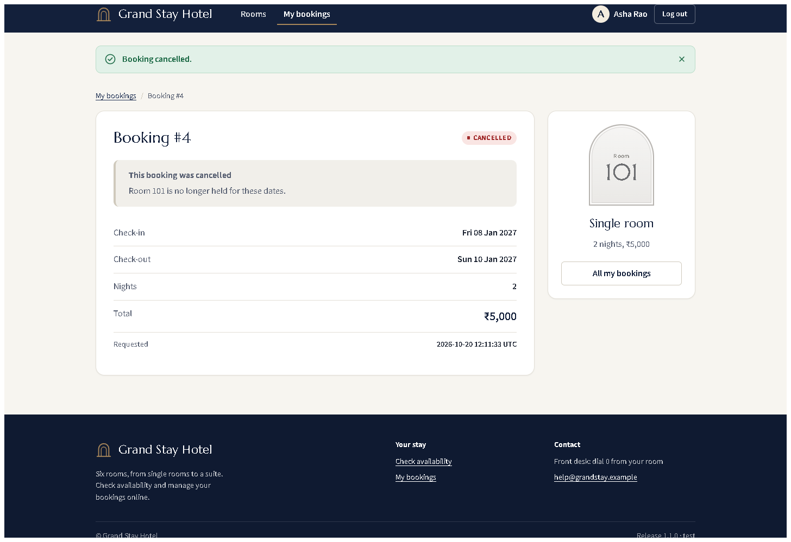
Figure 6.7 - Workflow 5: status CANCELLED, room released.
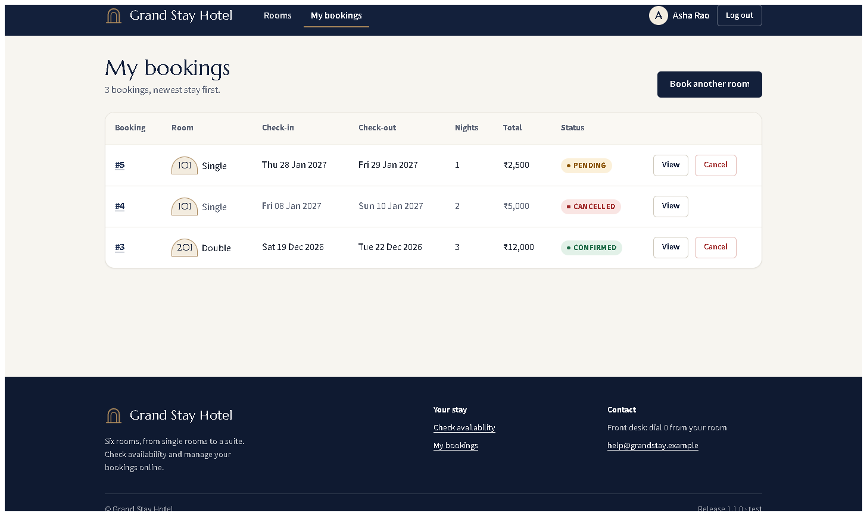
Figure 6.8 - Workflow 6: status tracking for all of the guest's bookings (PENDING, CANCELLED, CONFIRMED).
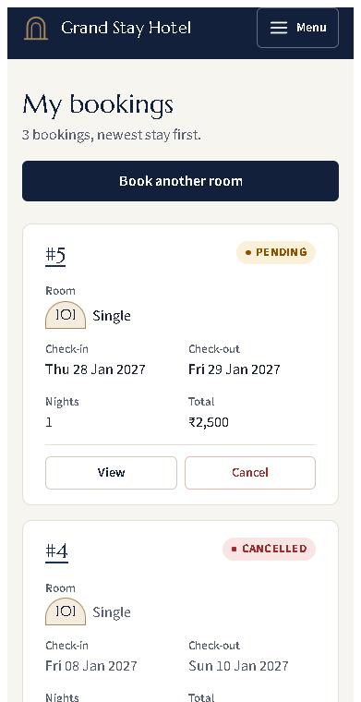 (part 1 of 3)
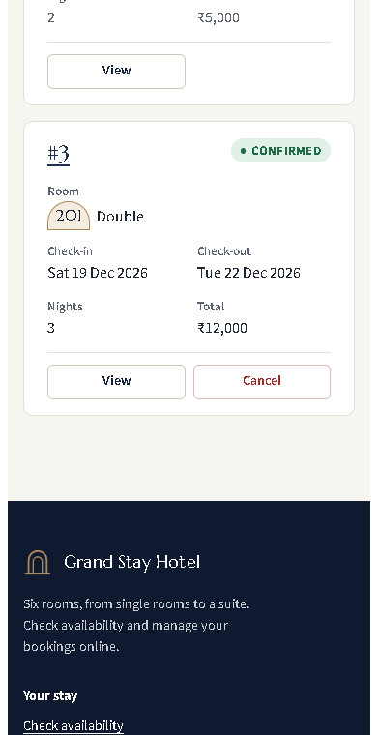 (part 2 of 3)
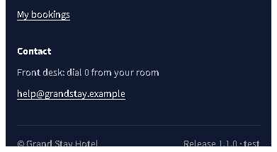 (part 3 of 3)
Figure 6.9 - The same page at phone width (375 px).
Collaboration
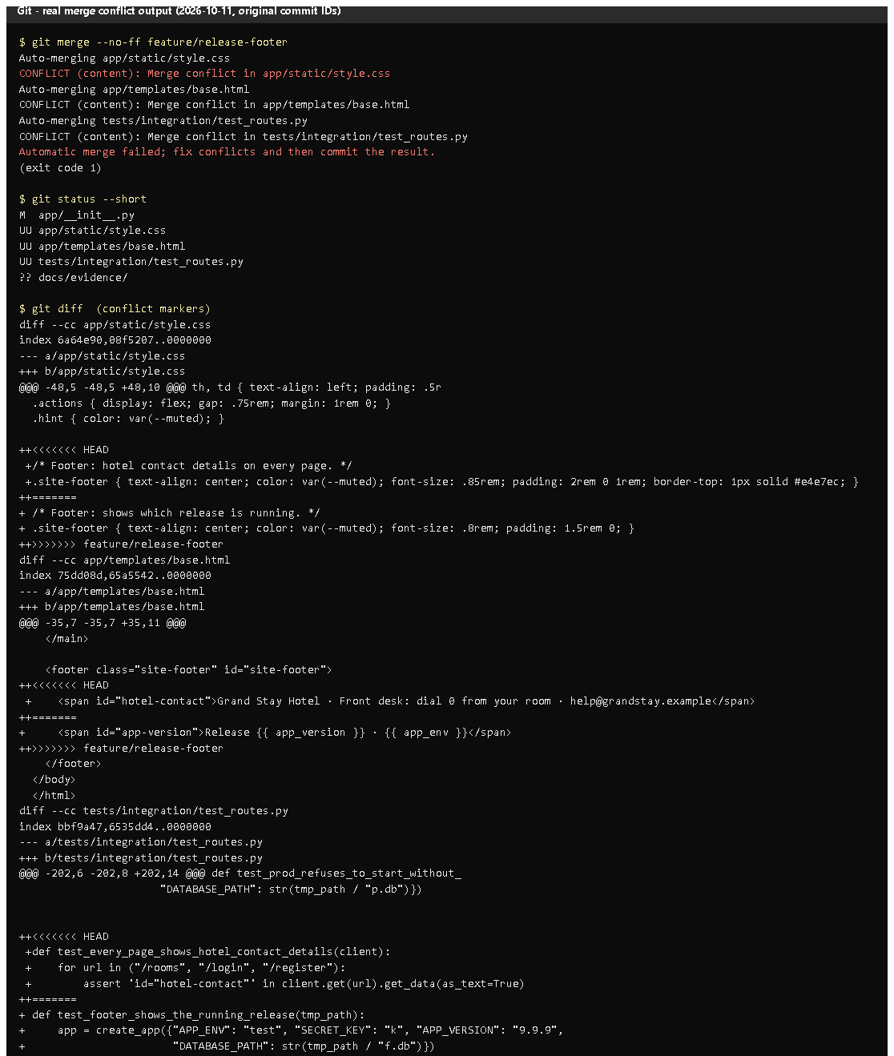 (part 1 of 2)
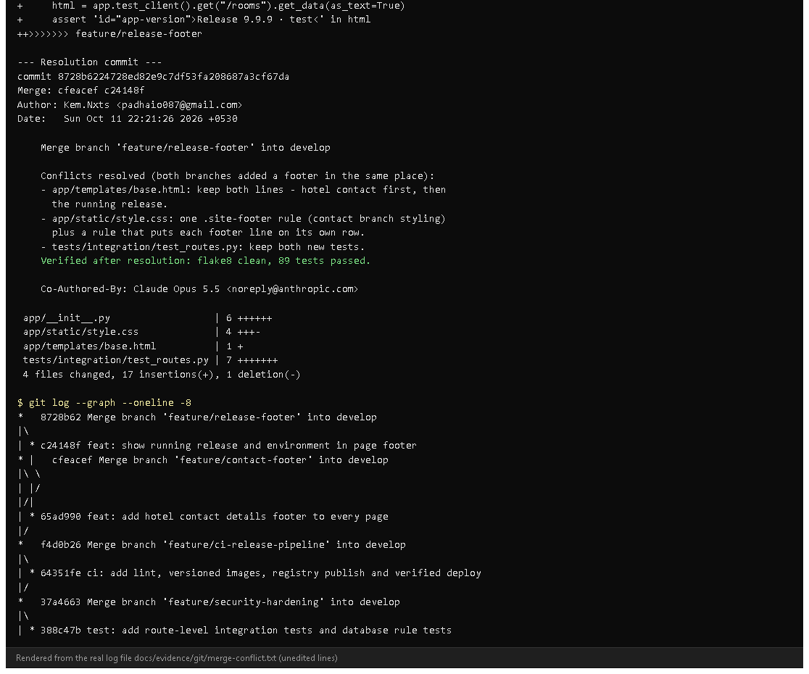 (part 2 of 2)
Figure 6.10 - The conflict as recorded on 2026-10-11 (rendered from docs/evidence/git/merge-conflict.txt; original commit IDs).
Notice: three CONFLICT (content) lines and the conflict markers from both branches.
Proves: the conflict was real Git output, not described afterwards.
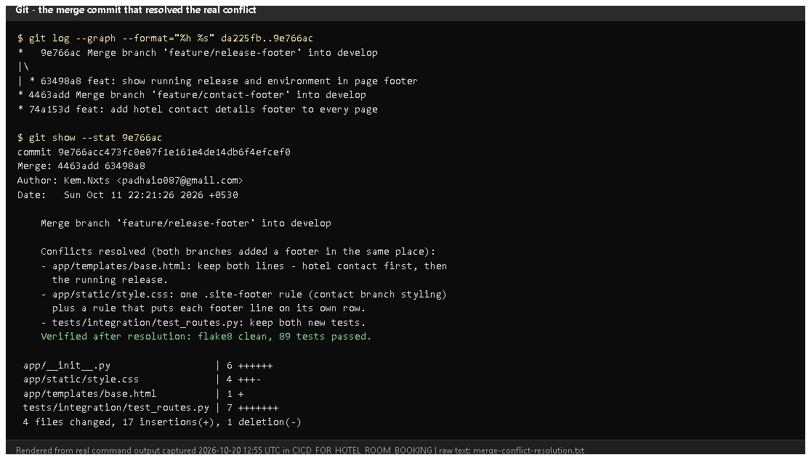
Figure 6.11 - git log --graph and git show --stat 9e766ac today (rendered from real output).
Notice: the two footer branches in the graph and the merge message describing each resolution decision.
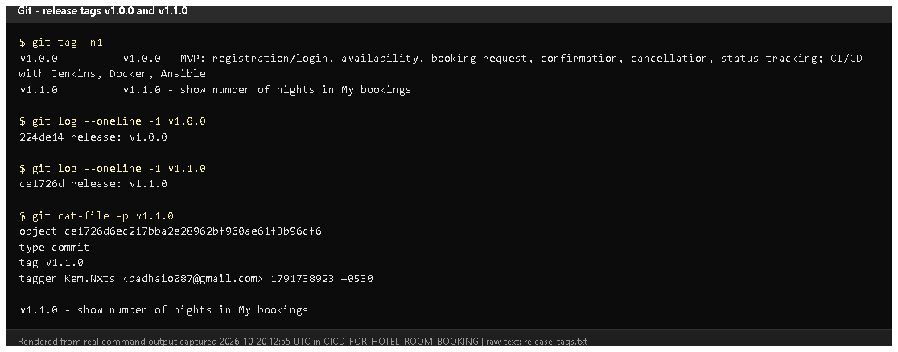
Figure 6.12 - git tag -n1 and the annotated tag object of v1.1.0 (rendered from real output).
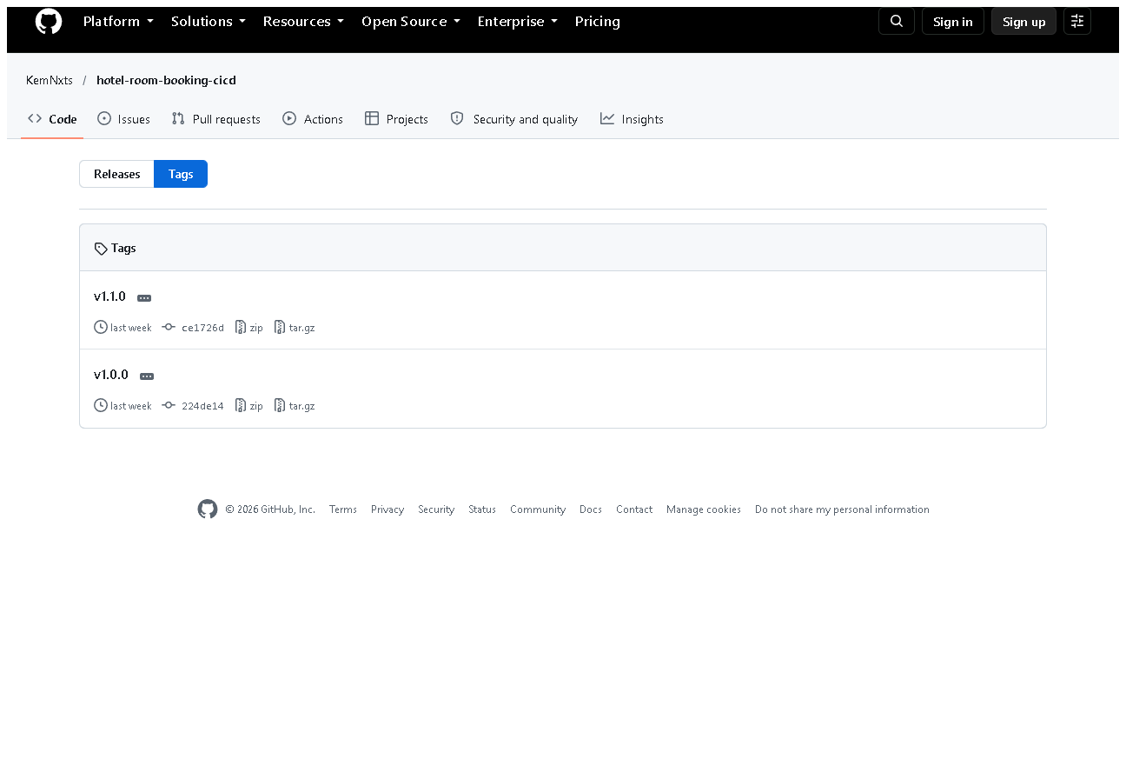
Figure 6.13 - v1.0.0 and v1.1.0 on GitHub.
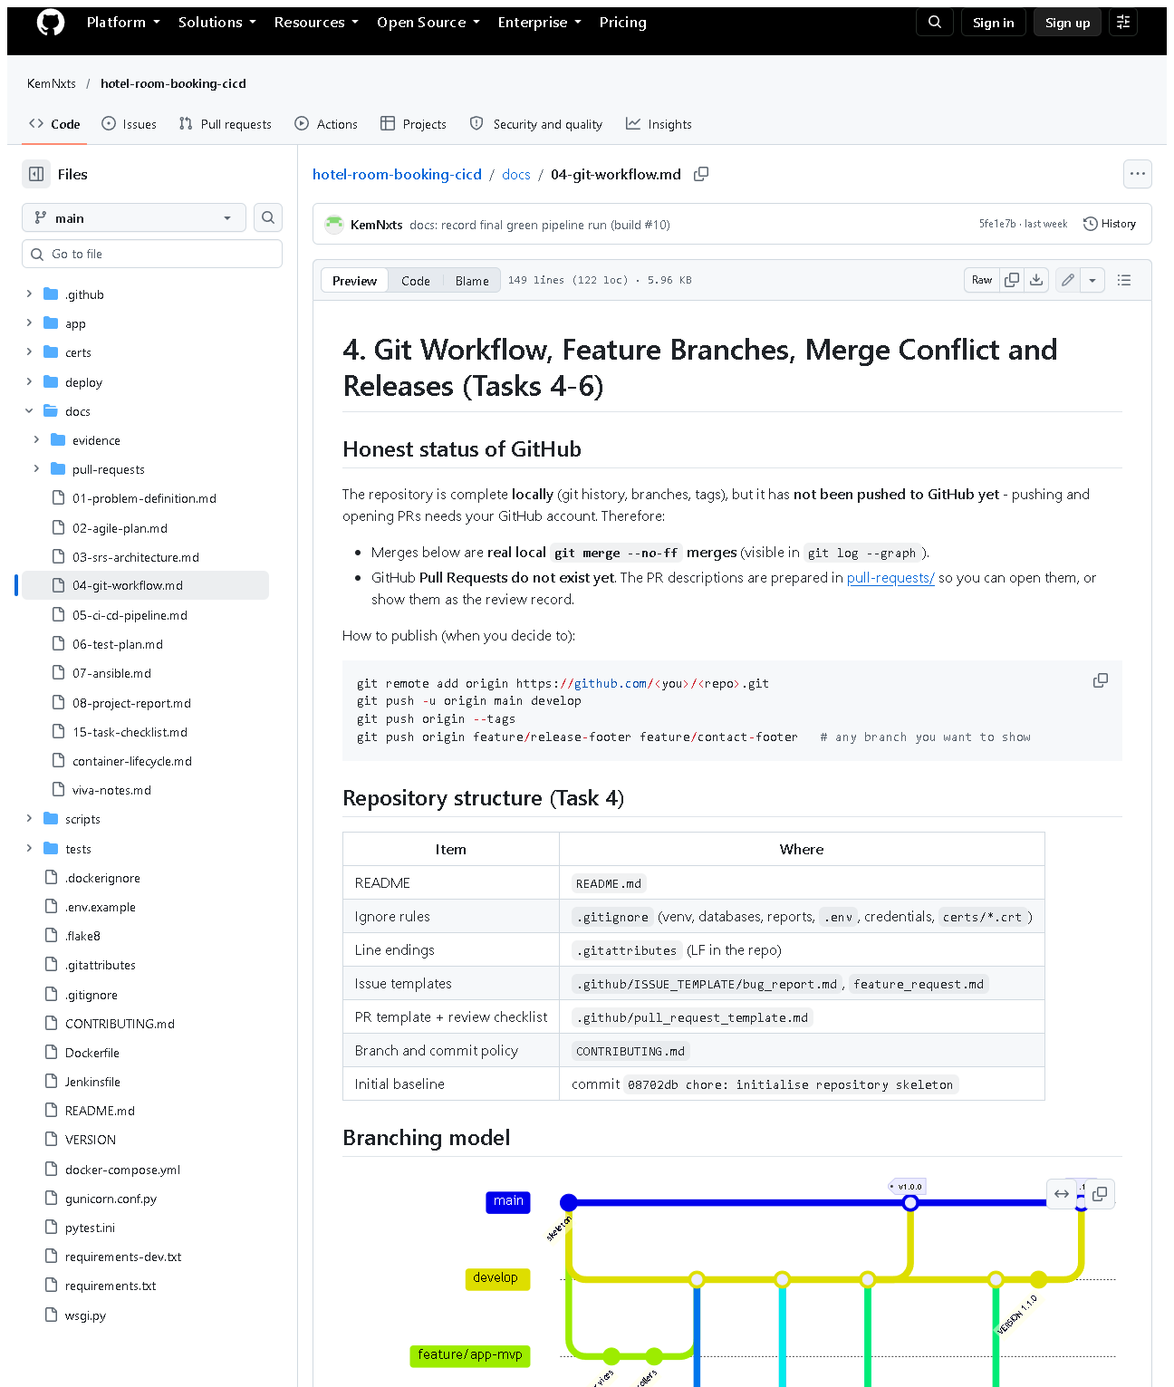 (part 1 of 3)
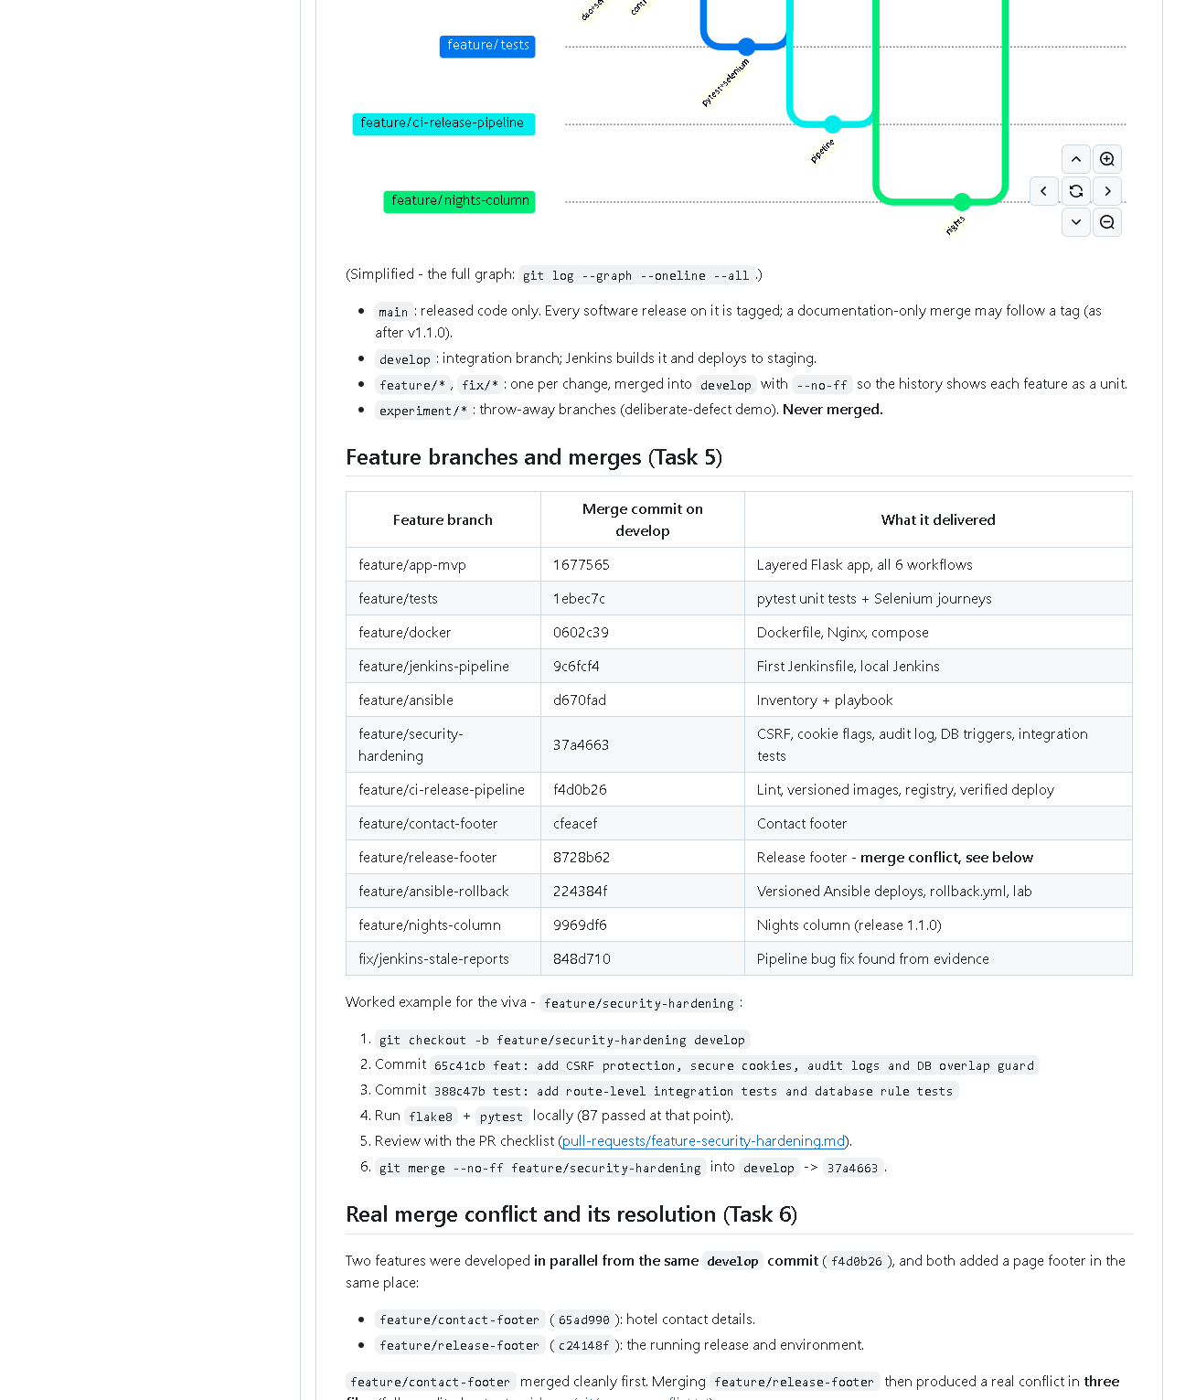 (part 2 of 3)
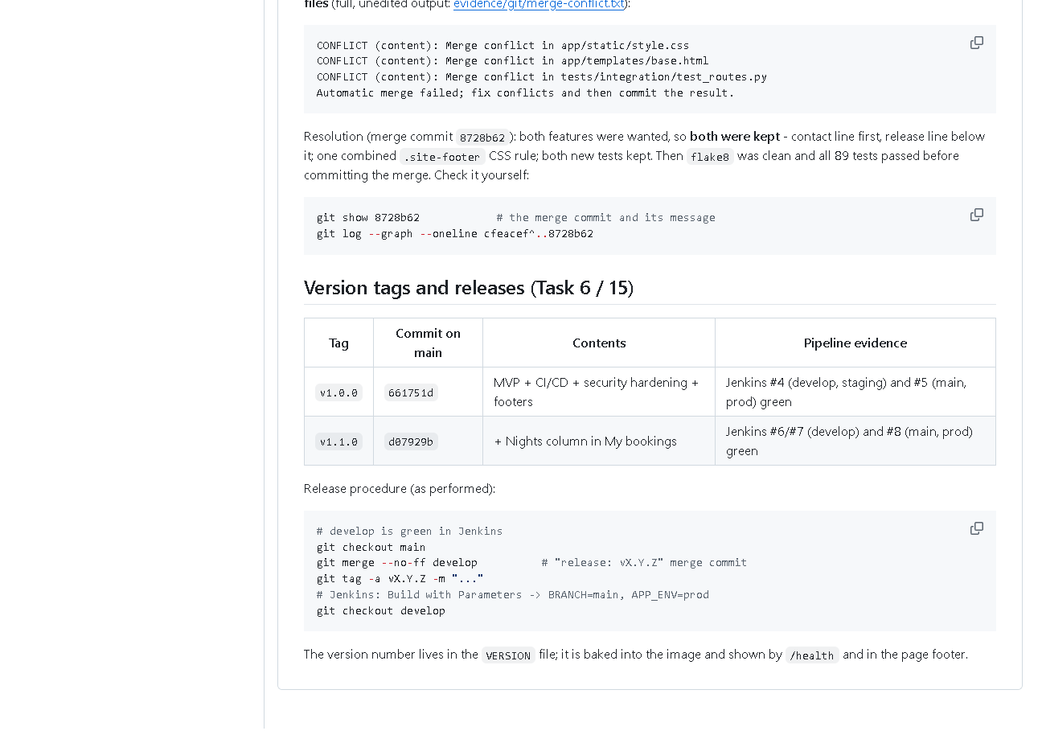 (part 3 of 3)
Figure 6.14 - docs/04-git-workflow.md on GitHub: branching model, merges, the conflict story and the release procedure.

E. How to demonstrate this task to the professor (about 5 minutes)
Before the demo: PowerShell in D:\DevOPS\CICD_FOR_HOTEL_ROOM_BOOKING.
Part 1 - the six workflows (browser).
.venv\Scripts\python -m flask --app wsgi run --port 5001
Open http://127.0.0.1:5001: register -> search dates -> Book room ->
Confirm booking -> book another -> Cancel booking -> Yes, cancel booking
-> My bookings. Say: "These are the six MVP workflows; they are also
checked automatically by five Selenium journeys."
Part 2 - the real merge conflict, replayed safely in a throw-away copy
(new PowerShell window; nothing in the real repository changes):
cd $env:TEMP
git clone D:\DevOPS\CICD_FOR_HOTEL_ROOM_BOOKING conflict-demo
cd conflict-demo
git checkout -b replay da225fb
git merge --no-ff --no-edit origin/feature/contact-footer
git merge --no-ff --no-edit origin/feature/release-footer
Expected: the first merge succeeds; the second prints three
CONFLICT (content) lines and "Automatic merge failed" (verified 2026-10-20).
git status
git diff
Point to: UU files and the <<<<<<< HEAD / ======= / >>>>>>> blocks.
Say: "Both branches added a footer in the same place, so Git asks a human.
I kept both lines." Then show the real resolution and clean up:
git merge --abort
git show --stat 9e766ac
cd ..
Remove-Item -Recurse -Force conflict-demo
Part 3 - tags. In the project folder:
git tag -n1
git show v1.0.0 --stat --oneline
Say: "Tags are fixed labels for the released commits; branches keep moving."
Recovery: if git clone says the folder exists, run
Remove-Item -Recurse -Force $env:TEMP\conflict-demo first.

F. Expected screenshots for the final submission
- assets/task-06/app-desktop-03-register.png - exists, 2026-10-20 (copied from docs/ui-evidence/after/).
- assets/task-06/app-desktop-05-login-error.png - exists, 2026-10-20.
- assets/task-06/app-desktop-06-availability-logged-in.png - exists, 2026-10-20.
- assets/task-06/app-desktop-08-booking-requested.png - exists, 2026-10-20.
- assets/task-06/app-desktop-09-booking-confirmed.png - exists, 2026-10-20.
- assets/task-06/app-desktop-10-cancel-dialog.png - exists, 2026-10-20.
- assets/task-06/app-desktop-11-booking-cancelled.png - exists, 2026-10-20.
- assets/task-06/app-desktop-12-my-bookings.png - exists, 2026-10-20.
- assets/task-06/app-mobile-12-my-bookings.png - exists, 2026-10-20.
- assets/task-06/merge-conflict-output.png - exists (rendered from the 2026-10-11 log).
- assets/task-06/merge-conflict-resolution.png - exists, 2026-10-20.
- assets/task-06/release-tags.png - exists, 2026-10-20.
- assets/task-06/github-release-tags.png - exists, 2026-10-20.
- assets/task-06/github-doc-04-git-workflow.png - exists, 2026-10-20.

G. Probable viva questions and answers
- What is a merge conflict? Two branches changed the same lines; Git cannot choose, so a human edits the result.
- How did your conflict happen? Two features branched from the same
commit and both added a footer in base.html (plus CSS and a test). The second merge conflicted in all three files.
- How did you resolve it? Kept both features (contact line, then release
line), merged the CSS into one rule, kept both tests, ran flake8 and all
tests (89 passed), then committed the merge 9e766ac.
- How do you know you didn't break anything? Tests after resolution, and
Jenkins build #4 of develop was green before the v1.0.0 release.
- Branch vs tag? A branch moves with new commits; a tag stays on one commit.
- Why tag releases? To redeploy or roll back exactly what was released
(v1.0.0 was used for the Ansible rollback demo).
- (Project-specific) How are passwords stored? Werkzeug scrypt hashes
(generate_password_hash), never plain text - a unit test checks this.
- (Project-specific) What stops one guest cancelling another's booking?
The service checks the owner; another user gets 404 and the status stays unchanged (integration test).
- What is a stable baseline? A tagged commit on main that passed the
full pipeline - v1.1.0 (ce1726d), running in prod.
- Why are there two IDs for the same commit in your documents? The
messages were edited once before publishing (removing a co-author line);
the map is in docs/evidence/git/commit-id-map.md.
- Is the conflict screenshot genuine? Yes - Git's own output was saved
to a file at the time, and the conflict can be reproduced live from the
pushed branches, as in the demo.

H. Common mistakes and troubleshooting
Symptom | Cause | Inspect | Fix | Confirm
Replay merge does not conflict | wrong start commit | git log --oneline -1 | start from da225fb | three CONFLICT lines
Conflict markers left in a file | resolution incomplete | git grep -n "<<<<<<<" | edit file, remove markers | grep finds nothing; tests pass
git merge --abort fails | merge already committed | git status | in the throw-away clone just delete it | folder removed
Booking button missing | logged out, or room booked | page shows "Log in to book"/"Booked" | log in / choose other dates | Book button appears
HTTP 400 on a form | stale CSRF token | page open across restart | reload the page | form submits

I. Quick revision notes
Five key points
- Six workflows, each with a route, a service function and a Selenium journey.
- Security: hashed passwords, CSRF tokens, secure cookies, owner checks.
- Real conflict between feature/contact-footer and feature/release-footer, 3 files.
- Resolved by keeping both; merge commit 9e766ac; 89 tests passed afterwards.
- Releases tagged v1.0.0, v1.1.0; prod runs v1.1.0.
30-60 second explanation
"All six booking workflows are complete and tested by Selenium. For
collaboration, two features were developed in parallel from the same commit -
a contact footer and a release footer. Both changed the same lines, so the
second merge produced a real conflict in three files. I kept both features,
ran all tests, and committed the merge. After the pipeline passed, I merged
develop into main and tagged the releases v1.0.0 and v1.1.0. I can replay the
conflict live in a throw-away copy of the repository."
Caveat: the screenshots show the new UI, which is not yet committed or deployed.
Readiness checklist
- â˜ I can click through all six workflows.
- â˜ I can replay the conflict in a temp clone and explain the markers.
- â˜ I can explain branch vs tag.
- â˜ I can explain the two commit IDs.

