Task 7 - Jenkins Installation and Continuous Integration

A. Task title and objective
Task 7: Jenkins Installation and Continuous Integration (CI) Job
Objective: install Jenkins and configure a job that, for every change,
checks out the repository, prepares Python, installs dependencies, runs
static checks and tests, publishes test reports and archives artifacts.
Professor's required deliverables
- Jenkins installed and a job configured for the repository
- Checkout; Python environment; reproducible dependency installation
- Linting / syntax checks
- pytest execution and test reports
- Archived artifacts (source package + reports)
- Build trigger: GitHub webhook if possible, otherwise polling or manual trigger (documented)
Current status: Implemented and verified. A real run on 2026-10-20 -
Jenkins build #11 - passed every stage with 90 tests and archived its
artifacts (Figures 7.3-7.5). All 11 builds are visible in Jenkins (Figure 7.1).
Two honest points:
- Trigger: Jenkins polls Git every ~5 minutes (pollSCM) and builds
are started with Build with Parameters. A GitHub webhook was not set
up because this Jenkins runs on localhost, which GitHub cannot reach.
- Build tool: the job uses Python tools (pip, compileall, flake8, pytest),
not a Maven job. Professor's approval of this equivalent is needed.

B. Explanation for a complete beginner
An everyday picture. Imagine a quality inspector at a factory who, every
time a new batch of parts arrives, takes them, assembles a sample, runs all
the standard checks and writes a report - every time, the same way, without
being asked. Jenkins is that inspector for code.
Continuous Integration (CI) - every change is automatically built and
tested soon after it is committed, so problems are found within minutes, not
weeks later.
Term | Meaning | In this project
Jenkins | an automation server that runs jobs | Jenkins LTS 2.580.1 in a Docker container, http://localhost:8090
Job | a configured task Jenkins can run | hotel-booking
Pipeline | a job made of ordered stages | defined in the Jenkinsfile (Task 8)
Build | one run of the job, numbered | #1 ... #11
Agent | the machine where steps run | here the Jenkins container itself (built-in node)
Trigger | what starts a build | polling every 5 min, or a person clicking Build
Polling | Jenkins asks Git "anything new?" on a schedule | pollSCM('H/5 * * * *')
Webhook | GitHub tells Jenkins immediately when something is pushed | not possible: Jenkins not reachable from the internet
Linting | automatic style/error checking without running the code | flake8
Artifact | a file produced by a build and kept with it | source tarball + checksum, test XML, deployment record
Plugin | add-on for Jenkins | Pipeline, Git, JUnit, Credentials Binding, Stage View, Timestamper

Three different things - don't mix them up
- An installed Jenkins - the server is running (http://localhost:8090 answers).
- A saved pipeline definition - the Jenkinsfile in Git.
- An executed job - a numbered build with results, e.g. build #11 SUCCESS.
Only (3) proves the CI works; this report shows all three.

C. What was actually implemented
Installation as code - deploy/jenkins/:
File | Purpose
Dockerfile | Jenkins LTS (JDK 21) + Python 3.11 + Chromium & chromedriver (for Selenium) + Docker CLI with the compose plugin; trusts extra CA certificates from certs/
plugins.txt | workflow-aggregator, git, junit, credentials-binding, pipeline-stage-view, timestamper
init.groovy.d/01-setup.groovy | on first start: creates user admin (password from .env), the secret-text credential hotel-secret-key, and the job hotel-booking ("Pipeline script from SCM", repository file:///repo, branch */${BRANCH}, parameters APP_ENV/BRANCH/REGISTRY)
docker-compose.yml | runs Jenkins on 127.0.0.1:8090 and a local image registry on 127.0.0.1:5000; mounts the repository read-only at /repo and the host's Docker socket
.env.example | template for the git-ignored .env (JENKINS_ADMIN_PASSWORD, HOTEL_SECRET_KEY)

Start command (from deploy\jenkins): docker compose up -d --build.
What the CI part of the job does (stages from the Jenkinsfile):
Stage | Command | Fails when
Checkout | checkout scm, rm -rf reports dist, read VERSION + commit | branch missing
Install dependencies | python3.11 -m venv .venv then pip install -r requirements-dev.txt (pinned versions) | a package cannot be installed
Static checks | python -m compileall -q app wsgi.py + flake8 app tests scripts wsgi.py gunicorn.conf.py | syntax or lint error
Unit & integration tests | pytest tests/unit tests/integration --junitxml=reports/unit-integration-tests.xml | any test fails
E2E tests (Selenium) | pytest -m e2e --junitxml=reports/e2e-tests.xml | any journey fails
Package source | git archive ... -o dist/hotel-booking-<tag>.tar.gz + sha256sum | -

Reports and artifacts (post { always { ... } }, Jenkinsfile lines 211-212):
junit allowEmptyResults: true, testResults: 'reports/*.xml' // test trend + Tests page
archiveArtifacts artifacts: 'reports/**, dist/**', allowEmptyArchive: true // kept with the build
Build #11 archived: hotel-booking-1.1.0-1c2103c.tar.gz (+ .sha256),
unit-integration-tests.xml, e2e-tests.xml, health.json, deployment.txt.
Build history (from the Jenkins API, 2026-10-20)
Build | Branch | Result
#1 | feature/ci-release-pipeline | SUCCESS
#2 | experiment/defect-demo | FAILURE (deliberate defect, Task 10)
#3-#8 | experiment fix, develop, main | SUCCESS
#9 | experiment/defect-demo-2 | FAILURE (deliberate, Task 10)
#10 | develop | SUCCESS
#11 | develop (1c2103c) | SUCCESS, 90 tests, 103 s - run during this audit

Python instead of Maven. A Maven job would run mvn test on a Java
project. This project is Python, so the equivalent steps are pip (dependencies),
compileall + flake8 (compile/lint) and pytest (tests, writing the same JUnit
XML format that Maven's Surefire plugin writes). They are not Maven.

D. Screenshots and evidence
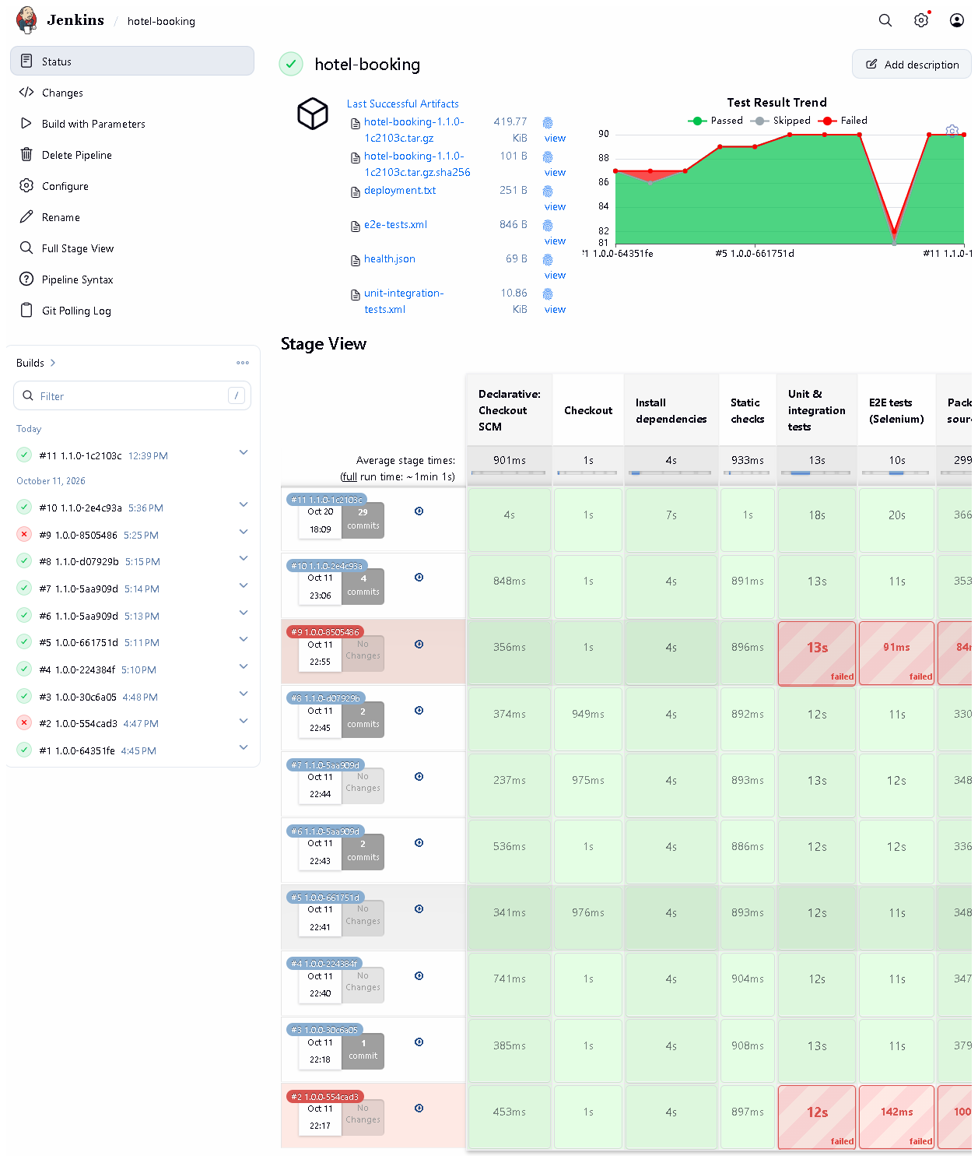 (part 1 of 2)
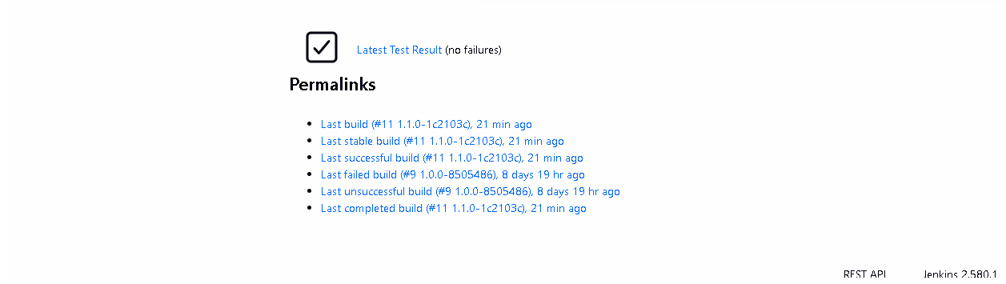 (part 2 of 2)
Figure 7.1 - Job hotel-booking: build history #1-#11, test-result trend, last artifacts and the stage view (captured 2026-10-20).
Notice: builds #2 and #9 red, all others green; each stage's duration per build.
Proves: Jenkins is installed, the job exists and has really executed builds.
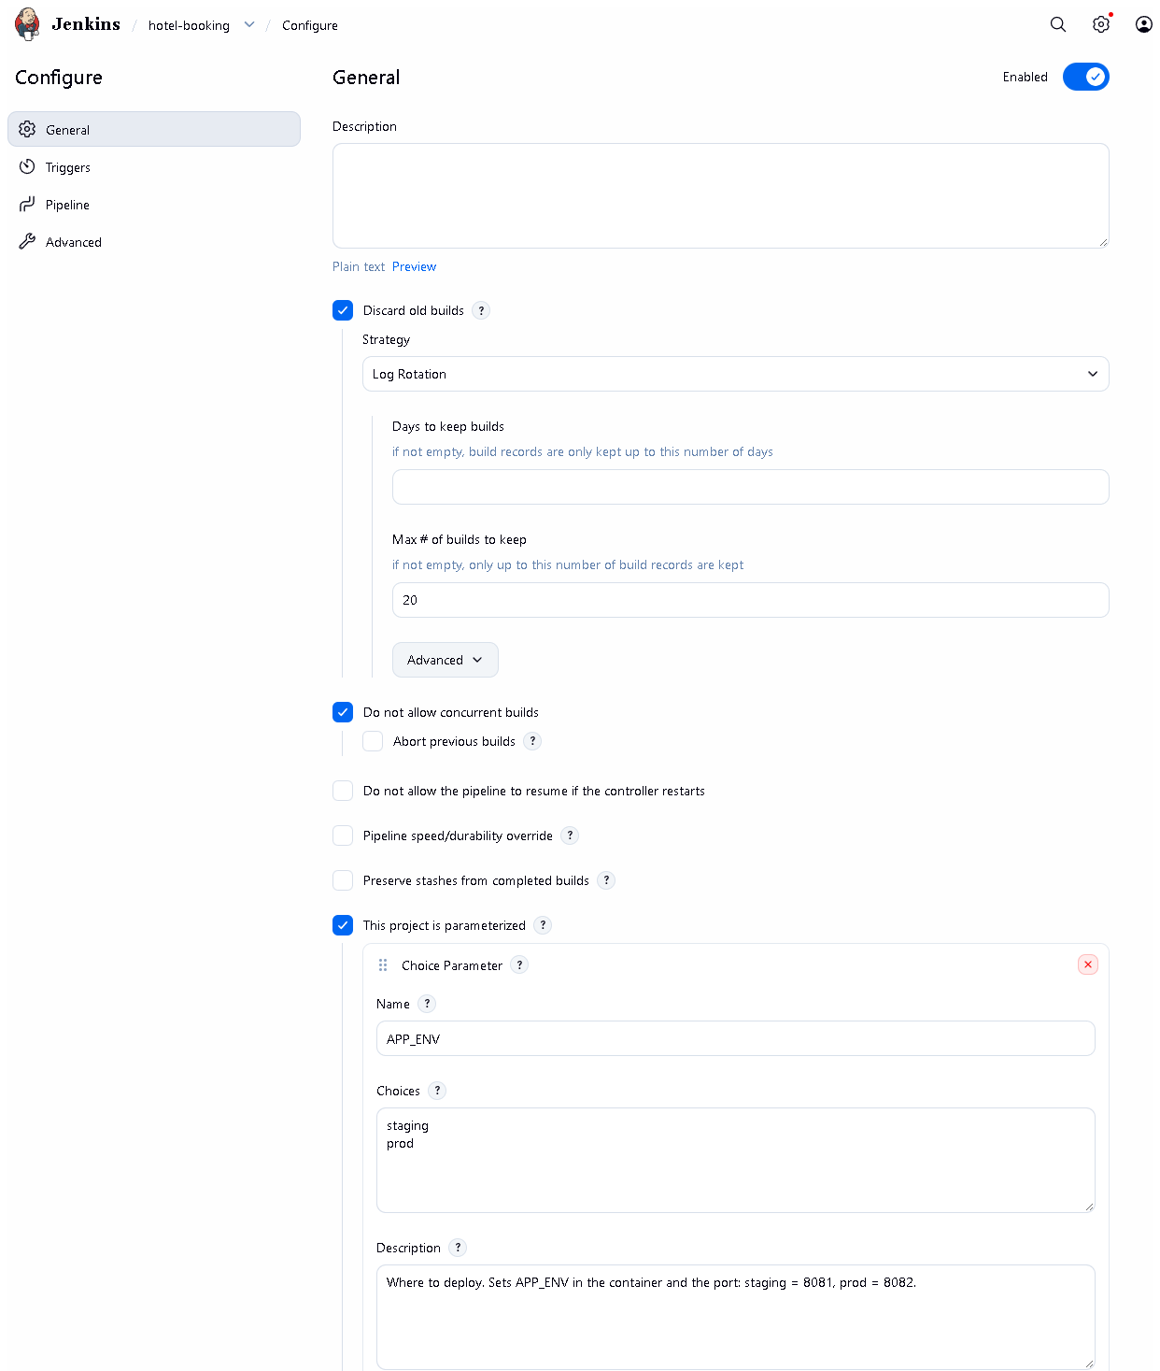 (part 1 of 3)
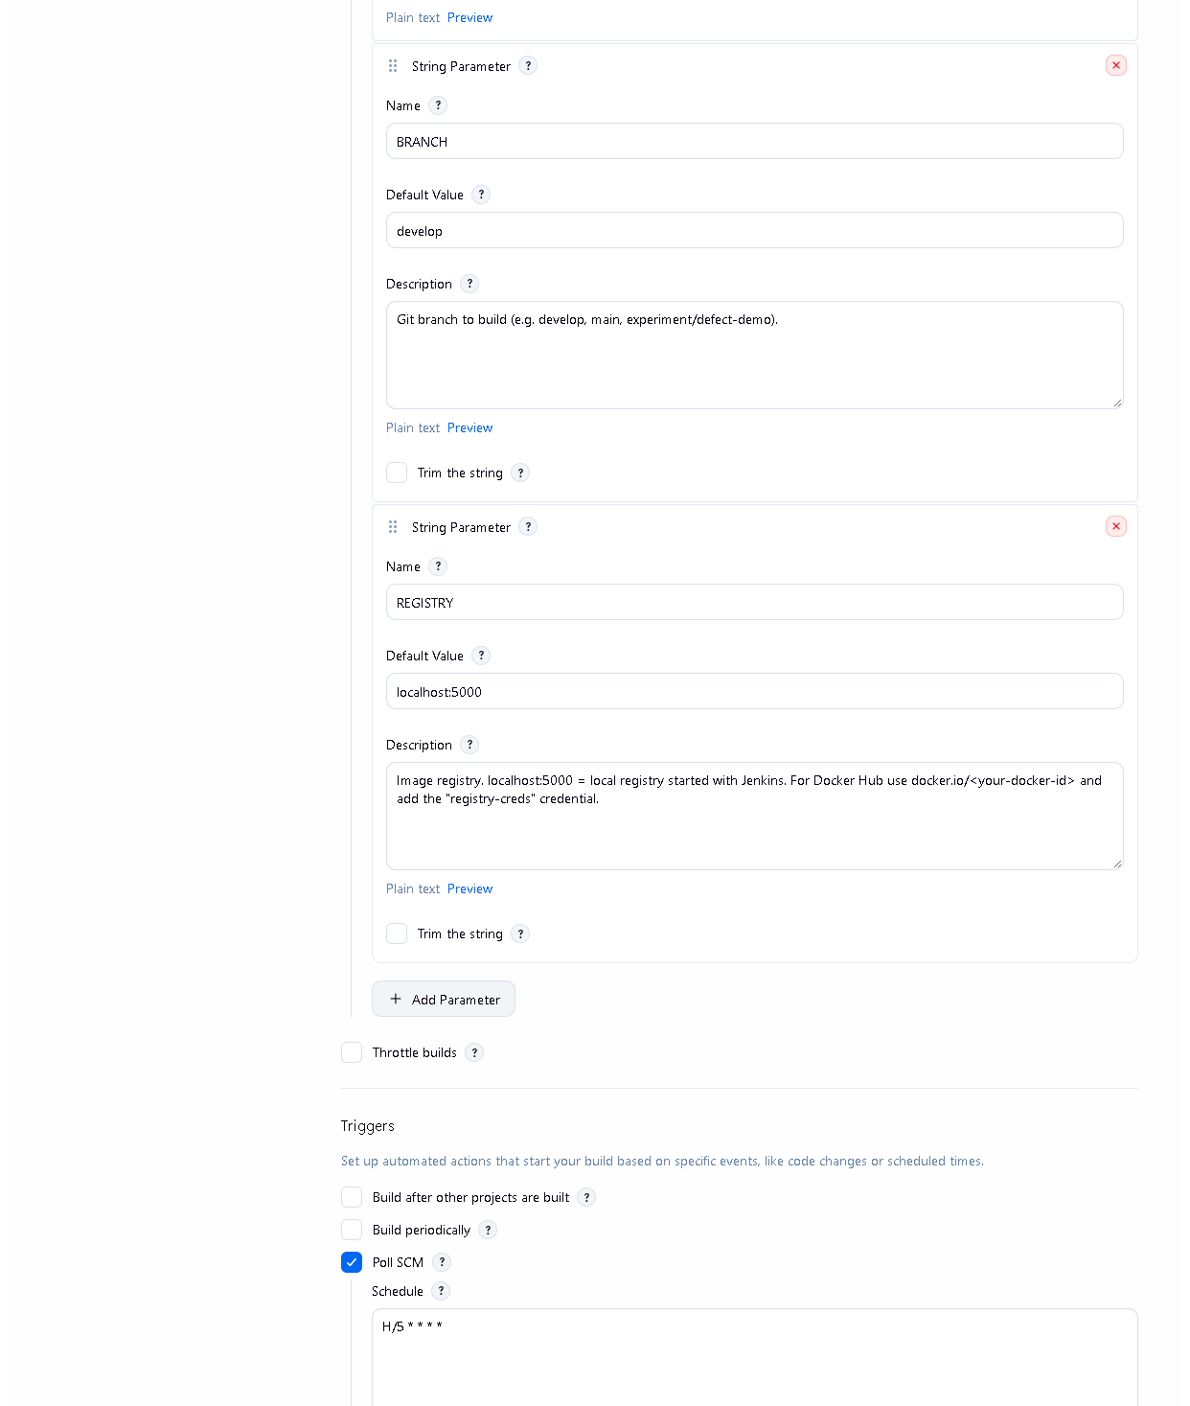 (part 2 of 3)
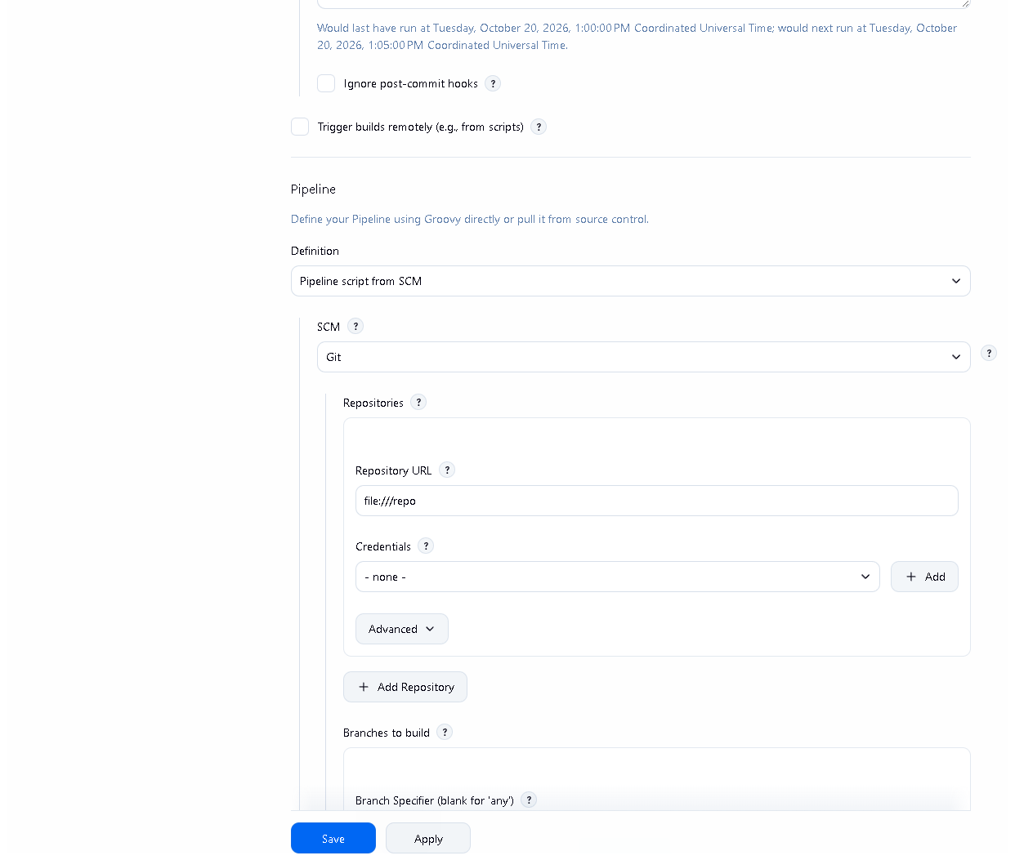 (part 3 of 3)
Figure 7.2 - Job configuration: the three parameters, "Do not allow concurrent builds", Poll SCM H/5 * * * *, and "Pipeline script from SCM" with repository file:///repo.
Proves: the trigger and SCM settings described above. No secret values appear on this page.
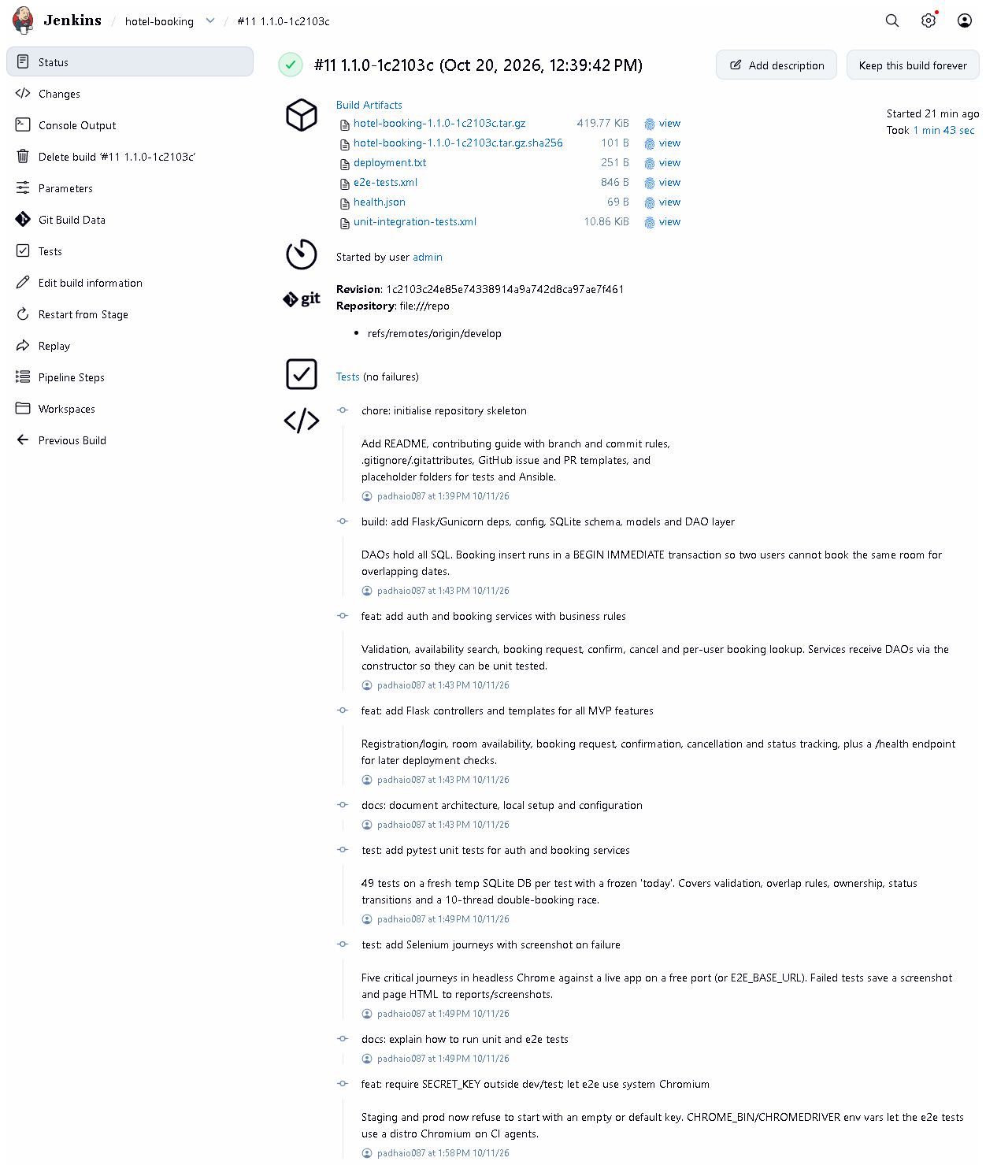 (part 1 of 3)
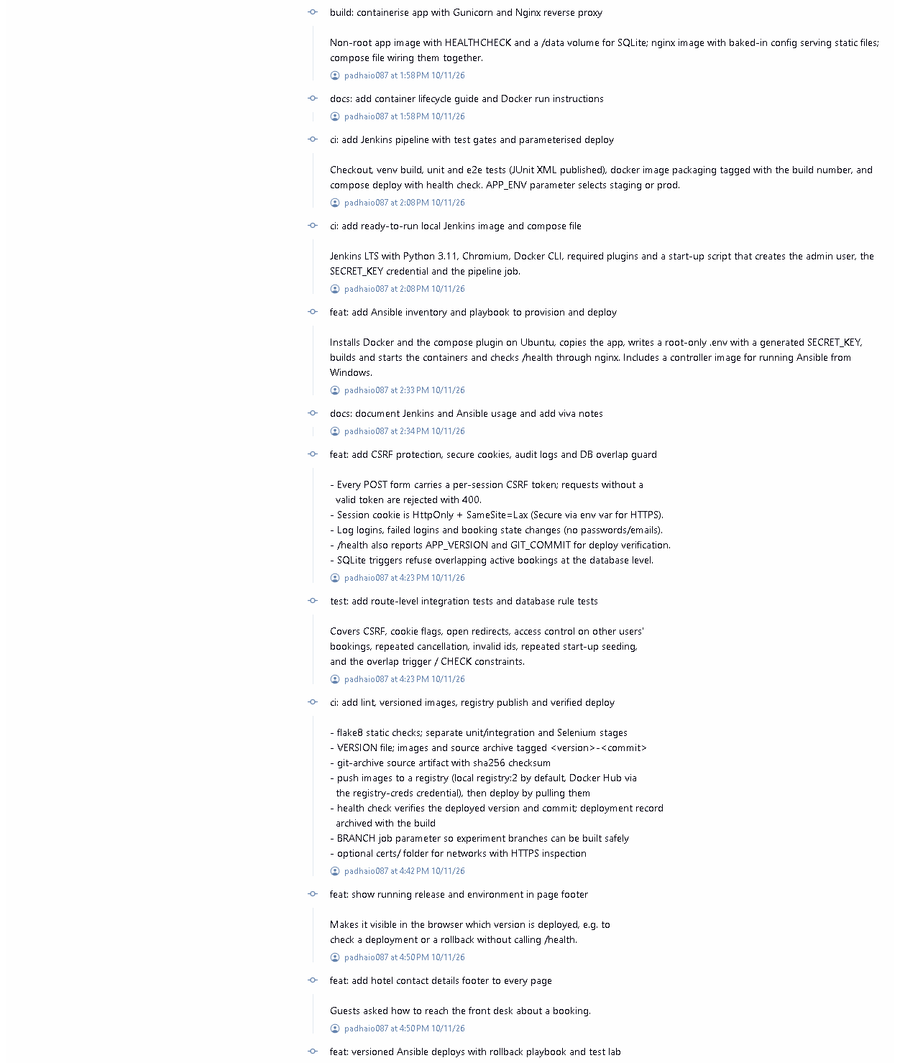 (part 2 of 3)
 (part 3 of 3)
Figure 7.3 - Build #11 (1.1.0-1c2103c), started 2026-10-20: result SUCCESS.
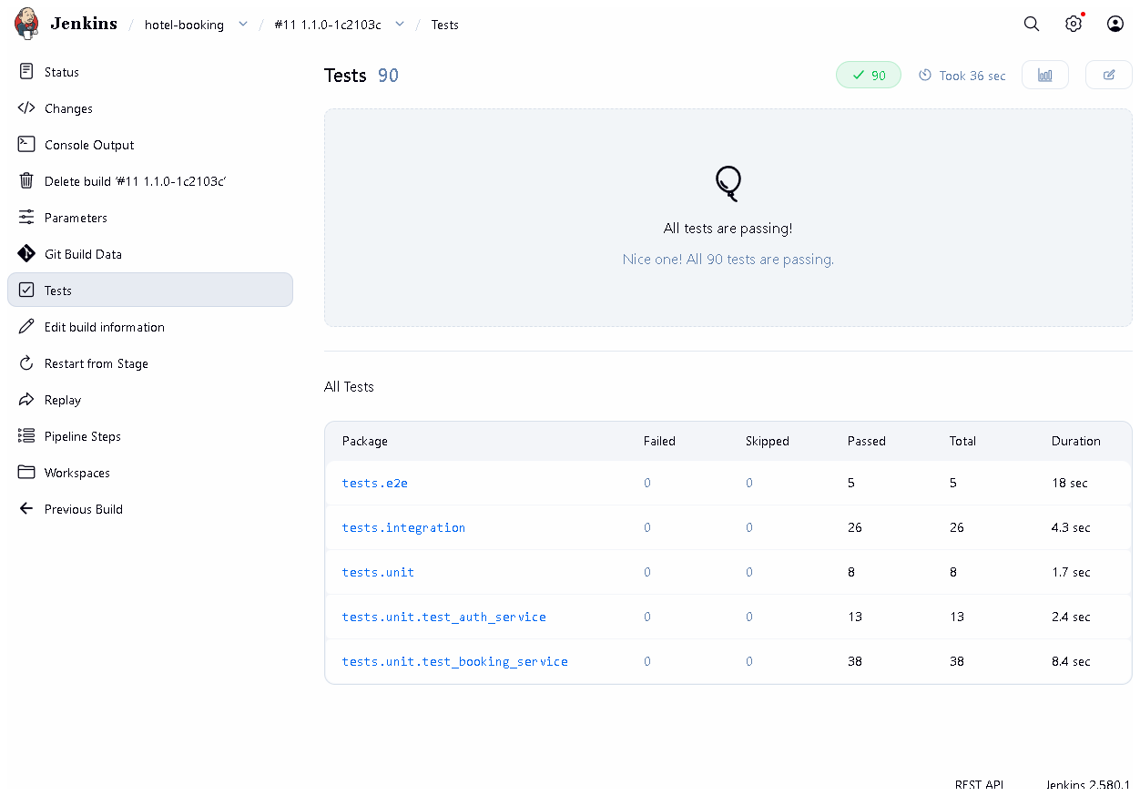
Figure 7.4 - Test report of build #11: 90 tests, 0 failures, grouped by package (unit, integration, e2e).
Proves: pytest ran inside Jenkins and its JUnit reports were published.
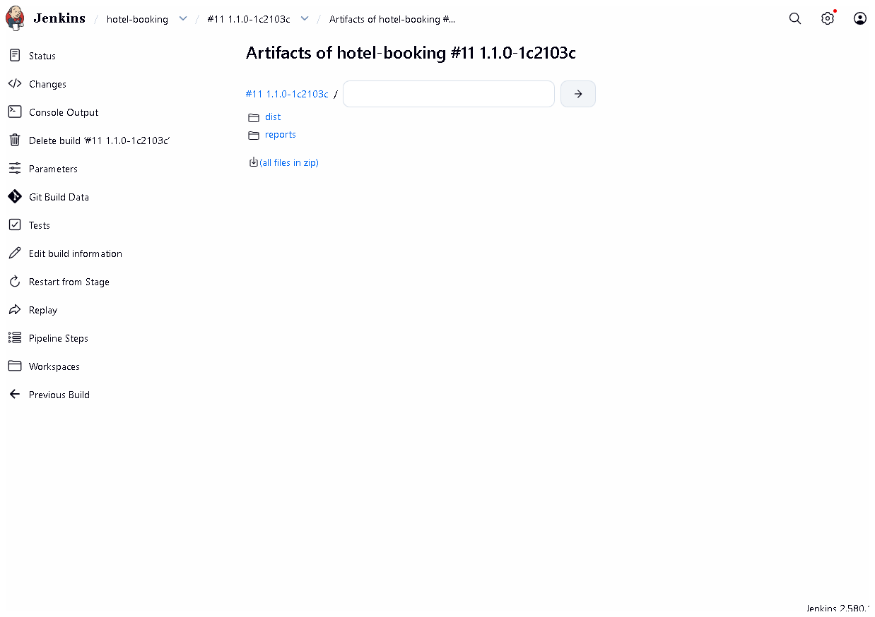
Figure 7.5 - Archived artifacts of build #11: source tarball + .sha256, test XML, health.json, deployment.txt.
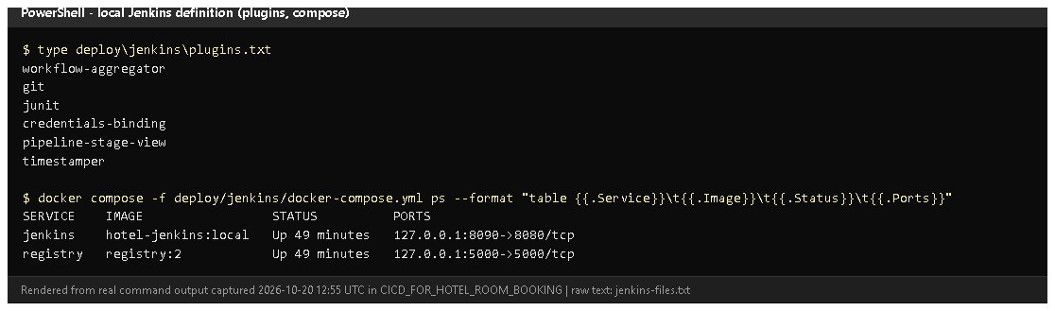
Figure 7.6 - deploy/jenkins/plugins.txt and the running Jenkins + registry containers (rendered from real output, 2026-10-20).

E. How to demonstrate this task to the professor (about 4 minutes)
Before the demo: Docker Desktop running ("Engine running" in its window).
Know the admin password: it is the JENKINS_ADMIN_PASSWORD= line in
deploy\jenkins\.env (do not show this file on screen).
- Make sure Jenkins runs (PowerShell):Expected: jenkins and registry "Up". If not: docker compose up -d, wait ~1 minute.
cd D:\DevOPS\CICD_FOR_HOTEL_ROOM_BOOKING\deploy\jenkins
docker compose ps
- Open http://localhost:8090, log in as admin.
- Open job hotel-booking. Say: "This is the CI job. The stage view shows
every build; red ones were deliberate experiments."
- Click Configure (read only - don't save). Show This project is
parameterized, Poll SCM H/5 * * * *, Pipeline script from SCM.
Say: "Jenkins checks the repository every five minutes. A webhook needs
Jenkins to be reachable from GitHub, which a laptop is not."
- Click Build with Parameters -> BRANCH=develop, APP_ENV=staging -> Build.
Watch the stage view (about 2 minutes). Say each stage name as it turns green.
- Open the new build -> Tests (90 passed) -> Build Artifacts (tarball, checksum, reports).
- Open Console Output and scroll to flake8 and 90 passed lines.
Recovery: login page not loading - wait: Jenkins needs ~60 s after a start.
"permission denied ... docker.sock" (Linux host only) - set DOCKER_GID in
deploy/jenkins/.env. Build cannot see your latest change - Jenkins builds
committed code only; commit first.

F. Expected screenshots for the final submission
- assets/task-07/jenkins-job-stage-view.png - exists, 2026-10-20.
- assets/task-07/jenkins-job-configuration.png - exists, 2026-10-20.
- assets/task-07/jenkins-build-11-summary.png - exists, 2026-10-20.
- assets/task-07/jenkins-build-11-tests.png - exists, 2026-10-20.
- assets/task-07/jenkins-build-11-artifacts.png - exists, 2026-10-20.
- assets/task-07/jenkins-files.png - exists, 2026-10-20.
- assets/task-07/github-webhook.png - only if a webhook is configured on a public Jenkins (manual; currently not applicable).

G. Probable viva questions and answers
- What is Jenkins? An automation server that runs build/test/deploy jobs automatically.
- What is Continuous Integration? Automatically building and testing every change soon after it is committed, so errors are found quickly.
- Installed Jenkins vs Jenkinsfile vs executed build? The server, the
pipeline definition stored in Git, and an actual numbered run with results.
Only a build (e.g. #11) proves it works.
- How is your build triggered? Poll SCM every ~5 minutes, plus manual
Build with Parameters. A webhook isn't possible because GitHub cannot reach localhost.
- How do you install dependencies reproducibly? A fresh venv each build
and pip install -r requirements-dev.txt with pinned versions (Flask==3.1.3, pytest==9.1.1...).
- What does flake8 check? Syntax errors, undefined names, unused imports and style (config in .flake8, line length 110).
- Where do the test reports come from? pytest writes JUnit XML
(--junitxml), and the JUnit plugin shows them on the Tests page.
- (Project-specific) What artifacts does a build keep? The source
archive hotel-booking-<version>-<commit>.tar.gz with its sha256, test XML,
health.json and deployment.txt.
- (Project-specific) Why run Jenkins in Docker? The whole server
(plugins, Python, Chromium, Docker CLI, the job) is defined in files in
deploy/jenkins/ and starts with one command; nothing is clicked by hand.
- Is this a Maven job? No. The project is Python; pip, flake8 and
pytest do the jobs Maven would do for Java. I'll confirm with the professor that this is acceptable.
- What is an agent? The machine that executes the steps; here the
built-in node (the Jenkins container), which uses the host's Docker through the mounted socket.

H. Common mistakes and troubleshooting
Symptom | Cause | Inspect | Fix | Confirm
http://localhost:8090 not reachable | Docker Desktop or the container stopped | docker compose ps in deploy\jenkins | start Docker Desktop; docker compose up -d | login page loads
Build doesn't include my change | change not committed | git status | commit (and choose that branch in BRANCH) | console "Building commit "
Stage "Install dependencies" fails with SSL errors | antivirus HTTPS scanning | console output | put the root CA in certs/ and rebuild Jenkins (docker compose up -d --build) | stage green
Login fails | wrong password | deploy\jenkins\.env (privately) | use that value; it is set on first start only | dashboard opens
Tests page shows old results | stale report files (fixed) | Checkout stage runs rm -rf reports dist | already fixed in fix/jenkins-stale-reports | build #9 lists only tests that ran

I. Quick revision notes
Five key points
- Jenkins runs in Docker, defined in deploy/jenkins/, at http://localhost:8090.
- Job hotel-booking = pipeline from SCM (Jenkinsfile), parameters APP_ENV / BRANCH / REGISTRY.
- CI stages: checkout, venv + pinned pip install, compileall + flake8, pytest (85 + 5).
- JUnit reports and artifacts (tarball + sha256) are kept with each build.
- Trigger = polling (no public URL for a webhook); Python tools, not Maven.
30-60 second explanation
"Jenkins runs in a Docker container that is completely defined in the
repository - plugins, Python, Chromium for Selenium and the job itself. The
job hotel-booking reads the Jenkinsfile from Git. For each build it checks
out the code, creates a fresh virtual environment, installs pinned
dependencies, runs flake8 and all 90 tests, publishes the JUnit reports and
archives a source package with a checksum. Build #11, run today, passed all
stages. It polls Git every five minutes because a webhook needs a public Jenkins."
Caveat: no webhook; Python tooling instead of a Maven job (needs approval).
Readiness checklist
- â˜ Docker Desktop running; docker compose ps shows Jenkins up.
- â˜ I can log in and start Build with Parameters.
- â˜ I can open Tests and Artifacts of a build.
- â˜ I can explain polling vs webhook and Python vs Maven.

