Task 8 - Pipeline as Code and Server Deployment

A. Task title and objective
Task 8: Pipeline as Code and Server Deployment
Objective: describe the whole build-test-package-deploy process in a
Jenkinsfile stored in Git, parameterise at least one environment-specific
setting, keep secrets out of the repository, and deploy automatically after
all quality gates pass, followed by a health check.
Professor's required deliverables
- A Jenkinsfile with stages for checkout, dependencies, static checks, tests, packaging, Docker build, deployment and health check
- At least one parameterised environment-specific setting
- Configuration through environment variables / files; passwords, keys and registry credentials outside source control
- Deployment to an available target (local deployment acceptable if no server exists - documented)
Current status: Implemented and verified. Jenkins build #11 on
2026-10-20 ran all 10 stages, deployed release 1.1.0-1c2103c to the
staging environment and the health check confirmed the version and
commit (Figures 8.3-8.5).
Deployment target: a Docker Compose stack on the same machine as Jenkins
(local "staging" on port 8081 and "prod" on port 8082). No separate remote
server is used by Jenkins; remote-server deployment is done by Ansible (Task 13).

B. Explanation for a complete beginner
An everyday picture. A recipe card that lists every step in order
("preheat, mix, bake 20 minutes, test with a toothpick") lets anyone bake the
same cake. A Jenkinsfile is the recipe card for releasing software: it
lists every step, and because it lives in Git, changes to the recipe are
reviewed and versioned like code.
Term | Meaning
Pipeline as code | the pipeline is a text file in the repository, not settings clicked in a web UI
Stage | one named step group (e.g. "Unit & integration tests"); stages run in order
Declarative pipeline | Jenkins' structured syntax: pipeline { parameters {...} stages {...} post {...} }
Parameter | a value chosen when starting a build (e.g. staging or prod)
Environment variable | a named value the commands can read (e.g. HOST_PORT)
Credential | a secret stored encrypted in Jenkins and injected only when needed
Deployment | starting the new version where users can reach it
Health check | asking the running app "are you OK, and which version are you?" (GET /health)
Quality gate | a check that must pass before the next step is allowed; here every test stage comes before Deploy

Why it helps: the same steps run every time, nothing is forgotten,
history shows who changed the process, and a broken step stops the release.

C. What was actually implemented
File: Jenkinsfile (declarative pipeline).
Parameters (lines 19-29)
Parameter | Values | Effect
APP_ENV | staging / prod | sets APP_ENV in the container, the port (staging 8081, prod 8082) and the compose project name hotel-staging / hotel-prod (separate containers and separate database volume)
BRANCH | e.g. develop, main | which Git branch is built
REGISTRY | localhost:5000 (default) or docker.io/<user> | where images are pushed and pulled

Derived variables (lines 45-51): HOST_PORT, COMPOSE_PROJECT_NAME. In the
Checkout stage: APP_VERSION (from the VERSION file), GIT_SHORT,
IMAGE_TAG = <version>-<commit>, IMAGE_PREFIX.
Stages and what build #11 did
# | Stage (line) | What it does | Build #11 result
1 | Checkout (55) | checkout scm, delete old reports/ + dist/, compute tag | commit 1c2103c, tag 1.1.0-1c2103c
2 | Install dependencies (76) | fresh venv, pinned pip install | ok
3 | Static checks (88) | compileall, flake8 | no findings
4 | Unit & integration tests (99) | pytest, JUnit XML | 85 passed
5 | E2E tests (Selenium) (105) | headless Chromium | 5 passed
6 | Package source (113) | git archive + sha256sum | hotel-booking-1.1.0-1c2103c.tar.gz
7 | Build images (127) | docker build app + nginx, with APP_VERSION/GIT_COMMIT | 2 images
8 | Publish images (141) | docker push to the registry | pushed (digests in console)
9 | Deploy (163) | withCredentials(hotel-secret-key); docker compose pull; docker compose up -d --no-build --wait | containers healthy
10 | Health check (177) | wget /health through Nginx; grep the expected version and commit; write reports/deployment.txt | {"commit":"1c2103c","env":"staging","status":"ok","version":"1.1.0"}

Secrets stay outside Git
withCredentials([string(credentialsId: 'hotel-secret-key', variable: 'SECRET_KEY')]) {
sh '''
docker compose pull
docker compose up -d --no-build --wait --wait-timeout 120
'''
}
- hotel-secret-key is a Jenkins secret text credential (created from the git-ignored deploy/jenkins/.env); Jenkins masks it in logs. The build #11 log was searched for the key: not present.
- A remote registry password would be the credential registry-creds, used with docker login --password-stdin.
- docker-compose.yml refuses to start without SECRET_KEY (${SECRET_KEY:?...}), and the app refuses to start in staging/prod with a missing or default key.
Health check stage (simplified excerpt of lines 177-200 - the real file
retries wget up to 5 times and escapes the quotes for Groovy as \\"; the
# comments are added here)
docker compose exec -T nginx wget -qO- http://127.0.0.1/health > reports/health.json
grep -q "\"version\":\"$APP_VERSION\"" reports/health.json # right release?
grep -q "\"commit\":\"$GIT_SHORT\"" reports/health.json # right commit?
If the running app reports a different version or commit, grep fails and
the build fails.
Deployment record (artifact reports/deployment.txt of build #11):
environment=staging
branch=develop
version=1.1.0
commit=1c2103c
image_tag=1.1.0-1c2103c
app_image=localhost:5000/hotel-booking-app:1.1.0-1c2103c
nginx_image=localhost:5000/hotel-booking-nginx:1.1.0-1c2103c
url=http://localhost:8081
jenkins_build=null
jenkins_build=null is a small known issue: Jenkins' own "Jenkins URL"
setting was never filled in, so BUILD_URL is empty. Fix: Manage Jenkins ->
System -> Jenkins Location -> Jenkins URL = http://localhost:8090/.

D. Screenshots and evidence
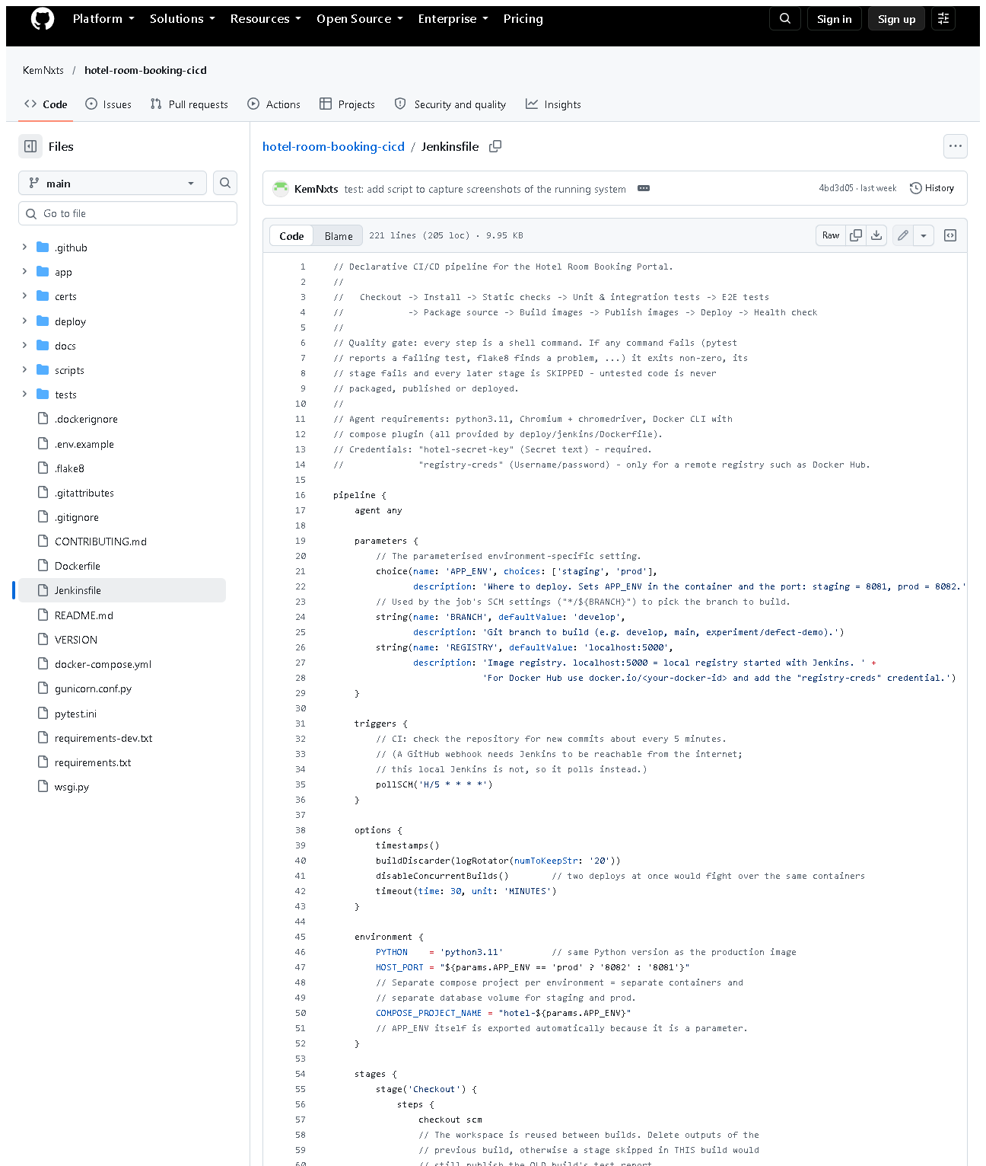 (part 1 of 4)
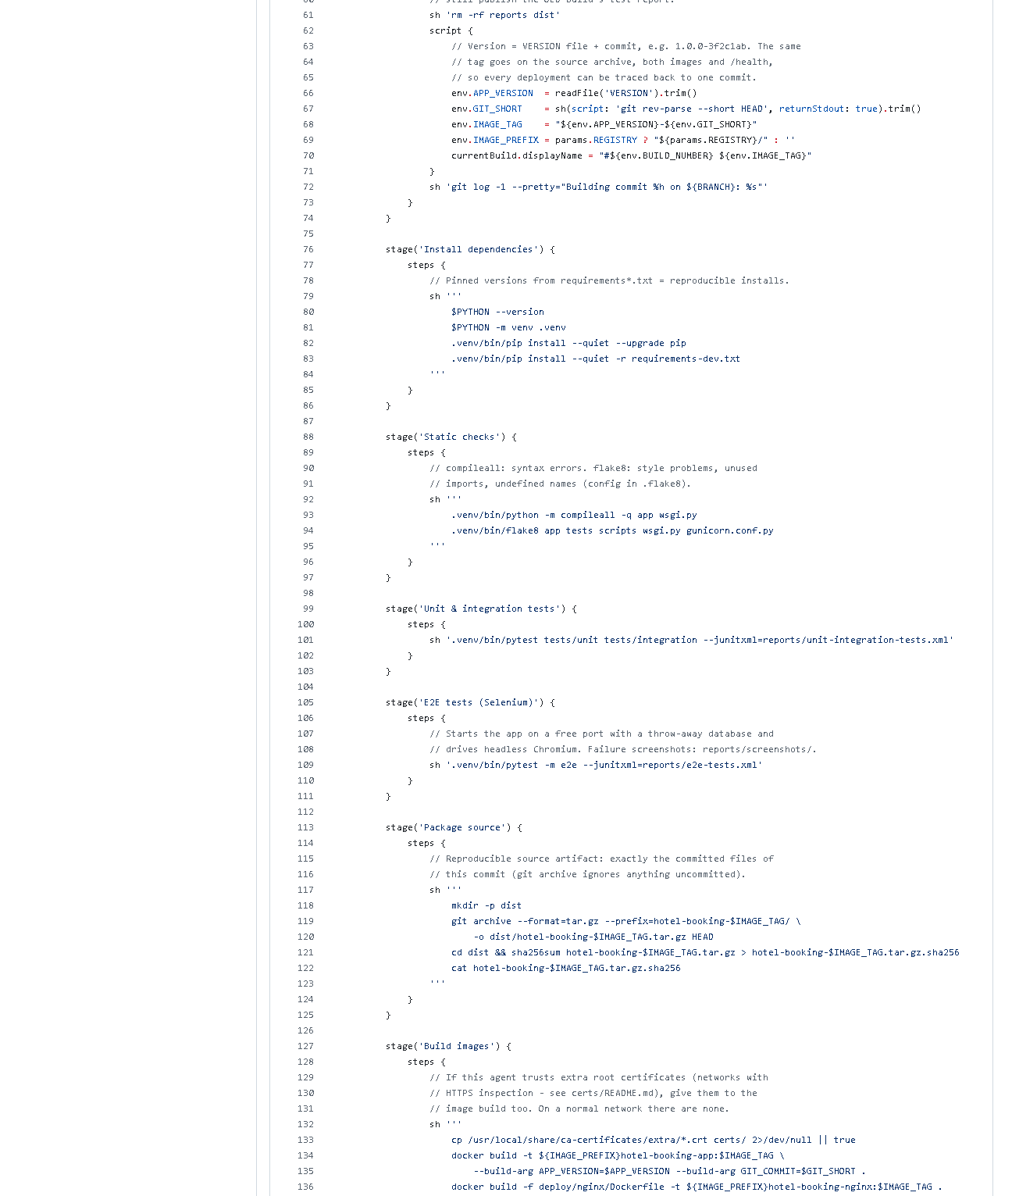 (part 2 of 4)
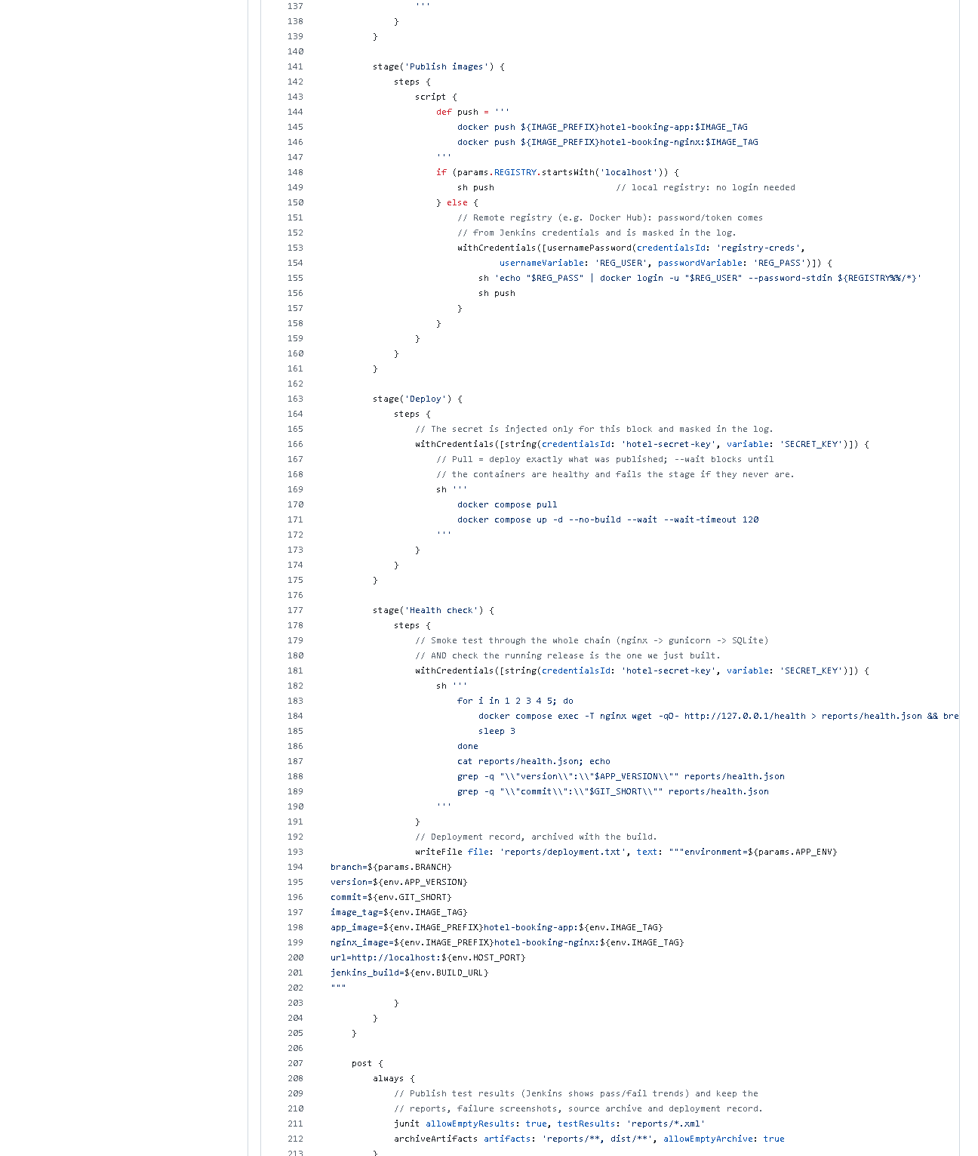 (part 3 of 4)
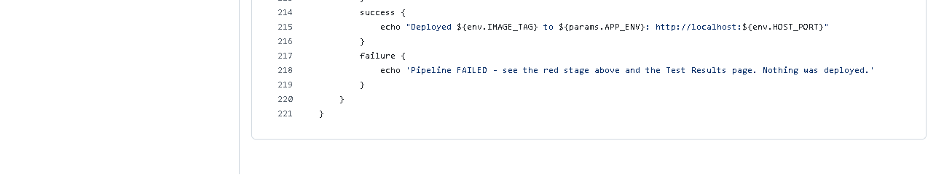 (part 4 of 4)
Figure 8.1 - Jenkinsfile on GitHub (captured 2026-10-20). Notice: parameters, triggers { pollSCM }, options, environment, the ten stages and post.
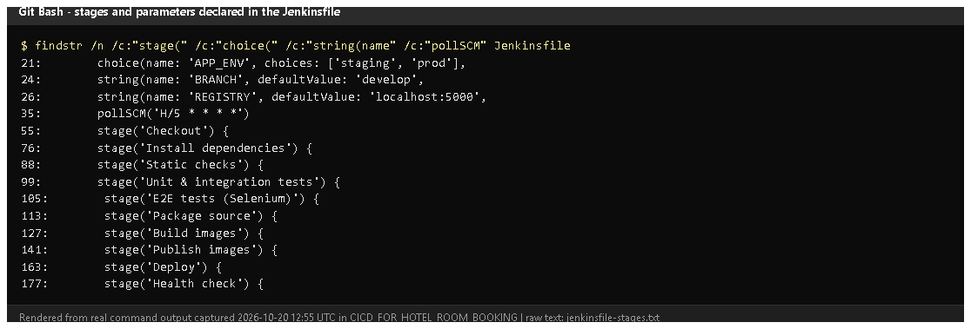
Figure 8.2 - Line numbers of every stage and parameter (findstr on the Jenkinsfile, rendered from real output).
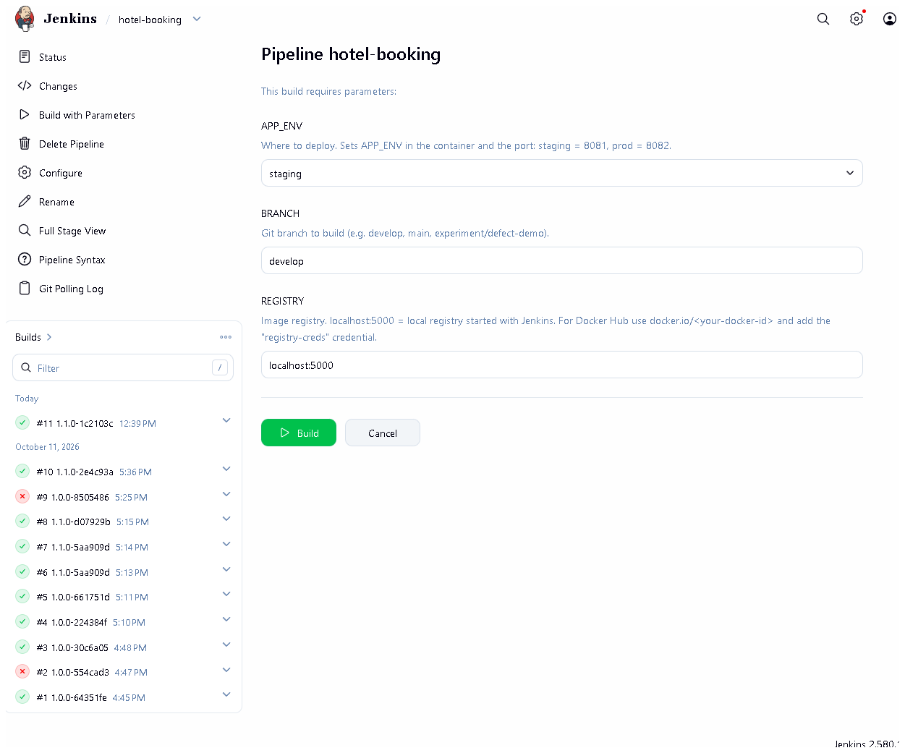
Figure 8.3 - The Build with Parameters form: APP_ENV, BRANCH, REGISTRY.
Proves: the environment-specific setting is a real parameter.
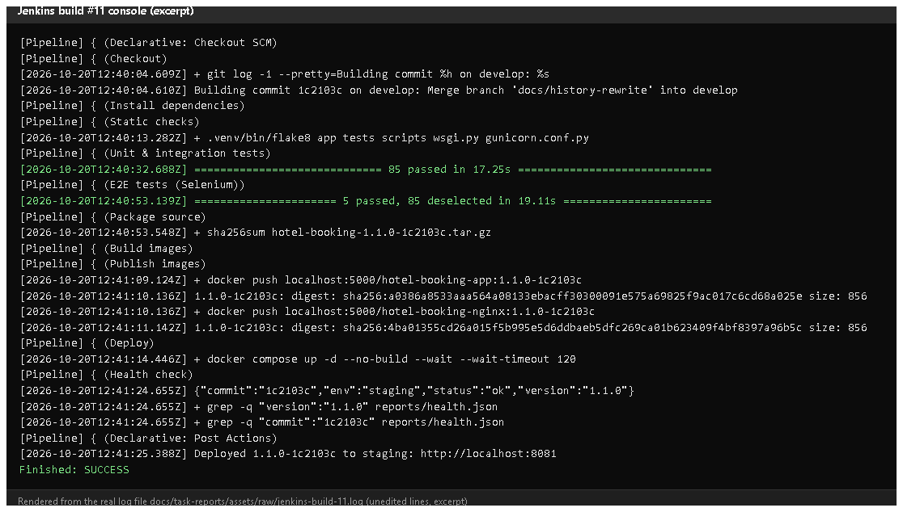
Figure 8.4 - Build #11 console excerpt (rendered from the saved console log): each stage starting, 85 + 5 tests passed, the archive checksum, image pushes with digests, /health and "Deployed 1.1.0-1c2103c to staging".
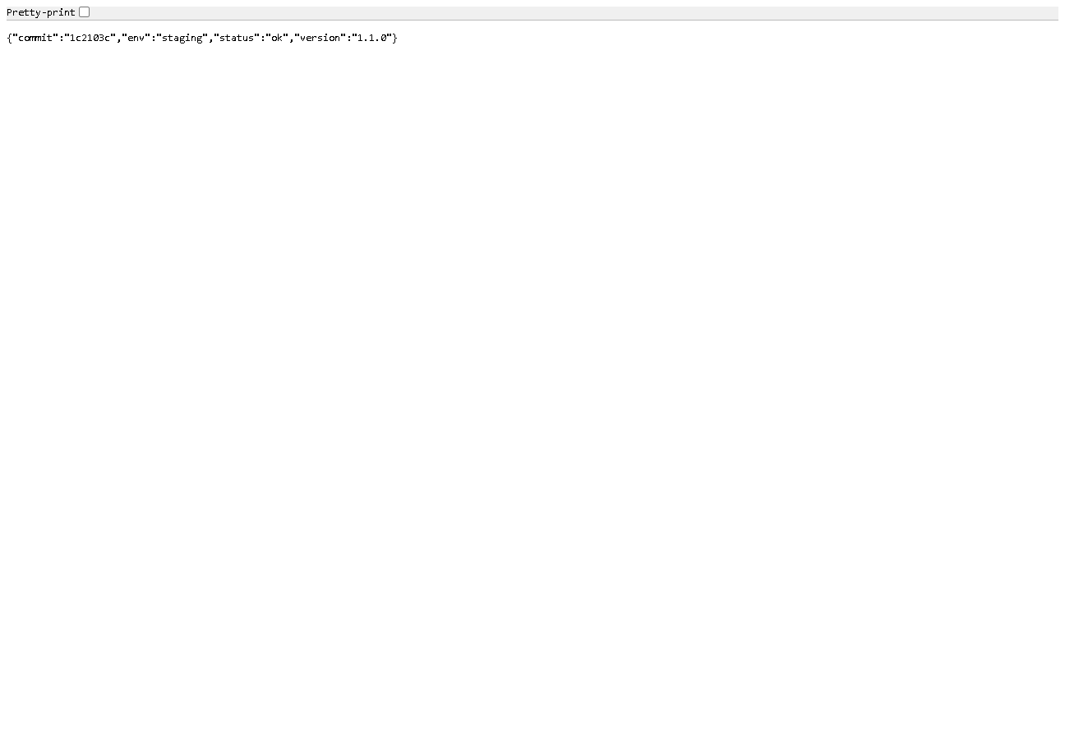
Figure 8.5 - http://localhost:8081/health in a browser after build #11: commit 1c2103c, env staging, version 1.1.0.
Proves: the deployed app is the exact commit that was built and tested.
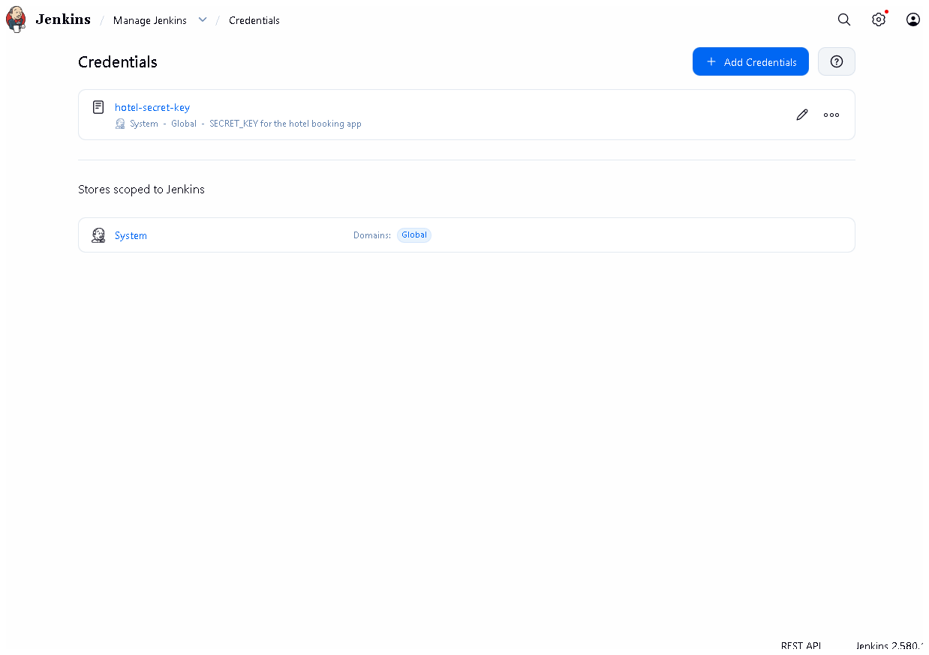
Figure 8.6 - Manage Jenkins -> Credentials: hotel-secret-key exists; its value is never displayed.

E. How to demonstrate this task to the professor (about 5 minutes)
Before the demo: Docker Desktop running; Jenkins up (docker compose ps in deploy\jenkins); VS Code open on the project.
- Open Jenkinsfile in VS Code. Walk through: parameters (APP_ENV),
environment (HOST_PORT), then each stage(...). Say: "The whole
pipeline is code in Git, so it is versioned and reviewed like the app."
- Start a deploy: Jenkins -> hotel-booking -> Build with Parameters ->
APP_ENV = staging, BRANCH = develop -> Build.
- Narrate the stage view as stages turn green (about 2 minutes). Point
out that Deploy is after both test stages - "that is the quality gate".
- Open the build's Console Output, search (Ctrl+F) for Deployed and
"status":"ok".
- Prove it in a browser: http://localhost:8081/health - the commit
equals the commit shown in the console line "Building commit ...".
- Show the parameter effect: run again with APP_ENV = prod and BRANCH = main;
then http://localhost:8082/health shows "env":"prod". Say: "Same pipeline,
different environment, chosen by one parameter."
- Show secrets handling: Manage Jenkins -> Credentials (value hidden);
in VS Code show withCredentials in the Deploy stage.
Recovery: Deploy stage "port is already allocated" - another program uses
8081/8082; stop it or docker compose -p hotel-staging down and rebuild.
Health check fails because of an old container - run the build again; it
pulls and recreates the containers.

F. Expected screenshots for the final submission
- assets/task-08/github-file-Jenkinsfile.png - exists, 2026-10-20.
- assets/task-08/jenkinsfile-stages.png - exists, 2026-10-20.
- assets/task-08/jenkins-build-with-parameters.png - exists, 2026-10-20.
- assets/task-08/jenkins-build-11-console.png - exists, 2026-10-20 (rendered from the real console log).
- assets/task-08/staging-health-after-build-11.png - exists, 2026-10-20.
- assets/task-08/jenkins-credentials-masked.png - exists, 2026-10-20.

G. Probable viva questions and answers
- What is "pipeline as code"? The pipeline is a file (Jenkinsfile) in
the repository, so it is versioned, reviewed and identical on every run.
- Name your stages in order. Checkout, Install dependencies, Static
checks, Unit & integration tests, E2E tests, Package source, Build images,
Publish images, Deploy, Health check.
- Which setting is parameterised? APP_ENV: staging or prod - it changes
the app environment, the port (8081/8082) and the compose project (separate data).
- How are secrets handled? SECRET_KEY is a Jenkins credential injected
with withCredentials only in Deploy/Health check and masked in logs; nothing secret is in Git.
- What happens if a test fails? That stage fails and every later stage,
including Deploy, is skipped (build #2 shows this).
- (Project-specific) How do you know the deployed version is the tested one?
Images are tagged <version>-<commit>; the health-check stage compares the
version and commit returned by /health with the ones built.
- (Project-specific) Where does it deploy? To a Docker Compose stack on
the Jenkins host: staging :8081, prod :8082. Real servers are handled by Ansible.
- Why --wait on docker compose up? It waits until containers are
healthy (Docker HEALTHCHECK) and fails the stage if they never are.
- What is post { always } for? It publishes test reports and archives
artifacts even when the build fails, so failures can be analysed.
- Why disableConcurrentBuilds? Two deployments at the same time would fight over the same containers.
- What is deployment.txt? A record archived with each build: environment, branch, version, commit, image names, URL.

H. Common mistakes and troubleshooting
Symptom | Cause | Inspect | Fix | Confirm
Health check stage fails on grep | old container still running another version | console: cat reports/health.json | rerun; check no other stack uses the port | /health shows the new commit
Deploy: SECRET_KEY is not set | credential missing | Manage Jenkins -> Credentials | recreate hotel-secret-key (secret text) | Deploy green
jenkins_build=null in deployment record | Jenkins URL not configured | Manage Jenkins -> System | set Jenkins URL http://localhost:8090/ | next record shows the build URL
Publish images: connection refused | registry container stopped | docker compose ps in deploy\jenkins | docker compose up -d registry | push succeeds
Changes in the Jenkinsfile ignored | not committed / wrong branch | console "Building commit" | commit and build that branch | stage list updated

I. Quick revision notes
Five key points
- Jenkinsfile = the pipeline as code, 10 stages, versioned in Git.
- Parameter APP_ENV chooses staging (:8081) or prod (:8082).
- Secrets come from Jenkins credentials (withCredentials), never from Git.
- Deploy runs only after lint + 90 tests; then /health must match version and commit.
- Build #11 (2026-10-20) deployed 1.1.0-1c2103c to staging and passed.
30-60 second explanation
"Our pipeline is a Jenkinsfile in the repository. It checks out a branch,
installs pinned dependencies, runs flake8 and all tests, packages the source,
builds Docker images tagged with version and commit, pushes them to a
registry, deploys them with Docker Compose and finally checks that /health
reports exactly that version and commit. The APP_ENV parameter chooses
staging or prod. The secret key is a Jenkins credential, never in Git. Build
#11 today deployed commit 1c2103c to staging successfully."
Caveat: Jenkins deploys to Docker on its own host, not a remote server; jenkins_build in the record is empty until the Jenkins URL is set.
Readiness checklist
- â˜ I can name the 10 stages in order.
- â˜ I can run a staging and a prod build and show both /health pages.
- â˜ I can point to withCredentials and explain masking.
- â˜ I can explain why the health check compares the commit.

