Task 9 - Selenium Test Design and Local Execution

A. Task title and objective
Task 9: Selenium Test Design and Local Execution
Objective: automate the most important user journeys in a real web
browser, with stable locators, explicit waits, clear assertions and isolated
test data; run them locally; produce reports and screenshots on failure.
Professor's required deliverables
- 3-5 meaningful Selenium journeys (register/login, availability, booking, confirmation/status, cancellation)
- Stable element selectors, explicit waits, assertions, deterministic test data
- Local execution (the brief mentions Maven - see the note below)
- Test reports and screenshots on failure
- Clean-up / isolated test database so repeated runs stay reliable
Current status: Implemented and verified. On 2026-10-20: 5 of 5
journeys passed locally (Figure 9.1), the full suite of 90 tests passed
(Figure 9.2), and the screenshot-on-failure feature was demonstrated with a
temporary, deliberately failing test (Figures 9.4-9.5) that was deleted afterwards.
Maven note: the tests are Python and run with pytest, not Maven.
pytest writes the same JUnit-XML report format that Maven would, which
Jenkins displays. If running through Maven is compulsory, this must be
discussed with the professor.

B. Explanation for a complete beginner
An everyday picture. A robot sits at the computer, opens Chrome, types
into the forms and clicks the buttons exactly like a guest - then checks
that the right message appears. If something is wrong it takes a photo of
the screen. That robot is Selenium.
Term | Meaning | In this project
Browser automation | a program controls a real browser | headless Chrome (no window)
WebDriver | the standard interface that lets code control a browser | selenium.webdriver.Chrome
Locator / selector | how the test finds an element on the page | By.ID, "booking-status"
Stable locator | one that does not change when the design changes | element ids like book-201, confirm-btn
Explicit wait | "wait until X is visible (max 10 s)", then continue at once | WebDriverWait(...).until(...)
Assertion | the check that decides pass/fail | assert status(driver) == "PENDING"
Test data | the users, dates and bookings a test creates | unique e-mails, random far-future dates
Fixture | pytest setup code a test can request | driver (a browser), base_url (a running app)
Headless | the browser runs without a visible window | default; HEADLESS=0 shows it

Why not time.sleep(3)? Sleeping either wastes time (page was ready
earlier) or fails (page was slower). Explicit waits are faster and more reliable.
Unit vs integration vs Selenium tests (all three exist here)
Type | What it tests | Speed | Count
Unit | one service/database rule, no web server | ms | 59
Integration | real routes through Flask's test client (HTTP status, redirects, CSRF) | fast | 26
Selenium (end-to-end) | a full journey in a real browser | seconds each | 5

C. What was actually implemented
Files: tests/e2e/test_journeys.py (journeys and helpers) and
tests/e2e/conftest.py (fixtures and the failure hook).
The five journeys (tests/e2e/test_journeys.py)
# | Test (line) | What the robot does | Key assertions
1 | test_journey_1_register_new_guest (81) | registers a new guest | name in the navbar, "account has been created", now on /rooms
2 | test_journey_2_login_rejects_wrong_password_then_accepts_right_one (89) | registers, logs out, wrong password, right password | "Invalid email or password", still logged out; then "Welcome back"
3 | test_journey_3_search_request_and_confirm_booking (108) | searches dates, books the first free room, confirms | status PENDING with the right dates; then CONFIRMED; no second Confirm button
4 | test_journey_4_cancel_booking_and_track_status (128) | books, confirms, cancels via the dialog, opens My bookings | dialog appears and status is still CONFIRMED until confirmed; then CANCELLED in detail and in My bookings
5 | test_journey_5_booked_room_is_unavailable_to_another_guest (150) | guest A books a room; guest B searches the same dates | the room shows "Booked" for B and has no Book button

Helpers (lines 22-75): wait() (explicit wait), stay() (dates),
unique_email(), register(), logout(), search(), book_first_free_room(), status().
Stable locators - ids added to the templates for testing: register-btn,
login-btn, nav-user, search-btn, availability-table, room-<number>,
book-<number>, booking-status, confirm-btn, cancel-btn,
cancel-confirm-btn, booking-row-<id>.
Explicit wait example (lines 22-23):
def wait(driver, condition, timeout=10):
return WebDriverWait(driver, timeout).until(condition) # continue as soon as true, fail after 10 s
Dates are set with JavaScript (line 60) because typing into
<input type="date"> depends on the computer's date format (dd/mm vs mm/dd).
Deterministic, isolated test data
- base_url fixture (conftest.py line 26): starts the real app on a free port
(make_server(..., 0, ...), line 36) with a throw-away SQLite database
in a temporary folder, deleted after the run - repeated runs never interfere.
- To test a running deployment instead, set E2E_BASE_URL; then the tests
use unique e-mails (uuid) and random dates 200-2000 days ahead
(_SESSION_OFFSET, line 17) and book whichever room is free.
Screenshots on failure (conftest.py)
- The hook pytest_runtest_makereport (line 80) stores each test's result on the test item.
- After the test, the driver fixture checks rep_call.failed (line 65).
- If failed, _save_failure_artifacts (line 71) saves reports/screenshots/<test>.png and the page HTML.
- Jenkins archives reports/** with the build.
Reports: pytest --junitxml=reports/e2e-tests.xml (as in the Jenkinsfile) -
JUnit XML that Jenkins shows on the Tests page.

D. Screenshots and evidence
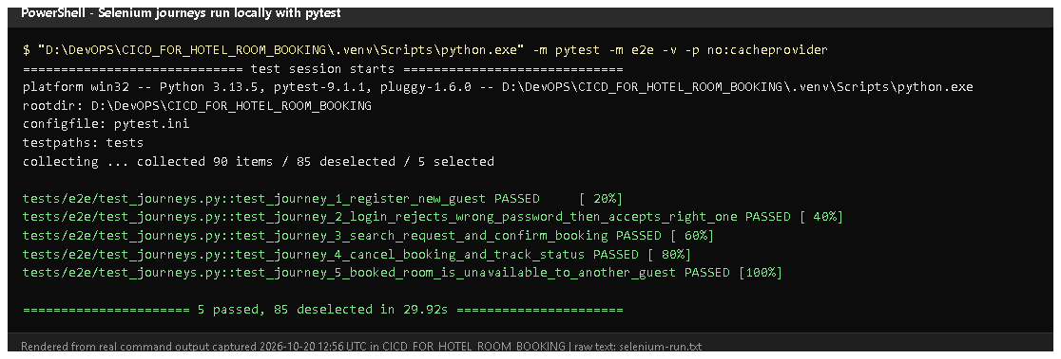
Figure 9.1 - pytest -m e2e -v on 2026-10-20 (rendered from real output): 5 journeys PASSED.
Proves: the journeys run locally through pytest.
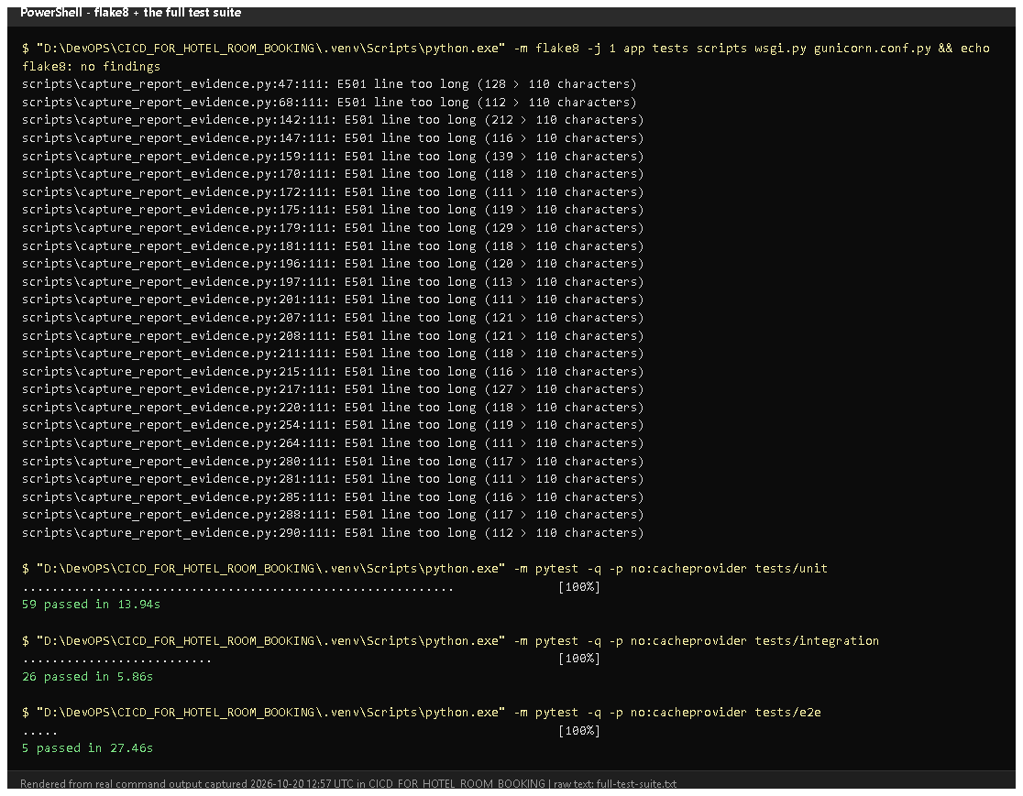
Figure 9.2 - flake8 (no findings), then unit 59, integration 26 and e2e 5 passed (rendered from real output, 2026-10-20).
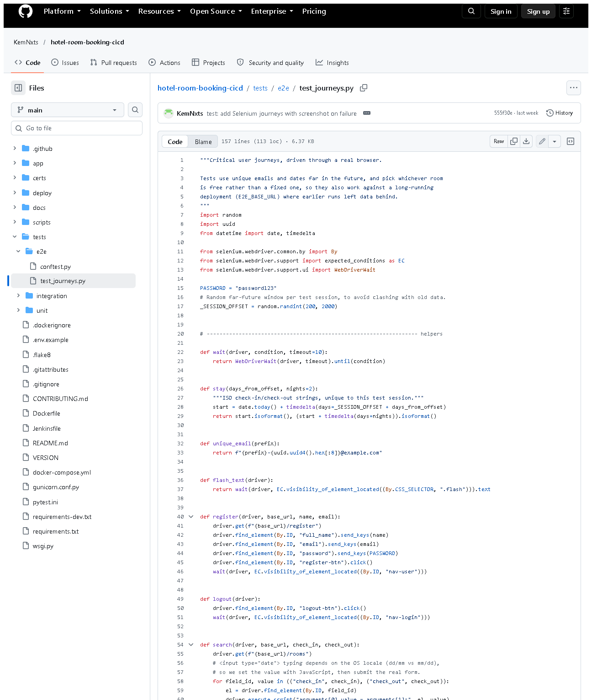 (part 1 of 3)
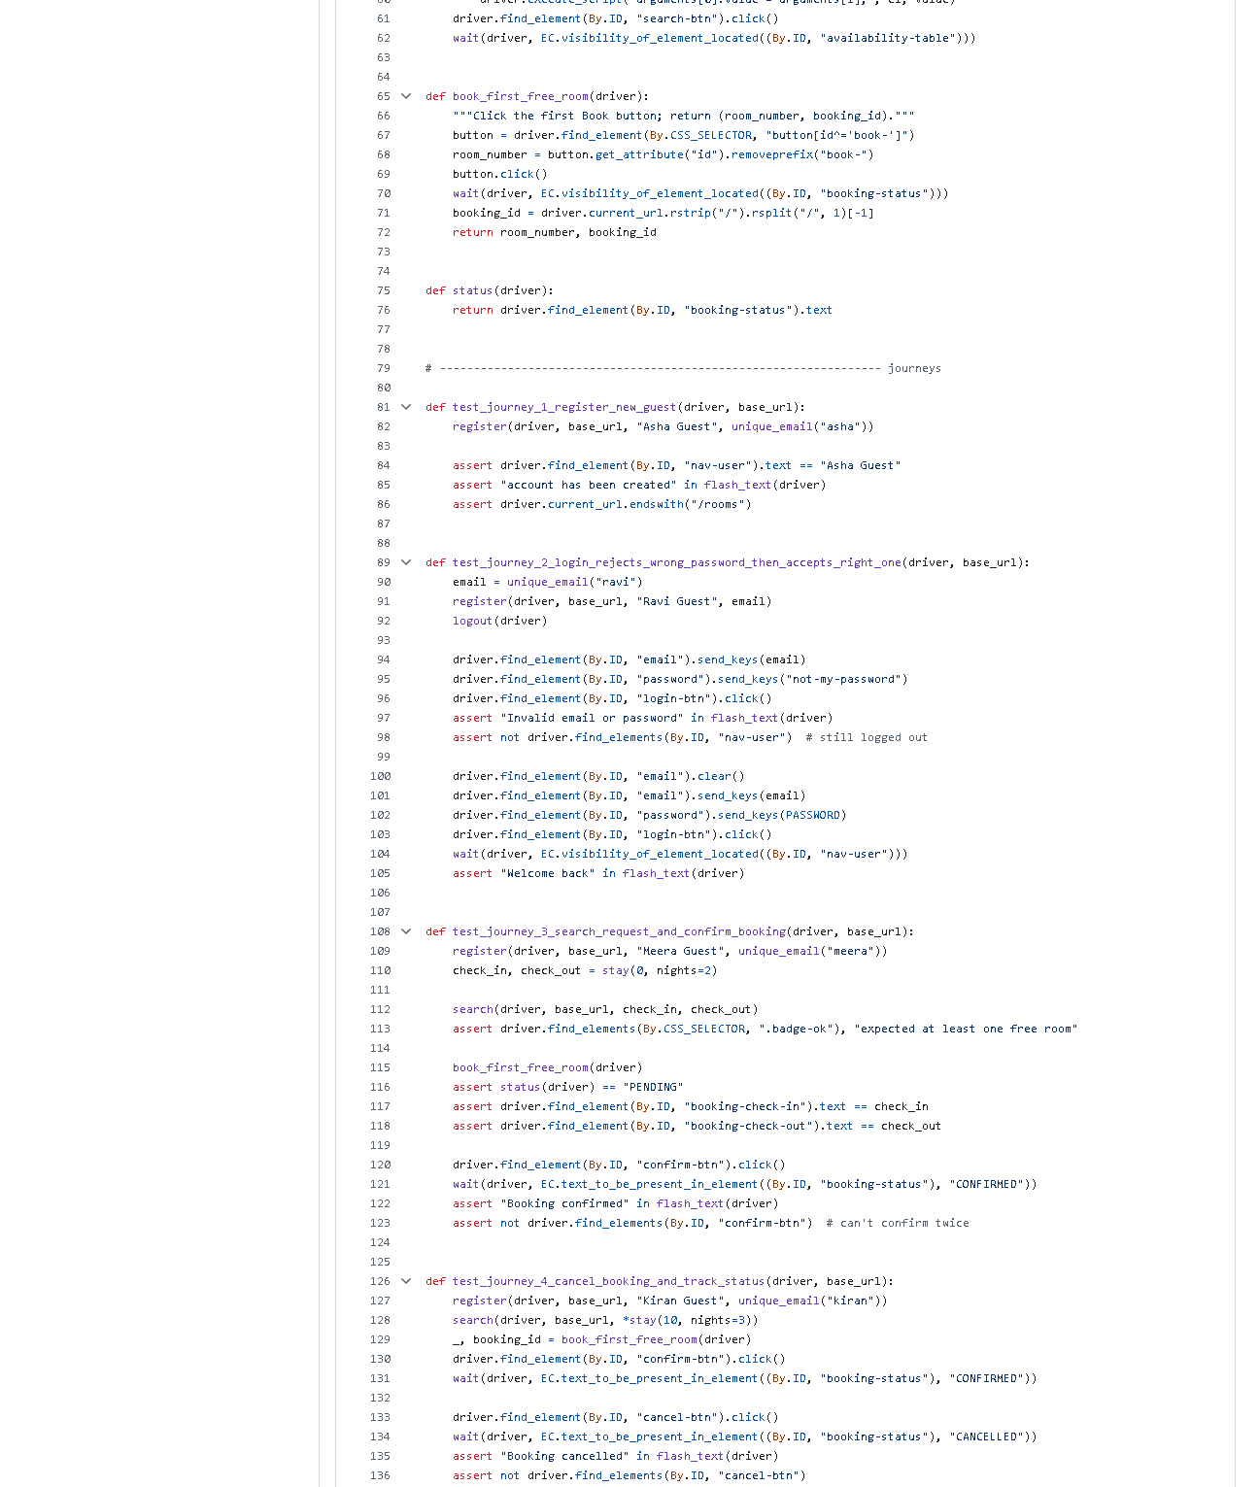 (part 2 of 3)
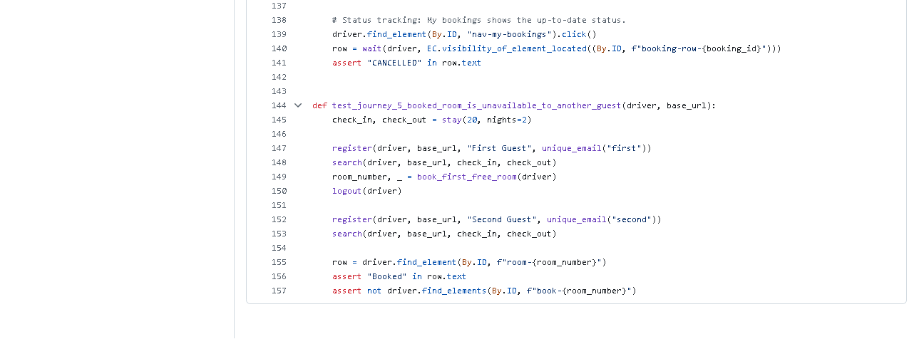 (part 3 of 3)
Figure 9.3 - tests/e2e/test_journeys.py on GitHub (the pushed version; the local
working copy adds the confirmation-dialog step in journey 4 and the readable-date
check in journey 3, both for the uncommitted UI redesign).
Notice: By.ID locators, the wait() helper, assertions.
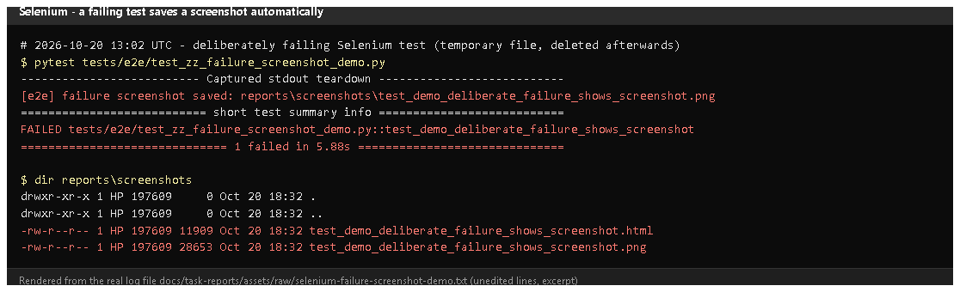
Figure 9.4 - A temporary, deliberately failing test run on 2026-10-20 (rendered from real output): "failure screenshot saved: reports\screenshots...png", then 1 failed; the folder contains a .png and an .html.
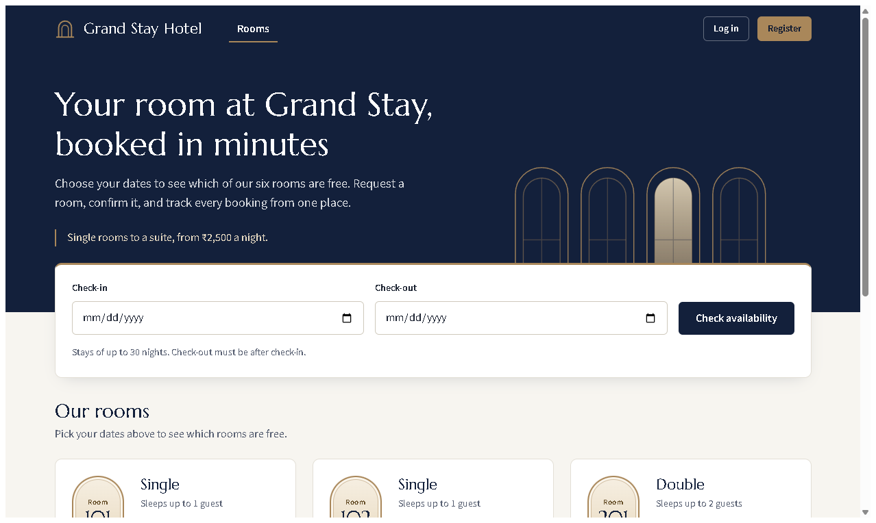
Figure 9.5 - The actual image saved by the hook: what the browser showed at the moment of failure.
Proves: failures leave visual evidence automatically.
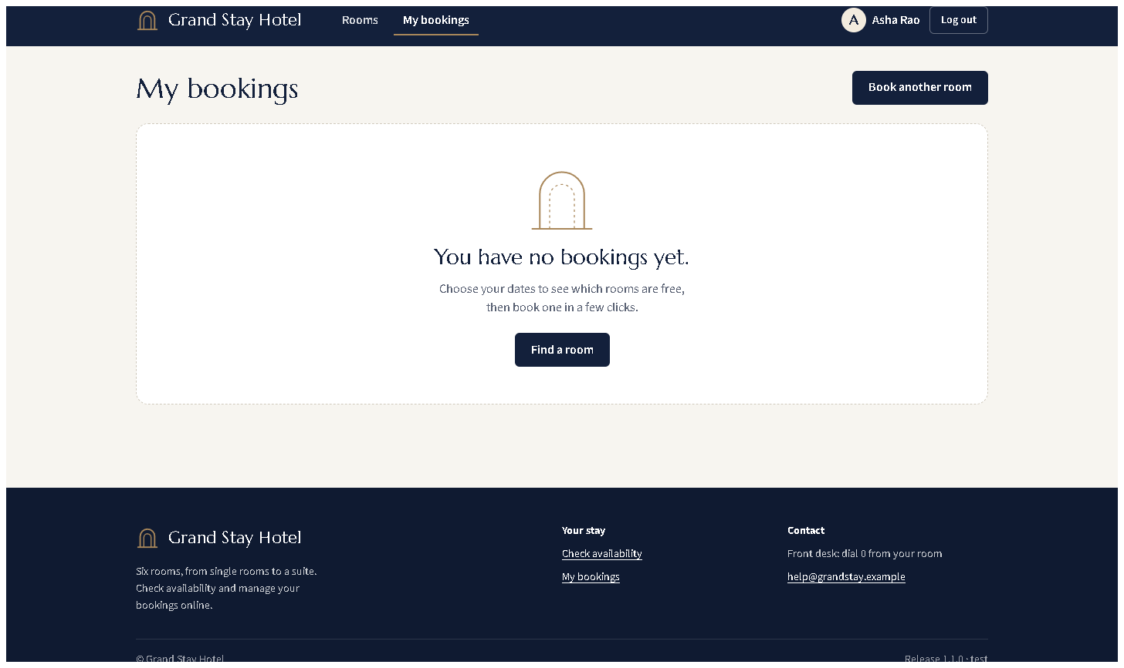
Figure 9.6 - The empty "My bookings" state (redesigned UI) - one of the pages the journeys navigate.

E. How to demonstrate this task to the professor (about 4 minutes)
Before the demo: Google Chrome installed; PowerShell in D:\DevOPS\CICD_FOR_HOTEL_ROOM_BOOKING.
- Open tests/e2e/test_journeys.py in VS Code; show journey 3 and the wait() helper.
Say: "Locators use ids; waits are explicit; each journey ends with assertions."
- Run the journeys and let the professor watch the browser:Expected: Chrome windows open and click through the pages; finally 5 passed, 85 deselected (about 30 s).
$env:HEADLESS="0"
.venv\Scripts\python -m pytest -m e2e -v
Remove-Item Env:HEADLESS
- Produce a JUnit report:Open reports\e2e-tests.xml - one <testcase> per journey.
.venv\Scripts\python -m pytest -m e2e --junitxml=reports/e2e-tests.xml -q
- Explain isolation: "Each run starts the app with a brand-new temporary
database, so runs never depend on each other."
- Screenshots on failure: show Figure 9.5, or point to conftest.py
lines 65-76 and say: "When a journey fails, a screenshot and the HTML are saved and archived by Jenkins."
- Against a running deployment (optional, staging must be up):Note: staging currently runs the committed v1.1.0 interface, while the
local tests expect the redesigned one (dialog, readable dates), so
journeys 3 and 4 fail there (checked 2026-10-20: 3 passed, 2 failed) until
the redesign is deployed. Test the
deployment with the tests of the same version.
$env:E2E_BASE_URL="http://localhost:8081"
.venv\Scripts\python -m pytest -m e2e -q
Remove-Item Env:E2E_BASE_URL
Recovery: SessionNotCreatedException - update Chrome (Selenium
downloads the matching driver automatically). Tests hang on first run -
Selenium Manager is downloading chromedriver; wait once.

F. Expected screenshots for the final submission
- assets/task-09/selenium-run.png - exists, 2026-10-20.
- assets/task-09/full-test-suite.png - exists, 2026-10-20.
- assets/task-09/github-file-tests_e2e_test_journeys.py.png - exists, 2026-10-20.
- assets/task-09/selenium-failure-demo-output.png - exists, 2026-10-20.
- assets/task-09/selenium-failure-screenshot-saved-by-hook.png - exists, 2026-10-20.
- assets/task-09/app-desktop-07-my-bookings-empty.png - exists, 2026-10-20.
- (optional) a photo/screen recording of the visible browser run with HEADLESS=0 - requires manual capture (it is a live demo).

G. Probable viva questions and answers
- What is Selenium WebDriver? A library and protocol that lets code control a real browser - open pages, type, click, read text.
- Which journeys did you automate and why? Register; wrong-then-right
login; search-book-confirm; cancel and track status; a booked room is
unavailable to another guest - the six MVP workflows end to end.
- What is an explicit wait? Waiting for a condition (e.g. element
visible) up to a timeout, continuing as soon as it is true. Better than sleep.
- Why ids as locators? They are unique and do not change when layout or
styling changes; the UI redesign kept them, so the tests still passed.
- How do you keep test data from interfering? Each local run uses a new
temporary database; against deployments, unique e-mails and random future dates.
- How do screenshots on failure work? A pytest hook records the result;
the browser fixture saves a PNG and the HTML if the test failed.
- (Project-specific) Why are dates set with JavaScript? Typing into a
date input depends on the OS date format; setting value is identical everywhere.
- (Project-specific) What changed in the tests for the UI redesign?
Journey 4 now confirms the cancel dialog; journey 3 reads the ISO date from
the datetime attribute and checks the readable text. Both still assert the same behaviour.
- Unit vs integration vs Selenium? Unit: one rule, no server. Integration:
real HTTP routes in-process. Selenium: the full journey in a browser.
- Do you run Selenium through Maven? No - through pytest. It produces JUnit
XML like Maven's Surefire would. Confirm with the professor if Maven is mandatory.
- How does Jenkins run a browser without a screen? Headless Chromium inside the Jenkins container (CHROME_BIN, CHROMEDRIVER set in its Dockerfile).

H. Common mistakes and troubleshooting
Symptom | Cause | Inspect | Fix | Confirm
SessionNotCreatedException | Chrome/driver mismatch or no Chrome | Chrome version | update Chrome | journeys start
TimeoutException waiting for nav-user | page layout changed or app error | reports/screenshots/*.png | look at the screenshot; fix the page or locator | test passes
Journeys 3/4 fail against staging | staging runs an older UI than the local tests expect | /health version | run the matching version's tests, or deploy the new UI | 5 passed
Tests pass alone but fail together | shared data | base_url fixture | keep the throw-away DB; use unique data | repeated runs pass
Date typed wrongly | locale-dependent typing | search() helper | use the JavaScript value setter | correct dates shown

I. Quick revision notes
Five key points
- 5 journeys covering all 6 MVP workflows, in tests/e2e/test_journeys.py.
- Stable By.ID locators + explicit WebDriverWait waits + clear assertions.
- Isolated data: a temporary database per run; unique e-mails and dates.
- Failure -> PNG + HTML in reports/screenshots/ (demonstrated 2026-10-20).
- Runs through pytest (JUnit XML), locally and in Jenkins; not Maven.
30-60 second explanation
"Selenium drives a real Chrome browser through five journeys: registering,
logging in with a wrong and then right password, searching and booking a room
and confirming it, cancelling it and checking My bookings, and making sure a
booked room is not offered to another guest. The tests find elements by id,
wait explicitly, and assert the visible result. Each run starts the app with
a fresh temporary database, so results are repeatable. If a journey fails, a
screenshot and the page HTML are saved, and Jenkins keeps them. Today all
five passed."
Caveat: pytest, not Maven, runs the tests.
Readiness checklist
- â˜ I can run the journeys with HEADLESS=0 so the browser is visible.
- â˜ I can explain explicit waits and stable locators with code on screen.
- â˜ I can show a failure screenshot (Figure 9.5).
- â˜ I can explain the three test levels.

