Task 10 - Continuous Testing in Jenkins

A. Task title and objective
Task 10: Continuous Testing in Jenkins
Objective: run all automated tests (backend and Selenium) inside the
pipeline, publish their reports, and make test failures stop the
deployment - then prove it with a deliberately introduced defect, a
corrective commit and a successful re-run.
Professor's required deliverables
- Backend and Selenium tests integrated into the pipeline
- Test report publication
- Failure propagation and a quality gate that blocks deployment
- A documented, deliberately introduced defect (on a disposable branch)
- Evidence the defect causes a test failure
- A corrective commit and a successful re-run
Current status: Implemented and verified. The experiment was run on
2026-10-11 (builds #2, #3, #9). On 2026-10-20 the build records were checked
again directly in Jenkins (Figures 10.1-10.5), and today's build #11 again
ran all 90 tests before deploying.

B. Explanation for a complete beginner
An everyday picture. At an airport, a plane cannot take off until the
safety checklist is complete. If one check fails, the plane stays at the gate
- nobody "takes off anyway". A quality gate is that rule for software:
if any test fails, the new version is not deployed.
Term | Meaning | In this project
Continuous testing | every build automatically runs the tests | every Jenkins build runs flake8 + 90 tests
Quality gate | a condition that must pass before the next step | test stages come before Deploy
Failure propagation | a failure travels up and marks the whole build failed | pytest exit code != 0 -> stage fails -> build FAILURE
Skipped stage | Jenkins does not run later stages after a failure | "Stage 'Deploy' skipped due to earlier failure(s)"
Regression | a test that passed before now fails | Jenkins labels it Regression
Defect experiment | breaking the code on purpose to prove the tests notice | an off-by-one bug in the overlap rule
Disposable branch | a branch for an experiment that is never merged | experiment/defect-demo

Build failure vs deployment failure. A build failure means the pipeline
stopped before deploying (e.g. a test failed) - users are not affected. A
deployment failure means the new version was started but is unhealthy -
that is what the health check and rollback are for.

C. What was actually implemented
How tests stop the pipeline - each test stage is a shell command; pytest
exits with a non-zero code when any test fails, so Jenkins marks the stage
failed and skips every later stage:
stage('Unit & integration tests') {
steps { sh '.venv/bin/pytest tests/unit tests/integration --junitxml=reports/unit-integration-tests.xml' }
}
stage('E2E tests (Selenium)') {
steps { sh '.venv/bin/pytest -m e2e --junitxml=reports/e2e-tests.xml' }
}
// ... Package, Build images, Publish, Deploy, Health check come only after these
post { always { junit allowEmptyResults: true, testResults: 'reports/*.xml' } }
The deliberate-defect experiment (branch experiment/defect-demo, never
merged into develop or main - git branch --contains 5844eec lists only the two experiment branches)
Step | Commit (current / original ID in logs) | What happened
Baseline | - | staging ran 1.0.0-64351fe (build #1)
1. Defect | 5844eec / 554cad3 | in app/dao/booking_dao.py the rule check_in < :check_out became check_in <= :check_out - an off-by-one that wrongly blocks a guest from arriving on the day the previous guest leaves
2. Build #2 | FAILURE | FAILED ...TestSearchRooms::test_overlap_rules[2030-01-08-2030-01-10-True], 1 failed, 81 passed; E2E, Package, Build images, Publish, Deploy, Health check skipped; staging still answered "commit":"64351fe"
3. Fix | 2fb62d6 / 30c6a05 | fix: restore strict overlap comparison in booking DAO
4. Build #3 | SUCCESS | 87/87 tests; staging moved to 1.0.0-30c6a05

The diff of the defect (Figure 10.3):
_OVERLAP_SQL = """
- check_in < :check_out
+ check_in <= :check_out
AND check_out > :check_in
The stale-report bug (found from the evidence, fixed, re-verified)
- Build #2's Tests page lists tests.e2e: 5 passed although its E2E stage
was skipped (Figure 10.4). Cause: Jenkins reuses its workspace, and
reports/e2e-tests.xml from build #1 was still there, so junit 'reports/*.xml' published it again.
- Fix on branch fix/jenkins-stale-reports: the Checkout stage now runs
rm -rf reports dist before anything else.
- Proof: build #9 (experiment/defect-demo-2 = the same defect + the fix,
current commit a3d8626, shown in Jenkins as 8505486) failed on the same
test and its report lists 82 tests and no e2e package - only the tests that actually ran (Figure 10.5).
- Every later build (including #11 today) starts with + rm -rf reports dist,
so a report can never come from an older build.

D. Screenshots and evidence
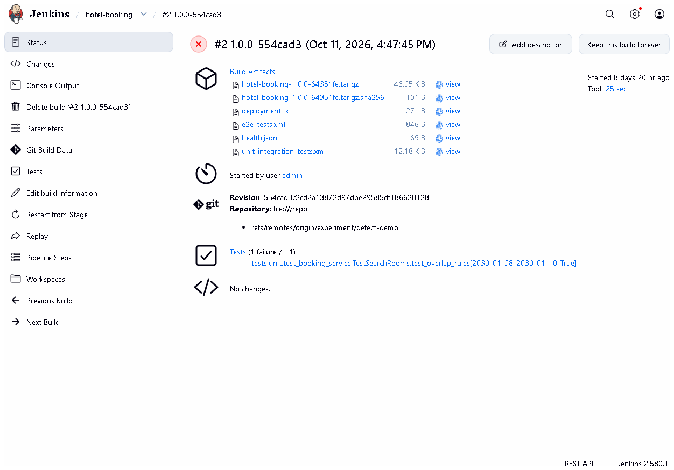
Figure 10.1 - Build #2 1.0.0-554cad3 in Jenkins (checked 2026-10-20): result FAILURE.
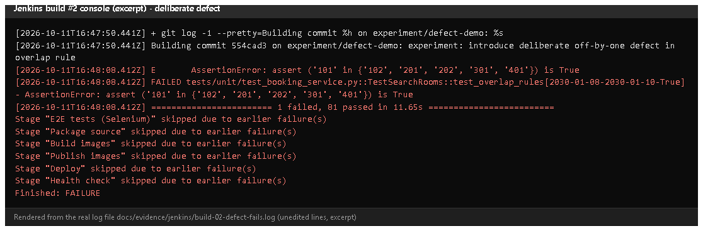
Figure 10.2 - Console excerpt of build #2 (rendered from the saved log docs/evidence/jenkins/build-02-defect-fails.log).
Notice: the failing assertion, 1 failed, 81 passed, and six "skipped due to earlier failure(s)" lines including Deploy.
Proves: the quality gate stopped the deployment.
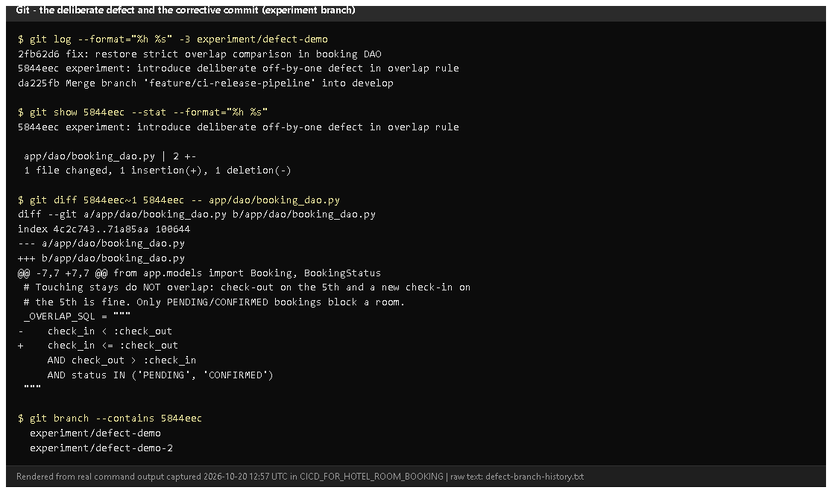
Figure 10.3 - The experiment branch history, the one-character diff, and the branches that contain the defect (rendered from real output, 2026-10-20).
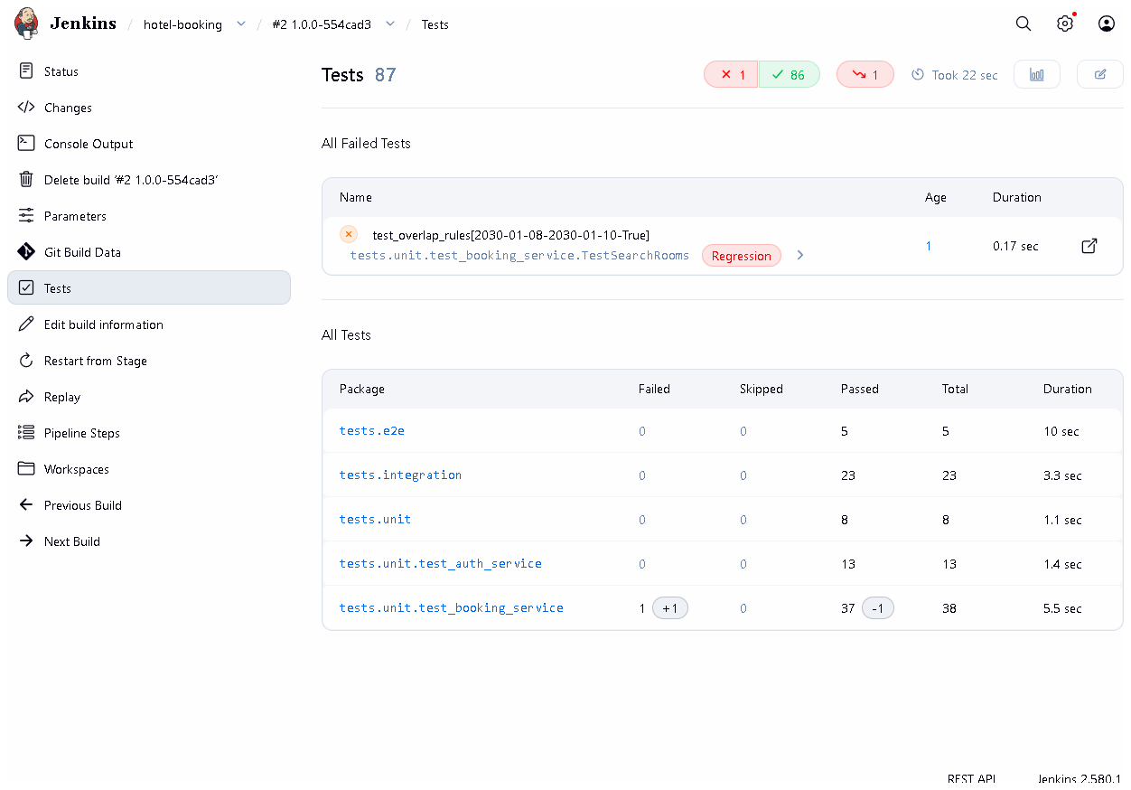
Figure 10.4 - Build #2's Tests page: 1 failed (test_overlap_rules[...-True], marked Regression). Also notice tests.e2e 5 - the stale report described above.
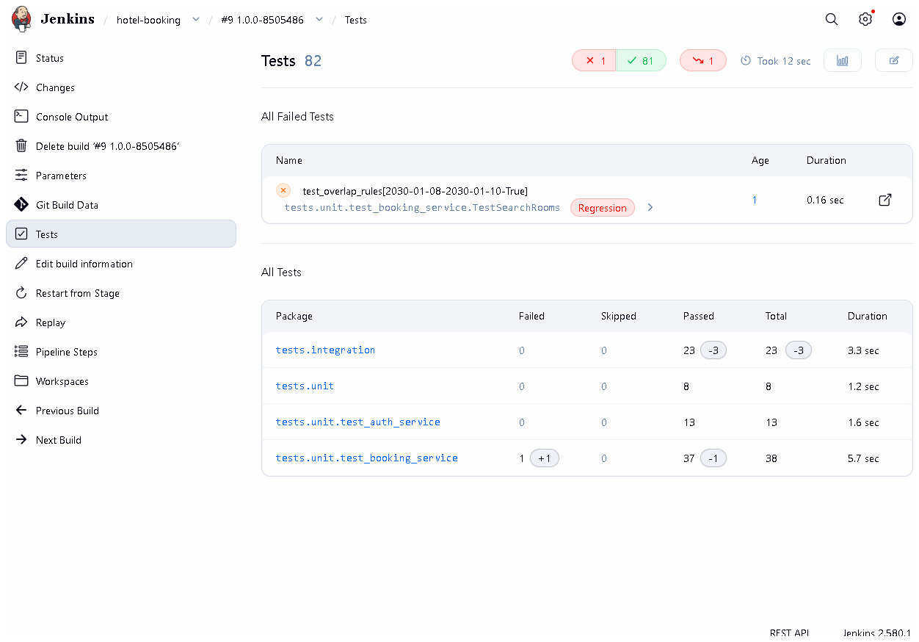
Figure 10.5 - Build #9 after the report fix: 82 tests, 1 failed, and no tests.e2e entry.
Proves: the current build's report cannot reuse an older build's results.
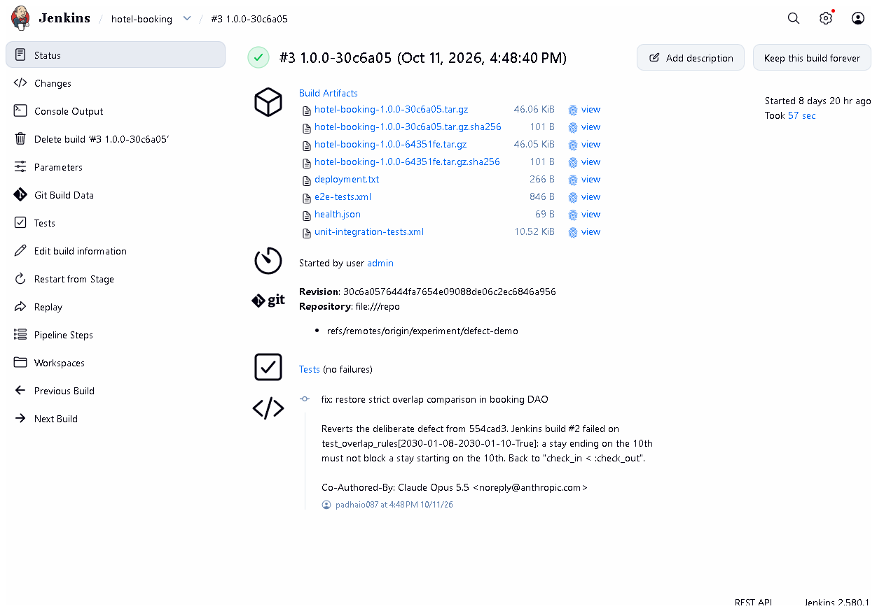
Figure 10.6 - Build #3 1.0.0-30c6a05: SUCCESS after the corrective commit.
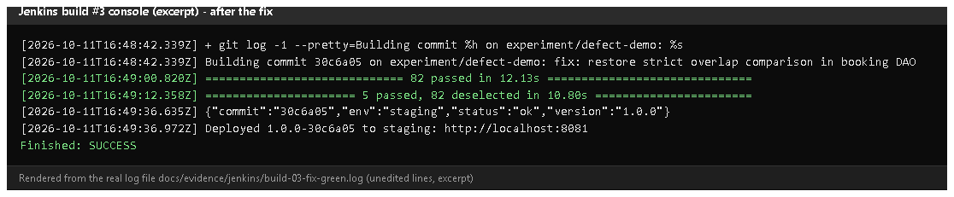
Figure 10.7 - Build #3 console excerpt (rendered from the saved log): tests passed, deployed, health check OK.
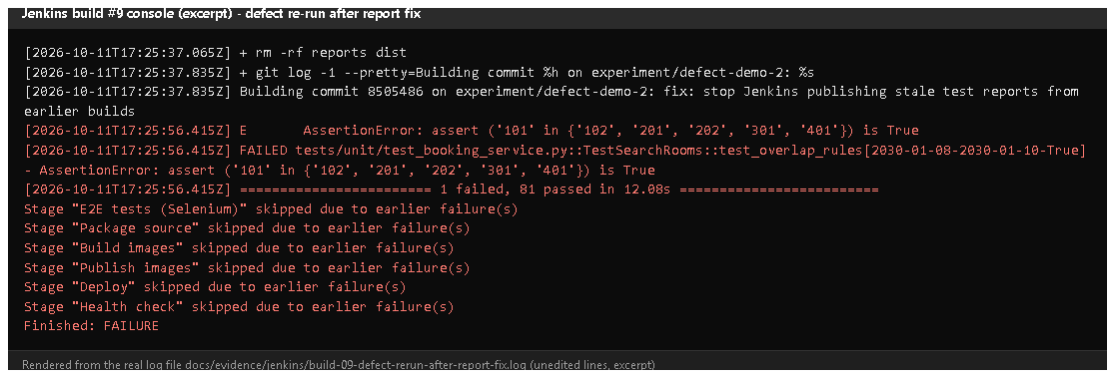
Figure 10.8 - Build #9 console excerpt: + rm -rf reports dist, the same failing test, later stages skipped.

E. How to demonstrate this task to the professor (about 5 minutes)
Option A - show the recorded experiment (safe, 2 minutes).
- Jenkins -> hotel-booking: point at red builds #2 and #9 in the stage view.
- Open #2 -> Console Output, Ctrl+F skipped due - Say: "The test failed,
so Jenkins skipped packaging and deployment."
- Open #2 -> Tests - the failed overlap test.
- Open #3 - green after the fix.
- In PowerShell (project folder):Say: "One character, < to <=, and the tests caught it."
git log --oneline -3 experiment/defect-demo
git diff 5844eec~1 5844eec -- app/dao/booking_dao.py
Option B - repeat the experiment live (about 6 minutes, disposable branch).
Warning: do this only on an experiment/* branch; never merge it.
git stash -u # only if you have uncommitted work (today: the UI redesign)
git checkout -b experiment/live-defect develop
Edit app/dao/booking_dao.py line 10: change check_in < :check_out to
check_in <= :check_out, save.
git commit -am "experiment: deliberate off-by-one defect (live demo)"
Jenkins -> Build with Parameters -> BRANCH = experiment/live-defect,
APP_ENV = staging -> Build. Expected: red at "Unit & integration tests",
later stages "skipped". Check http://localhost:8081/health - the commit is
unchanged (not deployed). Then fix and re-run:
git revert --no-edit HEAD
Build the same branch again - Expected: all green, staging shows the new
commit. Clean up:
git checkout feature/ui-redesign # or the branch you were on
git stash pop # only if you stashed
git branch -D experiment/live-defect

F. Expected screenshots for the final submission
- assets/task-10/jenkins-build-02-failed.png - exists, 2026-10-20.
- assets/task-10/build-02-defect-console.png - exists (rendered from the 2026-10-11 log).
- assets/task-10/defect-branch-history.png - exists, 2026-10-20.
- assets/task-10/jenkins-build-02-failed-test.png - exists, 2026-10-20.
- assets/task-10/jenkins-build-09-tests-no-stale-report.png - exists, 2026-10-20.
- assets/task-10/jenkins-build-03-fixed.png - exists, 2026-10-20.
- assets/task-10/build-03-fix-console.png - exists (rendered from the 2026-10-11 log).
- assets/task-10/build-09-rerun-console.png - exists (rendered from the 2026-10-11 log).

G. Probable viva questions and answers
- What is a quality gate? A check that must pass before the pipeline continues - here all lint and tests before Deploy.
- How does a failed test stop deployment? pytest exits non-zero, the
sh step fails, the stage fails and Jenkins skips all later stages.
- What defect did you introduce? < became <= in the overlap SQL,
blocking back-to-back stays (check-out day = next check-in day).
- Which test caught it? TestSearchRooms::test_overlap_rules[2030-01-08-2030-01-10-True] - a stay ending on the 10th must not block one starting on the 10th.
- How do you know it wasn't deployed? The log shows Deploy skipped, and
staging's /health still reported the previous commit 64351fe.
- Why on an experiment branch? So the defect never reaches develop or
main; git branch --contains 5844eec lists only experiment branches.
- (Project-specific) What was the stale-report problem? Build #2's
report showed 5 E2E tests passing although that stage never ran - an old
XML file in the reused workspace. Fixed by deleting reports/ and dist/ at checkout; build #9 proves it.
- (Project-specific) Why do the IDs in Jenkins (554cad3) differ from Git (5844eec)?
Commit messages were edited once before publishing, which changed all IDs;
see docs/evidence/git/commit-id-map.md.
- Build failure vs deployment failure? Build failure: stopped before
deploying (users unaffected). Deployment failure: the new version started
but is unhealthy - caught by --wait and the health check, fixed by rollback.
- Do Selenium tests also gate the deploy? Yes - the E2E stage comes before Package/Deploy.
- Why publish reports even when the build fails? post { always } runs
on failure too, so you can see which test failed.

H. Common mistakes and troubleshooting
Symptom | Cause | Inspect | Fix | Confirm
Report shows tests from an earlier build | stale XML in workspace | Checkout stage in the console | ensure rm -rf reports dist is present (it is since the fix) | report count = tests actually run
Defect build is green | defect not committed, or wrong branch built | console "Building commit ..." | commit and set BRANCH correctly | red stage
Experiment merged by accident | merged into develop | git branch --contains <defect id> | git revert the merge on develop | tests pass
git checkout refuses | uncommitted work | git status | git stash -u / git stash pop | branch switched

I. Quick revision notes
Five key points
- Every build runs flake8 + 85 unit/integration + 5 Selenium tests before deploying.
- A failing test -> stage fails -> later stages (incl. Deploy) skipped.
- Defect < -> <= (commit 5844eec) failed build #2; fix 2fb62d6 made build #3 green.
- Staging kept the old version during the failed build.
- Stale-report bug found, fixed (rm -rf reports dist), proven by build #9.
30-60 second explanation
"Tests are the quality gate of our pipeline: Jenkins runs lint, unit,
integration and Selenium tests, and only if all pass does it package and
deploy. To prove it I introduced a one-character bug on an experiment branch,
changing < to <= in the overlap rule. Build #2 failed on the overlap
test, every later stage was skipped, and staging kept the previous version.
A corrective commit made build #3 green. I also found that build #2's report
reused an old Selenium result; I fixed that, and build #9 proves reports now
only contain tests that really ran."
Caveat: the experiment ran on 2026-10-11; on 2026-10-20 its records were re-checked, not re-run (Option B shows how to re-run it).
Readiness checklist
- â˜ I can open builds #2, #3, #9 and explain each.
- â˜ I can show the one-line diff.
- â˜ I can explain the stale-report fix.
- â˜ I know how to repeat the experiment safely on an experiment branch.

