Task 11 - Docker Image and Container Lifecycle

A. Task title and objective
Task 11: Docker Image and Container Lifecycle
Objective: package the Flask application into a Docker image that runs
with a production server, as a non-root user, configured by environment
variables and without secrets inside; then demonstrate the full life of a
container: build, tag, run, port mapping, logs, inspection, stop, restart,
removal and persistent data.
Professor's required deliverables
- Dockerfile with a suitable Python base image, reproducible dependency install, production WSGI server, exposed and mapped port, non-root user, environment-variable configuration, no baked-in secrets, .dockerignore, a health check
- Demonstration of build and tag, create and run, port mapping, logs and inspection, stop / restart / remove, persistent database storage
- Proof that the container actually starts and serves requests
Current status: Implemented and verified. The complete lifecycle was
run again on 2026-10-20 (Figures 11.1-11.2): the container became healthy,
answered on the mapped port, ran as appuser, and an account created in one
container still worked in a new container using the same volume.

B. Explanation for a complete beginner
An everyday picture. A shipping container holds goods in a standard box
that fits every ship, train and truck. A Docker container holds an
application plus everything it needs (Python, libraries, settings) in a
standard box that runs the same on any machine with Docker - "it works on my
machine" stops being a problem.
Term | Plain meaning | In this project
Dockerfile | the recipe for building an image | Dockerfile (app), deploy/nginx/Dockerfile
Image | a read-only package built from the recipe (like a class / a template) | hotel-booking-app:1.1.0
Container | a running instance of an image (like an object) | hotel-demo, hotel-prod-app-1
Tag | the name:version label of an image | 1.1.0, latest, 1.1.0-1c2103c
Port mapping | connect a port on your computer to a port inside the container | -p 8095:8000
Volume | storage managed by Docker that lives outside containers | hotel-demo-data / hotel-data mounted at /data
Logs | what the app prints, collected by Docker | docker logs
Inspect | detailed JSON description of a container/image | docker inspect
Health check | a command Docker runs regularly to ask "are you OK?" | GET /health every 10 s
Docker Compose | starts several containers together from one file | docker-compose.yml: nginx + app + volume

Why can data survive deleting a container? A container's own file
system disappears with it. Our SQLite file lives at /data/hotel.db, and
/data is a volume, which Docker keeps until you delete the volume itself.
A new container that mounts the same volume sees the same data.
Lifecycle states: created -> running -> (stopped = exited) -> running
again -> removed. Health status: starting -> healthy (or unhealthy).

C. What was actually implemented
Dockerfile (application image) - key lines:
Line | Instruction | Why
3 | FROM python:3.11-slim-bookworm | small official Python image, same Python as the pipeline
7-8 | ARG APP_VERSION, ARG GIT_COMMIT | release info, shown by /health and as image labels
12-17 | ENV APP_ENV=prod, DATABASE_PATH=/data/hotel.db ... | configuration by environment variables
20-22 | LABEL org.opencontainers.image.version / revision | docker inspect shows which release and commit an image came from
29 | COPY certs/ ... + update-ca-certificates | optional extra root CAs (antivirus HTTPS scanning); folder normally empty
35-36 | COPY requirements.txt then RUN pip install --no-cache-dir ... | pinned dependencies; copied before the code so this slow layer is cached
38-39 | COPY app/ ..., COPY wsgi.py gunicorn.conf.py | the application
44-46 | useradd ... appuser, USER appuser | not root inside the container
50 | VOLUME /data | the database lives on a volume
52 | EXPOSE 8000 | Gunicorn's port
56-57 | HEALTHCHECK ... urllib.request.urlopen('http://127.0.0.1:8000/health') | Docker knows when the app is really ready
59 | CMD ["gunicorn", "--config", "gunicorn.conf.py", "wsgi:app"] | production WSGI server (2 workers)

No secrets in the image: SECRET_KEY is given at run time (-e or
--env-file); the app refuses to start in prod without it.
.dockerignore excludes .git, .venv, tests, docs, deploy/ansible,
deploy/jenkins, *.md, .env and *.db.
docker-compose.yml - two services: app (image
${IMAGE_PREFIX}hotel-booking-app:${IMAGE_TAG}, volume hotel-data:/data,
no published port) and nginx (reverse proxy, published on
${HOST_PORT:-8080}:80, starts only when the app is service_healthy); both
restart: unless-stopped. The Nginx image (deploy/nginx/Dockerfile) bakes
in hotel.conf and serves /static/ directly.
Lifecycle demo run on 2026-10-20 (raw output: assets/raw/docker-lifecycle.txt):
Step | Command (shortened) | Observed
build | docker build -t hotel-booking-app:1.1.0 --build-arg APP_VERSION=1.1.0 --build-arg GIT_COMMIT=1c2103c-dirty . | image built
tag | docker tag hotel-booking-app:1.1.0 hotel-booking-app:latest | two tags, same image ID
inspect image | docker image inspect -f '...' | labels version/revision, user=appuser, exposed 8000/tcp
volume | docker volume create hotel-demo-data | created
run | docker run -d --name hotel-demo -p 8095:8000 --env-file ... -v hotel-demo-data:/data hotel-booking-app:1.1.0 | Up (healthy), 0.0.0.0:8095->8000/tcp
request | curl -s http://localhost:8095/health | {"commit":"1c2103c-dirty","env":"prod","status":"ok","version":"1.1.0"}
use | register a guest over HTTP | HTTP 302 (success)
logs | docker logs --tail 6 hotel-demo | Gunicorn start, health checks, POST /register 302
inspect | docker inspect -f 'state=... health=... mounts=...' | running, healthy, hotel-demo-data->/data
user | docker exec hotel-demo whoami | appuser
stop | docker stop hotel-demo | Exited (0)
start / restart | docker start, docker restart | healthy again
remove | docker rm -f hotel-demo | gone
new container | same docker run on the same volume | healthy
data survived | log in with the account from the first container | HTTP 302 (success)
clean up | docker rm -f, docker volume rm | removed

(-dirty in the commit label means the image was built from a working tree
with uncommitted changes - the UI redesign - and is honest about it.)

D. Screenshots and evidence
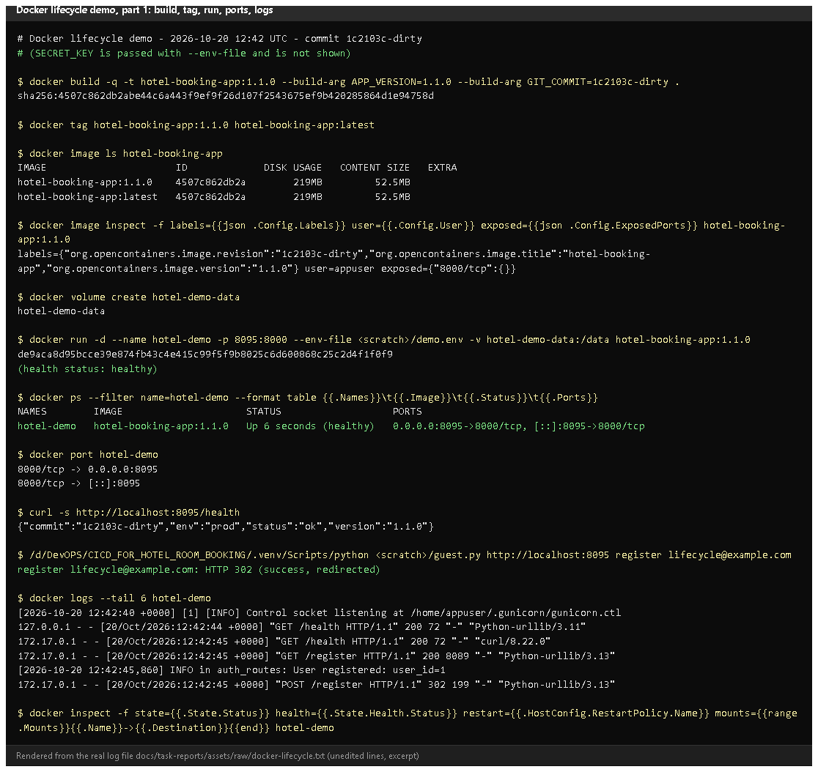
Figure 11.1 - Lifecycle demo, part 1: build, tag, image labels/user/port, volume, run, docker ps with port mapping, /health, registration, logs (rendered from the real run on 2026-10-20).
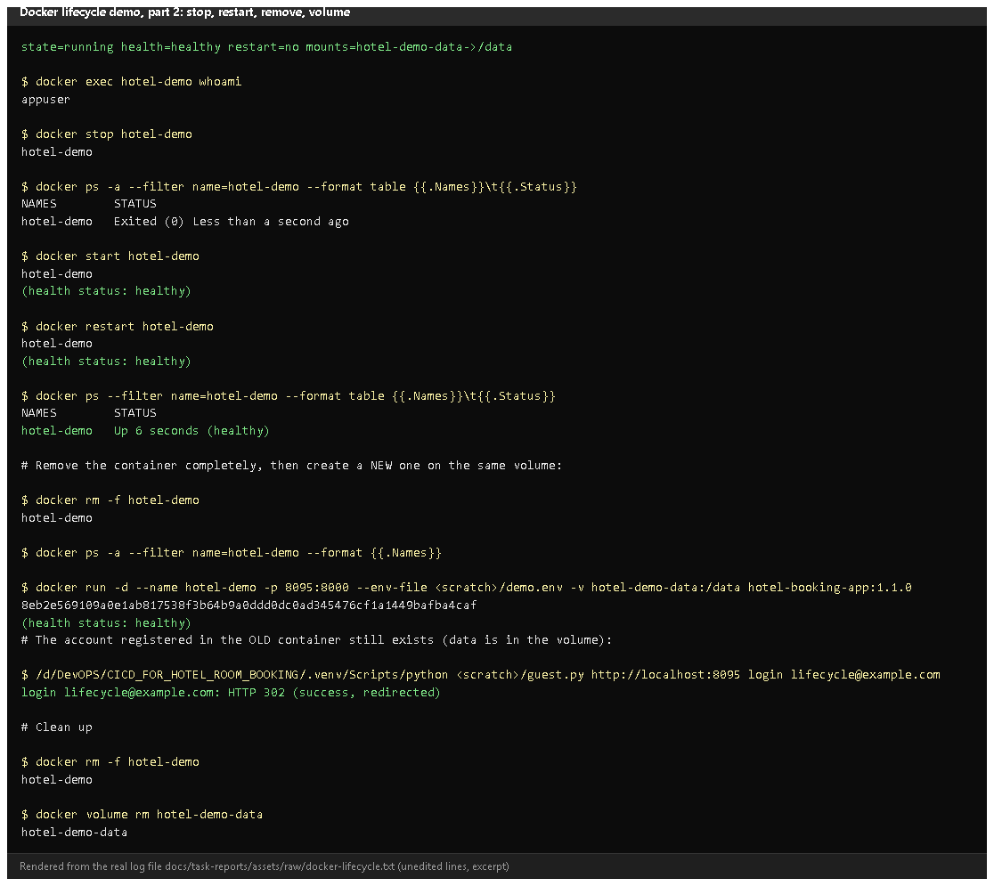
Figure 11.2 - Part 2: inspect, whoami = appuser, stop -> Exited, start, restart, remove, a new container on the same volume, the old account still logs in, clean-up.
Proves: every lifecycle operation, and persistence through a volume.
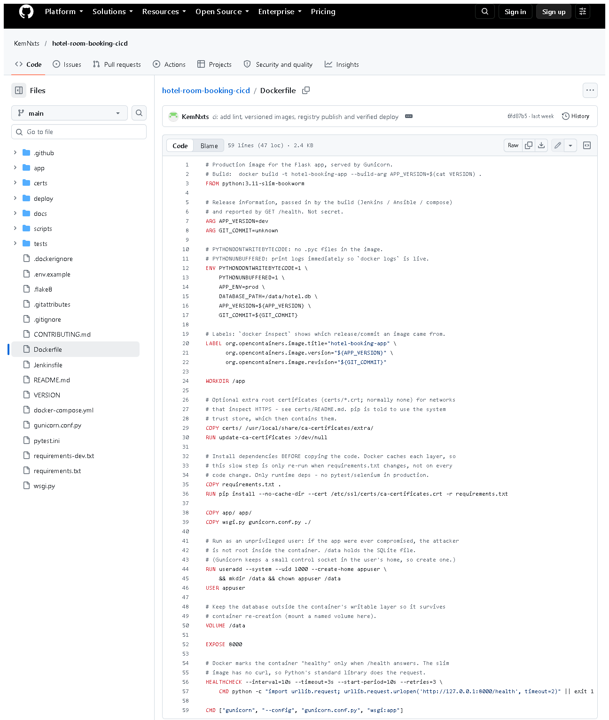 (part 1 of 2)
(part 2 of 2)
Figure 11.3 - Dockerfile on GitHub. Notice: slim base, dependencies before code, USER appuser, VOLUME, EXPOSE, HEALTHCHECK, Gunicorn CMD.
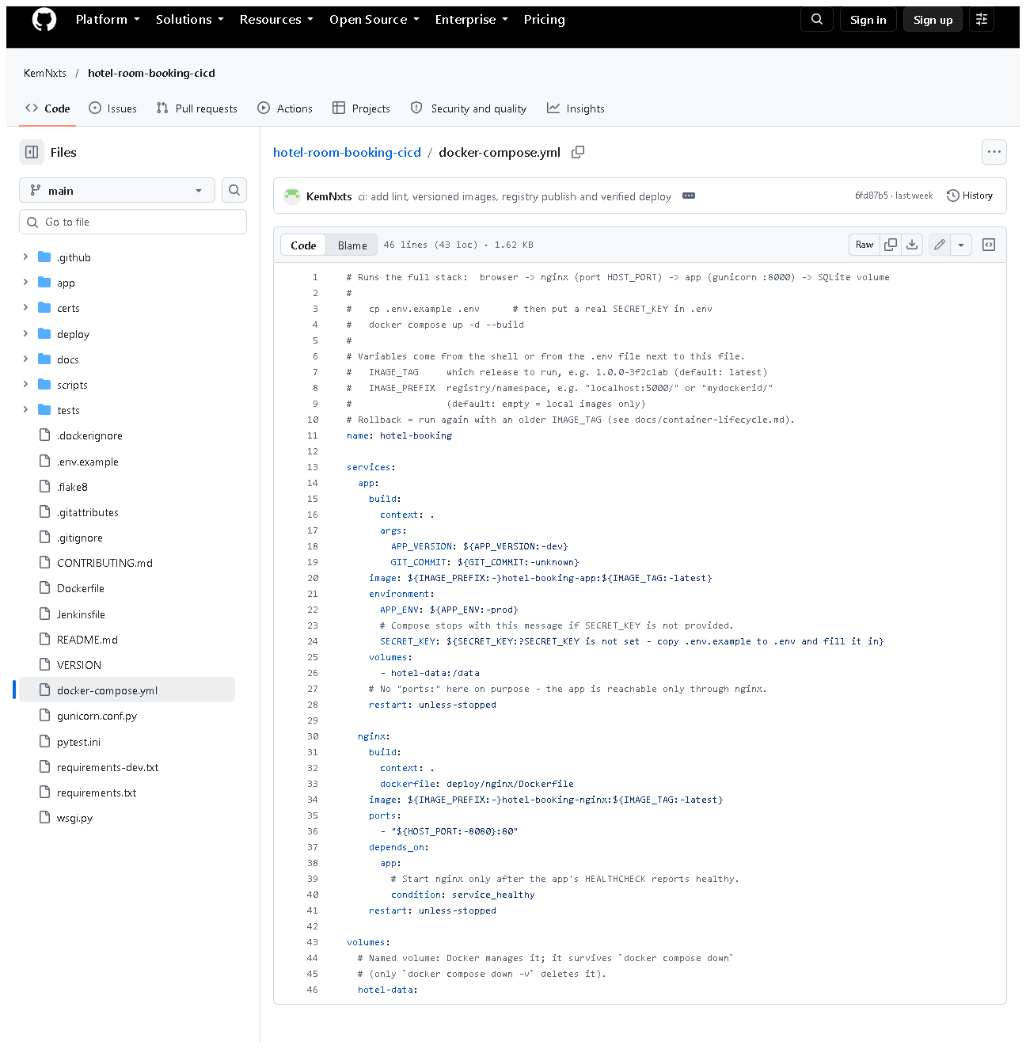
Figure 11.4 - docker-compose.yml: app + nginx, named volume, service_healthy dependency, SECRET_KEY required.
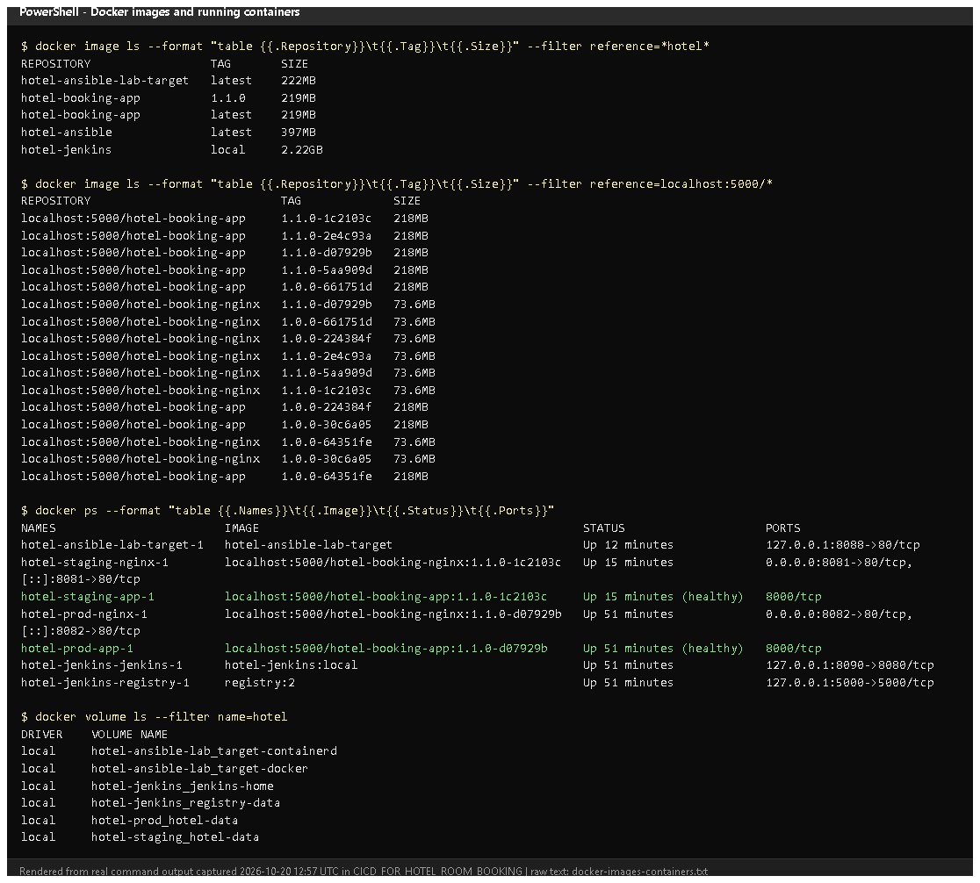
Figure 11.5 - docker image ls, docker ps and docker volume ls on 2026-10-20 (rendered from real output): versioned images, the running staging/prod/Jenkins/lab containers and the data volumes.

E. How to demonstrate this task to the professor (about 5 minutes)
Before the demo: Docker Desktop running. PowerShell in
D:\DevOPS\CICD_FOR_HOTEL_ROOM_BOOKING. These exact commands were run on 2026-10-20.
# 1. build and tag the image
docker build -t hotel-booking-app:demo --build-arg APP_VERSION=1.1.0 .
docker image ls hotel-booking-app

# 2. create a volume and run a container with a port mapping
docker volume create hotel-demo-data
docker run -d --name hotel-demo -p 8095:8000 -e SECRET_KEY=demo-only-secret-123 -v hotel-demo-data:/data hotel-booking-app:demo
docker ps --filter name=hotel-demo
Expected: status Up ... (healthy) after ~10 s and 0.0.0.0:8095->8000/tcp.
Say: "Port 8095 on my laptop is mapped to port 8000 inside the container."
# 3. it serves requests
curl.exe -s http://localhost:8095/health
Open http://localhost:8095/register in the browser and create an account.
# 4. logs and inspection
docker logs --tail 5 hotel-demo
docker inspect -f "{{.State.Health.Status}}" hotel-demo
docker exec hotel-demo whoami

# 5. stop, start, restart
docker stop hotel-demo
docker ps -a --filter name=hotel-demo
docker start hotel-demo
docker restart hotel-demo

# 6. remove the container, start a NEW one on the same volume
docker rm -f hotel-demo
docker run -d --name hotel-demo -p 8095:8000 -e SECRET_KEY=demo-only-secret-123 -v hotel-demo-data:/data hotel-booking-app:demo
Log in at http://localhost:8095/login with the account from step 3.
Say: "The container was deleted, but the database is on a volume, so the
account still exists." (Use the same SECRET_KEY - a different one only logs existing sessions out; the account stays.)
# 7. clean up
docker rm -f hotel-demo
docker volume rm hotel-demo-data
docker image rm hotel-booking-app:demo
Notes: in PowerShell use curl.exe (plain curl is a different
PowerShell command). -e SECRET_KEY=... here is a throw-away demo value; real
deployments take it from .env or Jenkins credentials.
Recovery: "port is already allocated" - choose another port, e.g.
-p 8096:8000. "Conflict. The container name is already in use" -
docker rm -f hotel-demo. Build fails with CERTIFICATE_VERIFY_FAILED -
antivirus HTTPS scanning; see certs/README.md.

F. Expected screenshots for the final submission
- assets/task-11/lifecycle-part1-build-run.png - exists, 2026-10-20 (rendered from the real run).
- assets/task-11/lifecycle-part2-stop-restart-volume.png - exists, 2026-10-20.
- assets/task-11/github-file-Dockerfile.png - exists, 2026-10-20.
- assets/task-11/github-file-docker-compose.yml.png - exists, 2026-10-20.
- assets/task-11/docker-images-containers.png - exists, 2026-10-20.
- Earlier lifecycle evidence (2026-10-11): docs/evidence/docker/lifecycle.txt - exists.

G. Probable viva questions and answers
- Image vs container? An image is the read-only package; a container is a running instance of it. Many containers can run from one image.
- Why copy requirements.txt before the code? Docker caches each layer;
dependencies are reinstalled only when requirements.txt changes, not on every code change.
- Why a non-root user? If the app were compromised, the attacker would not be root inside the container (whoami shows appuser).
- How is the app configured? Environment variables (APP_ENV,
SECRET_KEY, DATABASE_PATH...); no secrets are in the image.
- What does the HEALTHCHECK do? Every 10 s it requests /health; Docker
marks the container healthy/unhealthy, and compose starts Nginx only when the app is healthy.
- What is port mapping? -p 8095:8000 connects port 8095 on the host to 8000 in the container.
- (Project-specific) How did you prove data persistence? I created an
account, deleted the container, started a new one on the same volume and
logged in with that account - HTTP 302 success (2026-10-20).
- (Project-specific) Why Gunicorn and Nginx? Gunicorn runs the Python app
with several workers; Nginx is the only public entry point and serves CSS
directly. The app port isn't even published in compose.
- What does .dockerignore do? Keeps files like .git, .venv, tests,
docs and .env out of the build context - smaller images, no secrets.
- docker stop vs docker rm? Stop ends the process (container still
exists, can start again); rm deletes the container (volume kept).
- What happens to data with docker compose down -v? -v also deletes the volume - the database is lost. Plain down keeps it.

H. Common mistakes and troubleshooting
Symptom | Cause | Inspect | Fix | Confirm
failed to connect to the docker API | Docker Desktop not running | Docker Desktop window | start it, wait for "Engine running" | docker ps works
Container exits immediately | missing SECRET_KEY in prod | docker logs hotel-demo | pass -e SECRET_KEY=... | Up (healthy)
port is already allocated | port used | docker ps | other host port | container starts
Status stays starting/unhealthy | app error | docker logs, docker inspect | fix config; rebuild | healthy
Data gone after restart | no volume, or down -v | docker inspect -f "{{.Mounts}}" | always mount -v name:/data | data present
curl in PowerShell prints a table | PowerShell alias | - | use curl.exe | JSON shown

I. Quick revision notes
Five key points
- Image = package, container = running instance, tag = name:version.
- Dockerfile: slim Python, cached dependencies, non-root, VOLUME /data, HEALTHCHECK, Gunicorn.
- Configuration by environment variables; SECRET_KEY only at run time.
- Full lifecycle demonstrated on 2026-10-20, including persistence via a volume.
- Compose runs Nginx (public) + app (private) + named volume.
30-60 second explanation
"The Dockerfile builds a small Python image: dependencies first for caching,
then the code, a non-root user, a volume for the SQLite database, a health
check, and Gunicorn as the production server. Configuration comes from
environment variables, so the image contains no secrets. I demonstrated the
lifecycle: build and tag, run with a port mapping, check /health, read the
logs, inspect, stop, start, restart and remove. Because the database is on a
volume, an account created in one container still worked in a brand-new one."
Caveat: the demo image was built from a working tree with uncommitted UI changes, so its commit label ends in -dirty.
Readiness checklist
- â˜ Docker Desktop is running before the viva.
- â˜ I can run the 7-step demo without notes.
- â˜ I can explain image vs container and why the volume keeps data.
- â˜ I remember curl.exe in PowerShell.

