Task 13 - Configuration Management with Ansible

A. Task title and objective
Task 13: Configuration Management with Ansible
Objective: describe in code how a server must be set up - packages,
directories, configuration, permissions, services, ports, Nginx and health
verification - and let Ansible bring a server to that state automatically,
using variables for environment-specific values.
Professor's required deliverables
- Ansible inventory and playbook for the selected target
- Automated prerequisites: packages, deployment directories, application configuration, service/container setup, file permissions, network ports, Nginx configuration, application health verification
- Variables for environment-specific configuration
- No destructive changes; SSH/firewall settings not changed without checking
- If no separate target exists: the safest local/virtualised setup, documented
Current status: Implemented and verified (container-based lab).
On 2026-10-20 the playbook provisioned a fresh lab server from scratch
(Docker not installed beforehand): ok=14 changed=7 failed=0, and /health
answered with release 1.0.0 (Figure 13.1).
Target honesty: the "server" is a disposable Ubuntu 24.04 Docker
container with systemd and SSH (deploy/ansible/lab/), not a separate
virtual machine or cloud server. The real-server inventory
(deploy/ansible/inventory.ini, 192.168.56.10) has not been used.

B. Explanation for a complete beginner
An everyday picture. Instead of telling a new employee "install this,
then create that folder, then copy these files...", you give them a written
checklist that describes the finished state of the office. Anyone following
it gets the same result - and if something is already done, they skip it.
Ansible follows such a checklist on servers, over SSH.
Term | Meaning | In this project
Configuration management | describing a machine's desired state in files and applying it automatically | deploy/ansible/
Control node | the machine that runs Ansible | the hotel-ansible container (Ansible doesn't run natively on Windows)
Managed node / target | the server being configured | hotel-server (the lab container)
Inventory | the list of servers, in groups | inventory.ini (real) / lab/inventory.ini (lab) - group [web]
Playbook | a YAML file listing tasks for a group of hosts | playbook.yml, rollback.yml
Task | one desired state, using a module | "Install Docker engine..." using apt
Module | a built-in action (apt, copy, file, service, uri...) | 10 built-in modules, no extra collections
Variables | values that differ per environment | group_vars/web.yml
become | run tasks with administrator rights (sudo) | become: true
Handler | a task that runs only when notified by a change | not used in this project (compose restarts containers itself when their image or settings change)
Idempotent | running it again changes nothing if the state is already right | see Task 14 (changed=0)
Agentless | nothing needs installing on the server except SSH and Python | true for Ansible

Playbook vs inventory: the inventory says where (which servers); the playbook says what (which state).

C. What was actually implemented
Files (deploy/ansible/)
File | Content
inventory.ini | [web] group: hotel-server ansible_host=192.168.56.10 ansible_user=ubuntu (edit for a real server)
lab/inventory.ini | the same group pointing at the lab container target (lab-only password, not reachable from outside Docker)
group_vars/web.yml | app_dir: /opt/hotel-booking, app_env: prod, host_port: 80, app_version (read from the VERSION file), image_tag, git_commit (from Git, -dirty if uncommitted changes), secret_key (generated once by the password lookup into the git-ignored credentials/secret_key)
ansible.cfg | inventory path, interpreter_python = auto_silent, host_key_checking = False (lab setting, commented)
playbook.yml | provision + deploy (14 tasks, below; the run output also shows Ansible's automatic "Gathering Facts")
rollback.yml | return to the previous release (Task 14)
Dockerfile | the control-node image (python:3.12-slim + ansible-core 2.21.5 + ssh + git)
lab/docker-compose.yml, lab/Dockerfile.target | the disposable Ubuntu 24.04 target (systemd, sshd, privileged, port 8088 -> 80) and the controller

Tasks in playbook.yml and the deliverable each covers
Line | Task | Module | Deliverable
33 | Install Docker engine and the Docker Compose plugin | apt | packages
42 | Make sure Docker is running and starts on boot | service | service setup
49 | Create application directories (/opt/hotel-booking, .../deploy, root 0755) | file | directories, permissions
60 | Copy application source and Docker files | copy | application files
70-83 | Read current .env, work out the running release, remember it in previous_release | slurp, set_fact, copy | release tracking (for rollback)
90 | Write the environment file (SECRET_KEY, APP_ENV, HOST_PORT, version, IMAGE_TAG) mode 0600, no_log: true | copy | application configuration, permissions, secret protection
109 | Check whether images for this release and commit already exist | command (docker image inspect) | idempotency
119 | Build the Docker images on the server (only if needed) | command | container setup
126 | Start (or update) the containers and wait until healthy | command (docker compose up -d --no-build --wait) | container/service setup
134 | Check the portal answers through Nginx | uri with retries | health verification
143 | Check the expected release is the one running | assert | health verification
149 | Show result | debug | -

Nginx and ports: Nginx runs as a container whose configuration is baked
into the hotel-booking-nginx image (deploy/nginx/hotel.conf); it publishes
host_port (80) on the server. Not touched on purpose: SSH settings and
firewall rules (the playbook says so in its header). If ufw is active, open
host_port yourself after checking what else is exposed.
What the first run on the fresh lab server changed (2026-10-20, changed=7):
Install Docker; start/enable Docker; create directories; copy files; write
.env; build images; start containers. Then /health =
{"commit":"224de14","env":"prod","status":"ok","version":"1.0.0"}.
State of the server afterwards (Figure 13.5): .env is 600 root,
previous_release exists, images for 1.0.0 and 1.1.0 are present, the
containers are healthy and Docker is enabled at boot.

D. Screenshots and evidence
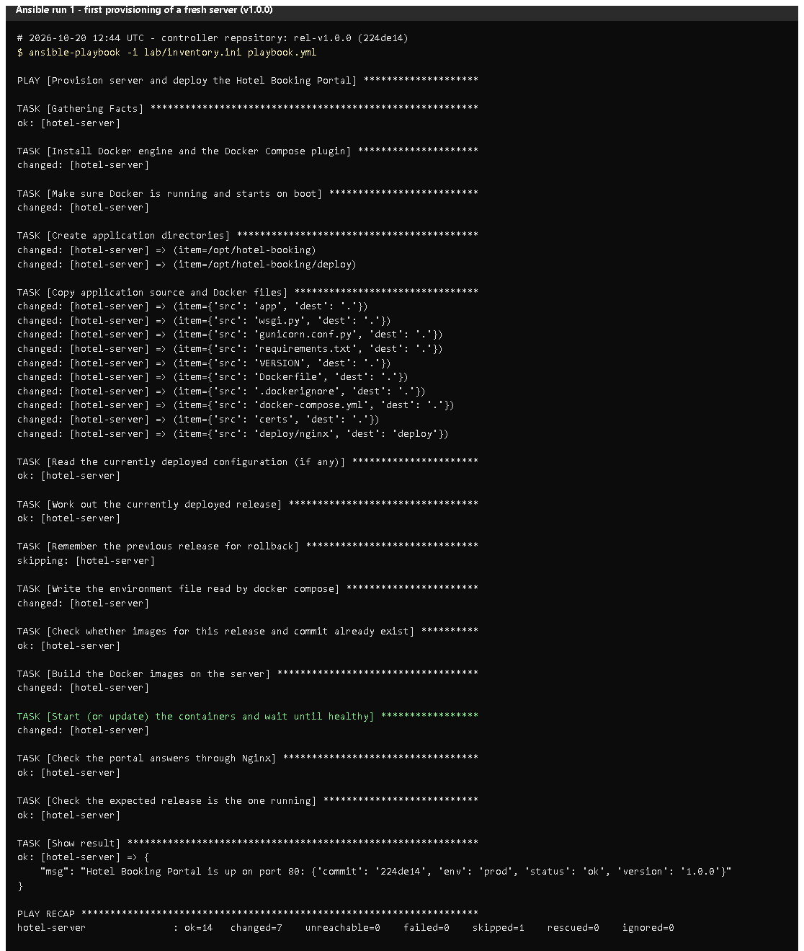 (part 1 of 2)
(part 2 of 2)
Figure 13.1 - Run 1 on a fresh lab server, from a clean clone of tag v1.0.0 (rendered from the real run on 2026-10-20).
Notice: each task's changed/ok, the censored .env task (no_log), the final
message with /health, and PLAY RECAP ... ok=14 changed=7 failed=0.
Proves: Ansible installed prerequisites and deployed the application automatically.
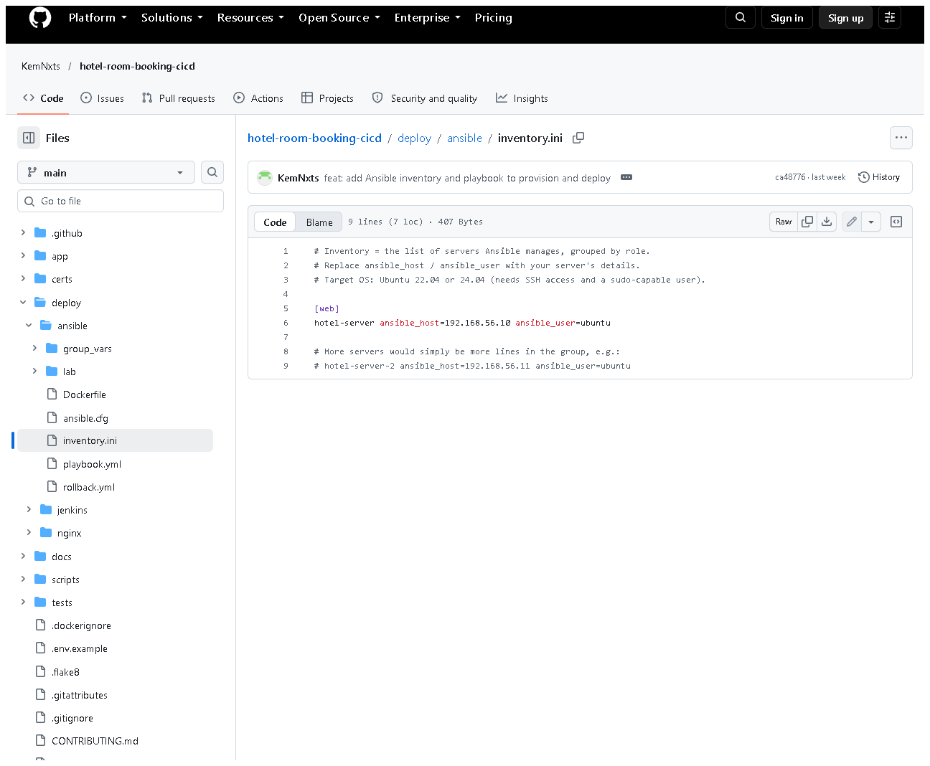
Figure 13.2 - deploy/ansible/inventory.ini on GitHub - group [web].
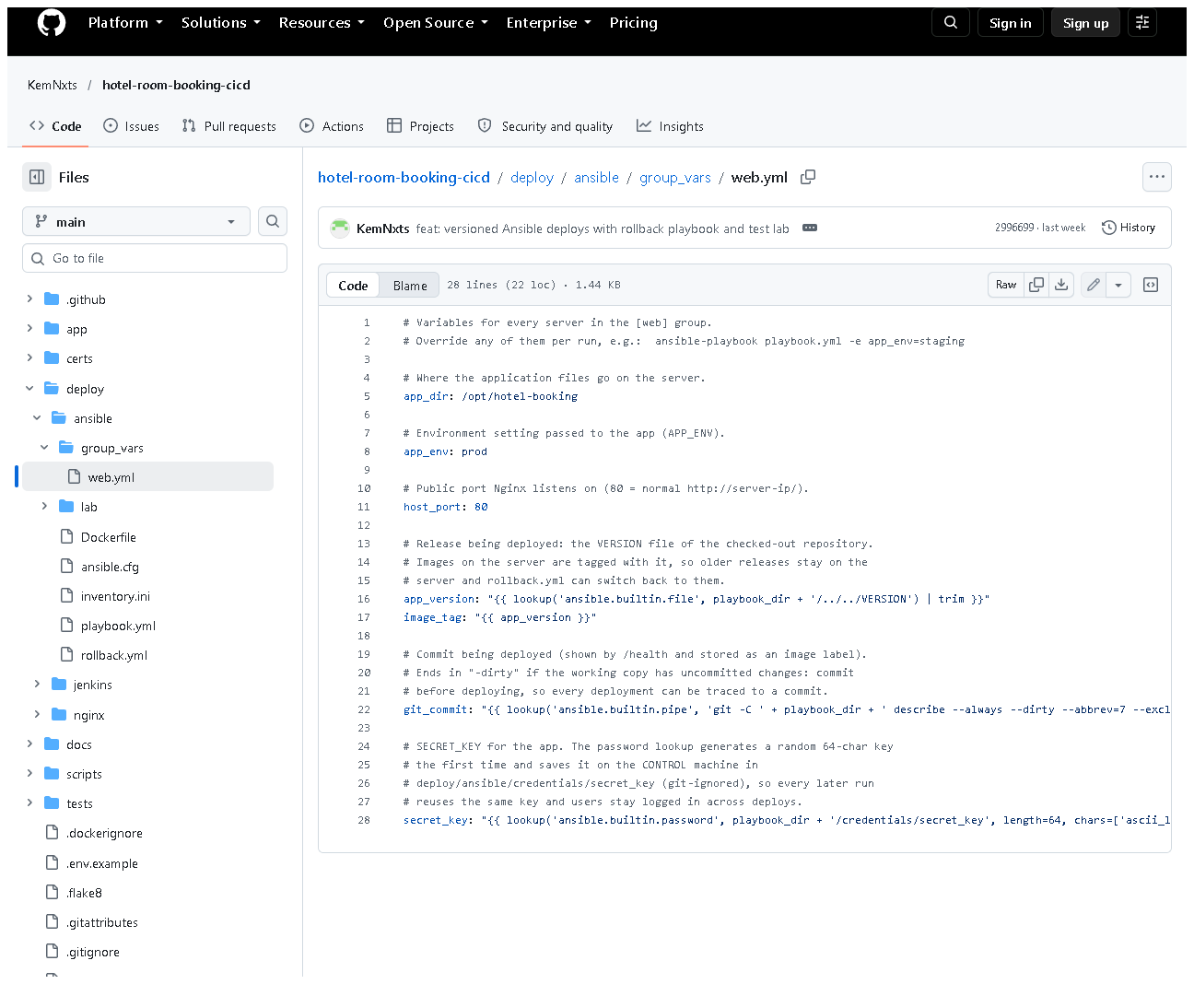
Figure 13.3 - group_vars/web.yml: environment-specific values, the version taken from VERSION, and the generated secret key.
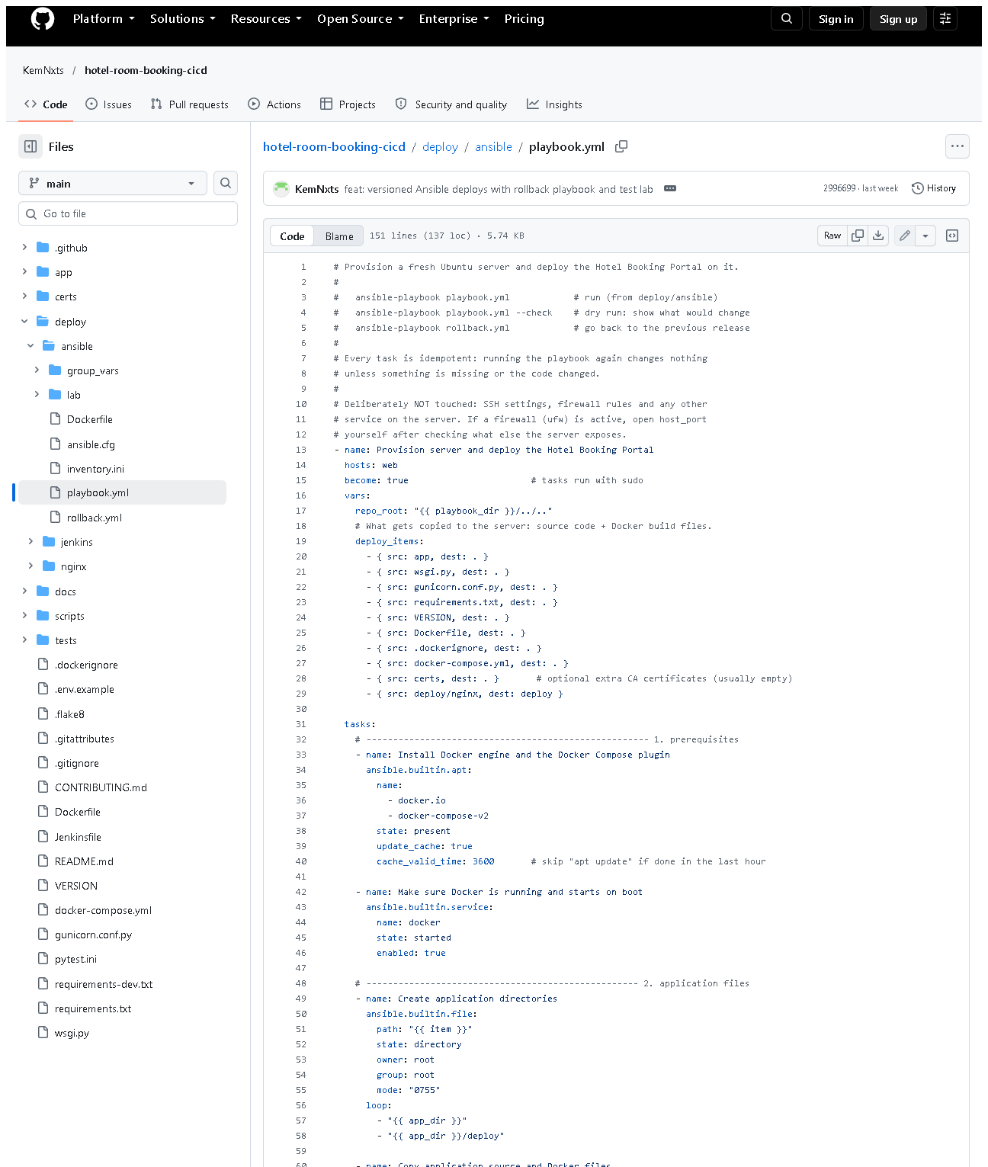 (part 1 of 3)
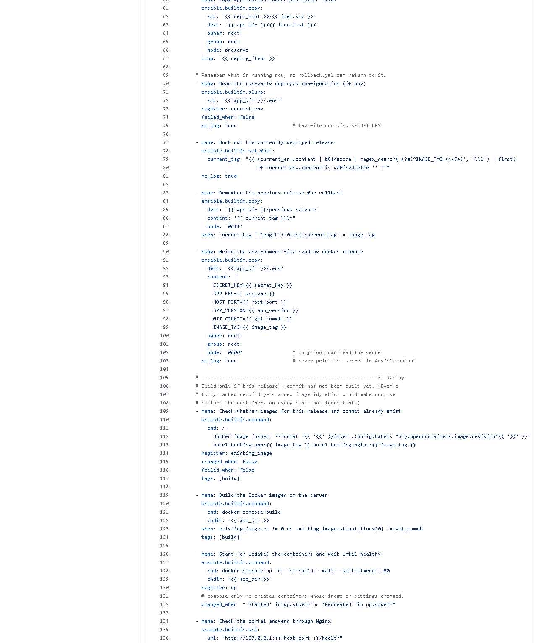 (part 2 of 3)
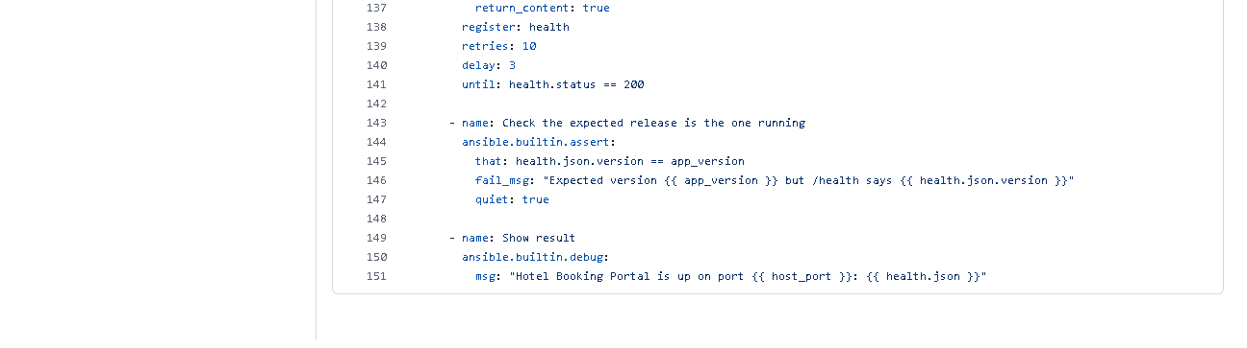 (part 3 of 3)
Figure 13.4 - playbook.yml on GitHub: the tasks listed above.
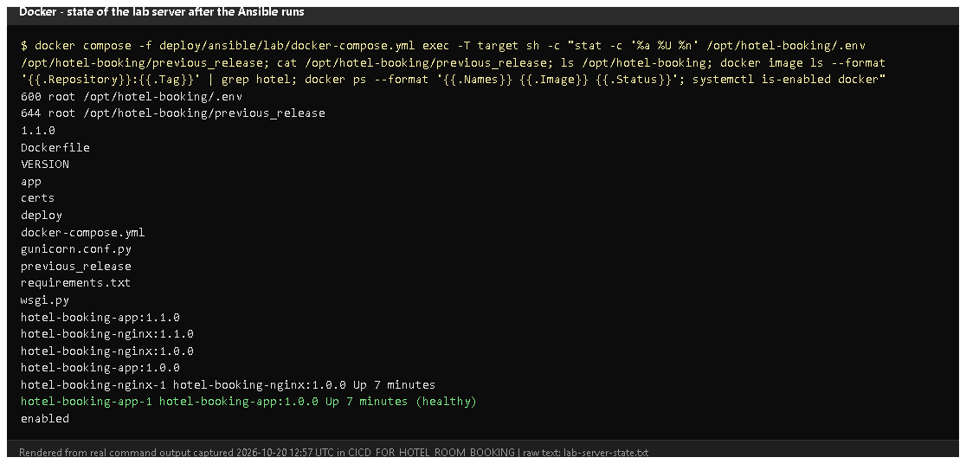
Figure 13.5 - Inside the lab server (rendered from real output, 2026-10-20): file permissions (600 root .env), the files in /opt/hotel-booking, images, running containers, docker enabled.

E. How to demonstrate this task to the professor (about 5 minutes)
Before the demo: Docker Desktop running. PowerShell. These commands were
run exactly like this on 2026-10-20.
cd D:\DevOPS\CICD_FOR_HOTEL_ROOM_BOOKING\deploy\ansible\lab

# 1. a brand-new "server" (only if you want to start from zero - this deletes the old lab)
docker compose down -v
docker compose up -d --build target
docker compose exec target sh -c "command -v docker || echo no docker yet"
Expected: "no docker yet". Say: "This is a fresh Ubuntu server with nothing installed."
# 2. run the playbook (takes 3-5 minutes the first time)
docker compose run --rm controller ansible-playbook -i lab/inventory.ini playbook.yml
Point at: the task names scrolling by, changed vs ok, the censored .env task,
the final "Hotel Booking Portal is up" message and PLAY RECAP ... failed=0.
# 3. prove it
curl.exe -s http://localhost:8088/health
docker compose exec target stat -c "%a %U %n" /opt/hotel-booking/.env
Expected: {"status":"ok",...} and 600 root /opt/hotel-booking/.env.
Open http://localhost:8088 in the browser - the portal served from the "server".
- Show inventory.ini, group_vars/web.yml and playbook.yml in VS Code
and map a few tasks to the deliverables (packages, directories, config, health).
- Say honestly: "The target is a container acting as a server because I
had no VM; for a real server I put its IP in inventory.ini and run the same playbook."
For a real Ubuntu server (not done in this project): from the repository root
docker build -t hotel-ansible -f deploy/ansible/Dockerfile .
docker run --rm -it -v "${PWD}:/work" hotel-ansible ansible-playbook playbook.yml --ask-pass --ask-become-pass
Recovery: "UNREACHABLE" - the target container isn't running:
docker compose up -d target and wait ~10 s. First run slow - it downloads
Docker packages and base images. CERTIFICATE_VERIFY_FAILED during the image
build on the server - antivirus HTTPS scanning; the certs/ folder is copied to the server.

F. Expected screenshots for the final submission
- assets/task-13/ansible-run1-first-deploy-v1.0.0.png - exists, 2026-10-20 (rendered from the real run).
- assets/task-13/github-file-deploy_ansible_inventory.ini.png - exists, 2026-10-20.
- assets/task-13/github-file-deploy_ansible_group_vars_web.yml.png - exists, 2026-10-20.
- assets/task-13/github-file-deploy_ansible_playbook.yml.png - exists, 2026-10-20.
- assets/task-13/lab-server-state.png - exists, 2026-10-20.
- assets/task-13/real-vm-run.png - a run against a real Ubuntu VM - requires manual capture if a VM becomes available (pending).

G. Probable viva questions and answers
- What is configuration management? Describing the desired state of
servers in files and applying it automatically and repeatably.
- Playbook vs inventory? Inventory = which servers; playbook = which tasks/state.
- Why Ansible? Agentless (only SSH + Python on the server), readable
YAML, idempotent built-in modules.
- What does your playbook set up? Docker + compose plugin, the docker
service, /opt/hotel-booking directories, the app files, a root-only
.env, the images, the containers, and a health/version check.
- How are environment differences handled? Variables in
group_vars/web.yml, overridable per run, e.g. -e app_env=staging -e host_port=8080.
- How is the secret protected? Generated once on the control machine
(git-ignored), written to .env with mode 0600 and no_log: true, so it is never printed.
- (Project-specific) What was your target? A disposable Ubuntu 24.04
container with systemd and SSH, defined in deploy/ansible/lab/ - not a separate VM.
- (Project-specific) What did the first run change? 7 tasks: install
Docker, enable it, create directories, copy files, write .env, build images, start containers.
- Do you use handlers? No. Docker Compose recreates containers itself when
their image or settings change, so no separate restart handler is needed.
- Does the playbook change the firewall or SSH? No, deliberately - those
are risky to automate without knowing the server; it is documented.
- Why host_key_checking = False? Convenience for fresh lab machines; for real servers it should be True with known hosts.

H. Common mistakes and troubleshooting
Symptom | Cause | Inspect | Fix | Confirm
UNREACHABLE | target not running / wrong host | docker compose ps in lab | docker compose up -d target | ok= in recap
"Missing sudo password" (real server) | become needs a password | inventory | add --ask-become-pass | tasks run
Ansible ignores ansible.cfg | world-writable folder (Windows mount) | - | the controller image sets ANSIBLE_CONFIG | inventory found
Image build fails on the server | TLS interception | build task output | put the root CA in certs/ | build ok
assert fails: wrong version | old containers / wrong app_version | /health | rerun; check VERSION | assert ok

I. Quick revision notes
Five key points
- Inventory (where) + group_vars (values) + playbook (what) in deploy/ansible/.
- 14 tasks with built-in modules: packages, service, dirs, files, .env 0600, build, start, health, assert.
- Secret generated once, never printed (no_log), file mode 0600.
- Fresh lab server provisioned on 2026-10-20: changed=7, /health OK.
- Target is a container lab, not a VM; firewall/SSH deliberately untouched.
30-60 second explanation
"Ansible describes the server I want: Docker installed and running, an
application folder, the app files, a root-only environment file with the
secret, the images built and the containers healthy. The inventory says which
server, group_vars holds environment values, and the playbook lists the
tasks using built-in modules. I ran it against a fresh Ubuntu server in a
container lab: it installed everything and deployed the portal, with seven
changes and no failures, and the final tasks check /health and the version."
Caveat: tested on a container-based lab target, not a separate VM.
Readiness checklist
- â˜ I can start the lab and run the playbook.
- â˜ I can map tasks to deliverables (packages, dirs, config, health).
- â˜ I can explain inventory vs playbook vs variables.
- â˜ I can explain the lab-vs-VM limitation.

