Task 14 - Automated Provisioning and Reliability Validation (Idempotency and Rollback)

A. Task title and objective
Task 14: Automated Provisioning, Idempotency and Reliability Validation
Objective: prove that automated provisioning is safe to repeat
(idempotent), that health checks confirm the application works, and that a
bad release can be rolled back to a previous stable release - and that the
restored release really works.
Professor's required deliverables
- First Ansible execution
- Second execution with evidence of idempotency
- Application health checks
- Recovery / rollback to a previous stable release
- Verification that the restored release actually works
- Commands, outcomes and limitations recorded (no unproven claims of zero downtime)
Current status: Implemented and verified (container-based lab). The
whole sequence was run again on 2026-10-20 on a fresh lab server:
Run | What | PLAY RECAP | /health afterwards
1 | first provisioning, release v1.0.0 | ok=14 changed=7 failed=0 | 1.0.0 (224de14)
2 | upgrade to v1.1.0 | ok=15 changed=5 failed=0 | 1.1.0 (ce1726d)
3 | same playbook again | ok=13 changed=0 failed=0 skipped=2 | 1.1.0
4 | rollback.yml | ok=11 changed=3 failed=0 | 1.0.0 (224de14)
5 | v1.0.0's own Selenium journeys against the restored server | 5 passed | -

Limitation: the target is a privileged Ubuntu 24.04 container, not a
separate VM. Rollback re-creates the containers, so there is a short
interruption - zero downtime is not claimed.

B. Explanation for a complete beginner
An everyday picture. A light switch labelled "ON": pressing it when the
light is already on changes nothing. A good provisioning script works the
same way - running it twice gives the same result as running it once.
Term | Meaning | In this project
Provisioning | preparing a server from nothing to ready (software, folders, config, app) | playbook.yml on a fresh server
Idempotency | applying the same operation again changes nothing if the state is already correct | run 3: changed=0
Idempotency vs repeatability | repeatable = gives the same end result each time; idempotent = additionally makes no changes when nothing needs changing | our playbook is both
changed=N | Ansible's count of tasks that actually modified the server | 7 -> 5 -> 0
Health check | asking the running app whether it works and which version it is | GET /health through Nginx + assert
Stable release | a tested, tagged version that is known to work | v1.0.0, v1.1.0
Rollback | switching back to a previous stable release | rollback.yml
Deployment vs rollback | deployment moves to a new version; rollback returns to an older, already-tested one, without rebuilding | -

Why changed=0 matters: it proves the playbook checks before acting.
Nothing was reinstalled, rewritten or restarted, so a repeat run is safe -
you can run it any time to make sure the server is still correct.

C. What was actually implemented
Making the playbook idempotent
- Built-in modules are idempotent by design: apt state=present does nothing
if Docker is installed; copy does nothing if the file content is identical; file/service likewise.
- Special case - images: even a fully cached docker build produces a
new image ID, which would make compose restart containers every time. So
the playbook first checks the image label (lines 109-119):
- name: Check whether images for this release and commit already exist
ansible.builtin.command:
cmd: docker image inspect --format '...org.opencontainers.image.revision...' hotel-booking-app:{{ image_tag }} hotel-booking-nginx:{{ image_tag }}
register: existing_image
changed_when: false # only reads, never counts as a change
failed_when: false

- name: Build the Docker images on the server
ansible.builtin.command: { cmd: docker compose build, chdir: "{{ app_dir }}" }
when: existing_image.rc != 0 or existing_image.stdout_lines[0] != git_commit # build only if missing
(Excerpt simplified: the real cmd uses a Jinja-escaped Go template.)
- docker compose up reports changed only if its output contains
Started or Recreated.
Health checks - every run ends with uri http://127.0.0.1:{{ host_port }}/health
(10 retries) and assert health.json.version == app_version.
Rollback mechanism (deploy/ansible/rollback.yml)
- Each deploy tags images with the release (hotel-booking-app:1.1.0) and keeps older images on the server.
- Before switching releases, the playbook writes the running release to /opt/hotel-booking/previous_release.
- rollback.yml reads that file (or -e rollback_to=1.0.0), refuses if
the target images are not on the server, sets IMAGE_TAG in .env,
saves the release it is leaving (so running it again rolls forward), runs
docker compose up -d --no-build --wait, then asserts /health shows the target version.
- The database volume is kept, so bookings survive (no release changed the schema).
What each run changed (from the saved logs):
Run | Changed tasks
1 (7) | install Docker; start/enable Docker; create directories; copy files; write .env; build images; start containers
2 (5) | copy files (new code); remember previous release (1.0.0); write .env; build images; recreate containers
3 (0) | nothing - build skipped, previous-release skipped, everything ok
4 (3) | point .env at 1.0.0; save 1.1.0 as previous; restart containers on 1.0.0

Verification that the restored release works: after run 4, the Selenium
journeys of release v1.0.0 (from a clean clone of the tag - the current
tests expect the newer UI) were run against http://localhost:8088: 5 of 5 passed.
Rollback without Ansible (Docker level) - also demonstrated on
2026-10-11 for prod: IMAGE_TAG=1.0.0-661751d docker compose up -d --no-build --wait
switched prod 1.1.0 -> 1.0.0 and back (docs/evidence/docker/rollback-prod.txt).

D. Screenshots and evidence
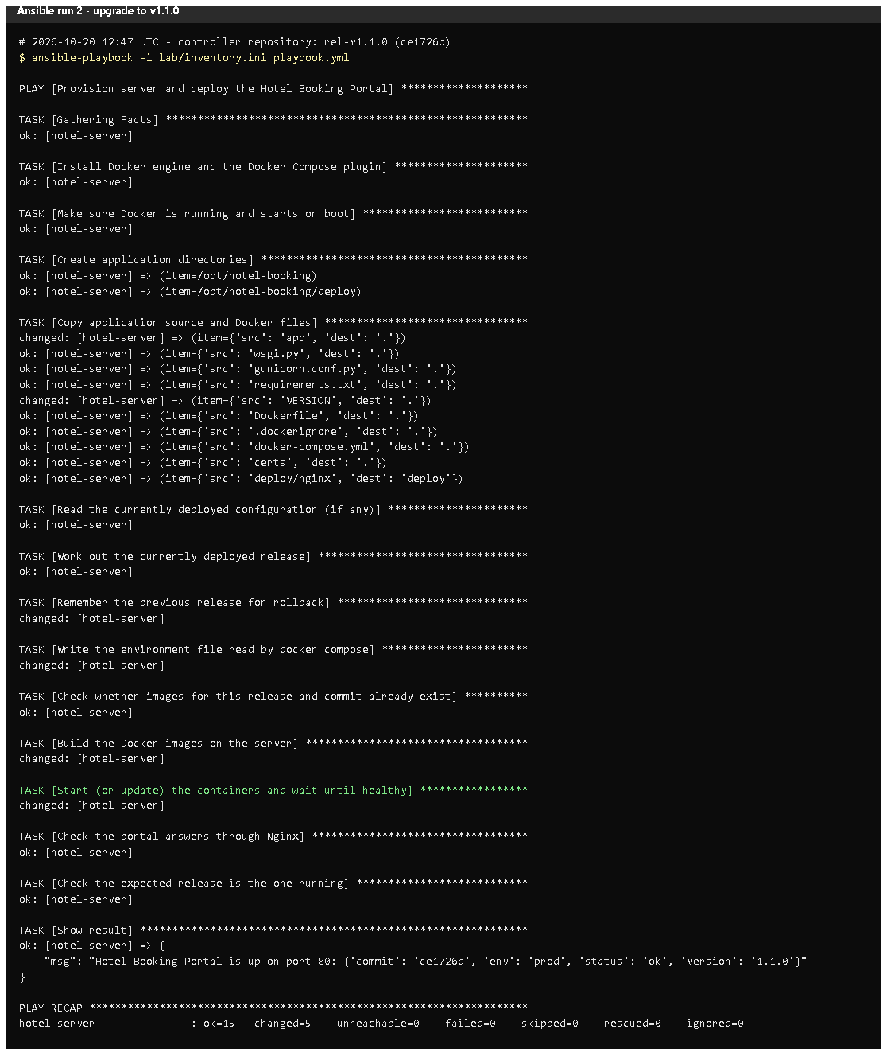 (part 1 of 2)
(part 2 of 2)
Figure 14.1 - Run 2 (upgrade to v1.1.0): changed=5, /health 1.1.0 (rendered from the real run, 2026-10-20).
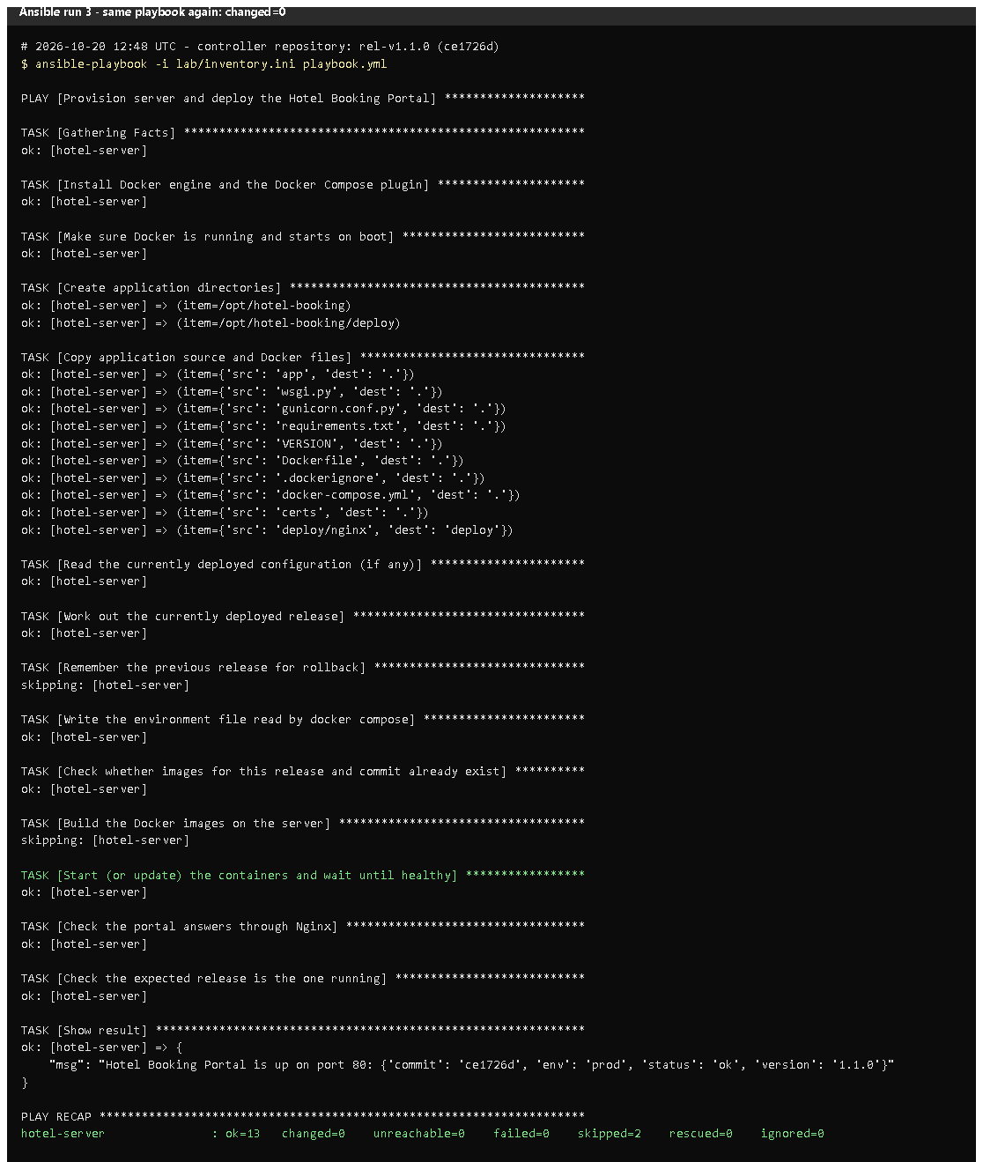 (part 1 of 2)
(part 2 of 2)
Figure 14.2 - Run 3, the same playbook again: every task ok or skipping, PLAY RECAP ... changed=0.
Proves: idempotency.
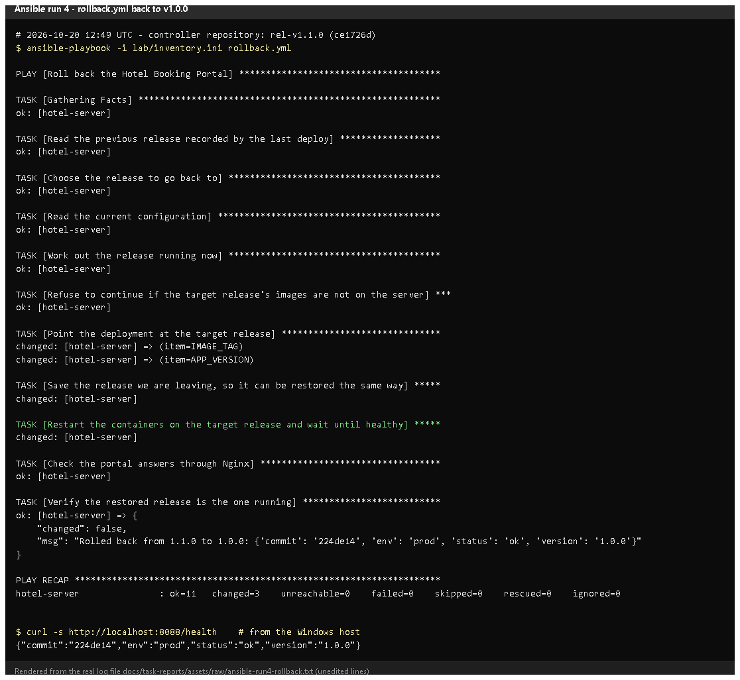
Figure 14.3 - rollback.yml: "Rolled back from 1.1.0 to 1.0.0", changed=3, /health 1.0.0.
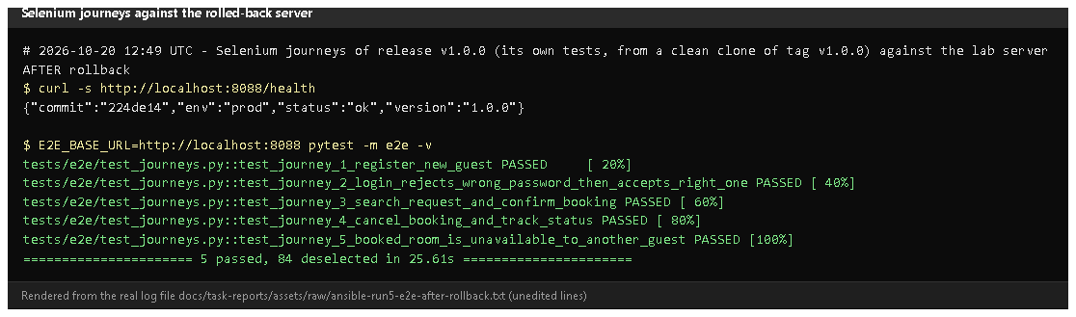
Figure 14.4 - The five v1.0.0 Selenium journeys pass against the rolled-back server.
Proves: the restored release actually works, not only /health.
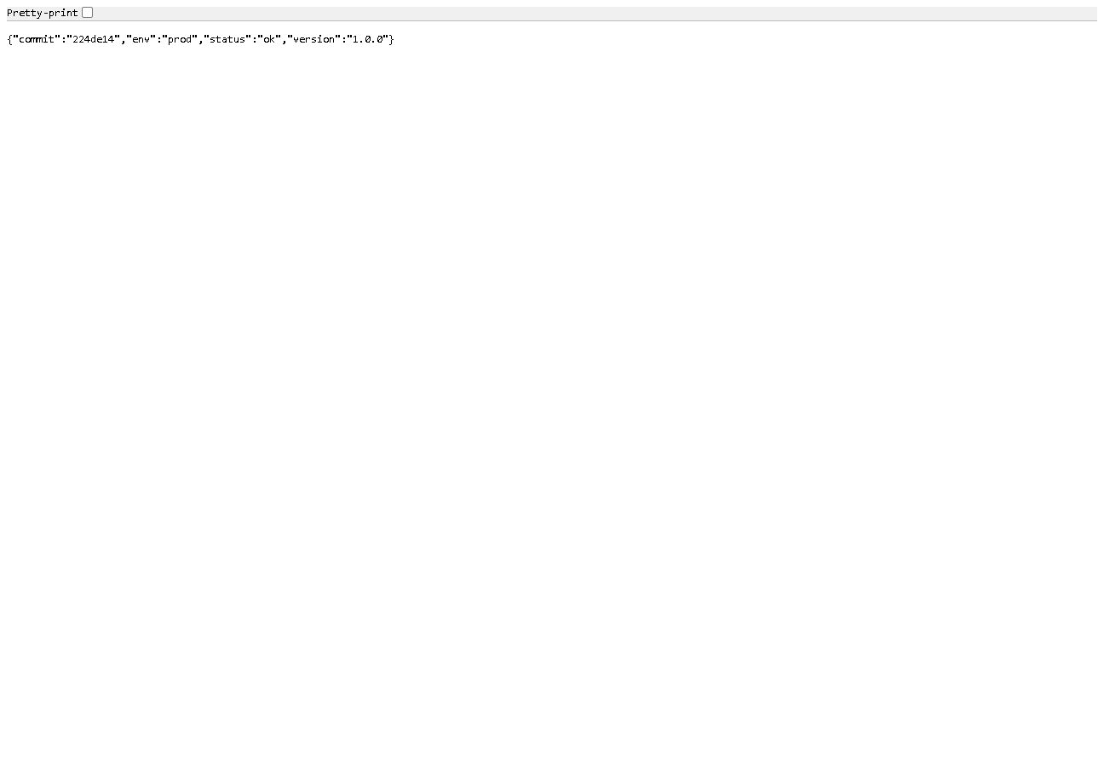
Figure 14.5 - http://localhost:8088/health: version 1.0.0, commit 224de14.
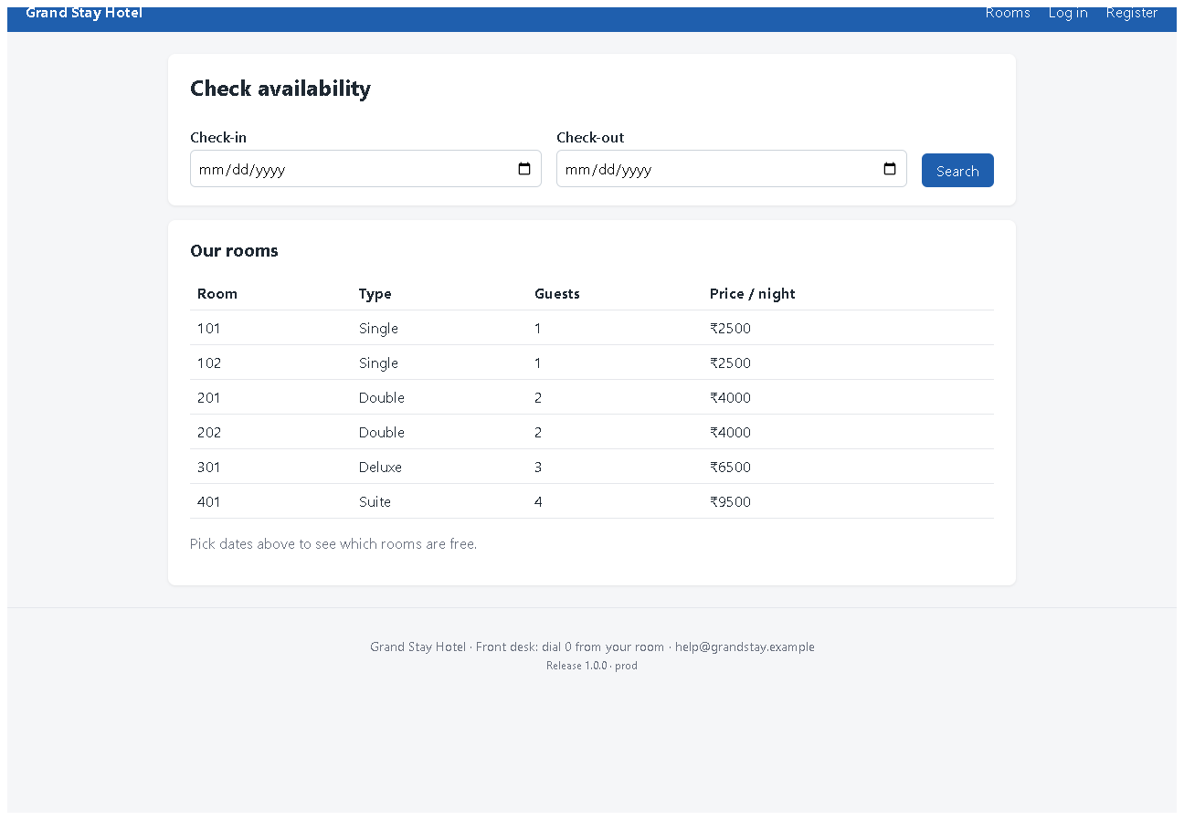
Figure 14.6 - The portal served by the lab server after the rollback (v1.0.0 interface).
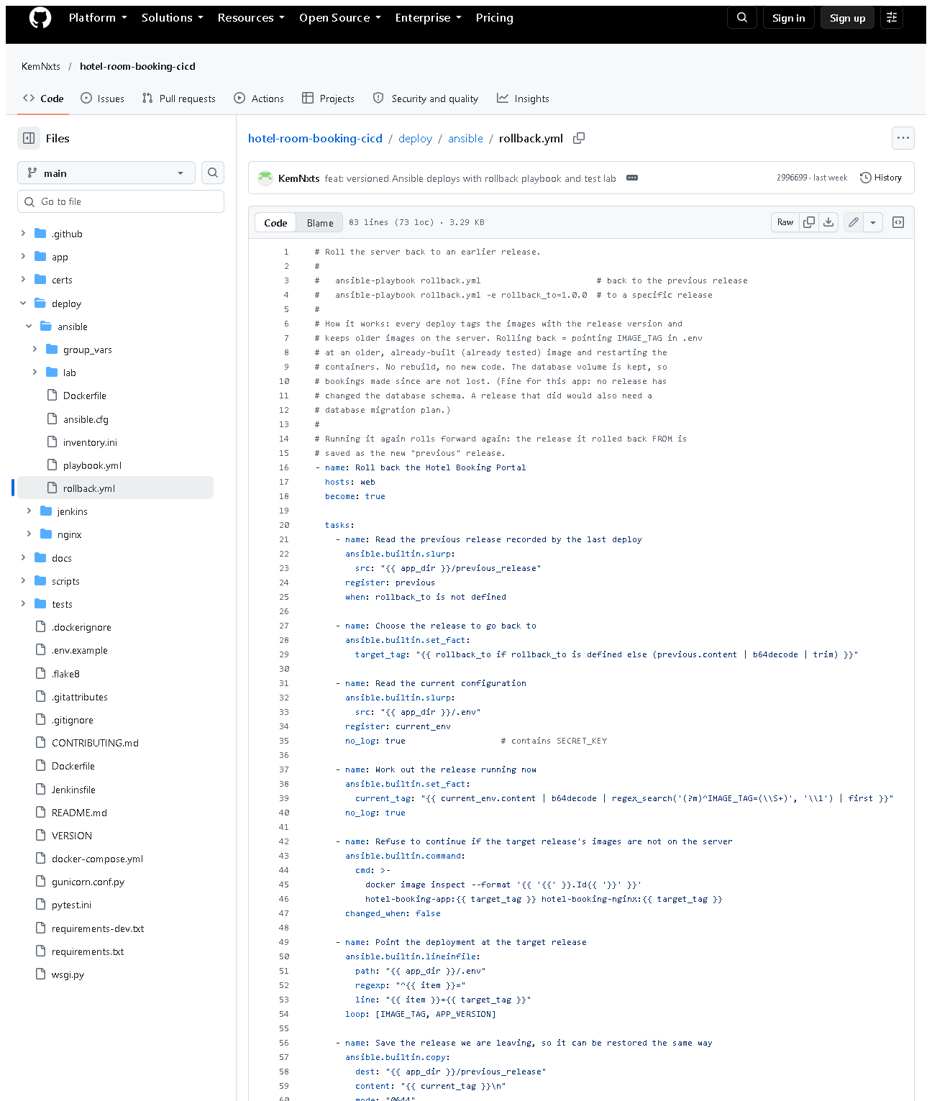 (part 1 of 2)
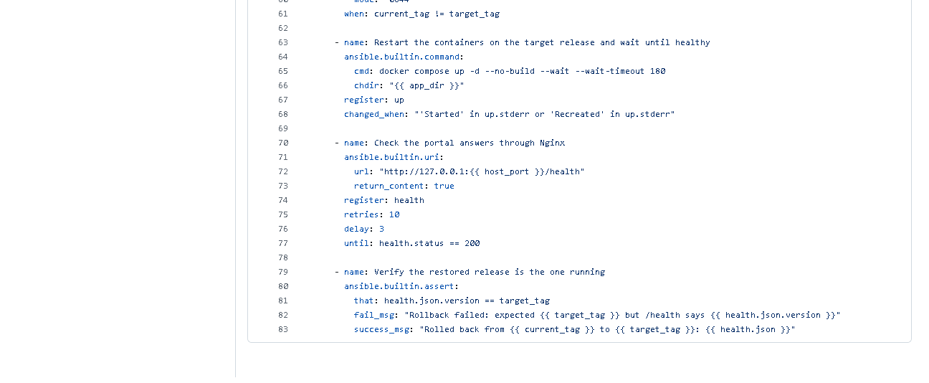 (part 2 of 2)
Figure 14.7 - deploy/ansible/rollback.yml on GitHub.

E. How to demonstrate this task to the professor (about 6 minutes)
Before the demo: Docker Desktop running; the lab target up
(docker compose up -d target in deploy\ansible\lab). These commands were run exactly like this on 2026-10-20.
cd D:\DevOPS\CICD_FOR_HOTEL_ROOM_BOOKING\deploy\ansible\lab

# 1. deploy (if the server is fresh this is the first provisioning)
docker compose run --rm controller ansible-playbook -i lab/inventory.ini playbook.yml

# 2. run it again - idempotency
docker compose run --rm controller ansible-playbook -i lab/inventory.ini playbook.yml
Point at: PLAY RECAP ... changed=0. Say: "The second run checked
every task and found nothing to change - that is idempotency." (If the lab
server was already up to date, even run 1 shows changed=0 - verified on
2026-10-20. To show a first run with changes, start from a fresh server as in
Task 13, step 1.)
# 3. simulate a new release (same code, new version number)
docker compose run --rm controller ansible-playbook -i lab/inventory.ini playbook.yml -e app_version=1.1.1-demo
curl.exe -s http://localhost:8088/health
Expected: "version":"1.1.1-demo". Say: "Pretend this release is bad."
# 4. roll back
docker compose run --rm controller ansible-playbook -i lab/inventory.ini rollback.yml
curl.exe -s http://localhost:8088/health
Expected: "Rolled back from 1.1.1-demo to 1.1.0" and "version":"1.1.0".
Say: "The previous image was still on the server, so rollback is just a switch - no rebuild."
- Prove the restored version works: open http://localhost:8088, register and
make a booking - or run the Selenium journeys (from the project folder):(The local tests match the interface of the working tree; for the
v1.0.0 interface use the tests from that tag, as in Figure 14.4.)
cd D:\DevOPS\CICD_FOR_HOTEL_ROOM_BOOKING
$env:E2E_BASE_URL="http://localhost:8088"
.venv\Scripts\python -m pytest -m e2e -q
Remove-Item Env:E2E_BASE_URL
Recovery: rollback.yml fails "No such image" - that release was never
deployed on this server; deploy it first or pass an existing
-e rollback_to=.... UNREACHABLE - start the target container.

F. Expected screenshots for the final submission
- assets/task-14/ansible-run2-upgrade-v1.1.0.png - exists, 2026-10-20.
- assets/task-14/ansible-run3-repeat-idempotent.png - exists, 2026-10-20.
- assets/task-14/ansible-run4-rollback.png - exists, 2026-10-20.
- assets/task-14/ansible-run5-e2e-after-rollback.png - exists, 2026-10-20.
- assets/task-14/lab-server-health-after-rollback.png - exists, 2026-10-20.
- assets/task-14/lab-server-after-rollback-v1.0.0.png - exists, 2026-10-20.
- assets/task-14/github-file-deploy_ansible_rollback.yml.png - exists, 2026-10-20.
- Run 1 (first provisioning) is in Task 13: assets/task-13/ansible-run1-first-deploy-v1.0.0.png - exists, 2026-10-20.

G. Probable viva questions and answers
- What is idempotency? Running the same automation again makes no
changes when the system is already in the desired state. Our run 3 reported changed=0.
- Idempotency vs repeatability? Repeatable = same end result each time;
idempotent = also no unnecessary changes (nothing reinstalled or restarted).
- Why did run 1 change 7 things but run 3 none? Run 1 started from an
empty server; run 3 found Docker installed, files identical and images for
this release and commit already present, so it skipped the build.
- How did you make the image build idempotent? By checking the image's
revision label first and building only if the release/commit is missing.
- How does rollback work? Old images stay on the server; rollback.yml
points .env to the previous tag, restarts with --no-build and asserts /health shows that version.
- (Project-specific) How do you know the rollback really worked?
/health returned 1.0.0 (224de14) and the five v1.0.0 Selenium journeys passed against the server.
- (Project-specific) What happens to bookings during rollback? They are
kept - the database is on a volume that rollback does not touch.
- Is there downtime? A few seconds while containers are re-created; zero downtime would need blue/green deployment.
- What if the release changed the database schema? Rollback would need a
migration plan; no release here changed the schema, so it was not needed.
- Deployment vs rollback? Deployment moves forward to a new version;
rollback goes back to an earlier tested version without rebuilding.
- What are the limits of your test? It used a container acting as a
server, not a VM, and a rollback within one server.

H. Common mistakes and troubleshooting
Symptom | Cause | Inspect | Fix | Confirm
Second run shows changed=1 | uncommitted changes since run 1 (commit label -dirty changed) or new code | the changed task | commit, then run twice | changed=0
rollback.yml: "No such image" | target release never deployed here | docker compose exec target docker image ls | deploy that release first / pick an existing one | rollback ok
/health still shows the new version | rollback task failed | rollback output | rerun; check previous_release | version = old
Selenium fails after rollback | tests from a newer UI | test version | use tests from the same tag | 5 passed
Lab gone after down -v | -v deletes volumes | - | docker compose up -d --build target + playbook | portal back

I. Quick revision notes
Five key points
- Run 1 changed=7, run 2 changed=5, run 3 changed=0 = idempotent.
- Images are built only when the release/commit is missing (label check).
- Each deploy remembers the previous release; images are kept.
- rollback.yml switches IMAGE_TAG, restarts without rebuilding, asserts /health.
- Restored v1.0.0 verified by /health and 5/5 Selenium journeys.
30-60 second explanation
"On a fresh lab server the playbook made seven changes - installing Docker,
copying the app, building images and starting containers. Upgrading to v1.1.0
made five. Running the same playbook again made zero changes, which proves
it's idempotent and safe to repeat. Every deploy keeps the old images and
remembers the previous release, so rollback.yml just switches the image tag
and restarts. After rolling back to 1.0.0, /health showed 1.0.0 and that
release's Selenium journeys all passed."
Caveat: container-based lab, not a VM; rollback has a short interruption.
Readiness checklist
- â˜ I can run the playbook twice and point at changed=0.
- â˜ I can simulate a release with -e app_version=... and roll back.
- â˜ I can explain why run 3 skipped the build.
- â˜ I can state the limitations honestly.

