ESKISEHIR TECHNICAL UNIVERSITY
FACULTY OF ENGINEERING
DEPARTMENT OF COMPUTER ENGINEERING

BIM 308 – DEEP LEARNING
PROJECT REPORT

Steel Surface Defect Classification
Using Convolutional Neural Networks (CNN)
on NEU-DET Dataset

Prepared by:
Kemal Furkan Saygılı

May 2025

1. Problem Definition
Steel surface defects are a critical quality control issue in the manufacturing industry. Identifying these defects manually is time-consuming, error-prone, and costly. Automated defect detection using deep learning offers a reliable and scalable alternative to traditional inspection methods.
In this project, we address the problem of classifying six types of steel surface defects using Convolutional Neural Networks (CNN). The classification task involves assigning each grayscale steel surface image to exactly one of the following six defect categories:
- Crazing – a network of fine surface cracks
- Inclusion – embedded foreign particles within the steel
- Patches – irregular discolored areas on the surface
- Pitted Surface – small pits or holes on the surface
- Rolled-in Scale – scale pressed into the surface during rolling
- Scratches – linear grooves or scratches on the surface
The key challenges of this problem include the visual similarity between certain defect classes (e.g., scratches vs. pitted surface), relatively low image resolution (200×200 pixels), and the need for high accuracy to be applicable in industrial settings.

2. Neural Network Models Used
Two CNN-based models were implemented and compared in this project: a Custom CNN built from scratch, and a pre-trained ResNet18 adapted via Transfer Learning.

2.1 Custom CNN Architecture
The Custom CNN was designed specifically for this classification task. It consists of four convolutional blocks followed by global average pooling and a fully connected classification head:
- Conv Block 1: 3 → 32 filters (Conv2D × 2, BatchNorm, ReLU, MaxPool 2×2) — output: 112×112
- Conv Block 2: 32 → 64 filters (Conv2D × 2, BatchNorm, ReLU, MaxPool 2×2) — output: 56×56
- Conv Block 3: 64 → 128 filters (Conv2D × 2, BatchNorm, ReLU, MaxPool 2×2) — output: 28×28
- Conv Block 4: 128 → 256 filters (Conv2D × 2, BatchNorm, ReLU, MaxPool 2×2) — output: 14×14
- Global Average Pooling → 256-dimensional feature vector
- Fully Connected: 256 → 512 → Dropout(0.5) → 6 (softmax output)
Batch Normalization is applied after each convolutional layer to stabilize training and accelerate convergence. Dropout (p=0.5) is applied in the classifier head to reduce overfitting. The total number of trainable parameters is approximately 2.4 million.

2.2 ResNet18 with Transfer Learning
ResNet18 is a 18-layer deep residual network pre-trained on the ImageNet dataset (1.2 million images, 1000 classes). Transfer learning allows us to leverage the powerful feature representations already learned from large-scale data.
For this project, all layers of ResNet18 were frozen (weights not updated during training) and only the final classification head was replaced and trained:
- Frozen backbone: ResNet18 (11,176,512 parameters — not updated)
- New classification head: FC(512→256) → ReLU → Dropout(0.4) → FC(256→6)
- Trainable parameters: 132,870 (~1.2% of total)
This approach is computationally efficient and particularly effective when the target dataset is relatively small, as ImageNet features generalize well to texture-based classification tasks such as defect detection.

3. Dataset Description
The NEU-DET (NEU Surface Defect Database) dataset was used in this project. It is a widely used benchmark dataset for steel surface defect detection and classification, provided by Northeastern University, China.
Dataset statistics:
Split | Images per Class | Total Classes | Total Images
Train | 240 | 6 | 1,440
Validation | 60 | 6 | 360
Total | 300 | 6 | 1,800

Images are grayscale, 200×200 pixels, and organized into per-class subdirectories. The dataset is perfectly balanced with equal samples per class in both splits.
Data augmentation was applied to the training set to improve generalization:
- Random horizontal and vertical flipping
- Random rotation (±15°)
- Color jitter (brightness, contrast, saturation)
- Resize to 224×224 pixels (required for ResNet18 input)
The dataset was obtained from the official NEU-DET distribution. It is a standardized benchmark frequently cited in industrial defect detection research.
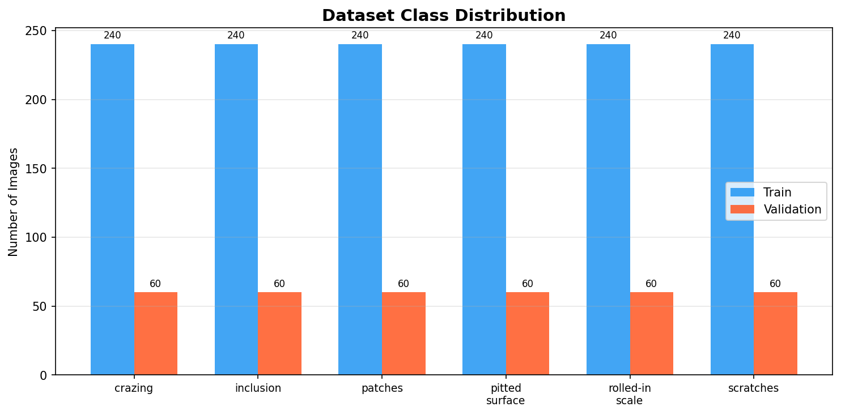
Figure 1. Class distribution of the NEU-DET dataset across train and validation splits.

4. Implementation Details
The project was implemented in Python using the PyTorch deep learning framework. All experiments were run on CPU (Intel). The following hyperparameters were used for both models:
- Optimizer: Adam (lr=1e-3, weight_decay=1e-4)
- Loss function: Cross-Entropy Loss
- Scheduler: ReduceLROnPlateau (factor=0.5, patience=3)
- Batch size: 32
- Number of epochs: 20
- Image size: 224×224 (RGB)

5. Simulation Results
Both models were trained for 20 epochs and evaluated on the validation set. The best model state (highest validation accuracy) was saved and used for final evaluation.

5.1 Training History
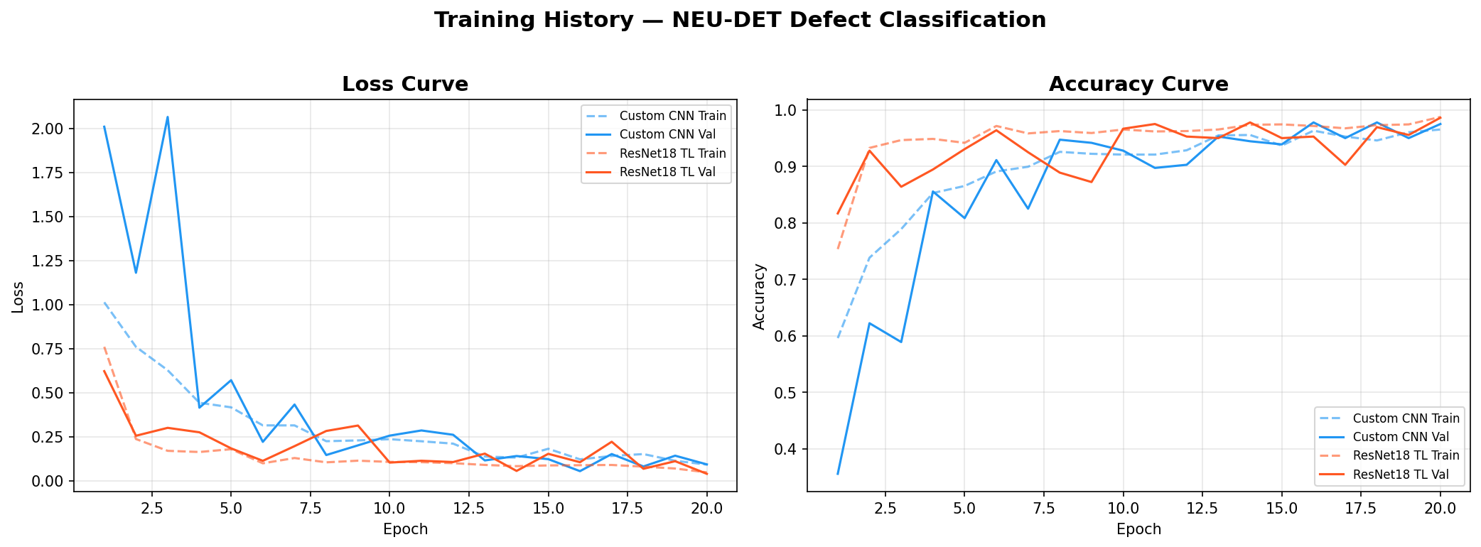
Figure 2. Training and validation loss and accuracy curves for both models over 20 epochs.

5.2 Custom CNN Results
The Custom CNN achieved the following results on the validation set:
- Validation Accuracy: 97.78%
- Macro F1-Score: 0.9777
- Best performance on: crazing, patches, rolled-in_scale (F1 = 1.00)
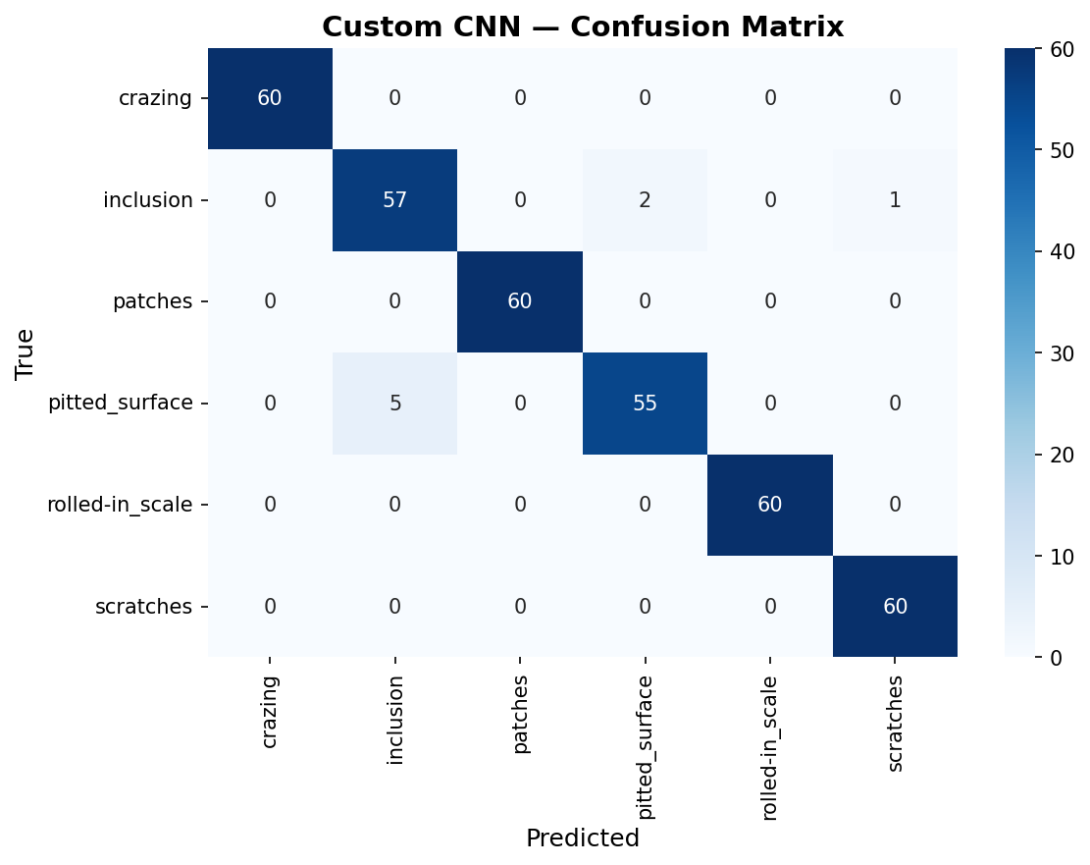
Figure 3. Confusion matrix of the Custom CNN on the validation set.
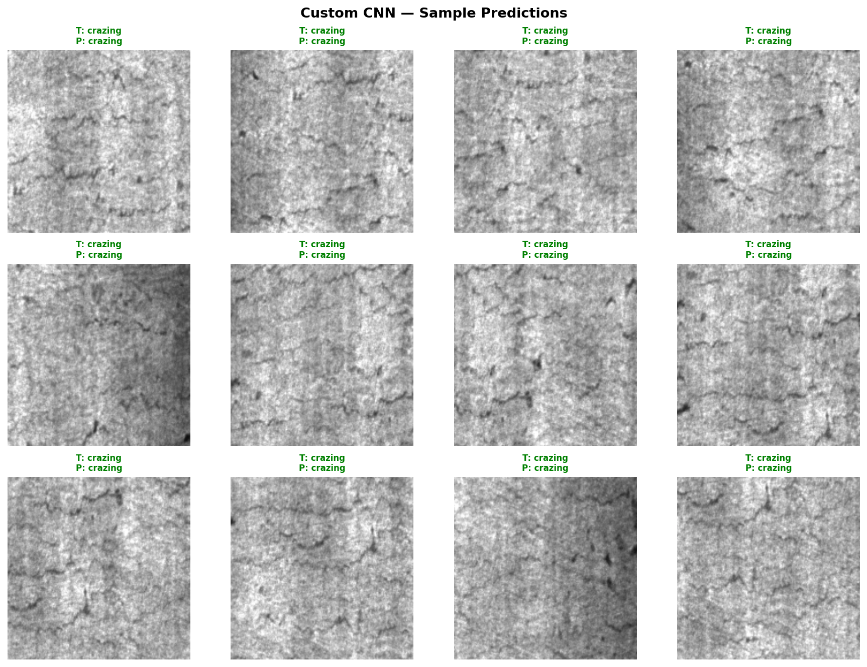
Figure 4. Sample predictions of the Custom CNN (green = correct, red = incorrect).

5.3 ResNet18 Transfer Learning Results
The ResNet18 model with Transfer Learning achieved the following results:
- Validation Accuracy: 98.61%
- Macro F1-Score: 0.9861
- Correctly classified: 355 out of 360 images
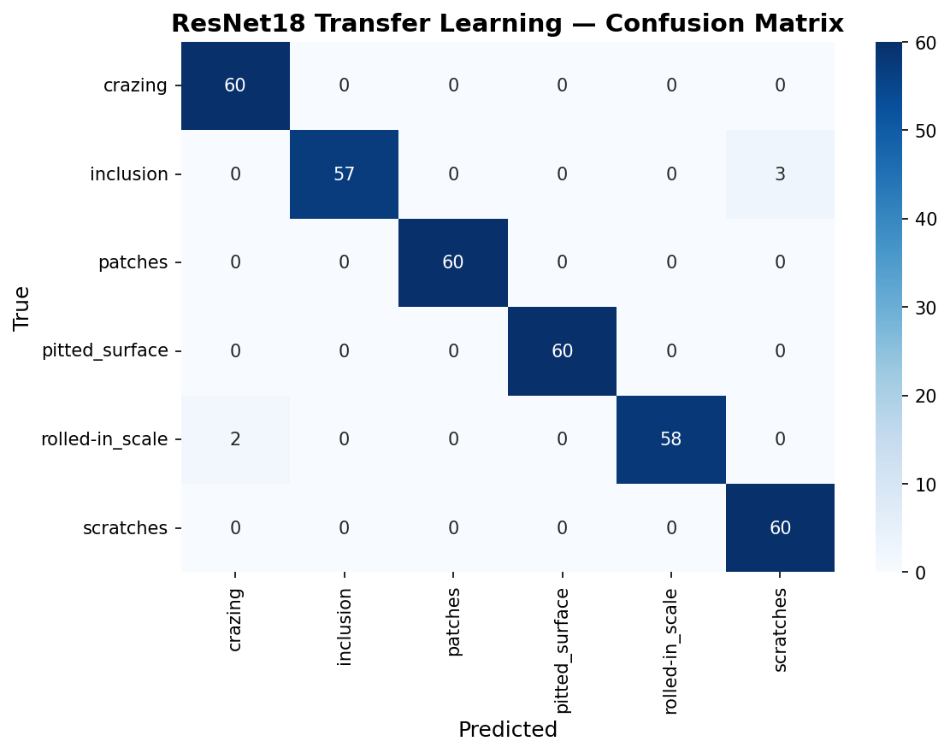
Figure 5. Confusion matrix of ResNet18 (Transfer Learning) on the validation set.
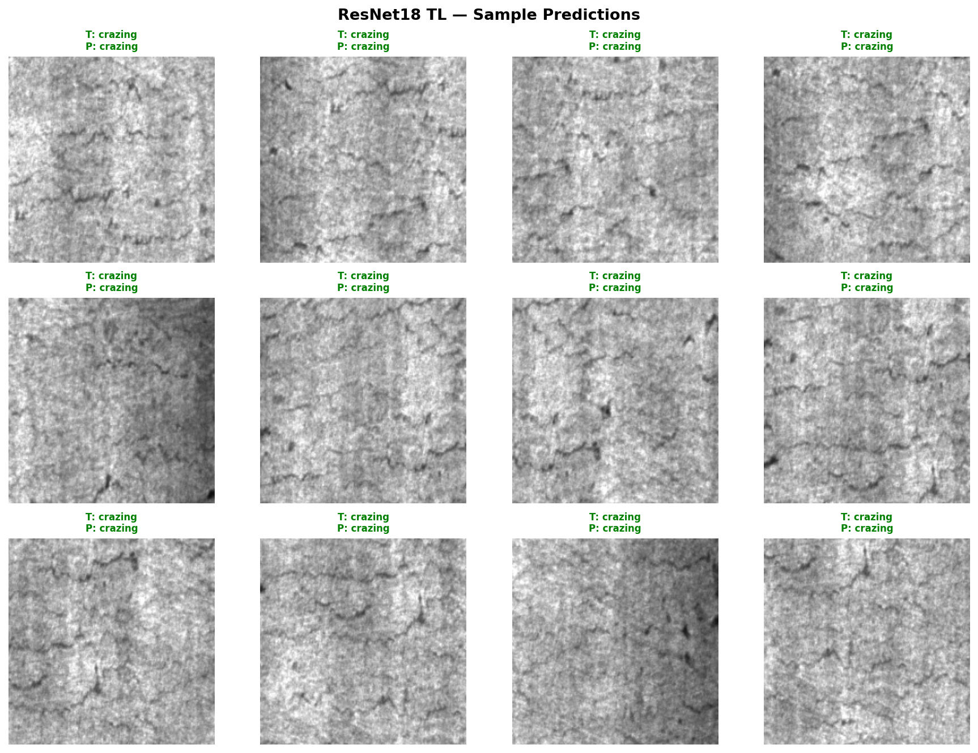
Figure 6. Sample predictions of ResNet18 (green = correct, red = incorrect).

5.4 Model Comparison
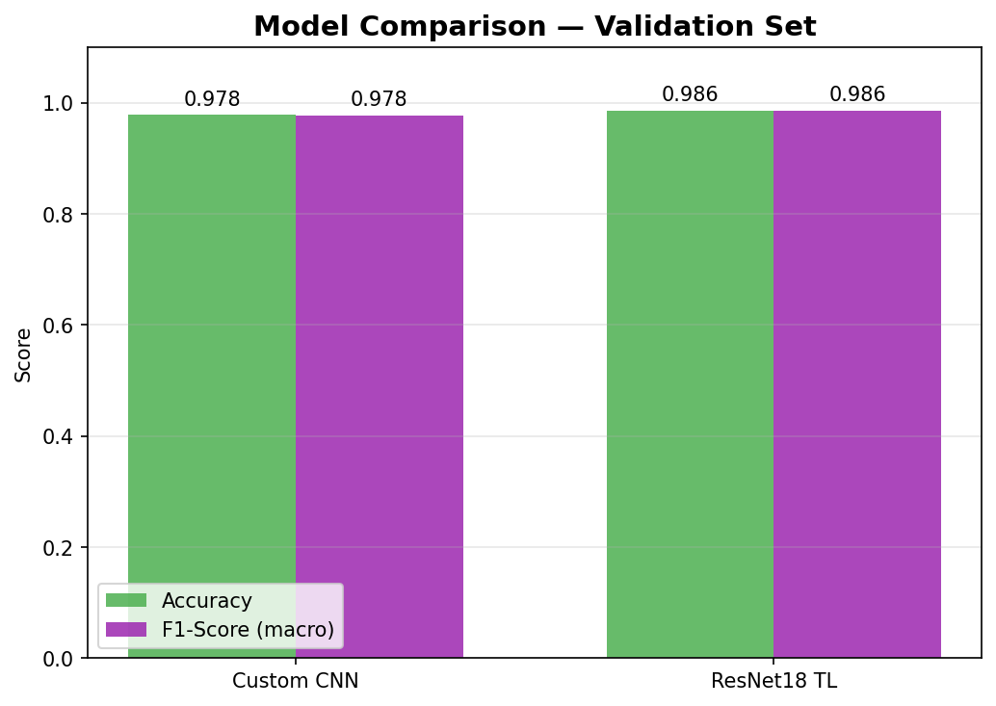
Figure 7. Comparison of validation accuracy and macro F1-score for both models.
Summary of results:
Model | Val Accuracy | Macro F1 | Trainable Params
Custom CNN | 97.78% | 0.9777 | ~2.4M
ResNet18 (TL) | 98.61% | 0.9861 | 132,870

6. Discussion and Analysis
Both models achieved excellent performance on the NEU-DET validation set, with accuracies above 97%. This demonstrates that CNN-based architectures are well-suited for steel surface defect classification.
Transfer Learning (ResNet18) outperformed the Custom CNN by approximately 0.83 percentage points in accuracy. Despite using only 132,870 trainable parameters (compared to ~2.4M for Custom CNN), ResNet18 benefited from rich feature representations pre-trained on ImageNet, enabling faster convergence and better generalization.
The confusion matrices reveal that the most challenging class pair is pitted_surface vs. scratches. These two defects share similar low-level texture features (sharp discontinuities on the surface), making them harder to distinguish even for deep networks.
The training curves show that both models converged smoothly without significant overfitting. The ReduceLROnPlateau scheduler effectively decreased the learning rate when validation loss plateaued, helping models find better optima.
Data augmentation (flipping, rotation, color jitter) played a key role in preventing overfitting on the relatively small training set of 1,440 images.

7. Conclusion
In this project, we successfully applied Convolutional Neural Networks to the task of steel surface defect classification using the NEU-DET dataset. Two approaches were implemented and compared:
- Custom CNN trained from scratch: 97.78% validation accuracy
- ResNet18 with Transfer Learning: 98.61% validation accuracy
Both models achieved strong results, with the Transfer Learning approach proving slightly superior. The results confirm that deep learning is an effective and practical solution for automated quality control in steel manufacturing.
Future work could explore: (1) fine-tuning all ResNet18 layers with a lower learning rate, (2) using more advanced architectures such as EfficientNet or Vision Transformers, (3) multi-label classification for images containing multiple defect types, and (4) deploying the model as a real-time inspection system.

8. How to Run the Code

Prerequisites
Ensure you have Python 3.8+ installed.
Install the required libraries:
python -m pip install torch torchvision matplotlib scikit-learn seaborn pdfplumber

Directory Setup
Place the following files in the same directory:
- deeplearning.py (main training script)
- NEU-DET/ (dataset folder with train/ and validation/ subdirectories)
- test.py (optional: for standalone evaluation)

Training
python deeplearning.py
Training will run for 20 epochs. Results (plots and model weights) will be saved automatically to the results/ folder.

Submission Mode (100 samples)
To run with only 100 dataset samples, open deeplearning.py and set:
SUBMISSION_MODE = True
Then run: python deeplearning.py

Evaluation
python test.py --model resnet18
python test.py --image "NEU-DET/validation/images/crazing/crazing_241.jpg"

References
- K. Song and Y. Yan, "A noise robust method based on completed local binary patterns for hot-rolled steel strip surface defects," Applied Surface Science, vol. 285, pp. 858–864, 2013.
- He, K., Zhang, X., Ren, S., & Sun, J. (2016). Deep residual learning for image recognition. In Proceedings of the IEEE conference on computer vision and pattern recognition (pp. 770–778).
- NEU Surface Defect Database. http://faculty.neu.edu.cn/yunhyan/NEU_surface_defect_database.html
- Paszke, A., et al. (2019). PyTorch: An imperative style, high-performance deep learning library. Advances in Neural Information Processing Systems, 32.
- Pan, S. J., & Yang, Q. (2009). A survey on transfer learning. IEEE Transactions on knowledge and data engineering, 22(10), 1345–1359.
- Litjens, G., et al. (2017). A survey on deep learning in medical image analysis. Medical image analysis, 42, 60–88.

