COMMERCIAL SOLAR PV + BATTERY ENERGY STORAGE
TECHNO-ECONOMIC PROJECT REPORT
Barstow, California

Historical Utility Analysis • PV/ESS Sizing • Demand-Charge Modeling • Financial Evaluation

Keman Xiang
kemanxiang005@gmail.com

Commercial Project Case Study
Based on project work completed at Stored Power Technology Inc.

Project report based on the project workbook and client proposal.
Project-specific numerical results follow those source files; assumptions are identified explicitly.

Executive Summary
This commercial behind-the-meter solar photovoltaic (PV) and battery energy storage system (ESS) project evaluates two utility accounts in Barstow, California. The analysis covers a 12-billing-cycle electricity baseline, time-of-use (TOU) characterization, PV production scaling, battery energy and power screening, demand-charge analysis, scenario comparison, and a 30-year project financial evaluation. Together, these steps connect the site’s historical electricity use with system sizing, operating economics, and investment performance.
Historical electricity consumption across the two analyzed accounts is 709,501 kWh/year, comprising 117,058 kWh for Meter 1 and 592,443 kWh for Meter 2. The minimum PV configuration satisfying the annual-generation constraint uses 838 panels rated at 485 W each, equivalent to 406.43 kW DC, with modeled annual production of 710,207.5 kWh. The ESS model selects two 215.04-kWh battery sizing units, or 430.08 kWh nominal energy. A 100-kW fixed demand-shave target is used for the proposal base case; the corresponding modeled AC PCS rating is 200 kW, based on a benchmark assumption of 100 kW AC per battery sizing unit.
In the project model, the historical annual electricity bill is $286,732.11. Modeled Year-1 electricity savings are $106,305.62, reducing the annual bill to approximately $180,426.49. The modeled savings consist of PV energy savings, demand-charge savings, export value, and grid-charging arbitrage. The project cost is $1,074,972.30 before modeled incentives and tax benefits. The proposal financial model reports a 21.5% IRR, $1.758 million NPV at a 5% discount rate, a 3.9-year payback period, and $4.694 million of cumulative 30-year electricity-bill savings.
The project should be interpreted as a decision-support and proposal-development model rather than a final engineering dispatch study. Monthly PV production is aligned to billing-cycle-ending months as a approximation, demand savings assume the battery can reduce the relevant billing maxima, and several ESS operating parameters are modeling assumptions. These boundaries are material: the analysis is suitable for preliminary commercial decision-making, while final implementation would require interval-data dispatch validation, current tariff and export rules, final equipment specifications and quotations, interconnection verification, and tax eligibility review.

Table of Contents
Executive Summary 2
Table of Contents 3
1. Project Context and Decision Problem 5
1.1 Commercial setting 5
1.2 Project objectives 5
2. Report Design and Analytical Framework 5
2.1 Techno-economic decision framework 5
2.2 Analytical workflow 5
3. Data Foundation and Historical Baseline 6
3.1 Utility-account baseline 6
3.2 Monthly load profile and demand exposure 6
3.3 Data-quality treatment 7
4. Solar PV Sizing Method 7
4.1 Production scaling 7
4.2 Annual coverage versus temporal self-consumption 8
5. Battery Energy Storage Sizing 8
5.1 Battery sizing basis 8
5.2 Energy requirement versus power requirement 8
5.3 Demand-charge modeling 9
6. Configuration Scenarios and Recommendation 9
7. Electricity-Cost Savings and Bill Impact 10
7.1 Historical bill structure 10
7.2 Modeled savings stack 10
7.3 Grid-charging logic 11
8. Financial Evaluation 11
8.1 Capital cost and modeled tax benefits 11
8.2 Long-term financial performance 12
9. Environmental Benefits 12
10. Business Interpretation and Project Impact 12
10.1 Why the combined PV + ESS configuration creates value 12
10.2 Decision value of minimum-feasible sizing 12
10.3 Process and stakeholder implications 12
11. Project Execution and Individual Contribution 13
12. Limitations and Verification Requirements 13
13. Conclusion 13
References and Source Notes 14

1. Project Context and Decision Problem

1.1 Commercial setting
Commercial solar-plus-storage decisions differ from simple annual-energy comparisons because customer value is determined by the interaction among load timing, PV production timing, TOU energy prices, demand charges, storage duration, power capability, export compensation, capital cost, and incentives. Research and professional practice on behind-the-meter solar-plus-storage similarly treat utility tariff structure, building load, technology cost, and policy as major economic drivers. NREL's commercial solar-plus-storage work emphasizes that storage can create value through peak-demand reduction and time shifting, while PV contributes substantial energy-charge savings.
For this Barstow case, the practical business question was therefore not merely how many solar panels would match annual consumption. The project required a sequence of linked decisions: establish a defensible historical baseline; identify the minimum PV capacity meeting the annual-generation constraint; determine whether storage sizing is driven by peak-window energy or power; quantify demand-charge and TOU value streams; compare alternative configurations; and translate the technical result into a client-facing financial proposal.

1.2 Project objectives
- Establish annual electricity consumption from two analyzed utility accounts.
- Characterize monthly load, TOU energy use, and demand-charge exposure.
- Size a PV system using a 485-W panel basis and a historical modeled production profile.
- Screen ESS requirements using peak-window energy, a fixed 100-kW demand-shave target, usable-energy assumptions, and product-source battery specifications.
- Evaluate alternative PV/ESS configurations and select the lowest-cost scenario satisfying the defined technical constraints.
- Estimate Year-1 electricity-cost savings and long-term financial outcomes.
- Document environmental benefits and the principal limitations requiring engineering or commercial verification.

2. Report Design and Analytical Framework

2.1 Techno-economic decision framework
The project uses a techno-economic decision framework that links site electricity use, tariff structure, PV and ESS sizing, operating savings, capital cost, and long-term financial performance. The analysis proceeds from measured billing information to technical configuration and then to commercial outcomes, allowing each sizing decision and value stream to be traced through the model.
This approach is consistent with professional solar-plus-storage analysis practice. NREL's techno-economic work evaluates technology configuration jointly with utility rates, load profiles, costs, and financial metrics such as NPV and IRR; U.S. Department of Energy case-study materials similarly connect system design with operating savings and owner value. The Barstow-specific quantities and results in this report come from the project workbook and proposal.

2.2 Analytical workflow
Stage | Analytical task | Decision output
1 | Utility baseline | Two account-level billing histories → 12-period load and bill baseline
2 | TOU characterization | Energy-use categories, demand indicators, energy charges, demand charges, residual charges
3 | PV sizing | 485-W panel basis + historical 485-kW production profile → minimum annual-coverage configuration
4 | ESS sizing | Peak-window energy + fixed 100-kW demand-shave target → units required by energy and power
5 | Scenario analysis | PV/ESS alternatives compared on constraint compliance, installed cost, and screening savings
6 | Electricity-bill analysis | PV energy + demand + export + grid-arbitrage value streams → modeled new bill
7 | Financial analysis | Capital cost, modeled tax benefits, cash flows, NPV, IRR, payback, 30-year savings

3. Data Foundation and Historical Baseline

3.1 Utility-account baseline
The electricity baseline covers 12 billing cycles ending from October 2023 through September 2024. Two specifically analyzed utility accounts were combined: Meter 1 contributed 117,058 kWh and Meter 2 contributed 592,443 kWh, producing verified annual electricity consumption of 709,501 kWh. This value represents electricity load for the two analyzed accounts; it is not PV generation and should not be generalized to unobserved meters or other site loads.
Account | Annual load (kWh) | Share of analyzed load
Meter 1 | 117,058 | 16.5%
Meter 2 | 592,443 | 83.5%
Combined | 709,501 | 100.0%

3.2 Monthly load profile and demand exposure
The load profile is seasonal. Monthly combined consumption ranges from 40,752 kWh in April 2024 to 84,369 kWh in September 2024, with July through September forming the highest-consumption portion of the observed year. The site max-demand indicator, defined as the maximum of the two account-level monthly maximum demands rather than a coincident sum, reaches 730 kW. This distinction is important because the available bills do not provide timestamped coincident demand across both accounts.
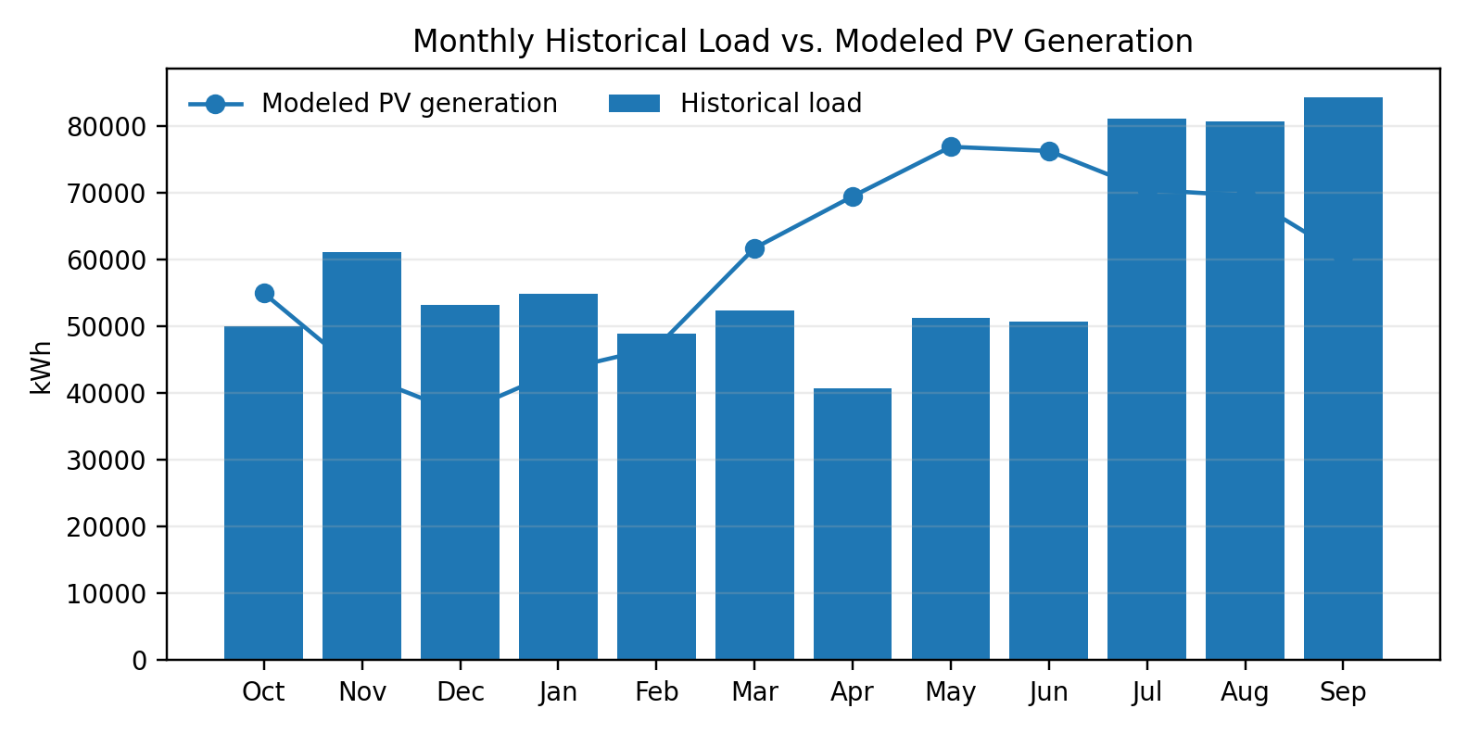
Figure 1. Monthly historical electricity load and modeled production of the recommended 406.43-kW DC PV system.
Source: project workbook.

3.3 Data-quality treatment
The workbook distinguishes observed data from estimated fields. Meter 1's May 2024 total load of 6,057 kWh and bill total are observed, while the missing TOU detail is estimated from adjacent April and June periods and proportionally aligned with the observed May total. The month is retained to preserve the complete annual baseline and is flagged explicitly in the documentation and ESS-sizing sheets. The annual load total is therefore treated as observed, while the May TOU composition is treated as an approximation.

4. Solar PV Sizing Method

4.1 Production scaling
PV sizing uses a 485-W module basis. The design constraint is annual modeled PV generation greater than or equal to the verified annual load of 709,501 kWh.
The minimum integer panel count satisfying this constraint is 838 panels. At 0.485 kW per panel, the resulting DC capacity is 406.43 kW. Modeled annual production is 710,207.5 kWh, equivalent to 100.10% annual generation coverage. A system with one fewer panel would fall below the annual-load constraint, making 838 panels the minimum feasible panel count under the model.
PV metric | Recommended configuration
Panel rating | 485 W DC
Panel count | 838
PV DC capacity | 406.43 kW
Modeled annual PV generation | 710,207.5 kWh
Historical annual load | 709,501 kWh
Annual generation coverage | 100.10%
Annual net generation surplus | 706.5 kWh

4.2 Annual coverage versus temporal self-consumption
Annual energy balance does not imply that the facility is electrically self-sufficient in every month or hour. The monthly model shows large spring and early-summer production surpluses but deficits in winter and late summer. The workbook's monthly self-consumption proxy totals 615,927.4 kWh and its gross surplus proxy totals 94,280.1 kWh..
This timing effect explains why a system can produce approximately 100% of annual consumption while the customer still imports electricity from the grid. Solar generation and customer demand do not occur at identical times; storage can shift part of the available energy and can also be dispatched for demand management.

5. Battery Energy Storage Sizing

5.1 Battery sizing basis
The ESS platform is the SPT6800 commercial energy-storage system. The battery energy sizing unit used in the model is 215.04 kWh, and the available product material provides a 0.5C design discharge-rate basis for that battery cluster. The corresponding battery-side theoretical power is 107.52 kW per unit. Two operating parameters are explicitly modeled assumptions: a 90% usable-energy fraction and 95% discharge efficiency. Together they yield 183.8592 kWh of modeled delivered energy per sizing unit.
The AC power conversion system is treated separately from battery-side C-rate. The proposal model assumes 100 kW AC PCS per 215.04-kWh sizing unit based on a comparable-product benchmark, resulting in 200 kW estimated AC for two units.

5.2 Energy requirement versus power requirement
Storage sizing combines two constraints. The energy constraint is based on average daily On-Peak plus Mid-Peak energy. The highest observed average daily peak-window energy occurs in August 2024 at approximately 190.45 kWh/day. Because one unit provides 183.86 kWh of modeled delivered energy, the energy criterion requires two units in that month. The proposal power criterion uses a fixed 100-kW demand-shave target. At 100 kW per assumed AC PCS unit, the power criterion alone requires one unit. The final requirement is therefore the maximum of the energy- and power-based unit counts: two units.
ESS metric | Result
Battery sizing unit | 215.04 kWh
Units required by energy | 2
Units required by power | 1
Required units | 2
Nominal ESS energy | 430.08 kWh
Modeled delivered energy | 367.72 kWh
Estimated AC PCS rating | 200 kW
Proposal demand-shave target | 100 kW
Approx. duration at 100-kW target | 3.68 h

5.3 Demand-charge modeling
Demand charges are modeled account-specifically rather than by summing noncoincident meter peaks. Meter 2 is the proposal modeling basis because it carries the dominant demand-charge exposure. For each billing period, the model derives effective base-demand and TOU-demand rates from observed bill charges and billed demand, then applies the 100-kW shave target subject to the relevant monthly demand quantity. The resulting annual base-demand savings are $29,634.80 and annual TOU-demand savings are $9,737.95, for total modeled demand savings of $39,372.75.
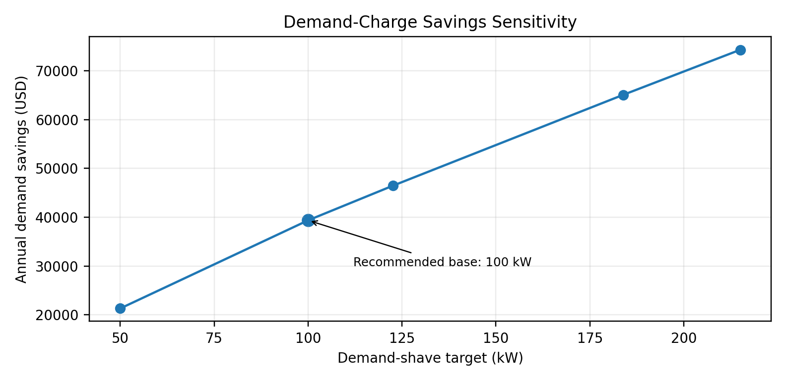
Figure 2. Demand-charge savings sensitivity. The 100-kW point is the recommended proposal base case; higher values are screening sensitivities rather than verified dispatch outcomes.

6. Configuration Scenarios and Recommendation
Five PV/ESS configurations were compared. All satisfy the model's annual PV-coverage and storage-sizing constraints, but installed cost rises faster than modeled Year-1 savings as capacity increases. The decision rule therefore selects the lowest-cost passing scenario rather than maximizing gross generation or storage capacity.
Scenario | PV panels | PV kW DC | ESS units | ESS kWh | Screening installed cost
Minimum | 838 | 406.43 | 2 | 430.08 | $1,074,972
Balanced A | 850 | 412.25 | 2 | 430.08 | $1,086,671
Balanced B | 875 | 424.38 | 3 | 645.12 | $1,240,066
Higher Storage | 900 | 436.50 | 4 | 860.16 | $1,393,461
Historical PV Scale | 1,000 | 485.00 | 6 | 1,290.24 | $1,748,994

The recommended 'Minimum' configuration is therefore 838 PV modules and two ESS sizing units. The recommendation should be understood as minimum-cost feasibility under the defined constraints, not as a globally optimized engineering design. A rigorous optimization could change the result if interval load, coincident meter demand, alternative dispatch strategies, current equipment quotations, or revised tariff/export rules were introduced.

7. Electricity-Cost Savings and Bill Impact

7.1 Historical bill structure
The two-account 12-period historical bill total is $286,732.11. The workbook separates approximately $65,519.80 of extracted energy charges, $193,627.17 of extracted demand charges, and $27,585.14 of residual or other charges. The large demand-charge component is economically important because it creates a value stream for storage that is distinct from solar energy offset.

7.2 Modeled savings stack
The project's modeled Year-1 savings are $106,305.62. The largest components are PV energy savings of approximately $57,593.04 and demand-charge savings of $39,372.75. Additional modeled value comes from $4,327.20 of PV export value and $5,012.64 of grid-charging arbitrage. The resulting modeled annual bill is $180,426.49.
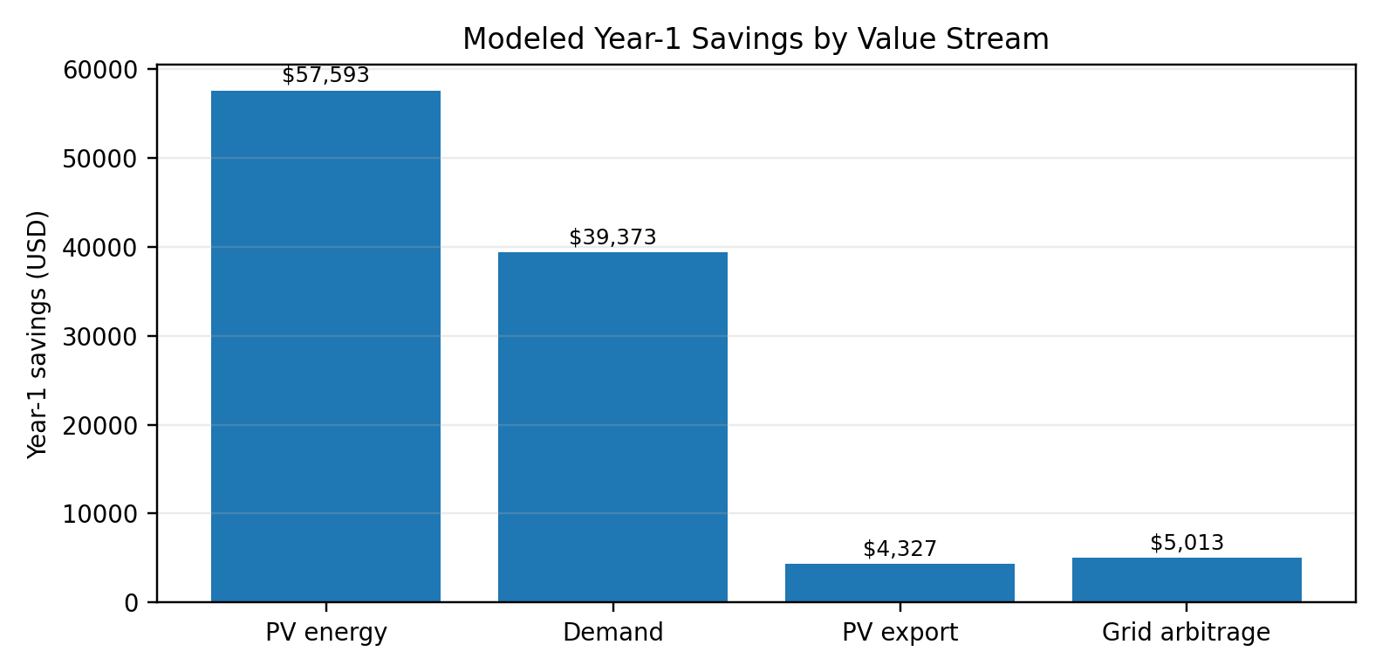
Figure 3. Modeled Year-1 electricity savings by value stream. Values follow the project model.
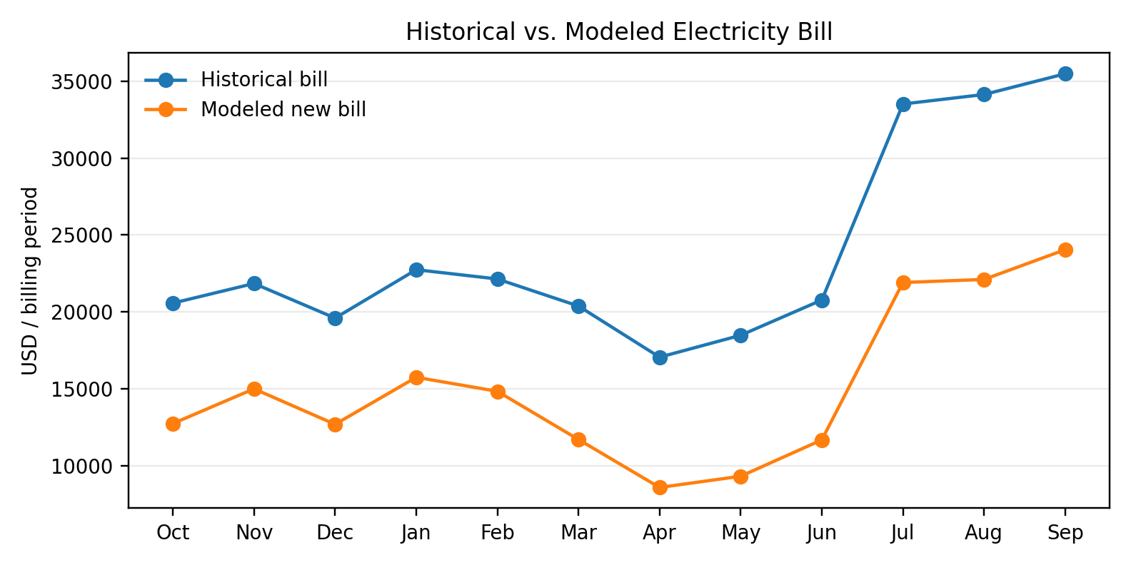
Figure 4. Historical monthly electricity bills compared with the modeled post-project bills. Source: project proposal and workbook.

7.3 Grid-charging logic
The dispatch model allows grid charging when PV is insufficient and the TOU price spread supports arbitrage. In summer, the conceptual sequence is Off-Peak charging followed by On-Peak discharge; in winter it is Super-Off-Peak charging followed by Mid-Peak discharge. Annual modeled grid-charged delivered discharge is 20,349 kWh. With the model's discharge-efficiency treatment, grid input is approximately 22,610 kWh, producing about $7,090.54 of avoided high-price energy cost against $2,077.90 of charging cost, or $5,012.64 of net modeled arbitrage value. This is a bill-based screening calculation rather than an interval-optimized dispatch schedule.

8. Financial Evaluation

8.1 Capital cost and modeled tax benefits
The proposal's gross project cost is $1,074,972.30, consisting of $816,924.30 for PV and $258,048.00 for ESS under the historical internal cost assumptions embedded in the project model. The proposal models $682,607.41 of total tax benefits and incentives, reducing the modeled net economic cost to $392,364.89. These figures are proposal-case financial assumptions, not current quotations or tax advice.
Financial item | Proposal model
Gross project cost | $1,074,972
PV cost | $816,924
ESS cost | $258,048
Federal tax credit modeled | $322,492
Federal depreciation tax benefit modeled | $274,118
California depreciation tax benefit modeled | $85,998
Total modeled tax benefits / incentives | $682,607
Net economic cost after modeled benefits | $392,365

8.2 Long-term financial performance
Using the proposal's 30-year analysis horizon, 5% discount rate, 3% annual electricity escalation assumption, and 0.8% annual PV degradation assumption, the model reports $4,694,064 of cumulative 30-year electricity-bill savings. The reported NPV is $1,757,719 at a 5% discount rate, IRR is 21.5%, and simple payback is approximately 3.9 years. The proposal also reports a PV-generation LCOE proxy of approximately $0.016/kWh.
These financial outputs are best interpreted as an integrated proposal case rather than independent empirical estimates. They inherit the uncertainty of the operating model: historical bill-derived tariff estimates, demand-shave feasibility, export value, battery dispatch, tax eligibility and timing, and long-run electricity-price assumptions. Their value is in showing how technical sizing decisions propagate into business economics and in supporting sensitivity and go/no-go discussions.

9. Environmental Benefits
The client-facing proposal reports the following 20-year environmental equivalents. These are proposal-level equivalency metrics rather than directly measured emissions reductions. They are useful for communicating sustainability implications to nontechnical stakeholders, but the financial case in this report does not depend on monetizing these environmental benefits.
Environmental Metric | 20-Year Proposal Equivalent
CO₂ offset | 11,127 tons
Vehicle miles equivalent | 25,298,775 miles
Trees equivalent | 166,899 trees

10. Business Interpretation and Project Impact

10.1 Why the combined PV + ESS configuration creates value
The project economics arise from multiple mechanisms rather than a single savings source. PV primarily offsets purchased energy, while storage addresses timing: it can shift energy across TOU periods and reduce billed demand when dispatched at the appropriate peaks. This is consistent with commercial solar-plus-storage research, which finds that utility rate structure and demand charges materially influence storage economics. In this case, the historical bill decomposition makes that mechanism visible: demand charges form a large share of the observed bill, so a relatively modest 100-kW shave target produces a material modeled annual benefit.

10.2 Decision value of minimum-feasible sizing
The scenario comparison shows the importance of defining the business objective before increasing system size. Larger configurations generate more energy and offer more storage, but they also require substantially more capital. Because the design constraint was annual PV coverage plus adequate peak-window storage, the 838-panel / two-unit configuration is preferred as the lowest-cost passing scenario. This is a practical capital-allocation result: more equipment is not automatically more economic when incremental savings do not keep pace with incremental cost.

10.3 Process and stakeholder implications
The project also illustrates a cross-functional workflow. Utility data and customer bills establish the operating baseline; analytical sizing translates those records into candidate PV and ESS configurations; engineering inputs constrain equipment and site feasibility; financial modeling converts technical outputs into investment metrics; and the final proposal communicates the result to a commercial decision maker. The analytical workbook therefore functions as an interface between customer information, engineering constraints, tariff economics, and management decision-making.

11. Project Execution and Individual Contribution
The project combined analytical work with coordination across customer, engineering, and proposal-development activities. The utility data were obtained from customer-provided account access and organized into a two-account historical baseline. Preliminary PV and ESS sizing, the Excel calculation model, component-level cost modeling, Aurora modeling, Energy Toolbase configuration, financial assumptions, and iterative proposal preparation were performed as part of the project-management and proposal-development role. Engineering personnel conducted the site survey and authored the electrical single-line diagram; those outputs were coordinated and incorporated into subsequent proposal revisions. The Energy Toolbase calculation engine produced software outputs from configured project inputs and scenarios.
This division of responsibility defines the scope of the work. The project demonstrates applied analytics, utility-data analysis, scenario design, techno-economic reasoning, and cross-functional project coordination.

12. Limitations and Verification Requirements
- The site max-demand indicator is the maximum of two account-level monthly peaks, not a simultaneous sum.
- Monthly PV production is compared with billing-cycle-ending-month load, so monthly surplus/deficit and self-consumption are proxies rather than interval-matched energy balances.
- Meter 1 May 2024 TOU detail is estimated from adjacent periods; its annual contribution is documented but its intra-month TOU composition is approximate.
- The 100-kW AC PCS-per-unit value is a benchmark-based modeling assumption. The proposal therefore labels 200 kW as estimated AC.
- The 100-kW demand-shave target is a proposal base case, not an optimized dispatch result. Real savings depend on the battery being available at the billing peaks.
- Historical effective energy and demand rates are derived from the utility bills and should not be treated as current tariff quotations.
- PV export value, equipment costs, tax benefits, depreciation treatment, and incentive eligibility require current commercial and tax verification before investment.
- The analysis does not establish that one ESS can reduce demand on both accounts; the proposal demand model uses Meter 2 as the economic basis, and final interconnection topology must be verified.

13. Conclusion
The Barstow project demonstrates an end-to-end commercial analytics workflow for solar PV and battery storage. Across the two utility accounts, annual electricity consumption is 709,501 kWh. The analysis identifies a minimum 406.43-kW DC PV configuration that slightly exceeds annual load on a modeled basis and screens a two-unit 430.08-kWh ESS configuration driven by peak-window energy rather than the 100-kW power requirement alone. The resulting proposal combines energy offset, demand reduction, export value, and TOU arbitrage into a modeled Year-1 savings estimate of $106,305.62.
The strongest contribution of the analysis is not any single headline metric but the explicit chain from historical operating data to system configuration and then to financial decision metrics. The project also shows why evidence boundaries matter: verified utility data, product-source specifications, modeling assumptions, and derived outputs are separated rather than presented as equally certain. Under the proposal assumptions, the project produces a 21.5% IRR, $1.758 million NPV, 3.9-year payback, and $4.694 million in 30-year bill savings. Those results support further commercial and engineering development, while the documented limitations define what must be validated before final implementation.

References and Source Notes
Project-specific numerical data and results
- Barstow_PV_ESS_Portfolio_Project.xlsx — project workbook used for the historical baseline, PV/ESS sizing, scenario comparison, demand-charge model, electricity-bill analysis, and financial calculations.
- Barstow_Proposal_Portfolio_Project.pdf — client-facing proposal used for proposal summary metrics, cash-flow presentation, and environmental-equivalency outputs.
External methodological context
- National Renewable Energy Laboratory / National Laboratory of the Rockies. Solar-Plus-Storage Analysis. Used for conceptual context on distributed PV + storage, energy shifting, demand reduction, and customer economics.
- McLaren, J., Anderson, K., Miller, H., Bloom, A., & DiOrio, N. Solar-plus-storage economics: What works where, and why? Used for contextual framing of commercial behind-the-meter economics and tariff/load drivers.
- U.S. Department of Energy Better Buildings. Energy Storage resources and commercial case-study materials. Used for professional case-study framing and business-value context.
- NREL Solar Techno-Economic Analysis tutorials. Used for methodological context on project pro forma analysis, LCOE, IRR, and cost modeling.
Note: External references were used to inform report structure and general methodological framing. No Barstow-specific numerical result was imported from an external source.

