5. Modifications and New Work
[PENDING: working title and structure. The reviewer asked that Chapter 5 report what was modified and what is new, and that Chapter 6 report the results. This chapter is written from the deviations log (Appendix C, D-1 to D-40). The labels Modified and New in the tables are the drafter’s reading of each entry and have to be confirmed by the team against the approved proposal. Three entries still carry an open item in Appendix C: D-13 (hardware test of the fsync change), D-14 (full-run and sniffer validation at 20 MHz) and D-19 (exact Yuchengco area). Chapters 1 to 4 and the appendices still refer to the results chapter as Chapter 5, and every such reference has to be renumbered to Chapter 6.]
This chapter states what was changed from the approved proposal and what was added to it. The results that follow from these changes are reported in Chapter 6. Each change carries its identifier from Appendix C (D-1 to D-40), where the full entry is kept. A change is labelled Modified when it replaces something that the proposal specified, and New when it adds a rule, a procedure or a data item that the proposal did not contain.

5.1. Overview of the Changes
The 40 entries fall into five groups (Table 5.1): data collection and sampling, feature definitions, the implementation of the attacks, the experimental design, and run control and validation. Three reasons recur in Appendix C. The first is that a planned measure could not be taken on the ESP32 platform as planned, as with the MAC retry count (D-15) or the round-trip time (D-2 and D-3). The second is that the planned design would not have produced the intended attack or would have exposed the label, as with the relay feature that existed on the attacker alone (D-12) and the wormhole ends at the same depth (D-17). The third is that a check or a gate was needed to make a run a valid experiment, as with the pre-run gates (D-22) and the grading of missing boards (D-32).
Table 5.1 Groups of Changes and Where Their Effect Is Reported
Group | Entries | Main change | Reported in
Data collection and sampling | D-1, D-9, D-13, D-14, D-25 | Boards log at 10 Hz and the analysis uses one-second windows of ten samples (the proposal had five-second windows of five samples). The radio is fixed at 20 MHz. | Section 6.1, Table 6.2
Feature definitions | D-2, D-3, D-7, D-8, D-10, D-11, D-15 | Latency is one-way, not a round trip. The retry rate comes from application counters, not from the MAC layer. Run identifiers are columns on every row. | Section 6.1 (Table 6.7), Section 6.2.4
Implementation of the attacks | D-12, D-16, D-17, D-20, D-28, D-30, D-36, D-39 | Both attacks are emulated at the application layer, and every node relays probes hop by hop so that forwarding can be counted. The wormhole ends join the mesh as leaf nodes, and in the tree they scan the mesh channel only. | Sections 6.2.1, 6.2.2 and 6.5.3
Experimental design | D-5, D-6, D-18, D-19, D-26, D-29, D-33, D-35, D-37, D-38, D-40 | The baseline is phase 0 of each attack run, and 8 matched benign runs are added, which gives 80 runs. Runs are made at three sites with three scenarios, and the tree builds have their own rules for parents. | Sections 6.1 and 6.5.4
Run control and validation | D-4, D-21, D-22, D-23, D-24, D-27, D-31, D-32, D-34 | A run starts only after pre-run gates are met, and the verifier grades each run, including runs with a missing board and runs whose scenario was not applied. | Tables 6.4, 6.6 and 6.9

Legend:
- Entries = the identifiers of Table C.1 in Appendix C; D-n stands for deviation number n from the approved proposal. The tables of Sections 5.2 to 5.6 list the entries of each group.
- Hz = hertz, samples per second; 10 Hz = one sample every 0.1 s.
- Window = one second of recording from one board, with up to ten samples.
- MHz = million hertz; here the width of the Wi-Fi channel that the radio uses.
- Latency = the time a probe takes to travel from its sender to the root; one-way = measured in the direction of the root only; round trip = there and back.
- MAC layer = the Wi-Fi layer that controls access to the radio channel and retransmits frames that were lost; retry rate = the share of send attempts that failed in a window.
- Application layer = the software of the study that runs on each board, above the mesh stack; application counters = the counts that this software keeps.
- Run identifiers = the columns that name the attack, topology, site, scenario and repeat of a run.
- Relay = to receive a probe and send it on one hop towards the root; the forwarding of a node is counted from this.
- Baseline (phase 0) = the first 300 s of an attack run, before the attack starts.
- Benign run = a run with no attack; matched = set up like an attack run, so that it can be compared with the attack runs.
- Pre-run gates = the checks that the root makes before the timed phases of a run can start, for example that every child has joined.
- Verifier = the script that checks every run against its schedule (Section 4.2.7.1).
Chapters 5 and 6 cite each change by its identifier, in the form D-20. D stands for deviation from the approved proposal. Table 5.2 lists all 40 identifiers in numerical order with the topic name used in Appendix C, what the change means in one line, and the table of this chapter that gives the entry in full.
Table 5.2 Index of the Deviation Identifiers D-1 to D-40
ID | Topic | In plain words | Given in full in
D-1 | Sampling rate | Each board records 10 samples per second, so a one-second window holds ten samples. | Table 5.3
D-2 | LatencyHopRatio | Latency is the one-way delay of a probe per hop, not a round-trip time. | Table 5.4
D-3 | TunnelLatency | Tunnel latency is the gap in arrival time between a probe and its tunnelled copy at the root. | Table 5.4
D-4 | Topology check | Parent changes in the first 60 s count as the mesh forming, not as re-routing. | Table 5.7
D-5 | Baseline control | The first 300 s of every attack run serve as the baseline. | Table 5.6
D-6 | Repeats and parents | The topology type is fixed for a run, but which board sits where is left to the mesh. | Table 5.6
D-7 | run_repeat column | Every row records which repeat of a run it belongs to. | Table 5.4
D-8 | PDR attribution | A window gets a delivery ratio, even 0, when the node sent in it and the root’s log covers it. | Table 5.4
D-9 | Grid and window | The data are cut into one-second windows, and a window needs at least 8 of its 10 samples. | Table 5.3
D-10 | Run columns | Every row records the attack, topology, site and scenario of its run. | Table 5.4
D-11 | Hop, not layer | The feature counts hop changes, where hop = mesh layer − 1. | Table 5.4
D-12 | Application-layer relay | Every node forwards probes itself at the application layer, so that forwarding can be counted. | Table 5.5
D-13 | microSD mirror | The memory-card copy of the log is forced to be written to the card. | Table 5.3
D-14 | Radio width | The Wi-Fi channel is fixed at 20 MHz and recorded in every capture. | Table 5.3
D-15 | Application counters | Retry counts come from the software on the boards, not from the Wi-Fi hardware. | Table 5.4
D-16 | Star and blackhole | In the star topology the attacker is the hub and the root sits behind it. | Table 5.5
D-17 | Wormhole ends | The two ends of the wormhole tunnel are chosen at run time from mesh depth and then locked. | Table 5.5
D-18 | Matched benign runs | Benign runs without any attack are added as a matched control; the final plan has 8. | Table 5.6
D-19 | Sites | Runs are made at three sites: G402, the DLSU Library and the Yuchengco Building. | Table 5.6
D-20 | Attack emulation | Both attacks act on the study’s own probes at the application layer, not on the routing. | Table 5.5
D-21 | Wormhole verification | The wormhole is verified by two independent measures, one from the attackers and one from the root. | Table 5.7
D-22 | Pre-run gates and START | A run starts only when the setup checks pass and the operator types START. | Table 5.7
D-23 | Parent changes in the attack | A board may change parent during the attack if it stays a victim or stays a bystander. | Table 5.7
D-24 | START lock | A failed check blocks START unless a reason is typed and logged. | Table 5.7
D-25 | Tick alignment | Each sample takes the earliest free time slot, at most 300 ms late. | Table 5.3
D-26 | Sticky tree parents | In tree runs the boards switch parent less readily. | Table 5.6
D-27 | Topology gate | A board passes the topology check if it is attached at the start of the baseline and does not re-route. | Table 5.7
D-28 | Star wormhole | In the star the exit end of the wormhole is the hub. | Table 5.5
D-29 | Partial mesh | The partial mesh is defined by placement and at most two children per node. | Table 5.6
D-30 | Wormhole end depth | In tree and partial-mesh wormhole runs the entry end sits deeper than the exit end. | Table 5.5
D-31 | Attacker re-parenting | The attacker may change its own parent only if no board changes class and its uplink is down at most 10% of the attack. | Table 5.7
D-32 | Missing boards | A missing board is graded by its role, and not by a plain board count. | Table 5.7
D-33 | Jitter scenario | The jitter scenario is left out of the plan, which leaves three scenarios. | Table 5.6
D-34 | Scenario not applied | A run whose scenario was not applied is graded as minor gaps. | Table 5.7
D-35 | Benign run plan | The benign runs are spread over the sites and the scenarios; 8 remain in the final plan. | Table 5.6
D-36 | Wormhole ends as leaves | In the tree and the partial mesh, the wormhole ends join as leaf nodes. | Table 5.5
D-37 | Tree fan-out cap | Tree boards were limited to two children, and wormhole end B was given a fallback parent. | Table 5.6
D-38 | Tree association time | In the tree, a parent keeps a silent child for 30 s instead of 10 s. | Table 5.6
D-39 | Wormhole end scan | In the tree, the wormhole ends scan the mesh channel only. | Table 5.5
D-40 | Tree fan-out restored | The tree fan-out returns to the stock limit of 10 children. | Table 5.6

Legend:
- Topic = the name used in Table C.1 of Appendix C. Given in full in = the table of this chapter that gives the entry in full and shows whether it is Modified or New.
- D-n = deviation number n from the approved proposal; the full entry is in Table C.1 of Appendix C.
- Kind: Modified = replaces what the proposal specified; New = added to the proposal.
- Window = one second of recording from one board, with up to ten samples.
- Hz = hertz, samples per second; 10 Hz = one sample every 0.1 s.
- Tick = one slot of the 10 Hz sampling grid (0.1 s).
- Probe = the small packet that a node sends towards the root about once a second to measure delivery.
- Root = the board that receives every probe and logs the arrivals (one in each run).
- Hop = one wireless link on the path to the root.
- Mesh layer = the depth of a board in the mesh tree, with the root as layer 1; hop = layer − 1.
- PDR = packet delivery ratio, the share of a node’s probes that reached the root (ratio, 0 to 1).
- LatencyHopRatio = the relative one-way delay of a probe divided by its hop count; TunnelLatency = the difference in arrival delay between the two copies of one probe at the root.
- run_repeat = the column that gives the number of the repeat of a run; HopChangeCount = the number of changes of the hop of a board in a window.
- Topology = the shape in which the boards are linked to the root: linear (a chain), star, tree or partial mesh.
- Wormhole = the emulated tunnel in which a probe is also copied over a wired link from the entry end (Node B) to the exit end (Node A).
- Hub = the board in the centre of the star, through which every other board reaches the root.
- Application layer = the software of the study that runs on each board, above the mesh stack; application counters = the counts that this software keeps.
- microSD mirror = the copy of the log that each board writes to a memory card.
- START = the operator’s command that begins the timed phases of a run.
- Pre-run gates = the checks that the root makes before the timed phases of a run can start, for example that every child has joined.
- Verifier = the script that checks every run against its schedule (Section 4.2.7.1).
The 40 entries of Appendix C were not planned at the start of the study. They were made between July and October 2026, each time that a capture or a review showed that the approved plan could not be followed as written, or that following it would yield data that could not be trusted. The earliest entries arose from the first captures of July (D-1, D-2, D-3 and D-4), several from the work of September (D-8, D-11, D-14 and D-15), and the last from the October campaign, in which failed runs and reviews were turned into rules so that the same failure could not recur, and in which the plan itself was adjusted (D-21 to D-40, 16 to 23 October 2026). For each entry, Appendix C records what the proposal said, what is done instead, why, and what the change costs.
Three reasons recur. The first is that a planned quantity could not be measured on the platform: a round-trip time requires a reply that the probes never receive (D-2 and D-3), and ESP-IDF provides no MAC retry count (D-15). The second is that the planned design would have allowed the label to be read from the data without any learning, or would not have produced the intended attack: a relay feature that exists on the attacker alone identifies the attacker (D-12), a wormhole whose two ends lie at the same depth has no shortcut (D-17, D-28 and D-30), and the ends of a wormhole in a tree or a partial mesh did not join the mesh in a way that gave a valid run (D-36 to D-40). The third is that a run must constitute one valid experiment, whereas a mesh heals itself, boards reset and cards fail, so that rules had to be written for when a run may start and for what a run may contain (D-4, D-21 to D-32 and D-34). Some entries record a decision on the scope of the study and not a problem of the platform, for example the choice of sites (D-19), of benign runs (D-18 and D-35) and of scenarios (D-33). Of the 40 entries, 15 are labelled Modified and 25 New in the tables of this chapter.
Sections 5.2 to 5.6 take the five groups of Table 5.1 in turn. Each begins with a table that states, for every entry, what the study does and why, and continues with a narration that treats the entries of the group one by one. The narration supplies what the table cannot: what the proposal specified, what happened in the captures, how the change works, the evidence that it worked, and what it costs. Section 5.7 states which of the changes limit how the results of Chapter 6 can be read.
[PENDING, internal note to delete before submission: Appendix C also holds D-41 (23 October 2026), which the log marks as not for the paper. For tree wormhole runs only, it applies the mesh logic of the partial mesh (a limit of two children, an association expiry of 10 s, no sticky parents, B as the strongest open parent at least as deep as A, and a scan of all channels) and keeps the leaf ends of D-36. For those runs it therefore replaces what D-26, D-38, D-39 and D-40 say about the tree and brings back the limit of D-37. This chapter follows the log and does not describe D-41, so it counts D-1 to D-40. Decide whether the tree wormhole runs captured after D-41 need a note, because the rules described here would not apply to them.]
[PENDING: D-33 to D-40 are written as the log records them. D-36 to D-40 were compile-checked and not yet tested on hardware when they were entered, and tree wormhole captures of 23 and 24 October followed, so confirm their status. D-40 withdraws the sentence on at most two children in the tree that D-37 proposed for the paper (checklist A38). Confirm that Appendix C lists D-33 to D-40, and confirm the labels of these eight entries, which are the drafter’s reading (D-33 Modified, the others New).]

5.2. Data Collection and Sampling
The proposal planned five-second windows of five samples. The first captures showed that this left no room for a dropped sample, so the sampling rate, the grid and the window were changed (D-1, D-9, D-25), and two protections of the data were added (D-13, D-14).
Table 5.3 Changes to Data Collection and Sampling
ID and topic | Kind | What the study does | Why
D-1 Sampling rate | Modified | The boards log at 10 Hz, and the analysis keeps the 10 Hz samples (see D-9). | Five samples per window left no room for a dropped sample.
D-9 Grid and window | Modified | A 10 Hz grid and one-second windows are used; a window with fewer than 8 of 10 samples is discarded. | The 80% completeness ratio is kept, with more support per row.
D-25 Tick alignment | New | Each sample takes the earliest free tick, at most 300 ms late. | Placement on the nearest tick discarded healthy windows.
D-13 microSD mirror | New | The microSD mirror is flushed with fsync(). [PENDING: mid-run-reset test on hardware] | It fixes a failure in which a card file held 0 rows. It has not been validated on hardware.
D-14 Radio width | New | The radio is fixed at 20 MHz (HT20), and every capture records its width. [PENDING: full-run and sniffer validation] | The sniffer captures 20 MHz only, and the two widths differ in PHY behaviour.

Legend:
- Kind: Modified = replaces what the proposal specified; New = added to the proposal.
- Window = one second of recording from one board, with up to ten samples.
- Sample = one reading of a board (one telemetry row); the boards take 10 samples per second.
- Hz = hertz, samples per second; 10 Hz = one sample every 0.1 s.
- Tick = one slot of the 10 Hz sampling grid (0.1 s).
- Interpolation = filling a short gap with values computed from the samples on either side; forward fill = repeating the last value.
- Baseline run = a capture with no attack.
- microSD mirror = the copy of the log that each board writes to a memory card.
- fsync() = a call that forces the data in a file to be written to the card.
- Mesh formation = the time in which the boards join the mesh and choose their parents.
- HT20 = the 20 MHz Wi-Fi channel width; HT40 = the 40 MHz width, which is the default of the ESP32; MHz = million hertz.
- PHY = the physical layer of Wi-Fi, which sets the radio rates and the use of the channel.
- Sniffer = a separate radio that records the Wi-Fi frames.
Entries D-1 and D-9 concern the sampling rate and the analysis window. The proposal planned raw telemetry at 1 Hz and windows of five seconds, which gives five samples per window, with a window being discarded when fewer than 4 of its 5 samples are present. With so few samples, a single lost sample costs 20% of a window and can trigger the discard rule. The boards therefore sample at 10 Hz, one sample every 100 ms.
In its first form, the change (D-1) preserved the analysis rate of the proposal by reducing the data to 1 Hz before windowing, which discarded 9 of every 10 samples that had been captured. D-9 replaced that step: the data are analysed on the 10 Hz grid in windows of one second, as the panel and the adviser requested, and a window with fewer than 8 of its 10 samples is discarded, which is the same 80% completeness ratio as 4 of 5.
The number of rows provided a further reason. The panel asked for about 10,000 rows per run and the team had proposed 6,000, and the number of rows is determined by the number of nodes and by the analysed seconds divided by the window length. With five-second windows and the six nodes then in use, 6,000 rows would have required a run of about 83 minutes.
Each window now holds ten samples instead of five and therefore carries more support. Nothing is invented to reach this: gaps of one or two samples are filled, by interpolation or forward fill, which at 10 Hz covers 0.2 s where at 1 Hz it covered 2 s, so that less of the data is synthetic than before. On a clean baseline run, the change raised the number of rows from 577 to 2,894 (five times as many) and lowered the share of discarded windows from 1.0% (6 of 583 windows) to 0.1%.
One consequence must be kept in mind. A probe is sent about once a second, so a window of one second holds about one probe, and the delivery ratio of a single window is close to 0 or 1. The delivery ratio is therefore read through the mean over many windows and not as a fine-grained rate.
Entry D-25 concerns the alignment of the samples to the 0.1 s grid. The sampling task of the firmware runs on a fixed period. When the task is held up, it takes the missed samples back to back, so that the gaps between consecutive rows can be, for example, 258 ms, 1 ms and 41 ms. The first version of the analysis placed every sample on the nearest tick of the grid. Two samples that arrived in a burst therefore shared one tick and left an empty tick behind, and three empty ticks were sufficient to discard the window. Windows were consequently lost although no sample was missing on the card.
The rule is now that each sample takes the earliest free tick for which it could have been scheduled, at most 3 ticks (300 ms) late and never early. The lateness limit derives from the data, since the 99th percentile of the measured delay was 278 ms. There is one sample per tick, and nothing is invented, interpolated further or counted twice. The 80% rule and the filling of gaps of one or two samples remain as before. On two boards with clustered timestamps, FE90 and ED80, the share of discarded windows fell from 10% to 0% and from 15% to 0%, and boards that were already clean did not change. No verdict changed, but the grades of some runs became more accurate. The reason for the change is that the old rule measured the resampling and not the board, whereas a missing window should now correspond to a missing sample.
Entry D-13 concerns the microSD mirror of the log. Each board writes every telemetry row to its flash memory and mirrors it to a microSD card. Operators found that a file pulled from a card sometimes held no rows, with no pattern that could be identified, and the run had to be repeated. The cause lay in the logger, which flushed with fflush() alone. On the file system that ESP-IDF uses for the card, this pushes the bytes to the card but does not update the directory entry of the file, which holds its recorded size and is updated only by fsync() or by closing the file. A run that did not end cleanly, because of a brownout, a reset, a card pulled while the board was on, or a killed run, therefore left a file whose size still read 0 bytes although its rows were on the card, and every host tool counted it as empty. Clean runs were never affected, which is why the failure appeared random.
The logger now calls fsync() on the mirrored files at most every 5 s and at every phase boundary, so that the worst case falls from the whole run to the last few seconds. The change repairs nothing that was captured before it, and a file from before the change that holds 0 rows has to be treated as lost and not as a board that logged nothing. None of the 435 campus capture files has 0 rows. At import, the number of rows streamed is now compared with the number in the manifest of the run, and a difference is printed. The firmware compiles, but the change has not yet been tested on hardware, which requires a board, a reset in the middle of a run and a read-back of the card.
Entry D-14 concerns the width of the radio channel. The proposal does not state a channel width, so every capture made before 23 September 2026 used the ESP32 default of 40 MHz (HT40). The only independent observer available to the study, a sniffer, captures 20 MHz only, and a 20 MHz receiver cannot decode 40 MHz data frames. In a capture of 23 September it heard the beacons of every board but almost none of their data frames (0 for the root and 3 of 1,848 for a child). Without a change, the sniffer could not have served as the third-party check on the dataset.
The radio is now fixed at 20 MHz (HT20) on both of its interfaces before it starts. Every boot prints the width, and the status report of the card records it, so that every capture carries its own width. The order matters: a first version fixed the width after the radio had started, and no node joined the mesh in a full 11-minute run, whereas fixing it before the start resolved this.
Captures at 40 MHz differ in the PHY (the rates, the airtime and possibly the RSSI by a few dB). They are archived, labelled by width and never pooled unlabelled, and the dataset uses the captures at 20 MHz only. The verifier is not affected, because it compares phases within one run. Mesh formation at 20 MHz was verified on hardware on 24 September 2026 in a test of 3 minutes. A full run at 20 MHz and a sniffer capture of its data frames remain to be validated.

5.3. Features and Measurements
Several features were defined differently from the original planned implementation because the platform does not provide the quantity that was planned. Probes travel one way to the root, so latency is one-way (D-2, D-3), and ESP-IDF returns no MAC retry count, so the retry rate comes from application counters (D-15). Three entries add rules for when a feature has a value (D-8) and for naming and labelling (D-7, D-10, D-11).
Table 5.4 Changes to Feature Definitions and Measurements
ID and topic | Kind | What the study does | Why
D-2 LatencyHopRatio | Modified | LatencyHopRatio is the relative one-way delay divided by the hop count (Equation 4.14). | Probes travel one way, so no round trip exists in the data.
D-3 TunnelLatency | Modified | TunnelLatency is the difference in arrival delay between the two copies of one probe. | The tunnel is a one-way UART write with no echo.
D-8 PDR attribution | New | A window gets a PDR, including 0, when the node sent, was associated and the root’s log covers it. | The old run-wide rule hid the zeros of the nodes most affected.
D-11 Hop, not layer | Modified | The feature is named HopChangeCount, and hop = layer − 1 is added next to the raw layer. | The old name suggested network-layer data.
D-15 Application counters | Modified | retry_count and tx_count are application counters, and RetryRate is not a model input. | ESP-IDF returns no MAC retry count.
D-7 run_repeat column | New | The repeat number is a column in the windowed and feature tables. | Pooled runs cannot be separated again, so per-repeat variance would be lost.
D-10 Run columns | New | Attack, topology, location and scenario are columns on every row. | Without them, runs of different scenarios collapsed into one group.

Legend:
- Kind: Modified = replaces what the proposal specified; New = added to the proposal.
- PDR = packet delivery ratio, the share of a node’s probes that reached the root (ratio, 0 to 1).
- UART = the wired serial link between the two tunnel boards.
- MAC = medium access control, the Wi-Fi layer that controls access to the radio channel and retransmits frames that were lost.
- Sniffer = a separate radio that records the Wi-Fi frames.
- LatencyHopRatio = the relative one-way delay of a probe divided by its hop count (Equation 4.14); relative = counted from the fastest delivery of the same sender in the run.
- TunnelLatency = the difference in arrival delay between the two copies of one probe at the root.
- One-way = the time to go to the root only; round trip = the time to go to the root and come back.
- Probe = the small packet that a node sends towards the root about once a second to measure delivery.
- Root = the board that receives every probe and logs the arrivals (one in each run).
- Hop = one wireless link on the path to the root.
- Mesh layer = the depth of a board in the mesh tree, with the root as layer 1; hop = layer − 1.
- HopChangeCount = the number of changes of the hop of a board in a window; RetryRate = the share of send attempts that failed in a window.
- Application counters = counts kept by the software of the study, here retry_count (failed sends; on Node B, frames sent into the tunnel) and tx_count (frames sent).
- Mesh association = the state in which a board holds a parent in the mesh.
- Network layer (IP) = the layer of the OSI model that carries IP addresses and routing; the mesh works below it.
- ESP-IDF = the software framework of Espressif, the maker of the ESP32.
- Windowed table = the table of one-second windows made by the preprocessing; feature table = the same windows with the features added.
Entry D-2 concerns LatencyHopRatio. Equation 4.14 defines it as the mean round-trip time divided by the hop count, computed from probe-response exchanges between the victim nodes and the root. In the system that was built, a probe goes from a node to the root, and the root logs the arrival and sends nothing back, so no round trip exists in the data. The root does log a delay for every arrival, but it is the difference between the clock of the root and the clock of the sender, and each clock starts at the boot of its own board and is never synchronised with the other. The raw value is therefore the true one-way delay plus a large constant, which is strongly negative in practice because the children are powered before the root (−194 s on one wormhole run).
The constant is the same for all arrivals of one sender in one run, so subtracting the smallest delay of that sender cancels it and leaves the delay relative to the fastest delivery of that sender. LatencyHopRatio is this relative delay divided by the hop count. Each arrival is assigned to the window of the sender whose probe sequence numbers contain it, which is the same clock-free join that PDR uses. An earlier version joined on time, which mixed the two clocks and placed the latencies of the cooldown in attack windows; it was corrected on 26 September 2026.
On a baseline run of 25 July, the median was between 2.4 and 2.8 ms per hop at every depth from 1 to 5 hops. A flat ratio is what Equation 4.14 describes as normal forwarding. The range of 10 to 30 ms per hop that the proposal expected was an estimate for a round trip, and a one-way leg is about half of that, on boards that are faster than the estimate assumed. What the feature is for, namely detecting a delay that does not match the reported path length, is preserved, because it depends on the ratio varying and not on its size. Its limit is that the zero point belongs to each node and each run, so the values cannot be compared in absolute terms between nodes or runs. Only their shape can be compared, and the clustering of Chapter 6 uses standardised features.
Entry D-3 concerns TunnelLatency. The proposal defines it as the round-trip latency of the tunnel itself, measured with periodic echo messages. The tunnel between the two wormhole boards is a one-way write on a UART line, from Node B to Node A, and no echo frame is defined or sent, so there is no round trip to measure. What does exist is the signature of a wormhole: the same probe reaches the root twice, once by the multi-hop path and once through the tunnel, with a measurable difference in delay. The root does not remove the duplicate, so both arrivals reach the log.
TunnelLatency is therefore the largest minus the smallest delay among the arrivals of one probe (one sender and one sequence number). The two copies share one sender clock and one root clock, so the offset of D-2 cancels exactly, and the value is a measurement and not an estimate. On a linear wormhole run of 20 July there were 541 pairs of duplicates with a median difference of 12.2 ms and a range of 1.2 to 242 ms, and 102 of the 109 rows that have a value fall in the attack window.
The proposal gives the tunnel fields to the attacker nodes only. TunnelLatency is instead assigned to the sender whose probes were duplicated, as PDR is, because the difference belongs to the manipulated traffic and because the arrival log does not mark which copy came through the tunnel. TunnelIntensity and TunnelBytes remain with the attacker as specified. For the same reason, the difference has no sign: it does not indicate whether the tunnel was the faster path.
Entry D-8 concerns the attribution of PDR (Equation 4.5), which joins what each node sent with what the root logged. In the first code, a window could have a PDR only if the root had logged something from that node somewhere in the run. A node that the root never heard from therefore received no PDR in any window, and this is the node that a blackhole affects most severely. On a linear blackhole capture of 16 September 2026, three of the four victims sent in nearly every window and were treated as having no data, so that PDR = 0 appeared in none of the 446 rows. The feature that exists to detect the suppression of forwarding could not record the value it exists to detect.
A window now receives a PDR, including 0, when three conditions hold. First, the node sent in the window, because a ratio of 0 over 0 is undefined. Second, the node held a mesh association (a layer above 0 and a parent address that is not empty), because the undelivered probes of a detached node show lost connectivity and not suppressed forwarding. Third, the window lies inside the span in which the root was logging arrivals, which still prevents a missing root file from being read as a failure of delivery.
The first code also divided by the sum of 0 and a small constant, so that a window in which a node sent nothing came out as 0.0, the same as total failure, and a false blackhole signature could arise in this way. Such windows are now missing values. On that capture, the windows with a PDR rose from 41 to 238 of 446 and the windows with PDR = 0 from none to 201, and the PDR of the victims in the three phases read 0.217, 0.000 and 0.750, which is the expected shape of suppression and recovery. The definition of PDR is unchanged. Only the rule for when a window can be judged changed, and it is conservative in both directions, because it stops hiding real zeros and stops inventing false ones.
Entry D-11 concerns the naming of the hop count. ESP-WIFI-MESH numbers the depth of a node in its tree as a layer, with the root as layer 1, so that a direct child of the root is layer 2. Reviewers read the column name as an OSI layer. It is not, because the mesh runs entirely below IP and the dataset holds no network-layer data, and each time the name is misread, the reader believes that the cross-layer claim is larger than it is. The adviser asked for the change and a second reviewer asked for it independently (21 September 2026), so the problem lay in the name and not in the reader.
A new column hop = layer − 1 is added next to the raw layer, which is kept for traceability to what the firmware reported, and LayerChangeCount is renamed HopChangeCount. The offset of one is essential: a direct child is one hop from the root and the root is 0 hops from itself, and a rename that kept the values would have made every hop count wrong by one. The no-parent value of the firmware (layer = −1) becomes a missing hop value. HopChangeCount counts changes in depth, which a constant offset does not alter, so no feature value changed, and the pipeline gave identical values under the new name.
Entry D-15 concerns the application counters. The proposal takes retry_count, the cumulative MAC-layer retransmissions, and tx_count, the cumulative frames transmitted, from the Wi-Fi statistics of ESP-IDF. It also gives a fallback for a version that does not expose them: record zero, flag it in the metadata, leave RetryRate out of the core set, and use an application-layer proxy if wanted. The firmware reads no driver statistics. This was checked on 27 September 2026: the only statistics call in ESP-IDF 5.3.5 and in the documentation of version 5.5, esp_wifi_statis_dump(), prints the statistics to the log and returns only a status, so no number reaches the application, and no change to the firmware could put a MAC retry count into the data.
Both columns are therefore filled with application counters. On every role except the wormhole entry node B, retry_count is the number of failed esp_mesh_send() calls, that is, sends that the mesh stack refused, and not radio retransmissions. On Node B it holds the number of frames sent into the tunnel, because the tunnel features read it from there. The columns are not zero and are not flagged in the metadata, so this departs from the fallback of the proposal, and the MAC layer of the cross-layer claim rests on the RSSI and on the state of the link and the parent, and not on retransmissions.
RetryRate remains a column of the dataset. It is not a model input, as the fallback prescribes, and since 30 September 2026 the verifier no longer uses it as a check, because none of the attack studies cited (Airehrour et al. [70], Zhukabayeva et al. [71], Ramírez Gómez et al. [72]) names a retry rate as a signature. The predicted rise in the retransmissions of the victims (Table 3.4) cannot be seen with these counters. A blackhole that drops at the application layer still acknowledges every frame, so the radio of the victim never sees a failure; the prediction is reported in Section 6.2.4 as predicted and not observed, and not as missing data.
Real retries come from the sniffer: a retransmitted 802.11 frame carries the retry bit, and counting it per link and per phase gives the retry rate of an independent observer. Where a sniffer capture exists, the pipeline can add its retry rate and the number of frames it heard (MacRetryRate and MacFramesHeard) to the feature table, and a run without a capture remains a missing value and never 0.
Entries D-7 and D-10 concern the columns that identify a run. One analysis folder holds all repeats of a cell, and the preprocessing reads the whole folder, so the windows of the three repeats, and of the different scenarios, landed in one table with nothing to tell them apart. The script that gathered the folders re-derived the cell from the folder path and ignored the scenario, so a run with mobility and a run with no variation, of the same attack, topology and site, collapsed into one group. Runs can always be pooled but can never be separated again.
The preprocessing now writes run_repeat, taken from the file name, and attack, topology, location and scenario, taken from the path of the export, as columns on every windowed row, and they pass unchanged into the feature table. A run with no scenario folder is read as stationary, and a path that is not an export tree receives no value, so that an unknown origin is never labelled as if it were known. These columns are identifiers: no feature value, count of windows or label changed. They make every row self-describing, which the dataset needs in order to be reused, and they allow Chapter 6 to report results by topology, site and scenario.

5.4. Implementation of the Attacks
Both attacks are application-layer emulations (D-20). The mesh stack relays packets by itself and documents no way to write a node’s routing table, so the attacks act on the probes that the study sends and not on the routes. To make forwarding visible, every node relays probes at the application layer (D-12). The remaining entries fix where the attacker and the wormhole ends sit in each topology (D-16, D-17, D-28, D-30) and how the ends join the mesh (D-36, D-39).
Table 5.5 Changes to the Implementation of the Attacks
ID and topic | Kind | What the study does | Why
D-12 Application-layer relay | Modified | Every node relays at the application layer and counts packets received, forwarded and dropped. | The relay features existed only on the attacker.
D-20 Attack emulation | Modified | Both attacks act on the data plane only, and no route or parent selection is changed. | ESP-WIFI-MESH documents no way to write a routing table.
D-16 Star and blackhole | Modified | In the star, the attacker is the hub and the root sits one hop behind it. | The root cannot drop instead of forward, and it is the referee.
D-17 Wormhole ends | New | The wormhole ends are assigned at run time from mesh depth, locked at the first phase and recorded in every row. | The mesh decides which board is near the root, and a fixed assignment can give no shortcut.
D-30 Wormhole end depth | New | In tree and partial-mesh builds, Node B never joins the root and stays deeper than Node A. | Both ends kept landing at the same depth.
D-28 Star wormhole | New | In the star, wormhole end A is the hub and the root sits one hop behind it. | In a flat star, the tunnel skips no hop.
D-36 Wormhole ends as leaves | New | In tree and partial-mesh builds, the wormhole ends join as leaf nodes, and the telemetry stack is 6144 bytes. | Boards under an end moved whenever the end restarted, and the telemetry stack ran low.
D-39 Wormhole end scan | New | In tree builds, the wormhole ends scan the mesh channel only when they look for a parent. | A scan of all channels made a connected end miss the beacons of its parent.

Legend:
- Kind: Modified = replaces what the proposal specified; New = added to the proposal.
- Hub = the board in the centre of the star, through which every other board reaches the root.
- Hop = one wireless link on the path to the root.
- Wormhole = the emulated tunnel in which a probe is also copied over a wired link from the entry end (Node B) to the exit end (Node A).
- Node A = the exit end of the wormhole, on the root side; Node B = the entry end, on the leaf side.
- Star = every other board is linked to one central board, the hub; tree = boards branch from the root over several hops; partial mesh = a branched tree in which a board can hear several candidate parents and has at most two children (Section 5.5).
- Blackhole = the emulated attack in which a board that relays probes silently drops them; the attacker is that board.
- Relay = to receive a probe and send it on one hop towards the root; the forwarding of a node is counted from this.
- Application layer = the software of the study that runs on each board, above the mesh stack; application counters = the counts that this software keeps.
- Referee = the root, which drives the phases and logs the arrivals from which PDR is measured.
- Routing = the choice of the path that a packet takes; parent selection = the way in which a board chooses the board it sends to.
- Shortcut = a path to the root with fewer hops than the normal path.
- Mesh depth = the layer of a board in the mesh tree; locked = a role that is fixed at the first phase and does not change for the rest of the run.
- UART = the wired serial link between the two tunnel boards.
- Baseline (phase 0) = the first 300 s of an attack run, before the attack starts.
- Verifier = the script that checks every run against its schedule (Section 4.2.7.1).
- Leaf node = a board that forwards no traffic for other boards, so that no board can attach below it; child = a board that attaches below another board.
- Telemetry task = the task on each board that reports its state to the root; stack = the memory reserved for a task; backtrace = the record of the calls that led to a restart.
- Layout = which board sits at which place in the mesh; recapture = to run the capture again.
- Scan = the search of a board for access points to join as parent; passive = the board only listens; beacon = the frame by which an access point announces itself; mesh channel = the Wi-Fi channel of the mesh (channel 11).
Entry D-20 concerns the way in which the attacks are emulated. In the studies that the thesis cites, a blackhole advertises a false short route to attract traffic and then drops it, and the tunnel of a wormhole causes the routing protocol to adopt a false shortcut, so that distant nodes appear to be neighbours. Both attacks therefore act on the control plane. This study implements only the behaviour on the data plane, on real hardware. The blackhole is a legitimate mesh node that silently drops the probes it relays during the attack phase, and traffic reaches it because of where it is placed, between the victims and the root, and not because of a false route. The wormhole is a real out-of-band wired tunnel on a UART line between two boards: Node B sends a copy of each probe through it, Node A re-injects the copy near the root, and the root keeps both copies. The routing of the mesh never adopts the tunnel.
The reason is the platform. ESP-WIFI-MESH is a self-organising tree, so there are no route request and reply messages to falsify. Each node chooses its parent from information in the mesh beacons, and the routing tables are kept inside the closed-source mesh library of Espressif. To our knowledge, the documentation of the public interface lists a call that reads the routing table, and none that writes a route or changes what a node advertises, so that false routes could be created only by forging the management frames of the mesh or by reverse-engineering a proprietary stack, which lies outside an exploratory data analysis.
The dataset therefore records the data-plane signature of each attack (for the blackhole, probes that vanish; for the wormhole, duplicated probes with a difference in latency) and not the stage in which the attacker attracts traffic, so no parent changes or shifts in the topology that the attacker caused are in the data. The position of the attacker becomes an experimental variable instead, which is why D-12, D-16 and D-17 matter. Section 6.5.3 discusses what an emulation can and cannot show.
Entry D-12 concerns the relaying of traffic at the application layer. Three of the 16 features (ForwardingRatio, IngressEgressDelta and ConsistencyScore) are relay features. In the first traffic model, the honest nodes sent to the root with esp_mesh_send(), and the mesh stack relayed that traffic below the application layer, so the code of an intermediate node never saw what it forwarded. Only the blackhole attacker saw transit packets, and only because the victims were built to address it by its MAC address. The three features therefore existed on one node role, and a column that is empty identified the attacker and with it the label. This is the objection that the panel raised: if one feature decides whether an instance is an attack, machine learning is unnecessary. It could not be repaired in Python, because the numbers did not exist.
A shared relay component now runs on every node. Each node sends to its own parent with the MESH_DATA_P2P flag and relays what it receives one hop further up, and it counts the packets received, forwarded and dropped. The blackhole attacker runs the same relay and differs from an honest node by one decision, whether to forward. Both wormhole ends relay as well, with their tunnel logic unchanged. This follows the forwarding discipline that the proposal itself requires of intermediate nodes. Every hop goes to the node’s own parent, so traffic only ascends the tree and no loop is possible, and a node without a parent counts the packet as dropped. Two effects follow. The relay features are now present on every node, so that the attacker is an outlier in a populated distribution and not the only value that exists. And the attacker intercepts traffic because of where it sits in the tree and not because the victims were built to address it.
A fault was found and corrected during the work: the relay at first forwarded only ordinary probes, so the duplicate that Node A re-injects, which carries a different marker, would have been dropped silently by every intermediate relay. The duplicates that constitute the wormhole signature would then never have reached the root, and the wormhole runs would have shown no wormhole signature. The relay now forwards both kinds. Captures made before this change are not comparable with later captures, because the traffic model differs. The change also departs from the text of the milestone form, in which victims address the attacker directly, although the milestone criteria are all still met.
Entry D-16 concerns the blackhole in the star topology. The star figure of the proposal makes the root the attacker, with the victims connected directly to it as their parent. This cannot be done as written, for three reasons. First, the mesh is standalone, with no router, so the root is the destination of the probes and there is nothing onward to forward to, and ‘drop instead of forward’ has no meaning at the root. Second, the root is also the referee, because it drives the phases and PDR is measured from its log of arrivals, so that a root that drops is indistinguishable from a root that stops logging, and the attacker would be grading itself. Third, the other reading, one ring node as the attacker, cannot work either, because the star was limited to a depth of 2 and a node in layer 2 has no children, so nothing ever passes through it.
In the star blackhole builds, the star is therefore built one hop down: the root, as the sink and the referee, in layer 1; the attacker as the hub in layer 2; and every victim in layer 3. The victims do not organise themselves. Each scans for the mesh access point of the attacker and fixes it as its parent with esp_mesh_set_parent(), the sequence of the manual networking example of ESP-IDF. A victim that cannot find the attacker keeps scanning and never joins the root directly, because it would then be an unexposed bystander, and the root holds the baseline until every board is in.
The first hardware run (1 October 2026) formed the hub shape, but only the victims built with the address of the real attacker joined, and a victim built with an old address scanned indefinitely. The setup tool now passes the address of the chosen attacker into every blackhole build. What the proposal intended is preserved: one central node that every victim uses as its direct parent and that drops everything during the manipulation window. Every victim is behind the attacker, so in the star the PDR is not averaged with unaffected nodes, unlike the tree and the partial mesh.
Entry D-17 concerns the assignment of the two ends of the wormhole. Which board ends up near the root is chosen by the mesh and not by the experimenter. Until 7 October 2026, the end of each board was fixed when the board was flashed. A linear wormhole setup of that day formed with Node B next to the root (hop 1) and Node A at hop 6, so the tunnelled copy had to climb back up 6 hops and arrived later than the normal copy of B, which is no shortcut and gives no latency signature, while every check passed. A tree capture of 2 October had both ends at hop 1 for the whole attack. A fixed assignment cannot guarantee the shortcut that defines a wormhole.
One firmware image now serves both ends. The two boards exchange a message with a check code (HELLO) over the tunnel cable every second, carrying their mesh layer, their role and whether it is locked. Before phase 0, the deeper board becomes B, the entry, and the shallower board becomes A, the exit, and at equal depth the board with the lower MAC address is A. The role locks at the first real phase and never changes, because a swap during a run would corrupt the capture, and a board that restarts in a running run takes the locked role that its peer reports. If no HELLO arrives, because of a cable fault or old firmware, the role flashed on the board is used. The role that was decided is in the heartbeat and in the role column of every telemetry row, so that the dataset records which board was which.
The assignment worked on hardware on 7 October 2026 on a linear run at the DLSU Library: A in layer 5, B in layer 7, roles stable for the whole run, and all 181 of B’s attack probes duplicated. The labelling changed with it. The firmware tunnels only the probes of B, so a wormhole run has no victims: every other non-attacker child is labelled as not tunnelled, and the attack is the duplication of B’s probes. The automatic assignment fixes the direction, with A always the shallower, but not the separation, which still depends on where the mesh places the boards, so that the number of hops skipped is reported for each run.
Entry D-30 concerns the depth of the wormhole ends in the tree and partial-mesh topologies. The tunnel is a shortcut only if A is closer to the root than B. Placement was expected to provide this, but the two ends hang off one UART cable and therefore lie close together, and ESP-WIFI-MESH joins the shallowest parent that it can hear. On 19 October 2026, a partial-mesh setup repeatedly placed both ends at hop 1, with B remaining on the root even at −82 to −89 dBm, so that the root held phase 0 because of the ‘same depth’ condition and boards had to be moved and unplugged repeatedly. The automatic assignment of D-17 cannot help with equal depth, because it only renames the ends.
In tree and partial-mesh builds, the board flashed as B therefore no longer organises itself. It scans and fixes as its parent the strongest mesh node that is not the root, so that B is always at hop 2 or deeper, and if no such node is within reach it waits and the root holds phase 0. The board flashed as A fixes as its parent the shallowest open parent it hears at −85 dBm or better, which is the root whenever the root has room, and the parent of B must be at least as deep as A, so that B is at least one hop deeper. The two ends do not use the automatic switching of parents of ESP-WIFI-MESH. They keep a parent while it works, even if the link weakens, and change only when the parent is lost (three drops in a row) or full, and the new parent must still keep A shallower than B. Every other board organises itself as before.
Linear needs no rule, because with one child per node every board has a different depth, and star is covered by D-28. The price is that the position of B is constrained by design, so the tunnel skips at least one hop by construction, and in the builds of 19 October B can still hang directly under A, in which case A relays the normal copy of B as in the star.
Entry D-28 concerns the wormhole in the star topology. In a flat star every child is one hop from the root, so both tunnel ends lie at hop 1. The normal copy of B reaches the root in one hop, and the tunnelled copy, B through the cable to A and then to the root, is also one hop. No hop is skipped and no latency advantage can exist. The gate of D-22 would hold phase 0 indefinitely, and the verifier would mark every such run as the same depth and duplication only. Moving boards cannot help, because a flat star has no deeper layer for B.
The star wormhole is therefore built as the star blackhole of D-16: the root in layer 1, wormhole end A as the hub in layer 2, and every other board, B included, in layer 3. Every non-root board other than the hub scans for the access point of the hub and fixes it as its parent, and the hub organises itself and can reach only the root. The hub is the A board of the preset, whose address the setup tool passes to the build in the same way as the address of the blackhole attacker, and the automatic assignment of D-17 needs no change, because the hub is the shallower end. The normal copy of B now takes two hops (B, A, root) and the tunnelled copy one (B through the cable to A, then the root), a shortcut of one hop. It remains a star in structure, with one centre, every other node one link from it and no links among the leaves; what changes is where the sink sits, which is behind the centre and not at it, as in D-16.
Two alternatives were rejected. A star kept flat with the gate relaxed would give duplicated probes with no shortcut, which is a replay and not a wormhole, and the latency side of the signature could never appear. Dropping the wormhole in the star would lose one cell of the 2 by 4 matrix of attacks and topologies.
Three side effects have to be disclosed. First, A also relays the normal copy of B, because A is the only parent of B, so that both copies pass through A; neither primary check depends on this, since DuplicateRate is measured at the root and TunnelIntensity on B. Second, the shortcut of one hop is the smallest possible, so the difference in latency is small and may lie within the jitter, and TunnelLatency and LatencyHopRatio are measured and not scored (D-21). Third, the control boards are two hops from the root, through A, so their PDR and latency baseline differs from that of a flat star; they are labelled as not tunnelled and are not victims (D-17).
Entry D-36 concerns the way in which the wormhole ends join the mesh. Until 22 October 2026, the two tunnel ends joined as ordinary mesh nodes, so that other boards could attach below them. In a tree run at G402 with stationary traffic on 22 October, end A, at hop 1, carried two boards (1C38 and FE90) as children, and the normal path of B ran through 1C38. A restarted three times during the run, and each time its children re-parented during the attack phase, which the verifier reports as a layout that changed during the capture and which requires a recapture. The tunnel was also down while A rebooted, and the root printed a warning that the telemetry task had only 504 bytes of its 4096-byte stack left. The cause of the restarts of A was not proven when the entry was written, because no backtrace had been retrieved yet, and exhaustion of the telemetry stack was one candidate. The boards had already been placed by hand, and a team member asked for a fix in the firmware because the problem remained.
In the tree and partial-mesh builds, the wormhole ends, which are parented by hand (D-30), now declare themselves leaf nodes of the mesh. In ESP-IDF a leaf has no forwarding ability, so no board can attach below A or B. The stack of the telemetry task is raised from 4096 to 6144 bytes on every board, which adds about 2 KB of memory to each board. The star builds and all other parent rules are unchanged. The reason is that an end that also relays the traffic of honest boards mixes two roles. As a leaf, it carries only its own probes and the tunnelled probes, and a restart of an end no longer moves honest boards, while the normal copy of B still goes through honest relays. Captures made before the evening of 22 October may have had children under A or B. When the entry was written, the firmware had been compile-checked and not yet tested on hardware, and every board had to be flashed again because the stack change is in every build. The entry was checked with the adviser.
Entry D-39 concerns the way in which the wormhole ends scan for a parent in the tree. The scan that both ends use to find a parent by hand listened passively on all 13 channels, about 360 ms for each, so that a board was off the mesh channel for about 4.7 s. Once end A has joined, its UART message gives B the depth of A, and in the tree B then checks its parent every 15 s before phase 0 by running this scan while it is connected. B therefore missed the beacons of its parent, dropped and joined again. On 23 October 2026, a team member reported that when one wormhole end joins, the other has difficulty in joining. The report matches this code path, because B scans again only once the depth of A is known.
In the tree builds, the scan now listens on the mesh channel only (channel 11), which takes about 0.36 s a scan. The mesh never leaves that channel, because switching of channels is disabled and there is no router, so nothing is lost. B stays associated while it looks for a better parent, and the first-join scans of both ends run about 13 times faster. The fallback of B after six scans takes about 2 s instead of about 28 s. The partial, star and linear builds are unchanged. When the entry was written, the change had been compile-checked and not yet tested on hardware, and the expected check is that the serial log of B shows no beacon timeout right after it starts to look for a parent.
Because of D-20, the blackhole results of Chapter 6 describe the suppression of forwarding and not the attraction of traffic (Section 6.5.3).

5.5. Experimental Design
The design of Section 4.2.2.5 crosses 4 topologies, 2 attacks, 3 sites and 3 scenarios, which gives 72 attack runs, and adds matched benign runs. The plan for the benign runs changed several times (D-18, D-33 and D-35) and ended on 24 October 2026 with 8 benign runs, which gives 80 runs in all. The changes concern the baseline and the benign control (D-5, D-18, D-35), the scenarios (D-33), the sites (D-19) and the definition of the topologies (D-6, D-26, D-29, D-37, D-38, D-40).
Table 5.6 Changes to the Experimental Design
ID and topic | Kind | What the study does | Why
D-5 Baseline control | Modified | The baseline is phase 0 (300 s) of each attack run, with the benign runs of D-18 and D-35 added. | Phase 0 shares firmware, roles, session and placement with the attack.
D-18 Matched benign runs | New | Each site and topology gets one benign run, under different scenarios (the final plan is in D-35). | Every topology needs a stand-alone benign capture, under more than one condition.
D-35 Benign run plan | New | The benign runs are spread over the sites and the scenarios; 4 uncaptured ones were dropped, which leaves 8 in a plan of 80 runs. | The team wanted one benign run at each site under a different scenario; the campaign ended before the other 4 were captured.
D-33 Jitter scenario | Modified | The jitter scenario is left out of the plan, which leaves three scenarios. | A scope decision of the team, checked with the adviser.
D-19 Sites | Modified | Runs are made at G402, the DLSU Library and Yuchengco. | The three sites differ in Wi-Fi interference.
D-6 Repeats and parents | Modified | The topology class is fixed and checked; the position of each board is not fixed. | Pinning parents would override the parent selection under study.
D-26 Sticky tree parents | New | In tree runs, the parent-switch and weak-link thresholds are 6 dB lower and the watch is three times longer. | Children re-parented on weak but working links.
D-29 Partial mesh | New | The partial mesh is defined by placement and at most two children per node. | No processed run showed a node under a second parent.
D-37 Tree fan-out cap | New | Tree boards were limited to two children, and wormhole end B was given a fallback parent. | A tree run came out flat like a star, whereas partial-mesh runs with this limit formed several hops.
D-38 Tree association time | New | In tree runs, a parent keeps a silent child for 30 s instead of 10 s. | ESP-IDF advises about 30 s for an encrypted mesh, and children dropped from good links.
D-40 Tree fan-out restored | New | The tree fan-out returns to the stock limit of 10 children. | A limit of two could not form the layout of the one tree wormhole run that worked end to end.

Legend:
- Kind: Modified = replaces what the proposal specified; New = added to the proposal.
- Scenario = the traffic pattern of a run: stationary, burst or highload (Section 4.2.2.5).
- Sites: G402 (Room G402, Gokongwei College of Computer Studies (GCCS)), the DLSU Library and the Yuchengco Building.
- Weak-link watch = the time a link must stay weak before a board changes parent.
- Baseline (phase 0) = the first 300 s of an attack run, before the attack starts.
- Benign run = a run with no attack; matched = set up like an attack run, so that it can be compared with the attack runs.
- Originate = to send probes of one’s own, as opposed to relaying those of other boards.
- Topology class = linear, star, tree or partial mesh, fixed by a limit on the depth and on the number of children of a node.
- Star = every other board is linked to one central board, the hub; tree = boards branch from the root over several hops; partial mesh = a branched tree in which a board can hear several candidate parents and has at most two children (Section 5.5).
- Sticky parents = tree parents that a child keeps unless the link is really bad.
- dB = decibels; the thresholds for switching parent are 6 dB lower.
- Parent switching = a board changing the board it sends to.
- Firmware = the program stored on the boards.
- Hop = one wireless link on the path to the root.
- Root = the board that receives every probe and logs the arrivals (one in each run).
- Mesh layer = the depth of a board in the mesh tree, with the root as layer 1; hop = layer − 1.
- Depth = the highest layer of the mesh; a mesh of depth 2 is flat like a star.
- Jitter = a fourth traffic scenario of the working plan, which is not one of the three scenarios of Section 4.2.2.5.
- Plan = the list of runs that the campaign tool draws for every site, topology, attack and scenario; skip = a setting that leaves a scenario out of the plan.
- Confounded = mixed with another factor, so that the effect of one cannot be told from the effect of the other.
- Fan-out = the number of children that a board accepts; stock limit = the default of the mesh software, which is 10 children.
- Soft access point = the part of a board to which other boards connect; association expiry = the time for which a parent keeps a child that has gone silent before it drops the child.
- Fallback = the rule that is used when the preferred rule finds no parent; scan = the search of a board for a parent to join.
- dBm = decibel-milliwatts, the unit of the signal strength of a link.
- Heartbeat = a status frame that a board sends to the root periodically; staleness timer = the time after which the root counts a heartbeat as too old.
Entry D-5 concerns the baseline control. The milestone form implies a separate capture without an attack for each topology, as the reference of normal behaviour. The study instead takes phase 0 of each attack run, the first 300 s in which nothing is attacked, and labels it normal. This control is better matched. Phase 0 shares the firmware, the node roles, the mesh session and the placement of the attack that follows, so that the attack that is switched on is the only variable.
A separate baseline run differs in two ways at once: it has a different firmware, and it has a different number of probing nodes, because in an attack run one board is the attacker or a tunnel end and relays probes instead of originating them. In the first captures of the linear topology, a baseline run had 5 probing nodes that together sent 4.90 probes per second, and phase 0 of an attack run had 4 that together sent about 3.9. Comparing the windows of a baseline run with the windows of an attack run would therefore confound the attack with a change in the composition of the traffic, whereas comparing within a run does not. The cost is that, for the star, the tree and the partial mesh, there is no reference of how the topology behaves with no attack firmware at all. The matched benign runs of D-18 are meant to supply a stand-alone control.
Entry D-18 concerns the matched benign runs. Until 7 October 2026, a benign run was added only to the cells that drew the burst scenario, and every other cell used phase 0 of its attack run as its control. The team decided that every topology should have a whole benign run of its own and that the benign runs should cover different conditions, and not all be burst. Every combination of a site and a topology was given exactly one benign run. The four topologies of a site were given four different scenarios, each of them a scenario that the attack runs of that cell had drawn, so that the benign run is still matched. With the three sites of D-19, this came to 12 benign runs and 108 runs in all (96 attack runs and 12 benign runs). A benign run has the attack set to none and is otherwise run like an attack run, with the same phases and the same traffic scenarios, so that it is matched to the attack runs at its site and scenario. It gives the dataset a stand-alone class of normal behaviour, apart from the phase 0 and the cooldown of the attack runs.
Entry D-35 concerns the distribution of the benign runs over the sites and the scenarios. With the jitter scenario taken out of the plan (D-33), three of the 12 benign slots of D-18 had been jitter and were dropped, which left 9 benign runs. On 21 October 2026, the team asked for the benign runs to be arranged differently: for each topology, the three benign runs, one at each site, use three different scenarios, and the assignment of the scenarios to the sites is shuffled for each topology. Each scenario then has four benign runs, and each site has one or two benign runs of each scenario. The attack runs are not changed and still cover every scenario. This restored the number of benign runs to 12 and brought the plan to 84 runs (72 attack runs and 12 benign runs). The pairing with the attack runs holds, because every attack cell runs all three scenarios, but within one topology the benign scenario and the site are confounded, so that the attack runs at the same site and scenario provide the matched comparison. This point was checked with the adviser.
The campaign ended with fewer benign runs than planned. On 24 October 2026, the four benign runs that had never been captured were removed from the plan: the DLSU Library with the tree (burst) and with the partial mesh (highload), and Yuchengco with the tree (highload) and with the partial mesh (stationary). The final plan has 8 benign runs and 80 runs in all, and all 8 benign runs have been captured. Four of the benign runs are at G402 (linear with highload, star with burst, tree with stationary and partial mesh with highload), two at the DLSU Library (linear and star, both with stationary) and two at Yuchengco (linear with stationary and star with highload). There are therefore 4 stationary, 3 highload and 1 burst benign runs, and the tree and the partial mesh each have one benign run, both at G402.
[PENDING: the removal of four benign runs on 24 October 2026 and the final list of 8 benign runs are in tools/campaign_plan.json and are now in the draft row of D-35 for Appendix C. The final list differs from the draw logged in D-35 (for example, the star has burst at G402, stationary at the DLSU Library and highload at Yuchengco, and the linear topology has stationary at both the DLSU Library and Yuchengco), so the rule of three different scenarios for each topology no longer holds for the linear topology. State why. Table 5.6 and this section give the final plan of 8 benign runs and 80 runs in all. Chapter 6 analyses the 8 benign runs.]
Entry D-33 concerns the jitter scenario. The plan of the campaign had four scenarios for every combination of site, topology and attack: stationary, highload, burst and jitter, which came to 108 planned runs (96 attack runs and 12 matched benign runs). On 21 October 2026, the team decided to take jitter out of the plan for the time being. This is a decision about the plan and not a response to a problem in the data. A setting of the planning tool now lists the scenarios that are skipped, and with jitter skipped the plan comes to 81 runs (72 attack runs and 9 benign runs). The drawn order of the slots is kept, so that restoring jitter restores the plan of 108 runs exactly. The five jitter captures that had already been made remain on disk and are counted as outside the plan. The three scenarios that remain are those of Section 4.2.2.5, stationary, burst and highload, and the results of Chapter 6 use them. The entry is a scope decision of the team, checked with the adviser.
Entry D-19 concerns the sites. The panel-change plan of September 2026 listed four sites: home, G402, the DLSU Library and a site called Goks. On 7 October 2026, the team dropped home as a campaign site and named the site called Goks as Yuchengco. The campaign is now designed around three sites, which differ in Wi-Fi interference. The tools that plan a run and the pickers of the setup tool now offer G402, the DLSU Library and Yuchengco. The draws of the attack scenarios for these three sites were not changed, the draws for home were removed, and the benign runs were drawn again for three sites. The captures already made at home remain on disk, and the tools still accept home for them, but the results of Chapter 6 come from the three campaign sites. In the firmware, the name Goks was replaced by Yuchengco, and no data were ever captured under the old name. Boards that carry older firmware do not know the new name and have to be flashed again before it is written to the card as the location.
Entry D-6 concerns the repeats and the parents. The milestone form implies three repeats of the same configuration for each cell. The topology class, whether linear, star, tree or partial mesh, is fixed at build time by a limit on the depth and on the number of children of a node, and it is verified in every run, because the verifier rebuilds the structure from the parent links that were logged. Which board sits at which position is not fixed, because every board chooses its parent by signal strength each time it boots. Pinning parents would mean overriding the parent selection of the mesh, which is the behaviour under study, and the self-organising structure is what makes the data mesh data and not data of a fixed route.
The evidence is in three repeats of a linear wormhole setup, in which the distance between Node A and Node B was adjacent, then 2 hops and then 3 hops, and all three still passed the check of one node per layer and depth 6. The attack signature did not change (181, 181 and 180 duplicates), because the tunnel is a physical wire whose behaviour does not depend on the distance in the mesh. The features of the radio path, RSSI_Hop_Diff, LatencyHopRatio and HopStabilityDuration, do vary between repeats. This is real behaviour of the mesh and not noise to be removed, and the run_repeat column of D-7 allows the variance to be measured.
Entry D-26 concerns the stability of parents in the tree topology. In the standard ESP-WIFI-MESH, a child starts to look for a better parent when the RSSI of its parent falls into the bands of −78, −82 and −85 dBm. The links of the testbed lie at a median of −71 to −78 dBm and many boards are below −78 dBm, so the children of a tree re-parented in the middle of a run on a link that still worked, and this changes who is a victim without any fault.
In the tree builds, on the boards other than the root, the defaults of the mesh are read at boot and the thresholds for keeping or switching a parent are made 6 dB weaker, and the weak-link watch lasts three times as long. The old and the new values are printed on the serial log of every board. A parent that crashes or vanishes still makes its children move, so the self-healing of the mesh is kept (D-23). A first version also lowered the thresholds that a board uses when it first picks a parent. The root then counted as good enough from 6 dB farther away, more boards joined it directly, and a tree run stayed two hops deep and flat like a star, so on 19 October 2026 the change was narrowed to the keeping and switching of a parent, and the selection of a parent is the standard one again.
The trade-off is that a child may stay on a weak link and lose some packets, which is why the setup tool warns below −78 dBm so that the placement can be corrected first. Tree runs captured before this firmware used the standard thresholds, and this has to be stated for each such run.
Entry D-29 concerns the partial mesh. The proposal describes the partial mesh as the primary experimental environment, with branched, semi-structured connectivity in which nodes can attach to a subset of parents and switch between them. In all 9 partial-mesh captures examined, the structure was a plain tree: no child was seen under a second parent during the experiment, and the verifier prints a warning that it is still a plain tree. Switching cannot be checked before START, because every mesh looks like a tree until a node actually switches, so no gate before the start can enforce it.
The team chose to keep the captures and the method, and to describe the partial mesh by how it is built: boards placed so that each is in radio range of several candidate parents, at most two children per node, which forces branching and depth instead of a flat star, and ESP-WIFI-MESH left free to re-parent. Parent switching was allowed but not observed. Forcing a switch, or checking before the start that a board can hear two parents, would need new firmware and a new capture of all 9 runs, and a forced switch would be an artefact and not behaviour of the mesh, so this was rejected. The results for the partial mesh are reported as placement-defined branched trees with a limit of two children, and adaptive parent switching is not claimed but listed as a limit (Section 6.5.4).
Entry D-37 concerns the number of children that a tree board accepts. Until 22 October 2026, the tree used the stock limit of 10 children for each board. In a tree wormhole run at G402 with stationary traffic on that day, the root took five boards at hop 1, and the only deep branch (one board at hop 1, a second at hop 2 and B at hop 3) dropped during the baseline. The root then reported that the layout was flat like a star (depth 2) and marked the run for recapture, after which the board at hop 2 re-parented to the root. Partial-mesh runs in the same room, with a limit of two children, had formed the root, two boards at hop 1, and then hops 2 and 3 every time. The rule of B that applied to the tree only could also leave B waiting indefinitely for a parent at the required depth, which held phase 0.
On the evening of 22 October, a team member asked that the result of the partial mesh, whose wormhole runs all looked like a tree, be applied to the tree, even with major changes of the firmware. ESP-WIFI-MESH organises itself by signal strength and joins the shallowest parent that it hears, so that with a free root every board in one room lands at hop 1. Limiting the connections of the soft access point of each node is the documented lever in ESP-IDF, and it is what made the partial-mesh runs multi-hop. The tree builds therefore limit each board to two children, by the setting that the partial mesh uses. B still prefers a parent exactly one hop below A, so that A is at hop 1 and B at hop 3, and after six empty scans it falls back to the rule of the partial mesh, which takes the strongest open parent that is at least as deep as A. The sticky parents of D-26 remain on in the tree, because the switching of parents is the defining feature of the partial mesh, whereas tree runs are failed by re-parenting. Tree captures made before the evening of 22 October used the stock fan-out. When the entry was written, the change had been compile-checked and not yet tested on hardware, and all tree boards, the root included, had to be flashed again. The entry was checked with the adviser.
Entry D-38 concerns the time for which a tree parent keeps a silent child. Every topology set the association expiry of a parent to 10 s. In the exported tree runs, 12 of 87 boards changed parent during the phases (8 of 148 in the partial mesh), almost all at G402. Each change was a drop of about 20 s from a parent with a good signal (−66 to −77 dBm) followed by a rejoin, mostly of boards directly under the root. In the tree blackhole run at G402 with stationary traffic, for example, boards 0C80, 1C38 and FE90 dropped off the root within 16 s and came back. The documentation of ESP-IDF advises a value such as 30 s for this setting when the soft access point of the mesh is encrypted, and the mesh of the study is encrypted.
The tree builds therefore keep a silent child associated for 30 s, whereas the star, linear and partial builds keep 10 s. A busy parent, such as a root under load, can miss the frames of a child for more than 10 s without the link being bad. A child that really dies is released after up to 30 s instead of 10 s, and the staleness timer of the heartbeat table of the root is unchanged. Fewer false drops are expected. This had not been measured when the entry was written, and the check is to compare the parent changes in the phases with the 12 of 87 boards. Tree runs captured before this change used 10 s.
Entry D-40 withdraws the limit of D-37 for the tree. With the two wormhole ends side by side and both leaves (D-36), the ends competed for the few free places near them, according to the entry, and on 23 October 2026 a team member reported that when one end joined, the other had difficulty in joining. The tree wormhole run that had worked from end to end was the run of 22 October at 7:57 PM at G402 with stationary traffic, made with firmware that used the stock limit of 10 children. All 7 children joined in 42 s, with A at hop 1 and B at hop 3, so that the tunnel skipped 2 hops. The UART worked, 8 tunnel tests were made, nothing dropped, went offline or re-parented in the baseline, the attack or the cooldown, and all 8 boards finished. The root of that run had five direct children, including A, which is a layout that a limit of two cannot form.
The default fan-out of the tree is therefore set back to the stock limit of 10. The other protections stay in place: the leaf ends of D-36, the fallback of B of D-37, the expiry of 30 s of D-38 and the single-channel scan of D-39. The partial mesh is unchanged at two children, and the limit can still be set for each build. Tree builds form again as in the run of 7:57 PM, with the protections of D-36, D-38 and D-39 added, and the depth of the tree comes from the placement of the boards. When the entry was written, the change had been compile-checked and not yet tested on hardware.
[PENDING: add an entry to Appendix C for the move from the plan file’s earlier assignment of scenarios to cells to the crossed design of Section 4.2.2.5, as the note in Appendix C already asks, and cite it here.]

5.6. Run Control and Validation
Most of the new work lies here. A mesh heals itself, boards reset and cards fail, so a run is valid only if the topology, the attack and the boards are checked against the run’s own schedule. The proposal did not contain the pre-run gates, the START lock, the grading of missing boards, the rules for parent changes during an attack or the grading of a scenario that was not applied. They were added one by one as captures failed (D-21 to D-32 and D-34).
Table 5.7 Changes to Run Control and Validation
ID and topic | Kind | What the study does | Why
D-4 Topology check | Modified | Parent changes in the first 60 s of a node’s log count as mesh formation. | Initial parent acquisition was read as baseline re-routing.
D-22 Pre-run gates and START | New | The root holds the baseline until the gates pass, and the operator then types START. | Runs that would have been invalid can no longer start.
D-24 START lock | New | A failed pre-run check locks START, and an override needs a typed, logged reason. | START could be pressed before the requirements were met.
D-27 Topology gate | Modified | A board passes if it is attached at the start of the baseline and does not re-route during it. | The time taken to form is no longer part of the data.
D-21 Wormhole verification | New | The wormhole has two independent primary checks, TunnelIntensity and DuplicateRate [72]. | A self-reported counter is weak evidence, and the root’s view is independent.
D-23 Parent changes in the attack | New | A parent change during the attack is tolerated if the board keeps its class; a class flip fails the run. | The mesh heals itself, and what matters is whom the attack reaches.
D-31 Attacker re-parenting | New | The attacker’s own parent change is tolerated only if no board changes class and its uplink was down for at most 10% of its attack windows. | An attacker outage drops probes in the same way as the attack.
D-32 Missing boards | New | A missing board is placed by structure only and graded by its role. | A board count hid two missing boards and could not tell evidence from control.
D-34 Scenario not applied | New | A run whose scenario was not applied is graded as minor gaps. | The attack result stands, but the run is not the scenario it is filed as.

Legend:
- Kind: Modified = replaces what the proposal specified; New = added to the proposal.
- Verifier = the script that checks every run against its schedule (Section 4.2.7.1).
- Victim = a board other than the root and the attacker whose path to the root passes through the attacker; bystander = such a board whose path does not (the terms are defined at the start of Chapter 6).
- Transition window = a window whose rows belong to two phases.
- START = the operator’s command that begins the timed phases of a run.
- START_ANYWAY = the command that overrides the pre-run gates; it is logged.
- Pre-run gates = the checks that the root makes before the timed phases of a run can start, for example that every child has joined.
- Node A = the exit end of the wormhole, on the root side; Node B = the entry end, on the leaf side.
- UART OK = the wired link between the two wormhole boards works in both directions.
- Topology table = the list, printed by the root, of every board with its layer and parent.
- Operator = the person who runs the capture.
- TunnelIntensity = the number of messages per second sent through the tunnel, counted by the attacking boards; DuplicateRate = the share of the windows of Node B in which the root receives a duplicate arrival of a probe.
- TunnelLatency and LatencyHopRatio are defined in Table 5.4; reported and not scored = shown for description and not used to decide the verdict.
- 3-sigma test = the check that an attack value lies at least three baseline standard deviations from the baseline mean (Section 4.2.7.1).
- Class = victim, bystander, detached (rejoining) or unknown (the chain of parents cannot be resolved), decided for each board and each second from its chain of parents; re-parenting = a board changing its parent.
- Uplink = the link from a board to its parent.
- Undetermined = the grade of a run whose outcome cannot be judged, because the role of a missing board, or the evidence it held, cannot be determined.
- Scenario = the traffic pattern of a run: stationary, burst or highload (Section 4.2.2.5).
- Grade = the verdict of the verifier on a run: strong, good, minor gaps or major gaps; a run with minor gaps is done, with a recapture advised.
- Scenario check = the part of the verifier that tests whether the traffic of a run was the scenario under which the run is filed; NOT APPLIED = the check found that it was not.
- Impact check = the part of the verifier that repeats the test of the attack without the boards that have gaps, to see whether the result depends on them.
Entries D-4 and D-27 concern the topology check. The milestone form asks that each topology converge to its intended structure within 60 seconds, and that the mesh stay stable through a full baseline of 5 minutes with no spontaneous re-routing. The verification tool was treating these as one criterion. The firmware stamps a row as baseline before the first broadcast of the root arrives, so the first acquisition of a parent by a node was counted as re-routing in the baseline. On the baseline run of 25 July, all 6 changes happened between 0 and 12.8 s, with no re-parenting in the remaining 470 s or so. The mesh was stable and the tool said it was not. By D-4, parent changes in the first 60 s of the log of a node count as formation, and the number is printed on its own line and never hidden.
D-27 went further. The tool timed convergence from the first log row of each board and failed any board that took longer than 60 s, even one that had settled minutes before the experiment, and it failed 31 of 54 captures. Since D-22, the operator presses START only after the mesh has settled, so the time to form depends on the setup and is not part of the data. A board now passes when it has a parent at the moment phase 0 begins and does not re-route during the baseline. The time to form is printed (‘settled N s before phase 0’) and not judged. Moves after the start of phase 0 are judged by the verifier (D-23), so that the two tools cannot contradict each other. Of these 31 captures, 29 changed from fail to pass, because nothing moved during their experiments, 2 remain as fail for genuine reasons, and no verdict or grade changed, since the verifier never used the rule of 60 s.
Entries D-22 and D-24 concern the conditions under which a run may start. The proposal starts the baseline when the mesh has stabilised. Wormhole ends lock their roles at phase 0, and a tree run is corrupted when boards are moved after it. On 16 October 2026, linear runs started with both tunnel ends set as B because of a UART jumper that carried data one way only. The root now holds phase 0 until the following conditions are met: every child is in (the roster gate); in a tree blackhole run, the attacker has a child; in a wormhole run, there is exactly one Node A and one Node B, the UART works in both directions, and A is closer to the root than B; and the operator has typed START, in both attacks, after checking the topology table. START_ANYWAY overrides the gates and is announced prominently in the log.
D-24 (18 October) moved the checks of the setup tool from a question to a lock. A check that would put a known fault into the data (children missing, the wrong location on a card, a tree blackhole attacker without a child, victims aiming at another attacker address, a wormhole that is not set up) locks START, shown in red, and unlocks it again when the check turns green. An override needs a typed reason of at least 15 characters and the word OVERRIDE, the reason is written to the run log, and the verifier prints it as a warning. Checks shown in amber, such as the estimate of the clock and a weak link, only ask. Neither change touches the data. They stop a run that would have been invalid from starting, and the procedure can state that the operator confirmed the layout before the baseline.
Entry D-21 concerns the verification of the wormhole. Windows are labelled by phase, and an attack is confirmed by a 3-sigma test of the signature features, following Zhukabayeva et al. [71]. For the wormhole there are two independent primary checks. The first, TunnelIntensity, is the count of the attacking boards themselves. The second, DuplicateRate, is the share of the windows of Node B in which the root records a duplicate arrival, measured at the root as in Ramírez Gómez et al. [72]. A single self-reported counter is weak evidence, and the view of the root is independent of the attacking boards.
TunnelLatency and LatencyHopRatio are reported and not scored. TunnelLatency exists only while the tunnel runs, so there is no distribution for the normal phase, and the unsynchronised relative delay of LatencyHopRatio is so dispersed that the largest attainable |z| was between 0.23 and 0.64; a test that can never pass is not evidence in either direction. A window whose raw rows span two phases is marked as a transition window and receives no label, because the first tunnelled probe was being counted as baseline. A board whose exit from a phase fell in discarded windows is anchored on that exit, so that its valid baseline is kept, because a stall in the telemetry had been deleting valid baseline windows. On a dry run over 44 attack cells, every live verdict was unchanged, and the wormhole cells now have 2 of 2 primary checks.
Entry D-23 concerns parent changes during the attack. A mesh heals itself, so boards change parent for reasons that have nothing to do with the attack. Before 18 October 2026, any change of parent by a board that the attack depends on, an attacker or a victim, during the attack failed the run as an invalid setup, even when the board had only rejoined under the same attacker after a neighbour crashed. The verifier now classes every board in every window by following its chain of parents at that moment: a victim if its path to the root runs through the attacker, a bystander if it does not, detached if it is rejoining, and unknown if the chain cannot be resolved.
A parent change of a victim or of a wormhole end is tolerated, with a warning, only if all of the following hold. The board stays in one class, with fewer than 3 windows in the other, and a flip of 3 or more in each direction fails the run. The windows with no traceable path to the root are left out of the 3-sigma test, which makes the test harder and not easier, and up to 10% of them is reported as a brief rejoin and more as a long outage. And the 3-sigma test, repeated on the attack windows before the first re-route alone (at least 60 s are needed), still confirms the attack; otherwise the run fails as not robust.
The rule is outcome-blind, which is why it cannot make an invalid run acceptable. The decision to tolerate or to reject reads only the parent address and the hop. PDR and ForwardingRatio, which the test scores, are shown and never used to accept a run, which is tested. The thresholds were fixed in advance and are the same for every run. The rule is symmetric, because a flip from victim to bystander and from bystander to victim fail alike. The outcome is used once, in the robustness test, and it can only lower a verdict. In a wormhole run, a change is tolerated while A stays shallower than B, and 3 seconds or more of the opposite fail the run. A board whose class in the last 60 s of the baseline, or the first 60 s of the cooldown, differs from its class in the attack receives a warning, because that confounds the features of the board. A victim that drops out is a warning while other victims remain, and losing the attacker or every victim is a failure.
A lock that pins the parents at START was rejected, because it would contradict the self-healing that the proposal describes, it could not help when the parent itself crashes, and it is a larger change of method than a rule of the verifier. What decides whether a run is one experiment is who the attack reaches, and not which address a board has as its parent. A check over 53 analysed captures changed one verdict. A tree blackhole run at G402 of 18 October was an invalid setup because two victims rejoined after another board crashed. They stayed victims, they were detached for 5 s and 7 s against a limit of 18 s, and the 156 s before the re-route confirm the attack on their own, so the run is confirmed with 2 tolerated warnings. The tree run at G402 with highload remains an invalid setup, because board B768 really did flip between victim and bystander.
Entry D-31 concerns the re-parenting of the attacker. D-23 never tolerated the attacker moving, because its position is the treatment. A review of 20 October 2026 held that a change in the relations of the nodes should not invalidate a run unless it breaks an essential requirement of the experiment or compromises the evidence. The treatment of a blackhole is who sits behind the attacker, its subtree of victims, and who does not, the bystanders. An attacker that takes a different parent above it changes neither by itself, and what can change them is already measured every second by the classes.
A second flaw was found in the same code. A board counted as a victim as soon as its chain of parents met the attacker, also while the attacker had no uplink or had crashed, when every probe is lost for a reason that is not the blackhole. A board is now a victim in a given second only if its whole path to the root runs through the attacker, and the seconds in which the attacker has no uplink or is silent count as no path and are left out of the 3-sigma test, which can only make the test stricter.
The attacker changing its own parent is tolerated, with a warning, only if all three conditions hold: no board switched between victim and bystander during the attack, at least one board stayed a victim, and the attacker was without an uplink for at most 10% of its attack windows. Otherwise the run fails with the reason named. The decision uses the layout only and never delivery or forwarding. Re-running the verifier over all 56 cells then live changed no verdict, grade or campaign status, because no capture had a moved attacker.
Entry D-32 concerns missing boards. Completeness used to mean a root, the file of arrivals, at least 3 child files, and at least 95% coverage of each. A board with no file at all was invisible to the verifier, and a board that went silent made one blanket major gap in every blackhole run. A missing board should not by itself invalidate an attack that is otherwise valid, but missing data that could compromise the signature must never be overlooked. A separate tool now finds the boards that the root heard (at least 100 arrivals in phases 0 to 3) but that have no file, and the boards with no attack windows. It places each by structure only, from its own file, then from the run log of the root, then from the boards that name it as their parent, and never from its delivery.
The tool grades by role. A missing attacker is critical. A missing victim is yellow if the other victims keep at least 60 traceable seconds, and critical if not. A missing bystander, or a relay above the attacker, is yellow if another control board keeps at least 60 s, and undetermined if it was the last control. A board in an unknown position is undetermined, and a plain child of a wormhole is yellow. The new grade, undetermined, means that the outcome is inconclusive and the run is flagged for investigation, and a capture that is incomplete only in the coverage of a board is marked for checking and not for repeating.
Two real runs had a board that the root heard but that had no file (a tree blackhole run at G402 with highload, board B768, and a partial-mesh wormhole run at G402 with highload, board 2805), and both had been graded without anyone knowing. Both now carry a named yellow footnote. The thresholds of 100 arrivals and 60 s are engineering decisions.
Entry D-34 concerns a scenario that was not applied. The scenario check of the verifier only labelled the verdict line of a run, for example ‘scenario burst: NOT APPLIED’, and the grade ignored it, so that a run could still be graded strong or good although its traffic was not the scenario under which it was filed. On 21 October 2026, a scenario that was not applied became a minor gap, which grades the run as done with a recapture advised. The attack result stands, but the run is not the scenario it is filed as. The scenario check was added after the impact check, which repeats the test of the attack without the boards that have gaps, had been merged into the grade. The scenario check concerns no board, so the impact check never tests it again, and it never raises a run to a major gap by itself. A scenario that is unclear or not visible remains a note. Two blackhole runs changed from good to minor gaps, linear at G402 with burst and linear at home with burst (home was removed as a campaign site by D-19), and both had already been marked for checking in the campaign table by design. No other run changed.
These rules explain why Chapter 6 reports a run as confirmed, as carrying a minor or major gap, or as inconclusive (Tables 6.4 and 6.6), and not only as passed or failed.

5.7. What the Changes Mean for the Results
Three of the changes limit how the results can be read. The first is D-20: the dataset records the effect of the emulated attacks on traffic and not the attraction of traffic by a routing protocol. The second is D-15: no MAC retry count is available on the boards, so retransmissions are read from the application counters and, where a sniffer was present, from the sniffer. The third is D-18, as revised by D-35: the 8 benign runs of the final plan are a control and not a counterpart of every cell (Section 6.5.4), and within one topology the benign scenario and the site are confounded.

6. Results, Discussion and Conclusion
This chapter reports what the collected data show and what they do not show. The changes made to the approved proposal are described in Chapter 5, so only results are reported here. All 80 runs of the final plan were captured and analysed: 36 blackhole runs, 36 wormhole runs and 8 benign runs (repository snapshot THESIS3, commit 970fb15, analysis of 24 October 2026). Section 6.1 describes the dataset as collected. Section 6.2 reports whether each attack behaved as designed. Section 6.3 describes the data through exploratory analysis and states no detection result. Section 6.4 reports the clustering. Section 6.5 sets the results against the research objectives and the published studies, Section 6.6 lists future work and Section 6.7 concludes. Both attacks are emulated at the application layer, that is, they act on the study’s own probes and not on the routing (deviation D-20, Section 5.4), so every result describes what the emulated attack does to the traffic and to the cross-layer features, and not what an attack on the routing protocol would do. A reference such as D-20 points to the deviation log of Appendix C, and Table 5.2 explains all 40 in plain words.
Several terms are used throughout the chapter in a fixed sense. The root is the board that receives every probe and logs the arrivals, and there is one in each run. The child nodes are the boards other than the root, 7 in a run of 8 boards. In a blackhole run, one child node is the attacker, which drops the probes it should relay, and the other 6 are non-attacker nodes. In a wormhole run, two child nodes are the tunnel ends, the exit end (Node A) and the entry end (Node B), and the other 5 are non-attacker nodes. The tunnel ends are reported on their own, because their tunnel counters and the duplicate copies of the entry end’s probes at the root are the direct record of the attack. Wherever a table or a figure refers to non-attacker nodes, these boards are meant. In a blackhole run, a non-attacker node is a victim when its path to the root passes through the attacker, and a bystander (also called an unaffected node) when it does not. In a wormhole run only the probes of the entry end are sent through the tunnel, so no non-attacker node is a victim and none of them is touched by the attack. A benign run has no attack and no attacker, and its child nodes are all treated as normal.
A window is one second of recording from one board, with up to ten samples, and every count of windows in this chapter counts such windows. Baseline and cooldown windows are labelled normal (0), blackhole attack windows are labelled 1 and wormhole attack windows are labelled 2. The analysis of one attack alone uses attack against normal, and the pooled analysis of Section 6.4.7 uses the three labels. The label is set for every board of the run, including the bystanders and the other non-attacker nodes of a wormhole run.

6.1. Dataset Collected
The design of Section 4.2.2.5, as changed by D-18 and D-35 (Section 5.5), crosses 4 topologies, 2 attacks, 3 sites and 3 scenarios, which gives 72 attack runs, and adds 8 benign runs, which gives 80 runs. All 80 were captured (Table 6.1). Each attack has one run in each of its 36 cells: the 4 topologies (linear, star, tree and partial mesh) at the 3 sites (Room G402 (GCCS), the DLSU Library and the Yuchengco Building), each in the 3 scenarios (stationary, burst and highload). The 8 benign runs are 4 stationary, 3 highload and 1 burst, spread over the 4 topologies and the 3 sites (Table 6.3). Every run has 8 boards, the root and 7 child nodes, except the benign run in the star topology at Yuchengco with highload, which has 6, and the blackhole run in the tree topology at G402 with highload, which has 7 because board B768 recorded no data. Every attack run follows the same schedule: 60 s of mesh formation, 300 s of baseline, 180 s of attack and 120 s of cooldown, and a benign run has the same schedule without the attack phase. Ten samples per second are taken by each board and grouped into one-second windows (10 Hz sampling, D-1, and one-second windows, D-9). The captures were made between 30 September and 24 October 2026: the blackhole runs between 30 September and 19 October, the wormhole runs between 7 October and 24 October, and the benign runs between 22 October and 23 October.
Table 6.1 Runs Captured against the Plan, by Topology, Site and Scenario
Group | Value | Blackhole (runs) | Wormhole (runs) | Benign (runs) | All runs
Topology | Linear | 9 of 9 | 9 of 9 | 3 of 3 | 21 of 21
Topology | Partial mesh | 9 of 9 | 9 of 9 | 1 of 1 | 19 of 19
Topology | Star | 9 of 9 | 9 of 9 | 3 of 3 | 21 of 21
Topology | Tree | 9 of 9 | 9 of 9 | 1 of 1 | 19 of 19
Site | G402 | 12 of 12 | 12 of 12 | 4 of 4 | 28 of 28
Site | DLSU Library | 12 of 12 | 12 of 12 | 2 of 2 | 26 of 26
Site | Yuchengco | 12 of 12 | 12 of 12 | 2 of 2 | 26 of 26
Scenario | stationary | 12 of 12 | 12 of 12 | 4 of 4 | 28 of 28
Scenario | burst | 12 of 12 | 12 of 12 | 1 of 1 | 25 of 25
Scenario | highload | 12 of 12 | 12 of 12 | 3 of 3 | 27 of 27
All runs |  | 36 of 36 | 36 of 36 | 8 of 8 | 80 of 80

Legend:
- Each entry gives the runs captured out of the runs planned.
- Blackhole and wormhole = the two emulated attacks (Section 4.2.2); benign = a run with no attack, used as a control.
- Topology = the shape in which the boards are linked to the root (Section 5.5); site = where the run was made (G402 = Room G402 (GCCS), DLSU Library, Yuchengco = the Yuchengco Building).
- Scenario = the traffic pattern of the run (Section 4.2.2.5): stationary, burst or highload.
- The plan is the final plan of D-18 and D-35: 36 cells for each attack and 8 benign runs.
The 80 runs hold 456,195 one-second windows (Table 6.2). The windows labelled baseline and cooldown are treated as normal, and the windows labelled attack as attack. The windows recorded before the baseline, which include the formation of the mesh, and the windows on a phase boundary or without a phase label are not analysed. The windows analysed number 369,678: 266,491 normal windows and 103,187 attack windows.
Table 6.2 Windows in the Dataset by Phase and Kind of Run
Phase | Blackhole (windows) | Wormhole (windows) | Benign (windows) | All runs (windows) | Share of all windows (%)
Before the baseline (not analysed) | 40,666 | 34,065 | 10,704 | 85,435 | 18.7
Baseline (normal) | 85,613 | 86,255 | 18,555 | 190,423 | 41.7
Attack (blackhole or wormhole) | 51,438 | 51,749 | 0 | 103,187 | 22.6
Cooldown (normal) | 34,200 | 34,435 | 7,433 | 76,068 | 16.7
Phase boundary or no phase label (not analysed) | 502 | 521 | 59 | 1,082 | 0.2
All windows | 212,419 | 207,025 | 36,751 | 456,195 | 100.0

Legend:
- Window = one second of recording from one board, with up to ten samples. The number of windows is also the number of board-seconds recorded.
- Share = the window count of all runs divided by the 456,195 windows recorded.
- Baseline = the 300 s before the attack (or before the point at which an attack would start, in a benign run); attack = the 180 s in which the attack is on; cooldown = the 120 s after it.
- Normal = baseline plus cooldown. A benign run has no attack phase.
- Phase boundary or no phase label = windows whose rows belong to two phases (transition windows), or windows that carry no phase label. The first and the fifth row are not analysed.
- Blackhole = the emulated attack in which a board that relays probes silently drops them; wormhole = the emulated attack in which one board sends the probes of another through a side channel (Section 4.2.2).
Every window kept has at least 8 of its 10 samples, and the mean number of samples in a window is 9.97 or more in every run. The lowest value is that of the blackhole run in the tree topology at G402 in the stationary scenario.
The 8 benign runs serve as a stand-alone control (Section 6.3.3). They hold 18,555 baseline windows and 7,433 cooldown windows, and the verifier rates all 8 as benign and confirmed (Table 6.3). The benign runs cover the three scenarios, but each topology and each site is covered by fewer runs than in the attack runs, so a benign run is compared with the attack runs of its own cell wherever the comparison needs the same placement (Section 6.3.3).
Table 6.3 The 8 Benign Runs
Topology | Site | Scenario | Boards (count) | Baseline windows (count) | Cooldown windows (count) | Verifier grade
Linear | DLSU Library | stationary | 8 | 2,392 | 960 | Strong
Linear | G402 | highload | 8 | 2,392 | 960 | Strong
Linear | Yuchengco | stationary | 8 | 2,397 | 960 | Strong
Partial mesh | G402 | highload | 8 | 2,393 | 959 | Strong
Star | DLSU Library | stationary | 8 | 2,396 | 960 | Strong
Star | G402 | burst | 8 | 2,399 | 956 | Strong
Star | Yuchengco | highload | 6 | 1,794 | 720 | Strong
Tree | G402 | stationary | 8 | 2,392 | 958 | Strong
All |  |  |  | 18,555 | 7,433

Legend:
- Benign run = a run in which no attack is switched on; baseline = the 300 s of normal operation, cooldown = the 120 s that follow (the point at which an attack would have started is the end of the baseline).
- Boards = the boards that recorded in the run (the root and the child nodes); the star run at Yuchengco has 6 boards.
- Windows = one-second windows of all boards (Table 6.2).
- Verifier grade = the confidence grade that the verifier gives to its verdict (Section 4.2.7.1).
- Scenario = stationary, burst or highload (Section 4.2.2.5).
Whether a node is a victim depends on where the attacker sits in that run, so the number of victims differs by topology (Table 6.4). In the star, every non-attacker node sits behind the attacker, which is the hub, so the star has no bystanders. In the other topologies some non-attacker nodes are not behind the attacker. During the attack window these nodes carry the attack label, because the label is set for the whole run, but nothing is done to their traffic. This matters for the clustering results of Section 6.4. The blackhole runs hold 123 victim boards and 92 bystander boards. In a wormhole run, every non-attacker node is untouched, and the 36 runs hold 180 such boards. The verifier confirmed the attack in all 36 blackhole runs and all 36 wormhole runs, and found no attack signature in any of the 8 benign runs (Section 6.2).
Table 6.4 Runs and Boards by Topology
Topology | Blackhole runs, confirmed in brackets (count) | Blackhole victim boards (count) | Blackhole bystander boards (count) | Wormhole runs, confirmed in brackets (count) | Wormhole non-attacker boards (count) | Benign runs, confirmed in brackets (count)
Linear | 9 (9) | 33 | 21 | 9 (9) | 45 | 3 (3)
Partial mesh | 9 (9) | 18 | 36 | 9 (9) | 45 | 1 (1)
Star | 9 (9) | 54 | 0 | 9 (9) | 45 | 3 (3)
Tree | 9 (9) | 18 | 35 | 9 (9) | 45 | 1 (1)
All | 36 (36) | 123 | 92 | 36 (36) | 180 | 8 (8)

Legend:
- Topology = the shape in which the boards are linked to the root (Section 5.5).
- Confirmed = the verifier found the attack in the run (Section 6.2); for a benign run, confirmed = the verifier found no attack signature.
- Verifier = the script that checks every run against its schedule (Section 4.2.7.1).
- Victim and bystander are defined at the start of the chapter; boards are non-attacker nodes. The blackhole runs hold 6 non-attacker nodes each, and the tree run at G402 with highload has 5 labelled boards, because board B768 has no data and its position is unknown (Table 6.6).
- Wormhole non-attacker boards = the 5 boards of each wormhole run that are neither the root nor a tunnel end; none of them is a victim.
- Board names such as B768 = the last four hexadecimal digits of the MAC address of the board.
- G402 = Room G402; highload = one of the traffic scenarios (Section 4.2.2.5).
Some cells were captured more than once. Since 18 October, 15 earlier captures of 11 cells have been replaced by a newer capture and moved to an archive folder of the repository: 7 of the blackhole runs, 7 of the wormhole runs and 1 of the benign runs (Table 6.5). Only the newest capture of a cell is analysed, and every run counted in this chapter is the capture that stands in the dataset. The table gives the verdict that the verifier recorded for the earlier capture where one exists. The reasons for each replacement are kept in the verification log of the repository and are not repeated here.
Table 6.5 Earlier Captures Replaced by a Newer Capture
Attack | Run (topology, site, scenario) | Earlier captures replaced (count) | First replaced on | Verdict recorded for the earlier capture
Blackhole | Linear, Yuchengco, stationary | 1 | 19 October | confirmed
Blackhole | Tree, G402, stationary | 2 | 18 October | confirmed; not confirmed, setup invalid
Blackhole | Tree, G402, burst | 1 | 19 October | confirmed
Blackhole | Tree, G402, highload | 3 | 19 October | 2 × not confirmed, setup invalid; confirmed
Wormhole | Partial mesh, G402, stationary | 1 | 21 October | confirmed
Wormhole | Partial mesh, G402, highload | 1 | 21 October | confirmed
Wormhole | Star, G402, highload | 2 | 20 October | no verdict recorded; confirmed
Wormhole | Tree, G402, stationary | 1 | 22 October | not confirmed, setup invalid
Wormhole | Tree, G402, highload | 1 | 23 October | confirmed
Wormhole | Tree, Yuchengco, burst | 1 | 24 October | confirmed
Benign | Partial mesh, G402, highload | 1 | 23 October | no verdict recorded

Legend:
- Replaced = the earlier capture was archived (folder named replaced in the archive of the repository) and a new capture of the same cell was made; only the new capture is analysed.
- Verdict = the verdict that the archive note of the earlier capture records; no verdict recorded = the archive note of that capture holds no verdict line.
- Not confirmed, setup invalid = the verifier found that the roles or the topology were not as planned.
- Run = topology, site and scenario as in Table 6.1.
- The dates are in 2026.
The export folders of the repository also hold 12 captures that are not part of the final plan: 5 captures of the jitter scenario of the earlier design (blackhole runs in the tree, partial-mesh and linear topologies), 6 blackhole runs and 1 benign run recorded at home, which served as tests. None of them is analysed or counted in this chapter.
Seven groups of runs carry a note from the verifier or from the capture, and all of them are kept in the dataset and in the pooled analyses (Table 6.6). In the blackhole runs, one run is rated undetermined, four are rated minor gaps and the other 31 are rated good. All 36 wormhole runs are rated good. The undetermined run is the tree run at G402 with highload: board B768 has no data and no structure source places it, so it may have been a victim or a bystander, and the run is confirmed on the other boards. In the partial-mesh run at Yuchengco with highload, the entry end of the wormhole and one non-attacker node sent about one probe per second, where the scenario asks for four. The scenario check of the verifier is satisfied by the rate of the other boards, so the run is rated good, but the highload effect on these two boards is not present, and the run is read with that in mind.
Table 6.6 Runs Carrying a Note
Attack | Run (topology, site, scenario) | Note
Blackhole | Linear, G402, burst | The scenario was not applied in the attack phase: board 0C80 sent about 297 probes outside the attack window. The run stays confirmed with minor gaps (D-34).
Blackhole | Partial mesh, G402, highload | Victim ED80 has baseline windows for 266 of 300 s (88%), below the 95% that the verifier requires.
Blackhole | Tree, G402, stationary | Victim B768 has attack windows for only 28 of 180 s and no cooldown windows; board ED80 moved to a new parent in the attack.
Blackhole | Tree, G402, highload | Board B768 has no data and its position is unknown (victim or bystander); the verifier rates the run undetermined, and the attack is confirmed on the other boards.
Blackhole | Tree, Yuchengco, burst | Bystander 0C80 has baseline windows for 40 of 300 s (13%).
Blackhole and wormhole | All 9 partial-mesh runs of each attack | Every node was seen under a single parent, so the topology is a plain tree (Section 6.5.4).
Wormhole | Partial mesh, Yuchengco, highload | The entry end (0C80) and the child 1C38 sent 1 probe per second instead of 4 (TunnelIntensity of B is 1.0 in the attack); the scenario check of the verifier passes.

Legend:
- Note = a remark of the verifier or of the capture on a run; every run in the table is kept in the dataset.
- Minor gaps = a gap that does not change the verdict; undetermined = the verdict depends on a board whose position is unknown; grades are those of the verifier (deviation D-32).
- Victim, bystander and non-attacker node are defined at the start of the chapter.
- Plain tree = the topology that the mesh reported contains one parent for every node and no other link (Section 1.4.1).
- Probes per second = the rate at which a board sends its probes; in the other runs a board sends about 1 probe per second in the stationary and burst scenarios and about 4 in the highload scenario (Table 6.21).
- Board names such as 0C80 = the last four hexadecimal digits of the MAC address of the board.
The dataset defines 16 features (Table 4.17). Table 6.7 gives, for each feature, its unit, a short description and its use in this chapter. Table 6.8 gives the share of windows in which each feature has a value, for the kinds of board that the runs contain, over all windows recorded, including those not analysed. The text after the tables explains what each feature measures and why it is used or left out. The tunnel features exist only on the two ends of a wormhole, and eight features can enter the clustering of non-attacker nodes (Section 6.4).
Table 6.7 Features, Their Units and Their Use in This Chapter
Feature (unit) | What it measures | Use in this chapter
ForwardingRatio (ratio, 0 to 1) | Packets forwarded divided by packets received. | Direct record of the blackhole at the attacker (Section 6.2.1). Not clustered (leakage guard, Section 6.2.3).
IngressEgressDelta (packets per window) | Packets received minus packets forwarded. | Support check of the blackhole. Not clustered (leakage guard, Section 6.2.3).
RetryRate (ratio, 0 to 1) | Share of send attempts that failed (application counters, D-15). | Means reported only (Section 6.2.4). Not clustered. On a tunnel end it counts something else.
PDR (ratio, 0 to 1) | Share of a node’s probes that reached the root. | Primary check of the blackhole on the non-attacker nodes. FULL and REDUCED sets.
ParentSwitchRate (parent changes per second) | Parent changes of the node per second. | FULL set only; dropped from REDUCED (identical values).
HopChangeCount (count per window) | Changes of the node’s mesh layer (hop) in the window. | FULL set only; dropped from REDUCED (identical values).
HopStabilityDuration (s) | Longest interval with the same layer and parent. | FULL set only; dropped from REDUCED (identical values).
RSSI_mean (dBm) | Mean RSSI of the link to the parent. | Every feature set.
RSSI_var (dBm²) | Variance of the RSSI samples in the window. | Every feature set.
RSSI_stability (s) | Longest interval with the RSSI within ±3 dBm of the window mean. | FULL set only; dropped from REDUCED (identical values).
RSSI_Hop_Diff (dB) | Observed RSSI minus the baseline median RSSI at the node’s reported layer. | Every feature set.
LatencyHopRatio (ms per hop) | One-way delay of a probe per hop (D-2). | Not clustered; where it is missing, it reveals the label of a blackhole victim.
ConsistencyScore (ratio, 0 to 1) | |ForwardingRatio − 1|. | Support check of the blackhole. Not clustered (leakage guard, Section 6.2.3).
TunnelIntensity (messages per second) | Messages sent through the tunnel by a tunnel end. | Primary check of the wormhole (Section 6.2.2). Tunnel ends only; not clustered with the non-attacker nodes.
TunnelBytes (bytes per window) | Bytes sent through the tunnel in the window. | Support check of the wormhole. Tunnel ends only.
TunnelLatency (ms) | Spread in arrival time between the two copies of one probe at the root (D-3). | Entry end of the wormhole only (Section 6.2.2).

Legend:
- The features are those of Table 4.17; a feature has no value in a window where it is undefined, for example a ratio with nothing received.
- FULL and REDUCED are the feature sets of Table 6.24.
- Leakage guard = the list in the analysis code of the columns that may not be model inputs, with the reason for each; the single-feature audit tests whether one feature alone gives the label away (Section 6.2.3).
- RSSI = received signal strength indicator; dBm = decibel-milliwatts; dB = decibels.
- Relay counters = the counts of packets received, forwarded and dropped that every node keeps (D-12).
- Parent change = a board moving to another board as its parent; hop = layer − 1 (Section 5.3).
- Tunnel end = a board at one end of the wormhole tunnel: the entry end (Node B) and the exit end (Node A).
- Cross-layer feature = a feature that combines the physical link (signal strength) with the state of the mesh (layer).
- Probe = the small packet that a node sends towards the root about once a second (or about four times a second in the highload scenario) to measure delivery.
- Identical values = more than 90% of the windows of the pool hold the same value (the low-variance filter of Section 6.4.1).
Table 6.8 Windows with a Value for Each Feature, by Kind of Board (%)
Feature | Blackhole attacker | Blackhole non-attacker | Wormhole exit end (A) | Wormhole entry end (B) | Wormhole non-attacker | Benign child
ForwardingRatio | 94.4 | 36.3 | 50.9 | 24.8 | 48.7 | 39.1
IngressEgressDelta | 100.0 | 100.0 | 100.0 | 100.0 | 100.0 | 100.0
RetryRate | 70.4 | 96.3 | 26.1 | 87.7 | 98.8 | 98.5
PDR | 0.0 | 94.8 | 0.0 | 0.0 | 97.3 | 97.5
ParentSwitchRate | 100.0 | 100.0 | 100.0 | 100.0 | 100.0 | 100.0
HopChangeCount | 100.0 | 100.0 | 100.0 | 100.0 | 100.0 | 100.0
HopStabilityDuration | 100.0 | 100.0 | 100.0 | 100.0 | 100.0 | 100.0
RSSI_mean | 98.6 | 99.1 | 99.7 | 99.8 | 98.8 | 99.4
RSSI_var | 100.0 | 100.0 | 100.0 | 100.0 | 100.0 | 100.0
RSSI_stability | 100.0 | 100.0 | 100.0 | 100.0 | 100.0 | 100.0
RSSI_Hop_Diff | 97.8 | 98.7 | 99.6 | 99.7 | 98.5 | 99.1
LatencyHopRatio | 0.0 | 66.3 | 0.0 | 88.4 | 83.8 | 73.6
ConsistencyScore | 94.4 | 36.3 | 50.9 | 24.8 | 48.7 | 39.1
TunnelIntensity | 0.0 | 0.0 | 100.0 | 100.0 | 0.0 | 0.0
TunnelBytes | 0.0 | 0.0 | 100.0 | 100.0 | 0.0 | 0.0
TunnelLatency | 0.0 | 0.0 | 0.0 | 26.6 | 0.0 | 0.0

Legend:
- Each entry is the share of windows (%) of that kind of board in which the feature has a value; all windows recorded are counted, including those before the baseline and on a phase boundary.
- A feature has no value when it is undefined, for example a ratio with nothing received, or when its role gate excludes the board (the tunnel features exist only on the tunnel ends).
- Blackhole attacker = the board that drops probes; non-attacker = the child nodes that are neither the attacker nor a tunnel end; tunnel ends are defined at the start of the chapter.
- Benign child = a child node of a benign run.
- Features are defined in Table 6.7.
Three of the features describe the relaying of probes. ForwardingRatio is the number of packets a node forwarded divided by the number it received in the window. It is defined only in windows in which the node received packets, so that the share of windows with a value is 94.4% for the blackhole attacker and 36.3% for the blackhole non-attacker nodes (Table 6.8). For the attacker, it is the direct record of what it did with the probes (Section 6.2.1). IngressEgressDelta is the number of packets received minus the number forwarded in the window. It is computed from the same two relay counters as ForwardingRatio and therefore repeats that information. ConsistencyScore is the distance of the forwarding ratio from 1, |ForwardingRatio − 1|, and is computed from ForwardingRatio. The leakage guard of the analysis code keeps all three out of the model inputs of the non-attacker nodes (Section 6.2.3): ConsistencyScore and IngressEgressDelta add no information of their own, and the guard excludes the relay features unless more than one kind of node reports them. So none of them is used in the clustering of non-attacker nodes.
PDR is the share of the probes a node sent in the window that reached the root. It is the direct measure of delivery, which a blackhole is expected to reduce for the nodes behind it (Table 3.4), and it is used in the FULL and REDUCED feature sets. It has no value on the blackhole attacker or on the wormhole ends, which are not scored on delivery. RetryRate is the share of send attempts that failed in the window, taken from application counters and not from the MAC layer (deviation D-15). These counters stay near zero in every phase on the non-attacker nodes, so RetryRate is not used in the clustering, and its means are reported only to test the prediction of Table 3.4 (Section 6.2.4). On the entry end of the wormhole the same counter holds something else: it counts the frames sent through the tunnel, so on that board it records the attack and is not a retry rate (Section 6.2.3). LatencyHopRatio is the one-way delay of a probe divided by the number of hops (deviation D-2). It has no value when no probe is delivered, so that a missing value alone reveals the attack label of a blackhole victim (Section 6.2.3), and it is therefore not used in the clustering.
ParentSwitchRate, HopChangeCount and HopStabilityDuration describe the stability of the topology. ParentSwitchRate is the number of parent changes of the node per second, HopChangeCount is the number of times the node’s mesh layer (hop) changed in the window, and HopStabilityDuration is the longest interval in the window in which the node kept the same layer and parent. They are included in the FULL set because parent changes indicate an unstable topology and a short interval indicates reconfiguration (Section 4.2.4.2.3). The low-variance filter drops them from REDUCED, because almost every window of the pool has the same value (Table 6.24).
The four RSSI features describe the radio link. RSSI_mean is the mean received signal strength (RSSI) of the link to the parent in the window, and it reflects link quality and distance to the parent (Section 4.2.4.2.4), so it shows whether the attack changes the radio link. RSSI_var is the variance of the RSSI samples in the window and serves as the signal-stability measure of the physical-layer group (Section 4.2.4.2.4): a high variance points to interference, mobility or an unstable topology. RSSI_stability is the longest interval in the window in which the RSSI stays within ±3 dBm of the window mean, and a short interval points to a fluctuating signal, for example from interference or a parent switch. RSSI_Hop_Diff is the difference between the RSSI observed and the median RSSI that the same run showed at the node’s reported layer during the baseline. It is the cross-layer feature: a large difference (above 10 dB) would mean that a node hears a signal that does not fit its layer, the physical–logical mismatch expected under a wormhole (Section 4.2.4.2.5). RSSI_mean, RSSI_var and RSSI_Hop_Diff are used in every feature set, whereas RSSI_stability is used in FULL only and dropped from REDUCED, because almost all of its windows have the same value (0.9 s) (Table 6.24).
The three tunnel features exist only on the two ends of a wormhole, and they are empty on every other board (Table 6.8). TunnelIntensity is the number of messages per second that a tunnel end sends through the tunnel, and TunnelBytes is the number of bytes sent through it in the window, which is 30 bytes for every message. TunnelLatency is the difference in arrival time between the two copies of one probe at the root (deviation D-3). It is defined only on the entry end, and only in a window in which a copy of one of its probes arrived twice, so it has a value in 6,508 windows of the wormhole runs, 6,468 of them in the attack phase, and in no window of the blackhole or the benign runs. They are the direct record of the wormhole and are reported in Section 6.2.2.

6.2. Attack Validation Results
Validation has two parts, as set out in Chapter 4: a check of every run against its own schedule and setup, and a comparison with published studies. This section reports the first part for the blackhole, the wormhole and the benign runs, and the single-feature audit. The comparison with published studies is in Section 6.5. Every run has a known schedule, so the expected effect of the attack is stated before the data are read, and the verifier tests it with the 3-sigma test of Chapter 4: a feature passes when its value in the attack phase lies at least three baseline standard deviations from its baseline mean, in the expected direction. The 3-sigma test pools five one-second windows into each point, and the score z is the distance in baseline standard deviations. When the baseline never varies, the standard deviation is 0 and z is infinite. Each attack has primary checks, which decide the verdict of a run, and support checks, which do not.

6.2.1. Blackhole: Forwarding Suppression
The attacker’s own forwarding ratio is the direct record of the suppression. It is 1.000 to 1.004 in the baseline of every run and 0.000 to 0.007 during the attack, so between 0.0% and 0.7% of the probes received were forwarded by the attacker. Where the 3-sigma test gives a finite z-score (21 runs), the attack value lies at least 22.9 baseline standard deviations from the baseline mean (median 111). In 15 runs the baseline value never varied, so the z-score is infinite there. Table 6.9 lists the five checks of the verifier. Two are primary and decide the verdict, and three are support only.
Table 6.9 Attack Checks of the Verifier over the 36 Blackhole Runs
Check | Role | Passed (runs) | Detail
ForwardingRatio of the attacker | Primary | 36 of 36 | Baseline 1.000 to 1.004; attack 0.000 to 0.007.
PDR of all non-attacker nodes | Primary | 35 of 36 | One run excluded because of an unstable baseline (0.930 ± 0.253).
ConsistencyScore | Support | 31 of 36 | The 5 misses have z between 1.4 and 2.7.
IngressEgressDelta | Support | 31 of 36 | The 5 misses have z between 0.4 and 2.9.
NeighbourForwardingRatio of the attacker | Support | 32 of 36 | 4 runs have no attack-phase values; no run fails.

Legend:
- Primary checks decide the verdict of a run, and support checks do not.
- Passed = runs that passed the check, out of the 36 blackhole runs; excluded = the test was not applied; no data = the board did not report the value in the attack phase.
- z = the distance between the attack value and the baseline mean, in baseline standard deviations (the 3-sigma test); a check passes at z of 3 or more in the expected direction.
- ForwardingRatio = packets forwarded divided by packets received in the window; ConsistencyScore = the distance of the forwarding ratio from 1; IngressEgressDelta = packets received minus packets forwarded.
- NeighbourForwardingRatio = the forwarding ratio of the attacker as reported by its neighbours.
- PDR = packet delivery ratio, the share of a node’s probes that reached the root (ratio, 0 to 1).
- ± = the mean plus or minus the standard deviation of the baseline.
- Baseline = the 300 s before the attack; attack = the phase in which the blackhole is on.
Of the five checks, the forwarding ratio of the attacker passed in all 36 runs, and the PDR of all non-attacker nodes in 35 of 36. The remaining run, partial mesh at Yuchengco with stationary traffic, is excluded from the PDR test because its baseline is unstable (0.930 ± 0.253), and it is confirmed on the attacker’s forwarding ratio. Each of the two support checks on the relay counters passed in 31 of the 36 runs. For ConsistencyScore, the 5 misses (linear at G402 with stationary traffic, linear at G402 with highload, linear at the DLSU Library with highload, partial mesh at G402 with stationary traffic and partial mesh at Yuchengco with highload) have z between 1.4 and 2.7, and for IngressEgressDelta the 5 misses (linear at G402 with highload, linear at the DLSU Library with stationary traffic, linear at the DLSU Library with highload, partial mesh at G402 with stationary traffic and partial mesh at Yuchengco with highload) have z between 0.4 and 2.9. For NeighbourForwardingRatio of the attacker, 4 runs have no attack-phase values (partial mesh at G402 with highload, partial mesh at the DLSU Library with highload, partial mesh at Yuchengco with stationary traffic and tree at the DLSU Library with burst), and the other 32 pass.
The verifier confirmed the blackhole in all 36 runs, in every topology, at every site and in all three scenarios (Table 6.4). It grades 31 runs as good, 4 as having minor gaps and 1 as undetermined. The 4 runs with minor gaps (linear at G402 with burst, partial mesh at G402 with highload, tree at G402 with stationary traffic and tree at Yuchengco with burst) are listed in Table 6.6: in each of them a board has too few windows in one phase, or the scenario was not applied in the attack phase, and the verdict is not affected (deviations D-32 and D-34). The undetermined run, tree at G402 with highload, is confirmed on the other boards, but board B768 has no data and cannot be placed, so the verifier cannot say whether it was a victim or a bystander (Table 6.6).
Delivery behind the attacker collapses at once and returns at once. In the 123 victim boards of the 36 runs, the PDR fell below 0.5 in the first second of the attack (121 boards in the first window, the other 2 within 1 s). After the attack ended, it was back above 0.5 within 3 s (median 2 s) in the 122 boards that kept reporting. One board went silent and has no recovery data (tree at G402 with stationary traffic, Table 6.10). The mean PDR of the victims is 0.998 in the baseline and 0.000 in the attack phase of every run, and every one of the 123 victim boards has a mean attack-phase PDR of exactly 0. The bystanders stay at 1.000 during the attack (0.996 in the baseline).
Table 6.10 Collapse and Recovery of Delivery in the Victim Boards of the 36 Blackhole Runs
Topology | Victim boards (count) | PDR below 0.5: median (max), s after the attack starts | Boards with recovery data (count) | PDR above 0.5 again: median (max), s after the attack ends
Linear | 33 | 0 (0) | 33 | 2 (2)
Partial mesh | 18 | 0 (0) | 18 | 2 (2)
Star | 54 | 0 (1) | 54 | 2 (3)
Tree | 18 | 0 (1) | 17 | 2 (2)
All | 123 | 0 (1) | 122 | 2 (3)

Legend:
- Each time is counted in seconds from the start (or the end) of the attack phase.
- Median (max) = the middle value and the largest value over the victim boards of that topology.
- A victim board that went silent has no recovery time.
- Collapse = the time from the start of the attack until the PDR of a victim board falls below 0.5; recovery = the time from the end of the attack until it rises above 0.5 again.
- PDR = packet delivery ratio, the share of a node’s probes that reached the root (ratio, 0 to 1).
- Boards with recovery data = the victim boards for which a recovery time exists.
- The victim boards of the run with an undetermined placement (Table 6.6) are those that the verifier could place.
Figure 6.1 shows the mean PDR of the victims in the attack phase of each of the 36 runs. It is 0.00 in all 36 runs. Figure 6.2 follows the PDR over the run for each topology, and Figure 6.3 shows the forwarding ratio of the attacker, which falls from about 1 to about 0 for the 180 s of the attack and recovers when the attack ends.
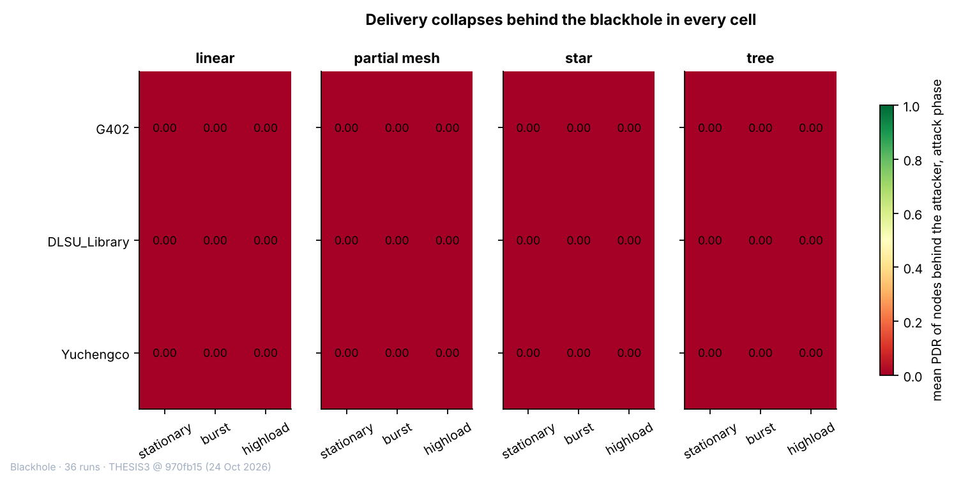

Figure 6.1 Mean PDR of the Victim Boards in the Attack Phase, for Each of the 36 Blackhole Runs
In Figure 6.1, each rectangle is one run. The panels are the topologies, the rows are the sites and the columns are the scenarios. The colour and the number give the mean PDR (ratio, 0 to 1) of the victim boards during the attack phase, where 0 means that no probe from them reached the root.
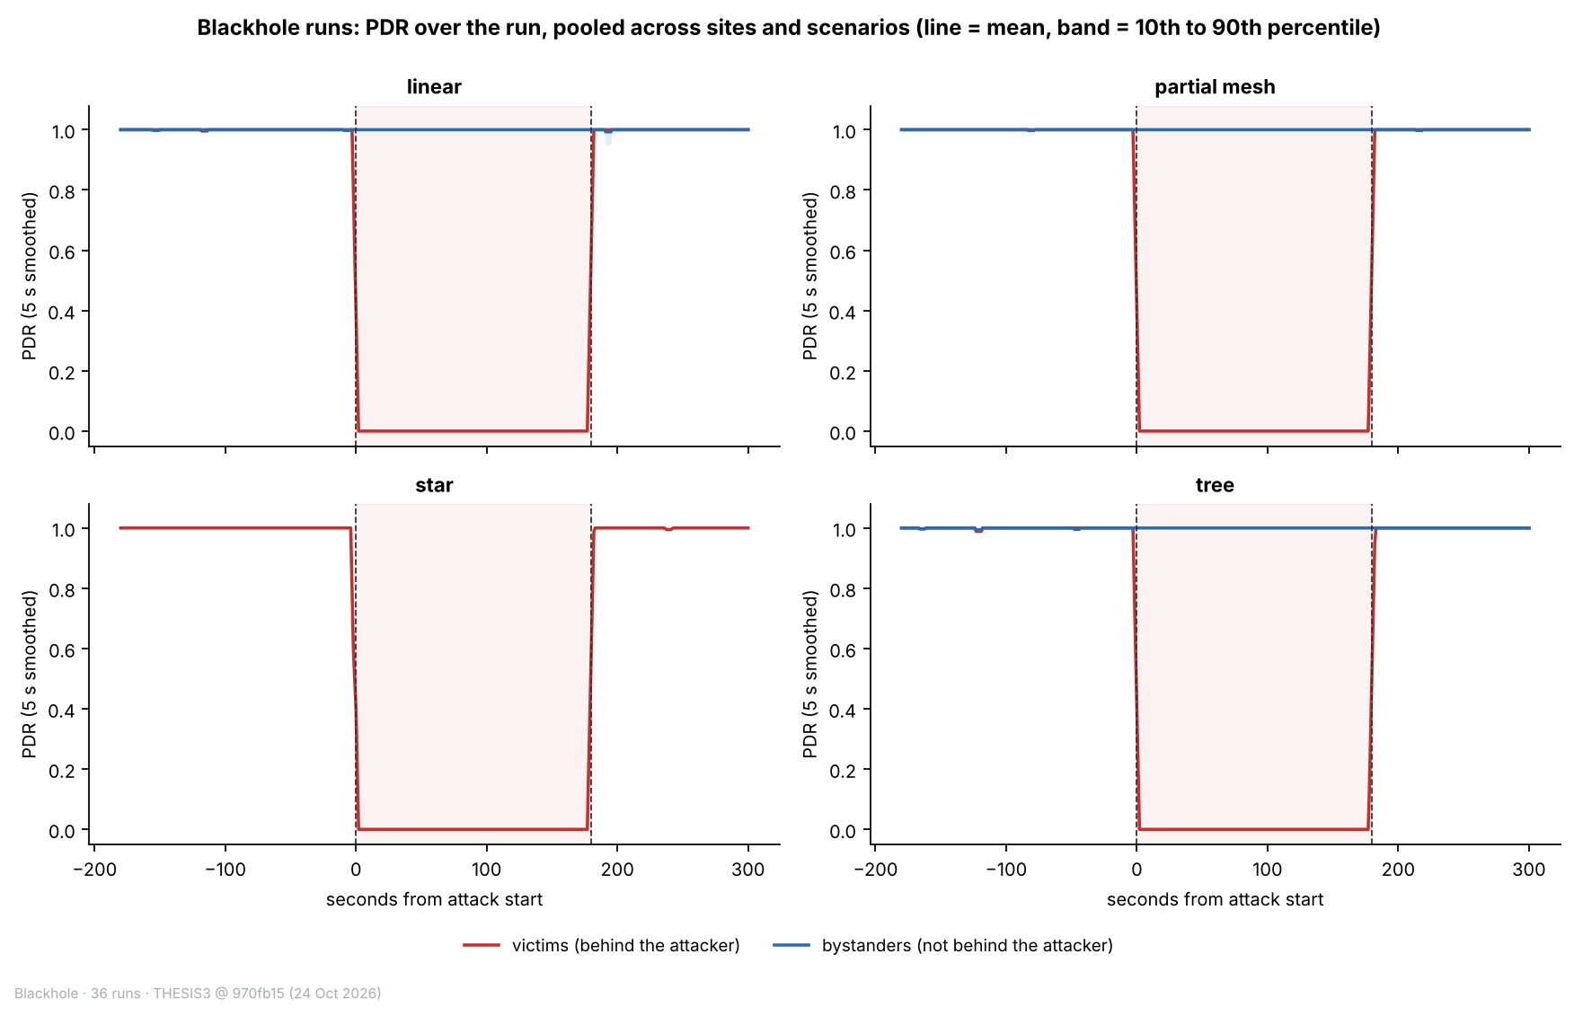

Figure 6.2 PDR of the Victim and Bystander Boards over the Run, by Topology
In Figure 6.2, the horizontal axis is time in seconds from the start of the attack (0 s = start, 180 s = end, negative values = baseline), and the vertical axis is the PDR, the share of probes that reached the root (ratio, 0 to 1), as a 5 s moving average. The red line shows the victims (the boards behind the attacker) and the blue line the bystanders (the boards that are not behind it), with a band from the 10th to the 90th percentile of the windows. The star has no bystanders. The shaded area is the attack phase.
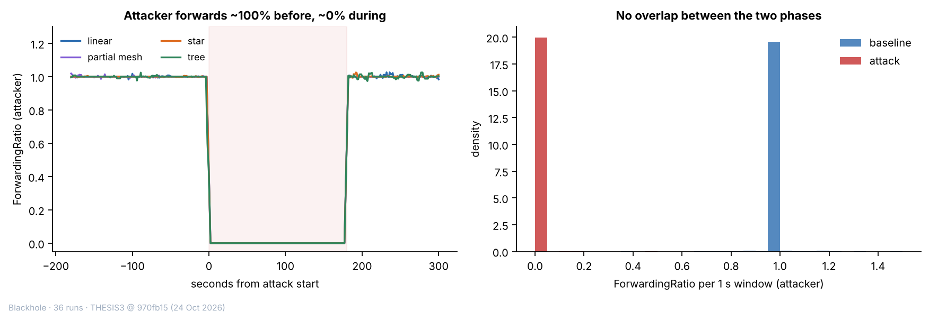

Figure 6.3 Forwarding Ratio of the Attacker over the Run (Left) and in Each One-Second Window (Right)
In the left panel of Figure 6.3, the horizontal axis is time in seconds from the start of the attack, and the vertical axis is the forwarding ratio of the attacker (packets forwarded divided by packets received, 5 s moving average; 1 = everything forwarded, 0 = nothing forwarded), with one line for each topology. In the right panel, each bar counts the one-second windows of a phase whose forwarding ratio lies in that range, as a density, and values above 1.5 are drawn at 1.5. The two phases do not overlap.

6.2.2. Wormhole: Tunnel Replay
In a wormhole run, the entry end (Node B) sends each of its own probes to the root in the normal way and also over a wire to the exit end (Node A), which sends a copy on from its own place in the mesh (Section 4.2.2). The root therefore receives each probe of B twice, once by each route, and both ends count the messages that go through the wire. Only the probes of B are tunnelled, so the other 5 boards of the run are not touched. The expected evidence is therefore of three kinds: tunnel messages and bytes on the two ends and none in the baseline, duplicates of the probes of B at the root, and an entry end that is deeper in the mesh than the exit end, so that the tunnel skips hops (D-17). The 3-sigma test is applied to the duplicate rate and the tunnel intensity as primary checks and to the tunnel bytes as a support check (Table 6.11). The duplicate rate is not a feature of the dataset. It is computed by the verifier as the share of the probes of B that reach the root twice in a window.
Table 6.11 Attack Checks of the Verifier over the 36 Wormhole Runs
Check | Role | Passed (runs) | Detail
DuplicateRate of the entry end | Primary | 36 of 36 | Baseline 0 in every run; attack 0.986 to 1.000 (median 1.000).
TunnelIntensity of the tunnel ends | Primary | 36 of 36 | Baseline at most 0.001 messages per second; attack 0.994 to 4.0 messages per second.
TunnelBytes of the tunnel ends | Support | 36 of 36 | Baseline at most 0.035 bytes per window; attack median 30, largest 120 bytes per window.

Legend:
- Primary checks decide the verdict of a run, and support checks do not.
- Passed = runs that passed the check, out of the 36 wormhole runs.
- DuplicateRate = the share of the probes of the entry end that reach the root twice in a window (computed by the verifier; ratio, 0 to 1).
- TunnelIntensity = tunnel messages per second; TunnelBytes = bytes sent through the tunnel in the window (30 bytes per message).
- The 3-sigma test (the attack value at least three baseline standard deviations from the baseline mean) is applied in the expected direction, upwards. The baseline never varied in 36 runs for DuplicateRate and in 35 runs for TunnelIntensity and TunnelBytes, so z is infinite there.
- Baseline = the 300 s before the attack; attack = the 180 s in which the wormhole is on.
- Entry end = Node B, which sends the probes into the tunnel; exit end = Node A, which sends them on.
All three checks passed in all 36 runs. The verifier also confirmed the setup of every run: the scenario and the tunnel check are satisfied in all 36, and the topology check is satisfied in 27 runs. In the 9 partial-mesh runs it gives a warning, because every node was seen under a single parent, so that the topology is a plain tree (Section 6.5.4). The runs are confirmed in every topology, at every site and in every scenario, and all 36 are graded good (Table 6.4). In the baseline there are practically no tunnel messages (the highest baseline mean is 0.001 messages per second) and no duplicates. In the attack, the tunnel intensity of each run lies between 0.994 and 4.0 messages per second, which is the probe rate of the entry end: about 1 per second in the stationary and burst scenarios and 4 per second in highload. The tunnel bytes follow, at 30 bytes for each message. In one run, partial mesh at Yuchengco with highload, the entry end sent about 1 probe per second instead of 4 (Table 6.6), so its tunnel intensity is 1.0.
The tunnel acted as designed in every cell (Table 6.12). In every run the entry end was deeper in the mesh than the exit end, and the hop of both ends stayed constant for the whole run (36 of 36 runs, no hop change in any phase). The tunnel skips from 1 to 5 hops: 2 to 5 in the linear runs (median 4), 1 to 2 in the partial-mesh runs, 1 in the star runs, where the exit end is the hub (D-28), and 1 to 2 in the tree runs. The wire between the two ends delivered the tunnel messages: the exit end received 99% to 101% of the messages that the entry end sent in all 36 runs. In the attack, 6,468 of the 6,469 windows of the entry end (99.98%) hold a duplicate, against none in the baseline or the cooldown (Figure 6.5).
Table 6.12 Evidence of the Tunnel by Topology and Scenario, over the 36 Wormhole Runs
Group | Value | Runs (count) | Hops skipped: min to max (median) | Messages received by the exit end (% of those sent), min to max | Windows of the entry end with a duplicate, lowest run (%) | Probes of the entry end arriving twice, lowest run (%) | Median spread between the two copies: median of runs (range), ms
Topology | Linear | 9 | 2 to 5 (4) | 99 to 101 | 100.0 | 99.4 | 5.4 (2.8 to 9.9)
Topology | Partial mesh | 9 | 1 to 2 (1) | 99 to 101 | 100.0 | 98.8 | 4.0 (2.4 to 6.4)
Topology | Star | 9 | 1 to 1 (1) | 99 to 101 | 99.4 | 100.0 | 3.7 (3.0 to 4.6)
Topology | Tree | 9 | 1 to 2 (1) | 100 to 101 | 100.0 | 99.7 | 3.3 (2.0 to 4.3)
Scenario | Stationary | 12 | 1 to 5 (1) | 99 to 101 | 100.0 | 99.4 | 3.4 (2.0 to 9.9)
Scenario | Burst | 12 | 1 to 4 (1) | 100 to 101 | 99.4 | 100.0 | 3.4 (2.1 to 6.4)
Scenario | Highload | 12 | 1 to 4 (1) | 99 to 101 | 100.0 | 98.8 | 4.0 (3.1 to 7.4)
All runs |  | 36 | 1 to 5 (1) | 99 to 101 | 99.4 | 98.8 | 3.7 (2.0 to 9.9)

Legend:
- Group = the runs of one topology, of one scenario, or all runs; each run is one cell of the design.
- Hops skipped = the hop (layer − 1) of the entry end minus the hop of the exit end; the hop of each end is constant during the run.
- Messages received by the exit end = the tunnel messages counted by the exit end as a share of those counted by the entry end.
- Windows with a duplicate = the share of the attack windows of the entry end in which a probe of it reached the root twice (the duplicate rate of Table 6.11).
- Probes arriving twice = the share of the probes of the entry end that reached the root twice, from the arrival log of the root; the two copies of a probe have the same sequence number.
- Spread between the two copies = the difference between the delays of the two copies of one probe (TunnelLatency, ms); each run contributes its own median.
- Entry end and exit end are defined in Table 6.11.
The root’s arrival log gives the same picture at the level of single probes. Of the 12,465 probes that the entry end sent in the attack, 12,448 (99.86%) reached the root twice, and none of the probes of the other 5 boards did. The two copies do not arrive together: the difference between their delays is TunnelLatency, with a median of 3.9 ms, a 90th percentile of 12.1 ms and a 99th percentile of 417 ms over the 6,468 windows that have a value. The tail is long, because 84 windows have a spread above 200 ms, but the typical spread is a few milliseconds in every topology (Figure 6.6). The spread does not grow with the hops skipped: the Spearman correlation between the hops skipped and the median spread of the 36 runs is 0.25 (p = 0.14), and 0.29 with the 90th percentile (p = 0.09), so no relation can be claimed from 36 runs. Because the two copies travel by different routes, some probes arrive out of order. 232 of the 24,913 arrivals of the entry end in the attack (0.93%) reached the root after a probe with a higher sequence number. The out-of-order arrivals are rare, and are concentrated in a few runs (tree at G402 with highload (94), partial mesh at G402 with highload (55) and partial mesh at the DLSU Library with highload (47)).
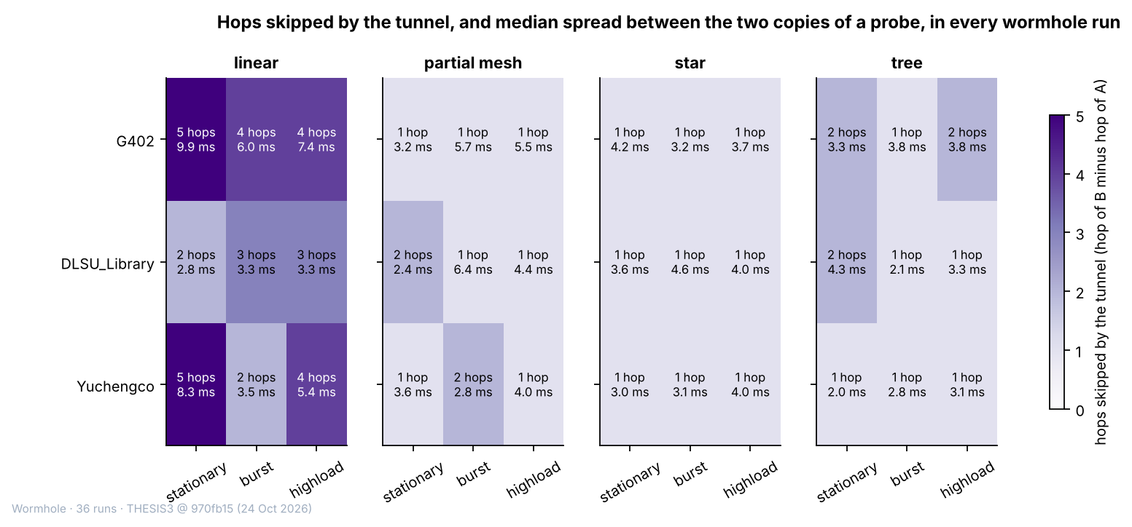

Figure 6.4 Hops Skipped by the Tunnel and Median Spread between the Two Copies of a Probe, in Each of the 36 Wormhole Runs
In Figure 6.4, each rectangle is one run. The panels are the topologies, the rows are the sites and the columns are the scenarios. The shade gives the hops skipped by the tunnel (the hop of the entry end minus the hop of the exit end, from 1 to 5), and the second number in each cell is the median spread between the two copies of the probes of the entry end, in milliseconds.
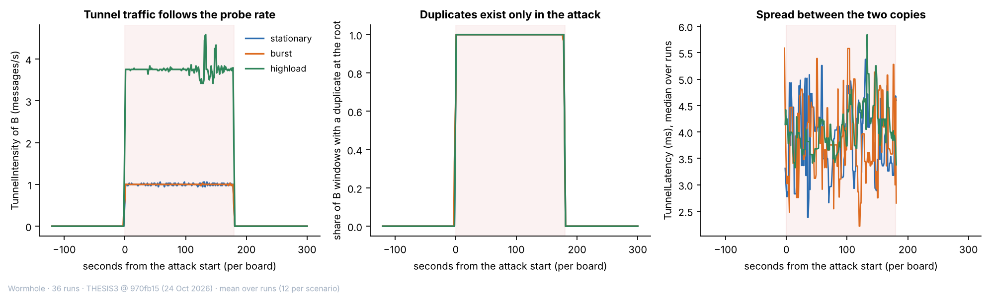

Figure 6.5 Tunnel Traffic, Duplicates and Spread over the Run, Averaged over the Runs of Each Scenario
In Figure 6.5, the horizontal axis is time in seconds from the start of the attack on each board (0 s = start, 180 s = end). The left panel shows the TunnelIntensity of the entry end (messages per second), the middle panel the share of its windows in which a probe reached the root twice, and the right panel the median spread between the two copies (ms). One line is drawn for each scenario, as the mean of its 12 runs. The shaded area is the attack phase.
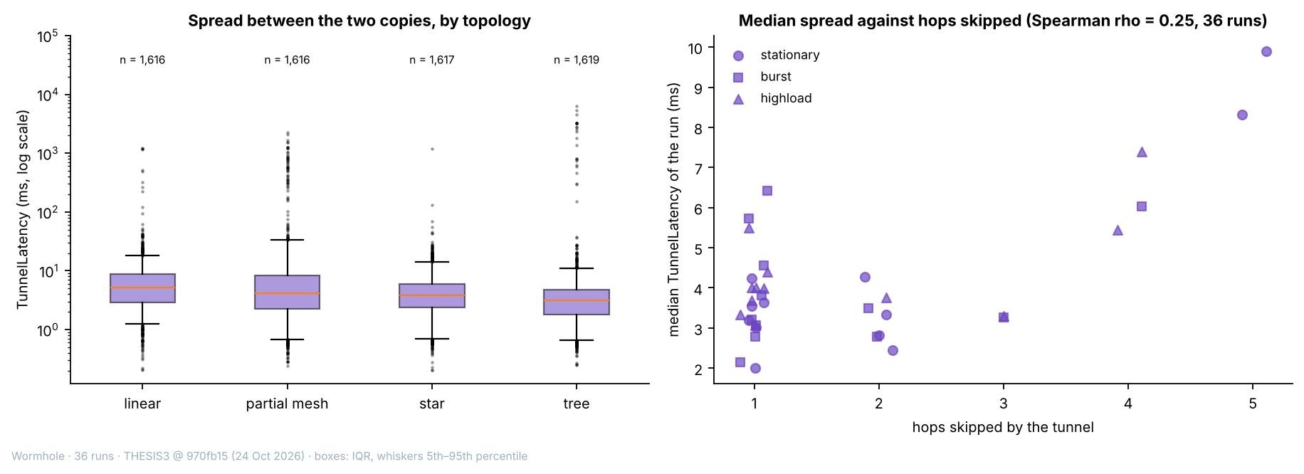

Figure 6.6 Spread between the Two Copies of a Probe, by Topology (Left) and against the Hops Skipped (Right)
In the left panel of Figure 6.6, each box spans the middle half of the windows of the entry end in the attack (25th to 75th percentile) with the median as a line, and the whiskers reach the 5th and 95th percentiles; the vertical axis is the spread in milliseconds on a logarithmic scale. In the right panel, each point is one run, placed at the hops skipped by its tunnel and at the median spread of the run, with the scenario as the marker.

6.2.3. Single-Feature Audit
If one feature alone could separate attack windows from normal windows, the clustering would be unnecessary. Each feature is therefore tested alone. A single threshold on the feature is chosen, with sight of the labels, so that as many windows as possible are classified correctly (normal = 0, attack = 1), and the share classified correctly is the accuracy of the feature. The accuracy is compared with the majority rate, the accuracy of a rule that always answers with the larger class (about 70% here, because normal windows are the larger class). An accuracy at the majority rate means that the feature carries no information about the label by itself, and an accuracy well above it means that the feature alone separates the windows. A high accuracy does not by itself show that the feature reveals the attack, because it can also come from an artefact of how the data were made. Arp et al. [80] list spurious correlation, where a feature that is an artefact of how the data were made decides the result, among the common pitfalls of machine learning in security, and this audit tests for it. A feature that is undefined in some windows is judged on the windows in which it has a value, so for these features the majority rate of the same windows is also given, together with the accuracy of the rule that predicts the label from whether the value is missing (Table 6.15).
The analysis code contains a leakage guard, a list of the columns that may not be model inputs, with the reason for each. It excludes RetryRate, because it counts failed sends at the application layer and, on the entry end of the wormhole, holds the frames sent through the tunnel (D-15); the three tunnel features, because they exist only on the tunnel ends, so that their presence identifies the kind of run; and the relay features ForwardingRatio, IngressEgressDelta and ConsistencyScore, which the guard excludes unless more than one kind of node reports them. The last two are computed from ForwardingRatio and add no information of their own. The audit applies the guard to each group of boards in turn: where a group holds the attacker as well as other nodes, two kinds of node report the relay features and the guard does not flag them in that group. A bar is drawn in grey where the guard flags the feature in the group.
For the blackhole runs, the audit is made on three groups of boards (Table 6.13): all boards other than the root (the attacker and the non-attacker nodes), the non-attacker nodes, and the victims only.
Table 6.13 Best Single-Threshold Accuracy of Each Feature in the Blackhole Runs (%)
Feature | All boards but the root (%) | Non-attacker nodes (%) | Victims only (%)
PDR | 86.9† | 86.9 | 99.9
LatencyHopRatio | 84.3† | 84.3† | 100.0†
ForwardingRatio, ConsistencyScore | 80.4† | 71.7† | 70.0†
IngressEgressDelta | 73.7 | 70.0 | 70.1
RetryRate | 73.1 | 70.0 | 70.1
RSSI_mean, RSSI_var, RSSI_stability, RSSI_Hop_Diff, ParentSwitchRate, HopChangeCount, HopStabilityDuration (highest of the seven) | 70.0 | 70.0 | 70.1
Run clock: raw board clock (window_start) / aligned (t_anchor_s) | 70.2 / 80.0 | 70.3 / 80.0 | 70.4 / 80.0
Majority rate | 70.0 | 70.0 | 70.1

Legend:
- Accuracy (%) = the share of windows labelled correctly by the best single threshold on the feature (normal = 0, attack = 1).
- Best single threshold = the cut-off value on one feature that labels the largest number of windows correctly.
- Majority rate = the accuracy of always answering with the larger class; a value at this rate means that the feature alone says nothing about the label.
- All boards but the root = the 7 child nodes of each run (the attacker and the 6 non-attacker nodes); non-attacker nodes = the 6 boards that are neither the root nor the attacker; victims only = the non-attacker nodes behind the attacker.
- † = the feature has no value in more than 5% of the windows, so the accuracy is that of the windows that have a value; the majority rate of those windows is in Table 6.15.
- The run clock is the position of a window in the run; it is not a feature and is tested only to show how much the fixed phase schedule gives away.
- Raw board clock (window_start) = the time on the clock of each board, which starts when that board starts; aligned clock (t_anchor_s) = the position of a window in the run on a time axis that the boards of one run share.
- Highest of the seven = the best accuracy among the seven features named in the row.
- Features are defined in Table 6.7.
On the victims, one feature alone decides the label: PDR reaches 99.9%, against a majority rate of 70.1%, and every other feature that has a value in nearly all windows stays at the majority rate. This is expected for a blackhole, which drops every packet for the whole attack window, so a complete collapse of delivery is separable by construction. LatencyHopRatio decides the label for a different reason. Its threshold accuracy on the windows that have a value is 100.0%, but those are the 69% of the windows in which a probe was delivered, and almost all of them are normal windows (the majority rate of those windows is 100%), so the threshold carries no information. The information is in the missing values, because a probe that is not delivered has no delay: whether the value is missing predicts the label with 99.2% accuracy on the victims, and it is missing in 100.0% of their attack windows. For that reason LatencyHopRatio is kept out of the clustering. The aligned run clock alone gives 80.0%, about 10 percentage points above the majority rate, because every run follows the same phase schedule and one cut can remove the end of the run. It cannot isolate a window in the middle of the run, and it is kept out of the model inputs. The raw board clock gives 70.4%, because the boards start at different times.
For the non-attacker nodes and for all boards other than the root, PDR reaches only 86.9%, because the bystanders carry the attack label but behave as normal nodes (Section 6.4.3). The forwarding ratio and the consistency score reach 80.4% when the attacker is included, because the attacker’s own forwarding ratio falls to 0 in the attack; on the non-attacker nodes they reach 71.7% on the 37% of the windows that have a value, which is the majority rate of those windows, so they carry no information there. IngressEgressDelta, which is computed from the same counters, reaches 73.7% when the attacker is included and the majority rate on the other boards, and RetryRate stays at the majority rate of its windows. Figure 6.7 shows the audit for the three groups of boards.
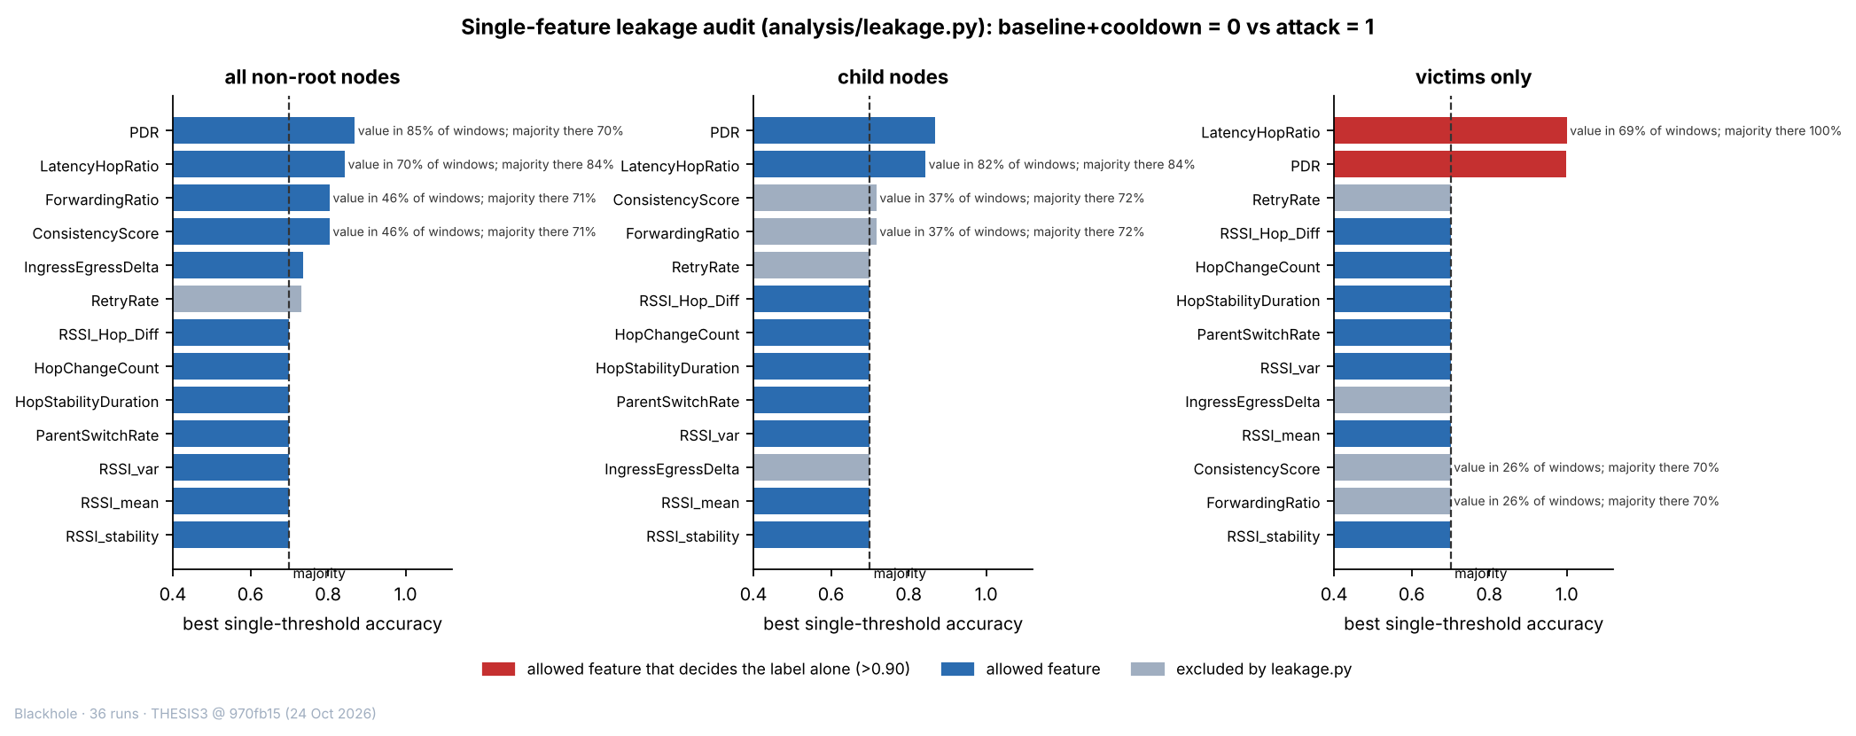

Figure 6.7 Best Single-Threshold Accuracy of Each Feature in the Blackhole Runs, for Three Groups of Boards
In Figure 6.7, each bar is the accuracy (%) of the best single threshold on one feature in telling attack windows from normal windows. The dashed line is the majority rate, about 70%, which is the accuracy of always answering “normal”. A bar that ends at the dashed line means that the feature alone says nothing about the label, and a bar that goes beyond it means that the feature alone separates the windows to that degree. Red bars are allowed features that decide the label alone (above 90%), blue bars are the other allowed features, and grey bars are features that the leakage guard excludes from the model inputs in that group of boards (Table 6.7). Where a feature has a value in fewer than 95% of the windows, the text beside the bar gives the share of windows with a value and the majority rate of those windows. The left panel covers all boards other than the root, the middle panel the non-attacker nodes and the right panel the victims.
For the wormhole runs, the audit is made on the non-attacker nodes, on the two tunnel ends together, and on the entry end alone (Table 6.14). The tunnel features exist only on the ends, so they have no value on the non-attacker nodes.
Table 6.14 Best Single-Threshold Accuracy of Each Feature in the Wormhole Runs (%)
Feature | Non-attacker nodes (%) | Tunnel ends A and B (%) | Entry end B only (%)
TunnelIntensity, TunnelBytes | no value | 99.7 | 99.7
TunnelLatency | no value | 100.0† | 100.0†
RetryRate | 70.0 | 76.9† | 100.0
ForwardingRatio, ConsistencyScore | 68.7† | 70.0† | 70.0†
IngressEgressDelta | 70.0 | 70.0 | 70.0
PDR | 70.0 | no value | no value
LatencyHopRatio | 70.0 | 69.9† | 69.9
RSSI_mean, RSSI_var, RSSI_stability, RSSI_Hop_Diff, ParentSwitchRate, HopChangeCount, HopStabilityDuration (highest of the seven) | 70.0 | 70.0 | 70.0
Run clock: raw board clock (window_start) / aligned (t_anchor_s) | 70.0 / 80.0 | 72.1 / 80.0 | 73.1 / 80.0
Majority rate | 70.0 | 70.0 | 70.0

Legend:
- Accuracy (%) = the share of windows labelled correctly by the best single threshold on the feature (normal = 0, attack = 1).
- Majority rate = the accuracy of always answering with the larger class; a value at this rate means that the feature alone says nothing about the label.
- Non-attacker nodes = the 5 boards of each run that are neither the root nor a tunnel end; tunnel ends A and B = the exit end and the entry end; entry end B only = the board that sends the probes into the tunnel.
- No value = the feature is not defined on these boards.
- † = the feature has no value in more than 5% of the windows, so the accuracy is that of the windows that have a value; the majority rate of those windows is in Table 6.15.
- The run clock is the position of a window in the run; it is not a feature and is tested only to show how much the fixed phase schedule gives away; raw and aligned board clocks are defined in Table 6.13.
- Highest of the seven = the best accuracy among the seven features named in the row.
- Features are defined in Table 6.7.
On the two tunnel ends, the tunnel features decide the label alone: TunnelIntensity and TunnelBytes reach 99.7%, against a majority rate of 70.0%. This is expected, because the tunnel carries messages only in the attack. TunnelLatency exists only on the entry end and only in the attack, so its presence alone gives the label (the rule that predicts the label from whether it is missing is correct for 100% of the windows of the entry end); this is why it is flagged by the audit, and why all three tunnel features are excluded from the model inputs of the non-attacker nodes. RetryRate reaches 76.9% on the two ends together and 100.0% on the entry end alone, although the retry counter is not a signature of the wormhole: on the entry end the counter that RetryRate reads holds the frames sent through the tunnel (Section 6.2.4), so the feature records the attack by construction and it is excluded from the model inputs. Every other feature stays at the majority rate on the ends, except for the raw board clock of the entry end (73.1%). On the non-attacker nodes no feature gets more than 0.01 percentage points above the majority rate (70.0% at most), which means that the wormhole leaves no trace on them that a threshold on one feature can use. The aligned run clock gives 80.0%, as in the blackhole runs. Figure 6.8 shows the audit.
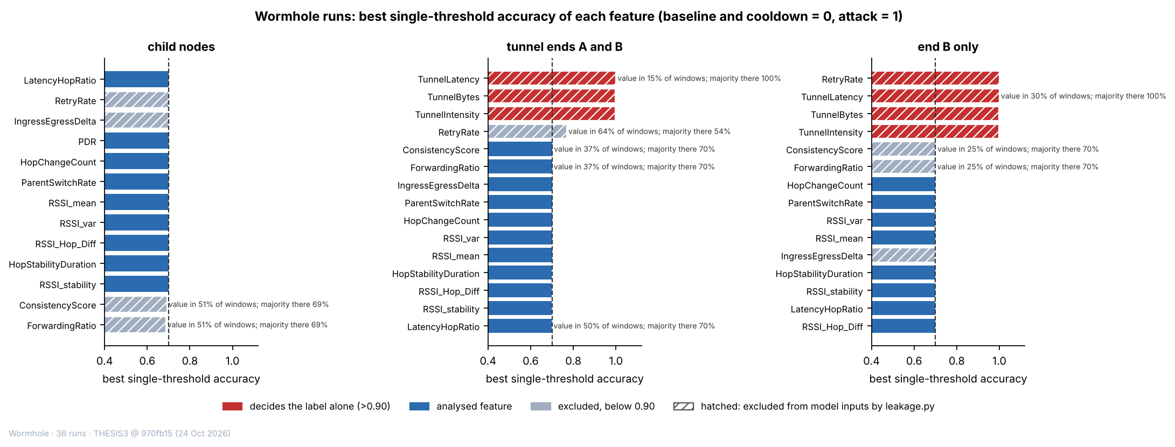

Figure 6.8 Best Single-Threshold Accuracy of Each Feature in the Wormhole Runs, for Three Groups of Boards
In Figure 6.8, each bar is the accuracy (%) of the best single threshold on one feature in telling attack windows from normal windows. The dashed line is the majority rate, about 70%. Red bars are features that decide the label alone (above 90%), blue bars are the other analysed features, and grey bars are features that are excluded from the model inputs and stay below 90%; a hatched bar is a feature that the leakage list of the analysis excludes from the model inputs. Where a feature has a value in fewer than 95% of the windows, the text beside the bar gives the share of windows with a value and the majority rate of those windows. The left panel covers the non-attacker nodes, the middle panel the two tunnel ends and the right panel the entry end alone.
Table 6.15 gives, for every feature that has no value in more than 5% of the windows of a group, the accuracy of its best threshold on the windows that have a value, the share of windows with a value, the majority rate of those windows, and the accuracy of the rule that predicts the label from whether the value is missing. The threshold carries information only where its accuracy is above the majority rate of the same windows. This is the case for PDR, which is missing only on the attacker and the tunnel ends, for the forwarding ratio of the attacker, and for RetryRate on the tunnel ends. LatencyHopRatio and TunnelLatency carry their information in the missing values, which is the finding of the rule on the right of the table.
Table 6.15 Features with Missing Values in the Single-Feature Audit
Runs | Group of boards | Feature | Accuracy of the best threshold, windows with a value (%) | Windows with a value (%) | Majority rate of those windows (%) | Accuracy of the rule “is the value missing?” (%)
Blackhole | All boards but the root | PDR | 86.9 | 85 | 70.0 | 64.0
Blackhole | All boards but the root | LatencyHopRatio | 84.3 | 70 | 84.3 | 78.4
Blackhole | All boards but the root | ForwardingRatio | 80.4 | 46 | 71.1 | 50.5
Blackhole | All boards but the root | ConsistencyScore | 80.4 | 46 | 71.1 | 50.5
Blackhole | Non-attacker nodes | LatencyHopRatio | 84.3 | 82 | 84.3 | 86.5
Blackhole | Non-attacker nodes | ConsistencyScore | 71.7 | 37 | 71.7 | 53.9
Blackhole | Non-attacker nodes | ForwardingRatio | 71.7 | 37 | 71.7 | 53.9
Blackhole | Victims only | LatencyHopRatio | 100.0 | 69 | 100.0 | 99.2
Blackhole | Victims only | ConsistencyScore | 70.0 | 26 | 70.0 | 59.6
Blackhole | Victims only | ForwardingRatio | 70.0 | 26 | 70.0 | 59.6
Wormhole | Non-attacker nodes | ConsistencyScore | 69.2 | 51 | 68.7 | 50.8
Wormhole | Non-attacker nodes | ForwardingRatio | 68.7 | 51 | 68.7 | 50.8
Wormhole | Tunnel ends A and B | TunnelLatency | 100.0 | 15 | 100.0 | 85.0
Wormhole | Tunnel ends A and B | RetryRate | 76.9 | 64 | 53.9 | 65.0
Wormhole | Tunnel ends A and B | ConsistencyScore | 70.1 | 37 | 70.0 | 55.0
Wormhole | Tunnel ends A and B | ForwardingRatio | 70.0 | 37 | 70.0 | 55.0
Wormhole | Tunnel ends A and B | LatencyHopRatio | 69.9 | 50 | 70.0 | 50.0
Wormhole | Entry end B only | TunnelLatency | 100.0 | 30 | 100.0 | 100.0
Wormhole | Entry end B only | ConsistencyScore | 70.2 | 25 | 70.1 | 60.0
Wormhole | Entry end B only | ForwardingRatio | 70.0 | 25 | 70.1 | 60.0

Legend:
- Only features with no value in more than 5% of the windows of the group are listed; a feature that is not defined on the boards of a group is not listed.
- Accuracy of the best threshold = the share of the windows that have a value that the best single threshold labels correctly; it is compared with the majority rate of the same windows, which is given in the sixth column.
- Accuracy of the rule “is the value missing?” = the share of all windows of the group that are labelled correctly by predicting the attack label from the presence (or the absence) of a value; n/a = the feature has a value in every window or in none.
- Groups of boards are defined in Tables 6.13 and 6.14.
- Features are defined in Table 6.7.

6.2.4. Predictions Tested and Not Observed
Table 3.4 predicted that victim nodes would retransmit more under the blackhole. The table rests on the cross-layer premise that a routing attack leaves correlated traces in the physical, MAC and network layers. This premise is taken from Al-Anzi [5] and Amouri et al. [8], on which the feature design of Section 4.3.1 is based, and from Srinivasan [19], who combines physical, MAC and network-layer knowledge against blackhole and wormhole attacks. These studies were used as the basis because they treat the three layers together, as this study does. The retransmission row itself is a hypothesis of this study and not a published result: a victim whose frames are not acknowledged would repeat them, and any rise was expected to be small because the attacker still acknowledges each frame (Section 3.3.1).
The prediction was not observed. The retry rate of the victims (the share of send attempts that failed, from application counters, deviation D-15) was 0.0000 in the baseline, 0.0004 in the attack and 0.0000 in the cooldown, so it did not rise during the attack: a failed send occurs in only 9 of the 21,742 attack windows of the victims that have a value, and in none of their baseline or cooldown windows. For the bystanders it was 0 in every phase. A rise would be expected if frames were left unacknowledged, but the attacker acknowledges every frame at the link layer (Section 3.3.1.2), so the sender never sees a failed delivery. Parent changes were also almost absent: the mean ParentSwitchRate (parent changes per second) of the victims was 0.00000 in the baseline and 0.00009 in the attack (Cohen’s d = 0.01). Table 3.4 is kept as it was written at proposal time, before any capture. The result is that an application-layer blackhole removes the delivery of the probes and leaves the link layer and the routing tree as they were.
One further measurement bears on the prediction. A sniffer captured the real 802.11 retry rate (MacRetryRate, the share of the frames of a board to its parent that carry the retry bit) in 7 of the 36 blackhole runs (17,204 windows with a value), and in none of the wormhole or benign runs. It is not one of the 16 features of Table 4.17 and not a model input, because the boards cannot measure it (D-15). In these runs, the frame-weighted retry rate of the victims was 0.295 in the baseline, 0.364 in the attack and 0.323 in the cooldown, and that of the bystanders was 0.355, 0.342 and 0.354. The change from the baseline to the attack differs in sign between runs: for the victims it lies between −0.10 and +0.33 (3 runs up, 4 down) and for the bystanders between −0.06 and +0.10 (2 runs up, 3 down). The data therefore show no consistent rise in the retransmissions of the victims, but 7 runs, with few frames heard in the attack in some of them, are too few to rule out a small effect, and this column is reported as supplementary.
Table 3.5 lists nine indicators that a wormhole was expected to leave in the physical, MAC and network layers. Table 6.16 gives each of them with what was measured in the 36 wormhole runs.
Table 6.16 Predicted Indicators of the Wormhole (Table 3.5) and What Was Measured in the 36 Wormhole Runs
Indicator | Expected (Table 3.5) | Measured | Observed
Hop count consistency | Nodes report unexpectedly low hop counts given physical placement | The hop of A and of B is constant during the attack in 36 of 36 runs; windows with a hop change on any board: baseline 0, attack 0, cooldown 0 | No
Parent-child validity | Relationships violate physical constraints | Windows with a parent change on any board: baseline 0, attack 0, cooldown 0 | No
Routing table entries | Self-referential entries or impossible neighbour relationships | The routing table is not logged by the firmware, so it is not measured | Not measured
RSSI-hop correlation | High RSSI observed from physically distant nodes | RSSI_Hop_Diff mean baseline → attack: A 2.79 → 2.76 dB (share of windows above 10 dB: 10.6% → 9.2%); B 5.41 → 5.68 dB (share of windows above 10 dB: 25.5% → 25.2%) | No
RSSI variance | Abnormally high RSSI values inconsistent with the expected path loss | RSSI_var mean baseline → attack: A 0.390 → 0.343 dBm² (d = −0.03); B 0.366 → 0.278 dBm² (d = −0.07) | No
Frame arrival pattern | Duplicates or out-of-order frames due to tunnelling | Probes of B reaching the root twice: baseline 0 of 20,717, attack 12,448 of 12,465 (99.86%); out-of-order arrivals of B in the attack 232 of 24,913 (0.93%); other boards: 0 probes twice | Yes for duplicates; out-of-order arrivals are rare
Retransmission count | May increase near tunnel endpoints due to timing issues | The RetryRate of B is 0.50 in the attack and 0.00 in the baseline, but on B the retry counter holds the frames sent through the tunnel (D-15), so it is not a retransmission count; MacRetryRate has no values in the wormhole runs; the RetryRate of the other boards is 0.000 in every phase | Not measurable on the ends; none on the children
Duplicate arrivals | The same probe reaches the root twice | B windows with a duplicate: 6,468 of 6,469 attack windows (100.0%) and 0 baseline windows | Yes
Latency mismatch | The two arrivals of one probe differ in latency | Spread between the two copies: median 3.9 ms, 90th percentile 12.1 ms, 99th percentile 417 ms over 6,468 windows; Spearman rho with hops skipped (run medians) = 0.25 | Yes

Legend:
- Indicator and expected value are those of Table 3.5, which is kept as it was written at proposal time, before any capture.
- A and B = the exit end and the entry end of the tunnel; the other boards are the 5 non-attacker nodes of each run.
- RSSI_Hop_Diff = the observed RSSI minus the baseline median RSSI at the node’s layer (dB); RSSI_var = the variance of the RSSI samples in the window (dBm²); d = Cohen’s d, the shift of the mean in units of the spread (Section 6.3.2).
- Baseline → attack = the mean in the baseline phase and in the attack phase.
- Not measured = the quantity is not recorded by the boards.
- The routing table is not logged by the firmware.
- Out-of-order arrival = a probe that reaches the root after a probe with a higher sequence number from the same board.
- MacRetryRate = the 802.11 retry rate seen by a sniffer (Section 6.2.4); the sniffer captured none of the wormhole runs.
Three of the nine indicators are observed: the duplicate arrivals, the frame arrival pattern (duplicates, while out-of-order arrivals are rare) and the latency mismatch between the two copies. All three are properties of the traffic that the tunnel creates directly. Four indicators of the physical and network layers are not observed: the hop count, the validity of parent and child links, the relation between signal strength and hop, and the signal variance. The hop and the parent of every board stay the same in every phase of all 36 runs, and the RSSI features of the two ends and of the other five boards do not shift (|d| of at most 0.07 for the ends). The routing table is not logged, so that row is not measured, and the retransmission row cannot be tested on the two ends, because the retry counter of the entry end holds the frames sent through the tunnel, while on the other boards it is 0 in every phase. This is the pattern that an application-layer tunnel implies. The mesh does not see the tunnel, so its routing and its radio links are left as they were, and only the data plane carries the signature (D-20, Section 6.5.3). Table 3.5 is kept as it was written at proposal time.

6.2.5. Cells That Could Not Be Fully Tested
Some blackhole cells could be tested in part only. Partial mesh at Yuchengco with stationary traffic could not be tested on PDR, because its baseline is unstable, and it is confirmed on the attacker’s forwarding ratio. The run tree at G402 with highload is rated undetermined, because board B768 has no data and cannot be placed. Four runs have no attack-phase values of the NeighbourForwardingRatio (Table 6.9), so that support check was not run for them. In the run linear at G402 with burst the scenario was not applied in the attack phase (board 0C80 sent about 297 probes outside it), and it is rated minor gaps (D-34), so the burst effect is not present in that attack phase. Three further runs carry a minor gap because one board has too few windows in a phase (Table 6.6). None of these gaps changes a verdict.
All 36 wormhole cells passed the three checks, and none carries a gap. Two limits remain. The routing table and the retransmissions of the two ends cannot be measured (Section 6.2.4). In the run partial mesh at Yuchengco with highload the entry end and one non-attacker node sent about one probe per second where the scenario asks for four, so the highload effect is missing on these two boards, although the scenario check of the verifier passes on the rate of the other boards. The nine partial-mesh runs of each attack are plain trees, so the partial-mesh cells test a branched tree with a limit of two children and not a mesh with alternative parents (Section 6.5.4).

6.2.6. Benign Runs: No Attack Signature
A benign run is the normal reference, so it has to be shown normal with the same tests that the attack runs are held to, pointed the other way. The verifier applies the 3-sigma test of both attack signatures, with the later phase of the run (the cooldown, where an attack would have run) against the baseline, and no signature may pass. It also checks that delivery is healthy in both phases, that every relay forwards at least 90% of what it receives, that every board has windows for at least 95% of each phase, and that the scenario was applied. All 8 benign runs are rated BENIGN CONFIRMED with the grade strong, which means that no signature passed and nothing is to be noted (Table 6.17). Of the 21 signature checks that could be evaluated, none passed, and the 43 checks that need a tunnel or an attacker had no data, as expected. Delivery is healthy: the mean PDR of each run is between 0.9994 and 1.0000 in both phases, and 4 of the 54 child boards ever had a window below 1, all of them in linear at G402 with highload (lowest window 0.75).
Table 6.17 Verifier Result for the 8 Benign Runs
Topology | Site | Scenario | PDR in the baseline | PDR in the cooldown | z of the PDR check | Signature checks passed (of those evaluated) | Verdict and grade
Linear | DLSU Library | stationary | 1.0000 | 1.0000 | +0.00 | 0 of 3 | Benign Confirmed, strong
Linear | G402 | highload | 0.9994 | 0.9997 | +0.06 | 0 of 3 | Benign Confirmed, strong
Linear | Yuchengco | stationary | 1.0000 | 1.0000 | +0.00 | 0 of 3 | Benign Confirmed, strong
Partial mesh | G402 | highload | 1.0000 | 1.0000 | +0.00 | 0 of 3 | Benign Confirmed, strong
Star | DLSU Library | stationary | 1.0000 | 1.0000 | +0.00 | 0 of 2 | Benign Confirmed, strong
Star | G402 | burst | 1.0000 | 1.0000 | +0.00 | 0 of 2 | Benign Confirmed, strong
Star | Yuchengco | highload | 1.0000 | 1.0000 | +0.00 | 0 of 2 | Benign Confirmed, strong
Tree | G402 | stationary | 1.0000 | 1.0000 | +0.00 | 0 of 3 | Benign Confirmed, strong

Legend:
- PDR in the baseline / cooldown = the mean PDR of all child boards in that phase (ratio, 0 to 1).
- z of the PDR check = the distance of the cooldown mean from the baseline mean in baseline standard deviations, as in the blackhole check (the attack signature needs z of −3 or lower); infinite = the baseline never varied.
- Signature checks = the checks of Tables 6.9 and 6.11 that can be evaluated on the data; the checks that need a tunnel or an attacker board have no data in a benign run.
- Verdict and grade = the result of the verifier for a benign run: BENIGN CONFIRMED means no signature passed and delivery and forwarding are healthy; strong = all board data present, nothing to note.
- The star run at Yuchengco has 6 boards, and the others have 8 (Table 6.3).
- Topology, site and scenario are defined in Table 6.1.

6.3. Exploratory Data Analysis
The exploratory analysis describes the three kinds of run with summary statistics and plots, and it states no detection result. For each feature it compares the baseline with the attack phase by the two means and by Cohen’s d, which is the difference of the two means divided by the pooled standard deviation. By the common reading, an absolute d below 0.2 is a negligible shift, 0.5 a medium one and 0.8 or more a large one. The windows of one board follow one another and are not independent, so d describes the size of a shift and is not used for a significance test. A negative d means that the mean is lower in the attack phase. The blackhole runs are described for the victims and the bystanders separately (Section 6.3.1), the wormhole runs for the two tunnel ends and for the other five boards (Section 6.3.2), and the benign runs are described on their own and against the normal windows of the attack runs (Section 6.3.3).

6.3.1. Blackhole Runs
Table 6.18 gives, for each feature, the mean in the baseline and in the attack phase and the value of d, separately for the victims and the bystanders. Only the PDR of the victims moves: it falls from 0.998 in the baseline to 0.000 in the attack phase (d = −29.71). Every other feature of both groups shifts by less than 0.1 standard deviations, and the largest shift is RSSI_var of the bystanders (d = −0.09). The PDR of the bystanders is 0.996 in the baseline and 1.000 in the attack phase (d = 0.09), so the bystanders, which carry the attack label, are not affected by the attack. The collapse of the victims’ PDR is the whole of the effect that the blackhole has on the features of the non-attacker nodes.
Table 6.18 Mean of Each Feature in the Baseline and in the Attack Phase, and Cohen’s d, for the Victims and the Bystanders of the Blackhole Runs
Feature (unit) | Victims: baseline mean | Victims: attack mean | Victims: d | Bystanders: baseline mean | Bystanders: attack mean | Bystanders: d
PDR (ratio) | 0.9977 | 0.0000 | −29.71 | 0.9963 | 1.0000 | 0.09
RetryRate (ratio) | 0.0000 | 0.0004 | 0.03 | 0.0000 | 0.0000 | n/a
IngressEgressDelta (packets per window) | 0.019 | 0.013 | −0.01 | 0.031 | 0.018 | −0.03
RSSI_mean (dBm) | −74.72 | −74.95 | −0.03 | −72.24 | −72.53 | −0.04
RSSI_var (dBm²) | 0.412 | 0.311 | −0.07 | 0.332 | 0.199 | −0.09
RSSI_stability (s) | 0.894 | 0.896 | 0.04 | 0.895 | 0.898 | 0.07
RSSI_Hop_Diff (dB) | 3.18 | 3.28 | 0.02 | 4.07 | 3.99 | −0.01
ParentSwitchRate (changes per second) | 0.00000 | 0.00009 | 0.01 | 0.00000 | 0.00000 | n/a
HopChangeCount (count per window) | 0.00000 | 0.00009 | 0.01 | 0.00000 | 0.00000 | n/a
HopStabilityDuration (s) | 0.9998 | 0.9998 | 0.01 | 0.9999 | 0.9999 | 0.00

Legend:
- Mean = the mean over the one-second windows of the group in that phase; d = Cohen’s d, the difference of the means divided by the pooled standard deviation (negative = lower in the attack).
- Victims = the non-attacker nodes behind the attacker; bystanders = the non-attacker nodes that are not behind it (defined at the start of the chapter). The attacker is not included.
- Windows (baseline, attack): victims 36,774 and 21,962; bystanders 27,281 and 16,531. A feature that has no value in a window is left out of its own mean.
- n/a = d cannot be computed because the feature has one value in both phases (RetryRate of the bystanders, ParentSwitchRate and HopChangeCount of the bystanders).
- LatencyHopRatio is not listed, because the victims have no value of it in the attack phase (Section 6.2.3).
- RetryRate = the share of send attempts that failed, from application counters (D-15); PDR = the share of a node’s probes that reached the root.
- Features are defined in Table 6.7.
The signal-strength features do not respond to the attack. The RSSI_mean of the victims is −74.7 dBm in the baseline and −74.9 dBm in the attack (d = −0.03), and that of the bystanders is −72.2 dBm and −72.5 dBm (d = −0.04). The victims are the deeper boards, so their mean signal is about 2.5 dB weaker than that of the bystanders already in the baseline, which reflects where the boards sit and not the attack. RSSI_var is lower in the attack phase in both groups (d = −0.07 for the victims and −0.09 for the bystanders), and because the bystanders are not touched by the attack, a change of this size cannot be attributed to it. The retry rate of the victims is 0.0000 in the baseline and 0.0004 in the attack phase, because a failed send occurs in 9 of their 21,742 attack windows (d = 0.03); the bystanders have none. LatencyHopRatio cannot be followed through the attack for the victims, since a probe that is dropped has no delay, but for the bystanders its median is 4.26 ms per hop in the baseline, 3.15 in the attack phase and 2.46 in the cooldown. The decline continues after the attack has ended and is also seen in the benign runs (Section 6.3.3), so it follows the course of the run and not the attack.
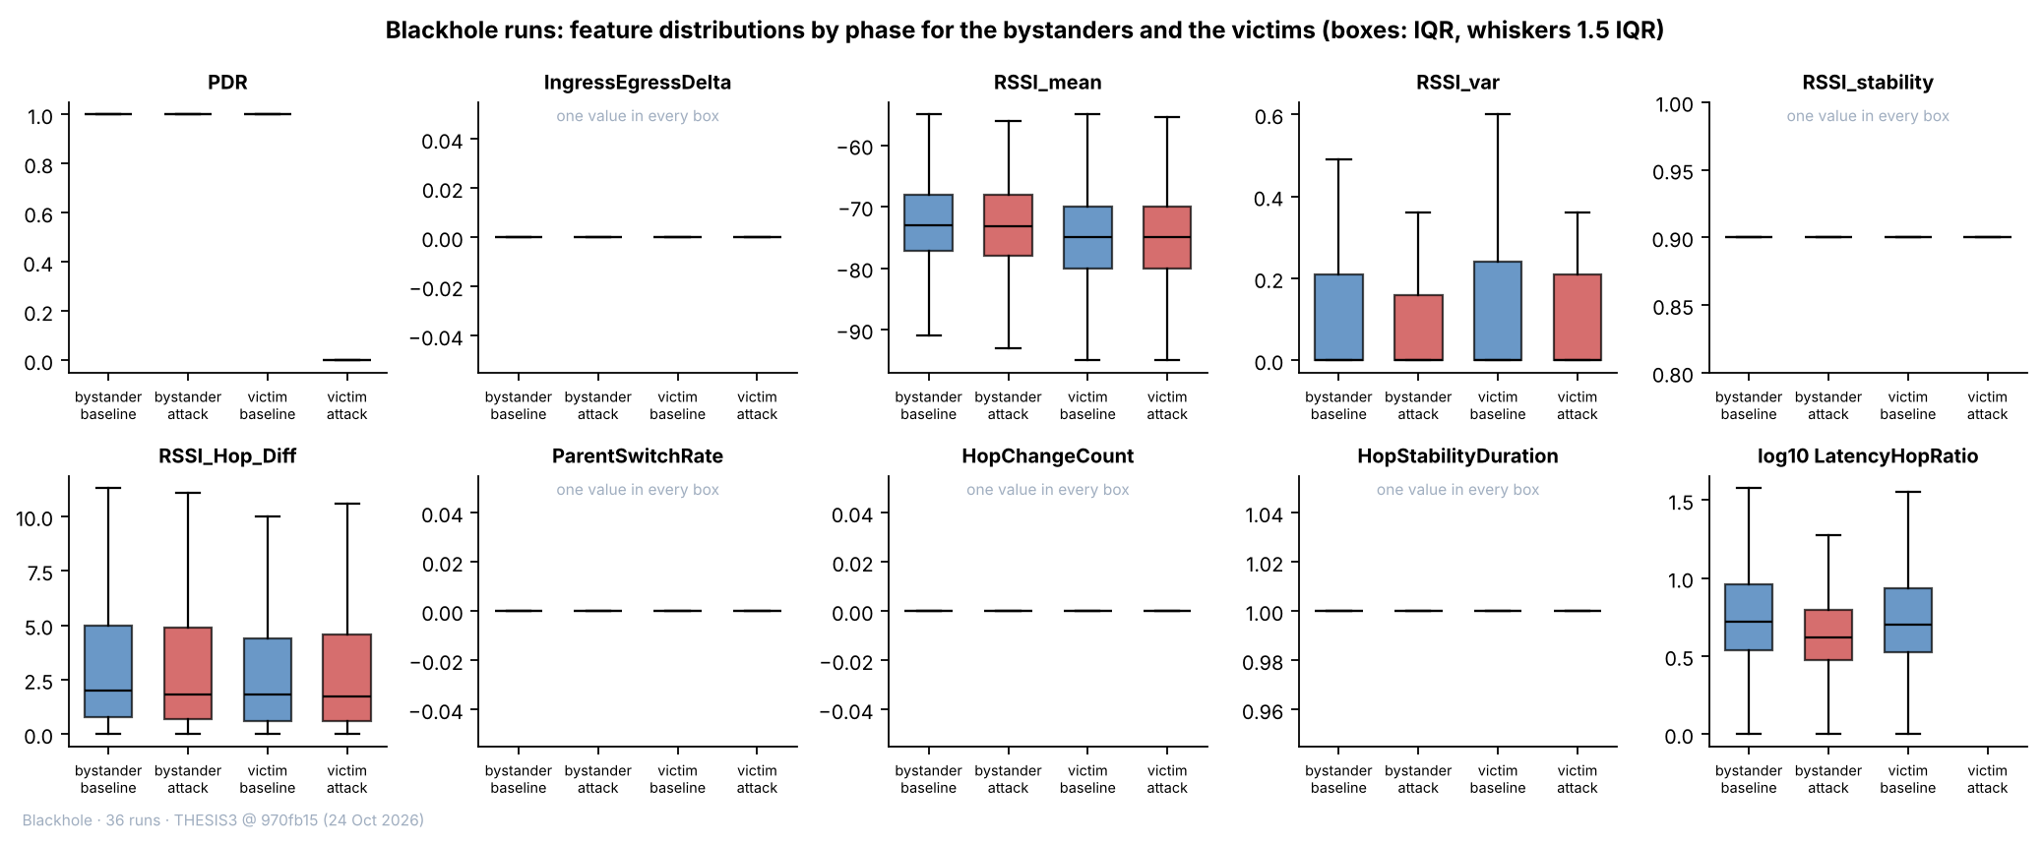

Figure 6.9 Distributions of Ten Features by Phase for the Bystanders and the Victims of the Blackhole Runs
In Figure 6.9, each panel is one feature and each box is one group in one phase: bystander or victim, baseline (blue) or attack (red). The box spans the middle half of the windows (25th to 75th percentile) with the median as a line, and the whiskers reach 1.5 times that range. Only the PDR panel shows a change: the victims’ box in the attack lies at 0, and all other boxes lie at 1. The panels of IngressEgressDelta, RSSI_stability, ParentSwitchRate, HopChangeCount and HopStabilityDuration hold one value in every box and are marked as such. The boxes of RSSI_mean, RSSI_var and RSSI_Hop_Diff overlap between the phases. In the panel of LatencyHopRatio (plotted as the logarithm of 1 plus the value), the victims’ box in the attack is missing because the victims have no value in that phase.
Four pairs of features are strongly correlated (Figure 6.10). ConsistencyScore is computed from ForwardingRatio as |ForwardingRatio − 1|, so the two are strongly rank-correlated (Spearman −0.94), although the Pearson coefficient is only 0.12 because the relation is not linear. IngressEgressDelta and ConsistencyScore have a Pearson coefficient of 0.65 over all windows (0.78 in the baseline), since both are built from the same relay counters. RSSI_var and RSSI_stability have a Pearson coefficient of −0.79 but a Spearman coefficient of only 0.05: the link comes from a few windows with a high variance and a short stable interval, and not from a general relation. ParentSwitchRate and HopChangeCount have a coefficient of 1.00 in the attack windows, where both are non-zero in the same windows; in the baseline both are constant and no coefficient exists. No other pair among the eight features of the FULL set of Section 6.4 has an absolute Pearson coefficient above 0.4 (the largest is 0.36 between ParentSwitchRate and HopStabilityDuration, in the attack windows). The correlation structure is the same in the baseline and in the attack windows, apart from the pairs that involve ParentSwitchRate or HopChangeCount, which have a coefficient only in the attack windows because both are constant in the baseline.
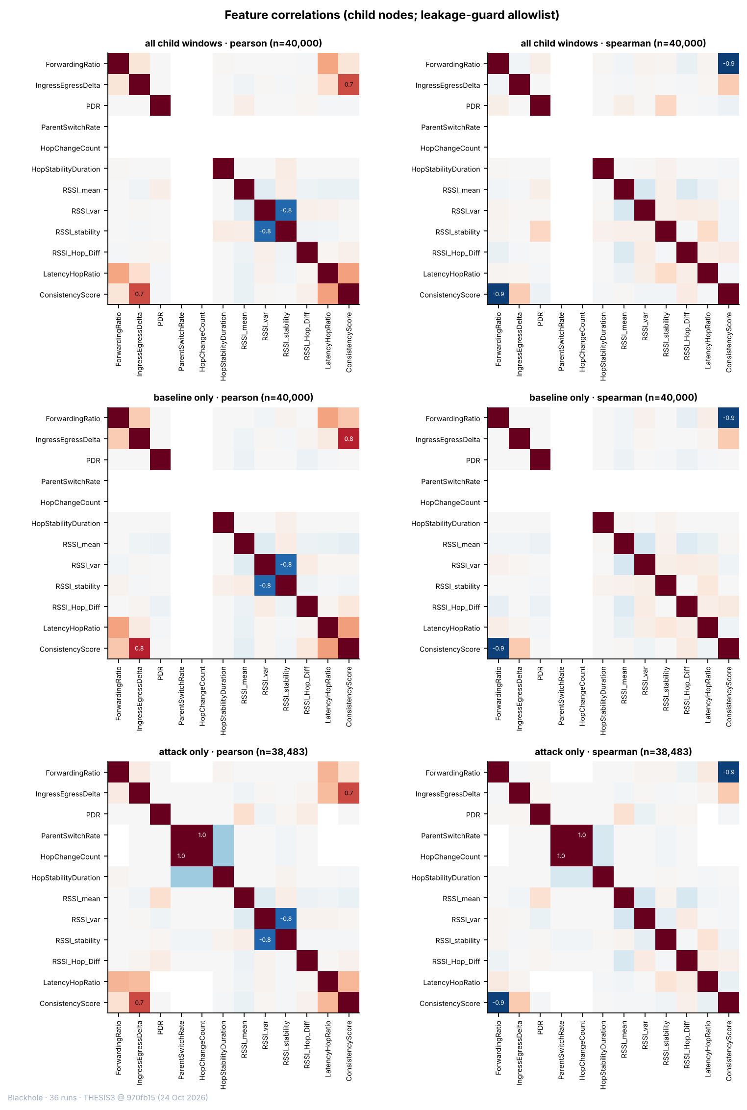

Figure 6.10 Correlations between the Features of the Child Nodes of the Blackhole Runs
In Figure 6.10, each square is the correlation between two features, from −1 (blue) to +1 (red), and values of 0.5 or more in absolute size are printed. The left column is the Pearson coefficient and the right column the Spearman coefficient. The rows are all windows, the baseline windows and the attack windows of the child nodes, each on a sample of up to 40,000 windows. The twelve features are those that the leakage guard allows in a group that holds the attacker (Section 6.2.3); RetryRate and the tunnel features are not shown. An empty row means that the feature is constant in those windows.

6.3.2. Wormhole Runs
Table 6.19 gives the same comparison for the wormhole runs, for the exit end (A), the entry end (B) and the non-attacker nodes. On the two ends, the tunnel features are the only ones that change. TunnelIntensity rises from 0 to 1.92 messages per second on both ends (d = 1.83), and TunnelBytes from 0 to 57.5 bytes per window on both ends, which is 30 bytes for each message. The shift is large, but d is limited by the spread of the attack values, which lie between 1 and 4 messages per second according to the scenario, while the baseline never varies. TunnelLatency exists only on B and only in the attack, with a mean of 21.1 ms and a median of 3.9 ms; the mean is drawn up by a few windows with a long delay (Section 6.2.2).
Table 6.19 Mean of Each Feature in the Baseline and in the Attack Phase, and Cohen’s d, for the Two Tunnel Ends and the Non-Attacker Nodes of the Wormhole Runs
Feature (unit) | Exit end A: baseline → attack | Exit end A: d | Entry end B: baseline → attack | Entry end B: d | Non-attacker nodes: baseline → attack | Non-attacker nodes: d
TunnelIntensity (messages per second) | 0.000 → 1.916 | 1.83 | 0.000 → 1.916 | 1.83 | no value | n/a
TunnelBytes (bytes per window) | 0.0 → 57.5 | 1.83 | 0.0 → 57.5 | 1.83 | no value | n/a
TunnelLatency (ms) | no value | n/a | no value → 21.1 | n/a | no value | n/a
RetryRate (ratio) | no value → 0.000 | n/a | 0.000 → 0.500 | 42.99 | 0.000 → 0.000 | n/a
PDR (ratio) | no value | n/a | no value | n/a | 0.9999 → 0.9999 | 0.00
IngressEgressDelta (packets per window) | 0.068 → 0.086 | 0.03 | 0.009 → 0.007 | −0.01 | 0.038 → 0.051 | 0.02
RSSI_mean (dBm) | −65.63 → −65.82 | −0.02 | −62.47 → −62.35 | 0.01 | −69.18 → −69.13 | 0.01
RSSI_var (dBm²) | 0.390 → 0.343 | −0.03 | 0.366 → 0.278 | −0.07 | 0.451 → 0.331 | −0.06
RSSI_stability (s) | 0.895 → 0.895 | 0.01 | 0.895 → 0.897 | 0.04 | 0.893 → 0.896 | 0.06
RSSI_Hop_Diff (dB) | 2.79 → 2.76 | −0.01 | 5.41 → 5.68 | 0.04 | 2.65 → 2.72 | 0.02
LatencyHopRatio (ms per hop) | no value | n/a | 12.0 → 11.2 | −0.01 | 11.3 → 9.9 | −0.03
HopStabilityDuration (s) | 1.0000 → 1.0000 | 0.00 | 0.9999 → 0.9999 | 0.01 | 0.9999 → 0.9999 | −0.01
ParentSwitchRate (changes per second) | 0.0000 → 0.0000 | n/a | 0.0000 → 0.0000 | n/a | 0.0000 → 0.0000 | n/a
HopChangeCount (count per window) | 0.0000 → 0.0000 | n/a | 0.0000 → 0.0000 | n/a | 0.0000 → 0.0000 | n/a

Legend:
- Each pair gives the mean in the baseline and in the attack phase, over the one-second windows of the group; d = Cohen’s d, the difference of the means divided by the pooled standard deviation (negative = lower in the attack).
- Exit end A = the board that sends the tunnelled probes on; entry end B = the board whose probes are tunnelled; non-attacker nodes = the 5 other child nodes of each run (defined at the start of the chapter).
- Windows (baseline, attack): end A 10,778 and 6,474; end B 10,779 and 6,469; non-attacker nodes 53,917 and 32,334.
- No value = the feature is not defined for that group in that phase (the tunnel features exist only on the ends, TunnelLatency only on B in the attack, and PDR is not scored on the ends).
- n/a = d is not defined, because the feature has no value or has one value in both phases. Where only the baseline never varies (the tunnel features), d is limited by the spread of the attack values.
- RetryRate of B counts the frames sent through the tunnel (D-15), so its shift records the tunnel and is not a retry rate (Section 6.2.4).
- Features are defined in Table 6.7.
Every other feature of the two ends and of the non-attacker nodes stays where it was. The largest shift on the ends is RSSI_var of B (d = −0.07) and the largest on the non-attacker nodes is RSSI_var (d = −0.06). The PDR of the non-attacker nodes is 0.9999 in the baseline and 0.9999 in the attack phase, whereas the PDR of the blackhole victims falls to 0 (Figure 6.11). RSSI_Hop_Diff is larger on B than elsewhere, 5.4 dB in the baseline and 5.7 dB in the attack phase, against 2.8 and 2.8 dB on A and 2.7 and 2.7 dB on the non-attacker nodes, which reflects where B sits, because it is as large before the attack as during it. The RetryRate of B changes from 0.00 to 0.50 (d = 42.99), but it is not a retry rate: on B, the counter holds the frames sent through the tunnel (Section 6.2.4), so it records the attack by construction. The wormhole leaves the delivery, the signal strength and the position of the nodes in the mesh unchanged, which is what an attack at the application layer is expected to do (D-20).
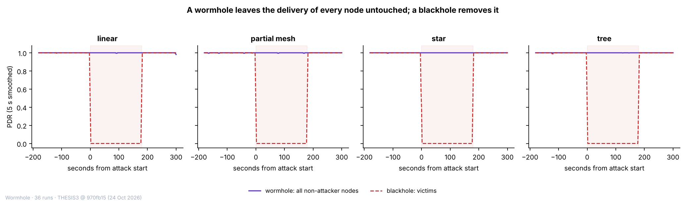

Figure 6.11 PDR of the Non-Attacker Nodes of the Wormhole Runs and of the Victims of the Blackhole Runs, by Topology
In Figure 6.11, the horizontal axis is time in seconds from the start of the attack (0 s = start, 180 s = end) and the vertical axis is the PDR, the share of probes that reached the root (ratio, 0 to 1), as a 5 s moving average. The solid purple line is the mean PDR of all non-attacker nodes of the wormhole runs of the topology, and the dashed red line is the mean PDR of the victims of the blackhole runs of the same topology. The shaded area is the attack phase. The wormhole line does not leave 1, whereas the blackhole line falls to 0 for the whole of the attack phase.
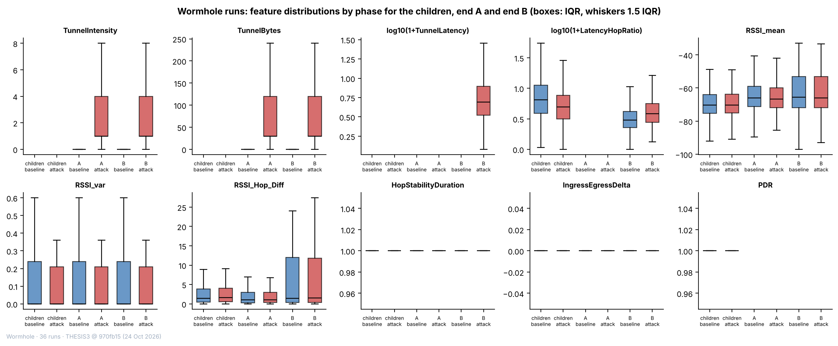

Figure 6.12 Distributions of Ten Features by Phase for the Non-Attacker Nodes and the Two Ends of the Wormhole Runs
In Figure 6.12, each panel is one feature and each box is one group in one phase: non-attacker nodes, end A or end B, in the baseline (blue) or in the attack (red). The box spans the middle half of the windows (25th to 75th percentile) with the median as a line, and the whiskers reach 1.5 times that range. TunnelIntensity, TunnelBytes and TunnelLatency exist only on the ends and take values only in the attack; TunnelLatency exists only on B (logarithmic scale of 1 plus the value). The boxes of RSSI_mean, RSSI_var and RSSI_Hop_Diff coincide between the phases for every group, and the boxes of LatencyHopRatio differ between the groups and shift only slightly between the phases. HopStabilityDuration and IngressEgressDelta hold one value in every box, and PDR has no value on the two ends.

6.3.3. Benign Runs
Table 6.20 describes each benign run by its delivery, its signal and the stability of its mesh. Delivery is complete: a window with a PDR below 1 occurs only in linear at G402 with highload (0.2% of its windows, lowest 0.75), and the other seven runs have none. The mean RSSI_mean of the baseline ranges from −74.4 dBm (linear at Yuchengco with stationary traffic) to −61.8 dBm (linear at the DLSU Library with stationary traffic), a spread of 12.5 dB between runs, which the matched comparison below shows to be a property of the capture. The mesh is stable: no run has a hop change, and one parent change is recorded in the 8 runs (tree at G402 with stationary traffic). The median LatencyHopRatio is lower in the cooldown than in the baseline in all 8 runs, which shows that the decline seen in the blackhole runs in Section 6.3.1 belongs to the course of a run.
Table 6.20 Delivery, Signal and Mesh Stability in Each of the 8 Benign Runs
Topology | Site | Scenario | Windows with PDR below 1 (%) | Lowest window PDR | RSSI_mean in the baseline (dBm) | RSSI_var in the baseline (dBm²) | Median LatencyHopRatio, baseline → cooldown (ms per hop) | Parent changes (count) | Deepest hop (count)
Linear | DLSU Library | stationary | 0.00 | 1.00 | −61.8 | 0.158 | 1.9 → 1.3 | 0 | 7
Linear | G402 | highload | 0.20 | 0.75 | −70.6 | 0.174 | 3.6 → 2.4 | 0 | 7
Linear | Yuchengco | stationary | 0.00 | 1.00 | −74.4 | 0.224 | 3.3 → 2.1 | 0 | 7
Partial mesh | G402 | highload | 0.00 | 1.00 | −69.1 | 0.629 | 4.7 → 2.5 | 0 | 3
Star | DLSU Library | stationary | 0.00 | 1.00 | −64.9 | 0.173 | 4.9 → 3.4 | 0 | 1
Star | G402 | burst | 0.00 | 1.00 | −71.6 | 0.414 | 6.3 → 4.7 | 0 | 1
Star | Yuchengco | highload | 0.00 | 1.00 | −65.7 | 0.087 | 6.7 → 4.8 | 0 | 1
Tree | G402 | stationary | 0.00 | 1.00 | −68.2 | 1.114 | 5.9 → 3.3 | 1 | 2

Legend:
- Each value is computed over the one-second windows of the child boards of the run; the baseline is the first 300 s and the cooldown the last 120 s.
- Windows with PDR below 1 = the share of the windows of the run in which at least one probe of the board was not delivered; lowest window PDR = the lowest value of any window.
- Parent changes = the number of windows in which a board changed its parent; deepest hop = the largest hop (layer − 1) of any board in the run. No run has a hop change.
- PDR = the share of a board’s probes that reached the root; RSSI_mean and RSSI_var are the mean and the variance of the signal strength of the link to the parent.
- LatencyHopRatio = the one-way delay of a probe divided by its hops (ms per hop).
- Topology, site and scenario are defined in Table 6.1.
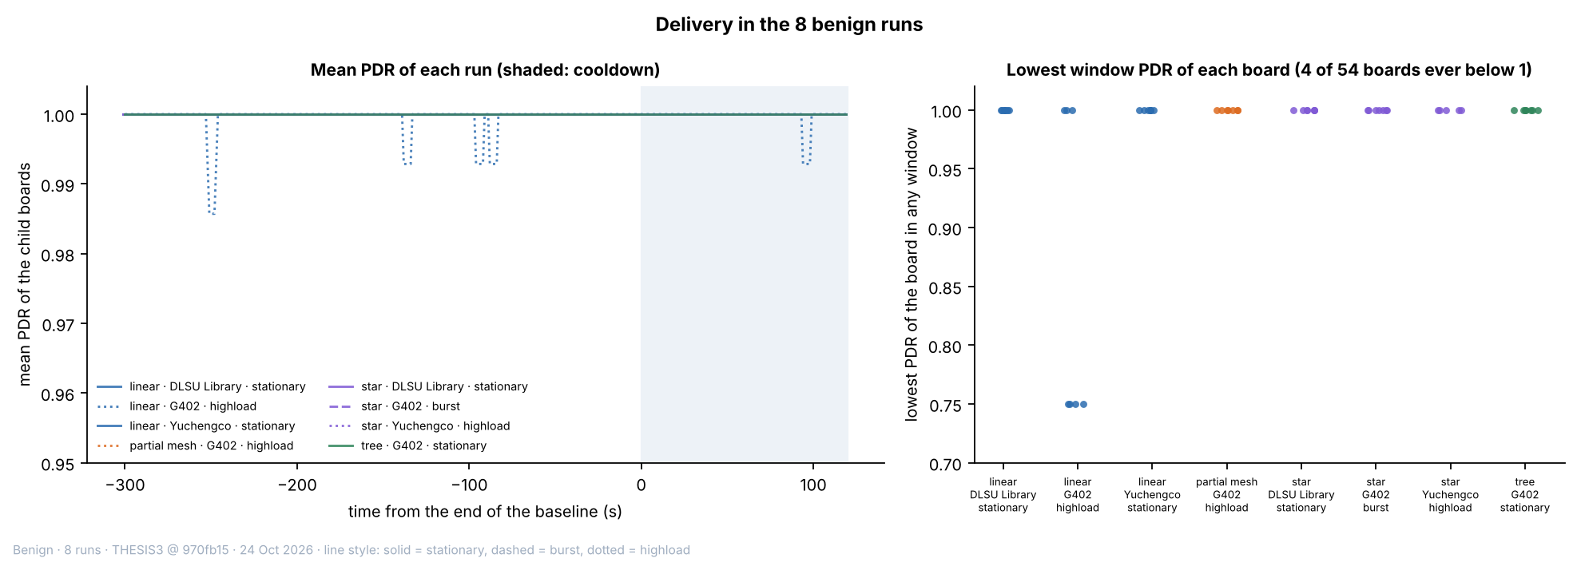

Figure 6.13 Delivery in the 8 Benign Runs over Time and the Lowest PDR of Each Board
In Figure 6.13, the left panel plots the mean PDR of the child boards of each run as a 5 s moving average against the time from the end of the baseline (0 s = end of the baseline, shaded = cooldown), and the vertical axis is cut at 0.95 to make small changes visible. The line style gives the scenario (solid = stationary, dashed = burst, dotted = highload). The only departures from 1 are short dips in the linear run at G402 with highload, to 0.986 at the lowest. In the right panel, each point is one board and its lowest PDR in any window; four of the 54 boards fall below 1, all in the linear run at G402 with highload (to 0.75), and the other 50 stay at 1.
Table 6.21 sets the benign runs against the normal windows of the attack runs, scenario by scenario. The probe rate follows the scenario and is the same in both kinds of run: about 1.0 probes per board per second in the stationary scenario, 1.1 in the burst scenario and 3.9 in the highload scenario (benign runs; 1.0, 1.0 and 3.9 in the attack runs). Delivery is close to complete everywhere. The lower mean PDR of the stationary attack runs, 0.9967 against 1.0000 in the benign runs, comes from one run: the partial-mesh blackhole run at Yuchengco, whose baseline is unstable (mean PDR 0.931 over 2,513 windows, Table 6.9); without it the mean is 0.9999 and the share of windows below 1 falls from 0.33% to 0.01%. The medians of LatencyHopRatio and the mean RSSI_mean differ by scenario and by kind of run by a few ms per hop and a few dB, which is within the spread between runs described below.
Table 6.21 Normal Windows of the Benign Runs and of the Attack Runs, by Scenario
Scenario | Runs of | Runs (count) | Windows (count) | Mean PDR | Windows with PDR below 1 (%) | Median LatencyHopRatio (ms per hop) | Mean RSSI_mean (dBm) | Probes per board per second
stationary | Benign runs | 4 | 11,739 | 1.0000 | 0.00 | 3.22 | −67.5 | 1.00
stationary | Attack runs | 24 | 55,229 | 0.9967 | 0.32 | 4.06 | −72.0 | 1.00
burst | Benign runs | 1 | 2,935 | 1.0000 | 0.00 | 5.78 | −71.7 | 1.10
burst | Attack runs | 24 | 55,096 | 0.9998 | 0.02 | 3.66 | −72.1 | 0.99
highload | Benign runs | 3 | 7,961 | 0.9998 | 0.08 | 3.94 | −69.1 | 3.87
highload | Attack runs | 24 | 54,860 | 0.9999 | 0.05 | 4.09 | −70.9 | 3.92

Legend:
- Normal windows = the baseline and the cooldown windows of the child boards; attack runs = the blackhole and the wormhole runs together (24 runs in each scenario), their windows before and after the attack phase.
- Probes per board per second = the mean number of probes that a board sent in a one-second window, successful and failed sends together, from the application counters; it gives the probe rate of the scenario (Section 4.2.2.5).
- Windows with PDR below 1 = the share of the windows in which at least one probe of the board was not delivered.
- The stationary attack runs include the partial-mesh blackhole run at Yuchengco, whose baseline is unstable (mean PDR 0.931 over 2,513 windows).
- LatencyHopRatio = the one-way delay of a probe divided by its hops (ms per hop); RSSI_mean = the mean signal strength of the link to the parent (dBm).
- Scenario is defined in Section 4.2.2.5.
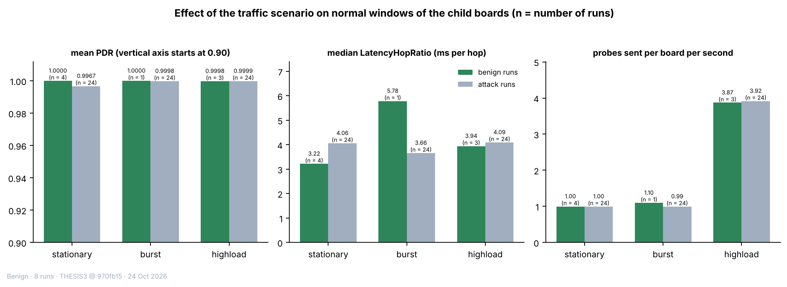

Figure 6.14 Mean PDR, Median LatencyHopRatio and Probe Rate of the Benign Runs and of the Normal Windows of the Attack Runs, by Scenario
In Figure 6.14, each group of bars is one scenario, with the benign runs in green and the normal windows of the attack runs in grey; the number of runs is printed over each bar. The left panel shows the mean PDR (the vertical axis starts at 0.90), the middle panel the median LatencyHopRatio (ms per hop) and the right panel the probes sent per board and second. The probe rate is the same in both kinds of run and about four times higher in highload; the mean PDR differs only for the stationary attack runs, because of the one run with an unstable baseline.
Table 6.22 compares the normal windows of the benign runs with those of the attack runs. The only large difference is that of the signal strength: the mean RSSI_mean is −68.6 dBm in the benign runs, against −73.8 dBm in the normal windows of the blackhole runs (d = 0.69) and −69.2 dBm in those of the wormhole runs (d = 0.07). Every other difference is below 0.1 standard deviations, except RSSI_Hop_Diff against the wormhole runs (d = 0.23). The benign runs are 8 runs in a few cells, so this difference is read together with the matched comparison that follows.
Table 6.22 Normal Windows of the Benign Runs against the Normal Windows of the Blackhole and the Wormhole Runs
Feature (unit) | Benign runs: mean | Blackhole runs, normal windows: mean | Benign against blackhole: d | Wormhole runs, normal windows: mean | Benign against wormhole: d
PDR (ratio) | 0.9999 | 0.9979 | 0.06 | 0.9999 | 0.00
RSSI_mean (dBm) | −68.57 | −73.78 | 0.69 | −69.15 | 0.07
RSSI_var (dBm²) | 0.393 | 0.343 | 0.03 | 0.413 | −0.01
RSSI_Hop_Diff (dB) | 3.50 | 3.61 | −0.02 | 2.67 | 0.23
LatencyHopRatio (ms per hop) | 11.28 | 9.45 | 0.03 | 10.33 | 0.02
RSSI_stability (s) | 0.894 | 0.895 | −0.03 | 0.894 | 0.01
HopStabilityDuration (s) | 0.9999 | 0.9998 | 0.03 | 0.9998 | 0.02
ParentSwitchRate (changes per second) | 0.00009 | 0.00000 | 0.01 | 0.00000 | 0.01

Legend:
- Normal windows = baseline and cooldown windows of the child boards. Benign runs: 22,481 windows; blackhole runs: 89,140; wormhole runs: 75,211.
- d = Cohen’s d, the benign mean minus the attack-run mean divided by the pooled standard deviation (positive = higher in the benign runs).
- n/a = d cannot be computed because the feature has one value in both groups. RetryRate and HopChangeCount are 0 in every one of these windows and are not listed.
- Features are defined in Table 6.7.
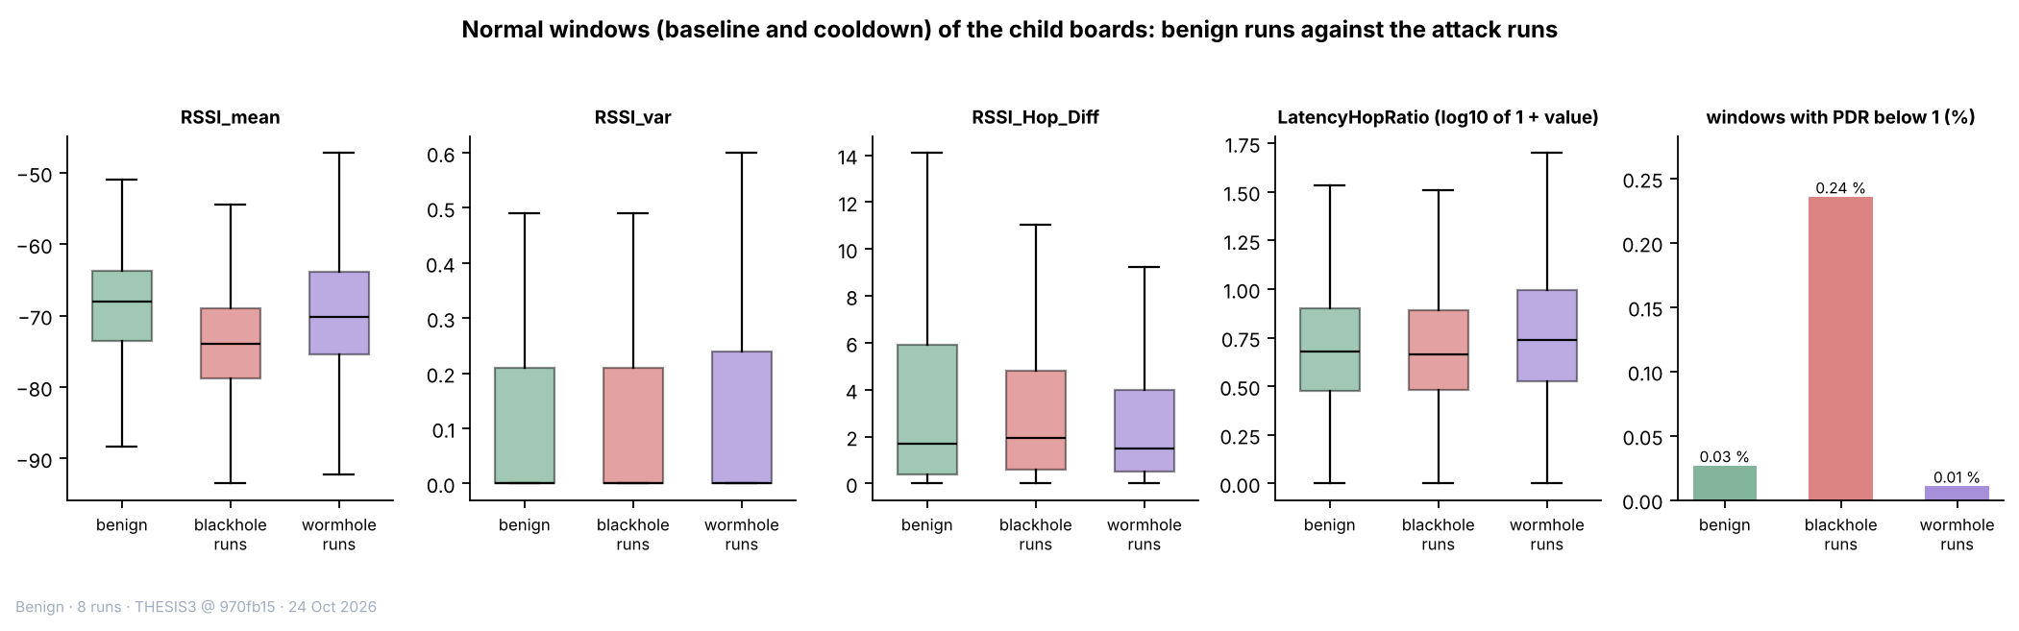

Figure 6.15 Normal Windows of the Child Boards: Benign Runs against the Blackhole and the Wormhole Runs
In Figure 6.15, the first four panels are box plots of RSSI_mean, RSSI_var, RSSI_Hop_Diff and LatencyHopRatio (logarithm of 1 plus the value) for the normal windows of the benign runs (green), the blackhole runs (red) and the wormhole runs (purple); the box spans the middle half of the windows with the median as a line, and the whiskers reach the 5th and 95th percentiles. The last panel gives the share of windows with a PDR below 1. Only the RSSI_mean boxes differ clearly, with the blackhole runs lower than the benign runs.
The benign runs share their topology, site and scenario with an attack run of the same cell, so each of them can be set against the baseline of that attack run, in which the attack has not started (Table 6.23). The baseline RSSI_mean of two captures of the same cell differs by 8.1 dB on average from the blackhole run and by 7.1 dB from the wormhole run, in both directions: the mean signed difference is +6.3 dB for the blackhole runs and −1.0 dB for the wormhole runs, and the largest absolute d is 1.97 and 3.29. The PDR differs by at most 0.0001. Each capture is a separate set-up of the boards, and the received signal strength depends on where they stand and on their surroundings, so a difference of this size between two runs is a property of the capture and not of an attack. This bears on the clustering of the non-attacker nodes, because RSSI_mean can then separate the runs by their set-up and not the attack from the normal windows (Section 6.4).
Table 6.23 Baseline of Each Benign Run against the Baseline of the Attack Run of the Same Topology, Site and Scenario
Attack run compared | Feature (unit) | Runs (count) | Mean difference (benign − attack run) | Mean absolute difference | Median d | Largest absolute d
Blackhole | PDR (ratio) | 8 | −0.0000 | 0.0001 | 0.00 | 0.03
Blackhole | RSSI_mean (dBm) | 8 | 6.34 | 8.08 | 1.29 | 1.97
Blackhole | RSSI_var (dBm²) | 8 | −0.092 | 0.359 | −0.14 | 0.51
Blackhole | RSSI_Hop_Diff (dB) | 8 | 0.59 | 0.81 | 0.12 | 0.62
Blackhole | LatencyHopRatio (ms per hop) | 8 | 0.46 | 6.82 | 0.02 | 0.23
Wormhole | PDR (ratio) | 8 | −0.0000 | 0.0001 | −0.01 | 0.07
Wormhole | RSSI_mean (dBm) | 8 | −1.00 | 7.12 | −0.61 | 3.29
Wormhole | RSSI_var (dBm²) | 8 | −0.027 | 0.285 | 0.02 | 0.35
Wormhole | RSSI_Hop_Diff (dB) | 8 | 1.79 | 1.94 | 0.65 | 1.27
Wormhole | LatencyHopRatio (ms per hop) | 8 | 0.24 | 8.03 | −0.04 | 0.30

Legend:
- Each benign run is compared with the baseline windows of the blackhole run and of the wormhole run of the same topology, site and scenario; the differences are taken between the benign mean and the attack-run baseline mean, one pair for each of the 8 runs.
- Mean difference = the average of the 8 signed differences; mean absolute difference = the average of their absolute values; d = Cohen’s d of each pair, summarised by its median and its largest absolute value.
- The attack runs are separate captures of the same cell, each with its own set-up of the boards.
- Features are defined in Table 6.7.
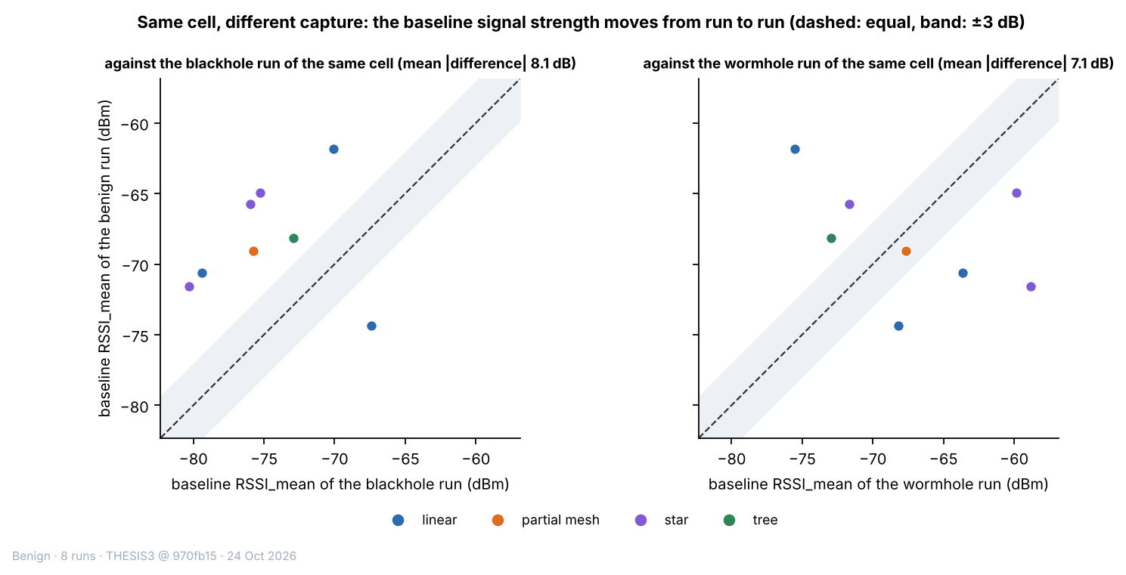

Figure 6.16 Baseline RSSI_mean of Each Benign Run against That of the Attack Run of the Same Cell
In Figure 6.16, each point is one benign run and the panels are its comparison with the blackhole run (left) and the wormhole run (right) of the same topology, site and scenario. The horizontal axis is the baseline RSSI_mean of the attack run (dBm) and the vertical axis that of the benign run; the dashed line marks equal values and the band is ±3 dB around it. The colour gives the topology. The points lie on both sides of the line and mostly outside the band, which shows a difference between captures of the same cell that goes in both directions.
The cooldown of a benign run is the stretch in which an attack would have run in the attack runs, so it is compared with the baseline of the same run. For RSSI_mean, RSSI_var and LatencyHopRatio the cooldown mean lies within 0.5 baseline standard deviations of the baseline mean in all 24 comparisons (8 runs, 3 features). The PDR can be compared in 1 run only, because in the other seven the baseline PDR never varies; there the distance is +0.06. The benign runs thus show no drift that a detector could mistake for an attack. The 8 benign runs are used again in the pooled clustering of Section 6.4.7, as a reference group of normal windows.

6.4. Clustering Results
Clustering asks whether the windows fall into groups by themselves, from the values of their features alone, and whether those groups coincide with the attack. The label is never given to the algorithms. It is used only afterwards, to score the clusters. The blackhole runs are clustered first (Sections 6.4.1 to 6.4.5). The wormhole runs follow (Section 6.4.6), and the last analysis pools the 80 runs, benign runs included, and scores the clusters against three labels: normal, blackhole and wormhole (Section 6.4.7).

6.4.1. Setup
The clustering follows the procedure of Chapter 4. A cluster is a set of windows that an algorithm puts together because their feature values are close. Five algorithms (K-Means, Ward hierarchical clustering, a Gaussian mixture model (GMM), DBSCAN and spectral clustering) are run on standardised features, with k, the number of clusters, from 2 to 8 and three seeds (42, 7 and 123). Each seed draws a new sample of 6,000 windows from the 127,372 windows of the non-attacker nodes that have every feature of the FULL set (of the 128,175 labelled windows of these nodes, 803 lack at least one feature), and restarts the algorithm. DBSCAN takes min_samples between D + 1 and 2D, where D is the number of features, and eps, the neighbourhood radius, at the knee of the k-distance graph (Figure 6.17); of the settings tried, the one with the highest silhouette score is kept. The cluster purity and the adjusted Rand index (ARI) are computed afterwards against the label (baseline and cooldown = 0, attack = 1). All results below are means over the three seeds, with k = 2 for the four methods that need k.
Table 6.24 Feature Sets Used for Clustering
Feature set | Features | Count | Purpose
FULL | PDR, ParentSwitchRate, HopChangeCount, HopStabilityDuration, RSSI_mean, RSSI_var, RSSI_stability, RSSI_Hop_Diff | 8 | All features eligible for clustering (Table 6.7); the start of both filters.
REDUCED | PDR, RSSI_mean, RSSI_var, RSSI_Hop_Diff | 4 | FULL after the low-variance and correlation filters (Section 4.2.4.6).
REDUCED without PDR | RSSI_mean, RSSI_var, RSSI_Hop_Diff | 3 | Control: REDUCED without the delivery ratio.

Legend:
- A feature set is the group of features given to the clustering algorithms.
- The names FULL, REDUCED and Without PDR are used in Table 6.25 and in the figures of this section.
- Percentages in the text are the share of the 127,372 non-attacker-node windows of the blackhole runs that hold the most common value of the feature.
- Low-variance filter = drops a feature when more than 90% of the windows have the same value; correlation filter = drops a feature when |r| > 0.85 with another kept feature; r = the correlation coefficient between two features (−1 to 1).
- PDR = packet delivery ratio, the share of a node’s probes that reached the root (ratio, 0 to 1).
- Control = a set used to test whether anything other than the delivery ratio separates the windows.
Three feature sets are compared (Table 6.24). FULL contains the 8 features that may enter the clustering of non-attacker nodes. The dataset defines 16 features, but ForwardingRatio, IngressEgressDelta, ConsistencyScore, RetryRate and the three tunnel features are kept out by the leakage guard of Section 6.2.3, and LatencyHopRatio is kept out because the fact that it is missing alone predicts the label in 86% of the windows (Section 6.2.3). REDUCED is FULL after the two filters of Section 4.2.4.6. The low-variance filter removed ParentSwitchRate (100% of the windows hold the same value), HopChangeCount (100%), HopStabilityDuration (99.8%) and RSSI_stability (98.5%). The correlation filter removed none, because the largest |r| among the four features that remain is 0.11. The third set, REDUCED without PDR, is a control that removes the delivery ratio from REDUCED, to show whether anything other than PDR separates the windows. The sets were derived on the blackhole windows by these rules and were kept for the wormhole and pooled analyses. On the pooled windows the low-variance rule would also remove PDR, because 91.5% of them have a PDR of 1, which is the case of the wormhole and benign runs (100.0% and 100.0%); PDR was kept so that the three analyses use the same features. Two populations are clustered: all non-attacker nodes, and victims only (72,687 windows). The first includes the windows of bystanders that carry the attack label (Section 6.1), and the second does not.
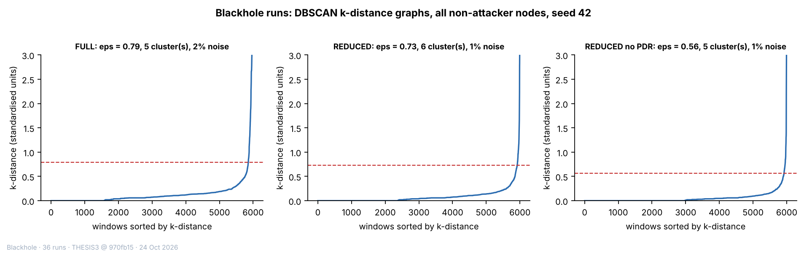

Figure 6.17 DBSCAN k-Distance Graphs for the Three Feature Sets (All Non-attacker Nodes, Seed 42)
In Figure 6.17, each curve orders the 6,000 sampled windows (horizontal axis) by their distance to the k-th nearest other window, where k is the min_samples value of the setting that was kept (vertical axis, standardised units). The dashed line is eps, the neighbourhood radius used by DBSCAN, set at the knee where the curve turns upward: 0.79 for FULL (5 clusters, 2% noise), 0.73 for REDUCED (6 clusters, 1% noise) and 0.56 for REDUCED without PDR (5 clusters, 1% noise). A window with fewer than min_samples neighbours within eps is treated as noise. The vertical axis is cut at 3 and the curves rise to 47, 35 and 33.

6.4.2. Quality and Agreement with the Label
Table 6.25 gives the quality metrics and the agreement with the label for every algorithm and feature set. A purity of 0.702 is the majority rate of the sample (0.705 for victims only), so it means no separation. The table is read in two steps: first the silhouette score and the Davies–Bouldin index, which describe the shape of the clusters, then the purity and the ARI, which describe their agreement with the label.
Table 6.25 Clustering Quality and Agreement with the Label, Means over Seeds 42, 7 and 123
Feature set | Algorithm | Silhouette (−1 to 1) | Davies–Bouldin (0 and up) | Purity, all non-attacker nodes (0 to 1) | ARI, all non-attacker nodes (−1 to 1) | Purity, victims only (0 to 1) | ARI, victims only (−1 to 1)
REDUCED | K-Means | 0.489 | 0.917 | 0.870 | 0.514 | 0.999 | 0.996
REDUCED | Ward | 0.478 | 0.887 | 0.867 | 0.503 | 0.973 | 0.891
REDUCED | GMM | 0.489 | 0.917 | 0.870 | 0.514 | 0.904 | 0.659
REDUCED | DBSCAN (5 to 9 clusters, 1.3% noise) | 0.510 | 0.447 | 0.866 | 0.485 | 0.992 | 0.940
REDUCED | Spectral | 0.157 | 0.729 | 0.702 | −0.001 | 0.707 | 0.008
FULL | K-Means | 0.773 | 0.558 | 0.757 | 0.172 | 0.705 | −0.001
FULL | Ward | 0.905 | 0.332 | 0.702 | 0.000 | 0.705 | −0.002
FULL | GMM | 0.790 | 0.409 | 0.757 | 0.173 | 0.705 | 0.002
FULL | DBSCAN (5 to 6 clusters, 2.0% noise) | 0.524 | 0.499 | 0.865 | 0.476 | 0.991 | 0.929
FULL | Spectral | 0.072 | 0.882 | 0.702 | 0.000 | 0.706 | 0.001
Without PDR | K-Means | 0.315 | 1.269 | 0.702 | 0.000 | 0.705 | 0.000
Without PDR | Ward | 0.728 | 0.687 | 0.702 | 0.000 | 0.705 | −0.001
Without PDR | GMM | 0.414 | 1.938 | 0.702 | −0.016 | 0.705 | −0.009
Without PDR | DBSCAN (5 to 7 clusters, 1.4% noise) | 0.615 | 0.333 | 0.702 | 0.000 | 0.705 | 0.001
Without PDR | Spectral | 0.165 | 0.927 | 0.702 | 0.000 | 0.705 | 0.000

Legend:
- Feature set: REDUCED = 4 features (PDR, RSSI_mean, RSSI_var, RSSI_Hop_Diff); FULL = 8 features; Without PDR = the 3 REDUCED features other than PDR (Table 6.24).
- K-Means = groups windows around k centres, each window going to the nearest centre; Ward = hierarchical clustering that merges the two clusters whose union adds the least spread; GMM = Gaussian mixture model, which assumes that the windows come from k bell-shaped groups; DBSCAN = groups windows that lie in dense regions and leaves isolated windows as noise; Spectral = groups windows using the eigenvectors of a graph of their similarities.
- k = 2 for K-Means, Ward, GMM and Spectral. DBSCAN chooses its own number of clusters: for it, the range of the number of clusters over the three seeds and the share of windows left as noise are given in brackets for all non-attacker nodes. On victims alone DBSCAN found 2 to 4 (FULL), 5 to 6 (REDUCED) and 3 to 5 clusters (Without PDR).
- Seeds 42, 7 and 123 = the three random starting values; each draws a new sample of 6,000 windows and restarts the algorithm.
- Silhouette = how well each window fits its own cluster compared with the nearest other cluster (higher is better); Davies–Bouldin = the average similarity of each cluster to its most similar cluster (lower is better).
- Purity = the share of windows that carry the majority label of their cluster; ARI (adjusted Rand index) = agreement between the clusters and the labels: 1 = exact match, 0 = no better than chance, negative = worse than chance.
- The two populations are clustered separately: all non-attacker nodes and victims only (Section 6.4.1). Silhouette and Davies–Bouldin are given for all non-attacker nodes.
With the delivery ratio among the features, clustering separates the windows in which the attack is felt. K-Means with k = 2 on the REDUCED set reaches an ARI of 0.514 on all non-attacker nodes and 0.996 on victims alone. GMM, Ward and DBSCAN agree on all non-attacker nodes (0.514, 0.503 and 0.485) and are less exact on victims alone (0.659, 0.891 and 0.940). Without the delivery ratio, no algorithm finds the attack: for every algorithm and every k from 2 to 8, on both populations, the ARI lies between −0.016 and 0.002, and the projection shows no structure (Section 6.4.5). The blackhole does not show in the signal-strength features. The ARI against k is given in Figure 6.18, the silhouette score in Figure 6.19 and the Davies–Bouldin index in Figure 6.20.
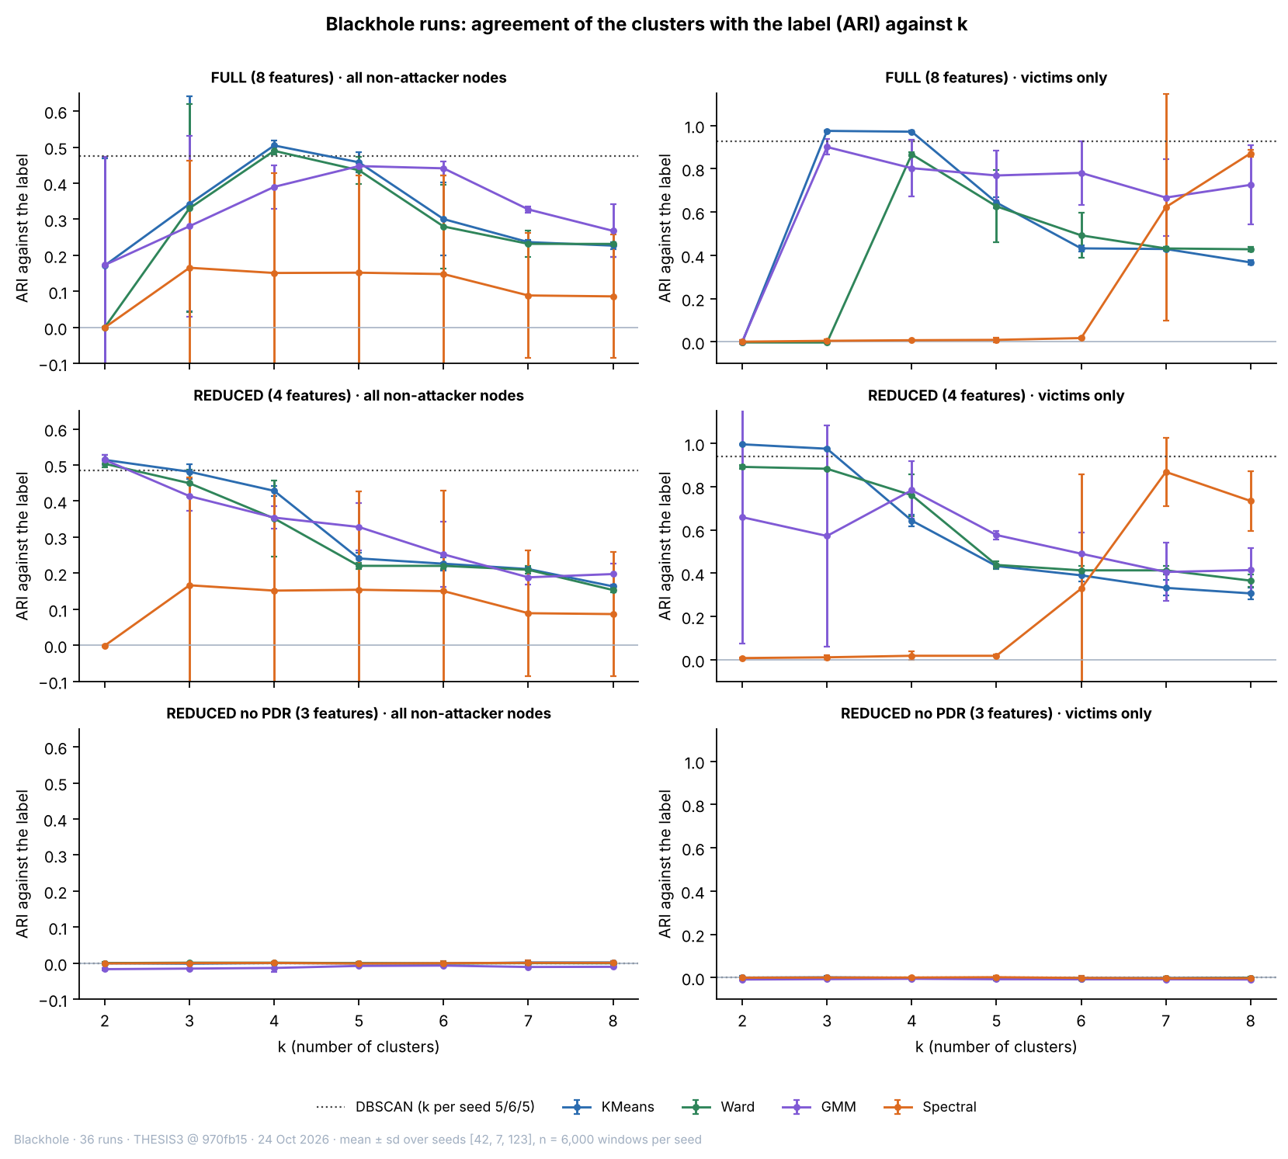

Figure 6.18 Adjusted Rand Index against the Number of Clusters, by Feature Set and Population (Mean and Spread over Three Seeds)
In Figure 6.18, the horizontal axis is k, the number of clusters, and the vertical axis is the ARI against the label (1 = the clusters match the labels exactly, 0 = no better than chance). The rows are the feature sets, the left column is all non-attacker nodes and the right column is victims only. Each coloured line is one algorithm, and its bars show ±1 standard deviation over the three seeds. The dotted line is DBSCAN, which chooses its own number of clusters. In the bottom row, all values lie between −0.016 and 0.002 and are drawn on the same scale as the rows above.
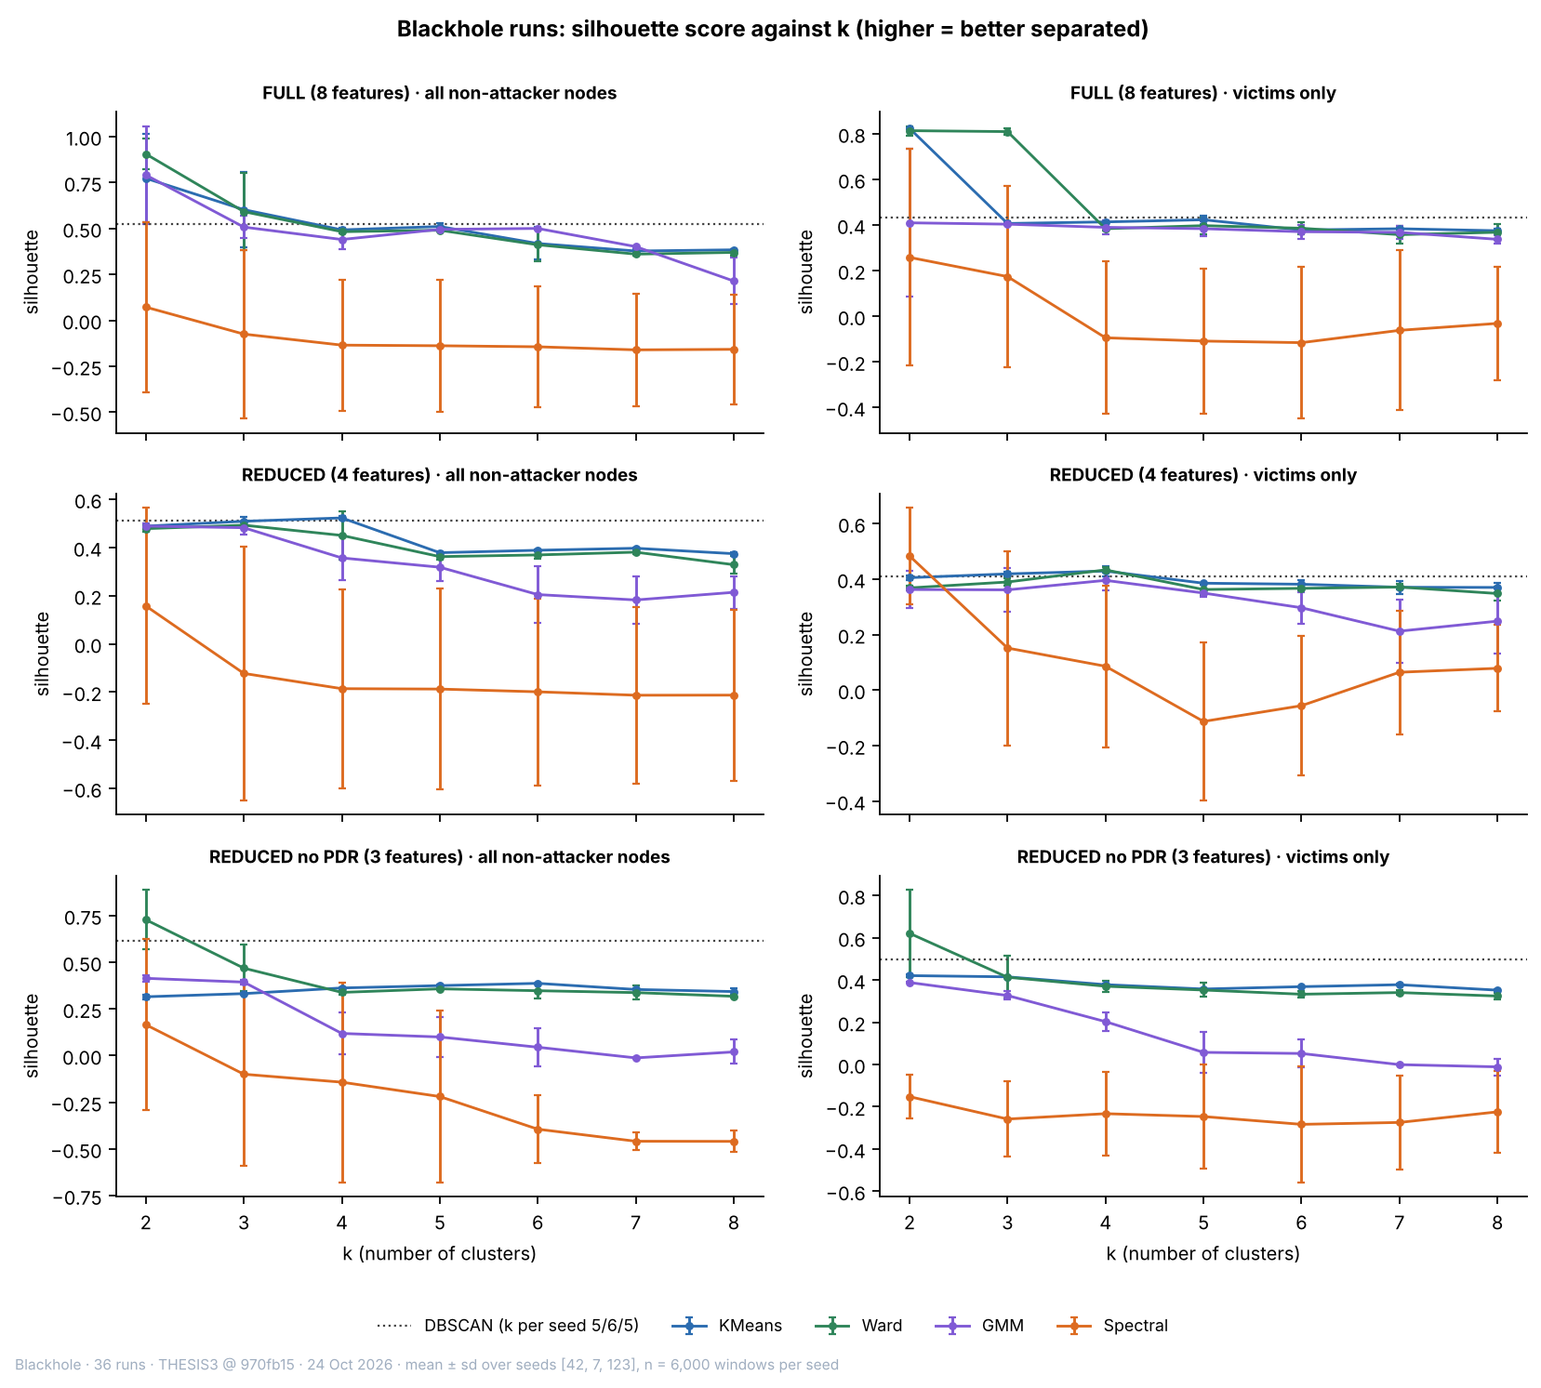

Figure 6.19 Silhouette Score against the Number of Clusters, by Feature Set and Population
Figure 6.19 has the same layout as Figure 6.18. The vertical axis is the silhouette score (−1 to 1, no unit), and a higher value means that the windows lie closer to their own cluster than to the nearest other cluster. The silhouette score describes the shape of the clusters and not their agreement with the label.
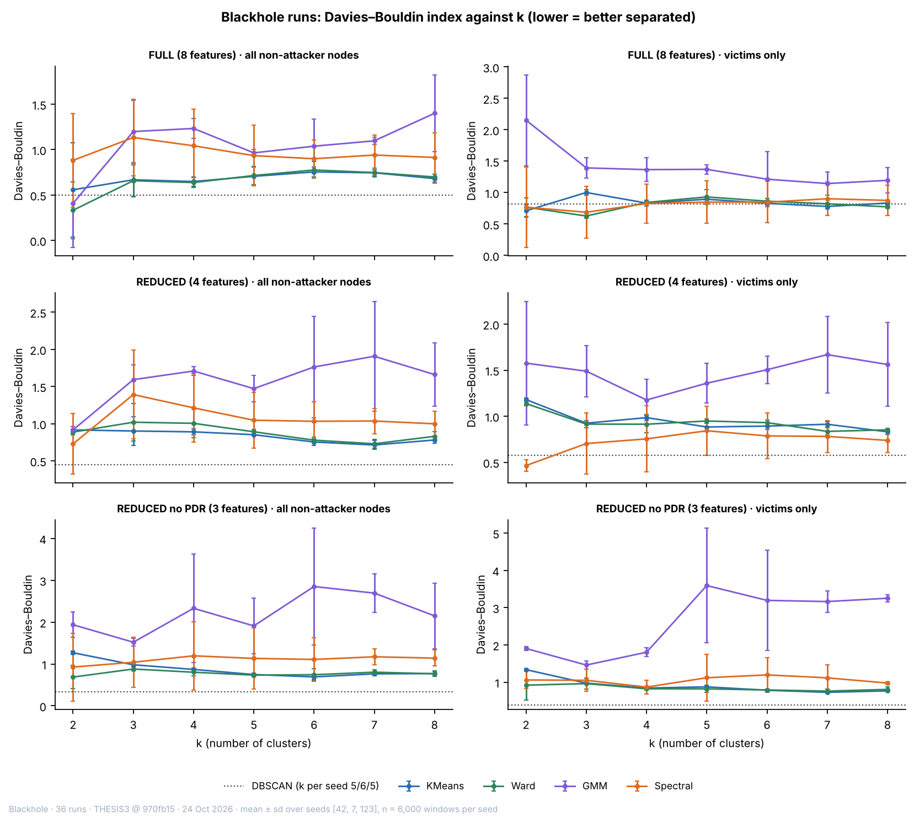

Figure 6.20 Davies–Bouldin Index against the Number of Clusters, by Feature Set and Population
Figure 6.20 has the same layout as Figure 6.18. The vertical axis is the Davies–Bouldin index (0 and above, no unit), and a lower value means that the clusters are more compact and further apart.

6.4.3. What Limits the Agreement
The ceiling on all non-attacker nodes is an ARI of 0.515, not 1. A bystander carries the attack label in the attack window but behaves like a normal node, and 43.2% of the attack-labelled non-attacker-node windows (16,499 of 38,232) come from bystanders. No method that reads only the features of a window can group them with the attack. A perfect separation of the windows in which the attack is felt scores 0.515 on all non-attacker nodes, and K-Means on the REDUCED set scores 0.514 (sd 0.014 over the seeds). On victims alone the same method scores 0.996. The victims-only figure is therefore reported next to the all-nodes figure.
The silhouette score alone picks the wrong k on the FULL set. K-Means and Ward score highest at k = 2 (0.77 and 0.90), but the split does not follow the attack. For K-Means the ARI at k = 2 is 0.515, 0.000 and 0.000 on the three seeds (mean 0.172, sd 0.298). On seed 42 the two clusters are the attack windows of the victims and the rest. On seed 7 the smaller cluster holds 44 of the 6,000 windows, with a mean RSSI_var of 8.8 against 0.22 in the rest and a low RSSI_stability, and on seed 123 it holds a single window, in which the board changed its parent (ParentSwitchRate and HopChangeCount are non-zero in that window and zero in almost all others). Ward at k = 2 gives an ARI of −0.001, 0.001 and 0.000. The attack is recovered when k reaches 4: K-Means gives 0.505 (sd 0.014) and Ward 0.490. The choice of k therefore has to use the elbow, the silhouette peaks and interpretability together, as Chapter 4 sets out, and not the silhouette alone.
GMM is stable on the REDUCED set at k = 2 on all non-attacker nodes (ARI 0.520, 0.524 and 0.498 on the three seeds), but on victims alone its mean ARI is 0.659 with a standard deviation of 0.58 over the seeds, and on the FULL set it behaves like K-Means (0.520, −0.001 and 0.000). Spectral clustering finds nothing at k = 2 on any feature set (the largest absolute ARI is 0.008). For k = 3 to 6 on the FULL and REDUCED sets its mean ARI on all non-attacker nodes lies between 0.148 and 0.167, with a standard deviation of 0.27 to 0.30 over the seeds, which means that it finds the attack on one seed and not on the others; on victims alone it reaches 0.871 at k = 8 on the FULL set. It is therefore reported and not relied on. DBSCAN, which is given no k, agrees with K-Means: on the REDUCED set it finds 5 to 9 clusters (purity 0.866, ARI 0.485) and leaves 1.3% of the windows as noise.
Figure 6.21 shows what each K-Means cluster contains at k = 3. With the delivery ratio among the features, one cluster (1,008 windows in the FULL set and 1,000 in the REDUCED set) is almost entirely attack windows of the victims (99.4% and 99.4% of its windows are in the attack phase). A second cluster holds the rest. On the FULL set the third cluster has 12 windows and an extreme RSSI variance (a mean of 27.2), and on the REDUCED set it has 303 windows with a mean RSSI_Hop_Diff of 20.0 dB, so a small cluster of extreme windows appears in both. Without the delivery ratio, every cluster of 100 windows or more is a mixture of the four kinds of window, and the attack-phase share lies between 28% and 31% in them, against 29% in the sample. Table 6.26 gives the profile of the two K-Means clusters at k = 2 on the REDUCED set.
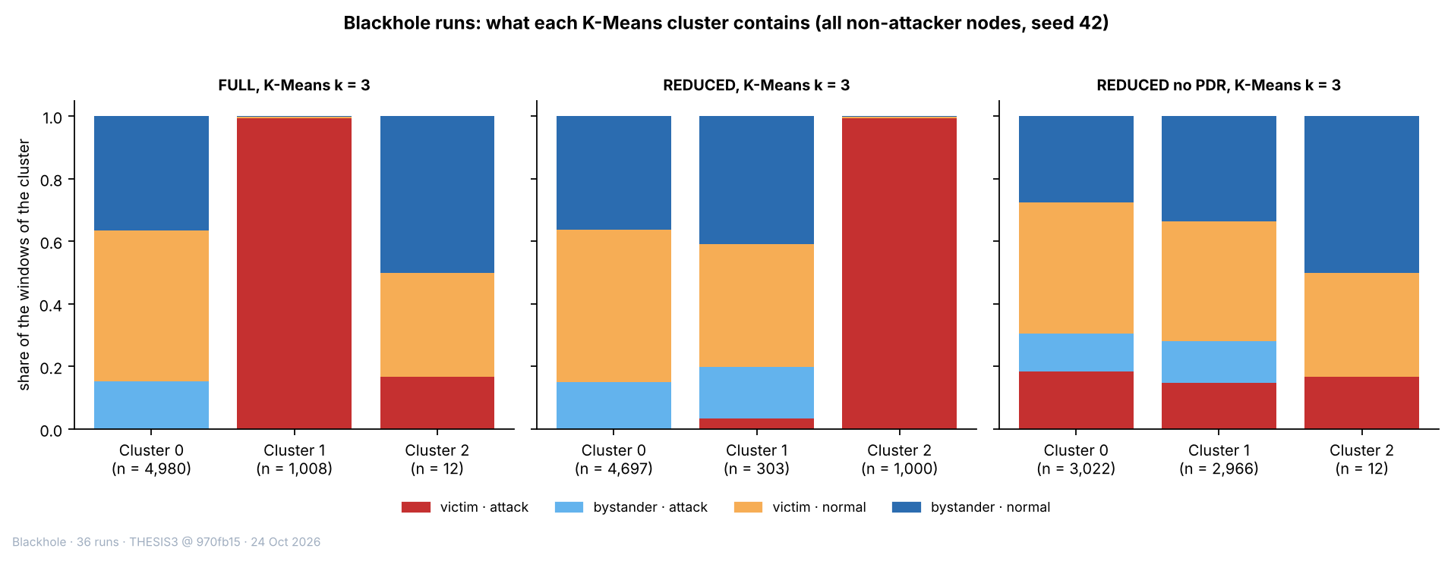

Figure 6.21 Composition of Each K-Means Cluster at k = 3, by Feature Set (All Non-attacker Nodes, Seed 42)
In Figure 6.21, each bar is one cluster, with the number of windows in it (n) under its name, and its height is split into the share of four kinds of window. Red = victim windows in the attack phase, light blue = bystander windows in the attack phase, orange = victim normal windows and dark blue = bystander normal windows. Normal means baseline or cooldown. A bar that is entirely red holds only attack windows of victims. With PDR (left and centre), one cluster is entirely red; without PDR (right), no cluster is.
Table 6.26 K-Means Clusters at k = 2 on the REDUCED Set (All Non-attacker Nodes, Seed 42)
Measure (unit) | Cluster A (no delivery loss) | Cluster B (delivery lost)
Windows (count) | 4,990 | 1,010
Attack-phase windows (%) | 15.2 | 99.4
Baseline windows (%) | 59.5 | 0.6
Cooldown windows (%) | 25.4 | 0.0
Windows from victims (%) | 48.2 | 99.7
Mean PDR (ratio) | 1.000 | 0.000
Mean RSSI_mean (dBm) | −73.6 | −74.9
Mean RSSI_var (dBm²) | 0.315 | 0.322
Mean RSSI_Hop_Diff (dB) | 3.65 | 3.33

Legend:
- The percentages are shares of the windows in the cluster. The three phase rows (attack, baseline and cooldown) add up to 100% in each cluster.
- Cluster A is the cluster with a mean PDR of 1 and Cluster B the cluster with a mean PDR of 0; the cluster numbers given by the algorithm carry no meaning.
- Mean values are the mean of each feature over the windows of the cluster. Windows from victims = the share of the windows of the cluster that come from victim boards.
- K-Means = groups windows around k centres; k = 2 is the number of clusters; REDUCED = the feature set of Table 6.24; seed 42 = the random starting value that fixes the sample of 6,000 windows and the start of the algorithm.
- PDR = packet delivery ratio (ratio, 0 to 1); RSSI = received signal strength indicator; dBm = decibel-milliwatts; dB = decibels.
Cluster B holds 17% of the windows of the sample and is 99.4% attack-phase windows with a mean PDR of 0.000, and Cluster A, with a mean PDR of 1.000, holds the baseline and cooldown windows and the attack windows of the bystanders (15.2% of its windows are attack-phase windows). The other three features differ little between the two clusters.

6.4.4. Robustness across Sites, Topologies and Labelling
The result holds in every subgroup (Table 6.27). K-Means with k = 2 on the REDUCED set stays within 0.03 of the best possible ARI inside each site and each topology, and without the delivery ratio it stays at 0 inside each of them (between −0.006 and 0.002). The best possible figure is the ARI of one particular partition, so a method can edge past it, as it does in the linear topology. In the star the ARI is 0.999, because the star has no bystanders. Dropping the cooldown windows from the normal label keeps the same pattern: with the delivery ratio, K-Means purity is 0.836 against a majority rate of 0.628, and without it purity equals the majority rate (0.628).
Table 6.27 K-Means (k = 2) ARI inside Each Site and Topology, All Non-attacker Nodes
Subgroup | Best possible ARI (−1 to 1) | REDUCED: K-Means ARI (−1 to 1) | REDUCED without PDR: K-Means ARI (−1 to 1)
Site G402 | 0.531 | 0.516 | 0.002
Site DLSU Library | 0.572 | 0.574 | 0.002
Site Yuchengco | 0.445 | 0.420 | −0.006
Linear | 0.560 | 0.565 | −0.001
Partial mesh | 0.286 | 0.277 | −0.001
Star | 1.000 | 0.999 | −0.003
Tree | 0.279 | 0.278 | 0.000

Legend:
- ARI = adjusted Rand index, the agreement between the clusters and the labels (1 = exact match, 0 = no better than chance).
- Best possible ARI = the ARI of the partition that puts exactly the windows in which the attack is felt (victim windows in the attack phase) in one group and every other window in the other; it is the agreement that a method reading only the features of a window would reach if it found exactly those windows, and it is below 1 where there are bystanders, which carry the attack label but behave as normal nodes. Because it is the ARI of one particular partition, a method can edge past it.
- REDUCED and REDUCED without PDR are the feature sets of Table 6.24. K-Means (k = 2) = groups windows around two centres, each window going to the nearest.
- Each row clusters only the windows of that site or topology (mean over seeds 42, 7 and 123). Site = where the runs were made; topology = the shape in which the boards are linked to the root.
The seed spread of Section 6.4.2 measures only how much the result moves when the sample of 6,000 windows and the starting points of the algorithm change. It does not measure how much it moves from run to run, and the 127,372 windows come from only 36 runs. A run-level check was therefore added. One K-Means model (k = 2, REDUCED set, seed 42) was fitted on a sample of 6,000 windows and applied to every window of the non-attacker nodes. Its ARI over all windows is 0.511. Resampling the 36 runs with replacement (300 times) gives a 95% interval of 0.41 to 0.63, which is much wider than the seed spread (sd 0.014) and still far from 0. Inside each run, the model comes within 0.05 of the best possible ARI of that run in 35 of the 36 runs. The exception is partial mesh at Yuchengco with stationary traffic (ARI 0.066 against a best possible 0.139), the run whose baseline delivery ratio is unstable (Section 6.2.1). Without the delivery ratio, the same check gives an ARI of 0.000 (95% interval −0.001 to 0.002) over all windows, and between −0.06 and 0.04 in the single runs; no run comes within 0.05 of its best possible value.

6.4.5. Projections
Figure 6.22 projects the standardised FULL features of a sample of 6,000 non-attacker-node windows to two dimensions with PCA and t-SNE, so that each window becomes a point on a plane. In the PCA, the first component is dominated by a few windows of extreme RSSI variance, so most points lie in a narrow column, and the attack windows of the victims lie along its lower part together with some normal windows. In the t-SNE, the attack windows of the victims form their own group at the bottom of the plot, and the attack windows of the bystanders lie among the normal windows. Figure 6.23 repeats the projection after the delivery ratio is removed: the four kinds of window overlap and no structure is visible. The axes of t-SNE have no units, and only nearness is read from them.
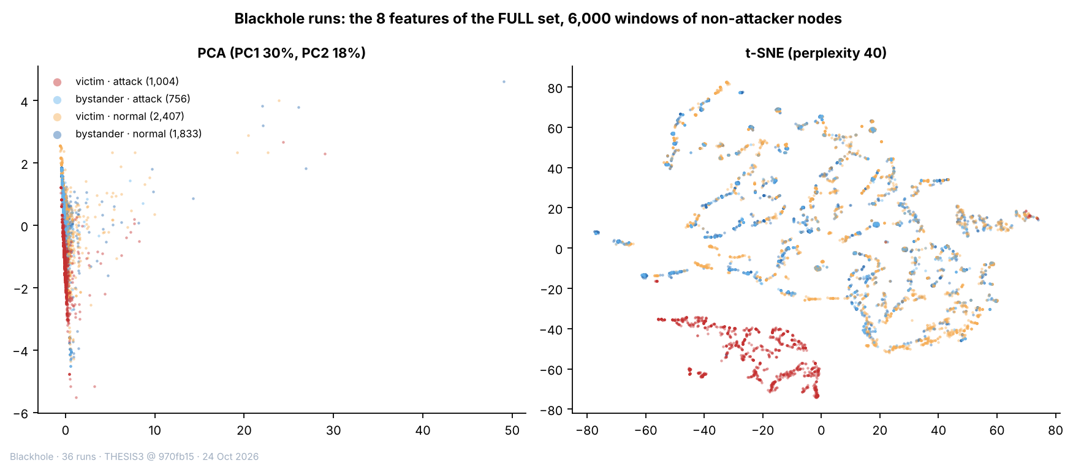

Figure 6.22 PCA and t-SNE Projections of the FULL Feature Set (Blackhole Runs)
In Figure 6.22, each point is one window (a sample of 6,000), coloured by its kind (red = victim attack-phase, orange = victim normal, light blue = bystander attack-phase, dark blue = bystander normal). The eight features of a window are reduced to two numbers so that the window can be drawn on a plane. PCA (left) uses the two directions that hold the most variance: PC1 holds 30% of the variance and PC2 holds 18% (the axes are in standardised feature units). t-SNE (right) places windows with similar features close together; its axes have no unit, and only the distance between points means anything. “Group” here means points that lie close together in the picture. A cluster, by contrast, is the result of an algorithm (Section 6.4.1).
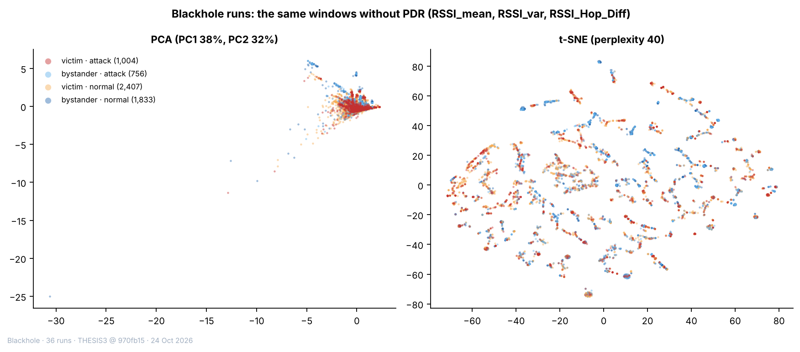

Figure 6.23 PCA and t-SNE Projections with the Delivery Ratio Removed (Blackhole Runs)
Figure 6.23 is built in the same way as Figure 6.22, but only RSSI_mean, RSSI_var and RSSI_Hop_Diff are used. In the PCA, PC1 holds 38% of the variance and PC2 holds 32%. The colours are the same as in the previous figure. The four colours lie on top of one another in both pictures, which means that these three features do not separate the attack windows.

6.4.6. Wormhole Runs
The wormhole runs were clustered with the same procedure, three seeds, k from 2 to 8 and the same five algorithms. The label is attack (the phases of the tunnel) against normal. Three populations are clustered. The first is the five non-attacker boards of each run (107,405 windows), with the three feature sets of Table 6.24; they are not touched by the wormhole, which acts only on the probes of the entry end B, so no agreement with the label is expected. The second and third are the exit end A and the entry end B, clustered on the three signal-strength features (RSSI_mean, RSSI_var and RSSI_Hop_Diff), and the entry end B also with LatencyHopRatio. As a diagnostic, each end was also clustered with TunnelIntensity, the number of tunnelled messages per second, which the leakage guard keeps out of the model inputs (Section 6.2.3). It shows whether the data contain a tunnel signal that a clustering algorithm can find at all. The wormhole windows are 30% of the windows of each end (the majority rate of the normal label is 0.697 on the end B and 0.700 on the end A).
Table 6.28 Agreement of the Clusters with the Attack Label in the Wormhole Runs (ARI, Means over Seeds 42, 7 and 123)
Population and feature set | K-Means k = 2 | K-Means k = 3 | Ward k = 2 | GMM k = 2 | Spectral k = 2 | DBSCAN (own k)
Non-attacker boards, FULL | −0.005 | −0.003 | −0.004 | −0.006 | 0.000 | −0.005 (2 to 3 clusters)
Non-attacker boards, REDUCED | −0.001 | 0.001 | −0.001 | −0.008 | −0.001 | −0.005 (2 to 3 clusters)
Non-attacker boards, without PDR | 0.000 | −0.001 | −0.004 | −0.008 | −0.001 | −0.005 (4 to 5 clusters)
Exit end A, cross-layer | −0.001 | −0.002 | −0.001 | −0.008 | −0.003 | −0.002 (2 to 6 clusters)
Exit end A, cross-layer + TunnelIntensity | −0.003 | 0.207 | 0.087 | 0.080 | −0.007 | 0.300 (2 to 13 clusters)
Entry end B, cross-layer | 0.000 | −0.001 | 0.000 | −0.006 | 0.003 | −0.003 (5 to 8 clusters)
Entry end B, cross-layer + LatencyHopRatio | 0.000 | 0.001 | 0.000 | 0.009 | 0.000 | −0.004 (3 clusters)
Entry end B, cross-layer + TunnelIntensity | 0.000 | 0.141 | 0.010 | 0.161 | −0.003 | 0.827 (9 to 12 clusters)

Legend:
- ARI = adjusted Rand index, the agreement between the clusters and the labels (1 = exact match, 0 = no better than chance, negative = worse than chance). The label is attack against normal.
- Non-attacker boards = the five boards of each run that are neither end of the tunnel; exit end A = the shallower end of the tunnel, where the tunnelled probes are re-injected; entry end B = the deeper end, which tunnels its own probes. Sets for the non-attacker boards are those of Table 6.24.
- Cross-layer = RSSI_mean, RSSI_var and RSSI_Hop_Diff; TunnelIntensity = tunnelled messages per second (a diagnostic that the leakage guard keeps out of the model inputs); LatencyHopRatio = the latency per hop of the probes of the node.
- DBSCAN chooses its own number of clusters; the range over the three seeds is given in brackets. K-Means = groups windows around k centres; Ward = hierarchical clustering; GMM = Gaussian mixture model; Spectral = clustering on the eigenvectors of a similarity graph.
- Majority rate of the normal label: 0.700 (non-attacker boards), 0.700 (exit end A), 0.697 (entry end B).
Without a tunnel feature, no algorithm finds the wormhole. On the non-attacker boards the ARI lies between −0.012 and 0.003 for all algorithms, feature sets and values of k from 2 to 8, and the purity equals the majority rate. On the two ends, with the cross-layer features alone (and with LatencyHopRatio on the end B), it lies between −0.012 and 0.009. The run-level check gives the same result for the K-Means model (k = 2, REDUCED set) over all windows of the non-attacker boards: an ARI of −0.001 with a 95% interval of −0.008 to 0.009, and between −0.04 and 0.09 in the single runs. This agrees with Table 3.5: the wormhole leaves the other boards as they are, and what the two ends show, the duplicate arrivals of the tunnelled probes, is not one of the features of the cross-layer set.
With TunnelIntensity the picture depends on the algorithm. The feature is exactly 0 in every normal window of the entry end B (and in all but 1 of the 15,092 normal windows of the exit end A) and above 0 in 98.9% of the wormhole windows of the entry end B (99.4% on the exit end A), with a median of 1 message per second in the stationary and burst runs and 4 in the highload runs. A single threshold on it would therefore separate the labels, which is why it is a tunnel feature and is excluded from the model inputs. A clustering algorithm does not use it so directly. On the entry end B, K-Means with k = 2 splits the windows by signal level, which varies between runs (Table 6.29: mean RSSI_mean of −67.6 and −47.1 dBm), and TunnelIntensity does not enter the split (0.56 and 0.64 message per second in the two clusters); its ARI is 0.000. At k = 3 it forms a third cluster of 540 windows that are all wormhole windows with a mean TunnelIntensity of 4.04, the level of the highload runs, and the ARI rises to 0.141. GMM gives 0.161 at k = 2, and DBSCAN finds 9 to 12 clusters, nearly all of them pure in the label, with a purity of 0.991, an ARI of 0.827 and 1.4% noise. On the exit end A, DBSCAN reaches 0.300, K-Means at k = 3 0.207 and GMM at k = 8 0.459 (with a large spread over the seeds). K-Means at k = 2 therefore does not find the tunnel even when a tunnel feature is given; DBSCAN finds it, and K-Means finds its highload part from k = 3. Figure 6.24 gives the ARI against k for all populations and Figure 6.25 the projections.
Table 6.29 K-Means Clusters of the Entry End B with TunnelIntensity (Seed 42)
k | Cluster | Windows (count) | Wormhole windows (%) | Mean RSSI_mean (dBm) | Mean RSSI_Hop_Diff (dB) | Mean TunnelIntensity (messages per second)
k = 2 | Cluster 0 | 4,523 | 30.4 | −67.6 | 1.7 | 0.56
k = 2 | Cluster 1 | 1,477 | 32.1 | −47.1 | 17.3 | 0.64
k = 3 | Cluster 0 | 4,139 | 24.0 | −67.7 | 1.7 | 0.24
k = 3 | Cluster 1 | 1,321 | 24.1 | −47.5 | 17.3 | 0.24
k = 3 | Cluster 2 | 540 | 100.0 | −60.1 | 6.0 | 4.04

Legend:
- Entry end B = the deeper end of the tunnel, which tunnels its own probes; features = RSSI_mean, RSSI_var, RSSI_Hop_Diff and TunnelIntensity, standardised.
- Wormhole windows = the share of the windows of the cluster that lie in the attack phase; the rest are baseline and cooldown windows.
- Cluster numbers are the labels given by the algorithm and carry no meaning. Seed 42 = the random starting value that fixes the sample of 6,000 windows.
- RSSI = received signal strength indicator; dBm = decibel-milliwatts; dB = decibels. TunnelIntensity = tunnelled messages per second (a diagnostic that the leakage guard keeps out of the model inputs).
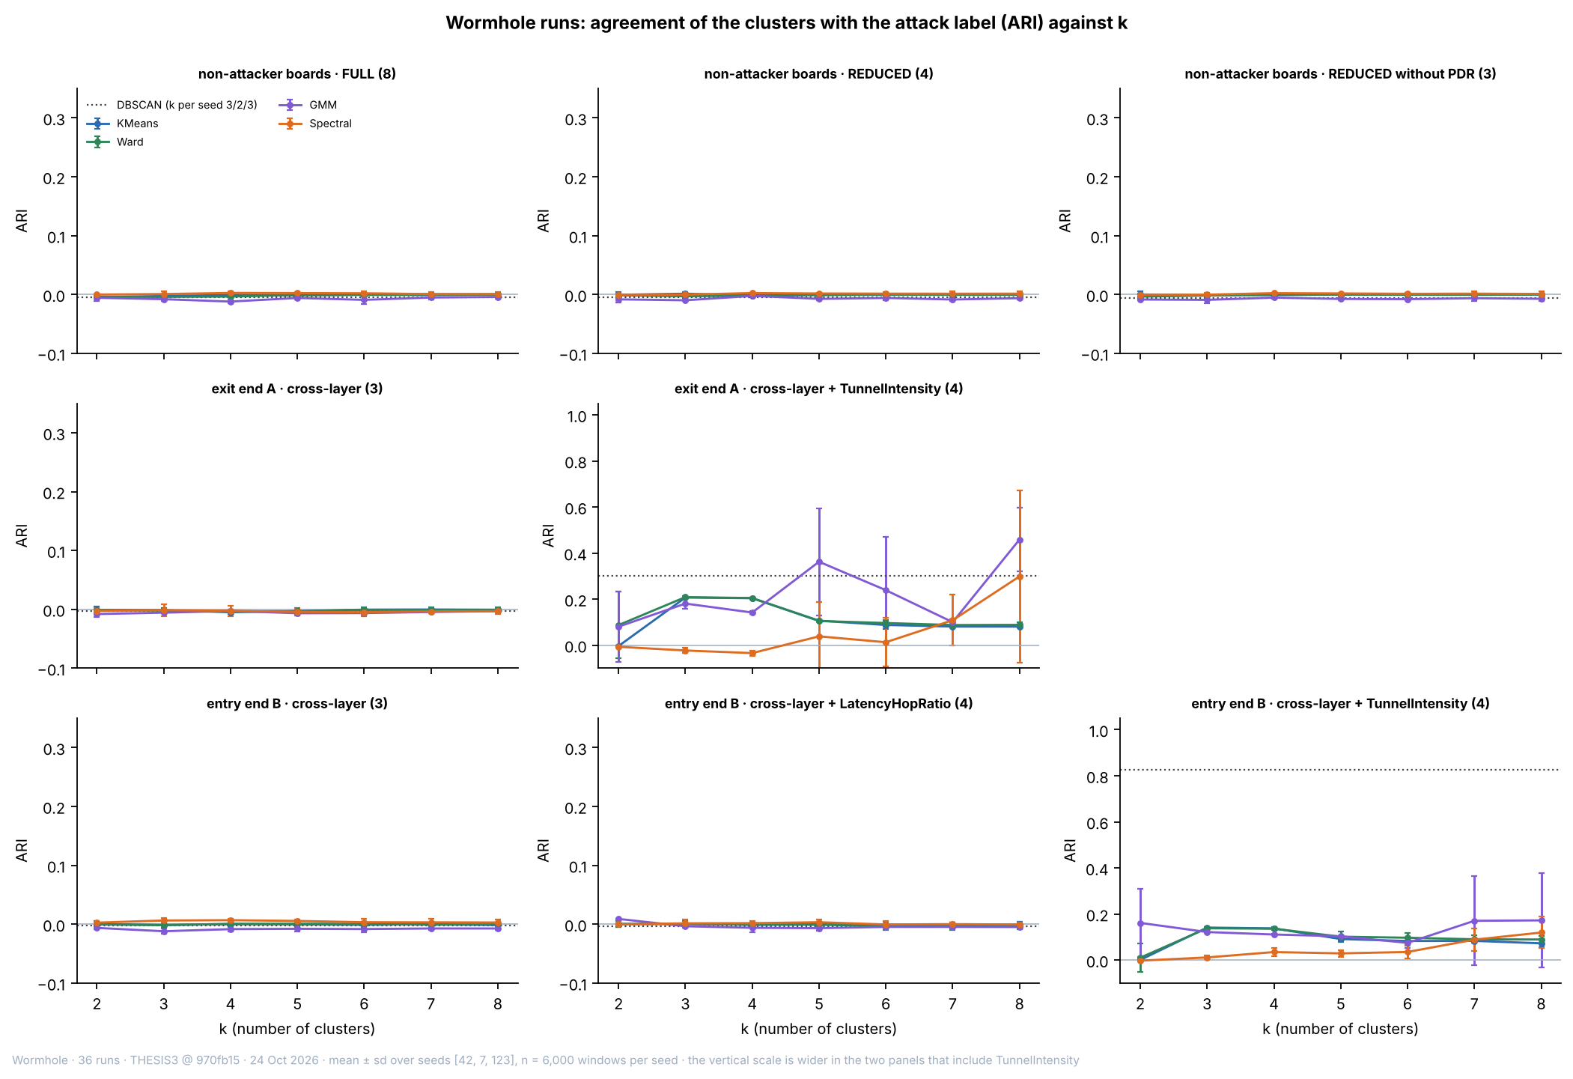

Figure 6.24 Adjusted Rand Index against the Number of Clusters in the Wormhole Runs (Mean and Spread over Three Seeds)
In Figure 6.24, each panel is one population and feature set, with the number of features in brackets. The top row is the non-attacker boards (FULL, REDUCED and without PDR), the middle row the exit end A (cross-layer, and with TunnelIntensity) and the bottom row the entry end B (cross-layer, with LatencyHopRatio, and with TunnelIntensity). The horizontal axis is k and the vertical axis the ARI against the attack label; each line is one algorithm with bars of ±1 standard deviation over the three seeds, and the dotted line is DBSCAN. The vertical scale is wider in the two panels that include TunnelIntensity, so that the DBSCAN value of the entry end B (about 0.83) can be drawn.
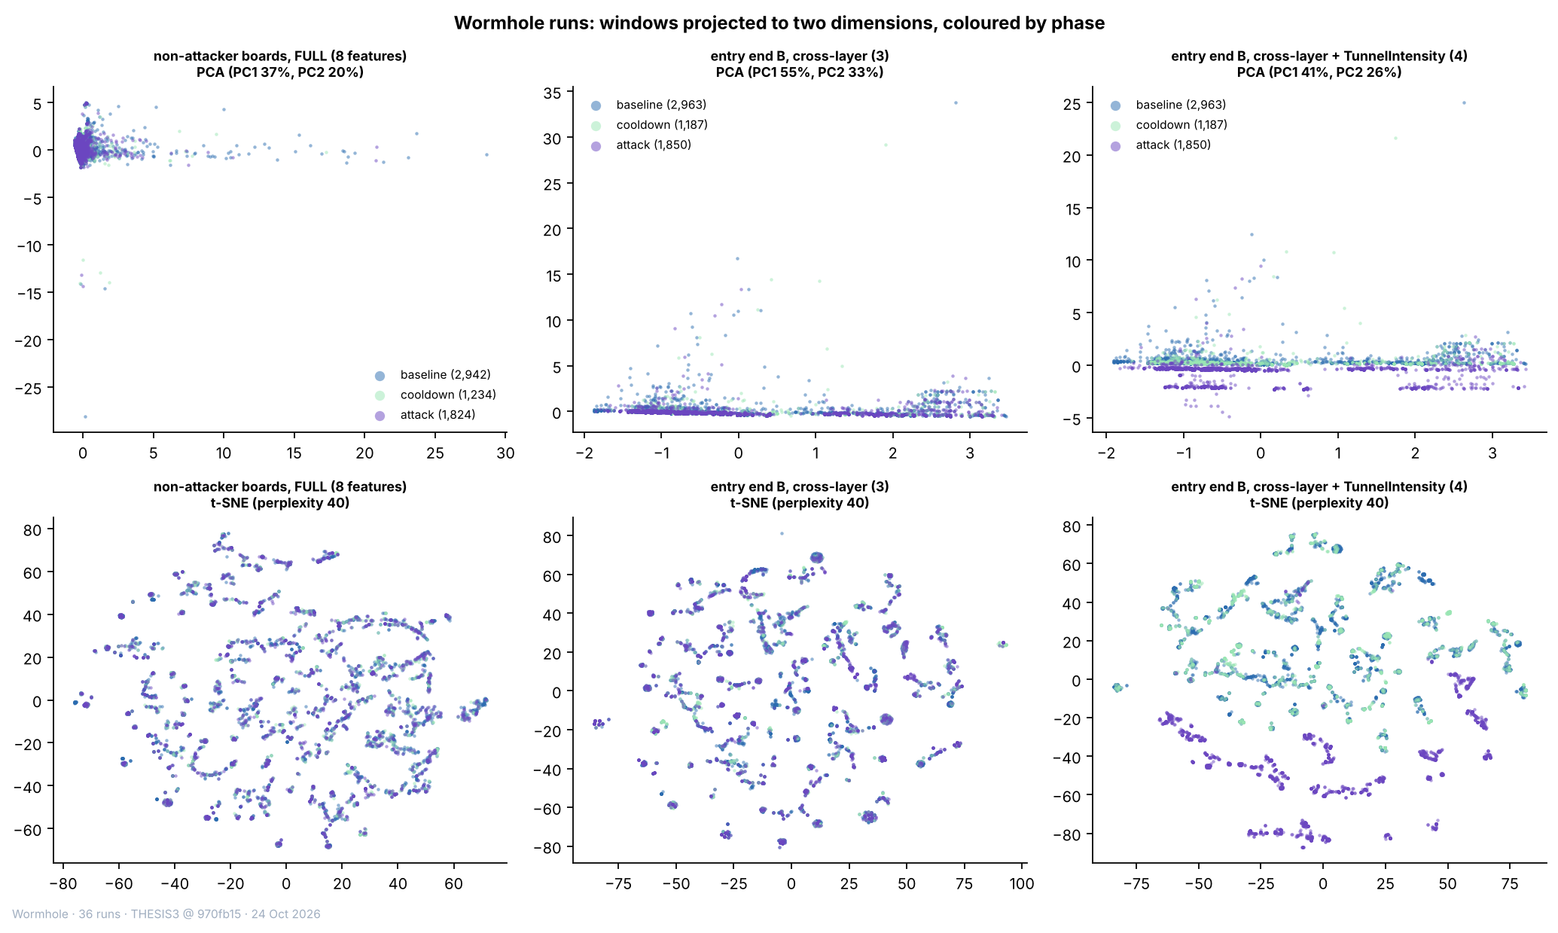

Figure 6.25 PCA and t-SNE Projections of the Wormhole Runs, Coloured by Phase
In Figure 6.25, each point is one window (a sample of 6,000), coloured by phase: blue = baseline, light green = cooldown and purple = attack. The top row is PCA and the bottom row t-SNE, for the non-attacker boards with the FULL set (left), the entry end B with the cross-layer features (centre) and the entry end B with TunnelIntensity added (right). The phases overlap in the first two columns. In the third, the attack windows form separate groups in the t-SNE and a separate band in the PCA, because TunnelIntensity is 0 in the normal windows.

6.4.7. Pooled Runs with Three Labels, with and without the Benign Runs
The last analysis pools the non-attacker boards of all 80 runs (257,258 windows with every feature of the FULL set) and asks whether three kinds of window separate: normal (label 0), blackhole attack (label 1) and wormhole attack (label 2). The same feature sets are used, with PDR kept although the low-variance rule would remove it on the pooled windows (Section 6.4.1). Table 6.30 gives the groups. The analysis is run twice: on the 80 runs, to see whether the benign runs change the result, and on the 72 attack runs. The majority rate of the samples is 0.730 with the benign runs and 0.694 without them. A partition that puts exactly the victim attack windows in one group and everything else in the other is the best that a method reading only the features of a window can reach, because the bystanders of the blackhole and the other boards of the wormhole behave as normal nodes. Its ARI against the three labels is 0.334 with the benign runs and 0.317 without them.
Table 6.30 Groups of Windows in the Pooled Clustering of the 80 Runs
Group of windows | Label | Windows (count) | Share of the windows (%)
normal · benign run | 0 (normal) | 22,481 | 8.7
normal · blackhole run | 0 (normal) | 89,140 | 34.7
normal · wormhole run | 0 (normal) | 75,211 | 29.2
blackhole attack · victim | 1 (blackhole) | 21,733 | 8.4
blackhole attack · bystander | 1 (blackhole) | 16,499 | 6.4
wormhole attack · other board | 2 (wormhole) | 32,194 | 12.5

Legend:
- Group = the kind of run (benign, blackhole, wormhole), the phase (normal = baseline or cooldown; attack) and, for the attack phase, the board: victim = a non-attacker node behind the blackhole attacker; bystander = a non-attacker node of a blackhole run that is not behind it; other board = a board of a wormhole run that is neither end of the tunnel.
- Only the non-attacker boards are pooled; the blackhole attacker and the two wormhole ends are not included. The windows are those that have every feature of the FULL set.
- Label 0 = normal (186,832 windows), 1 = blackhole attack (38,232) and 2 = wormhole attack (32,194).
Table 6.31 gives the quality and the agreement with the three labels for k = 3, the number of labels, and for DBSCAN with its own k. With the delivery ratio, the agreement is close to the best possible value and no more. K-Means with k = 2 on the REDUCED set reaches an ARI of 0.333 on the 80 runs and 0.315 on the 72 attack runs, which equals the best possible value (0.334 and 0.317): it finds the victim attack windows and nothing else. At k = 3 the ARI is 0.272 and 0.173 for K-Means, because the third cluster is a small set of windows with extreme RSSI variance, and 0.320 for Ward on the 80 runs; DBSCAN reaches 0.312 and 0.305. On the FULL set, K-Means with k = 2 again isolates a few extreme windows (ARI −0.004) and recovers the victims at k = 3 (0.325). Without the delivery ratio, no algorithm and no k separates anything: the ARI lies between −0.023 and 0.005 with and without the benign runs. The benign runs do not change the conclusion: the ARI differs by 0.017 between the two populations for K-Means at k = 2.
Table 6.31 Clustering Quality and Agreement with the Three Labels in the Pooled Runs, Means over Seeds 42, 7 and 123 (k = 3)
Feature set | Algorithm | Silhouette, 80 runs (−1 to 1) | Purity, 80 runs (0 to 1) | ARI, 80 runs (−1 to 1) | Purity, 72 attack runs (0 to 1) | ARI, 72 attack runs (−1 to 1)
REDUCED | K-Means | 0.511 | 0.812 | 0.272 | 0.787 | 0.173
REDUCED | Ward | 0.595 | 0.811 | 0.320 | 0.785 | 0.269
REDUCED | GMM | 0.405 | 0.812 | 0.225 | 0.778 | 0.235
REDUCED | DBSCAN (5 to 6 clusters, 1.6% noise) | 0.597 | 0.809 | 0.312 | 0.783 | 0.305
REDUCED | Spectral | −0.176 | 0.759 | 0.115 | 0.756 | 0.171
FULL | K-Means | 0.588 | 0.811 | 0.325 | 0.786 | 0.307
FULL | Ward | 0.598 | 0.810 | 0.317 | 0.784 | 0.301
FULL | GMM | 0.576 | 0.784 | 0.203 | 0.742 | 0.166
FULL | DBSCAN (2 to 5 clusters, 2.1% noise) | 0.536 | 0.809 | 0.303 | 0.784 | 0.296
FULL | Spectral | −0.036 | 0.759 | 0.062 | 0.785 | 0.271
Without PDR | K-Means | 0.340 | 0.730 | −0.001 | 0.694 | 0.004
Without PDR | Ward | 0.424 | 0.730 | −0.003 | 0.694 | 0.002
Without PDR | GMM | 0.312 | 0.730 | −0.019 | 0.694 | −0.007
Without PDR | DBSCAN (4 to 5 clusters, 1.4% noise) | 0.663 | 0.730 | −0.007 | 0.695 | 0.003
Without PDR | Spectral | −0.285 | 0.730 | −0.002 | 0.694 | 0.001

Legend:
- 80 runs = the 36 blackhole, 36 wormhole and 8 benign runs; 72 attack runs = the blackhole and wormhole runs without the benign runs. The windows are those of the non-attacker boards (Table 6.30).
- Feature sets are those of Table 6.24. k = 3 for K-Means, Ward, GMM and Spectral; DBSCAN chooses its own number of clusters, given in brackets (range over the three seeds) with the share of windows left as noise for the 80 runs.
- The label has three values: normal, blackhole attack and wormhole attack. Majority rate: 0.730 (80 runs) and 0.694 (72 attack runs); best possible ARI: 0.334 and 0.317.
- Silhouette = how well each window fits its own cluster compared with the nearest other cluster (higher is better); purity = the share of windows that carry the majority label of their cluster; ARI = adjusted Rand index (1 = exact match, 0 = no better than chance).
- K-Means = groups windows around k centres; Ward = hierarchical clustering; GMM = Gaussian mixture model; DBSCAN = groups windows in dense regions and leaves isolated windows as noise; Spectral = clustering on the eigenvectors of a similarity graph.
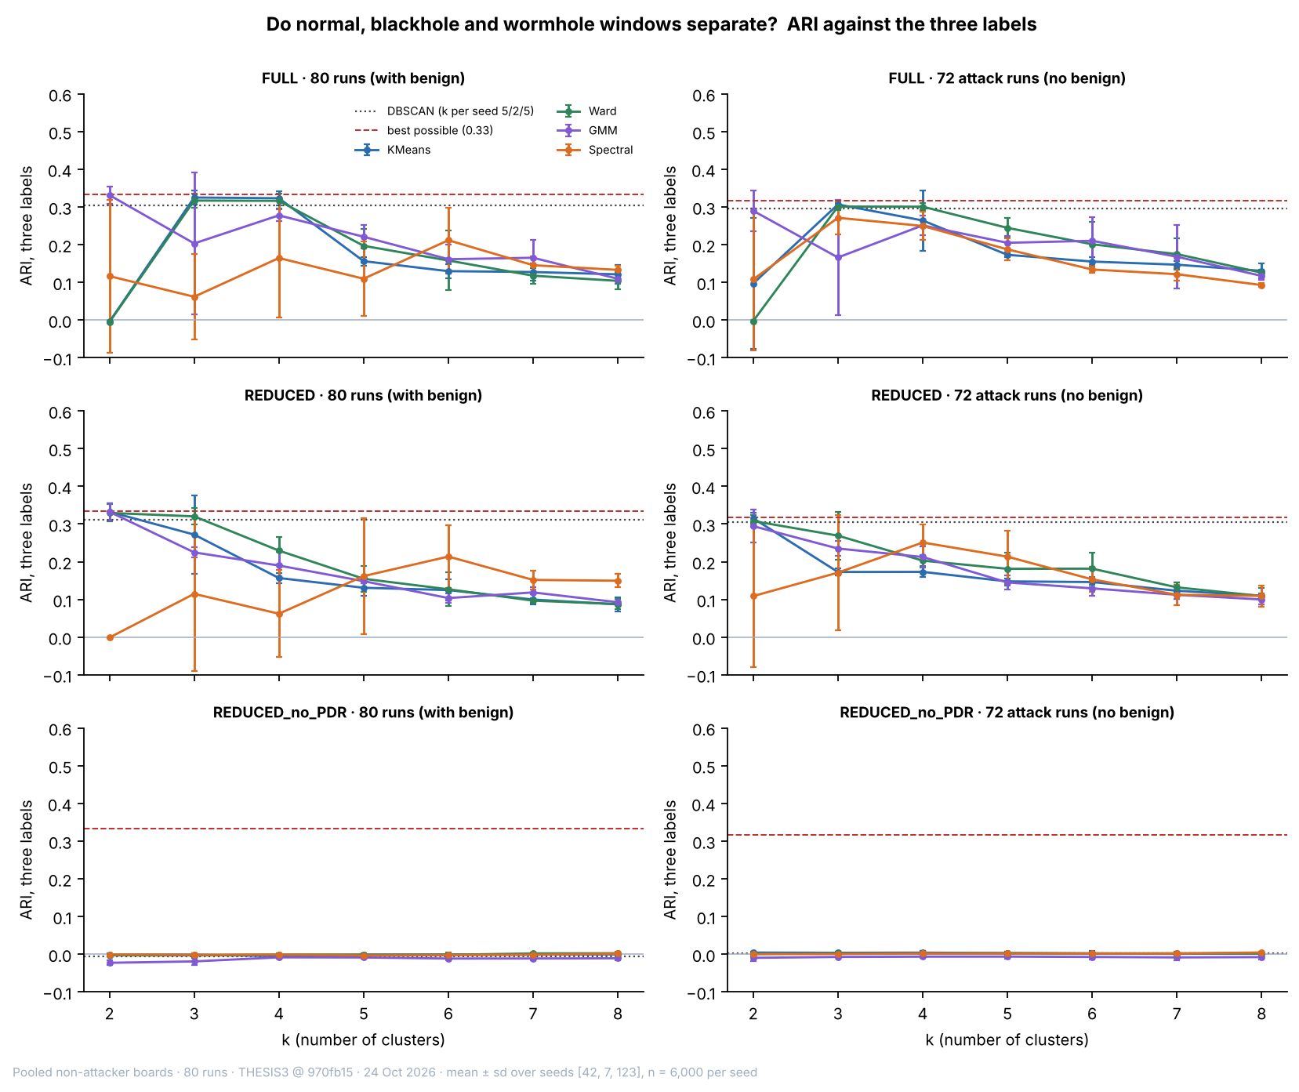

Figure 6.26 Adjusted Rand Index against the Three Labels, by Feature Set and Population (Mean and Spread over Three Seeds)
In Figure 6.26, the left column is the pooled 80 runs and the right column the 72 attack runs; the rows are the feature sets. The vertical axis is the ARI against the three labels, the dashed red line is the best possible ARI of a method that finds exactly the victim attack windows, and the dotted line is DBSCAN. Each coloured line is one algorithm with bars of ±1 standard deviation over the three seeds. The bottom row is on the same scale as the rows above.
Figures 6.27 and 6.28 show what the K-Means clusters of the 80 runs contain. With the delivery ratio, one cluster (537 windows of the sample of 6,000) consists of victim attack windows and nothing else, and the other holds the benign, blackhole-normal, wormhole-normal, bystander and wormhole windows in nearly the shares in which they occur in the sample. The wormhole windows are 12.5% of the sample, and in no K-Means cluster of 100 windows or more (k = 2 to 4, all three feature sets) do they exceed 16.3%. The cluster is separated by PDR alone (a mean of 0.000 against 1.000, Figure 6.29); the other three features are about the same in the two clusters. Without PDR, the clusters split the windows by signal level (a mean RSSI_mean of −77.2 and −63.9 dBm in the two clusters of Figure 6.27) and each holds all six kinds of window.
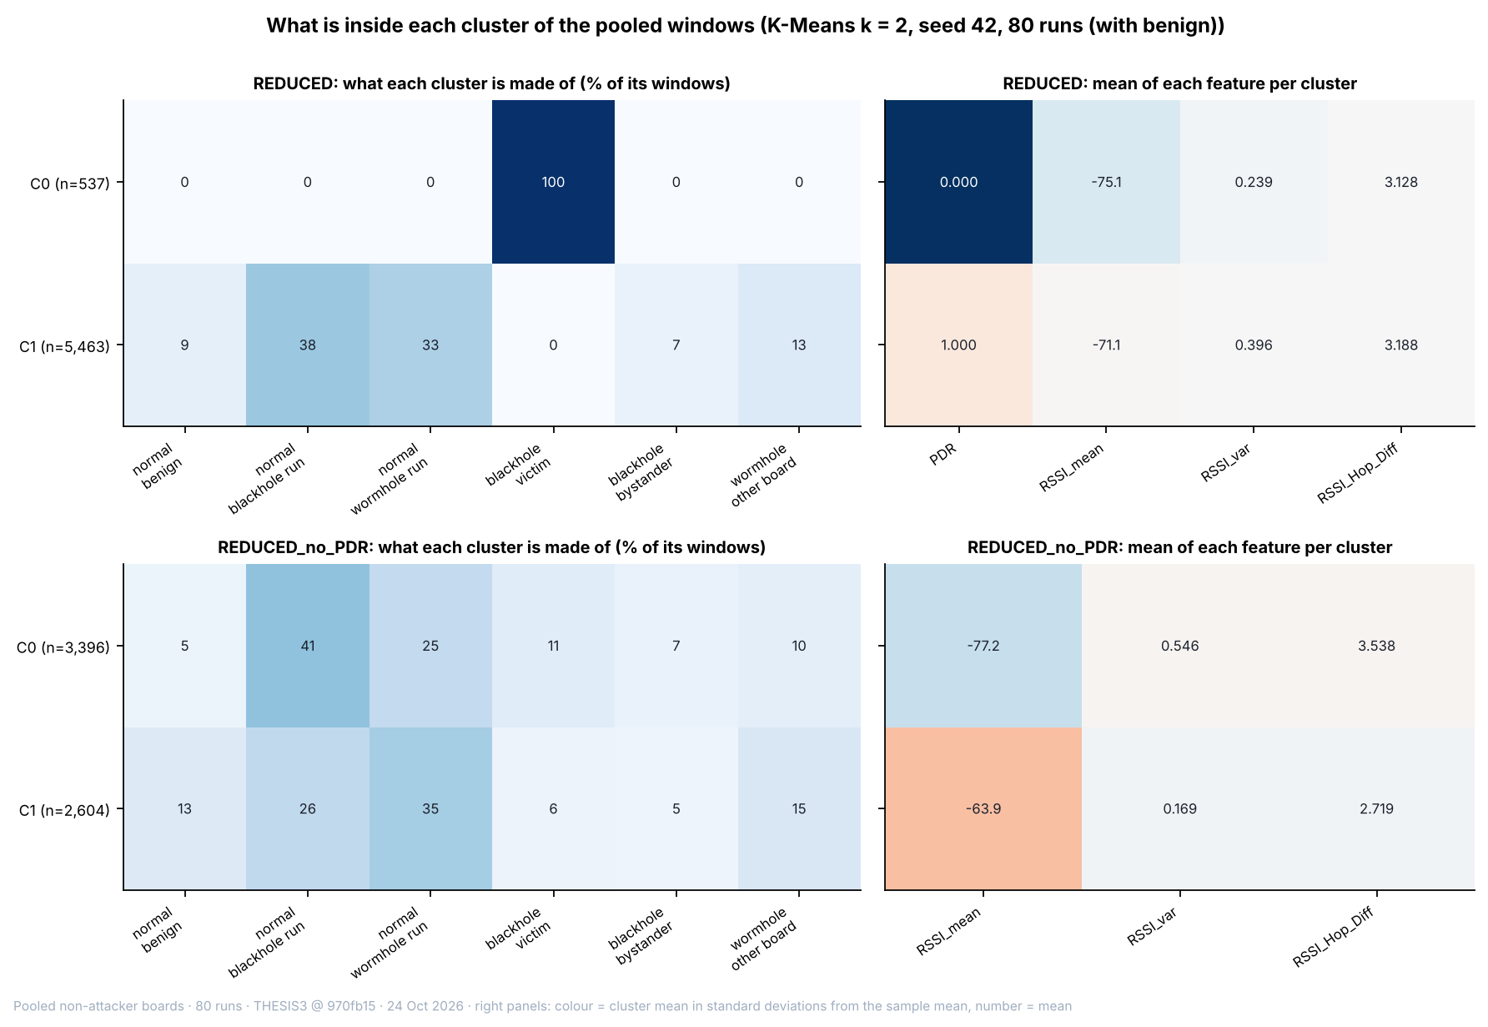

Figure 6.27 Composition and Feature Means of the K-Means Clusters at k = 2 in the Pooled 80 Runs (Seed 42)
In Figure 6.27, each row is a cluster, with its number of windows in brackets. The left panels give the share (%) of each kind of window in the cluster, and the right panels give the mean of each feature in the cluster; the colour of a right-panel cell is the cluster mean in standard deviations from the mean of the sample, and the number is the mean. The top row is the REDUCED set and the bottom row the REDUCED set without PDR. Only the victim windows of the blackhole form a cluster of their own (top), and it is defined by a PDR of 0. Without PDR (bottom), both clusters hold every kind of window.
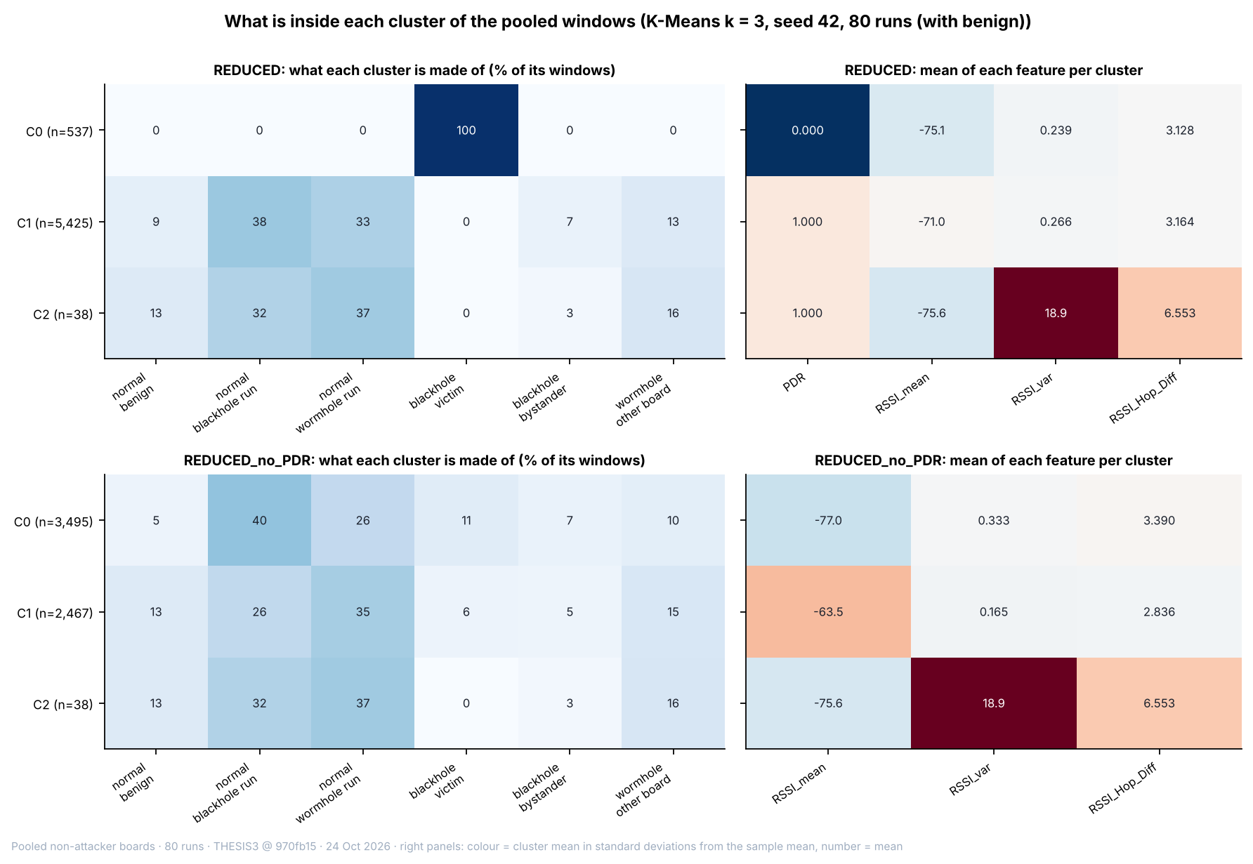

Figure 6.28 Composition and Feature Means of the K-Means Clusters at k = 3 in the Pooled 80 Runs (Seed 42)
Figure 6.28 has the same layout as Figure 6.27. At k = 3 the victim windows are still one cluster, and the third cluster is a set of 38 windows with a mean RSSI_var of 18.9 and a mean RSSI_Hop_Diff of 6.55 dB, with the kinds of window in their usual shares. The wormhole windows lie in the two larger clusters in the shares of the whole sample.
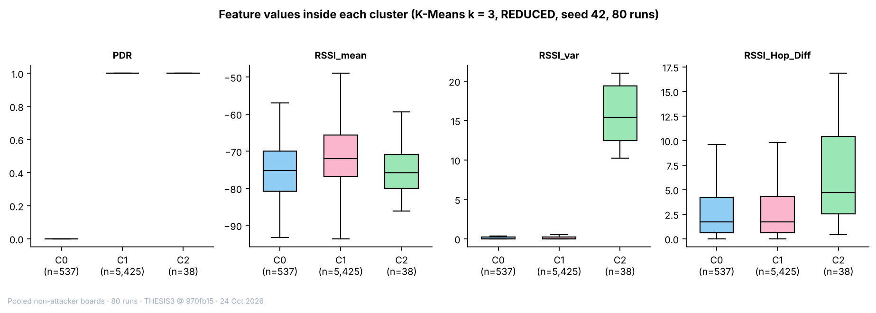

Figure 6.29 Feature Values inside Each K-Means Cluster at k = 3 (REDUCED Set, Pooled 80 Runs, Seed 42)
In Figure 6.29, each panel is one feature and each box is one cluster (C0, C1, C2, with the number of windows). The box spans the middle half of the windows with the median as a line, and the whiskers reach 1.5 times that range. PDR separates C0 (0) from the other two (1); RSSI_mean and RSSI_Hop_Diff overlap in all three; RSSI_var is far higher in C2, the small cluster of extreme windows.
The clusters can also be used as a detector. A K-Means model (k = 2, REDUCED set, seed 42) was fitted on a sample of 6,000 windows of the 80 runs and applied to every window. The cluster with a mean PDR of 0 contains 21,733 of the 21,733 victim attack windows (100.0%) and none of the 22,481 windows of the benign runs, so the benign runs raise no alarm in the sense of this model. It contains 183 of the 89,140 normal windows of the blackhole runs (0.21%) and 3 of the 32,194 wormhole attack windows (0.01%). The wormhole windows are therefore not separated, in line with the verdict of Section 6.2.2, that the wormhole leaves the other boards untouched. The result is the same when the benign runs are left out (Table 6.32). The same figures are shown in Figures 6.30 and 6.31 as projections.
Table 6.32 Windows of Each Group that Fall in the Cluster of the Victims (K-Means, k = 2, REDUCED Set, Fitted on a Sample of 6,000 Windows)
Group of windows | Windows (count) | In the victim cluster, 80 runs (count) | In the victim cluster, 80 runs (%) | In the victim cluster, 72 attack runs (count) | In the victim cluster, 72 attack runs (%)
normal · benign run | 22,481 | 0 | 0.00 | – | –
normal · blackhole run | 89,140 | 183 | 0.21 | 183 | 0.21
normal · wormhole run | 75,211 | 5 | 0.01 | 5 | 0.01
blackhole attack · victim | 21,733 | 21,733 | 100.00 | 21,733 | 100.00
blackhole attack · bystander | 16,499 | 0 | 0.00 | 0 | 0.00
wormhole attack · other board | 32,194 | 3 | 0.01 | 3 | 0.01

Legend:
- The model is fitted on a sample of 6,000 windows (seed 42) and applied to every window of the group; the victim cluster is the cluster with the lower mean PDR (0.000 in both fits). The groups are those of Table 6.30.
- In the 72-run fit the benign runs are not part of the fit; the benign windows are not scored there (–).
- K-Means = groups windows around k centres; REDUCED = PDR, RSSI_mean, RSSI_var and RSSI_Hop_Diff (Table 6.24).
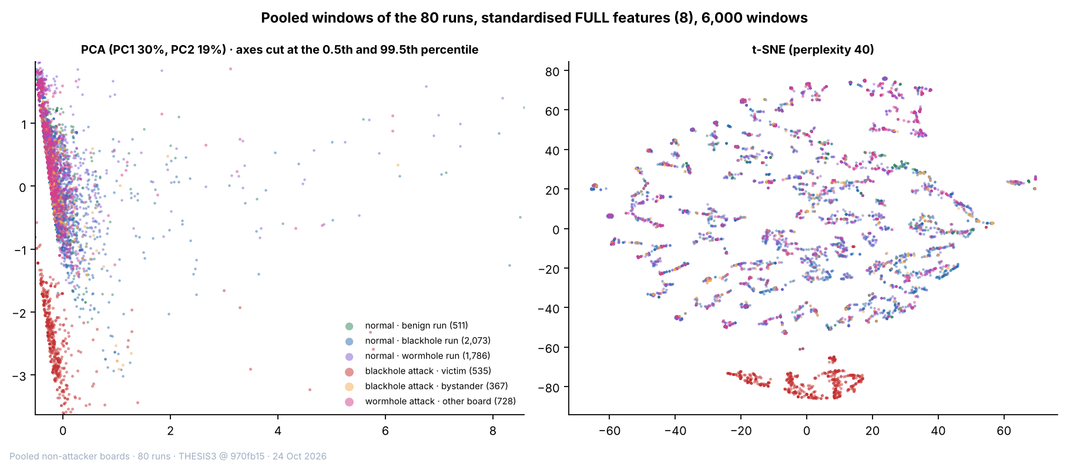

Figure 6.30 PCA and t-SNE Projections of the Pooled Windows of the 80 Runs, FULL Set
In Figure 6.30, each point is one window of the 80 runs (a sample of 6,000), coloured by group: green = normal windows of the benign runs, blue = normal windows of the blackhole runs, purple = normal windows of the wormhole runs, red = victim attack windows, orange = bystander attack windows and pink = wormhole attack windows of the other boards. The PCA axes are cut at the 0.5th and 99.5th percentile, and the t-SNE axes have no unit. The red windows lie apart from the others in both projections, and the other five groups overlap.
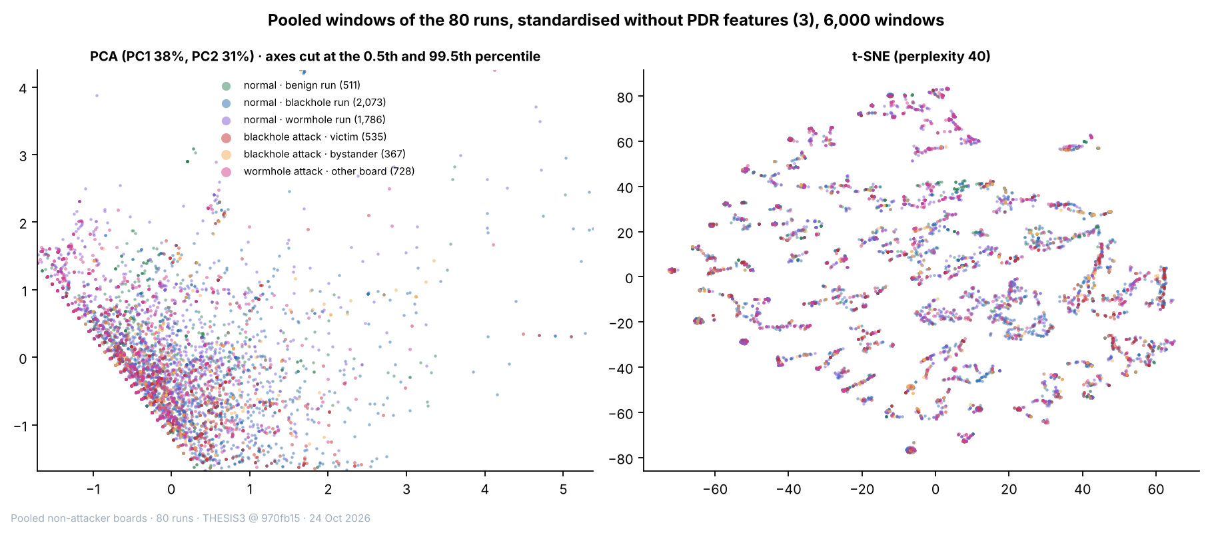

Figure 6.31 PCA and t-SNE Projections of the Pooled Windows of the 80 Runs, without PDR
Figure 6.31 is built in the same way as Figure 6.30, with RSSI_mean, RSSI_var and RSSI_Hop_Diff only. The six groups overlap in both projections, and the victim windows are no longer apart.
The benign runs serve in this section as the control. They contribute 22,481 windows, all normal, and they are spread over the clusters of the other normal windows (9% of the largest cluster at k = 2 in Figure 6.27). None of them falls in the victim cluster (Table 6.32), so the benign runs, which use the same testbed and the same traffic scenarios as the attack runs and have no attack, show that the delivery collapse is what the cluster of the victims picks up, and not a feature of the traffic.

6.5. Discussion
This section reads the results against the research objectives of Section 1.3.2 (Section 6.5.1) and against the published studies (Section 6.5.2). It then states what an emulated attack can and cannot show (Section 6.5.3) and the limits of the data (Section 6.5.4). Every number in it comes from the tables and figures of Sections 6.1 to 6.4.

6.5.1. In Relation to the Research Objectives
The first objective (Section 1.3.2) was to establish an ESP32 mesh testbed that generates multi-hop traffic under normal operation and controlled attack. All 80 runs of the plan were captured on the testbed, which has 8 boards in a run (the root and 7 child nodes), at three sites, in four topologies and in three traffic scenarios (Table 6.1). In every blackhole run the attacker did what the design says: it forwarded between 0.0% and 0.7% of the probes it received during the attack, against 100% before (Table 6.9), and the verifier confirmed all 36 blackhole runs (31 good, 4 with minor gaps and 1 undetermined). In every wormhole run the root received the probes of the entry end twice during the attack (12,448 of 12,465 probes over the 36 runs, 99.86%) and never in the baseline, the three checks of the verifier passed in all 36 runs, and all 36 are graded good (Table 6.11). The 8 benign runs show the testbed without an attack: none of the 21 signature checks that could be evaluated passed, the mean PDR of each run lies between 0.9994 and 1.0000, and the cooldown lies within 0.5 baseline standard deviations of the baseline in all 24 comparisons (Table 6.17). The objective is met for the behaviour of the two attacks. Two qualifications apply: the attacks are emulated at the application layer (Section 6.5.3), and the nine partial-mesh runs of each attack behave as plain trees (Section 6.5.4).
The second objective was to collect and structure cross-layer features into a labelled and documented dataset. The dataset holds 456,195 one-second windows from the 80 runs (Table 6.2), and 369,678 of them carry a normal or an attack label (baseline and cooldown are normal; the formation phase and the windows that span two phases are not labelled). Each window has the 16 features of Chapter 4, the label and the identity of the run (Table 6.7), and every run is documented by a verifier report. Of the 16 features, 8 can enter the clustering of the non-attacker nodes. The other 8 are recorded and documented, and they are kept out of the model inputs for reasons set out in Section 6.2.3 and Table 6.7: the relay features and the tunnel features record the attack directly, the RetryRate stays near zero and counts the tunnelled frames on the entry end, and a missing LatencyHopRatio reveals the label of a blackhole victim. Only one of the 8 features that can be clustered, the PDR, responds to the blackhole (d = −29.7 on the victims, while |d| is below 0.1 for every other feature, Table 6.18), and none of them responds to the wormhole (|d| of at most 0.07 on the two ends and on the non-attacker nodes, Table 6.19). What the wormhole changes is recorded by features that exist only on the tunnel ends or at the root: TunnelIntensity, TunnelBytes, TunnelLatency and the duplicate arrivals.
The third objective was to evaluate the usability and quality of the dataset through exploratory analysis and unsupervised techniques, in order to assess whether normal and attack-induced behaviours are separable. The quality is shown by the verification of every run (Section 6.2) and by the exploratory analysis (Section 6.3), and the separability differs for each attack. For the blackhole, the windows in which the attack is felt separate from the normal windows when PDR is a feature: K-Means with k = 2 reaches an ARI of 0.514 on all non-attacker nodes against a best possible value of 0.515, and 0.996 on the victims alone, and without PDR the ARI lies between −0.016 and 0.002. The best possible value is below 1 because 43.2% of the attack windows are windows of bystanders, which the label marks as attack and which behave as normal nodes. The separation is carried by one feature. Because PDR is also what the verifier checks to confirm the attack (Table 6.9), the agreement shows that the clustering finds the effect that the verifier measured. It is not independent evidence that the cross-layer features detect the blackhole.
For the wormhole, the cross-layer features do not separate the attack windows at all. On the non-attacker nodes the ARI lies between −0.012 and 0.003, and on the two tunnel ends, with the signal features alone, between −0.012 and 0.009 (Table 6.28). A tunnel feature changes this only in part: with TunnelIntensity added, DBSCAN reaches an ARI of 0.827 on the entry end, whereas K-Means with k = 2 stays at 0.000. TunnelIntensity is a count kept by the attacking boards, so it is excluded from the model inputs, and the result shows that a tunnel signal exists in the data and that it is not carried by the cross-layer features. In the pooled analysis of the 80 runs with three labels (Section 6.4.7), K-Means with k = 2 reaches an ARI of 0.333 on the 80 runs and 0.315 on the 72 attack runs, which is the best possible value for a method that finds the blackhole victims and nothing else (0.334 and 0.317), and without PDR the ARI lies between −0.023 and 0.005. Applied to every window, the model puts 21,733 of the 21,733 victim attack windows in the victim cluster, 3 of the 32,194 wormhole attack windows of the other boards, and none of the 22,481 windows of the benign runs, so the benign runs raise no alarm in the sense of this model (Table 6.32).
Table 6.33 What Each Kind of Run Leaves in the Data
Kind of run | Direct record | Cross-layer features that change | Separation by clustering
Blackhole | Forwarding ratio of the attacker 0.000 to 0.007 in the attack, against 1.000 to 1.004 before; PDR of the victims 0.998 → 0.000. | PDR of the victims only (d = −29.7); every other feature has |d| below 0.1. | ARI 0.514 on all non-attacker nodes (best possible 0.515) and 0.996 on the victims; between −0.016 and 0.002 without PDR.
Wormhole | Probes of the entry end reach the root twice (99.86% in the attack, none in the baseline); TunnelIntensity 0 → 1.92 messages per second. | None: |d| of at most 0.07; hop and parent unchanged in all 36 runs; PDR of the other boards 0.9999 → 0.9999. | ARI between −0.012 and 0.009 without a tunnel feature; DBSCAN 0.827 on the entry end with TunnelIntensity.
No attack (benign) | No signature passed in 21 of 21 checks evaluated; PDR 0.9994 to 1.0000. | Cooldown within 0.5 baseline standard deviations of the baseline in 24 of 24 comparisons. | 0 of 22,481 benign windows fall in the victim cluster.

Legend:
- Direct record = the measurement that confirms the attack in the verifier (Sections 6.2.1, 6.2.2 and 6.2.6).
- Cross-layer features that change = the features of the cross-layer set (Table 6.7) whose mean shifts between the baseline and the attack; d = Cohen’s d (Section 6.3).
- Separation by clustering = the ARI of K-Means with k = 2 on the REDUCED set (Section 6.4); ARI = adjusted Rand index (1 = exact match, 0 = no better than chance); best possible = the ARI of a partition that puts exactly the victim attack windows in one group.
- DBSCAN = a clustering method that groups windows in dense regions and leaves isolated windows as noise; TunnelIntensity = tunnelled messages per second, which the leakage guard keeps out of the model inputs.
- PDR = packet delivery ratio, the share of a node’s probes that reached the root (ratio, 0 to 1).
Table 6.33 puts the three kinds of run side by side. Chapter 4 expected that the clusters would reflect a confluence of cross-layer evidence. For the two attacks as they were emulated, this is not what the data show. The evidence of each attack sits in the data plane, in the delivery of the probes for the blackhole and in their duplication for the wormhole, and the physical, MAC and network-layer features stay where they were. This is a result about the emulated attacks and about the feature set, and not a statement that cross-layer detection fails against attacks that act on the routing (Section 6.5.3).

6.5.2. In Relation to the Published Studies
Four published studies serve as the reference. Khan et al. [22] measured the delivery of a healthy ESP-MESH network, the platform of this study, and Airehrour et al. [70] measured a blackhole attack in an RPL network. Zhukabayeva et al. [71] and Ramírez Gómez et al. [72] implemented a wormhole in ZigBee networks. Table 6.34 sets each measured value beside the published one.
Table 6.34 Measured Values Compared with Published Studies
Feature | This study | Published value | Study, protocol and device | Reason for the difference
Blackhole: PDR in the baseline (ratio) | 0.998 (victims), 0.996 (bystanders); 0.9994 to 1.0000 in the benign runs | More than 0.97 for every node except one outdoor node [22] | Khan et al. [22]: ESP-MESH on ESP32 boards, 7 sensor nodes and a root. | Same protocol and device family; the counting differs, so the two are not claimed equal.
Blackhole: PDR in the attack (ratio) | 0.000 in the victims of all 36 runs | Packet loss of 60% to 75%, which is a delivery of 25% to 40% [70] | Airehrour et al. [70]: RPL (MRHOF), 14 AS-XM1000 (Telos-B) motes in a laboratory. | Loss there depends on which motes choose the attacker as parent; here the attacker is on the path of its victims.
Blackhole: ParentSwitchRate (parent changes per s) | 0.00000 → 0.00009 (victims, d = 0.01) | 16 to 246 rank changes per mote [70] | Airehrour et al. [70]: as above. | Different metric and mechanism; routing is untouched here (D-20).
Blackhole: RetryRate (ratio) | 0.0000 → 0.0004 (victims) | No published value for this attack in the studies compared here | Not applicable. | ESP-IDF gives no MAC retry count (D-15).
Wormhole: hop count | Constant in the attack in 36 of 36 runs; no window with a hop change | Route of 4 hops becomes 3 hops [71] | Zhukabayeva et al. [71]: ZigBee (XBee) chain, wormhole tunnel between two Raspberry Pi nodes. | In [71] the tunnel is a shorter route that ZigBee chooses; here it is an application-layer relay and the mesh keeps its routes (D-20).
Wormhole: delay | LatencyHopRatio of the entry end 12.0 → 11.2 ms per hop (d = −0.01); spread between the two copies of a probe: median 3.9 ms, 90th percentile 12.1 ms | Delay of 80 to 100 ms rises to 120 to 200 ms, about 40% more [71] | Zhukabayeva et al. [71]: as above. | Different measure: [71] gives the delay of the route, here the delay per hop of the entry end and the spread between two copies.
Wormhole: delivery of the other boards (ratio) | 0.9999 → 0.9999 (non-attacker boards) | Packet loss increased after the attack, without a value in the text [71] | Zhukabayeva et al. [71]: as above. | Only the probes of the entry end are tunnelled here, and the emulation drops none on purpose.
Wormhole: duplicate arrivals | Probes of the entry end at the root twice: 99.86% in the attack, none in the baseline | Two source-routing packets per data packet [72] | Ramírez Gómez et al. [72]: ZigBee (XBee S2C) with source routing, one coordinator and two routers. | Same kind of evidence at a different layer: a duplicated routing packet there, a duplicated data probe at the root here.
RSSI_mean, RSSI_var, RSSI_Hop_Diff and the other features of Tables 6.18 and 6.19 | |d| below 0.1 in both attacks | No comparable value in [70], [22], [71] or [72] | Not applicable. | No published value to compare with.

Legend:
- This study: 8 ESP32 boards running ESP-WIFI-MESH, with both attacks emulated at the application layer (D-20), measured in one-second windows.
- Published value = the value reported by the cited study. For [71], the delay and hop count are those of its description of the testbed; its abstract gives the rise in delay as 40% and the share of false readings as over 30%.
- d = Cohen’s d (Section 6.3). Victims and bystanders are defined at the start of the chapter.
- MRHOF = minimum rank with hysteresis objective function of RPL; RPL = routing protocol for low-power and lossy networks.
- Mote = a small wireless sensor node; rank = the value that an RPL mote computes for its distance from the sink, so a rank change means that the mote moved in the routing tree; sink = the node that collects the data.
- Packet loss = the share of packets that do not arrive; loss = 1 − delivery.
- ZigBee = a low-power wireless standard for sensor networks; XBee = a ZigBee radio module; source routing = the sender writes the route into the packet.
- PDR = packet delivery ratio, the share of a node’s probes that reached the root (ratio, 0 to 1); LatencyHopRatio = the one-way delay of a probe divided by the number of hops (ms per hop).
For the baseline PDR, Khan et al. [22] used ESP-MESH on ESP32 boards, with 7 sensor nodes and a root, and one 64-byte package per node every minute (open-area test) or every 2 min (campus test) for 5 days. The protocol and the device family are the same, and the values agree in size. The published figure counts one package every 1 to 2 min over five days, whereas this study counts probes in one-second windows over a 300 s baseline, so the two are not claimed to be equal. The baseline PDR of the blackhole runs (0.998 for the victims and 0.996 for the bystanders) is a little lower than that of the wormhole and benign runs (0.9999 and at least 0.9994), and all of them are consistent with the benchmark of more than 0.97.
For the PDR in the attack and for the parent changes, the source is Airehrour et al. [70], who used RPL with the MRHOF objective function in a research laboratory of about 30 m by 30 m, with a testbed described as 14 AS-XM1000 (Telos-B) motes running InstantContiki 3.0 (1 UDP sink, 12 UDP senders and 2 blackhole motes are listed). In [70] the loss depends on which motes select a blackhole mote as parent through the routing protocol (their Figures 5 and 6), and loss is counted between a sender and the sink. Here the attacker is placed on the path (D-20, the attack is emulated at the application layer) and every probe of a victim passes it, so all are lost. The direction agrees with [70], and the size does not, because the setups differ, so the comparison covers direction and not equal values. The metric for parent changes also differs (rank changes of RPL motes against parent changes of mesh boards per second), and so does the mechanism. In [70] the attack acts inside the routing protocol and ranks change, whereas here forwarding is suppressed without touching routing (D-20), so the tree stays as it was.
For the wormhole, Zhukabayeva et al. [71] built a ZigBee chain of Arduino-based sensor nodes with XBee modules, and made the wormhole with two Raspberry Pi nodes joined by a GSM link and a TCP/IP tunnel that forwards the ZigBee packets, so that the two nodes appear as direct neighbours. ZigBee prefers the shortest route, so the route of 4 hops becomes a route of 3 hops through the tunnel, and the paper reports a rise in the delay from 80 to 100 ms to 120 to 200 ms and 20% to 30% of the readings modified by the attacker. The attack there changes the routing, and its effects (shorter route, longer delay, altered data) follow from that change. In this study the tunnel does not change the routing: the hop and the parent of every board stay the same in all 36 runs, the LatencyHopRatio of the entry end does not move, and the other boards keep a PDR of 0.9999. The difference is explained by the attack design, as in the blackhole. The published figure of modified readings has no counterpart here, because this study measures the delivery and the timing of probes and not the integrity of sensor readings. The paper marks a measurement as anomalous when it lies more than three standard deviations from the mean (the 3-sigma rule), and the verifier of this study applies the same rule to the signature features of each run (Section 6.2).
Ramírez Gómez et al. [72] implemented a classic and a reverse wormhole against XBee S2C nodes that use source routing, with a Raspberry Pi 3 and a USB radio dongle running the KillerBee framework as the malicious node, in two small networks of one coordinator and two routers. Their results are qualitative: they show the captured and modified route records, and they give no delivery, loss or delay figure, so there is no number to set against. They propose detection signatures instead, and the first is the duplication of routing packets: the attack makes the nodes receive two source-routing packets per data packet. The duplicate arrival is also the main signature in this study (99.86% of the probes of the entry end reach the root twice), and the two agree in kind, but they are not the same measure, since [72] counts routing packets inside a ZigBee network and this study counts data probes at the root of an ESP-WIFI-MESH network. Their other signatures (beacon requests without a join, and link-status and neighbour tables) concern the routing and the neighbour tables, which the firmware of this study does not log (Section 6.2.4), so they cannot be tested on this dataset.
For RetryRate, the studies compared here give no published value for this attack. ESP-IDF returns no MAC retry count, so RetryRate is an application counter (deviation D-15) and cannot be compared with MAC-layer retransmission counts. Finally, RSSI_mean, RSSI_var, RSSI_Hop_Diff and the other features of Tables 6.18 and 6.19 belong to the cross-layer feature set of this study (Section 4.2.4), so that there is no comparable published value in [70], [22], [71] or [72] to set them against.
[PENDING: update Chapter 4 from the final results. Table 4.23 and Section 4.2.7.6 say that Khan et al. [22] report delivery above 97%, but their campus result excludes node H, so the sentence has to add that exception. Tables 4.22, 4.23 and 4.26 to 4.30 need the final values of the 80 runs. Delete this note when done.]

6.5.3. What an Emulation Can and Cannot Show
Both attacks act on the application-layer probes of the study and not on the mesh. The blackhole receives the probes of the nodes behind it and does not forward them, but every frame is still acknowledged at the link layer, so signal strength, retries and parent choices are not touched (D-20). The dataset therefore records the effect of forwarding suppression on delivery. It does not record how a node attracts traffic to itself, which is the route-attraction stage of a classical blackhole (Section 6.6). This is why the delivery ratio carries the whole result, and it is a property of the emulation as much as of the attack.
The wormhole is an application-layer relay between two boards joined by a wire. The entry end B sends its own probes in the normal way and also writes them to the wire, and the exit end A, which lies closer to the root, sends them on into the mesh, so that the root receives two copies of each probe of B. Only the probes of B are tunnelled, the five other boards of a run are not touched, and no node is a victim. The mesh does not see the tunnel, so its routing, its parent choices and its radio links are left as they were. Of the indicators of Table 3.5, the three that belong to the traffic that the tunnel creates are observed (the duplicate arrivals, the frame arrival pattern and the latency mismatch between the two copies), and the four that belong to the routing and the radio are not (hop count, parent-child validity, the relation between signal strength and hop, and signal variance); the routing table is not logged, and the retransmissions of the two ends cannot be separated from the tunnelled frames (Table 6.16). Section 3.3.2.2 expected that application-layer relaying would reproduce latency anomalies and RSSI–hop inconsistencies. The first is observed. The second is not, which is what an emulation that leaves the radio and the routing alone implies.
Three things follow for the use of the dataset. First, a result on this dataset says what an attack of this kind does to the traffic and to the features, and it does not say what an attack inside the routing protocol would do. Second, a detector that is tested on the blackhole windows of this dataset is tested on the loss of delivery, and one that is tested on the wormhole windows is tested on duplication, and both signals are available at the root without cross-layer features. Third, the question whether cross-layer features add anything to such a detector is open, and a dataset of attacks that act on the routing is needed to answer it (Section 6.6).

6.5.4. Limits
Each combination of topology, site and scenario was run once for each attack, so no cell has a repeat, and differences between sites cannot be separated from run-to-run noise. The signal level shows how large this noise can be: the mean RSSI_mean of the baseline differs by 8.1 dB (blackhole) and 7.1 dB (wormhole), on average, between a benign run and the attack run of the same cell (Table 6.23), so the signal level is a property of the capture and not of the attack. The seeds of Section 6.4 change the sample and the starting points of the algorithms and not the data.
The windows are also not independent. The 456,195 windows come from 80 runs, and the windows of one board in one phase are not independent draws, so the number of independent observations is closer to the number of runs than to the number of windows. This is why the run-level interval of Section 6.4.4 is wider than the seed spread of Section 6.4.2: the ARI of K-Means with k = 2 on the blackhole runs is 0.511 with a 95% interval of 0.410 to 0.626 over runs, against a standard deviation of 0.014 over seeds. The effect sizes of Tables 6.18 and 6.19 treat windows as independent and are therefore read as sizes of a shift and not as significance tests.
The partial-mesh runs behave as plain trees. In all 9 partial-mesh blackhole runs every node was seen under a single parent during the labelled phases, and parent changes occurred only during mesh formation (Section 1.4.1); the 9 partial-mesh wormhole runs are the 9 runs whose topology check carries a warning (Section 6.2.2). The partial-mesh cells therefore test a branched tree with a limit of two children and not a mesh with alternative parents, and adaptive parent switching is not claimed.
The label imposes a further limit. It marks every window of every node in the attack phase as attack, including the windows of bystanders, which caps the ARI of the blackhole at 0.515 on all non-attacker nodes (43.2% of the attack windows are bystander windows). For the same reason, a pooled analysis of the three labels cannot exceed 0.334 on the 80 runs and 0.317 on the 72 attack runs for a method that reads only the features of a window.
The benign runs are a control, but a small one. There are 8 of them (54 child boards), 4 stationary, 3 highload and 1 burst, with 3 in the linear topology, 3 in the star, and one each in the partial mesh and the tree, so most cells of the design have no benign counterpart. They show that the verifier raises no alarm on 8 runs and that the model of Section 6.4.7 puts none of their 22,481 windows in the victim cluster. They do not give a false-alarm rate for a detector, which would need more runs, in every cell and with repeats. The burst and highload scenarios add controlled variation in traffic, so that traffic volume alone cannot indicate an attack, but they are not a model of campus traffic.
Some measurements are limited by the boards. The routing table is not logged, the boards cannot count MAC retransmissions (D-15), and the RetryRate of the entry end holds the frames sent through the tunnel, so it records the attack by construction and is not read as a retransmission count. The 802.11 retry rate seen by a sniffer exists for 7 of the 36 blackhole runs only (Section 6.2.4). In the run partial mesh at Yuchengco with highload, the entry end and one non-attacker node sent about one probe per second where the scenario asks for four (Section 6.2.5). The feature sets of the clustering were fixed on the blackhole windows and kept for the wormhole and pooled windows, because a low-variance rule applied to the pooled windows would remove PDR, the one feature that responds to the blackhole (Section 6.4.1); a different rule would give different sets.
Finally, the results hold for a network of 8 ESP32 boards at three sites. They are not claimed for larger meshes, for other devices or for traffic other than the three scenarios. In this chapter, normal means baseline and cooldown.
[PENDING: add [80] Arp, D., Quiring, E., Pendlebury, F., Warnecke, A., Pierazzi, F., Wressnegger, C., Cavallaro, L., & Rieck, K. (2022). Dos and don’ts of machine learning in computer security. In 31st USENIX Security Symposium (USENIX Security 22). USENIX Association. to Appendix A, because Section 6.2.3 cites it.]

6.6. Future Work
The two attacks in this study are application-layer emulations, so the route-attraction stage of a blackhole and the false-neighbour effect of a wormhole are not in the dataset. A later study could add them, either on a routing protocol whose route handling can be modified, or on ESP-WIFI-MESH itself by building the attack below the application layer, for example by forging the management frames of the mesh, which needs radio-level tools and was outside this study. A dataset made that way could be set beside this one to show what the route-attraction stage adds to the cross-layer signature, and whether the indicators of Tables 3.4 and 3.5 that were not observed here (the retransmissions of the victims, and the hop, parent and signal indicators of the wormhole) appear when the attack acts on the routing.
Three extensions of the data would remove limits of this study. The first is a repeat of each cell, so that run-to-run variation can be estimated and site effects separated from noise. The second is a larger set of benign runs, in every cell of the design, so that a false-alarm rate can be estimated. The third is a wormhole that tunnels the traffic of other nodes, which would create victims and show whether the cross-layer features move when a node other than the tunnel end is affected. A sniffer that records the 802.11 retry rate in every run would also close the gap left by the boards, which cannot count MAC retransmissions.
The dataset also allows a detection study that this work did not attempt. A detector should be tested by leaving out whole runs, because the windows of one run are not independent, and it should be compared with the two simple baselines that this chapter identifies, the delivery ratio for the blackhole and the duplicate arrival for the wormhole. Only a gain over those baselines would show that cross-layer features add to the detection.

6.7. Conclusion
This study produced a labelled and documented cross-layer dataset of an ESP-WIFI-MESH network: 80 runs of 8 ESP32 boards, 456,195 one-second windows, 16 features, 36 blackhole runs, 36 wormhole runs and 8 benign runs, in four topologies, at three sites and in three traffic scenarios. Each run was checked against its own schedule by a verifier, and all 72 attack runs and all 8 benign runs were confirmed. The first objective of Section 1.3.2 is met for the behaviour of the attacks, and the second for the dataset, with the limits of Section 6.5.4.
The two attacks, emulated at the application layer, leave their trace in the data plane. The blackhole forwards between 0.0% and 0.7% of what it receives, and the PDR of the nodes behind it falls from 0.998 to 0.000. The wormhole makes the root receive 99.86% of the probes of the entry end twice. In both attacks the other cross-layer features do not move (|d| below 0.1), and the hop and the parent of every board stay the same in the wormhole runs.
In answer to the third objective, the quality of the dataset is shown by the verification of every run, and the unsupervised methods separate the blackhole windows that matter, those of the victims, and nothing else. K-Means with k = 2 reaches an ARI of 0.514 on the blackhole runs, against a best possible 0.515, and 0.996 on the victims, and it falls to between −0.016 and 0.002 without PDR. The wormhole windows are not separated by the cross-layer features (ARI between −0.012 and 0.009), and are found only when a tunnel feature is added to the entry end and DBSCAN is used (ARI 0.827). In the pooled analysis, the model puts 21,733 of 21,733 victim windows in the victim cluster and none of the 22,481 benign windows. The confluence of cross-layer evidence that Chapter 4 expected is therefore not found for attacks that act on the application layer, and the finding is stated as a result of this study.
The contribution is the dataset, the method that verifies each run, and this negative result with its reasons. A user of the dataset can test detectors that rely on delivery and on duplicate arrivals, can use the benign runs as a control, and can read which features respond to which attack. Testing whether cross-layer features add to detection needs attacks that act on the routing, which this study identifies as the next step (Section 6.6).

