Attack and Dataset Validation Basis
Oct 14, 2026 · @Ricardo
This document sets out how we show that each attack is done correctly and that the dataset is valid, which sources we use for that, and why they suit our study. Collection is still running, so results are marked pending until the runs are final.

Approach
We argue validity in three layers, and each layer answers one thing the panel asked.
- The attack matches its published definition. We compare each implementation to a cited source, criterion by criterion, and we list the criteria that fail. This answers "where is the script based, and how do you know the attack is right?"
- The attack does what it should in our own data. Every run has a known timeline, with a 300 s baseline, a 180 s attack and a 120 s cooldown, so each run is its own control. We test whether features leave their baseline range only during the attack, using the 3-sigma method of Zhukabayeva et al. [71].
- The dataset is usable, not just correct. We check that files are complete, that the mesh formed the intended topology, that no single feature gives the label away, and that scenarios and sites add real variation.
Published studies are used as a cross-check on direction and rough size. They describe other platforms, so we do not claim our values equal theirs.
Status on Oct 14. 46 runs are captured and 24 of the 84 planned runs are done, 23 blackhole and 1 wormhole. The plan is 4 topologies, 3 sites and 3 scenarios (stationary, burst, highload) for each attack, which gives 72 attack runs, plus 12 matched runs with no attack. Results below are therefore marked as provisional.

Sources We Use and Why They Work for Us
Blackhole and wormhole are defined by what the attacker does to traffic, not by one routing protocol. Matching a published definition and a published effect is therefore a fair test for an ESP32 mesh, even when the source used RPL or ZigBee. Airehrour, Khan, Zhukabayeva and Ramírez Gómez were read from their PDFs. Hu et al. is cited from the thesis, and the REAL-IoT, Abdallah, Espressif and Wireshark entries come from the project's reference list and were not re-opened for this document.
Source | What it is | What we take from it | Why it works for us | Limit
Airehrour, Gutierrez & Ray (2018) [70] | Blackhole and selective forwarding on an RPL hardware testbed, 14 motes in a smart building | The blackhole definition (false low rank, then discard), packet loss of 60 to 75% unmitigated, and 16 to 246 rank changes | Hardware results, not simulation, in an indoor building like ours | RPL, not ESP-WIFI-MESH. It also studies a defence, which we do not
Khan et al. (2022) [22] | ESP-MESH deployment across a campus | Healthy delivery of 96.5 to 99.1% and loss under 1.8% except one node | Same platform and a campus setting, so it is the reference for our baseline | Sampled every 2 minutes, with no attack
Zhukabayeva et al. (2025) [71] | Real-time wormhole and sinkhole detection in wireless sensor networks | The 3-sigma test, a wormhole with an out-of-band link, and a sinkhole log with Forwarded then Dropped | Gives both a statistical method and a physical tunnel like our UART wire | A different network type. Its hop-count text and figure disagree, so check before quoting
Ramírez Gómez et al. (2019) [72] | A wormhole built with XBee ZigBee nodes and an out-of-band link | Duplicated routing packets as a wormhole effect | An implemented wormhole on real radios, as ours is | ZigBee source routing, and it duplicates routing packets, not data packets
Hu, Perrig & Johnson [46] | The packet-leash wormhole definition, already cited in the thesis | The wormhole criteria used in Table 4.18 | The canonical definition, and it is protocol-independent | Defines the attack, gives no measurements
Zhan, Zhou & Haddadi (2025) [73] | REAL-IoT, a study of intrusion detection on IoT data | Handling of class balance, z-score standardisation and distribution drift across places | Supports how we prepare and split the dataset | Supports dataset handling only. It is not proof that an attack is correct
Abdallah, Mnasri & Val (2022) [74] | Indoor deployment of connected objects | Nodes are placed by coverage and signal strength, not at random | Grounds our topology-to-place mapping | Not about attacks
Espressif ESP-IDF v5.3 documents [75] to [77] | The ESP-WIFI-MESH API, esp_mesh.h and the MAC address API | What the protocol guarantees, the peer-to-peer data flag, and that no 802.11 MAC statistics are exposed | Bound what our attack may claim | Vendor documents, not experiments
Wireshark and the sniffer [78] | An independent 802.11 frame capture | Frame-level evidence from outside the mesh | Does not rely on the attacker counting its own drops | Covers only part of each run
Our repository [79] | Code, tools and run logs | The record of how each run was made and checked | Lets anyone repeat a check | Written by the group
Candidates we have not opened and do not cite yet: MITRE CAPEC, MITRE EMB3D, NIST NVD and the IETF RFCs for AODV and RPL. Open each one before adding it.

Blackhole (Forwarding Suppression)
What we claim. One relay node sits on the forwarding path, receives packets and does not pass them on, while staying a normal mesh member. We call it forwarding suppression because it does not advertise a false route.
Layer 1. Match to the definition. Airehrour et al. [70] describe a blackhole as a node that advertises a false low rank so that neighbours choose it as parent, then discards what it receives.
Criterion | Met | Evidence in our implementation
Adversary sits on the forwarding path | Yes | Victims address the attacker, which relays to the root
Receives the packets rather than jamming | Yes | The relay queue receives before the forward or drop decision
Drops instead of forwarding | Yes | During the attack the drop counter rises and nothing is sent on
Stays protocol-compliant, so the node looks alive | Yes | It remains a mesh participant and keeps logging telemetry
Delivery collapses while the node stays reachable | Yes | See layer 2
Attracts traffic by advertising a false route | No | The attacker is a placed relay, so no routing decision is fooled
The last row is stated, not hidden. It is the reason the attack is named forwarding suppression, and the adaptation to ESP-WIFI-MESH is described in the thesis.
Layer 2. What the data show. The checks run on every captured run, and the figures below are from the verified runs so far.
Check | Tool | Result in the verified runs
Files complete, 10 Hz sampling, phases present | validate_integrity.py | Pass on the verified runs
Mesh formed the intended topology | verify_topology.py | Pass. Failures seen so far were false alarms from a root restart, now handled
Attack test against the run's own baseline | verify_attack.py | Confirmed in the verified runs
Counters recomputed by hand from raw files | Manual check | Match the tool output
Two examples. In the G402 linear stationary run, the attacker's ForwardingRatio falls from 0.995 to 0.000 and its child's PDR from 0.938 to 0.238. In the DLSU Library linear jitter run, the attacker's ForwardingRatio falls from 0.997 to 0.000, the four nodes behind it fall from 0.998 to 0.000, and the two nodes above it stay at 1.000. The attacker's own counters for that run read received 806, forwarded 0, dropped 806 in the attack phase, against 1751 received and 1751 forwarded in baseline.
That pattern, a collapse behind the attacker with no change above it, is what a node on the forwarding path should produce. It is why victims are labelled by position, as nodes downstream of the attacker, and not by their firmware role.
Layer 3. Agreement with published results.
Measure | Published | Ours | Reading
Packet loss under an unmitigated blackhole | 60 to 75% [70] | About 76% in G402 linear stationary | Same order of magnitude
Node behaviour | Packets change from Forwarded to Dropped at the attacker [71] | Forwarded count falls to 0 and dropped count rises | Same behaviour, seen at the application layer
Routing instability | 16 to 246 rank changes per mote [70] | Almost no parent switches | Does not match, and it should not, because forwarding suppression does not touch routing
What we state we did not reproduce. The false route advertisement. Table 3.4 of the thesis predicted more victim retransmissions, and we did not observe them, because the attacker still acknowledges every frame at the link layer. The retry counters are application counters, not 802.11 retries (D-15).

Wormhole (Wormhole-Inspired Tunnel)
What we claim. Two attacker boards joined by a UART wire copy packets from one place in the mesh to another, so the same packet reaches the root twice. We call it wormhole-inspired because the tunnel runs above the mesh's routing and does not change the topology.
Layer 1. Match to the definition. Hu, Perrig and Johnson [46] define a wormhole by two colluding endpoints, an out-of-band channel, and packets captured at one end and replayed at the other.
Criterion | Met | Evidence in our implementation
Two colluding endpoints | Yes | Node A (exit) and Node B (entry)
Out-of-band channel outside the normal path | Yes | Physical UART link between the two boards
Packets captured at one end and replayed at the other | Yes | Each of Node B's attack probes reaches the root twice
No compromise of keys or hosts | Yes | Application layer only
Creates a false neighbour relationship | No | No parent switches during the attack
The ends are assigned when the run starts, by mesh depth: the deeper board becomes Node B and the shallower one Node A, so the wire is always a shortcut toward the root (D-17). The roles lock at the first phase and are written to every telemetry row. Only Node B's own probes are tunnelled, so a wormhole run has no victims.
Layer 2. What the data show. The first run with the run-time assignment is linear, DLSU Library, stationary.
Check | Result
Roles stayed fixed all run | Node A at layer 5, Node B at layer 7, so the wire skipped two hops
Duplication in the attack phase | All 181 probes from Node B arrived twice, 362 arrivals in total
Duplication outside the attack | None in baseline or cooldown, where Node B sent 300 and 120 single copies
Other nodes | About one probe a second, single copies, in every phase
Gap between the two copies | About 2.8 ms (median), and 90% within 6.5 ms
Topology | One parent per node for the whole run
Auto-switch logic | Host test of the real firmware file, 35 of 35 cases passed
Two features cannot be tested with the 3-sigma method, and this is by design. TunnelLatency has no baseline spread, because the baseline has no tunnel and so no duplicates. Its attack value, 2 to 4 ms between copies, is reported descriptively. LatencyHopRatio is infeasible, because the baseline spreads across an eight-hop line. Neither enters the verdict.
Layer 3. Agreement with published results.
Measure | Published | Ours | Reading
Duplicated packets as a wormhole effect | Duplicated routing packets, two per data packet, in ZigBee [72] | Duplicated data packets at the root | Related effect, not the same packet type
Shortcut and added delay | Hop count 4 to 3 and delay 80 to 100 ms up to 120 to 200 ms [71] | A hop-skipping wire, no hop change in the mesh | Partly matches. Check the hop-count text of [71] before quoting
Data modified | 20 to 30% [71] | Not modified | Does not match, because our tunnel only copies
What we state we did not reproduce. The false neighbour relationship. Table 3.5 of the thesis predicted a distorted topology, and none was observed, so an application-layer replay tunnel reproduces the duplicate-delivery signature without the topological one.
Limits. Wormhole conformance is shown on the linear topology only, and 1 of the 36 planned wormhole runs is done. An earlier tree capture at G402 had both ends at the same depth, so the wire was no shortcut, and it is being recaptured.

Dataset Validation
Design. 4 topologies (linear, star, tree, partial mesh), 2 attacks, 3 sites (G402, DLSU Library, Yuchengco) and 3 scenarios give 72 attack runs. 12 matched runs with no attack bring the plan to 84. Each run has a 60 s formation period (label 255, excluded), a 300 s baseline, a 180 s attack and a 120 s cooldown.
How the design answers the panel. The panel's comments (Improvements.pdf) map to the design as follows.
Panel concern | What we did | Status
One feature should not decide attack or not | Leakage audit on every feature, and relay features computed on every relaying node, not only the attacker (D-12) | Audit per run done. Pooled audit pending
Attacks are identical every run | Attacker position follows each topology, and scenarios change the traffic | Partly. Attacker position and probe-interval randomness are not varied by a scenario
Repeats r1 to r3 are redundant | Repeats replaced by different sites and scenarios, one run per combination | In the plan
Only one environment | Three campus sites with different interference | G402, DLSU Library and Yuchengco have captures
No stated IoT scenario | Smart campus, indoor monitoring at DLSU Manila, following Khan et al. [22] | Settled
How do you know the attack is right | Layers 1 to 3 above, with sources | Blackhole checked in many runs. Wormhole in one
Benign traffic is not characterised | Burst and highload scenarios, and 12 matched runs with no attack | Burst and highload captured. Benign runs 0 of 12
Shorter runs, more variation | 11-minute runs across many combinations instead of long runs | Done
Integrity checks on every run.
- Every board must reach 95% sample coverage at 10 Hz, and files must hold one boot with baseline, attack and cooldown.
- The mesh must form the intended topology and stay stable through the baseline. Parent changes before a root restart are excluded, because that restart is already marked as pre-baseline.
- Windows are 1 s long and need at least 8 of 10 samples. Windows with too few samples are dropped and counted.
- Only the last 300 s of phase 0 is labelled baseline. Extra time before it is excluded.
- Radio is fixed to HT20 (D-14). Captures made before the relay change, or with HT40, are not pooled.
- Attack counts are recomputed by hand from raw files for the verified runs, and match the tools.
Single-feature audit (provisional). Each feature is tested alone as a threshold classifier against the majority rate of about 0.70. Across 38 analysed runs, PDR and LatencyHopRatio reach 0.95 or more in 11 runs each, and ForwardingRatio and ConsistencyScore in 8. RSSI, parent-switch and hop features stay near the majority rate. A blackhole drops everything in a fixed window, so this is expected, and we report it as such and not as a model result. A pooled audit across all runs is the stricter test and is run once collection ends.
Time in the run. In an earlier measurement, window_start alone scored 0.857, because every run uses the same timeline. Jitter would have broken that, and it is cut for time. So time in the run is kept out of model inputs, and the paper states the limit.
Known data-quality items.
- Highload at seven boards can collapse the mesh even without an attack. The root's arrival writer was fixed on Oct 7 and worked on hardware, and highload captures from before it are being recaptured.
- A wormhole capture at G402 on the tree topology had no shortcut and is being recaptured. Two G402 tree runs lost boards and also need a second run.
- Sniffer coverage of retry rate is sparse on some boards, so MacRetryRate is not a model input.
- About 16 captured runs are off the plan, including Home pilot runs. They are not counted in the 84.
Why the sources help here. Khan et al. [22] give the healthy-delivery range our baselines are compared with. Zhan et al. [73] and Abdallah et al. [74] support how we standardise features, handle several places, and place nodes. None of them is used to claim an attack is correct.

Fit with the Smart Campus Scenario
The paper frames the testbed as a smart campus: indoor environmental and building monitoring at DLSU Manila, where each node sends a periodic sensor-style probe toward the root. The validation is argued for that setting, not for mesh networks in general.
Part of the study | How it fits a smart campus
Platform | ESP-WIFI-MESH on ESP32 boards, the same platform Khan et al. [22] deployed across a campus
Sites | A classroom (G402), the library and the Yuchengco Building, which are real campus spaces with different Wi-Fi interference
Topologies | Linear is a corridor, star a room or lobby, tree a multi-floor or stairwell, and partial mesh an atrium (thesis Table 4.14)
Node placement | Placed by coverage and signal strength, following indoor deployment practice [74]
Baseline reference | Khan et al. [22] report healthy campus delivery of 96.5 to 99.1%
Attack reference | Airehrour et al. [70] ran a blackhole in a 14-mote smart building, which is the closest published setting
Blackhole | A compromised relay silently drops sensor readings, so the monitoring data behind it never reaches the root
Wormhole | Two compromised nodes tunnel traffic between two places, so the same reading arrives twice and path evidence is distorted
Scenarios | Stationary is steady sensor reporting, burst is an event that makes one node send many readings at once, and highload is a dense deployment reporting more often. This mapping is our proposed wording and the adviser should confirm it
What the scenario does not claim. The testbed forms its own isolated mesh and connects to no campus or production network, so the results describe attack insertion in occupied indoor campus spaces and not attacks on the live campus network. Seven boards are far fewer than a real campus deployment, so we claim the behaviour of the attacks, not the scale of the loss.

Why We Deem It Valid, and the Limits
We call the attacks and the dataset valid for this study for five reasons, and each one can be checked.
- The attacks match published definitions, and we say where they do not. The two criteria we fail, the false route and the false neighbour, are stated and explained by where the attack runs.
- The effect appears only when it should. Delivery collapses behind the blackhole and the duplicates appear at the root only in the attack phase, with none in baseline or cooldown. Each run is its own control, so place and hardware are held fixed within the run. The attack always comes after the baseline, which is why time in the run is kept out of model inputs.
- The numbers were checked twice. A tool tests each run, and the counts were recomputed by hand from the raw files for the verified runs.
- Independent studies agree in direction. Packet loss is the same order of magnitude as the hardware blackhole testbed, and the node behaviour matches the published sinkhole log. Where we differ, such as parent switching, the difference follows from how our attack is built.
- Everything that changed is on record. Each change to the method has a numbered entry in the deviations log (D-1 to D-19) with its reason and the paper edit it needs.
What this does not mean.
- It is not proof that our attacks equal the published ones. The platforms, protocols and scales differ, so we compare behaviour and rough size.
- The blackhole is checked in many runs, and the wormhole in one linear run. We make no wormhole claim for other topologies yet.
- PDR alone separates the classes in some runs. We report this as expected for a blackhole.
- With jitter cut, time in the run stays a possible shortcut, so it is not used as a model input.
- The results are provisional until the planned runs are done, and 24 of 84 are.
What would make us change the claim. We would say an attack is not valid for a run if its effect appears in the baseline, if the wormhole duplicates appear in baseline or cooldown, if the topology gate fails for a reason other than a root restart, or if a pooled audit shows one feature separating the classes almost perfectly across all runs. Each of these is tested, and the outcome is reported either way.

Exhibits from the Sources
Each exhibit is cropped from the cited paper, and each is the published result that one of our checks is compared with.
Airehrour et al. [70], blackhole on a hardware testbed
Exhibit 1. Testbed parameters. Adapted from Airehrour et al. [70, Table 2]
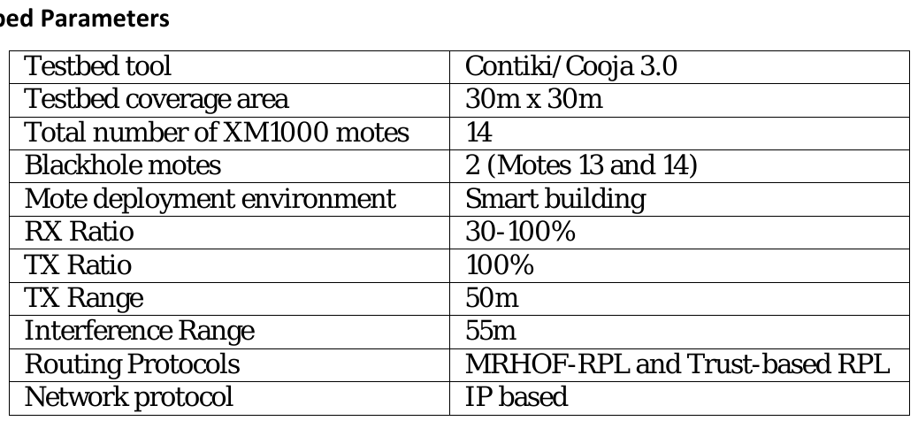
This is the setup our blackhole is compared with: 14 motes in a smart building, with two blackhole motes. Ours is smaller, with one attacker and seven boards.
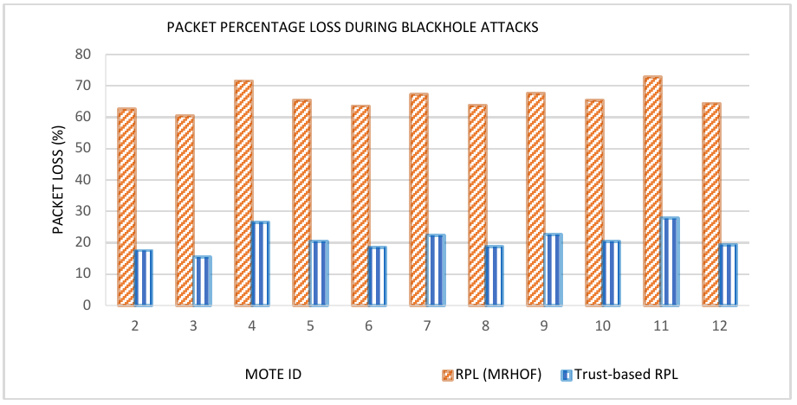
Exhibit 2. Packet loss under blackhole attacks. Adapted from Airehrour et al. [70, Figure 10]
Under the standard protocol, loss was 60 to 75%. We compare this with our child delivery ratio behind the attacker.
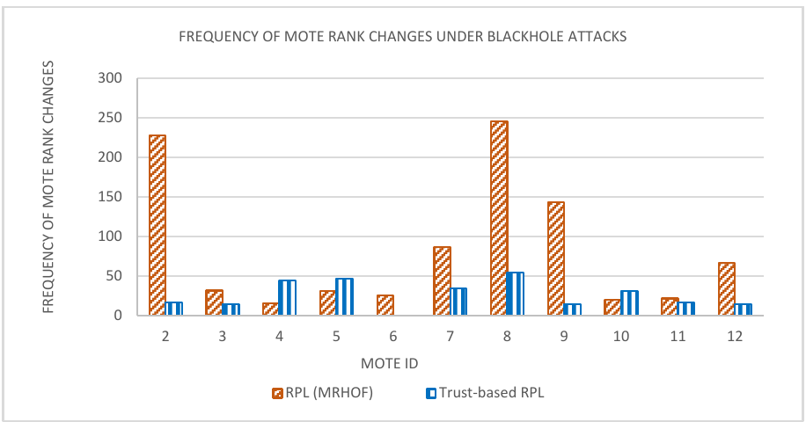
Exhibit 3. Frequency of mote rank changes. Adapted from Airehrour et al. [70, Figure 8]
Rank changes ranged from 16 to 246. We see almost no parent switches, which follows from our attack not touching routing.
Khan et al. [22], healthy ESP-MESH on the same platform
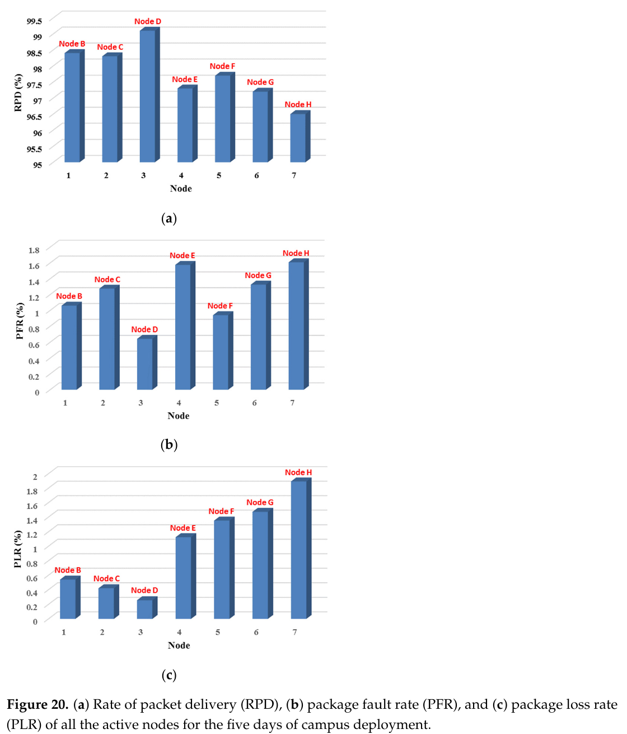
Exhibit 4. Received packet delivery, packet loss and forwarding ratio per node. Adapted from Khan et al. [22, Figure 20]
Delivery stayed between 96.5 and 99.1%, and loss under 1.8% except at one node. This is the reference for our baseline phase.
Exhibit 5. Network performance. Adapted from Khan et al. [22, Table 6]
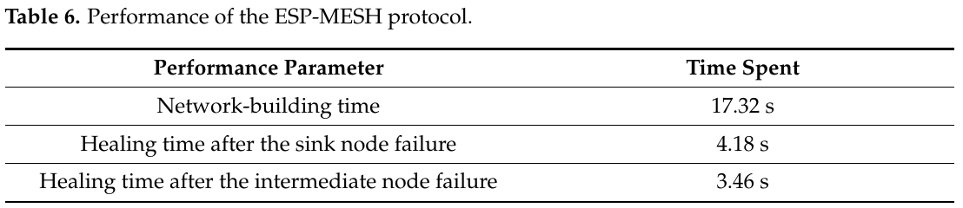
Zhukabayeva et al. [71], wormhole and sinkhole
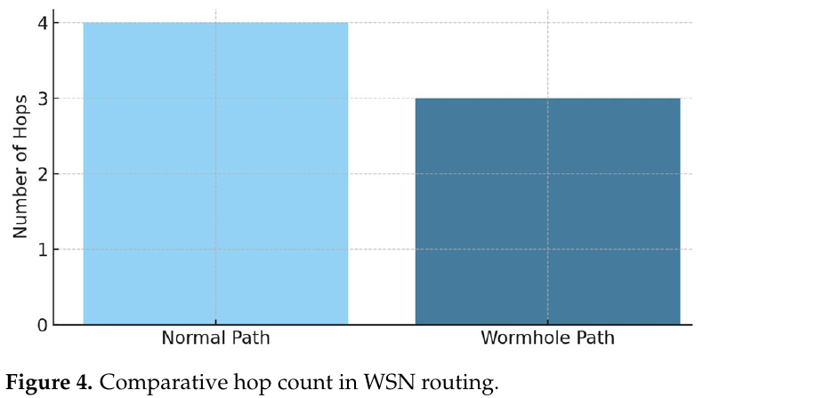
Exhibit 6. Hop count under the wormhole attack. Adapted from Zhukabayeva et al. [71, Figure 4]
The hop count falls under the attack. The text and this figure of the paper disagree on the numbers, so check before quoting them.
Exhibit 7. Changes in network parameters under a wormhole attack. Adapted from Zhukabayeva et al. [71, Table 7]
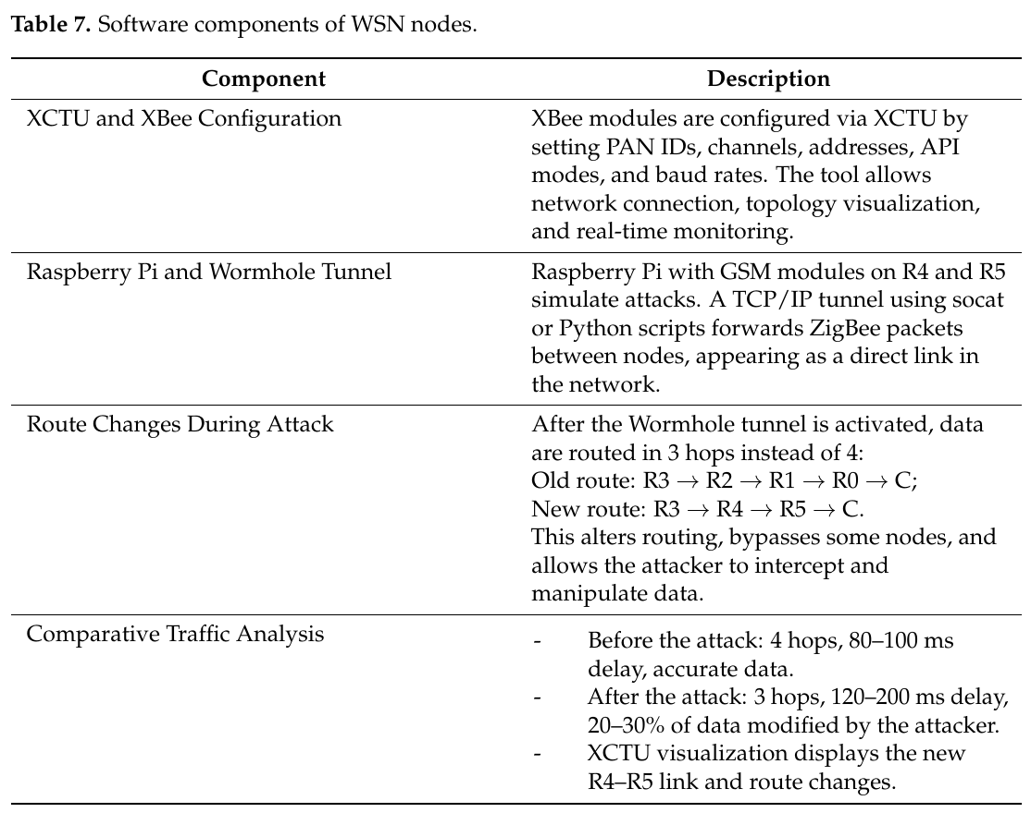
Delay rises and 20 to 30% of the data is modified. Our tunnel adds a shortcut but does not modify data.
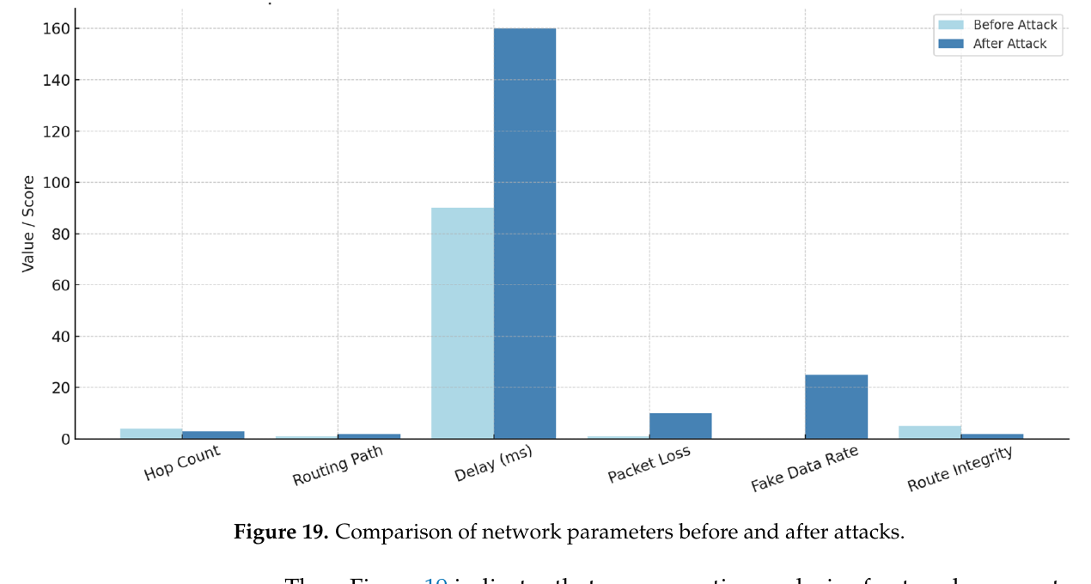
Exhibit 8. Network behaviour before and after the attack. Adapted from Zhukabayeva et al. [71, Figure 19]
Exhibit 9. Sinkhole event log. Adapted from Zhukabayeva et al. [71, Table 4]
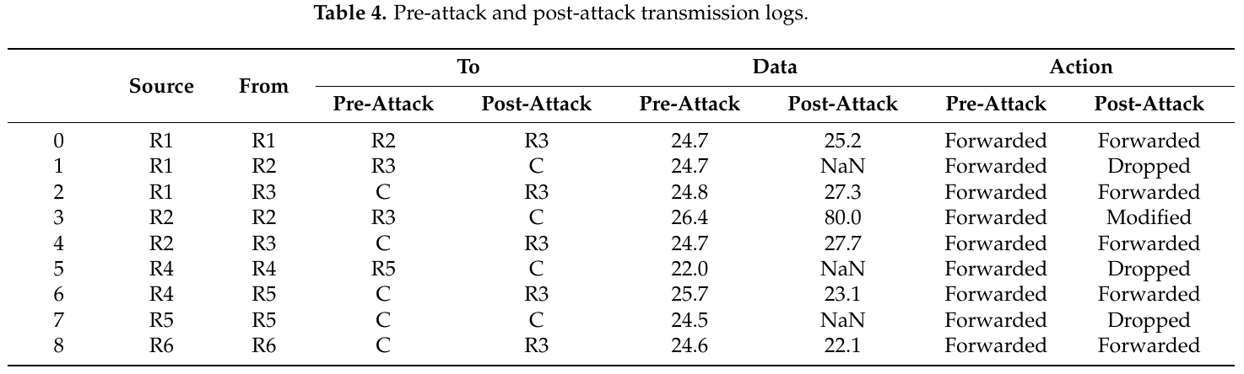
A node's packets change from Forwarded to Dropped or Modified. This is the closest published record of the behaviour our blackhole produces.
Ramírez Gómez et al. [72], wormhole on ZigBee
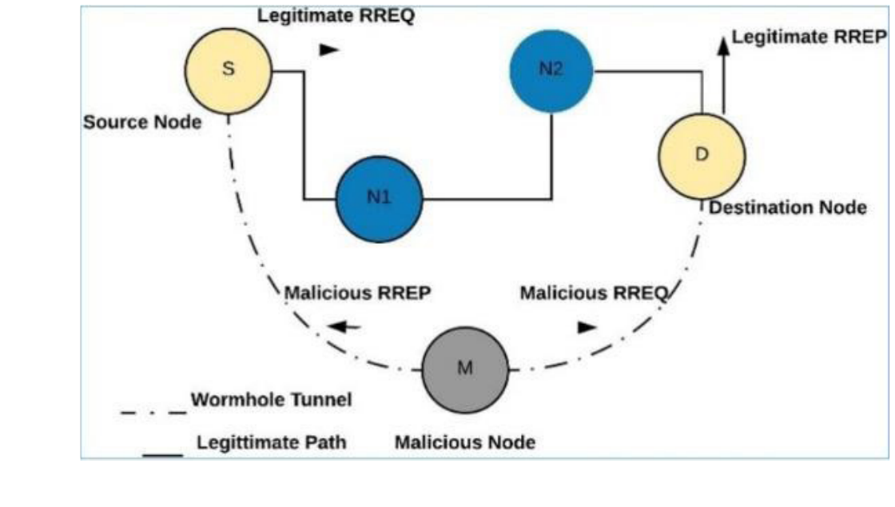
Exhibit 10. Wormhole attack setup. Adapted from Ramírez Gómez et al. [72, Figure 2]
Two nodes joined by an out-of-band link, with duplicated routing packets as the effect. Ours duplicates data packets, so the effect is related and not the same.

