## client’s vision/objective

The Electro-Optic Systems (EOS) 1.8m telescope is currently used for satellite and space debris tracking at Mt Stromlo Observatory in Canberra. In order to measure the wave front distortion of the light going through atmosphere, systems has been developed in both Electro-Optic Systems and ANU. Adaptive Optics system (AO) run by the Advanced Instrumentation and Technology Centre (AITC) is also required to receive reference from GSL and eliminate distortion for the telescope. AITC shows great interest to the ANU developed GSL trying to compare its’ performance with EOS developed GSL and probably the commercial GSL developed by Toptica.

(details in handover document)

## stakeholders and interrelation

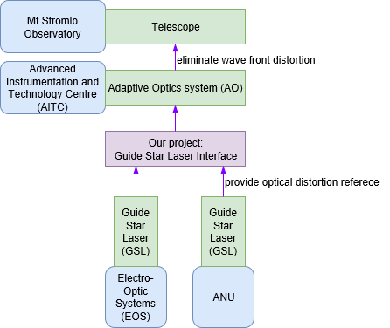

## expectations of clients and stakeholders

Previous group has done an excellent job in the system subsystem specification, requirement gathering and mechanical design. *we can refine the mechanical design and add some electrical design?*

## project milestones scheduling and deliverables

Detailed scheduling in ‘current status’ folder

## main constraints

* lots of requirement conflicts found between four systems: the 1.8m telescope and dome, the EOS GSL, Toptica GSL, and ANU GSL.
* Most of our team member are majoring mechatronics and electronics, so we don’t want to touch the optical interface design.
* Development of ANU GSL haven’t completed. We don’t have much ANU GSL information
* Unknow power availability in the dome and unknow cleanness of the air.

## resources, risks, potential costs

## Non-Disclosure Agreement and any Intellectual Property

*We need to sign the ‘Confidentiality Deed and IP Assignment_V6_2017S2’?*

## development approach

*ad-hoc or continuous?*