Software Requirements Specification

for

Elsa EDI Software

Version 1.0 approved

Prepared by Steeve Moyo

23/11/2022

Table of Contents

1. Introduction 1

1.1 Purpose 1

1.2 Intended Audience and Reading Suggestions 1

1.3 References 1

2. Overall Description 1

2.1 Product Features 1

2.2 Business Model 1

2.3 Sequence Diagrams 2

2.4 Architecture 2

Revision History

|  |  |  |  |
| --- | --- | --- | --- |
| **Name** | **Date** | **Reason for Changes** | **Version** |
| Document Creation | 23/11/2022 | Creation of the document | 1.0 |
|  |  |  |  |

# Introduction

## Purpose

The purpose of this project is to build a Proof of Concept of an EDI software like Microsoft Logic App. The logic is to use Http to receive data, decode, transform to other formats using a workflow build with Elsa Core Workflow Engine.

## Intended Audience and Reading Suggestions

This document is intended to be read by the product owner of the software Gary Zhang. We suggest to use this document as a base for the conception of the software.

## References

The main reference of this project is [Microsoft Logic Apps](https://learn.microsoft.com/en-us/azure/logic-apps/logic-apps-overview). It’s a cloud platform where you can create and run automated workflows with little to no code.

# Overall Description

## Product Features

For the proof of concept, the principal features to implement are:

* Split the software into two parts.
  + A process endpoint for the external user. On this part, the external will be able to see the list of existing processes and trigger it with specified data.
  + A Web console for the internal developers or IT guys. This part will be used to create new workflow definitions, activities or to list workflow instances.
* Give the possibility to a user to only see the workflow instances created by him and for the IT guys to see only his workflow definitions.

## Business Model

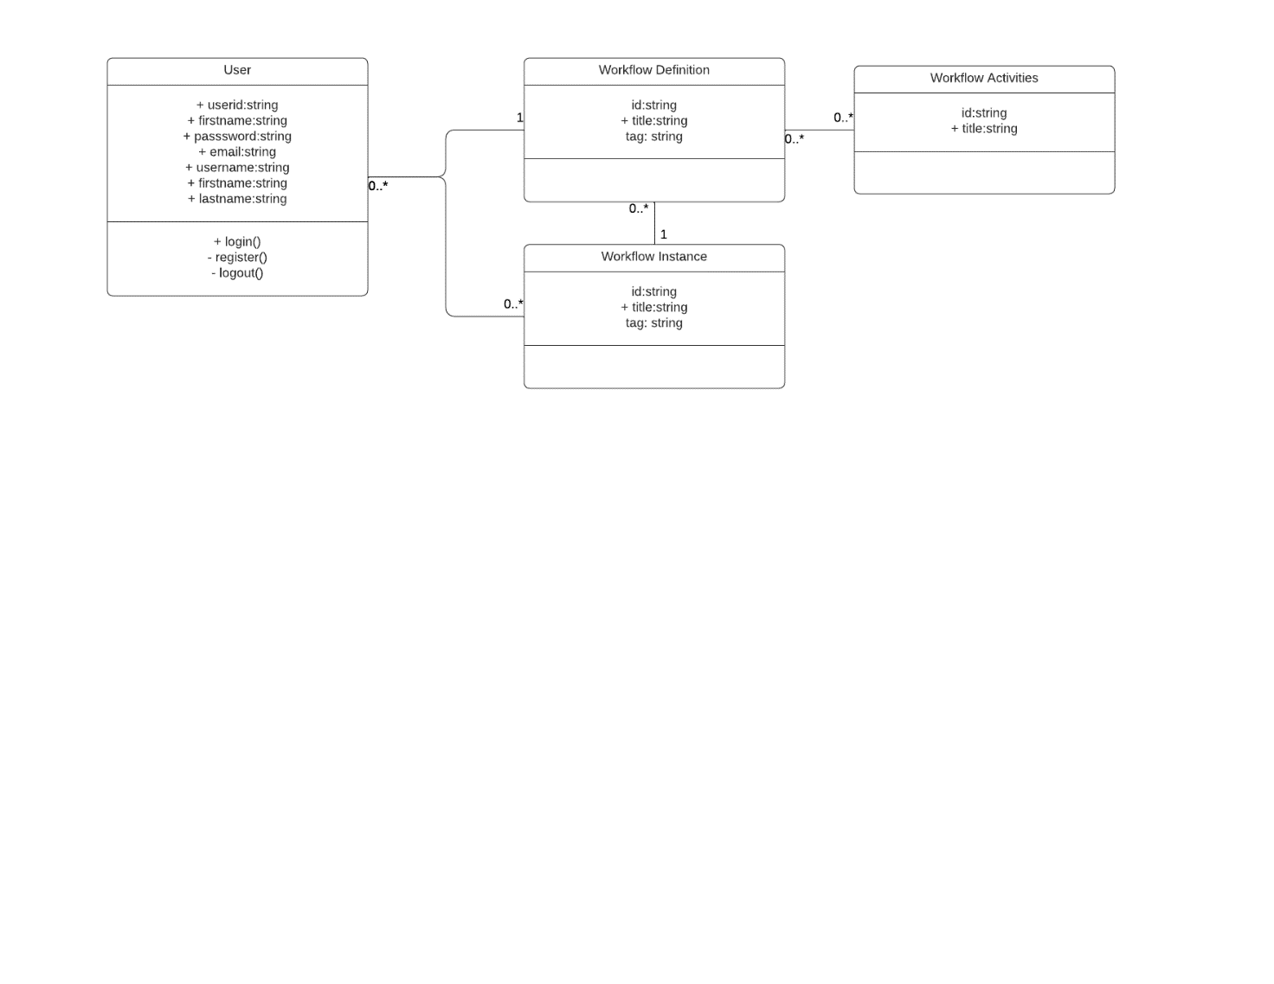

## Sequence Diagrams

## Architecture

