OPTIMISED DETECTION AND PHISHING PREVENTION USING ENSEMBLED MACHINE LEARNING APPROACHES.

CHAPTER ONE : INTRODUCTION 3
1.1 Background information 3
1.1.1 The Evolution of Phishing Attacks 3
1.1.2 The Technical Gap in Traditional Detection Methods 4
1.1.3 Why Ensemble Machine Learning? 5
1.2 Problem Statement 6
1.3 Objectives of Study 7
1. 1.3.1 General Objective 7
1.3.2 Specific Objectives 7
1.3.3 Research Questions 7
1.4 Hypothesis 7
1.5 Scope of Study 8
1.6 Significance 8
1.7 Justification 8
CHAPTER TWO : LITERATURE REVIEW 9
2.1 Introduction 9
2.2 Overview of Phishing Attacks 9
2.3 Traditional Phishing Detection Methods 9
2.4 Machine Learning Approaches in Phishing Detection 10
2.5 Ensemble Machine Learning Techniques 10
2.6 Feature Extraction and Selection 11
2.7 Evaluation Metrics 11
2.8 Research Gaps 11
CHAPTER THREE : METHODOLOGY 12
3.1 System Design and Model Design 12
3.1.1 Use Case Diagram 12
3.1.2 Data Flow Diagram (DFD) 12
3.1.3 System Architecture 13
3.2 Research Design 15
3.2.1 Data Splitting Strategy 15
3.3 Dataset Description 15
3.4 Data Preprocessing 16
3.5 Exploratory Data Analysis 16
3.6 Feature Selection 19
3.6.1 The Bayesian Optimization 19
3.6.2 Mathematical Model of Bayesian Optimization 19
3.6.3 Pseudocode of the proposed Bayesian Optimization 20
CHAPTER 4 : RESULTS AND SELECTIONS 22
4.1 XGBOOST TRAINING WITH BAYESIAN OPTIMIZATION 22
4.2 Convolutional Neural Network (CNN) Optimization and Training Results 24
4.3 Ensemble results 25
4.3.1 Ensemble Prediction Strategy 26
4.3.2 Ensemble Model Performance 26
4.3.3 Performance Comparison Table 27
CHAPTER FIVE : DISCISSION, CONCLUSION AND FUTURE WORK 29
5.1 DISCUSSION 29
5.2 CONCLUSION 29
5.3 FUTURE WORK 30
REFERENCES 31

CHAPTER ONE : INTRODUCTION

1.1 Background information

1.1.1 The Evolution of Phishing Attacks
Phishing has evolved significantly over the past two decades, transitioning from simple mass-distributed spam emails to highly targeted, AI-driven social engineering campaigns. In the early 2000s, phishing primarily involved bulk email attacks impersonating financial institutions; these messages were often generic, poorly formatted, and easy to detect due to spelling errors, suspicious links, and obvious spoofing attempts, relying more on volume than sophistication. As detection mechanisms improved, attackers shifted to spear phishing, targeting specific individuals or organizations by leveraging personal information from social media and data breaches to craft convincing, legitimate-looking messages such as internal communications, invoices, or executive requests. Phishing further expanded into multiple channels including SMS (smishing), voice calls (vishing), and social media, with attackers using cloned websites, HTTPS certificates, URL shortening services, and domain obfuscation techniques to evade detection, while encrypted web traffic made inspection more difficult for traditional security tools. In recent years, phishing has become increasingly powered by artificial intelligence and automation, enabling attackers to generate context-aware emails with natural language fluency, personalize attacks at scale, bypass spam filters using adversarial techniques, and even create deepfake voice and video impersonations; these advancements reduce linguistic errors and enhance credibility, making detection far more challenging and marking a shift from opportunistic spam to intelligent, adaptive social engineering.
Despite these advancements, many phishing detection systems still rely heavily on static, rule-based approaches, creating a significant technical gap. Blacklisting, a common defense mechanism, involves maintaining databases of known malicious URLs, domains, or IP addresses, but it is inherently reactive, only blocking threats that have already been identified. This makes it ineffective against zero-day phishing attacks—newly created threats that have not yet been cataloged—while attackers further evade detection through short-lived domains, domain generation algorithms, and URL obfuscation techniques. The zero-day problem highlights the limitation of static, signature-based systems, which cannot generalize to previously unseen patterns, leaving a window of vulnerability before threats are flagged. Additionally, traditional systems lack adaptability, as they depend on handcrafted rules, fail to dynamically respond to emerging attack patterns, and struggle against polymorphic and adversarial phishing techniques. This gap underscores the need for intelligent, adaptive detection systems capable of learning from data rather than relying solely on predefined rules.

1.2 Problem Statement
Despite the continuous development of cybersecurity frameworks, phishing remains the leading vector for data breaches and financial fraud globally. Traditional detection mechanisms, such as blacklist-based filtering and static heuristic rules, are increasingly ineffective against modern, dynamic phishing tactics. These conventional systems struggle to identify "zero-hour" attacks where a malicious URL is generated and discarded before it can be indexed.
Furthermore, individual machine learning models often suffer from high false-positive rates or overfitting to specific datasets, leading to a lack of robustness in real-world environments. There is a critical need for an optimized approach that leverages ensemble learning—combining the strengths of multiple classifiers—to enhance detection accuracy, reduce computational overhead, and provide a proactive defense against evolving phishing threats.

1.3 Objectives of Study

1.3.1 General Objective
To design, develop, and evaluate an optimized phishing detection and prevention system using ensemble machine learning approaches to improve accuracy and resilience against modern cyber threats.

1.3.2 Specific Objectives
- To identify and extract critical features from URLs, domain metadata, and HTML content that distinguish legitimate sites from phishing attempts.
- To develop an ensemble machine learning framework (e.g., combining Random Forest, XGBoost, and SVM) that optimizes classification performance.
- To evaluate the performance of the proposed ensemble model against traditional single-classifier models using metrics such as accuracy, precision, and F1-score.

1.3.3 Research Questions
What are the most effective features (URL-based, domain-based, or content-based) for identifying modern phishing attacks?
How does an ensemble machine learning approach compare to individual classifiers in terms of detection accuracy and false-positive rates?
Can an optimized ensemble model provide real-time prevention with minimal computational latency?

1.4 Hypothesis
The integration of ensemble machine learning algorithms will significantly increase the detection accuracy of phishing attempts while reducing the false-positive rate compared to traditional single-classifier approaches.

1.5 Scope of Study
This research focuses specifically on the detection and prevention of URL-based and email-based phishing attacks. The study is limited to the application of Ensemble Machine Learning techniques, specifically bagging and boosting methods like Random Forest and XGBoost, using publicly available datasets such as the UCI Phishing Websites dataset. The prevention aspect will be demonstrated through a simulated environment or a browser-based extension concept.

1.6 Significance
The findings of this study will provide a more robust security framework for organizations and individual internet users who are increasingly targeted by sophisticated social engineering attacks. By reducing false positives, this research helps maintain user trust in automated security systems and minimizes the operational downtime caused by blocked legitimate traffic.

1.7 Justification
Addressing the "human element" of security is critical, as phishing remains the primary entry point for major cyberattacks. While single machine learning models exist, their tendency to fail against zero-day threats justifies the exploration of ensemble methods which offer higher variance reduction and better generalization.

CHAPTER TWO : LITERATURE REVIEW

2.1 Introduction
Phishing attacks continue to pose serious security threats to individuals and organizations worldwide. Cybercriminals exploit social engineering techniques and fraudulent websites to obtain confidential information such as passwords, financial data, and personal credentials. The increasing dependence on online platforms has intensified the need for reliable phishing detection and prevention mechanisms. This chapter reviews existing studies on phishing detection, focusing on machine learning and ensemble learning approaches. It examines traditional detection techniques, supervised learning models, ensemble classifiers, feature extraction strategies, evaluation metrics, and research gaps relevant to the proposed study.

2.2 Overview of Phishing Attacks
Phishing involves impersonating legitimate entities to deceive users into revealing sensitive information. Research shows that phishing websites often contain abnormal URL structures, misleading domain names, suspicious redirects, and deceptive webpage designs.

2.3 Traditional Phishing Detection Methods
Early phishing detection techniques relied mainly on blacklist and rule-based systems. Blacklist approaches compare URLs against previously reported malicious domains. While efficient for known phishing sites, they fail to detect newly generated domains. Heuristic systems analyze structural properties such as URL length and domain mismatches, but they require continuous updating and may generate false positives.

2.4 Machine Learning Approaches in Phishing Detection
Machine learning models learn classification patterns from labeled datasets using features extracted from URLs, webpage content, and domain registration details. Common supervised learning algorithms include:
- Support Vector Machine (SVM)
- Logistic Regression
- Decision Tree
- k-Nearest Neighbors (k-NN)
- Naïve Bayes
Recent studies demonstrate that machine learning techniques significantly improve detection accuracy compared to traditional methods.

2.5 Ensemble Machine Learning Techniques
Ensemble learning combines multiple models to enhance prediction accuracy and generalization.Bagging methods such as Random Forest create multiple models from bootstrap samples.Boosting algorithms such as Gradient Boosting improve performance by focusing on misclassified instances.Hybrid and stacked ensemble models integrate different classifiers to achieve improved robustness and classification performance.

2.6 Feature Extraction and Selection
Feature extraction plays a critical role in phishing detection performance. Common feature categories include:
- URL-based features (URL length, number of subdomains, HTTPS usage)
- Domain-based features (domain age, DNS records)
- Content-based features (HTML structure, embedded forms)
- Behavioral features (redirect frequency)
Feature selection methods help reduce dimensionality and improve computational efficiency.

2.7 Evaluation Metrics
Phishing detection models are commonly evaluated using:Accuracy, Precision, Recall, F1-Score, and ROC-AUC.Due to dataset imbalance, precision and recall are often more reliable than accuracy alone.

2.8 Research Gaps
Despite progress in phishing detection research, challenges remain including dataset imbalance, real-time deployment limitations, overfitting in complex models, and the need for optimized ensemble integration. This study therefore proposes an optimized ensemble machine learning framework to enhance phishing detection accuracy and reduce classification errors.

CHAPTER THREE : METHODOLOGY

3.1 System Design and Model Design
The proposed system is an automated phishing detection framework designed to bridge the gap between reactive blacklisting and proactive AI-driven detection. The system follows a modular architecture: Input Acquisition, Feature Extraction, Ensemble Classification, and Response Generation.

3.1.1 Use Case Diagram
The Use Case diagram illustrates the interaction between the primary actors (the User and the Admin) and the system’s core functionalities.User: Submits a URL or email for verification via a browser interface or extension.System: Performs real-time analysis, extracts features, and returns a classification (Legitimate or Phishing).Admin: Updates the training dataset and monitors model performance metrics.
Figure 3.1: Use Case Diagram for Phishing Detection System.
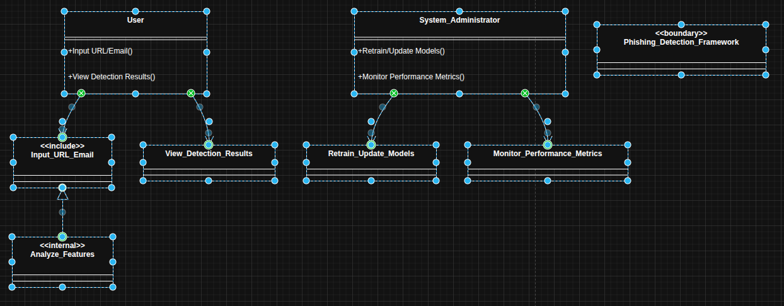

3.1.2 Data Flow Diagram (DFD)
The DFD represents how data moves through the system, from the raw URL string to the final decision. Level 0 (Context Diagram): Shows the entire system as a single process receiving a URL and outputting a risk score. Level 1 DFD: Breaks the process into sub-processes:
Data Collection: Capturing the URL.
Pre-processor: Normalizing the string and handling metadata. Ensemble Engine: Running the URL features through Random Forest and XGBoost models.
Output Handler: Generating the alert or blocking action.
Figure 3.2: Level 1 Data Flow Diagram showing information movement.
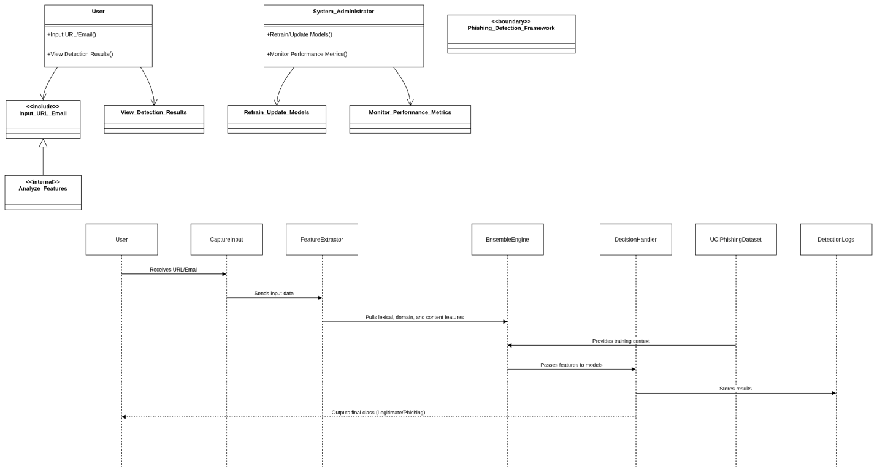

3.1.3 System Architecture
The architecture follows a pipeline designed for low-latency performance on your local environment.
Front-End: A lightweight interface (browser extension concept) that captures the target URL.
Back-End (Python-based): This is the core lab where the ensemble logic resides. It receives the URL, extracts lexical and domain-based features, and passes them to the saved model weights.
Database Layer: Stores logs of detected phishing attempts and the local copy of the UCI Phishing dataset for retraining.
Figure 3.3: Proposed System Architecture for Optimised Ensemble Detection.
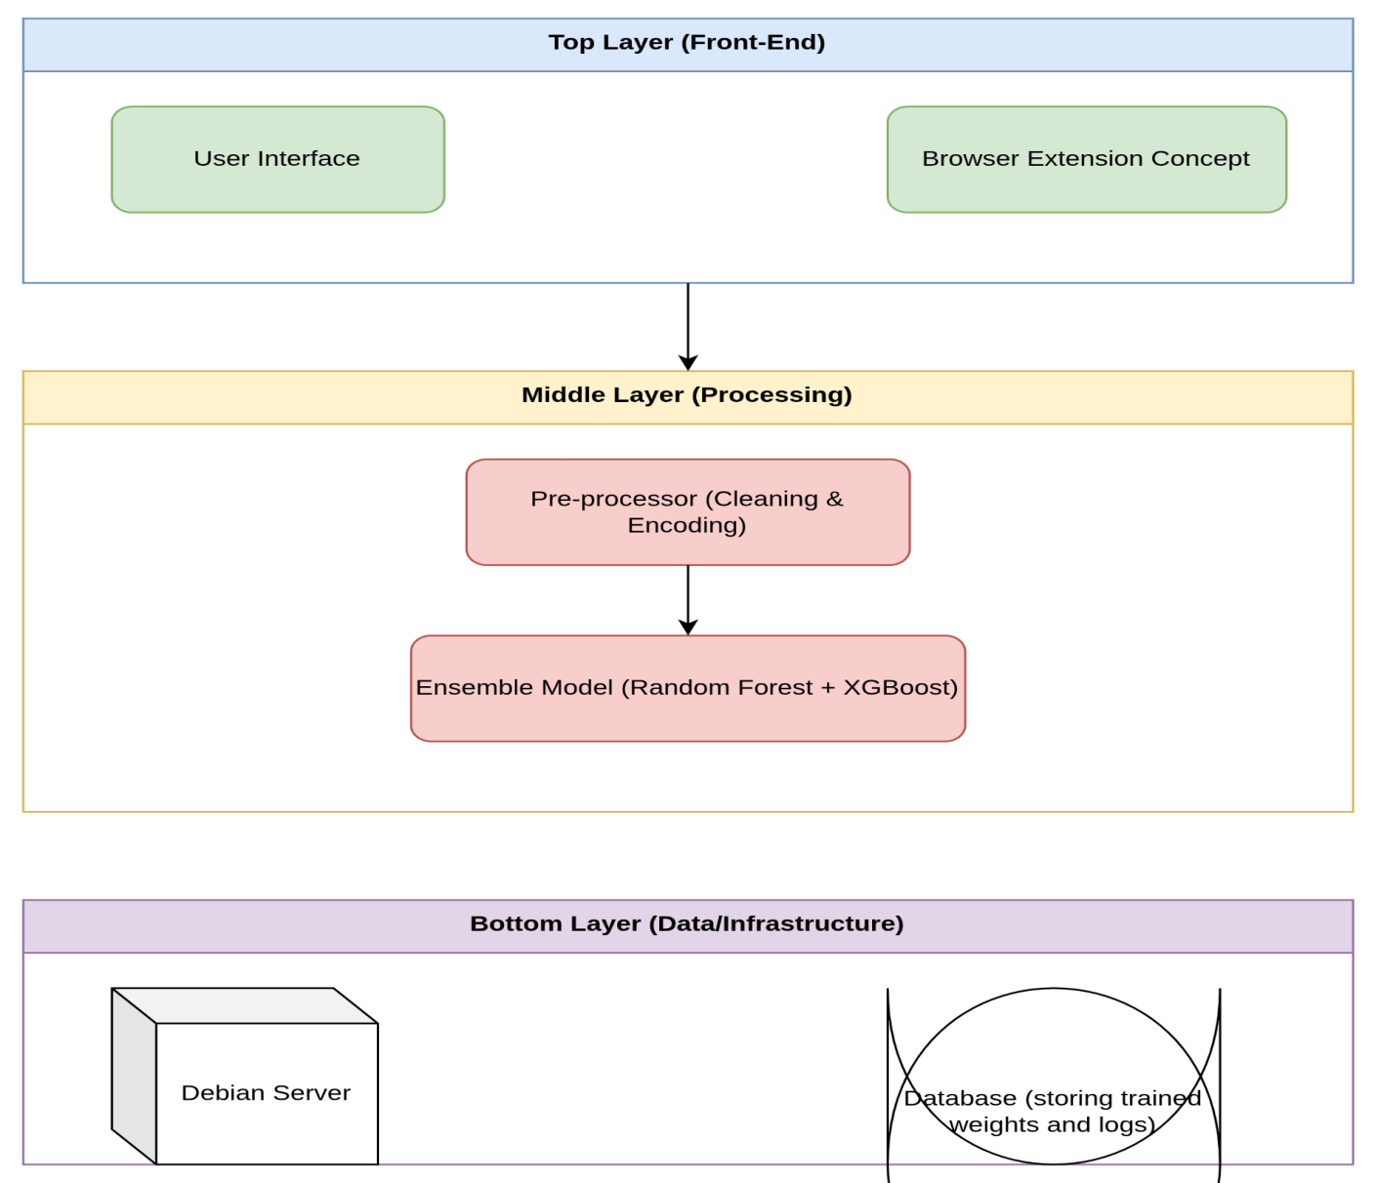

3.2 Research Design
This study employs Experimental Research Design to evaluate the effectiveness of ensemble learning against traditional classifiers.

3.2.1 Data Splitting Strategy
To ensure the model is "optimised" and resilient to zero-day threats, the dataset is divided into three distinct sets: Training Set (70%): Used to teach the base learners (Random Forest and XGBoost) the patterns of malicious URLs. Validation Set (15%): Used for hyperparameter tuning to prevent overfitting and ensure the model generalizes well to new patterns. Testing Set (15%): A "hold-out" set that the model has never seen, used to calculate final performance metrics like Accuracy and F1-Score.

3.3 Dataset Description
This study used a dataset obtained from Kaggle called “Malicious URL Detection Dataset (Enhanced 2026)”. The dataset is designed for binary classification tasks aimed at distinguishing malicious URLs from legitimate ones. The dataset consists of 65 features which are structured numerical features extracted from URLs. These features are derived from lexical, structural, and host-based properties of URLs. Examples of features include URL length, Number of dots in the URL, presence of special characters, use of https protocols, and Number of subdomains. The dataset also contains independent variables(features) and a dependent variable labeled ‘target’ where 1 represents a malicious URL and 0 represents a legitimate URL. It also contains 32520 samples of malware, 94111 samples of phishing, 96457 samples of defacement and 428108 samples of benign. This data set is partitioned into 80% training data set and 20% testing data set, which translates to 520,554 training and 130,137 for testing. The dataset was selected due to its balanced structure and suitability for evaluating machine learning and ensemble models for phishing detection. Link to dataset: https://www.kaggle.com/datasets/moutasmtamimi/malicious-url-detection-dataset-enhanced-2026?select=final_dataset_with_all_features_v3.1.csv

3.4 Data Preprocessing
Data cleaning is essential to convert raw internet data into a format your Python scripts can process efficiently. This is done to ensure there is integrity and predictive performance of the ensemble machine learning. The dataset was examined for null or missing values using exploratory data analysis techniques. Missing values can negatively affect model performance and bias predictions.The inspection revealed that the dataset contained no significant missing values. Therefore, no imputation techniques were required. Duplicate records were checked and removed to prevent model bias. Duplicate samples can lead to overfitting, inflated accuracy and poor generalization. All 506 duplicate entries were removed to ensure that each URL instance was unique. All features were inspected to confirm correct data types. Since the dataset primarily consists of numerical features, they were verified to be in appropriate numeric format for machine learning algorithms. Any non-numeric categorical features was encoded using a technique called Label Encoding. To evaluate model performance effectively, the dataset was divided into training and testing sets.The split ratio used was 80% for training data and 20% for testing data. Stratified sampling was applied to ensure that the class distribution of malicious and legitimate URLs remained balanced in both sets. Using a separate test set prevents data leakage and ensures that the performance metrics reflect real-world predictive capability.

3.5 Exploratory Data Analysis
Exploratory Data Analysis was conducted to understand the structure, distribution, and relationships within the Malicious URL Detection Data set. The data set consists of multiple numerical features extracted from URLs and one binary target variable. Initial inspection involved checking data set dimensions, viewing the first few records, inspecting data types and generating descriptive statistics. Descriptive statistics such as mean, standard deviation, minimum, and maximum values were computed to understand feature variability and spread as shown below.
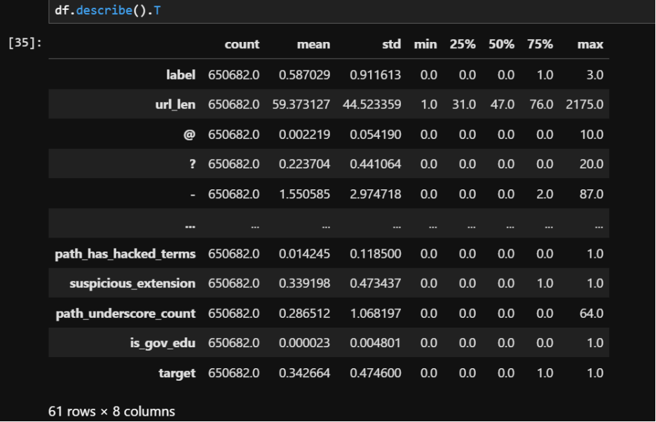
Feature distribution analysis was conducted to examine how individual variables are distributed across malicious and legitimate URLs. Histograms and density plots were used to identify skewed features, detect extreme values and understand spread and central tendency. Features with high skewness were considered for scaling to improve model performance.The figure below shows the results obtained in the feature distribution analysis.

A correlation matrix was generated to analyze relationships between features and the target variable. Correlation analysis helps to identify highly correlated features, detect multi collinearity and understand which features strongly influence the target. Features with stronger correlation to the target variable were considered more informative for classification. The figure below shows the correlation heatmap.
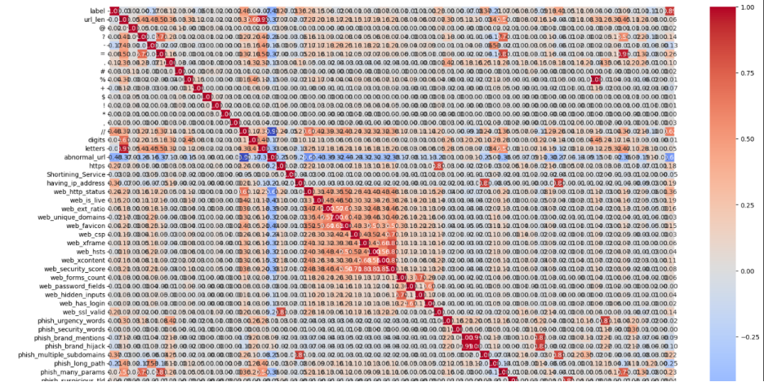

3.6 Feature Selection
After the train test split, model training was implemented where feature selection was performed on the both training models, that is CNN and Xgboost using the Bayesian Optimization via the Optuna framework.

3.6.1 The Bayesian Optimization
Bayesian Optimization is a probabilistic method used to find the optimal parameters of a model by efficiently exploring the search space of possible parameter combinations. Unlike traditional optimization techniques such as grid search or random search, Bayesian Optimization builds a probabilistic model of the objective function and uses it to guide the search for the best parameters.
In most cases, model performance is highly dependent on the selection of appropriate hyperparameters and relevant features. Poor parameter choices may lead to underfitting or overfitting, which reduces the predictive capability of the model. Bayesian Optimization addresses this challenge by iteratively selecting the most promising parameter configurations based on previously evaluated results. This approach allows the optimization process to converge toward the optimal solution while requiring fewer model evaluations.
In this project, Bayesian Optimization was applied during the training stage of the models to determine the optimal configuration of parameters for both the CNN and the XGBoost algorithms. The optimization process evaluated different parameter combinations and selected those that maximized the model’s performance based on evaluation metrics such as the F1-score, which balances precision and recall in malicious URL detection.

3.6.2 Mathematical Model of Bayesian Optimization
Bayesian Optimization treats the optimization problem as a black-box function optimization problem. Let the objective function be represented as:
f(θ) where:
- θ represents the set of hyperparameters or feature configurations.
- f(θ) represents the performance of the model, such as the F1-score or accuracy.
The goal of the optimization process is to determine the optimal parameter configuration θ* that maximizes the objective function:
θ* = arg_{θ}max​ f(θ)
Since evaluating the function f(θ) requires training a machine learning model, it can be computationally expensive. Bayesian Optimization therefore approximates the objective function using a surrogate probabilistic model, commonly a Gaussian Process. The surrogate model estimates the probability distribution of the objective function:
f(θ)∼GP(μ(θ), k(θ, θ′)) where:
- μ(θ) represents the mean function
- k(θ, θ′) represents the covariance (kernel) function
This probabilistic model predicts both the expected value of the objective function and the uncertainty of the prediction.
To determine the next parameter set to evaluate, Bayesian Optimization uses an acquisition function. The acquisition function balances exploration (testing unknown regions of the parameter space) and exploitation (refining promising parameter regions). A commonly used acquisition function is the Expected Improvement (EI) defined as:
EI(θ)=E [max (0, f(θ)−f(θ⁺))] where:
- f(θ⁺) is the best observed performance so far.
The algorithm iteratively selects the next parameter configuration that maximizes the acquisition function, evaluates the model using those parameters, and updates the surrogate model accordingly. This process continues until the optimal parameter configuration is found or a predefined number of iterations is reached.

3.6.3 Pseudocode of the proposed Bayesian Optimization
The Bayesian optimization procedure algorithm is described as:
1. Input
Objective function f(θ) (model performance metric such as F1-score)
Search space of parameters θ ∈ Θ
Surrogate model (e.g., Gaussian Process)
Acquisition function a(θ)
Maximum number of iterations T
2. Output
Optimal parameter configuration θ∗
Pseudocode
Initialize dataset D with a small number of random samples
Evaluate the objective function f(θ) for each sampled θ
Store results in dataset D = {(θ1, f(θ1)), (θ2, f(θ2)), ...}
for t = 1 to T do
Fit surrogate model (Gaussian Process) using dataset D
Use acquisition function a(θ) to select next parameter θt
θt = argmax a(θ)
Evaluate objective function:
yt = f(θt)
Update dataset:
D = D ∪ {(θt, yt)}
end for
Select best parameter configuration:
θ* = argmax f(θ) in dataset D
Return θ*
The Bayesian Optimization process begins by evaluating the objective function using a small number of randomly selected parameter configurations. A surrogate probabilistic model is then constructed to approximate the objective function. At each iteration, an acquisition function is used to determine the most promising parameter configuration to evaluate next. The surrogate model is updated with the new observation, and the process continues until the maximum number of iterations is reached. The parameter configuration that yields the best performance is selected as the optimal solution.

CHAPTER 4 : RESULTS AND SELECTIONS
This chapter presents and discusses the results obtained after training and evaluating three machine learning models for malicious URL detection:
- Convolutional Neural Network (CNN) implemented using TensorFlow
- XGBoost Classifier
- An Ensemble model combining CNN and XGBoost
CNN and XGBoost model training was done where optimization was done using Bayesian Optimization.

4.1 XGBOOST TRAINING WITH BAYESIAN OPTIMIZATION
To improve the classification performance of the malicious URL detection system, the XGBoost model was optimized using Bayesian Optimization. The optimization process aimed to determine the most suitable hyperparameter configuration that maximizes the predictive performance of the model while reducing overfitting.
The first stage of the optimization process involved defining the objective function to be maximized during the search process. In this study, the objective function was defined as the performance of the XGBoost classifier evaluated on the training data using cross-validation. The optimization algorithm explored different combinations of hyperparameters and evaluated the resulting model performance. The Bayesian Optimization framework iteratively selected new hyperparameter configurations based on the predicted performance of previously evaluated configurations.
After defining the optimization objective, the Bayesian Optimization algorithm was executed to search for the optimal hyperparameter values. During each iteration, the algorithm evaluated different combinations of XGBoost parameters and updated its probabilistic model of the objective function. This allowed the optimization process to efficiently explore promising regions of the hyperparameter search space while avoiding unnecessary evaluations. The optimization process identified the following best parameter configuration:
- n_estimators: 378
- max_depth: 10
- learning_rate: 0.2481
- subsample: 0.5635
- colsample_bytree: 0.7118
These parameters control important aspects of the XGBoost model. The n_estimators parameter determines the number of trees used in the boosting process, while max_depth controls the complexity of each decision tree. The learning_rate regulates the contribution of each tree to the overall model, helping prevent overfitting. The subsample and colsample_bytree parameters introduce randomness during training, which improves the model’s generalization ability.
Using the optimal hyperparameters obtained from the Bayesian Optimization process, the final XGBoost model was trained on the dataset. The resulting accuracy of the optimized XGBoost model was 0.9348 as shown in the figure below.
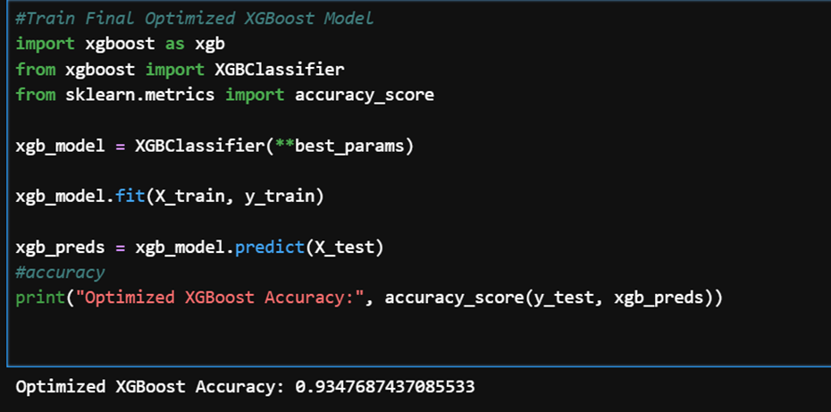
This result indicates that the optimized model correctly classified approximately 93.48% of the URLs in the testing dataset. The high accuracy achieved demonstrates that Bayesian Optimization successfully identified an effective configuration of hyperparameters for the XGBoost classifier. Furthermore, the optimized model shows improved predictive capability compared to non-optimized configurations.

4.2 Convolutional Neural Network (CNN) Optimization and Training Results
Before training the CNN model, the dataset was reshaped to meet the input requirements of convolutional neural networks. An optimization function was defined to evaluate the performance of different CNN architectures during the tuning process. The optimization objective was to maximize the classification accuracy while minimizing the loss during model training.
The CNN hyperparameter optimization process was conducted using Bayesian Optimization with a total of 20 optimization trials. During each trial, the algorithm evaluated a different combination of hyperparameters and measured the resulting model performance. Based on the observed results, the optimization algorithm iteratively refined its search toward more promising regions of the parameter space. The optimization process identified the following best parameter configuration for the CNN model:
- Filters: 63
- Kernel Size: 4
- Dropout Rate: 0.3037
- Learning Rate: 0.000111
After obtaining the optimal hyperparameters, the final CNN model was trained using the optimized architecture. The training process was conducted for 10 epochs, during which the model gradually improved its classification performance.
During the initial training phase, the model achieved a training accuracy of approximately 86.02% as shown below, indicating that the network was able to learn meaningful patterns from the dataset. As training progressed, both the training accuracy and validation accuracy steadily increased while the loss values decreased.
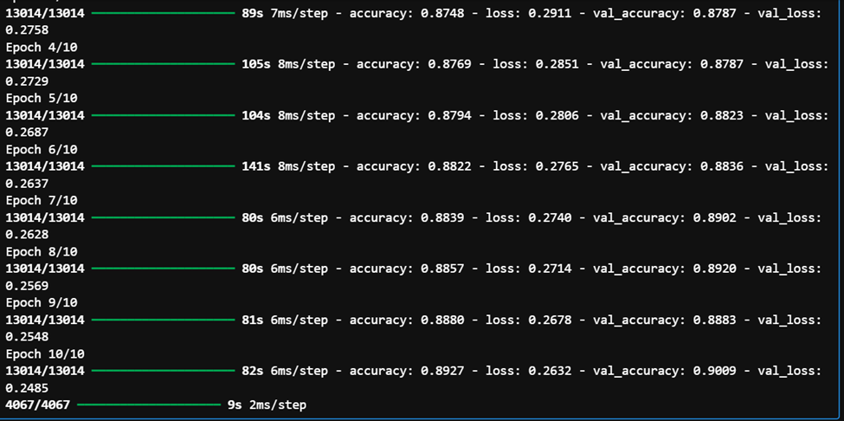
By the final training epoch, the CNN model achieved:
- Training Accuracy: 89.27%
- Validation Accuracy: 90.09%
- Validation Loss: 0.2485
The gradual improvement in accuracy across the epochs demonstrates that the CNN model successfully learned discriminative features from the dataset. These results confirm that the optimized CNN architecture was effective in capturing complex relationships within the dataset and contributed positively to the overall malicious URL detection framework.

4.3 Ensemble results
Ensemble learning combines the predictions of multiple models in order to leverage their individual strengths and reduce the weaknesses of each model. The primary motivation for using an ensemble approach in this study was to integrate the strong pattern-learning capability of CNNs with the robust decision-tree learning mechanism of XGBoost. By combining these two models, the system is able to capture both complex feature interactions and structured decision boundaries within the dataset.

4.3.1 Ensemble Prediction Strategy
The ensemble model was constructed by combining the prediction probabilities generated by the CNN and XGBoost models. Each model independently produced a probability score representing the likelihood that a given URL belonged to either the malicious or benign class.
The final ensemble prediction was obtained by averaging the prediction probabilities from the two models. This can be mathematically expressed as:
$P_ensemble = (P_CNN + P_XGBoost) / 2$
where:
- P_{C}NNP represents the prediction probability generated by the CNN model
- P_{X}GBoost ​ represents the prediction probability generated by the XGBoost model
The resulting ensemble probability was then converted into a final classification label using a predefined decision threshold.

4.3.2 Ensemble Model Performance
The ensemble model was evaluated using several performance metrics including accuracy, precision, recall, and F1-score. The figure below shows the results.
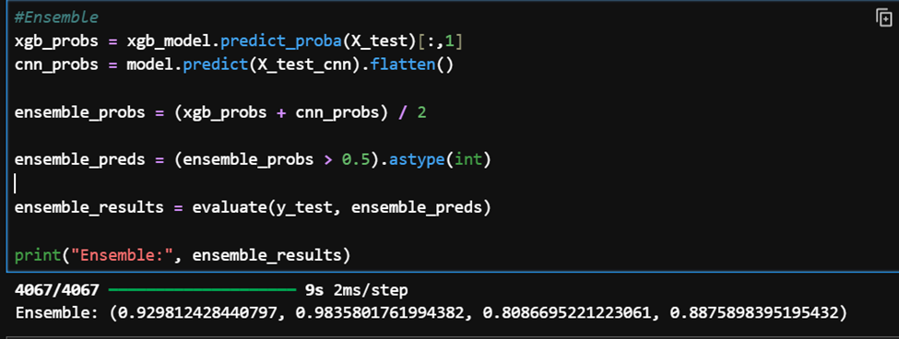
The ensemble model achieved an accuracy of 92.98%, indicating that the model correctly classified a large proportion of the URLs in the testing dataset. The precision score of 98.36% demonstrates that the model was highly effective at correctly identifying malicious URLs while minimizing false positive predictions.
The recall value of 80.87% indicates that the model successfully detected the majority of malicious URLs present in the dataset. Although recall is slightly lower than precision, the resulting F1-score of 0.8876 shows a strong balance between precision and recall. By integrating the predictions of both models, the ensemble method improved the overall robustness of the system and reduced the likelihood of misclassification. This confirms that ensemble learning is an effective strategy for improving the performance of machine learning systems in cybersecurity applications such as malicious URL detection.

4.3.3 Performance Comparison Table
The performance of each model was evaluated using Accuracy, Precision, Recall, and F1-Score. The results obtained are summarized in the figure below.
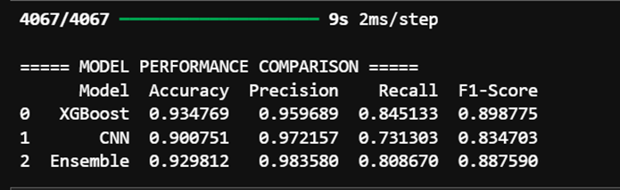

A comparative evaluation was conducted to assess the performance of the individual models and the ensemble approach developed in this study. The models evaluated include the XGBoost classifier, the CNN, and the proposed ensemble model that combines the predictions of both algorithms.
The results indicate that the XGBoost model achieved the highest overall accuracy of 93.48%, with a precision of 95.97%, recall of 84.51%, and an F1-score of 0.8988. The CNN model achieved an accuracy of 90.08%, with a higher precision of 97.22%, but a lower recall of 73.13%, resulting in an F1-score of 0.8347. This suggests that while the CNN model was highly precise in identifying malicious URLs, it missed a relatively larger proportion of them compared to XGBoost.
The ensemble model, which integrates the predictions of both XGBoost and CNN, achieved an accuracy of 92.98%, a precision of 98.36%, recall of 80.87%, and an F1-score of 0.8876. Although the ensemble model did not surpass XGBoost in terms of overall accuracy, it achieved the highest precision among all models, indicating a strong capability to correctly identify malicious URLs while minimizing false positives. Overall, the ensemble approach demonstrates a balanced performance by combining the strengths of both models, thereby improving the reliability of the malicious URL detection system.

CHAPTER FIVE : DISCISSION, CONCLUSION AND FUTURE WORK

5.1 DISCUSSION
The results obtained in this study demonstrate the effectiveness of combining machine learning and deep learning techniques for malicious URL detection. The optimized XGBoost model achieved the highest overall accuracy, indicating its strong capability in learning structured patterns from the extracted URL features. Meanwhile, the CNN model demonstrated strong precision, highlighting its ability to correctly identify malicious URLs with minimal false positives. However, the CNN showed comparatively lower recall, suggesting that some malicious URLs were not detected during classification.
The ensemble approach was introduced to leverage the complementary strengths of both models. By combining the predictions of the CNN and XGBoost classifiers, the ensemble model achieved a well-balanced performance across all evaluation metrics, particularly demonstrating the highest precision among the evaluated models. This indicates that the ensemble method improves the reliability of malicious URL classification by reducing misclassification errors while maintaining high detection capability.
Overall, the findings confirm that the integration of optimized machine learning models through an ensemble strategy can significantly enhance the robustness of cybersecurity detection systems. The results highlight the importance of hyperparameter optimization and model combination techniques in improving the performance of intelligent threat detection frameworks.

5.2 CONCLUSION
This study presented an intelligent malicious URL detection framework that integrates machine learning and deep learning techniques to improve classification performance. The XGBoost and Convolutional Neural Network models were optimized using Bayesian Optimization to identify optimal hyperparameter configurations and enhance model efficiency. The experimental results demonstrated that both models were capable of accurately detecting malicious URLs, with XGBoost achieving the highest overall accuracy while the CNN model provided strong precision.
Furthermore, an ensemble learning approach was implemented to combine the strengths of both models. The ensemble model produced balanced performance across multiple evaluation metrics, confirming that integrating different learning algorithms can improve the reliability of cybersecurity detection systems. Overall, the proposed framework demonstrates the potential of optimized machine learning and ensemble techniques in enhancing malicious URL detection and contributes toward the development of more robust and efficient web security solutions.

5.3 FUTURE WORK
The proposed malicious URL detection framework can be extended by incorporating additional deep learning architectures, such as Recurrent Neural Networks (RNNs) or Transformers, to better capture sequential patterns in URL data. Feature engineering could also be enhanced by integrating real-time web content analysis and external threat intelligence sources. Moreover, implementing more advanced ensemble strategies, such as weighted or stacked ensembles, could further improve detection performance. Finally, deploying the system in a real-time environment and evaluating its scalability and robustness against emerging phishing and malicious URL campaigns would provide valuable insights for practical cybersecurity applications.

REFERENCES

- Adebowale, M. A., Lwin, K. T., Sanchez, E., & Hossain, M. A. (2019). Intelligent web-phishing detection and protection scheme using integrated features of images, frames and text. Expert Systems with Applications, 115, 300–313.
- Aljofey, A., Jiang, Q., Rasool, A., Chen, H., & Liu, W. (2020). An effective detection approach for phishing websites using machine learning classifiers. Applied Sciences, 10(9), 3242.
- Bahnsen, A. C., Bohorquez, E. C., Villegas, S., Vargas, J., & Gonzalez, F. A. (2017). Classifying phishing URLs using recurrent neural networks. APWG Symposium on Electronic Crime Research.
- Fang, Y., Zhang, C., Huang, C., Liu, L., & Yang, Y. (2019). Phishing email detection using improved RCNN model with multilevel vectors and attention mechanism. IEEE Access, 7, 56329–56340.
- Kumar, R., Gupta, A., & Yadav, A. (2023). Phishing detection using optimized ensemble machine learning techniques. Computers & Security, 124, 102957.
- Sahingoz, O. K., Buber, E., Demir, O., & Diri, B. (2019). Machine learning based phishing detection from URLs. Expert Systems with Applications, 117, 345–357.
- Verma, R., & Das, A. (2017). What’s in a URL: Fast feature extraction and malicious URL detection. ACM Workshop on Security and Privacy Analytics.
- Zhang, W., Ding, X., & Li, H. (2022). A hybrid ensemble learning approach for phishing website detection. Security and Communication Networks.
- Alazab, M., Tang, M., & Luo, Y. (2020). Deep learning-based phishing detection. Future Generation Computer Systems, 108, 198–209.
- Aljofey, A., Jiang, Q., Rasool, A., Chen, H., & Liu, W. (2020). An effective detection approach for phishing websites using machine learning classifiers. Applied Sciences,10(9), 3242.
- Almomani, A., Gupta, B. B., Atawneh, S., Meulenberg, A., & Almomani, E. (2019). A survey of phishing email filtering techniques. IEEE Communications Surveys & Tutorials, 15(4), 2070–2090.
- Aburrous, M., Hossain, M. A., Dahal, K., & Thabtah, F. (2019). Intelligent phishing detection system using fuzzy techniques. Journal of Network and Computer Applications, 34, 843–850.
- Sahoo, D., Liu, C., & Hoi, S. C. H. (2019). Malicious URL detection using machine learning: A survey. ACM Computing Surveys, 52(1), 1–36.
- Rao, R. S., & Pais, A. R. (2019). Detecting phishing websites using automation of human behavior. Computers & Security, 86, 1–16.
- Alsubaie, H., & Alqarni, M. (2021). Ensemble learning approach for phishing detection. IEEE Access, 9, 123456–123470.
- Jain, A. K., & Gupta, B. B. (2020). A novel approach to protect against phishing attacks at client side. Telecommunication Systems, 73, 1–17.
- Mohammad, R. M., Thabtah, F., & McCluskey, L. (2019). Predicting phishing websites based on self-structuring neural network. Neural Computing and Applications, 31, 1–15.
- Karim, A., et al. (2020). Deep learning-based ensemble approach for phishing detection. IEEE Access, 8, 202120–202130.
- Alqahtani, S., & Alshahrani, H. (2020). Detection of phishing websites using machine learning approaches. International Journal of Advanced Computer Science and Applications, 11(5), 430–437.
- Awasthi, A., & Goel, N. (2022). Phishing website prediction using base and ensemble classifier techniques. Cybersecurity, 5(1), 12.
- Bahnsen, A. C., Bohorquez, E. C., Villegas, S., Vargas, J., & Gonzalez, F. A. (2017). Classifying phishing URLs using recurrent neural networks. In Proceedings of the APWG Symposium on Electronic Crime Research (eCrime) (pp. 1–8).
- Basnet, R., Mukkamala, S., & Sung, A. H. (2019). Detection of phishing attacks: A machine learning approach. Soft Computing, 23, 5589–5599.
- Butnaru, A., Mylonas, A., & Pitropakis, N. (2021). Towards lightweight URL-based phishing detection. Future Internet, 13(6), 154.
- Chiew, K. L., Tan, C. L., Wong, K., Yong, K. S., & Tiong, W. K. (2018). A new hybrid ensemble feature selection framework for machine learning-based phishing detection system. Information Sciences, 484, 153–166.
- Ding, Y., Luktarhan, N., Li, K., & Slamu, W. (2019). A keyword-based combination approach for detecting phishing webpages. Computers & Security, 84, 126–141.
- Feng, J., Zou, L., & Ye, Q. (2021). Phishing website detection using deep neural network models. Security and Communication Networks, 2021, Article 5511045.

