**Patterns of speciation under adaptation from standing genetic variation**

Ken A. Thompson1,2,3, Matthew M. Osmond2,3, Dolph Schluter2,3

1Corresponding author. Thompson, K.A. email: [kthomp1063@gmail.com](mailto:kthomp1063@gmail.com).

2Biodiversity Research Centre, University of British Columbia, Vancouver, Canada

3Department of Zoology, University of British Columbia, Vancouver, Canada

**Abstract**

When populations adapt in allopatry, they often fix alternative mutations that are incompatible in hybrids and thus contribute to speciation. If adaptation is largely from standing genetic variation (SGV) rather than new mutation, however, populations can fix the same mutations, reducing hybrid incompatibility. Here, we use simulations to explore the genetics of adaptation from SGV and the associated implications for speciation. We find that the main effect of SGV is to reduce reproductive isolation between populations undergoing parallel adaptation, supporting earlier verbal theory. However, if there is an excess of SGV in the ancestral population, there are many alternative paths to any given optimum and populations readily fix incompatibilities from SGV. We also find that, due to geometric features of the adaptive process, the opportunity for parallel genetic adaptation from SGV decreases faster than linearly as environments become more dissimilar. We conclude that there is no consistent effect of SGV on speciation. Rather, the effect of SGV on speciation depends on the balance between the characteristics of the SGV and the environments to which populations are adapting. Importantly, processes akin to ‘mutation-order’ speciation can occur even when adaptation is from SGV. Our study demonstrates that SGV can, under some circumstances, have a substantial effect on the process of speciation, and provides a general mechanism to explain the widespread correlation between ecological divergence and reproductive isolation. Further study is needed to evaluate whether adaptation from SGV is an important factor driving the dynamics of speciation in natural populations.

Keywords: Fisher’s geometric model; ecological speciation; mutation-order speciation; simulation;

Natural selection can directly contribute to the origin of species (Coyne and Orr 2004). This largely occurs because populations fix different alleles during the process of adaptation that, when combined, cause hybrids to suffer reduced fitness. Divergent natural selection favours different alleles in different populations, and the fixation of these different alleles leads to hybrids that are maladapted to either parental environment (Hatfield and Schluter 1999; Schluter 2000). Parallel natural selection, by contrast, favours the same alleles in different populations. Although parallel selection may favour the same alleles, allopatric population may encounter alternative adaptive alleles due to chance processes in which mutations occur in the population (Mani and Clarke 1990). Through this ‘mutation-order’ pathway, parallel natural selection can lead to the evolution of reproductive isolation (hereafter *RI*) if these alternative alleles are incompatible in hybrids (Schluter 2009). To this end, identifying the mechanisms through which natural selection drives the evolution of RI is a central pillar of speciation research.

Empirical evidence suggests that divergent natural selection generates reproductive isolation more readily than parallel selection. The strongest evidence comes from a meta-analysis conducted by Shafer and Wolf (2013), who found that ecological divergence between taxa directly explained neutral divergence when controlling for isolation by distance. This result of widespread ‘isolation-by-ecology’ in natural populations indicates that ecological divergence between taxa directly leads to reduced gene flow and/or increased RI. This evidence, while valuable, is strictly correlative and the causality could easily be reversed. For example, data from both Riesch et al. (2017) and Stuart et al. (2017) suggest that gene flow constrains ecological divergence between populations. By sidestepping issues of correlation, theoretical studies can shed light on the conditions under which divergent and parallel selection cause the evolution of RI.

Several theoretical studies have investigated the link between parallel and divergent adaptation and the evolution of reproductive isolation. The most relevant study is that of Chevin et al. (2014), who found that the rate at which ‘intrinsic’ incompatibilities accumulate between allopatric populations is identical when they adapt to the same optimum (i.e., mutation-order speciation) or different optima (i.e., ecological speciation). This conclusion does not predict the positive correlation between ecological divergence and gene flow (Shafer and Wolf 2013) or components of reproductive isolation (Funk et al. 2006) that have been documented in a wide range of natural populations.

To date, most models of ‘speciation-by-selection’ (including Chevin et al. 2014) have assumed that all adaptation comes from random *de novo* mutations. This assumption is likely valid for tests of adaptation in laboratory experiments where founding populations lack variation (Elena and Lenski 2003), or when considering large evolutionary changes over long timescales. In natural populations, however, much adaptation, especially during the short term, proceeds via the sorting of existing, ancestral, standing genetic variation (hereafter *SGV*) (Barrett and Schluter 2008). The ability to adapt from standing genetic variation permits independent populations to fix identical alleles during adaptation. Indeed, a recent survey estimated that between 32 % and 55 % QTL are reused in populations adapting to parallel selection (Conte et al. 2012). Parallel genetic evolution is expected to lower the ease with which parallel natural selection leads to speciation (Schluter and Conte 2009), because incompatibilities are less likely to arise if populations undergo parallel genetic adaptation.

In this article, we investigate how adaptation from SGV affects the process through which natural selection drives the evolution of RI between populations. Using simulations, we provide evidence that adaptation from SGV can slow the evolution of RI, but that the strength of this effect likely varies among taxa. We conclude that incorporating adaptation from SGV into models of ‘speciation-by-selection’ improves the alignment between empirical results and theoretical predictions.

**The model**

*General approach: Fisher’s Geometric Model*  
We used simulations to investigate the role of SGV in speciation. Our simulations use the framework of Fisher's (1930) Geometric Model of Adaptation (FGM). In FGM, adaptation is a ‘geometric’ process wherein populations adapt by fixing phenotypically additive mutations to reach a phenotypic optimum (Fig. 1A) (Orr 2005; Tenaillon 2014). The greatest advantage of FGM is that it makes clear predictions which are testable in empirical systems. Several such predictions have received support in both laboratory and field studies (MacLean et al. 2010; Rogers et al. 2012; Stearns and Fenster 2016). While originally developed by Fisher (1930) to make inferences about the genetics of adaptation, the model has been adapted to study the evolutionary genetics of speciation (Barton 2001; Chevin et al. 2014; Fraïsse et al. 2016). For these reasons, FGM is an ideal framework in which to investigate the effects of adaptation from SGV as it relates to speciation.

*Simulation mechanics*We used individual-based simulations to investigate the role of standing genetic variation in speciation. We consider the case of a single founder population that seeds two populations which then adapt in allopatry (i.e., no gene flow). The phenotype of a haploid individual is represented by an *m*-dimensional vector, *z* = [*z*1, *z*2,…,zm], where *m* is the number of independent ‘traits’ (see Table 1 for descriptions of all parameters). We assume a sexual life cycle with non-overlapping generations. Viability selection occurs at the beginning of each generation, during the haploid phase. The probability a haploid individual survives is a Gaussian function of its phenotypic distance to the optimum (cite an equation somewhere). If the number of survivors exceeds the carrying capacity, *K*, then survivors are randomly culled to a haploid population size of *K*. Surviving haploids then randomly conjugate and immediately undergo meiosis, with free recombination between all loci, to produce the next generation of haploids. Each diploid generates 2*B,* potentially unique, haploid offspring. Each haploid offspring acquires a new mutation with probability *μ*. We assume universal pleiotropy such that each mutation affects all traits, with the effect of a mutation on each trait being independently drawn from a normal distribution with mean of 0 and SD of *σ*.

The mechanics of our simulations have their basis in realistic geographic models of speciation. A typical model of speciation in fishes of postglacial lakes begins with the splitting of an ancestral population, subsequent adaptation in allopatry, followed by secondary contact in sympatry (Svärdson 1961). Similar patterns seem common in other taxa, such as plants (e.g., Pettengill and Moeller [2012]) and birds (summarized by Price [2008]).

The simulations were written in Python (version 3.5.1, www.python.org) and data were plotted using R (R Core Team 2014). All code and data associated with this article is archived on [Dryad], and instructions to generate all results contained herein are included. (Cite packages and software version in final draft) (Include link to GitHub for reviewers).

*Generating ancestral standing genetic variation*Populations in our simulations adapt from varying amounts of ancestral SGV. To generate ancestral SGV, we first generate a list of *n* mutations; mutations in the SGV have identical properties to those which arise in adapting populations (i.e., drawn from a normal distribution with mean of 0, SD of *σ*). We vary the quantity of SGV by varying *n*. We then generate an ancestral population with *K* haploid individuals, where each individual inherits each mutation with probability, *p*. This population acts as the identical ‘founder’ for both adapting populations.

*Adaptation to a new environment*After generating ancestral standing variation, this ancestor founds two identical focal populations that adapt to their respective phenotypic optima. The optimum of each population is an *m*-dimensional vector specifying the optimal value for each phenotypic trait. There are two key features of the phenotypic optima. The first is the distance to the optimum, *d*, which is the Euclidean distance between the expected mean ancestral phenotype (the origin, [0, 0, …, 0]) and optimal phenotype. More distant optima exert stronger selection on adapting populations. The second key feature is the angle separating the optima of both populations, *ϴ*, with the origin at the vertex (Fig. 1A). Populations separated by a small angle undergo a process akin to parallel evolution, whereas populations separated by a large angle undergo more divergent evolution. We end the simulation after *T* generations, at which time the populations have reached mutation-selection balance.

*Formation of hybrids and quantification of hybrid load and fitness*After *T* generations, derived populations ‘meet’ in secondary contact and produce hybrids. We randomly pair haploid individuals between populations—the parents – to form diploids that produce 2*B* hybrids through meiosis with free recombination between all loci. If an allele is shared by both parents—which is possible only if it originates from the ancestral SGV—then the allele will be present in all hybrids created by that pair. A derived allele from *de novo* mutation, present in only one parent, is inherited by a hybrid with probability 0.5.

We calculate two quantities of interest in the hybrids: hybrid load and hybrid fitness. Hybrid load is a population-level metric that represents the segregation variance in hybrids and is calculated following Chevin et al. (2014); it is the mean fitness of hybrids when the mean hybrid phenotype is set as the optimum phenotype. Higher loads indicate greater segregation variance (Fig. 1B). Hybrid load is a function of genetic divergence between populations and can be considered an ‘intrinsic’ component of RI (Chevin et al. 2014). We also consider the fitness of individual hybrids, as measured in one of the parental environments. Hybrid fitness is an ‘extrinsic’ component of RI, and is calculated based on hybrid phenotypes in the same manner as the fitness of their parents (Fig. 1C). If parents adapted to different optima, we record the fitness of each hybrid in the environment to which it is most well-suited.

**Results**  
Using the simulation framework described above, we investigate several specific questions. For each question, we briefly introduce its motivation, discuss the approach used for our investigation, and highlight the key results. An unavoidable and important effect of SGV is that it quickens adaptation because populations do not have to ‘wait’ for beneficial mutations (Barrett and Schluter 2008). In FGM, RI mostly accumulates during the process of adaptation and then plateaus as populations reach mutation-selection balance at the optimum (Barton 2001; Chevin et al. 2014). In all cases below, hybrids are formed when both populations have reached mutation-selection balance, and thus the effect of SGV on the rate of adaptation does not affect our conclusions about speciation.

*SGV and the accumulation of hybrid load under divergent and parallel evolution*Populations and species differ markedly in the extent to which they possess SGV (Frankham 1997). In addition, the strength of selection is quite variable among populations (Siepielski et al. 2013), suggesting that populations differ in the extent to which they have reached local optima. We investigate how both the quantity of SGV within populations and the distance to phenotypic optima affect predictions about the accumulation of RI.

To investigate these dynamics, we first examine hybrid load between populations that have undergone either parallel (identical optima, theta=0) or divergent (opposite optima, theta=180) adaptation. We varied the distance to the optimum, and ran simulations that were initiated with different amounts of ancestral SGV. The results of these simulations are illustrated in Figure 2.

Several conclusions emerge from these simulations. First, hybrid load is greater between populations that adapt to more distant optima (Chevin et al. 2014), as more mutations and mutations of larger effect are fixed. Second, SGV does not affect hybrid load under divergent (theta=180°) adaptation. This is because any mutations that are beneficial in one environment are strictly deleterious in the other (note that this does not hold for *m* > 2); thus, populations adapt using alternative mutations from the same pool of standing variation. Third, under parallel evolution, the only effect of SGV is to reduce hybrid load. This occurs because the same alleles in the SGV are adaptive in both populations. Parallel genetic adaptation from SGV reduces hybrid load because it leads to fewer alleles that segregate in hybrids.

The fourth result concerns the interaction between SGV and the distance of the optimum under parallel evolution. When there is insufficient SGV (e.g., *n* = 0), populations undergo non-parallel genetic evolution due to their reliance on *de novo* mutation. When there is an excess of SGV (e.g., *n* = 100), there are many redundant mutations in the SGV and populations tend to fix alternative alleles from this shared pool of SGV. That is, excess SGV provides many paths to any given optimum. Hybrid load is lowest when the amount of SGV is ‘just right’. Critically, the amount of SGV that most effectively reduces hybrid load depends on the distance of the optimum (compare value of *n* at minimum hybrid load in Fig. 2B and C; arrows[next version of fig; they’ll point to n = 14 in B and n = 27 in C]), because more mutations are required, on average, to reach distant optima than relatively proximate optima.

This result extends a key finding from an earlier study on the conditions favourable for mutation-order speciation. Nosil and Flaxman (2011) investigated this process in a model with one or two loci and gene flow between populations. They found that mutation-order speciation is most likely when alternative and incompatible alleles had equivalent effects on fitness. This occurs because a difference in fitness effects leads to a competitive imbalance that favours the fixation of one allele over the other in both populations. That is, speciation occurs most readily when alternative alleles are redundant. In our simulations, alternative adaptive paths are taken when there is excess SGV; excess SGV reflects a high degree of redundancy among favourable alleles. We conclude that incompatibilities evolve most readily from SGV when there are multiple equivalent paths to the optimum.

A final result concerns the point at which an excess of SGV reaches equivalence to an absence of SGV with respect to hybrid load under parallel evolution. Specifically, we find that this differs with the distance to the optimum. For intermediate optima, there is no difference in hybrid load between simulations where *n* = 0 and *n* = 100 (compare left and right extent of red line in Fig. 2B). By contrast, for distant optima(Fig. 2C), hybrid load when *n* = 0 is substantially greater than when *n* = 100. This result emerges from the fact that selection is stronger when a population is more distant from an optimum, and the probability of parallel genetic evolution from SGV increases with the strength of selection (MacPherson and Nuismer 2017). That is, the evolutionary trajectory from SGV is more repeatable under stronger selection, leading to reduced hybrid load.

*Effects of SGV on hybrid load across environments*  
Natural environments typically differ by degree rather than kind. While ecological and mutation-order speciation are useful concepts in verbal models, in quantitative models they are the endpoints of a continuum of environments (Martin and Lenormand 2015). As optima tend from completely dissimilar (i.e., theta=180°) toward identical (i.e., theta=0°), the proportion of mutations that are beneficial in both populations necessarily increases. Thus, the amount of genetic parallelism during adaptation is expected to increase with environment similarity.

To investigate the relationship between SGV, environmental similarity, and hybrid load, we conducted simulations across a continuum of paired environments that differed only in the angle between their optima (*ϴ*). In Figure 3, we depict the results under adaptation to intermediate (Fig. 3A) and distant (Fig. 3B) optima. We conducted these simulations under two SGV scenarios: no SGV (i.e., mutation-only), or under the ‘optimal’ amount of SGV for reducing hybrid load at theta=0° for a given distance (see arrows in Fig. 2).

Several key results emerge from these simulations. First, hybrid load is not affected by the angle between parental optima when there is no SGV (red lines, Fig. 3A&B). Second, when there is SGV, hybrid load increases with the angle between parental optima. Critically, this relationship is non-linear: there is an appreciable decrease in parallel adaptation from SGV for small angles, but the effect is minute at larger angles. This non-linearity arises because the fraction of mutations that are beneficial in both populations decreases more rapidly than the angle that separates populations at small angles. The mathematical relationship is plotted in Figure 3C, along with a cartoon illustration. This effect is independent of the distance to the optima. In sum, the effect of SGV for reducing hybrid load is strongest for identical environments, and deteriorates fairly rapidly as environments become increasingly dissimilar. [Need a sentence about the effect of dimensionality. Also: How does this change with optima that vary in distance but are in the same direction? Is this only because linear distance increases with angle?]

*Relationship between hybrid load and environment-specific fitness*Until this point, we have only discussed patterns as they relate to hybrid load, and not hybrid fitness. Here, we illustrate the effects of hybrid load on fitness as measured in the parental environments. Before proceeding further, it is important to note that hybrid load might affect hybrid fitness as a form of intrinsic RI. That is, instances of high hybrid load reflect a high probability of Bateson-Dobzhansky-Muller (BDM) incompatibilities (Maheshwari and Barbash 2011). This is because hybrid load reflects genetic divergence between populations (Chevin et al. 2014), and both the number of BDM incompatibilities between species (Matute et al. 2010; Moyle and Nakazato 2010; Wang et al. 2015), and degree hybrid inviability and sterility (Coyne and Orr 1989; Bolnick and Near 2005) increase with genetic divergence. Thus, we conclude that the findings presented thus far are best viewed as corresponding to the accumulation of intrinsic RI. In this section, we illustrate the relationship between environmental similarity, hybrid load, and extrinsic—environment-dependent—hybrid fitness.

We investigate both mean and maximum environment-dependent hybrid fitness. Mean fitness is relevant for speciation because as it decreases, selection against hybridization (i.e., reinforcement) is expected to increase (Burke and Arnold 2001). Maximum fitness is relevant because if some individual hybrids have high fitness, then natural selection can favour the spread of hybrid genotypes (Barton 2001), or hybrids can act as a ‘genetic bridge’ that facilitates gene flow between parents (Comeault et al. 2015). To investigate this question, we simulated hybrid populations with variable amounts of hybrid load, where the expected mean phenotype of a hybrid population is exactly intermediate between parental optima. We measured the fitness of each hybrid in the parental environment is was best adapted to. The results of this analysis are depicted in Figure 4.

The general effect of environmental similarity is intuitive. In the extreme case of parallel adaptation (i.e., theta=0°), the hybrid population is centered directly atop both parental optima. When adaptation is strictly divergent (i.e., theta=180°), the hybrids are far from either parental optimum. Thus, both mean and maximum hybrid fitness have a negative correlation with the angle separating parental optima (Fig. 4, compare left to right).

The effect of hybrid load on fitness is more nuanced. Under parallel adaptation, where the mean of a group of hybrids is atop the phenotypic optimum, hybrid load is strictly deleterious. This occurs because any variation from the mean displaces individual hybrids further from the optimum. Under divergent evolution, hybrids fall between parental optima and hybrid load causes some individuals to deviate in the direction of an optimum and others to deviate in a direction orthogonal to either optimum. Thus, hybrid load does not have much of an effect on mean fitness under divergent evolution. At intermediate angles (e.g., theta=90°), some hybrid load is beneficial as some hybrids approach the optimum, but too much is deleterious as they overshoot it. Maximum hybrid fitness increases with hybrid load under divergent evolution, because without any variation, no hybrids are near either parental optimum.

**Discussion**Our simulations demonstrate that the main effect of adaptation from SGV on speciation is to reduce the efficiency with which parallel natural selection causes speciation. This occurs because, as populations adapt to similar environments, they can fix the same mutations and have lower hybrid load. SGV is thus expected to reduce the rate at which incompatibilities accumulate under parallel evolution. In addition, the greatest mean (extrinsic) hybrid fitness occurs when hybrid load is minimized and parents undergo parallel evolution. As selection becomes more divergent, the effect of SGV on speciation at mutation-selection balance decreases faster than linearly (while the effect of SGV on the rate of adaptation is consistent across environments). The importance of SGV for limiting RI, however, critically depends on the match between the quantity of ancestral SGV and nature of the evolutionary trajectories of adapting populations. Thus, while the main effect of SGV under parallel selection is to make speciation more difficult, there are many circumstances under which this does not hold.

*Additional factors influencing the probability parallel genetic evolution*  
Though we focus on adaptation from SGV, any factor that facilitates parallel genetic evolution under parallel selection will reduce the likelihood of mutation-order speciation. Recent work demonstrates that mutations can be constrained such that phenotypic evolution occurs in allopatric populations by recurrent *de novo* mutation at the same loci (Chan et al. 2010; Gerstein et al. 2015). Constraint on mutations is thus an additional source of parallel genetic evolution that will reduce hybrid load, and greater constraint on what adaptive mutations are possible will correspond to a proportional reduction in hybrid load under parallel evolution.

Gene flow between populations reduces the likelihood of mutation-order speciation because advantageous derived alleles are easily shared among populations. Nosil and Flaxman (2011) investigated this case, and found that the probability of mutation-order speciation declines as gene flow increases because the same allele tends to fix in both environments. A particularly effective case of gene flow limiting mutation-order speciation is the ‘transporter’ process discussed by Schluter and Conte (2009). In the transporter model, adaptive alleles from derived populations are introgressed back into the founding population during secondary contact, where they are maintained at low frequency. If such mechanisms frequently occur in nature—that is, if much of SGV is pre-tested by selection rather than random in size and orientation—this would further reduce the likelihood of mutation-order speciation.

MacPherson and Nuismer (2017) investigated the conditions under which, for a given pool of SGV, parallel phenotypic evolution is likely to proceed via parallel genetic evolution. They found that parallel genetic evolution is more likely in instances where selection is strong, when effective population size is large, and for alleles with a high initial frequency and large (beneficial) phenotypic effect. Because parallel genetic evolution reduces the ease of mutation-order speciation, the conclusions reached by MacPherson and Nuismer (2017) are directly relevant for mutation-order speciation.

*Evolutionary consequences of hybrid load*Hybrid load leads to particular combinations of parental traits that have never been ‘tested’ in the same genetic background. In some cases, such combinations have been shown to possess environment-specific negative effects on fitness, and thus behave like intrinsic incompatibilities. This leads to a ‘saddle-shaped’ (i.e., hyperbolic paraboloid) fitness landscape where hybrids with phenotypes that fall along the main axis of parental divergence are more fit than hybrids who deviate along a perpendicular axis. Consider two populations that have diverged for limb size, one with long legs and long arms (*LLAA*), the other with short legs and short arms (*llaa*). Under a perfectly symmetrical fitness landscape, such as the one used in the present study, genotype *LlAa* (intermediate legs and arms) has a similar fitness as either of *LLaa* or *llAA*. If these latter genotypes are ‘mismatched’, wherein there is negative epistasis between the traits with respect to fitness, then the fitness landscape will be saddle-shaped.

Testing for the existence of ‘phenotypic incompatibilities’ has only recently been undertaken. Such studies require measuring the fitness of a series of recombinant hybrids in a natural environment. Arnegard et al. (2014) generated F2 hybrids between ecologically-divergent populations of threespine stickleback (*Gasterosteus aculeatus*) and found that individuals with mismatched phenotypes grew more slowly than individuals with intermediate phenotypes. Using a similar F2 stickleback cross, Keagy et al. (2016) found that intermediate hybrids have higher mating success than ‘mismatched’ hybrids. Recent genomic scanning studies suggest that hundreds of ‘soft’, or non-lethal incompatibilities, exist between species (Schumer et al. 2014). Experimental hybridization studies (Lexer et al. 2003) investigating the fitness consequences of phenotypic mismatch in hybrids will be valuable for clarifying the role of hybrid load in promoting speciation.

*Caveats*The analysis of our simulation results has several important caveats. First, we only consider a haploid model and strict additivity. A diploid model would require the survival of F1 hybrids to produce a recombinant generation, which is most likely under parallel evolution. We also assume that the sole fitness optima are those that the parents are adapted to. The validity of this assumption will depend on the environment. For example, in relatively simple habitats, such as those of postglacial lakes, the number of optima is likely quite small (Schluter 1996). However, for more complex habitats the number of optima can differ substantially. Hybrids often perform best when there is a novel environment available (Rieseberg et al. 1999), and thus under a more rugged fitness landscape (*sensu* Gavrilets [2004]) there is weaker selection against hybrids.

*Outstanding empirical questions*

Several testable predictions emerge from our analysis. A first step could attempt to replicate our results in laboratory models. Sexual populations could be tasked with independently adapting to similar optima with varying amounts of ancestral SGV, and then the fitness of the hybrids measured in the parental environment. This can be accomplished by controlling the same number of individuals but varying the amount of founding ‘strains’. Recent work suggests that alternative first-step mutations readily result in incompatibilities when combined in hybrids (Ono et al. 2017), suggesting that reliance on new mutation for adaptation readily reduces hybrid fitness under parallel adaptation. Our simulations also predict that parallel genetic evolution decreases faster than linearly with environmental similarity. Studies could task populations with adapting to optima that vary in their degree of similarity, but not in the strength of selection, and evaluate whether the amount of gene reuse is a linear function of environmental similarity [???].

Second, our study highlights the utility of examining phenotypic segregation variance in recombinant hybrids for inferring the extent of parallel genetic evolution. Under the assumption that the genetic basis of adaptation is additive—which is met for many species and traits (e.g., threespine stickleback trophic position and morphology [Arnegard et al. 2014; Miller et al. 2014], songbird migratory orientation [Delmore et al. 2016], and flowering time in maize [Buckler et al. 2009]—phenotypic segregation variation in hybrids between populations that have undergone parallel phenotypic evolution is expected to directly reflect the extent to which adaptation had a parallel genetic basis. Whether parallel phenotypic evolution actually does generate appreciable segregation variance in recombinant hybrids has never been thoroughly tested (but see Schluter et al. 2004). An ideal test of this hypothesis would make crosses between pairs of populations that have diverged in parallel to varying distance (i.e., constant and low *ϴ* but variable *d*) from a common ancestor, and test the prediction that segregation variance increases with divergence from an ancestor. Such studies will inform our understanding of the degree to which SGV and/or mutational constraint governing the outcome of evolutionary change.

*Coda*The results of our study provide support for the hypothesis that divergent selection generates RI more readily than parallel selection. When there is SGV available for adaptation, populations undergoing parallel evolution are—under some circumstances—less likely to fix incompatibilities (i.e., lower hybrid load) than populations undergoing divergent evolution. Incorporating adaptation from SGV into models of speciation generates a closer alignment between theory (Barton 2001; Chevin et al. 2014; Fraïsse et al. 2016) and data (Funk et al. 2006; Shafer and Wolf 2013). We do not mean to suggest that adaptation from SGV is the only cause of the observed widespread correlation between ecological divergence and RI. Rather, we simply wish to emphasize that there are fundamental differences in the genetics of adaptation in response to parallel and divergent selection with and without SGV, and that these differences can influence the evolution of RI.

Verbal models suffice to say that divergent selection generates extrinsic RI because hybrids fall between parental optima under divergent—but not parallel—evolution. However, fitness landscapes in nature are complex and intermediate hybrid phenotypes often are not selected against when tested in the field (Arnold and Hodges 1995; Arnold and Martin 2010). Although the claim that ‘hybrids fall between the niches’ explains reproductive isolation in some systems (e.g., threespine stickleback species pairs [Hatfield and Schluter 1999]; butterflies adapted to different host-plants [McBride and Singer 2010]), we suggest that this model is insufficient to fully explain patterns of ‘isolation-by-ecology’. Our study indicates that adaptation from SGV makes mutation-order speciation more difficult, and thus provides a general mechanism linking adaptive divergence and the origin of species .

**Author contributions**K.A.T. and D.S. developed the ideas upon which the paper is based. K.A.T. wrote the first draft of the manuscript with input from M.M.O. and D.S., and all authors contributed to subsequent revisions. M.M.O. wrote the simulations with input from K.A.T.

**Acknowledgements**Feedback from S. Otto and L. Rieseberg improved the manuscript. K.A.T. was funded by The University of British Columbia, the Natural Sciences and Engineering Research Council of Canada (NSERC) and the Izaak Walton Killam Memorial Fund for Advanced Studies. M.M.O. was funded by The University of British Columbia. D.S. was funded by the Canada Foundation for Innovation, Genome BC, and NSERC, and????

**Data accessibility**

All code and data associated with this paper will be archived on Dryad following acceptance in a journal. For the time being, it can be accessed from GitHub (<https://github.com/Ken-A-Thompson/SVS>).

**References**

Arnegard, M. E., M. D. McGee, B. Matthews, K. B. Marchinko, G. L. Conte, S. Kabir, N. Bedford, S. Bergek, Y. F. Chan, F. C. Jones, D. M. Kingsley, C. L. Peichel, and D. Schluter. 2014. Genetics of ecological divergence during speciation. Nature 511:307–311.

Arnold, M. L., and S. A. Hodges. 1995. Are natural hybrids fit or unfit relative to their parents? Trends Ecol. Evol. 10:67–71.

Arnold, M. L., and N. H. Martin. 2010. Hybrid fitness across time and habitats. Trends Ecol. Evol. 25:530–536.

Barrett, R. D. H., and D. Schluter. 2008. Adaptation from standing genetic variation. Trends Ecol. Evol. 23:38–44.

Barton, N. H. 2001. The role of hybridization in evolution. Mol. Ecol. 10:551–568.

Bolnick, D. I., and T. J. Near. 2005. Tempo of hybrid inviability in centrarchid fishes (Teleostei: Centrarchidae). Evolution 59:1754.

Buckler, E. S., J. B. Holland, P. J. Bradbury, C. B. Acharya, P. J. Brown, C. Browne, E. Ersoz, S. Flint-Garcia, A. Garcia, J. C. Glaubitz, M. M. Goodman, C. Harjes, K. Guill, D. E. Kroon, S. Larsson, N. K. Lepak, H. Li, S. E. Mitchell, G. Pressoir, J. A. Peiffer, M. O. Rosas, T. R. Rocheford, M. C. Romay, S. Romero, S. Salvo, H. S. Villeda, H. S. Da Silva, Q. Sun, F. Tian, N. Upadyayula, D. Ware, H. Yates, J. Yu, Z. Zhang, S. Kresovich, and M. D. McMullen. 2009. The genetic architecture of maize flowering time. Science 325:714–718.

Burke, J. M., and M. L. Arnold. 2001. Genetics and the Fitness of Hybrids. Annu. Rev. Genet. 35:31–52.

Chan, Y. F., M. E. Marks, F. C. Jones, G. Villarreal, M. D. Shapiro, S. D. Brady, A. M. Southwick, D. M. Absher, J. Grimwood, J. Schmutz, R. M. Myers, D. Petrov, B. Jónsson, D. Schluter, M. A. Bell, and D. M. Kingsley. 2010. Adaptive evolution of pelvic reduction in sticklebacks by recurrent deletion of a *Pitx1* enhancer. Science 327:302–305.

Chevin, L. M., G. Decorzent, and T. Lenormand. 2014. Niche dimensionality and the genetics of ecological speciation. Evolution 68:1244–1256.

Comeault, A. A., S. M. Flaxman, R. Riesch, E. Curran, V. Soria-Carrasco, Z. Gompert, T. E. Farkas, M. Muschick, T. L. Parchman, T. Schwander, J. Slate, and P. Nosil. 2015. Selection on a Genetic Polymorphism Counteracts Ecological Speciation in a Stick Insect. Curr. Biol. 25:1975–1981.

Conte, G. L., M. E. Arnegard, C. L. Peichel, and D. Schluter. 2012. The probability of genetic parallelism and convergence in natural populations. Proc. R. Soc. B Biol. Sci. 279:5039–5047.

Coyne, J. A., and H. A. Orr. 1989. Patterns of speciation in Drosophila. Evolution 43:362–381.

Coyne, J. A., and H. A. Orr. 2004. Speciation. Sinauer.

Delmore, K. E., D. P. L. Toews, R. R. Germain, G. L. Owens, and D. E. Irwin. 2016. The genetics of seasonal migration and plumage color. Curr. Biol. 26:2167–2173.

Elena, S. F., and R. E. Lenski. 2003. Evolution experiments with microorganisms: The dynamics and genetic bases of adaptation. Nat. Rev. Genet. 4:457–469.

Fisher, R. F. 1930. The Genetical Theory of Natural Selection. Oxford University Press, Oxford, UK.

Fraïsse, C., P. A. Gunnarsson, D. Roze, N. Bierne, and J. J. Welch. 2016. The genetics of speciation: Insights from Fisher’s geometric model. Evolution 70:1450–1464.

Frankham, R. 1997. Do island populations have less genetic variation than mainland populations? Heredity 78:311–327.

Funk, D. J., P. Nosil, and W. J. Etges. 2006. Ecological divergence exhibits consistently positive associations with reproductive isolation across disparate taxa. Proc. Natl. Acad. Sci. U. S. A. 103:3209–3213.

Gavrilets, S. 2004. Fitness Landscapes and the Origin of Species. Princeton University Press, Princeton, NJ.

Gerstein, A. C., J. Ono, D. S. Lo, M. L. Campbell, A. Kuzmin, and S. P. Otto. 2015. Too much of a good thing: The unique and repeated paths toward copper adaptation. Genetics 199.

Hatfield, T., and D. Schluter. 1999. Ecological speciation in sticklebacks: environment-dependent hybrid fitness. Evolution 53:866–873.

Keagy, J., L. Lettieri, and J. W. Boughman. 2016. Male competition fitness landscapes predict both forward and reverse speciation. Ecol. Lett. 19:71–80.

Lexer, C., R. A. Randell, and L. H. Rieseberg. 2003. Experimental hybridization as a tool for studying selection in the wild. Ecology 84:1688–1699.

MacLean, R. C., G. G. Perron, and A. Gardner. 2010. Diminishing returns from beneficial mutations and pervasive epistasis shape the fitness landscape for rifampicin resistance in *Pseudomonas aeruginosa*. Genetics 186:1345–1354.

MacPherson, A., and S. L. Nuismer. 2017. The probability of parallel genetic evolution from standing genetic variation. J. Evol. Biol. 30:326–337.

Maheshwari, S., and D. A. Barbash. 2011. The Genetics of Hybrid Incompatibilities. Annu. Rev. Genet. 45:331–355.

Mani, G. S., and B. C. Clarke. 1990. Mutational Order: A Major Stochastic Process in Evolution. Proc. R. Soc. B Biol. Sci. 240:29–37.

Martin, G., and T. Lenormand. 2015. The fitness effect of mutations across environments: Fisher’s geometrical model with multiple optima. Evolution 69:1433–1447.

Matute, D. R., I. A. Butler, D. A. Turissini, and J. A. Coyne. 2010. A Test of the Snowball Theory for the Rate of Evolution of Hybrid Incompatibilities. Source Sci. New Ser. 329:1518–1521.

McBride, C. S., and M. C. Singer. 2010. Field studies reveal strong postmating isolation between ecologically divergent butterfly populations. PLoS Biol. 8:e1000529.

Miller, C. T., A. M. Glazer, B. R. Summers, B. K. Blackman, A. R. Norman, M. D. Shapiro, B. L. Cole, C. L. Peichel, D. Schluter, and D. M. Kingsley. 2014. Modular skeletal evolution in sticklebacks is controlled by additive and clustered quantitative trait loci. Genetics 197:405–420.

Moyle, L. C., and T. Nakazato. 2010. Hybrid incompatibility “snowballs” between Solanum species. Science 329:1521–1523.

Nosil, P., and S. M. Flaxman. 2011. Conditions for mutation-order speciation. Proc. R. Soc. B Biol. Sci. 278:399–407.

Ono, J., A. C. Gerstein, and S. P. Otto. 2017. Widespread Genetic Incompatibilities between First-Step Mutations during Parallel Adaptation of Saccharomyces cerevisiae to a Common Environment. PLoS Biol. 15.

Orr, H. A. 2005. The genetic theory of adaptation: a brief history. Nat. Rev. Genet. 6:119–127.

Pettengill, J. B., and D. A. Moeller. 2012. Phylogeography of speciation: Allopatric divergence and secondary contact between outcrossing and selfing *Clarkia*. Mol. Ecol. 21:4578–4592.

Price, T. D. 2008. Speciation in birds. Roberts and Co., Greenwood Village, USA.

R Core Team. 2014. R: A language and environment for statistical computing, Vienna, Austria. http://www.R-project.org/.

Riesch, R., M. Muschick, D. Lindtke, R. Villoutreix, A. A. Comeault, T. E. Farkas, K. Lucek, E. Hellen, V. Soria-Carrasco, S. R. Dennis, C. F. de Carvalho, R. J. Safran, C. P. Sandoval, J. Feder, R. Gries, B. J. Crespi, G. Gries, Z. Gompert, and P. Nosil. 2017. Transitions between phases of genomic differentiation during stick-insect speciation. Nat. Ecol. Evol. 1:82.

Rieseberg, L. H., M. a Archer, and R. K. Wayne. 1999. Transgressive segregation, adaptation and speciation. Heredity 83 ( Pt 4):363–372.

Rogers, S. M., P. Tamkee, B. Summers, S. Balabahadra, M. Marks, D. M. Kingsley, and D. Schluter. 2012. Genetic signature of adaptive peak shift in threespine stickleback. Evolution 66:2439–2450.

Schluter, D. 1996. Ecological speciation in postglacial fishes. Philos. Trans. R. Soc. B Biol. Sci. 351:807–814.

Schluter, D. 2009. Evidence for ecological speciation and its alternative. Science 323:737–741.

Schluter, D. 2000. The Ecology of Adaptive Radiation. Oxford University Press, New York.

Schluter, D., E. A. Clifford, M. Nemethy, and J. S. McKinnon. 2004. Parallel evolution and inheritance of quantitative traits. Am. Nat. 163:809–822.

Schluter, D., and G. L. Conte. 2009. Genetics and ecological speciation. Proc. Natl. Acad. Sci. USA 106.Sup1:9955–62.

Schumer, M., R. Cui, D. L. Powell, R. Dresner, G. G. Rosenthal, and P. Andolfatto. 2014. High-resolution mapping reveals hundreds of genetic incompatibilities in hybridizing fish species. Elife 3:e02535.

Shafer, A. B. A., and J. B. W. Wolf. 2013. Widespread evidence for incipient ecological speciation: A meta-analysis of isolation-by-ecology. Ecol. Lett. 16:940–950.

Siepielski, A. M., K. M. Gotanda, M. B. Morrissey, S. E. Diamond, J. D. Dibattista, and S. M. Carlson. 2013. The spatial patterns of directional phenotypic selection. Ecol. Lett. 16:1382–1392.

Stearns, F. W., and C. B. Fenster. 2016. Fisher’s geometric model predicts the effects of random mutations when tested in the wild. Evolution 70:495–501.

Stuart, Y. E., T. Veen, J. N. Weber, D. Hanson, M. Ravinet, B. K. Lohman, C. J. Thompson, T. Tasneem, A. Doggett, R. Izen, N. Ahmed, R. D. H. Barrett, A. P. Hendry, C. L. Peichel, and D. I. Bolnick. 2017. Contrasting effects of environment and genetics generate a continuum of parallel evolution. Nat. Ecol. Evol. 1:158.

Svärdson, G. 1961. Young sibling fishes species in Northwestern Europe. P. *in* Vertebrate speciation.

Tenaillon, O. 2014. The Utility of Fisher’s Geometric Model in Evolutionary Genetics. Annu. Rev. Ecol. Evol. Syst. 45:179–201.

Wang, R. J., M. A. White, and B. A. Payseur. 2015. The Pace of hybrid incompatibility evolution in house mice. Genetics 201:229–242.

**Table 1.** Description of parameters.

|  |  |
| --- | --- |
| Parameter | Value |
| *B*, number of offspring produced by each mating | 2 individuals |
| *K*, carrying capacity (# individuals) | 1000 |
| *m*, number of traits, or ‘dimensionality’ | 2 |
| *σ*, mutation size SD | 0.1 |
| *p*, probability that a mutation is present in an individual ancestor | 0.1 |
| *t*, number of generations during adaptation phase | 1000 |
| *μ*, probability an individual acquires a new mutation | 0.001 |
| *n*, number of ancestral mutations | 0-100 |
| *d*, distance to the optimum | 0.1, 0.3, 0.7 |
| *ϴ*, angle between optima (°) | 0-180 |

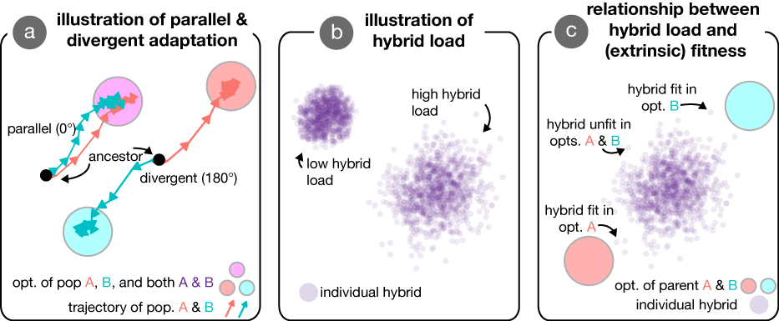

**Figure 1. Visual overview of concepts.** Panel (a) illustrates the process of adaptation in our simulations, wherein two populations (arrows) independently adapt to specified optima (coloured circles). These optima can be identical (i.e., parallel), opposite (i.e., divergent), and everything in between. ‘Distance’ to the optimum (*d*), which is fixed in this illustration, is the distance from the ancestor (black circles) to the respective optima. Panel (b) illustrates ‘hybrid load’, which captures the extent of phenotypic variation in a group of hybrids formed after their parents adapt and reach mutation-selection balance. Panel (c) depicts how the (extrinsic) fitness of individual hybrids is measured. Specifically, hybrids that are near an optimum have high fitness in that environment, whereas hybrids that are far from an optimum have relatively low fitness.

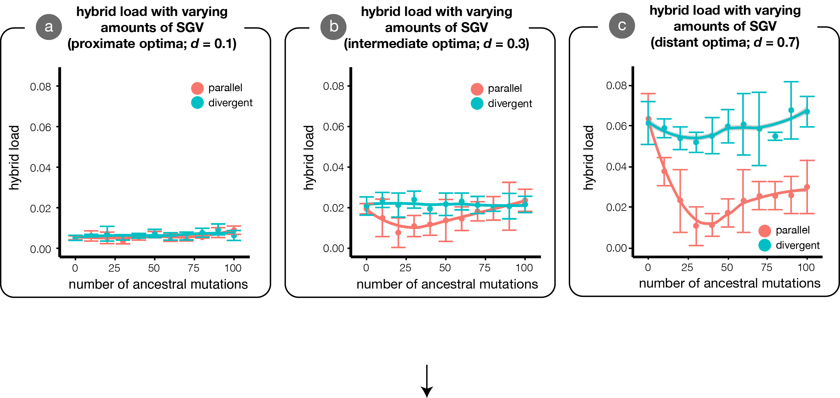

**Figure 2. The effects of standing genetic variation (SGV) on hybrid load under parallel (theta=0°) and divergent (theta=180°) evolution.** We plot hybrid load, measured at mutation-selection balance, for populations adapting with varying quantities of ancestral SGV. In all cases, there is no effect of SGV on hybrid load when populations adapt to divergent (theta=180°) optima. Under parallel (theta=0°) adaptation, the effect of SGV on hybrid load depends both on the quantity of SGV and on the distance of the phenotypic optimum. For proximate optima (a), SGV does not affect hybrid load. For intermediate optima (b), SGV reduces hybrid load optimally when *n* = 14 (arrow), but does not reduce hybrid load when there is an excess amount of SGV. When populations adapt to distant optima (c), SGV reduces hybrid load optimally when *n* = 27 (arrow), and continues to reduce hybrid load even when there is an excess of mutations. Lines are generalized additive models of the form…(this will be implemented in the next draft), points are the mean hybrid load over X simulations ± 1 SE. I will remake panels once we ‘finalize’ the figure contents.

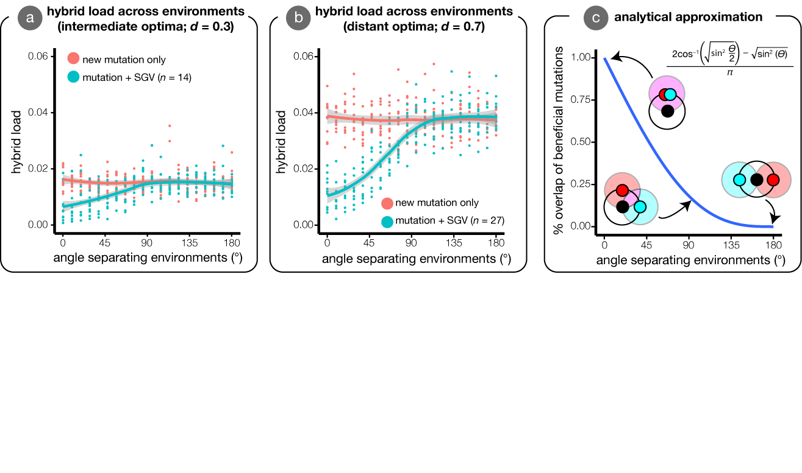

**Figure 3. Hybrid load across environments with and without SGV.** The x-axis depicts the ‘angle’ between optima, where theta=0° indicates identical optima and theta=180° indicates opposite optima. We depict the relationship for adaptation to intermediate (a) and distant (b) optima. We plot two cases of SGV here: no SGV (*n* = 0) and the amount of SGV that optimally reduces hybrid load at *ϴ* = 0deg as determined by simulation. Points depict mean hybrid load over X simulations ± 1 SE [I will remake panels once we ‘finalize’ the figure contents.] Panel (c) illustrates the relationship between the fraction of overlap between two circles separated by varying angles. This faster-than-linear decrease in the fraction of overlap causes the non-linearity observed in (a) and (b). [Linear distance btt two optima also decreases faster than the angle between them; I want to know what the fraction of overlap is btt topima that are separated by 0, 0.5, and 1 ‘units’… i.e., is there anything ‘special’ about angle BEYOND the fact that it rapidly leads to increased distance].

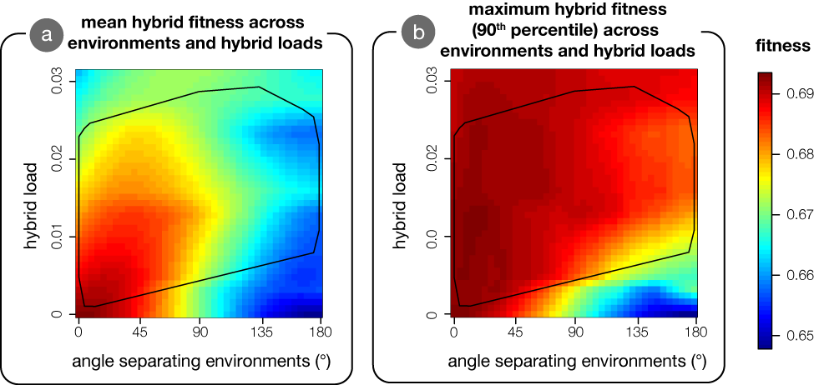

**Figure 4. The effects of hybrid load on mean and maximum hybrid fitness across environments.** Fitness is calculated for populations that have adapted to optima at intermediate distances from the origin (*d* = 0.3). The black outline depicts the range of hybrid load values (i.e., convex hull) observed in simulations under the relevant parameters (see Fig. 3A). Mean fitness (a) is negatively affected by hybrid load under parallel selection (theta=0°), and has less of a role as the angle between parental optima increases. By contrast, maximum fitness (b) is relatively constant across most parameter values, and is only appreciably affected by hybrid load under divergent selection.