**Patterns of speciation and parallel genetic evolution under adaptation from standing variation**

Ken A. Thompson1,2, Matthew M. Osmond2 and Dolph Schluter2

1Corresponding author. Ken Thompson, email: [kthomp1063@gmail.com](mailto:kthomp1063@gmail.com)

2Biodiversity Research Centre and Department of Zoology, University of British Columbia, Vancouver, Canada

Article type: Letter

Running title: Speciation from standing genetic variation

Keywords: Fisher’s geometric model; ecological speciation; mutation-order speciation; numerical theory; simulation

Total word count: TBA

**Abstract**

When isolated populations adapt to novel environments, they may do so using the same or different alleles. The former scenario—parallel genetic evolution—is increasingly likely if populations have shared ancestral variation that can be used for adaptation. Here, we investigate the conditions under which populations undergo parallel genetic evolution from standing variation and the associated implications for speciation via environment-specific hybrid fitness. Using computer simulations, we confirm that populations adapting to identical environments tend to fix the same alleles from standing variation unless there is a deficient or excess amount of variation in the founding population. We also find that the degree of parallel genetic adaptation decreases faster-than-linearly as selection deviates from parallel toward divergent selection. Analytical approximations reveal that seemingly small differences in the environments to which populations are adapting can substantially reduce the likelihood of parallel genetic evolution. Last, standing variation weakens progress toward speciation under parallel selection because hybrids have higher fitness than when adaptation is from new mutation. This occurs because standing variation causes parents to fix the same alleles and therefore fewer incompatibilities arise. By contrast, standing variation strengthens progress toward speciation under divergent selection because hybrids have reduced fitness relative to when adaptation is from new mutation. This is because past stabilizing selection removes large-effect alleles from the standing variation and therefore adaptation from standing variation proceeds via a greater number of mutations with individually smaller effects compared to adaptation from new mutation. This in turn leads to reduced phenotypic segregation variance in hybrids, causing them to possess a uniformly intermediate phenotype that is poorly suited to either parental environment. We conclude that the effects of standing genetic variation on the process of speciation depend on both the characteristics of standing variation and on the environments in which derived populations are adapting.

**Impact summary**

Among all of the questions that evolutionary biologists have posed, some of the most lingering concern the predictability of evolution. For example, if two groups of organisms independently evolve similar traits in similar habitats, is it likely that this evolution proceeded using the same genes? And if this is the case, what can we learn about the probability that these groups have evolved reproductive barriers causing them to become distinct species? In our article, we investigate these two questions from a theoretical perspective in the attempt to make generalizations that will apply to the real world. In particular, we investigate the role that standing genetic variation—the genetic variability within a population at any given time—has in causing populations to evolve using the same genes. That is, we investigate the role of standing genetic variation in driving parallel genetic evolution. We have three main conclusions. First, groups of organisms that possess standing genetic variation are, under some conditions, more likely to follow similar evolutionary trajectories than those that adapt only from new mutation. Our second conclusion is that parallel evolution from standing genetic variation is likely only when they adapt to very similar environments; seemingly small environmental differences largely preclude parallelism at the genetic level. Finally, we find that standing genetic variation decreases the likelihood of speciation when two populations adapt to similar environments, but actually increases the likelihood of speciation when population adapt to different environments. In sum, our article generates predictions about how standing variation affects parallel genetic evolution and speciation that are readily testable in nature.

**Introduction**

The process of adaptation involves positive natural selection on beneficial alleles that improve the fit of a population to its environment. Adaptation can proceed via selection on new mutations or on pre-existing standing genetic variation (Orr and Betancourt 2001). If populations experience divergent natural selection, which favours distinct phenotypes in different environments, then distinct alleles are expected to fix regardless of their origin. Parallel natural selection, by contrast, favours the same phenotypes and alleles in different populations. Nevertheless, distinct populations not connected by gene flow (i.e., allopatric) might also encounter and fix alternative adaptive alleles by chance (Mani and Clarke 1990). If populations share a common pool of ancestral standing variation, however, they are more likely fix the same mutations during parallel adaptation (Schluter and Conte 2009; Conte et al. 2012). Here, we investigate how the availability of standing genetic variation for adaptation affects parallel genetic evolution—defined as reuse of the same genes during independent bouts of adaptation—across environments and the associated implications for speciation.

Adaptation facilitates progress towards speciation when adapting populations evolve reproductive isolating barriers as a by-product. These reproductive isolating barriers can arise because genetic differences between populations reduce the fitness of their hybrids, thereby reducing gene flow upon secondary contact. Under ecological speciation driven by divergent selection (Schluter 1996), F1 hybrids might be intermediate in phenotype and unfit in either parental environment (e.g., Hatfield and Schluter 1999). Under an alternative process of speciation by selection, populations diverge genetically by chance in the course of adapting to similar environments despite parallel natural selection ('mutation-order' speciation; Schluter 2009). In this case, distinct populations fix alternative adaptive alleles that, when combined render hybrids less fit than either parent because they cause a transgressive maladaptive phenotype poorly suited to the parental habitat. A central goal of research on speciation is to characterize the conditions that can facilitate and impede progress toward ecological and mutation-order speciation.

Whether adaptation proceeds largely via standing variation or from new mutation may influence the evolution of reproductive isolation between adapting populations. It is well understood that standing genetic variation can be an important contributor to parallel genetic evolution between populations (e.g., Jones et al. 2012). We therefore expected that standing variation would contribute to parallel genetic evolution under parallel natural selection and cause populations to fix fewer incompatibilities. By contrast, we expected that standing variation would have relatively little effect on ecological speciation—besides speeding up the process—because alternative alleles are favoured regardless of whether populations possess shared ancestral standing variation. In addition to testing this intuition, we also sought to investigate the effects of standing variation on parallel adaptation and speciation across a continuum of environments.

While ‘divergent’ and ‘parallel’ natural selection—and their corollaries of ecological and mutation-order speciation—are useful concepts, they are the endpoints of a continuum of possible environmental differences (Langerhans and Riesch 2013; Martin and Lenormand 2015; Stuart et al. 2017; Bolnick et al. 2018). As optima tend from identical (i.e., *ϴ* = 0°) toward opposite (i.e., *ϴ* = 180°), the fraction of mutations that are beneficial in both populations, and therefore the extent of parallel genetic adaptation (i.e., gene re-use), will decrease. The specific patterns of parallel genetic evolution across environments of varying similarity, however, is largely uninvestigated. For example, at what angle of divergence do populations begin to share less than half of beneficial first-step mutations? Resolving this sort of question will provide a theoretical basis on which to calibrate expectations of parallel genetic evolution.

In this article we address three questions. First – under what conditions does standing genetic variation lead to parallel genetic evolution? Second – how does the probability of parallel genetic evolution from standing variation change as populations experience selection that ranges from parallel to divergent? And third – what are the implications of the above for progress toward speciation? We use individual-based simulations to investigate these questions, as well as some analytical derivations to explain simulation results. Our approach is motivated by our empirical research efforts with threespine stickleback (*Gasterosteus aculeatus*) where we are interested in the evolution of reproductive isolation between populations that adapted to varying environments in allopatry after colonization by a common ancestor (see Bell and Foster [1994]). Similar processes occur in other taxa, for example in insects with respect to their host-plants (‘micro-allopatry, e.g., Drès and Mallet 2002), and in birds and plants isolated within glacial refugia (e.g., Weir and Schluter 2004; Pettengill and Moeller 2012). Thus, we sought to investigate how adaptation from standing variation might be expected to affect progress toward speciation among derived populations and identify the proximate ecological causes. Our results suggest that standing variation has important and non-intuitive implications for speciation under both parallel and divergent natural selection.

**Methods**  
We used computer simulations to investigate parallel genetic adaptation and speciation from ancestral standing variation. Our simulations were inspired by Fisher's (1930) geometric model of adaptation (reviewed in Tenaillon 2014). Fisher’s model incorporates both pleiotropy and epistasis for fitness while making explicit and testable predictions that have received support in laboratory and field studies (MacLean et al. 2010; Rogers et al. 2012; Stearns and Fenster 2016). While originally developed to make inferences about the genetics of adaptation, the model has been adapted to study the evolutionary genetics of speciation (Barton 2001; Chevin et al. 2014; Fraïsse et al. 2016; Simon et al. 2018). For these reasons, Fisher’s model is well-suited to investigate the effects of adaptation from standing variation as it relates to parallel genetic adaptation and speciation.

*Simulation overview*We used individual-based simulations to investigate the impact of standing variation on parallel genetic adaptation and speciation (see **Data accessibility**). We considered the case of a single ancestral population that founds two identical populations in novel environments, which then adapt in allopatry (i.e., no gene flow; see Fig. 1A for an overview).

*Genotype to phenotype*

The phenotype of an individual is represented by an *m*-dimensional vector, *z* = [*z*1, *z*2,…, zm], with *m* the number of independent ‘traits’ (Orr 2000). Each trait value, *zi*, is determined by summing the effects across all loci, which are initially fixed for alleles with an effect of 0 on all m traits. Although we focus on *m* = 2 here, we verified that the central conclusions generated herein are robust to the value of m [data not shown].

*Life-cycle*

We assume non-overlapping generations. Viability selection occurs at the beginning of each generation, during the haploid phase. The probability that an individual survives is P = exp(-s ||z-o||^2/2) (equation 1 in Fraïsse et al. [2016]), where ||z-theta||^2 is the Euclidean distance of its phenotype from the optimum, o, and *s* is the strength of selection. (Empirical estimates of fitness functions have supported the use of Gaussian fitness functions [Martin and Lenormand 2006]). If the number of survivors exceeds the carrying capacity, *K*, then survivors are randomly culled to a population size of *K*. Surviving haploids randomly conjugate (with anyone but themselves) and undergo meiosis with free recombination between all loci. Each mating pair (i.e., diploid cell) generates 2*B* haploid offspring, which each acquire a new mutation with probability *μ*. An infinite number of loci is assumed, such that each mutation arises at a new locus (‘infinite-sites’; Kimura 1969 Genetics 61:893). For simplicity we assume that the effect of a mutation on each of the m traits is independently drawn from a normal distribution with a mean of 0 and SD of *σ*. Thus all mutations are unique (continuum-of-alleles; Kimura 1965 PNAS 54:731). The effect of mutational covariance and modularity (restricted pleiotropy; Chevin 2010 Evolution 64:3213) is left for future work and could be readily explored with the provided simulation code (online material). See Table 1 for descriptions of all parameters and values used in simulations.

*Generating ancestral standing genetic variation*We found focal populations with standing genetic variation from a common ancestor. To generate ancestral standing variation, we conducted burn-in simulations of a large population (*K*anc = 10,000) under weak stabilizing selection (*s*anc = 0.01) at the origin (*o*anc = [0, 0, … 0*m*]) for 100,000 generations. All other parameters were identical to adapting populations (Table 1). Ancestral populations reached mutation-selection balance and had, on average, a mean of 200 segregating alleles (Fig. S1A). Each segregating allele was present in, on average, 10 % of individuals (Fig. S1B).

*Adaptation to a new environment*Following the burn-in we generated two initially-identical founder (i.e., colonizing) populations. Founding populations were fixed for alleles that were fixed in the ancestor, and the amount of standing variation was determined by sampling *n* segregating alleles from the ancestor. Populations adapted from only new mutation when *n* = 0 and contained standing genetic variation otherwise. Each of the n segregating alleles were selected for inclusion in the founding populations with a probability proportional to their frequency in the ancestor. The frequency of an allele in the ancestral population was used as the probability of inclusion in a founding individual, such that the expected frequency of an allele in a founding population was equal to its frequency in the ancestor. For each parameter combination, we began each simulation from a unique realization of the ancestor (i.e., distinct burn-in).

After initialization, founder populations adapted to their respective specified phenotypic optima (Fig. 1B). Adaptation proceeded via the reassortment of ancestral standing variation (if *n* > 0) and via new mutation (all simulations) simultaneously. There are two key features of the new phenotypic optima. The first is the expected initial distance to the optima, calculated as the Euclidean distance between the optima and the origin, *d*. More distant optima require a greater amount of phenotypic change and initially exert stronger selection. The second key feature is the angle of divergence, *ϴ*, which captures the difference in direction from the origin to the optima of both populations (see Fig. 1B). Angle is a common concept used to describe the continuum of (non)parallel evolution and is explicitly invoked in most metrics that quantify parallelism (see Bolnick et al. [2018]). Optima separated by a small angle experience relatively parallel natural selection, whereas optima separated by large angles experience relatively divergent selection (though note that these are ends of a continuum).

We ended simulations after 2000 generations, at which time all populations had reached their phenotypic optima (Fig. S2A) and mutation-selection balance (Fig. S2B). An unavoidable and important effect of standing variation is that it quickens adaptation because populations do not have to ‘wait’ for beneficial mutations to arise (Barrett and Schluter 2008). In our model and others like it (e.g., Barton [2001] & Chevin et al. [2014]), reproductive isolation evolves rapidly during the initial stages of adaptation and then decelerates as populations approach their optima. Accordingly, any reduction in hybrid fitness that evolves does so more rapidly when evolution occurs from standing variation. We allow sufficient time in our simulations for all populations to reach the optimum even when adaptation is from only new mutation. Therefore, our conclusions refer to equilibrium conditions rather than transient states and are unaffected by standing variation’s influence on the speed of adaptation.

*Formation of hybrids and quantification of segregation variance & fitness*After the adaptation phase of simulations had ended, derived populations ‘met’ in secondary contact and produced hybrids. We randomly chose a haploid individual from each the two allopatric populations to form a diploid (F1) that produced a recombinant haploid hybrid through meiosis with free recombination among loci. If an allele was shared by both parents—which is possible only if it originates from the ancestral standing variation because mutations are unique and thus cannot arise de novo in both allopatric populations—then the allele was present in the hybrid. Alleles present in only one parent—all alleles arising from new mutation during adaptation in allopatry and alternative alleles fixed from the standing variation—were inherited by the hybrid offspring with probability 0.5. This was repeated 100 times to create 100 hybrids for each pair of parental populations.

We calculated two quantities of interest in the hybrids: segregation variance and fitness. Segregation variance is the phenotypic variation of hybrids (Wright 1968; Slatkin and Lande 1994) and is calculated here as the mean phenotypic variance across all m traits.Higher segregation variance results when parents are differentiated by a greater number of alternative alleles (holding effect size constant) or alleles of individually-larger effect (holding number of alleles constant) (Slatkin and Lande 1994; Chevin et al. 2014). Segregation variance captures the phenotypic consequences of hybridization and is therefore more biologically meaningful than simply quantifying the number of different mutations that distinguish populations or their average effect size. Phenotypic variance in parental populations before hybridization is near zero and is not affected by the quantity of standing variation nor the initial distance to the optimum (Fig. S2C).

An individual hybrid’s fitness was calculated from its phenotype in the same manner as the fitness of their parents (Fig. 1C). We quantified the fitness of each hybrid in both parental environments and recorded its final fitness as the larger of the two values. This can be imagined as giving the hybrid a choice of alternative host-plants (Drès and Mallet 2002), for example. Our fitness metric reflects what is traditionally recognized as ‘extrinsic’ isolation, and explicitly considers epistasis in fitness between alleles. Accordingly, two alleles that reduce hybrid fitness when combined in a hybrid can be considered Bateson-Dobzhansky-Muller incompatibility loci (Bateson 1909; Dobzhansky 1937; Muller 1942; Chevin et al. 2014; Fraïsse et al. 2016) with environment-specific effects on fitness (see Arnegard et al. [2014], Schumer et al. [2014], and Ono et al. [2017] for discussion of environment-specific incompatibilities).

**Results and discussion**  
*Effects of standing variation on the segregation variance after hybridization for parallel and divergent selection*We first investigate how the quantity of standing variation in the founding populations affects the segregation variance after hybridization (hereafter simply ‘segregation variance’). To investigate these dynamics, we ran simulations in which populations underwent either parallel (identical optima, *ϴ* = 0°) or divergent (opposite optima, *ϴ* = 180°) evolution, and repeated this with different amounts of ancestral standing variation (via *n*). A representative set of simulationsare plotted in Figure 2A.

Several conclusions emerge from these simulations. First, segregation variance does not depend on the amount of standing genetic variation when populations undergo divergent (*ϴ* = 180°) adaptation. This is because alleles that are beneficial in one environment are deleterious in the other. Thus populations to fix alternative alleles regardless of whether they arise from standing variation or new mutation. This is true for any dimensionality, m. Second, under parallel evolution (*ϴ* = 0°), standing variation generally reduces segregation variance. This is largely because the same variants are fixed in both populations and therefore do not segregate in hybrids. Third, segregation variance under parallel selection is minimized when populations are founded with intermediate quantities of standing variation. When there is little or no standing variation, populations undergo non-parallel genetic evolution due to their reliance on alternative newmutations. When there is substantial standing variation, there are many redundant alleles in the standing variation and populations fix alternative beneficial variants. The quantity of standing variation that minimizes segregation variance under parallel selection (arrow in Fig. 2A) is greater for more distant optima (Fig. 2B), as more mutations are then required for adaptation, reducing redundancy.

It has been widely suggested in the literature that parallel genetic evolution is most likely when populations are founded from a common ancestor with the same pool of standing variation (Conte et al. 2012). Our results largely confirm this intuition because the simulations indicate that the populations adapt using the same alleles under parallel selection. For maximal parallel evolution, however, there must be a match between the supplied standing variation and the demands of the environment. Significant redundancy in the standing variation can lead to non-parallel genetic evolution from standing variation even when optima are identical.

*Parallel genetic evolution across environments*  
To investigate the relationship between the angle of divergence, *ϴ,* and segregation variance, we conducted simulations across a range of angles between 0° to 180°. In this section, simulations had either no standing variation (i.e., only *de novo* mutation) or the amount of standing variation that minimized segregation variance under parallel selection (*ϴ* = 0°; arrow in Fig. 2A). We plot a representative set of simulations in Figure 3A.

Several key results emerge from these simulations. First, segregation variance is not affected by the angle of divergencewhen there is no standing variation (*n* = 0 in Fig. 2; red line and points in Fig. 3A). This occurs because all new mutations are unique and arise at different loci in our simulations. Second, when there is standing variation, segregation variance increases faster-than-linearly with the angle of divergence (compare blue and black lines in Fig. 3A). This result is partially caused by the specific geometric properties of angles: a given change in *ϴ* causes a larger change in the Euclidean distance between optima, *δ*, when *ϴ* is smaller (Fig. S3A; see also Fig. S3B for same data as in Fig. 3A plotted with *δ* on x-axis). Several additional and more biologically interesting processes—arising from the geometric features of adaptation—contribute to the observed rapid decrease in parallel genetic evolution across environments.

Why does parallel genetic adaptation decline faster-than-linearly as the angle of divergence increases? We investigate this question analytically (see derivations in Appendix), and suggest three main causal forces. First, ignoring drift, a mutation is only expected to fix in two allopatric populations if it is beneficial in both. For a given population, beneficial mutations lie within a hypersphere (which is a circle when *m* = 2) centered at the optimum with the adapting population a point on the surface (Fisher 1930; see cartoon inset of Fig. 3B). Considering two populations, a given mutation is mutually beneficial if it lies in the intersection of two hyperspheres (pink region in Fig. 3B inset). The expected degree of non-parallelism driven by the initial stages of adaptation is therefore captured by the fraction of mutations initially beneficialin one population that are not beneficial in the other (area of the black region divided by the area of the pink and black regions combined in Fig. 3B inset). Analytically, we find that this `fraction of non-overlap’ is zero when *ϴ* = 0°, one when *ϴ* = 180°, and increases faster-than-linearly with *ϴ* (Fig. 3B; see also Fig. S3A for the relationship between *ϴ*, *δ*, and the fraction of non-overlap). In agreement with our numerical results (figure?) the fraction of non-overlap increases even more rapidly in higher dimensions (compare solid to dashed in Fig. 3B).

The above result considers the initial stages of adaptation, but the dynamics of adaptation change in important ways during the course of an adaptive ‘walk’ (Orr 1998). Specifically, the fraction of non-overlap changes as populations approach their distinct optima. We plot the change in the fraction of non-overlap during the course of an adaptive walk—that is as populations approach their respective optima from a shared origin—for three angles and two dimensionalities in Fig. 3C. Considering 60° (where *δ* is exactly intermediate between *ϴ* = 0° and 180°), when dimensionality is low (e.g., *m* = 2) the fraction of non-overlap reaches unity rapidly when populations are approximately halfway through their respective walks. When dimensionality is high (e.g., *m* = 10), the fraction of non-overlap reaches unity much later in the adaptive walk.

Finally, the average probability of fixation of mutations that lie within the region of overlap decreases with the angle of divergence. This is intuitive: when *ϴ* = 0°, the region of overlap contains mutations that are highly beneficial in both populations (e.g., their shared optima). As *ϴ* increases, the mutations remaining in the region of overlap are less beneficial. Therefore the mean selective coefficient of shared initially beneficial mutations decreases with *ϴ* (quantifying this decrease is beyond the scope of this article).

We note that the above arguments reflect the probability of parallel genetic evolution generally and not from standing variation specifically. Therefore, populations adapting to similar environments have a higher probability of fixing similar mutations whether the mutations arise de novo or were segregating in the ancestor. The arguments above are thus component pieces of a comprehensive theory of the probability of genetic parallelism during allopatric adaptation. Integrating the processes discussed above with estimates of both the distribution of fitness effects of new mutations (Eyre-Walker and Keightley 2007) and the fitness effects of mutations across environments (Martin and Lenormand 2015) may lead to valuable insights.

The simulations depicted in Fig. 3 also illustrate an unanticipated general effect of standing variation: a reduction of segregation variance for all angles of divergence. This is apparent by examining the right side of Fig. 3A. When selection is divergent, *ϴ* = 180°, there are no beneficial alleles shared between adapting populations. Why, then, does standing genetic variation cause hybrids to have lower segregation variance when their parents underwent divergent selection? There are several non-mutually exclusive possibilities. First, populations may undergo maladaptive parallel genetic evolution due to drift. Second, small-effect alleles are more likely to fix when from standing variation as compared to new mutation (Orr and Betancourt 2001; Hermisson and Pennings 2005), and therefore adaptation in simulations initiated with standing variation may proceed via primarily via the small-effect alleles. (Segregation variance decreases as a greater number of genes contribute to character divergence because, on average, individuals will recover an intermediate phenotype [Castle 1921]). Finally, past stabilizing selection shapes the alleles present in the standing variation, and alleles in the standing variation may have different properties than those arising from new mutation (Hermisson and Pennings 2005).

We tested these hypotheses by running simulations where standing variation was generated by randomly drawing mutations from a distribution identical to those which arise from new mutation (i.e., without a burn-in) and similar initial frequencies. This effectively controls for ‘past selection’ while maintaining adaptation from standing variation. These simulations completely removed the effect of standing variation on reducing segregation variance at large angles (Fig. S4). Therefore, we infer that past stabilizing selection in the ancestor causes a reduction in segregation variance under divergent selection. Examining the distribution of mutation effect sizes in the ancestor, we indeed find that the average allele effect-size is smaller than what arises from new mutation (Fig. S1C), and that the largest-effect mutations are absent in the standing variation.

*Effect of standing variation on environment-specific hybrid fitness*In this section, we investigate the effects of standing variation on mean and maximum hybrid fitness in the parental environments. The mean fitness of hybrids is relevant for speciation because, if hybrids are generally unfit, this reduces gene flow via poor hybrid survival and reproduction and can also promote the evolution of pre-mating isolation via reinforcement (Burke and Arnold 2001). Maximum observed fitness is relevant because occasional individual hybrids with high fitness can facilitate gene flow between parents (Barton 2001), potentially impeding divergence.

We use data from the simulations in the previous section (see Fig. 3A) to evaluate the effect of standing variation on hybrid fitness by calculating the difference in mean and maximum relative hybrid fitness between simulations that were initiated with and without standing variation. The results of these simulations with respect to mean fitness are plotted in Figure 4 A & B. We discuss the maximum fitness results below but plot results in the supplementary material (figure S?).

The simulations reveal that standing variation improves mean hybrid fitness when parental populations adapt to similar optima, but reduces hybrid fitness when parents undergo divergent adaptation. This result is caused by environment-specific consequences of segregation variance on hybrid fitness (Fig. 4C). When the hybrid phenotype distribution is centred at the phenotypic optimum, as it is under parallel selection, theta=0, any variation around the optimum is deleterious; in this case mean hybrid fitness is maximized when there is no variation at all such that all hybrids lie exactly on the optimum. By contrast, when the hybrids fall in a fitness valley between parental optima, some variation is beneficial with respect to mean hybrid fitness. This is because phenotypic variation in hybrids causes some individuals with extreme phenotypes to approach an optimum (see Fig. 1C). Maximum hybrid fitness—here measured as the relative mean fitness of the top 5 % of hybrids to reduce stochasticity between replicate simulations—is not affected by standing variation under parallel selection, and is reduced by standing variation under divergent selection (Fig. S5).

These results indicate that the effect of standing variation is to make mutation-order speciation more difficult and ecological speciation relatively easier, compared to when adaptation is from only new mutation. We emphasize that this conclusion relates to the equilibrium conditions after populations have reached the phenotypic optima in their new environments (see Fig. S6 for plots of hybrid fitness over time). Given that standing variation causes adaptation to proceed more quickly, conclusions about the effect of standing variation on speciation are sensitive to the time at which measurements are made.

The predictions of this section are readily testable. Sexual populations could be challenged with independently adapting to similar or different optima with varying amounts of ancestral standing variation (i.e., manipulate number of founding ‘strains’). Following adaptation, populations can be hybridized and the fitness of hybrids measured in the parental environment(s) (e.g., Ono et al. [2017]). Under parallel evolution, the simulations predict that intermediate quantities of standing variation lead to highest mean hybrid fitness, whereas standing variation is expected to universally reduce hybrid fitness under divergent selection. Simultaneous investigation of maximum hybrid fitness and phenotypic segregation variance would be an important addition.

*Additional factors influencing the probability of parallel genetic evolution*  
Several processes that we did not consider could affect the probability of parallel genetic evolution. First, in nature parallel genetic adaptation can proceed via recurrent mutation at the same locus (e.g., Chan et al. 2010), which was not possible in our simulations because each new mutation was unique and arose at a new locus. Second, migration between populations reduces the likelihood that populations will fix alternative alleles under parallel natural selection (Nosil and Flaxman 2011; Anderson and Harmon 2014), and our simulations considered only allopatry (i.e., no migration). Last, we assume that the ancestral standing variation is naïve with respect to the new environment. In some cases, however, alleles that are beneficial in a particular derived habitat are introduced into the ancestral population via periodic introgression where they are maintained indefinitely in the standing variation (Schluter and Conte 2009). Such ‘transported’ alleles are favoured by selection in the derived habitat and are particularly likely to fix in parallel (Nelson and Cresko 2018). Implementing recurrent mutation, migration, or a transporter process would increase the probability of parallel genetic evolution under parallel selection and further weaken progress toward mutation-order speciation.

While the above factors increase the probability of parallel genetic evolution, several competing processes are expected to weaken parallelism. First, if populations are founded with different subsets of ancestral standing variation, this will reduce parallelism (Conte et al. 2015). Even if populations begin with identical alleles in the standing variation, differences in their initial frequencies (as occur in our simulations by chance) weakens parallel evolution because mutations at high frequency are most likely to be used for adaptation (MacPherson and Nuismer 2017). And second, as illustrated in our analytical results, increasing phenotypic dimensionality leads to relatively fewer shared beneficial mutations for all angles except 0° and 180°. Even if two populations are adapting to identical optima, greater dimensionality leads to more possible paths to any given optimum and thus populations are less likely to fix identical alleles. Founder events and increased dimensionality will therefore facilitate progress toward mutation-order speciation.

The interpretation of our simulation results has several additional caveats. First, we considered only haploid selection and strict additivity with respect to phenotype. Diploid selection would reduce the survival of F1 hybrids that are needed to produce a recombinant F2 generation, which would therefore be more abundant under parallel evolution. We also assume that the sole fitness optima are those that the parents are adapted to and that it is not possible to simultaneously exploit both optima. Hybrids often perform best when there is a novel environment available (Rieseberg et al. 1999), and therefore the application of our results may be limited where such environments exist.

*Alternative measures of reproductive isolation*  
Our analysis focused on quantifying reproductive isolation via reduced hybrid fitness in the parental habitats. We chose hybrid fitness because we are specifically interested in the ecological component of speciation, but there are alternative ways we could have quantified isolating barriers. Divergent alleles might lead to complications during development in hybrids and contribute to ‘intrinsic’ or environment-independent isolation (Orr 1995)—a model that has received empirical support (Matute et al. 2010; Moyle and Nakazato 2010; Wang et al. 2015). In our simulations, segregation variance captures the effects of genetic divergence among populations as expressed in hybrids. Therefore segregation variance could interpreted as a form of intrinsic isolation (i.e., ‘variance load’ as in Chevin et al. [2014]).

Adaptation from standing variation could both increase or decrease the number of intrinsic incompatibilities that evolve during adaptation. Standing variation leads to gene re-use under parallel selection and therefore should generally reduce the likelihood of intrinsic isolation evolving. Under divergent selection, however, populations fix alternative alleles regardless of the source of variation. If the accumulation of hybrid incompatibility loci is simply a function of the number of substitutions that separate parental taxa, as in yeast (Greig 2009), then standing variation could reasonably be expected to increase the rate at which divergent adaptation yields hybrid incompatibility; this is because it proceeds via a greater number of (smaller-effect) mutations than adaptation from new mutation. Alternatively, ‘intrinsic’ incompatibilities may be generally less likely to evolve from standing variation simply because alleles in the standing variation have previously segregated in the same population and incompatibilities could have been removed by selection. Adaptation from new mutation might also involve more serious incompatibilities arising because the average effect size of new mutations is larger than alleles in the standing variation. Because adaptation from standing variation reduces reliance on new mutation, it is probable that fewer large-effect intrinsic incompatibilities will fix when populations adapt from standing variation. As we did not explicitly consider ‘intrinsic’ isolating barriers in our model, such barriers might act as an additional dimension of reproductive isolation that alter our predictions. Given the wide range of possible outcomes, it would be useful for future empirical work to investigate the evolution of ‘intrinsic’ hybrid incompatibility from standing variation.

*Implication for studies of parallel evolution*  
Our results highlight the importance of accurately quantifying environmental similarity when investigating the extent of gene reuse during parallel adaptation. This is because seemingly small differences in habitat similarity (via *ϴ*) drastically reduce the quantity of alleles that are expected to be beneficial in both populations. If researchers wrongly assume that environments are similar or even identical, they may be misled into attributing genetic non-parallelism to particular biological mechanisms when a better explanation is that the allele is not mutually beneficial. Theoretical predictions about the maximal extent of parallel evolution should therefore be used to calibrate expectations of parallelism. Indeed, our analytical approximations may provide some clues about why non-parallel genetic evolution is so common (Bolnick et al. 2018): parallel genetic evolution is unlikely in all but the most similar environments, especially when dimensionality is high.

*Conclusion*Our analyses confirm an intuition that allopatric populations adapting from a common pool of ancestral standing genetic variation tend to undergo parallel genetic evolution in response to parallel natural selection. This genetic parallelism, in turn, reduces the likelihood that parallel natural selection will lead to speciation. We show that several general processes interact to rapidly reduce the probability of parallel genetic evolution as selection tends from parallel toward divergent and that this reduction in genetic paralleleism is expected to occur faster when more traits are involved in adaptation. We also find that standing genetic variation reduces the phenotypic segregation variance in hybrids, regardless of the angle of divergence, because it causes adaptation to proceed using more alleles of individually smaller effect relative to adaptation from new mutation. This reduced segregation variance further improves mean hybrid fitness under parallel natural selection but reduces mean hybrid fitness under divergent selection. In summary, our article provides evidence that standing variation has variable effects on progress toward speciation that depend on both the characteristics of the standing variation itself and the environments to which populations adapt.

**Acknowledgements**Discussions with S. Otto motivated and refined the approach used in this study. Feedback from S. Arnold, M. Chapuisat, L. Chavarie, R. Holzman, A. MacPherson, S. Otto, L. Rieseberg, and J. Rolland improved the manuscript. K.A.T. was funded by The University of British Columbia, the Natural Sciences and Engineering Research Council of Canada (NSERC) and the Izaak Walton Killam Memorial Fund for Advanced Studies. M.M.O. was funded by The University of British Columbia. D.S. was funded by the Canada Foundation for Innovation, Genome BC, and NSERC, and????.

**Author contributions**K.A.T. and D.S. developed the original ideas upon which the paper is based. K.A.T. wrote the first draft of the manuscript with input from M.M.O. and D.S., and all authors contributed to subsequent revisions. M.M.O. wrote the simulations and conducted analytical investigations with input from K.A.T.. K.A.T. performed, optimized, and analyzed the simulations, with input from M.M.O.

**Data accessibility**Python (version 3.6.1) scripts, resulting data, R (version 3.4.1) scripts to process and plot the data, and Mathematica (version 11) notebooks, will be archived on Dryad. For now, this is hosted on GitHub (<https://github.com/Ken-A-Thompson/SVS>).

**References**

Anderson, C. J. R., and L. Harmon. 2014. Ecological and Mutation-Order Speciation in Digital Organisms. Am. Nat. 183:257–268.

Arnegard, M. E., M. D. McGee, B. Matthews, K. B. Marchinko, G. L. Conte, S. Kabir, N. Bedford, S. Bergek, Y. F. Chan, F. C. Jones, D. M. Kingsley, C. L. Peichel, and D. Schluter. 2014. Genetics of ecological divergence during speciation. Nature 511:307–311.

Barrett, R. D. H., and D. Schluter. 2008. Adaptation from standing genetic variation. Trends Ecol. Evol. 23:38–44.

Barton, N. H. 2001. The role of hybridization in evolution. Mol. Ecol. 10:551–568.

Bateson, W. 1909. Heredity and variation in modern lights. Pp. 85–101 *in* A. C. Seward, ed. Darwin and Modern Science. Cambridge University Press, Cambridge.

Bell, M. A., and S. A. Foster. 1994. The Evolutionary Biology of the threespine stickleback. Oxford University Press.

Bolnick, D. I., R. D. H. Barrett, K. B. Oke, D. J. Rennison, and Y. E. Stuart. 2018. (Non)Parallel Evolution. Annu. Rev. Ecol. Evol. Syst. In press.

Burke, J. M., and M. L. Arnold. 2001. Genetics and the fitness of hybrids. Annu. Rev. Genet. 35:31–52.

Castle, W. E. 1921. AN IMPROVED METHOD OF ESTIMATING THE NUMBER OF GENETIC FACTORS CONCERNED IN CASES OF BLENDING INHERITANCE. Science 54:223.

Chan, Y. F., M. E. Marks, F. C. Jones, G. Villarreal, M. D. Shapiro, S. D. Brady, A. M. Southwick, D. M. Absher, J. Grimwood, J. Schmutz, R. M. Myers, D. Petrov, B. Jónsson, D. Schluter, M. A. Bell, and D. M. Kingsley. 2010. Adaptive evolution of pelvic reduction in sticklebacks by recurrent deletion of a *Pitx1* enhancer. Science 327:302–305.

Chevin, L. M., G. Decorzent, and T. Lenormand. 2014. Niche dimensionality and the genetics of ecological speciation. Evolution 68:1244–1256.

Conte, G. L., M. E. Arnegard, J. Best, Y. F. Chan, F. C. Jones, D. M. Kingsley, D. Schluter, and C. L. Peichel. 2015. Extent of QTL reuse during repeated phenotypic divergence of sympatric threespine stickleback. Genetics 201:1189–1200.

Conte, G. L., M. E. Arnegard, C. L. Peichel, and D. Schluter. 2012. The probability of genetic parallelism and convergence in natural populations. Proc. R. Soc. B Biol. Sci. 279:5039–5047.

Dobzhansky, T. 1937. Genetics and the origin of species. Columbia University Press, New York.

Drès, M., and J. Mallet. 2002. Host races in plant-feeding insects and their importance in sympatric speciation. Philos. Trans. R. Soc. B Biol. Sci. 357:471–492.

Eyre-Walker, A., and P. D. Keightley. 2007. The distribution of fitness effects of new mutations.

Fisher, R. F. 1930. The Genetical Theory of Natural Selection. Oxford University Press, Oxford, UK.

Fraïsse, C., P. A. Gunnarsson, D. Roze, N. Bierne, and J. J. Welch. 2016. The genetics of speciation: Insights from Fisher’s geometric model. Evolution 70:1450–1464.

Greig, D. 2009. Reproductive isolation in Saccharomyces.

Hatfield, T., and D. Schluter. 1999. Ecological speciation in sticklebacks: environment-dependent hybrid fitness. Evolution 53:866–873.

Hermisson, J., and P. S. Pennings. 2005. Soft sweeps: Molecular population genetics of adaptation from standing genetic variation. Genetics 169:2335–2352.

Jones, F. C., M. G. Grabherr, Y. F. Chan, P. Russell, E. Mauceli, J. Johnson, R. Swofford, M. Pirun, M. C. Zody, S. White, E. Birney, S. Searle, J. Schmutz, J. Grimwood, M. C. Dickson, R. M. Myers, C. T. Miller, B. R. Summers, A. K. Knecht, S. D. Brady, H. Zhang, A. A. Pollen, T. Howes, C. Amemiya, Broad Institute Genome Sequencing Platform & Whole Genome Assembly Team, E. S. Lander, F. Di Palma, K. Lindblad-Toh, and D. M. Kingsley. 2012. The genomic basis of adaptive evolution in threespine sticklebacks. Nature 484:55–61.

Langerhans, R. B., and R. Riesch. 2013. Speciation by selection: A framework for understanding ecology’s role in speciation. Curr. Zool. 59:31–52.

MacLean, R. C., G. G. Perron, and A. Gardner. 2010. Diminishing returns from beneficial mutations and pervasive epistasis shape the fitness landscape for rifampicin resistance in *Pseudomonas aeruginosa*. Genetics 186:1345–1354.

MacPherson, A., and S. L. Nuismer. 2017. The probability of parallel genetic evolution from standing genetic variation. J. Evol. Biol. 30:326–337.

Mani, G. S., and B. C. Clarke. 1990. Mutational Order: A Major Stochastic Process in Evolution. Proc. R. Soc. B Biol. Sci. 240:29–37.

Martin, G., and T. Lenormand. 2006. The fitness effect of mutations across environments: a survey in light of fitness landscape models. Evolution 60:2413–2427.

Martin, G., and T. Lenormand. 2015. The fitness effect of mutations across environments: Fisher’s geometrical model with multiple optima. Evolution 69:1433–1447.

Matute, D. R., I. A. Butler, D. A. Turissini, and J. A. Coyne. 2010. A Test of the Snowball Theory for the Rate of Evolution of Hybrid Incompatibilities. Source Sci. New Ser. 329:1518–1521.

Moyle, L. C., and T. Nakazato. 2010. Hybrid incompatibility “snowballs” between Solanum species. Science 329:1521–1523.

Muller, H. J. 1942. Isolating mechanisms, evolution and temperature.

Nelson, T. C., and W. A. Cresko. 2018. Ancient genomic variation underlies repeated ecological adaptation in young stickleback populations. Evol. Lett. In press.

Nosil, P., and S. M. Flaxman. 2011. Conditions for mutation-order speciation. Proc. R. Soc. B Biol. Sci. 278:399–407.

Ono, J., A. C. Gerstein, and S. P. Otto. 2017. Widespread Genetic Incompatibilities between First-Step Mutations during Parallel Adaptation of Saccharomyces cerevisiae to a Common Environment. PLoS Biol. 15.

Orr, H. A. 2000. Adaptation and the cost of complexity. Evolution 54:13–20.

Orr, H. A. 2005. The genetic theory of adaptation: a brief history. Nat. Rev. Genet. 6:119–127.

Orr, H. A. 1998. The Population Genetics of Adaptation: The Distribution of Factors Fixed during Adaptive Evolution. Evolution 52:935.

Orr, H. A. 1995. The population genetics of speciation: The evolution of hybrid incompatibilities. Genetics 139:1805–1813.

Orr, H. A., and A. J. Betancourt. 2001. Haldane’s sieve and adaptation from the standing genetic variation. Genetics 157:875–884.

Pettengill, J. B., and D. A. Moeller. 2012. Phylogeography of speciation: Allopatric divergence and secondary contact between outcrossing and selfing *Clarkia*. Mol. Ecol. 21:4578–4592.

Rieseberg, L. H., M. a Archer, and R. K. Wayne. 1999. Transgressive segregation, adaptation and speciation. Heredity 83 ( Pt 4):363–372.

Rogers, S. M., P. Tamkee, B. Summers, S. Balabahadra, M. Marks, D. M. Kingsley, and D. Schluter. 2012. Genetic signature of adaptive peak shift in threespine stickleback. Evolution 66:2439–2450.

Schluter, D. 1996. Ecological speciation in postglacial fishes. Philos. Trans. R. Soc. B Biol. Sci. 351:807–814.

Schluter, D. 2009. Evidence for ecological speciation and its alternative. Science 323:737–741.

Schluter, D., and G. L. Conte. 2009. Genetics and ecological speciation. Proc. Natl. Acad. Sci. USA 106.Sup1:9955–62.

Schumer, M., R. Cui, D. L. Powell, R. Dresner, G. G. Rosenthal, and P. Andolfatto. 2014. High-resolution mapping reveals hundreds of genetic incompatibilities in hybridizing fish species. Elife 3:e02535.

Simon, A., N. Bierne, and J. J. Welch. 2018. Coadapted genomes and selection on hybrids: Fisher ’ s geometric model explains a variety of empirical patterns. bioRxiv.

Slatkin, M., and R. Lande. 1994. Segregation variance after hybridization of isolated populations. Genet. Res. 64:51–56.

Stearns, F. W., and C. B. Fenster. 2016. Fisher’s geometric model predicts the effects of random mutations when tested in the wild. Evolution 70:495–501.

Stuart, Y. E., T. Veen, J. N. Weber, D. Hanson, M. Ravinet, B. K. Lohman, C. J. Thompson, T. Tasneem, A. Doggett, R. Izen, N. Ahmed, R. D. H. Barrett, A. P. Hendry, C. L. Peichel, and D. I. Bolnick. 2017. Contrasting effects of environment and genetics generate a continuum of parallel evolution. Nat. Ecol. Evol. 1:0158.

Tenaillon, O. 2014. The Utility of Fisher’s Geometric Model in Evolutionary Genetics. Annu. Rev. Ecol. Evol. Syst. 45:179–201.

Wang, R. J., M. A. White, and B. A. Payseur. 2015. The Pace of hybrid incompatibility evolution in house mice. Genetics 201:229–242.

Weir, J. T., and D. Schluter. 2004. Ice sheets promote speciation in boreal birds. Proc. R. Soc. B Biol. Sci. 271:1881–1887.

Wright, S. 1968. Evolution and the Genetics of Populations Vol. 1. Genetic and Biometric Foundations. University of Chicago Press, Chicago, IL.

**Table 1.** Description of parameters in adapting populations.

|  |  |
| --- | --- |
| Parameter | Value |
| *B*, number of offspring produced by each mating (# individuals) | 2 |
| *d*, distance to the optimum | * 1. ≤ *d* ≤ 1 |
| *K*, carrying capacity (# individuals) | 1000 |
| *m*, number of traits, or ‘dimensionality’ | 2 |
| *n*, number of alleles in the standing variation | 0 - 150 |
| *σ*, mutation size SD | 0.1 |
| *p*, probability that a mutation is present in an individual ancestor | 0.1 |
| *μ*, probability an individual acquires a new mutation | 0.001 |
| *s*, strength of selection | 1 |
| *ϴ*, angle of divergence (°) | 0 ≤ *ϴ* ≤ 180 |

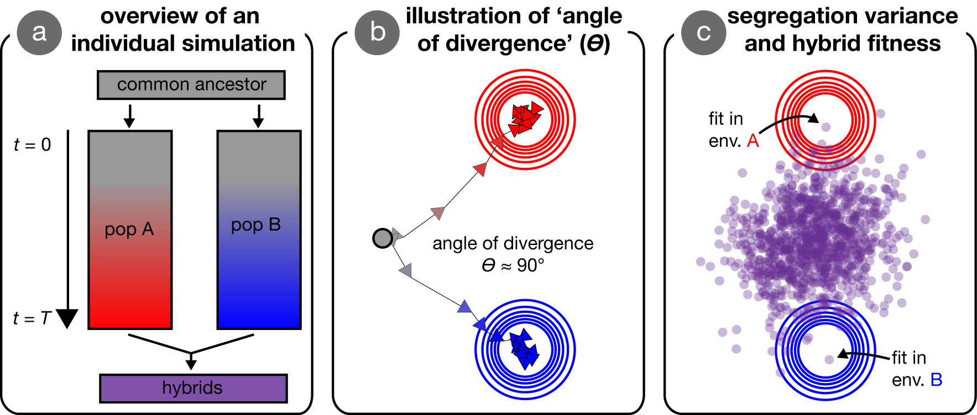

**Figure 1. Visual overview of simulations and concepts.** Panel (a) provides an overview of an individual simulation. An ancestral population founds two initially-identical populations, that evolve independently for *T* generations in their respective environments. After *T* generations of adaptation, these derived populations interbreed to form hybrids. Panel (b) illustrates the process of adaptation in our simulations, wherein two populations (arrows) independently adapt to specified optima. The distance between the origin (grey dot) and the optima (red and blue contours), *d*, is a parameter in the model, as is the angle of divergence, *ϴ*, here approximately 90°. Panel (c) illustrates the segregation variance in a group of hybrids and how the fitness of individual hybrids is measured. Specifically, hybrids that are near an optimum have high fitness in that environment.

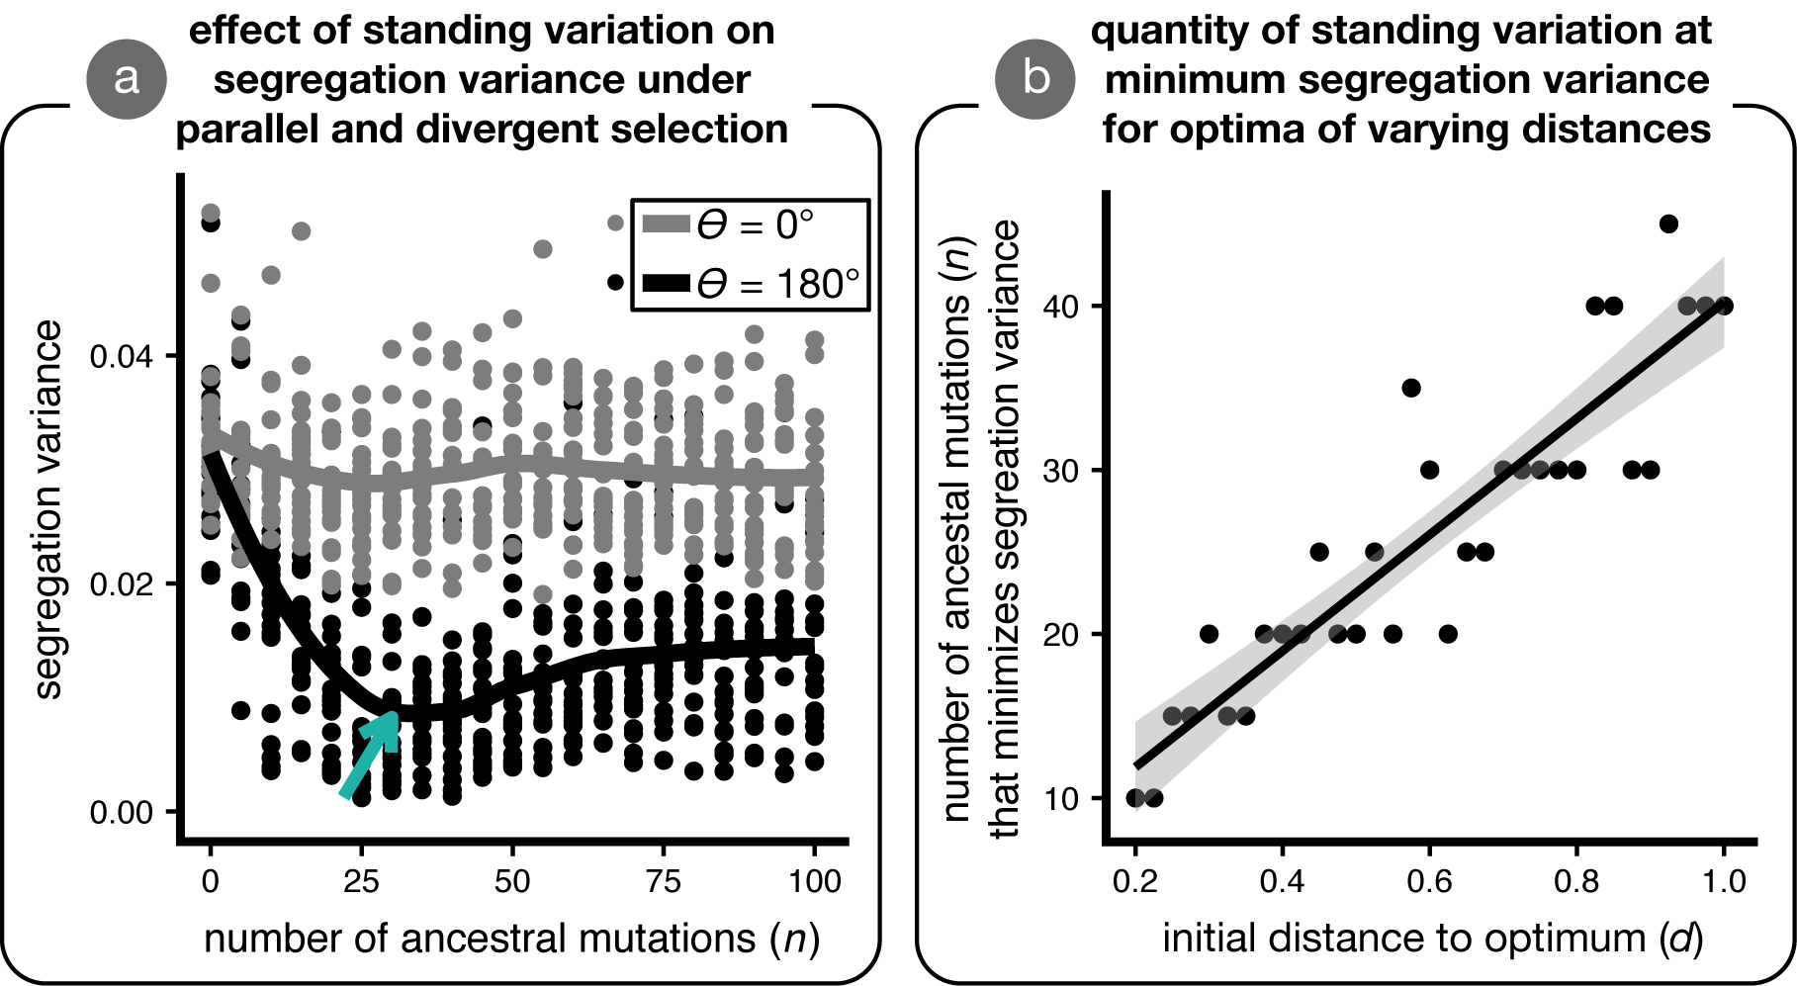

**Figure 2. The effects of standing genetic variation on segregation variance in hybrids under parallel and divergent natural selection.** Panel (a) shows values of segregation variance observed in 10 simulations for both divergent (*ϴ* = 180°; grey) and parallel (*ϴ* = 0°) evolution for populations founded with varying quantities of ancestral standing variation (*d* = 1). The curves are loess fits. Panel (b) shows that the quantity of ancestral standing variation that minimizes segregation variance increases when populations adapt to more distant optima. The line is a linear regression.

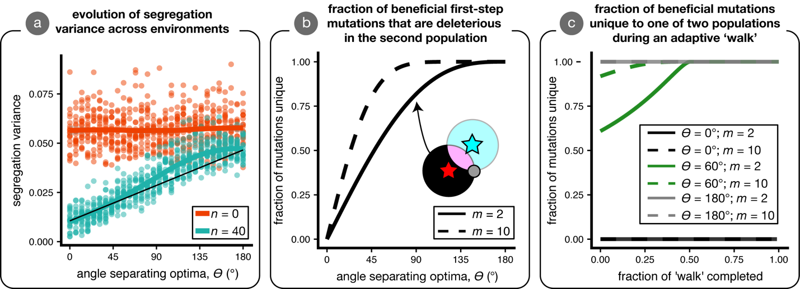

**Figure 3. Segregation variance and non-parallel evolution across environments.** We conducted simulations for optima separated by different angles (*ϴ* = 0° to 180°; *d* = 1) and measured the resulting segregation variance in hybrids. Panel (a) plots two cases of standing variation: no standing variation (*n* = 0; red) and the amount of standing variation that minimizes segregation variance at *ϴ* = 0°(*n* = 40; blue). Curves are loess fits. Panel (b) depicts the relationship between the initial fraction of beneficial mutations that are not beneficial in the other population for two different dimensionalities (*m* =2 & 10). In the inset cartoon, mutations in the black and blue regions are initially beneficial only in the ‘red’ or ‘blue' environments, while mutations in the pink region are mutually beneficial (i.e., the black area divided by the pink and black area is the fraction of non-overlap). Panel (c) shows the analytical relationship between the fraction of beneficial mutations beneficial to only one of two populations over the course of an adaptive ‘walk’ for specified angles and dimensionalities (see inset legend).

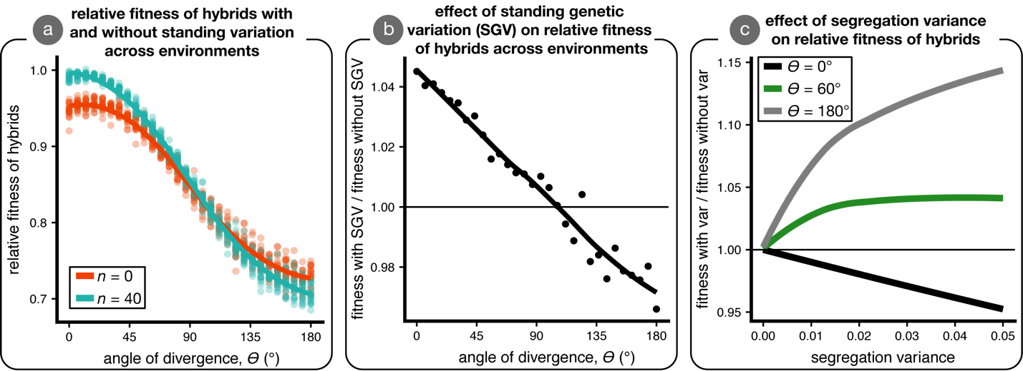

**Figure 4. The effect of standing variation on mean hybrid fitness.** Panel (a) shows the mean relative fitness of hybrids—as compared to parents—across environments in simulations initiated with (*n* = 40; blue) and without (*n* = 0; red) ancestral standing genetic variation. Panel (b) shows the effect of standing variation on mean relative hybrid fitness (the difference between red and blue lines in panel a); the horizontal line indicates no effect of standing variation on relative mean hybrid fitness. Panel (c) illustrates the relationship between segregation variance and mean hybrid fitness for three values of *ϴ* angles (black, *ϴ* = 0°; green, *ϴ* = 60°; grey, *ϴ* = 180°) when hybrid phenotypes are multivariate normal with mean between the two parental optima and equal variance in all phenotypic dimensions (no covariance). Hybrid fitness is plotted for each *ϴ* as relative to the case of no variance; the horizontal line ay *y* = 1 indicates that segregation variance has no effect on hybrid fitness. The data in panels (a) and (b) are from the simulations plotted in Fig. 3A.

**Supporting information for:**

**Patterns of speciation and parallel genetic adaptation from standing variation**

**by**

**Ken A. Thompson, Matthew M. Osmond and Dolph Schluter**

**Contents:**

Appendix 1

Figures S1-6.

**Appendix 1**

TBA

**Supplementary figures**

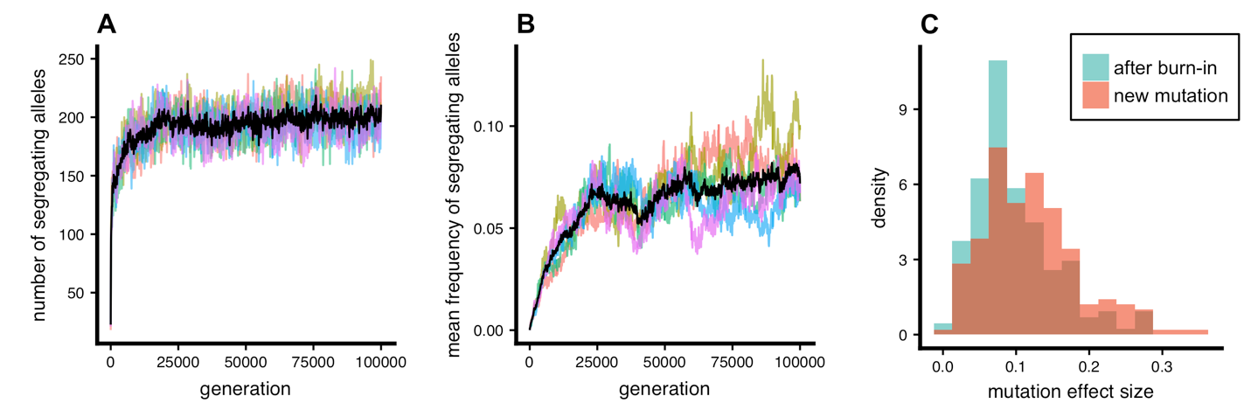

**Fig. S1. Mutation-selection balance and mutation effect sizes in ancestral populations.** (a) The number of segregating (i.e., unfixed) alleles in each of 10 ancestral populations and (b) the mean frequency of such alleles in the ancestral populations. The black line is plotted through the mean of all populations at each generation, and all ten burn-ins used to generate our results are shown. Panel (c) illustrates the distribution of mutation effect sizes at the end of a single burn-in simulation, as compared to the distribution of mutations that arise *de novo*.

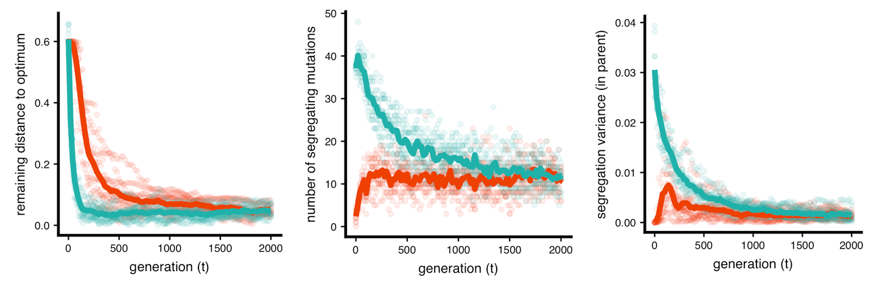

**Fig. S2. Effect of standing variation on the pace of adaptation and attainment of mutation selection-balance.** (a) Populations that adapt with standing variation in addition to new mutation (*n* = 35 mutations; blue) reach the phenotypic optimum more quickly than populations that adapt from new mutation only (*n* = 0; red). (b) Although populations equipped with standing variation adapt more quickly than populations adapting from new mutation only, they both reach mutation-selection balance by *t* = 2000. (c) The segregation variance in parental populations, calculated as it is in hybrids (see main text), is stable and near zero by the end of each simulation. The initial distance to the optima is *d* = 0.6 for all simulations. We plot 10 replicate simulations, and lines connect the mean values at each sampled generation.

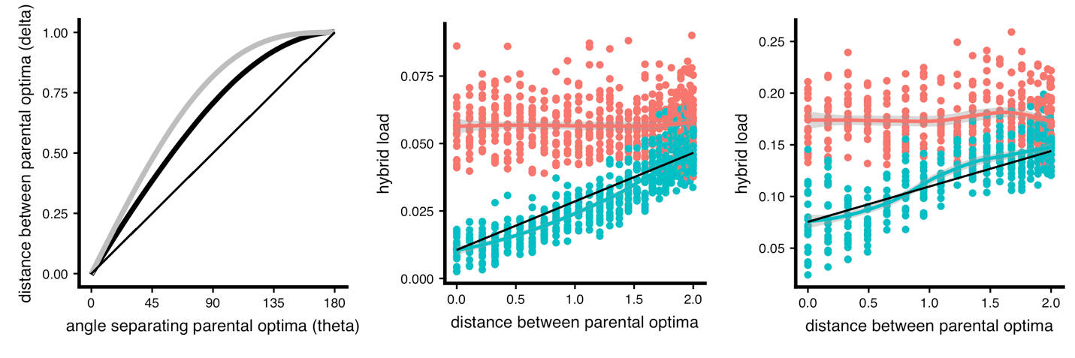

**Fig. S3. Alternative presentation of simulation results across environments: distance between optima (𝛿).** Panel (a) plots the relationship between the angle of divergence, *ϴ*, and the Euclidean distance between parental optima, 𝛿 (thick black line). We also plot the fraction of beneficial mutations expected to be beneficial in just one population (grey line; see Fig. 3B). Panel (b) plots the same data in as in Fig. 3A, respectively, but with 𝛿 on the x-axis. The black line is the 1:1 line for simulations initiated with standing variation.

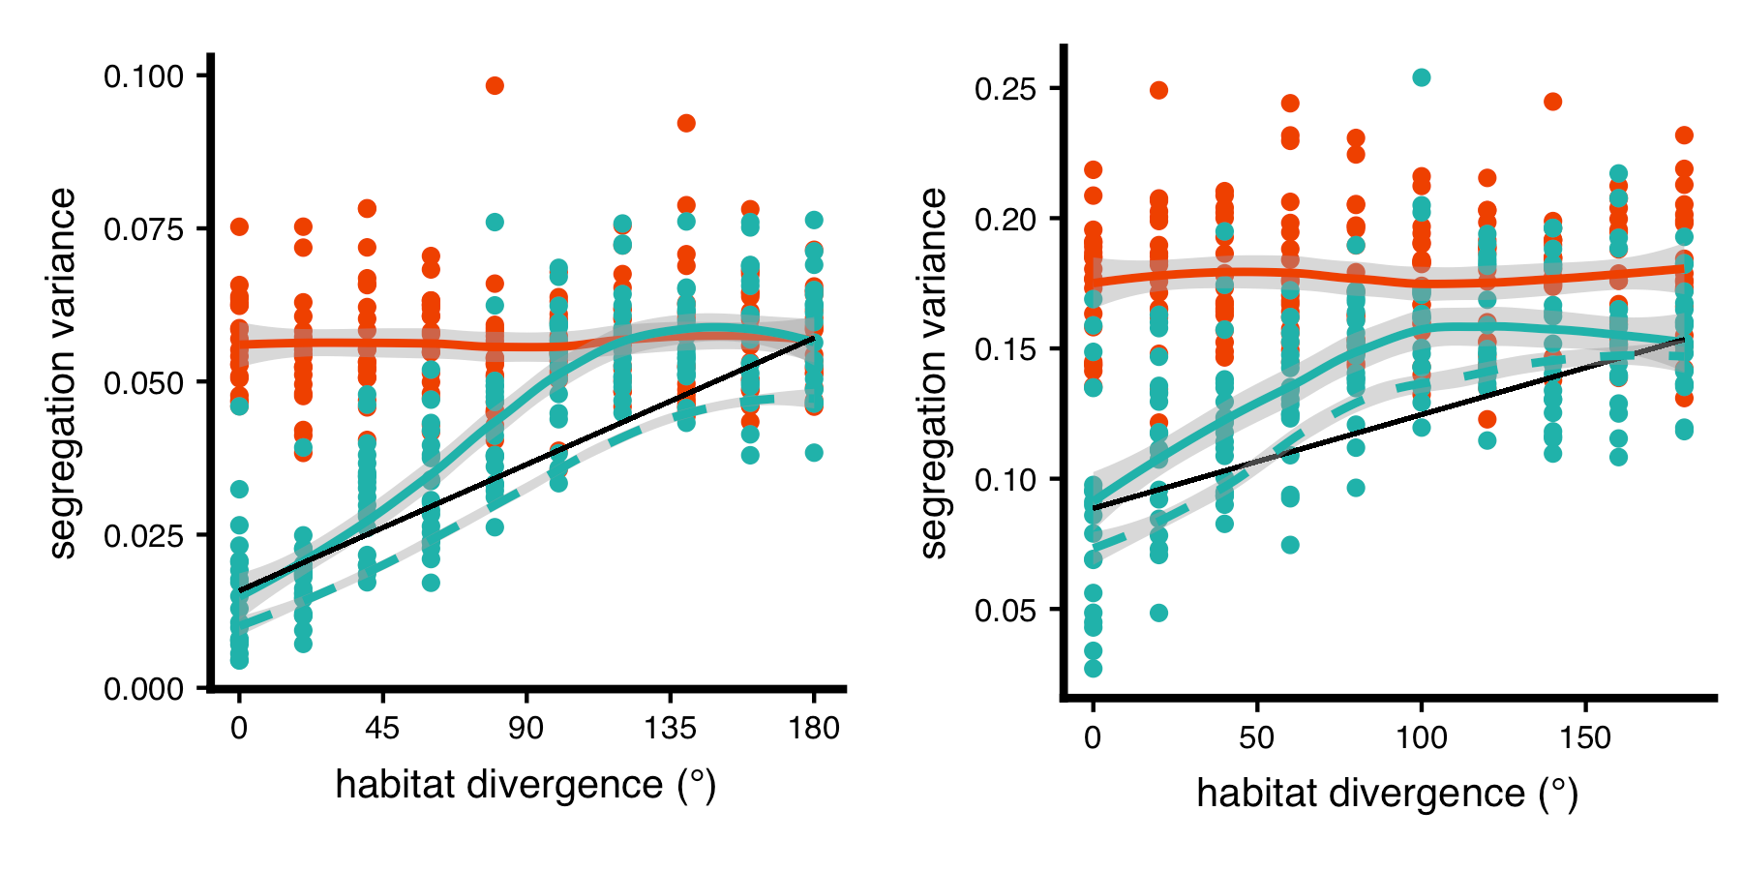

**Fig. S4. Evolution of segregation variance with standing variation generated from the mutation-distribution, rather than burn-in.** We generated standing variation from the raw mutation distribution, such that mutations in the standing variation have identical properties to those arising *de novo* (i.e., before selection). The dashed line is the smooth from simulations where the standing variation was generated from a burn-in using the same data as from Fig. 3A in the main text. Segregation variance is equivalent for simulations initiated with and without standing variation from the mutation-distribution for large angles, indicating that populations fix alternative mutations from standing variation, and that the properties of these mutations are similar. *d* = 1, initial frequency of mutations was 10 %.

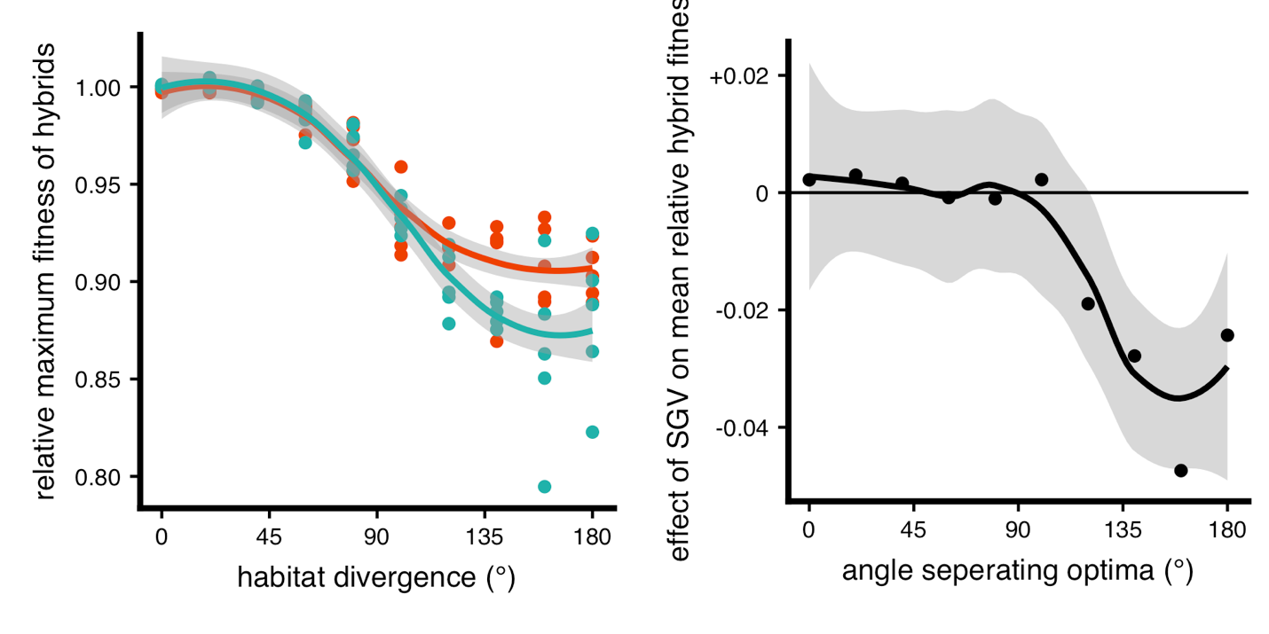

**Figure S5. The effect of segregation variance on maximum hybrid fitness across environments.** (NOTE: WILL RUN MORE SIMULATIONS IN NEXT DRAFT) Data are identical to that plotted in Fig. 3A and 4A & B of the main text, but instead of mean fitness we depict the relative fitness of top 5 % of hybrids to all parents. We plot both the (a) raw values of relative fitness (blue = standing variation; red = *de novo*) and (b) the effect of standing variation on maximum hybrid fitness. There is no meaningful effect of standing variation on maximum hybrid fitness under parallel natural selection, and negative effect under divergent selection.

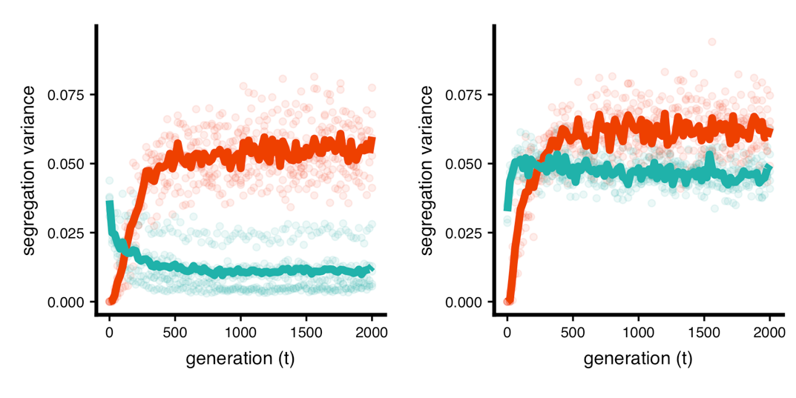

**Fig. S6. Evolution of segregation variance over time with and without standing variation.** We depict two scenarios, (A) parallel (*ϴ* = 0°) and (B) divergent (*ϴ* = 180°) for *m* = 2 and *d* = 1. We plot segregation variance, a component of hybrid fitness, measured every 100 generations over the course of the adaptive walk. We plot 10 replicate simulations, and lines are drawn through the mean value at each sampled generation. Standing variation is *n* = 40.