Experiment No. 1
Aim: To create a local blockchain and deploy a smart contract using Truffle.

Theory:
Ethereum is a blockchain that allows applications to run on it. The code is written in Solidity language in the form of smart contracts. To compile these contracts, we need an Ethereum compiler, which converts smart contracts to machine-readable code.
What is Truffle?
The Truffle suite is a collection of tools made specifically for blockchain development on Ethereum. The suite includes three pieces of software: Truffle, a framework for smart contract development; Ganache, which enables you to set up a personal Ethereum blockchain on the local network for testing and development; and Drizzle, which is used for creating DApp user interfaces and includes a collection of ready-to-use components.
A] Truffle
Truffle is a world-class development environment, testing framework and asset pipeline for blockchains using the Ethereum Virtual Machine (EVM), aiming to make life as a developer easier. With Truffle, you get:
• Built-in smart contract compilation, linking, deployment and binary management.
• Advanced debugging with breakpoints, variable analysis and step functionality.
• Use console.log in your smart contracts.
• Deployments and transactions through MetaMask with Truffle Dashboard to protect your mnemonic.
B] Ganache
Ganache is a personal blockchain for rapid Ethereum and Filecoin distributed application development. You can use Ganache across the entire development cycle, enabling you to develop, deploy and test your dApps in a safe and deterministic environment.

Implementation:
Steps to Deploy a Smart Contract
1] Install Node.js and npm. Truffle is installed globally using npm.
npm install -g truffle
2] Install Ganache, a personal Ethereum blockchain for development.
npm install -g ganache-cli
Ganache UI can also be downloaded from the Truffle Suite website.
3] Create a new directory for the project and initialize a new Truffle project.
mkdir my-smart-contract
cd my-smart-contract
truffle init
4] Write the smart contract in the contracts directory as MyContract.sol.
contract MyContract {
string public message;

constructor(string memory initialMessage) {
message = initialMessage;
}

function setMessage(string memory newMessage) public {
message = newMessage;
}
}
5] Compile the smart contract to ensure there are no errors.
truffle compile
6] Start the local blockchain and deploy the contract to it.
ganache-cli
truffle migrate --network development
7] Interact with the deployed contract through the Truffle console.
truffle console --network development
The contract was then interacted with using the Truffle console, as shown below.
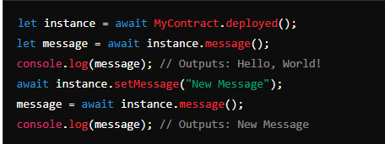

Conclusion:
Thus, we have successfully created a local blockchain and deployed a smart contract using Truffle.

