Experiment No. 4
Aim: To study and implement a smart contract using Remix IDE and MetaMask for the development and deployment of a cryptocurrency.

Theory:
A cryptocurrency is a digital or virtual currency secured by cryptography and typically built on a blockchain. Ethereum allows developers to create their own cryptocurrency tokens using smart contracts written in Solidity.
Remix IDE is a web-based integrated development environment used to write, compile, deploy and debug Solidity smart contracts directly from the browser. MetaMask is a browser extension wallet that manages Ethereum accounts and keys, and connects decentralized applications to the Ethereum network.
Steps Followed
• Write or paste the smart contract in Remix IDE.
• Compile the smart contract using a Solidity compiler version compatible with the contract.
• Connect Remix to MetaMask using the Injected Web3 environment.
• Deploy the contract by passing the token name, symbol, decimals and initial supply.
• Confirm the deployment transaction in MetaMask and verify the deployed contract.
• Interact with the contract functions such as balanceOf and transfer.

Implementation:
1] Write the Smart Contract
In Remix, under File Explorers, a new file named SimpleCryptoCurrency.sol was created and the following smart contract code was pasted into it.
// SPDX-License-Identifier: MIT
pragma solidity ^0.8.0;

// This contract implements a basic cryptocurrency
contract SimpleCryptoCurrency {
// Mapping to store balances of all addresses
mapping(address => uint256) public balances;

// Address of the contract owner (usually the deployer)
address public owner;

// Basic token information
string public name; // Name of the token
string public symbol; // Symbol or ticker of the token
uint8 public decimals; // Number of decimal places for token amounts
uint256 public totalSupply; // Total number of tokens in circulation

// Event emitted when tokens are transferred
event Transfer(address indexed from, address indexed to, uint256 value);

// Constructor function, called when deploying the contract
// It sets up the initial state of the cryptocurrency
constructor(string memory _name, string memory _symbol, uint8 _decimals, uint256 _initialSupply) {
owner = msg.sender; // Set the contract deployer as the owner
name = _name;
symbol = _symbol;
decimals = _decimals;
// Calculate total supply considering decimals
totalSupply = _initialSupply * 10 ** uint256(decimals);
balances[msg.sender] = totalSupply;
}

function transfer(address to, uint256 value) public returns (bool) {
require(balances[msg.sender] >= value, "Insufficient balance");
balances[msg.sender] -= value;
balances[to] += value;
emit Transfer(msg.sender, to, value);
return true;
}
}
2] Compile the Smart Contract
The Solidity Compiler tab was opened and the compiler version was set to match the version specified in the contract (^0.8.0). The contract SimpleCryptoCurrency.sol was then compiled successfully, as indicated by the green checkmark.
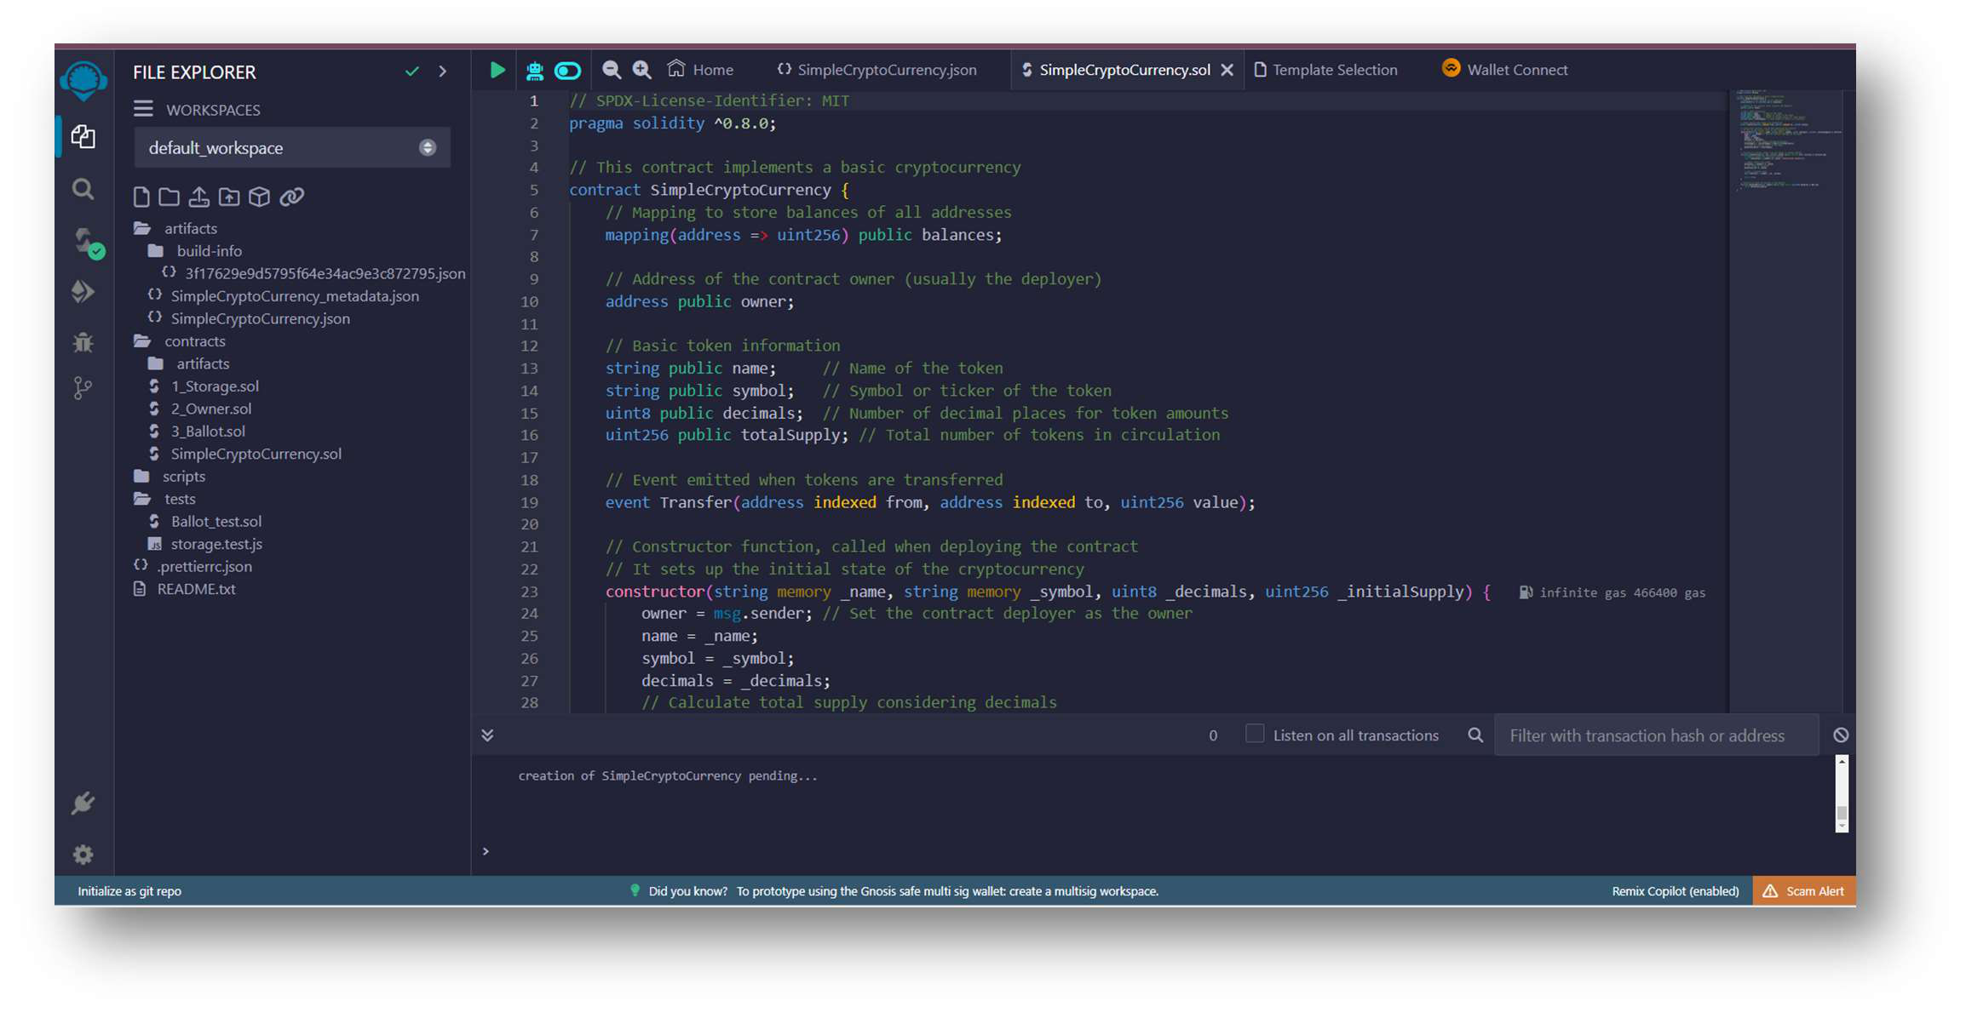
3] Deploy the Contract using MetaMask
The Deploy & Run Transactions tab was opened and the environment was set to Injected Web3, which connects Remix to MetaMask. After approving the connection, the constructor parameters were entered: _name as "MyToken", _symbol as "MTK", _decimals as 18 and _initialSupply as 1000000. On clicking Deploy, the transaction was confirmed in MetaMask and the contract was deployed.
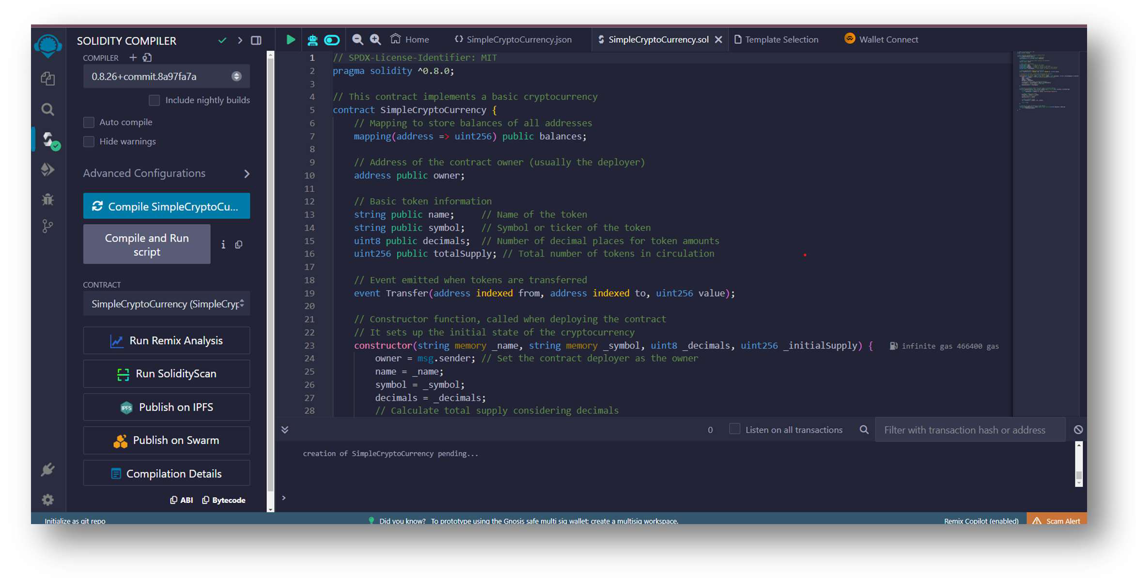
4] Verify the Contract Deployment
Once deployed, the transaction details became visible in the Deployed Contracts section of Remix. The contract address was displayed and the contract functions such as balanceOf and transfer could be invoked directly from Remix.
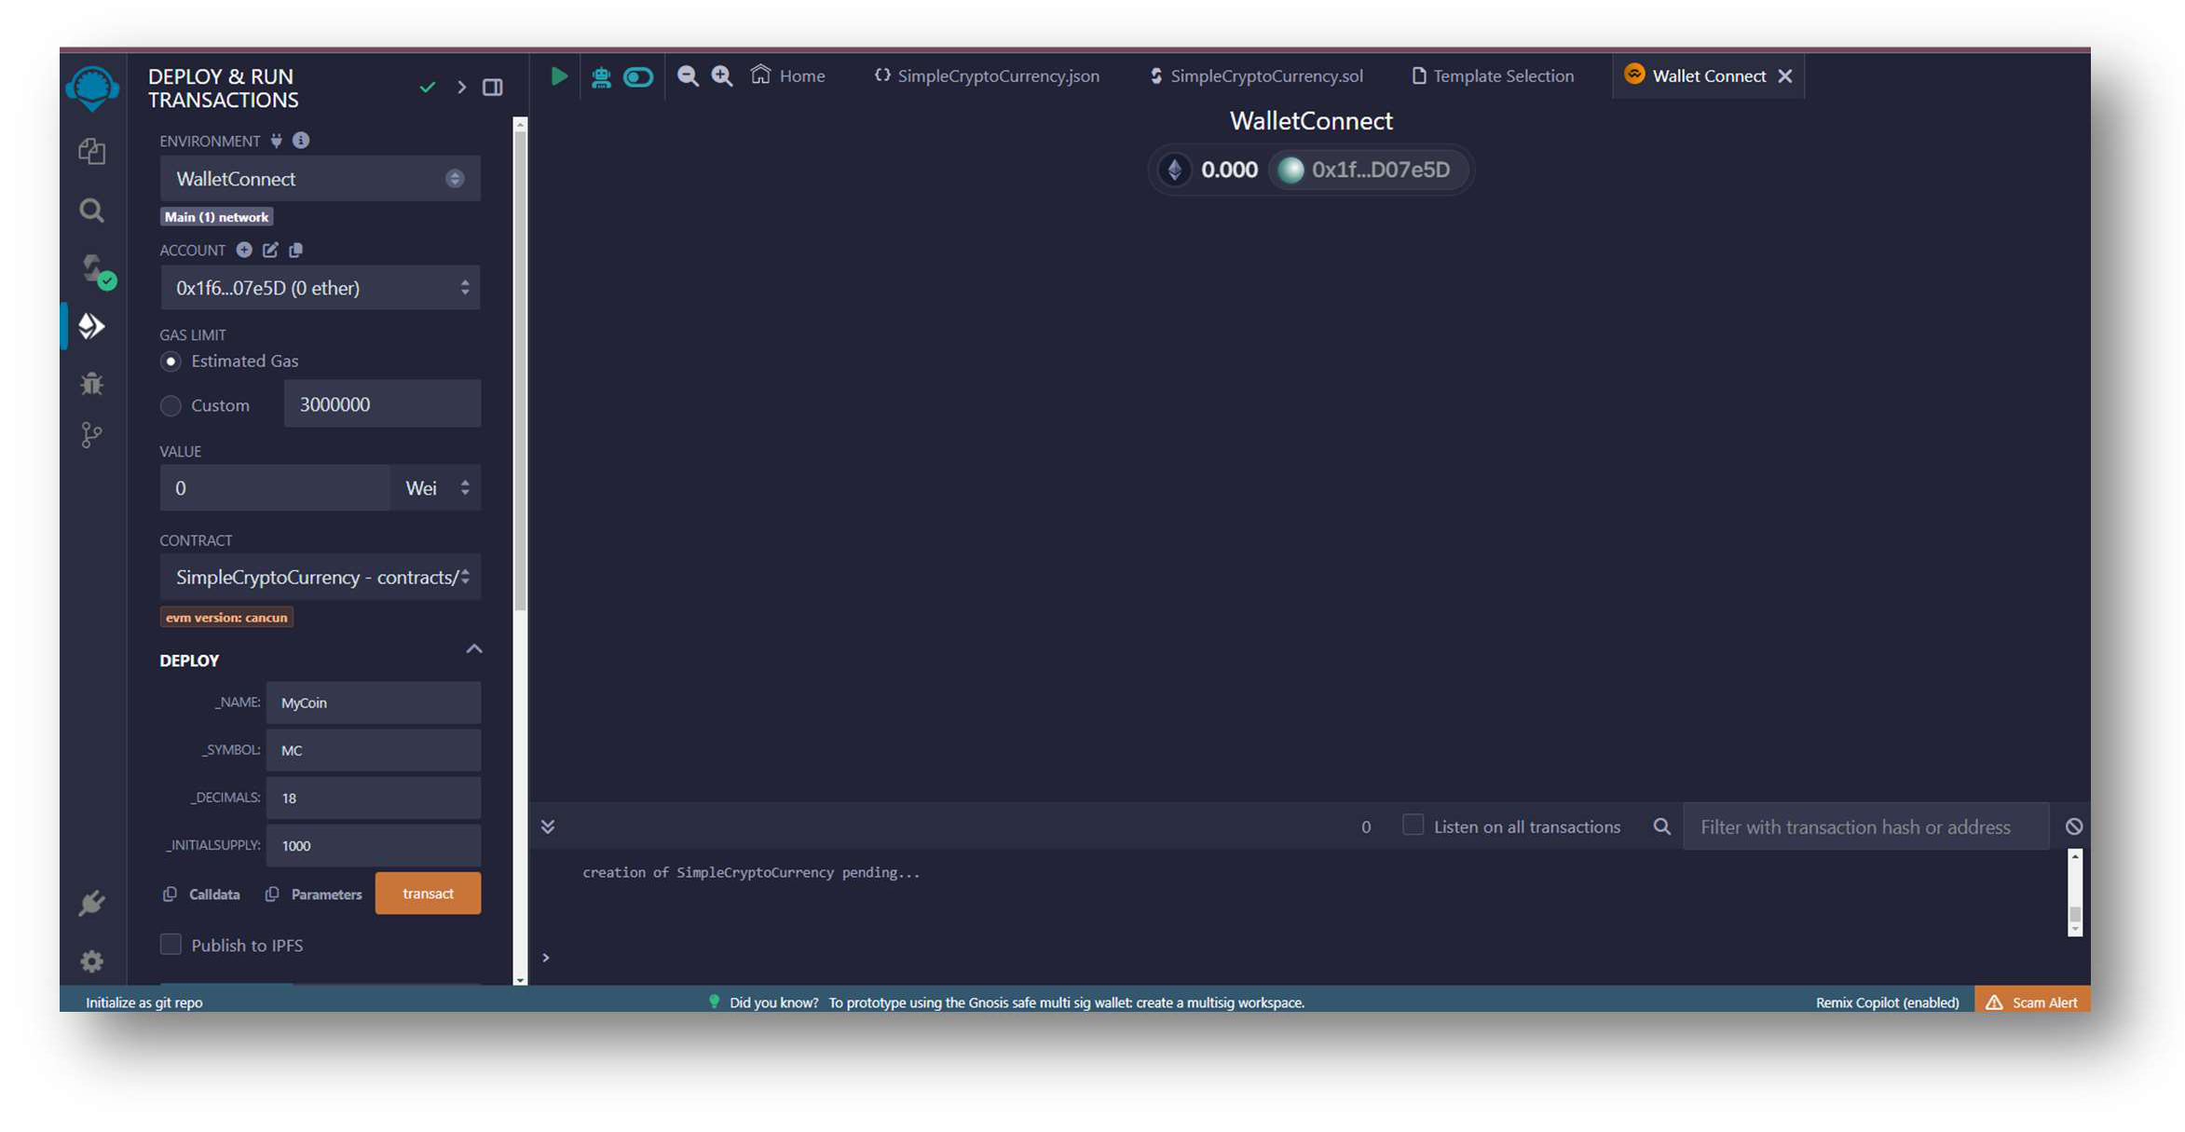
5] Interact with the Deployed Contract
The balanceOf function was used to check the token balance of an address and the transfer function was used to send tokens from one address to another. Every interaction with the contract required the transaction to be signed and sent through MetaMask.
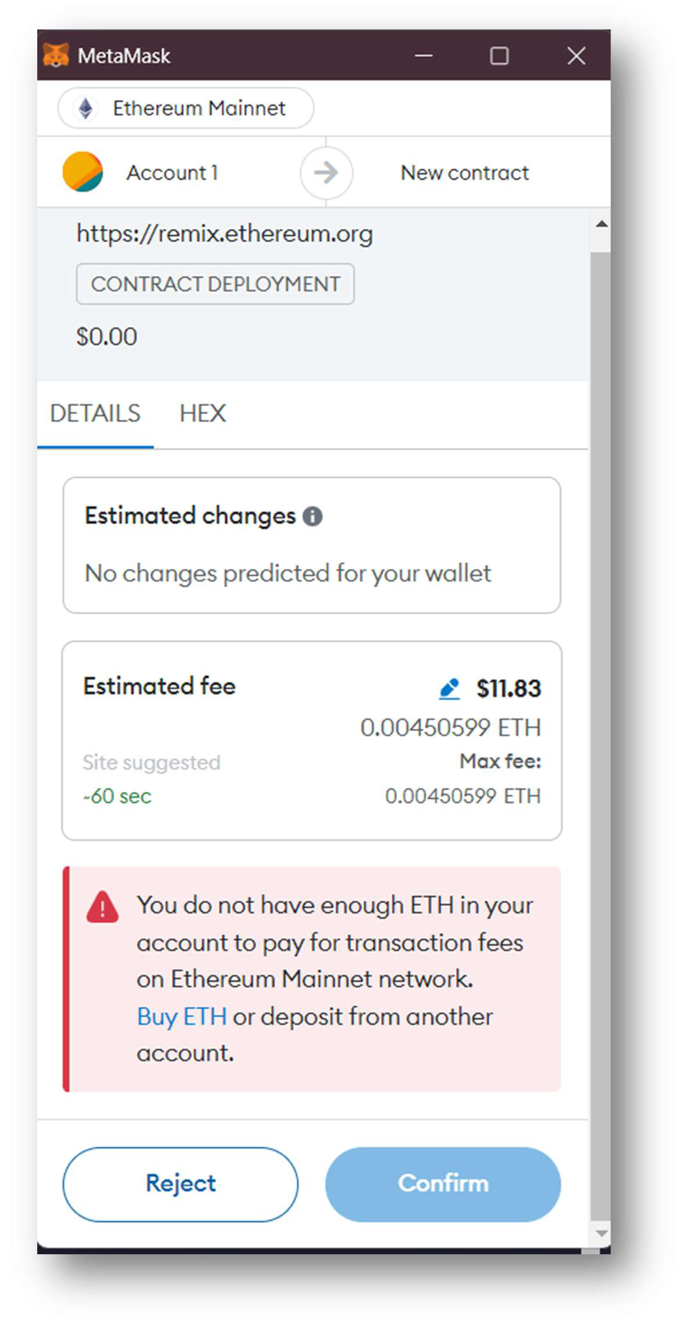

Conclusion:
Hence, we have successfully designed and deployed a smart contract using Remix IDE and MetaMask for the development and deployment of a cryptocurrency.

