Experiment No. 9
Aim: To design and develop a mini-project on a blockchain-based course payment DApp using Ethereum smart contracts.

Theory:
Abstract
This project presents the development and implementation of a smart contract using Solidity to manage payments for a course. The smart contract leverages the security and decentralization benefits of Ethereum blockchain technology. The contract allows users to pay for a course while recording each payment transaction securely on the blockchain. The contract also includes functionalities for payment retrieval by the contract owner and user-specific payment history.
1.1 Literature Survey
Blockchain technology has shown remarkable potential in various industries due to its decentralized nature, immutability and transparency. In the field of education, blockchain is increasingly used to handle payments, certification and credential verification securely and efficiently. Existing systems often rely on intermediaries such as banks or payment processors, which introduce delays, higher costs and risks of fraud.
1.2 Problem Definition
Traditional systems of course fee management can suffer from the following challenges:
• Centralized systems introduce a single point of failure.
• Payments can be delayed or rejected due to banking systems.
• There is no real-time transparency on payment records for users.
1.3 Objectives
The primary objective is to develop a decentralized course payment system using blockchain technology that:
• Allows students to pay for courses in a trustless manner.
• Records payments on the blockchain for immutability.
• Allows the course owner to withdraw funds at any time.
• Provides transparency of payment history for users and the course owner.
1.4 Proposed Solution
The proposed system uses a smart contract on Ethereum that stores payments on-chain, allows the contract owner (course provider) to withdraw funds securely, and enables students to view their past payments using blockchain transactions. The contract implements access control using the Ownable smart contract, ensuring that only the contract owner can perform certain operations.
1.5 Technology/Platform Used
• Solidity: language for writing smart contracts.
• Ethereum Blockchain: for secure deployment and decentralized management.
• Truffle Suite: development framework.
• Ganache: blockchain simulator for local development.
• MetaMask: wallet for interacting with the contract.
2.1 System Design - Flowchart
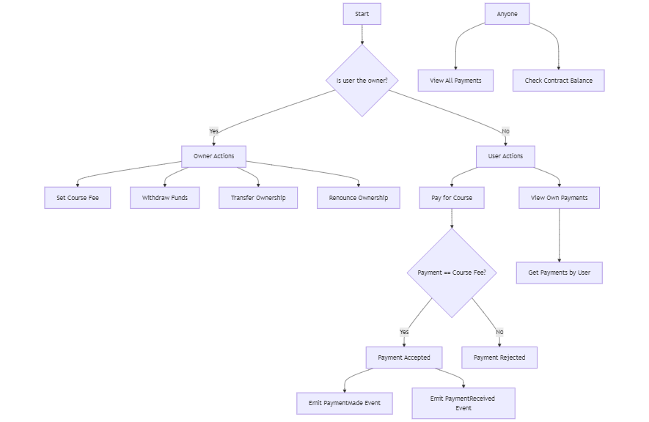
2.2 Software Requirements
• Operating System: Windows
• IDE: Remix IDE
• Blockchain Platform: Ethereum, Ganache (for local testing)
• Wallet: MetaMask
• Development Tools: Truffle Suite, Node.js
2.3 Cost Estimation
Cost will include deployment costs on Ethereum's testnet or mainnet. Gas fees vary depending on network congestion and the number of transactions executed.

Implementation:
3.1 Code
CourseContract.sol:
// SPDX-License-Identifier: MIT
pragma solidity ^0.8.0;

import "./Ownable.sol";

contract CourseContract is Ownable {
uint courseFee;
Payment[] public payments;

event PaymentMade(address indexed user, string email, uint256 amount);

constructor(uint _newCourseFee) Ownable(msg.sender) {
courseFee = _newCourseFee;
}

struct Payment {
address user;
string email;
uint256 amount;
}

function withdraw() external payable onlyOwner {
payable(owner()).transfer(address(this).balance);
}

function payForCourse(string memory _email) external payable {
require(
msg.value == courseFee,
"Payment must be equal to the course fee"
);
payments.push(Payment(msg.sender, _email, msg.value));
emit PaymentMade(msg.sender, _email, msg.value);
}

function getPaymentsByUser(
address _user
) public view returns (Payment[] memory) {
uint ctr = 0;

for (uint i = 0; i < payments.length; i++) {
if (payments[i].user == _user) {
ctr++;
}
}

Payment[] memory result = new Payment[](ctr);
uint index = 0;

for (uint i = 0; i < payments.length; i++) {
if (payments[i].user == _user) {
result[index] = payments[i];
index++;
}
}
return result;
}

function getAllPayments() public view returns (Payment[] memory) {
return payments;
}
}
Ownable.sol:
// SPDX-License-Identifier: MIT
pragma solidity ^0.8.0;

contract Ownable {
address private _owner;

event OwnershipTransferred(address indexed previousOwner, address indexed newOwner);

constructor(address initialOwner) {
_transferOwnership(initialOwner);
}

modifier onlyOwner() {
_checkOwner();
_;
}

function owner() public view virtual returns (address) {
return _owner;
}

function _checkOwner() internal view virtual {
require(owner() == msg.sender, "Caller is not the owner");
}

function renounceOwnership() public virtual onlyOwner {
_transferOwnership(address(0));
}

function transferOwnership(address newOwner) public virtual onlyOwner {
_transferOwnership(newOwner);
}

function _transferOwnership(address newOwner) internal virtual {
address oldOwner = _owner;
_owner = newOwner;
emit OwnershipTransferred(oldOwner, newOwner);
}
}
3.2 Implementation Snapshots
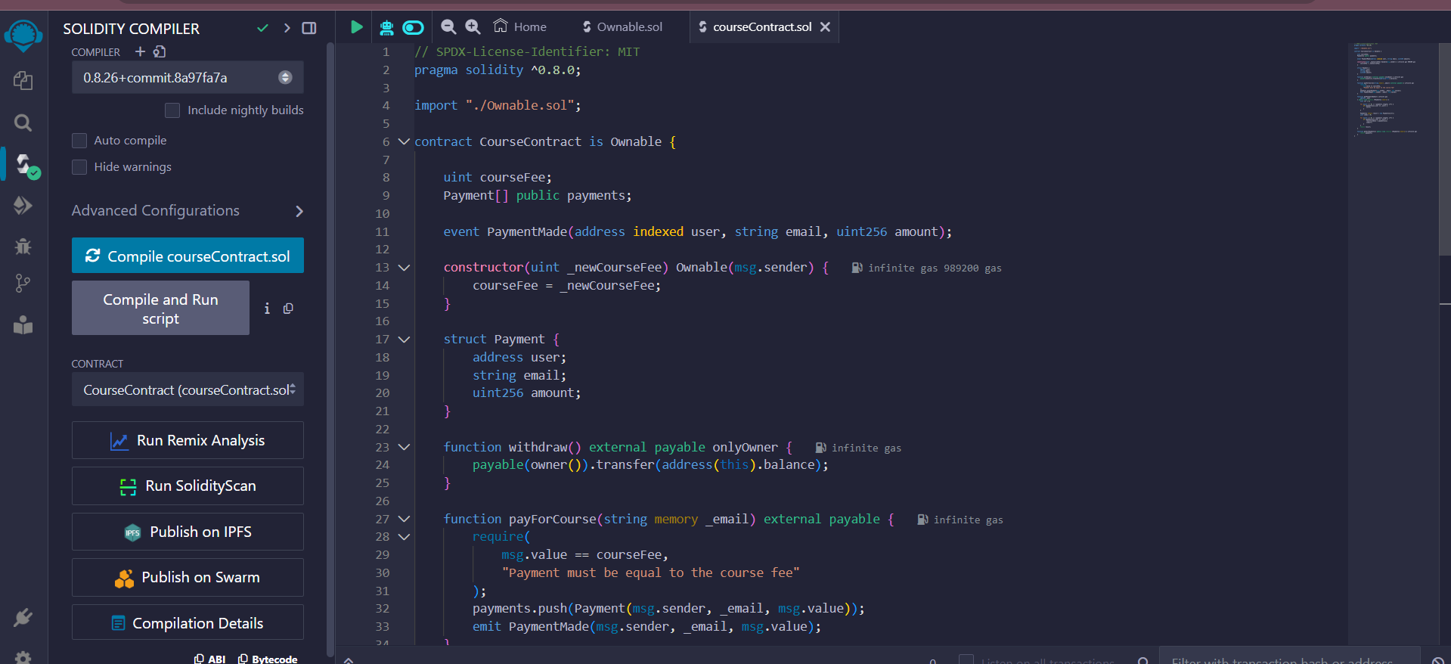
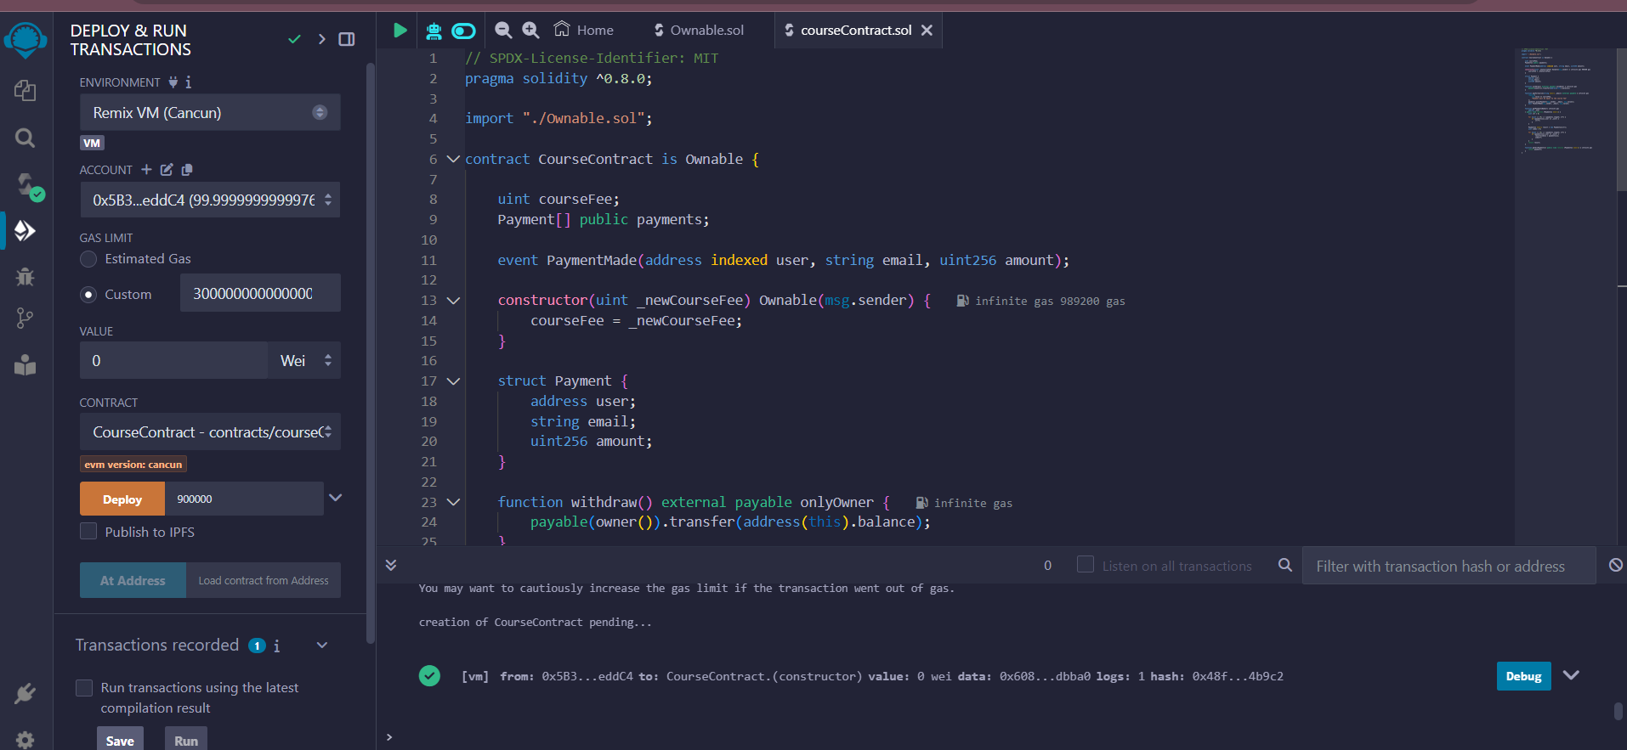
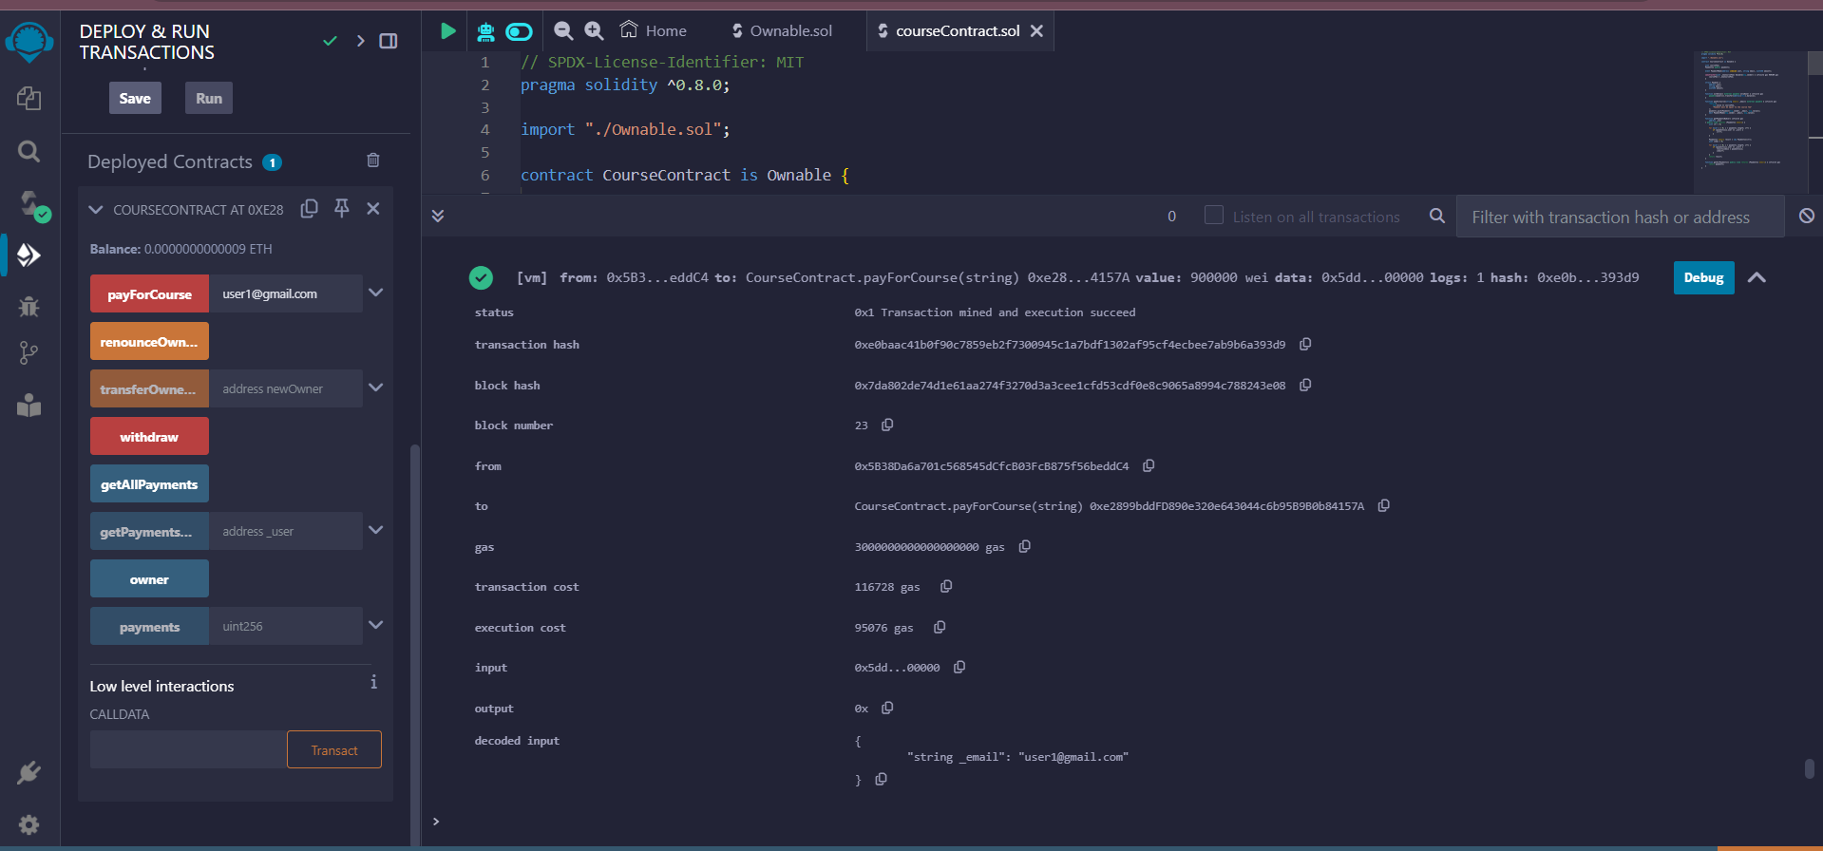
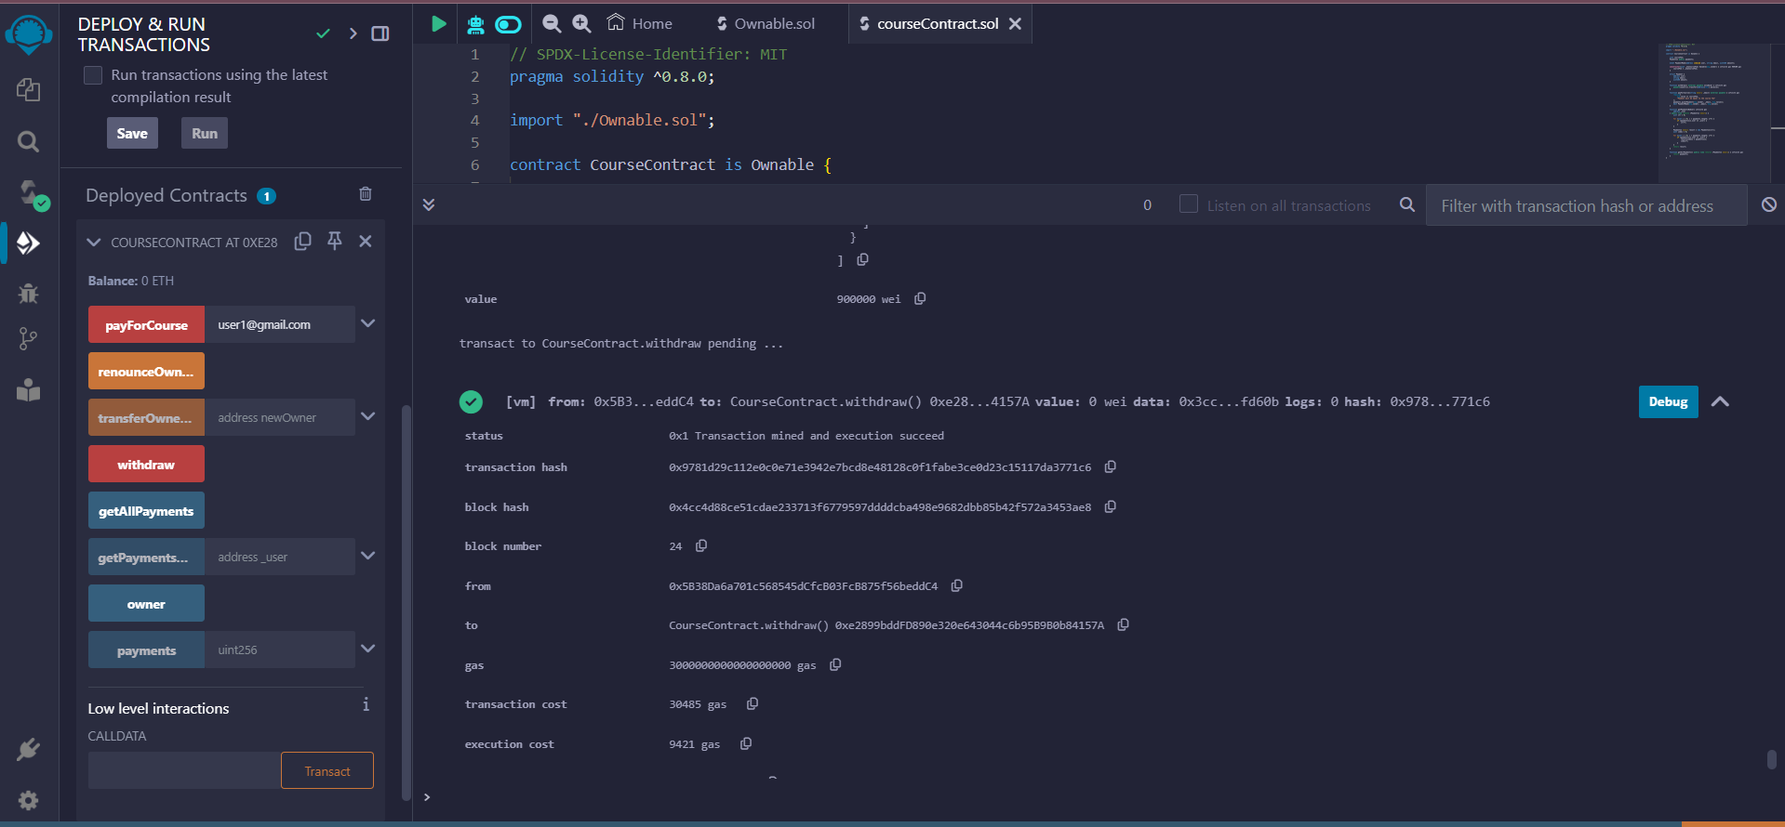
3.3 Future Directions
• Add refund functionality.
• Integrate with a frontend for easy user interaction.
• Support multiple course payments.

Conclusion:
This project demonstrates a simple implementation of a course payment system using Ethereum smart contracts. The system leverages the transparency and security of blockchain to record immutable payment transactions while offering direct fund management for course providers. The implementation also shows how access control can be enforced on-chain using an Ownable contract. References: Solidity documentation (https://docs.soliditylang.org/en/v0.8.0/), Truffle Suite documentation (https://www.trufflesuite.com/docs) and MetaMask (https://metamask.io/).

