Experiment No. 3
Aim: To study and implement the deployment and publishing of smart contracts on the Ethereum test network.

Theory:
Introduction to Ethereum and Smart Contracts
Ethereum is a decentralized platform that runs smart contracts, which are applications that run exactly as programmed without any possibility of downtime, censorship, fraud, or third-party interference. These smart contracts are self-executing contracts with the terms of the agreement directly written into lines of code.
Ethereum Test Networks
Before deploying smart contracts on the main Ethereum network, it is advisable to use a test network. Ethereum offers several test networks such as Ropsten, Rinkeby and Kovan. These networks allow developers to test their smart contracts in a risk-free environment using test ether, which has no real-world value.
Tools and Technologies
To deploy and publish smart contracts, the following tools are commonly used:
• Solidity: a programming language for writing smart contracts.
• Remix IDE: an online IDE for developing, deploying and testing smart contracts.
• MetaMask: a browser extension that acts as a wallet for managing Ethereum accounts and connecting to the Ethereum network.
• Ganache: a personal blockchain for Ethereum development.
• Truffle: a development framework for Ethereum that provides tools for developing and testing smart contracts.
Steps to Deploy a Smart Contract
• Write the smart contract using Solidity.
• Compile the Solidity code to check for errors and generate the bytecode.
• Deploy the compiled contract to the Ethereum test network using Remix IDE or Truffle.
• Interact with the deployed smart contract using Remix IDE, Truffle or web3.js.

Implementation:
The smart contract was written, compiled and deployed on an Ethereum test network using Remix IDE and MetaMask. The complete implementation is shown in the snapshots below.
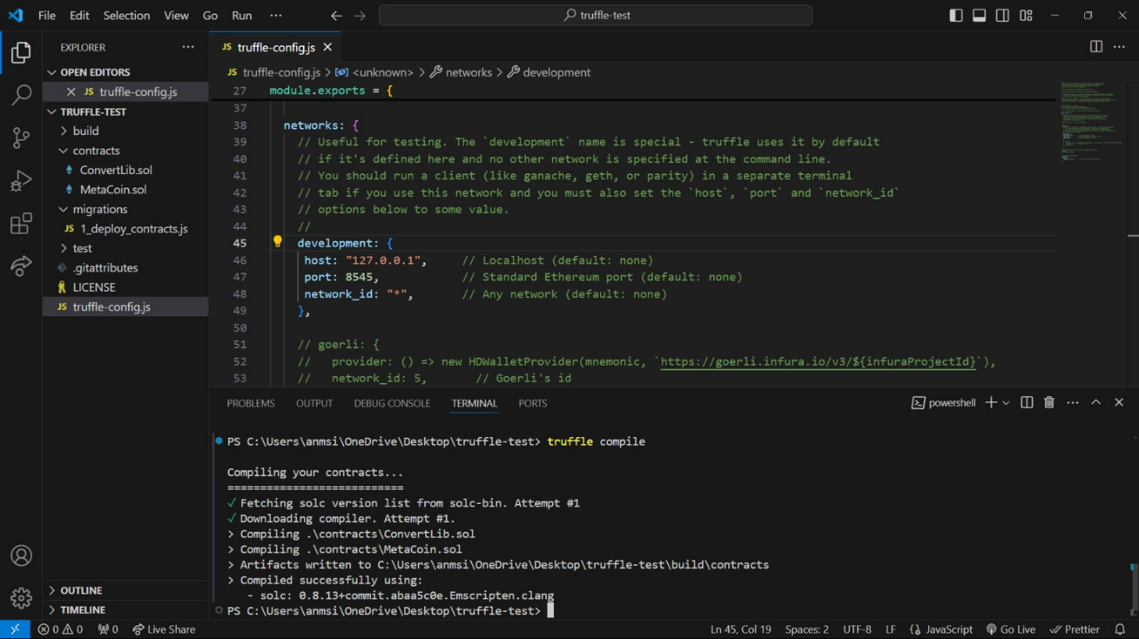
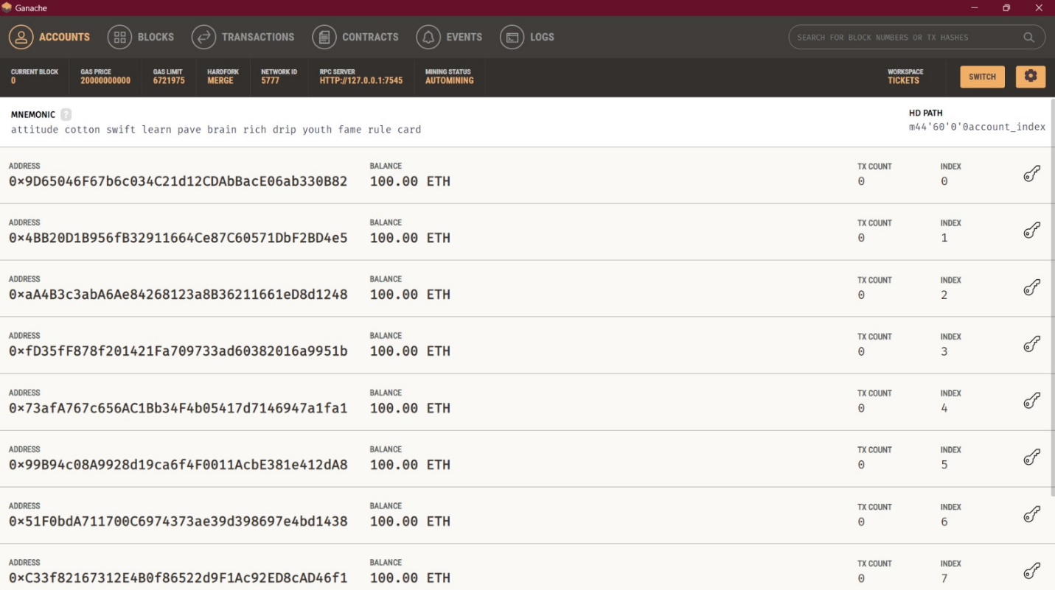
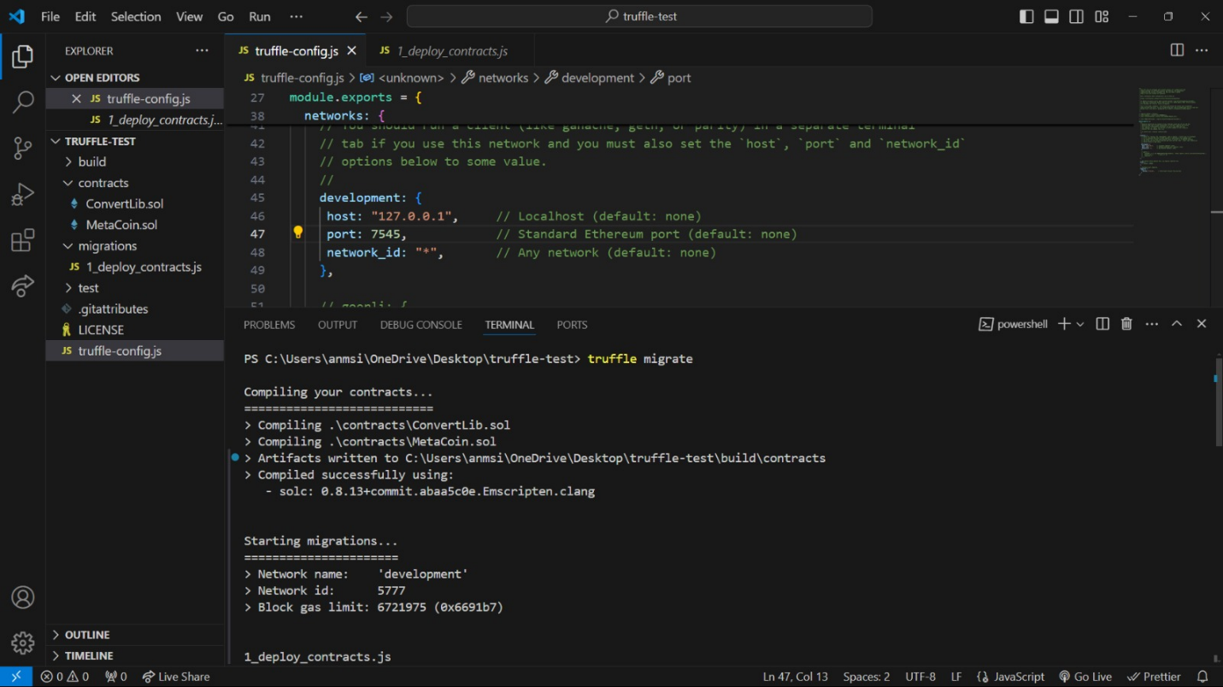
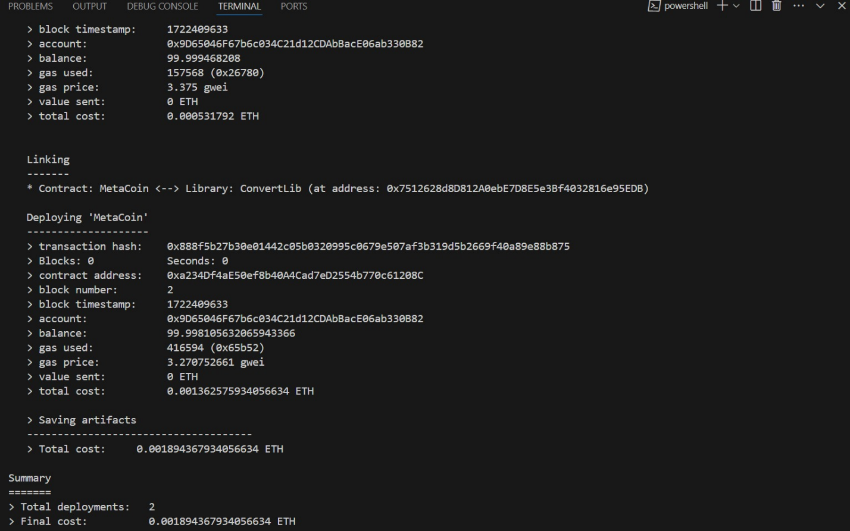
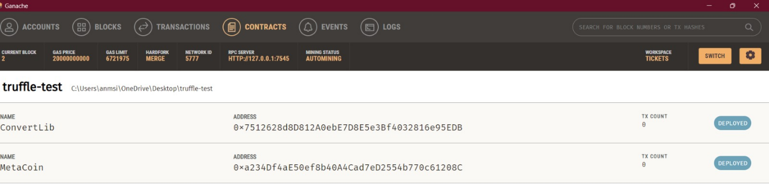
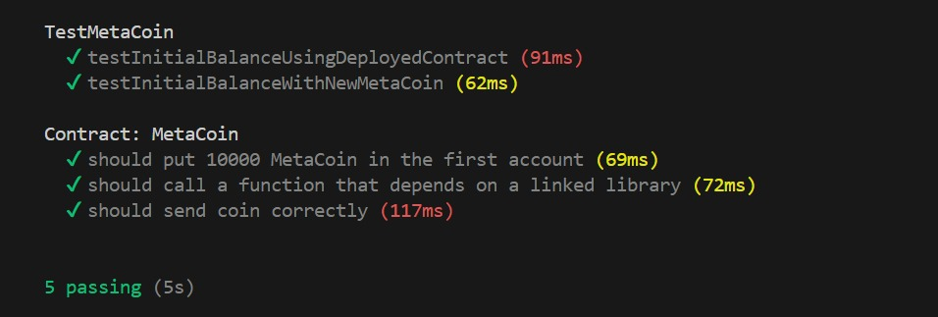
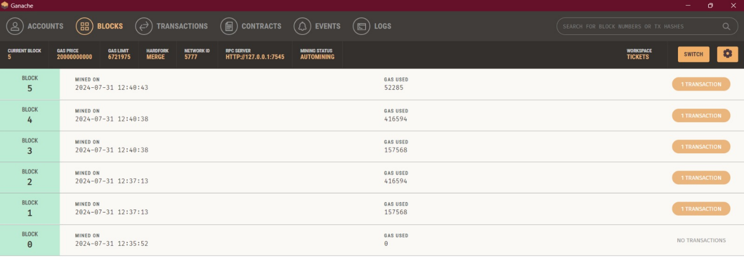
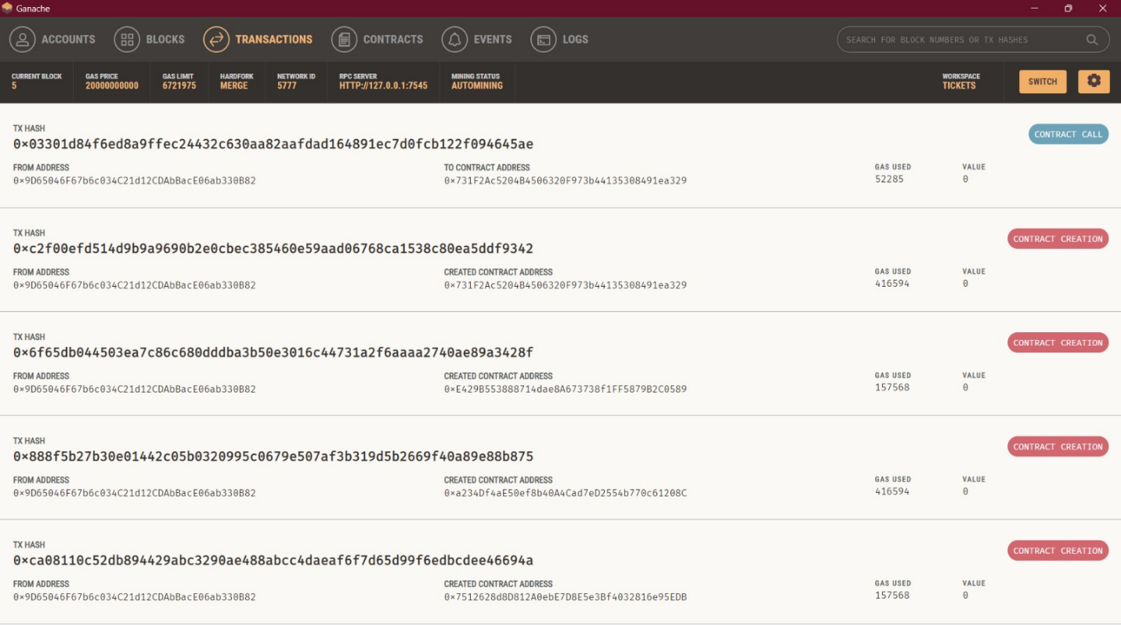
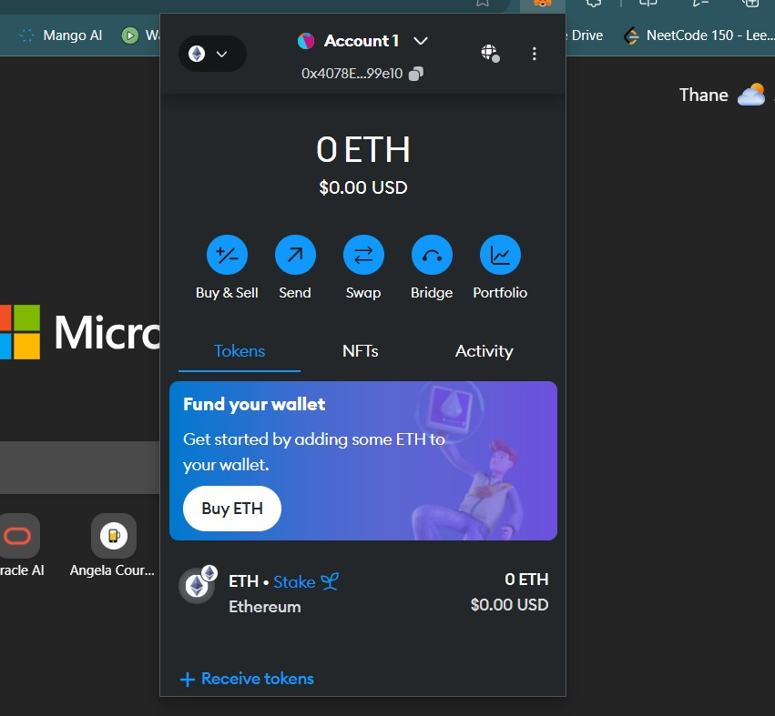
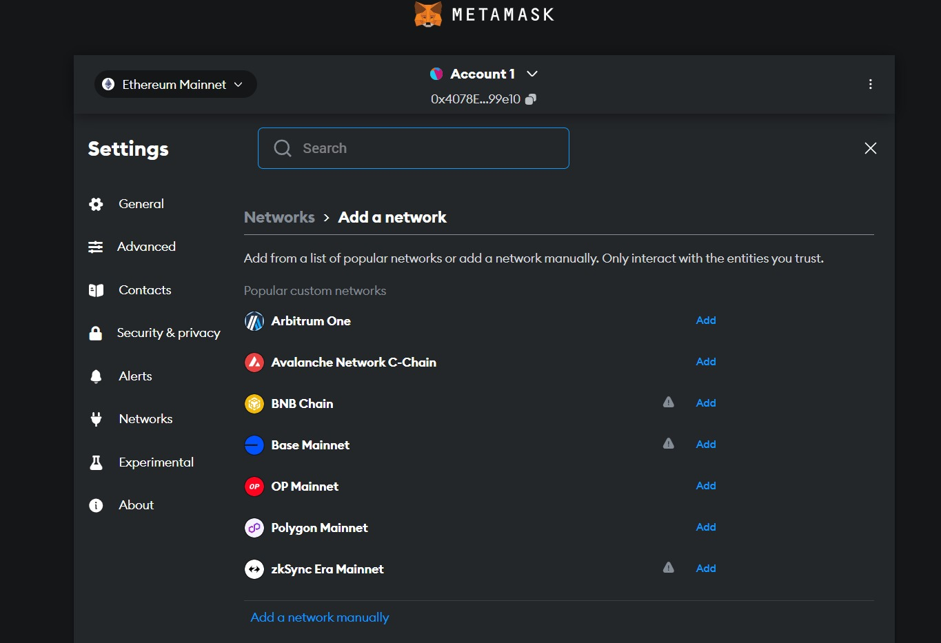
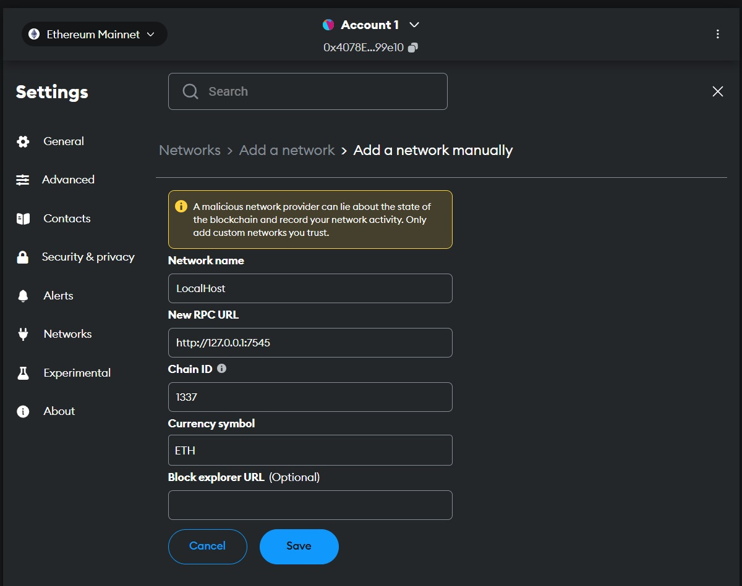
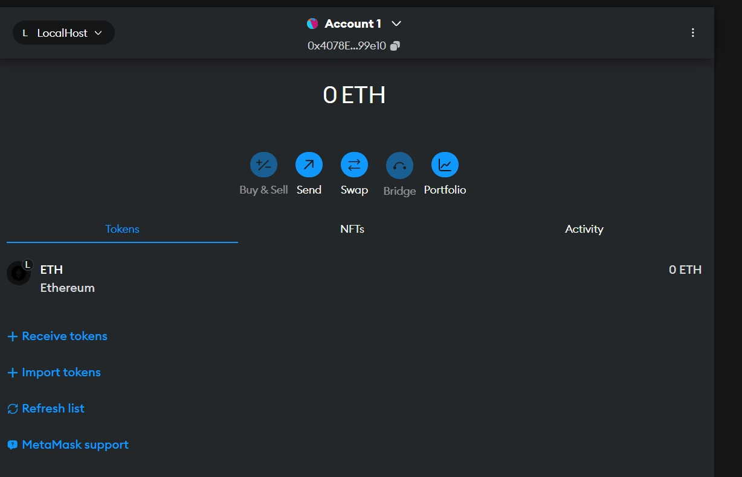
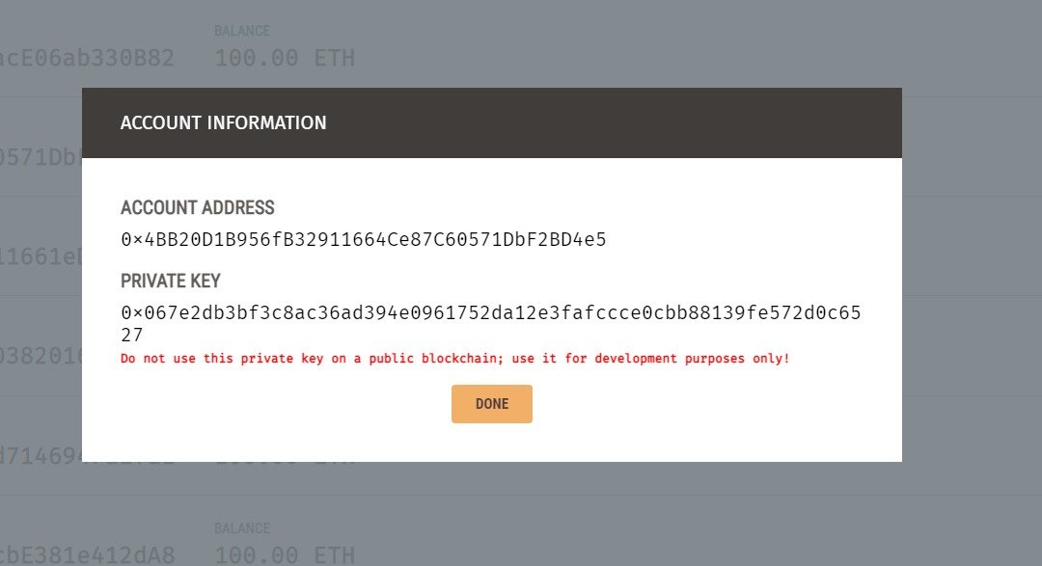
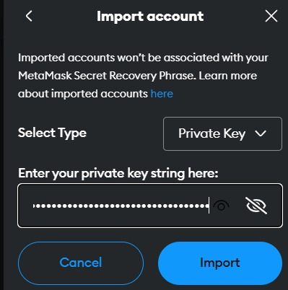
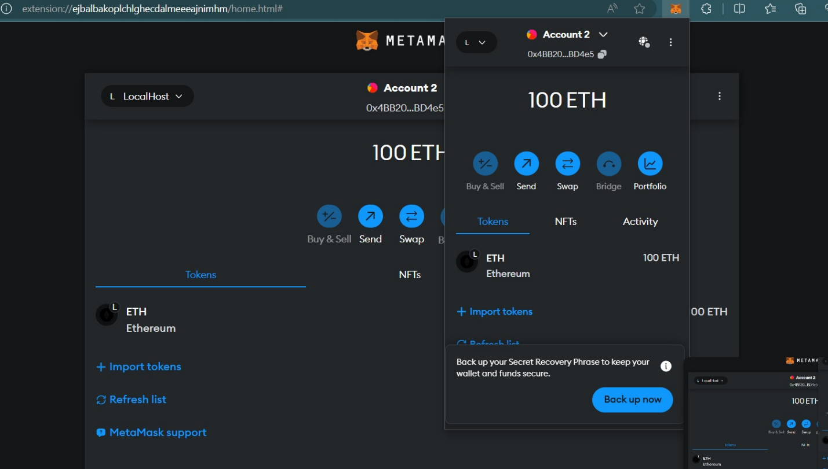
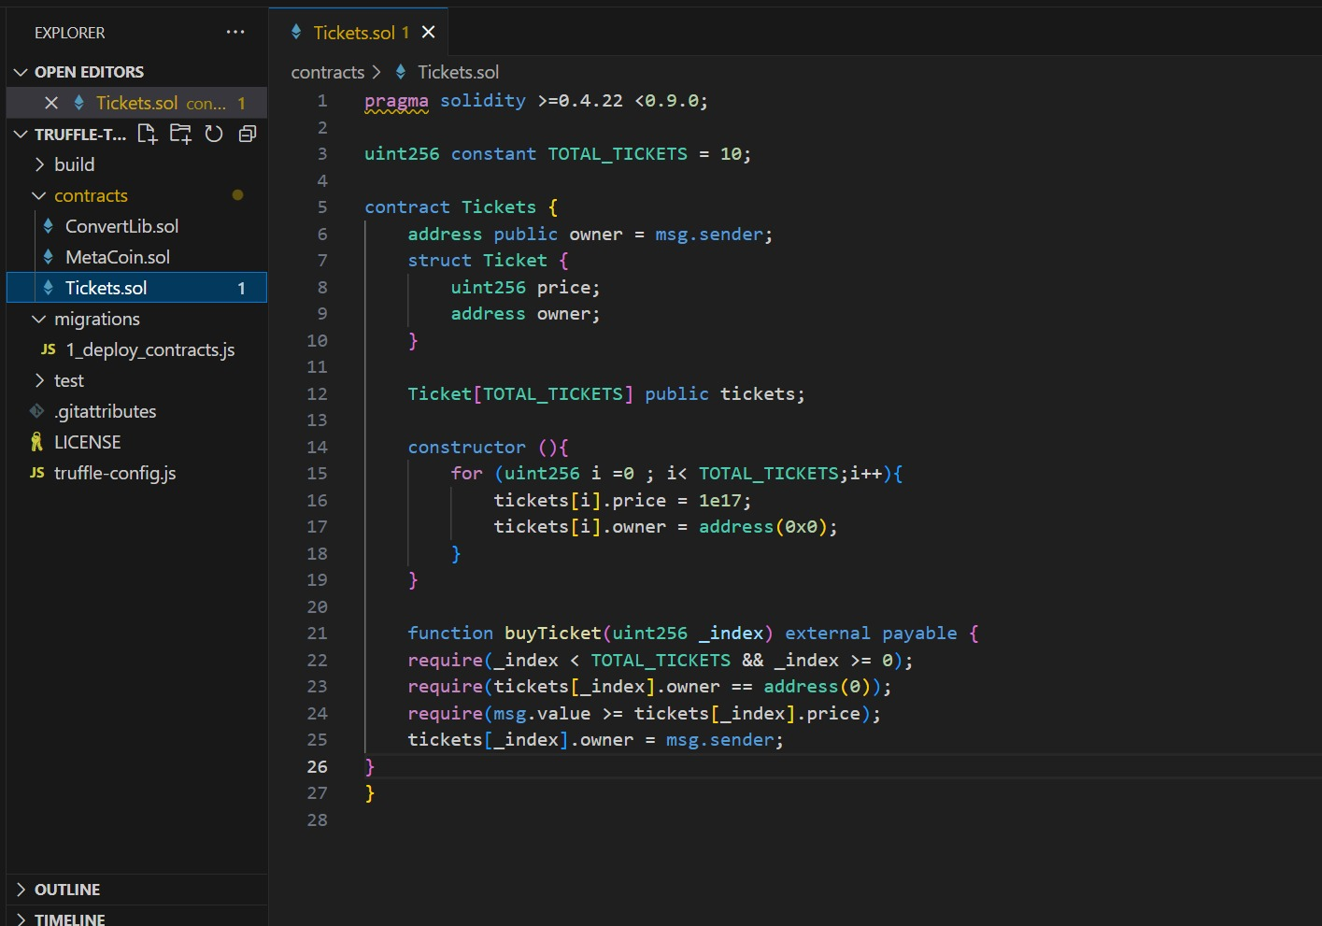
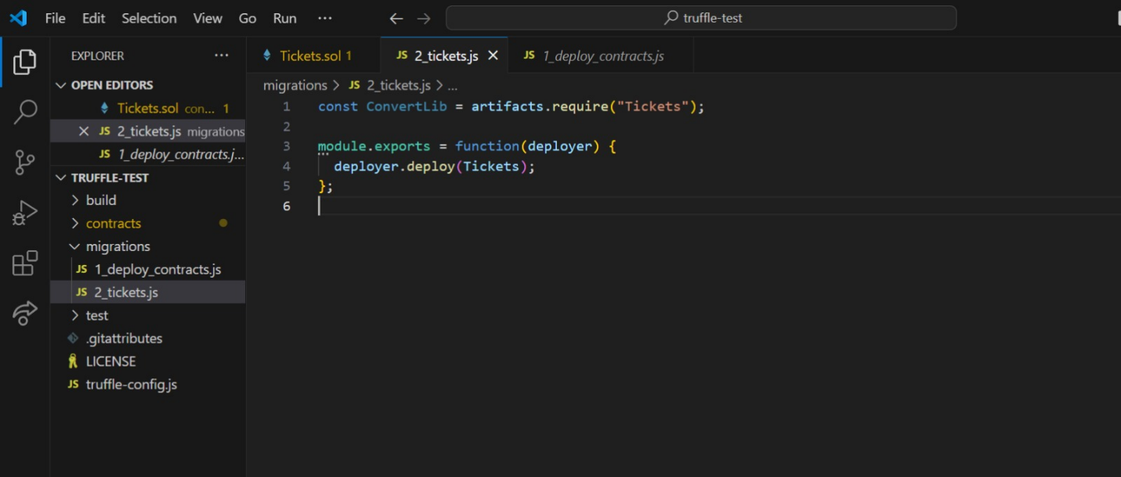
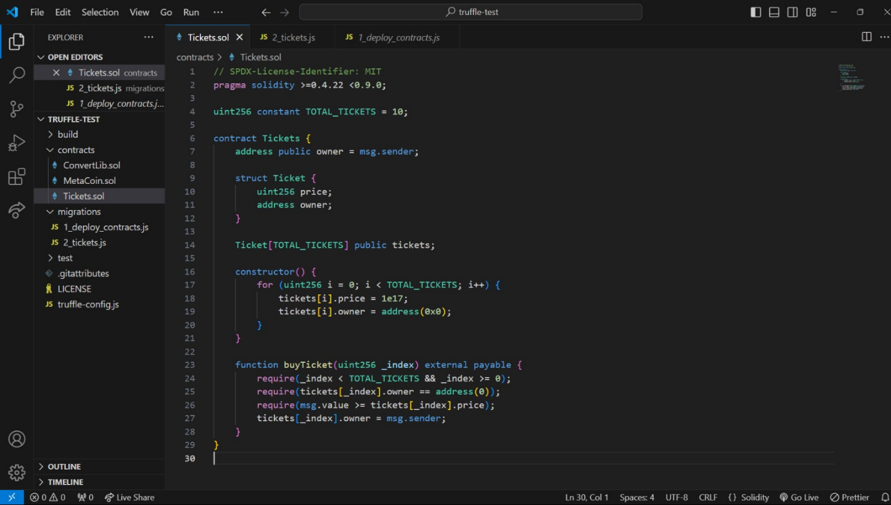
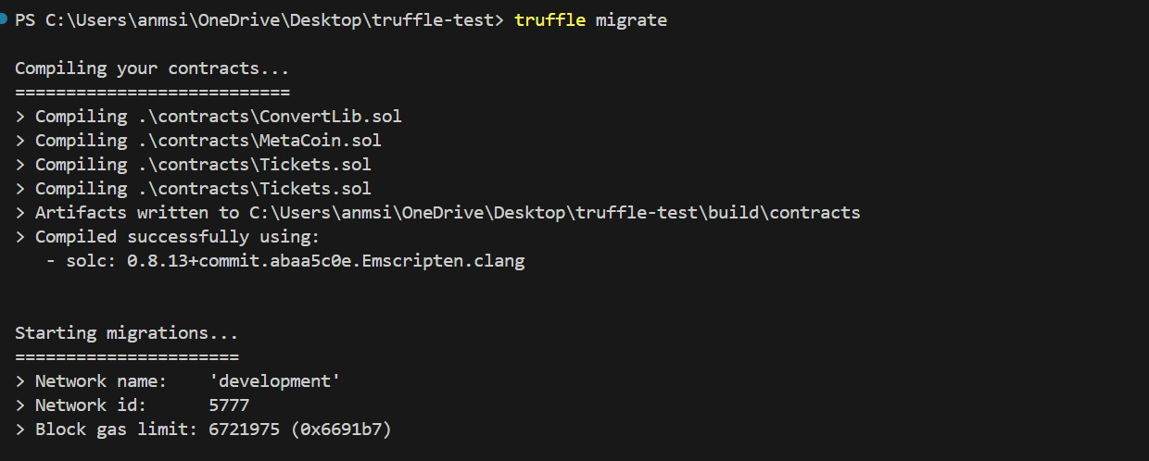
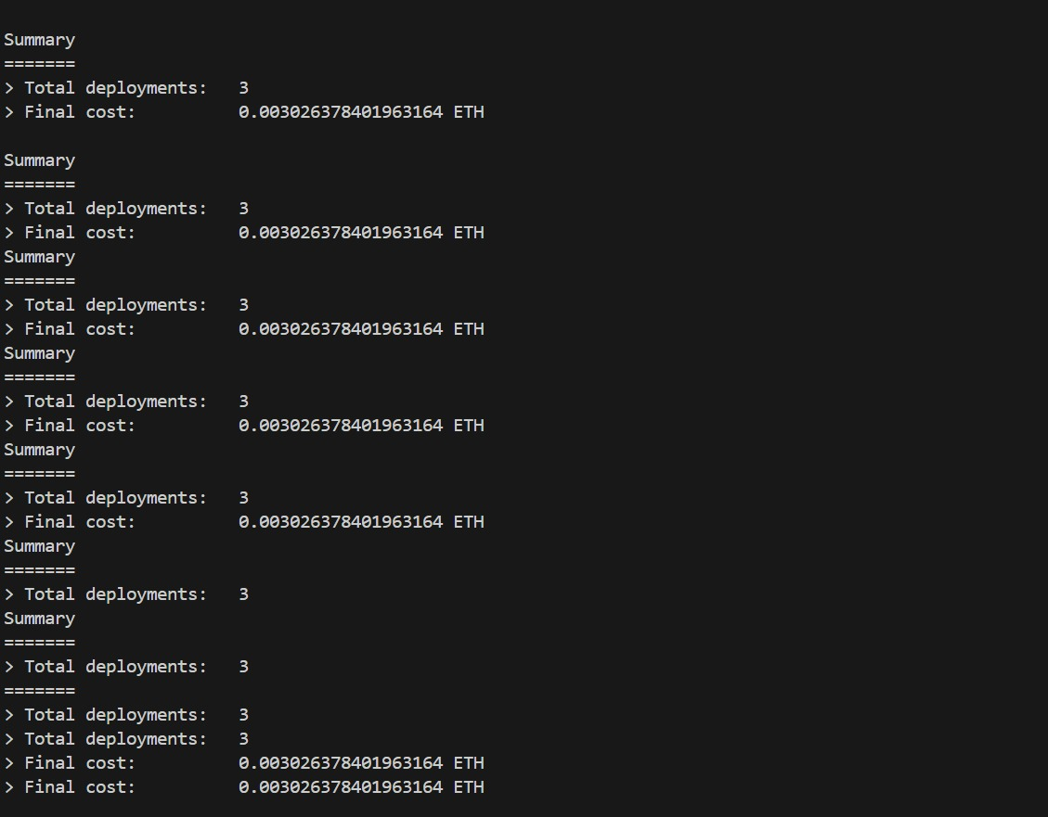
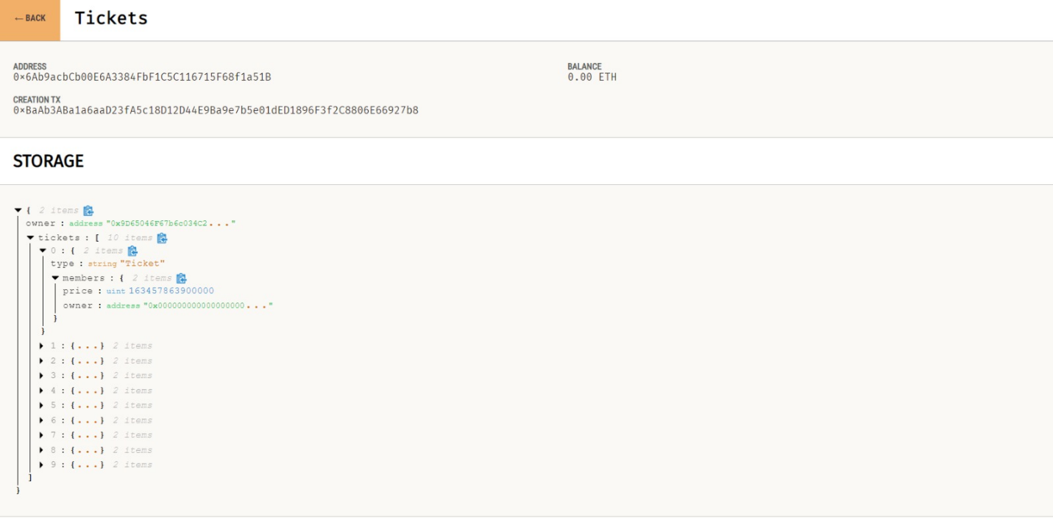
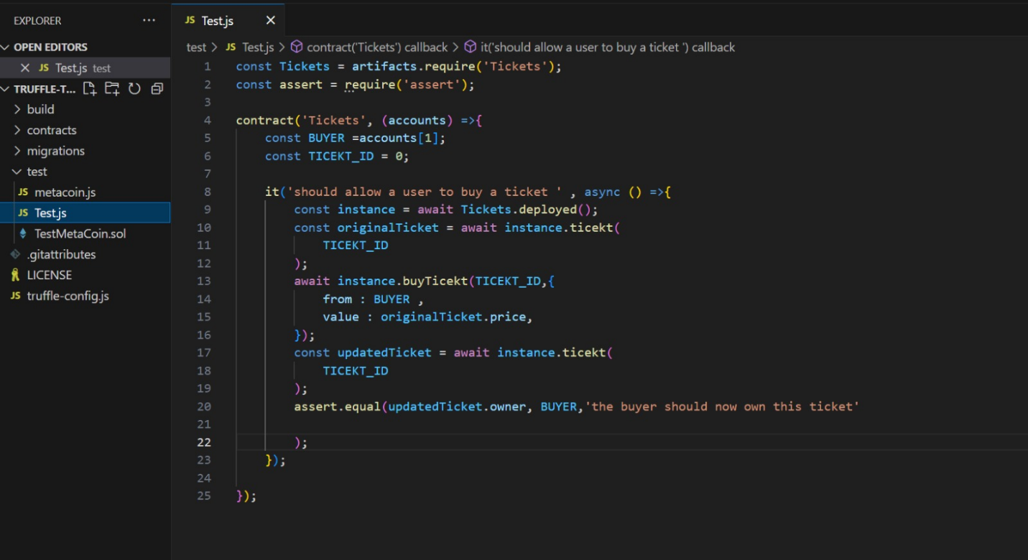
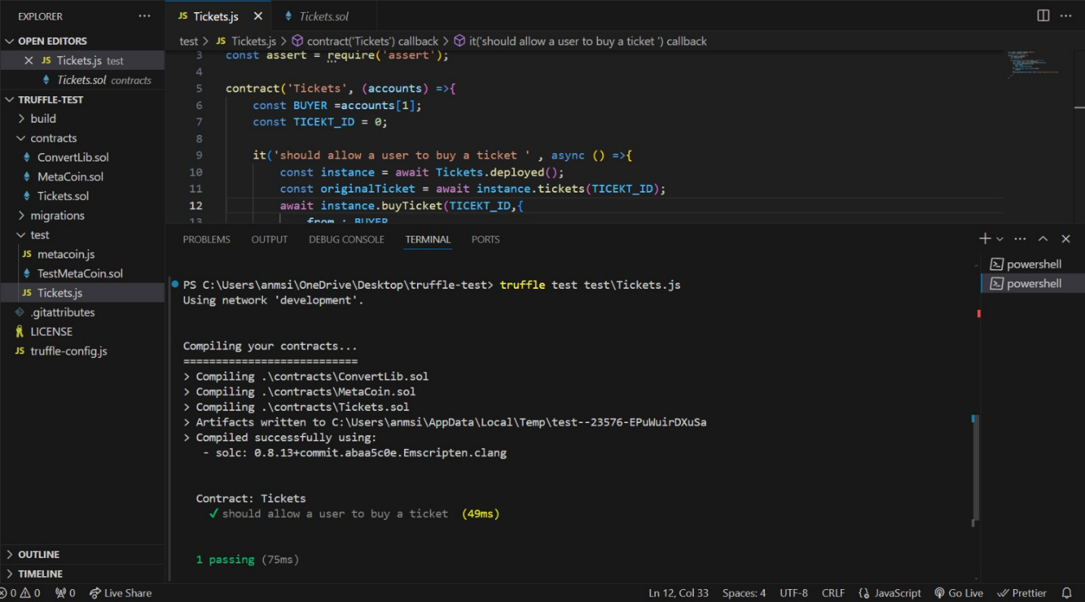
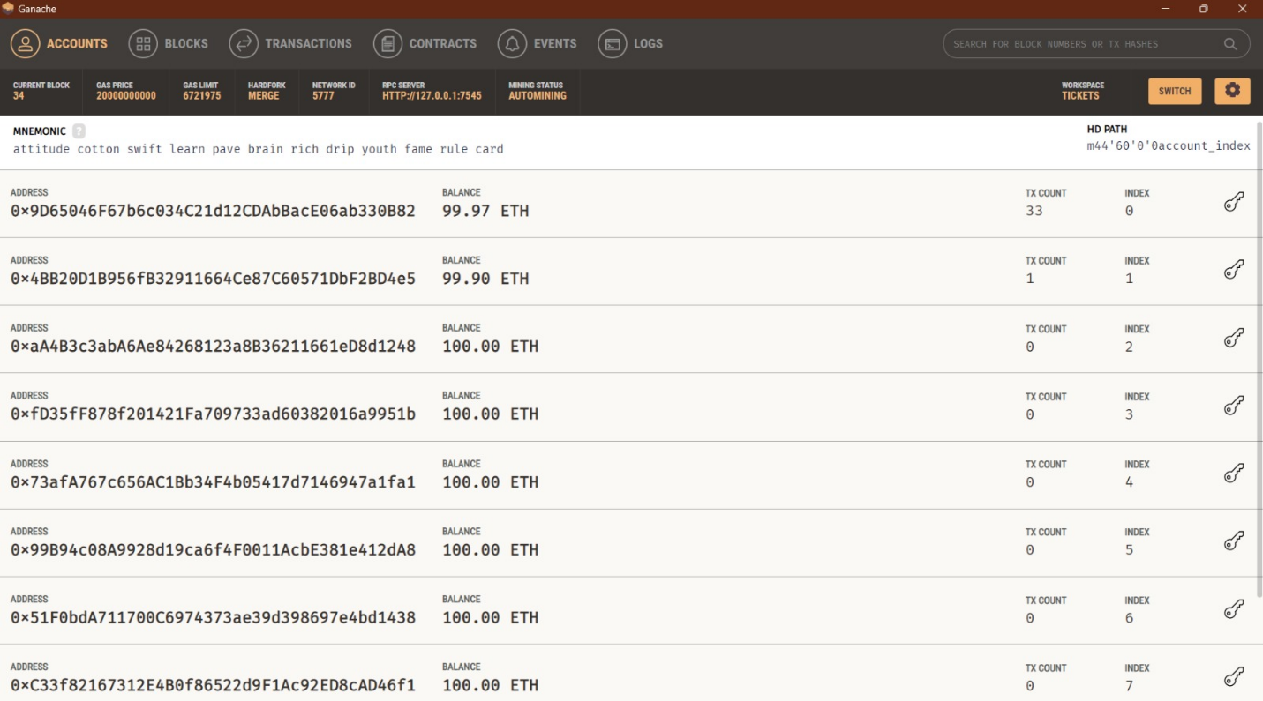

Conclusion:
In this experiment, we successfully deployed and published a smart contract on the Ethereum test network. We used tools such as MetaMask for managing our Ethereum accounts, Remix IDE for writing, compiling and deploying the smart contract, and a test network to safely deploy and test our contract. This process is essential for understanding the workflow of smart contract development and deployment in a real-world scenario.

