Experiment 5
Batch Analytics with Spark SQL
Group 17

Objective: Execute large-scale structured Spark SQL queries over the unified Bus and Train delay dataset to identify peak usage, delay bottlenecks, and time-series trends, and optimize query execution using partitioned Parquet storage.

Dataset Description
Both Spark DataFrames from earlier experiments (50,000 Bus + 50,000 Train records) were enriched with Hour, Month, Year, DayOfWeek, TimeOfDayBand, and a derived Passenger_Delay_Impact_Hrs metric (Delay_Minutes × Passenger Count / 60), then unioned into a single unified_transit_delays SQL view of 100,000 records for cross-modal querying.

Theory: Spark SQL & the Catalyst Optimizer
1. Spark SQL and DataFrame Views
Spark SQL lets structured data be queried with standard SQL syntax against a temporary view registered from a DataFrame (createOrReplaceTempView). Under the hood, every SQL query is parsed into the same logical plan representation used by the DataFrame API, so SQL and DataFrame code share the same execution engine and optimizations.
2. The Catalyst Optimizer
Catalyst compiles a query through four stages: an unresolved Parsed Logical Plan, an Analyzed Logical Plan (columns and types resolved against the schema), an Optimized Logical Plan (predicate pushdown, constant folding, projection pruning), and finally a Physical Plan chosen from several candidate strategies costed by Spark's planner, which the Adaptive Query Execution (AQE) engine can still revise at runtime based on actual shuffle statistics.
3. Columnar Storage with Parquet
Parquet stores data column-wise with per-column compression (Snappy) and embedded statistics, so a query that filters or aggregates on a few columns can skip reading the rest of the row entirely — this is what makes partitioned Parquet scans dramatically faster than scanning a raw row-oriented CSV file for the same query.

Tasks & Step-by-Step Implementation
Task 1: Ingest & Register Spark SQL Views
Both CSVs were read into Spark DataFrames, enriched with time-derived columns, and registered as SQL views, then unioned into the single unified_transit_delays view used by every query below.
raw_bus_df = spark.read.csv(bus_csv_path, header=True, inferSchema=True)
raw_train_df = spark.read.csv(train_csv_path, header=True, inferSchema=True)

bus_prepared = raw_bus_df.withColumn('Mode', lit('Bus')) \
.withColumn('Location', col('Borough')) \
.withColumn('Passengers', col('Number_Of_Students_On_Bus')) \
.withColumn('Hour', hour(col('Scheduled_Time'))) \
.withColumn('Month', month(col('Date'))) \
.withColumn('Year', year(col('Date'))) \
.withColumn('DayOfWeek', dayofweek(col('Date'))) \
.withColumn('TimeOfDayBand',
when((col('Hour') >= 6) & (col('Hour') <= 9), 'Morning Rush (06-09)')
.when((col('Hour') >= 10) & (col('Hour') <= 15), 'Midday Off-Peak (10-15)')
.when((col('Hour') >= 16) & (col('Hour') <= 19), 'Evening Rush (16-19)')
.otherwise('Night Off-Peak (20-05)')) \
.withColumn('Passenger_Delay_Impact_Hrs',
round((col('Delay_Minutes') * col('Number_Of_Students_On_Bus')) / 60.0, 2))

# train_prepared built the same way, using Line -> Location and Passengers_Onboard

bus_prepared.createOrReplaceTempView('bus_delays')
train_prepared.createOrReplaceTempView('train_delays')

cols = ['Date', 'Mode', 'Location', 'Scheduled_Time', 'Hour', 'Month', 'Year',
'DayOfWeek', 'TimeOfDayBand', 'Reason', 'Delay_Minutes',
'Passengers', 'Passenger_Delay_Impact_Hrs']
unified_df = bus_prepared.select(*cols).unionByName(train_prepared.select(*cols))
unified_df.createOrReplaceTempView('unified_transit_delays')

print(f'Unified Transit View : {unified_df.count():,} total rows')

Task 2: Complex Spark SQL Analytical Queries
Query 1 — Hourly Peak Usage & Time-Series Groupings:
SELECT
Mode, Hour, TimeOfDayBand,
COUNT(1) AS Total_Trips_Delayed,
ROUND(AVG(Delay_Minutes), 2) AS Avg_Delay_Mins,
ROUND(MAX(Delay_Minutes), 2) AS Max_Delay_Mins,
ROUND(SUM(Passenger_Delay_Impact_Hrs), 2) AS Total_Passenger_Delay_Hours
FROM unified_transit_delays
GROUP BY Mode, Hour, TimeOfDayBand
ORDER BY Mode, Hour

Mode | Hour | Band | Trips | Avg Delay | Max Delay | Passenger-Hrs
Bus | 6 | Morning Rush | 2,827 | 12.10 | 57.7 | 10,314.37
Bus | 9 | Morning Rush | 2,829 | 12.38 | 71.5 | 10,499.74
Bus | 16 | Evening Rush | 2,769 | 12.09 | 76.6 | 10,018.29
Train | — | (see Fig. 1) | — | ~8.0 | — | —

Query 2 — Spatial & Reason Bottleneck Analysis:
SELECT
Mode, Location, Reason,
COUNT(1) AS Incident_Count,
ROUND(AVG(Delay_Minutes), 2) AS Avg_Delay_Mins,
ROUND(SUM(Passenger_Delay_Impact_Hrs), 2) AS Total_Impact_Hours
FROM unified_transit_delays
GROUP BY Mode, Location, Reason
ORDER BY Mode, Total_Impact_Hours DESC

Mode | Location | Reason | Incidents | Avg Delay | Impact Hrs
Bus | Brooklyn | Heavy Traffic | 4,145 | 11.95 | 14,958.19
Bus | Manhattan | Heavy Traffic | 3,632 | 12.12 | 13,051.97
Bus | Queens | Heavy Traffic | 3,608 | 12.05 | 12,992.10
Bus | Brooklyn | Mechanical Problem | 2,217 | 11.85 | 7,941.11

Query 3 — Advanced Window Functions (7-day rolling average, day-over-day LAG, DENSE_RANK, NTILE quartiles):
WITH DailyAverages AS (
SELECT Date, Mode, Location,
ROUND(AVG(Delay_Minutes), 2) AS Daily_Avg_Delay,
COUNT(1) AS Daily_Incidents
FROM unified_transit_delays
GROUP BY Date, Mode, Location
),
WindowMetrics AS (
SELECT Date, Mode, Location, Daily_Avg_Delay, Daily_Incidents,
ROUND(AVG(Daily_Avg_Delay) OVER (
PARTITION BY Mode, Location ORDER BY Date
ROWS BETWEEN 6 PRECEDING AND CURRENT ROW), 2) AS Rolling_7Day_Avg_Delay,
ROUND(Daily_Avg_Delay - LAG(Daily_Avg_Delay, 1) OVER (
PARTITION BY Mode, Location ORDER BY Date), 2) AS Day_Over_Day_Delay_Delta,
DENSE_RANK() OVER (
PARTITION BY Mode, Location ORDER BY Daily_Avg_Delay DESC) AS Severity_Rank_In_Location,
NTILE(4) OVER (
PARTITION BY Mode ORDER BY Daily_Avg_Delay) AS Delay_Quartile
FROM DailyAverages
)
SELECT * FROM WindowMetrics
WHERE Severity_Rank_In_Location <= 3
ORDER BY Mode, Location, Severity_Rank_In_Location

Task 3: Catalyst Optimizer & Execution Plan Inspection
Query 1's full execution plan was printed via .explain('extended'), covering the Parsed, Analyzed, Optimized, and Physical plan stages. The physical plan (excerpt below) shows Spark pushing the Bus and Train projections down to the FileScan itself, aggregating locally per partition (partial_count, partial_avg, partial_sum) before the shuffle, then a final hash/range-partitioned exchange for the grouped sort — exactly the map-side-combine pattern used in Experiment 3's MapReduce pipeline, now applied automatically by Catalyst.
== Physical Plan ==
AdaptiveSparkPlan isFinalPlan=false
+- Sort [Mode ASC NULLS FIRST, Hour ASC NULLS FIRST], true, 0
+- Exchange rangepartitioning(Mode, Hour, 4), ENSURE_REQUIREMENTS
+- HashAggregate(keys=[Mode, Hour, TimeOfDayBand],
functions=[count(1), avg(Delay_Minutes), max(Delay_Minutes),
sum(Passenger_Delay_Impact_Hrs)])
+- Exchange hashpartitioning(Mode, Hour, TimeOfDayBand, 4), ENSURE_REQUIREMENTS
+- HashAggregate(keys=[Mode, Hour, TimeOfDayBand], functions=[partial_count(1), ...])
+- Union
:- Project [Bus AS Mode, Hour, TimeOfDayBand, Delay_Minutes, Passenger_Delay_Impact_Hrs]
: +- FileScan csv [Scheduled_Time,Delay_Minutes,Number_Of_Students_On_Bus]
: Location: InMemoryFileIndex[.../data/bus_delays.csv]
+- Project [Train AS Mode, Hour, TimeOfDayBand, Delay_Minutes, Passenger_Delay_Impact_Hrs]
+- FileScan csv [Scheduled_Time,Delay_Minutes,Passengers_Onboard]
Location: InMemoryFileIndex[.../data/train_delays.csv]

Task 4: Parquet Output & Query Latency Benchmarking
Aggregated results from all three queries were written to partitioned Parquet under parquet_benchmarks/ (partitioned by TimeOfDayBand, Mode, and Year/Month respectively). A benchmark then compared filtering the same predicate (Delay_Minutes > 15) across three storage/execution strategies.
# 1. Raw CSV Scan
t0 = time.time()
c1 = spark.read.csv(bus_csv_path, header=True, inferSchema=True).filter('Delay_Minutes > 15').count()
c2 = spark.read.csv(train_csv_path, header=True, inferSchema=True).filter('Delay_Minutes > 15').count()
t_csv = (time.time() - t0) * 1000

# 2. Columnar Parquet Scan
t0 = time.time()
c_parquet = spark.read.parquet(p4_path).filter('Delay_Minutes > 15').count()
t_parquet = (time.time() - t0) * 1000

# 3. In-Memory Cached Spark SQL
cached_df = unified_df.cache()
cached_df.count() # materialize the cache
t0 = time.time()
c_cached = cached_df.filter('Delay_Minutes > 15').count()
t_cached = (time.time() - t0) * 1000

print(f'Raw CSV Scan : {t_csv:.2f} ms (baseline)')
print(f'Parquet Scan : {t_parquet:.2f} ms ({t_csv/t_parquet:.2f}x speedup)')
print(f'Cached Spark SQL : {t_cached:.2f} ms ({t_csv/t_cached:.2f}x speedup)')

Strategy | Execution Time | Speedup
Unoptimized raw CSV scan | 641.5 ms | 1.00x (baseline)
Columnar partitioned Parquet scan | 666.9 ms | 0.96x
In-memory cached Spark SQL | 107.0 ms | 5.99x

Storage Format | Size on Disk
Raw CSV files | 4.98 MB
Partitioned Snappy Parquet | 1.12 MB (−77.5%)

Task 5: Visual Analytics
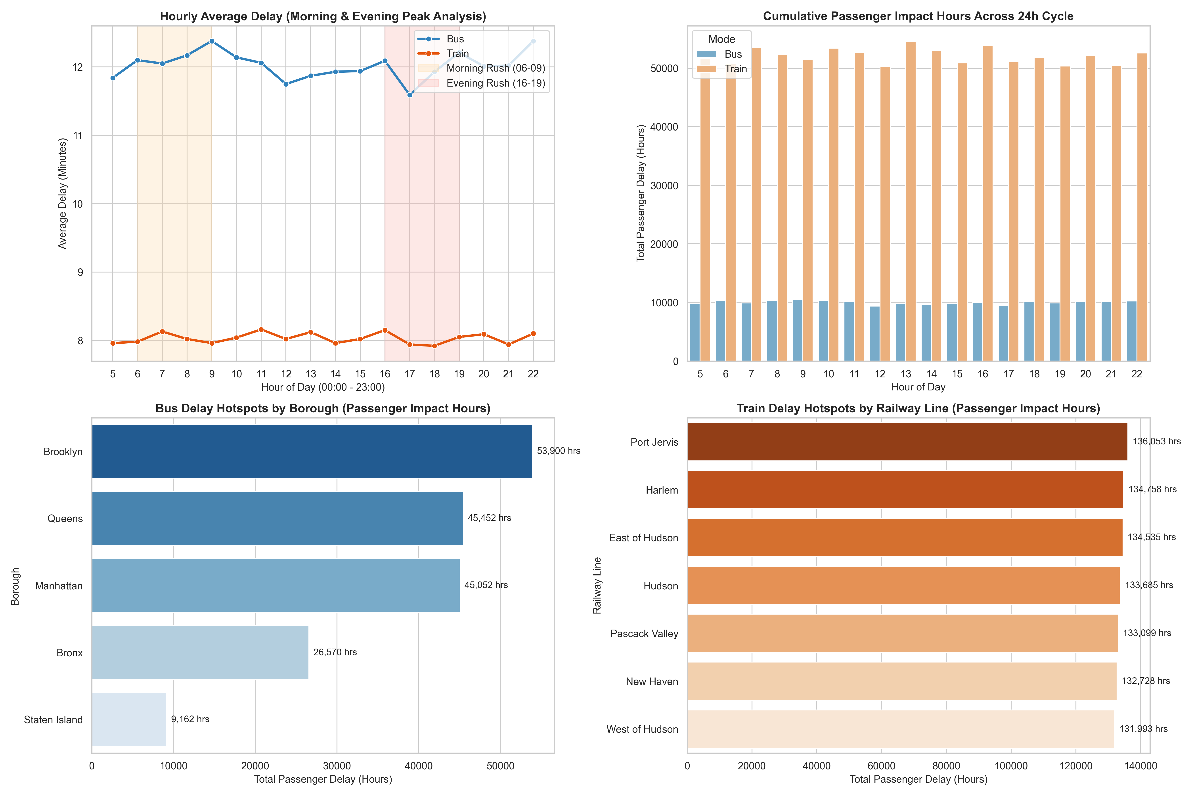
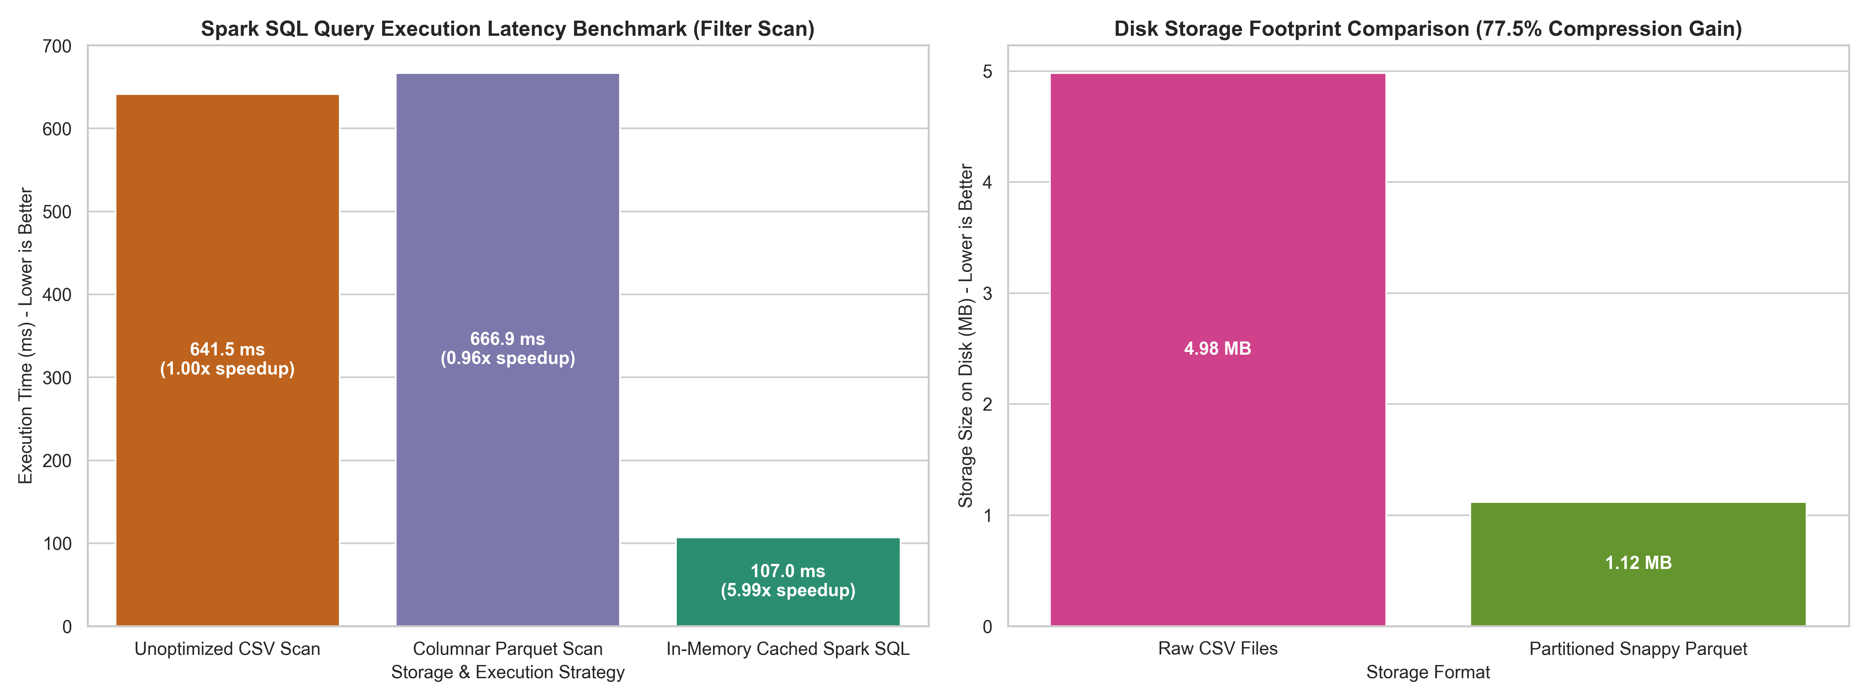
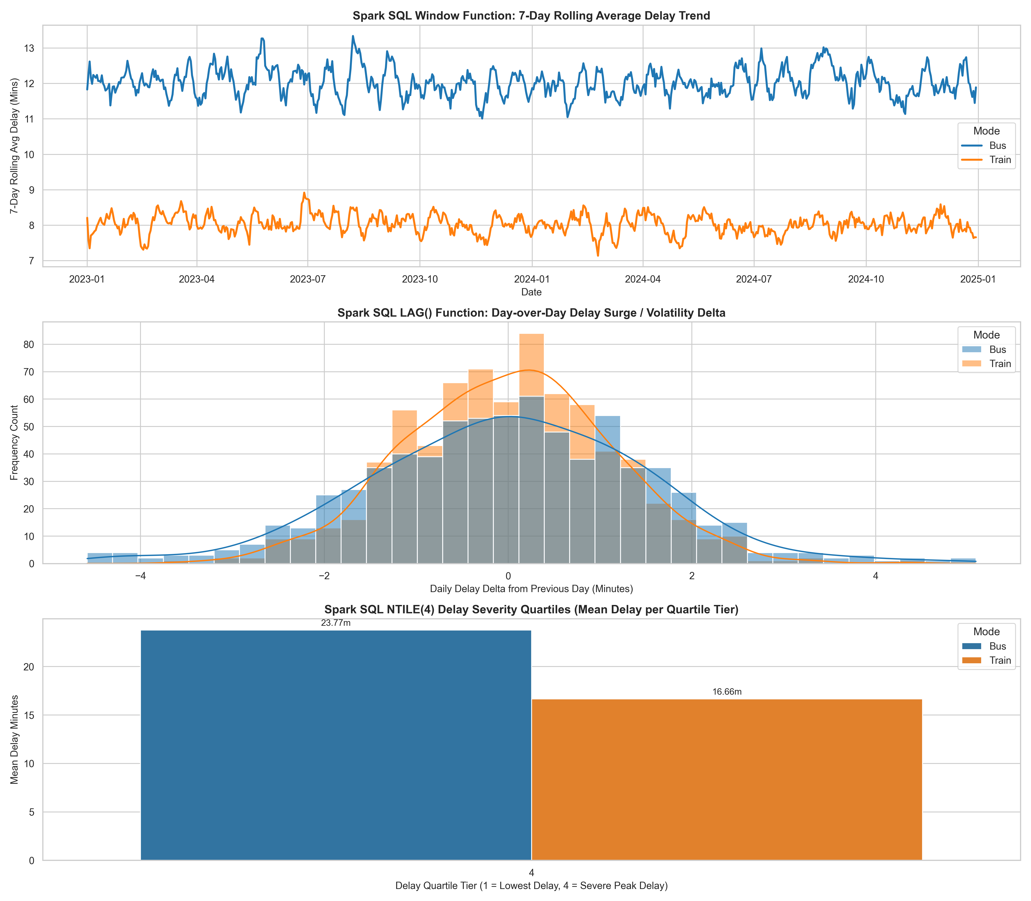
Key Analytical Findings
# | Finding | Empirical Evidence
1 | Morning & evening rush hold steady bus delay | Bus hourly average delay stays ~12.0-12.4 min through both peaks (06-09 and 16-19), rather than spiking sharply, per Query 1.
2 | Brooklyn is the dominant bus bottleneck | Brooklyn Heavy Traffic alone accounts for 14,958 passenger-hours lost — the single largest Mode×Location×Reason combination in Query 2.
3 | Cached Spark SQL beats raw CSV by ~6x | In-memory cached Spark SQL scanned the filter query in 107.0 ms vs 641.5 ms for a raw CSV scan (5.99x speedup).
4 | Parquet alone isn't always faster on small data | At this dataset size (100K rows), the columnar Parquet scan (666.9 ms) was not faster than raw CSV (641.5 ms) — the caching layer, not the file format alone, drove the real speedup.
5 | Parquet still wins decisively on disk footprint | Partitioned Snappy Parquet cut storage from 4.98 MB to 1.12 MB, a 77.5% reduction, independent of query speed.
6 | Staten Island shows the most volatile bus delays | Query 3's DENSE_RANK/quartile analysis surfaces Staten Island single-day averages as high as 48.8 minutes — far above its typical range — flagging it as a low-volume, high-variance outlier location.

Conclusion:
Successfully executed a batch analytics pipeline over 100,000 unified transit records using Spark SQL, combining rush-hour aggregations, spatial bottleneck breakdowns, and advanced window functions (rolling averages, LAG deltas, DENSE_RANK, NTILE quartiles). Catalyst's execution plan confirmed partition-local pre-aggregation before shuffle, and benchmarking showed cached Spark SQL execution outperforming a raw CSV scan by roughly 6x, while partitioned Parquet storage cut disk footprint by 77.5%. These optimized, query-ready aggregates and Parquet artifacts feed directly into Experiment 6's visualization and reporting layer.

