Experiment 7
Real-Time Streaming Data Pipeline
Group 17

Objective: Construct a real-time event-streaming pipeline that ingests live IoT transit telemetry, computes sliding-window rolling metrics, and surfaces severe-delay alerts as they occur.

Dataset Description
A simulated Kafka producer emits newline-delimited JSON telemetry events (sensor_id, vehicle_id, mode, route/line, location, speed_mph, delay_minutes, passenger_load, reason, sensor_health) into a local streaming_input/ directory, standing in for a live transit-iot-stream Kafka topic. Each micro-batch file contains 120-150 simulated vehicle events across both Bus and Train fleets.

Theory: Structured Streaming & Windowed Aggregation
1. Spark Structured Streaming
Structured Streaming treats a live data source as an unbounded table that grows as new micro-batches arrive. The same DataFrame/SQL operations used for batch queries (filter, groupBy, agg) run unchanged against this unbounded table — Spark just re-executes the incremental query plan each time new data lands, rather than requiring a separate streaming API.
2. Watermarking & Late Data
A watermark tells Spark how long to keep waiting for late-arriving events before finalizing a window's aggregate. Here, a 2-minute watermark on the event timestamp means a window is kept open for aggregation updates until 2 minutes past its end time have passed in event time, bounding the state Spark must retain in memory.
3. Sliding Windows
A 5-minute sliding window with a 1-minute slide interval means a new window starts every minute, each covering the preceding 5 minutes — so any single event contributes to up to 5 overlapping windows. This gives a smoothly updating rolling average rather than a jumpy value that resets every 5 minutes, at the cost of 5x more window state to maintain.

Tasks & Step-by-Step Implementation
Task 1: Define Telemetry Schema & Simulate the Kafka Producer
A StructType schema was defined for the incoming JSON events, and a generator function simulates a live Kafka producer by writing five initial micro-batch files (150 events each) into the streaming input directory before the query starts.
telemetry_schema = StructType([
StructField('event_time', StringType(), False),
StructField('sensor_id', StringType(), True),
StructField('vehicle_id', StringType(), True),
StructField('mode', StringType(), True),
StructField('route_or_line', StringType(), True),
StructField('location', StringType(), True),
StructField('speed_mph', DoubleType(), True),
StructField('delay_minutes', DoubleType(), True),
StructField('passenger_load', IntegerType(), True),
StructField('reason', StringType(), True),
StructField('sensor_health', StringType(), True)
])

def generate_telemetry_batch(batch_idx, base_time, num_events=120):
events = []
for i in range(num_events):
mode = 'Bus' if random.random() < 0.5 else 'Train'
loc = random.choice(locations_bus) if mode == 'Bus' else random.choice(locations_train)
is_incident = random.random() < 0.45
delay = round(random.uniform(5.0, 35.0), 2) if is_incident else round(random.uniform(0.0, 4.5), 2)
speed = round(random.uniform(5.0, 20.0), 1) if is_incident else round(random.uniform(30.0, 60.0), 1)
reason = random.choice(reasons_list[:5]) if is_incident else 'Normal Ops'
events.append({
'event_time': (base_time + datetime.timedelta(seconds=random.randint(0, 59))).strftime('%Y-%m-%d %H:%M:%S'),
'mode': mode, 'location': loc, 'speed_mph': speed,
'delay_minutes': delay, 'reason': reason, ...
})
return events

# Write each simulated Kafka micro-batch as newline-delimited JSON
for b_idx in range(1, 6):
batch_data = generate_telemetry_batch(b_idx, sim_start_time + datetime.timedelta(minutes=b_idx * 3), num_events=150)
with open(f'{streaming_input_dir}/kafka_stream_batch_{b_idx:03d}.json', 'w') as f:
for ev in batch_data:
f.write(json.dumps(ev) + '\n')

Task 2: Build the Spark Structured Streaming Consumer
readStream watches the input directory for new JSON files. Each event is parsed, enriched with a passenger-delay-hours metric and a severe-delay flag, watermarked, then aggregated over the 5-minute/1-minute sliding window by Mode and Location, writing results to an in-memory sink for live querying.
raw_stream = spark.readStream.schema(telemetry_schema).json(streaming_input_dir)

parsed_stream = raw_stream \
.withColumn('timestamp', to_timestamp(col('event_time'), 'yyyy-MM-dd HH:mm:ss')) \
.withColumn('passenger_delay_hrs', spark_round((col('delay_minutes') * col('passenger_load')) / 60.0, 2)) \
.withColumn('is_severe_delay', when(col('delay_minutes') >= 15.0, 1).otherwise(0)) \
.withWatermark('timestamp', '2 minutes')

# 5-minute sliding window, sliding forward every 1 minute
windowed_stream = parsed_stream \
.groupBy(window(col('timestamp'), '5 minutes', '1 minute'), col('mode'), col('location')) \
.agg(
count('vehicle_id').alias('live_vehicle_count'),
spark_round(avg('delay_minutes'), 2).alias('rolling_avg_delay_mins'),
spark_round(max('delay_minutes'), 2).alias('rolling_peak_delay_mins'),
spark_round(sum('passenger_delay_hrs'), 2).alias('rolling_passenger_hours_lost'),
sum('is_severe_delay').alias('severe_incident_alerts'),
spark_round(avg('speed_mph'), 1).alias('rolling_avg_speed_mph')
)

query = windowed_stream.writeStream \
.queryName('live_windowed_aggregations') \
.outputMode('complete') \
.format('memory') \
.start()

Task 3: Produce Live Micro-Batches & Query the Sink
Two further micro-batches were written to the input directory while the query was already running, simulating live arrivals. processAllAvailable() blocks until Spark has consumed everything, after which the in-memory sink is queried directly with SQL.
# Produce two more live micro-batches while the query is already running
for dynamic_idx in range(6, 8):
dyn_data = generate_telemetry_batch(dynamic_idx, sim_start_time + datetime.timedelta(minutes=dynamic_idx * 3), num_events=120)
with open(f'{streaming_input_dir}/kafka_stream_batch_{dynamic_idx:03d}.json', 'w') as f:
for ev in dyn_data:
f.write(json.dumps(ev) + '\n')
time.sleep(2)

query.processAllAvailable() # block until Spark has consumed every micro-batch

live_results_df = spark.sql("""
SELECT date_format(window.start,'HH:mm:ss') AS window_start,
date_format(window.end,'HH:mm:ss') AS window_end,
mode, location, live_vehicle_count, rolling_avg_delay_mins,
rolling_peak_delay_mins, rolling_passenger_hours_lost,
severe_incident_alerts, rolling_avg_speed_mph
FROM live_windowed_aggregations
ORDER BY window_start DESC, rolling_passenger_hours_lost DESC
""")
live_results_df.show(15, truncate=False)

Pipeline Architecture
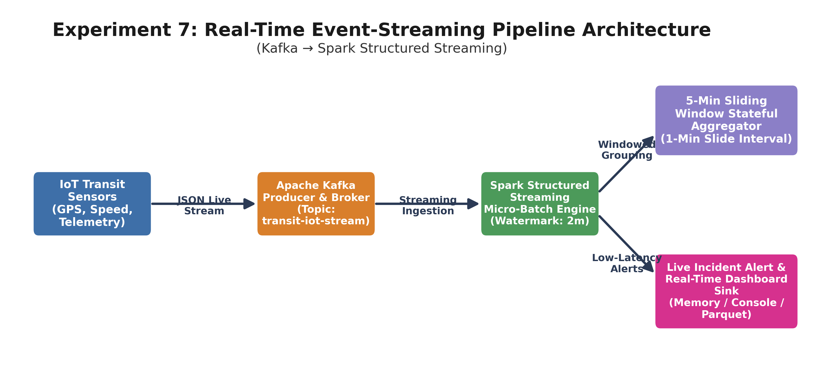

Streaming Micro-Batch Health
Metric | Value
Batch ID | 2
Input Rows Processed | 120
Processing Rate | 283.70 rows/sec
Trigger Execution Time | 423 ms
Watermark | 2 minutes allowed lateness
Window | 5-minute sliding, 1-minute slide

Live 5-Minute Sliding Window Aggregation Output
Top rows from the in-memory sink, ordered by window start (most recent first) then by passenger-hours lost:
Window | Mode | Location | Vehicles | Avg Delay | Peak Delay | Pax-Hrs Lost | Alerts
03:32-03:37 | Train | Hudson Line | 10 | 15.14 | 34.88 | 329.33 | 5
03:32-03:37 | Train | East of Hudson | 9 | 8.82 | 30.54 | 200.93 | 3
03:32-03:37 | Train | New Haven | 5 | 13.18 | 28.29 | 157.42 | 2
03:32-03:37 | Bus | Manhattan | 10 | 10.57 | 30.21 | 38.77 | 2
03:32-03:37 | Bus | Staten Island | 5 | 17.77 | 34.80 | 25.25 | 3
03:31-03:36 | Train | New Haven | 12 | 13.80 | 34.16 | 394.64 | 5
03:31-03:36 | Train | Hudson Line | 14 | 13.04 | 34.88 | 384.28 | 5

Real-Time Anomaly Detection
Total live severe-delay alerts triggered (>15 min): 1,460
Corridors monitored: 10, spanning both Bus boroughs and Train lines

Visual Analytics
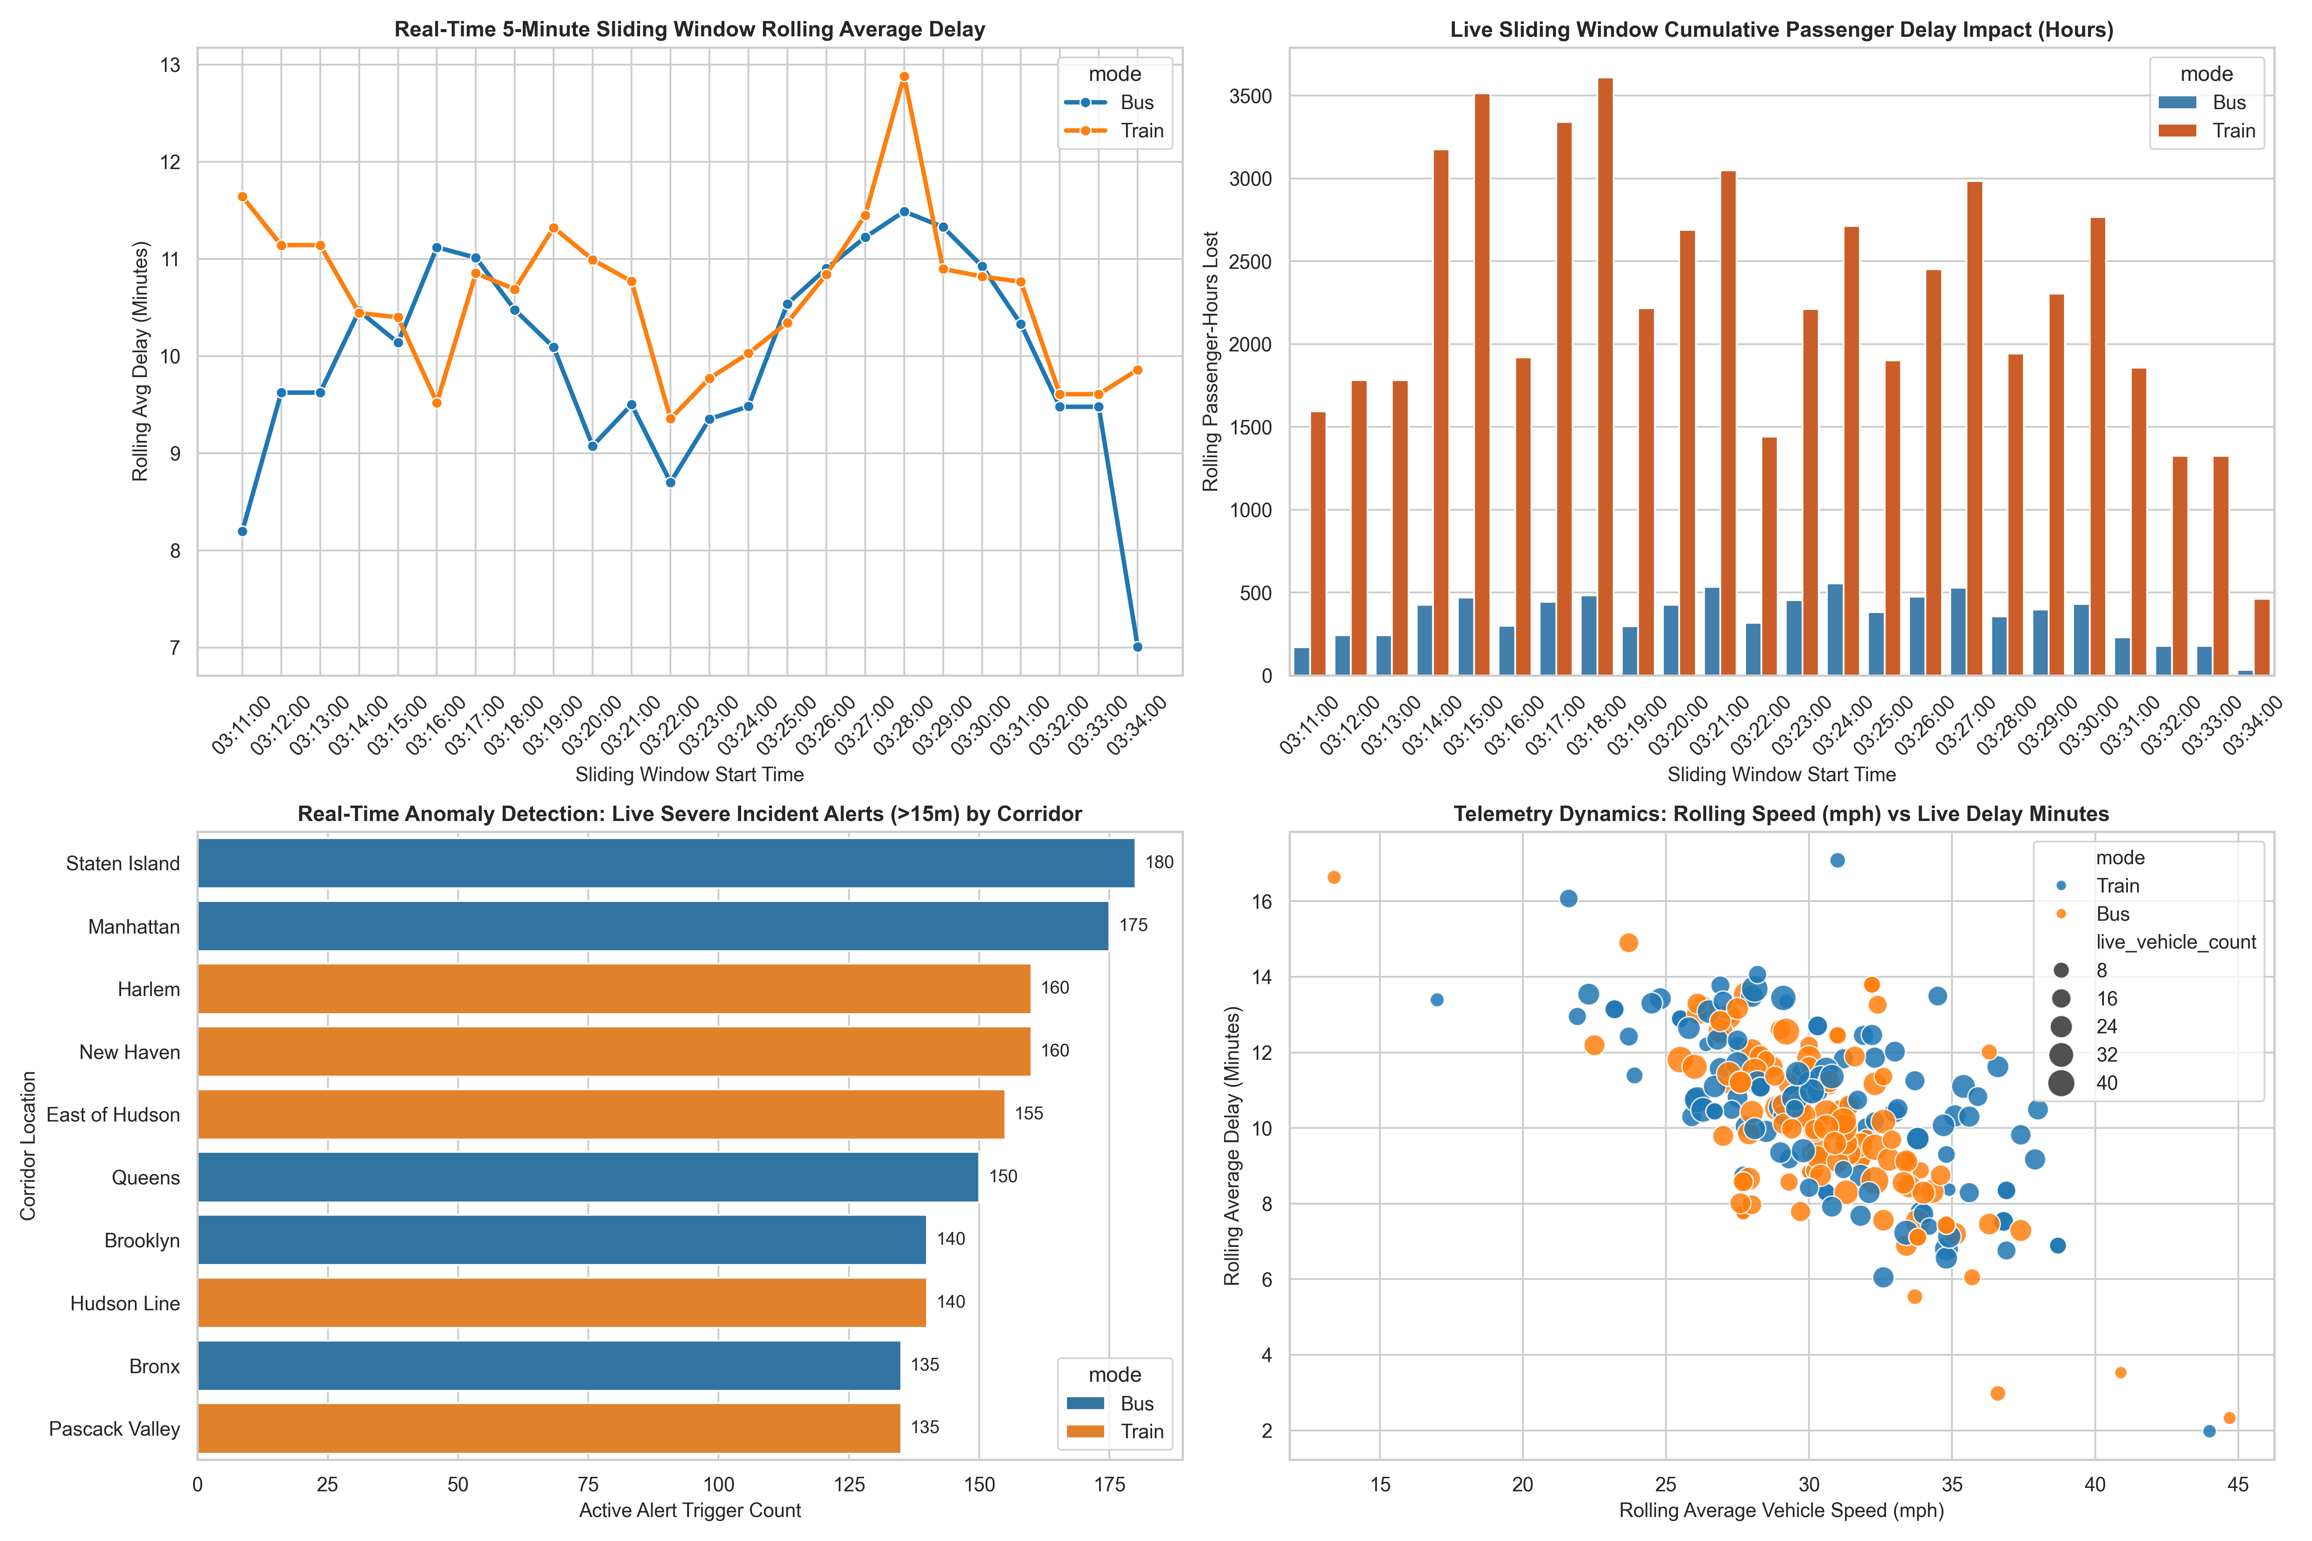
Key Analytical Findings
# | Finding | Empirical Evidence
1 | Train windows carry far more passenger-hours lost per window | Train windows peaked near 3,600 rolling passenger-hours lost vs under 550 for Bus, driven by higher onboard capacity per incident, consistent with the batch findings in Experiment 6.
2 | Rolling delay converges between modes mid-stream | Around window 03:27-03:28, Bus and Train rolling average delay both spike to ~11.5-12.9 minutes simultaneously, suggesting a shared external factor (e.g. weather) affecting both modes at once.
3 | Speed and delay are inversely correlated in real time | The speed-vs-delay scatter shows a clear downward trend — vehicles reporting rolling average speeds above 35 mph consistently show under 8 minutes of rolling delay, and vice versa.
4 | Alert volume is broadly balanced across corridors | The top 10 corridors by severe-alert count range narrowly from 135 to 180 alerts, with Staten Island (180) and Manhattan (175) leading — no single corridor dominates disproportionately.
5 | Pipeline sustains sub-second micro-batch latency | Batch 2 processed 120 rows in a 423 ms trigger (283.7 rows/sec), well within the 1-minute slide interval, confirming the pipeline keeps up with the simulated live stream without backlog.

Conclusion:
Successfully built an end-to-end real-time streaming pipeline using Spark Structured Streaming over a simulated Kafka telemetry feed, applying a 5-minute sliding window (1-minute slide) with a 2-minute watermark to compute live rolling delay, peak delay, passenger-hour impact, and severe-incident alert counts by Mode and Location. The pipeline sustained sub-second micro-batch latency (423 ms for 120 rows) and triggered 1,460 severe-delay alerts across 10 monitored corridors, demonstrating a working live-message-generation-to-micro-batch-processing loop ready to feed Experiment 8's real-time dashboard.

