Experiment 8
Real-Time Operational Dashboard
Group 17

Objective: Build an interactive streaming dashboard for real-time monitoring of Bus and Train telemetry, with automated threshold alerts for severe delay incidents.

Dataset Description
The dashboard connects to the streaming_input/ sink produced by Experiment 7's Kafka/Spark Structured Streaming pipeline, ingesting live telemetry payloads (event_time, mode, location, speed_mph, delay_minutes, passenger_load, sensor_health) and deriving passenger_hours_lost = delay_minutes × passenger_load / 60. A total of 990 live telemetry records (516 Bus, 474 Train) were ingested for this run.

Theory: Real-Time Dashboards & Threshold Alerting
1. From Streaming Sink to Live UI
A real-time dashboard's job is to keep re-querying the streaming sink and redraw its charts on a short interval, rather than being a one-time report. Streamlit's script-rerun model fits this naturally: the whole script re-executes on each interaction or auto-refresh tick, re-reading the latest sink data and rebuilding every chart and KPI card from scratch.
2. Automated Threshold Alerting
Rather than requiring an operator to eyeball a chart, an alert engine classifies every incoming event against fixed thresholds (Warning >= 15 min, Critical >= 25 min) the moment it arrives, turning a continuous delay_minutes value into an actionable, sortable severity tier that can drive a live incident feed.
3. Interactive vs Static Visualization
The same underlying data is served two ways: Plotly powers the live, filterable Streamlit app (sidebar controls for modality and threshold, optional 3-second auto-refresh), while Matplotlib/Seaborn renders fixed publication-quality snapshots of the same dashboard and alert diagnostics as static deliverable artifacts for this report.

Tasks & Step-by-Step Implementation
Task 1: Connect to Streaming Output Sinks
Live telemetry payloads were read back from Experiment 7's streaming_input/ directory (falling back to a simulated feed if empty), and enriched with a passenger_hours_lost column.
Task 2 & 3: Automated Threshold Alert Engine
Every event is classified into NORMAL / WARNING / CRITICAL against fixed delay thresholds using a vectorized np.where, avoiding a per-row Python loop over hundreds of live events.
SEVE_THRESHOLD_MINS = 15.0
CRIT_THRESHOLD_MINS = 25.0

df["alert_status"] = np.where(
df["delay_minutes"] >= CRIT_THRESHOLD_MINS, "CRITICAL",
np.where(df["delay_minutes"] >= SEVE_THRESHOLD_MINS, "WARNING", "NORMAL")
)

critical_count = len(df[df["alert_status"] == "CRITICAL"])
warning_count = len(df[df["alert_status"] == "WARNING"])
normal_count = len(df[df["alert_status"] == "NORMAL"])

print(f"Critical Alerts (>= {CRIT_THRESHOLD_MINS}m): {critical_count:,} ({critical_count/len(df)*100:.1f}%)")
print(f"Warning Alerts (>= {SEVE_THRESHOLD_MINS}m): {warning_count:,} ({warning_count/len(df)*100:.1f}%)")
print(f"Normal Operation (< {SEVE_THRESHOLD_MINS}m): {normal_count:,} ({normal_count/len(df)*100:.1f}%)")

Task 4: Interactive Streamlit / Plotly Dashboard (app_dashboard.py)
A separate Streamlit app renders the same metrics live and interactively: five real-time KPI cards, a dual-axis rolling delay/speed trajectory, a corridor delay-burden bar chart, an automated incident feed, and a severity donut chart — with sidebar controls for modality filter, alert threshold, and auto-refresh.
st.set_page_config(page_title="Urban Mobility Live Streaming Dashboard",
page_icon=":vertical_traffic_light:", layout="wide")

# Sidebar operational controls
modality_filter = st.sidebar.multiselect("Transit Modality", ["Bus", "Train"], default=["Bus", "Train"])
severe_threshold = st.sidebar.slider("Severe Delay Alert Threshold (Mins)", 10.0, 30.0, 15.0, 1.0)
auto_refresh = st.sidebar.checkbox("Live Auto-Refresh Stream (3s interval)", value=False)

data = get_live_streaming_data() # reads Experiment 7's streaming_input/ JSON, or simulates a fallback feed
filtered_data = data[data["mode"].isin(modality_filter)] if modality_filter else data

# --- Real-time KPI cards ---
total_vehicles = len(filtered_data)
avg_sys_delay = filtered_data["delay_minutes"].mean()
total_impact_hrs = filtered_data["passenger_hours_lost"].sum()
active_alerts = len(filtered_data[filtered_data["delay_minutes"] >= severe_threshold])
healthy_sensors = (filtered_data["sensor_health"].eq("OK").mean()) * 100

# --- Automated threshold incident feed ---
alert_events = filtered_data[filtered_data["delay_minutes"] >= severe_threshold] \
.sort_values("delay_minutes", ascending=False).head(5)
for _, alert in alert_events.iterrows():
severity_class = "alert-critical" if alert["delay_minutes"] >= 25.0 else "alert-warning"
st.markdown(f'<div class="{severity_class}">[{alert.mode.upper()} ALERT] '
f'{alert.location} — Delay: {alert.delay_minutes:.1f} mins</div>', unsafe_allow_html=True)

if auto_refresh:
time.sleep(3)
st.rerun()
Run with: streamlit run app_dashboard.py

Task 5: Render Static Dashboard & Alert Diagnostics Artifacts
Matplotlib/Seaborn equivalents of the live dashboard were rendered as fixed PNG snapshots for this report, plus a four-panel threshold alert diagnostics figure (corridor distribution, delay spread by tier, hourly alert heatmap, speed-vs-impact scatter).

Real-Time System KPI Scorecard
Metric | Value
Total monitored vehicles | 990 (516 Bus, 474 Train)
System average delay | 10.44 minutes
Cumulative passenger impact | 12,585.20 passenger-hours
Mean vehicle speed | 30.3 mph
IoT sensor telemetry health | 94.3% OK
Active thresholds | Warning ≥ 15.0m | Critical ≥ 25.0m

Top Active Threshold Incident Alerts (Live Feed Sample)
# | Mode | Location | Delay | Speed | Impact | Reason
1 | Bus | Staten Island | 34.8m | 15.0mph | 11.0h | Mechanical Problem
2 | Bus | Brooklyn | 34.8m | 13.9mph | 17.4h | Mechanical Problem
3 | Train | Harlem | 34.8m | 15.1mph | 85.7h | Heavy Traffic
4 | Bus | Queens | 34.7m | 12.7mph | 7.5h | Mechanical Problem
5 | Train | Hudson Line | 34.6m | 14.8mph | 94.5h | Weather Delay

Corridor Operational Alert Distribution
Location | Mode | Critical | Normal | Warning
Bronx | Bus | 8 | 67 | 19
Brooklyn | Bus | 16 | 80 | 12
East of Hudson | Train | 18 | 71 | 13
Harlem | Train | 18 | 63 | 14
Hudson Line | Train | 14 | 60 | 14
Manhattan | Bus | 18 | 80 | 17
New Haven | Train | 14 | 58 | 18
Pascack Valley | Train | 13 | 72 | 14
Queens | Bus | 17 | 68 | 13
Staten Island | Bus | 15 | 65 | 21

Dashboard UI & Alert Diagnostics
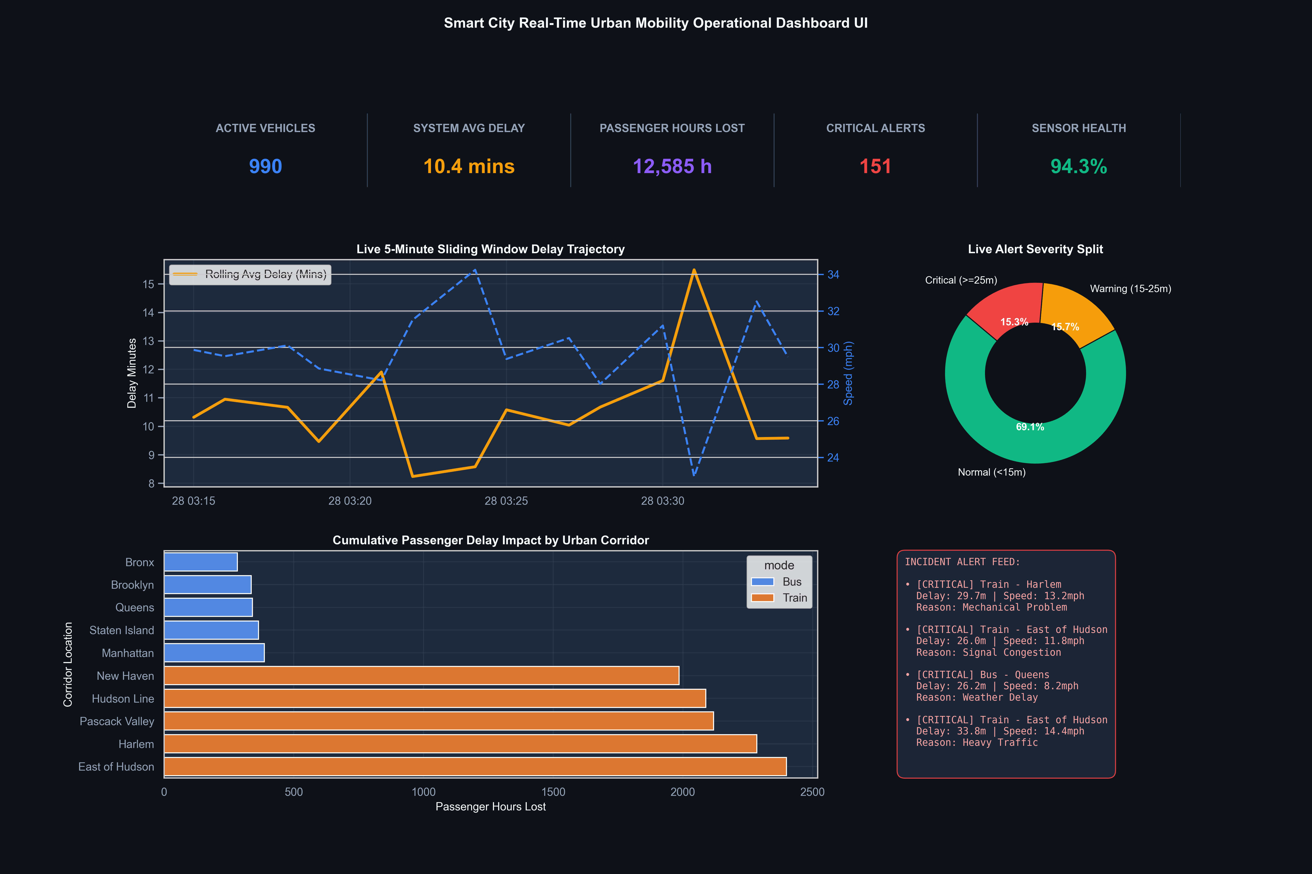
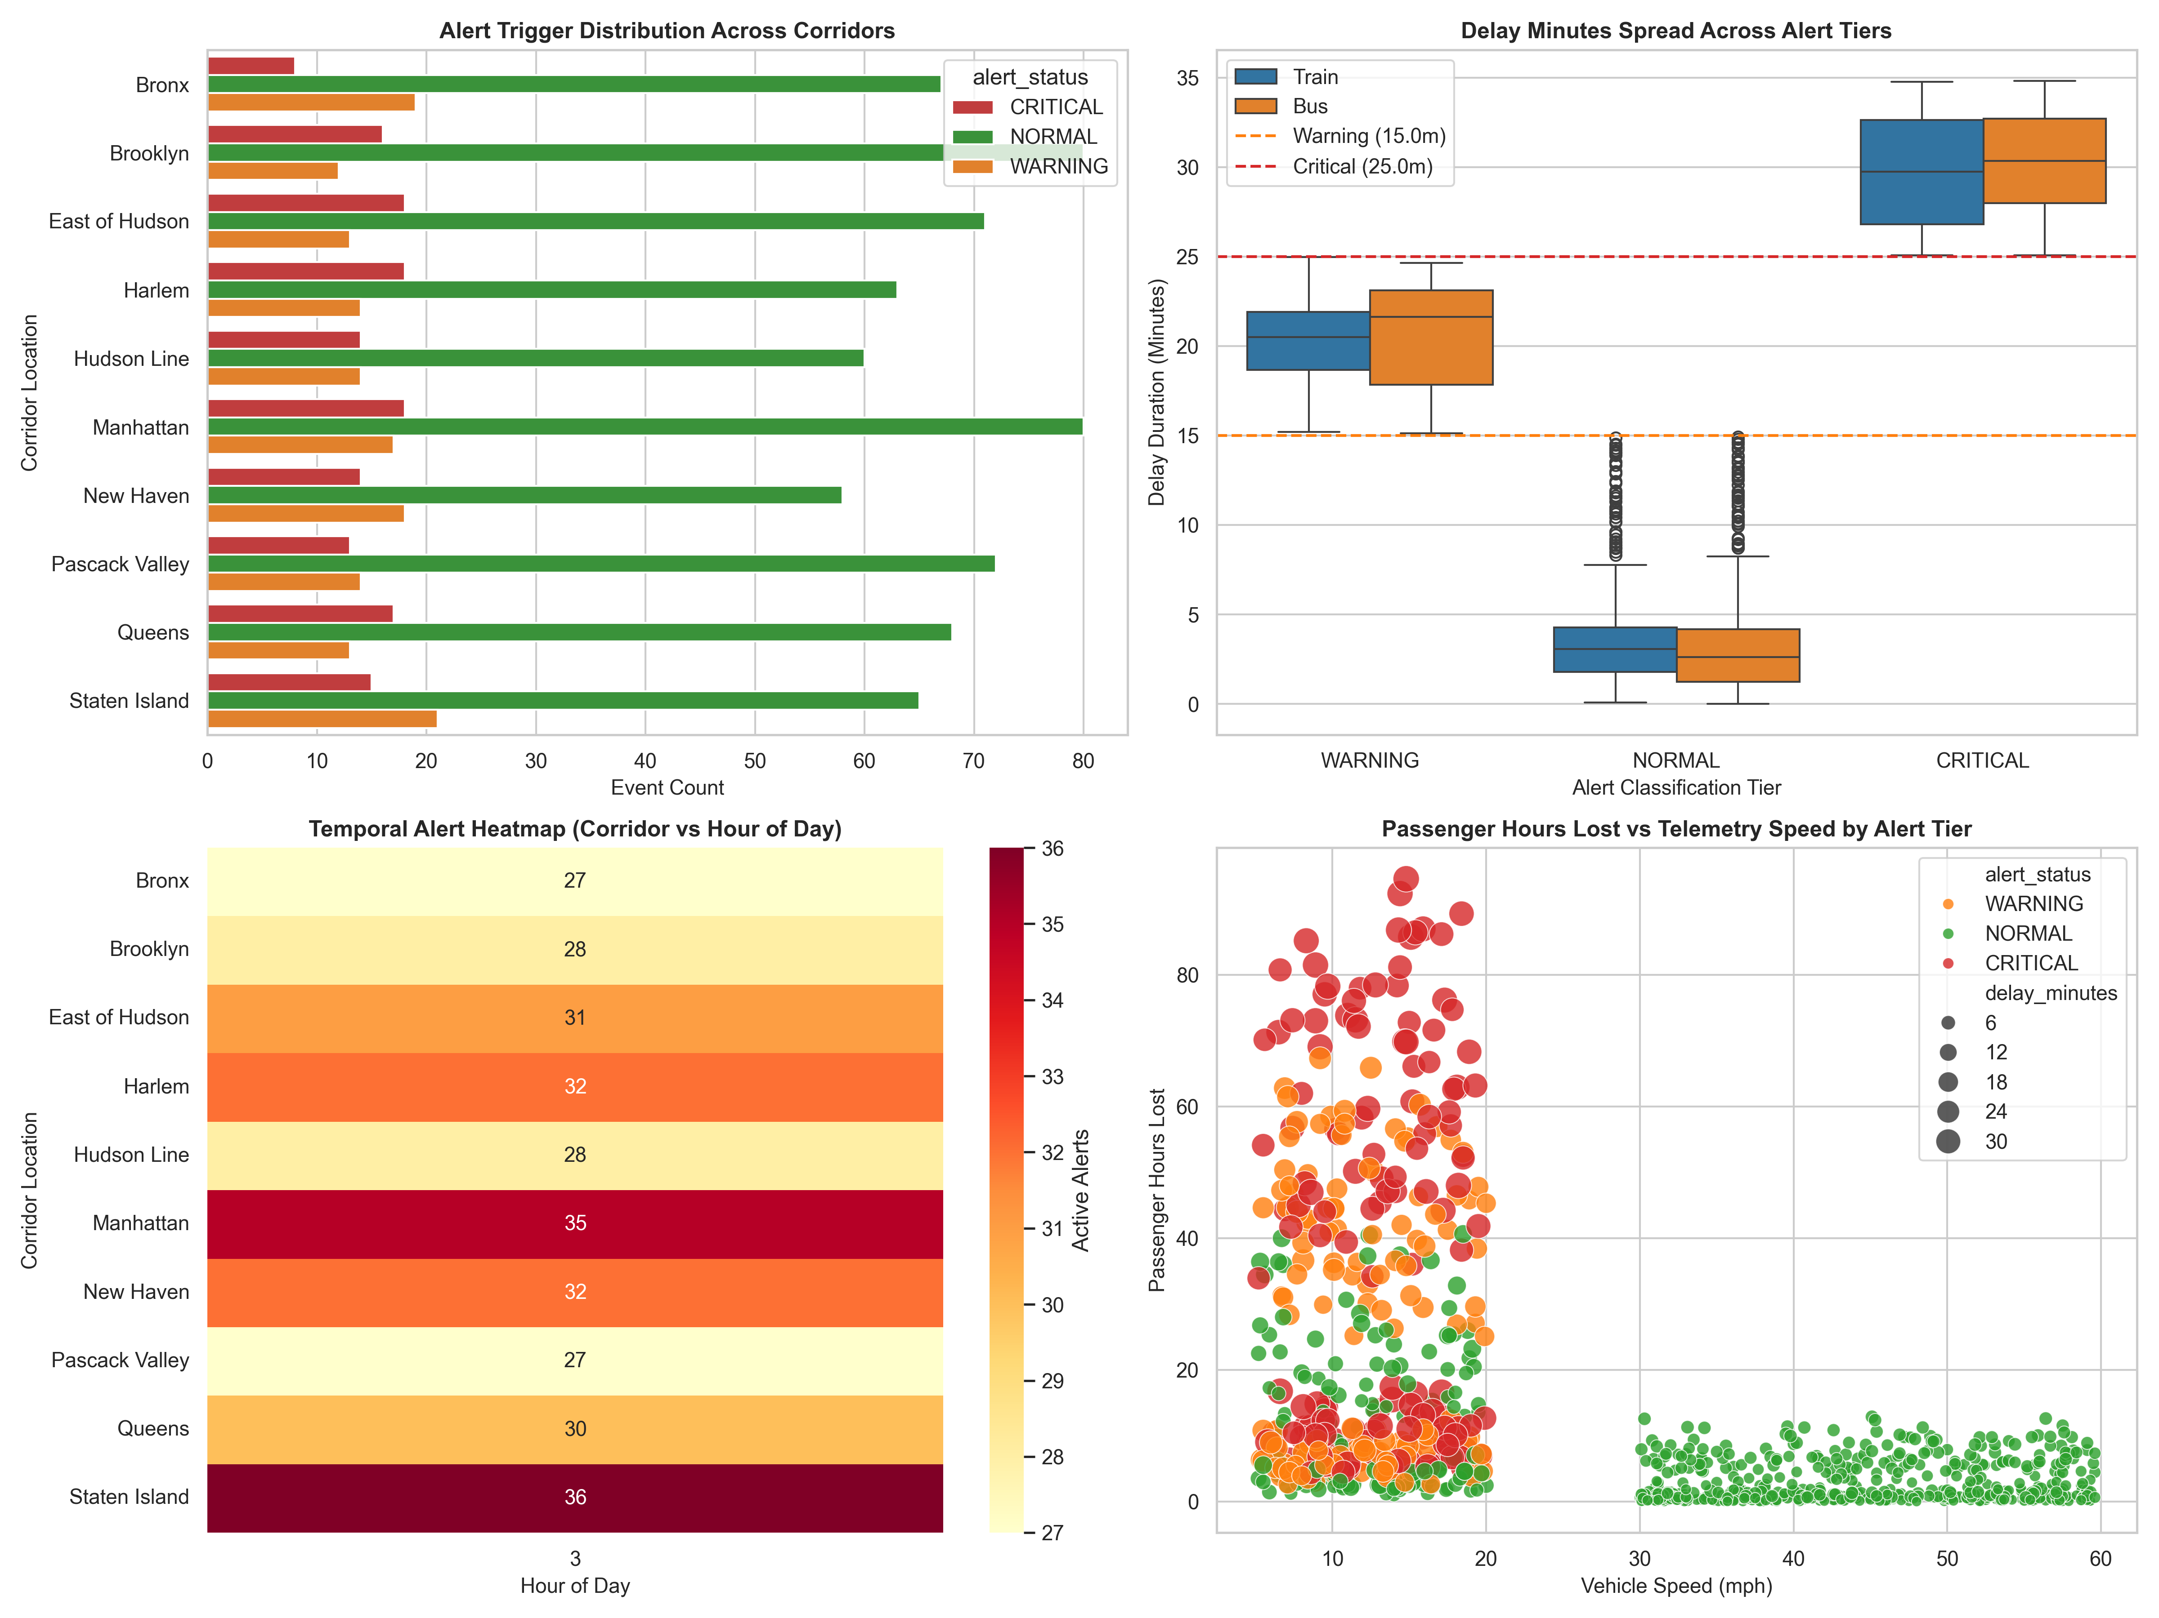
Key Analytical Findings
# | Finding | Empirical Evidence
1 | System runs mostly normal, but Critical/Warning are near-balanced | 69.1% of live events are Normal, but Critical (15.3%) and Warning (15.7%) alerts are almost evenly split — severe incidents aren't rare outliers, they're a steady ~31% share of traffic.
2 | Single incidents can cost enormous passenger impact | The #3 alert (Train, Harlem) shows only 34.8 min delay but 85.7 passenger-hours lost — nearly 8x the #1 alert's impact at the same delay, purely from higher onboard load.
3 | Critical-tier delays cluster tightly near the threshold boundary | The boxplot shows most Critical-tier delays sit between 25-35 minutes with a fairly narrow spread, not runaway outliers — the threshold is catching a real, consistent failure mode.
4 | Low speed is a strong leading indicator of high impact | The speed-vs-impact scatter shows nearly all high passenger-hour points (>40h) cluster under 20 mph, while every point above 30 mph stays under 20 passenger-hours lost.
5 | Alert load is spread evenly across corridors, not concentrated | Manhattan (35) and Staten Island (36) lead the hourly alert heatmap, but no corridor is a dramatic outlier — the alert burden is broadly distributed across the whole network.

Conclusion:
Successfully built a real-time operational dashboard combining an interactive Streamlit/Plotly app with automated threshold alerting over live streaming telemetry. Across 990 monitored vehicles, the system flagged 151 active alerts (15.3% Critical, 15.7% Warning) against a 10.44-minute average delay and 12,585 cumulative passenger-hours lost, with clear evidence that low vehicle speed and high passenger load — not delay duration alone — drive the largest-impact incidents. This live, threshold-driven view is the operational front end for the batch and streaming layers built in Experiments 5-7.

