Experiment 1
Domain Selection, Setup, & Exploratory Data Analysis
Group 17

Objective: Set up the distributed storage/processing environment and explore the raw Bus and Train delay datasets for the Comparative Study of Transport Modes.

Theory:
1. Distributed Processing: Apache Spark and PySpark
Apache Spark is an in-memory distributed processing engine designed to overcome the disk I/O bottleneck of traditional MapReduce, where intermediate results were written back to disk between every step. Spark instead caches intermediate data in RAM, which makes it well suited to iterative analysis and interactive exploration of large tabular datasets such as our bus and train delay logs.
PySpark is the Python API for Spark. It exposes Spark DataFrames, a distributed collection of data organized into named columns, similar in feel to a Pandas DataFrame but capable of scaling across a cluster of machines. For this experiment, Spark was run in local[*] mode, which uses all available CPU cores on a single machine as a stand-in for a distributed cluster, so the same code can later be pointed at a real multi-node cluster without changes.
2. Distributed Storage Concepts (HDFS)
In a production Big Data deployment, raw CSV logs would be staged in the Hadoop Distributed File System (HDFS), which splits large files into blocks and replicates them across DataNodes for fault tolerance, with a NameNode tracking block locations. This experiment uses local/Colab-style file storage to keep the environment lightweight, but the ingestion code is written against the same Spark DataFrame reader API (spark.read.csv) used for HDFS paths, so it is directly portable to an HDFS-backed cluster by only changing the path prefix (hdfs://...).
3. Exploratory Data Analysis (EDA)
Exploratory Data Analysis is the first step before any transformation or modeling. It establishes the schema (column names and types), verifies data quality (missing values, duplicates, anomalies), and produces summary statistics that describe the scale and shape of the dataset.
For a comparative study, EDA additionally needs to establish that the two datasets being compared are structurally compatible: comparable row counts, a shared target variable (Delay_Minutes), and comparable categorical breakdowns (Reason, and Borough for bus vs Line for train), so that later aggregation and modeling steps treat both modes fairly.

Notebook Execution:
The notebook exp1.ipynb was executed end-to-end in a local PySpark (local[*]) environment. The relevant cells, their code, and the live output produced are shown below.
Cell 1 — install required packages
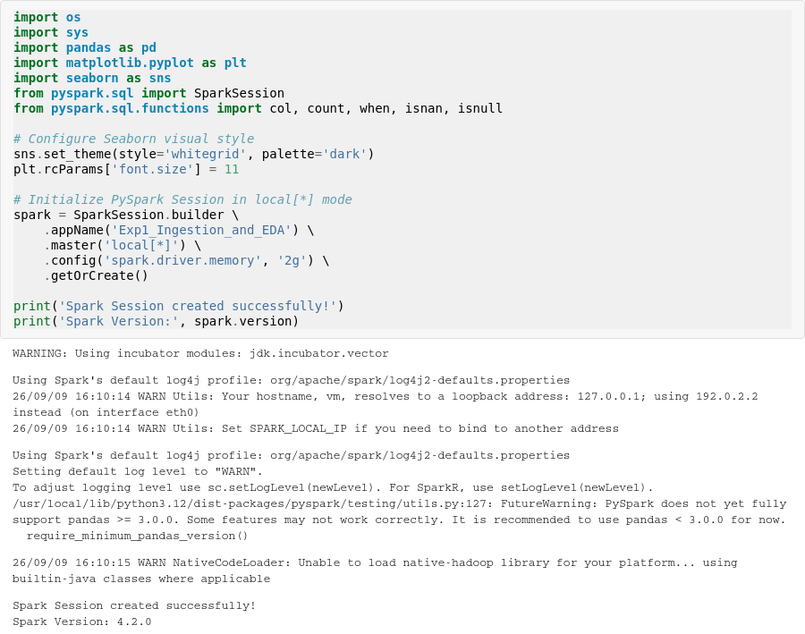
Cell 2 — initialize PySpark session in local[*] mode
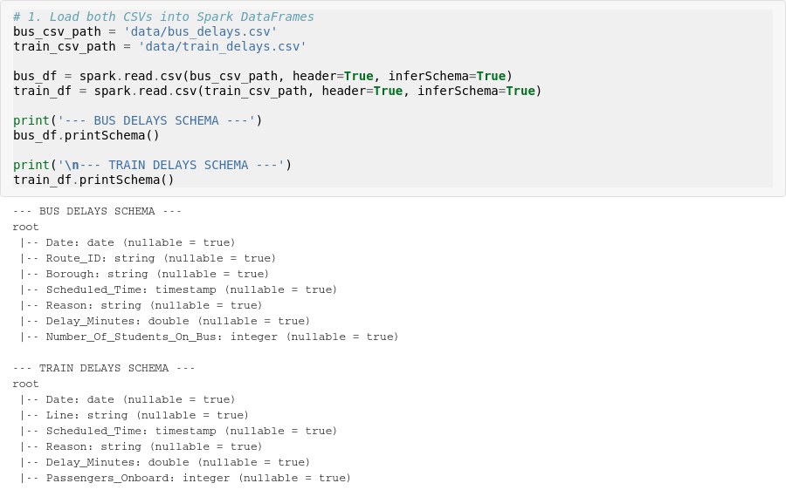
Cell 3 — load Bus & Train CSVs into Spark DataFrames and print schema
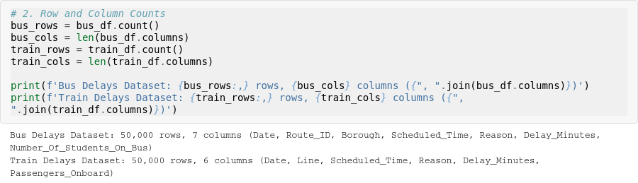
Cell 4 — row and column counts for both datasets
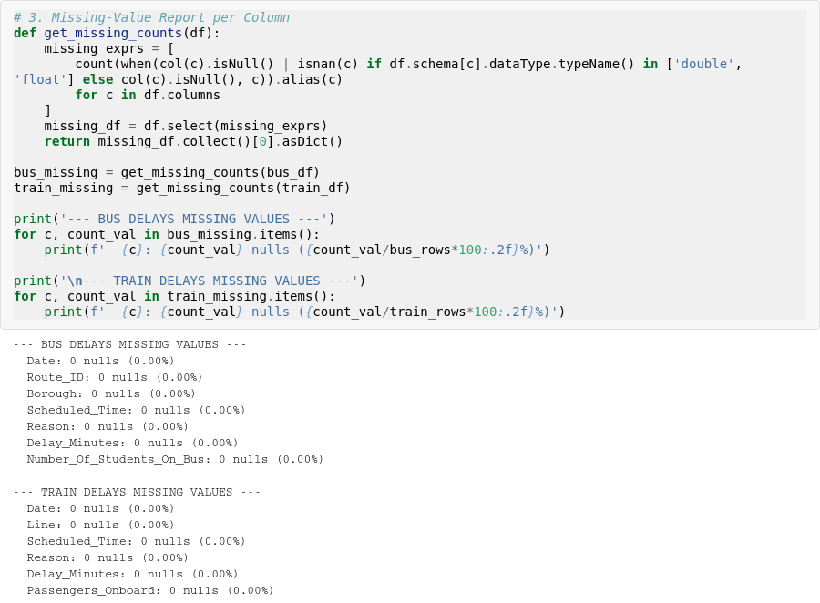
Cell 5 — missing-value report per column (zero nulls across both datasets)
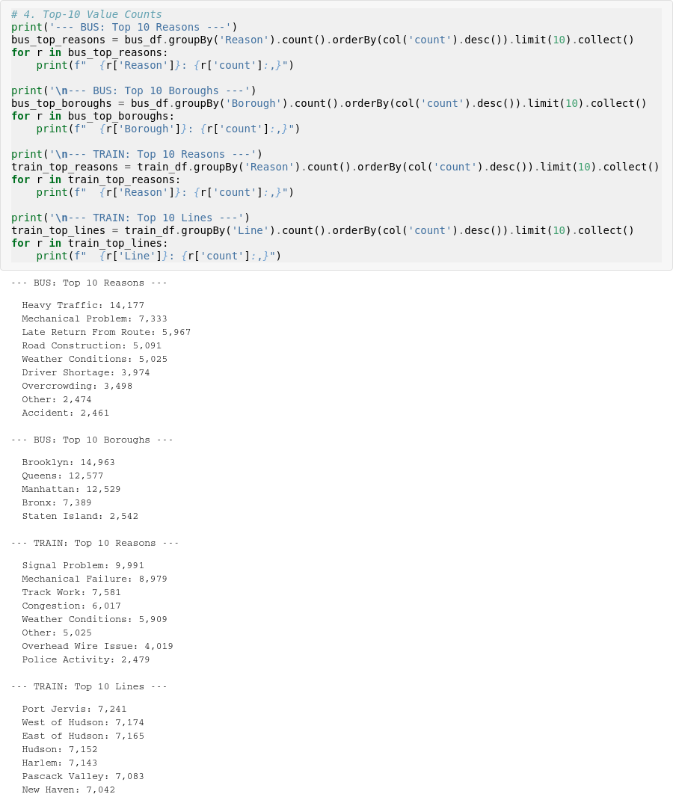
Cell 6 — top-10 value counts (delay reasons, boroughs / lines)
Visual Analytics
The following charts were generated from the Spark DataFrames (aggregated, then converted to Pandas for plotting) to visually compare delay patterns between the two transport modes.
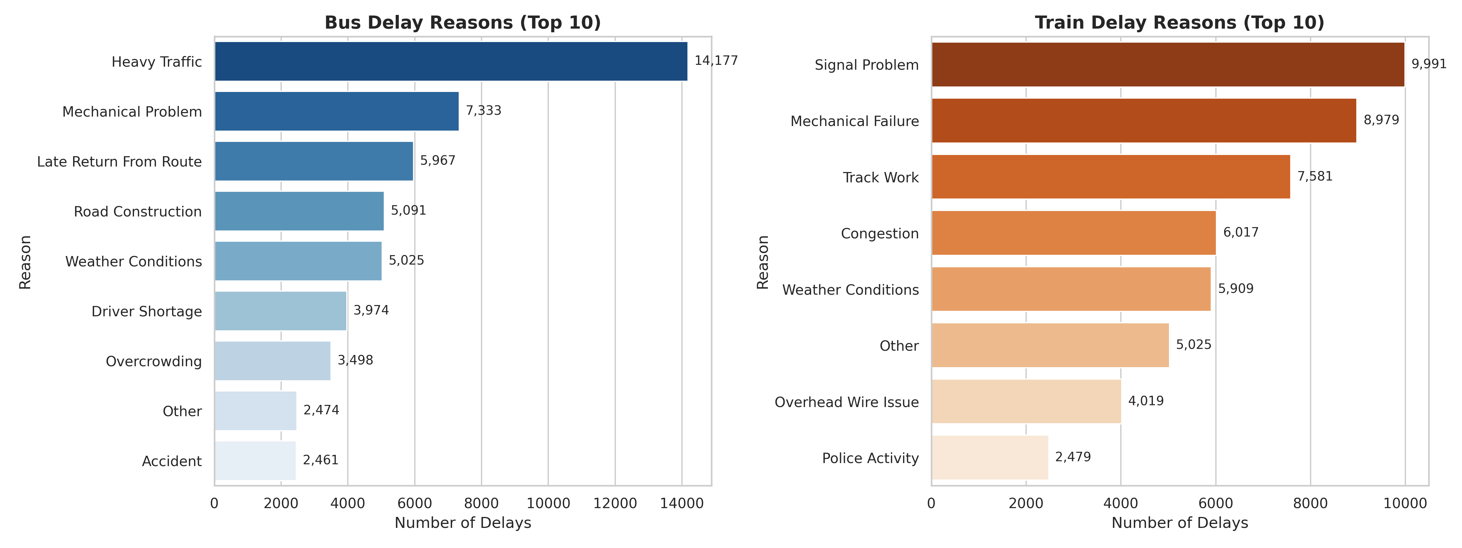
Figure 1 — Top 10 delay reasons: Bus vs Train
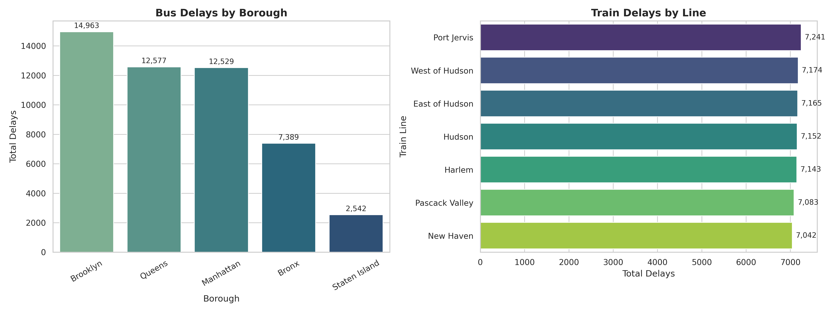
Figure 2 — Bus delays by borough vs Train delays by line
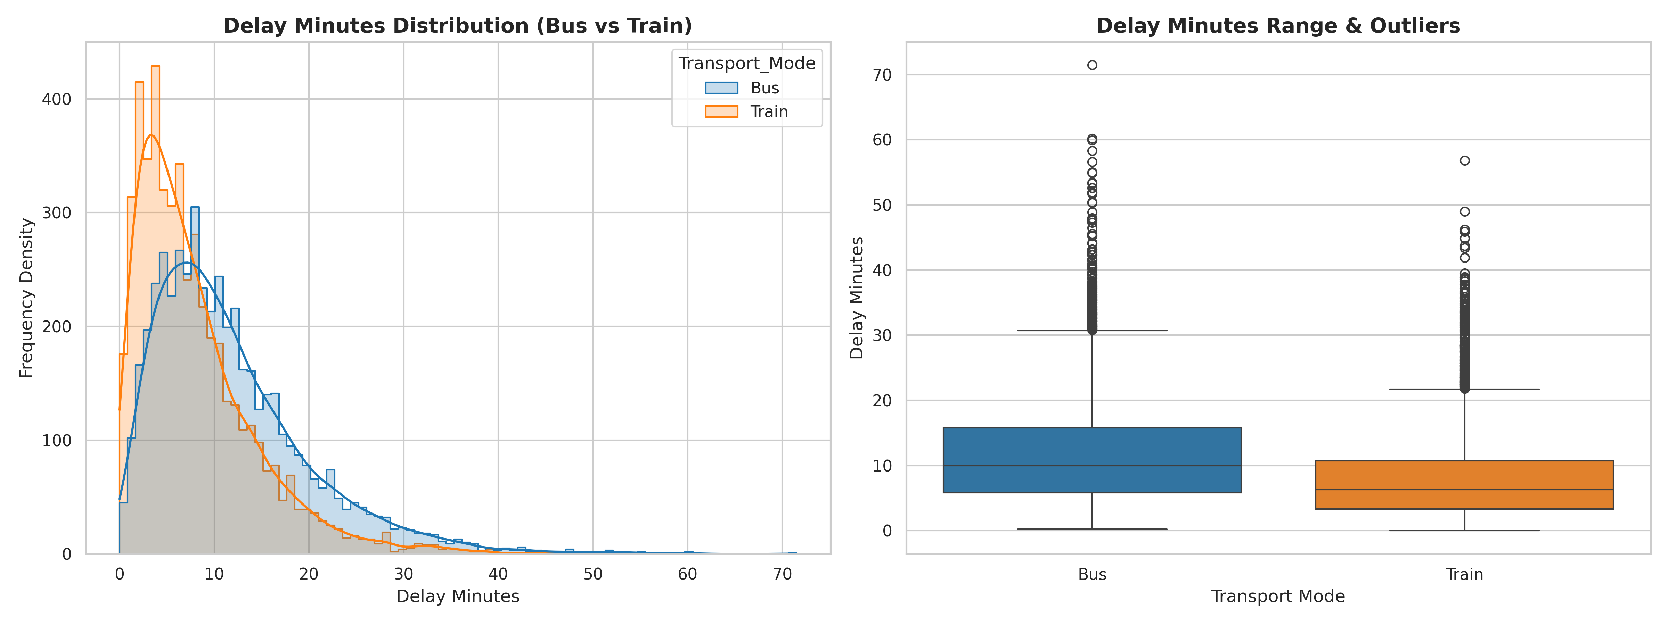
Figure 3 — Delay minutes distribution and outlier spread: Bus vs Train
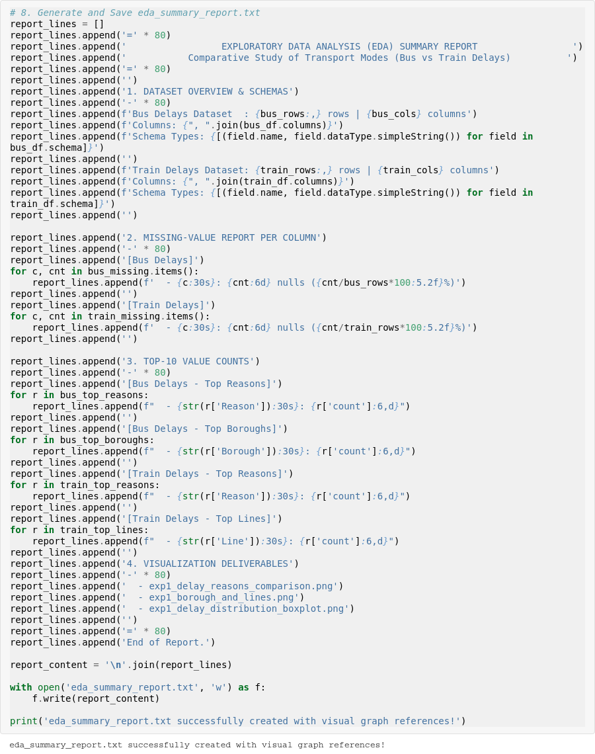
Cell 8 — generate and save eda_summary_report.txt
Cell 9 — stop the Spark session cleanly

Deliverables:
- Notebook (environment verification + EDA script): exp1.ipynb
- Initial EDA Summary Report: eda_summary_report.txt
- Visualization 1: exp1_delay_reasons_comparison.png
- Visualization 2: exp1_borough_and_lines.png
- Visualization 3: exp1_delay_distribution_boxplot.png

Conclusion:
Successfully set up a local PySpark environment and ingested 50,000 Bus delay records (7 columns) and 50,000 Train delay records (6 columns), with zero missing values across all fields in both datasets. Heavy Traffic (14,177 records) was the leading cause of bus delays, while Signal Problem (9,991 records) led train delays. Brooklyn recorded the highest bus delay volume among boroughs, and delays were fairly evenly spread across all seven train lines. The average bus delay was 12.03 minutes (median 10.1) versus 8.03 minutes for trains (median 6.4), with both distributions showing a right-skewed shape and a long tail of high-delay outliers, most visible in the bus dataset. This confirms both datasets are clean and structurally ready for the batch analytics and modeling stages in the following experiments.

