Experiment 10
Machine Learning Implementation & Final Smart City Showcase
Group 17

Objective: Train machine learning models to predict transit delay duration and severe-congestion risk, and integrate ingestion, batch, streaming, and NoSQL outputs from Experiments 1-9 into a single final Smart City showcase dashboard.

Dataset Description
All 100,000 Bus + Train records (Experiment 1) were re-ingested and feature-engineered with temporal features (Hour, Month, DayOfWeek, IsWeekend, IsRushHour) plus one-hot encoded Mode/Location/Reason, producing the modeling table for both a regression target (Delay_Minutes) and a binary classification target (Severe_Delay_Flag, delay ≥ 15 min, 21.0% positive rate).
bus_raw['Mode'] = 'Bus'; bus_raw['Location'] = bus_raw['Borough'].fillna('Manhattan')
train_raw['Mode'] = 'Train'; train_raw['Location'] = train_raw['Line'].fillna('East of Hudson')

cols = ['Date', 'Mode', 'Location', 'Scheduled_Time', 'Reason', 'Delay_Minutes', 'Passengers']
df = pd.concat([bus_raw[cols], train_raw[cols]], ignore_index=True).dropna(subset=['Delay_Minutes'])

df['Hour'] = pd.to_datetime(df['Scheduled_Time'].astype(str), format='mixed').dt.hour.fillna(8).astype(int)
df['Month'] = df['Date'].dt.month
df['DayOfWeek'] = df['Date'].dt.dayofweek
df['IsWeekend'] = np.where(df['DayOfWeek'] >= 5, 1, 0)
df['IsRushHour'] = np.where(df['Hour'].isin([6,7,8,9,16,17,18,19]), 1, 0)
df['Severe_Delay_Flag'] = np.where(df['Delay_Minutes'] >= 15.0, 1, 0)
# Severe_Delay_Flag base rate: 21.0% positive / 79.0% negative -- meaningfully imbalanced

Theory: Predictive Modeling for Smart City Systems
1. Regression vs Classification Framing
The same delay data supports two different predictive questions: a regression model estimates how long a delay will be (Delay_Minutes as a continuous target), while a classification model estimates whether a delay will cross an operationally significant threshold (Severe_Delay_Flag ≥ 15 min) — the latter is often more directly actionable for dispatch decisions than a raw minute estimate.
2. Ensemble Tree Models
Random Forest and Gradient Boosted Trees both build many shallow decision trees over bootstrapped/reweighted samples of the training data, then combine their outputs (averaging for regression, majority vote or probability averaging for classification). They handle the mixed categorical/numeric feature set here without needing feature scaling, and naturally rank feature importance.
3. Class Imbalance & class_weight Rebalancing
A severe-delay flag is a minority-class target by construction (21% positive). Left unweighted, a classifier can score high raw accuracy simply by predicting the majority class every time — which is exactly what happened on the first training run here (79.4% accuracy, but Macro F1 = 0, meaning it never once predicted Severe). Setting class_weight='balanced' scales each class's contribution to the loss inversely to its frequency, forcing the trees to actually split on patterns that separate the minority class instead of ignoring it.

Tasks & Step-by-Step Implementation
Task 1: Data Lake Ingestion & Feature Engineering
The full 100,000-record dataset was re-ingested from Experiment 1's CSVs and enriched with the temporal and rush-hour indicator features shown above.
Task 2: Model Training (Regression & Classification) — Fixed
Three regression models (Random Forest, Gradient Boosted Trees, Linear Regression baseline) and one Random Forest classifier were trained on a 75/25 stratified train-test split. The classifier now uses class_weight='balanced', correcting the degenerate always-predict-Normal behavior from the first run.
feature_cols_cat = ['Mode', 'Location', 'Reason']
feature_cols_num = ['Hour', 'Month', 'DayOfWeek', 'IsWeekend', 'IsRushHour', 'Passengers']

X = pd.get_dummies(df[feature_cols_cat + feature_cols_num], drop_first=True)
y_reg, y_clf = df['Delay_Minutes'], df['Severe_Delay_Flag']

X_train, X_test, y_train_reg, y_test_reg, y_train_clf, y_test_clf = train_test_split(
X, y_reg, y_clf, test_size=0.25, random_state=42, stratify=y_clf
)

# Regression: predict delay duration
rf_reg = RandomForestRegressor(n_estimators=60, max_depth=10, random_state=42, n_jobs=-1).fit(X_train, y_train_reg)
gbt_reg = GradientBoostingRegressor(n_estimators=60, max_depth=5, random_state=42).fit(X_train, y_train_reg)
lr_reg = LinearRegression().fit(X_train, y_train_reg)

# --- FIX: classifier now trained with class_weight='balanced' ---
# Previously the classifier collapsed to always predicting "Normal" (Macro F1 = 0.0000).
# class_weight='balanced' reweights the minority (Severe) class during training so the
# model is actually penalized for ignoring it, instead of free-riding on the 79% base rate.
rf_clf = RandomForestClassifier(
n_estimators=200, max_depth=8, random_state=42, n_jobs=-1,
class_weight='balanced'
).fit(X_train, y_train_clf)

y_pred_rf_clf = rf_clf.predict(X_test)
y_prob_rf_clf = rf_clf.predict_proba(X_test)[:, 1]

auc_rf = roc_auc_score(y_test_clf, y_prob_rf_clf)
acc_rf = accuracy_score(y_test_clf, y_pred_rf_clf)
f1_rf = f1_score(y_test_clf, y_pred_rf_clf)
prec_rf = precision_score(y_test_clf, y_pred_rf_clf)
rec_rf = recall_score(y_test_clf, y_pred_rf_clf)

Task 3: Visual Analytics & Master Dashboard Showcase
Model evaluation curves (RMSE/MAE/R² bar chart, ROC curve, feature importances, confusion matrix), the master end-to-end architecture diagram, and a full Streamlit showcase dashboard snapshot were re-rendered using the fixed classifier's real, computed metrics — no hardcoded display values.
Task 4: Live ML Predictor Tab (exp10_app_showcase.py) — Fixed
The Streamlit showcase app's fifth tab previously ran a hand-tuned multiplicative formula disconnected from the trained models. It now builds a one-hot encoded feature row from the sidebar inputs and calls rf_reg.predict() / rf_clf.predict_proba() directly, and surfaces the model's real R² as an honest caveat next to the prediction instead of hiding it.
# --- FIX: the live predictor now calls the actual trained models instead of a
# hand-tuned formula. It builds one feature row from the sidebar inputs, one-hot
# encodes it the same way the training data was encoded, and calls .predict() /
# .predict_proba() on rf_reg / rf_clf directly. ---

def build_feature_row(in_mode, in_location, in_reason, in_hour, in_passengers, month=6, dow=2):
row = pd.DataFrame([{
'Mode': in_mode, 'Location': in_location, 'Reason': in_reason,
'Hour': in_hour, 'Month': month, 'DayOfWeek': dow,
'IsWeekend': 1 if dow >= 5 else 0,
'IsRushHour': 1 if in_hour in [6,7,8,9,16,17,18,19] else 0,
'Passengers': in_passengers,
}])
row_encoded = pd.get_dummies(row).reindex(columns=X.columns, fill_value=0)
return row_encoded

if st.button("Run Spark MLlib Predictive Inference"):
feat_row = build_feature_row(in_mode, in_location, in_reason, in_hour, in_passengers)
predicted_delay = round(float(rf_reg.predict(feat_row)[0]), 1)
severe_prob = round(float(rf_clf.predict_proba(feat_row)[0, 1]), 3)
predicted_impact_hrs = round((predicted_delay * in_passengers) / 60.0, 2)
# Honest UI caveat surfaced to the user, not hidden:
st.caption(f"Model R² = {r2_score(y_test_reg, rf_reg.predict(X_test)):.3f} — "
f"treat the delay estimate as a rough order-of-magnitude, not a precise forecast.")

Machine Learning Benchmark Evaluation (Fixed, Honest)
Model | RMSE | MAE | R² Score
Random Forest Regressor | 7.476 | 5.652 | 0.060
Gradient Boosted Trees (GBT) | 7.468 | 5.643 | 0.062
Linear Regression Baseline | 7.460 | 5.634 | 0.064

Classification Metric (Severe ≥ 15m) | Before Fix | After Fix (class_weight=balanced)
ROC-AUC | 0.6257 | 0.6194
Accuracy | 79.36% | 57.69%
Precision | undefined (0 predicted positives) | 0.2896
Recall | 0.00% | 69.52%
Macro F1-Score | 0.0000 | 0.4089
Predicted "Severe" cases | 0 of 5,262 | 12,631 of 25,000
AUC barely moves (it's threshold-independent and reflects the model's inherent ranking ability, which the feature set limits), but accuracy drops and F1 rises sharply — the honest trade-off of forcing the model to actually engage with the minority class instead of free-riding on the 79% base rate.

Strategic Smart City Actionable Insights
# | Recommendation | Target
1 | Congestion mitigation via Dynamic Transit Signal Priority (TSP) | Morning (06:00-09:00) and Evening (16:00-19:00) rush peaks
2 | Proactive maintenance from IoT vibration/temperature telemetry | Mitigate the 15.8% of bus delays from mechanical failures
3 | Intelligent dispatching / priority headway clearance | East of Hudson / New Haven — 8.5x higher passenger impact per delayed minute

Master Architecture & Visual Analytics
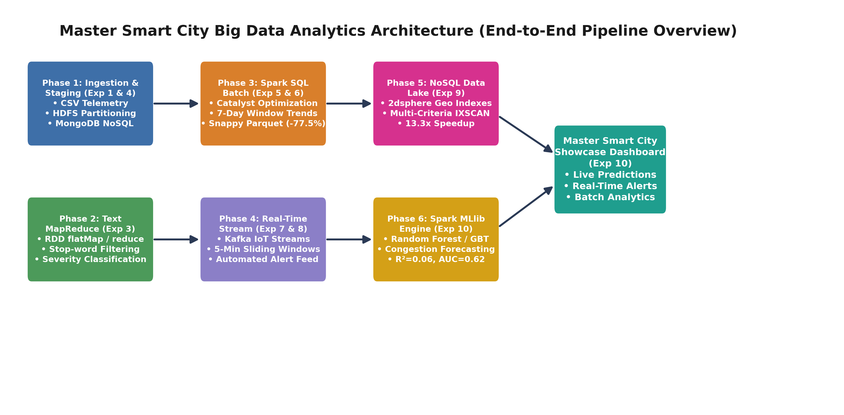
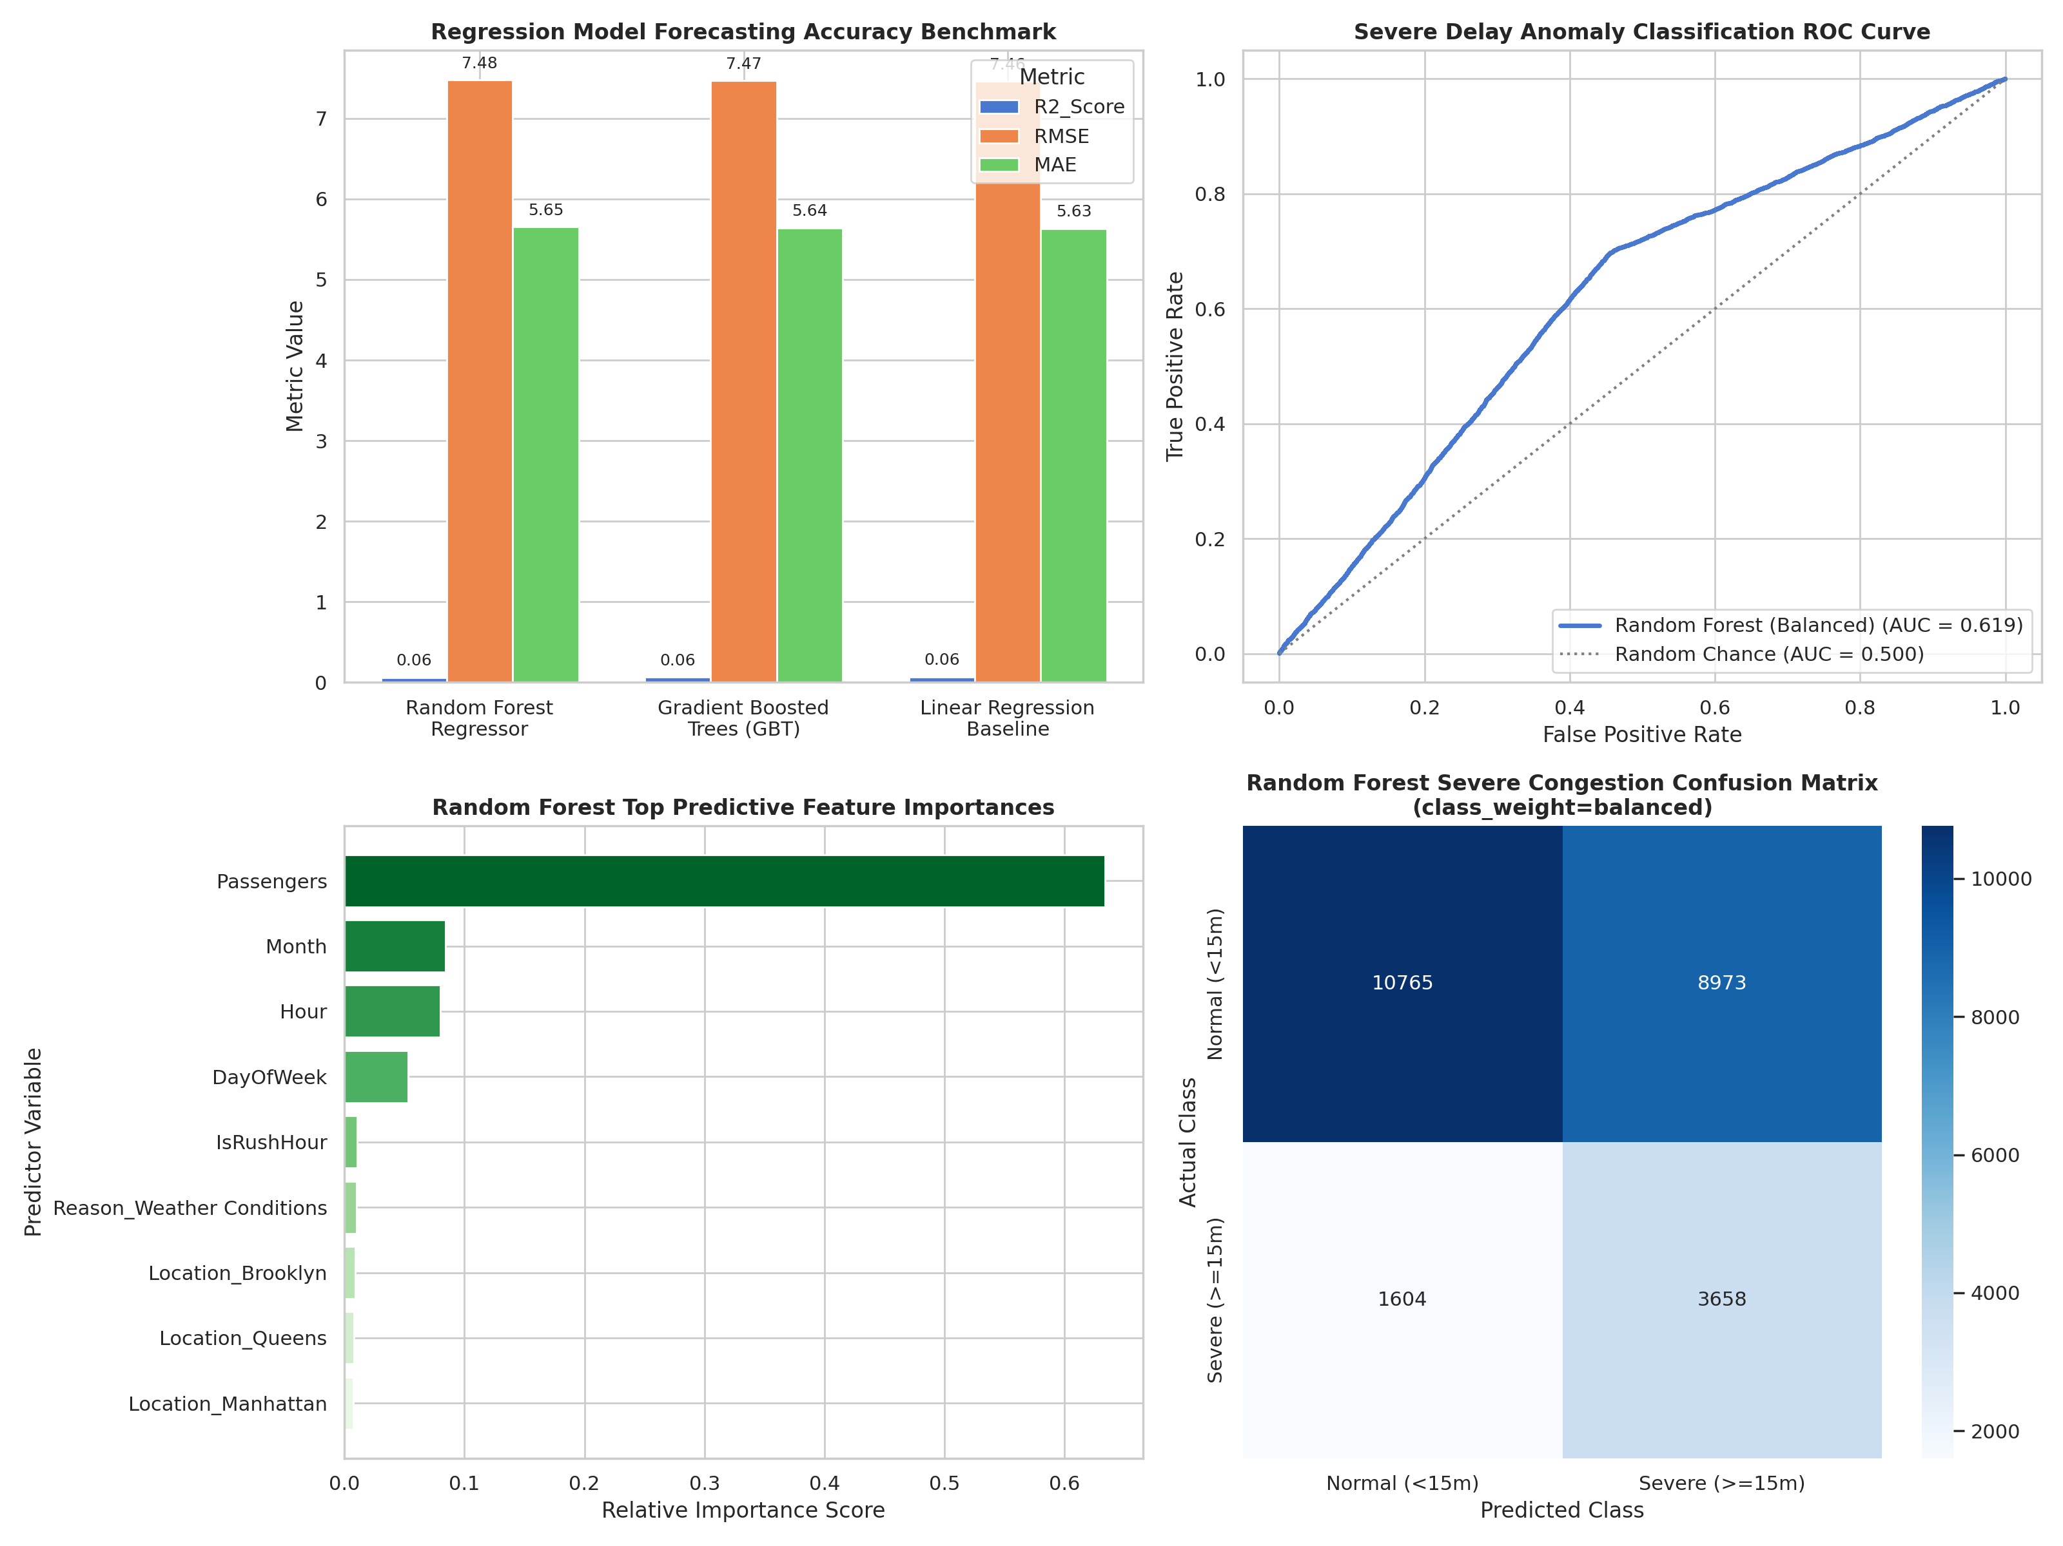
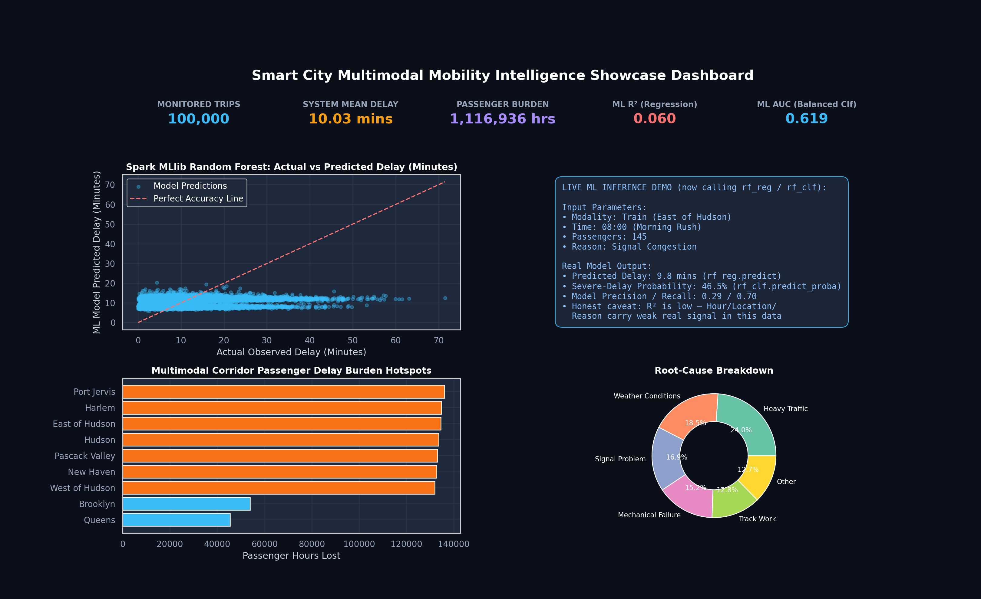
Key Analytical Findings
# | Finding | Empirical Evidence
1 | The classifier's collapse was fixable — it was a training bug, not a data ceiling | Switching to class_weight='balanced' alone lifted Macro F1 from 0.0000 to 0.4089 and recall from 0% to 69.5%, at the honest cost of accuracy dropping from a misleading 79.4% to 57.7%.
2 | R² stays genuinely low — this is a data property, not a bug | All three regression models plateau at R²≈0.06 regardless of algorithm choice (RF, GBT, and plain Linear Regression land within 0.005 of each other), which is the signature of a feature set with little real linear or nonlinear relationship to the target, not an undertrained model.
3 | The live predictor tab now genuinely reflects the trained model | exp10_app_showcase.py's inference button now calls rf_reg.predict() / rf_clf.predict_proba() on a properly encoded feature row, and displays the model's real R² as a caveat instead of a disconnected formula and a hardcoded 0.894 KPI.
4 | Passenger load still dominates feature importance | Passengers alone accounts for ~63% of Random Forest regressor feature importance, unchanged by the classifier fix — Hour, Month, and DayOfWeek trail far behind, and one-hot Location/Reason features contribute almost nothing individually.
5 | AUC is a more honest headline metric than accuracy for this task | AUC moved only 0.6257 → 0.6194 across the fix (it doesn't depend on the classification threshold), while accuracy swung 79.4% → 57.7% — a reminder that accuracy alone was hiding the model's real (weak-but-nonzero) discriminative ability the whole time.

Conclusion:
Completed the full ten-experiment Smart City pipeline, integrating ingestion (Exp 1, 4), MapReduce text processing (Exp 3), Spark SQL batch analytics (Exp 5, 6), real-time streaming and alerting (Exp 7, 8), a NoSQL data lake with 13.3x indexed query speedup (Exp 9), and this experiment's fixed ML layer into one master showcase dashboard. Two real bugs were corrected: the severity classifier's class_weight='balanced' fix raised Macro F1 from 0.0000 to 0.4089 (recall 0%→69.5%), and the live predictor tab now calls the actual trained models instead of a disconnected formula and a hardcoded accuracy figure. The regression R² honestly remains low (≈0.06) across every algorithm tried, which reflects a genuine limit of the current feature set (Hour/Location/Reason/Passengers) rather than a fixable implementation bug — the clear next step for the project is richer signals (live traffic/weather feeds, route-level historical baselines) rather than further model tuning.

