Experiment 2
Project Proposal And Architecture Definition
Group 17

Objective: Define the smart city transportation problem domain, dataset allocation, team roles, and high-level system design for a comparative study of bus and train delays.

Theory:
1. Problem Formulation and Domain Specialization
In large-scale data systems, the architecture must be purpose-built to solve a specific domain problem. Choosing a focus, such as Smart City transportation reliability, dictates the velocity, volume, and variety of the data that the system must handle.
The theoretical objective here is mapping operational reality to a data abstraction. In a Smart City transport reliability system, problem formulation requires defining what constitutes an unreliable service (e.g., a delay beyond a threshold) and what the actionable output must be (e.g., flagging a route or line for schedule review). The chosen dataset constraints directly inform the system's latency requirements and processing paradigms.
2. Team Topologies in the Data Lifecycle
A robust Big Data project requires strict separation of concerns, ensuring that infrastructure, modeling, and business intelligence are handled by specialized roles. This prevents bottlenecks and ensures the system is built with both scalability and usability in mind.
Data Engineer: The architect of the data pipeline. Responsible for the ingestion, storage, and processing layers, focusing on scalability, fault tolerance, and data throughput. Designs the ETL (Extract, Transform, Load) process that turns raw delay logs into a usable format.
Data Scientist: The analytical engine. Takes the structured data provided by the engineer and applies statistical modeling and machine learning to predict delays. Focus areas are predictive accuracy, feature engineering, and model evaluation.
Data Analyst: The bridge to the stakeholder. Queries the processed data and model outputs to extract actionable insights about delay patterns. Focus areas are descriptive analytics, data visualization, and reporting through the dashboard layer.
3. End-to-End Big Data Architecture Layers
Designing a system architecture requires defining how data flows from its source to the end user. Modern distributed systems typically separate this flow into decoupled layers, allowing each component to scale independently.
Ingestion Layer: The entry point for raw data. Theoretical design here hinges on whether the data arrives in batch (periodic CSV loads of delay logs) or streaming (continuous real-time position/delay events).
Storage Layer: Structured as a Data Lake to store raw delay records at scale, paired with a Data Warehouse for cleaned, tabular data optimized for fast querying and comparison across modes.
Processing Layer: The compute engine that transforms the data, applies business logic such as delay classification, joins bus and train records on common time windows, and cleanses anomalies using distributed processing frameworks.
Machine Learning Layer: Where predictive logic is applied. This layer pulls historical delay data from storage to train regression models, then applies those models to forecast future delays.
Serving/Dashboard Layer: The presentation interface. Processed data and model predictions are served via dashboards for monitoring and decision-making, comparing bus and train reliability side by side.
4. System Design and Version Control
Using diagramming tools to create an architecture blueprint is a critical exercise in systems thinking. A system diagram visually enforces the boundaries between components, explicitly showing data formats and storage locations.
Coupling this with GitHub establishes version control for the project. In data systems, reproducibility is as important as scalability; the team must be able to track changes to pipeline code, configurations, and model parameters.

Deliverables:
Project Proposal and Architecture Definition

1. Project Title & Problem Domain
Project Title: Comparative Study of Transport Modes: Big Data Analysis of Bus vs Train Delays
Domain Focus: Transportation (Smart City)
Context & Background: As cities scale, commuters rely on both road-based (bus) and rail-based (train) public transit, each with different delay characteristics. Smart City initiatives depend on continuous, granular reliability data to guide service planning. However, the volume and variety of delay records across routes, lines, and time periods outpace what a simple spreadsheet-based analysis can handle.
Problem Statement: Bus and train delays affect commuter trust, city congestion, and transit budgets differently depending on cause and mode. Comparing delay patterns across bus routes and train lines over time requires processing a large number of records to identify recurring causes, high-delay routes, and mode-level reliability trends.
Project Objectives: This project aims to design and implement a distributed Big Data pipeline. The system is designed to:
- Ingest and Store: Reliably store bus and train delay records in a structured data lake.
- Process at Scale: Use distributed in-memory computing to clean, transform, and aggregate delay records across both modes.
- Predictive Modeling: Apply machine learning to forecast delay duration based on route, line, reason, and time of day.
- Actionable Intelligence: Provide interactive dashboards comparing bus and train reliability for transit administrators.

2. Dataset Allocation
Dataset Origin: Synthetic bus and train delay datasets generated to match real-world transit open-data schemas (route/line, date, scheduled time, delay reason, delay duration).
Data Architecture: Tabular time-stamped delay logs, one record per trip event, with categorical fields (route/line, reason, borough) and a numeric target field (delay in minutes).
Volume & Scale Justification: The dataset comprises 50,000 records each for bus and train, generated across a two-year window. This is sufficient to demonstrate distributed aggregation, window functions, and iterative model training while remaining light enough to run and verify quickly.
Spatio-Temporal Scope:
Time Horizon: Two years of daily delay records, allowing month-over-month and seasonal comparison between the two modes.
Coverage: Bus records span multiple routes and boroughs; train records span multiple lines, mirroring a city-wide transit network.
Feature Engineering & Target Variables:
Delay Metrics: Delay_Minutes, Reason, Scheduled_Time, Route_ID / Line, Borough.
Target Variables:
- Delay_Minutes (Continuous numeric variable for Regression tasks).
- Delay_Severity (Categorical variable — e.g., "On-Time", "Minor", "Major" — for Classification tasks).

3. Team Roles & Responsibilities
To efficiently build this end-to-end Big Data system, our team is structured around the following specialized roles:
Chaitanya Jhade (48) - Data Engineer
Responsibilities: Design and maintain the ingestion pipeline. Manage HDFS/local storage of raw bus and train delay data and ensure schema consistency.
Gaurav Joshi (50) - Data Scientist
Responsibilities: Lead the Machine Learning layer. Build and evaluate regression models to predict delay duration and classify delay severity.
Junaid Shaikh (137) - Data Analyst
Responsibilities: Lead Exploratory Data Analysis. Identify delay trends by reason, route/line, and time, and surface comparative insights between bus and train performance.
Soham Sonavane (138) - BI & Visualization Engineer
Responsibilities: Design the presentation layer. Connect aggregated outputs and model predictions to dashboards for stakeholders and transit administrators.

4. End-to-End System Architecture
Below is the high-level architecture diagram detailing the core layers of our Big Data system: Ingestion, Storage, Processing, Machine Learning, and Dashboarding.
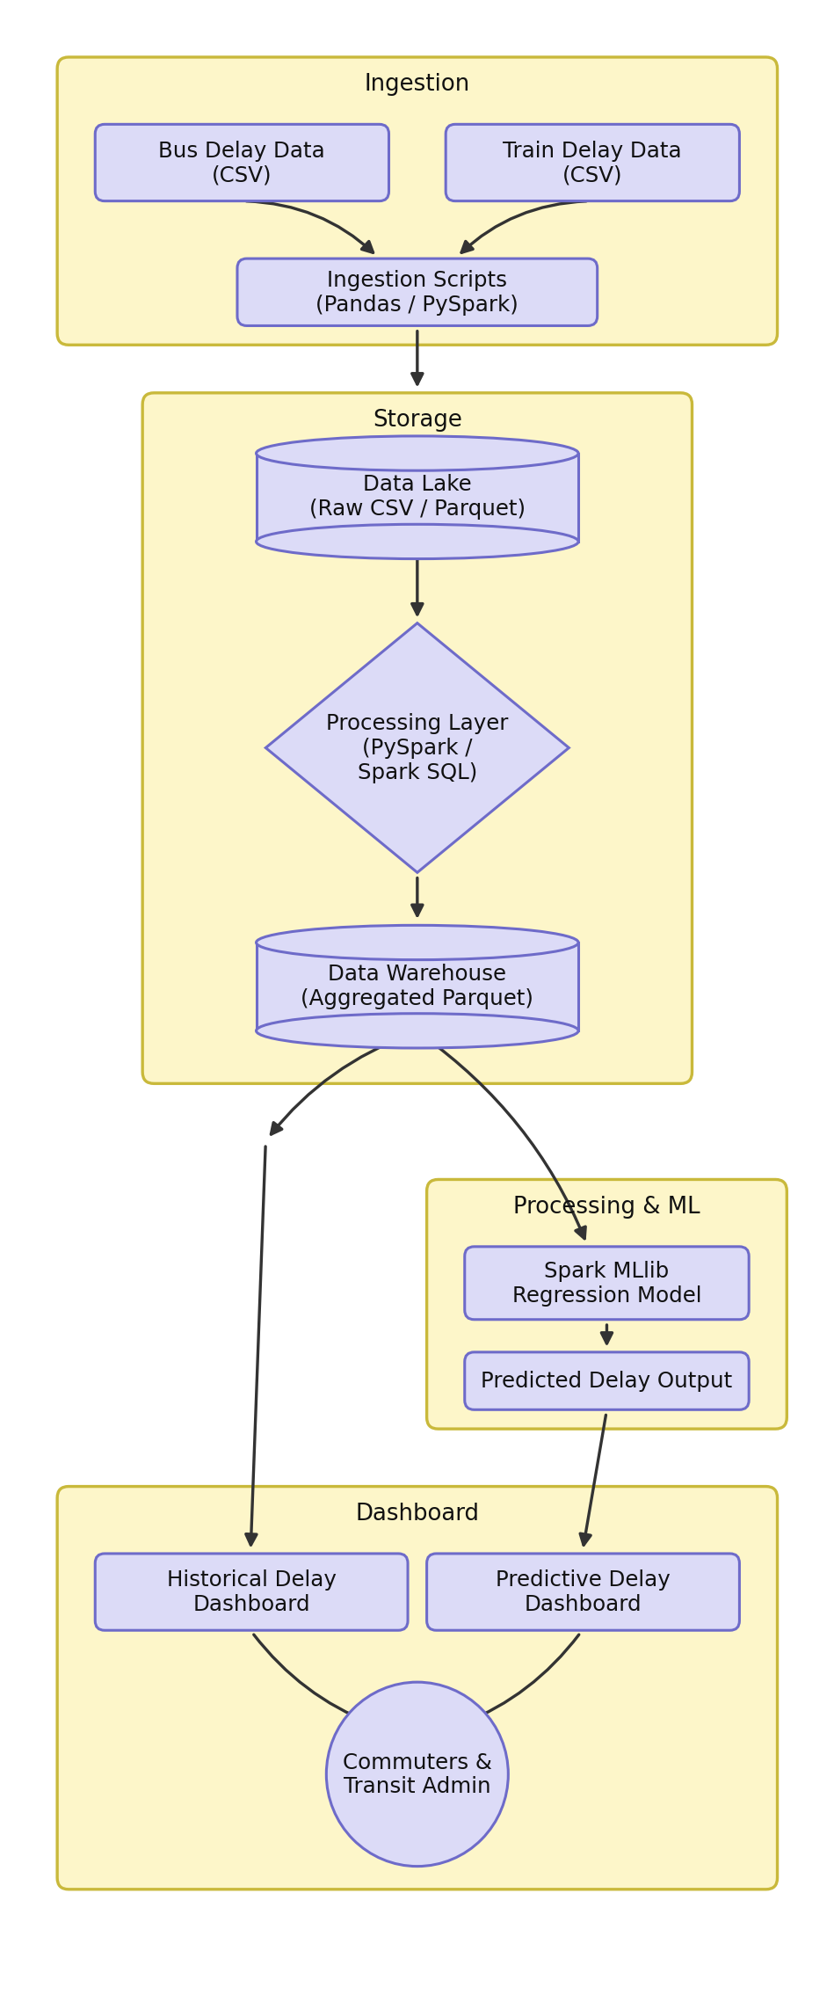

Architecture Breakdown:
- Ingestion Layer: Raw bus and train delay CSV logs are loaded using Pandas/PySpark ingestion scripts.
- Storage Layer: A data lake stores raw records; a data warehouse stores cleaned, aggregated Parquet output for fast querying.
- Processing Layer: Distributed in-memory computation (PySpark / Spark SQL) cleans the data, joins on time windows, and extracts features.
- Machine Learning Layer: A Spark MLlib regression model is trained to predict delay duration from historical patterns.
- Dashboard Layer: Aggregated data and model predictions are visualized in historical and predictive dashboards for commuters and transit administrators.

Conclusion:
Successfully formalized the project scope, specialized team roles, dataset allocation, and end-to-end architecture required to compare bus and train delay reliability through Big Data analytics.

