Experiment 3
MapReduce Processing on Unstructured Text Data
Group 17

Objective: Perform distributed text processing on the unstructured/semi-structured delay-reason logs of both transport modes using MapReduce concepts.

Dataset Description:
The MapReduce pipeline operates on the free-form 'Reason' text column already present in the Bus and Train delay datasets (data/bus_delays.csv, data/train_delays.csv), each holding 50,000 records. This column is treated as the unstructured/semi-structured text source for tokenization and keyword extraction.
Dataset | Text Column | Records | Sample Value | Description
Bus Delays | Reason | 50,000 | Heavy Traffic | Free-form delay cause logged per bus trip
Train Delays | Reason | 50,000 | Signal Problem | Free-form delay cause logged per train trip

Theory: Distributed MapReduce & PySpark RDD Architecture
1. The MapReduce Computational Paradigm
MapReduce is a distributed programming model for processing large datasets concurrently across a cluster of machines, proceeding in three stages. In the Mapper phase, the input is split across worker partitions and each record is tokenized and emitted as an intermediate key-value pair — for word count, a line of text is split via flatMap and mapped into (word, 1) pairs. In the Shuffle & Sort phase, Spark redistributes these pairs by key using hash partitioning so that all values sharing a key land on the same reducer. In the Reducer phase, reduceByKey() combines all values for each key using an associative function, performing map-side (partition-local) pre-aggregation before the network shuffle to reduce data movement.
2. Apache Spark RDD Architecture
Spark represents distributed data as Resilient Distributed Datasets (RDDs). RDDs maintain a lineage graph (DAG) of the transformations used to build them, so a lost partition can be recomputed from lineage instead of restarting the whole job. Transformations such as flatMap, map, filter, and reduceByKey are lazily registered and only executed once an action (count, collect, take, glom) is called, which lets Spark's scheduler optimize the execution plan before running it.

Tasks & Step-by-Step Implementation
Task 1: Environment Setup & Spark Initialization
The PySpark session was initialized in local cluster simulation mode (local[*]), using all available CPU cores as worker threads to emulate a distributed cluster on a single machine.
Task 2: Ingestion & Distributed RDD Partitioning
The Reason column was extracted from both Spark DataFrames into RDDs and explicitly repartitioned into 4 partitions each, so the workload distribution across simulated worker threads could be audited.
Task 3: Distributed Word Count Pipeline (MapReduce)
Each RDD was tokenized (flatMap), lower-cased and stripped of punctuation, filtered against a stop-word list, mapped into (word, 1) pairs, and aggregated with reduceByKey(), then sorted by frequency descending.
Top 10 Bus Delay Keywords
Rank | Keyword | Frequency
1 | heavy | 14,177
2 | traffic | 14,177
3 | mechanical | 7,333
4 | problem | 7,333
5 | return | 5,967
6 | route | 5,967
7 | late | 5,967
8 | road | 5,091
9 | construction | 5,091
10 | weather | 5,025

Top 10 Train Delay Keywords
Rank | Keyword | Frequency
1 | signal | 9,991
2 | problem | 9,991
3 | failure | 8,979
4 | mechanical | 8,979
5 | work | 7,581
6 | track | 7,581
7 | congestion | 6,017
8 | weather | 5,909
9 | conditions | 5,909
10 | overhead | 4,019

Task 4: Preliminary Severity Classification
Each Reason string was mapped to a severity tier (Critical, Severe, Moderate, Minor) using keyword-based rules, then aggregated with reduceByKey() — the same map/reduce pattern as the word count, applied to a classification instead of a token.
Severity | Bus Count | Bus % | Train Count | Train %
Moderate | 25,169 | 50.3% | 11,926 | 23.9%
Minor | 5,972 | 11.9% | 5,025 | 10.1%
Severe | 9,065 | 18.1% | 17,572 | 35.1%
Critical | 9,794 | 19.6% | 15,477 | 31.0%

Task 5: Cluster Node & Partition Distribution Audit
Using rdd.glom().map(len).collect(), the record count held by each of the 4 partitions was inspected for both RDDs to confirm balanced parallel distribution with no data skew.
Partition | Bus Records | Train Records
Part 0 | 12,500 | 12,500
Part 1 | 12,500 | 12,500
Part 2 | 12,500 | 12,500
Part 3 | 12,500 | 12,500

Visualizations & Graphical Analyses
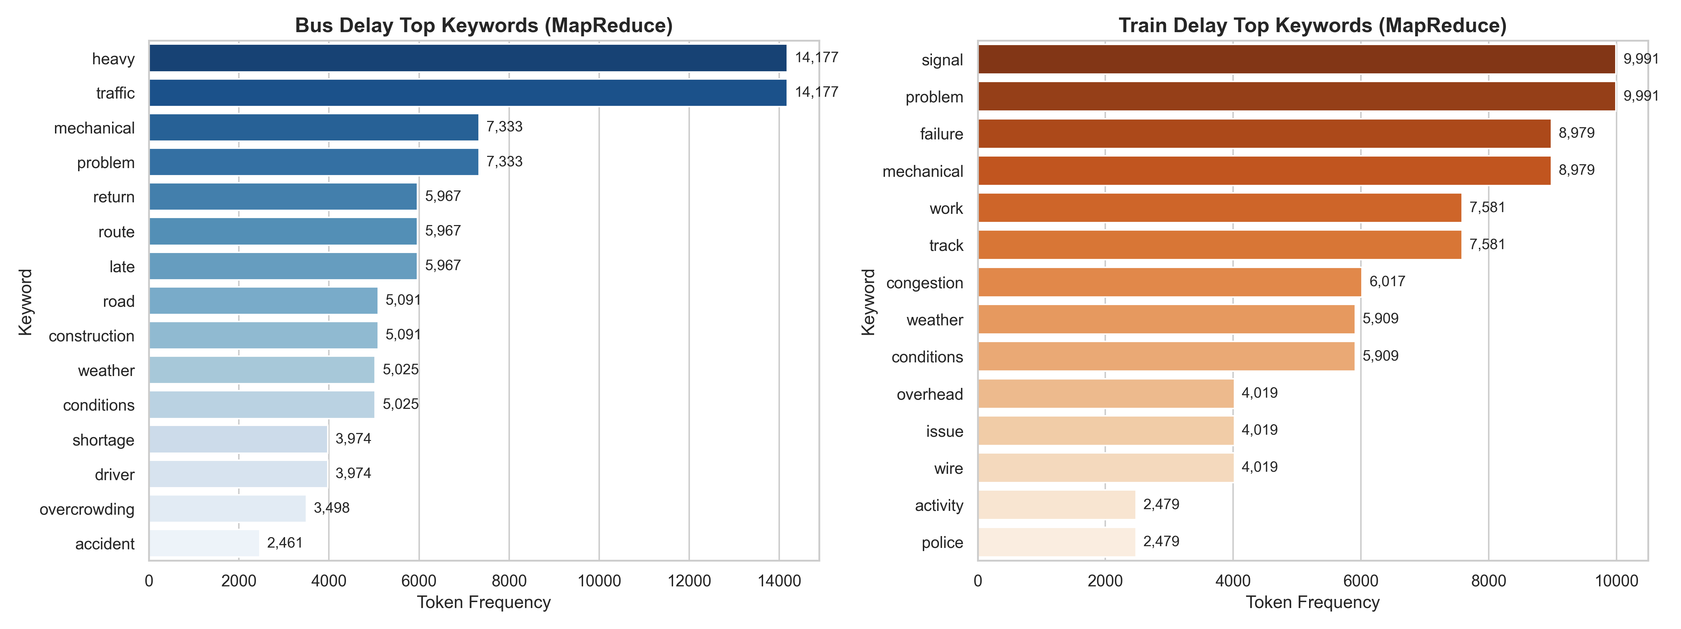
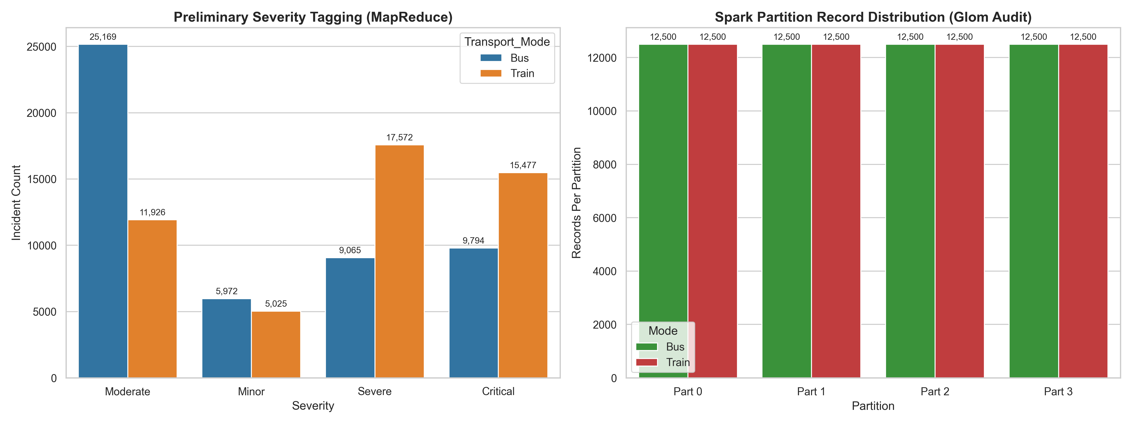
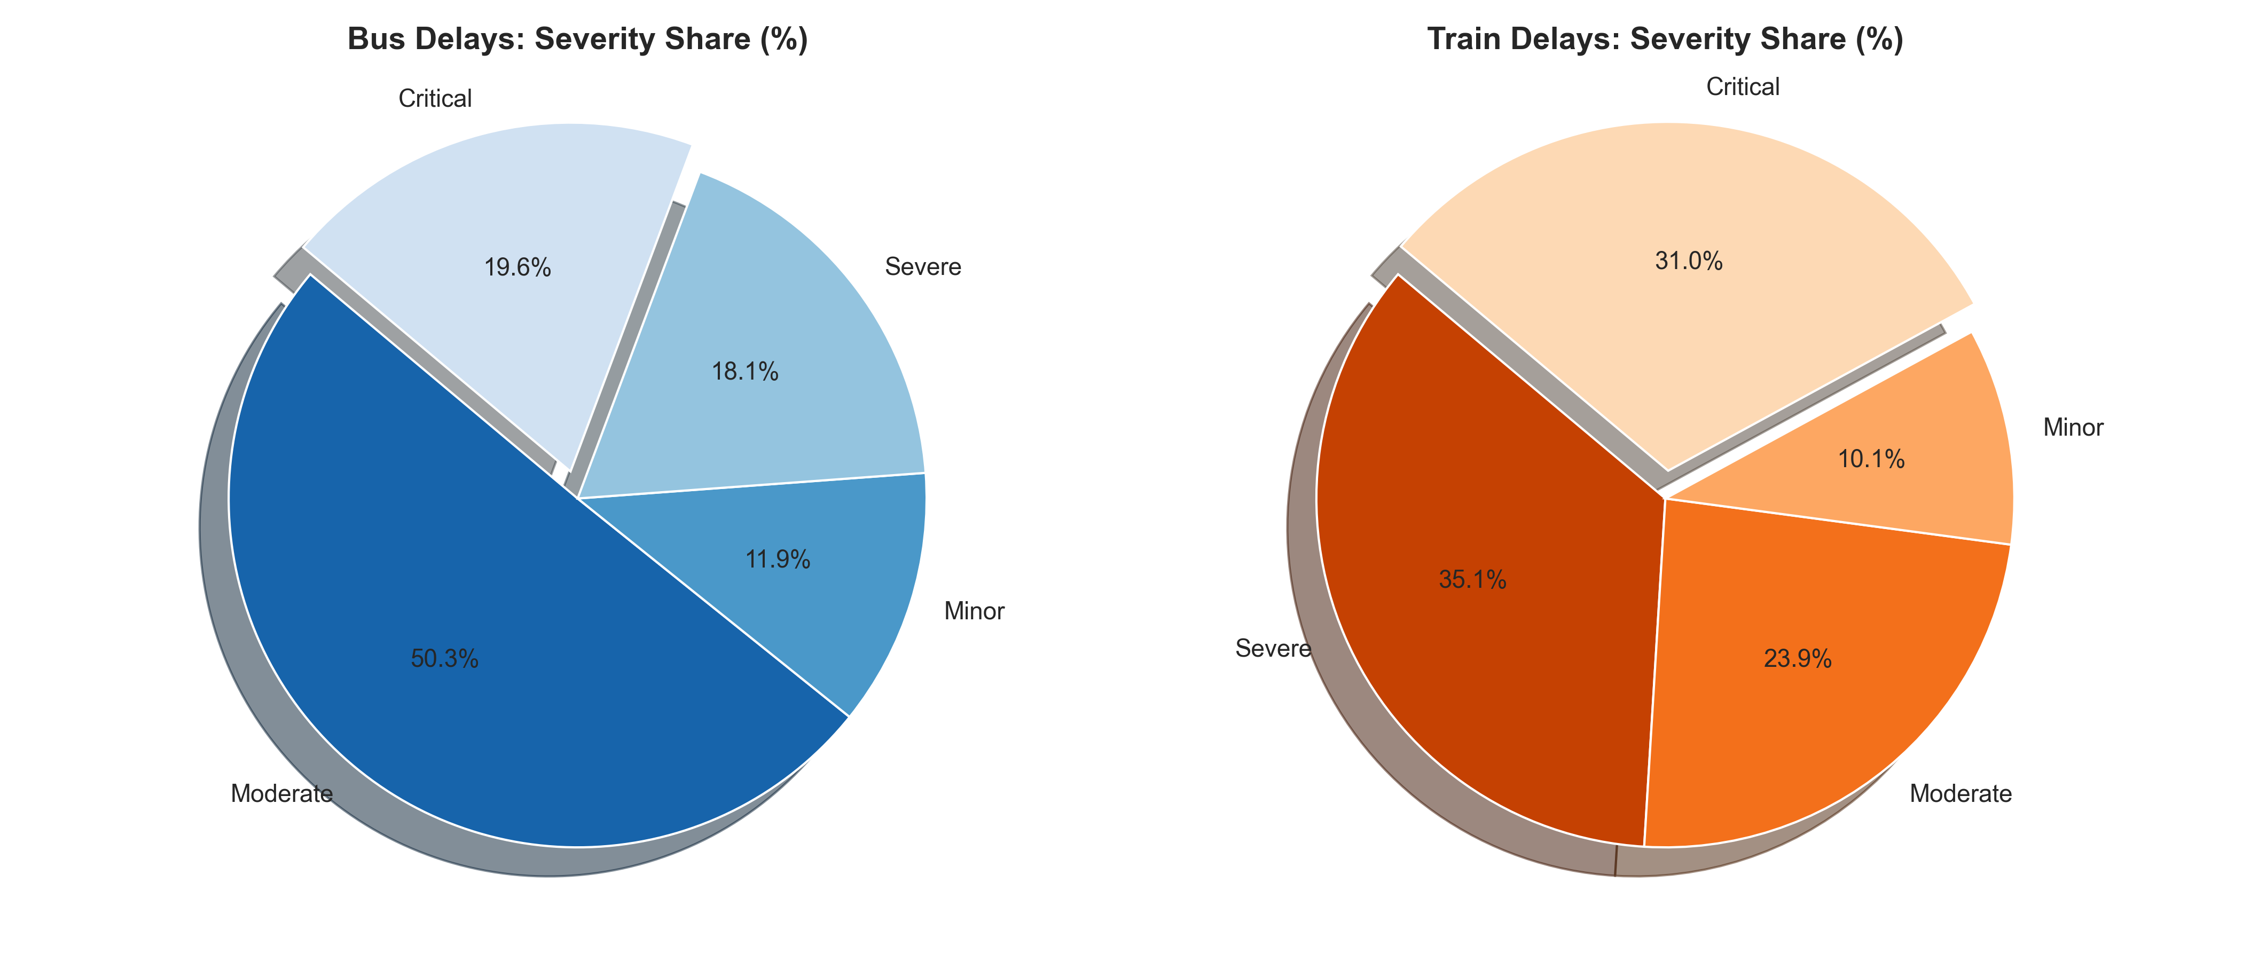
Key Analytical Findings
# | Finding | Empirical Evidence from MapReduce Output
1 | Traffic dominance in bus delays | "heavy" / "traffic" tied as the top bus keyword at 14,177 occurrences (28.4% of all 50,000 bus records), confirming road congestion as the leading bus bottleneck.
2 | Signal & mechanical dominance in train delays | "signal"/"problem" led train keywords at 9,991, with "mechanical"/"failure" close behind at 8,979, pointing to infrastructure and rolling-stock issues as the primary rail bottlenecks.
3 | Severity profile inverts between modes | Bus delays skew Moderate (50.3%), while Train delays skew Severe + Critical (66.1% combined) — rail disruptions are less frequent but more severe once they occur.
4 | Balanced partitioning, zero skew | Both RDDs were evenly split into 4 partitions of exactly 12,500 records each, confirming efficient parallel distribution across local[*] worker threads.
5 | Shared, mode-agnostic bottleneck | "Weather Conditions" appears in the top-10 keywords for both modes (5,025 bus / 5,909 train), making it a shared disruption source worth prioritizing across both fleets.
6 | Map-side combining efficiency | reduceByKey() aggregated partition-local counts before the shuffle phase for both the word-count and severity-tagging jobs, keeping the pipeline efficient at 50,000 records per mode.

Conclusion:
Successfully implemented a distributed MapReduce pipeline using PySpark RDDs to process the unstructured Reason text field for both Bus and Train delay datasets. The pipeline tokenized and aggregated 50,000 records per mode into keyword frequency counts, with "heavy traffic" as the dominant bus delay cause (14,177 occurrences) and "signal problem" the dominant train delay cause (9,991 occurrences). Severity tagging classified bus delays as majority Moderate (50.3%), while train delays skewed toward Severe and Critical (66.1% combined). Both RDDs were evenly partitioned across 4 workers with zero skew (12,500 records/partition), confirming the pipeline is balanced and ready to scale to a true multi-node cluster.

