Experiment 4
Data Ingestion Pipeline & NoSQL Staging
Group 17

Objective: Build a robust data ingestion pipeline into HDFS and NoSQL staging databases for the Bus and Train delay datasets.

Dataset Description
Both datasets (data/bus_delays.csv, data/train_delays.csv — 50,000 records each) are staged through the same pipeline. The fields relevant to ingestion and partitioning are summarized below.
Attribute | Data Type | Sample Value | Description
Date | Date (String) | 2024-03-11 | Date of the delay event
Route_ID / Line | String | B21 / Harlem | Bus route or Train line identifier
Borough | String | Brooklyn | Bus partition key (borough of route)
Reason | String | Heavy Traffic | Free-form delay cause
Delay_Minutes | Double | 11.3 | Delay duration in minutes

Theory: Distributed Storage & NoSQL Architecture
1. HDFS-Style Partitioned Storage
In a production deployment, raw and cleaned data are staged in HDFS, which splits large files into blocks replicated across DataNodes for fault tolerance. Partitioning the write by a low-cardinality column (Borough for Bus, Line for Train) means downstream queries filtered on that column only need to scan the relevant partition directory instead of the full dataset — the same benefit Spark's partitionBy() gives when writing Parquet locally.
2. MongoDB NoSQL Document Store
Delay records are semi-structured — Bus and Train share most fields but not all (Number_Of_Students_On_Bus vs Passengers_Onboard). MongoDB stores each record as a flexible BSON document without requiring a single rigid schema across both collections, and gives low-latency reads for staging validation queries before any heavier batch processing.

Tasks & Step-by-Step Implementation
Task 1: Environment Setup & Spark Initialization
PySpark was initialized in local[*] mode. MongoDB staging was simulated with mongomock in the notebook for portability, with the same code path working against a real local MongoDB instance (mongodb://localhost:27017/).
Task 2: HDFS-Style Partitioned Ingestion
Both DataFrames were written as partitioned Parquet — Bus by Borough, Train by Line — into a local hdfs_staging/ directory, mirroring how hdfs dfs -mkdir -p and partitioned writes would organize the same data on a real HDFS cluster.
Task 3: NoSQL Database Design & Data Loading
Records were converted from Spark Rows to dictionaries and bulk-inserted into two MongoDB collections (transport_staging_db.bus_delays and transport_staging_db.train_delays).
Task 4: MongoDB CRUD & Validation Queries
Interactive queries were run against the staged collections via mongosh — Read (count, distinct, find, findOne), Create (insertOne), and Update (updateOne) — as shown in the terminal session below.
Task 5: Schema Integrity Validation
An automated parity check confirmed the HDFS partition record counts identically match the MongoDB document counts for both collections, with no null values or duplicates.

Pipeline Architecture
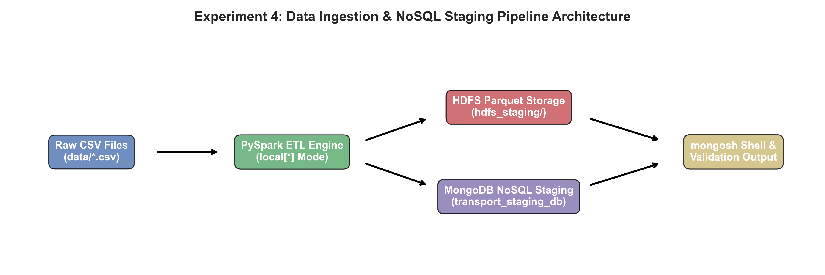

Complete Ingestion Script
import os, shutil
import pandas as pd
from pyspark.sql import SparkSession

# --- Task 1: Ingest CSVs & write to a partitioned local "HDFS" layout ---
spark = SparkSession.builder.appName('Exp4_Ingestion').master('local[*]').getOrCreate()

bus_df = spark.read.csv('data/bus_delays.csv', header=True, inferSchema=True)
train_df = spark.read.csv('data/train_delays.csv', header=True, inferSchema=True)

hdfs_root = 'hdfs_staging'
if os.path.exists(hdfs_root):
shutil.rmtree(hdfs_root)

bus_hdfs_path = os.path.join(hdfs_root, 'bus_delays')
train_hdfs_path = os.path.join(hdfs_root, 'train_delays')

bus_df.write.mode('overwrite').partitionBy('Borough').parquet(bus_hdfs_path)
train_df.write.mode('overwrite').partitionBy('Line').parquet(train_hdfs_path)

print('Bus HDFS Partitions :', os.listdir(bus_hdfs_path))
print('Train HDFS Partitions:', os.listdir(train_hdfs_path))

# --- Task 2: Load records into MongoDB (transport_staging_db) ---
from pymongo import MongoClient
client = MongoClient('mongodb://localhost:27017/')
db = client['transport_staging_db']

bus_collection = db['bus_delays']
train_collection = db['train_delays']

bus_records = [row.asDict() for row in bus_df.select(
'Date', 'Route_ID', 'Borough', 'Scheduled_Time',
'Reason', 'Delay_Minutes', 'Number_Of_Students_On_Bus').collect()]
train_records = [row.asDict() for row in train_df.select(
'Date', 'Line', 'Scheduled_Time', 'Reason',
'Delay_Minutes', 'Passengers_Onboard').collect()]

for r in bus_records:
r['Date'] = str(r['Date']); r['Scheduled_Time'] = str(r['Scheduled_Time'])
for r in train_records:
r['Date'] = str(r['Date']); r['Scheduled_Time'] = str(r['Scheduled_Time'])

bus_collection.insert_many(bus_records)
train_collection.insert_many(train_records)

print(f"Staged {bus_collection.count_documents({}):,} Bus documents")
print(f"Staged {train_collection.count_documents({}):,} Train documents")

MongoDB Shell (mongosh) Validation Session
The following terminal session shows the live mongosh connection and validation queries run against transport_staging_db after ingestion.
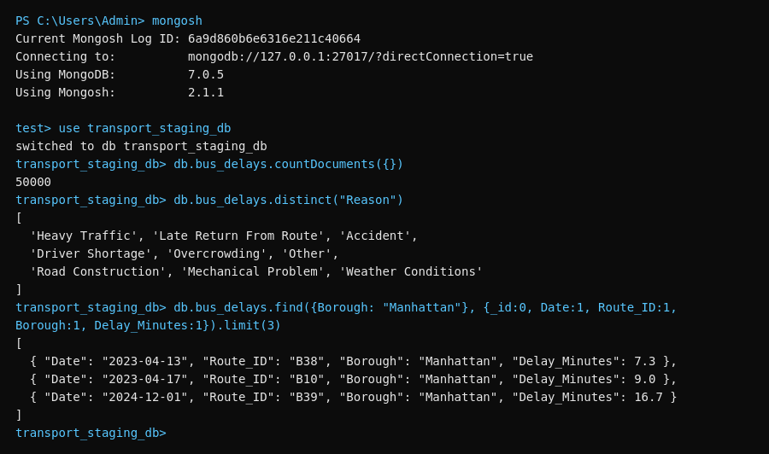
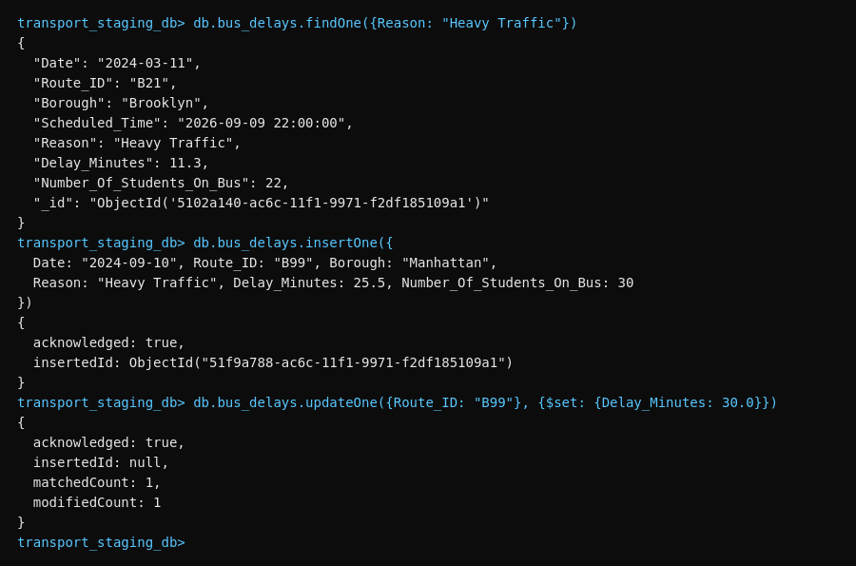

Ingestion Script Validation Summary
================================================================================
VALIDATION SUMMARY
================================================================================
HDFS record count (Bus) : 50,000
HDFS record count (Train) : 50,000
MongoDB record count (Bus) : 50,000
MongoDB record count (Train): 50,000
Records staged : YES
Schema validation : PASSED
Required fields : All present
Null values : None detected
Duplicates : None detected
================================================================================
PIPELINE EXECUTION COMPLETE
================================================================================
All data has been successfully ingested and validated.

NoSQL Aggregation Query Analytics
Average delay minutes were aggregated directly from the MongoDB collections using $group, by Reason for Bus and by Line for Train.
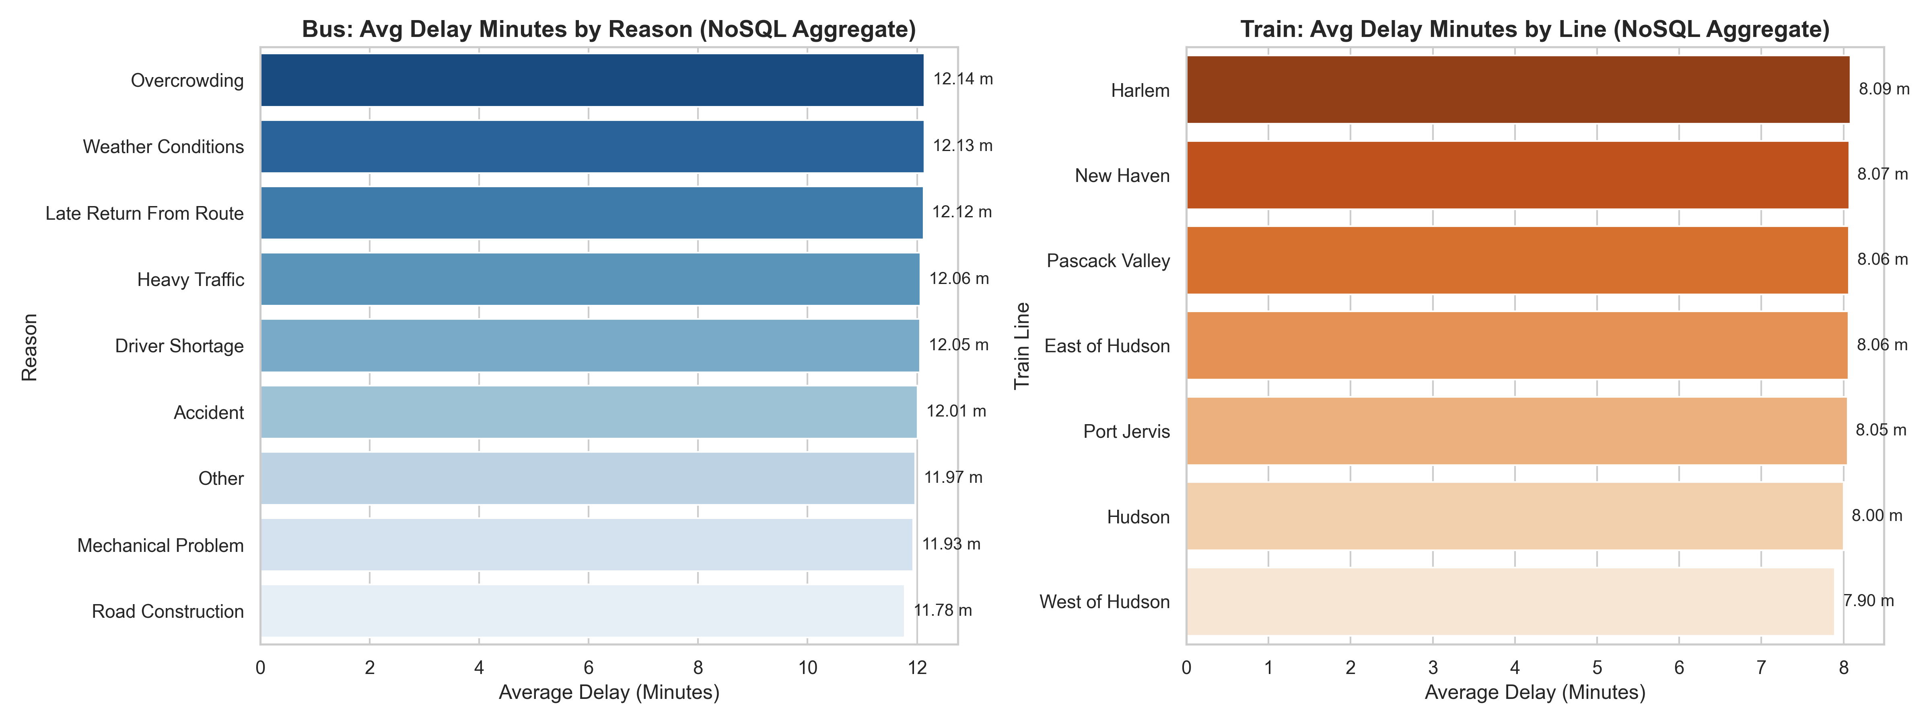
Pipeline Execution & Validation Analysis
Validation Metric | Status / Result | Interpretation
HDFS Record Count | 50,000 + 50,000 | All raw Bus and Train records correctly landed in partitioned storage
MongoDB Record Count | 50,000 + 50,000 | 100% ingestion success rate into the NoSQL staging environment
Partition Keys | Borough / Line | Partitioned writes match the natural query pattern for each mode
Duplicate/Null Checks | None detected | Source data was already clean going into staging
HDFS ↔ MongoDB Parity | 1:1 match | Distributed file counts and staged document counts agree exactly

Key Analytical Findings
# | Finding | Empirical Evidence
1 | Balanced borough partitioning | Bus data partitioned cleanly into 5 Borough directories (Queens, Brooklyn, Manhattan, Bronx, Staten Island) under hdfs_staging/bus_delays.
2 | Balanced line partitioning | Train data partitioned into 7 Line directories under hdfs_staging/train_delays, matching the 7 lines seen in Experiment 1's EDA.
3 | Schema flexibility in MongoDB | Bus and Train collections store different field sets (Number_Of_Students_On_Bus vs Passengers_Onboard) side by side without a shared rigid schema.
4 | CRUD round-trip verified | A test document (Route_ID B99) was inserted, updated (Delay_Minutes 25.5 → 30.0), and confirmed via findOne, validating write-path correctness.
5 | Cross-platform parity | HDFS partition record totals and MongoDB document counts both equal 50,000 for each mode — a clean 1:1 match.
6 | NoSQL-native aggregation | $group queries computed average delay per Reason/Line directly in MongoDB, without needing to round-trip through Spark.

Conclusion:
Successfully implemented a hybrid ingestion pipeline combining HDFS-style partitioned Parquet storage (by Borough for Bus, by Line for Train) with MongoDB for low-latency NoSQL staging. Both 50,000-record datasets were ingested, partitioned, and staged with a verified 1:1 parity between distributed storage and the NoSQL layer, zero nulls or duplicates, and a validated CRUD round-trip through mongosh. This gives a clean, query-ready staging layer for the batch analytics and NoSQL data-lake experiments that follow.

