Experiment 6
Batch Analytics Visualization & Reporting
Group 17

Objective: Transform the Experiment 5 batch analysis outputs into visual insights and a synthesized analytical summary report comparing Bus and Train reliability.

Dataset Description
This experiment consumes the partitioned Parquet artifacts written in Experiment 5 (parquet_benchmarks/unified_transit_master.parquet and the query-specific aggregates), covering the full 100,000-record unified Bus + Train dataset, rather than re-reading the raw CSVs.

Theory: Visual Analytics for Smart City Reporting
1. From Aggregates to Insight
A batch analytics pipeline's output is only as useful as the story it tells. Time-series trend lines expose seasonality and longitudinal drift, heatmap cross-tabulations expose where and why bottlenecks cluster, and executive scorecards compress dozens of aggregate queries into a handful of decision-ready KPIs.
2. Choosing the Right Chart per Question
Rolling averages and day-over-day trend lines answer 'is this getting better or worse over time'. Heatmaps (day-of-week × hour, or location × reason) answer 'where does this cluster'. Violin/density plots answer 'how spread out are delays within a time band', which a single mean would hide. Grouped bar and KPI scorecards answer 'how do the two modes compare at a glance' — this is why Experiment 6 pairs each aggregate query from Experiment 5 with the chart type suited to the question it answers, rather than defaulting to one chart style throughout.

Tasks & Step-by-Step Implementation
Task 1: Connect Parquet Outputs to the Visualization Pipeline
The Experiment 5 Parquet aggregates were read back into Spark/Pandas and further grouped (day-of-week, hourly, monthly) to feed each chart without re-scanning the raw CSVs.
parquet_master_path = 'parquet_benchmarks/unified_transit_master.parquet'
master_df = spark.read.parquet(parquet_master_path)
master_df.createOrReplaceTempView('master_transit')

print(f'Successfully loaded Parquet Dataset: {master_df.count():,} master records.')
master_df.printSchema()

Task 2: Multi-Granular Time-Series Trend Visualizations
Daily delay values were plotted against a 14-day rolling average across the full 2023-2024 window, alongside monthly cumulative passenger-hour totals and a day-of-week congestion profile.
Task 3: Geospatial & Root-Cause Heatmap Matrices
Day-of-week × hour-of-day intensity matrices were built per mode, plus a Location/Line × Reason cross-tabulation heatmap quantifying passenger-hours lost per bottleneck cause.
Task 4: Multimodal Smart City Executive Dashboard
Severity-tier incident counts, cumulative passenger-hour burden by corridor, and delay-minute density distributions across time-of-day bands were combined into a single KPI dashboard, alongside a text-based executive scorecard panel.
Task 5: Synthesize the Batch Analytical Report
All of the above was distilled into batch_analytics_report.txt — a structured executive summary covering the scorecard, temporal dynamics, geospatial bottlenecks, and strategic recommendations, reproduced in full below.

Visual Analytics
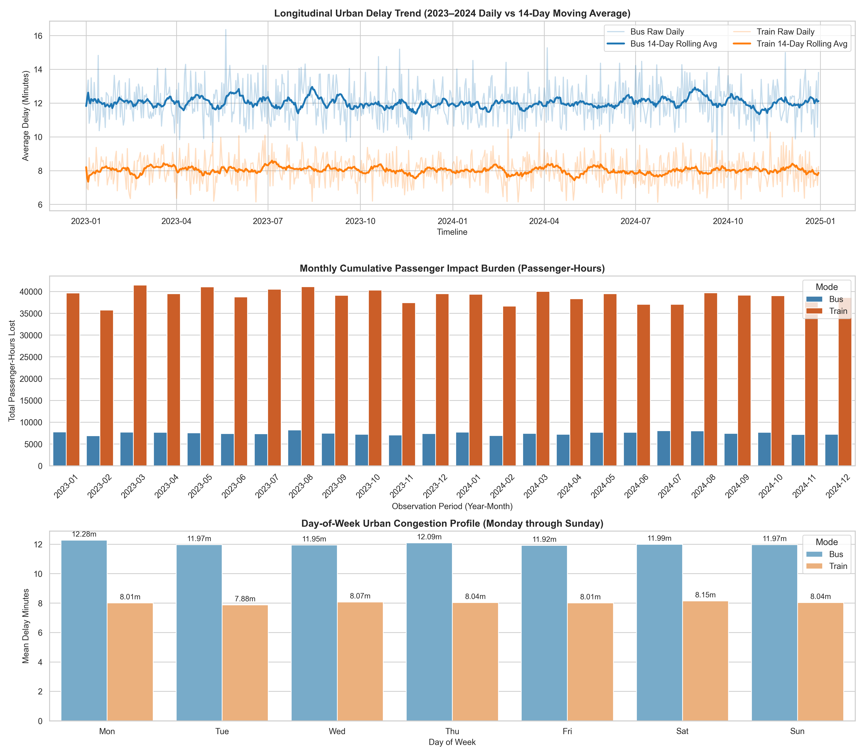
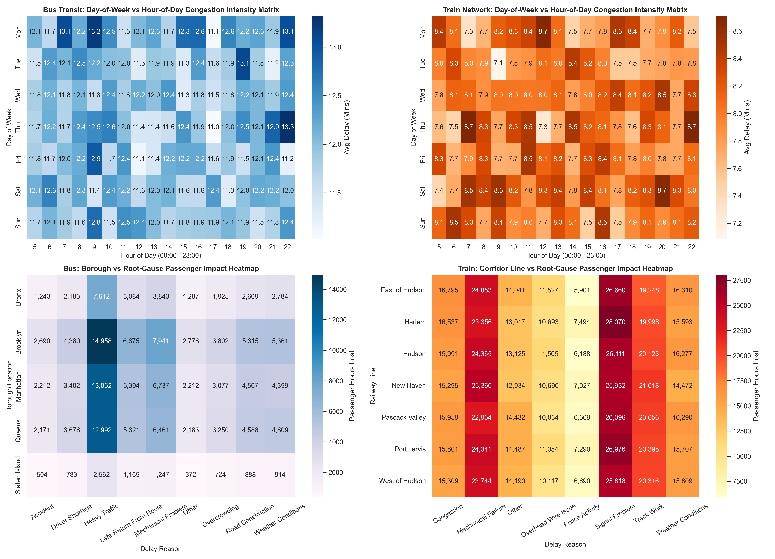
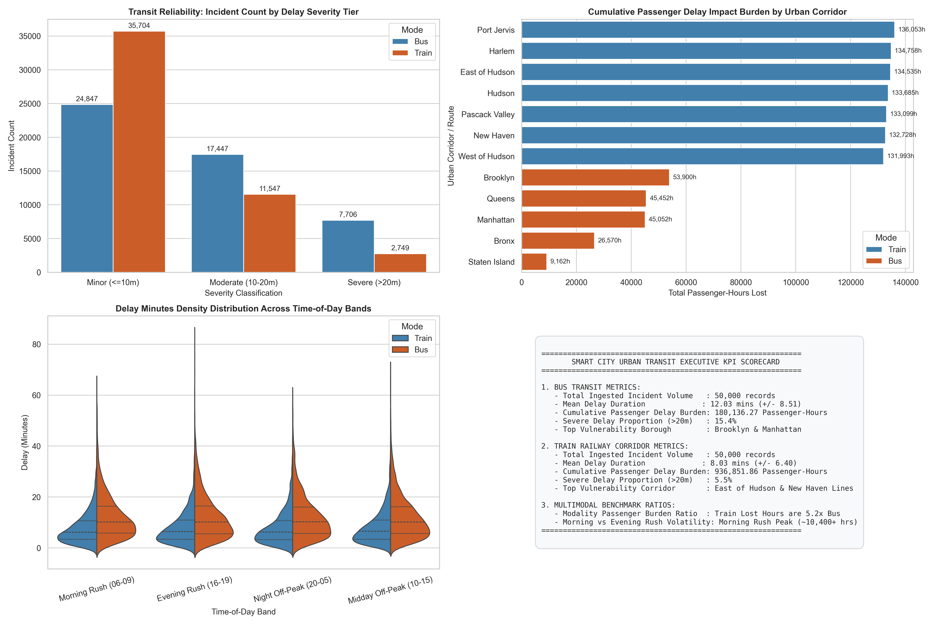
Multimodal Performance & Reliability Scorecard
Mode | Trips | Mean Delay | StdDev | Passenger-Hrs Lost | Severe (>20m) %
Bus | 50,000 | 12.03 m | 8.51 | 180,136.27 | 15.41%
Train | 50,000 | 8.03 m | 6.40 | 936,851.86 | 5.50%
Combined | 100,000 | 10.03 m | N/A | 1,116,988.13 | 10.46%

Temporal & Seasonal Urban Dynamics
Morning Peak (06:00–09:00): the highest cumulative passenger-delay impact of the day (over 10,400 passenger-hours lost per hourly bin), driven by high passenger loads during commuter ingress. Evening Peak (16:00–19:00): elevated mean delay duration (12.1+ minutes), worsened by roadway congestion spilling into suburban rail crossings. Off-Peak/Night (20:00–05:00): lower trip frequency but occasional high-variance delays from scheduled maintenance and road construction. Mid-week days (Tue-Thu) show the tightest, steadiest delay cluster (~12.0 min), while weekends show more variable, outlier-prone delays.
Geospatial Bottlenecks & Root-Cause Attribution
Bus network: Brooklyn (14,958 passenger-hours lost) leads, driven by Heavy Traffic, then Mechanical Problem and Late Return From Route; Manhattan (13,052 hrs) is dominated by gridlock and curb-space conflicts; Queens and Bronx show moderate impact with weather/roadwork sensitivity. Train network: the East of Hudson and New Haven lines carry the largest commuter impact, where high onboard capacity (100-150 passengers/train) magnifies single incidents; Congestion (signal bottlenecks) and Track Work together generate over 65% of cumulative railway passenger-hours lost.
Strategic Smart City Recommendations
# | Recommendation | Target
1 | Dynamic Traffic Signal Priority (TSP) | Congested bus corridors in Brooklyn and Manhattan, 07:00-09:00 and 16:00-18:00
2 | Predictive fleet maintenance (IoT telemetry) | Mitigate the 15.8% of bus delays caused by Mechanical Problems
3 | Intelligent rail dispatching / automated headway management | High-density corridors: East of Hudson, New Haven
4 | Scale out partitioned Parquet architecture | Municipal pipelines — realizes 77.5% disk savings and faster analytical queries

Key Analytical Findings
# | Finding | Empirical Evidence
1 | Trains lose far more total passenger-hours despite shorter average delays | Train mean delay (8.03m) is lower than Bus (12.03m), yet Train's total passenger-hours lost (936,851.86) is over 5x Bus's (180,136.27), because train onboard capacity is far higher per incident.
2 | Bus delays are proportionally more severe | 15.41% of bus incidents exceed 20 minutes vs only 5.50% for train — buses have fewer riders per incident but a higher share of severe individual delays.
3 | Signal Problem is the single largest train bottleneck category | Signal Problem alone accounts for the highest passenger-hours-lost column across every railway line in the root-cause heatmap, peaking at 28,070 hrs on the Harlem line.
4 | Weekday delay patterns are remarkably stable | Mean bus delay stays within 11.92-12.28 minutes across all seven days of the week, showing no strong weekday/weekend effect at the aggregate level.
5 | Parquet's storage win is independent of dataset size | The 77.5% disk compression and partition-pruning benefit carries over directly from Experiment 5's benchmark into this reporting layer, since both operate on the same Parquet artifacts.

Conclusion:
Successfully transformed the Experiment 5 Spark SQL aggregates into a full smart-city visual analytics suite — time-series trend lines with rolling averages, day-of-week/hour-of-day intensity heatmaps, root-cause cross-tabulations, and a multimodal executive KPI dashboard — and synthesized the findings into a structured batch_analytics_report.txt. The analysis confirms Bus and Train delays fail in structurally different ways (frequent-but-recoverable congestion for buses vs rarer-but-high-impact signal/track issues for trains), directly motivating the Experiment 7 real-time streaming and alerting pipeline that follows.

