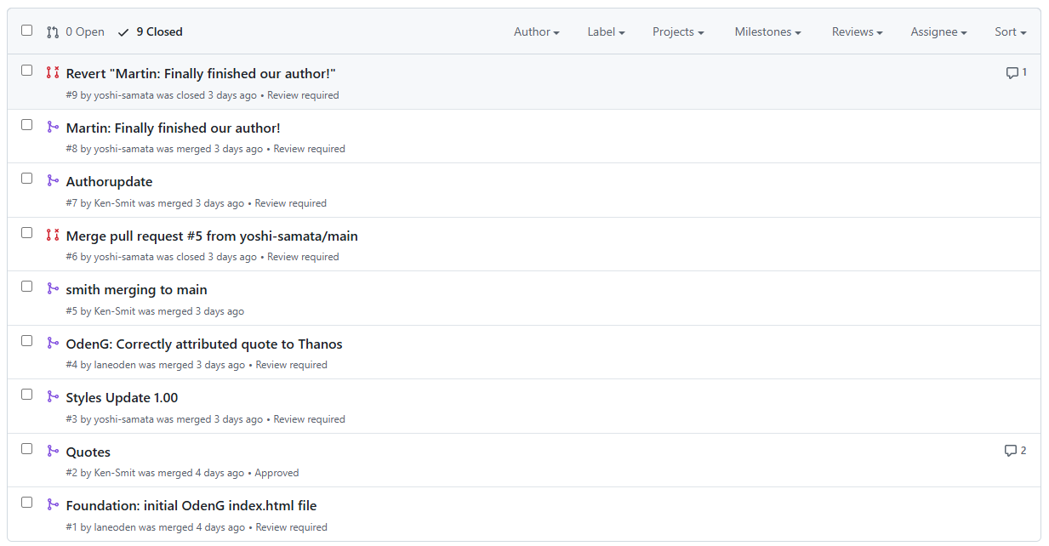

<https://github.com/yoshi-samata/GitLab><https://github.com/Ken-Smit>