One available function MySQL offers is CURRENT_TIME(). This function returns the current time. This may be used to get the current when working with MySQL.

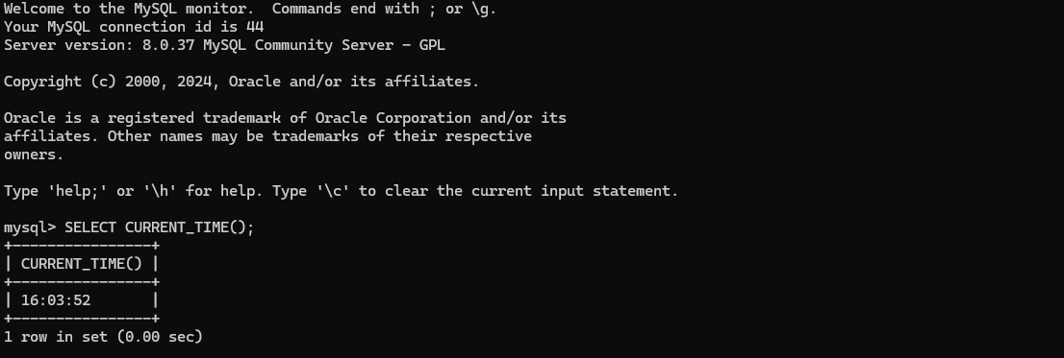

The function DAYOFMONTH() returns the day of the month for the date that is provided. This function is equivalent to the DAY() function.

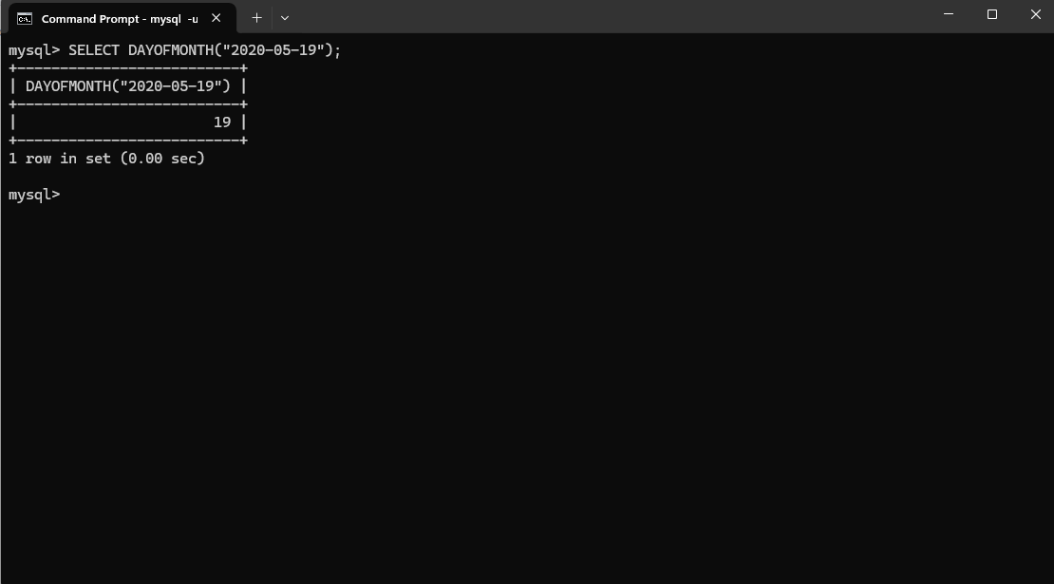

The function WEEKOFYEAR() returns the week number for the date provided. The function uses Monday as the first day of the week. This function is similar to the WEEK() function.

