INTERIORS OF THE VICTORIAN ERA

by

Name

Institution Affiliation

Course

Date

**Interiors of the Victorian Era. How a typical Victorian house was structured and how this is linked to the society and costumes of that epoch.**

The Victorian period contributes to the history of interior design and decoration of houses due to the unique architectural designs linked to the cultural norms of the people living in this era. The society at this time showcased their ambitions, beliefs, and values through art which was represented by the design and structure of the Victorian house. This era started in the early 19th Century during the time of the power of England’s Queen Victoria and became across the globe due to the stylish interior design of the houses (Shemelina, T.A. and Solomenko, n.d, p.1). The Victorian era was characterized by a society with class and a taste of elegant architectural structure of the houses. The main factors that influenced the society during this time to decorate and design their houses using the Victorian style are the growth in industrialization and the historical events that shaped the people (Huyysteen, 2021, para.3). The houses had several rooms that were uniquely designed for a particular function and decorative furniture that aligned with the architectural structure of the rooms. The design of the frontal area of the houses was meant to display the social class of the household and attract visitors whereas the other rooms were for privacy purposes (Huyysteen, 2021, para.2). This paper seeks to discuss the interiors of the Victorian Era and assess how a typical Victorian house was structured and linked to the society and costumes of this period.

**Interiors of the Victorian Era**

According to research, the industrial revolution contributed to changes in the architectural designs of houses, and also people in the middle class could afford to structure and decorate their homes using the Victorian style (Shemelina, T.A. and Solomenko, n.d, p.5-6). Society during this historical time considered two aspects when it came to the interiors of the houses and these were color and the wallpaper. The location of building a house determined the type of colors and wallpaper that will be appropriate for a specific house. For instance, in cities and towns which experienced environmental emissions of gases, dark colors were mostly preferred hence determining the wallpaper that will match the selected colors (Victorian Era, 2022, para.4). Dark interior colors were mostly used during the early phase of the Victorian era because society at the time mainly depended on coal as a source of energy to heat houses. The colors include darker shades of brown, blue, red, and green but brighter colors came into play during the later phases of the Victorian era (Shemelina, T.A. and Solomenko, n.d, p.3). These dull colors were selected for the purpose of hiding the impact of smoke on the wall as a result of burning coal at the fireplace. According to research, walls were at times painted with decorations that looked similar to woody materials (Shemelina, T.A. and Solomenko, n.d, p.2). The wallpapers used during this period were floral in pattern and the designers selected their preferred colors for the background to compliment the wallpapers.

The style and design of the furniture were also an aspect of the interior decorations that society considered during the Victorian period. According to research, the type of furniture that would match the household’s taste and high to middle social class include carved and decorated armchairs and tufted sofas (Nazmiyal Antique Rugs, 2020, para.2). The home décor was an essential aspect of Victorian interior design which comprised souvenirs, potted plants, framed pictures, and other wall hangings whose colors matched the theme of the rooms. According to research, the windows of Victorian houses were covered with curtains that had fabric material such as cotton and silk, and whose colors matched the selected color of the wallpaper, furniture, or other decors (Nazmiyal Antique Rugs, 2020, para.5). The floor of the houses in this historical period was also an aspect that the owners considered in the interior design. According to research, the architects during the early Victorian era used wood material for the floors whereas, towards the end of the second phase of this period, tiles with unique patterns and also carpets became common (Downey, 2013, p.12).

**Figure. 1** The Victorian Interior Design (Victorian Era, 2022, para.3).

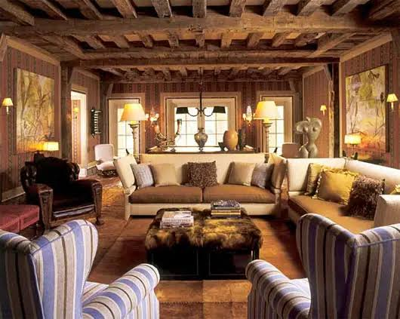

**How a typical Victorian house was structured?**

The architectural structure of a typical Victorian house comprised of unique style and several materials that contributed to the artistic design of this historical period hence making it distinct from other houses. According to research, a Victorian house comprised a blend of different materials such as bricks, specific types of wood, and stones that made the outlook more stylish than the previous designs of houses (Audrey, 2022, para.2). The rooms in these houses were occupied according to the social status of the family. Despite having several rooms upstairs, these houses had a unique layout design comprising the main living room on the ground floor which was spacious enough to contain a kitchen, study area, or library and a fireplace. The houses were characterized by stories whereby the family occupied the first and second stories whereas the workers or servants were given the rooms in the top stories (Victorian Era, 2022, para.2). The Victorian style had steeply pitched roofs and unique designs that complemented the overall outlook of the house. As for the porches, the architectural designers of these houses selected closed and open porches depending on the preferences of the occupants and were decorated with brackets or railings (Huyysteen, 2021, para.3).

The selection of window shapes and sizes also contributed to the architectural structure of Victorian houses. The windows had varied shapes such as arched and were large for the purpose of allowing more light into the house during the day (Downey, 2013, p.6). The windows were also covered with unique and stylish glass which were at times stained to add more paint or color that matches with the interior paintings. The staircase also contributed to the architectural design of Victorian houses due to the craftsmanship that was responsible for their unique carves and decorative patterns. These houses also had additional living rooms which were used for storage or workers’ room, especially in the attics and basements. According to research, Victorian houses were constructed using the asymmetrical style which focuses on giving the roof a wing-like structure that protrudes in different directions (Nazmiyal Antique Rugs, 2020, para.4). The decorative carvings or trimmings on the rooflines and windows gave the stylish outward appearance of the house which in many cases matched with the class status of the owners. According to research, the exterior walls were colored using dull shades of brown, red, green, or blue to complement the decorations on the windows, walls, and roof (Downey, 2013, p.14-15).

**Figure 2.** The Architectural design of a Victorian house (Huyysteen, 2021, para.4)

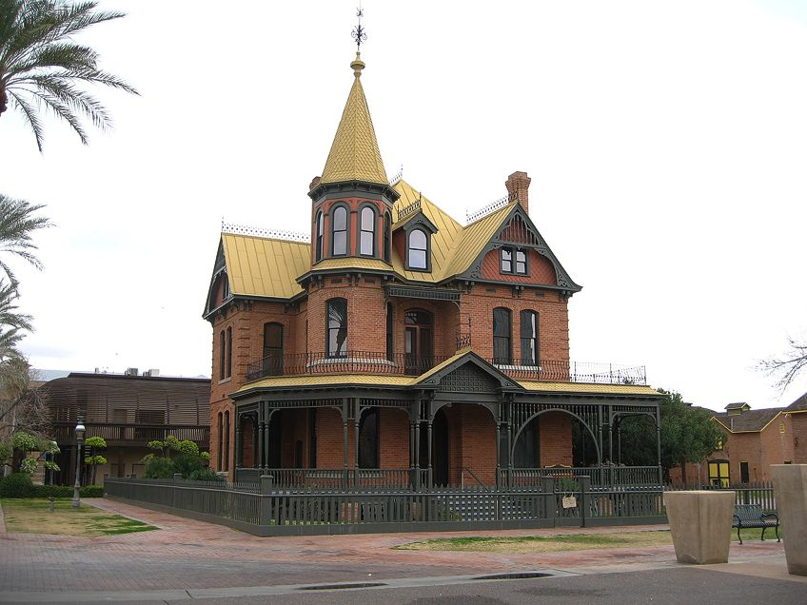

**How is the Victorian house structure linked to society and costumes of that period?**

The cultural norms and practices during the Victorian era greatly influenced the architectural structure and design of the houses. The architectural structure of the houses during that era reflects the values, beliefs, and ambitions of this society which indicate their taste for fashion styles at the time. According to research, the layout of the houses constructed during this historical period displays the social class of the occupants hence it is what separated the haves and the haves not (Addicott, 2020, para.4). The elite wealthy folks in Victorian society owned the largest and more stylish houses as compared to the individuals at the bottom of the hierarchy. Research proves that the wealthy individuals in this society preferred owning homes with unique and state-of-the-art dining rooms, elegant wall decorations, and types of furniture, as a way of impressing visitors and maintaining the family’s reputation or image (Audrey, 2022, para.6). Servant quarters were hidden from public view because the elites did not want to tarnish their elegant taste in fashion hence designed these types of rooms at the back of the Victorian house. This form of artistic craftsmanship during this historical period underscored the efforts that the workers (who occupied the basement rooms) put to maintain the posh lifestyle of the occupants (Downey, 2013, p.12). Therefore, the Victorian era contributed to the widening gap in the social classes which was supported by the architectural design of the house.

The architectural structure of the Victorian house displayed the harsh gender roles of this period. For instance, women associated themselves with the dining and parlor rooms which served the main purpose of allowing interactions between the family and guests. The bedroom, kitchen, and dining rooms symbolized the femininity that society had conferred on women as primary caregivers (Downey, 2013, p.17-18). On the other hand, the library area was considered to display a sense of masculinity due to the intellectual capacity that this society had bestowed upon men as the main providers and decision-makers during the Victorian era. The fashion during the Victorian era influenced the interior design of the houses especially the wallpaper patterns, furniture décor and curtain fabrics.

**Figure 3.** A Gothic style of Victorian house (Nazmiyal Antique Rugs, 2020, para.4)

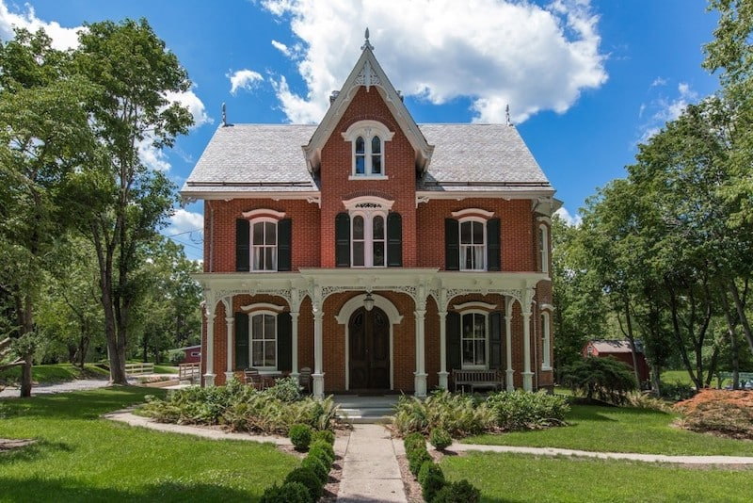

There are several architectural styles that influenced Victorian society to construct these types of houses. One of the styles is the Gothic Revival style which displayed ancient Roman artistic decorations (Long, 2007, p.23). This style became a fashion because Victorian society appreciated their history by using the castle-like structure in their construction of houses. The Gothic Revival style of Victorian houses has an asymmetrical shape of roofing and brownish external paintings which represented the houses during the middle-age period (Long, 2007, p.20).

**Conclusion**

The Victorian era is among the historical periods that were characterized by fashion in terms of the architectural structure of the houses. This period displayed the cultural norms and traditions of the society in terms of the widening gap between the haves and the haves not. The elite wealthy folks built Victorian-style of houses that were characterized by large dining rooms and asymmetrical roofing that pointed in different directions resembling a castle. The interior design of a Victorian house was characterized by elegant furniture décor and dull paintings that hid the effects of smoke from the fireplace and complemented the wallpaper patterns. Paintings with wood finishing were used on the walls as a substitute for wallpapers and had to match the selected color theme. The floor was made of decorative wood carvings during the early stages of the Victorian era but towards the later phases, stylish tiles were used instead. The architectural structure of the houses represented the values, aspirations, and beliefs that the society at the time had due to historical influence.

The architecture was characterized by a stylish staircase that led to the rooms upstairs which were separated into two or three stories. This house structure represented the separation in terms of social class because the family occupied the upper rooms whereas the servants occupied the basement rooms despite their efforts to maintain the posh lifestyle of the family. The architecture of the Victorian houses was also linked to the societal given roles of men and women because the library rooms were associated with masculinity whereas the dining, bedroom, and kitchen areas were associated with femininity. Therefore, the construction of Victorian houses was associated with the historical events before the industrial revolution and the cultural norms of the people at this time.

**Bibliographies**

Addicott, A. (2020). Victorian Architecture | The characteristics of a Victorian House -. [online] Arch Articulate. Available at: https://archarticulate.com/victorian-architecture-the-characteristics-of-a-victorian-house/.

Audrey (2022). The Styles and Features Of a Victorian House. [online] Strange Buildings - Architecture and Real Estate. Available at: https://strangebuildings.com/the-styles-and-features-of-a-victorian-house/ [Accessed 16 Aug. 2023].

Downey, G. ed., 2013. Domestic Interiors: Representing Homes from the Victorians to the Moderns. A&C Black. https://books.google.com/books?hl=en&lr=&id=SNVBAgAAQBAJ&oi=fnd&pg=PR7&dq=Interior+design+of+the+Victorian+houses&ots=SM8tAYnnod&sig=AElNw2IRkM8snsiBAhS5j3GK9ms

Huyysteen, J. van (2021). Victorian Architecture - The Best Victorian-Era Buildings and Architects. [online] artincontext.org. Available at: https://artincontext.org/victorian-architecture/.

Long, H., 2007. Victorian houses and their details. Routledge. https://api.taylorfrancis.com/content/books/mono/download?identifierName=doi&identifierValue=10.4324/9780080492414&type=googlepdf

Nazmiyal Antique Rugs (2020). Victorian House Styles. [online] Nazmiyal Antique Rugs. Available at: https://nazmiyalantiquerugs.com/blog/victorian-house-architecture/.

Shemelina, T.A. and Solomenko, A.G., FEATURES VICTORIAN STYLE IN INTERIOR DESIGN. https://jrnl.nau.edu.ua/index.php/Design/article/download/6181/12415/0

Victorian Era. (2022). Victorian Era Interiors: Popular Colours, Wallpapers and Design Patterns. [online] Available at: https://victorian-era.org/victorian-era-interior.html?expand_article=1 [Accessed 16 Aug. 2023].