HW7 Report

STuser19 賴昱凱

**Training result:**

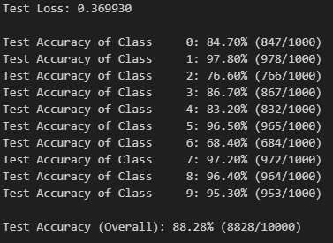

**Model:**

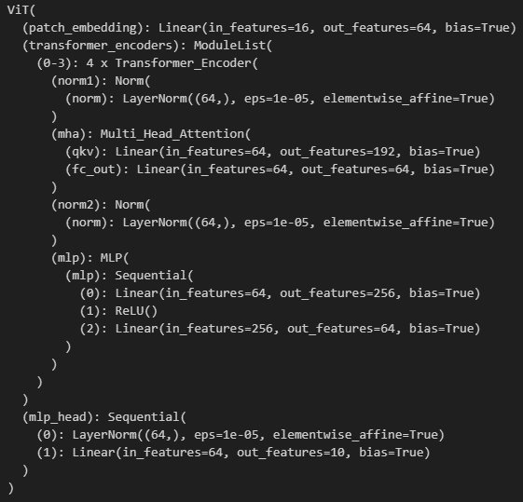

**參數量 (a single transformer encoder layer)**

Transformer Encoder

Multi-Head Attention:

* + **norm1**: 每個channel中皆有gamma, beta兩個參數。64個channels
 $$Parameters=64+64=128$$

 + **qkv linear layers**: 64 input channels, 192 output channels
 $$Parameters=64×192+192=12480$$

 + **fc_out linear layers**: 64 input channels, 64 output channels
 $$Parameters=64×64+64=4160$$

 + **norm2**: 每個channel中皆有gamma, beta兩個參數。64個channels

$$Parameters=64+64=128$$

MLP:

* + **Linear Layer 1**: 64 input channels, 256 output channels
 $$Parameters=64×256+256=16640$$

 + **Linear Layer 2**: 256 input channels, 64 output channels

$$Parameters=256×64+64=16448$$

$$Total parameters=128+12480+128+4160+16640+16448=49984$$

**計算量 (calculate linear layer only for a single transformer encoder layer)**

**一個 $n×m$ 矩陣與一個 $m×n$ 矩陣做矩陣乘法**，共需要 $n×m^{2}$ 個乘法以及 $\left(n-1\right)×m^{2}(sum of product)+m^{2}(bias)=n×m^{2}$ 個加法，共 $n×m^2$**個乘加計算(MACs)**。

Transformer Encoder

Multi-Head Attention:

* + **qkv linear layers**: 64 input channels, 192 output channels
 $$MACs=B×N×input channel×output channel=100×50×64×192=61,440,000$$

 + **Calculate attention score alpha = Q @ KT**
  + **Calculate output out = attention @ V**
 $$MACs=B×num heads×N×\left(N×head dim\right)=100×4×50×\left(50×16\right)=16,000,000$$

 + **fc_out linear layers**: 64 input channels, 64 output channels

$$MACs=B×N×input channel×output channel=100×50×64×64=20,480,000$$

MLP:

* + **Linear Layer 1**: 64 input channels, 256 output channels
 $$MACs=B×N×input channel×output channel=100×50×64×256=81,920,000$$

 + **Linear Layer 2**: 256 input channels, 64 output channels