National Yang Ming Chiao Tung University December 5, 2023

Department of Electrical and Computer Engineering Instructor: H.-M. Chen

Data Structures, Fall 2023 TA: H.-C. Chang

**Programming Assignment #5**

**Hashing**

**Be sure to design your own hash table in this programming assignment. You are NOT allowed to use any container in the Standard Template Library(STL), or any other open-source library, such as vector, list, map, set, and all the other container classes. The submitted source codes will NOT be graded if those open-source container classes are found in your source codes.**

1. **Problem Description**

In this programming assignment, you are asked to design your own hash function to speed up the process of finding two integers in an array whose product is equal to the target number, instead of using linear search.

1. **Input Format ( read input file )**

The input file contains two lines. The first line gives the target number, while the second line gives all the integer numbers in the array, which are distinct.

A sample input file is given below:

8

4 7 5 2 3

The number in the target and array will not exceed the maximum number that an int can represent. The number in the array will not be duplicated

1. **Output Format ( output on terminal )**

You will need to output the index of two numbers in the integer array whose product is equal to the target number.

If there exits more than one solution, you have to choose the one with minimum indices.

A sample output resulting from sample input is given below:

0 3

1. **Submission Information**

1. Your program must be written in C/C++ language and can be compiled on the Linux platform.

2. Please put the required files in a folder named with your Student_ID and the required files should also be named with your Student_ID (.cpp, .c).

3. To submit your program, please use the command below to compress the folder named with “[Student_ID].tar” in the Linux environment and upload it to E3.

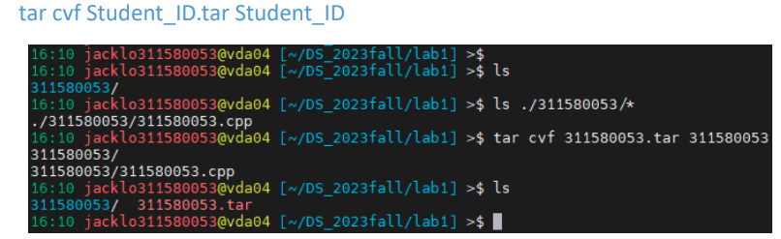

1. **Due Date**

Be sure to upload the tar file by “December 19, 2023”. There will be a 10% penalty per day for the first four days (weekend included) and will not be accepted afterwards.

1. **Grading Policy**

The programming assignment will be graded based on the following rules:

˙ Pass the open cases with compilable source code (60%)

˙ Pass the hidden cases with compilable source code (40%)

˙ -10% of your total score if any file occurs naming error or not compress

˙ -10% of wrong output format

˙ No credits for plagiarism

For each case, the runtime limit is 5 seconds. It will be regarded as ”failed” if the

execution time is more than 5 seconds.

