Deep Learning HW1
111511141 賴昱凱

- Regression
- network architecture (number of hidden layers and neurons)
3 hidden layers (Number of neurons for each hidden layer: [32, 16, 16])
Activation function: ReLU, except for the output layer.
Architecture: 16(input) – 32 – 16 – 16 – 1(output)

- learning curve
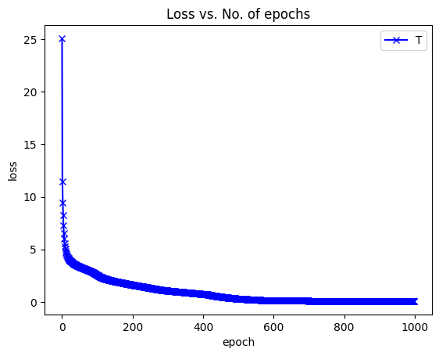
- training RMS error
Training RMSE: 0.3904

- test RMS error
Test RMSE: 1.8149

- regression result with training labels
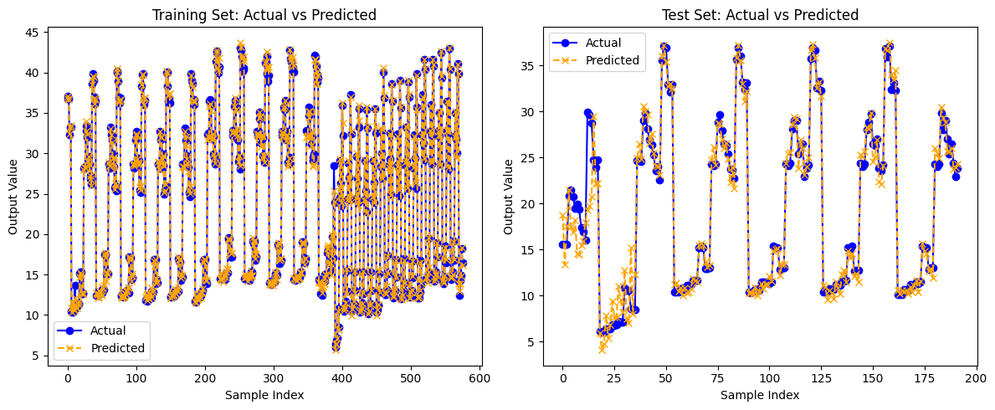
- regression result with test labels

- feature selection procedure
I compared the correlation coefficients of output results and the features, and chose the features that its correlation coefficient is higher than threshold.
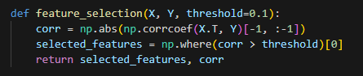
Threshold | Selection | Training RMSE | Test RMSE
0 (no selection) | 0 ~ 15 | 0.3904 | 1.8149
0.01 | 0 ~ 5, 10 ~ 15 | 0.4477 | 0.9593
0.02 | 0 ~ 5, 10, 11, 12, 14 | 0.4345 | 1.0074
0.1 | 0, 1, 2, 3, 4, 5, 10 | 0.5544 | 0.9217
0.3 | 0, 1, 2, 3, 4 | 2.8289 | 6.4530

According to the results, we find that the model is overfitting, since the test RMSE is much higher than the training RMSE (blue one) and using fewer features may result in better performance (red one). However, using too few features will result in very poor performance.
- Classification
- network architecture (number of hidden layers and neurons)
3 hidden layers (Number of neurons for each hidden layer: [64, 64, 32])
Activation function:
ReLU for the input and hidden layers, sigmoid for the output layer.
Architecture: 34(input) – 64 – 64 – 32 – 1(output)

- learning curve
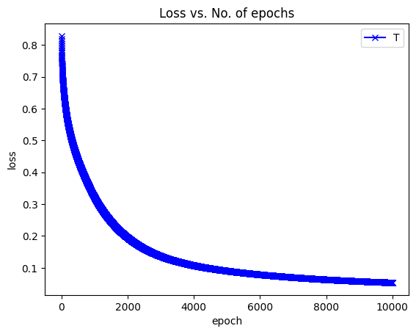
- training error rate
Training Error Rate: 0.0214 (2.14%)

- test error rate
Test Error Rate: 0.0857 (8.57%)

- Compare the results of choosing different numbers of nodes in the layer before the output layer by plotting the distribution of latent features at different training stage.
