Deep Learning HW2
111511141 賴昱凱
- Using Convolutional Neural Network for Image Recognition

design your network architecture and analyze the effect of different stride size and filter size
I used a total of 6 convolutional layers with the ReLU activation function and applied max-pooling after the 1st and 6th convolutional layers to reduce the image size from 28x28 to 7x7, halving the size each time. I also added residual links between conv3 and conv4, and between conv5 and conv6. This helps to avoid the problem of gradient vanishing. After these layers, the image passes through 3 linear layers, and the final output consists of 10 neurons representing the digits 0 to 9.
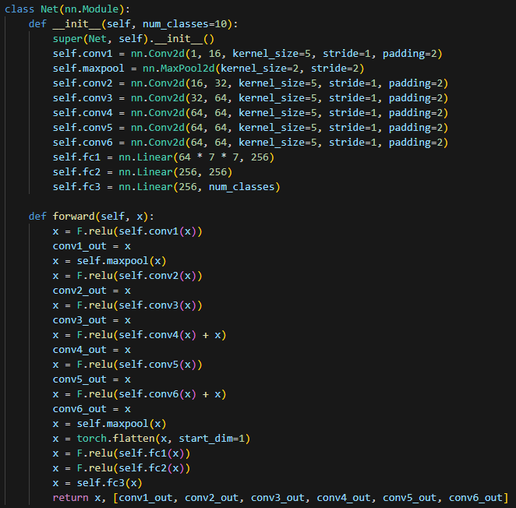
Analyze the effect of different stride size and filter size :
- Definition
Stride :
Stride is the step size by which the convolutional filter moves across the input image. Therefore, increasing the stride value will cause the output image to become smaller if other parameters, such as padding, are not modified.

Filter size :
Also known as kernel size, it refers to the dimensions of the convolutional filter, typically represented as a k*k matrix. The convolutional filter slides over the input image and applies the convolution operation.

- Effect
Stride and filter size affect several things of the CNN, including the size of the output feature map, the amount of computation, and the ability to capture features.

For the size of the output feature map, here’s the formula :
W, H : size of input feature map, F : filter(kernel) size, P : padding, S : stride

Basically, we can simply prove it by drawing the process of convolution.

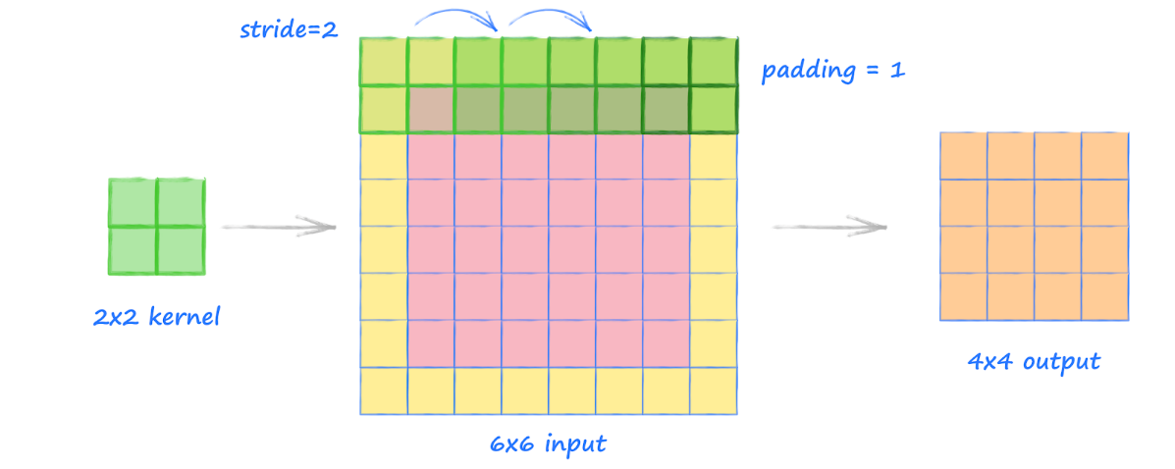

For the computation cost, increasing the stride or decreasing the filter size will reduce the computation cost. That's because we reduce the number of matrix multiplications by taking larger steps or decreasing the matrix size.

For the ability to capture features of the image, it mostly depends on the filter size (if other parameters are within a normal range). A small filter size allows the model to focus on small but essential features, such as the color of the eyes for recognizing the species of people. On the other hand, a larger filter size causes the model to focus on larger features, such as an animal's color and shape. We can choose the filter size according to the purpose of our models.

For my model, the stride = 1 and the filter size = 5
Since the input image is 28*28 pixels, I think a filter size of 5 perfectly matches the size of number’s features, such as the hole in 6 and 8, the curve in 3, and the angle in 4. To avoid losing any features in the image, I decided to use a stride of 1.
To ensure that the output feature maps have the same size as the input feature maps, I used a padding of 2. This padding ensures that the size of the output feature maps does not decrease continuously, according to the formula mentioned above.

learning curve and accuracy of training, validation and test sets
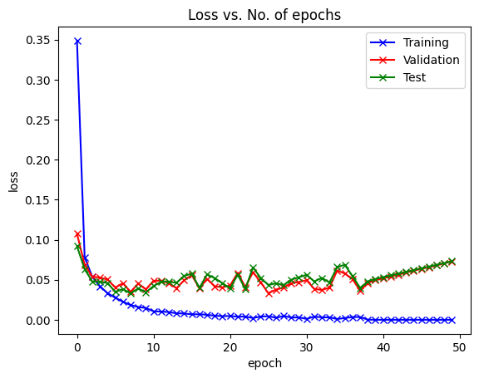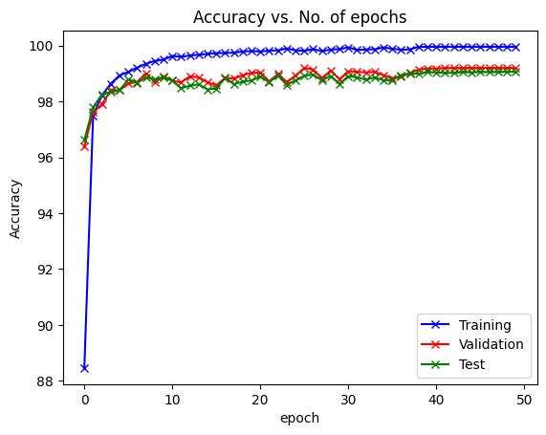

distributions of weights (blue) and biases (green)
for 6 convolution layers and 3 linear layers
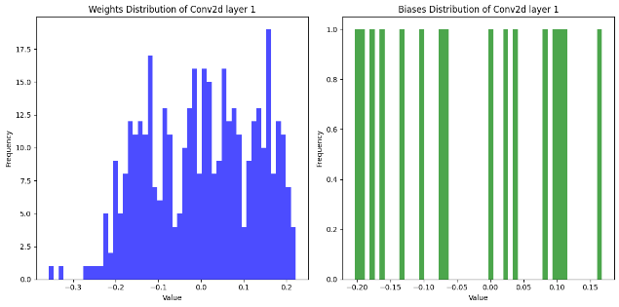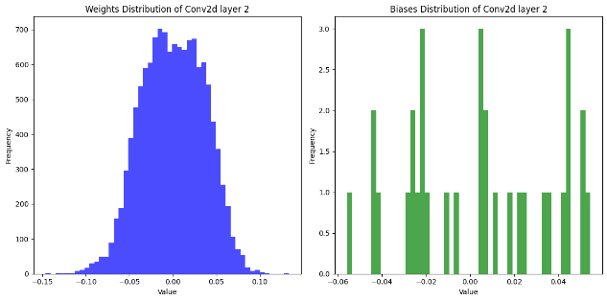
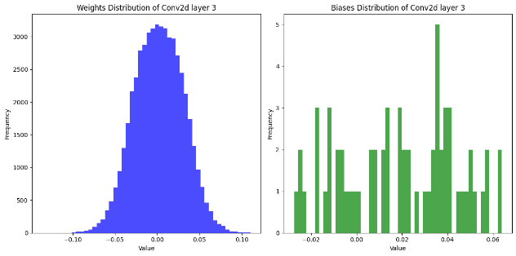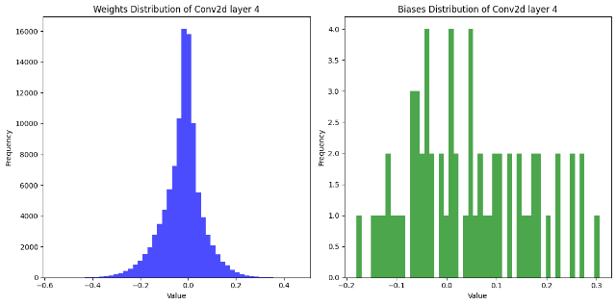
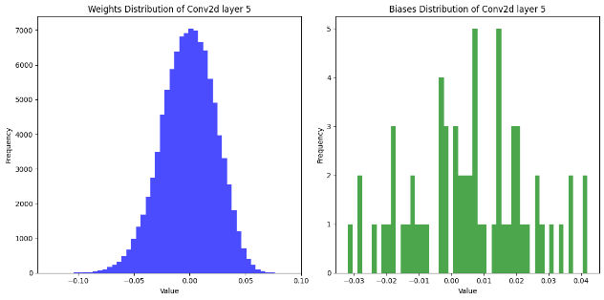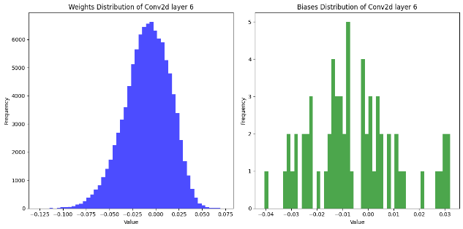
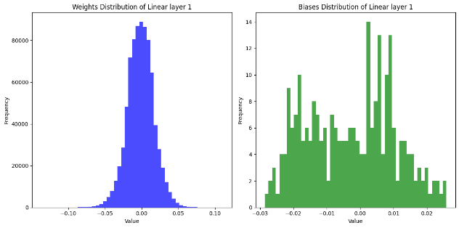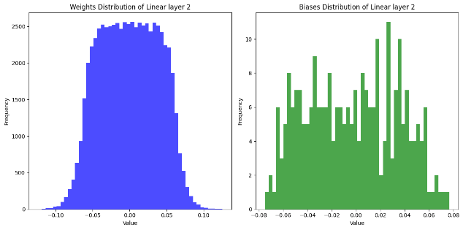
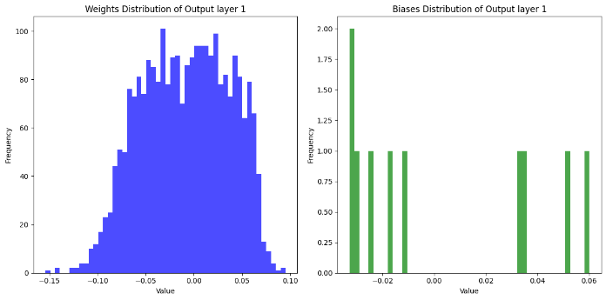

1-2
Show some examples of correctly classified and miss-classified images and discuss your results.
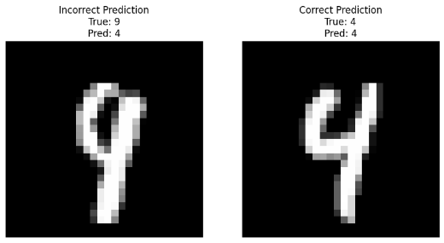

The example I chose is the number 4 and 9. On the left-hand side, it shows the model recognizing it as a 4 instead of a 9, and on the right-hand side is an image correctly recognized as a 4.
The biggest difference between the two images is the bottom of the number, the 9 is closed while the 4 is open. However, the 9 is not perfectly closed, so the model may interpret it as an open shape, resulting in it being recognized as a 4.

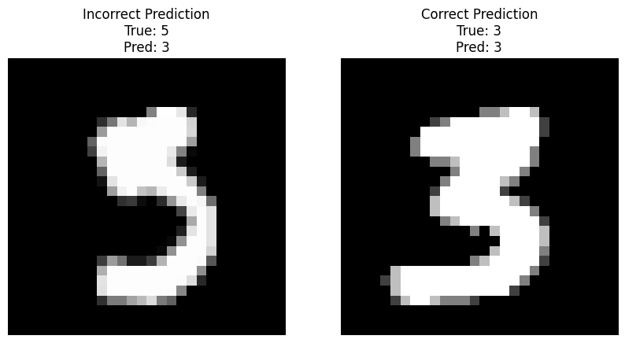
Another example I chose is the numbers 3 and 5. On the left-hand side, it shows the model recognizing it as a 3 instead of a 5, and on the right-hand side is an image correctly recognized as a 3.
The biggest difference between the two numbers is the side of the upper connection, the 5 is connected on the left side while the 3 is on the right. However, the upper region of the 5 is messy, so the model can't correctly recognize the side of the connection, resulting in it being recognized as a 3

1-3
Following 1-2, observe the feature maps from different convolutional layers and describe how a feature map changes with increasing depth.
Here are the feature maps output from each convolutional layer. Since the output channels of each layer are 16, 32, 64, 64, 64, and 64, the number of images for each layer's outputs will match the number of its output channels.

Left : incorrect prediction / Right : correct prediction
Convolution layer 1 (output channel : 16)
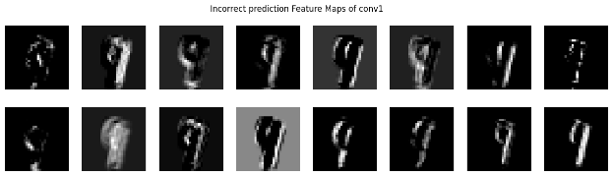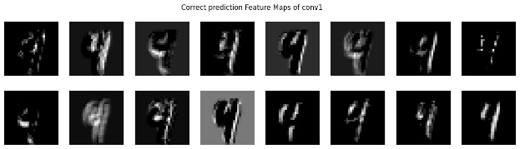
Convolution layer 2 (output channel : 32)
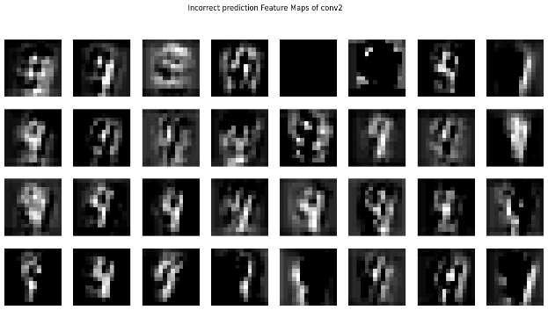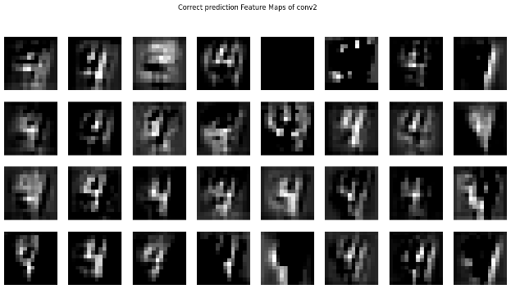
Convolution layer 3 (output channel : 64)
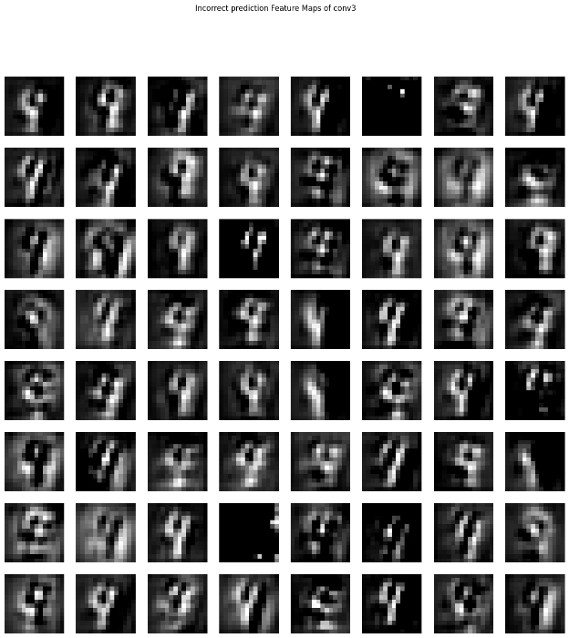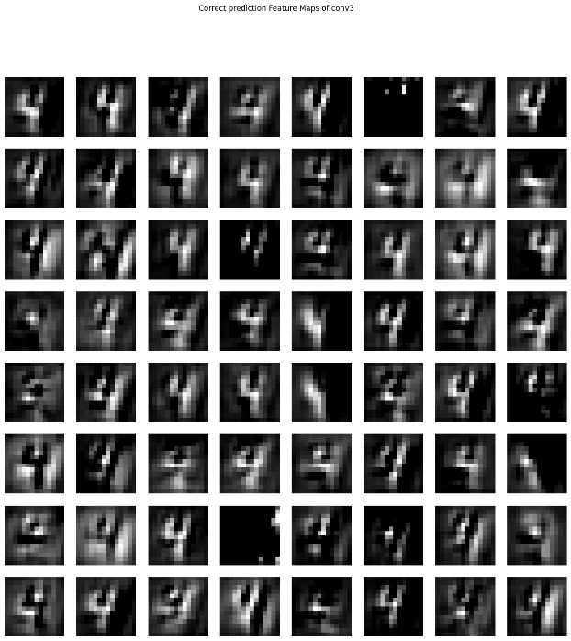
Convolution layer 4 (output channel : 64)
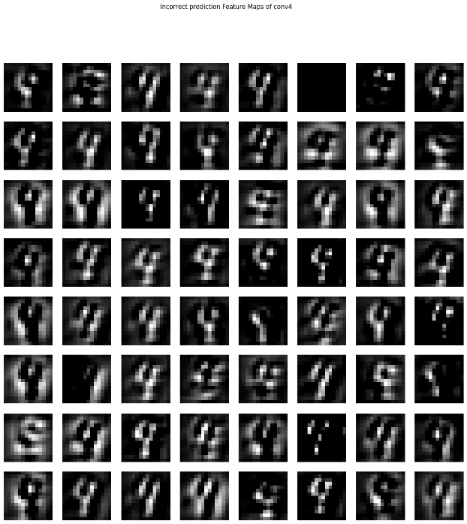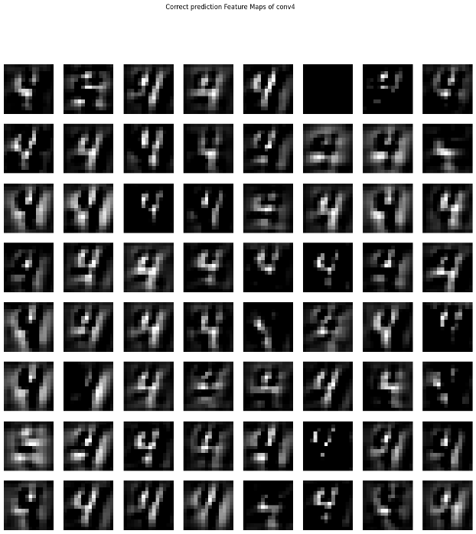
Convolution layer 5 (output channel : 64)
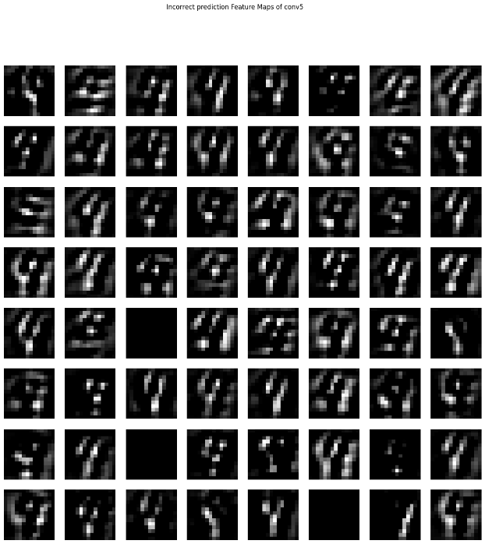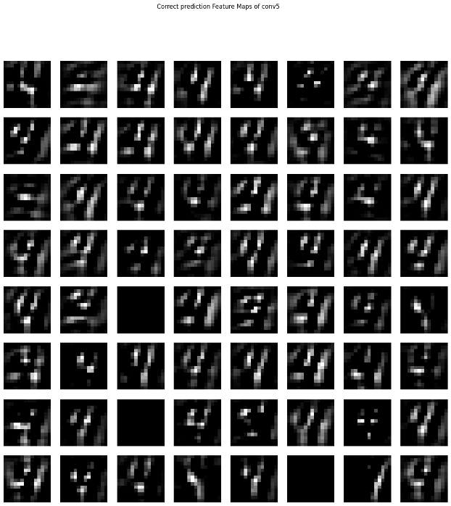
Convolution layer 6 (output channel : 64)
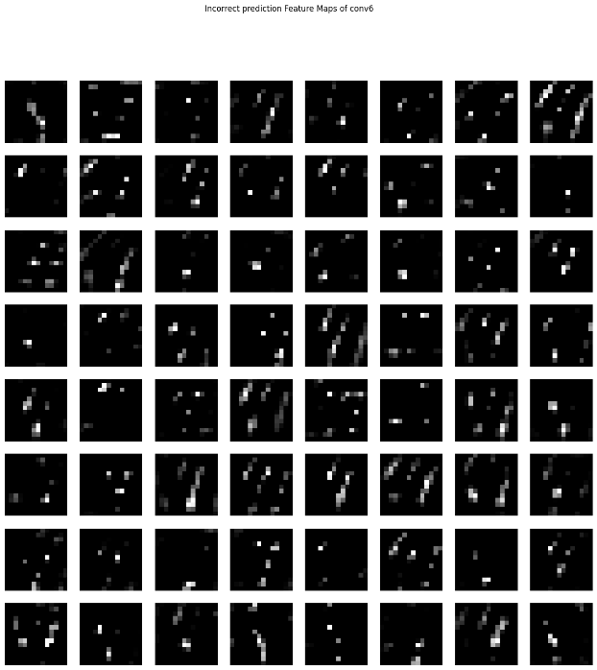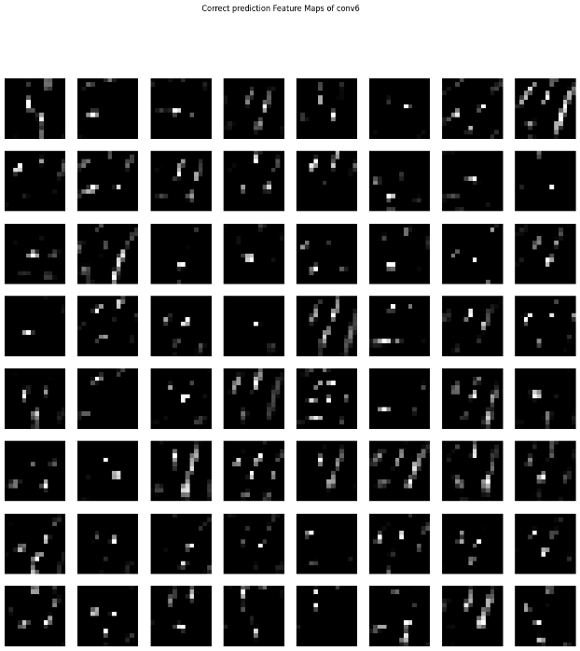

Select a random feature map (red circle) from each convolution layer
and compare the two images
Left : incorrect prediction (9 4) Right : correct prediction (4 4)




As we can see, the feature maps of the two digits have a high similarity. As the input image goes deeper into the network, the shape of the number becomes vaguer. However, the deeper the layer, the clearer the features of the digit become, regardless of where or how the digit is written.

1-4
Following 1-1, please add L2 regularization to the CNN implemented in 1-1 and discuss its effect.
L2 regularization, also known as weight decay, is a technique used to prevent overfitting in models. It works by adding a penalty term to the loss function that is proportional to the sum of the squared values of the weights. This encourages the network to keep the weights small, which can help improve generalization, which means having good performance with the new data that the model never seen before.
Loss and Accuracy
No L2 regularization L2 regularization
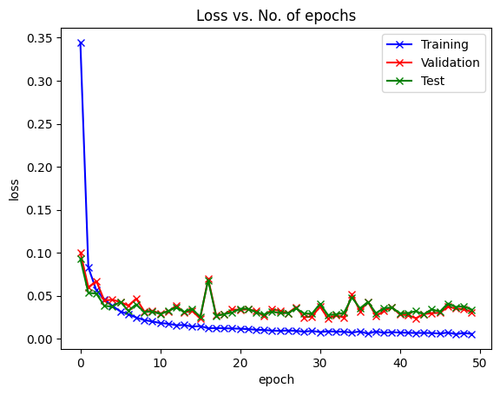
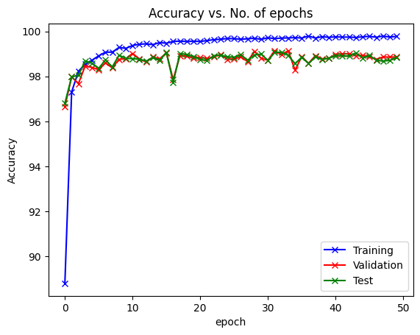
L2 regularization is

distributions of weights (blue) and biases (green)
No L2 regularization L2 regularization
