**Chapter 2**

**FUNCTIONAL SPECIFICATION REPORT**

**2.1 Data Requirements**

**2.1.1 Forms**

**2.1.1.1 List of Forms**

**2.1.1.2 Sample Forms**

**2.1.2 Reports**

**2.1.2.1 List of Reports**

**2.1.2.2 Sample Reports**

**2.2 Policies and Procedures**

**2.2.1 Procedures**

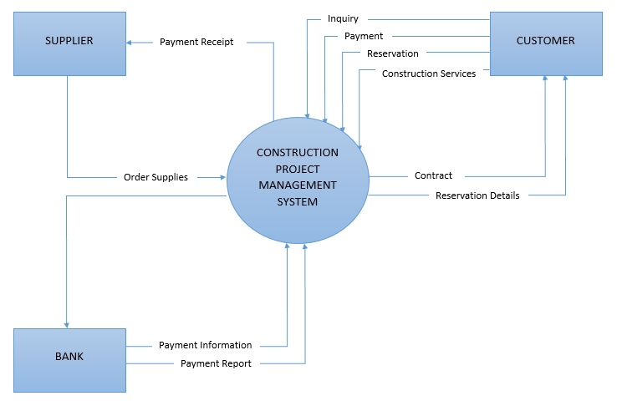 **2.2.1.1 Context Diagram**

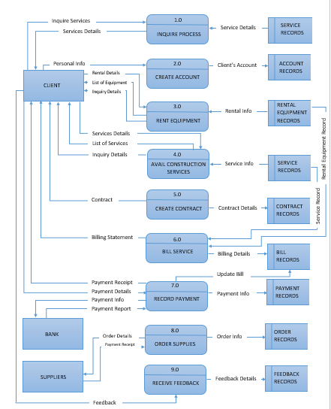 **2.2.1.2 Level 1 DFD**

**2.2.2 Policies**

**2.2.2.1 Business Requirements**

**2.2.2.2 Business Policies**

**2.3 Problem Analysis**

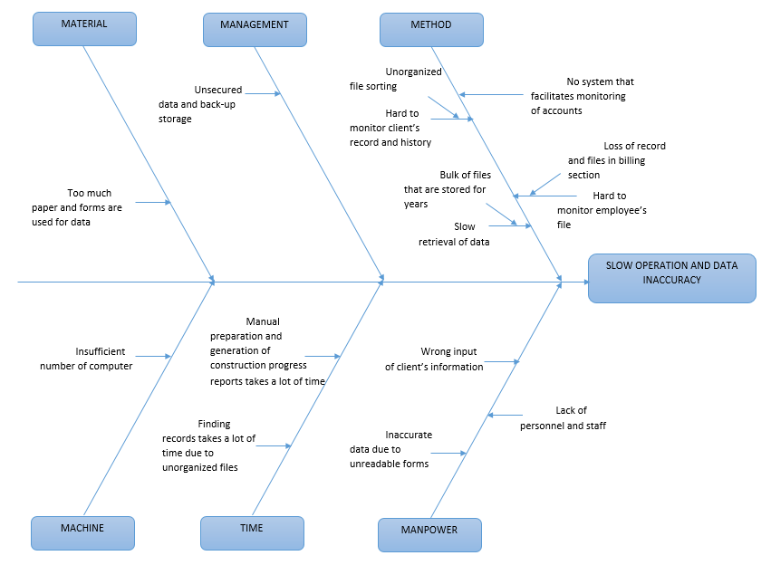 **2.3.1 Fishbone**

**2.3.2 Conclusion**

Ang Construction Company is a company who aims to give the best construction services to their clients.

Based on analysis and observations, inaccurate data entry of client information, misplaced equipment, lost record of past contracts and financial report, tracking records of employee, confidentiality of reports and difficulty on finding reservation of equipment poses as the main problem of the construction company. They are also using logbooks, typical paper transactions and do not have any virtual back-up data that causes inaccurate and time consuming retrieving, deleting, recording, and updating of large amounts of data. This could lead to poor standards of the company, which is not an acceptable description to uphold.

Possibly, the problem that occurs in their company can be resolved by keeping track of the employees whether they are doing their task well or not but observations of their performance could be a waste of time and does not assure efficiency in the absence of the observer. Training could be another possible solution, but this does not conclude that personnel could not be subjective to human error at any given time during activities. Proper file organization is also an option, but it does not assure that it could be done when vastly amounts of files are fetched and stored at the same time.

With the list of problems occurring at their company prior to an acceptable solution, Payroll System, Equipment Inventory and Reservation, Employee Management System and Contract Management System is the solution to the problem. Clients should be able to monitor their contracts with the help of the Contract Management System. Equipment will be easier to find and rent thanks to the Equipment Inventory and Reservation. Organizing the tasks of employee payment and the filing of employee taxes are accomplished in time with minimal number of error and with fast and accurate results. The owner and the management will be at ease in monitoring of every payment transactions and securing records of their company.

**2.3.3 Recommendations**

This proposal is recommended to Ang Construction Company to have fast and efficient way of responding to their client’s need.

The Payroll System, Equipment Inventory and Reservation, Employee Management System and Contract Management System are proposed to meet up the needs of the organization of producing accurate forms, reports and data to provide transparency for their business transactions.

The Payroll System is responsible for organizing all the tasks of employee payment and the filing of employee taxes. These tasks can include keeping track of hours, calculating wages, withholding taxes and deductions, printing and delivering checks and paying employment taxes to the government. Renting and reserving equipment for construction purposes is made easier by Equipment Inventory and Reservation System. The quantity of materials is always tracked so if by any chance something got lost, the company will be notified quickly. Managing legal agreements and keeping it is made efficient and safe by the use of Contract Management System. It also covers the process that contribute, create or utilize contract data. Time tracking for employees are much more efficient and saves both time and money for the company with the help of Employee Management System. By using it, the managers can easily prepare a record based on their requirements apart from daily/ weekly report.