E();



**Reynoldsburg Lodge #340**

**7350 Broadwyn Drive**

**Reynoldsburg, Ohio 43068**

**(614) 866-8179**

**Stated Meetings:**

**First and Third Tuesdays**

**7:30 PM**

**Special Meetings:**

**As called by WM**

**Lodge Officers:**

**Worshipful Master**  Derek Martin

[wm@mason340.com](mailto:wm@mason340.com) 614-747-5150

**Senior Warden**  Alex Jackson

[sw@mason340.com](mailto:sw@mason340.com) 614-371-1424

**Junior Warde** John Wronski, PM

[jw@mason340.com](mailto:jw@mason340.com) 614-861-3883

**Secretary** Gary Wehr, PM

secy@mason340.com 614-202-1523

**Treasurer** Buck Boyd

treas@mason340.com 614-759-4398

**LEO**  Charles Ashley

[leo@mason340.com](mailto:leo@mason340.com) 614-861-3425

**Trestleboard Editor** Gary Wehr

tb@mason340.com

**Web Editor** Ken Cohen

Ken.Cohen@mason340.com

**Next Trestleboard Deadline**: Jan 10,2014

**Website:** <http://www.mason340.com>

***Mark Your Calendars!***

**C:\Documents and Settings\gxw027\Local Settings\Temporary Internet Files\Content.IE5\DTU7LITY\MC900410407[1].wmf**

**December 2013 –**

3rd – Reynoldsburg’s Stated Meeting 7:30pm   
(Dinner 6:30pm)

7th – Past Master’s Convocation

10th –Whitehall 761- Stated Meeting 7:30pm

11th –Eugene Chapter OES 7pm

14th –Breakfast with Santa 8-11am

17th -Reynoldsburg’s Stated Meeting 7:30pm  
(Dinner 6:30pm)

18th –Eugene Chapter’s Social Club 1pm

24th –Whitehall 761 Stated Meeting 7:00 pm

28th –Reynoldsburg’s Monthly Breakfast 8-11am

**January 2014 -**

7th –Reynoldsburg’s Stated meeting 7:30pm  
**Leather Apron Night** (Dinner 6:30pm)

8th – Eugenie Chapter’s Stated Meeting 7:30pm

12th -Whitehall’s Stated Meeting 7:30pm

21st -Reynoldsburg‘s Stated meeting 7:30pm  
(Dinner 6:30)

25th –Reynoldsburg’s Monthly Breakfast 8-11am

26th –Whitehall’s Stated Meeting 7:00 pm

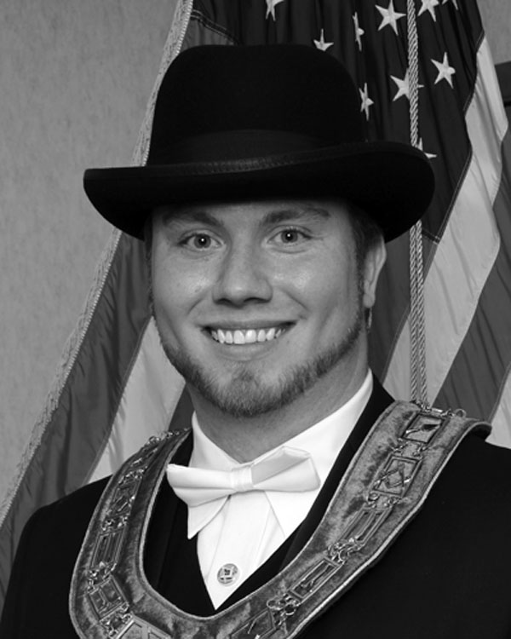From the East,

Derek Martin, WM

I want to be the first person to say thank you to the officers, brethren, and guests that attended the installation on Sunday, Nov 10th. The event went off without a hitch and I could not be any happier with the turn out. As the new Master of Reynoldsburg lodge it is a great honor to be elected to serve Reynoldsburg lodge for the 2014 year. I want to make sure that there is an open line of communication between myself and the membership. I am here for you and I want to assure everyone that this lodge means the world to me, if I can do anything to make the year more enjoyable please be sure to let me know.

This is my first article as the Master and I want to take this chance to say special thanks to certain people. To Brad Love, our newest Past Master: it was an honor to be your Senior Warden and I hope I can live up to the expectations that you set for the quality of degree work, friendship, and fun around lodge. Thanks to you and your family for the time you spent over the last years. To my newly installed officers: I have high expectations for the coming year; and for good reasons. I have seen the dedication and quality of work that you all have put in over the years. I hope that we can continue to deliver exceptional degree work to our candidates and represent Reynoldsburg Lodge the way it deserves. Also, mark your calendars officers February 6th is our inspection date and I have my eye on that best Fellow Craft degree award!

Last but certainly not last, the members of lodge. The officers and I are blessed to be able to serve you. Without you, we can't exist as a lodge. I cannot tell you how happy it makes me feel to see the number of seats filled on our meeting nights. I want to put a challenge out to the membership. I want 2014 to be a year of positive lodge membership, talk to those men at work, friends and family about masonry. Share your experience and why you are better because of Masonry, and how they too could be a better man because of Masonry.

I am looking forward to what the year has to bring. Let's have fun and make this one of the best ever!

*Derek M. Martin*

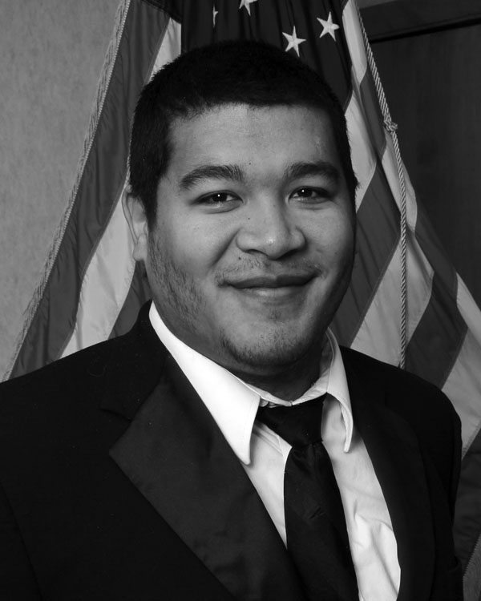From the West,

Alex Jackson, SW

A new Masonic year is upon us and right back into the work we go. I am very pleased to have seen the recent increase in brothers attending meetings and getting involved with the new members and programs that the Lodge has been putting together. Brother Charles Ashley has made the year very enlightening with his education talks and I, for one, look forward to his continuing as the LEO for WM Martin's upcoming year. Education is a key part of Masonry, so much so that we, as Masons, dedicated an entire degree to teaching how to learn and another to teaching what to learn and our support of these endeavors is a great necessity. When making good men better, we ourselves must know how to teach and Brother Ashley, along with programs from the Grand Lodge of Ohio, are doing everything possible to afford us these luxuries. For those who want something more to learn and can't make it to Lodge, I urge you to visit [FREEMASONUNIVERSITY.COM](http://FREEMASONUNIVERSITY.COM). This website contains valuable information on leadership and other aspects of life which not only improve the management of the lodge but can help outside of our sacred retreat. As our numbers grow smaller we must make sure that the quality we have here inside the Lodge outshines the quantity of members we have on the rolls. Please do what you can to help Freemasonry maintain its vaunted status as a fraternity and brotherhood.

I would also like to point out some work for our newest members. Last year, during awards and installation, Brother Jim Woodward was presented with Reynoldsburg Lodge's First Rookie Award. The “Rookie Award” was designed to help new members transition into Masonry and give them the opportunity to get involved. I'm pleased to say that we have a handful of members this year who are in the running to earn said award. As much as this is a means to encourage our new members to be active we need the support of our more senior members too. I would like to ask all of your help to make this a fun and successful year. The more we do together for Masonry the more likely we are to keep Freemasonry a Timeless Treasure.

(Cont. on page 3)

**(Cont.) Reynoldsburg #340 Rookie Award**

This award has been designed to encourage participation, and recognize those Brothers who take to heart the adage “You get out what you put in”. This award shall be given to any MM who, within a year from his raising, completes 4 of the Elective tasks and all of the required tasks. Any tasks completed before the 3rd degree will still count towards the tally.

**Required**

\_\_\_Attend one conferral of each degree after you receive it \_\_\_ Attend one inspection outside of your home Lodge    
\_\_\_ Attend home Lodge's inspection    
\_\_\_ Assist with one breakfast (cooking, serving or clean-up) \_\_\_ Help with Trustee's Clean Up Day 

**Elective**

\_\_\_ Attend one "Officer's Meeting"    
\_\_\_ Attend one Masonic Funeral    
\_\_\_ Serve on an Investigation Committee    
\_\_\_ Sponsor a candidate for membership    
\_\_\_ Perform a part in the MM degree (speaking or non)    
\_\_\_ Assist with one Lodge event or fundraiser    
\_\_\_ Assist once with setting up the Lodge    
\_\_\_ Assist once with the preparation of a candidate  
\_\_\_ Attend at least seven stated meetings at home Lodge    
\_\_\_ Mentor one candidate in the degree proficiency

*Fraternally and Sincerely  
Alex Jackson*

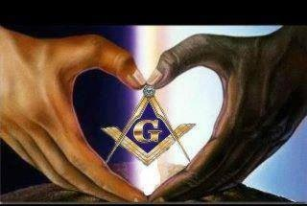

From the Secretary,   
Gary Wehr,PM

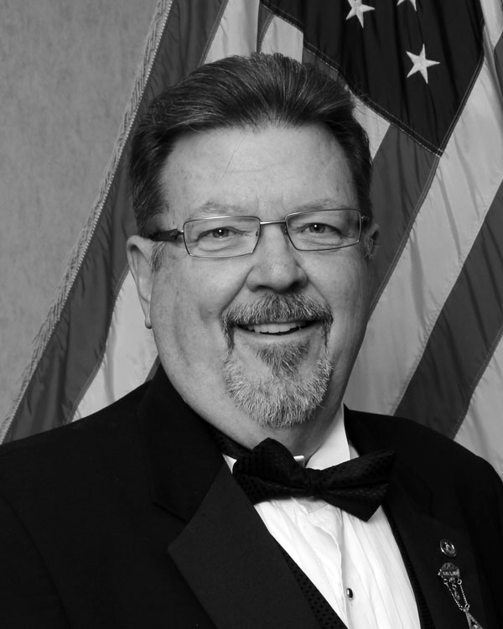IMPORTANT MESSAGE ….My email address is changing and maybe my phone number. I’m switching internet providers and by the time you get this issue of the Trestleboard my personal email address will be different and maybe my home phone number. All of the officer email addresses are listed on the front page of the Trestleboard. You can always reach me at [secy@mason340.com](mailto:secy@mason340.com) or [gary\_wehr@yahoo.com](mailto:gary_wehr@yahoo.com). If you want to call me, please use my cell phone number   
(614) 202-1523.

Now for some Lodge news. As we begin the new Masonic year we are also starting with just over **$9000.00** behind in 2014 dues payments. Our Lodge depends on this income to pay our bills and keep our Lodge building operational. If you have already paid you annual dues then thank you! If you added some additional funds to your annual dues then THANK YOU!!! You can’t image how much that helps. If you are part of the $9000 then you still have time to correct that by getting your annual dues payment in to me by Dec 31st.

On a lighter note, we held our first (of many I hope), Dinner and Trivia night. It was a sooo much fun! If you missed it you missed a good evening of laughter and great fellowship. It was a great opportunity to get the wives and kids involved. I need to take this opportunity to publically thank my wife, Sandy, for all she did that night to help make this event a success. She not only cooked the food, she also prepared the plates and then she helps serve it too. The winners that evening are David Gubanc and his wife Phyllis and Mike Martin. They will have bragging rights until the next go round.

The officers are trying their best to hold events such as this to include the family as much as possible. If your family can see the members having a great time then they might understand why Masonry is so important to many of us.  
 (Cont from page 4)

(Cont from page 3)

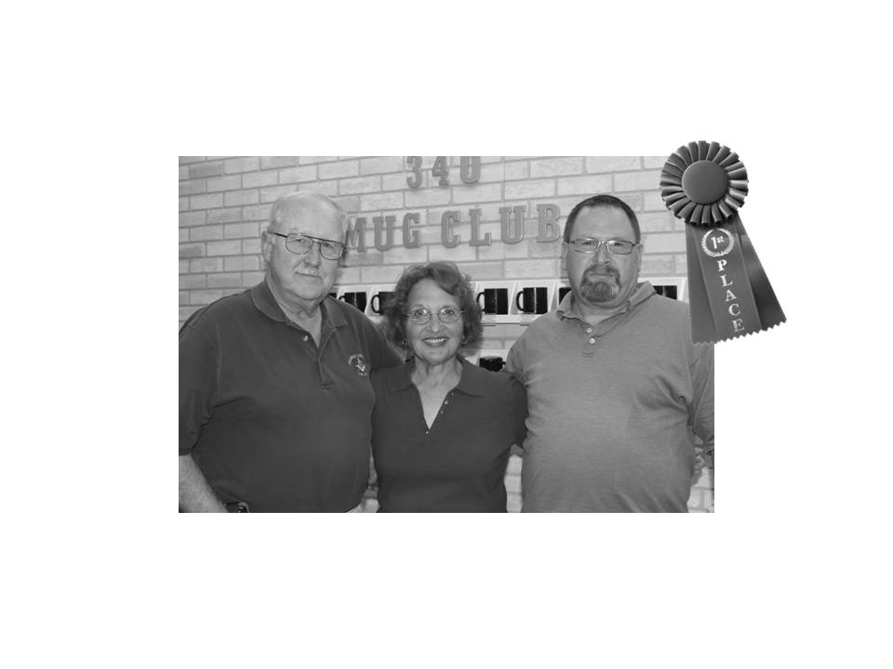These are also a chance for you to get back into Lodge. If you have been away for a while but feel uncomfortable about attending a meeting because you might not know anybody then come to our family events and we’ll make you feel more comfortable than a Lazy Boy! Our monthly breakfast is a great place to start.

Lodge is not a place full of strangers; it’s the place where the friends you have been missing are. Give it a try; after all, you’re paying dues for this opportunity.

*Fraternally  
Gary Wehr, PM*

Rent the Lodge  
Got a big family gathering? Office party?  
Rent Godfrey Hall for your function  
Just $50 to rent Godfrey Hall for members of Reynoldsburg Lodge, Whitehall Lodge or Eugenie Chapter  
Only $75 for non-members  
Additional Charge for kitchen use  
Contact WM Brad Love at 614-868-2696 for details

**Breakfast with Santa at the Lodge**

**Dec 14th 8 – 11am**

**Free Photos and gifts for kids of ALL ages!!!!!**



**Photos from Dinner and Trivia Night**

**Trivia Champions!**

Team *– “Take it to the Gubanc”*

Dave Gubanc,Phyllis Gubanc, Mike Martin

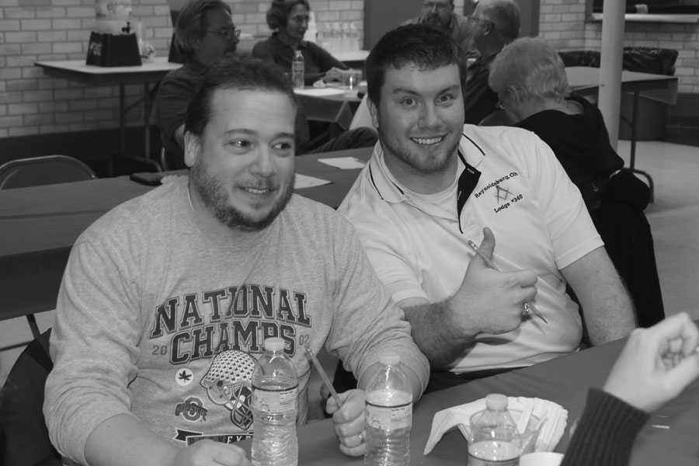

Half of Team – “Gotta Love Martin”

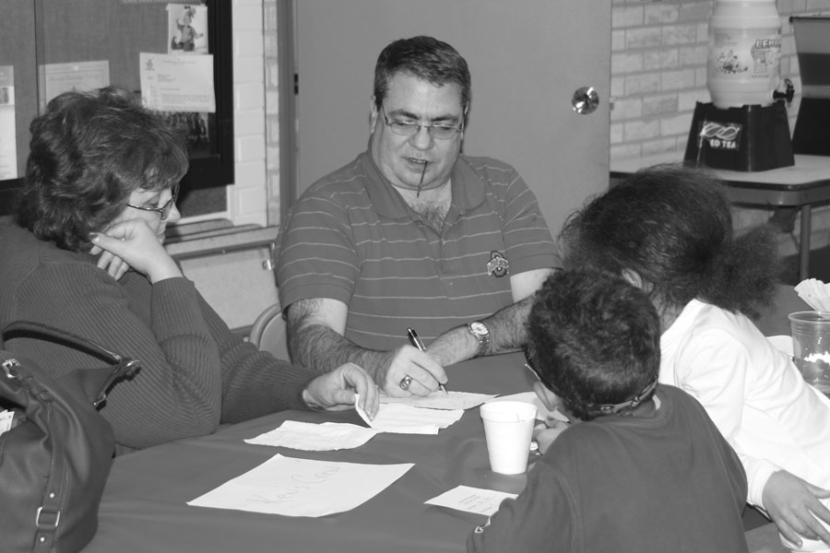  
Team – “Ken’s Krew”  
(the kids only missed 1 question!

**The Reynoldsburg Lodge #340 Officers**

|  |  |  |
| --- | --- | --- |
| **K:\DCIM\100CANON\Derek - TB.jpg** | **K:\DCIM\100CANON\Alex - TB.jpg** | **K:\DCIM\100CANON\John - TB.jpg** |
| **Derek Martin, WM** | **Alex Jackson, SW** | **John Wronski, PM, JW** |
| **K:\DCIM\100CANON\Gary - TB.jpg** | **K:\DCIM\100CANON\Buck - TB_edited-1.jpg** | **K:\DCIM\100CANON\Monroe - TB.jpg** |
| **Gary Wehr, PM, Secretary** | **Buck Boyd, Treasurer** | **Monroe Bradley, SD** |

**The Reynoldsburg Lodge #340 Officers**

|  |  |  |
| --- | --- | --- |
| **K:\DCIM\100CANON\Jim - TB.jpg** | **K:\DCIM\100CANON\Jeff - TB.jpg** | **K:\DCIM\100CANON\John T - TB.jpg** |
| **Jim Woodward, JD** | **Jeff Mason, SS** | **John Trikouros, JS** |
| **K:\DCIM\100CANON\Charlie - TB.jpg** | **K:\DCIM\100CANON\Al - TB.jpg** | **K:\DCIM\100CANON\Rod - TB.jpg** |
| **Charles Ashley, LEO** | **Al Nelson,PM,Trustee 1yr** | **Rod Basye,PM,Trustee 3yrs** |



**December**

2 JeffRannebarger,PM.PDDGM

4 Samuel Cohen

5 Mark Borror

5 Richard Montgomery

5 Chris Brigode

6 Amos Stroud

8 Earl Ruble, PM

8 John Waldorf, PM

9 Howard Hupp

10 Ed Komraus, PM

10 Stuart Ensign

11 Chris Bell

13 Wade Haines

14 John King

14 Mike Longfellow

15 Richard Maxim

17 Kendric Ball, PM

21 Richard Elsworth

22 Dan Merrick

22 Stephen Martanovic

22 James Russell

23 Harold Wesley

24 Cecil Rodgers

25 Ted Habak

26 Harold Herd

28 Hassan Omar

30 Jerry Dunn

31 Dwight Rinehart

31 Tommy Richard

31 Al Nelson, PM



**January**

2 Ronald Irion  
2 Ronald Brofford

1. Ronald Moore

5 Raymond Deem

6 William Davis

10 Gene Wise. PM

10 George Dountz

16 Robert Ashbrook

19 John Cochran

20 Larry Middendorf

20 Thomas Romine

21 Henry Turner

21 James Webber

21 Chad Brown

22 Mark Lochstampfor

23 Thomas Pace

25 Henry Tucker

28 Ralph Turley

28 Wilford Williams

28 Steven Hartshorn

29 Harold Baker

30 Michael Davis

**A Freemason's “Twas the Night Before Christmas”**

Revised by Gary Wehr, PM

**'Twas the night before Christmas, and all through the Lodge  
Not a Brother was stirring, which was quite odd;  
The jewels were hung at the stations with care,  
In hopes that a candidate would soon be there;**

**WB Brother Basye was all snug in his chair,  
With visions of Cowans and Eavesdroppers he had trapped in his snare;  
and Bro Lollar at his piano and WM Martin in his hat  
Bro Merrick fell asleep during Bro Ashley’s Masonic Education Crap,**

**When out in the ante-room there arose such a clatter  
Even the Past Masters awoke to see what was the matter.  
Away to the door they flew in a flash  
But Bro Woodward held tight and into the door they all crashed.**

**The Master gave three knocks with his new wooden gavel  
lest the curiosity of the Brethren would cause them to unravel,  
When the door was opened we were amazed at what would appear,  
Twas a miniature sleigh, and eight tiny reindeer,**

**With a hoodwinked driver, so lively and quick,  
We knew in a moment it must be St. Nick.  
Mr. Claus was the candidate, Bro Bradley proclaimed,  
And he asked to entered and gave the reasons by name;**

**"Now Apron! Now Compass! Now Plumb Rule and Trowel!  
On, Chisel! On Mallet! On, Level and Square!  
To the North, to the South, to the East and the West!  
The Brethren notice of how oddly the candidate was dressed!"**

**As Mr. Claus went around to each station and spot,  
we wondered while hoodwink if he still knew Bro Boyd was naughty or not,  
he was instructed in the steps by the SW, Bro Jackson  
and was then asked if he understood and he answered ‘Yep, When are we startin?’**

**(Cont on page 9)**

**And then we all listened in silence as the candidate took  
that solemn obligation of an Entered Apprentice on that Great Holy Book.  
When we all sat down, the candidate rose,  
A newly made brother with a red shiny nose.**

**He was dressed all in fur, from his head to his feet,  
But he was our Brother now and Happy we were to meet;  
He was allowed to retire to put back on something that suits,  
But when he came back he was the same but wearing boots.**

**His eyes -- how they twinkled! His dimples how merry!  
As he was congratulated by his sponsor, W. Brother Gary!  
Out to the kitchen we went to enjoy in some cheer  
Happy to have had at least one candidate this year;**

**The stump of a pipe he held tight in his lip  
As he passed around the room practicing his grip;  
He had a broad face and a little round belly,  
and sandwiches! Could he eat? - Whoa Nelly.**

**He was chubby and plump, like most jolly old elves,  
A typical Freemason, we all thought to ourselves;  
With a wink of his eye and a twist of his head,  
He scanned the table to see if Bro Trikouros had brought out more bread;**

**He spoke not a word, but went straight to his book,  
And memorized the obligation he recently took,  
He repeated it to his coach Bro Mason and was correct in the first draft,  
How quick Santa was ready to be made a Fellowcraft;**

**He sprang to his sleigh, with really quite a rumpus  
On the back of the sleigh was a new square and compass.  
We heard him exclaim, ere he drove out of sight,  
"Merry Christmas to All, For Letting Me See the Light."**

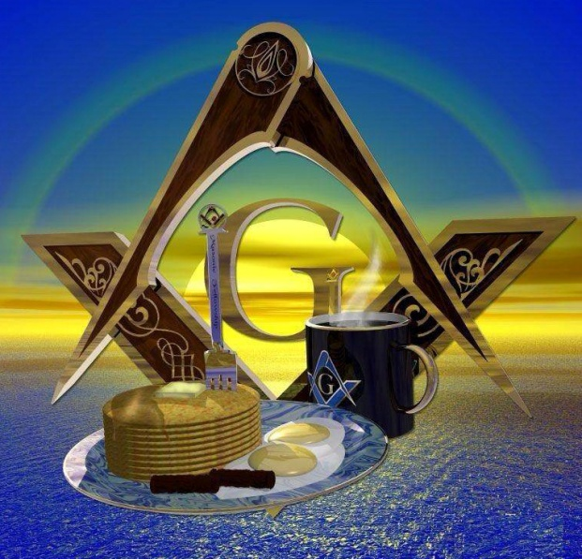

**Don’t forget our monthly breakfast on the   
Saturday of EVERY month, 8-11am. All you can eat for $6.**

**WHAT A DEAL!!!!!**

Please support OUR SPONSORS

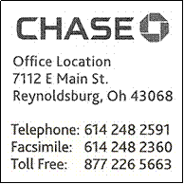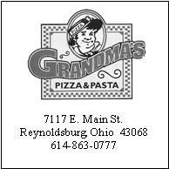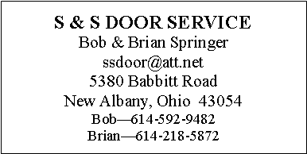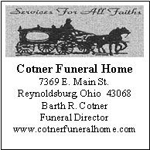Please support OUR SPONSORS

[](http://www.google.com/url?sa=i&rct=j&q=&esrc=s&frm=1&source=images&cd=&cad=rja&docid=qC9MotqY53XYYM&tbnid=W2vq0nQPmWpd3M:&ved=0CAUQjRw&url=http://theupiafiles.wordpress.com/2011/04/17/i-am-a-freemason/&ei=K4w6UaeVB-Xp0AHg0YGoDg&bvm=bv.43287494,d.dmQ&psig=AFQjCNHGurslu-Gg3ElBFY_CpbL3nZVgyA&ust=1362877607056919)

P.O. Box 624

Reynoldsburg Lodge #340 F&AM

Reynoldsburg, OH 43068

DATED MATERIAL – PLEASE DO NOT DELAY

NON-PROFIT ORGANIZATION  
U.S. POSTAGE PAID  
PERMIT NO. 30  
REYNOLDSBURG, OHIO 43068