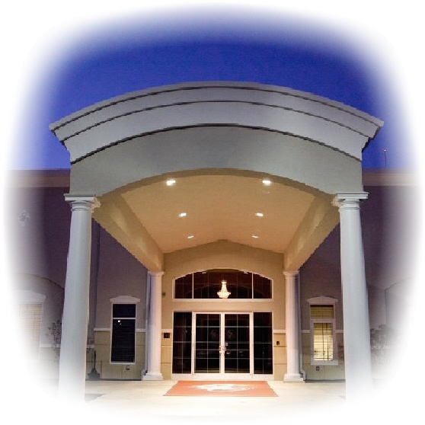

Aladdin Shriners

Petition for **Affiliation Membership - 2016**

1801 Gateway Circle, Grove City, Ohio 43123

(614) 475-2609 (800) 475-3850

www.aladdinshrine.org

TO THE ILLUSTRIOUS POTENTATE, OFFICERS AND MEMBERS OF Office Use Only:

ALADDIN SHRINE SITUATED IN COLUMBUS, OHIO: Member Number: _____________

I, the undersigned, a Noble of the Mystic Shrine, initiated into _________________________________________ Shrine located at ________________________________________ on (date) _______/_______/________ and a member of _________ Shrine located at __________________________, which has granted the attached Certificate of Demit. I furthermore state that I have resided within the jurisdiction of Aladdin Shrine for not less than 6 months as required by the Bylaws of the Imperial Council. I furthermore declare that I am a member in good standing of:

____________________________________ Lodge No. ____________________ F. & A.M., at ______________________________,

which is a lodge by or in amity with the Conference of Grand Masters of North America. Furthermore, I have resided at my current address for not less than 6 months, as required by the Bylaws of the Imperial Council. I respectfully pray that I may be made a Noble of the Mystic Shrine and become a member of your temple.

Print Full Name: _____________________________________________________ Lady’s Name: ____________________________

Residence Address: ___________________________________________________ Phone: (_______)________________________

City: ______________________________________________ State: _____________________ Zip: _______________-_________

Birthplace: __________________________________________________________ Date of Birth: ___________________________

Profession or Occupation: ______________________________________________________________________________________

(If retired, what did you do before you retired?)

Nickname: __________________________________________ County of Residence: _____________________________________

Email Address: ________________________________________________________ Fez Size: ______________________________

Employed By: _______________________________________ Business Phone Number: (_______)__________________________

Business Address: _____________________________________________________________________________________________

SIGNATURE: ___________________________________________________________ Date: ________________________________

Name in full, no initials.

Recommended and vouched for on the honor of:

Noble’s Name (Print) _______________________________________ Unit/Club: __________________________________  
Noble’s Signature: _________________________________________ Member Number: ___________________________

Noble’s Name (Print) _______________________________________ Unit/Club: __________________________________  
Noble’s Signature: _________________________________________ Member Number: ___________________________

There is no fee to affiliate with Aladdin Shriners in the same year you Demit from another temple. Dues will be assessed at the end of the year for 2017. If you do not have a demit from 2016 the fee to affiliate is:

January – March: $89 April – June: $75.50 July – September: $62 October – December: $102.50 (Includes 2017 dues)

Please attach original demit form.

Revised 01/15